Microflowers of Sn-Co-S derived from ultra-thin nanosheets for supercapacitor applications
Sachin Kumar^{a,b}, Irshad Ahmed Mirª, Zubair Ahmad^{b}, Kwan San Hui^{c}, Duc Anh Dinh^{d}, Ling Zhu^{a*}, Kwun Nam Hui^{e*}, Jae-Jin Shim^{b*}

Supporting Information

Characterization Techniques
The microstructural and morphological analyses of the samples were done using field-emission scanning electron microscopy (FE-SEM, JEOL JSM-6701F) and high-resolution transmission electron microscopy (HR-TEM, Hitachi H-H7650). Elemental information of the samples was obtained using energy-dispersive X-ray spectroscopy (EDX) equipped with FE-SEM. To obtain TEM images, the material was removed from the Ni foam using ultrasonication. To analyze the crystalline features and the phase purity of the synthesized samples, the samples were characterized using an X-ray diffractometer (Rigaku D/Max 2500V/PC, Japan) with Cu-Kα radiation (λ = 1.5406 Aº). The chemical compositions and oxidation states of the prepared samples were analyzed by X-ray photoelectron spectroscopy (XPS; Thermo Fisher Scientific, UK).
Electrochemical Characterizations
The electrochemical properties of the samples were studied by an electrochemical workstation (CHI 760E, USA). To test the electrochemical performance of the as-synthesized samples, a three-electrode configuration was used, where Pt foil was used as a counter electrode, and Ag/AgCl was used as a reference electrode. Sn-Co-S/NiF was directly used as a working electrode in 1 M KOH electrolyte solution. Moreover, electrochemical impedance spectroscopy (EIS) study was also carried out by an open circuit potential under ambient conditions in the frequency range of 100 kHz to 0.01 Hz. The detailed information of electrochemical characterization is given in supporting information.
The specific capacitances of the working electrode was calculated through the GCD curve by the given equations (1) [17].
$$C_{m}=\frac{2I ʃVdt}{m∆V^{2}}……(1)$$
where, ʃVdt, m, I, and ΔV represent the integral area under the discharge curve, mass of the active material (g), discharge current (A), and potential window (V) respectively.
The electrochemical properties of the asymmetric supercapacitor were studied in two-electrode configuration system. The ASCs device was fabricated by using Sn-Co-S/NiF (positive electrode) and AC/NiF (negative electrode), NKK TF40 (40 mm thickness, Nippon Kodoshi Corporation) as the separator and 1 M KOH as an electrolyte solution. The operating potential window was optimized to be 1.7 V. To balance the charge, mass ratio between the positive and negative electrodes of the ASC device was estimated by the following equation (2) [17].
$$\frac{m_{+}}{m_{-}}=\frac{C_{-}*V_{-}}{C_{+}*V_{+}}……(2)$$
where, C, m and V are the specific capacitance, mass and potential ranges for the positive and negative electrodes.
The specific capacitances, energy density, and power density of the ASC device were calculated by given equations (1), (3) and (4), respectively [1].
$$E=\frac{I ʃVdt}{m*3.6}……(3)$$
$$P=\frac{E_{cell}*3600}{t_{discharge}}……(4)$$
where, t_{discharge} is the discharge time, ΔV is the potential range, I is the discharge current, m is the total mass of both electrodes, ʃVdt is the integral area under the discharge curve and C_{cell} is the specific capacitance of the device.

Figure 1S (a-b) FESEM images of 3D broccoli-like microflowers of Sn-S/NiF at different scale, (c) real image of broccoli for comparison.

Figure 2S EDS patterns of (a) Sn-S/NiF (b) Sn-Co-S/NiF.

Figure 3S FESEM-EDS color mapping of Sn-Co-S/NiF (a) showing selected area for mapping, (b-d) corresponding EDS elemental mapping.

Figure 4S Nitrogen adsorption-desorption isotherms for Sn-Co-S/NiF

Figure 5S STEM-EDS elemental color mapping of Sn-S/NiF (a) showing selected area for mapping, (b-c) corresponding EDS elemental mapping.

Figure 6S XPS survey spectra of Sn-Co-S

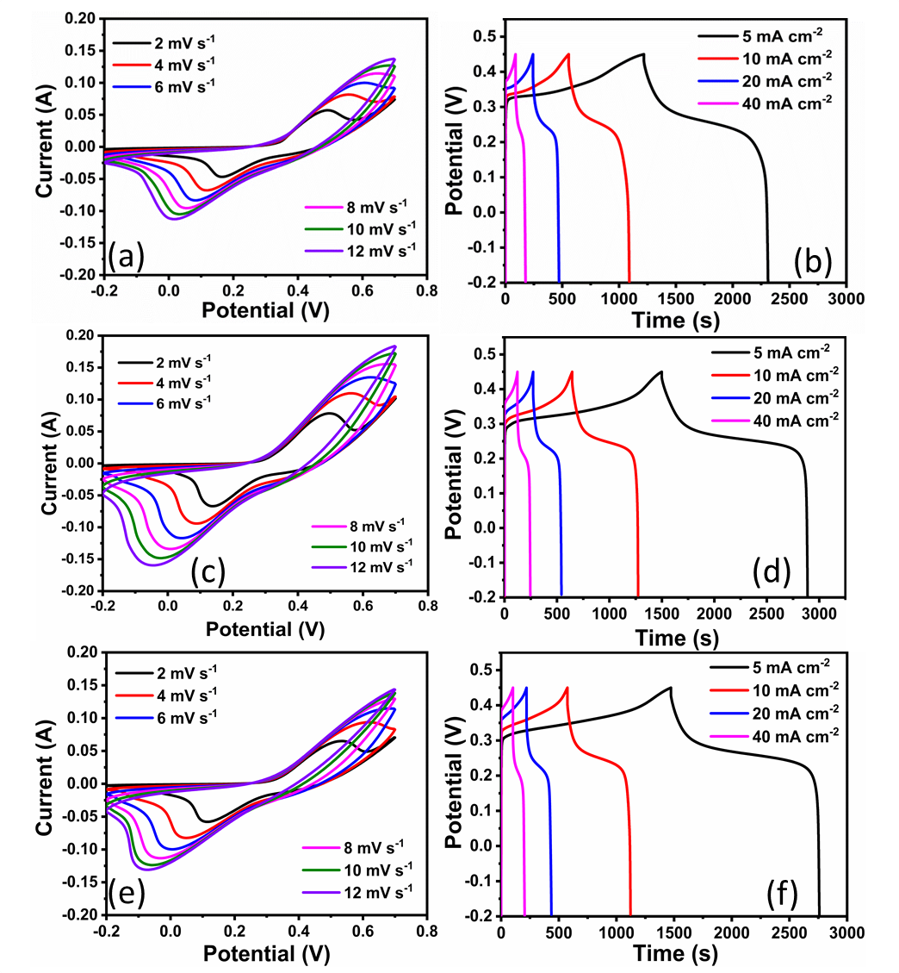
Figure 7S (a) CV and (b) GCD curve, of Sn-Co-S (5%). (c) CV and (d) GCD curve, of Sn-Co-S (10%). (e) CV and (f) GCD curve, of Sn-Co-S (15%).

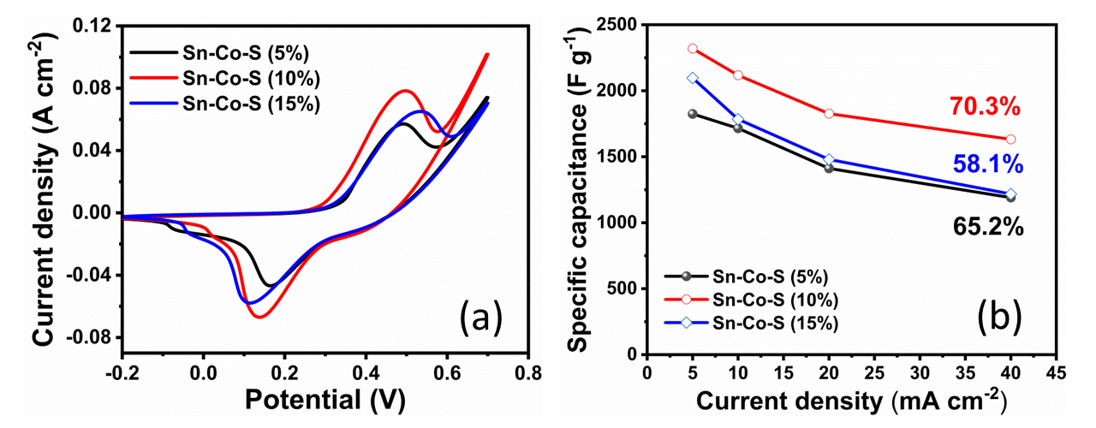

Figure 8S (a) CV comparison among Sn-Co-S (5%), Sn-Co-S (10%), Sn-Co-S (15%). (b) Specific capacitance vs. current density curve for Sn-Co-S (5%), Sn-Co-S (10%), Sn-Co-S (15%).

Figure 9S CV curve of Sn-S/NiF electrode.

Figure 10S The log(ν) and log(i) curve for the Sn-Co-S/NiF electrode.

Negative electrode characterization
The activated carbon (AC) electrode was fabricated by dissolving the activated charcoal (acid-washed with HCl), mesoporous carbon and polyvinylidene fluoride (PVDF) in N-methyl-2- pyrrolidinone (NMP) in a weight ratio of 8:1:1. This slurry of mixture was coated on Ni foam (1×2 cm²) and then dried at 80 °C under vacuum. The slurry coated Ni foam was pressed for 60 s under 8.0 MPa. The mass loading of AC was calculated to be ~11. 7 mg cm⁻² and named as AC/NiF. To test the electrochemical performance using three-electrode system, the active material coated Ni foam was employed as the working electrode, Pt foil as counter electrode and an Ag/AgCl electrode in a saturated KCl solution as reference electrode in 1 M KOH electrolyte, respectively. The recorded CV and GCD curves for AC/NiF are shown in Fig. S7 (a-b), demonstrating a typical EDLC nature of the electrode. The calculated specific capacitance is plotted against current density in Fig. S7 (c). The maximum specific capacitance of AC/NiF electrode is calculated to be 252.2 F g⁻¹ at a current density of 1 A g⁻¹ which is comparable to earlier reported study [18].

Figure 11S (a) CV curve, (b) GCD curve (c) Specific capacitance vs. current density, of AC/NiF.

Figure 12S 10 cycles recorded before cycling test, after completing 5000 cycles and then after completing 10000 cycles.

Table S1 Comparison of capacitances between the present Sn-Co-S/NiF electrode and similar types of electrodes taken from the recently published reports.

S. No | Electrode Material | Electrolyte | Specific Capacitance | Ref.
1 | SnS nanorods | 2M Na₂SO₄ | 70 F g⁻¹ at 0.5 mA cm⁻² | 1
2 | Flower Like SnS₂ | 2 M KOH | 431.8 F g⁻¹ at 1 A g⁻¹ | 2
3 | orthorhombic-SnS nanoflower | 2 M KOH | 1203 F g⁻¹ at 5 mV s⁻¹ | 3
4 | Mn doped SnS₂-graphene aerogels | 6 M KOH | 523.51 F g⁻¹ at 5 mV s⁻¹ | 4
5 | CF-SnS₂ | 1 M KCl | 524 Fg⁻¹ at 0.08 A g⁻¹ | 5
6 | NiCo₂S₄@CoMoO₄ | 2 M KOH | 2118.8 F g⁻¹ at 1 A g⁻¹ | 6
7 | Ni_{0.75}Co_{0.25}S₂ | 2 M KOH | 2141.9 F g⁻¹ at 2 A g⁻¹ | 7
8 | Ni-Co-S@Ni-W-O | 6 M KOH | 1988 F g⁻¹ at 2 A g⁻¹ | 8
9 | SnS₂/g-C₃N₄ | 3 M KOH | 552 F g⁻¹ at 0.5 A g⁻¹ | 9
10 | NiS-SnS | KOH/PVA | 1653 Fg⁻¹ at 1 Ag⁻¹ | 10
11 | NiCo₂S₄/Co₉S₈ | 1M KOH | 1008 Fg⁻¹ at 1 Ag⁻¹ | 16
12 | 3D broccoli-like Sn-Co-S microflowers on Ni foam | 1 M KOH | 2319.3 F g⁻¹ at 5 mA cm⁻² | Current work

Table S2 Comparison of the Sn-Co-S/NiF//AC/NiF asymmetric supercapacitor with those in recently published reports.

S. No. | Electrode material (Positive//Negative) | Specific Capacitance (F g⁻¹) | Working Potential (V) | Energy density (W h kg⁻¹) | Power density  (W kg⁻¹) | Cycling Life | Ref.
1 | β-MnO₂/SS//O-SnS/SS | 122 F g⁻¹ at 5 mV s⁻¹ | 1.6 V | 29.8 | 1250 | 95.3%, 5000 cycles | 3
2 | Mn-SnS₂-GA//Mn-SnS₂-GA | - | 1.6 V | 18.02 | 8000 | 98.5%, 2000 cycles | 4
3 | Ni-Co-S@Ni-W-O/NF//AC/NF | 155 F g⁻¹  at 1 A g⁻¹ | 1.6 V | 55.1 | 15975 | 91.7%, 6000 cycles | 8
4 | Ni₁Co₁-S/NF//NG | 164.9 F g⁻¹  at 1 A g⁻¹ | 1.6 V | 58.1 | 25,081.7 | 92%, 70000 cycles | 11
5 | SnS₂/G//SnS₂/G | 262.5 F g⁻¹  at 1 A g⁻¹ | 0.8 V | 23.5 | 2985 | - | 12
6 | CuCo₂S₄//AC | 114.5 F g⁻¹  at 1 A g⁻¹ | 1.45 V | 33.4 | - | 78%, 10000 cycles | 13
7 | Ni₃S₂/MnS/rGO//rGO | 232.5 F g⁻¹  at 1 A g⁻¹ | 1.7V | 58.9 | 8894.1 | 99%, 8000 cycles | 14
8 | copper tungsten sulfide /Ni//graphene | 107.93 F g⁻¹  at 0.75 mA | 1.8 V | 48.57 | 12857 | 92.1%, 10000 cycles | 15
9 | NiCo₂S₄/Co₉S₈//AC | 103.2 F g⁻¹  at 1 A g⁻¹ | 1.6 V | 36.7 | - | 90%, 3000 cycles | 16
10 | Sn-Co-S/NiF//AC/NiF | 164.1 F g⁻¹  at 1 A g⁻¹ | 1.7 V | 66.9 | 6793.1 | 95.8%, 10,000 cycles | This  work

References
[1] H. Chauhan, M. K. Singh, S. A. Hashmi and S. Deka, Synthesis of surfactant-free SnS nanorods by a solvothermal route with better electrochemical properties towards supercapacitor applications, RSC Adv. 5 (2015) 17228–17235.
[2] N. Parveen, S. Ansari, H. Alamri, M. Ansari, Z. Khan and M. H. Cho, Facile Synthesis of SnS₂ Nanostructures with Different Morphologies for High-Performance Supercapacitor Applications, ACS Omega 3 (2018) 1581–1588.
[3] A. M. Patil, V. C. Lokhande, U. M. Patil, P. A. Shinde, and C. D. Lokhande, High Performance All-Solid-State Asymmetric Supercapacitor Device Based on 3D Nanospheres of β‑MnO₂ and Nanoflowers of O‑SnS, ACS Sustainable Chem. Eng. 6 (2018) 787–802.
[4] H. Chu, F. Zhang, L. Pei, Z. Cui, J. Shen, M. Ye, Ni, Co and Mn doped SnS₂-graphene aerogels for supercapacitors, J. Alloys Comp. 767 (2018) 583–591.
[5] R. K. Mishra, G. W. Baek, K. Kim, H. Kwon and S. H. Jin, One-step solvothermal synthesis of carnation flower-like SnS₂ as superior electrodes for supercapacitor applications, Appl. Surf. Sci. 425 (2017) 923–931.
[6] Y. Zhao, X. He, R. Chen, Q. Liu, J. Liu, D. Song, H. Zhang, H. Dong, R. Li, M. Zhang and J. Wang, Hierarchical NiCo₂S₄@CoMoO₄ core-shell heterostructures nanowire arrays as advanced electrodes for flexible all-solid-state asymmetric supercapacitors, Appl. Surf. Sci. 453 (2018) 73–82.
[7] S. Xie, J. Gou, B. Liu and C. Liu, Synthesis of cobalt-doped nickel sulfide nanomaterials with rich edge sites as high-performance supercapacitor electrode materials, Inorg. Chem. Front. 5 (2018) 1218–1225.
[8] W. He, Z. Liang, K. Ji, Q. Sun, T. Zhai and X. Xu, Hierarchical Ni-Co-S@Ni-W-O core–shell nanosheet arrays on nickel foam for high-performance asymmetric supercapacitors. Nano Res.11 (2018) 1415–1425.
[9] Y. Xu, Y. Zhou, J. Guo, S. Zhang, Y. Lu, Preparation of SnS₂/g-C₃N₄ composite as the electrode material for Supercapacitor, J. Alloys Comp. 806 (2019) 343–349.
[10] N. Kumar, D. Mishra, S. Y. Kim and S. H. Jin, Self-assembled NiS-SnS heterostructure via facile successive adsorption and reaction method for high-performance solid-state asymmetric supercapacitors, Thin Solid Films 709 (2020) 138138.
[11] D. Zha, Y. Fua, L. Zhang, J. Zhu and Xin Wang, Design and fabrication of highly open nickel cobalt sulfide nanosheets on Ni foam for asymmetric supercapacitors with high energy density and long cycle-life, J. Power Sources 378 (2018) 31–39.
[12] S. P. Lonkar, V. V. Pillai, S. P. Patole, and S. M. Alhassan, Scalable in situ synthesis of 2D−2D-type graphene-wrapped SnS₂ nanohybrids for enhanced supercapacitor and electrocatalytic applications, ACS Appl. Energy Mater. 3 (2020) 4995–5005.
[13] J. Du, Q. Yan, Y. Li, K. Cheng, K. Ye, K. Zhu, J. Yan, D. Cao, X. Zhang and G. Wang, Hierarchical copper cobalt sulfides nanowire arrays for high-performance asymmetric supercapacitors, Appl. Surf. Sci. 487 (2019) 198–205.
[14] G. Zhang, H. Xuan, R. Wang, Y. Guan, H. Li, X. Liang, P. Han and Y. Wu, Enhanced supercapacitive performance in Ni₃S₂/MnS composites via an ion-exchange process for supercapacitor applications, Electrochim. Acta 353 (2020) 136517.
[15] P. Pazhamalai, K. Krishnamoorthy, S. Sahoo, V. K. Mariappan and S. J. Kim, Copper tungsten sulfide anchored on Ni-foam as a high-performance binder free negative electrode for asymmetric supercapacitor, Chem. Eng. J. 359 (2019) 409–418.
[16] Y. Shen, K. Zhang, B. Chen, F. Yang, K. Xu and X. Lu, Enhancing the electrochemical performance of nickel cobalt sulfides hollow nanospheres by structural modulation for asymmetric supercapacitors, J. Colloid Interf. Sci. 557 (2019) 135–143.
[17] G. Saeed, S. Kumar, P. Bandyopadhyay, N. H. Kim, and J. H. Lee, Hierarchical design of Cu-Ni(OH)₂/Cu-Mn_{x}O_{y} core/shell nanosheet arrays for ultra-high performance of asymmetric supercapacitor, Chem. Eng. J. 369 (2019) 705–715.
[18] L. Niu, Y. Wang, F. Ruan, C. Shen, S. Shan, M. Xu, Z. Sun, C. Li, X. Liu, Y. Gong, In situ growth of NiCo₂S₄@Ni₃V₂O₈ on Ni foam as a binder–free electrode for asymmetric supercapacitors, J. Mater. Chem. A 4 (2016) 5669–5677.

