British National Identity and Maritime Film and Television, 1960-2012

Mark Fryers 3370879

This dissertation is submitted for the degree of Doctor of Philosophy at The University of East Anglia.

September 2015

Abstract

This thesis considers the mythology connected to the maritime sphere and notions of British national identity and collective unity through the projection of the maritime in British film and television. Specifically, it traces the evolution of this myth through the period 1960-2012, a post-Imperialist era characterised by broad social, economic and political changes and internal divisions within the historic Union of Great Britain, demonstrating how British culture continually uses the past to comment on the present.

The thesis argues that the maritime remains a vibrant cultural site of British national self-examination and re-examination despite the precipitous decline of both Empire and Royal Navy within this time period. The specific audio-visual properties of the filmic and televisual forms and their position as the most successful cultural industries of the 20th Century suggest themselves as vital components for interrogating national myth and projections of collective unity and the attendant challenges to these.

Aligned to this is the manner in which critical reception continues to operate as an indigent of collective memory, morality and communality aligning itself as provision not only of positive cultural taste but also of a wider debate on the merits or de-merits of the specific components of myth and identity.

Each text is situated within its specific historical and industrial context and a combination of primary sources, textual analysis and reception studies are unified to argue that both the texts themselves and their reception within critical discourse collectively negotiate the role that media cultures play in constructing and challenging notions of collective identity and myth.

Finally, this thesis argues constructively, that the seemingly banal cultural symbols of national identity and mythology, far from being an irrelevance in a globalised age, remain amongst the most vital cultural, social, political and economic discourses of the age.

Acknowledgements

In the spirit of the thesis, it is true to say that not one person is an island, nor indeed is any project the discrete endeavour of one individual alone. In a broader sense, this thesis is the work of one Captain ably assisted by a diverse and disparate group of individuals who helped to steer it in the right direction, keep it on a steady course and guided it through numerous maelstroms.
First thanks go to the AHRC for funding this project and the University of East Anglia for supporting it. Special thanks are due to Keith Johnston and Victoria Carolan for providing guidance and encouragement through the uncertain waters of the project’s incipience and who helped to plot a navigable course.
Indeed, at times, the ocean seemed so un-penetrable that the expert guidance of professional colleagues Su Holmes, Rayna Denison, Sean Redmond and Tim Snelson were invaluable. These individuals offered both professional and pastoral care and when an S.O.S. was sounded, those friends and family close to me provided a sound, steady and sympathetic lifeboat. There are too many to mention but those closest are mentionable by name. My parents, Bruce and Yvonne Fryers were, as always both an anchor and safe harbour throughout as well as Cheryl Fryers and Lilian French. Special mention must go to two souls lost at sea, but for whom a flag is always raised. Gwendoline Lucy Fryers sadly passed away during the voyage, but her strength and love continue to provide an inspiration. Frank Herbert French, who worked at Chatham and Plymouth Dockyards, and for whom the whole project would probably never have materialised had he not been such an inspiration in life was also present in spirit throughout the venture.
Proving that friendship is eternal like the tides, not mere driftwood, Simon Scorey, Stephen Nunn, Flora Mearon and Sarah Hill all stood firm during the storms and more than earned their comradeship. Similarly, Louise North at the BBC written archives also earned her sea legs for invaluable help and advice.
Last, but by no means least in the sea of gratitude, the largest and most heartfelt thanks must go to Melanie Williams for going above and exceedingly beyond what could be hoped for from a thesis supervisor. Melanie provided criticism when it was needed, expert advice of immeasurable value and the full resources of her immense academic prowess of which was beyond the wildest sea dreams of this academic novice. More than this, however, was the support and encouragement that dated back to an initial and un-formed idea at MA level. Melanie listened and gave up so much of her valuable time to support this thesis as well as providing a level of help and understanding for which choosing words to fully express fully defies my imagination. So simply, thank you, and thank you to all I have not personally mentioned- from conversations on trains from inquisitive and enthusiastic strangers to academics who took the time to listen to my project and express interest and provide advice at various encounters over the three years. That is all here in the final project.

Contents

Contents

List of Illustrations……………………………………………………….P7.

Introduction………………………………………………………………P.9.
Methodological Approach……………………………………………… P.10.
Questions of National Identity…………………………………………..P.15.
British National Identity: Understanding the Precious Jewel in the Silver Sea ……………………………………………………………………………..P.19.
The Maritime, Film and Television and British National Identity……P.22.
Myth and Mythology……………………………………………………..P.25.
The Island Nation Myth………………………………………………….P.26.
Historical Context: Decline………………………………………………P.29.
National Media and National Identity…………………………………..P31.
Landscapes and Seascapes, Media and Identity………………………..P.36.
Overview of the Thesis Structure………………………………………..P.39.

Section 1. The Royal Navy in Film and Television, 1960-2012………...P.46.
Introduction……………………………………………………………….P.46.

1:1 “Ever Seen so Much Ignorance All in one Place?” HMS Defiant, Billy Budd and Early 1960s Naval Revisionism……………………………………...P.51.

“An Impulse of Anger, Instantly regretted”- HMS Defiant (1962)
Billy Budd…………………………………………………………………P.56.
Conclusion………………………………………………………………...P.67.

1:2 Do We Need Another Hero…Again? The Re-interpretation of the Myth of Nelson……………………………………………………………………...P.68.

The Falklands and British Film and Television…………………………P68.
The ‘Cult of Nelson’ on Screen……………………………………………P.70.

“A Boundless Enthusiasm for Admiration”: I Remember Nelson: Recollections of a Hero’s Life………………………………………………………………. P.71.
Reception and the Falklands War……………………………………….. P.87.
Conclusion ………………………………………………………………….P.88.

1:3 “Heroic Resistance to Cultural Updating”: Hornblower and Old Myths Reconstructed………………………………………………………………P.90.
Introduction…………………………………………………………………P.90.

1:4 To The Ends Of The Earth…and Back Again………………………..P.105.
Introduction………………………………………………………………... P.105.
Conclusion………………………………………………………………....…P116.

1:5 Warship, Making Waves and Contemporary Naval Television…….. P.117.
Cultural Power- Warship (1973-77)………………………………………...P.117.
Warship and the ‘Cod Wars’………………………………………………..P.117.
Making Ripples? Making Waves (2004)………………………………….....P.121.
Conclusion……………………………………………………………………P.126.
Chapter Conclusion………………………………………………………….P.127.

Section Two- Maritime Industries on Screen: Community and Regionality.P.129.
Introduction…………………………………………………………………..…P.129.

2:1 The Merchant Navy On Screen: Capitalising the Sea for Great Britain.P.134.
The Onedin Line………………………………………………………………..P.134.
A Nation Built On Slavery? Class, Economic and Gender Servitude in The Onedin Line.. ……………………………………………………………………P.142.
The ‘Black’ Atlantic………………………………………………………….... P.144.
Gender………………………………………………………………………….. P.147.
Conclusion……………………………………………………………………….P.152.

2:1 Howards’ Way: Class, Gender and the Maritime on British Screens..P.153.
Introduction………………………………………………………………….P153.
Howards’ Way and the 1980s………………………………………………..P.153.
“We Live in a Commercial World Ken, Everything’s is for Sale”: Howards’ Way and the Spaces of Capitalism………………………………………………..P160.
Space and Power Relations………………………………………………….P162.
“I Don’t Think I’ll Ever Love a Man as Much as The Flying Fish”: Gender Politics in Howards’ Way……………………………………………………P.166.
Conclusion………………………………………………………………….…P171.

2:3 Oil! Roughnecks (1994) and the North Sea Industries…………………P.172.
Introduction…………………………………………………………………...P.172.
Conclusion……………………………………………………………………..P.180.

2:4 On a Clear Day (2004) Dockyards and Shipbuilding after 1960…….....P.181.
Introduction……………………………………………………………………P.181.
Conclusion…………………………………………………………………...…P188.

2:5 The Sea Shall Have Them? Fractured Maritime Landscapes and Disappearing Britain…………………………………………………………..P190.
Introduction: Fishing…………………………………………………………………………..P190.
Fishing on Television…………………………………………………………...P.191.
Ghosts (2006): Britain’s Physical and Cultural Battlegrounds……………...P192.
Conclusion………………………………………………………………………P.200.

Section Conclusion……………………………………………………………...P.201.

Section Three: ‘Sea Dreams and Dark Deeds’: Smuggling, Piracy and Maritime ‘Mercenaries’……………………………………………………………………P204.
Introduction…………………………………………………………………...P.204.
3:1 “Brandy for the Parson”: Smuggling, Community and Identity in British Film…………………………………………………………………………….P.208.
Conclusion……………………………………………………………………..P217.
3:2 Piracy and Sea Change: Treasure Island (2012)………………………...P218.
Conclusion……………………………………………………………………...P228.

3:3 On Her Majesty’s Service: Drake’s Venture (1980)……………………..P.229.
Conclusion: Drake’s Venture and the National Sea Journey Metaphor……P234.

3:4 North Sea Hijack (1979)………………………………………………….. P237.
Introduction…………………………………………………………………….P237.

3:5 James Bond, the 2012 Olympics and ‘Mother Britain’
Conclusion……………………………………………………………………....P.249.

Section Conclusion…………………………………………………………….. P250.

Thesis Conclusion……………………………………………………...………………..P252.

Bibliography……………………………………………………………………..P268.
Appendix A. List of Films………………………………………………………P294.
Appendix B. List of Television Programmes…………………………………..P303.

List of Illustrations

Page 59. Figures 1-2. Billy Budd (1962).
P. 60. Figure 3. Billy Budd (1962).
P. 74. Figure 4. I Remember Nelson (1982).
P. 71. Figure 5. I Remember Nelson (1982).
P. 76. Figures 6-9. I Remember Nelson (1982).
P. 78-9. Figures 10-12. I Remember Nelson (1982).
P.81. Figure 13. I Remember Nelson (1982).
P.83-4. Figures 14-15. I Remember Nelson (1982) & Nelson’s
Column.
P.86. Figures 16-17. I Remember Nelson (1982).
P.95. Figures 18-21. 1990s Diet Coke Advert.
Pride and Prejudice (1995).
Pride and Prejudice (1995).
Hornblower (1998).
P.108. Figures 22-23. To The Ends Of The Earth (2005).
P.109. Figures 24-26. To The Ends Of The Earth (2005).

P.111. Figures 27-28. To The Ends Of The Earth (2005).
P.123-4 Figures 29-34 Warship (1973) & Making Waves (2004).
P.136. Figure 35. The Onedin Line (1977).
P.157. Figure 36. Howards’ Way (1985-1990).
P. 164. Figures 37-38. Howards’ Way (1985-1990).
P. 165. Figures 39-40. Howards’ Way (1985-1990).
P.175-76. Figures 41-44. Roughnecks (1994-1995).
P. 183-4. Figures 45-47. On A Clear Day (2004).
P.187. Figures 48-50. On A Clear Day (2004).
P.195. Figures 51-55. Ghosts (2006).
P.197. Figures 56-58. Ghosts (2006) & The Slave Ship J.M.W. Turner
(1840).
P.213. Figures 59-60. Fury At Smuggler’s Bay (1960).
P. 214. Figures 61-62. Fury At Smuggler’s Bay (1960).
P.215. Figure 63-64. Fury At Smuggler’s Bay (1960).
P.216. Figures 65-66. Fury At Smuggler’s Bay (1960).
P.223. Figure 67-68. Treasure Island (2012).
P.224. Figure 69. Treasure Island (2012).
P.225. Figures 70-1. Treasure Island (2012) & The Searchers (1956).
P.232-4. Figures 72-76. Drake’s Venture (1980).
P.248. Figures 77-80. George Gower, Elizabeth I, circa 1588, Britannia c. Nineteenth Century, Opening Olympics Ceremony 2012 & Skyfall (2012).

Introduction

It was watching one of the earliest British silent films Rough Sea at Dover (1896) by Birt Acres and R.W. Paul that the premise for this thesis first occurred to me. It combined two things that have long held a personal fascination: the British coastline and the English county of Kent with which I share familial connections. Why had the sea been chosen as a vehicle for film’s incipient technology and artistic capabilities? Why was it so mesmerising to watch it now, consisting simply of seventeen seconds of waves crashing off of Admiralty Pier without audio? What might that have meant to late nineteenth century British audiences? Thinking about these questions only seemed to prompt much broader questions about the national relationship with the sea, about how moving images mediate this and how these coalesce into a collective form of belonging predicated half on myth and half on individual responses to the natural environment. As Britons, the sea completely surrounds us, and has long been synonymous with the cultural life of the nation, as well as occupying the centre of its social, military and political rhetoric. Yet, what furthermore occurred to me was what had been lost as well as what remained. The relationship undulates and changes like the ebb and flow of the sea, yet at the same time, there is a regularity and consistency as of the tides. Why was this? What underpinned the vitality or obsolescence of national myth and landscape (or seascapes)? What part do the cultural industries play in constructing, reflecting or mediating this complex process of identity and belonging?

These were the questions that first ignited the research aims and objectives of this thesis. Upon further research, it also seemed that scholars across a wide variety of disciplines had attempted to unravel the enigma of the British relationship with the sea and the maritime sphere, yet working within the often narrow academic constraints of these fields, little attempt had been made to suture together the different strands which inform national history, culture and myth and specifically the part played by visual and aural and popular cultural industries in these processes. Therefore, this thesis seeks to make a number of important interventions within cultural history, and specifically, consider the role that film and television plays within this paradigm. Specifically the focus is on a post-empire period (after 1960) in which the proliferation of a once vibrant type of film-making (Naval film) almost vanished within a short time period, and television became the most popular cultural form.

This thesis aims to describe how the sea, and everything connected to that continues to inform notions of a national sense of pride, but also suggests an increasing fragility bought about by the contraction of British global power within a very short time period. It will describe the many ways it functions in British film and television in this period and how these projections inform the wider political and social contexts and national ‘project’. In particular, it will speak to academics working within the fields of national identity, national media and the manner in which audio-visual texts work as signifiers of myth, ideology and identity

Methodological Approach
Following the filmic work of scholars within the sphere of national media and national identity, this thesis will make primary use of filmic and televisual texts as vibrant and important cultural documents in their own right. As a result, close textual analysis of the texts is a guiding methodological principle. Close attention will be paid to the thematic concerns of the texts themselves, but furthermore to their specific aural and visual properties and the manner in which these are arranged and projected, particularly the use of spaces, places and landscape. Their conception of the literal, symbolic and imaginative concepts of nationality and identity is central to the aims of the thesis in the manner in which issues of identity are disseminated within the cultural sphere. In particular, the many competing visions of the sea and the maritime are instructive of the manner in which this physical landscape (and seascape) is imbricated with different values and ideologies at different times and in different contexts. Their original context of production, broadcast and reception is therefore important, so an empiricist approach to both production materials and reception materials through archival documents (from the BFI Library’s Special Collections and BBC Written Archives in particular) will work in unison with a close study of the arrangement of their aural and visual properties to build up a picture of coherency in which these texts operate and their relationship and importance in wider cultural and socio-political-economic sphere (within a ‘national’ context). In order, therefore, to emphasise the power and importance of these texts as visual documents which invite visual analysis, this thesis will make periodic use of screen shots to assist in illuminating the scholarly analysis.

The aim and rationale of the thesis is therefore, not only to re-engage with the importance of national identity as a concept, no matter how diffuse, but also to place film and televisual texts at the apex of considering how media reflects, constructs and disseminates the ideals and values of a collective community. It will draw upon the importance of studying history as a means to help understand and negotiate these broad and seemingly intangible concepts, by emphasising the importance of cultural history in this process. To borrow a phrase from Mcluhan and Powers,

Because the present is always a period of painful change, every generation views the world in the past- Medusa is viewed through the polished shield: the rearview mirror (1989: vii).

No more is this more keenly felt in the historical period in which this thesis engages, as the notion of ‘Britain’ is challenged by internal strife brought about by rapid social, economic, institutional and political change. Media, far from being simply a transient and ephemeral entity, gives voice to these notions through its unique presentational form. As Mcluhan and Powers further elaborate:

…all medias and technologies have a fundamentally linguistic structure. Not only are they like language but in their essential form they are language having their origins in the ability of man [sic] to extend himself through his senses into the environment (1989: x).

This echoes the words of historian E.H. Carr that history is a dialogue between the past and the present (in Johnson, 1995: 8). Similarly, Colley also signals that ‘Britishness (like Britain’s Empire), was imagined, communicated, debated and memorialised in stone and on canvas, in maps, sketch-books and embroidery’ (2003: xii). My focus is on the visual and aural cultures rather than literature and printed media as the use and arrangement of space is integral to conceptions of the sea or as Panofsky describes cinema as exploiting the ‘unique’ possibilities of the medium- the ‘dynamisation of space’ and the ‘spatialisation of time’ (1999: 281). Maltby (2003: 311-365) describes the Hollywood use of cinema as ‘utopian’- conforming to the optimum aesthetic and fulfilling qualities as escapist entertainment whilst Pam Cook (1996: 51) has suggested that studying other texts outside a ‘respected canon’ of critically respectable cinema can challenge the hegemonic and ‘parochial’ views of a national cinema.

Similarly, my analysis will privilege the visual and aural form of film and television of which Bell (2010: 12) describes ‘so often evades film historians’, as the power of the image and its aural juxtaposition can produce powerful social and political meanings which can either justify or challenge the hegemonic norm- it can also be ‘dystopic’. The selection of texts also allowed for the study of these industries in their broadest sense, navigating and illuminating unexplored territories and attempting to conform to Harper and Smith’s maxim that, ‘Film historians have a duty to attend to the whole film culture of a period, irrespective of quality, and to try to account for its variety’ (2012: 3). It will also engage with the methods described by Chapman, Glancy and Porter’s ‘New Film History’ (2007) including an awareness that style and content can be a result of the production context (2007: 6) and that ‘the new film history places the film text at the nexus of a complex and dynamic set of relationships between producers and consumers’ (2007:7). I will add television to this definition, with the understanding that the processes and relationships can be even more complex and dynamic in this regard given that is traditionally a medium broadcast viewed within the home, invoking the domestic and familial as part of its ritual and mythic dimensions.

The time period of this thesis (1960-2012) is notably yet deliberately broad. This is in order to take account of broad historical changes within that time period and focus on the way that, by examining this particular aspect of British myth and history, it describes the changing collective values or re-emphasis of old ones on a national psyche. 1960, as the start of the decade in which Britain abandoned national service (December 31st 1960 was the last call-up), abortion (1963) and homosexuality (1967) were de-criminalised and a new wave of energy swept through all aspects of art and culture from the satire of Cook, Moore, Bennett and Miller’s Beyond the Fringe to the music of The Beatles and The Rolling Stones, the landscape of Britain seemed, at least on the surface, to alter irrevocably. 1960 was also the year that the first Nuclear Submarine was launched, HMS Dreadnought (Friel, 2003: 254-255), ushering in the new atomic age for the Royal Navy. The same year Harold Macmillan offered his ‘Wind of Change’ speech at Cape Town addressing colonies which were becoming independent with rapidity, (Ghana, Cyprus and Nigeria were ceded that year, followed by Malta and Tanganyika in 1961, Jamaica, Trinidad, Tobago and Uganda in 1962 and Nyasaland, Zanzibar and Kenya in 1963, Macmillan, 2011: 267-531). For Mander (1963), the Cuban Missile Crisis in 1962, following the humiliation of Suez whereby Britain and France were forced to relinquish their claims to the Suez canal to an Egyptian government who had nationalised it and America who did not support military intervention to re-claim it, represented the point at which global affairs were conducted without British intervention (Macmillan, 2011: 1-179). It represented therefore a symbolic loss of influence and the last vestiges of an Empire which had disappeared but still continued to haunt the mother country.

Of course, decades are not discrete boundaries marking the beginning or end of anything in particular except a calendar date, so the continuity of British life of earlier periods will also be considered. Similarly, 2012 offered a natural end-point as the year in which Britain’s ‘greatness’ was showcased through the media, through the pageantry and spectacle of the London Olympics, James Bond’s Skyfall becoming the most financially successful film in British history (unadjusted for inflation, Vanity Fair, 2012) and Queen Elizabeth II celebrated her Diamond Jubilee all of which meant that the Union Jack was once again a constant and visible presence in British life and the notion of what it means to be British, what traditions and history to celebrate were questions which once again dominated the life of Great Britain (and the world looking on). As Stuart Hall provocatively suggests,

Empires come and go. But the imagery of the British Empire seems destined to go on forever. The Imperial flag has been hauled down in a hundred different corners of the globe. But it is still flying in the collective unconscious (Hall, 1988: 69).

Film and television were deliberately chosen in order to demonstrate the importance of these texts as cultural signifiers, and show how the latter overtakes the former in this period as the most prominent and popular cultural form within the nation. It will draw attention to the similarities between these two audio-visual forms, but perhaps more importantly- their differences and the attendant manner in which they depict and disseminate this specific and important cultural sphere.

Television overtakes film as the number one cultural institution in this time period and my aim is to take account of this. As Hill observes ‘television drama reaches higher audiences’ (2001: 210), than perhaps film ever did but also points out that television enables films to be broadcast into people’s home and often repeated endlessly. This ritual, cultural reproduction of the maritime sphere enables it to be viewed as a habitual British cultural practice.

This thesis will therefore focus on fictional film and television in this period, as to include documentary and non-fictional programming would be too large a consideration. The analysis of these would be hugely rewarding and would be an excellent companion piece to this study but the necessities of covering a large time period and both cinematic and televisual texts mean that it would not be afforded the consideration it deserves here. Also, the methodology for approaching documentary has an approach and discipline quite different from fictional texts as academic debates surrounding the representation of ‘reality’ again, are too complex to address in this study (e.g. Corner, 1996, Friedman 2002). Similarly, the role of fantasy films, animation and children’s programming are not considered here, as again, there is both a vast corpus of texts and separate methodologies involved in addressing these media which merit their own distinct consideration. Section three does deal with piracy, smuggling and adventure films as these are not necessarily aimed purely at a juvenile market and have themes and considerations conversant with the aims of the thesis. Finally, this thesis will not fully engage with academic and cultural work on the British seaside. There is a large body of work on the cultural relevance of both the seaside as a British cultural institution and on films dealing with the British seaside (e.g. Richards, 1984, Walton, 2000, Ferry, 2009) which again, demand more intense scrutiny as a separate but related topic and would risk becoming too tangential as this thesis is primarily concerned with the cultural meaning of the sea meeting the land and not the other way around. These texts are often marked by the landed society in the liminal spaces in-between. This thesis does consider other spaces where the sea meets the land in an industrial consideration of docks, shipbuilding and fisheries as these are determined by the industrial and economic possibilities of the sea for Great Britain.

Finally, this thesis omits the comedy service film and maritime comedy in general. Although previous to the time period, naval service comedy films were a consistent presence in British film, often starring the popular comedy stars of the age (Will Hay, George Formby, Gracie Fields, Norman Wisdom etc.) they had largely disappeared by the early 1960s. Rayner (2007), Spicer (2004) and Carolan (2012) have all pointed out how integral comedy films were to providing a ‘bottom up’ conception of life in the navy and at sea and thus providing an alternative form of national identity to that depicted within more respected genres (the war film and historical epic for example).

Questions of National Identity

The vexed and seemingly insoluble question of what defines nationalism, nationhood and national identity has in recent years been discussed in relation to the writings of Anderson (1983; 1991; 2006) and Billig (2005). Anderson described the formation of modern nation states as ‘obscure’, reliant mainly on the strength of collective imagination to propagate national cohesion. Similarly, Billig was concerned with an adherence to what he described as the ‘banal’ or a ‘daily reproduction’ (2005: 6) which characterised national belonging, the strength of long- established traditions and routine, as providing a mundane basis for national feeling, galvanised and deployed at will by the ruling elite in order to gain almost un-questioning support for unpalatable politicking. As Billig describes, the ‘aura of nationhood always operates within contexts of power’ (2005: 4), an idea that this thesis will engage with, yet furthermore suggest that the cultural can also challenge these contexts by illuminating the forgotten or obscured. The association with nationhood and national identity with both ‘banality’ and ‘obscurity’ has undoubtedly impacted upon the critical thinking of these discourses, and blunted the fervour of those wishing to deploy the terms with any certainty. Allied to this, particularly in the period between the late 1980s and late ‘noughties’ was the proliferation of globalisation and transnational cultures, aided in no small part by the increasing appearance of international conglomerates and the unprecedented rise in global media facilitated by technology such as the world- wide web. The term ‘global village’ (McLuhan, 1964) was termed to describe a global community connected by travel and technology that had arisen in the post-World War II era. This has led many scholars to see the notion of national identity as ‘increasingly irrelevant’ (Papastergiadis, 2000 in Skey, 2013).

However, since the global economic breakdown and ‘credit crunch’ after 2007, which was largely the result of a ‘bubble’ created by over-lending, an unsustainable rise in house prices, light regulation and particular the re-packaging and re-selling of ‘sub-prime’ mortgages (mortgages being granted to home-owners who could not afford the re-payments, which was then packaged off as ‘toxic’ loans and re-sold until there was no original referent) in the United States (The Economist, 2013). There has been a contraction from the global to the local as banks, businesses and citizens sought to protect their spending and assets (the so-called metaphorical retreat to the ‘cave door’). The re-assessment of local and national values as both blame for the crisis and security from it were sought has led to a less positive and prevalent view of the ‘global village’ in many quarters (The Economist, 2013). As a result, collective value and identity in relation to attachment to nation states with a ruling class, in part elected by and to protect the interests of the citizens residing in that nation state have given rise to increased scrutiny of national (and to a degree, local) identity and values, as well as renewed interest in defining national borders. A residual effect of this has led to increased scrutiny over the role of international, inter- continental and intra-continental connections and organisations, such as the U.N., NATO and the European Union. As Gamble and Wright observe, the ‘financial crisis has shattered the basis of the common economic enterprise’ (2009: 4).

Another issue that has intensified within the period of study is an increased desire for political and economic autonomy within certain pre-existing ‘national’ contexts such as the connection between Russia and Ukraine, and territorial disputes between traditional and emerging super-powers such as China and Japan over the Senkaku Islands (BBC, 2014), Britain and Spain over Gibraltar (BBC, 2013) and Scottish Independence. Indeed, many of these disputes and concerns are not new (the phantom of Imperialism casts a long shadow over the present day), but the arguable destabilisation over international unity that occurred particularly after 9/11, the ‘war on terror’ and the ‘Arab Spring’ of 2011 has seen the notion of ‘national identity’ (and old ghostly echoes of Imperialism) return within media discourses with renewed vigour (see for example; Blacker, 2013; Hatfield, 2013; Kelner, 2013; Whittam Smith, 2013, Moore, 2014; Dejevsky, 2014).

However, as many scholars have attempted to address within recent years, national identity and nationalism is not simply a passing or obscure product of nationalism. Alter stresses the impact that movement and ideologies have on the political,

To conceive of nationalism as a political aberration, or as an inevitable but ultimately transitory historical phenomenon is to disregard its unabated impact upon politics (1989: 2).

Similarly, Smith argues that ‘we cannot understand nations and nationalism simply as an ideology or form of politics but must treat them as a cultural phenomena as well’ which are ‘no more invented than other kinds of culture, social organisations or ideology’ (1990: vii; 71). Smith also contends that:

Symbols and ceremonies have always possessed the emotive collective qualities described by Durkheim and nowhere is this more apparent than in the case of nationalist symbols or ceremonies’ (1990: 77).

A more inclusive sense of identity that is not simply a top-down imposition of values from an elitist centrality of power is beginning to be refined by scholars. Media is a key area in analysing these debates as they are capable of fulfilling both criteria of replication and contestation and also offering a ‘bottom-up’ (Skey, 2013: 81) conception and retaining ‘emotive collective qualities’. Following scholars such as Bratsis (2000), Kinnvall, (2004) and Davis, (2006) and particularly within the realm of social psychology, Skey acknowledges the more nuanced sense of belonging in a national context which ‘provide a sense of symbolic and institutional order thus making our relations with other people more meaningful, manageable and secure’ (2013: 87). The daily reproduction of identity relies on a more inclusive sense of metaphorical and geographic space:

…it is familiarity with the nation’s social and physical landscapes… that enables such a large, abstract, idealised ‘entity’ to feel like home…Moreover, national boundaries also make both individual national spaces and the globe as a whole, knowable, and in setting limits, manageable (2013: 92).

It is spaces and identity, their representation within film and television, and the attendant meanings within a local and national context which will inform the sense of belonging and identity, or exclusion from it within the remit of this thesis. As Skey also concedes, this sense of identity can produce its own hierarchies and exclusions (2013: 83). This study will also focus on how local identities engage with or challenge the national to exemplify the tensions at the heart of national identity: on the one hand a collective unity and sense of belonging to a shared past and shared values, but also one which is also in flux due to myriad social, political and economic changes and further nuanced by local and other allegiances within that. For example, Clayton (2012), in his analysis of identity in the Clydeside area of Glasgow, Scotland, suggests that identity is ‘spatial, psychological and institutional’ and can be informed by a variety of factors which are both inherited through local and familial association and also through affinity to local places and spaces.

A particular challenge to the ‘national’ in terms of identity occurs through religious identity: one will identify as Muslim first and Pakistani or British second for example (Ware, 2007: 156). However, as Ware has suggested, ‘your identity only becomes important when you are in a minority’ (2007: 63), something which this thesis does not entirely endorse but acknowledges as a symptom of exclusion from the hegemony, albeit imagined, symbolic or tangible. This will be demonstrated in a consideration of particularly how class, gender, economic and race exclusions are demonstrated in the texts discussed within a British context.

For the purposes of this thesis, the traditionally vexed question of what constitutes ‘British’ national identity’ has been intensified by the referendum over Scottish independence and the debate over the devolution of economic and political powers to both nations within the Union and regions within it (e.g. Turner, 2013: 452-62). All of these factors have provided further scholarly evidence that the analysis of national identity and identities, far from having been made redundant, are amongst the most vital discursive features of our time. As Catlin asserted in the 1950s, but still holds true today, ‘The issue is of more than passing academic importance. It is one of the most critical of our times’ (1959: 116).

British National Identity: Understanding the Precious Jewel in the Silver Sea

To return to the specific focus of British national identity, it is necessary for both a historical overview in order to demonstrate what is meant when a British, English, Welsh or Northern-Irish identity is discussed- and furthermore how and why this thesis has sought to discuss them in this manner. As we have seen, the notion of nationhood and belonging, and of ‘identity’ itself are extremely difficult to define and extreme caution should necessarily be exercised when making general or even specific reference to them. The notion of a ‘British’ national identity is made even more diffuse by the nature of several nation-states grouped under one banner. As should be made clear, as the thesis develops, this is in no small part due to the disparity in power relations within Britain that routinely precipitate anxiety over the terms.

Perhaps it would be instructive to begin by a speech by one of the most famous figures and orators in recent British history. In 1946, Winston Churchill gave a speech to the people of Dover which served as a salutation for their fortitude during the Second World War. Here, in one paragraph, Churchill exhibits much of the contours of a British ‘Imagined Community’: “We have thus been able in a manner not open to continental states, to develop our own English and British way of life” (in Peter Hennessey: 2009).

This last line is particularly useful when considering the concept of ‘British’ National Identity, as it underlines the constant slippage between ‘English’ and ‘British’: that even an elder Statesman and recently ousted Prime minister of Great Britain felt the need to distinguish between the two so soon after calling for a unified Britain in the face of German and axis aggression in World War II. It also provides an example of what Marquand (2009) describes as a right- wing fascination with ‘English’ nationhood, also including Margaret Thatcher and Enoch Powell (also Kearney: 319).

In the second instance, the idea of difference, particularly to the rest of continental Europe, has marked both English and British history for hundreds of years. In no small part, the fact that the British Isles is separated from the rest of Europe and the world by sea, has informed this mentality. Churchill’s speeches were peppered with references to the ‘island nation’ as the defining feature of ‘Britishness’. His own history of the British peoples’ is entitled The Island Race and begins:

‘Our story centres in an island…It is very accessible to the invader, whether he comes in peace or war, as pirate or merchant, conqueror or missionary. Those who dwell there are not insensitive to any shift of power, any change of faith, or even fashion, on the mainland, but they give to every practice, every doctrine that comes to it from abroad, its peculiar turn and imprint… (1964: vii).

This ‘peculiar imprint’ has fostered a sense of difference which is expressed in the manner in which British and English institutions continue to be referred to. Marquand (2009: 12, also, O’Morgan, 1991: x, Seaton, 2009: 75) describes ‘Britain was an exceptional nation, and the British an exceptional people’. Great Britain has its own Judicial system (constantly seen as being under threat from Strasbourg, Strong, 2011: 63), its own Church (the Church of England- the English Victory over the Spanish Armada in 1588 ensured that Catholicism was a fringe religion throughout the British Isles, largely confined to Ireland) and unique sense of liberty and democracy (dating back to the Magna Carta). In a broader sense, the English ‘sense of humour’ is even seen to be unique as well as a sporting sense of ‘fair play’ and during the age of Empire, personal virtues of courage, stoicism and fortitude were projected as being peculiar to the British citizen (Richards: 1997). Both established scholars and cultural commentators point to this as a feature of either Englishness or Britishness or Englishness as Britishness. Jeremy Paxman (1999: 24), in his study of ‘The English’ states: The first profound influence upon the English is the fact that they live on an island’, whilst scholar Kenneth O’ Morgan (1991: v) affirms, ‘The distinctiveness, even uniqueness, of the British as a people has long been taken for granted by foreign observers and native commentators alike’.

It has also been argued that a definition of, particularly, British national identity is actually defined by opposition: to what they are not- chiefly continental or ‘foreign. George Orwell stated that the schisms within the union are emboldened by a greater antagonism to non-British peoples, ‘somehow these differences fade away the moment that any two Britons are confronted by a European’ (in Kumar: 12). Colley also points out that internal difference is also mobilised in the name of unity, ‘attacking an internal minority that was perceived as alien, dangerous and inferior helped foster a sense of nationhood and common purpose’ (2003: xiv). Colley conflates the crisis of English national identity in a post-empire context as being intrinsically linked to the ‘Empire project’. Similarly, Gamble and Wright implicate, ‘The weakening of the attachment to Britishness has been associated with the weakening of the two enterprises that defined a large part of what Britishness meant in the Twentieth century Empire and welfare (2009: 2). Subsequently, the shadow of Empire and Imperialism continue to inform debates surrounding history, nationality, liberty and sovereignty not just in a British sense, but worldwide. According to Cannadine, Empire is a concept ‘pre-dating and outliving the ‘nation state ‘and subsequently ‘the part played by the empire in defining the nation receives unprecedented attention’ (2007: 1-2). The British Royal and Merchant Navies and related oceanic endeavours are placed at the heart of these concepts and as Cannadine also states:

…one of the key themes during this period, which links together and informs the national, the imperial, the international and the global aspects of the British past is the sea: for both the British world, and Britain’s relations with the world beyond its own dominions, were defined in maritime terms and should be understood in such terms (2007: 2).
As with the concept of national identity in a wider sense, it is perhaps more useful to regard Britain as a nation that is constantly adapting, rather than a rigid and stubborn entity: ‘Britain absorbs and adapts external influences’ (Ware, 2007: 13). For Hennessy, British Identity is ‘a kaleidoscopic mixture of particles’ (2009: 1) and for Gamble and Wright, Britishness is a ‘cluster of attributes and tendencies, the balance between them always contested and constantly being reshaped’ (2009: 6). They continue:

The very capaciousness of ‘Britishness’, a mansion of many rooms, enables multiple identities and loyalties to flourish within it, whilst a strong argument for not trying to pin it down in a way that excludes’. (2009: 7).

This study will consider that there is still a legitimate case to talk about ‘Britishness’ as well as ‘Englishness’, ‘Scottishness’, ‘Welshness’ and ‘Northern Irishness’, but consider them as challenges to the hegemonic view which is constantly in flux and reshaped by different factors whilst a shared sense of myth and shared history continues in many conceptions of the British and national.

The Maritime, Film and Television and British National Identity
Joseph Conrad once declared that ‘salt is in the blood of every Englishman’, whilst Klein suggested that the sea is the ‘natural home of every Englishman’. As Carolan (2012) and Bernhardt (1977) have also discussed, the fascination with Britain and its affinity with the sea seemed to reach its apex during the Victorian era with the ‘Pax Britannica’ after the defeat of the Napoleonic navies at Trafalgar when British sea power went unchallenged for approximately seventy years. This was the ‘golden age of Empire’ when British overseas territories covered one third of the globe, and as O’Morgan states, ‘with the consequent centrality of sea power, a broad social fluidity in which the early demise of feudalism helped to generate a new industrial and commercial enterprise’ (1991: 5). This commercial enterprise was facilitated by the Merchant Navy and its trade routes and overseas empire protected by the Royal Navy. The Royal Navy, in particular, therefore attained a special place within the British imagination, and the strict discipline and hierarchies of the navy came to represent the nation as a whole. This is what Carolan (2012) and others (Behrmann, 1977, Wilson, 2002, Ruger 2007) have termed ‘the cult of the navy’ in which naval heroes like Drake and Nelson achieved totemic status in the eyes of the nation and the sea became a territory which symbolised British victory and supremacy: a place where other nations and nature itself was subjugated. Writers, poets and artists extended the sea into the cultural consciousness and maritime adventurers and heroes were venerated as the best examples of national virtue. Some have suggested that in this period, with the industrial revolution literally changing the landscape of Great Britain with ‘dark satanic mills’ (Blake, 1808) the sea took on an even greater significance. Indeed, as this thesis will demonstrate, this period retains a ‘genesis’ myth in British history and culture as the period when Britain was literally ‘Great’, and one in which filmmakers consistently return to view the present through Jason’s metaphorical shield. However, as this thesis will also demonstrate, the link between Britain and the sea existed long before this period of history and extends to the present day. The sea has not just signified the martial and commercial in the national imagination, it represents a much deeper sense of belonging- a place which has existed in citizen’s daily encounters with it, at sea and on land, and which (literally) shapes and informs their lives, sustenance, security and imagination. This thesis will discuss how it is represented in the twentieth centuries’ most popular and vibrant forms of entertainment and culture: film and television.
Despite this, and as Carolan (2012) points out, scholarly work linking English and British national identity and the sea has not produced many major studies: obfuscated by a focus on the rural landscape and its place within the national psyche. Take for example this extract from Roy Strong’s recent book on England:
It is similarly curious that although England is an island, whose commercial and imperial success depended for most of its history on its role as a great maritime power, the sea has never been at the heart of English identity. It too has never eclipsed the central role of the countryside (2011: 11).
As will be examined the ‘island nation’ motif is routinely invoked by scholars and commentators alike, but the role of the sea not often examined in a sustained manner, and certainly not within British film and televisual studies.
To demonstrate the endurance and longevity of the maritime myth in the English and British cultural imagination, Rose has suggested that ‘It has been suggested that there is hardly a single poem written in Anglo-Saxon which is not full of images of the sea’ (2007: 3). Sea journeys became shorthand for the progress of the nation, and after the defeat of the Spanish Armada, the Royal Navy and its heroes dominated national myth and imagination. Adventurers and explorers were also venerated and woven into the tapestry of national myth, as the voyages of Captain Cook, Ernest Shackleton and even Charles Darwin became synonymous with national virtue and character. These inspired writers and artists and in turn, as this thesis will discuss, film and television makers. This national journey motif continues throughout the twentieth century and into the 21st with the global circumnavigations of Sir Francis Chichester and Dame Ellen McArthur subjects for national pride (hence their respective honoured titles). National myth is closely aligned to the little ships at Dunkirk in 1940 and the successful naval expedition to the Falklands Islands in 1982 (which, in its last minute scramble and commandeering of merchant vessels as troop convoy, resembled Dunkirk’s flotilla), (Wilson, 2013: 635). This mythology also functions to position Great Britain as both global power and plucky ‘underdog’ at the same time, demonstrating the flexible nature of the sea as a myth within the British context, moulded and manipulated to achieve specific propaganda purposes. In the time period I am looking at, there is a tendency within film and television production to focus on World War II, the Elizabethan age and the Napoleonic era as periods in which to project the superior achievements of British history or to scrutinize the past and present. Similarly, the ‘phantom empire’ is projected through the lone endeavours of characters such as James Bond (a hired maritime mercenary enrolled in MI5 from the Royal Navy) or phantom wars expressed through the symbolic wars and inferred victories and defeats of the ‘Cod wars’, the successful protest to stop the white cliffs of Dover falling into the hands of a French company (The Guardian, 2012) or the debates surrounding the proposed name changes to the daily shipping forecast (see Carolan, 2011).
As Carolan (2012) and others have observed, since film’s inception at the end of the nineteenth century, the sea has informed and inspired British filmmakers. Carolan has identified over 580 fictional films which featured the sea between 1900 and 2000, 500 of which made 500 were made before 1960 (2012: 13). As the ‘cult of the navy’ was still prominent in the British cultural imagination at this time, film functioned as a vital propaganda arm of the Royal Navy, particularly in World War II, and proved a key genre in British filmmaking. Further than this, until the 1950s, cinemas in Britain had an evening ‘closedown’ at the end of trading which featured images of the Monarch and the playing of ‘God Save the Queen’. In this period, the Monarch was depicted performing a review of the naval fleet, meaning that, aside from the numerous films and newsreels featuring the sea and the navy, every day in every cinema in the country, this image was a constant, projecting a form of national community through the maritime and audio-visual spheres (demonstrating Billig’s form of ‘banal’, everyday routine of nationalism).

Myth and mythology
The Concept of ‘myth’ has been debated for several hundred years, and Beattie (1964) describes how the study of myth is concerned with three key questions: origin, function and subject matter. This thesis will primarily concern itself with how the sea and British identity have suggested the second and third questions. Specifically, as described with regards to Billig, the concept is based on ritual and as Harrison (1913) described in relation to myth and literature, ritual for its own sake becomes art, or as this thesis discusses, it becomes culture in a more general sense. It will suggest that it can function to unite a specific society, question its value structures or indeed create a submission to it (after Manilowski, 1947 and Sorel, 1941). The use of ‘myth’ as a national, cultural symbol will follow Slotkin’s definition as a conduit which ‘expresses ideology in a narrative, rather than a discursive or argumentative structure: its language is metaphorical and suggestive rather than logical and analytical’,
Myths are stories drawn from a society’s history that have acquired through persistent image the power of symbolising that society’s ideology and of dramatizing its moral conscious- with all the complexities and contradictions that consciousness may contain. Over time, through frequent retellings and deployments as a source of interpretive metaphors, the original mythic story is increasingly conventionalised and abstracted until it is reduced to a deeply encoded and resonant set of symbols, “icons”, “keywords”, or historical clichés. In this form, myth becomes a basic constituent of linguistic meaning and of the processes of both personal and social “remembering”. (1993: 5)

This study will suggest that it can indeed be challenged in some of the examples given, becoming a discursive tool, yet one which also contains the iconography, symbolism, and “keywords” of mythic structure

The Island Nation Myth
It would be almost possible to address the issue of British maritime identity without considering the attendant myth of the ‘island nation’. Shakespeare’s ‘sceptred isle set in a silver sea’ assumed an identity of its own in British cultural and political life and has come to be synonymous with the citizens of Great Britain. Considering national identity through the role of the island appears to justify the insularity, individualism and peculiarities of the British nation, as it insists on an image of separateness: a nation set apart from others by the ‘cordon of the sea’ (1999: 30). To return to Churchill’s Dover speech of 1946, he speaks of being able to develop a way of life ‘not open to continental states’, predicating national specificity on geographical grounds. He also spoke in 1940 of the ‘home island’ subjugated and starving (in Marquand, 2009: 12). Margaret Thatcher also invoked the concept of an island race during the Falklands conflict, casting the Falkland Isles as a miniature Britain whose liberty and security was therefore to be protected at all costs. The symbolism seems to have most traction in times of war as it serves to remind the citizen precisely what is at stake, the map of the isles comes vividly to mind with the sea as the means of defence. For Bryson (1995: 32) ‘it is a lonely island in the middle of an empty green sea’ and for him explains why ‘the British have a totally private sense of distance’ (1995: 32). This geographical relativity also explains a national fascination with defining and mapping space. Like the Dutch and their relationship with the sea predicated on creating and reclaiming space from the elements by building dykes, British cultural life has given rise to the Ordnance survey map, Shell driving guides and a preponderance for mapping coastlines (Gardiner, 2010: 244-9). In a more socio-political sense, the concept of enclosure and the placement of hedgerows across the English landscape have ensured that the concern is not purely topographical, but encompasses philosophical and political notions of liberty and equality (e.g. Thompson, 1991; Rubenstein, 2013).
However, politicians routinely invoke the imagery for a number of other reasons as the concept of Britain as an island serves to illustrate the fact that as a nation, it continues to over-perform due to its small size but mighty stature. Historian G.M. Trevelyan (2000: 14) describes the founding of modern English history as being in the time of Chaucer (approximately 1340-1400): ‘And when the attempted conquest at length failed, England was left as a strange island anchored off the continent, no longer a mere offshoot or extension of the European world’. Similarly, O’Morgan describes the genesis of a British Empire, ‘Secure in itself, a vibrant, outward-looking island had proceeded to colonise and civilise the world’ (1991: v), whilst Paxman concludes that ‘The island idea has a special place in the English imagination’ (2009: 33) going on to describe:
The fact of being an island even dictated the shape of English cities: when there was a natural defence in the sea, there was no need for towns to be contained within walls; the consequence was that they grew higgledy-piggledy’ (2009: 34).
Much like the use of the sea as a national myth, the ‘island nation’ symbolism is polysemic: functioning for different uses in different contexts, but always linking the British (or English) identity and achievements to its status as an island. Within this context, the role of the coast as the first and last line of defence takes on deeper resonance. Shakespeare likened the British sea and coast as a secure drawbridge, whilst Churchill defiantly declared that ‘we shall fight them on the beaches’. The coast, the beach, ports, docks, jetties and marinas become a place of vital importance in the national imagination. They are liminal and transitory spaces for some as they signify the point of departure for great adventure and the accumulation of wealth and Empire, for others they are a home- a constant reminder of what is worth fighting for and the last piece of Britain before it meets the mighty seas. Nick Crane, in his book inspired by his experiences on the factual BBC television Coast (2006- ), proclaims:
There’s a sense that Britons are discovering how much fun the coast can be, and what a huge role it has played in forging our identity. This has less to do with nationality than with being islanders. Everybody who grew up on these islands has a relationship with the sea, imaginary or actual…The history of these islands was built upon an understanding of the sea, and as we look for more enlightened ways to amuse ourselves, the coast is being revalued (2010: xi).
As this thesis will demonstrate, this particular facet of the national maritime culture has great significance in film and television, as a visual and aural language of signification has also grown which positions these spaces in a particular way. Similarly, this thesis will show that these spaces are not static and unchanging both in a literal and metaphorical sense. In many regards, the British coastline itself has come to signify danger and change. Sea levels are rising and coastal erosion is a very serious problem. This also alters the perception of the sea in the time period, as it increasingly moves away from being a place of prosperity, assurance and victory, to being a threat to place and sense of identity. Similarly, the British coast has also come to function as a space which illuminates the defilement of nature at the hands of humankind’s hubris as they are a dumping ground for our sewage, cast-off goods and toxic waste. The detritus that washes up on beaches serves as a constant reminder of the transitory culture, and the ephemerality of modern life.
In a metaphorical sense, the British coast has also began to function as a ‘cultural battleground’ (e.g. Terkenli, 2004: 337-348) in which decline and demographic change is so vividly conveyed. The decline of the British seaside resort in this time period, with crumbling edifices, abandoned places of leisure and play and struggling local economies provide a striking visual example of the decline of a peculiarly British way of life. Places like Dover and Hastings are now spaces where immigration is most keenly felt, adding to a sense of loss and change and the unrecognizability of spaces. For many, the appearance of non-British peoples in these spaces so traditionally linked to a sense of British identity (the White Cliffs of Dover for example, popularised by the American penned Vera Lynn wartime song which provided citizens with an image to put their sacrifices and fighting spirit to) represents an invasion by foreigners to which Churchill had pointed out in 1946 that ‘nearly a thousand years have passed since a foreign invader has set foot upon English soil’. This thesis will critically engage with these discourses, demonstrating how film and television has navigated these conflicting visions in its representation of the maritime sphere and ‘Britishness’.
Historical Context: Decline

In his entry on Britain after 1960 in The Collins History of the World in the Twentieth Century, historian J.A.S. Grenville begins thus: ‘Whatever the rest of the world may have expected, the British people did not spend much energy grieving over their lost empire or hankering over past glories’ (1994: 858). However, the time period this thesis covers argues that, even if this was not always at the forefront of domestic affairs, it was a pre-occupation that was ever-present, particularly with regards to England attempting to negotiate its post-empire identity. Linda Colley talks of ‘an excessively self-flagellatory obsession with decline’ (2003: xiii), Kenneth O’ Morgan describes a ‘forcible wrenching of Britain out of its place in the sun’ (1991: ix), John Mander describes a ‘Phantom Empire’ (1964) replacing the real one in the British psyche, David Cannadine opines ‘England underwent a contraction of power that was monumental, unprecedented and irreversible’ (2003: 281) and for Paxman, ‘The belief that something has rotted in England is widely held: a people cannot spend decades being told their civilization is in decline and not be affected by it’ (1999: 17). Ware further suggests that ‘Oral memory of solidarity and hardship has been replaced by a chronic form of nostalgia for a time when Great Britain was victorious, regardless of against whom or in what cause’ (2007: 97). For Johnson, ‘The decline of Britain as a world power, slow and almost perceptible in the 1940s and 1950s, began to accelerate with unmistakeable speed, and palpable results’ and ‘entered the age of humiliation’ (1995: 4-5). This thesis will cover the period of this decline, and through the prism of representation of one of its most potent myths of supremacy, The Royal Navy, as well as the sea as attendant myth, demonstrate that both lamentation and ‘chronic nostalgia’ for past glories very much inform a collective national identity and identities. Indeed it follows the previous course of British history, ‘The history of the British people is a complex, sometimes violent or revolutionary one, full of disjunctions and abrupt changes of pace or of course’ (O’ Morgan, 1991: vii).

A sense of national decline is inevitable, particularly for the English, when we consider that for many years, the notion of international expansion and Empire building was integral to a sense of Britishness which was often an extension of Englishness. As Colley suggests, it was easier for Wales, Scotland and Ireland to retain a national sense of belonging in the post-Empire period as their individual identities were not linked to the project of empire so distinctly, despite being active, enthusiastic and important architects of it (2003: xi-xviii). Historians tend to disagree when the period of decline started, accelerated or even suggested itself to the national conscious, yet most agree that the process was rapid and precipitous between 1945 until the 1960s. Mander draws parallels between the great Empires of Athens and Carthage, ‘when the crash comes, it comes quickly and leaves little behind’ (1963: 27). Indeed, it is a common feature to think of Empires in relation to their decline and fall, as the Barbarians storming Rome and Constantinople provide effective and elegiac images for what is lost in history- Coleridge’s Ozymandius or Edward Gibbon’s History of the Decline and fall of the Roman Empire for example. For the British Empire, the referent is even closer and is characterised by a ‘nostalgic longing’. This thesis is particularly concerned with mapping the changes in visual myth depiction to the broader changes in Britain during this period. This thesis therefore maps these changes from the ‘British invasion’ of popular music in the 60s and the projection of ‘soft’ cultural power, through the industrial unrest of the 70s and economic capitulation to the IMF in 1979 (Turner, 2008), through the bullish revival of the 80s and brief return of nationalism and patriotism over The Falklands and the ‘Cool Britannia’ of the late 1990s and conception of Britain as a ‘young country’ (Turner, 2014) again to 2012 and the Olympics as a demonstration of ‘where we are now’ in its melding of old institutional influence and pop cultural relevance.

What is true of this period, is that when the Empire disappeared, and took the navy with it from most citizen’s daily lives, it revealed somewhat the schisms of ethnic, racial, national, class, gender and power in-balances, lying under the rhetoric of unity that had been so effectively utilised during the Second World War. As Gamble and Wright discuss:

[the] establishment of democracy in the twentieth Century increased rather than diminished ideas of Britishness both through the creation of many new British institutions, such as the BBC and the welfare state, and also through the experience of war and the enormous sacrifices made in defence of the British State and the British Empire. Universal welfare and universal military service gave Britishness a solid basis in everyone’s experience. (2009: 1)

The creation of the Commonwealth, the EC and EU, mass immigration, youth culture, the woman’s movement, the rise and collapse of the ‘Cold War’, the abolition of military service and the demise of Empire itself are many of the factors in this time period which have disrupted this secure basis. Yet, the galvanising of large popularity for the Queen’s Jubilee’s, Royal Weddings and births and the sense of belonging articulated through the Olympics in 2012 as examples, it is still older institutional loyalty and belonging which tends to typify mass collective experience. The opening ceremony for the 2012 Olympics itself is symptomatic of the mixture of old and new institutional affiliation, with the creation of the NHS nestling alongside more traditional symbols of Britishness such as Churchill, James Bond and Queen Elizabeth II. That these events are largely constructed through the new visual medium of television shows the importance of the visual medias in constructing identity and community. This thesis is concerned with illuminating these changes and conflicts as expressed through the vital cultural sphere of film and television and their reception contexts

National Media and National Identity
“It’s like writing history with lightning”: Woodrow Wilson, then President of the United States of America, was credited for describing director D.W. Griffith’s epic The Birth of a Nation (1915, Cook, 1990: 80). Historians disagree as to whether the President uttered these words, but the runaway success of the film, its depiction of the American Civil War and its aftermath, and the attendant rise of the Ku Klux Klan as a result of the film’s heroic depiction of the militant group all indicate that film was at the forefront of depictions and conceptions of national myth only twenty years since its own origins as mass, projected entertainment (Maltby, 2003: 272, Robinson, 1996: 130). The question of national media’s and national cinemas is beset with the same terminological and academic difficulties as national identity, but also emboldened by its demonstrative relevance as disseminator of national myth. As Anthony Smith describes, ‘Few have done more to confirm, express and disseminate the ideals and problems of the nation than the artist in painted or in moving images’ (2000: 57).
For many years in film studies, the link between film, national media industries and national identity were discussed in fairly uncomplicated terms. As Chapman attests:
The idea that films ‘reflect’ the societies and cultures in which they are produced and consumed is far from being a revelation: it has informed theoretical discourses around film ever since Siegfried Kracauer posited the notion that film provided insights into the collective unconscious of their audiences (2005: 1)
Early film scholars identified links between national cinematic traits which spoke of cultural, historical and political national contexts. Kracauer linked German expressionism to national politics and then linked this to the rise of fascism, whilst in Hollywood, the ‘Western’ was seen as giving full expression to the ‘frontier’ mentality and concepts of ‘manifest destiny’ writ large on the epic space of the cinema screen. In Britain, critical discourse was consistently marked by a feeling of inadequacy that British cinema could neither compete with the glamour of Hollywood on the one hand or the artistic sensibilities of other European national cinemas (France, Germany and Russia in particular). Subsequently, the British critical establishment following the pioneering documentary work by John Grierson and others at the GPO revered a tradition of ‘realism’. As film began to be established as a legitimate subject of study, these notions were complicated by factors such as the movement of actors, directors, producers and other personnel across national borders, and Hollywood was seen as an industry of émigrés, particularly from Europe. For example, in David A .Cook’s A History of Narrative Film, he confusingly refers to Alfred Hitchcock as an ‘American Director’.
Similarly, the study of television was also often linked to national industries. In Britain, the establishment of the BBC as the sole major broadcaster and as a publically funded institution was a particularly strong example of media broadcaster as national institution. Even with the introduction of commercial television in 1955 (after years of fierce debates in parliament), British television companies not only had a national flavour, but a regional one as well as companies like Thames Television, Anglia Television and Tyne Tees Television served both region and nation alike. Sinclair, Jacka and Cunningham contend that although technically independent, commercial stations functioned in a similar manner to the BBC:
The ITV sector in the UK, though technically a privately owned commercial system, was so heavily regulated and protected from competition up until 1992 that to all intents and purposes it operated as a second public service network after the BBC (2002: 2).
In both the case of film and television, the rise of international media conglomerates owning or co-owning media outlets throughout the world and the rise of multi-channel, cable and satellite television has complicated the business of establishing the main country of origin for a film or television programme (Higson, 2006). The main indicator was traditionally where the finance had originated yet this is now diffuse as international co-productions are rife. Even in the period when this was less opaque, a film series like James Bond presented difficulties, as on the surface it seemed quintessentially British yet was entirely financed and produced with American dollars. The same problems that beset the idea of national identity in a ‘globalised’ era are transplanted onto the notion of a national film or television industry.
As a consequence, it is far from a foregone conclusion to talk about a British cinema or other media institutions and yet, as with the case of discussing national identity, far from obsolete or unhelpful. A case in point is the recent trend for selling television franchise formatting. Shows like The X Factor, Who Wants to be a Millionaire or even the BBC sitcom The Office are produced as a national version in countries throughout the globe, fulfilling the dual purpose of an internationally recognised show or format with a local or national appeal and flavour (see Barker, 1999, Sinclair, Jacka, Cunningham, 2002, & Moran, 2004: 258-266). Television producers clearly feel that a national media form is of vital importance in programming. In a filmic context, the Academy Awards ceremony provides an annual opportunity for British media outlets to bullishly declare ‘the British are coming’ or to lament the declining state of the British Film Industry, depending on the relative success of British film or artists that year. Such discourses suggest that firstly, there is very much a British film industry and secondly, the success or failure of this is a cause of national concern. As Pam Cook describes:
The Stakes are high: what is at issue is the investment of each of us in the culture in which we live, even though we may not have been born into it, and the status of that culture in relation to others (1996: 51).
It is clear that this shared culture does need some parameters established however, even if they prove to be flexible and porous. Recent scholarship on national cinema has attempted to navigate past the hurdles here. Andrew Higson, for example, has noted the ‘instability of the national’ in a globalised era (2000: 2006) in common with Hill (1999) and others. Higson argues that:
On the one hand, modern nations exist primarily as imagined communities. On the other, these communities actually consist of highly fragmented and widely dispersed groups of people with as many differences and similarities and little in the sense of real physical contact with each other (2006: 16)
Some commentators have followed the work of Hobsbawm (1990) and Gellner (1997) in suggesting that national media is an extension of nationalism, itself an expedient by-product of modernity. Culture and social organisation are constants, argues Gellner (1997:4), nations and nationalism are not. For Tomlinson, ‘Globalisation lies at the heart of modern culture’ in a process of ‘complex connectivity’ (1999: 1-2), a view similarly endorsed by Iwabuchi who adds ‘transculturation’ as a process by which cultural products associated with a particular nation state are transformed in meaning when introduced to other national contexts and ‘the creation of a new style’ (2002: 40). Higson (1989) argues that ‘histories of national cinema can only… be understood as histories of crisis and conflict, of resistance and negotiation’ (in Hjort & Mackenzie, 2000: 4). In consequence, this thesis will consider the role that resistance and negotiation, as expressed through culture, feature in competing discourses of identity.
Following on from the manner in which national identity will be discussed in this thesis as a legitimate and highly relevant concept, yet one which needs constant and rigorous definition, this thesis will also refer to national media’s (cinema and television) as value systems which operate often within the collective value systems of a particular culture and national context. It will attempt to link cinema and television back to the manner in which they have previously been discussed by Cook (1996) Richards (1997) Street (2009) Chapman (2000, 2009) amongst others, as potent indicators of concepts of national cultures and myth, which endure despite historical changes. Particularly instructive in this regard is the work within a broader visual artistic and cultural sphere in which the power of the image functions within a national context (e.g. Foss, 2007, Smith, 2000). According to Smith,
In the eyes of its devotees, the nations possess a unique power, pathos and epic grandeur, qualities which film, perhaps even more than painting or sculpture, can vividly convey (2000: 50).
This thesis will consider film and television in this context.
Symptomatic of the slippage between ‘Englishness’ and ‘Britishness’ in a broader sense, English cinema often functions for British cinema, with Welsh, Scottish and Northern Irish Cinema either under-represented or entirely absent from both the film, cinema and media landscape and furthermore from discussions of it. Wales, Scotland and Ireland have all produced actors, directors and other personnel who have shaped the content and destiny of both British national film and television and in a global sense, yet a national industry has struggled to exist within the ‘home nations’ outside of England. As Richards (1997) and others have pointed out, in a filmic sense, these nations are subject to imposed depictions and constructions from Hollywood. Scotland is often thought of through the lens of the Hollywood constructions Brigadoon (1954) and Braveheart (1995) (Richards, 1997, McArthur, 2003), Wales through How Green Was My Valley? (1941) and Ireland through The Quiet Man (1952). Indeed, England or Britain were not immune to American constructions, and as Chapman and Cull point out (2009: pp. 6-7), Hollywood produced a large number of films about the British Empire as it found affinity with the values and aims (Britain was also the largest overseas market for Hollywood for much of the ‘Golden Age’).
Historical cinema has long been a staple of British film and television, perhaps because, as Seaton observes,’ the life of nations depends on how the past is lined up with the present’ and Britain ‘explores itself through its history’ (2009: 75). This thesis will look at how the maritime sphere is projected in the contemporary and historical context, but consider how the past is projected through the prism of the contemporary. As Marcia Landy suggests (1991: 54), the historical film (and by extension, television) deals with ‘issues of power, community and continuity’ with ‘often stereotypical attitudes involving class, race, gender, kinship, work, war and peace’. Landy also observes that, ‘The historical film is deeply intertwined with myths of the nation that are integral to most national film cultures’ (1991: 54), much like Trafalgar for example, which features in one or more depictions in this study as film and television function in ‘dramatizing the need for continuity and consensus around familiar images and events’ (1991: 56).

Landscapes and Seascapes, Media and Identity
The manner in which the landscapes of Britain are discussed in a cultural sense has attracted scholars from a range of disciplines, including (but by no means limited to) landscape history, geography, art, linguistics and literary studies. As Burden articulates:
Symbolic landscapes and places have specific cultural meanings that construct, maintain and circulate myths of a unified national identity, or whose visible ironies deconstruct these myths as we “think of England” (2006: 14).
This can be seen in the socio-political rendering of coastlines and island nation by Churchill and others as described above. Much of the focus tends to centre on the countryside, agrarian myth and the ‘bucolic’ countryside. The landscape paintings of Gainsborough and Constable, amongst others, have been discussed in the manner in which they convey a certain type of ‘Englishness’. Cosgrove and Daniels suggest that landscapes are a ‘cultural image’ offering ways of ‘seeing’ which confer ‘interconnectedness of place and identity:’ ownership, belonging and community. Landscapes themselves and the representation of them are ‘ideologically charged’ (1988: 4-10). ‘Seascapes’, therefore are subject to the same imbrication of ideology.
In a filmic sense, there has been more scholarly work in recent years on the link between cinematic landscapes and national and other types of identification and belonging. In his introduction to ‘Cinematic Countrysides’, Robert Fish asserts, ‘Cinematic landscapes are the iconographic backdrop to national founding myths…the place where identities are reconstructed and found’ (2007: 1). Such a philosophy of using film as an anthropological offshoot of human behaviour links back to the concept of film as expression of national identity. The use of Monument Valley in John Ford’s Westerns are an important reference point here and one which again, draws important parallels between the American Western film, its mythology and national values and the use of landscapes in British film. This is a factor which has prominently featured in the work of Andrew Higson, who speaks of the ‘Heritage’ spaces of, particularly, British historical costume drama (1989). Higson argued that these spaces functioned both as public cultural amnesia and as a political whitewash as they projected a ‘top-down’ version of British history and culture populated almost entirely by the aristocratic landed gentry: beautified cinematic landscapes which belied the putrid and squalid aspects of British history and class hierarchies. Higson also describes ‘rural landscapes’ as ‘vital’ to British national cinema (1995: 240) and that ‘pastoralism, [is] the dominant mobilising myth of the British people’ (1995: 274). These views have been nuanced and challenged by Higson himself (2000) and others (notably Claire Monk, 2005, Sheldon Hall, 2001) but the heritage debate, and the manner in which Britain is constructed in these films continue to inform scholarly work around British cinema (and, increasingly, television). Similarly, the increased popularity of British Costume Television drama with similar attributes has also increased dramatically within the last twenty years, with televisual literary adaptations of the great works of Jane Austen and Dickens amongst many others and historical dramas like Downton Abbey (2009-) achieving huge popularity both within Britain and abroad (Chapman, 2014, Taddeo & Leggott, 2014).
More recently, cinematic landscapes and the use and arrangement of space in film and television from other genres have been given greater consideration. Peter Hutching’s analysis of ‘Uncanny Landscapes’ (2007) in British horror, fantasy and science fiction television, provided the antithesis of Higson’s rural beautification. Similarly, Julia Hallam has provided more insight into how different cities and urban spaces have functioned as indicators of regional and national identity onscreen (2013), whilst Helen Wheatley has described the use of landscape and spectacle in such television shows as Coast (2011). So far, little or no consideration has been afforded to the sea and the maritime sphere in British film and television. However, in other fields- particularly literature and history, this is more prevalent. Higson invokes the work of Raymond Williams (2000: 242) in describing the ‘tradition, stability and tranquillity’ of the rural myth in creating a continuity with the past. This thesis will argue that the seascapes in film and television create a similar function, following work done in other disciplines. Victoria Carolan links the constant presence of the navy in film until 1960 as an important ‘continuity of tradition’. This thesis will argue that this not only extends to television and film after this period, but by focusing on the representation and presentation of similar spaces, this continuity exists in these spaces, but crucially, there are also an important landscapes in which hegemony and conformity are challenged in a re-appraisal of myth and history. This thesis seeks to not only intervene and describe the different uses of these spaces in British film and television, but also to suggest that as a space of national interest, triumph and defeat, the cinematic and televisual maritime provides a vivid counter-myth to the dominant strand of ruralism and national identity in the cultural sphere. As Johnson (332: 3) suggests, by the nineteenth century, agriculture ‘had ceased to be the underpinning of English society’ at the same time as the Royal and Merchant navies ruled the waves.
Throughout, the link with the Hollywood Western and its provenance in particularly, myth film and literature will be a constant referral in the manner to which medias construct landscapes and identity. The links between the two are manifest and this thesis will argue that the sea functions as a metaphysical frontier in British culture in the same way that the frontier mentality and manifest destiny have functioned as myths informing American culture. Perhaps due to the Western’s status as a peculiarly American genre, it is unsurprising that film scholars and other commentators have attempted to identify a ‘British Western’. For Durgnat (2011: 99), it is the war film, for Pirie (2009: xi) the Hammer horror films, for Chapman and Cull (2007: 6-7) the ‘Empire film’ fulfils a similar function and for others the costume or heritage drama in the manner in which they place citizens within the landscape. The basis of this thesis is to suggest that the sea functions as a British cultural frontier- a space of expansion and manifest destiny for the Englishman where masculinity is tested and character formed: a great wilderness whose successful taming is key to linking the human and the national to the natural landscape. As the term maritime covers a number of genres, including those suggested above as being ‘Westerns’ this survey will extend the idea that the sea functions as a cultural referent. The cultural historian Richard Slotkin (1993) has linked the frontier mentality and cowboy myth to film stars and presidents in a North American context. He cites John F. Kennedy for example for wearing a cowboy hat and talking of a ‘New Frontier’ (1993: 2) and Reagan being associated as a populist ‘cowboy’ president (1993: 497, 643) in a way that extends the western myths and frontier mentality to popular politicking. This functions in a slightly different context within Britain as a Democratic Monarchy but can be seen in the manner in which politicians invoke the ‘island nation’ concept and the Royal Navy has been the Armed Service of choice for the Royal Family. This thesis will make links between the two myths and mentalities, both in a generic film and televisual context but also in a wider cultural sense. The ‘Old West’ and the ‘Western’ frontier is a physical, artistic, cultural, political and ideological landscape of multiple possibilities. The co-existence of a physical and imaginative landscape is apparent in the sea in British film and television.

Overview of the Thesis Structure
In order to give sufficient attention to the many strands, conceptions and competing visions of the maritime in this extended, post-colonial survey of British film and television, the thesis is split into three large, thematic sections which contains sub-chapters exemplifying sub-themes and case studies in further detail. The first chapter will examine depictions of the Royal Navy in this time period as an important site of national identity in the period in which the institution rapidly recedes from the everyday lives of the general public of Great Britain compared with its status in previous time periods (the Victorian era and early to mid- twentieth century in particular). Subsequently, and crucially to the aims of the thesis to trace the evolution and devolution of a national myth, it will discuss the role of this national institution, and particularly historical depictions of it in contrast to the socio- economic contexts of the time period in question and the particular time of the text’s production and exhibition. What happens to projections of this institution as it receded in size, importance and visibility in this period? What is significant about a change from contemporary to historic depictions and what does that tell us about how a society conceives its myths in less certain times? What role does television play in the dissemination of this national myth? How are naval ‘heroes’ conceived in this period? Is there a startling contraction of naval mythology in line with contraction of Empire or a significant continuity of tradition? Is the navy still projected as indigent of national virtue and character or an epitaph for a nation’s ‘greatness’?
In order to answer these questions, the chapters in this section examine a number of disparate projections of the navy and naval personnel across genres and at specific historical moments which align with the changing circumstances of British social, political and economic history and within the cultural industries themselves. Chapter one examines two films released in 1962, Billy Budd and HMS Defiant, which resonate with certain trends and themes within both the industry and the nation state including a certain revisionist strain towards history in British film, the rise of the ‘angry young man’ and reinvigoration of British cultural industries (also known as the ‘swinging sixties’).
Chapter two will then move on to examining how the televisual form begins to take over from film as chief cultural disseminator of maritime myth from the 1970s onwards, a period in which film became increasingly fragmented as an industry and practice (both in Hollywood and within the UK) and lost its habitual audience for the first time (Harper and Smith, 2012: 5). I Remember Nelson: Recollections of a Hero’s Life (1982), a four-part examination of Admiral Nelson, will be used as a case study for the way in which television provides a lengthier platform with which to analyse national mythology. The text is nuanced and self-reflexive as well as partially revisionist and told from multiple viewpoints also fortuitously appearing at a time of increased naval awareness, broadcast at the same time as Britain was embarking on a major naval and military conflict with Argentina over the Falklands Islands after years of dwindling recruitment numbers, decommissioning and downscaling.
The next chapter will look examine ITV’s Hornblower (1998-2003) as representative of the opposite function of culture, to retrench and retreat into a period of safe historical distance and referral. It is a text which not so much holds a mirror up to examine history but a shield to protect against the complexities of Britain’s new position in the world. Like Sharpe (1993-2008), based on the novels of Bernard Cromwell, the Napoleonic and Nelsonian age is explored as a ‘genesis’ period for Britain’s prosperity and superior position in the world. That the critical reception points so forcefully at internal tensions and discourses, particularly with the first Labour government for eighteen years and on-going fears that British greatness in being eroded by liberalism and engagement with the European project suggests the importance of film and television in pointing to the concerns of the nation state, both within the texts themselves and how they are circulated and received.
Chapter four will show yet another corollary and differing projection of the national maritime myth in To The Ends Of The Earth (2005). An ambitious BBC adaptation of the Booker Prize- winning trilogy of books by William Golding, it depicts the Napoleonic sea journey as a brooding and gothic nightmare and the structures of that society and sacred British institutions of the navy and clergy as unstable, unjust and rotten from the inside. The difference in these last two projections of the national naval and maritime myth suggest the bi-polar nature of identity as a concept and how one historical period and institution can be conceived so differently as well as the manner in which film and television responds to other cultural forms of myth-making (poetry and literature).
Finally, the last chapter of this section will consider the rare role and appearance of the contemporary navy on screen in the later and early twenty first centuries, through an examination of BBC’s Warship (1973-77) and ITV’s Making Waves (2004). Whilst the former was successful with audiences the latter was a catastrophic failure and examination of the manner in which the Royal Navy assisted in making these series is instructive of the increasingly desperate manner in which television is utilised as potential propaganda and recruitment space for the Royal Navy, quite at odds with its relationship with film in the first half of the twentieth century.
Looking at filmic and televisual depictions of the navy and naval subjects in this manner allows for an exploration of its societal function in the post-empire period, across its many forms, visions and historical ‘moments’ and allows for an assessment on the manner in which its fortunes have ebbed and flowed with those of the nation state and internal discourses within that about what it means to be ‘British’ and ‘English’. It considers the role particularly of race, gender (often by absence) and class in the construction of nationality and the manner in which the formal audio and visual formal properties of the medium achieve this.
Following on from this, the second section of this thesis will consider the fortunes of the mercantile, industrial and leisure industries on British screens over the same period and particularly, how they construct narratives of identity out of maritime myths which inform alternative conceptions of British history and identity, offering a narrative of renewal and decline in line with the fluctuating social, political and economic fortunes of both the nation state and separate communities within it.
The first chapter of this will therefore consider The Onedin Line (1971-80) as a successful and long-running text in which the role of the Merchant Navy, as opposed to the Royal Navy, is projected as a sphere in which the might and success of the British Empire is actually constructed in the period of ‘Pax Britannica’ by the merchant and mercantile industries enabled by dominion of the seas and sea routes established in the Napoleonic era. Here, the nautical romance and audio- visual codes established in naval film are transferred to an alternate maritime sphere and the period of national success and ‘greatness’ established instead as the Victorian era. The programme therefore retained the power and romance of the sea but positioned it slightly differently, broadly coinciding with a period in which the history of maritime Britain began to give greater emphasis to the role of the working classes in British history (Lunn & Day, 2003). Accordingly, the series affords a greater consideration of social history and the desperate conditions employed in establishing capital success, the burden of which fell disproportionately on the marginalised and disenfranchised. Similarly, it gave a more prominent role to women and their role in this process in the same period as second-wave feminism was established, suggesting the ability of myths to retain their allure and structure whilst adapting somewhat to include wider sections of society as is appropriate to changing social conditions.
Chapter two follows on from this in consideration of the BBC series Howards’ Way (1985-1990) and the role of the maritime leisure industries. Particularly, in its arrangement of space and thematics, it further demonstrates how one mythological dimension can adapt to an even more extreme form and prove indispensable as a way to consider how creative cultural forms can project a coherent understanding of the social, historical, industrial and ideological era which produced them. It is instructive of the industrial shift from an emphasis on manufacturing to service, leisure and consumption by focusing on the maritime leisure industry and exemplifies the particular economic and ideological framework of its milieu by focusing on the economic aspirants of the age and excluding the working classes from the spaces it constructs whilst at the same time giving increasing attention to women in the world of business.
Chapter three gives further attention to the changing dynamics within heavy manufacturing by considering the manner in which the BBC series Roughnecks (1994-5) positions the North Sea oil industries as the maritime heir to the position once occupied by shipbuilding in the national sphere whilst the film On a Clear Day (2005) depicts the detrimental effect this has on communities which previously thrived under a different emphasis and value placed under the latter. Again, an engagement with the manner in which the sea and coastlines are projected in relation to identity, gender, class and race in these texts allow for a consideration in which myth and identity in a national, regional and maritime context are disseminated in texts which engage with changing social conditions and national priorities.
Finally, the films Ghosts (2006) and True North (2007) are considered in the manner in which the fishing industry is represented in film as indicators of the change from romance, tradition and dignity within their depiction in the first half of the twentieth century to elegiac depictions of desperate communities in perpetual and arrested decline. As communities traditionally isolated somewhat from the metropolitan centres of the nation, their depiction in these speaks to the manner in which continuities of tradition are fractured and dismembered- left behind in the changing values of the societies in which they operate. Alongside the changing projection of sea-side communities on screen from spaces of leisure and play to places of dissolution and death in the same period they serve as metaphorical ciphers for the precipitous decline of Britain and Empire as expressed by historians of the era.
The third and final section of the thesis will engage with an entirely separate depiction of the national maritime myth in British film and television but one which shares a commonality with the themes and representations discussed in previous chapters. It will consider the role of both legal and illegal conceptions of maritime endeavour in fantasy and adventure film and television in the period.
The first chapter will consider the depiction of smuggling in British culture, focusing on a film which appeared in the early period discussed by the thesis, Fury at Smuggler’s Bay (1960). It considers how liminal coastal communities like the ones depicted in Cornwall in these films, have been projected as proud and romantic, hermetically sealed communities tied to the coast and the sea which envelopes and informs their way of life. The practice of smuggling is one which is shown as necessary as the livelihood is threatened by punitive taxes set at the metropolitan centres. This film was selected as a case study as it is primarily a film aimed at juvenile audiences, and part of a swashbuckling genre that has traditionally been critically neglected. In both these examples, the maritime myth deployed provides an alternative to the national narrative of inclusive and connected communities, and depicts authority as duplicitous, providing a link back to the other early 1960s narratives of resistance and conformity in chapter 1:1.
This theme is continued in the next section which provides a more contemporary depiction of Britain and piracy in the 2012 SkyTV adaptation of Robert Louis Stevenson’s Treasure Island. This tale of sea-faring, sea folk and sea adventure is culturally updated for the twenty first century and suggests the endurance of the male, maritime rites- of- passage paradigm within British society and the positioning of maritime communities as central to the spirit of adventure and imagination of the nation, but also on the eternal periphery of it.
Following on from this, the role of privateers will be investigated; that is, State sponsored piracy upon which the wealth, prosperity and expansion of England was originally pre-figured. This will allow for a continuation of the theme of duality within the conception of the maritime sphere and national history and identity. Therefore, the HTV television film Drake’s Venture (1980) which reconstructs Sir Francis Drake’s successful circumnavigation of the globe between 1577-1580. By comparing the more critically respected genre of costume drama or ‘heritage’ film alongside the previous examples allows for thematic and positional repetition which crosses mediums and genres, suggesting the durability of myth and identity. It will also consider the role of the matriarch or ‘Mother England’ figure in standing as protector over the nation state in some of its most fruitful periods of flowering (the Elizabethan and Victorian eras as ‘genesis’ moments).
The final chapters will consider how these themes coalesce in this time period with the maritime mercenary figure standing almost entirely unilaterally in protecting the nation state- providing the last wheeze of a moribund imperial power (as also in The Sea Wolves, 1980), often in the charge of a female matriarch. The case study will consider the film North Sea Hijack (1979) in which Roger Moore’s hired mercenary saves the North Sea oil industry from an international group of terrorists, under the supervision of a seemingly impotent Admiral of the navy and a female prime minister. Moore’s link with James Bond will also be considered as a post- imperial projection of ‘phantom’ power- a fictional hero whose background in the navy as ‘Commander’ Bond is often invoked and whose relationship with female authority figures is increasingly at the fulcrum of the narrative (Queen Elizabeth II at the Olympics and Judi Dench’s ‘M’ in Skyfall, both 2012). These texts are all instructive of the changing fears, desires and priorities of a nation in flux, in which a female Prime Minister is a reality, the navy is no longer robust enough to defend the nation, oil is the most valued commodity of the maritime industries and terrorism is a visible and daily threat. This brings the discussion back to the early aims and questions of the thesis which posed- what can the continuing relationship with the sea suggest to us about the shifting notion of national identity?
This thesis therefore seeks to position the sea and maritime sphere as intrinsic cultural indicators of specifically British forms of cultural and national identity and discuss how film and television continue these traditions from artistic and literary antecedents. Alongside a continuity of history and heritage it also seeks to demonstrate how the sea, as a physical site of constant flux, is also utilised as an amorphous, symbolic metaphor that can serve to illustrate numerous ideological positions at any given time suggesting itself as a vital site of enquiry in studies of culture and identity.

Section One

Chapter 1 The Royal Navy in Film and Television, 1960-2012.

Introduction
Previous to 1960, the Royal Navy was a constant presence on British cinema screens. Early short films and newsreels were literally awash with depictions of ship launches, naval reviews, manoeuvres and other naval subjects alongside the other myriad depictions of maritime themes. The naval race with Germany prior to World War One was a source of anxiety in Britain as it was the first time the size and supremacy of the Royal Navy was challenged since Trafalgar. Early films tackled subjects such as spying and the possible stealing of naval secrets (whilst also establishing a British cinematic link between espionage and the navy which would come to fruition in the character of James Bond- see chapter 3:4). The heroic character Lieutenant Rose appeared in a number of films directed by Percy Stow in 1910 that dealt with such threats including Lieutenant Rose and the Foreign Spy and Lieutenant Rose and the Stolen Submarine, in another series in 1912 including Lieutenant Rose and the Stolen Ship (1912) and appeared again during World War I in How Lieutenant Rose Spiked the Enemy’s Guns (1915). Another series began in 1911 with a similar naval hero preserving national security with Lieutenant Daring RN and the Secret Service Agents (1911) following an earlier adventure in a South American Port. The series continued into World War I and also saw the character protecting the integrity of the nation, Lieutenant Daring Avenges an Insult to the Union Jack (1912), and intervening in labour disputes, Lieutenant Daring Quells a Rebellion (1912) and Lieutenant Daring and the Labour Riots (1913), suggesting unity and commitment to the Crown were just as important to national security. Daring made a later appearance as late as 1924 in Lieutenant Daring and the Water Rats, but was joined during WWI by the comic character Pimple in Lieutenant Pimple and the Stolen Submarine (1914) alongside a number of other films dealing with foiled naval espionage plots and neutralised invasion threats including Peril of the Fleet (1909), The Foreign Spy (1911) and London’s Enemies (1916). These all demonstrated the power of the new filmic form to engage with contemporary subjects of national and naval importance, to be used as naval propaganda and to also provide narratives of catharsis where these threats are averted. During the same period, the lives of British naval heroes were being placed on screen in such films as The Death of Nelson (1905), Nelson’s Victory (1907), Drake’s Love Story (1913) and Maurice Elvey’s Nelson: The Story of England’s Immortal Naval Hero (1918) whilst recent naval engagements from WWI were reconstructed in The Battles of Coronel and Falkland Islands (1927) reminding the British public both of the importance of naval history and tradition as well as its contemporary necessity. The early to late 1930s were dominated by comedy and romance films such as Josser Joins the Navy (1932) and Trust the Navy (1935) which continued into WWII whilst both Drake of England (1935) and Fire Over England (1937) were reminders of historic prowess as the situation in Europe destabilised with the growth of fascism in Adolf Hitler’s Nazi Germany, Benito Mussolini’s Italy and General Franco’s Spain. The depiction of the navy on British screens intensified during World War II and the MOI approved propaganda films, with the Noel Coward/David Lean collaboration In Which We Serve (1942) proving the most successful film in Britain during the war (Carolan, 2012: 185). After the war and well into the 1950s appeared a great number of films reflecting back on the heroism and sacrifice in World War II following a relatively fallow period between Alexandra Korda’a Perfect Strangers in 1945 and Landfall in 1949. As Rayner (2007) has pointed out, many of the naval films of the 1950s, whilst celebrating heroism, were often more downbeat and focused on loss and disaster as much as success evident in many of the titles alone, The Ship That Died of Shame (1955), The Cruel Sea (1953) and The Sea Shall Not Have Them (1954) whilst Morning Departure (1950) and Dunkirk (1958) tackled disaster and near defeat. The naval comedy continued to be popular during the period in such films as Skimpy in the Navy (1949), Raising a Riot (1955), The Baby and the Battleship (1956) and the adaptation of the successful radio show The Navy Lark (1959) all featuring chaos and disruption to naval life (often caused by the ‘disruption’ of the homo-social naval environment by babies, children and women).

The years following 1960 saw a precipitous decline in filmic representations of the Royal Navy particularly with regards to contemporaneous depictions. Victoria Carolan (2012) suggests a number of reasons for this including a public fatigue for ‘wet’ films, the high costs and unpredictability of filming at sea and on ships and the abolition of National Service in the late 1950s. What this entailed was a significant shift towards historical representation, particularly of the Napoleonic era. In many ways, this particular era has become one of the touchstone myths, to which British culture, particularly film and television, constantly returns, in order, partially at least, to explore the present. As Landy argues of the British historical genre film, ‘history is often invoked as a judgement on current events’ and,

The objective of the historical film is rarely the accurate and objective re-creation of the past. The film’s selection of a past moment in time is usually linked to contemporary attitudes or events (1991, 54-5).

This chapter will explore the possible reasons for this in connection with naval heritage.

However, this critical distancing in some regards helped to strengthen the historic myth in the public imagination, and inculcate nostalgia for a period when Britannia ruled the waves at a time when the present- day Empire was dwindling rapidly. Therefore the re-appearance of the Royal Navy in film and television in this period was often significant in that it occurred at specific flashpoints in British social history. Examinations of the past through the prism of naval history, its most historically triumphant institution, gave a valuable insight into the current socio-political climate. As Peter Rainer describes of the American Western during a similar time period: ‘Whenever the genre gets revived, it generally means that there’s some need in the culture to get back to basics. It’s either used as a code for what’s going on in America or as a shield against it’ (Jones, 2009: 240). As this chapter will examine, the life cycle of Nelsonian representations in film and television, post-empire, has a similar structure.

Indeed, the parallels one can draw with the Western are manifold. They are both genres that construct a highly masculine world operating on the fringes of civilisation, enacting the symbolic myths and rituals of nationhood against a physical environment which in itself is a seemingly limitless canvas of symbolism. This chapter will therefore trace the myth of nationhood and the symbolic elements that have traditionally shaped it, when the original referent began to recede with alarming rapidity. As Krishnan Kumar suggests of the Empire, ‘the problem arises when the projects of Empire no longer exist’ (Kumar, 2003: x) This ‘project’ was not only halted and reversed during this period, but was also combined with huge social changes and demographic shifts in the national collective which provided huge challenges to a hegemonic projection of British national identity, which by the pre-millennial period was in crisis as the break-up of the United Kingdom and the traditional Union became a political reality. In particular therefore, a crisis of ‘Englishness’ was perhaps subsumed under a crisis of British national identity, as even within the administrative hub of the Union identities became fragmented and diffuse.

This chapter therefore analyses the representation of the navy at key moments of social change, by contextualising film and television programmes at the moment of their release. The first two sub-chapters deal with what may be termed the transition period of the 1960s as depictions of the navy in film both hint at a continuity of traditions, at the same time as using historic moments to challenge it. Billy Budd (1962) and HMS Defiant (1962) both set their narratives against the backdrop of the famous naval mutinies at Spithead in 1797 and present a challenge to the myth of national unity.

The third section deals with both Nelson himself and the role that television played in taking on film’s role in the projection of national myths and heroes. I Remember Nelson: Recollections of a Hero’s Life (1982) is a re-examination of the heroic figure that was providently broadcast as the nation was embarking on its most significant naval campaign since the Second World War, the Falklands conflict. As such it balances a revision of the heroic myth on television with a historical moment of naval re-invention, demonstrating how cultural texts concerning nationhood compare with a media myth in the process of construction, providing a fortuitous insight into the conflation of myth and nationhood.

The next chapter examines what Rainer might describe as a cultural ‘shield’, as a new version of Horatio Hornblower, C.S. Forester’s fictional hero of Nelson’s Navy and the reading of choice for several young male generations of the twentieth century is re-invented by ITV for a new millennium (1998-2003). Here we can see how myth functions to enact a narrative of resistance and victory for traditional institutions at a time when the reality is markedly different for a nation in uncertainty and flux. However, at the same time, the BBC drama To The Ends of the Earth uses the ‘ship as England’ motif to deconstruct secure notions of nationhood and institution, offering another exploration of the foundation of modern Britain.

Lastly, Chapter five will look at the television programmes Warship (1973-77) and Making Waves (2004) as rare examples of the contemporary Royal Navy on British screens examining how projections of the post-war fictional navy differs significantly to the pre-1960 war film.

The five chapters may be thought of in the manner in the function of myth and national identity as examined in competing utterances through the projection of one of Britain’s most enduring symbols. This chapter will explore the manner in which the Napoleonic period in particular has affinities with America’s ‘Wild West’- a multi-faceted era in which myth and history, anarchy and civilisation collide at a ‘genesis’ moment in the establishment of national modernity.

1:1 “Ever Seen so Much Ignorance All in One Place?” HMS Defiant, Billy Budd and Early 1960s Naval Revisionism.

In the 1960s the new freedoms of expression and communication, the new universities and polytechnics and that combination of affluence and welfare which was so new to human history, powered the search for what was authentic… (Colls, 2002: 366)

On the 17th September 1961 a crowd gathered in London to demonstrate against the continued development of nuclear weapons whilst earlier in January of the same year, prison mutinies broke out at Maidstone and Shrewsbury (Castleden, 1994: 359). Whilst far from encapsulating the mood of rebellion at the time, it did foreshadow huge societal shifts which would typify the so called ‘counter-cultural rebellion’ of the next decade. A nascent youth culture was developing with the ‘Mods’ and the ‘Rockers’ fighting amongst themselves at Clacton, Margate and Brighton (The Times, 1964) leading to fears and ‘moral panics’ surrounding Britain’s Youth. Meanwhile, with East-Enders fighting with Oswald Moseley’s fascists, it is easy to look back at this era as being one of violent rebellion (Castleden, 1994: 358-72). Allied to this, the old certainties of Empire were changing with rapidity. Suez had shown how isolated, and insignificant Britain now was on the World Stage and according to Cannadine, this ‘humiliating venture’ was followed by another as Macmillan looked in vain to Europe to form another ‘special relationship’ by unsuccessfully applying for membership of the EEC (Cannadine, 2003: 280). Britain was isolated after Macmillan ‘promptly wound up what was left of Empire’ (Cannadine, 2003: 36). This reverted Britain back to the sixteenth century, according to Johnson (1995: 392), to a time before global power and influence and return it to, in the words of Schyler and Aushul, a ‘strange island anchored off the continent’ (in Johnson, 1995: 392). Similarly for Cannadine, ‘the empire state was superseded by the much-diminished island state’ (2008: 37). According to Marwick,

The upheavals of the 1960s were as least as great as those of the Second World War and have had, I would predict, though it may seem early to do so, an irreversible influence of British society (1982: 16).

The state of being an ‘Island Nation’ was in many ways reversed from glorious and successful providence to diminished and isolated.

However, alongside these changes, there was a continuity of tradition which served to buffer society from instant and violent upheaval. Depictions of World War Two as the defining British myth of the twentieth century continued in naval films which valorised the heroism of (often) small homo-social units in defence of Britain and her Empire. Films like Sink the Bismarck! (1960), The Valiant (1961) and later Submarine X-1 (1968) and Hell Boats (1969), returned to a recent naval past where victory against the forces of evil where a largely foregone conclusion- emotion was subsumed for duty and there was a clear sense of what the British were fighting for. As Kenneth More declares in Sink the Bismarck!, “getting emotional about things is a peace-time luxury”. Andrew Spicer describes this last film as ‘offering a consolatory reassertion of national self-esteem through celebrating the heroics of the officer class in winning the war’ (2004:1).

That is not to say that these myths weren’t being challenged. The biopic in particular, was serving a particular function to re-assess the ‘black and white’ rendering of history, with films like Lawrence of Arabia (1962) and Khartoum (1966) challenging uncomplicated narratives of British history and often positioning national heroes (particularly officer class) as vain, individualistic, dangerous and flawed (see 1:2). With regards to the maritime and particularly the naval film, the early 1960s saw a brief burgeoning of historical naval films which directly questioned the conduct of the navy, war and the hierarchy of naval servitude. In 1962, MGM produced another version of Mutiny on the Bounty, tapping into the vein of contemporary youth culture by casting Hollywood rebel Marlon Brando as the mutinous Fletcher Christian. Although an American film on a British subject, there was substantial British involvement (Carol Reed had been the original director before being fired, Eric Ambler contributed un-credited to the screenplay and the crew was mostly made up of English, Scottish, Irish and Welsh actors including Richard Harris and Gordon Jackson). Significantly, Trevor Howard took the role of the power-crazed and sadistic Captain Bligh (taking over from Charles Laughton in the 1935 version and pre-figuring Anthony Hopkins in The Bounty in 1984). Synonymous with Brief Encounter (1945), Howard represented an old England of emotional restraint and duty to protocol against the anti-authoritarian rock and roll spirit of Marlon Brando (although, the ‘new world versus old’ dynamic was also evident in the 1935 version, with American Clark Gable facing English Charles Laughton and in The Bounty, 1984, which pitted Australian Mel Gibson against Welshman Anthony Hopkins). Brando was one of the first exponents of the Stanislavsky school of method acting which bought a psychological realism to performance, so he became part of a movement of young actors challenging established acting methods. He also appeared in The Wild One (1953), as a juvenile delinquent, thus becoming identified with a particular strain of ‘youth rebellion’ during the 1950’s, before becoming known as a radical and activist in his own right, being outspoken on particular civil rights and emancipation issues (particular black and Native American movements) and Hollywood in general. The casting of Brando and Howard, therefore bought an extra- textual relevance to the tale of defiance, with Brando acquiring the status of being ‘difficult’ on set that was to influence the rest of his career. The production was hugely over budget due to many difficulties, including the firing of original director Carol Reed and bought MGM ‘to its financial knees’ (Knight, 1988: 116). History, myth and contemporary society therefore collide to indicate the importance of all three in culture, providing a line of continuity to protocol and also a continuity of resistance to it. 1962 also saw two British films which presented the same scenario.

“An impulse of anger, instantly regretted”- HMS Defiant (1962)

HMS Defiant was released in February 1962 and featured Alec Guinness as Captain Crawford of the eponymous Defiant in 1797 and Dirk Bogarde as his sadistic second-in-command Lieutenant Scott- Padget. The film was based upon Frank Tilsley’s novel Mutiny, which was the working title of the production (Kinematograph Weekly, 1960).

The film opens as Padget leads a violent press-gang through the streets on an unseemly spree contrasted with the domestic tranquillity of Crawford’s home as he prepares for duty aboard the Defiant and the initiation of his young son into navy life. It becomes clear that Paget’s excessive and sadistic methods such as drilling the men until they can’t stand and meting out harsh punishments such as flogging begins to inculcate mutiny amongst the crew, and Paget and Crawford clash so violently over these issues that they begin a battle-of-wills for control of the ship and the men. Mutiny is agitated below decks by division in the ranks between those wanting swift and violent overthrow and those wanting to do things with due legal recourse. Meanwhile Paget realises he can attack the captain by proxy by terrorising his son and beating him every day, realising that intervention would be seen as favouritism/nepotism. Crawford puts a stop to this by transferring his son to a captured French warship. After a surprise attack by a French frigate, in which the Defiant is victorious again, Paget stretches the crew to breaking point by issuing another flogging which leads to mutiny. The injured Captain, realising that the men have been wronged, promises to support the crew’s legal claim as there has been no bloodshed and the news filters onto the Valiant of the mutiny at Spithead and the Admiralty’s concessions. However, one of the crew kills Paget, leaving the crew in an invidious position. These events are interrupted by another engagement with French warships and this galvanises the crew into a fighting unit again. This puts everything back into place with the crew’s grievances met and old hierarchies restored. The film ends on this triumphant note and an equally stirring, romantic and bombastic soundtrack.

Ultimately, the status quo of naval order is restored in the film, as the benign and paternally minded Captain is not the target of the crew’s anger, but the sadistic Paget, who turns the men against the strict authority and discipline of service, and who sets himself against the Captain as well. Once he is removed, order can be restored. Similarly, it is one rotten apple (or malcontended youth) amongst the crew that threatens the unity and legality of the mutiny, who once removed, also allows for parity to be restored. It is therefore dangerous individualism that threatens the security of the group, and by extension the nation. Much is made in the film of the difference between French and English revolution, as Captain Crawford declares, “The only enemy is the Frenchman”. When the captured Frenchmen, upon seeing the mutinous actions of the crew declare “we are all revolutionaries now”, the crew see their actions in a new perspective, as though resistance to protocol is a form of debasement that is un-British. It is significant that it is warfare, and unity against the French enemy, that helps to restore the equilibrium aboard the Defiant, exemplifying a continuity of tradition of British attitude to revolution (See Hornblower 1:3 for more on this).

There is a discourse of responsibility in the film which therefore positions negative individuality against positive group and national identity. Warfare and a common enemy subsume the needs of the individual as the threat to the common identity is greater as continually iterated by the officers: “If you care for the safety of your country. If you don’t want to see her humiliated and overrun by the Frenchman” then conformity is a necessity. The film therefore shows the utility of rebellion, but there is a stress on legality and due process, a focus on collective unity both against internal grievances and common enemies, a suggestion that order is only upset by the actions of rare and isolated malcontents and that rebellion must return to the natural order and hierarchies of established institution. In short, it suggests a very ‘English’ revolution, whereby decency prevails over barbarity and violent upheaval.

Indeed, any insurrection that the film may have ignited in audiences was not recognised by critics, who talked about the film in generic terms. The Times described it as ‘a commonplace account of life in the British Navy at the beginning of the Napoleonic Wars’ and noted that it was a ‘curious’ film in which to find Alec Guinness in (Times, 1962). This is interesting, as curious is not qualified in this context, especially considering that Guinness had portrayed an Establishment military non-conformist in Tunes of Glory (1960). Like the revolutionary spirit inscribed in the text, its reception here was lukewarm. The Kine-Weekly (1962) was much more positive though and suggested it was the type of film which would make money for exhibitors as an ‘Excellent British booking’ and a ‘Gripping seaborne melodrama’. The review points out that the film is technically accomplished with ‘incisive direction’ which ‘lift the film into the “Mutiny on the Bounty class”’. Interestingly, it seems to take a particular patriotic pride in both the film and its content, focusing on the ‘spectacular victory over a French fleet’ and that the film ‘gives equal prominence to shameful and glorious pages yet logically ends on a strong patriotic as well as highly spectacular, note’. The review suggests that:

…’it stoutly supports the lofty contention that neither privation nor ill-treatment can destroy the Britisher’s patriotism. Grand, thrill-packed Senior Service adventure fare, seen through time’s searching and exciting telescope, it should win applause from both sexes’ (Kine-Weekly, 1962).

Despite the fact that it acknowledges the ‘shameful’ chapter, it rather glosses over this in favour of the indefatigable nature- the exceptionalism of the British character, which again, suggests that this chapter in British history exemplifies the character of a nation, revolution is continually deferred in favour of the greater project of ‘Rule Britannia’.

Billy Budd
In America, the film was often shown on a double bill with Billy Budd, and a review in the journal Show in October 1962 pointed to the ‘peculiar’ similarities between the films but that ‘“Damn the Defiant” does not even have the stamp of “honourable effort” upon it’. The review continues: ‘A heavy-handed naval adventure containing some of the most crudely directed fighting sequences since the days of Saturday Serials’ in complete contrast to the Kine review. The review suggests that the ‘scripters’ of “Damn the Defiant!” may never have heard of “Billy Budd” (conveniently ignoring the fact that the original novella was valorised as a masterpiece by British writers and critics like D.H Lawrence long before it was in Melville’s homeland). The ‘scripters’ included the distinguished The Quatermass Experiment (1953) and The Year of the Sex Olympics (1968) scribe Nigel Kneale, but the suggestion was that these lowly British writers were not familiar with a classic text of American literature, highlighting possible transatlantic cultural tensions, and the curious nature of cultural ‘borrowings’. The same review also compares Billy Budd unfavourably to the novella suggesting that ‘The best that can be said of his [Ustinov’s] production is that he has kept his lightweight cleverness out of it…it must fail utterly for anyone who knows and respects the book’. As the next section will extrapolate, this cycle of semiotic circularity and cultural difference is even more pronounced in Peter Ustinov’s vision of Billy Budd.

Billy Budd has been the source of several adaptations, including Claire Denis’ highly regarded Beau Travail (1999) which relocates the service to the French foreign legion and the setting to Djibouti. Undoubtedly the most famous adaptation is Benjamin Britten’s opera of 1951, with a libretto from E.M. Forster (Beau Travail also references this). Perhaps due to the fact that both Britten and Forster were homosexual, it is the opera that is positioned at the forefront of interpretations of the text as an exploration of the reaction to latent homosexual desires, discussed in this section.
The film, although closer to the themes of rebellion in HMS Defiant, sits somewhere between the other two films in its history, provenance and production context. A British film made with Hollywood money (Warner Brothers) of an American novella which deals with a very British subject- the material has a curiously transatlantic flavour- perhaps apt for a text about the sea. The plot, set in 1797, sees young innocent, Billy Budd (Terence Stamp) drafted into service from the British Merchant ship The Rights of Man, into the naval frigate Avenger. Sociable and adored by all sections of the crew, Budd’s popularity and simple innocence infuriates Claggart (Robert Ryan), the sadistic Master-at –arms (echoing Dirk Bogarde in Defiant), who makes it his business to destroy Billy by framing him for mutinous behaviour. In a terse exchange between Billy, Claggart and Captain Vere (Peter Ustinov), in which Claggart accuses Billy of mutiny in front of the captain, Billy, unable to defend himself verbally through a stammer that manifests at times of great emotion and confusion, lashes out and punches Claggart who falls and dies from the impact. Charged with following naval protocol, despite knowing Billy to be innocent, a court martial takes place between the Captain and his three subordinate officers in which they debate doing what is ‘right’ (acquitting Billy) or following protocol and hanging him for striking a superior officer, especially at a time of war. After much debate, and to the dismay of the court, they realise that the only way they can continue is to condemn Billy. Billy is hanged, with his only words being ‘God Bless Captain Vere’, seems to incite the men to mutiny. Just as this occurs however, a French ship is spotted and the vicissitudes of war jolt the company out of their existential angst and back into the mundanities of warfare. Like Defiant, the film ends at this point.

Billy Budd is shot in black and white, perhaps as a comment on the irony of the morality explored here, and is striking in its formal qualities. The following analysis will pay close attention to the visual and aural configurations of the text, and how these create a space for an examination, and interrogation, of the myths of British naval and national identity.

The film begins with a close up of a relatively calm sea, whilst the camera slowly tracks forward from a high angle to reveal the stern of the Avenger. Already, the formal elements of composition begin to subvert the established visual language of maritime film, whereby if a ship is slowly revealed in an establishing shot, it is traditionally the prow of a boat- normally from left-to- right, not overhead from south to north as here. The soundtrack, which features the non-diegetic voices of the crew of the Avenger introducing themselves and their position on ship, followed by the crew of The Rights of Man doing the same, exacerbates such subversions. The last voice we hear is Billy Budd whose broad Bristolian accent contrasts jarringly with the clipped voices of the senior naval officers. A sense of subtle unease is thus established over the opening titles by the flouting of traditional conventions of maritime films.
The first scene then follows the Avenger as it attempts to flag down The Rights of Man to impress members of its crew into naval engagement (Defiant similarly begins with scenes of ‘press-ganging’). Here the differences between the British Merchant navy and the Royal Navy are underlined in dramatic fashion. The captain of ‘The Rights’ knows that he is likely to lose some of his best crew and proclaims “It’s worse than any enemy- if she’s British, I’ll not heave to”. Captain Vere has to resort to firing across her bows before she relents and heaves to. Penny Summerfield (2011) suggests that the ‘liminal presence’ of the merchant navy on screen ‘hint[s] at the fragility of imperial masculinity’ and represents a disruptive presence which ‘undermined the secure portrayal of national unity’. Here, certainly, there is a clear dichotomy between the merchant and naval crews. On relenting and heaving to, the Captain orders Billy to sing to keep spirits up, at which the crew join in. Melville was perhaps not attempting subtlety by naming the merchant vessel The Rights of Man, and as the narrative unravels, it is clear that the Royal Navy is a menace which threatens the natural order of things (Billy says “goodbye Rights of Man” as he leaves the craft at which the naval commander snaps “what do you mean by that”!). When Claggart asks Billy what he did on his previous ship, his reply suggests an equal and collective community; “we took it in turns to do everything”, to which he is told “here you’ll have a station”. An inversion of Summerfield’s notion of the disruptive presence of the Merchant Navy is therefore enacted with the navy representing the threat to communal unity.

The photography in Billy Budd also presents the naval frigate as a site of terror. As Billy is taken aboard the ship, accompanied by ominous music, the crew are filmed from a low angle (much like horror or film noirs use this technique to emphasise menace) and an eerie, austere atmosphere is highlighted by the morose expressions of the crew and the absence of both music and dialogue.
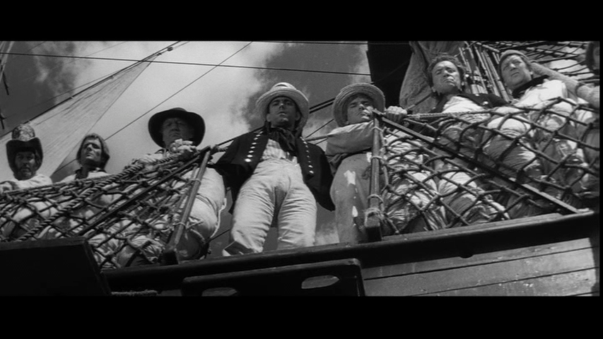Figure 1. The distorted mise-en-scene establishes the frigate as a claustrophobic site of terror.

Elsewhere, there is a formalism to the composition as scenes of the men on deck are ordered and arranged in distinct clusters (much like the strict hierarchy of the navy) and below decks as mainly cluttered and claustrophobic. Again, the eerie austerity of this formally ordered geometry gives the tone a subtle and brooding sense of impending menace which mirrors the narrative drama, as the disordered mass ranks below rise up to threaten the ordered symmetry above, yet that symmetry, in its unrelenting sense of order restores everything to its rightful place. Similarly, the contrast between ordered scenes and disarray suggests the injustice and iniquity that lies beneath the ordered structure of the naval universe. This can be seen distinctly in the scene in which the crew witness Billy’s execution.
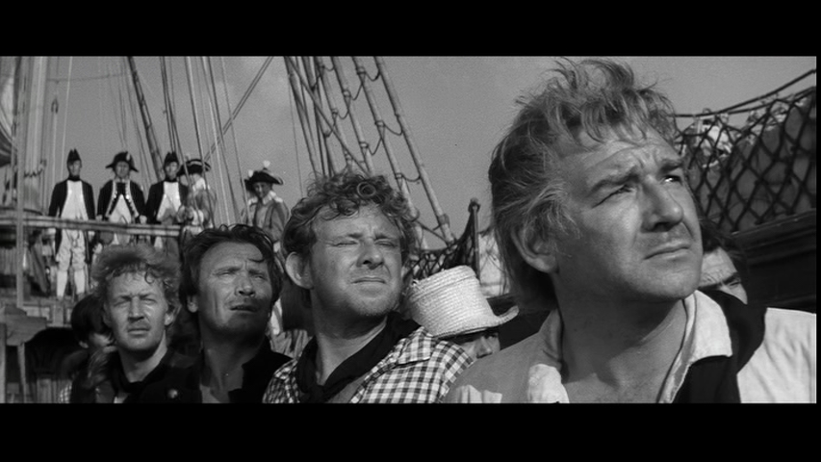Figure 2.
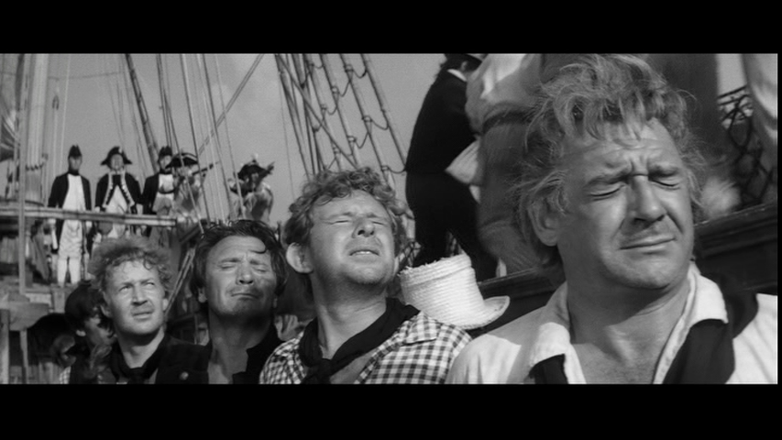Figure 3.

The contrast between the vindictiveness of the middle-man, the compassionate, but anchored- by- duty captain, and the innocent everyman paradigm established in HMS Defiant is also in evidence here. The ship, both in its geographical and bureaucratic organisation, can roughly exemplify the division of society thus:

Proletariat/Working class
(Common Crew)

Middle Class
(Middle management/ Master at Arms/Junior Lieutenants/Midshipmen)

Upper Class
(Captains/Senior Officers/ Ship’s Surgeon)

Comparing the two films, it is interesting to note that both Captain Vere and Captain Crawford as officer classes are not seen as outright evil but benevolent and institutionally bound to the old order and protocol. It is the middle men, or middle classes that represent the danger in both films, Lieutenant Padgett and Claggart, perhaps suggesting that the rebellious spirit of the time was more inclined to vent its true anger not at the old establishment but the aspirant middle classes who more directly exercise power and punishment (as middle managers and foremen for example- Saturday Night and Sunday Morning, 1960 is a good example, as the ‘bastards’ seeking to grind down Arthur Seaton are his direct superiors rather than the faceless upper management).

On a more philosophical level, the spirit of the times is represented both diegetically and non-diegetically by Terence Stamp/Billy Budd (as Stamp states in his autobiography, this is where ‘it begins’ for him, 1989: 11). In his film debut, Stamp perfectly embodies the innocence of youth that so irks Claggart, and whose jealousy of his popularity among all classes ferments a vendetta and will to destroy him. As the Danish Sailor Dansker (Melvyn Douglas), the everyman philosopher of the film, observes, “grown men have lost the answer, the answer went with innocence”. Stamp the actor went on to become a defining cultural icon and one whom David Boxwell describes as ‘a great star who went on to symbolise the free-wheeling counter-cultural impulses energising culture in the 1960s’ (Boxwell, 2001), and therefore it is difficult to analyse the film in hindsight without this star persona in mind. Although the text has its provenance as a story written seventy years before the film was produced and based on historical events from the late seventeenth century, it is clear that the themes are timeless and this iteration in its particular time and context of production, has resonance both with emergent working- class anger and the rise of youth culture in this particular historical moment. Casey Harrison (2011: 50) connects the original novel, its time of production (not publication, as this was not until the 1920s) and the revolutionary spirit of the British rock band The Who. Specifically, he links the use of Billy’s stammer: a physical defect that hinders the verbal articulation of his anger at injustice, with the use of the stammer in The Who’s song My Generation, which symbolises generational conflict. Harrison suggests the stammer in both texts as exemplifying an ‘inarticulacy among the working classes that finds an outlet in violence’ (2011: 50). Harrison describes ‘certain acts of violence as natural…even redemptive’ in this context, a view which squarely places the film within the contexts of the acts of (largely) working-class violence and rebellion occurring in Britain at the time. Billy does not even know his age or where he comes from, yet still has a humane and rational view on corporal punishment: “it’s wrong to flog a man; it’s against him being a man”. The film presents an endless cycle of inhumane violence leading to more anger and violence which finally is ended by the state sanctioned intervention of naval warfare. There is another link with the American myth of ‘manifest destiny’ and the mythology of the old West. Slotkin (1998: 1) describes the process of violence and expansionism on the frontier as ‘regeneration through violence’, in which national progress is only contingent on warfare and conflict, a concept he argues has continued to inform American foreign policy (alongside a continued national obsession with firearms). By both HMS Defiant and Billy Budd ending on an implicit (if not critiqued in the latter) necessary conflict, the same act of violent national regeneration is evident.

Significantly, as well as being borne of the vindictiveness and jealousy of the human condition, the inhumanity and degradation presented in the film are borne out of both naval culture, masculine culture in general and the manner in which these two culture’s intersect. Boxwell describes this as a ’rendition of the destructive (and self-destructive) consequences of all-male institutions’. Before he sees the hopelessness that his condition as ship’s Captain, upholder of navy propriety and judge of a man’s life at Billy’s court martial, he offers a speech to the crew designed specifically to quell any suggestion of mutiny:

“My I remind you that this ship is at war. This is a wartime cruise. We sail under the articles of war. Volunteer or impressed man, veteran seaman or recruit, you are no longer civilians but sailors. A crew that I shall mould into a weapon. One lawless act, one spurt of rebel temper from any of you, high or low, I shall pay you out in coin you know of. You have only two duties here- to fight, and to obey. And I will bend each contumacious spirit, each stiff-necked prideful soul of you if I must. Abide by the articles of war and my commands or they will cut you down.

Here, the conflation between rebellion and capital punishment is also bound to the crushing of spirit and the de-humanisation of individuals into a single ‘weapon’ (a theme addressed in Stanley Kubrick’s Full Metal Jacket over twenty years later, see also Bond, 3:5) clearly suggesting that both naval servitude and the articles of war degrade all who become involved, either by choice or by force. Vere later concedes that “battle makes a mockery of justice”. It is the common man, Billy, who is eventually cut down, perhaps prefiguring the abolition of the death penalty in Britain, as the last men to be hanged, Peter Allen and John Walby, were cut down two years later in August 1964 (Castleden, 1994: 364).

It is interesting to compare this projection of Britain’s naval past with earlier representations in literature. John R. Reed, assessing the representation of the navy in nineteenth century literature identifies a strain of dissatisfaction with what he describes as the ‘degrading features of service’ (Reed, 2011: 72). Reed suggests that ‘naval service constitutes an assault upon, rather than a refinement of, one’s manhood’ (Reed: 70) again suggesting that naval service represents an inhuman masculine space of debasement. Reed also suggests that even in that time period, there were a vast range of depictions of the navy in literature, so rather than a simple ‘continuity of tradition’, the navy then, as here, represents an impermanent symbol: a ‘tabula Rasa’ in which to explore the present. In this version of Billy Budd, as with HMS Defiant, the open questioning of Britain’s triumphant naval and mythic, military past of unity is contextualised by anti-nuclear movements, a rapidly disintegrating Empire, humiliation over the Suez crisis and youth rebellion amongst other contemporary events. It is perhaps more difficult to conceive of this in a pre-1960 context in British feature film.

This notion of an assault on masculinity also engages with the Manichean central themes of good and evil in Melville’s novella, which some critics suggest embodies overt homosexual discourse (e.g. Silva, 1990). It is perhaps inevitable that the notion of men alone at sea together in cramped quarters and engaging in close physical work in half- naked attire would lead to this question arising, as well as its opposite- the virile heterosexual sailor with a girl in every port and a voracious sexual proclivity for prostitutes. As Roy and Lesley Adkins point out, ‘The idea that sexual frustration would lead the men of the lower decks to ‘unclean acts’ of homosexuality was one reason why prostitutes were permitted on board when the ships were in port’ (2008: 154). It is Budd in the novella as ‘Handsome Sailor’ (Melville, 2012: 306) who embodies delicate feminine features as well as masculinity: ‘feminine in purity of natural expression’ (Melville, 2012: 313). The prominence of Terence Stamp in habitual close-up foregrounds the conflict within Claggart and helps to explain his cruelty, as it inculcates a confusion within that he cannot resolve (again, the use of violence and sadism is a masculine form of expression that elides language). Eve Sedgwick also interprets the threat of mutiny with homophobia (Sedgwick, 1990: 91-130) and as Dana Silva suggests, ‘Claggart’s fear of society’s reaction to homoerotic relations creates within him a dichotomist state, pinning his true desires, homosexuality, against his societal expectations, heterosexuality’ (Silva, 2006). So not only does Billy Budd utilise this era to question the value of strict institutional law, it also allows an examination of a specific nation’s suppression of desire and the brutality that characterises it (significantly, homosexuality was not legalised in Britain until 1967, positioning the film amongst strong contemporary debates for sexual equality). This is also evidenced extra-textually in Defiant by the presence of actors Alec Guinness, Dirk Bogarde and Murray Melvin. Although Bogarde had not revealed his homosexuality at the time and Guinness’s ‘cottaging’ scandal occurred much later, as Griffiths suggests:

…Britain’s queer audiences have had to activate their own very unique form of cultural identification, that are either mobilised around particularly significant themes and scenarios (from public school sublimation to war-time homosociality), or coloured by the tacit extra-textual nuances that surround the directors, writers and stars involved (from the loaded linguistic inflections of Noel Coward and Kenneth Williams to the ‘cottaging’ scandals of Alec Guinness and John Gielgud) (2006: 6).

Murray Melvin as Wagstaffe in Defiant is particularly positioned as a metropolitan ‘effete’ form of masculinity which is shown as being at odds with the rough physicality of press-ganged naval servitude, as he attempts to talk his way out of the situation and is then shown struggling with the tasks alongside his more ‘physical’ recruits. Melvin’s performance emphasises this, with his soft voice, intonations, gestures and slight physical frame providing a ‘disruption’ to ‘traditional’ naval masculinity. Also appearing as Geoffrey in the new-wave film A Taste of Honey (1961), Melvin’s performance here as what Griffiths describes as the ‘sad young man’ (2006: 79) links the film to the new- wave and to the repression of homosexuality both within the texts and within the social context of the time.

Responses from critics of the film responded positively to the ambition of Ustinov as director, if not universally of the final product, but the importance of the themes and their resonance with contemporary society were a common theme in the discourse. David Robinson, writing in The Financial Times (1962) demonstrates an intimate knowledge of Melville and states that Ustinov has his ‘admiration and sympathy’ as director, also noting that ‘it bears peculiar resemblances to H.M.S. Defiant in theme and style’. Robinson invokes the suggestion of homosexuality that is manifest particularly in Britten’s opera and present here in the discourses surrounding the aesthetic of youthful male beauty embodied in Terence Stamp: ‘Claggart, whose dark nature, which to Melville was a Satanic mystery, is in part explained by heavy hints of sadistic and homosexual desires’ (Robinson, 1962).

The intellectual bravery and rigour of Ustinov’s endeavour is a common theme with the Kinematograph Weekly (Billings, 1962) describing a ‘slightly uneven’ film but suggesting that it would be ‘particularly good for high-class halls’. Similarly, The Times review recorded that the picture was uneven but ‘Billy Budd remains, however, a serious film, a film that thinks and for that much may be forgiven it’ (1962). The Sunday Citizen describes a ‘stirring intellectual film’ (Lewis, 1962) and Dilys Powell in The Sunday Times uses intellectual discourse to describe the ‘crux’ of the character Billy Budd: ‘to present without insipidness the symbol of uninfected virtue’ (Powell, 1962). Even Leonard Mosley in The Daily Express speaks in high-minded terms, praising Ustinov for his ‘expansive, moving, and profoundly disturbing film’ speaking of the difficulty in getting intellectual and challenging films into cinemas without ‘ a single concession to the box-office’ (Mosley, 1962). Mosley (also chief war correspondent for The Times) describes, ‘For here is a story which invigorating and stimulating though it is, fits into no single formula by which the “front office boys” usually measure a film’s chances of commercial success’ (Mosley, 1962. Indeed, the press in general viewed the film as an intellectual exercise which it hoped would invigorate the British film industry. The socialist Daily Worker (1962) begins its review with the declaration ‘Suddenly it looks as if the British film industry has really turned a corner’ suggesting that the film ‘probes not only law and justice, but the very quality of mankind’. Alan Dent in the politically conservative Sunday Telegraph (Dent, 1962) begins his review by congratulating Ustinov ‘five times over’ and continues to revere the British approach to production that is subtle and challenging and does not recoil from unhappy endings (’which would have been a gross artistic crime’) and inconvenient truths: ‘If Hollywood had filmed “Billy Budd” it would have had a part specially written for either Miss Mea Culpa or Miss Senza Modesta or both’ (Dent, 1962).

It is revealing about the expectations of the cultural ‘gatekeepers’ that an intellectually serious and committed cinema that does not simply provide escapist entertainment and happy endings is lauded above all other factors by markedly different sections of political opinion and affiliation. Although none of the reviewers directly link the examination of class and hierarchical tensions to current social malaise (this is perhaps the providential reserve of the social historian) the film is seen as having great value in that it also derives from great literature, and the attempts by Ustinov to synergise the two art forms is commended. This reception is quite different from that of Defiant which did not have the distinction of great literary provenance, at least according to these reviewers and perhaps demonstrates Bourdieu’s theory of the ‘aristocracy of culture’, whereby ‘A work of art has meaning and interest only for someone who possesses the cultural competence, that is, the code to which it is encoded’ (2010: xxv, see also Ellis on ‘The Quality Film Adventure’, 1996) Defiant is compared unfavourably with The Battleship Potemkin: itself a film that was held up as an example by British critics, cineastes and intellectuals in the 1920s and beyond as artistically superior to both Hollywood product and home-grown filmmaking culture. Certainly, Billy Budd is not criticised for being deleterious to British history or proud naval tradition: its status as recognised great art and intellectual robustness serves to protect it from this.

Conclusion
Billy Budd and HMS Defiant, alongside The Mutiny on the Bounty, appear at a particular flashpoint in British social history that was both in the process of and on the precipice of major social changes. Violence, rebellion and male working-class anger are in evidence in these texts which choose to highlight a period in British naval (and Nelsonian) history which offers a different narrative of group unity to the ‘glorious’ victory at Trafalgar which followed. Although Defiant ultimately couches its rebellion in English and anti- French sentiment, it does demonstrate the agitations and brutality inherent in naval life. Billy Budd is clearly more of an expansive and philosophical work and offers no easy answers to the existential questions it raises except that life continues in any circumstances, especially when warfare necessitates it.
Critical responses to these films also demonstrate that critics of the time could digest revolutionary and contrary views of British history, as long as the texts themselves had the pretensions and/or appearance of high art. A curious construction of ‘Britishness’ in this context suggests cultural ‘habitus’ on the part of filmmakers, whereby anti-Hollywood product was the apotheosis of bravery and good filmmaking.

1:2 Do We Need Another Hero…Again? The Re-interpretation of the Myth of Nelson.

1982 was arguably the most significant year in British maritime history since the end of World War II. The year began with the Penlee Lifeboat Disaster on 19th December 1981, whereby sixteen souls perished off the coast of Cornwall (Castleden, 1994: 395). The same year saw the completion of the Thames Barrier which was set up to protect London from storm surges and high tides from the North Sea (Castleden, 1994: 395). It may have seemed that the sea which once nourished and protected the island from enemies had become the enemy itself. However, in October 1982, one of the most significant maritime excavations of all time took place off the coast of Hampshire whereby The Mary Rose, Henry VIII’s famous lost warship which sank in the Solent in 1545, was successfully (yet not without incident) raised from the seabed (Castleden, 1994: 395). It was a powerful reminder of British maritime heritage, particularly as Henry VIII is seen by many historians to be the true founder of the Royal Navy. Yet this itself was overshadowed by the events that took place between April 2nd and 14th June 1982, significant naval engagements took place between Britain and Argentina in what became known as the Falklands Conflict. It was against this backdrop that ITV broadcast the four-part series I Remember Nelson: Recollections of a Hero’s Life.

The Falklands and British Film and Television

‘Gotcha!’ Was the famous Sun (1982) headline that greeted the British Navy’s sinking of the Argentine submarine The Belgrano on 3rd May 1982 (The Guardian, 2002). Its’ fervent jingoism, as with the conflict itself, served to distract a nation fractious with 2 million on the dole and widespread rioting (Castleden: 1994: 395). The media, and television in particular, was awash with footage of the British naval task force however, probably the most significant coverage of naval manoeuvres in British televisual history. According to Dobson, Miller and Payne,

…at the very heart of the crisis is the question of modernity, national pride, the flag…the whole crisis was to bring the nation together in remarkable fashion and to restore feelings of patriotism and self-confidence (1982: 14, 171-2).

The conflict was not welcomed by all sections of society however, particularly on the left and pacifist wing of the political and artistic spectrum, with Robert Wyatt’s protest song, Shipbuilding particularly resonant as it connected the naval conflict with the recent closure of shipyards. What is significant, therefore, about fictional depictions of the Falklands Conflict in subsequent British film and television, is the lack of naval depictions. Dramas tend to focus on the minutiae of events, and personal stories, or in the instance of the first attempt, The Falklands Factor (David Buckley, 1983) - a BBC Play for Today entry, the events took place in the eighteenth century and an earlier attempt to instil peace through diplomatic means and securing public opinion for it. This is a perfect example of the historical drama being utilised to covertly comment on the present through safe historical distancing (as per Landy, 1991). The first large scale depiction was the BBC produced drama Tumbledown (Richard Eyre, 1988) based on the experiences of Lieutenant Robert Lawrence who was paralysed down his left side after a horrific brain injury whilst fighting at Tumbledown Hill. The film makes use of flashback from the ‘present day’ as Lawrence (Colin Firth) attempts to come to terms with his pre and post Falklands existence. Demonstrating how incendiary the topic still was six years after the war ended, the drama attracted controversy even before it was released as it was thought to be critical of the MOD’s after-care service for injured and traumatised veterans, prompting the defence secretary of the time to declare that the drama’s proposal made him ‘deeply unhappy’ (Turner, 2010: 302-3). Similarly, Resurrected (Paul Greengrass, 1989), also based on real events, details soldier Phillip Williams (David Thewlis) post-Falkland’s brutalisation as an apparent deserter after he returns to his hometown and to his barracks.

The next two productions to depict the conflict were television dramas. The Falklands Play (Michael Samuels, 2002) was produced by the BBC and featured Patricia Hodge as Margaret Thatcher, focusing entirely on the political events leading up to, during and after the event, whilst ITV’s An Ungentlemanly Act (2003) depicted the invasion from the perspective of the Falklander’s, particularly Ian Richardson’s Diplomat. The other major reference to the conflict in British film and television occurs in This is England (Shane Meadows, 2007). Set in the time period of the conflict, the film opens with newsreel footage of the conflict, with jubilant, flag-waving scenes of HMS Ark Royal sailing out from Portsmouth Harbour. The narrative then depicts Shaun’s (Thomas Turgoose) search for a father figure after it is revealed that his father was killed fighting for Britain during the conflict, and ends with battle footage detailing horrific casualties. Also prominent in public perceptions was the figure of Simon Weston, a member of the Welsh Guards who suffered horrific injuries when his ship, the RFA Sir Galahad which was carrying multiple explosives was struck and set on fire by enemy fire. He was the subject of a QED special in 1983, Simon’s War which focused on his rehabilitation for 46% burns. Elsewhere, the depiction of the thuggish and villainous Mitchell Brothers, Grant and Phil, in the long running popular soap Eastenders, added to a negative public portrayal of Falklands veterans and an episode of Jimmy McGovern’s critically acclaimed Cracker featuring a killer who is obsessed with the belief that he fought for nothing. The consistent failure to depict the naval campaign in any detail or in a positive light in all of these productions suggest a continual reticence artistically to valorise the role of the navy in contemporary society. It is interesting therefore that the four- part adaptation of Nelson’s life that aired at the time of actual naval conflict in the Falklands, does suggest a continuity of historic naval depictions, albeit infused with a certain degree of critique.

The ‘Cult of Nelson’ on screen

According to Cynthia Behrman, the ‘cult of Nelson’ as inspirational figurehead of a nation did not reach its zenith until the late Victorian era (Behrman, 1977: 96). She writes that ‘by 1885 interest in Nelson had diminished considerably’ and that ‘The critical period when Nelson became firmly entrenched in the national mythology were the years 1885 to 1905’ (Behrman: 96), arguing that by this time, the ‘Pax Britannica’ engendered by the defeat of the French and Spanish navies at the battle of Trafalgar, was being challenged by events abroad (mainly the economic rise of Germany and The United States) to Britain’s economic and military might. Behrman points to the death of Nelson at the moment of his greatest victory as having particular resonance with the Victorian virtue of self-sacrifice. It was during the same period, of course, that cinema was born and rapidly became entrenched in British cultural life (from 1895 onwards). Several early British films were produced on the subject of Nelson, perhaps the most famous being Maurice Elvey’s Nelson in 1919 (a year after the Great War ended: a conflict which re-iterated the importance of the navy to Britain’s security and prominence). Amy Sargeant describes that film as serving to ‘re-iterate a specific national history at a given moment’ (Sargeant, 2003: 16) and the same may be said of That Hamilton Woman (1941) which invoked the great Admiral’s love affair with Emma Hamilton and personal sacrifice for the greater good at a time when these virtues were needed again by the British people as they faced the tyranny of Hitler’s Germany. By 1973, the virtually unchallenged myth of Nelson was re-appraised by the Terrence Rattigan- scripted film (based on his play) Bequest to the Nation which examined the relationship between Nelson and Lady Hamilton. At a time when Hollywood Westerns were typified by their revisionist portrayals of mythical heroes such as Little Big Man (1970) and Pat Garrett and Billy the Kid (1973) as examples. Bequest to the Nation particularly focused on Lady Hamilton as a figure as much a victim of her own excess and refusal to conform as it was by the society that shunned her. In this production, both Nelson and Lady Hamilton are tragic figures, victims of their roles in society, and its refusal to honour Nelson’s personal bequest, but also by their extreme personalities which refused to conform to society’s standards.

“A Boundless enthusiasm for admiration”: I Remember Nelson: Recollections of a Hero’s Life

If Elvey’s and Korda’s films were utilised as war propaganda, then the release of I Remember Nelson during the Falklands conflict may seem to serve the same function. However, it was not intended so and happened by co-incidence and the vagaries of scheduling, rather than by design. The series is actually a re-appraisal of the man in an age that had, as Lawrence of Arabia as an example attests, somewhat begun to question national mythology, yet despite showing the faults and humanity of its subject via complex narrative structure and devices, it ultimately stops short of repudiating his ‘greatness’, but sets out that term in relation to reality. As General Jeremy Moore, Commander of Ground Forces, is quoted at saying at the time, ‘[Falklands] demonstrated the fighting qualities which have been their tradition through centuries, whether one goes back to Drake or Nelson or to more recent times’ (The Times, 1982).

ATV’s four- part re-appraisal of Lord Nelson I Remember Nelson: Recollections of a Hero’s Life was divided into four parts: Love, Passion, Duty and Battle with each being a recollection of the Admiral from, respectively, Lady Nelson (Anna Massey), Sir William Hamilton (John Clements), Captain Hardy (Tim Pigott-Smith) and a gunner on HMS Victory on the day of the Battle of Trafalgar named William ‘Billy’ Blacky (Phil Daniels). The series was directed by Simon Langton- a veteran well versed in historical/costume drama (Upstairs, Downstairs, 1975, The Duchess of Duke Street, 1976-7, Rebecca, 1979) and written by Hugh Whitemore, who had similarly worked with Langton on a number of productions and also had a background in literary and historical adaptations (Elizabeth R, 1971, Moll Flanders, 1975). Whitemore is perhaps best known for winning an Emmy award for The Gathering Storm (2002 and had graduated from RADA, which may explain the theatrical nature of the production. This is indeed one of the dramas’ strengths as the tight theatrical framing and often cluttered mise-en-scene mirror the feelings of frustration and entrapment Nelson often feels when he is away from duty. The casting, physical stature and performance of actor Robert Colley is significant here. Colley’s physical appearance is small and slight and the lighting gives his appearance a lack of lustre and skin tone. The role of the physical is here emphasised as it immediately contrasts with the dashing and heroic portrayals by Olivier or the rugged masculinity of Peter Falk and thereby appearance and performance already establish an undermining of the heroic myth. Yet it also adds reality as it accords with how history recalls Nelson’s actual appearance. As Christopher Hibbert writes in his biography of Nelson of a contemporary witness, ‘the sight of the small thin mutilated figure was a disappointment to those who had expected a latter day Drake or Raleigh’ (1994: 233).

As with the comedy genre, critical analyses of the role and significance of the biopic has only started to proliferate in recent years, and by extension the televisual biography. However, the persistence and popularity of the genre, which had its provenance in the written biography, suggests that it is an essential part of culture which demands further scrutiny. The first major work on the genre by Custen (1992) focused on the function of the Hollywood biopic as an essentially conservative genre which boiled history down to ‘accessible versions of history’ (1992: 34). He writes,

Biography, the isolation of a single line from the flow of history, can reduce the imputation of motive and the rendering of historical explanation to something even more facile (1992: 9).

The study of Biopics has become the focus of more intense study in recent years, particularly Bingham (2010) and Vidal and Brown (2014). Again though, the emphasis is often on the proliferation of the biopic as a middlebrow genre: a simplification of history which aligns biopics to the capitalist industrial process of film production which ‘feeds fantasies of national identity to the national film scene’ (2014: 2) in which ‘personality and point of view become the conduit of history in stories that often boil down complex social processes to gestures of individual agency’ (2014: 3). However, there have been acknowledged facets of the biopic which complicate simple narratives, most notably the ‘visual disjuncture’ of the actor’s performance- the ‘body too far’ which distracts viewers from the narrative either by the actorly or ‘star’ performance suggesting that the ‘transition from history to myth is not seamless’ (Smyth in Vidal: 2014: 7). As shall be seen, I Remember Nelson, as a television biography exemplifies this and other points which disrupt the biopic’s version of history and myth as hegemonic.

The first part of I Remember Nelson, Love, is narrated by Nelson’s estranged wife Lady Frances Nelson and the tragedy of the title is that her love was ultimately not reciprocated by the Admiral. The programme opens in London in 1800, as Nelson and Lady Nelson attend a play of Nelson’s life as part of the celebrations for his Victory at the Nile. The celebratory tone is disrupted by the attendance of Lady Hamilton (Geraldine James) as well. One of the actresses whispers to her colleagues “she’s in the Royal box sitting right next to him”, hinting that the public is already aware of Nelson’s amorous transgressions. It is significant that the producers chose to open the series with a theatrical version of Nelson’s life as it immediately establishes a number of pertinent questions surrounding Nelson’s life and the approach the series was to take to it.

Amy Sargeant points out that Elvey’s version of the Nelson legend follows Southey’s chronology including his boyhood experiences and ‘his fearless encounter with a polar bear’ (Sargeant, 2003: 17). It was this public story of Nelson’s private life that is exhibited in the theatrical version here, including Napoleon as a strutting pantomime villain. Here is thus established the dichotomy of public versus private life that has been a common feature in British representations of monarchs (The Private life of Henry VIII, 1933, Elizabeth R, 1971, and The King’s Speech, 2010 amongst numerous examples). By beginning with this display of theatrical mythology and proceeding to break it down in the following four part-series, it has a common narrative thread to Citizen Kane (1941), whereby the enigma of the public man is explored thereafter in his private life. There is therefore a play-within –a- play: a self- reflexive comment on the different cultural machinery for myth-making: the gauntlet passing here from the theatre to television. However, as we shall see, the tone of this production is very theatrical in its staging and there is much discourse around the subjects of ‘myth’ and ‘performance’.
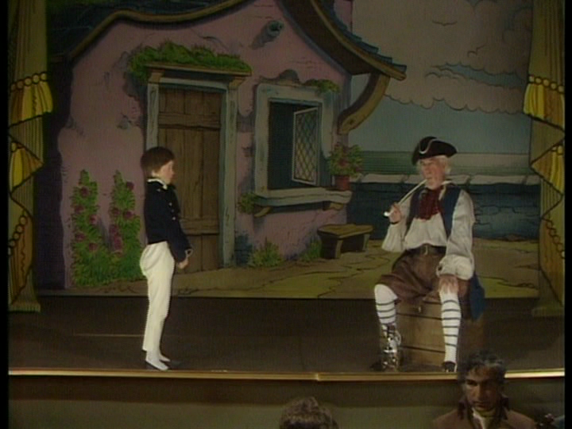
Figure 4. In the play within a play, a young Nelson is regaled with seafaring tales.

Unlike Citizen Kane, there is no ‘Rosebud’- no enigma to decode as to what its protagonist desires and loves the most: that is demonstratively Lady Hamilton. It is through Lady Nelson’s recounting of the breakdown of her relationship with Nelson and their separation that the decoding of the myth occurs. Their separate desires are neatly illustrated over a discussion at a dinner party given by the First Lord of the Admiralty in which Fran loudly cracks walnuts whilst Nelson is discussing destiny and ambition. In turn, he smashes a glass when she intimates that their life in Norfolk together is satisfactory. The disharmony of home life is enhanced by a claustrophobic and cluttered mise-en-scene and unusual camera placements. A blazing row ensues in which the dichotomy of public and private man is deconstructed by Fran, whereby Nelson admits to being in love with Emma. Nelson blames the vicissitudes of being a warrior on the situation, describing the horrors of battle and proclaiming “once you’ve seen these things, you can never be the same again” She levels at him that this is an excuse: “the trivial details of marriage and honour do not apply to you…the great Lord Nelson”. She continues that he is using the threat of mortality to excuse his behaviour: “if you start thinking that you’re the greatest hero that ever lived, if you start thinking you’re different from the rest of mankind…” It is through her analysis of what Nelson and Emma do for each other that pinpoints his frailty as a human being and brings the subject of performance back to the fore: “It’s just play acting, it’s not real- she’s just feeding your vanity so you can feel even more of a hero”. This tallies with what historians have described of Nelson: ‘Always hyper-sensitive and hungry for reassurance and affection, Nelson reacted badly to criticism’ (Sugden, 2012: 254) and having a ‘paranoid desire for recognition’ (Hibbert, 1984: 97). It was perhaps his vanity that was injured by Fran and may account for the fact that he brutally severs all ties with her after that, the rest of the episode deals with Fran’s loneliness as she continues to love him yet he refuses to even read her letters. There are links here with Billy Budd, Defiant and Hornblower (see 1:4) with the necessity of naval figures to be involved in warfare at sea, rather than boredom and stasis at home in order to satisfy their warrior instinct or affirm their masculine identity. Whereas in Budd and Defiant, the regeneration that violence elicited is to assuage moral complexity and mutiny, here it is necessary to mitigate against Nelson’s ‘dog days’ of domestic boredom between service, suggesting that the danger of being contained in the domestic space for too long risks ‘feminising’ the character and severing his identity. Here, the biopic can be read as instructive of the nation as a whole, as standing still for too long and not regenerating through strident martial action can cause it to emasculate, thus justifying military endeavour as necessary forward progress. As Vidal states, ‘the biopic feeds fantasies of national identity to the international film scene’ (2013: 12).
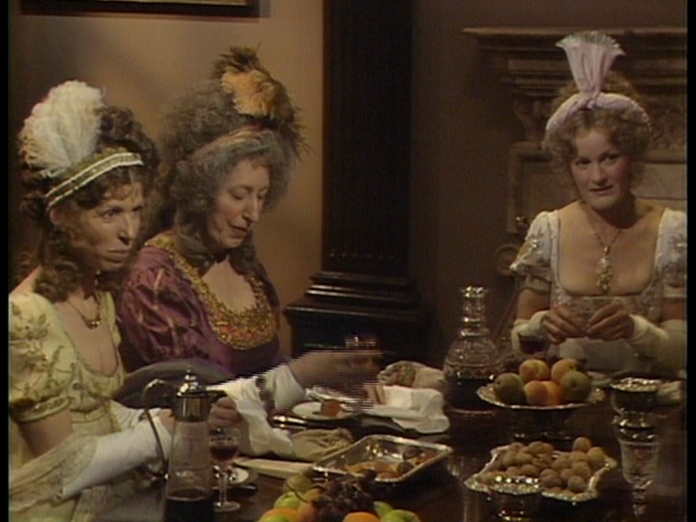
Figure 5. Cluttered mise-en-scene suggests disharmony in home life.

The second part, Passion, goes back to 1798 and Nelson’s arrival in Naples after the Victory at the Nile, which gave hope to the rest of Europe that Napoleon could be checked in his ambitions to subjugate Europe. In a pre-title sequence, we see the Hamilton’s rejoicing at the news, whereupon Lady Hamilton faints. Again, dramatic performance is emphasised. This chapter is narrated by Emma’s older husband (and one of history’s most notorious ‘cuckolds’) Sir William Hamilton (John Clements). Just as in the first chapter, Nelson is given a hero’s welcome by the people of Naples, which he revels in, but it is not enough to conceal how ill he looks: pale and haggard, grey and weak. This difference between the idealised portraits of the time and the physical realities is emphasised in a sequence in which Sir William show’s Nelson his portraits, including a Joshua Reynolds portrait of Emma Hamilton. Here image is conflated with performance in presenting idealised images in public discourse and private realities.

The rest of the episode concerns itself with the burgeoning affair between Nelson and Emma as the court of Naples is forced to flee to Palermo when the French troops advance. Sir William is forced to go hunting with the vain and cowardly King Ferdinand, whilst Nelson and Emma are free to frolic at home. A powerful sequence exemplifies the ‘play acting’ and performance of Nelson and Emma’s affair, as the action cuts between them frolicking and bathing and the boar hunt that William is forced to endure. As the sequence reaches a crescendo, the king is seen cornering the unfortunate beast and taking several shots of his rifle to fell the animal, despite the fact that it is surrounded, perhaps suggesting an emasculation motif for the equally unfortunate Sir William. To emphasise the fact that this version of Nelson’s life does not shrink from unpleasant details, the king is then shown gutting the pig and parading its entrails, the action switches back to Nelson and Emma in blissful ignorance and a naked embrace. The suggestion seems to be that there is nothing romantic about their adultery, and Nelson’s role as warrior is also subtly questioned as William laments of the King. “Like so many weaklings, he was never happier than when spilling the blood of helpless animals”.
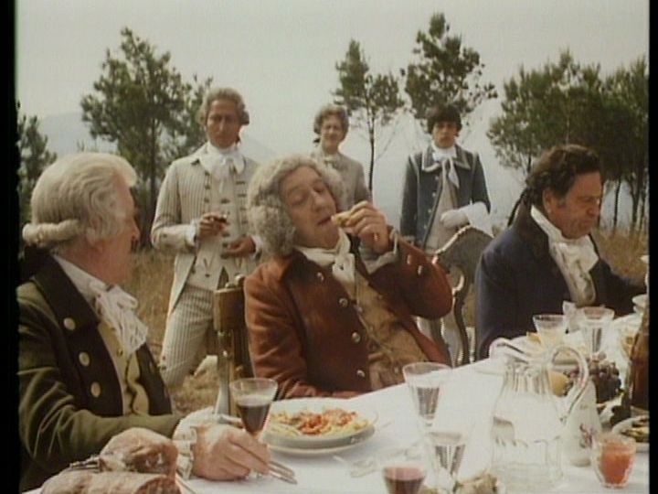
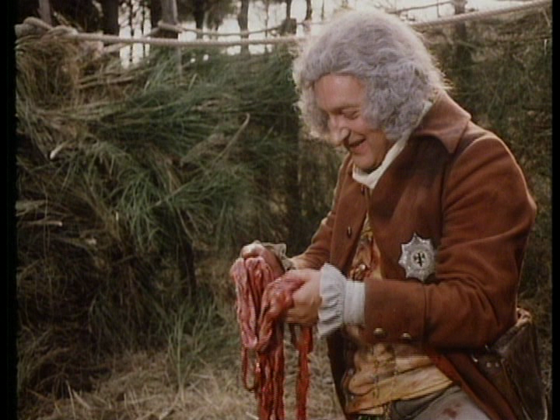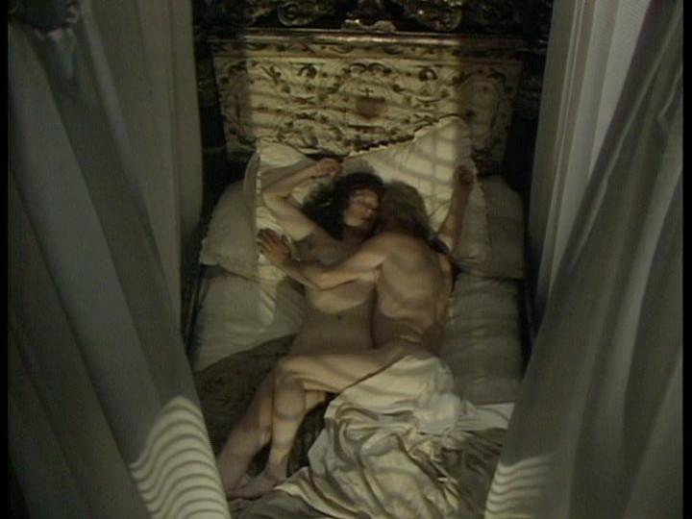
Figures 6-9 William’s hunting trip is juxtaposed with Emma and Horatio’s frolicking.

The episode is also concerned with the actions of Carraciolo, a resident of Naples. He requested to return to Naples in order to sort his affairs but was seduced by the Revolutionary ideals of the French Republic and took charge of the navy against the British. He was captured when the French troops in Naples were recalled to the North, tried as a traitor aboard Nelson’s flagship HMS Foudroyant, hung from the yardarm and flung into the sea. If the previous chapter showed that Nelson could be callous in affairs of the heart, then this chapter breaks the mystique of the hero as benign and honourable. The business of war is shown in its most de-romanticised light as bodies are heaped on the floor, and as Sir William’s narration describes: “women were tortured and raped, Republican sympathisers brutally hacked in the streets”. It is Nelson’s actions towards Carraciolo that irrevocably change Sir William’s view of Lord Nelson (rather than his affair with his wife). Firstly, Nelson denies him the leniency of amnesty promised previously to all rebels, insisting that he face trial aboard the British territory for betraying his King, despite the entreaties of Cardinal Ruffo (Vernon Dobtcheff). Once convicted, Nelson denies Carraciolo twenty four hours to prepare himself for a Catholic death and his request that he be shot as a nobleman rather than the “shameful death” of hanging, despite the pleas of Sir William stating, “I believe in prompt action-it’s the sign of self-confidence and a clear mind”. This is what truly shocks Sir William and as he confides to Emma: “I misjudged him. I was totally unprepared for such an un-yielding denial. It shocked me, made me wonder if I had mis-judged him in other aspects as well”. The narrative re-enforces the brutality of the decision with an eerie, wordless and visceral sequence in which Carraciolo is hanged from the rigging, compounded by the composition. He is seen swinging wildly from a distance through the sails, in a manner so detached that it emphasises the casual and callous manner of his trial and execution. Again, this is compounded when we see his horrific, blackened corpse re-surface a few days later and William declares “It is a sight that has haunted my dreams ever since”. Presumably the viewer is meant to feel the same. All this, of course, stands in opposition to the traditional myth of Nelson, as Behrman describes, ‘…the tradition persists of a hero representing the best of society, and to some extent, redeeming it with his virtuous action’ (Behrman, 1977: 92). It can also be interpreted another way, as another example of performance: Nelson is merely performing his naval duty.
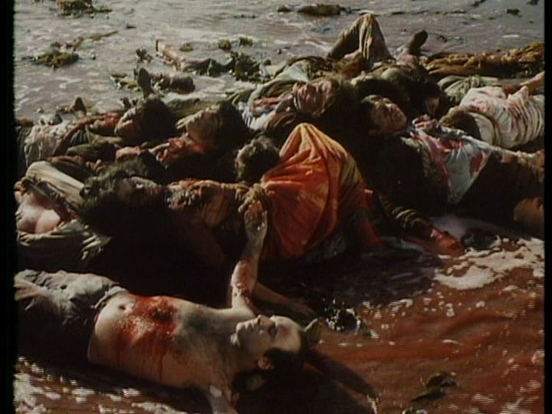
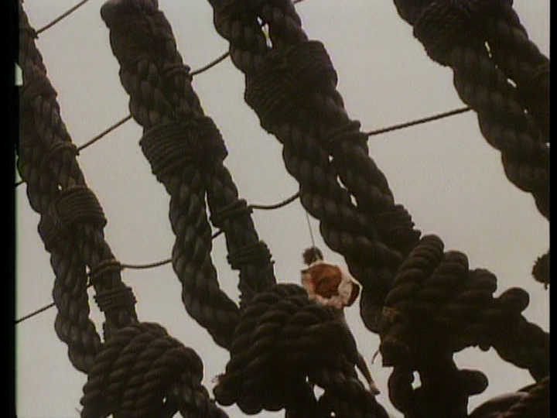
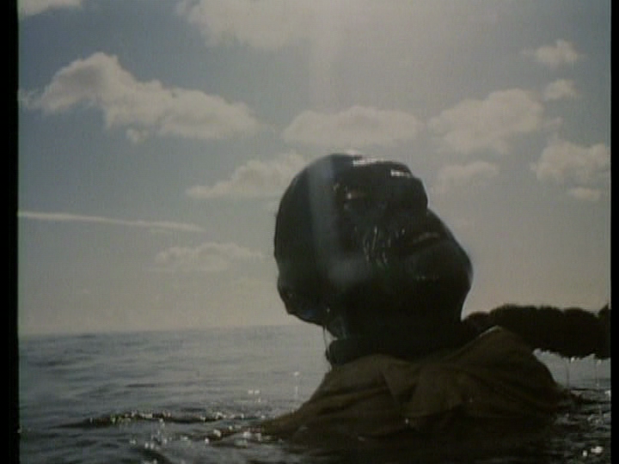
Figures 10-12 The brutal and visceral aspects of warfare are emphasised as massacred civilians litter the streets of Naples, whilst Carraciolo’s corpse swings from the rigging and re-surfaces, days later.

If the first two subjective recollections of Nelson contain a revision of the ‘great man’ myth, it may be attributed to the fact that these are recalled narratively by two jilted lovers. The third part, Duty, is described from the view of Nelson’s trusted right-hand-man Captain Hardy. Like the two previous recollections’, Hardy’s narrative is sober and down- to- earth; a position that further exacerbates the ‘performance’ element of the myth of Nelson. Hardy is already presented as a man who takes duty seriously, being the man who ordered Carraciolo not to be treated as a common prisoner in the previous episode, and who looked uncomfortable carrying out the swift execution. Pigott- Smith achieves this subtly by actorly performance- hinting at disharmony without inciting insubordination, exemplifying John Caughie’s assessment of the strength of British drama, ‘television and television drama belongs to the tradition of the detail rather than the tradition of the sublime’ a performance aesthetic which ‘invite a process of reading in detail and reading detail for which critical language has a much more tentative vocabulary’ (2014, 148-152).

As this episode opens, the voiceover positions the events as taking place in 1805, on the eve of the Battle of Trafalgar (“Perhaps the greatest sea battle of all time” Hardy ponders) as the joint French and Spanish fleets are cornered at Cadiz. Hardy is making his way to Merton Place, the country retreat that Nelson shared with Lady Hamilton to discuss tactics for the upcoming battle. His voiceover is very revealing about the dual and multi-faceted nature of Nelson’s character, and the division between the private and public man, as he describes him as, “neither easy to live with nor attractive in his manners. Excellent officer but poor seaman. By that I mean he has no little notion how to keep a ship in good order. Being fidgety to the greatest degree. Vain and proud. Nevertheless he is exceptionally firm and decisive. These are his chief merits.”

Hardy’s arrival is uncomfortable from the outset, his incompatibility in the world that Nelson and Emma have created for themselves at Merton immediately obvious as he is greeted by the aristocratic and theatrically flamboyant William Beckford. Beckford, the author of Vathek, is of rich and noble birth: “Probably the richest man in England”, but beset by scandal surrounding his private life and sexual proclivities (hinted at as homosexuality). Hardy’s lack of cultural capital is cruelly highlighted by his inability to penetrate Beckford’s poetic language and high cultural references, and is further alienated when Beckford and Emma converse in Italian. As the drama exemplifies, Hardy is a man of action and simple virtue and immediately highlights the theatricality, artifice and ambiguous morality of Merton Place in his inability to acclimatise, and also the vanity and snobbery of such an existence. As a viewer, our sympathies are deliberately intended towards Hardy.

Both Hardy and the viewer are afforded a respite as he and Nelson are reunited: the comradeship of fighting brothers-in-arms immediately warms the atmosphere. The two then discuss plans for the battle for which Beckford and Emma are noticeably excluded. Here, we see the decisiveness that Hardy praises at the beginning of the episode, as Nelson’s famous and revolutionary fighting tactics are unveiled, matched with dramatic and portentous music on the soundtrack. The ‘greatness’ of Nelson is revealed in his tactical courage and individuality as he counters Hardy’s scepticism with the statement, “we’re fighting men Hardy, not slaves to the admiralty…without risk, we’d be dead”. The viewer is afforded a rare glimpse of the greatness of Nelson- one that fits the myth performed at the beginning of episode one.

However, this serves to further highlight the pretensions of the private man, as Hardy’s encounters with Beckford and Emma thereafter intensify in discomfiture. Beckford, who clearly takes pleasure in shocking the conservative sensibilities of Hardy and mocking his lack of ‘high’ learning, is himself appalled by Hardy’s disgust at the suggestion that Beckford is attempting to buy patronage from Nelson who is by his own admission “crippled with debt”. An angry Beckford rounds on Hardy that he has no right to judge considering he is a military man whose fame and security rests on his ability to kill and maim. These short exchanges show how Nelson had to move differently in different contexts at the time, perhaps explaining the nature and necessity of his complex personality, and the need to ‘perform’ different roles.

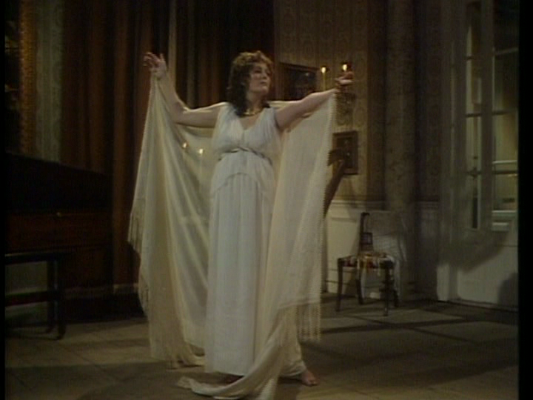
Figure 13. Emma performs an ostentatious display.

The relationship with Hardy and the company reaches an apex at a self-indulgent performance in which Beckford accompanies Emma on the piano, as she sings and dances, to Nelson’s delight and Hardy’s polite boredom. In an act of revenge, Beckford then humiliates Hardy with wordplay as Emma giggles and Nelson laughs, to which Hardy storms off and Nelson follows him to rebuke him for his manners. Here, as in the earlier tactics sequence, the conversation between Hardy and Nelson reveal another side to his personality. Defending Emma in the face of Hardy’s clear indifference towards her, he describes her as being crucial in his making, “By God she’s strong, that’s why I love her”, a reciprocal relationship emphasised throughout the drama. Nelson describes his strengths and weaknesses in relation to Emma and in doing so, manages to describe his greatest strength as an act of performance, in the face of Hardy’s protestations and dismay:

“I’ll tell you what the trouble is Hardy? I’m a weak man and you like to think I’m strong. But I’m not, never was, never will be. Oh, I can be strong- that’s something else. Nelson, the man who’s hiding beneath all this hullaballoo…and, glory and…That Nelson’s really rather weak and simple….You know I love playing the Admiral Hardy…We’re both great actors of sorts….But I can make them fight. By God, I can make them fight- make blood run through their veins”.

The men bond in the realisation that they are what they are as men, deep down. When Nelson explains that it is Emma who gives him his strength and life force and that despising her is despising him, Hardy concedes, “I have despised her, you know that. I can’t help being who I am any more than you can”. It is their comradeship in battle, and mutual respect for their different positions that forges them together and heals the rift. The public man is then re-emphasised as Hardy is mobbed by adoring crowds as he disembarks from the beach on his journey to Trafalgar. Nelson confirms his love of playing Admiral and cheerily proclaims to Hardy, “I had the cheers Hardy, now I have the hearts”. He also confirms Hardy’s assessment of himself and Lady Hamilton that they shared “a boundless enthusiasm for admiration”.

The episode ends on a melancholy note, as in the previous two chapters, as an aged Hardy reflects on the seafront that despite his hostility to Emma, he regrets that “she died penniless” and despite Nelson’s request that he leaves her and their daughter as “my legacy to the country”, she is ignored and forced to leave the country. Hardy invokes the title of the episode and Nelson’s famous declaration of the morning of Trafalgar that “England expects that every man shall do his duty” by lamenting the irony that “We all of us, sadly failed to do our duty”, with regards to the ‘great man’s’ private wishes.

The final part, Battle, differs in that it is narrated by a fictional character, albeit one who serves as a composite of characters who served aboard ships in the Napoleonic era. William ‘Billy’ Blacky (Phil Daniels) is a twenty one year old gunner on the decks of Nelson’s flagship Victory at the Battle of Trafalgar. Blacky’s narration affords a ‘commoner’s’ view of Nelson, but his experience of battle below decks is the most significant contribution to the episode. The narration highlights the broad backgrounds and ethnicities of those aboard the ship, some of whom were press-ganged into service, another who volunteered to escape the “nagging of his wife” and others included Portuguese, Irish, Americans, Danish and Italians who were “all facing death this fine October morning”. There is also a black sailor, of large physical stature and who has no dialogue. Blacky states of him:

“I’ve never seen a black man laugh. Nobody knows where he comes from. No-one knows and no-one cares…all we know about him is that he’s as strong as two men put together”

The black sailor is therefore seen and not heard, has no background or story or even the ability to recount it and is defined entirely by his physicality (see also To the Ends of the Earth, and chapter’s two and three). As such, he perfectly represents the history of the black race within the Empire, within the navy and within British history. A solemn reminder of this is contained within one of Britain’s culture’s most enduring physical icons, Nelson’s column. At the base is the face of a solitary black sailor (Figure 4), both acknowledging the role of the black race in this battle, whilst suggesting their silence and anonymity: ‘typically nameless and speechless’ (see Bourne, 2002: 49).
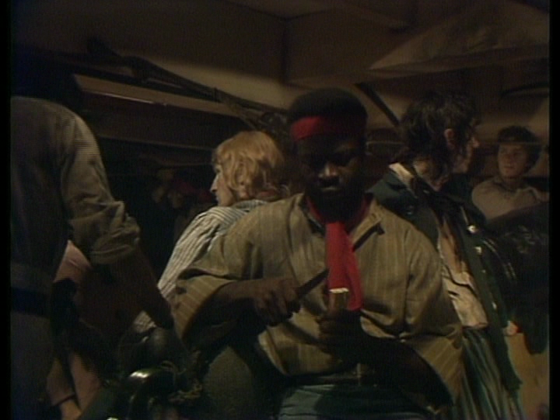
 Figures 14 & 15. An unnamed black sailor on Victory and a single black sailor at the base of Nelson’s column represents the multi-ethnic nature of Nelson’s Navy and the silence of the ‘other’.

This episode therefore carefully balances the myth of Nelson with the harsher and lesser known or lesser- remembered realities of life for the ratings during the famous battle and hints at the multi-national and multi-ethnic make-up of the navy. It also aligns itself with a late twentieth century re-conception of the maritime from a ‘top-down’ to a ‘bottom-up’ version of history as identified particularly by Lunn and Day (2003).

The minutiae and boredom of waiting for battle is detailed in the first section and this is interrupted after seventeen minutes when Nelson travels below decks to address the men, to which he is given a rapturous welcome. Blacky’s awe and admiration for the great man demonstrates the power of his myth amongst his fighting men. Nelson gives a stirring speech in which he tells the ratings that this will be the “greatest victory Britain ever saw” and urges the men to “fight on, fight bravely”. This demonstrates Nelson’s claim in the previous episode that he could inspire his men to fight, solidified when he personally states to Blacky, “Relish it, for this is the day you will remember for the rest of your life”, to which he can only respond “God bless you!” in dumbstruck tones.

This is balanced by the reality of battle, which is particularly graphically rendered (filmed aboard the actual HMS Victory for added verisimilitude). Myth collides with reality here as the corpses mount and the tunes of God save the King and Rule Britannia are elegiacally drowned out by the crash of cannon and the screaming of the wounded. In one particularly graphic scene, an officer is killed instantly by shrapnel, to which one of the gunners responds to his colleague, smiling, and says “thank God we’re rid of him eh?”, Despite the strict hierarchies and discipline of naval life, and the love of the men towards Nelson, the animosity felt towards the officer classes is chillingly rendered. Even Nelson is challenged at one point in which his famous signal to the fleet “England expects that every man will do his duty” is met with incredulity by one of the gunners: “What does he mean? Of course we’ll do our duty”.

Yet the battle is shown to have little regard for rank, as officers die alongside the ratings and one unfortunate screams to the surgeon “For Christ’s sake let me die!” This is made apparent by the wounding and death of Nelson, a deathbed scene as famous as any in British history. The episode details the myth much as it has been passed down in the public imagination, with a stoic, dutiful and dignified Nelson musing poetically as he dies and climaxing with “kiss me Hardy, I did my duty”. However this is undercut by its juxtaposition. For example, just before Nelson’s final words, shrapnel from a Dutch sailor’s shattered skull manages to break the leg of another sailor. Similarly, Nelson’s exhortation “How dear life is to all men” is followed by a scene in which sailors strip the corpse of a dead man for his valuables before throwing it overboard.

Serving also to undermine the myth of Nelson is the parallel story of Blacky, who is also wounded in the fighting. There is nothing poetic and dignified about his final scenes aboard the Trafalgar as, delirious and fearing he may spend his last hours in the darkness of the sick ward, he begins a journey back to the next available floor with port-holes, declaring “I must see the sun before I die”. Unable to walk, he is forced to crawl over the sick and wounded, yet eventually manages to find a hole and squint through it. It is significant that what he sees is the destruction of battle, and as a visual allusion to the gutted pig in episode two, he sees a shipwrecked pig paddling desperately in the water. He is then struck in the head by splintering from cannon shot (ironically, as the men celebrate victory) and his slow motion screaming in close-up before finally fading to a melancholy darkness.

The episode ends with a coda in which Blacky, now an old man in an institution (the splinter embedded in his brain) is visited by some Victorian well-wishers, one of whom patronisingly states to Blacky, “If it weren’t for fellows like you we wouldn’t be here. Our nation owes its strength and prosperity to people like you”. The series ends as Blacky smiles and looks up at the sky, yet it appears to be ambiguous whether this is a cause of celebration or lamentation. It is significant in a series that ostensibly explores the sanctification and myth of a nation’s history to end as it does, with a great man favoured by a hero’s death and another equally brave but anonymous man as a museum piece.


Figures 16 & 17. A young Blacky struggles to see sunlight before being hit whilst as an old man sits in silence in hospital.

This perfectly encapsulates Sarah Monks’ work on visual culture and Trafalgar as being ‘a sanctified vision of the past’ (Monks, 2010:2). She describes Greenwich as a ‘living museum’ by the mid nineteenth century:

A Living museum, Greenwich had become (within a few decades of the battle of Trafalgar) the ‘resting place’ of ‘national prowess on the …ocean’, an entire pantheon to a now-past greatness whose human and cultural fragments were placed on conspicuous display in order that a ‘commercial world’ be reminded of its moral debts (Monks, 2010: 2).

The makers of I Remember Nelson complicate this ‘sanctified’ evocation of the past, ‘heartfelt obedience’ and the idea of moral debt. What it perhaps suggests, is that Britain, like Nelson, owes a moral debt to Emma Hamilton, heartfelt obedience is a reciprocal relationship and what is ‘sanctified’ is an on-going relationship between the creators and the consumers of a given culture.

Reception and the Falklands War

It is not often that events synchronise with such serendipity as the confluence of the Falklands Conflict and I Remember Nelson: Recollections of a Hero’s Life. This fact was not lost on the press who made much of the synchronicity of the two events. The last episode, was actually postponed in deference to the actual naval engagements taking place at the time, yet was actually broadcast on 5th May 1982, three days after the notorious sinking of the Argentine warship Belgrano.

What is surprising, perhaps, is the manner in which all sides of the press praised the series and were sympathetic to the ‘revision’ of the Nelson myth. Chris Kenworthy wrote an article in The Sun describing it as ‘A million pound myth-busting series that takes the lid off the private life of one of England’s most beloved heroes…[and] strip[s] the glamour off every schoolboy’s idea of Britain’s most famous sailor” (The Sun, 1982). A later review in the same paper by Margaret Foxwood describes it as a first- class series (The Sun, 1982). The similarly conservative Daily Mail, famous for protecting the values of ‘middle England’ also welcomed this re-appraisal (Herbert Kretzmer, 1982). Under the title ‘Betrayed by a national hero’ Kretzmer admits that the depiction of Nelson is ‘decidedly at odds with received heroic myth’ but that:

It is a pleasure to welcome a sharply written, well received series which looks behind the mask of vanity and legend to prove that even a hero can behave like a heel (Kretzmer, 1982).

The Times (Appleyard, 1982) agreed describing ‘a formidable piece of television’ and appreciating the subtlety of the production with its ‘highly specific and cunningly oblique perspective’. Much like Billy Budd, this production united critical opinion in the British press, again indicating that a specific type of artistic ambition might enable Britain’s mythic past to be critically re-examined.

Conclusion

I Remember Nelson therefore represents a sustained and decidedly ‘adult’ re-conception of one of England’s mythical figures. He is shown as vain and weak- a fallible human being whose final wish was callously ignored despite his lionisation as a public figure. Yet it also shows him as strong, inspirational, individualistic and unique. Recently, Bingham (2010) has suggested that in recent years, the biopic has become less ‘middlebrow’ and more nuanced as it has transitioned from a prestige ‘middlebrow’ producer’s genre to one in which directors’ have imposed a more auteurist vision, citing recent examples such as Todd Hayne’s I’m Not There (2007) and Andrew Dominik’s The Assassination of Jesse James by the Coward Bob Ford (2007) as more experimental versions of the genre. It seems however, that this more expansive and more nuanced form has been in existence for longer in the television mini-series. As I Remember Nelson suggests, the television mini-series which took over in large part from film in ‘shaping public history’ (Vidal, 2013: 20) in the time period this thesis covers.

The balance of myth and history and the multiple subjective viewpoints are suited to the television mini- series, as it allows for a subtle examination of myth that complicates the ‘great-man narrative’. It gives prominence to the important role played in the life of a national hero of figures who are often on the periphery of such narratives, as the opening theatrical performance indicates. This narrative conceit also allows the series to reflect on the manner in which performance, display and theatricality help to fix a particular narrative in the public imagination, and the critical reception demonstrates that this in turn can be appreciated.

I Remember Nelson therefore perfectly demonstrates the role that television narratives, as opposed to filmic narratives, have in disseminating myth- suggesting how its unique qualities can convey a similarly unique treatment of the national narrative. Similarly, the emphasis on performance and oratory and predominantly enclosed spaces demonstrates Ellis’s conception of television as characterised by the ‘lack of dominance of the image and greater importance of sound in television’ (2005: 6).

As Thornham and Purvis (2004) point out, television engenders ‘direct address’ (Thornham & Purvis, 2004: 6) into the traditionally feminine realm of the domestic space, and as Feuer suggests, television is a medium of containment which ‘constructs spectators as domestic, familial objects’ (Thornham & Purvis, 2004: 9). I Remember Nelson inhabits these intimate domestic spaces with an intimate domestic narrative of its own, but one which speaks of a larger project- a national narrative imbibed with myth, history and personal relations. Tulloch similarly proposed that television drama, ‘re-divides the social totality across differentiated bundles of genres’ (2005: 25) with traditionally the costume drama assigned as feminine and the action genre designated as a masculine space. I Remember Nelson straddles these boundaries by contrasting the familial and domestic with the martial thus providing a disruption to discrete generic boundaries and gendered topography (see also 2:1).

The next chapter will demonstrate further the role that television played in disseminating the myths, narratives and symbols of British maritime heritage, by looking at two dramas that drew on fiction for their inspiration, Hornblower (1998-2003) and To the Ends of the Earth (2005), which both examine Britain’s past and present through the lens of the Napoleonic era, yet offer sharply divergent conclusions.

1:3 “Heroic Resistance to Cultural Updating”: Hornblower and Old Myths Reconstructed.

Introduction

If I Remember Nelson took a national myth and treated it to a considered and cerebral re-examination without destroying its basis, then this chapter will examine how Hornblower (1998-2003) perhaps exemplifies its opposite. The shield to social realities that Rainer (2009) identifies in de-constructed Westerns is in essence here as Hornblower returns the viewer to a world in which Britannia ruled the waves, the sea was a masculine space, gallantry, honour and duty were applauded and morality was characterised by its lack of opacity.

Hornblower debuted on ITV on 7th October 1998, but its appearance on British television had a long and tortuous history. Pitched somewhere between ten and twelve million pounds, it was the most expensive television drama on British television at that time (Evening Standard, 1997, Sunday Times, 1998). This was in no small part due to the cost of location shooting, especially at sea, and the construction of a replica eighteenth century frigate (the first wooden British frigate to be constructed for 150 years, according to The Times (1998). Such costs may also explain the paucity of competing maritime dramas on British television, and the difficulty in ensuring funding for such projects. However, tellingly the Frigate’s constructer, Mike Turk also suggests ‘if there is a ship available, sea films will be made’ (McGregor, 1998: 13).

Captain Horatio Hornblower, RN (Raoul Walsh, 1951) was famous for being a transatlantic ‘Runaway’ production, filmed in Britain by Warner Brothers, which utilised the ’blocked funds’ as prescribed by the ‘Eady Levy’ (Stubbs, 2008: 335-351). These were funds that were owned by the Hollywood production companies from film imports, but they were ‘frozen’ assets, which could not be converted to dollars or leave the country, encouraging the studios to re-invest this money in films shot in Britain and utilising personnel and facilities to protect and stimulate the British film Industry (Stubbs, 2008: 335-351). Warner Brothers had originally secured the rights in 1939 and in July 1940, a script surfaced that was to be used as ‘soft’ propaganda to support Britain in World War Two (Stubbs, 2008: 346) which was eventually abandoned as too expensive. The eventual film conflated three of C.S. Forester’s novels into one narrative and starred Gregory Peck in the title role and Virginia Mayo as his wife. It was successful enough that in 1964, UK and US companies co-produced a pilot for a series based on C.S. Forester’s stories, which was filmed in Britain. It aired on both sides of the Atlantic but was not picked-up for a series. It was not well received according to some sections of the press, as E. Shorter from The Telegraph (Shorter, 1963) proclaimed, ‘was this 50- minute epic on BBC television last night worth the effort? Hardly, one would have thought’. The BBC attempted to revive the character in the early 1970s, perhaps buoyed by the success of the BBC’s other nautical drama The Onedin Line (2:1), but ran into production trouble. Shaun Usher reported in The Daily Mail on the 2nd June 1973 that, ‘the BBC[s], long-range planning a spectacular series based on the famous Hornblower sea stories’. The article reported that the BBC were having difficulty sourcing the requisite ships needed for the series, which was planning to go into production the following year and was at the time un-cast, and that they were needing to negotiate gently with the French without mentioning the British hero and scourge of the French. Quoting producer Barry Letts the article revealed: “I haven’t mentioned Hornblower”, Barry Letts admits. “It seems wiser and more tactful to keep him in the background for the moment”. These problems were obviously insurmountable as the planned series never materialised.

It seemed a bold financial decision therefore, for ITV to resurrect the character in the 1990s, considering the troubled provenance and aforementioned costs. Indeed, The Evening Standard article (O’Carroll, 1997): “Rescue bid to stop £10m Hornblower sinking without trace”, suggested that the production was as doomed as its previous televisual iterations. The article reported that the production company had ‘launched a dramatic rescue operation” after a series of complications including the casting of ‘unknown actor’ Ioan Gruffudd in the lead role, spiralling costs of production and bad weather affecting shooting.

Indeed, it was most likely due to the success of ITV’s Sharpe series, starring Sean Bean and based on Bernard Cromwell’s novels, that the producers decided to take such a financial risk on the show, as there seemed, on the surface at least to be much in common between the two texts, not least their utilisation of the Napoleonic setting.
Much like Sharpe, Hornblower consisted of a series of self-contained episodes with the running length of a movie (each around one hour and forty minutes) in length, but which built up a continuing story arc of Horatio Hornblower’s rise through the ranks. Series one ran from 1998-1999 and consisted of four episodes, whilst series two (2001) and series three (2003) were foreshortened to two episodes apiece, most likely due to the continuing issue of production costs as the show was cancelled long before Forester’s original material had been exhausted.

The first episode, The Even Chance, introduces Hornblower as a midshipman, his position bought with privilege (like Horatio Nelson). The episode opens with a shot of stormy seas crashing against the beach accompanied by dramatic and stirring music (which becomes the programme’s signature music, deployed in scenes of romantic triumphalism). A title screen is then shown, establishing the time frame and historical context of the series:

January 1793
The British fleet lies at anchor at Spithead. Ships and men rot in idleness. Across the channel, revolution in France is sweeping away the old order.

This text is displayed over shots of stormy skies and is significant, much like Billy Budd and I Remember Nelson, in projecting the uncertainty and turbulence of a particular historical moment. In this instance, it is at a time of similar disquiet and discomfort over the nation’s relationship with Europe. By 1998, British identity was facing, as ever, a number of challenges from both within and without. Internally, the previous year, on May 2nd 1997 the first Labour government since 1978 was elected by a landslide, bringing with it traditional fears of fiscal irresponsibility, Trades Union influence, economic uncertainty and immigration anxiety (Turner, 2013: 384-421). In 1996, Charles and Diana divorced, whose ‘fairy-tale’ wedding in 1981 was a cause of national celebration and rare source of ostensible unity in an era of high unemployment, racial riots and divisive politics, were formally divorced, producing uncertainty over the traditional role of the sovereignty in British life. This was exacerbated on 31st August 1997 with the death of Diana, Princess of Wales and the media’s blanket media coverage of this event and the reluctance of the Royal Family to break protocol over it. Meanwhile, in 1996 the IRA re-commenced its campaign of bombing in the UK on February 8th with significant losses of life due to bombings in Canary Wharf and the West End in London (February 8th and 18th respectively) and the factionalist Omagh bombing of August 15th 1998 (Turner, 2013: 490-498). To further de-stabilise the Union, Scotland voted in favour of a devolved parliament via referendum on 11th September 1997, with Wales following suit seven days later. The official hand-over of Hong Kong back to Chinese influence on July 1st 1997 was perhaps the last major symbolic loss of the old British Empire- providing a requiem for what historian David Cannadine describes as ‘… [The] post-imperial trauma of disappointment and disillusion, resentment and regret, which lasted from Indian independence in 1947 to the Hong Kong handover fifty years later’ (Cannadine, 2003: xii). At the same time, Britain was in continuing conflict with France and Germany as dominant EU member states, with farm subsidies and the European Court of human rights as flagship issues, continuing to raise fears over the independence and influence of England/Britain in Europe and the world stage. According to Marquand, ‘Post-devolution nationalism in England…is a nationalism of relative decline- a nationalism of resentment’ (2009: 19-20).

In such contexts one could interpret the ‘rotting’ and ‘idleness’ of men and ships as the anxiety of inertia as Britain stands by as the Union and old institutions fragment at home and Britain’s status as world leader is further eroded and undermined abroad. As Colls wrote of the period, the “Myths of longevity and continuity were replaced by what was ‘new’ and ‘improved’’ under both Thatcher and Blair’s governments (2002: 5). Colls continues,

Everything stood ready to be restructured’, and by the 1990s the British knew they weren’t what they were anymore. National identity was unravelling with astonishing speed, almost in vulgar, Marxist fashion as the means of production changed under it’ (2002: 5).

Likewise, the late eighteenth century’s antipathy to revolutionary stirrings in France and Europe is re-enacted over the revolutionary changes that take place within the European Union, spearheaded by the French. As one cherished union dissolves, another less cherished Union grows in influence, and the certainties of British identity are further complicated.

Hornblower’s appearance at this stage is significant therefore, as a slightly old-fashioned projection of a codified ‘black and white’ morality tale, with clear villains and more importantly, national heroes. Hornblower is also an older type of gentleman hero- officer class and fiercely patriotic (see chapter 3:4 on James Bond), to further cement the idea that this is very much a hero from a bygone age with bygone values. However, as certain commentators pointed out at the time, ‘the Darcy factor’- the appeal to (particularly) female viewers of a man topless in a costume drama, may well have proven significant in attracting both male and female audiences. One viewer wrote to The Guardian (1998) and suggested, “Unlike Sharpe, there is no romantic interest. A pity because Mr Gruffudd is personable enough, although unlike Sean Bean, he appears to have legs of a normal length thus putting him at a disadvantage in the gorgeousness stakes”. James Walton in The Daily Telegraph (Walton, 1998) expresses caution at such a tactic, ‘In what I fear may be a doomed attempt to attract female viewers he [Gruffud] also brooded efficiently, and gamely provided several wet-torso shots’. Yet Victoria Coren in The Evening Standard (Coren, 1998) suggests it was not in vain, comparing Mr Gruffud favourably with the contemporary advert for Diet Coke in which a topless window cleaner becomes the focus of the female gaze:

Who needs some half-witted torso gargling fizzy drink when we now have a new kind of heart- throb? Yes, this morning’s office lust was focused solely on a certain Horatio Hornblower, star of last night’s big drama on TV. Horatio Hornblower is not just a slab of meat who can curl his upper lip. No: Horatio is good at maths. He speaks ancient Greek. (Coren, 1998)

What this suggests is that production companies were clearly aiming at wider demographics than just the ‘boy’s own’ crowd (again, see Chapter 3:4 for more discussion of this).
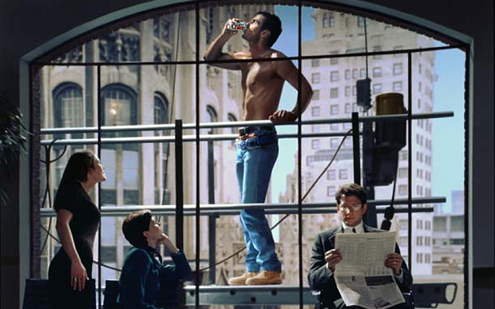
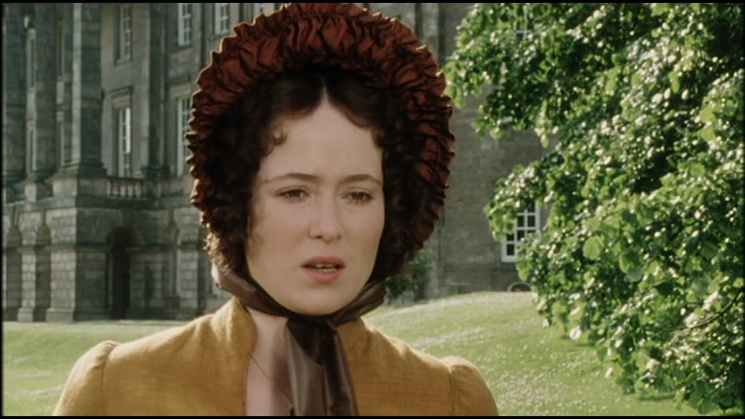

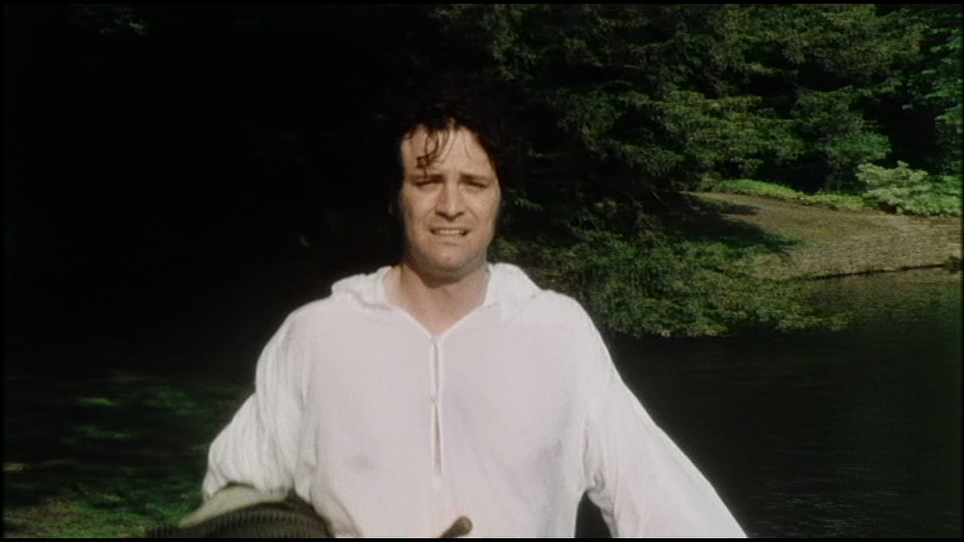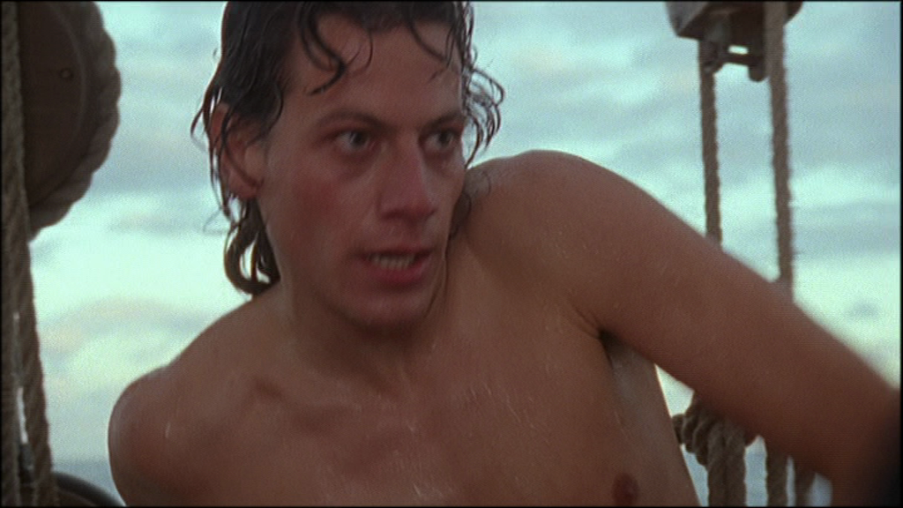
Figures 18-21 The objectified male becomes part of the ‘female gaze’ in the Diet Coke advert, a moist Darc’y is the subject of Elizabeth’s gaze in Pride and Prejudice (1995) as she looks downwards towards his crotch and similarly, Hornblower is naked, wet and on ‘display’.

The story, however, affects a rites- of- passage narrative that is a frequent trope of the maritime story, both in literature and on screen (see also Billy Budd, 1:1, The Onedin Line, 2:1, and Treasure Island, 3:2), and which also draws relevance from the Nelson myth. Hornblower experiences sea-sickness and cruel bullying at the hands of one senior midshipman, Jack Simpson (Dorian Healy). Symptomatic of the ideology of the series, Simpson is a villainous working-class character jealous of Hornblower’s more genteel status and background. The ‘even-chance’ of the title refers to a duel enacted between the characters after both Hornblower’s good name and that of his mother is besmirched by Simpson (a signal of genteel gallantry not routinely portrayed in contemporary film and television). In the first instance, Hornblower’s place is taken by fellow officer Clayton (Duncan Bell) who is killed in the duel but succeeds in injuring Simpson. Hornblower later re-takes the duel himself after Simpson attempts to shoot him during a battle with the French. Having bested him in the shoreline duel, Hornblower refuses to ‘waste his powder’ on Simpson, turns his back and is rescued from a cowardly attack by the injured midshipman when a watching Captain Pellew (Robert Lindsay) shoots him in the act. There appears to be a code of honour and comradeship among the officer classes (Clayton and Pellew) that is in stark contrast to the belligerent, murderous and cowardly Simpson. There is a strict set of codes of honour and discipline, rank and file and a comforting network of gentleman to enact the values of Empire and ‘Rule Britannia’ maritime protocol. Such solid projections of ideology function as a blanket against the uncertainties of the age the show was produced in.

Concomitant with this is the attitude towards Europe. The opportunity to refer to the French with the negative epithet ‘frogs’ in a safe historic context is taken with relish by the producers, as the term is constantly deployed throughout the series and even insinuates itself into the title of the fourth episode, ‘The Frogs and the Lobsters’. Historical re-enactment as ritual catharsis therefore typifies the series, perhaps best exemplified by Captain Pellew’s slightly paranoid declaration in the first episode, “I foresee a day when all Europe will be against us”, echoing the long and troubled history of Britain in the EU at the time. As David Marquand suggests, ‘She [Great Britain] took part in the European project in the end, but in a curiously resentful and suspicious way’ (2009: 16) Indeed the rhetoric of warfare as integral to the psychological health of the nation is emphasised from the outset, with the title screen lamenting the idle men and ships, whilst early scenes of indiscipline are blamed on the lack of action. When news of war with France is announced in the first episode, it is greeted with rapturous applause by the crew of the HMS Indefatigable, echoing similar episodes in Defiant and Billy Budd and invoking the boredom of the warrior in I Remember Nelson.

The second episode, The Examination for Lieutenant, continues Hornblower’s advancement through the naval ranks. The story concerns engagements with the Spanish who have just entered into a treaty with France. The crew of the Indefatigable rescue the crew of a sunken British supply boat and head towards Oman for much needed supplies. However, these turn out to be contaminated by the Black Death and Hornblower and his landing crew are quarantined, causing great tensions aboard the main ship as the food is rationed. Hornblower makes it to Gibraltar where his examination is interrupted by his rescue of the fleet from a Spanish fire ship. The Spanish, as enemies, are not portrayed as detrimentally as the French are in the series but the North African Muslims in Oman are described as ‘Heathen’ (although this is not necessarily pronounced, just added for reasons of historical fidelity).

The next episode, The Duchess and the Devil, provides a rare role for a female character. Hornblower is tasked with escorting the Duchess of Wharfedale (Cherie Lunghi) back to England but are captured by the Spanish along the way and imprisoned, before staging a dramatic escape. It transpires that the Duchess is actually an actress and a spy, representing both performance and duality, and Hornblower is initially appalled that she uses sexual favours to avoid capture, but she earns his grudging respect. This episode concerns itself greatly with proper manners, protocol and etiquette, beginning with Hornblower’s lack of knowledge concerning proper Admiralty dining and serving manners and continuing with an examination of the correct role for women in warfare and revolution: “In revolutionary France, the guillotine does not discriminate between sexes”. Hornblower demonstrates his elevated morality firstly by saving a crew from drowning in a shipwreck, then voluntarily returning to the Spanish prison afterwards when he was free to escape (the gaoler had let him go on condition he returned). The Spanish are seen to be almost as noble by allowing him his freedom for his act of valour. However, elsewhere another English sailor provides a possible slogan for British euro-sceptics when he throws away and then proceeds to destroy a basket of fresh fruit he is given by his Spanish captors declaring “It’s English beef we want, and English beer!” (also suggesting something of the unnourished appetite of the British seaman).

The last episode of the first series, The Frogs and The Lobsters, takes the previous sentiments to the extreme by basing the whole episode on English hatred of the French. Hornblower’s crew are forced to escort a French Marquis and a small army of French rebels against the Republic across the channel to retake their village from revolutionary forces and seize France back for the Royalists. Whilst affinity and overlap with Royalist England may have been expected, the two sides clash and the French Royalists are shown to be even more bloodthirsty and debased than their Napoleonic counterparts. As one sailor declares early on in the episode, “a frog is a frog sir, and the only good frog is a dead frog”. This is just one of many examples throughout the series where the term ‘frog’ is used with impunity to describe the French. Elsewhere, the French soldiers are shown to be uncommitted and untrustworthy. At one point as they frolic in the sea, an officer remarks, “if they were my troops, I’d have them flogged”. It is the Marquis, however, who is the most odious, marked out by sadism and snobbery, putting a gun to a child’s head (stopped only by Hornblower’s intervention), beheading the villagers and besmirching the honour of a maid who is also the village schoolteacher. This outrage is too much for Hornblower who storms away from the dinner table in protest: another signifier of his traditional chivalry.

Series two (2001) consisted of only two episodes and introduced the notion of a villainous Captain who is also valorised as a national hero. The two episodes, Mutiny and Retribution, pit Hornblower against the powerful Captain James Sawyer (David Warner) who accuses him of mutiny in taking charge of his ship when Sawyer displays signs of madness. The charges relate to the decision made to attack a Spanish fort by Hornblower and the other senior officers when Sawyer is incapacitated. Duty, and the correct implementation of it is a recurring presence in these episodes alongside the anti- French and Spanish rhetoric (French mercenaries turn out to be duplicitous). Sawyer uses the same accusations to rile Hornblower as the Marquis in the previous episode, challenging him, “You’re not a revolutionary are you Hornblower?” It is Hornblower’s extraordinary talents and individualism (like Nelson) which lead to his downfall here against the rather outmoded methods of Captain Sawyer. Such individuality and challenge to authority are punished here by the Captain’s proclivity for meting out brutal punishment, and like Billy Budd and HMS Defiant, insurrection is ultimately exonerated in the circumstances and Hornblower is promoted to Commander of The Retribution. The series is concluded with an examination of the importance of heroes as Pellew declares to Hornblower: “The nation needs heroes Hornblower. Heroes make people believe the impossible”. Indeed, this call to arms for national heroism resonates with the contemporary climate in which Britain was involved in armed conflict in Afghanistan following the September 11th attacks, and political rhetoric on both sides of the Atlantic (and elsewhere) established a similar dichotomy of ‘good and bad’ with a clear villains (Al Qaeda, a war on ‘terror’ and an ‘axis of evil’).

However, such sentiments are discussed within the critical reception as a call to arms against both the EU and a permissive liberal society. James Walton in The Daily Telegraph Walton states that:

The makers of Hornblower could easily have decided to update the original in line with modern attitudes: put some women in the ship’s crew, for instance, or tried to see things from Revolutionary France’s point of view…To their great credit…they did neither. The French were perfidious to un homme; the British fighting man was rough-hewn but oaken-hearted and suitably deferential to his betters (The Telegraph, 2008).

The newspaper clearly relishes a world where women and the lower orders know their place, the French are rightly seen as tyrannical and duplicitous, and everything is seen from the point of view of the homogenous elite in Britain. The Sun (1998) corroborated this view and even challenged the BBC (presumably as a British licence funded institution) to produce its own mythic iteration: ‘The big mystery is why ITV made this and not the Beeb. Make amends BBC1 and dramatise the life of a REAL naval hero, Horatio Nelson, in time for the 200th Anniversary of Trafalgar in 2005’. The article also celebrates the same phallocentric, nationalistic, class bound euro-phobic world as the previous article:

It is patriotic. It’s aimed at men. And it celebrates values telly liberals normally sneer at- courage, loyalty, decency, duty, enterprise. Horatio Hornblower is a hero in an age of none, an action man at the Sharpe end of TV drama- the late 18th Century, when Napoleon dreamt of forging the first Euro superstate and Britannia battled to rule the waves (The Sun, 1998).

The article states that the series is superior to Sharpe ‘by not having a chip on its shoulder about class’ thereby completing a valorisation of the series that differs significantly from the virtues appreciated in I Remember Nelson.

The final two episodes, Loyalty and Duty, (2003) have a more landed quality, as in 1803, a title at the beginning informs us, The seaman in the fleet have gone back to their homes and the officers languish on half pay. The landed life does not suit the officer class, and a broach in the war with France is a source of lamentation. Such is his idleness, Hornblower romances (and eventually marries) his landlady’s daughter Maria (Julia Sawalha) but it is not long before ‘Napoleon is stirring’ and naval warfare resumed. The villain of the piece (alongside the obvious French and Spanish miscreants) is a traitor in the ranks- the Irish Sailor Wolfe (Lorcan Cranitch). By siding with the French, Wolfe positions the English as the greater enemy to Ireland- “to save Ireland from worse tyrants” he declares and another crewman earlier tells him “maybe he [the Captain] would rather have a Frenchman in front of him than an Irishman behind him”. In this discourse, even the French are seen to be more loyal to the British army. Such representations were politically sensitive at a time when the peace process was at its height and the Good Friday Agreement had only recently been signed (as well as IRA and the Real IRA ceasefires). Exhortations by Wolfe like “I serve Ireland and her people” would have had particular social relevance and resonance. Hornblower realises the seriousness of the issue as he states that “more than one quarter of the force [British Navy] is Irish”. Eventually confronting Wolfe, his innate Englishness (i.e. goodness) surfaces and he refuses to shoot him in cold blood to which Wolfe responds “The decent Englishman…if only you had the guts to shoot”. In the end it is English (not British) virtues, particularly the duty of the title that restores order. Hornblower’s duty even extends to his new wife. Maria implores him on their honeymoon “can’t you forget about your ship for one day?” to which he replies with earnestness “no…I don’t believe I can…I need to be at sea, that’s where I’m needed.”…This convergence of masculinity, the sea, duty and affection is particularly asserted in this final episode. When his ship is lost in bad weather, Bracegirdle (Jonathan Coy) is crestfallen, “I lost my ship and I lost my men. I wish I were dead”. The series ends on the following exchange between Pellew and Hornblower:

Pellew- “One day, you will fight for what is more than England”
Hornblower- What is more than England?

And that indeed, is the question the series seems to ask of its audience, inviting them to pledge allegiance to the Georges Cross on the white ensign it prominently displays.

As suggested earlier, the critical reception of Hornblower is as significant as its content in disseminating discourses around nationhood, heritage and identity. Many of the reviews used nautical language and metaphors in a playful way to mock the old-fashioned pretensions of the series. Writing in The Times, Paul Hoggart employed a succession of tangled nautical terms:

Hoist the fo’castle! Splice the anchor! Poop decks away! It’s HMS Hornblower (ITV1) bearing down on the starboard bow to rate our Sunday evening with another broadside of nautical nonsense! (The Times, 2003).

This was echoed by Jasper Rees in The Independent who suggested that ‘The characters are hewn from the same timber as the vessels that carry them’ (Rees, 1998). The use of this nautical terminology itself is evidence of the lasting residue the maritime sphere has formed within the English language, and its deployment here to deride a show as stilted exemplifies the tension between old and new worlds that the show’s existence highlights. This tension surfaces in other reviews with The Daily Telegraph describing it as ‘An old-fashioned adventure’ and praising its antiquated ideology: ‘All the virtues of the first [episode] were back in place, especially the heroic resistance to any cultural updating’ (1998). A.A. Gill in The Sunday Times (1998) seemed to suggest that the series lack of revisionism was cynical marketing to attract ‘overseas sales’: a sanitised picture of Britannia that panders to transatlantic preconceptions. Gill also employs maritime language to make his point: ‘The series is rum, sodomy and the lash- only without the sodomy. There is an American market to consider, and they don’t like that sort of thing’. Gill does also praise the show as ‘excellent’ and perhaps vindicates the premise of the show in the greatest possible terms by suggesting that, ‘If 18th-century recruiting officers had had Hornblower, they would not have needed press gangs. Again, the lineage and line of tradition is highlighted and The Times reminds the reader that Winston Churchill was a great admirer of C.S. Forester and that Ioan Gruffudd invokes the spirit of John Mills with his expressions of ‘grit and moral integrity’ (Gill, 1998), a laudable continuance of tradition.

It is the reviews that appeared in The Sun which demonstrates how the virtues of a particular cultural product at a precise moment in history are hijacked to fulfil a broader ideological agenda. Garry Bushell (1999) took the opportunity to compare the show unfavourably with Sharpe, yet in doing so praised the virtues of the original character, declaring, ‘C.S. Forester’s Horatio Hornblower is one of the most courageous characters in British fiction’, yet Ioan Gruffud is ‘too wet’ to give the character the requisite gravity. The second half of the review is less a review, more right-wing political rhetoric:

There isn’t enough patriotic drama on TV, largely because the “culturati” are embarrassed by our island story. During the Napoleonic wars, the British were imbued with a certainty that has long deserted our ruling elite. What would the real-life equivalents of Sharpe and Hornblower make of successive governments who, having conned us into a Euro super-state, are busy overseeing the break-up of the UK? Relish dramas like this while we can. They will probably be banned by Brussels next, along with imperial measures and the quid, The Union flag will be electronically scrambled on TV and patriotism outlawed as thought-crime. Liberalism is doing to Britain what Napoleon and Hitler never could. (Bushell, 1999).

It is clear that Bushell resonates with the fictional world Hornblower creates, yet interprets it as history. The meta- history of cultural projection is here conflated by Bushell as patriotism and anti-liberalism, as he confuses real history (the Napoleonic wars) with the imagined musings of two fictional creations (Sharpe and Hornblower) as evidence that the Britain depicted in Hornblower is sustaining a three-pronged attack, from the “culturati”, ‘Liberalism’ and ‘Brussels’ (presumably representing the entire ideology of the European Union). The use of the term “our island story” is particularly revealing, especially as it is used in opposition to what is termed the “Culturati”. The term, with its conspiratorial overtones, is not fully explained by Bushell, yet one assumes he is referring to those gatekeepers of culture ideologically opposed to his views. Yet it is confused as it would suggest all producers of culture, including those that Bushell admires. Bushell invites the reader to take shared ownership of the ‘island story’, yet conflates it with his personal ideology and confused view of history.

This is important in examining the relationship between the intersection of culture, myth and media discourse. Much like the Western frontier, the Island story symbolism is a cultural space that is both culturally loaded and a ‘Tabula Rasa’ ready to be filled with a blend of history and myth. Here, there is an incestuous and circular relationship between the three. Richard Slotkin argues that myth can be a product instantly created by those cultural gatekeepers invested enough to wish to enact it. He describes the myth of Custer’s last stand as the instant and deliberate creation of the media of the time:

The primary acts of translation that turned the battle of Little Big Horn into the myth known as Custer’s last stand were performed by the journalists and editors of the Metropolitan daily newspapers in the summer and fall of 1876. They seem to have had some awareness of the fact that the story they were handling would become a legend; and they brought to their telling of it the full range of legendary references and metaphors… (Slotkin, 1985: 435).

The legendary references and metaphors are in abundance in Hornblower’s critical reception, symptomatic of the role of the maritime in creating and spreading the English language, and creating many of its most common and enduring metaphors.
Hornblower therefore provides a crucial example as to how ‘Britain explores itself through its history’ (Seaton, 2009: 74) but also through the mythology which is aligned to it. The use of naval heritage and maritime symbolism in Hornblower, and the Napoleonic era in particular, again demonstrates how vital that historical period is for navigating the present. In sharp contrast to I Remember Nelson, the production, aligned with the reception, reveal much about a crisis of national identity as the twentieth century turned into the twenty first. Television, as a conduit for myth, can offer a number of often competing discourses, in its privileged position in the home. As we shall see, To the Ends of the Earth (2005) offers yet another perspective on British naval history, which again positions the Napoleonic era as vital territory for examining the underlying structures of modern Britain.

1:4 To The Ends of the Earth… and Back Again

Alone, alone, all, all alone
Alone on a wide wide sea!
And never a saint took pity on
My soul in agony
(The Rime of the Ancient Mariner, Samuel Taylor Coleridge, 1834 ed.)

“I will not fight for my country…for my ship…my King… or Captain”
(Mr Pike, To the Ends of the Earth, 2005)

Introduction
Billy Budd was released at a time of great social change in British society, but its grand themes of morality, existential ennui and religious allegory are clearly timeless, as the many iterations and interpretations across a variety of artistic media (and transnational contexts) testify. The time period is important, though, (as with HMS Defiant), in eliciting a particular historical moment as the basis for exploring the established notions or ‘obscure genesis’ of nationalism and mythology. Yet, due to the fact that this particular historical moment is so rich and diffuse as source material for exploring a nation’s past, the ‘obscure’ becomes well defined. This chapter will explore this time period further, by examining yet another artistic evocation of the Napoleonic era that questions the projected values that military victory engendered. In 2005, the BBC produced an expensive (ten million pounds) three- part dramatization of William Golding’s trilogy of books collectively known as To The Ends of the Earth, which comprised the Booker Prize- winning Rites of Passage (1980) and the sequels Close Quarters (1987) and Fire Down Below (1989). The television series conflated the books into one master narrative, and produced a work that was widely praised in Britain and across the world. Like Billy Budd, both the novel and the film, the period is used as a backdrop to interrogate the valour, heroism and established notions of the era and vividly, viscerally and violently deconstruct them.

The series was directed by Davis Atwood who had previously directed period drama with The Fortunes and Misfortunes of Moll Flanders (1996) and The Hound of the Baskervilles (2002) whilst Golding’s novels were adapted by Tony Basgallup and Leigh Jackson who interestingly were better known for work of contemporary soaps and dramas such as Eastenders, Casualty and Teachers and Grange Hill respectively. Perhaps that explains why the finished product had much of the look and conventions of a period drama, but viewed the revered nineteenth century through a critical lens and dealt with decidedly social issues.

Benedict Cumberbatch portrays Edmund Talbot, a man of aristocratic bearing, travelling aboard a creaking warship, to take up a governor’s position in Australia. The ship is crewed by The Royal Navy under the watch of Captain Anderson (Jared Harris), and his first Officers Lieutenant Summers (Jamie Sives) and Lieutenant Deverel (JJ Field). Set in 1812, towards the end of the Napoleonic period, the ship is commissioned to engage with enemy ships if it encounters any on the long journey, but asides from that, the ship acts as a passenger vessel for Talbot and an assortment of other civilians heading for a new life in the colony. These are comprised of the political radical Mr Prettiman (Sam Neill), the artist and his wife Mr and Mrs Brocklebank (Richard McCabe, Denise Black), Miss. Granham- a governess (Victoria Hamilton), the craven Mr Pike (Jonathan Slinger) and his family as the principal leads.

Tensions begin to arise in this small community almost immediately as Talbot incurs the wrath of Captain Anderson by walking on the quarterdeck. Unable to discipline him due to Talbot’s social position, Anderson instead humiliates the Parson Colley (Daniel Evans) by throwing him to the ground. This sets of a chain of events which lead to Colley being selected to take part in the ‘Neptune Ceremony’- a custom prevalent amongst sailors when a ship crosses the Equator. The crew pay homage to Neptune by ceremonially stripping one of the novice member of the crew and dunking them in cold water before shaving their head or face. It is traditionally a fraternal rites of passage initiation for a novice sailor, but the choice of humiliating Colley sets him on a downward spiral, in which he then gets drunk and debases himself further by running naked and urinating on deck before administering fellatio to one of the crew members. Unable to cope with the shame of his actions, he eventually commits suicide, in which Talbot is implicated by virtue of his initial transgression (ironic given his intended position as a diplomat.

Meanwhile, Prettiman falls gravely ill after a fall and he and Miss Granham decide to wed. There is an interlude in which another ship is spotted in the fog and both crew and civilians prepare themselves for battle. However, it turns out to be a fellow British vessel, led by Sir Henry Somerset (Charles Dance) who brings news of the defeat of Napoleon at Waterloo. A lavish party takes place aboard Sir Henry’s ship whereby Talbot falls in love with Henry’s adopted daughter Marion Chumley (Joanna Page) and is distraught when they part. A swap takes place across the ships of Lieutenants as Deverel has fallen out of favour with Anderson, and likewise his replacement Lieutenant Benet (Niall McGregor) has fallen afoul of Sir Henry by having designs on Lady Somerset (Cheryl Campbell). Benet, who fancies himself a poet, falls out with Talbot whose petty bickering over how to help Mr Prettiman leads to Talbot falling on him and rupturing his swelling so badly that he almost dies, making Talbot almost responsible for two deaths. Prettiman slowly recovers and weds Miss Granham in excruciating pain.
The creaking warship snaps its mast and Benet distinguishes himself initially by soldering it back into place despite causing both fires in the timbers below and the mistrust of Summers. Talbot is promoted to Midshipman (the first position for both Horatio’s Nelson and Hornblower) and during one of these watches, a great mass of pack ice is spotted ahead, causing panic. Captain Summers successfully steers it out of danger and the ship finally arrives in one piece. On arrival, Talbot learns of the death of his benefactor, before spotting the ship burning in the distance (a legacy of Benet’s repairs). Realising Summers is still on board, Talbot races to rescue him and is badly burned in the process, failing to retrieve him from the burning ship. The series ends with Talbot and Miss Chumley reunited on the jetty.

The conceit of To the Ends of the Earth, invokes a number of long-established cultural and literal metaphors associated with the sea, ships, sailing and voyages. The voyage, or journey metaphor is the most prevalent perhaps, as Golding originally used this device to de-stabilise the heroic, masculine rights-of-passage motif established in texts like Odysseus and manifest in a British context in texts like Robinson Crusoe, Treasure Island and the Hornblower novels amongst numerous others. In Golding’s text, as with the television adaptation, the sea journey as romance and adventure is transformed into a nightmare of death, disease and degradation.

The series mixes elements of several generic tendencies, both stylistically and thematically, often in close proximity. The opening sees Talbot traversing the English countryside in a carriage, redolent of eighteenth century costume dramas of the period. The carriage then alights at the docks, where Talbot first views them through his muddy carriage window. The bucolic countryside is juxtaposed against the romantic docks, accompanied by a jaunty theme that incorporates nautical motifs. As Talbot embarks upon the ship, there are several under- sail, under- mast, low angle and panning shots, as is conversant with maritime filmic language to emphasise the size and majesty, as well as the intimidating scale of the three- masted frigate. The visual environment takes an abrupt departure as Talbot enters the upper decks of the ship. The interiors are dark, grim and claustrophobic, and as Talbot puts a handkerchief over his mouth and declares to his manservant “what’s that stink”, the viewer can almost smell the unpleasant conditions on board themselves.

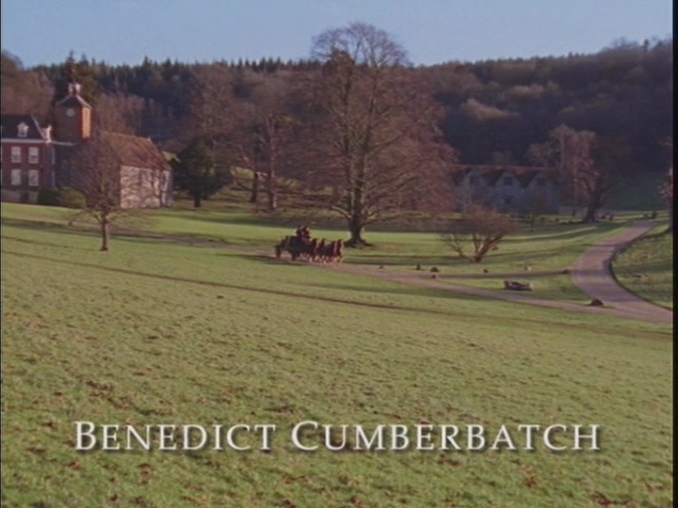

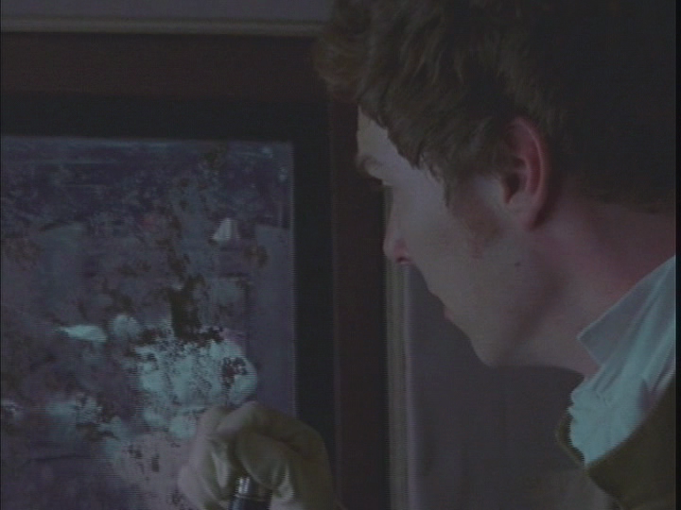
Figures 22 & 23. The picturesque spaces of the heritage drama is established and then despoiled with grime.
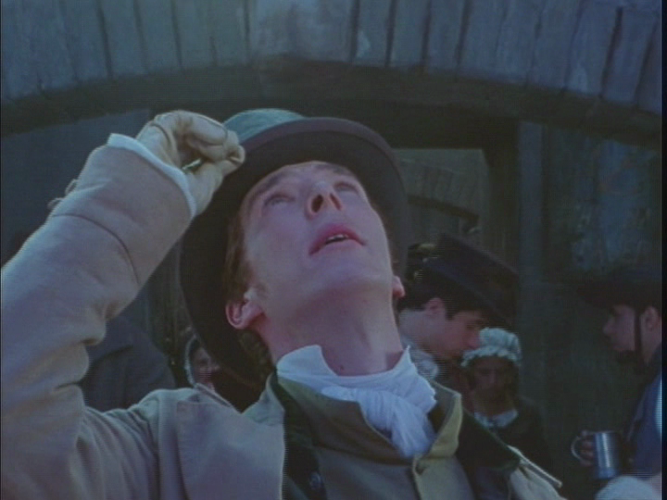

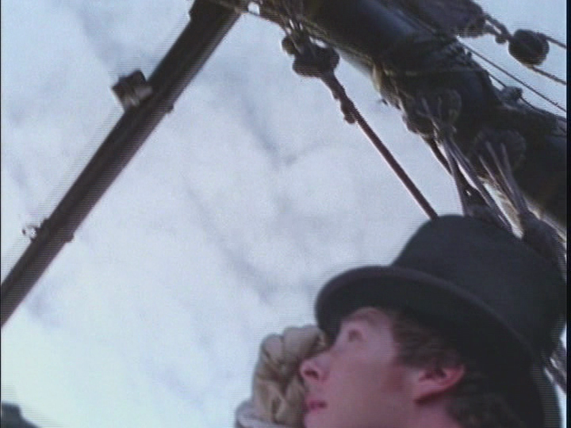
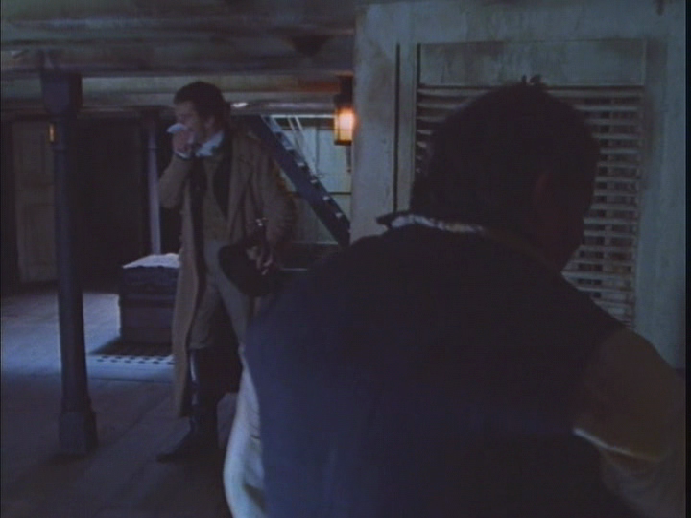
Figures 24-26. The awe and wonder of the ship is then contrasted with its grungy interiors.

Immediately then, the pattern of the series is established, as the romance of voyage and onward trajectory of novice sailor (see Treasure Island 3:2, The Onedin Line 2:2, or Hornblower 1:4) is undermined by the grungy reality of a nightmarish and decrepit ship. The heritage trope of country house and carriage, opulent interiors and wide open spaces is replaced by a foreboding and clustered interior more akin to gothic horror. If the ship represents a microcosm of society at sea, a stratified stately home afloat, then it resembles Manderlay or the House of Usher more-so than Downton Abbey. The adaptation is clearly conversing with these tropes to undermine them and present a gothic ‘return of the repressed’ in polite eighteenth century British society.

It is again useful to compare this iteration of Britain’s ‘Wild West’ (The eighteenth century Atlantic) to revisionist Hollywood westerns. The text is punctuated with rotting and putrefying flesh, loveless fornication and fellatio, vomit, flatulence, sickness and fetid stench, demystifying the romance of the sailing ship, oceanic voyages, the Napoleonic era and British history in general. As such it has more in common with films like McCabe and Mrs Miller (1971) and Unforgiven (1992) or television programmes like Deadwood (2004-2006), which deliberately challenge the established myths of the American West, and foreground the dirt and depravity.

At times, the production is expressionistic in its evocation, particularly in dream sequences Talbot experiences, as he is plagued by fever, self-doubt and the consequences of his actions. In a surreal and deliberately ghostly sequence of events, Talbot’s servant Wheeler (Brian Pettifer) vanishes overboard but later mysteriously turns up aboard Sir Henry’s ship, only to then to shoot himself in the head during heavy weather. Along with Colley and Prettiman, he is the third person that Talbot is accused of and accuses himself of being responsible for inadvertently killing (although Prettiman recovers). As he opines over voiceover “I kill people without knowing it”. Following this, Talbot dreams of seeing Wheeler and Colley as dark and dirty water seeps down the walls and under the doors like an encroaching plague, reminiscent of a similar usage of blood in The Amityville Horror (1979) and The Shining (1980). Seawater as dirty and disgusting is a direct challenge to the ‘ruler of the waves’ motif of English mythology. This is compounded in the narrative, as the veneer of civilisation begins to break down, and the ship is initially without a doctor on board, and then without a parson, recognisable icons of eighteenth century society. It does have an artist, a philosopher and an aristocrat however. Indeed, the entire crew, in their decadence, peculiarities and bodily functions, resembles a ‘Hogarthian’ sketch of English society.
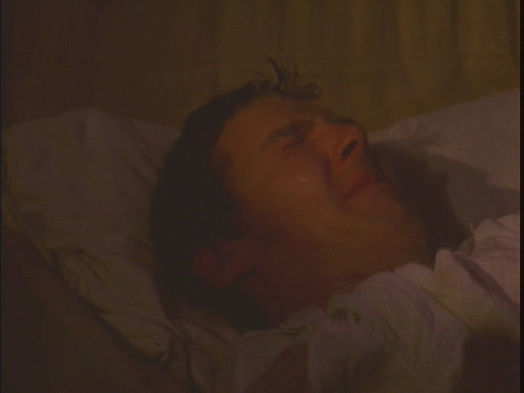

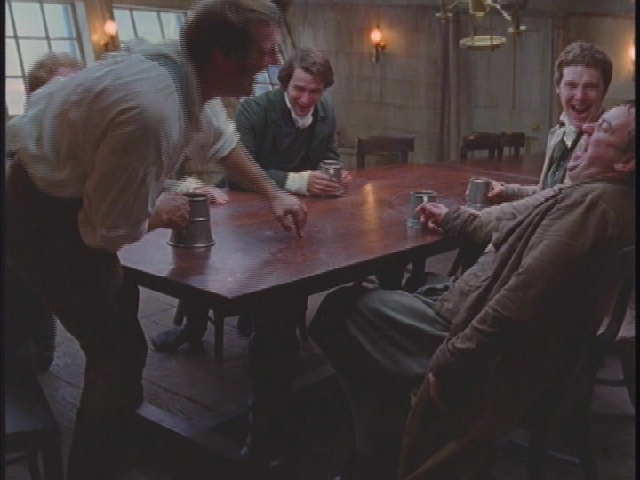
Figures 27-28. Talbot suffers nightmares and sickness and imagines the water seeping through is blood whilst figure 29. A ribald Hogathian sketch of 19th Century society is evoked.

As a referential text, Samuel Taylor Coleridge’s The Rime of the Ancient Mariner (1798) casts a spell, both over this production and Golding’s original novel. The poem is a supernatural fable that deals with the punishment and expiation of a mariner who shoots an albatross and undertakes a spiritual journey of pain, only to gain salvation when he learns to love the slimy beasts that swim in the sea- ‘He prayeth well, who loveth well/Both man and bird and beast’. It is directly referenced, as like the titular mariner, the radical and philosopher Prettiman shoots one to prove a point: “Superstition is the prospect of a feeble mind”. Yet Prettiman is punished for this by taking a bad fall which leaves him in agony with vicious swelling and his thigh bone painfully thrust up into his hips, and with no surgeon on board, he is left to lie in agony throughout the rest of the voyage.

Similarly, the poem deals with ice and fire, being set in the Artic region, as does this text (though the Antarctic in this instance). The ship is nearly undone by pack-ice and then finally consumed by fire, linking these elements of the voyage to romantic sublimity and redemption. Indeed, much like the Mariner’s journey of quasi-religious sin and redemption, To the Ends of the Earth follows a similar story. Captain Anderson is guilty of abusing the parson, but his composed and skilful avoidance of the pack-ice redeems him, which has traces, particularly in eighteenth and nineteenth century conceptions of the ship’s Captain metaphorically steering the nation on a ‘steady course’, thus positioning the maritime navigator as national hero (see Kinzel, 2002: 29-34). More significantly, it is Talbot, whose trajectory throughout the narrative echoes the journey of sin and expiation the mariner undertakes. Even more significantly, it is his aristocratic arrogance that leads him through a journey of discovery, as the text strikes a de-stabilising blow against another established structure of the Rule Britannia myth- institution and hierarchy and the societal protocols it engenders.

To the Ends of the Earth is a text about how society kicks downwards, through the hierarchical structure and how uneven, unjust and jaundiced society is as a result of this practice. Talbot declares at the beginning “my ambition is boundless” (see also I Remember Nelson 1:4), and due to his station in life, he has the opportunity to do so. It is made clear that his arrogance of breaking protocol and standing on the quarterdeck uninvited sets off a chain of events that leads to the parson’s humiliation and eventual death (quite the opposite of Hornblower as gentleman hero). His petty intellectual squabble with Benet also leads to Prettiman’s misery, whilst he also initially treats Summers with disdain as he has been promoted to lieutenant from below decks rather than from commission. He patronisingly declares to him: “A common sailor? Well then Mr Summers I must congratulate you…on imitating to perfection the manners and speech of a somewhat higher station in life”. Again, as with the performative aspect of Admiral and society figure in I Remember Nelson, the performance of Talbot’s manner underlines their artificiality.

It is interesting to compare this evocation of a Napoleonic journey of nightmare and redemption, class and society, with Anne- Julia Zwierlein’s (Zwierlein, 2002: 49-76) analysis of John Milton’s Paradise Lost (1667), a text that also deals with a dramatic fall from grace. Zwierlein analyses the poem, particularly the section depicting Satan’s sea voyage, in relation to the eighteenth century sea-faring trade, and changing attitudes to the sea and oceanic voyages. Zwierlein suggests that the sea and ocean, considered as chaotic, dangerous and ‘without dimension’ in Renaissance times, begins to be viewed differently as it becomes the axis of trade and wealth for the burgeoning English, and later British, overseas Empire. She suggests that by the eighteenth century, ‘the new ‘global players’ were not the heroes and noble soldiers of Sidney’s and Raleigh’s days, but the newly risen Merchant classes’ (Zwierlein, 2002: 51, see also The Onedin Line, 2:1). The sea, particularly within a British context, is transformed by ‘materialistic readings’ in the ‘secularised eighteenth century’ (Zwierlein, 2002:56), divesting oceanic metaphors of negative religious connotations and transposing them into commercialised spaces. The effect therefore, is of a leviathan domesticated, a sea that can be conquered by military, but more importantly, by commercial enterprise. To the Ends of the Earth, in its re-imagining of naval myth and secure institutional hierarchy, and its fidelity to texts like The Ancient Mariner, returns the sea, voyage and ship metaphors, as well as the stable vision of social structure to uncertainty and notions of humanity’s hubristic vice in the face of nature’s awesome power (see also the numerous renditions of the Titanic disaster). To the Ends of the Earth therefore has more in common with Milton’s conception of this landscape:

…Milton’s concept of space is not empirical, but hermeneutical: space is constructed through perception, and the uncharted ocean becomes a symbol of the instability of human knowledge. (Zwierlein, 2002: 61).

In this text, the perception of space is often governed by the lead protagonist, Talbot. As his perception is constantly altering and in flux, the visual and aural depiction of the ship and the sea are unstable: aligned to Talbot’s own journey of self- discovery. This would explain the expressionistic and fluid handling of established nautical visual language in the text. As discussed, the individualised journey motif is established from the opening, as the dizzying grandeur of the ship is evoked from Talbot’s nautical novice position, and the dreams and nightmares he has aboard sustain a consistent theme of subjectivity. Interstitial sailing scenes, usually a close up of the prow of the boat, the wake from behind, aerial shots of the rigging or the ship in full sail from a long-shot are common tropes in nautical film and television to express and compress the passage of time, and/or to indicate forward motion. They usually have a positive connation and are often romanticised or fetishized evocations of sailing, matched by a romantic and sweeping soundtrack and visually aligned to sunlight or twilight. Their use here however is more complicated, and again, linked expressionistically to Talbot’s shifts in mood. Talbot’s first foray on deck is in poor weather, gloomy, wet and turbulent. He veers ungainly across deck, and is vomited on by the parson, again undermining the romantic notion of sailing. Talbot’s entry into his journal concludes, “added to the heat and humidity, a sea voyage, I am learning, can have an effect on a man’s constitution”. As the narrative unfolds, this effect becomes more profound and is demonstrated visually and aurally for the viewer.

By making the ship an-ex ship of the line, rather than a merchant ship, the text deliberately engages with British naval history and cultural tradition, as well as other nautical references. This device also allows for the presence of woman aboard a warship, a notable absence in so many nautical dramas. The navy itself is represented mainly by the officer class; Captain Anderson and Lieutenant’s Deverel, Benet and Summers, who all inhabit the social and professional spaces conversant with their status. Anderson distinguishes himself after his brutal treatment of Colley, whilst Deverel as drunkard is heavily implicated in his degradation. Benet is a snob, but essentially harmless whilst Summers, as the non-privileged officer, there on merit, is the hero of the piece and the man responsible for showing Talbot his position has responsibilities and consequences for everyone. It is clear that the navy is not glorified but shown to be human, fallible and capable of atrocity in its strictures and protocol, much like in Billy Budd, but also capable of social mobility and a possible arena in which a man can show himself to be great, like I Remember Nelson. Again, a scrutiny of Britain’s naval heritage elicits a conflicting and complicated set of associations not present in Hornblower, which offer a more diffuse projection of the founding myths of Britain.

The drama was well-received, both in the UK and in English-speaking territories, with Broadcast reporting that it ‘cruised to a comfortable victory in the ratings’ with 4.3 million and 19% of the audience watching at 9.00pm (2005), indicating that there was an appetite for nautical drama in the twenty first century, even if it is not a jubilant celebration of British maritime history. The New York Times (Heffernan, 2006) praised the production, suggesting that it did a ‘heroic job of conveying the sweaty, stinking, sodden atmosphere of sea travel’. Ian Bell in The Glasgow Herald concurred (Bell, 2005), stating that ‘This was a great piece of work from the BBC’, whilst Charlie Courtauld in The Independent on Sunday (2005) spoke about it favourably in connection with nautical television, ‘Perhaps the most impressive feature of the film was its pace: anyone who saw Triangle knows that seaborne dramas can be dull’. Reviewers find it difficult, if not impossible, to divorce the visual iteration with its literary antecedent. An interview with the director David Atwood in The Times (2005) reveals this: ‘Apart from the old adage, that a great book never makes a great film, there is another saying in the film/TV business: making movies and boats don’t mix.’, before invoking Lew Grade’s famous quote about Raise the Titanic- “It would have been cheaper to lower the Atlantic” (Atwood, 2005).

However, the success of maritime films in recent years (Titanic, 1997 being chief amongst them) and the continuing success of literary adaptations, suggest the adage is perhaps false. What was interesting in the critical reception of the show is some of the references and parallels that reviewers drew to situate the programme in its national heritage and contemporary context. The first episode debuted on BBC television on July 6th 2005. This was the day that the Olympics were announced to be held in London in 2012 and the day before the 7/7 suicide bombings in the same city. Charlie Courtauld (Independent on Sunday, 2005) invokes the former in his review, beginning it by reviewing the Olympic Decision on BBC where France, or Paris more specifically, were the nearest contenders for the games, suggesting that the review will not be ‘xenophobic’ before ironically asserting of the drama ‘In those post- Trafalgar pre-Waterloo days, Brits feared Paris above all others. Plus ca change’.

Ian Bell (Glasgow Herald, 2005) uses Mrs Prettiman’s quote “We are, it seems, a broken ship” and adds, enigmatically without extrapolating ‘Yet not, like England, so Broken that the journey could not be completed’. As a reviewer in a Scottish newspaper, this is telling of the schism between the home nations at this time. Yet Bell does indeed have a point about the evocation of England in the text. Thomas Sutcliffe (2005), writing in The Independent tellingly writes, ‘Not least of the drama’s gifts was the continual reminder of how inextricably tangled maritime and emotional language have become for the British’ suggesting the continuing importance of naval and nautical heritage to British identity. Reminiscent of the barely disguised glee that reviewer’s took in using nautical language and metaphor to review Hornblower, the same is evident in reviews for To the Ends of the Earth. Peter Paterson’s review in The Daily Mail (Paterson, 2005) is titled ‘Sail of the Century’, whilst also suggesting that its evocation of the Napoleonic era ‘made Master and Commander and the Hornblower series seem hopelessly simplified’.

Conclusion
To the Ends of the Earth uses a number of metaphors and associations in British history and culture to examine the founding myths of modern England. As reviews demonstrate, its themes and depiction resonate with conceptions of Britain, both past and present. Unlike Hornblower it is not a celebration of the positive virtues of the era in which modern Britain was forged, but critical of the pernicious influences that persist to this day. It challenges the viewer to examine the disgrace as well as the grace of British history. The ‘ship as England’ metaphor which James Chapman (2005) identifies in Master and Commander and which certainly applies to Hornblower is here de-stabilised and de-constructed. The ship is fragile and at breaking point- as Miss Prettiman suggests ‘We are fragile, We are held together by ropes and cables”, as indeed is some of the mythology that defines a nation.

1:5 Warship, Making Waves and Contemporary Naval Television.

“We take pride in our History” (Commander Martin Brooke, Making Waves, 2004).

Echoing the ubiquity of actuality, newsreels and documentary in early British cinema, the presence of the contemporary navy on television is far more prevalent in documentary form than it is in drama with numerous programmes throughout the 1960s to the present day detailing the reality of life in the Royal Navy such as Sailor (1976) and HMS Brilliant (1995). The Admiralty were always willing to give support to shows which advertised the navy however (particularly in an exciting and positive light), surmising that it would be an important recruiting strategy in an era of dwindling recruitment.

Cultural Power- Warship (1973-77)

The BBC drama series Warship (1973-77) marked the largest deployment of naval equipment and man-power ever for a production, and the Admiralty were rewarded with a genuinely successful and well-received programme. Carolan describes the naval co-operation as ‘staggering’ in its scope (Carolan, 2012: 284), suggesting how important they felt it would be to their recruitment aims. They were no doubt heartened that the show’s creator was ex-naval officer Ian Mackintosh. It appeared at a time of both military cut-backs and dwindling naval recruitment and the culmination of the ‘Cod-Wars’ which, like the Suez crisis, was an un-welcome public exhibition of the contraction of British global power and influence this time which struck at the heart of British security and supremacy- the Royal Navy.

Warship and the ‘Cod Wars’
The fishing disputes between Britain and Iceland were a significant issue during the 1970s, that was labelled ‘the cod wars’ in the press but had its provenance from disputes the nineteenth century, where the British rejected the proposal of fishing exclusion zone as it would establish a dangerous precedent which threatened British marine sovereignty. The first modern ‘cod war’ was in 1958 when Iceland announced a new exclusion zone and British trawlers fished there in defiance under the escort of three naval warships, which resulted in nautical skirmishes eventually settled by an agreement by the International Court of Justice (Friel, 2003: 282). It reignited in 1972-3 in the second cod war in which a new Icelandic government ignored the treaty, and further skirmishes between British trawlers and Icelandic coastguard vessels resulted in the accidental fatality of an Icelandic engineer. The navy were deployed once more and another agreement reached until 1975, when the third and final ‘cod war’ began after Iceland again announced an un-agreed extension to its exclusion zone. Several confrontations occurred and this time, a naval force of 22 frigates was announced after HMS Andromeda was rammed by the Icelandic gunboat Por and a trawlerman from Grimsby was killed by a hawser. The British government eventually backed down and agreed to the larger exclusion zone, seriously impairing the maritime economies of Grimsby, Hull and Fleetwood who relied upon these fishing areas for sustenance (Friel: 282) It might perhaps be viewed as a naval ‘Suez’ in which British imperial power proved to be little more than a phantom force, and it might be true to say that the fishermen of these towns were let down by their country (a compensation scheme was not implemented until 2012).

Warship provided a number of responses to this. Firstly, it made visible again a contemporary armed service which had receded from the fictional cultural landscape and attempted to re-invigorate its historic vitality. The opening titles announced this. It opens with a sailor raising the ensign to military and patriotic music, followed by the Royal Naval flag in full vigour. Quick edits of gun batteries being swiftly deployed are then displayed followed by the prow of the ship at full steam traversing the sea (see 2:1 and The Onedin Line for a comparative, and contemporary treatment of a merchant and wooden sailing vessel deployed in a remarkably similar fashion). There is an emphasis on the ship navigating rough seas, ploughing forwards and the amount of turbulence that the ship experiences and triumphantly traverses, allied to the camera placement and martial soundtrack suggests the continuing triumph of the navy against the frontier of the sea- a space to enact the hallowed national (and masculine) sacred ground that the aforementioned flag signals and the successful conquest of the seas. The fact that the series, with its stewardship by an ex-naval commander, was attempting to culturally project an alternate environment is underscored by the proximity between its broadcast dates and actual events. The first episode was broadcast on BBC1 on June 7th 1973 at 9.25 (The Times, 1973), past the watershed, and suggesting that its recruitment potential was not aimed at a next generation buoyed by an educative connection to childhood mythical figures such as Drake or Nelson, but by a resilience in the face of contemporary pressures on the Royal Navy. Only one day after the debut of episode Warship was broadcast, on June 8th, The Times (1973) reported one of the most significant acts of the ‘cod war’ whereby a Royal Naval Frigate (much like the one used in the series) and a gunboat were involved in a ‘ramming’ incident. This occurred repeatedly during the first series. The disparity between actual events and the fictional universe that Warship portrayed is exemplified only weeks later when a reviewer from the same newspaper described, ‘Warship, the clean cut drama series, made with the help of the Royal Navy’ and again on the 2nd August ‘the compulsive Warship series, though set in the present, does seem to belong in the days when Britannia ruled the waves’. By both being ‘clean-cut’ and a throwback to the past, Warship functioned as an anomaly to the contemporary environment whereby the Royal was somewhat of an anomaly itself- figuratively important on the world stage and vital to conceptions of British national identity, yet barely visible to the population and powerless to protect British industry, security and, by extension, identity.

The content of the show itself focused on the internal lives of the crew, but particularly the officer class, and the more prosaic vicissitudes of life in the navy outside of combat including war-games, espionage smuggling and peace-keeping. The first episode, Hot Pursuit, introduces a new commanding officer and sets the tone for the series as officers with clipped, home-counties accents preside over the working-class ratings who spend their time fighting and gambling in between duties, and swap pornographic magazines. Indeed, there is an emphasis on the marked difference between life at sea and on land, with the former functioning as integral to male identity and the latter as troubling and disruptive. Episode 1:3, Off Caps, sees a crew member deliberately sabotage the ship’s boiler as he attempts to force the ship back to England in order that he can deal with a woman he got pregnant, whilst in 1:9, an officer gets drunk and assaults a crew member when he learns that he will be de-commissioned. The thought of civilian life terrifies him as service is all he has known- “what am I going to do when I get out?” he laments. His female companion, frustrated at being constantly second-choice to the navy, succinctly summarises the problem, “you’re like children- you’re in the army for all these years and no thought about what to do afterwards”. Indeed, women represent either a distraction from armed service in the series or the trouble associated with landed life. This is particularly marked in episode 1:4, Funny, they all say that. A crew member is constantly in debt as his aspirational wife is always overspending. The situation is such that he is blackmailed into stealing secret plans for Russian spies. The moral seems to be that women are trouble, a distraction to naval service and represent the intractibilities of civilian life for which the navy provides order and coherence. The programmes’ title hints that war is the pre-occupation, yet without any actual combat, the message is less regeneration through violence but regeneration through service.

The correspondence between producer Ian Mackintosh is even more revealing of the relationship between the BBC and the Admiralty. The cost of filming is underlined by the fact that the Admiralty originally suggested that there would be ‘no costs’ but Macintosh then had to explain to the BBC that the situation changed, explaining that ‘In the course of the series, a parliamentary question was tabled in respect of defence monies allocated to Warship; (28th September 1973, T/5/1/772). The BBC written archive attests to the close relationship Mackintosh kept with numerous figures in the Admiralty throughout, typified by this correspondence to Captain M.W. Hudson, Second to Commander-in-Chief of the Fleet on the imminent end to the series:

We were fairly certain that Warship would be rested after the current (fourth) series, particularly with the additional exposure of Sailor. Thanks for all efforts, the demands of Warship have complicated their lives more than a little- especially during the Cod War traumas (21st October 1976, T/5/1/772).

Again, this demonstrates how fiction collided with contemporary events and which made Warship seem ‘old fashioned’ by comparison (Carolan, 2012: 286-287). Mackintosh clearly felt that signalled the end of Warship and he was correct.

The BBC press release stated that the show ‘aims at presenting as realistic a picture of the modern navy as Softly, Softly does of the police’ (The Times, 1972). The Times were very positive about the programme, suggesting that ‘the trim drama series about the Royal navy, pays off’ (1973) and described it as ‘Warship, that spanking British bulldog series, is commissioned for some welcome new adventures’ (1974) suggesting that it represented a patriotic rendering of the institution. However, Stanley Reynolds also alluded to the fact that the navy was still alien to the general public, ‘One regular viewer of Warship told me that the pleasure was in watching the strange other world of the Royal Navy’ (The Times, 1977).

Making Ripples? Making Waves (2004)

No such class elitism typified the more recent Carlton TV drama Making Waves (2004) which likewise had the full support of the Admiralty. This expensive flagship drama was so unsuccessful that ITV attracted controversy in press and industry circles when it pulled the show from the schedules after only airing the first three episodes of a series of six, and a second series never materialised. The show’s viewing figures had plummeted drastically despite being in a prime-time slot and was mauled in the ratings by Channel Four’s Supernanny (a fitting emasculation for the once heroically masculine institution). According to The Guardian (2004), the producer Ted Childs ‘was looking to do with the navy what he’d done in the previous decade with the army in Soldier, Soldier’ (which he also produced) which is reminiscent of the strategy for Warship in relation to Softly, Softly. As with Warship, naval co-operation was integral, as was reported,

Royal Navy advisers worked with writers and producers on story lines and scripts, provided technical expertise and advice and gave access to ships, aircraft, personnel and locations to make everything as real as possible (Usher, 2004).

Carlton, the shows’ producers clearly considered that the show would resonate in the same manner as Soldier, Soldier by spending lavish figures on hiring naval equipment, a feeling shared by the Royal Navy who anticipated that, like Warship, it would make the navy visible again within the public sphere. Carlton spokesman Peter Mares declared, ‘Making Waves has been made in co-operation with the navy, which has seen the series as a potential boost to increase recruitment’ (Preece, 2004). Therefore, there was much press anticipation before the show aired. Ted Childs asserted “I believe the modern-day Royal Navy is a very appropriate setting for a contemporary drama series” whilst The first Sea Lord and Chief of the naval Staff Sir Nigel Essenhigh stated, “I am delighted that Carlton TV has decided to work with the Royal Navy on this series. Showing the Royal Navy in action on land, in the air and on the sea, will make for very exciting television and I am certain that our shareholders- the British public- will thoroughly enjoy watching this series” (Garnett, 2002). Such deference to the British public as custodians and ‘shareholders’ suggested that the navy was insecure as to its own position as protectors of national security and demonstrates how far the navy had receded as a national institution by the twenty first century. Carlton was loaned a type 23 Frigate, HMS Grafton, which was fictionalised in the series as HMS Suffolk, and the naval ship HMS Richmond embarked on a promotional tour in ports across Britain, including Liverpool, to promote the series, holding screenings on-board for naval personnel and local press (Usher, 2004). The Commanding Officer of the Richmond, Commander Mike McCartain, echoed Sir Nigel’s words stating “With our close co-operation, we believe Making Waves has captured the spirit of today’s versatile maritime force and will play an important role in developing better public understanding of the 21st Century Royal Navy” (Usher, 2004). Similarly, naval liaison officer Lieutenant Commander Kevin Fincher was buoyant that the show could enervate the navy’s image and was adamant that the show was as diligent as Warship in depicting the discipline of the service, “if, for instance, someone gets drunk and out of control in the series, you have to see that there are consequences” (Catchpole, 2004).

However, Making Waves was not successful, or given the chance to be in the ratings and the decision to take it off the air was greeted with apoplexy by the Admiralty, with The Guardian reporting that First Sea Lord Admiral Sir Alan West was ‘hopping mad’ after giving their co-operation on the series (The Guardian, 2004). It remains the last occasion that the Admiralty have given their co-operation to a fictional production, as, likely due to the show’s failure, it was also the last production that was attempted.

It is interesting that the show itself, which in no manner glamorises life in the Admiralty, should have been given its support, suggesting a change in strategy that would at least make the Admiralty visible again in contemporary drama. Set in Portsmouth, the series follows the endeavours of Commander Martin Brooke (Alex Ferns- best known as Trevor in Eastenders, or as The Sun stated ‘wife-beater Trevor Morgan’, (Ross, 2004) to get HMS Suffolk commissioned for active service, overcoming the difficulties that entails within the modern navy. Making Waves has a storyline perhaps better suited to a soap opera, as it follows the complicated lives of the Admiralty from the officers down to the ratings and deals with such topics as fighting and drinking, single mothers, and relationships across rank, class and gender lines. Compared to Warship, with its plethora of clipped accents in the commanding ranks, relegation of women to, at best, supporting roles and its relative demarcation between service life and everything else, Making Waves offered the opposite. However, there is a remarkable consistency between the two show’s opening credit sequences which foreground the romance of the navy and fetishises the frigate.
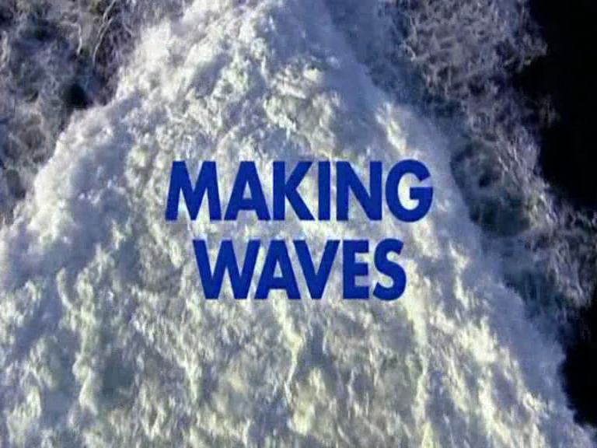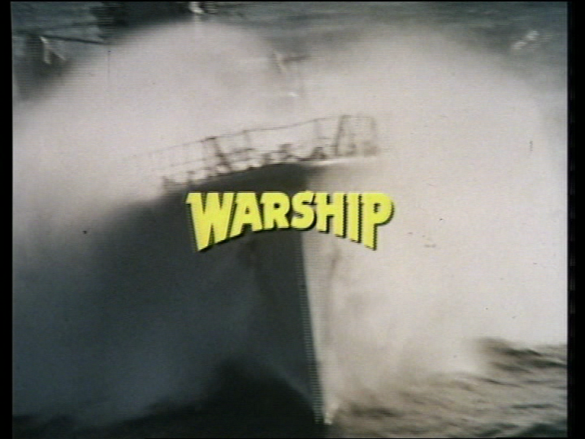

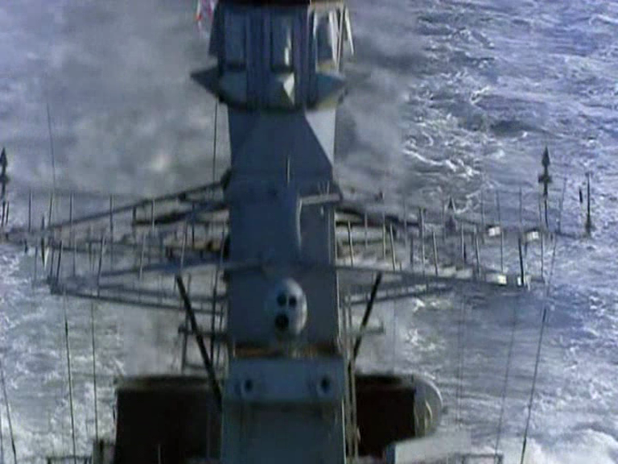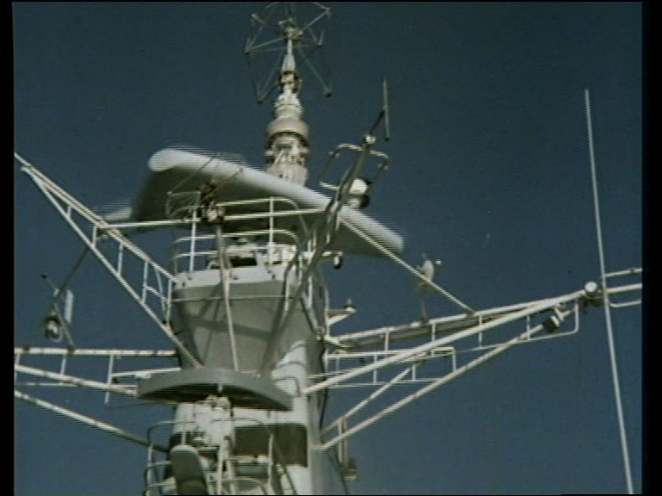
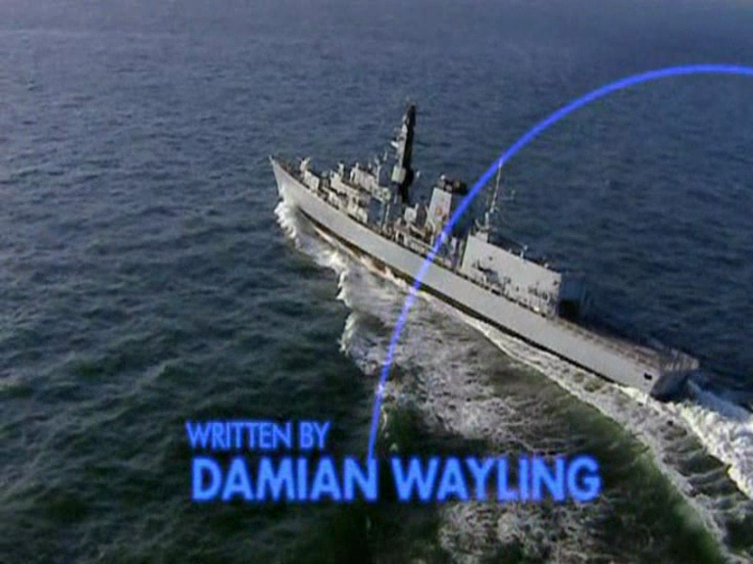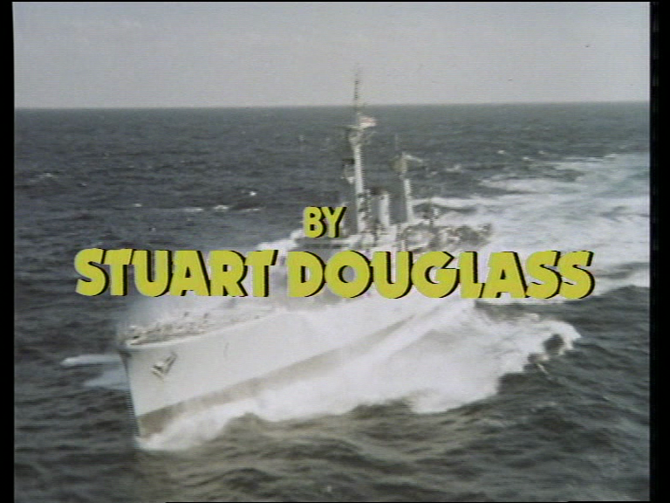
Figures 29- 34. A remarkable similarity of depiction between the opening titles of Making Waves on the left and Warship on the right suggest a consistency of visual and aural depiction.

Making Waves is particularly interesting for two reasons. Firstly, the manner in which it balances tradition with modernity, in its depiction of the navy. The theme music is particularly evocative, incorporating the boatswain’s whistles as a plaintive leitmotif, which immediately evokes a continuity of tradition in naval drama. There are numerous references to naval tradition, including naval funerals and the auctioning off of a deceased sailor’s kit, whilst the setting ensures that HMS Victory is often in the background. Juxtaposed alongside this is a depiction of the day-to-day role of the navy in contemporary society, perhaps unknown to many due to the decreasing importance and visibility of the armed forces in modern British society. The crew of the Suffolk therefore spend their days taking part in war games, dealing with pirates, protecting industrial waste from eco-warriors and rescuing Albanian refugees. Episode two is particularly revealing as it makes numerous references to the Falklands conflict, not least as the ship becomes host to a diplomatic coterie from the Argentine Navy, as a show of solidarity as trading partners. As one senior officer points out “all keeps the coffers full...you move on but never forget”, suggesting that trade is more important than nationalism, yet later on in the episode the crew are giving the delegates a tour around HMS Victory and Commander Brooke remarks, “we take pride in our history”. There is clearly a tension between the ‘glorious naval past’ and the altered, more prosaic and less triumphant navy of the twenty first century.

This is again emphasised by the second point, the visibility of women in the navy. Again, the invocation of naval tradition here provides a fascinating juxtaposition, as the series constantly sets up and then defies expectations. In episode one, a young rating- OM Mickey Sobanski (Lee Turnbull) fails to save a young Albanian boy who eventually dies, despite the more robust intervention of a female colleague. He is then forced to undergo therapy with a female psychiatrist, initially resisting and expressing himself with extreme violence (echoing Billy Budd), before eventually breaking down and overcoming his demons towards the end of the series. Similarly, the eco-warriors turn out to be radical feminists who make a complaint of molestation against one of the male crew members when he boards their ship. Eventually it transpires that he was unwilling to defend himself in Court as he himself was the victim of domestic abuse in a previous relationship. Elsewhere, there are lesbian crew members and the young novice seaman, masculine rites- of -passage narrative is supplanted by a female one as OM Rosie Bowen (Joanna Page) fulfils this ritual. She eventually proves her worth by triumphing in a boxing match (in which the round-keeper is a man in trunks, rather than a woman in a swimsuit).

There is a laudable attempt therefore, to re-populate the in a modern context, particularly one which seeks to balance a recognition and respect for venerable Admiralty tradition with the more contemporary challenges the navy faces. In particular, it remains the only attempt to display gender and sexual difference in the contemporary British Navy. That it failed was not necessarily just a rejection by the public for such a series, but rather the expense of production, and the tyranny of ratings. Realising it was in an impossible spot, ITV neither persevered nor moved it to another slot or channel. Critical reception of the series was damning, however, much of which focused on the casting, firstly with Ferns as leading character, given his public perception as a villainous character in Eastenders and secondly Jez Quigley as the chef, similarly associated as a disreputable drug-dealer in Coronation Street. Yet this was not the only flaw identified, as the script was the focus of negative criticism, blameworthy for not providing enough dramatic impetus. The Express, (Catchpole, 2004) utilised nautical metaphor and lamented that ‘Some of the dialogue is so leaden that it’s a wonder the Suffolk isn’t already lying six fathoms down’ and that the plot ‘seems to be drifting around in circles’ whilst The Sun (Ross, 2004) labelled it ‘ITV’s naval cack’ describing ‘a boatload of clichés’.

Conclusion
As the last failed attempt at producing a successful contemporary drama of the Royal Navy, it not only shows the relative decline in the fortunes of a once revered institution, but against the more successful rendering of historic depictions, it again highlights the nostalgic priority of the Royal Navy in British culture. The more compelling moment for audiences is the genesis moment of nationalism. This is perhaps, if inadvertently, best summarised by one of the show’s other naval advisors, Commander Richard Thomas, who accurately articulated many of the reasons why the navy had rapidly diminished in status in British national life,

These days, the British suffer from ‘sea-blindness’. The Royal Navy is a tremendous asset for this country but, since the demise of National Service and the Second World War generation, knowledge about it is slowly diminishing. We’ve reduced our ‘footprint’ around the world and we work at sea so the public can’t see what we do (Rampton, 2004).

It is perhaps inadvertent as Thomas was talking positively, as were his peers, about the ability of the show to increase positive public perception of the navy before it aired. Although positive, Thomas is correct in that both the eradication of National Service and ‘sea-blindness’ are products of the loss of Empire and the contraction of British global power and influence. The contemporary Royal Navy, once so integral to cultural projections and perceptions of British national identity had proven to be a cultural irrelevance by the numerous failures of Making Waves as a prime-time popular television show. It can be argued, that far from slowly diminishing, it actually had diminished by this time period, and although the ‘Second World War’ generation and the Second World War as national touchstone myth were still in evidence, the Royal Navy was more potent and, perhaps ironically, more relevant as depicted in the age of ‘wooden walls’. As the next section will exemplify, this fact is borne out by the success of the nineteenth century Merchant Naval drama The Onedin Line in the 1970s- nostalgia, and the romantic attraction of tall, wooden masted sailing ships held more appeal for the British public and more successful in creating a shared sense of memory and identity.

Chapter Conclusion
Depictions of the navy post-1960 have proven suggestive of national re-examination at key moments in British history. The contemporary depictions that were so profuse in the first 65 years of British film history declined rapidly, and largely migrated to historical re-enactments. There is a change from glorious celebrations of recent and historic events, to texts that use the Napoleonic and Nelsonian era as both a nostalgic and mythic celebration of Britain’s past, but more importantly a genesis moment whereby modern Britain, its strengths and challenges, are explored through the lens of history. Billy Budd and Damn the Defiant! are texts which focus on the mutiny period in Nelson’s navy, rather than the success at Trafalgar, and resonate with contemporary social change, the rise of youth culture and the instances of resistance and rebellion in early 1960s Britain. Defiant stops short of challenging naval authority and rank by making the villains dangerous mavericks, yet Budd conflates social and personal injustice with the strict and stifling nature of social structures and protocol and also the necessities of warfare.

I Remember Nelson also appears at a crucial moment in British history, and draws on cultural strengths (theatrical, acting tradition and incisive writing) to re-examine the mythology of the nation’s most famous naval heroes. It self-reflexively examines the nature of theatre and performance to complicate the greatness of an individual without denying it, showing his human frailties and difficulties and his reliance on other people in his life to contribute to his achievements. Hornblower, by contrast, draws upon ‘boys own’ literature to re-mythologise the period, restoring chivalry and both naval and social rank as well as an independent Britain to conceptions of heroism and the greatness of Britain.

Finally, To the Ends of the Earth, uses the same period to question the inherent greatness of Britain, its navy, its people, its institutions and its Empire by drawing on literary heritage, maritime symbolism and visual culture to challenge cherished myths of the nation. The ship and journey become symbolic of the journey of a nation, yet one whose successful completion is almost sunk by the very people who populate it. A journey of self- discovery by the lead protagonist is made possible only by rejecting the basis of being an Aristocratic English gentleman.

The contemporary navy may have lost its place in the hearts and minds of the British nation, but clearly not a fascination for its past, and the journey from the time of Nelson to the present day remains part of Britain’s own ‘manifest destiny’. To return to Frederick Jameson (Jameson, 2006) and Michael Billig’s (1995) conceptions of nationalism, it may well be ‘banal’ to some, but it is certainly not ‘obscure’. Society is built on myths, and clearly they still retain their connective and analytical power.

Section Two- Maritime Industries on Screen: Community and Regionality

Introduction
As the last chapter demonstrated, the importance and visibility of the Royal Navy in British film and television slowly dissipated, only to re-surface at specific times, often with a historical focus, functioning to illustrate consciously or otherwise the anxieties, debates and ideologies of the age. Alongside this, the depiction of other maritime industries and pursuits became particularly prevalent, especially as television rose to pre-eminence as the nation’s most popular cultural industry. As this chapter will show, the depiction of these industries often engaged with the same visual and aural language and national symbols as the naval films, particularly with regard to their evocations of sailing and the sea, thus providing a continuity of tradition with Britain’s historic relationship with the sea. However, they collectively offered a more diffuse and encompassing narrative of the British national story than the majority of naval texts, often exploring less celebratory or neglected versions of Britain’s past and showing the effects of social, economic and political change on the present. In the same way that naval texts constructed a collective identity in flux, often constructing an identity analogous to the time and context of the text’s production, texts concerning maritime industries in the time period also suggest as much about their production context.
The contraction of traditional maritime industries in the time period that this thesis covers also relates the narrative of the nation as a whole. Increased competition, particularly in shipbuilding from emerging post-war economies like Germany and Japan put pressure on the manufacturing basis of Britain’s power that was compounded during the oil crisis of the 1970s and the attendant industrial unrest (Turner: 2008). The period, particularly after the election of the Conservative government under Margaret Thatcher in 1979, saw the erosion of the so-called ‘post-war consensus’ and the shift from an economy reliant on manufacturing exports to one dependent on service industries and financial institutions. The precise effects of this seismic shift on community and identity is hard to define, but traditional industries such as mining, steel and shipbuilding, which formed the economic lifeblood of regional communities, particularly in Scotland, Wales and the North of England are often seen to have been disproportionally effected by the decline and closure of these industries, and perpetually dogged by high unemployment (Turner, 2010) Thus, the depiction of these on screen in this period has often been a mixture of lamentation and nostalgia for a bygone age or a site of (particularly) working- class defiance and resistance, often imbued with a sense of national divide between an affluent Southern England and impoverished regions which lacked the infrastructure to elide the changes enforced upon them from Westminster. As work was linked so heavily to individual and communal identity, and the work was traditionally done by men, we shall see that these maritime depictions are imbued with a sense of the deliberate evisceration of an old way of life which bears comparison to nostalgic depictions of agrarian life during the industrial revolution and the urban drift which accompanied that.
At the same time as traditional maritime industries have declined and service industries prospered, new maritime industries have appeared to take the place of these and therefore altered perceptions and conceptions of the maritime sphere. The discovery of North sea oil and gas in the 1970s created a new heavy industry which quickly became vital to the economic prosperity of Great Britain, as well as a further source of tension within the Union with Scotland (in the same time period, the Scottish Nationalist party came to prominence and the question over who owns these resources continues to be a political makeweight in debates over sovereignty). Similarly, the maritime leisure industry has increased in prominence, particularly after the 1980s where it became the focus of lifestyle choices by the new ‘nouveau riche’ that emerged in this economic period (Turner, 2008), with yachting in particular becoming a visible status symbol for new forms of disposable incomes and associated with ‘yuppies’ (young urban professionals). Similarly, the decline of the luxury cruise liners in the 1960s and 1970s, bought about in part by the prominence of increased and cheaper commercial air travel and British holidaymakers vacationing abroad, has recently been rejuvenated itself, again by more accessible pricing. Where once the masted sailing ships of the Merchant Navy, the decadent luxury liners such as the Titanic and Britannic and the new iron battleships were the behemoths of the sea, they have been replaced and dwarfed by the prevailing maritime industries of gargantuan cargo container ships, epitomised by the sheer number of containers piled upon them and the cruise liners which now proliferate (Friel: 267-271). Dockyards, particularly in the Thames and Scotland have been rejuvenated and large figures spent on converting them to the required ‘deep-water’ status to accommodate these giant vessels (Friel: 267-271), but arguably they are ‘silent industries’ which have little place in the nation’s affections, as they don’t hold the aesthetic and nostalgic qualities of the great age of sail.
Depictions of maritime industries after 1960 reflect these changes. The early 1960s carried over a tradition of depicting cruise ships as places of liminality wherein the vicissitudes of life are disposed of temporarily in an anarchic conflation of romance and play. This echoed the manner in which seaside resorts functioned in similar texts, eventually coming to represent the death of an old way of life as tourists deserted them for foreign climes. Films like The Girl on the Boat (1961) and Carry on Cruising (1962) display leisure and romance aboard ships which return to a more palatable status quo as the ship returns to port. Similarly, the television series Doctor at Sea (1974) carried a more ‘bawdy’ 1970s association, whereby casual sex is the aim of the male protagonists, rather than romance and the short-lived soap opera Triangle (1981-83) was set aboard a North Sea ferry (it ran for 78 episodes). The international success of the Hollywood blockbuster The Poseidon Adventure (1972) about an overturned cruise liner no doubt influenced the British film Juggernaut (1974) concerning the planting of a terrorist bomb aboard a British cruise ship. Attendant to this was the renewed terrorist threat of the IRA at the time, the link complicated (or perhaps as an attempt to portray Union solidarity) by the fact that the Irish actor Richard Harris
played the bomb disposal expert attempting to save the ship (see chapter three for more context on this).
Science and technology were also afforded a place within the national maritime narrative, with large prestige productions The Voyage of Charles Darwin (BBC 1978) and Longitude (Channel Four 1999) giving prominence to the innovative work of the famous scientist and his journey of discovery aboard the naval ship The Beagle and relating the extraordinary story and struggle of the uneducated carpenter John Harrison who defied the scientific community and The Board of Longitude by perfecting a timepiece which allowed a Captain to accurately plot his position at sea, thus saving the lives of millions, allowing Britain a huge advantage at sea and helping to make Greenwich the centre of international time (see chapter one and three for a more detailed discussion of the evolution of the ‘nation at voyage’ biopic).
This chapter will therefore focus on a number of case studies which exemplify these changes both within Britain’s maritime sphere and changes within the national narrative. The Onedin Line, a BBC costume drama about a Merchant shipping company ran from 1971 to 1980 over eight seasons and ninety episodes offering an account of the transition from the age of sail to the age of steamships, but more significantly about how the mercantile maritime industries were responsible for the prosperity of the British Empire in the Victorian era (and subsequently). It demonstrates the manner in which British maritime history is revisited, using the nostalgia and romance of the sea, to tell a number of stories occluded and truncated by the naval film’s almost exclusive focus on men on military missions. Due to the sheer size and scale of the series, it will be used to illustrate a number of themes relevant to the thesis, particularly the role of merchant shipping in daily lives and issues of class, gender and economic servitude.
Howard’s Way (1985-1990) was another television series which was hugely popular with the British public and perfectly captures the spirit of its age. Designed as a British version of the large scale American series Dallas and Dynasty, it was set amongst the rich and aspirational of the South coast of England in the yachting, power- boat and general maritime leisure industries. This chapter will demonstrate how it demonstrates the social and particularly political and economic changes in British society whilst still evoking the same romance of sail as a programme like The Onedin Line and its numerous nautical antecedents.
The next section will examine the mixture of nostalgia, lamentation and supressed anger for the declining maritime industries and the depiction of emergent ones. On a Clear Day (2004) is a comic drama film set on Clyde side and focuses on a recently laid-off ship-builder who decides to swim the English travel in order to restore his sense of pride and personal esteem as well as ruptured familial relations. It focuses on specific types of individual, regional and communal identities connected to the sea in a contemporary setting.
Likewise, the BBC drama series Roughnecks (1994-5) was set on and around a North Sea oilrig off the coast of Aberdeen, detailing the lives of the workers and their families. As will be argued, there is a transference of values and iconography from depictions of older maritime industries and the naval film onto this newer industry as well as a dramatic consideration of the manner in which wider ranging societal changes, particularly gender based and economic, affect the construction of these communities and identities.
The final case study of this chapter, the film Ghosts (2006), will demonstrate how film has engaged recently with more troubling elements surrounding maritime industries and the attendant effect on the national narrative. Ghosts tells the real-life story of illegal Chinese immigrants who perished (with one survivor) whilst picking cockles in Morecombe Bay in 2004. Here, the theme of maritime servitude and shifting social demographics intersects with late twentieth and early twenty first century anxieties of the British coastline as a cultural battleground between the nostalgic desire for the sea as a fortress against foreign invasion and the inevitable permeability of national borders in a globalised context. Similarly, the sea as a dangerous and often untameable frontier is revisited, again echoing an increased anxiety of the sea and coastline as the visible and fragile frontier of environmental concerns. A polluted and eroding British coastline at the mercy of the rising sea stands as a powerful indicator of dramatic changes in the popular national myth of secure and ‘Sceptr’d Isle’.
This chapter will therefore utilise the changing depictions of maritime industries to illustrate how political, social, economic and environmental changes have affected notions of British national identity in this period. As before, close attention will be paid to the specific visual and aural mechanics of film and television in demonstrating this phenomenon paying particular attention to the manner in which landscapes, and the sea are used as ciphers to project conflicting forms of maritime and national identity; to trace changes and suggest conflicts and anxieties within the conception of Great Britain.

2:1 The Merchant Navy On Screen: Capitalising the Sea for Great Britain
The Merchant Navy has received far less attention dramatically, either on film or television, as has the Royal Navy. Perhaps because it has a more commercial purpose, or that it is populated by an even more international crew of sailors, or does not have appear to have the same strict hierarchy of servitude or as dominated by the ‘officer class’ that is has been less apparent as a national virtue. Yet, arguably, its role in creating and maintaining the vast mercantile Empire of Great Britain has been as important, if not more important, in creating a prosperous and powerful nation. Penny Summerfield (2011) has written about several films such as San Demetrio London in which the role of the Merchant Navy in wartime has offered a different type of masculinity than Royal Naval films. Little remains written about the non-militaristic role of the navy in the films in which they are depicted. Lord Jim (D. Richard Brooks, 1965) is an epic adaptation of Joseph Conrad’s 1900 novel, starring Peter O’ Toole in the role of a merchant seaman stripped of his Navigation command due to an act of alleged cowardice, who eventually finds redemption, and the title of Lord, by helping to protect a tribe on Patusan from a rival order. Unlike Billy Budd, as a literary maritime classic adaptation, which is marked by an introspective and dour nature, Lord Jim sits somewhere between the spirit of adventure and possibility of redemption and the spirit of enquiry into the darker impulses of men. Elsewhere, merchant crews were often filmed ashore on leave, hinting at the difficulties of a life at sea and on land (Waterfront, 1950, Saturday Night Out 1964, and Letter to Brezhnev, 1985 for example). However, it was not until The Onedin Line (1971-1980) that the role of Merchant shipping and its contribution to the establishment of modern Britain had been depicted in any meaningful way.

The Onedin Line
Producer Peter Graham Scott initiated work on The Onedin Line (1971-1980), which he described as “embracing the strong popular lure of the ocean with a chance to expose the cruel hardships and ruthless ambition that dominated Victorian life” (Scott: 208) The show did exactly that and went on to become one of the BBC’s most popular programs, not just in Britain but successfully exported as far afield as North America, Australia, Zambia, Singapore, and Jordan (45 countries in total). The balance of sea romance and urban deprivation enabled the show to blend elements, retaining the splendour and familial intrigue of the costume drama with sea adventure, spectacle, and the exotic evocation of Britain’s maritime heritage. This section will discuss the show’s particular use of spaces, the de-limination and transgression of generic boundaries, and its use of dramatic juxtaposition to suggest that, through the use of television’s specific visual and presentational mechanics, The Onedin Line offered an often dramatic re-interpretation of British maritime identity on British (and international) screens. The program facilitated the metamorphosis of maritime symbols of national identity, from naval and military dominance to notions of an Empire built by the harshness and vagaries of mercantile endeavour. The Onedin Line sought to fulfil the British public’s appetite for the romance of the age of sail. Yet the show achieved much more than this by suggesting that modern mercantile Britain was forged as much by the men (and women) of the Merchant Navy than by the men of the Royal Navy.
The program navigated less explored “maritime spaces” and therefore articulated and gave prominence to a maritime Britain outside of the “Trafalgar” mentality of martial maritime victory. Over the nine years of its run, the central character, James Onedin (Peter Gilmore) built up a shipping empire from nothing, lost and won it back on more than one occasion, and travelled the world meeting danger and subterfuge in both his maritime and business life. He lost two wives, one to diphtheria and another in childbirth, as well as a having a stillborn child. He fought continually with business nemeses including his sister Elizabeth (Jessica Benton), who ended up owning a rival shipping line through marriage to sea Captain Daniel Frazer (Philip Bond). His lust for profit meant that he became embroiled in many of the important global events of the latter nineteenth century, including revolution in Brazil and Venezuela, The American Civil War, the communard occupation of Paris, and was even responsible for carrying Garibaldi back into Italy after his exile. However James Onedin was not interested in politics unless it affected his business interests, and this became the dramatic impetus for his various conflicts. Originally airing on a Friday evening, the show quickly became a Sunday evening fixture on BBC1.
It is undeniable that The Onedin Line foregrounds the form of maritime heritage that may be typified as “nostalgic.” The full power of this is derived from its visual and aural presentation and its juxtaposition against the series’ other elements. From the opening titles, which featured the visual and aural contiguity of Khachaturian’s romantic Spartacus theme against shots of the series’ featured ships majestically sweeping through the seas, the presentational paradigm of both the sea and sailing ships as fetishized objects of beauty is established. Here, the visual medium evokes Britain’s heritage of landscape, and particularly maritime painting. Specifically, the romantic notion of the sea as “sublime” so famously evoked by J. M. W. Turner is replicated with the added power of music. Turner was less interested in naval supremacy than he was with the inspiring power of nature, or as Sarah Monks describes, “the sea was emphatically assigned the status of testing ground for a self able to convert the world into indicative sensual experience” (Monks, 2010: 3). This ‘indicative sensual experience’ is evident in the manner in which The Onedin Line projected the romance of the sea and sailing in its audio-visual presentation.
The beginning of each episode is almost exclusively established at sea, aboard ship, at docks or shorelines, and each episode features interstitial establishing chapters where the ship, sea, and Spartacus refrain coalesce to perform the ritual function of nautical panacea.
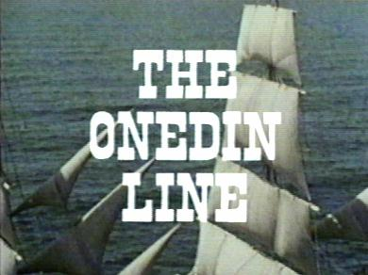
Figure 35. The opening titles evoke romance through lingering shots of a tall ship at sail and Khachaturian’s rich orchestration, which is replicated within the episodes as a ‘nautical panacea’ to assuage the turbulent narratives.

To take the episode No Smoke Without Fire (6:1) as an example of this style, the episode opens aboard ship as sailors busy themselves to the sounds of seagulls and a lone accordion player, whilst an old sailor shows a novice how to tie a sheepshank. The episode then goes below decks into James Onedin’s cabin as he discusses the business of gold bullion and South African mining. Once “business” is concluded, the action is back on deck again as the ship sets sail with the sound of a “heaving” sea shanty audible over a montage of shots of sailors at work in rigging, hauling ropes, and setting sails. The shanty is gradually faded in to the non-diegetic Spartacus refrain as wide shots of the ship at full sail conclude the sequence. The action then moves into the more functional and mundane offices of the Fraser Shipping Line and dockyard as the aspiring young businessman William Frazer (Marc Harrison) announces, “I want forty of the men laid off straight away.” The contrast between the two sequences is pronounced, with the romance of the sea and the life of a seaman truncated by the prosaic business of redundancies: the Machiavellian scheming of the land. These interstitial sequences are not just purely decorative, but fulfil an ideological function in emphasising these contrasts.
The episode continues in this vein as further sequences of the Machiavellian scheming of Victorian business are contrasted with nautical romance. A sequence dealing with Elizabeth Frazer’s strained business dealings is followed by a full ten-second sequence of a ship sailing and the Spartacus theme. It was clearly the view of the creators to establish this contrast and heighten it through the proper implementation of nautical verisimilitude. Here, male authorship is crucial. A BBC press release from the 1970s sums up the aims of the creator and “ex-sailor” Cyril Abraham:
In the Onedin Line, for which he has also written several scripts, he has drawn on his long study of maritime history to tell a story that combines the glamour of the square-rigged sailing ships of the 1860’s [sic] with action, adventure and a realistic view of the harshness of Victorian Life. (BBC Press Release, quoted in The Daily Telegraph, 1971).
This strategy is echoed by original producer and occasional director Peter Graham Scott, who served on the first three seasons. He indicated that each 50-minute episode “should give us about ten minutes action at sea.” Scott went to great lengths and expense to create the exterior shots, filming ships from helicopters, in all weather conditions and locations to create a “library” of shots to fulfil this function, believing that without this endeavour The Onedin Line would have “sunk unnoticed after one run” (Scott, 2000: 222). Like many of the writers and directors on the series, Scott had previous experience filming at sea, having worked on Sir Francis Drake, so he shared a collective vision of what the maritime could and should look like on television. It is unsurprising perhaps that the version of the maritime in The Onedin Line should have a masculine association.
This association is likewise dramatically emphasized in the themes, narrative, and characterization. James Onedin is a man made tough by the sea. It has engendered a rigid individuality that sets him at odds with everyone he comes into contact with: an English cowboy whose ranch is the sea and whose empire is not land and property but ships and cargo. Yet perhaps more than James, the most enduring and endearing character is Captain Baines (played by Howard Lang, an ex-naval gunner), Onedin’s faithful servant. Baines, more than any other character, represents the old sea salt, made tough by the sea but uncomfortable with the affairs of land. Unlike James, he has heart and humanity and represents what may be best described as a true English oak adrift at sea This, of course, has its roots in Britain’s literary heritage with sea texts like Robinson Crusoe (1719) and Treasure Island (1883) prescribed as “the energising myths of Empire”: boys-own stories to produce “men.”(See chapter 3:3 for a more detailed discussion of this). Episode 6:1 perfectly adumbrates the sensibility. In a discussion regarding the possible opening of a Panama Canal, Daniel Fogarty (Tom Adams) declares “and that will be the end of the sailing ship.” This is greeted with lamentation from Baines, for whom sailing round the horn is not only the mark of a true sailor and test of a man, but also a masculine rite of passage: “When that happens, no more real men. Just milk sops. Canal sailors.”

The same episode, as To The Ends Of The Earth, also features the ‘The Neptune Ceremony’. One of the unfortunates in this sequence is a young lad who is dunked in water and forcibly shaved, whilst Baines and Onedin look on smirking, recalling their own experiences of this degrading spectacle as a masculine initiation. The sea, ships, and sailing therefore create a nexus of masculinity, bearing comparison to Christine Geraghty’s description of real and symbolic space in 1950s maritime war films as a “masculine world operating in a clearly defined and separate ‘space’” (Geraghty, 2000: 176).
The sea, ships, and sailing, and their proximity to definitions of British masculine identity invite further comparisons with the American Western film, typified by a national mythology allied to strong and silent men made tough by the landscape. Here, the sea represents the masculine frontier: a place of both romance and danger, whose successful navigation is a masculine “rite-of–passage.” Both production and reception materials support this reading. Speaking of the show, Peter Graham Scott stated, “I like the sea, every Briton likes the sea—it’s one of those really root things with the people of these islands,” (Radio Times, 1973: 83) and Shawn Usher described “oceans for prairies and wind jammers replacing horses” (The Daily Mail, 1971). Similarly, reviewing the show, Sylvia Clayton described it as “one of the few adventures to use the sea as a kind of frontier background” adding “There are few sights more beautiful than the clipper in full sail” (The Daily Telegraph, 1971) Elsewhere, reviewers routinely praised the authenticity of the series and its nautical heritage, suggesting a continuity of national tradition which valorised ships, sailing and the sea.
There are further parallels between The Onedin Line and the Western, not least the time period involved (late nineteenth century), and the elegiac passing of one form of transportation to another. As the Radio Times suggests, ‘Like the Wild West Stagecoach fending off the coming off the railroad, ships of sail became locked in a desperate battle against those powered by steam’. Both genres tend to foreground the manner in which isolated, barren and potentially treacherous landscapes (or seascapes) highlight the line between civilised and savage.
The sailor, like the cowboy, exists on the periphery of society, literally and symbolically, hired hands spending labour time in lonely vistas, occasionally existing in society in docks or frontier towns and drinking and fighting in bars and saloons. The struggle of the sailor for basic living rights against the avaricious owners in Onedin, mirrors the Western trope of land and grazing rights of the cowboy and steersman pitted against ruthlessly capitalistic cattle barons. The onerous, hazardous and lonely voyages of merchant vessels have an affinity with the arduous cattle drive such as in Red River (1948), Open Range (2003) and even Brokeback Mountain (2005) in which different forms of masculinity are tested against the onerous nature of the trail and the harshness of the physical landscape. The frontier is ever shifting in this paradigm and its logic is for self-reliance and fortitude, against nature and against the elements. As Robert Onedin states in 6:2 “I had to pull myself up by the bootstraps”, echoing the American ideal of actualising ‘Manifest destiny’. Similarly, the ‘nautical panacea’, which blends sailing, seascape and dramatic music, echoes the panoramic sweep of the western landscape and a similar musical synthesis (for example, the Monument Valley of John Ford).
However, whilst The Onedin Line clearly both utilized and foregrounded romantic notions of British maritime identity and engaged with imperial masculine and other literary conceptions of the sea as being both in the blood and character of the archetypal British man, it still differed significantly from earlier projections of British maritime identity, offering a more complicated notion of British national identity than previously found in imperial and naval adventures. Perhaps the most striking feature of this is the manner in which the Royal Navy, so strongly associated with national pride and identity, is almost entirely absent in both thought and deed over the 91 episodes. There are three main characters that represent the navy during the series, and none can claim much respect or credit. James’s father- in- law Webster (James Hayter) is an old naval captain, and makes intermittent appearances until Series Three. He is a curmudgeon, ill tempered, and set in his ways. Episode 3:3 has Webster go head-to head with Captain Baines on a voyage regarding the correct protocol for sailing, the suggestion being that Merchant Navy Masters and Royal Naval Captains are from two different worlds. In Series Seven, Sarah Onedin (Mary Webster, the widow of James’s brother Robert) is romanced by an ex-naval Frigate Commander who “fought at Sebastopol,” but he turns out to purely be after her money and is sent packing by James. Perhaps the most odious advocate of naval imperialism appears in Episode 2:9 in the form of diplomat Sir Charles Gray (John Harvey), who tries to intervene with James and Albert Frazer doing business helping to provide ships for a Turkish fleet, calling it “treason.” He seeks to keep down every nation but Britain proclaiming “gold on our plates, dung on theirs.” It is James Onedin himself who perhaps illustrates the difference in attitude when he chides a young ship’s boy for incorrectly giving him a naval salute, which involves him standing back on his heels: “It’s not the navy— we don’t stand back to stand upwards.” The message is clear: the navy has its place, but the upward trajectory of Britain was consistently predicated on the merchant ships that carried goods back and forth all over the world and the men that sailed them were the ones that built Britain. Perhaps rightly observed by Carrel, Day and Topping in their book on British television, “Onedin was the original Thatcherite’ (1996: 365) in his ruthless, upwardly mobile ambition, adherence to free-market economics and disdain for Unionisation and social concern. In this way, the character of James Onedin, if not the series itself as a whole, pre-figures the ideology of a ‘meritocratic’ society that, during the 1970s, the Conservative party were fermenting in opposition, and which came into fruition after Margaret Thatcher gained power in 1979 (the next chapter, suggests that Howards’ Way is the natural continuance of this).
Although the sea is treated as a space of enterprise and fortitude, of sublimity and romance, it is also a space of danger and death, destruction and disaster. The Onedin Line does not shrink from showing the full horror of life for the common seaman and the relatives they left on land. At least two episodes concern themselves with the practice of “coffin ships” in which unscrupulous owners deliberately overload unseaworthy ships and send them out into hazardous waters where they founder and sink, taking their crew with them, in order to claim insurance. Sailors and immigrants suffer death and injury, have limbs mangled and amputated, catch dysentery, yellow fever, cholera, and sleeping sickness amongst numerous other diseases, and with highly flammable and explosive cargoes, danger and depredation is never far away. Episodes also deal with the establishment of missions and orphanages to help the lot of the sailor and his family. Another common theme is the practice of “crimping” or “shanghaiing” unsuspecting sailors or landsmen by getting them drunk or beating them and forcing them aboard ship as crew. The series did not shy away from depicting the atrocity of establishing capitalist spaces.
Yet despite this, the sea is still home to the merchant crews and their space of identification. In Episode 3:1, when Samuel Plimsoll himself declares that he is determined to help “that most miserable creature— the British seaman,” James responds by saying “I think you’ll find that seaman would prefer no other life.” The national maritime identity here, therefore, is not expressed as the actions or deeds of fighting men of the navy, bound to institution and nation or the arcane symbols of nationhood expressed by the defeat of the Armada or Trafalgar, but by the commonality of experience shared by men and their communal day- to- day lives. The “lure of the sea” is not just a symbolic myth or a passive adjunct of the “tourist gaze,” but a learned and tactile experience. The symbols of national identity migrate and morph in The Onedin Line from simple class bound projections of institutional and national servitude, to symbols less simple but no less potent, which foreground the tensions between sea and land. The landscape for which Higson (1995) describes as articulating a British national identity are not the bucolic landscapes of green fields and rolling pastures, but the endless, undulating ocean, and the liminal spaces of docks and shorelines in between.

A Nation Built on Slavery? Class, Economic and Gender servitude in The Onedin Line
Thematic juxtaposition in The Onedin Line has an effect just as striking as the visuals. The type of ‘Britishness’ or ‘Englishness’ projected in the series is powerfully bound up with the issue of power relations. An interesting construction and counter-construction of national identity is therefore offered from within the class structures of England and from without. In numerous episodes, negative stereotyping of English traits and attitudes by foreign characters is contrasted with expressions of patriotic fervour. In episode 3:6 for example when James describes a female as “most handsome”, he is chastened by Manuel Ortega (Edward Judd) “trust the English to use a masculine adjective to describe feminine beauty”, whilst in 8:3, he is told by his wife Margarita that “you live up to the English traditions- stiff-backed, formal”. Elsewhere, he is told that “you British, you see nothing but shillings and pence” and by the rebellious Brazilian Colonel Vega (John Moreno) “for years you people have exploited my country while the people starve”. Indeed, when patriotism is invoked, it is usually in an upper class, superior context- particularly by Robert and Sarah Onedin, the unashamed social climbers. However, despite the fact that patriotism is a distant second to capital enterprise in James’s world, his attitude to foreigners who stand in the way of his enterprise is loaded with negative epithets. The Irish come off particularly badly in this context, being described as “thieving bog dwellers” and on one occasion, James threatens to unleash an “Oliver Cromwell” style retribution on an Irish harbour master, showing that he will indulge in patriotic fervour if it suits his business ends.
Yet it is the struggle of the English working classes, particularly the sailors and all those related to mercantile industries that seem to suffer indignation and exploitation. In episode 4:9, captain Baines refuses to work for James any longer as he returns home from sea to discover that he has bought out the slum only to evict the residents in order to knock it down and turn it into warehouses. There is a Dickensian social juxtaposition of a poor family left out in the cold and snow whilst the Onedin family dine in luxury. Indeed, as E.L. Taplin points out, ‘Liverpool acquired the reputation of a town that was ugly, dirty, unhealthy and badly governed. Its slums and cellar dwellings were notorious’ (1974: 2). The attitude to the desperate is that of a benevolent veneer masking a tyrannical underbelly- as Sarah Onedin asserts, “The Labouring classes simply do not know where their best interests lie” (2:12). Assuming the role of director of the Fogarty Line, William Fogarty deliberately sends out his skipper Captain Olyphant, out in a heavy fog despite the latter’s protestations, which leads to a calamitous accident (6:2). Faced with a cross-examination at civil court, Olyphant commits suicide instead. The reasons were made clear in an earlier episode, whereby the barely literate Baines was forced to defend himself in a similar manner- the hostile Court was shown to be set up to protect owners’ interests and deliberately skew themselves in their favour at the mercy of the poor and uneducated. Taplin suggests that the ‘powerful shipping interest in parliament’ stubbornly resisted any changes in existing legislation and ‘generally protected the employers and owners rather than the worker (1974: 10).
Unionisation, in this context is also viewed as dangerous sedition which strikes at the heart of the power relations and is subsequently quashed with brutal efficiency. The subject is most notably tackled in episode 2:1 in which the attempts of a sailor, Jessop (Godfrey James), to form a Union (“with a union, no man stands alone”), are juxtaposed with the end of the American Civil War. As he stands on his soapbox at the dockside urging solidarity, a newspaper vendor announces the end of the Civil war and the cessation of slavery, and Jessop declares “the end of negro slavery and the whip, but let them look closer to home”. Jessop’s attempt to form a Union a curtailed after Daniel Fogarty hires strike- breakers to brutalise the incipient rising. Therefore, like the abolition of the slave trade by Wilberforce, the disenfranchised cause is necessarily fought only by the benevolence of those on the inside of the Establishment like Samuel Plimsoll or Onedin’s second wife (she establishes a home for orphans, much to his dismay), demonstrating Sarah Onedin’s adage that the disenfranchised themselves don’t know where their best interests lie.

The ‘Black’ Atlantic
Armstrong characterises the Atlantic slave trade as ‘bodies that disappear’ (2004) either through the dehumanisation of slavery or literally through brutality and death. In particular, the Atlantic slave routes were sights in which humans were seen as cargo ‘slaves were not persons but articles of trade (2004: 169). Similarly, the spectre of slavery haunts the town of Liverpool, dramatized here, as Pederson states, ‘more than half of all eighteenth century slavery voyages originated from Liverpool’ (2004: 192).
The issue of the slave trade is raised in a number of episodes, with slave traders characterised as venal and working outside the correct protocol of the British Empire. James boldly declares to an associate in episode 2:13 “My country’s law bears down heavy on those who traffic in slaves”. In reality, slavery and servitude cast a long shadow over the world that is created in the series. In Episode 1:14, James gets a commission to supply the Southern army in the American civil war. The episode opens with a black man in chains on Liverpool dock whilst an anti-slavery campaigner (white Englishman) is preaching on the docks, “he’s got one misfortune- he’s black” (later in the episode a character uses the term ‘creep like a nigger in a henhouse” to describe a nautical manoeuvre). Like the unionisation episode, this conflates the suffering of the American black slave with the starving Lancastrians, for whom the blockade of Southern ships is stopping cotton getting back to Britain and thus stifling industry. Whilst the power breakers- politicians and merchants- make decisions, it is those at the bottom of the socio-economic hierarchy that invariably suffer. James profits from it all though, and in a speech which perhaps pre-figures the ‘Thatcherite’ ethos of the singular valorisation of market forces a decade hence he declares “I’ve done it for money and money alone. The South is not my cause and nor is the North my cause. James Onedin is my cause” which pre-figures Thatcher herself who stated in an interview “there’s no such thing as society” (1998: 2). It also echoes James Bolam’s character, Jack Ford in the contemporary When the Boat Comes In (1976-1981). According to McNally, this character, like James Onedin, is closer to ‘Hollywood celebrations of urban determination and the American Dream’ (2007). She quotes producer James Mitchell as declaring,
He’s not interested in groups of people, marchers or counter-marchers…He’s interested in the achievements of the individual and the pursuit of the rich, full life (2007: 102-120, original reference, Radio Times, 1981).
Onedin also, albeit from an entirely different and top-down perspective, suggests something similar to how Paul Gilroy characterises the ‘in-between’ space of the Atlantic in the slave trade, ‘the unthinking assumption that cultures always flow into patterns congruent with the borders of essentially homogenous nation states’ (1993: 5). Capitalism tends to have its own logic outside the discrete borders of nationalism.
The discussion and depictions of the slave trade in Britain has often focused on a story of success and morality- the moralistic campaigning of Sir William Wilberforce and others in convincing parliament to abolish the practice by the Act of 1807, latterly showcased in the Wilberforce biopic Amazing Grace (2007). That Britain did so before its European and North American counterparts is portrayed as a triumph for British exceptionalism and sense of ‘fair play’. Subsequently, whenever a light is shone into this dim corner of British history, it has tended to be been illuminated with the spin of positivity- the harmonious singing of the hymn ‘Amazing Grace’ describing the moral ideology of the nation that outlawed the practice. This is reflected in James Onedin’s moral certainty, despite the fact that he tends to exploit those around him, using the laws of Britain for his own ends. Episode 3:10, Over the Horizon, is particularly representative of such colonial attitudes. The episode opens with stock footage of Africa- forests and rivers- accompanied by African music and singing, which then segues into footage filmed at Dartmouth Cove, yet representing the mouth of an African river. James and Baines take cargo of a rich Englishman, William Blanshard (Timothy Carlton), whose family has made its fortune in Africa. He brings aboard an exotic collection of paraphernalia for passage back to London, a monkey, African drums, a parrot and a large chest. Upon opening this, it contains an African woman, simply called ‘Alice’ (Vikki Richards) who he has smuggled out of her village. It transpires that she was originally married to a Yorkshireman who unsuccessfully attempted to grow cotton in the village. Blanshard takes the opinion that she is there to be used for sexual gratification, “Not that I mean to hog her all to myself. If you or Baines should get the urge…” He also does not envisage bringing her back to England, “ I can hardly take her to London- I don’t think she’s cut much of a figure in St. James. And I don’t think dear momma will take to her”. James is unimpressed with this interloper and associates her with the rest of the animal cargo bought aboard, “get rid of her”. He changes his mind when he spies a business opportunity and instructs Baines to take her with him on an exploratory trip up the river to ascertain the suitability of establishing a trading post. The colonial attitude to Africa is expressed in Blanshard’s view- why bother to spend money on transportation with “plenty of natives to carry it on their back. We’re sitting pretty aren’t we”? Another view is offered by Robert, “That’s the kind of place it is- somewhere you go into but don’t come out of”. This is almost the fate of Baines who contracts sleeping sickness on his journey upriver before realising that the plan is unworkable due to the river leading to a waterfall. It is Alice who nurses Baines back to health using traditional remedies. Alice therefore represents Africa in the colonial mind-set. Gratifyingly mute and pliant (much like the black sailor in I Remember Nelson, & 3:1), she is used for her resources and then abandoned (see also 3:1 & 3:2).
This episode is also notable for the manner in which it juxtaposes the exotic and colonial spaces of Africa with the spaces of England and centres of power. A tension is established between the two spaces in the way that they are sutured together, as a shot of Baines being rowed downriver fades into a shot of a carriage drawing up outside Elizabeth’s house. This colonial ellipsis suggests how the two places are connected yet so distant at the same time- the latter space made possible by the former but ignorant of its origin. A more poignant connection is made later as a scene of Alice singing aboard the steamship fades both aurally and visually into a scene of Liverpool docks with sailors singing a heaving shanty, indicating an affinity between two exploited demographies.

Gender
The historical manner in which the sea and ships have been personified as feminine is instructive of the logic of patriarchy. Traditional orthodoxy has designated the sea as feminine in western culture, as it is irrational and unpredictable in nature compared to the land. The same is true of ships. In The Onedin Line and as a cultural norm, ships are given female names and referred to in the feminine pronoun (the Charlotte Rhodes, for example). Ships are in many ways perfectly symbolic of the manner in which women are viewed in patriarchal terms. They are silent and passive vessels; beatified, fetishized and functional, with a clearly defined purpose. Yet they only work at the dedicated hand of man, and can be vilified for bad behaviour or idolised for their transcendent functionality.
The ways the series juxtaposed different elements, like the adventure of sailing and land-based mercantile activities, powerfully emphasized gender tensions at the heart of nineteenth century Britain. The show’s use and arrangement of space exemplified this, with Liverpool docks representing the liminal boundary between the freedom and adventure of the seas on the one hand, and the restrictions of society, business, and familial relations on land on the other. At the same time as the visual beauty and nautical panacea of sailing ships and the sea gave dramatic visual splendour to the maritime sequences, the land sequences functioned with an equal verisimilitude, and the female costumes in particular provided their own decorative splendour. This clearly allowed producers to appeal to multiple audiences. Put in simple binary terms, these were an intended male audience craving action and adventure and a female audience more interested in drawing rooms, costumes, and domestic drama.
The female characters in The Onedin Line also tended to straddle different boundaries. Whilst the sea sequences were dominated by males, women tended to dominate the other spaces, and James’s first wife Anne and his sister Elizabeth were highly visible and highly vocal presences both on ships and in dockyards and business spaces, troubling the gendered boundaries of these masculine spaces. The odds were skewed in favour of male authorship with only one episode penned by a female writer and one directed by a female (Elaine Morgan wrote Episode 2:3, A Woman Alone and Moira Armstrong directed 1:3, Other Points of the Compass), but the emphasis on active rather than passive females dominated the series. By connecting boundaries between the costume drama and the sea adventure, The Onedin Line conflated two versions of history: the “sanctioned version of the past” with what Alison Light (1991: 5) describes as, “that other history, a history from inside […]” Light elaborates that this version of history privileges the place of private life in the national context, entwining the public and personal in the national story. This dual nature of history is powerfully emphasised in A Woman Alone. In this episode, Anne leaves her husband on a matter of principle and is forced to endure two hardships- that of being poor and that of being a woman. She seeks shelter in a home for destitute women but is robbed of her meagre savings. She is then taken in by the wife of a business associate who informs her that “my England is different to yours” suggesting that there is still a hierarchy within the disenfranchised, and competing versions of what it means to be English or British according to class, gender, race and economics. The issue of women as slaves or chattel is a consistent theme throughout the series. Anne’s own father challenges her in 2:5, “When will you realise a woman can’t stand on her own feet in the world. You need a man”, whilst Elizabeth responds to Daniel when he informs her they are to have lots of children, “don’t look upon me as chattel that you can do with me as you please” (2:9). This is echoed by Caroline who suggests in 4:4 that, “In my view, the wedding ring is a licence for all sorts of brutality”. This echoes Said’s description of the slave trade functioning as a ‘subtext’ in nineteenth century British Literature (189). In the same way, slavery is treated as a sub-text in The Onedin Line.

The critical reception of Onedin is similarly instructive of gender relations in the 1970s context. Any hint of female empowerment in the series was held under scrutiny in the press. Peter McKay, concluded of the final series:
Since this salt-caked series first put to sea in October 1971 we have had equal rights legislation, and this now seems to be reflected in the story lines, despite the fact that they are all set in the last century (The Evening Standard, 1979)
McKay added that Jessica Benton, who plays Elizabeth Fogarty/Onedin, “has become the small screen’s answer to Vanessa Redgrave” and that “men dutifully cringe before the women, who run things both on sea and on land.” McKay also complained that the series was becoming “A whining wife on the ocean wave” with the male writers inventing “trendy Women’s Lib lines.” (The Evening Standard, 1979) He especially lamented that Jessica Benton, who “at the start of the series would have been the dream hammock partner of many a mariner,” has “turned into a glaring egomaniacal monster who makes Captain Baines look like a nancy boy.” An earlier interview with Ann Stallybrass (who played James’s assertive wife in the first two seasons) appeared to vindicate McKay’s concerns. An article, which appeared in The Sun, attempted to explain the early appeal of the series, concluding that “a ringside seat at the battle of the sexes” (1972) was a main consideration. It then quoted Stallybrass as saying:
“I was discussing it with Jessica Benton, who plays Onedin’s sister […] we’re both very anti- Women’s Lib. But in those days, women really needed protection. If a woman walked out on her husband society turned its back on her.” (The Sun, 1972)
Shaun Usher’s review in the Daily Mail (1972) contained a further interesting and gender- related link with the Western. He wrote:
American television, with a few exceptions, has emasculated the Western making cowboys sound like marriage guidance counsellors in some unusually arid garden suburb (Usher, 1972).
Interestingly, Usher views the televisual medium as domesticated and ‘feminine’ in relation to the, presumably, masculine widescreen vistas of the cinema (see chapter 2:2 for further discussion on this), and praises The Onedin Line for carrying on a more strident masculine tradition of adventure.
So if The Onedin Line did fall short of successfully “feminizing” British history, it did set out with clarity the terms of the imbalance. Such concerns further demonstrate the complicated form of national identity articulated in the series: that which challenged previous articulations of national identity surrounding the maritime sphere as hegemonic and almost unanimously masculine.
Elsewhere, reviewers were generally drawn to the attractiveness of the period setting, costumes and performances. It was nostalgia itself, and the widespread appeal of it, which remained a key issue both in discourses around Onedin and other period television of the time but also in a larger sense within British culture. Turner describes a large cultural shift away from the cultural innovation and avant-gardism of the 1960s in Britain by the mid-1970s, particularly within popular music,

Much of this yearning for yesterday reached back to a long-lost and semi-mythological society of harmony, deference and stability, to a time long before the war to end all wars ended all prospects of peace (2008: 152)

This was also felt by Onedin producer Peter Graham Scott, who writes of the era, ‘drama began to look backward to the Victorian era and the Second World War’ (2000: 208). Producer Gerard Glaister (see 2:2 & 2:3), who produced the World War II set Colditz (1972-4), Secret Army (1977-9) and Kessler (1981) went further, suggesting yet another location for Britain’s mythological frontier, stating ‘World War II has turned from history to myth, it is our last frontier, the English version of the western’ (2008: 153). This echoes Durgnat’s theory of the war film as the European western (2011). Yet Onedin reviewers were less concerned with World War II than they were with ‘Victoriana’ or ‘Edwardiana’. The Sunday Telegraph also began its review of Onedin in the year it launched by stating, ‘Victoriana continues to proliferate. At least I prefer it to the Tudorama that preceded it’ (Sunday Telegraph, 1971). In a review of The Edwardians a year later, Chris Dunkley wrote,

A series of one-off dramas about eminent Edwardians would seem a sure fire thing at the moment, with television pouring out a veritable cataract of programmes set in the Victorian and Edwardian eras. From the hazards of merchant shipping in The Onedin Line, through the domestic foibles of the gentry and their retainers in Upstairs, Downstairs and the adventures of the Army in The Regiment (returning soon) and The Boer War to the more mundane pleasures of the music hall, the entire genre is having a quite remarkable success; in terms of audience ratings anyway (The Times, 1972).

Writing in the Financial Times, T.C. Worsely also seemed concerned that period drama was too pervasive, and was dismissive of Onedin, ‘what we got on Friday was the most creaking and old-fashioned of romantic melodrama carried forward on a plot of positively strip-cartoon simplicity’ (Worsely 1971). To underline his point, Worsely also expresses reservations over Upstairs, Downstairs and juxtaposes critique of the two period shows with relative praise for the recent episodes of ITV’s Armchair Theatre (‘all is not lost’). This is combined with praise for BBC2’s recent adaptation of Aldous Huxley’s Eyeless in Gaza which, according to Worsely ‘is not just an excuse for a nostalgic wallow’.

Audience ratings were clearly not a definitive sign of quality for critics, who continually expressed anxiety about nostalgia and re-living the past. As the series continued to be popular, the reviews increasingly denigrated the supposed formulaic nature of the show, despite the fact it evolved over time. This was also noted by Quentin Crewe three years later in a television opinion piece entitled ‘looking for a miracle’ about the saturation of particular subjects, primarily that year’s general election, on television viewers, who observed that ‘the interesting thing about the regular programmes which get high ratings is that they are nearly all immensely old-fashioned’ and goes on to list The Onedin Line as an example of this (The Times, 1974). This is significant as it demonstrates a number of things. Firstly, that producers and audiences have different expectations of televisual drama than critics. Secondly, that popularity seems to breed contempt for ‘cultural gatekeepers’. Lastly, it creates a schism within Seaton’s observation that ‘Britain explores itself through its history’. As the critical reception for Onedin demonstrates, there is a barely definable difference for many critics between viewing culture as both entertainment and as a conduit for using history as a way to comment on the present or for it to function as a staid vessel in which to ‘wallow’ in former glories, romanticism and nostalgia which obfuscate the realities of the present. Aligned to this, for other critics, is a disdain for the manner in which, particularly contemporary gender politics, is expressed through historical depictions.

Conclusion
The Onedin Line therefore marks an important watershed for the projection of maritime and national identity on British television. It tapped into British visual and maritime heritage and how the concept of an island nation and maritime landscapes created a form of collective identity in Britain. The sea is an important site for identity formation, but as The Onedin Line suggests, it is not uniform and fully prescribed. It is a site of danger and hard work as well as romance and adventure. Collective identity is framed not through conformity to secure military and institutional symbols of dominance, but through hard labour and experience. The sea is projected very much as a masculine frontier, but is complicated by the occasional transgression of gender boundaries and the vicissitudes of business and commerce, building a more complex notion of collective and national identity. Slavery and servitude and the in-balance of power structures suggest an alternative national narrative that is indicative of similar structural iniquities in contemporary Britain.
These spatial de-liminations and gender boundaries are challenged further in Howard’s Way, which also took the notion of capitalising the sea and landscape even further.

2:1 Howard’s Way: Class, Gender and the Maritime on British screens
Introduction
If The Onedin Line demonstrated that there was more to nineteenth century British pre-eminence than martial success, and that the real maritime impetus behind British prosperity was the global networks of trade, then a contemporary series in the eighties suggested that times had changed irrevocably in the maritime sphere. As naval dockyards closed, Shipbuilding continued its decline and docks continued to lay off staff and move to new deep-water ports in favour of mechanised container ships and the economy continued to shift from manufacturing to leisure and service industries, the maritime leisure industry experienced the opposite, growing exponentially in the 80s to satisfy the increasing demand for high-end leisure vessels for a newly emerging affluent- aspirant economic class.

This chapter will argue that by utilising leisure and commerce as its themes and the maritime as its backdrop, Howards’ Way projects a specific form of British national identity that both references the past as well as presenting a very radical conception of the present. Specifically, by monetising physical landscapes and by virtue of its position as publicly funded culture (BBC), the ‘public’ and the ‘cultural’ are made ‘meaningful’ entirely in terms of the ‘economic’ (Thornham and Purvis: 32) in the narrative form of Howard’s Way. This chapter will consider the provenance of the show and its production in its 1980s British context, focusing on its representation of class, gender, economics, national identity and the treatment of physical and theoretical space to suggest how Howards’ Way was in many ways a meaningful expression of 1980s Britain. The alacrity with Margaret Thatcher’s tenure is underlined by the fact that the last episode was broadcast on 25th November 1990, two days after Margaret Thatcher resigned as Prime Minister of Great Britain.

Howards’ Way and the 1980s

Howards’ Way focused on the rich and the nouveau riche of the fictional Hampshire town of Tarrant (filmed in the real town of Burlesdon) and was produced by the BBC with a substantial budget (The BBC Cult TV website, 2009, cites the original budget was £1million whilst Glaister & Evans quote average filming as costing £5000 a day, 1988: 14). It was highly successful, and according to claims on the BBC website it is the only drama series to achieve viewing figures of over ten million for all six of its series, and became a regular fixture on Sunday evenings on BBC1 for five years (BBC Hampshire, 2009). Originally planned as a thirteen part series, it ran for six series and seventy-eight episodes in total and was eventually cancelled after the premature death of one of the main stars Maurice Colbourne (who played Tom Howard). Howard’s Way was originally conceived along two different but converging lines. Firstly, it was intended to be a BBC equivalent of the American series’ Dallas and Dynasty, in which the lives of the rich were presented against lavish and exotic backdrops, and the glamorous clothes and glossy decor could act as a primary appeal. This was referenced in the casting of Kate O’ Mara in the last two seasons, following her time on Dynasty. But, secondly Howards’ Way was conceived as a show about yachting and sailing, originally intended to be called The Boat Builders (Glaister & Evans, 1988: 14).

The show was the creation of veteran producer Gerard Glaister (although in his biography, director Michael E. Briant claims that it was he who proposed the idea to Glaister around five years previous, 2012: 146). Glaister’s The Brothers provided a template for Howards’ Way, with the drama centred on a lorry haulage business in the same way that the latter series was to revolve around a boatyard. The difference was that The Brothers had been produced in the austerity of the early 1970s which saw industrial unrest and economic downturn. In that era, yachting and sailing were associated somewhat with older men like Sir Francis Chichester and Conservative Prime Minister Edward Heath who led the country from 1970-74. By the mid-1980s there was an economic upturn and the yacht and the leisure industry were encountering a boom time. The yacht, in particular, had begun to represent the glamour of conspicuous consumption, exemplified by the music video accompanying ‘new romantic’ group Duran Duran’s hit record ‘Rio’. As historian Alwyn Turner describes:

Part of the new Britain that was being built was a desire to take centre-stage in the sporting world, reflecting the growing financial muscle of what was known as the leisure industry, (2010: 244).

Tellingly, Turner also points out that ‘by 1986, it was estimated that there were as many people employed making pleasure-boats in the south as there were building ships in the yards of the north’ (2010: 132), tying in the growth of yachting to the demise of the traditional heavy industry heartlands of Northern Britain. At the same time, sites previously used for commercial manufacture and upkeep were turned into marina’s and themes parks alongside the closure of naval dockyards at Chatham and Plymouth.

From its outset, Howard’s Way dealt with questions of industrial change and the adoption of new business methods. Recently unemployed aircraft designer, Tom Howard (Maurice Colbourne), takes the plunge and invests his redundancy money in the Mermaid Boat Yard, run by Jack Rolfe (Glyn Owen), to become “his own boss” and design world-leading boats. As Bradley describes of this era:

‘The moral crusade against the permissive, anti-capitalist ethos of the ‘social democratic consensus’ was to replace unproductive artistic and intellectual thought with a new enterprise culture, stressing the entrepreneur and the self-made man’ (1998: 6).

Tom’s ambition to become a ‘self-made’ man compares favourably with the same desire exhibited in Ken Masters (StephenYardley). Ken is the key ‘working-class’ character and intermittent villain: an economic aspirant whose devious business dealings astounds and disgusts those around him (“sincerity tends to make me a little bit tongue tied”, Series 1:11). Although frequently stymied by the ‘old boy’s network’, he makes it his mission to break into these upper echelons. Masters’ constant concern over the course of the series is to beat them and he often expresses awareness that he is not the right sort of money, talking of an “absence of the old school tie” and describes fellow businessman and fellow ‘villain’ Charles Frere (Tony Anholt) and his associates as “old money, joining ranks and protecting members of the club” (4:9). He decides that the best way of doing this is by involving himself in the leisure industry, declaring, “apart from psychiatry, leisure is the boom industry of the 80s” (4:7). He perhaps best exemplifies the ‘self-made’ or ‘yuppie’ aesthetic of the 1980s, treating everything and everybody as an opportunity to exploit for personal profit and advancement. Like the other main characters in the series, he displays the conspicuous trappings of wealth, or the iconography of aspiration. Helicopters, yachts, speedboats and Jaguar cars are the vehicles of choice whilst ski resorts, fashion boutiques, racing stables, country mansions and yacht clubs are the man-made (literally) spaces of display. Again, this indicates a definite and deliberate choice on the part of the producers. As Ray Evans describes of the show, ‘Design is vital in a drama whose characters are conscious of taste…the glossy image of the new affluence and its visual and entertainment values’ (1987: 17).

Yet at the same time, Howards’ Way makes clear who really owns the money and power in Britain, and who safeguards the means of attaining it. Sir Edward Frere, portrayed by Nigel Davenport, and his estranged son Charles Frere (Tony Anholt) represent the ‘old money’, whilst Charles, his lawyer Gerald Urquhart (Ivor Danvers) and his wife Polly (Patricia Shakesby) are all acquainted from their “Cambridge days”. Between them, they use Ken Masters as a pawn in their manoeuvres against each other, and continually frustrate Ken’s attempts to penetrate their upper circle. They dominate any decisions made by the other character by obstruction and manipulation, embodying the power structures of ‘old money’.

Howard’s Way was also characterised by the tension between a definite masculine hierarchy being increasingly questioned and challenged by the businesswomen in the show. Sir Edward Frere casts a long shadow over everything, even after he dies in series six, and one of the most important story arcs across the entire six series, is a custody battle between himself, an American counterpart Robert Hudson (Bruce Boa) and virtually every main character in the show, over which line of succession their respective grandson will follow. The antiquated notion of siring a male heir to carry on the dynasty is very much in evidence here. The image of the two on horseback, in front of the stately home conjures images of representations of land-owning gentry in visual culture.
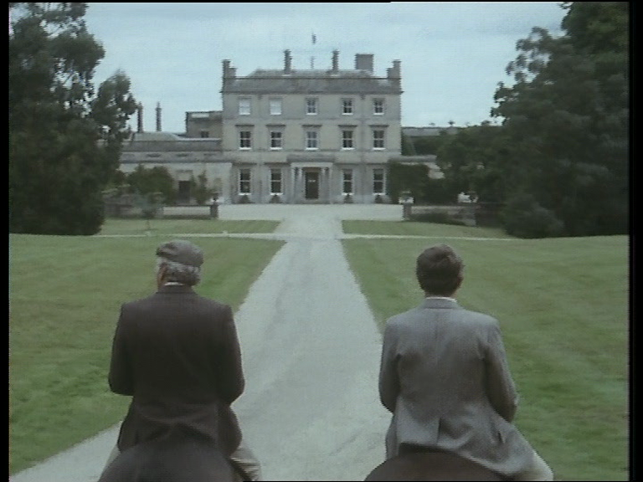
Figure 36. Edward and Robert in tweed and on horseback, outside the stately home, episode 4:11.

The appearance of ‘working-class’ characters in Howard’s Way is a rarity. Ken claims to be of humble stock but also takes pride in displaying the distance he has achieved from it. The only other significant ‘working-class’ character is Bill Sayers (Robert Vahey) the old boat builder, who is a minor character throughout the series. The working classes are rarely seen or heard and the rest of the show concerns itself with the superficial gloss of appearance. The working- class are not seen enjoying leisure time or its rewards. The ideology the show appears to perpetuate is that leisure can be purchased, and therefore not the product and reward of hard labour quite apart from The Onedin Line which balanced the lives of the rich and aspirant with depictions of poverty and industry. There is a brief suggestion of unionisation in the first season as the Mermaid workers declare “we down tools at 12.30” (1:4) but this storyline soon evaporates and despite a lone speech by Bill in episode 5:13 about the community in Tarrant- “the church, the pub-people living and working together”, the show focuses on ruthless individualism, often at the expense of close friends, lovers and family members. As Gerard Glaister states: “Everything has been selected to look good…The cast are all very easy on the eye” (1987: 121). It was also the intention to ‘replace the familiar locations of kitchen, back garden, corner-shop and public bar’ (1987: 10). This is particularly significant, as these are key locations in the depiction of working-class lives, particularly in soaps, as they tend to mirror the spaces inhabited by the working classes in actuality. As Such, Howards’ Way also presented itself at the opposite end of the spectrum to the BBC soap opera Eastenders, which was also launched in 1985. It is interesting, therefore, that it is often claimed that Howards’ Way morphed from a ‘drama’ into a ‘soap’ (see for example Edge, 2010). There were similarities in the format. Geraghty (2005) and others have traditionally associated certain features to the soap form, including an open-ended narrative form or ‘unwritten future’ (Geraghty, 1981: 12), ‘cliff-hanger’ endings, a regular broadcast slot which encourages habitual viewing and a large appeal to female audiences. Howards’ Way shared all of these but at the same time provided the antithesis of the ‘teacherly text’ (as Buckingham describes Eastenders, 1981: 19) and the assertion that,

…soaps have the function of representing groups or figures who tend to be under-represented in other dramas, characters whose political attitudes, ethnicity, sexuality or age makes them different from the standard hero, (Geraghty, 2005: 20).

As we shall see, there is mention of more transgressive or less accepted lifestyles, and storylines which incorporate broader social concerns, but as a general rule, they are rare or serve to function as a temporary impediment to the overarching narrative of economic progress.

Notwithstanding, old money or new, the characters in Howards’ Way are constantly over-stretching themselves financially, borrowing heavily from banks and corporations and are constantly on the precipice of financial disaster, indirectly echoing the late 80s housing bubble that eventually led to early 90s recession in Britain. Indeed, property acquisition is a central theme. Similarly, several of the characters are tried for fraud and insider trading, whilst venture capitalism, hostile take-overs, Swiss bank accounts, oil and the practice of ‘warehousing’ all form the basis of prominent storylines. Another key storyline is the attempt by Ken, Edward and Charles to build a luxury marina on land allotted as a nature reserve. The re-development of docklands areas as luxury marina districts was a particular cultural strand of 1980s Britain. As Charles Frere declares, “They’ll be intense pressure to leave things as they are”, to which Viscount Cunningham (Richard Wilson) laments “That’s one of our faults as a nation” (2:3).

In an extra-textual parallel, The Guardian reported in 1989 that the Marina Development Group, who operated on the River Hamble, ‘the background for the Howards’ Way sailing soap opera’ was being investigated by the Office of Fair Trading following a ‘flurry of complaints’ regarding 25% rent rises (The Guardian, 1989). Such is the synchronicity between the show’s aims and events in 1980s Britain that a slightly incestuous relationship between fiction and reality occurs. In the official accompanying book about the series, Producer Ray Evans proudly talks about the show in terms of numbers and profits. In particular, he describes the positive effect that the show has had on the leisure industry, stating that it ‘has undoubtedly stimulated interest in the small boats among the public’, and also that ‘Howards’ Way mirrors what already exists, and has also indirectly encouraged its expansion’ (1987: 23). He also mentions the exclusive design for a ‘spring’, a smaller yacht that was developed alongside the show and that, ‘Personal appearances by Howards’ Way stars at boat shows haven’t done any harm either’ (1987: 156). Between September 1987 and March 1988, 150 springs were sold.’ adding that, “Of course, the BBC is not financially involved, but its weight convinced others of the viability of the design” (1987: 156). This is validated by the designer Tony Castro who states that “there is no doubt in my mind that the series has had a good effect on the entire British marine industry”. The Times reported in January 1987 that the London International Boat Show ‘smashed all attendance records’ at the weekend, stating:

The figures undoubtedly reflect the increasing popularity of the sport, spurred on by media coverage of the Americas’ Cup and the continuing success of BBC television’s popular soap, Howards’ Way (Vercoe, 1987).

The same newspaper reported in June that year that Castro’s Barracuda from the show has received orders for eleven for the firm who manufacture it, Sadler Yachts, at ‘pounds 75,000 plus VAT’ (Gee-Smith, 1987) and on October 15th that the same vessel won The Channel Handicap Division of the yachting championship (Pickthall, 1987). So the show, produced by the publically funded Institution of the BBC and its specific limitations of sponsorship, became intrinsically integrated into the economy of the South of England.

This incestuous fiscal entanglement only exacerbated as the series continued and grew in popularity. A minor scandal arose when the BBC received a financial incentive to film the final series in Bermuda. As the Evening Standard Reported:

The BBC has accepted thousands of pounds of hospitality from the Bermuda Tourist Board as an inducement to film the final episodes of Howards’ Way on the island, it was disclosed today (Evening Standard, 1990).

The BBC defended their position by stating that the BBC guidelines instruct producers to: “Avoid giving publicity to individual persons, products, firms or organisations except insofar as it is necessary in providing effective and informative programmes” (1990). As can be seen above, the BBC tended to push the boundaries of this resolve with regards to Howards’ Way.

“We live in a Commercial World Ken, Everything is for sale”: Howards’ Way and the Spaces of Capitalism

Jean Seaton suggests that ‘British ‘exceptionalism’ has been defined and reinforced by a unique media institution which has played a role in metabolising the nation’s sense of itself…the BBC’ (2009: 78). Similarly, Jeanette Steemers suggests that the BBC retains a tradition of representing Britain:

In Britain the concept of nation and national identity was linked to public service broadcasting from the beginning, and the BBC, as the premier public broadcaster, has always underlined its cultural contribution to the nation (2004: 15).

The cultural residues of the age on screen in Howards’ Way are tied up to business and leisure, with one informing the other: leisure is a product of business acumen and the acquisition of wealth. Concomitantly, the ‘spaces’ of leisure, particularly seascapes and shorelines are also almost entirely shown as being populated by those with the wealth necessary to inhabit them. This is underlined by the treatment of space and landscape in the series, as illustrated in episode 4:6 in which Avril Rolfe declares “I claim this beach in the name of Frere Holdings”. In this way, leisure is bracketed as the exclusive preserve of the wealthy, and by extension the spaces that allow it. Thus the BBC in this instance, was in danger of substituting culture for commerce, yet this seemed to reflect the ‘meaningful expression’ of the culture of the time.

In his book Social Justice and the City (1973) David Harvey reflects that if urban processes under capitalism are to be understood, then an examination of the nature and use of spaces is necessary (120). He proposes a tripartite understanding of space that includes absolute space, relative space and relational space. Absolute space includes all those spaces we can touch and feel, relative space is slightly less corporeal but incorporates ‘flows of energy’, topology and geometry, speed, distance and motion (which also rely on temporal structure) and relational space which can include sounds, odours and sensations which are then related to a space, as evinced by such seemingly intangible concepts as surrealism and existentialism. Harvey’s ideas can be usefully applied to the different uses and representations of space in Howards’ Way. As broadcast television, divisions of labour and space decree that filming takes place in certain internal locations (Pebble Mill studios) and external locations (Hampshire, Malta, Gibraltar etc.). The specific arrangement and juxtapositions of these recorded images fulfil an aesthetic and industrial logic (narrative reason, verisimilitude, visual style and budgetary concern). As Fiske and Hartley attest, ‘television is a human construct, and the job that it does is the result of human choice, cultural decisions and social pressure’ (2003: 5). Producer Glaister points out, specific decisions were made regarding the use of wide- angle shots of the landscape (1988: 14). Whereas these are often used for aesthetic beauty and display in their own right, this idea was deliberately rejected in favour of a more static and contained camera. This is explained as the choice of Glaister in establishing his own ‘house style and keeping the style aligned to the central family:

‘The Style extends to the way the programme is shot, and no pandering to scenic backgrounds- when they are they are integrated. Shots are kept tight and angles interesting’ (1988: 14).

The idea of containment and reduction is thus evidenced by these stylistic choices, aligned to the domestic and familial.

The next important spaces to consider are the spaces of exhibition (or ‘display’ as Fish, 2007: 3, posits), the homes and individual rooms in which the show was watched on television: the domestic sphere (often still dominated by the lounge or living room in this era). Here the idea of containment takes on a gendered connotation, as this sphere is often considered as a feminine realm due to its relationship with traditional hetero-normative conceptions of the roles of housewife and mother. John Caughie has described the cinematic sphere as being characterised as a masculine desire for escape whilst television by contrast is ‘maternal- providing, nourishing, invisibly mediating’ (in Thornham & Purvis, 2005:23). Similarly, Jane Feuer talks of television as a medium of ‘containment’ which ‘constructs spectators as domestic, familial subjects’ (in Thornham & Purvis, 2005:9). Clearly, this is a negative conception of the medium, related to out-dated or chauvinistic concepts and conditioning which will be returned to later.

Perhaps the most important construction of spaces with regards to this analysis is the juxtaposition of sound and image in the text itself. It is here that intended and unconscious meaning is presented in relation to the narrative and the aims of the show, much like the dramatic juxtapositions of sea and land in The Onedin Line and the naval texts discussed in section one. It is important to acknowledge that in this regard, what is excluded is as important a consideration as what is included. It is worth considering that this would be prescribed as ‘relational space’ in Harvey’s schema, with the actions taken in absolute space only making sense in relational terms (136) removed further by the process of filming and the mechanics of editing, broadcasting and reception: ‘Symbolic space generates distinctive meanings through readings and interpretations’.

Space and Power Relations

It is not to strain the imaginative powers to link the display of wealth, space and landscape in this specific form of national visual culture to certain cultural antecedents. In particular, the painting Mr and Mrs Andrews (1750) by the English landscape artist Thomas Gainsborough evokes issues of landscape and ownership. This famous painting is often cited in debates surrounding the demarcation of public and private land. John Berger, citing Panofsky’s ‘layers of meaning’ suggests that the ‘They are not a couple in nature as Rousseau imagined nature’, but simply landowners, and therefore ‘landscape art served to naturalise, and hence to mystify property relations’ (1988: 5). In a similar way, the characters in Howard’s Way are arranged and presented primarily as land and property owners- their relationship to the environment predicated on a class and economic pretext, and the construction of televisual drama the process of both naturalising (by projecting within the cultural sphere) and mystifying (through the process of aspirational distancing) this relationship. Raymond Williams similarly claims that the ‘whole pastoral tradition in English literature has class connotations’ (2006: 22), whilst Burden and Kohl suggest that a ‘capitalist trinity [is] established in space…endowed with exchange value and is a commodity and a resource’. Burden and Kohl elaborate, ‘A Place (the English countryside) is a spatial practice (as landscape, scenery, farm, theme park) encoded with aesthetic, cultural relations- including those of class and power’ (2002: 18). This is expressed particularly in Howards’ Way in the manner in which it imbues the spaces of the sea and the maritime with the same ideologically. The countryside has a specific association with national identity (‘the dominant mobilising myth of the British people’, Higson, 1995: 274) with green pastures, hedgerows and rolling fields insinuating themselves into the cultural life of the nation. However, the sea and maritime spaces also perform a similar function as part of the physical and imaginative landscape of national mythology. As has been discussed, the sea was the site at which the prosperity and the Imperialist ascendency of the British and the British Empire was established by the mercantile expansion of the British Merchant Navy and the martial endeavours of the Royal Navy. Yet another layer of associative meaning is added to the text in the way it presents the sea and liminal spaces as romanticised, fetishized and exoticised. Here, the relational and juxtapositional configuration of the visual and aural elements, hint at a provenance of British maritime history and national relationship with the sea, but by association, render it a space only accessible or occupied by the moneyed or aspirational classes.

The opening titles of Howards’ Way acts as signifier of the show’s intended meanings and link it back to the national maritime conception. Romance is established through the use of sound and image, with the sea and sailing at the centre of this visual display. It begins with close-up shots of ropes, ties and sails as the music’s gentle staccato pulse establishes an anticipatory and relaxed forward momentum. We then see the prow of a ship, in sun-dappled water (nautical visual language, or synecdoche for linear progress or for literal or metaphorical journeys) which makes way for the show’s title, displayed over flowing and sun-dappled seas.
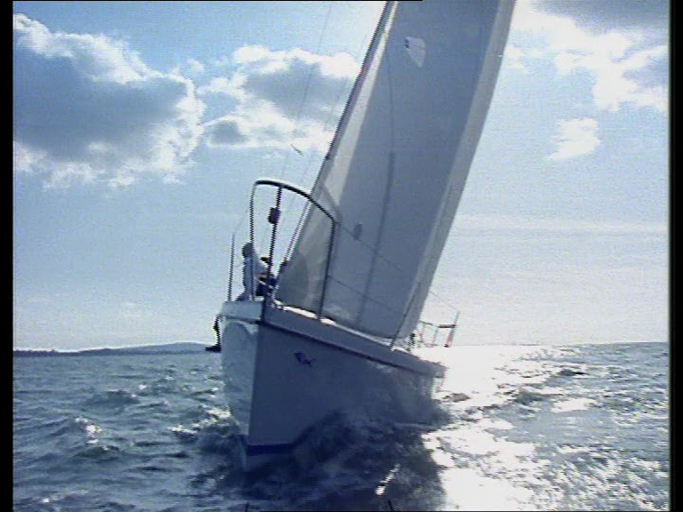
Figure 37. The opening titles convey onward progress as romantic nautical metaphor, compare with figure 35 from The Onedin Line’s opening titles.

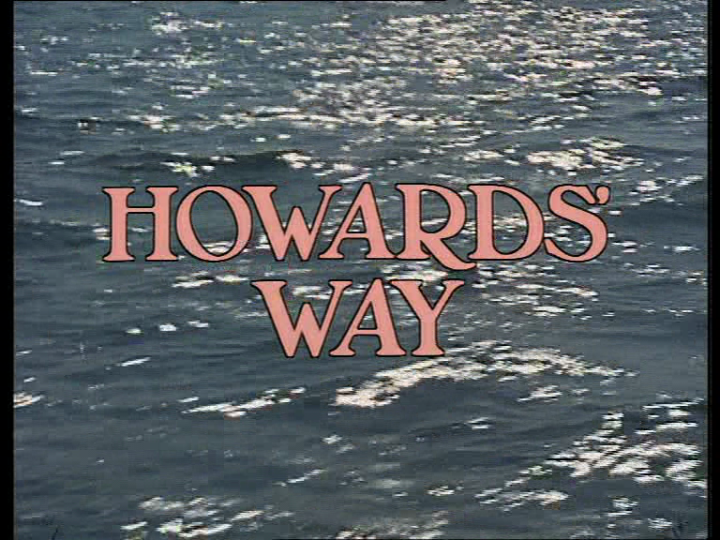
Figure 38. The show’s title glows ebulliently over sun-caressed waters.

A classical guitar riff is introduced after forty- five seconds as a sailor is silhouetted against the sun, followed by a yacht in full sail in the same perspective, evoking yet more romance between sailing and the sea. After one minute, the chorus bursts forth with increased orchestration as the forward momentum of the sailing images increases: a sequence depicting the perspective of a yacht, tilted towards the sky as it glides forward majestically is followed by a shot of the masts and sails seen upright from a low perspective (again, in nautical visual language, this depicts either the grandeur or majesty of sailing, or the dizzying and foreboding aspects of a sea voyage).
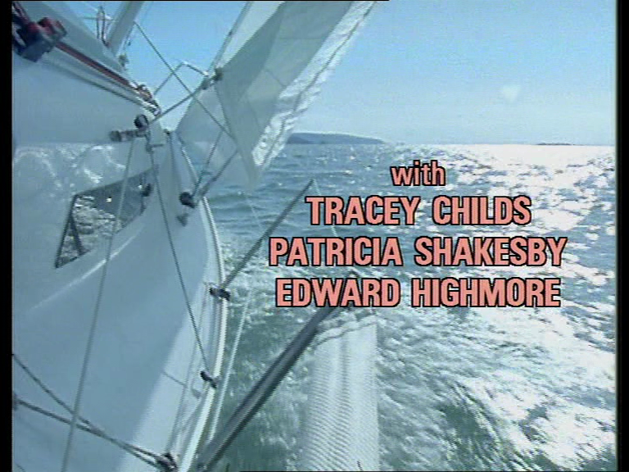Figure 39. The viewer is placed in the action as the yacht sails inexorably forward.
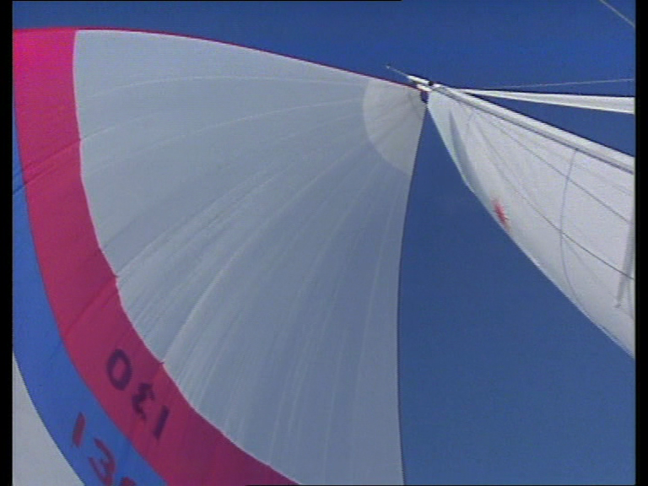
Figure 40. Low to high angle of mast denotes grandeur.

Finally, the music adopts a more plaintive tone as the yacht is seen sailing off into the sunset.

Sailing and the sea are linked to romance and adventure; relaxation, exoticism, and beauty. The ship and the sea are therefore fetishized- a landscape and a leisure activity conflated into one romantic package. This occurs throughout the series, and is not confined to the credits, but used throughout episodes to decoratively augment the passage of time or to bookend the opening and closing of the narrative. It is also employed to provide the same ‘nautical panacea’ evidenced particularly in The Onedin Line or Warship. For example, in episode 1:2, following two domestic scenes in which Jan Howard (Jan Harvey) discusses domestic duty with her daughter (“bang went all my ambitions”) and one in which Tom confronts Jan about investing all his redundancy money on the Mermaid Boatyard, a sense of calm is restored with scenes aboard Tom’s yacht. Similarly, in episode 3:8, following Gerald Urquhart’s moving description of his friend’s death from AIDS (another 80s referent- this was one of the first mentions of the disease in mainstream British fictional programming) addressed to his wife Polly, there follows a long sequence of sailing romance as the two are brought together and reconciled. As we have seen though, Howards’ Way takes this concept of material readings of natural landscapes to its logical conclusion, providing the opposite of what Klein and Mackenthun propose:

The most important effect of bringing the critical categories of working-class history to bear on the analysis of seafaring is that the history of modern maritime capitalism can be viewed from the bottom-up. (2004: 3)

In contrast, not only does Howard’s Way present modern marine capitalism from the top-down, the bottom is barely visible. Therefore, not only is the shows’ conception of a national maritime nation defined narratively by the dominant ideology of its age, it is also imbricated in its treatment of spaces and visual display.

“I don’t Think I’ll Ever Love a Man as Much as The Flying Fish”: Gender politics in Howards’ Way

In its narrative thrust and mechanics of presentation, Howards’ Way therefore shares much in common with The Onedin Line. The original aim of The Onedin Line was to detail the transition from the age of sail to the age of steam, fetishizing the former and lamenting the encroachment on the latter on the age of tall ships. In Howards’ Way, it is the same dichotomy created over the building of plastic or fibre- glass yachts in a production line-context, against the traditional artisanal craft of wooden boat- building (hence the original title). In this schema, a constant narrative antagonism is played out between uneasy Mermaid Yard partners, Tom Howard and Jack Rolfe- Jack representing the ‘old ways’ (“robots have replaced craftsmen) against Tom’s modern business methods. However, they do agree on the sea as a site of wonder and escape and there are numerous sequences in which the sea journey is a masculine rite-of-passage for both men: their space of escape and contemplation.

However, it would be wrong to suggest that the series merely perpetuated the masculine rite-of-passage narrative. The Onedin Line was extremely rare in that it highlighted the role of women in the maritime industry during the nineteenth century, occasionally portraying a woman aboard ship. Howards’ Way takes this concept even further by showing women not only succeeding in business but also sharing a deep love and affinity with the sea. From the opening episodes, this is embodied in the central characters of mother and daughter Jan and Lynn Howard (Tracey Childs). Lynn is particularly enamoured with the sea and sailing and is devastated at the prospect of her father having to sell his self-designed yacht ‘The Flying Fish’, to pay for his stake in The Mermaid, declaring “I don’t think I’ll ever love a man as much as The Flying Fish” at once professing her love for the sea and sailing (masculine dominated arenas), as well as her independence from men. In 6:9 Lynn declares, “Dad was right, there’s nothing like going out to open sea. It offers a different perspective”. This is underlined in episodes 2:5-2.6, in which Lynn is chosen to publicise the launch of her father’s new yacht Barracuda by sailing it single-handed across the Atlantic. As Abby Rolfe suggests it will have “ten times better publicity value” than if a man did it (2:5). Lynn had already been part of an-all female crew who won the Fastnet race (1:9) gaining revenge on Phil Norton (Patrick Head) who lured her with a promise of a place in his male crew, only to try and seduce her. When she rejects his advances he snarls, “Oh God, a professional virgin” to which she replies “no, a professional sailor” (1:6). Her sequences sailing are accompanied by the same romantic aural and visual treatment as the male characters (and in 2:5 she is even privileged a narrative voiceover-a device absent throughout the rest of the entire series). Her female maritime rite-of-passage is echoed in the final series in which Jenny Richards (Charmaine Gradwell), another solo sails-woman, is recruited by Ken Masters with the promise of sponsorship. It is soon apparent that Ken is more interested in having her as his secretary and using her as ‘eye-candy’ to sell his boats. When Ken attempts to school her on the way of the world, she declares “That doesn’t mean I have to sit around like a bimbo” to which he replies “yes it does!” Jenny proves him wrong by successfully circumnavigating the globe solo in the final episode (foreshadowing the real life achievement of Dame Ellen MacArthur in 2005).

Furthermore, Howards’ Way does represent the increasing expansion of women into the male dominated workforce that typified the 1980s. In series six, the establishment of a company that produces an organic line of cosmetics by Jan and Lynn, mirrors the creation of the highly successful ‘Body Shop’ founded in 1976 by female businesswoman Anita Ruddock (which expanded annually by 50% until she sold the business in 1987, Entine, 2002). As Hill argues, ‘the re-structuring of the labour force along more ‘flexible’ lines also had consequences for gender divisions, creating a pool of long-term unemployed males while drawing increasing numbers of women into the workforce’ (1999: 7), and this finds expression in this narrative thread.

Interesting questions of gender politics are also evident in the manner in which the series was conceived. Jill Hyem was one of the initial writers on the series and was instrumental in establishing the Jan Howard character who became fundamental to the development of the series. She describes, ‘in the treatment I was first shown they [female characters] were very black and white and one-dimensional: ‘Jan Howard- baddie’ and so on’ (Edge, 2010). In other interviews, she is more vociferous about this and the ‘male mafias’ (1987: 157) on certain police, spy or genre series,

I went to see the producer. The buzzwords were ‘glossy’, ‘fast moving’, ‘slick’, ‘Dallas’. He told me that the two other writers were to be men but he felt they ‘ought to have the feminine touch’. My first impulse was to run a mile, but I took the format home. I read it, and was so incensed by the biased and unsympathetic biography of the central female character that I determined to take the job, if only to redress the balance a little, (1987:158).

Hyem was not entirely alone. Sarah Hellings (Angels, 1975-83, Juliet Bravo, 1982-3) directed a number of episodes in the first two series (nine in total, including several written by Hyem, thus establishing a female auteur partnership). Yet this is where any female writing and directing ended and after series three, the show was entirely authored and directed by males, many of them veterans of The Onedin Line, including Tristan de Vere Cole, Pennant Roberts and Michael E. Briant, despite the fact that a female target audience was deliberately courted by featuring romantic storylines and the iconography of the fashion industry (‘one of the legitimate cultural pursuits of the eighties’, Turner: 243). As Hyem bemoans,

‘A Cynical male production team- more concerned with cash and catamarans- soon caused me to seek fresh waters. It is interesting to note that although other women writers were commissioned to write episodes over the subsequent series none of their scripts was used’ (1990: 45).

Howards’ Way therefore represents a constant tension between nostalgia for an old, patriarchal world and the changes taking place in contemporary Britain as women become more prominent in business and other male-dominated fields. This is complicated by a further internal tension between surface appearance and actual statistics, as Hill also describes, ‘in 1990, women represented over 43 per cent of the labour force. However, 76 per cent of these were in part-time work and, as such, were more likely to face low pay, diminished employment rights, and limited opportunities for advancement’ (1999: 8).

The ‘old order’ is perfectly embodied by Jack Rolfe (Glynne Madoc) who is identified with a history of Britain linked to the sea for prosperity and for practices long lost (he is to Howard’s Way what Baines was to The Onedin Line). He is befuddled both by the production-line mentality of the modern maritime industry and by the manner in which women are increasingly intruding in those spaces. The ‘new order’, is therefore best embodied in the character of Jan Howard. When Tom decides to go into business for himself, she does the same, opening up a string of fashion boutiques. However she runs into prejudice at every turn, and on more than one occasion is reliant on the whims of rich men who want to wed or bed her in order to sustain the business (Ken Masters and Sir Edward Frere chief amongst them). At one point she comes into direct conflict with Jack when she buys shares in the Mermaid and insists on modernising it. She is wolf-whistled by the male employees who show a lack of respect for their employer, and tensions between the pair force Jack to declare “boat-building is a man’s business” (3:13). These conflicts leave Jack concluding that he is irrelevant and seeking to quit the business (he is aptly described as “an old boating museum”, in episode 3:11, “forever living in the past”). Series four of Howards’ Way therefore links Jack, boats and the sea in a premature elegiac epitaph for masculinity. In episode 4:3, Rolfe meets old Merchant sailor Harry Sellers (Conrad Phillips, a Royal Navy veteran) who is sailing the waterways, and the following exchange takes place:

Harry: “The old sea never changes. A man can’t get a grip on her like he does with the land. Nature’s still alive for us”
Jack: “I’ve got to accept it Harry. I’m no bloody use anymore.
Harry: “Anchor up, it’s time to come in. But whatever you say, boats don’t change. It’s always the same.”

The episode ends with Jack sailing romantically into the sunset, much like Lynne in 2:5. The sea is therefore not the exclusive preserve of either sex, yet still reserved for a particular class. Tracey Childs herself is quoted as saying:

“It was absolutely a Thatcherite drama: ‘me’ generation, selfishness, greed, climbing to the top. And it started out as a 13-part drama series rather than a soap opera. Then, towards the end of series one, everything just cranked up a notch or two” (Edge, 2010).

The on-screen life of the Howard children exemplifies this point. Leo Howard begins the series as a sensitive teenager, dedicating his life to environmental issues (another cultural concern of the 1980s). However by series four and five, Leo has gone into business with Ken Masters and become a professional speed-boat racer. After a traumatic crash at the series four finale, Leo declares “life has no meaning” when he faces the prospect of not racing again (5:1). Similarly, despite her individualism in the first two seasons and love of boats over men, Lynn marries the designer Claude Dupont (Malcolm Jamieson) in series two before he is killed in a boating accident, and in the final episode (6:13) is pregnant with Charles Frere’s child, declaring that it’s “everything I’ve ever wanted” (again, this may be due to authorship, with Lynn’s lines by this time being entirely written by male writers).

Conclusion

To invoke Thornham and Purvis once more, with Howards’ Way, the BBC rendered ‘the economic, the public and the cultural’ sphere of 1980s Britain, meaningful in dramatic visual form. Howards’ Way therefore provides a striking example in which a national identity in flux is presented in cultural and economic form. Issues of class and gender struggles and the machinations of business are rendered narratively alongside the specific demarcation of landscape as an extension of culture and commerce. Landscape and its use in cultural history, specifically the sea and its relation to Britain are added to the package to provide a vivid visual evocation of Britain (or more specifically, a Southern England which often purported to speak synechdochically for the entire British Isles) at a particular moment in history. The specific capitalisation of space and leisure and the exclusion of certain classes from the depiction of these lifestyles in particular resonates with the dominant hyper-monetised ideology of the 1980s, indicating just how vital are popular cultural forms in providing vibrant examples of cultural history.

Both Onedin and Howards’ Way depict a regional evocation of Britain’s national prosperity- the affluent nineteenth century Industrial region of Liverpool replaced by the affluent leisure industry of the South. Chapter Three will focus on the outer fringes of Britain, the often overlooked partners in the Union.

2:3 Oil! Roughnecks (1994-5) and the North Sea Industries
Introduction
One of the most consistent and prominent features of the 2014 referendum was the issue of North Sea Oil. As Clayton observes ‘the period since the 1970s North Sea Oil boom has seen a surge in support for Scottish nationalism’ (2002: 816). Enthusiasts for an independent Scotland promised economic prosperity based almost entirely on the Oil and Gas reserves of the Scottish coast. It was a keystone argument on both sides of the independence debate: a bargaining chip and vessel for unqualified promises, indicating the centrality of these finite fossil fuel reserves to the economic and industrial vitality of Great Britain in the late 20th and early twenty first century. This chapter will examine Roughnecks (1994-5) as a late twentieth century exponent of this.
Indeed, the rise to prominence of North Sea fossil fuels intersected with the decline of the Shipbuilding industries. Television and film were not slow to exploit the dramatic possibilities of this new economic source. In film, the centrality of oil to British security was emphasised in the films Transfusion (1973) and North Sea Hijack (1979). The sadly lost UK/Netherlands co-production Transfusion (D.Mart Ambray) dealt with a plot by fishermen to blow up an oil pipeline whilst North Sea Hijack (Andrew V. Mclaglen) has a similar plot line with a group of international terrorists attempting to do the same to North sea oil rigs (see Chapter 3:4). Bill Forsyth’s Local Hero (1983) also centred on the attempts by a Texas oil company to buy a small fishing village in Scotland and develop it into an oil refinery.
On television, oil featured in the show The Troubleshooters which ran from 1965 to 1972 (BBC) for seven seasons and dealt with the high-powered, international machinations of the Mogul (also the series original title for the first series) oil company. Created by Peter Elliot and Peter Graham Scott (The Onedin Line), the series exploited fast-cars, exotic locations and the lives of the oil-rich, years before the American series Dallas (1978-1991) became an international success doing much the same. Howard’s Way producer Gerard Glaister produced Oil Strike North for the BBC in 1975, using the burgeoning North Sea oil business in Scotland as the backdrop for the drama series that featured Triumph Oil as the fictional company, also featuring Nigel Davenport as Jim Fraser- the boss of the company. It ran for only one series and thirteen episodes, failing to ignite public interest in the same manner that The Troubleshooters had, despite it being ‘a most expensive production (Evening News, 1975).
Many of the themes of Oil Strike North; Politics, gender, economics and environmental issues are just some of the topics covered in the BBC’s much later drama Roughnecks (1994-5) a drama that focused on the workers of the fictional oil rig, The Osprey Explorer and the Aberdeenshire coastal town which provides homes for the workers and their families. It ran for two series, amounting to thirteen episodes, and was filmed on a disused £10 million oil rig in the Firth of Forth at the cost of £2500 a day (McGregor, 2005). The BBC commissioned the independent production firm First Choice Productions in a bid seen by many to restore BBC drama ‘to try and repair a battered image and restore tumbling ratings’ (Scotland on Sunday, 1994). ITV drama shows like Peak Practice, London’s Burning and The Bill that tended to focus on working class characters in professional environments were defeating BBC drama in the ratings and it appeared that the BBC were trying to emulate this unsuccessfully. Lynda La Plante’s The Lifeboat (1994) ran for only one series before being cancelled due to poor ratings, but despite this, the BBC invested £4.5 million on another seaborne drama. Producer Moira Williams explained that the impetus for the series came not from the industry itself, but from a desire to represent the under-represented:
As someone who was brought up in Scotland, I was increasingly conscious that- until quite recently- Scotland got pretty short shrift in the television stakes. There wasn’t much coming out of the country and anything that did originate there was invariably awash with English actors and English voices (McGregor, 1995: 8).
Indeed, Moira Williams, as a female producer, had also been under-represented in the British media industry at the time yet according to Hallam (2007), the situation in the 1990s whereby the BBC and other channels increasingly commissioned independent companies to produce shows, allowed women to increase their influence as executives, producers, writers and directors and become increasingly less marginalised as was the case with Jill Hyem’s negative experience on Howards’ Way at the BBC in the 1980s. The series was developed by writer Kieran Prenderville who shared writing duties with Steve Coombes, Bryan Elsey, Dave Robinson and Alan Whiting whilst direction on the first series was by Sandy Johnson and in the second series by Aisling Walsh. Despite the presence of Williams as producer, it was therefore a very male- authored show, about a male-dominated industry.
The rig is populated by a group of individuals who are commonly identified by nicknames, hinting at the community ethos of the workplace or St. Benedict’s ‘Workshop of souls’ (Catlin, 1959: 115), focusing on their romantic and familial relationships and those connected to the workplace. Indeed, it is a similar narrative to Making Waves (1:5), with the rig replacing the ship and the carefully stratified work community echoing that of the navy. This is also reflected in the style. The rig is often displayed in dynamic helicopter shots and low angles to emphasise the scale and grandeur. Shots looking skywards at the large drilling equipment replace their counterpart in the ship’s mast, all the while accompanied by romantic music (by Mike Post, veteran composer of Hill Street Blues, LA Law, and Magnum P.I. amongst others) with a Celtic flavour. The characterisation of work as romantic, communal and a site of identity as well as taking part in a small, demarcated and tough masculine area again suggests the transferral of nautical iconography to the rig setting. There is even a masculine rite-of-passage ritual as ‘Village’ (Hywel Simons) is hazed and bullied until he proves his masculine credentials by fighting (1:3). As Michael Coyne writes of the Western, it ‘exalted self-reliance and posited violence as the main solution to personal and societies’ problems (Coyne, 1997: 3).
Like Onedin, Howard’s Way, and the numerous naval examples from Chapter One, interstitial chapters are inserted into the narrative to buffer scenes of domestic and industrial strife. Similarly, where Onedin for example featured montages of the ship’s crew at communal work within the sails and rigging and on deck, these are replaced by the crew at work on the rig, suggesting the same commonality of spirit and success achieved through group work. The ‘panacea’ that is nautical in the previous examples, is here embedded with a twentieth century, industrial ethos. The visual language used to establish the narratives of men making Britain ‘great’ through military and mercantile industries are replicated in the contemporary sphere in the maritime industry of oil excavation. Hard and dangerous work is the focus of community and signifier of proud identity. In this environment however, the work is also carried out by women, thus providing part of the dramatic impetus for the series as the homo-social environment is penetrated, albeit disproportionally fewer, by female workers. This is reflected in the language and customs also, as the presence of females aboard a rig echoes the superstitions aboard ship: “Women at sea- a bad omen” (1:1), and the funeral service for a dead worker also resembles the nautical custom for burial at sea (1:2).


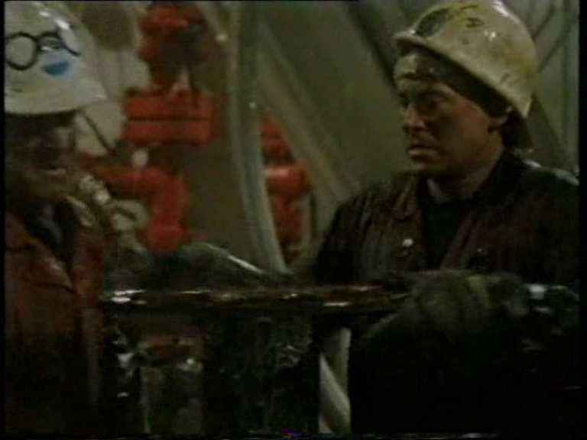

Figures 41 -44. The rig is presented in a similar paradigm to ships in maritime texts, with the ‘looking up’ shot of the mast replaced by the rig’s structure and an emphasis on the communal spaces ‘below decks’.
The term ‘roughneck’ is actually an American oil industry term, so-called as it was a symptom of workers consistently carrying large pipes on their shoulders and having them rubbing against their necks. Another term the series deploys is ‘North Sea Tigers’. The affinity with the rugged outdoor life is reflected in the masculine environment, with several of the characters dressing in cowboy attire (hats and boots) and is underlined at the end of episode one in which Archie sings ‘Rock-a-bye-sweet- baby James’ with its American mid-western imagery (albeit singing to a rabbit he has adopted). The tough and physical men of the rig are represented by Scottish (Archie), Welsh (Wilf), Irish (Chris) and Northern English (Cinders), consistent with the notion of the physicality of regional working class masculinity, and also echoing the same small crew of comrades representing the four corners of the British Isles seen in wartime propaganda films and other British war films. The centrality of the regional working-classes in this series indicates the evolution of British masculine representation that Spicer identifies as shifting in emphasis in British film after the late 1950s from, ‘the gentleman, a product not of modernity and of the city, but of tradition, Home counties pastoralism and the London Club’ (1999: 83), to the opposite, the urban, working-class employing tough, regional vernacular.
In episode one, the crew and local community mourn the death of the previous mechanic who died on the rig of a heart attack. They men struggle to cope with the emotions this causes and also the fact that the replacement mechanic is a woman. This prompts the traditional maritime superstitions of women being bad luck at sea, as well as more contemporary prejudice, “she wants equal rights in a force ten”. Tessa (Theresa Banham) is similarly convinced that she will not get the job, stating in the interview “you’re going to give the job to a man with the biggest family. Men with commitments” invoking traditional gender roles of bread-winning. When asked why the men had not shown their feelings for the deceased, Chris (Liam Cunningham), replies, “well they are feeling it, but why would they want to show it?” The tough, quiet masculine trope, silent as the landscape is evidenced in Gary Cooper or John Wayne. In the same way, drinking is both a means of coping and shutting out emotional response (this is particularly associated with Archie as he struggles with the break-up of his family and attempts to form new relationships).
Elsewhere in the series, politics and bureaucracy interfere in the lives and safety of the crew, and by the end of the second and final series, the crew are made redundant. The final shots see Chris leaving a petrol station, getting into a lorry and leaving his life and wife behind (reminiscent of Jack Nicholson in Five Easy Pieces, 1970) whilst the others all sing together in a pub (communal singing and drinking are a common feature of the series, as in war films). The show’s producer’s explained that they deliberately sought to avoid a show about boardroom politics, yet show how this impacted on the lives of the working man (McGregor: 1995, 9). Cutbacks and safety concerns are another common feature of the series and the Piper Alpha disaster is mentioned on several occasions as a test case on this issue. This occurred offshore in the North Sea on 6th July 1988. A gas explosion ripped through the Piper Alpha oil- rig killing 167 men (BBC NEWS, 2008). It remains the worst such accident of its kind and is commemorated in the city of Aberdeen, emphasising the dangerous nature of the work, and linking it to the numerous coal mining disasters that occurred in the nineteenth and twentieth centuries that devastated similar working class communities extracting fossil fuels. Industrial accidents caused by financial cutbacks in the myopic drive for profit remain a feature of the maritime industries in Britain, much as the ‘coffin ships’ did in the nineteenth century (see The Onedin Line). There is also a consistent commentary on the manner in which the workers are portrayed in the media, and how the media itself functions. In episode 1:4, an attractive young journalist visits the rig to write an article and is treated with suspicion and scorn by the crew who fear that she will just be exploiting and misrepresenting them or stoking safety fears (as was the case in the series development, McGregor: 1995). Also, a televisual report of a tragic helicopter accident that occurs in 1:5 and 1:6 departs seamlessly from solemnity “three people declared dead” to banality, “on a lighter note, an asthmatic owl…” suggesting both how the industry is vital yet invisible unless a major catastrophe occurs and also how quickly such events may be forgotten.
Much of the critical reception made reference to Piper Alpha as well as gender politics and the fact that the BBC was struggling to produce successful contemporary dramas to rival those of ITV. Timeliness, as a concept is reflected in the reference to the subject matter, as Hunter Davies laments in The Mail on Sunday Night and Day Magazine (1994), ‘[It’s a] shame it could not have been made 10 years ago when we didn’t know much about North Sea oil, except that it was going to save our economic lives’. The Sun (1994) also comments that it ‘should have been made 10 years ago- the thrill of the oil business vanished with the Piper Alpha disaster’. It is interesting to note that both reviewers seem to equate the oil business with ‘thrill’ whilst both seemingly having forgotten Oil Strike North attempted unsuccessfully to fulfil a similar agenda twenty years previously.
Much is also made of the masculine basis of the series with Geoffrey Phillips in the Evening Standard (1994) suggesting that contemporary television drama is saturated with what he terms ‘GLOBS’ (Great Lot of Blokes Syndrome) and Hugh Massingberd in the Daily Telegraph (1995) makes reference, as several other critics did, to the fact that the series writer and creator, Kieran Prenderville, worked previously on consumer and entertainment show That’s Life under main presenter Esther Rantzen (cruelly lampooned as “Esther’s Nancies” by Rowan Atkinson). Massingbird suggests that such ‘feminisation’ had driven Prenderville to this subject matter to prove that he was a ‘Real Man’. Massingberd places himself in this category, declaring, ‘I have nurtured an inferiority complex about my failure to match up to the ideal of masculinity. The North Sea became the modern equivalent in my eyes of “the great open spaces where men are men”, as Charles Stringham described Twenties Kenya in A Dance to the Music of Time”. John Marriot in the Daily Mail (1994) concurred suggesting that Prendeville’s experience in That’s Life, ‘sends a chap searching for macho visceral entertainment’ in this ‘muscular, edgy series’. The message appears to be that the particular form of intensified masculinity constructed in the series is largely in opposition to a particular form of femininity.
Massingberd also suggest that the ‘well-drawn characters’ helped to dispel the ‘whiff of tokenism’ of the female characters, a claim entirely repudiated by Nancy Banks- Smith,
Don’t expect Hamlet. It is a macho, ho-ho series about the workers on a North Sea oil rig. You can only live in hope that one [female] will be swept off in the inevitable disaster, but I doubt if sexual equality stretches that far in (The Guardian, 1994):
Smith is talking about the first series whilst Massingberd reviews the second, but Smith is right, in that the only deaths are among the male characters whilst the females largely concern themselves with the business of mourning. In contrast, John Naughton of The Observer (1994) suggests that there is not enough male physicality to engender verisimilitude. One should expect a ‘reasonable amount of physical contact’ he suggests and that there is ‘not enough male aggression’ in the series. Naughton seems to equate the accurate depiction of largely working class and male environments with the performance of physical aggression. It is perhaps a surprising opinion from a writer appearing in the liberal Observer that not only is gender a cultural construct, but rather it should be. It links back to the ‘Esther’s Nancies’ comments and is a fascinating insight into how patriarchal society at the time, across a broad range of opinion, seemed to suggest that masculinity had to be physical, aggressive and performative, in what is often seen as the era of the more sensitive ‘new man’ (Jeffords: 1993).
Conclusion
One particularly thoughtful and reflective review appeared in The Telegraph (1994) by Max Davidson. Davidson drew attention to the writer’s ability to ‘take his time and introduce scenes’ but complained that intrusive sound and unnecessary expositional dialogue detracted from the visual form, ‘Television is a visual medium: the tragedy is that most programme- maker’s don’t realise that’. Although Davidson’s complaint that film was ‘marred by the introduction of sound’ is slightly disparaging to the artistic and expressive capabilities of the medium, it does raise an issue that is overlooked. As the above analysis demonstrates, it is the visual language, and the arrangement of space, that carries both historical association and implicit meaning. Here, the maritime tropes of seascape and adventure are transposed to the modern industrial world of work and community, highlighting the importance of these to modern national identity and the fluid state of gender relations within it.

2:4 On a Clear Day (2004): Dockyards and Shipbuilding after 1960
Introduction
In a fractious Union, one thing that helped keep a semblance of solidarity outside of vague political and imperial platitudes of ‘togetherness’ in the twentieth Century was the labour movement. However, with the breakdown of these traditional industries- the sense of shared community values and spirit of unity and morality that was bound to the proudness of work and industry began to dissipate in tandem. In particular, the shipbuilding industry, particularly on the Clydeside in Glasgow had been the industrial pride of Scotland, and alongside the shipbuilding yards in England and Ireland, the sites that built the boats which forged the Empire. This economic industrial space will provide the first example of an examination of the uses and representations of space in relation to notions of power and identity, both national and regional. As Hoosen (1994 in Clayton, 2002) suggests, ‘with respect to identity, space is both an active agent in its construction, and a form of its expression, and is always influenced by relationships of power’ and likewise Clayton (2002), ‘the geography of politics, and how place-specific factors and the experience and perception of space influence national identity and its political expressions’.
Unsurprisingly, this industry has been a prominent feature of films made in or set in Scotland within the British film industry. Tellingly, they were often made by English based film-companies. Michael Powell’s ‘quota film Red Ensign (1934) told the story of a Glasgow ship-builder’s son and his struggle to launch an innovative ship design that would bring work and prosperity to the yard. It was followed during wartime by The Shipbuilders (1943) - a stirring, patriotic call-to-arms for solidarity which Richards (1997: 207-8) describes as a ‘masterpiece’ which fulfilled the MOI’s three tenets for wartime propaganda- how we fight, why we fight and the need for sacrifice. Richard’s points out that the film was not interested in Unionism and the industrial troubles of the 1930s:
There is no sign of ‘Red Clydeside’ here. In its depiction of industrial relations, it is consensualist, based on the dignity and respect of and respect for workers, the dedication and concern of the managing director and everyone pulling together in mutual sympathy and understanding. It is a retrospective rewriting of the 1930s from the perspective of the war. (1997: 207)

The industry was also famously chronicled in Frederick Wilson’s Floodtide (1949) which did appear to have a political dimension, concerning itself with the theme of social mobility at a time when the post-war Labour government had been in power for four years, promising social equality and protection ‘from the cradle to the grave’. Gordon Jackson portrays David Shields as a self-made man training as a shipbuilder after rejecting the family farming business and gaining the respect of the company boss Sir John Anstruther who similarly earned his position through merit. As Carolan (2012: 145-148) points out, these films were praised for their fidelity to the documentary strain of British filmmaking, perhaps being well-suited to it through the actual documentary work of Grierson’s team which often focused on industries such as dockyards and shipyards in its depiction of Britain. Those films, Carolan observes,
‘…promoted co-operation. In both cases the diversity and capacity of industry within the stable homogeneity of ‘nation’ were the keynotes: not regional identities and difference. In this sense they were very ‘British’ films representing Britain as a nation state’ (2012: 150-51).
After the experiment with amalgamation of shipyards failed in 1971, James Callaghan’s government nationalised the Govan shipyards in 1972, switching the focus back from merchant shipping construction to naval warships which continues to the present day under the stewardship of the private BAE systems (Burton, 1994: 200-225). The ship-building industry therefore still remains important and a source of pride to both Glasgow and Scotland, as evidenced by the award winning (Scottish BAFTA for best film and screenplay, 2005, BFI, 2004) film On a Clear Day, directed by Gaby Dellal. Carolan remarks of the Scottish shipping industry:

It is perhaps surprising that nobody had made the romantic or nostalgic shipbuilding equivalent of Brassed Off (1996) and Billy Elliot (2000) dealing with the decline of the mining industry, or The Full Monty (1997), dealing with the decline in the steel industry (2012: 149).

In many ways, On a Clear Day does fulfil the agenda of a shipbuilding Full Monty, and like the latter two examples, uses the declining industries as the backdrop rather than the focus. The film, set in Clydeside, is described in the press-book (BFI, 2004) as ‘an inspiring story of a man’s fight to regain his dignity’. Recently laid off ship-builder Frank (Peter Mullan) struggles to regain his purpose and dignity whilst coming to terms with his estranged son Rob (Jamie Sivas) and the loss of Rob’s brother who died when he was a child. His role of provider is also challenged by his wife Joan (Brenda Blethyn) and he begins to suffer panic attacks. In order to regain a sense of purpose he decides to swim the English Channel with the assistance of his friends and ex co-workers Danny (Billy Boyd), Eddie (Sean McGinley), Norman (Ron Cook) and the proprietor of the local fish and chip shop Chan (Benedict Wong). In doing so he overcomes his problems and repairs broken relationships.

From the opening, the position that ship-building plays and has played in the lives of Glaswegians is emphasised, as is community, solidarity and traditional masculine values of hard-work and loyalty, that are consistently challenged by twenty- first century vicissitudes or as Clayton and Hall describe ‘the distinctive Clydeside consciousness of ‘hard people doing hard manual jobs (Clayton: 2002, Hall, 1991: 64). The film opens with the community witnessing the launch of a new ship. The size and scale of the ships and the way the industry looms large over the city is emphasised in one shot of the ship literally cutting diagonally across the street). Here, the iron ship is fetishized in a similar fashion to the sail ship in Onedin, for example.

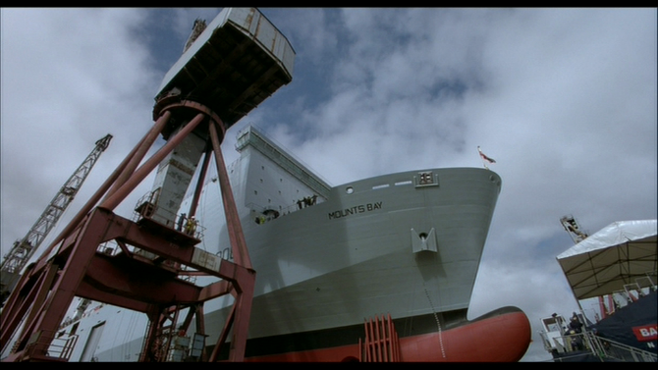
Figure 45. The size and grandeur of the ship is emphasised by low camera angles.

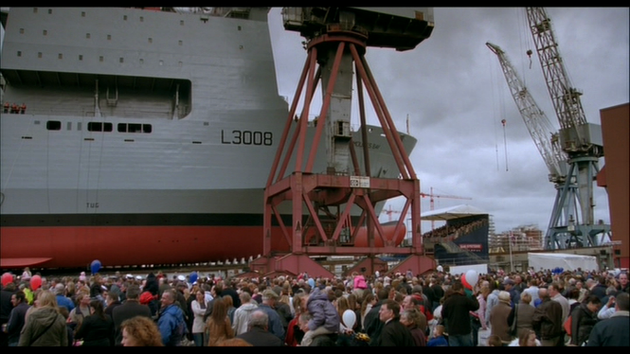
Figure 46. The community gather for the launch of the ship.
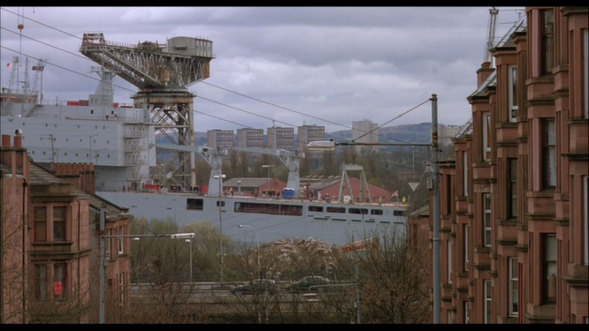
Figure 47. The ship literally passes through communal spaces.

The joyous, group occasion is interspersed by melancholy scenes of Frank, packing his work belongings away, whilst another machine worker deliberately immolates his hand in a piece of machinery. Danny approaches to tell Frank he is missing the launch, whilst he laments the state of legislation that allows ownership of British companies to be fall into the hands of foreign owners- “How can they let someone else build our navy ships?”. The “loss of the ship” that Rayner (2007) describes is present here as the communal loss of the symbolic vessel, but it is transposed into the loss of control of the means of their production. This is symbolically underlined as Frank tosses a model ship into the rubbish.

The melancholy tone is continued with Frank daydreaming in the bath about the loss of his other son, and compounded with a panic attack after an unhappy encounter at the local job centre, after which he also spots his wife being instructed to drive a bus. Frank’s struggle is the centre of the narrative and the traditional masculine role of provider is challenged here, both in the way that his wife seeks employment and how his son is a stay-at-home father to his two grandson’s whilst his wife is a successful businesswoman (the source of father and son estrangement alongside residual issues relating to the drowning of Rob’s brother). It is emphasised that Frank is particularly stubborn, refusing to stay at the yard in a down-graded role (Eddie stays on, sweeping floors) whilst refusing to engage with his son, thus concomitantly depriving him of time spent with his grandchildren. All communal and familial fissures appear to be healed by Frank’s one grand gesture.

Community, work and gender are at the centre of the narrative, indicative of social tensions in post-millennial Scotland. Producer Sarah Curtis asserts that, “When we first started working on the script, we all agreed that a sense of place and community was hugely important for the film. That is what we looked for –and found-in Glasgow” (Pressbook, BFI: 11). The community is still largely defined by Frank and his group of friends who view him as a role model. Similarly, inspiration and retribution and a set of standards are drawn from a patriarchal hierarchy. Initially, Danny volunteers to swim the channel with Frank but has to be rescued in his first sea training session due to cramps caused by a combination of over-enthusiasm and under-preparedness. Dealing with his failure he laments, “I just wanted to be the man for once…like you [Frank]”. Frank himself is inspired by a disabled boy he begins to see regularly in the swimming pool who does not let his disability affect him, swimming determinedly despite the obvious difficulty. This galvanises the group who also witness the boy and who also seem to bond in the swimming pool changing rooms (this is underlined when Frank’s son, his wife and children and attend one day, forcing Frank to hide in a cubicle to avoid them). It gives Eddie the confidence to quit his diminished role at the shipyard and Danny finds the confidence to ask out a girl he had been trying to impress. Similarly, Chan (Benedict Wong), the local chip-shop proprietor is racially abused- particularly by the potato deliverer who insists on dumping the bag and spoiling its contents in the shop doorway. After seeing the boy, he successfully, but politely stands up to him. Communality, despite racial or ethnic difference, is the dominant theme- as Frank points out to the Norwegian owners of the shipyard when he testifies unsuccessfully to get compensation for the man who injures his hand “There’s not a man in this yard who’d piss on you if you were on fire”. Here, the “collective effervescence’ is enacted foremost in the male relationships of the ship-workers.

Water, and more specifically the sea around Britain is also at the centre of the narrative, as a baptismal and life-affirming element. Again, this symbolism is centred around Frank. The film opens with him reciting a poem as his twin boys play on the beach that ends with an underwater shot of water engulfing and a fade to black (denoting the death of his son). Here the sea is linked to death as well as being a liminal space of play. The ship launch sequence then follows, interspersed as it is by the end of Frank’s career, continuing the theme of death and renewal. Following the confrontation with the owners, Frank then walks fully clothed into the waters of the Clyde- the camera pauses for a while as he disappears under water, and the next shot is of him on the bus, soaking wet but with a euphoric smile on his face. The waters of the Clyde here, the local sea that is a constant link between past, present and future provide a panacea to the intangible and threatening changes on land for Frank- a shield against economic and societal change. This is given a more playful treatment, though inflected with a gender commentary, in a scene in which the four men are talking and skimming stones on the beach as Joan and Frank’s wife sit talking in a bench, further away. The visual style and geometry is crucial here as the men are framed within FW’s fingers. “They look very small from here” she says, to which Joan replies “they are very small- they shrink when you get near them”, suggesting the emotional reticence that can manifest from homo-social groupings. They then discuss Joan’s impending bus driving test to which she replies “he’ll think it’s about him losing his job”. The camera angle cuts to a high shot with the women framed from behind, on a higher level and larger than the distant man, indicating the shifting roles of gender power relationships in the narrative.

The key reconciliation takes place in the baptismal waters between father and son, after an earlier confrontation between the two in the swimming pool. The earlier, unsuccessful reconciliation is enacted in salt-water, providing a link to the death of the son and (presumably) creating a re-birth. In order for the male characters to function properly as men, there has to be safely delineated spaces of masculinity, in common with the naval films. The final shot in the film is of the two grandsons playing by the water, correcting the asymmetry caused by the loss of Rob’s twin. Water and the sea, therefore, surround and envelop the film, insinuating itself into and highlighting key moments and themes in the narrative. The sea and shorelines are a place of death and finality, but also of birth and (masculine) renewal.

Figure 48. Frank is revived by the waters of the Clyde.
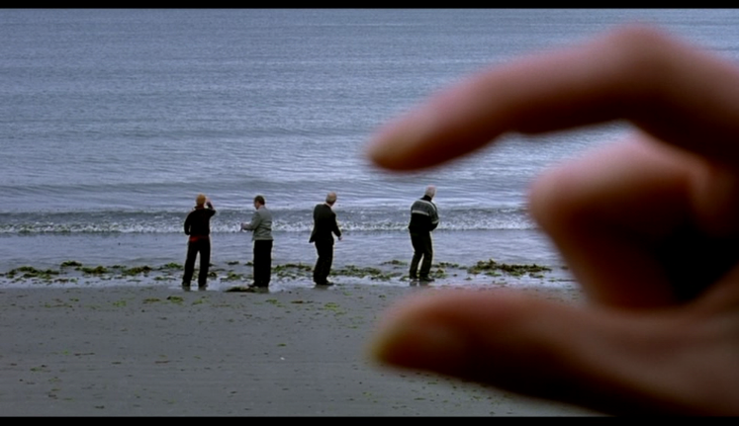

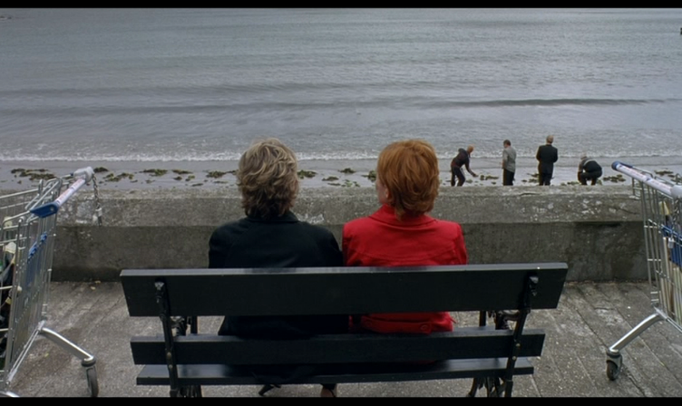 Figure 49- 50. Gender, space and power relationships are evoked visually.

Critical material focused on the fact that the film was derivative of the aforementioned strain of British films featuring plucky underdogs in post-industrial contexts or coming of age comedy dramas. Phillip French in The Observer described the film as ‘another British post-industrial movie in the Full Monty manner’ (2005) which echoed Peter Bradshaw in The Guardian (2005) the film is a ‘derivative British heartwarmer written according to the Full Monty/Calendar Girls handbook’ equating two films with very different settings and gender focus. This is suggestive of traditional tensions in the British press, firstly for films to be both financially successful, and internationally exportable but also to be relevant, innovative and of the highest quality. Hence, the film’s spirit and feel-good message are praised as well as Peter Mullan who is universally lauded for his performance, but that the film’s script prevents it from achieving true quality. According to Bradshaw, it ‘is just too pat, too easy’, whilst for Anthony Quinn, it ‘can’t help seeming soppily programmatic’ (The Independent, 2005). American reviews were similar and offered a revealing international perspective on British film. Writing in The New York Times, Jeanette Catsoulis (2006) summarises British film,

‘In the movies, bankable Brits fall into one of two categories: those who live in stately homes and possess a firm grasp of the Queen’s English, and those who live in cottages or tenements and possess accents thick enough to caulk boats’ (adding that On A Clear Day ‘fits neatly into the second category’).

Roger Ebert (2006), much like the British reviews, believes that Mullan is the films’ only attraction and similarly criticises the formulaic plot dynamics, even suggesting that they are exploitative, ‘The movie offers those varieties of depression and panic that function not as real problems but as plot conveniences, setting the other characters astir’. Catsoulis was more positive, and usefully observes that ‘the specter [sic] of male irrelevance blankets the film, and the repeated drowning motif encompasses an entire class of men whose wives are now sole breadwinners’. This is also a point expressed elsewhere, as David Gritten writes of Frank’s decision to swim the Channel, ‘It’s a choice weighted with meaning, of course: water is not a benign factor in Frank’s life’ (The Daily Telegraph, 2005)

Conclusion
If Howard’s Way and The Onedin Line bracket the natural vistas of Great Britain and its surrounding seas as capitalist and mercantile spaces, then Roughnecks and On A Clear Day demonstrate that industry, gender, region and community in modern maritime industries remain important arenas of identity formation. These latter maritime dramas highlight the tensions between shifting gender roles, the collapse of traditional industries and rise of new ones, and the fight for recognition within the Union of different nations and regions. As Clayton suggests, ‘Nationalist movements are largely defined by, and act within, the boundaries of a distinct territory…nationalism is thus an inherently geographical phenomenon’ (2002: 813-843). The focus therefore on how work, community and locality help to forge common identity therefore provide a more complete picture of national unity and collective value systems.

2:5 The Sea Shall Have Them? Fractured Maritime Landscapes and Disappearing Britain

Introduction: Fishing
Much like the Royal Navy, fishing and the fishing industries occupied British cinema screens with regularity in the first half of the twentieth century. As the Royal Navy straddled both fiction and non-fiction filmmaking, so did fishing subjects, with short films and newsreels detailing the endeavours of British fishing folk and fishing fleets continuing into the 1940s, covering fishwives (1896), oyster dredging (1902, 1907), herring (1902, 1906, 1910, 1912, 1925, 1929) mackerel (1911, 1912) sardines (1906), Lobsters (1908) shark fishing (1909) whaling (1908) and many more besides. Herring held a particular fascination for filmmakers, being the centre of Grierson’s Drifters (1929) and the eponymous subject of the fictional The Silver Darlings (1947). In other fictional works, the thirty films released before 1930 with commercial fishing as a central theme, tended to be romantic dramas or love stories such as Heart of a Fisher-girl (1910), Fisherman’s Luck (1913) and Alfred Hitchcock’s The Manxman (1929). As Carolan points out, they had an affinity with naval films and also other films with a naval subject:

Common elements in the representation of maritime industries were to be found regardless of genre, crossing over comedies, dramas and the information film. First, there was a certain romanticism of the worker in the tight-knit community. Second was an emphasis on the unique skills of the worker passed through the family line and the debt owed to them by the whole country. Third, the documentary style became the dominant mode of representation of maritime industries (2012: 138).

However, there does appear to be a contradiction between the documentary style and romanticism, which in its origins, is an anti- realist movement intended to connect with inner emotion and the ‘sublime’ and the preponderance, at least in fictional films, was for romance and melodrama, which traditionally was positioned as the opposite of documentary realism. The romanticisation of ‘fisher-folk’ is something that continued after the post 1960s period (see also 3:1), yet national debt owed to them was something that became sorely lacking, and a major point of contention in an industry, much like shipbuilding and dock working, that appeared to be in perpetual decline. As shall be demonstrated, it also began to be representative mainly of the North of England, indicative of a schism that intensified in this period between an affluent south and a struggling north. There also exists a tension between fishing as a leisure pursuit and as a profession. The latter will occupy the analysis here as the former is more aligned to the world of luxury yachts and also has a spiritual ancestor in the world of whimsy and play. Much like the seaside resort as a space of leisure and play has come to represent a conspicuous site of decline in a national context, fishing and ‘messing about on the river’ occupy a similar terrain.

Fishing on television
The number of films about fishing declines rapidly after 1940 and is more visible on television. Again, in the same manner that fictional naval films and television decline in this period but remain a regular presence in non-fictional and documentary programming, particularly in the early 1970s on BBC, kept the nation informed on the fishing industry with such programmes as Deckie Learner (1965), The Shoals of Herring (1972) whilst Skipper Pitts Goes to War (1972) detailed the increasing enmity between British and Icelandic deep sea fishermen over territorial fishing rights in the so-called ‘Cod Wars’ (see 1:5).

This was one of a number of battles being waged in the 1970s, which placed industry at the centre of the cultural sphere. Another, which began to gain momentum at the same time, was the environmental movement. Rachel Carson’s Silent Spring, published in 1962, remains a seminal text of the effects of man-made pollution and led indirectly to the establishment in 1970 of The United States Environmental Protection Agency, with Greenpeace being founded in the same year and Friends of the Earth a year previously. The natural landscapes and seascapes so beloved of purveyors of patriotism and national identity and belonging, began to be viewed as a place where human progress was causing the defilement of beauty. The BBC television series Doomwatch (1970-72) was part science- fiction part science fact which dealt with a section of the government which dealt with environmental catastrophe arising from twentieth century industrial activity and the spin-off film of 1972 details the effects of illegally dumped pituitary gland growth hormones in the coastal water of the Isle of Balfe, just off of the Cornwall Coast and the destruction of a small fishing community. In Alan Plater’s Land of Green Ginger (1973), Hull is seen to be a place in transition. As Dave Rolinson (2007) describes of the programme, alongside talk of building the Humber Bridge which promised jobs and connections for Hull (but was still a long way off at the time of broadcast), it is also about bridges and transitions. It is about the character Sally Brown (Gwen Taylor) returning to Hull from London to find it much changed. As Rolinson describes it is about ‘Sally’s attempt to bridge London and Hull’ but also about bridging ‘traditional and fragmented communities, childhood and adulthood, and the way jobs require people to move away from home’ (2007: 285). The opening credits and montage accompanied by folk music (by The Watersons) suggest both nostalgia and romance, but that this is a proud tradition that is moribund. The fishing industry is positioned as the hub of the community and without it the community is in crisis also evident in the cold-war thriller series Spyship (1983).

Ghosts (2006): Britain’s Physical and Cultural Battlegrounds.

Ghosts deals with illegal Chinese labour as with the following year’s True North, which featured the crew of a Scottish trawler carrying illegal Chinese immigrants ending in death and disaster. Ghosts posits what Terkenli describes as a ‘cultural battleground’ (2014), as the coastal spaces on display project the site of new anxieties surrounding the permeability of the British coast. The film centres on Ai Quin (Ai Qin Lin), a poor Chinese woman from agricultural China, who borrows $25,000.00 from local warlords with the promise of a fake work permit for Britain, where she plans to earn enough to provide for her young son. Smuggled in the back of a lorry, she ends up in a cramped house in Norfolk full of other illegal Chinese migrant workers, doing various low-paid manual jobs, such as picking onions for the supermarkets (mentioned by name: Asda, Sainsbury’s and Tesco) with long hours in order to pay off her debts. Eventually forced out of their home and under the leadership of Mr Lin (Zhan Lu) they head to Morecambe Bay and the promise of riches to be made cockling. However, they are ostracised and brutalised by the indigenous cocklers, a move that forces them to work in hazardous tidal zones which leads to them becoming trapped by high tides. Ai Quin is the sole survivor of the tragedy that occurs.
The film is directed by Nick Broomfield, documentarist who pioneered the ‘gonzo’ style of documentary film-making in both film and television in which he places himself as a prominent and visible part of the documentary, rather than passively reflecting on events, thus creating a star of the documentarian. He has had a major influence on succeeding film-makers such as Louis Theroux and Michael Moore who adopt the same approach. His early films, which adopt a more ‘verite’ approach to the form than the later ‘gonzo’ style, tackled controversial subjects such juvenile crime in the BFI banned Juvenile Liaison (1975), the clearance of Liverpool slums, Who Cares? (1971), and prostitution, Chicken Ranch (1983). Later films covered conspiracy theories, murder and celebrity death in Kurt and Courtney (1998), Biggie and Tupac (2002) and Aileen: Life and Death of a Serial Killer (1992). Ghosts therefore marked Broomfield’s first ‘fictional’ film and Broomfield explained that this approach was deliberate in order to strengthen its emotional impact and allow the viewer to experience the drama (and Great Britain) through the eyes of an illegal migrant worker (Key, 2007). The film was released in 2007, whilst the abolition of slavery in Britain was being celebrating and the biopic of Wilberforce, Amazing Grace, was also released that year. As Broomfield explained,

“It seemed to me that we’re celebrating the 200th anniversary of the abolition of the slave trade in England and yet modern slavery is worse than ever. People were no longer in chains but were paying off enormous debts and had no freedom of movement. They don’t have civil rights, they live in terrible conditions” (in Key, North Wales Daily Post, 2007).

Broomfield’s film is based on the incident that occurred on February 5th 2004 in which twenty- three Chinese migrant workers drowned in the same circumstances. The incident highlighted the fate of migrant workers in Great Britain, the hostility they face from British citizens and the dangers that the sea poses to everyone. The idea of servitude fuelling a black economy links back to representations of servitude in The Onedin Line and A Respectable Trade and suggests that Britain is a country changed demographically, yet economically reliant on dark industries as it was in the eighteenth century. Bromley describes a post-cold war era in which ‘deepening global inequalities have generated an ever-increasing number of refugees, people who have been thrown into condition of ‘liminal drift’, without voice or place, on the margins of the world’ (2012: 341). It is these disenfranchised in ‘liminal drift’, existing in transit and in degrading conditions which both ‘Ghosts’ and ‘True North’ make temporarily ‘visible’.

Although the maritime sequences only occur in the last twenty minutes of the film, it is a powerful and visually arresting climax that positions the British coast as the site of representations of modern Britain: the fighting on those beaches was of a different complexion to Churchill’s famous rallying call. As Allen (2008) has pointed out, recent depictions of British seaside resorts in film have emphasised the ‘Limits of liminality’ the difference of coastal resorts being depicted as spaces of freedom and display, to those of restriction and barriers which ‘raises pertinent questions about national specificity in a multicultural society’ (2008: 54). Allen also proposes that ‘liminality is a state that should be socially unifying, as it acts as a space devoid of social status’ (2008: 66). This is not the case in Ghosts, as it is hostility to migrant ‘others’ which disengages them into the landscape of tragedy.

Julian Freeman suggests of the opening up of the coast by the railways in the nineteenth century,

The visual and sensory expansiveness of thousands of people was simply transformed…previously…less…picturesque…more…romantically sublime…terrifying in its ever-changing and limitless grandeur…The nearness of the sea, the proximity of its changing detail. Its timelessness. Its sights, sounds and smells (2006: 166).

This evocation of the coast as a tactile, sensory experience had been entwined with the rise of maritime painting in Britain in the same century, with romanticism eliciting a new way of visualising the sea as ‘rough, powerful and terrifying’ (Denys Brook-Hart, 1981: 18). This is evidenced in the sea sequences in which the sea is personified as insidious and terrifying- almost unpredictable. The carefully composed shots, with slightly oblique angles are reminiscent of the horror genre.
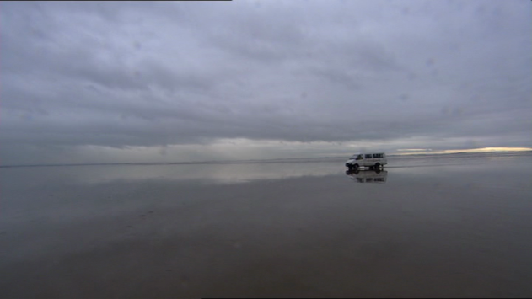
Figure 51. Lonely, desolate, grey and beautiful.
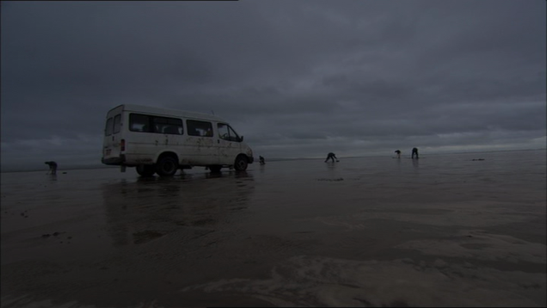
Figure 52. Oblique angles emphasise the sea and sky.
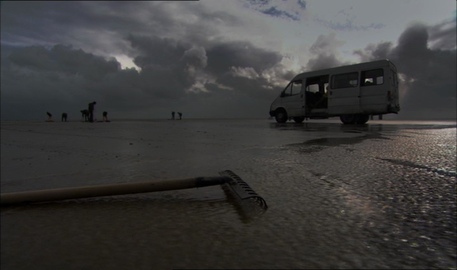
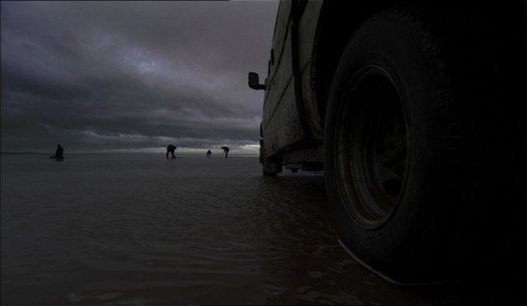 Figures 53- 54. Water creeps insidiously.
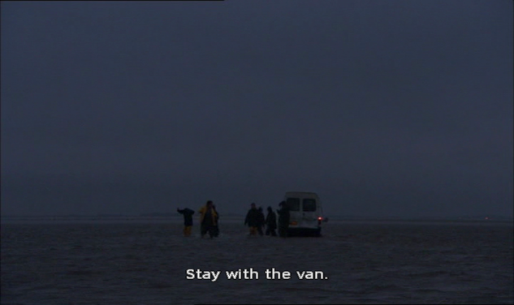
Figure 55. The sea has reclaimed the land.

As can be seen in figures 8-9, the smallness and isolation of the figures is enhanced by wide shots which emphasise the expansiveness of the tidal flats and the size, powerful greys and shades of light of the sky. Figures 9-12 - also demonstrate the creeping insidiousness of the water as it rapidly reclaims the spaces and objects occupied by the human characters before it is too late. The beauty of these scenes is balanced by the terrifying force of nature, and the use of space here is revealing of the construction of natural landscapes through human eyes. Interestingly, the news reports of the actual incident included in the DVD extras describes the mudflats as a “vast prairie” evoking images of the widescreen landscapes of westerns- a very different connection to the genre than has been made previously, demonstrating again, how landscape is a cultural construction with myriad interpretive possibilities. As Roy Strong describes of the rural myths of England, it is ‘a landscape of the imagination’ (2011: 87) or as Peter Fuller elaborates, ‘it collapses into topography on the one hand and abstraction on the other’ (Cosgrove & Daniels, 1988: 5).

These sequences evoke a Britain of a bygone age, and a long history of British visual culture. When the workers first arrive at Morecombe, they see it as a new beginning. Ai announces “It’s beautiful” as she contemplates the seafront. Her companion tells her “our home is just on the other side. Your son is there” and a rainbow appears, which he describes as “announcing a new beginning”. As can be seen in figures 5-7, whether consciously or otherwise, J.M.W. Turner’s work is echoed, most strikingly his 1840 painting ‘The Slave Ship’, which depicts an incident which occurred in 1781 in which a British Captain, Luke Collingwood, of the slave ship ‘The Zong’, threw a number of slaves bound for Jamaican plantations overboard to collect insurance money under the articles of ‘general average’ (sacrificing part of a ship’s cargo to save the rest). The incident, one of the most notorious and darkest chapters in British maritime history created a landmark legal case in which the propriety of equating human beings as cargo against their rights as human beings was debated and provided further impetus for the abolition movement. As Armstrong observes,

It is this liminal in-transit condition that is assigned to the slave at sea…Slavery thus occupies a middle position in the progress from insurance on goods to insurance on persons, providing a way of thinking about the value of life (2004: 170).

Turner accompanied his painting with a poem, the last lines of which read “Hope, Hope fallacious hope/Where is thy market now?” Indeed, Ghosts provides a modern echo of insidious slavery, particularly maritime, in a twenty first century context. Turner’s haunting reference to the ‘market’ suggest that little has actually changed despite a change in legality.

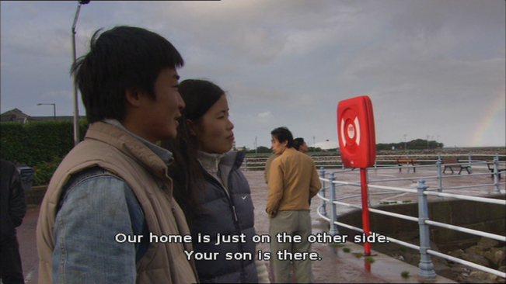 Figure 56. A rainbow appears.
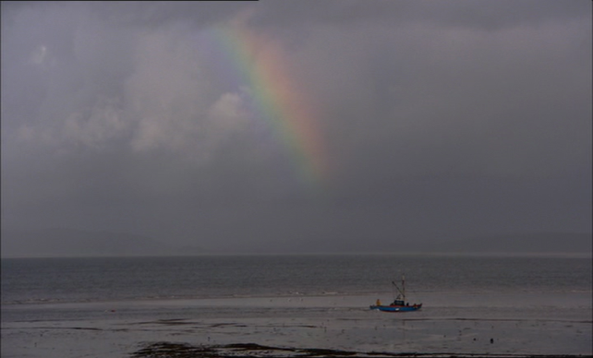 Figure 57. Beauty and desolation.
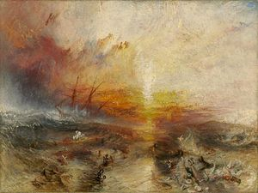
Figure 58. Turner’s The Slave Ship (1840) has much in common visually and thematically.

The film was reviewed very favourably by critics and was nominated for the Grand Jury Prize at Sundance and won a Solidarity Award. Many of the reviews focused on the ability by Broomfield to blur the distinction between fact and fiction, which was seen to enhance the drama and emotion of the film. Jonathan Romney wrote,

We have to take it as read that Ghosts is simply showing a representative, rather than an actual case, but its detached, unemotional approach carries a compelling polemical weight. The film points the finger at supermarket chains- Sainsbury and Asda are mentioned by name- whose codes of practice may not in themselves be unethical, but which are implicated in the chain of labour that exploits illegal immigrants (which means that, by extension, Ghosts also accuses us, the consumers). (Romney, 2007).

This last point, about implicating the consumer makes the blurring of distinctions even more powerful as complicity is evident at every stage of slavery as are the distinctions between legality and illegality. Anthony Quinn also contended that this approach and the use of non-professional actors lent ‘overwhelming pathos’ to a film ‘surprising in its intensity and compassion’ (Independent, 2007). For Quinn, ‘the horror leaks out of every frame’, using watery metaphor to recall the insidious cruelty of both nature and humankind depicted.

Broomfield’s utilisation of space and place was also recognised in its strength at depicting the squalor and claustrophobia of internal spaces and the bleakness of external places creating dystopian images of both,

Broomfield begins and ends his movie on the Morecambe beach: not a haven for holidaymakers, but a huge, empty cruel space which looks like something from the end of the universe. It seems like Ai Qin and her wretched friends have been finally washed up on some vast shore in a neverworld of undreamt-of callousness and indifference. Ai Qin awakes in awakes in her overcrowded, rented, two-bed house in a gaunt housing estate to look on to a cheerless landscape into which globalisation has transplanted the chill of world poverty…they [Thetford and Norfolk] look like new centres of hypocrisy, brutality and racism (Peter Bradshaw, 2007).

Peter Bradshaw’s review, like Quinn’s allusion to consumer complicity, places slavery squarely within a British national context, reminding readers that the film’s depiction of maritime slavery has a much longer history than the contemporary drama:

Coolie Labour was for centuries the dirty little non-secret of the British Empire, and a few years ago, a calamity here showed that, in 21st-century Britain, it is alive and well…The 58 Chinese immigrants found dead in a lorry in Dover three years earlier was horrifying enough, but this was a grotesque mass death nurtured well within our national boundaries, cultivated by UK market forces in the heart of picturesque seaside England (Bradshaw, 2007)

Significantly, Bradshaw links UK economic forces to death and tragedy which again raises the spectre of the Zong or the coffin ships depicted in The Onedin Line, suggesting that life is still cheap and dispensable compared to economic progress. It is significant also that Bradshaw further links these to images of Britain’s coastlines, national boundaries and seaside spaces suggesting that these are battlegrounds between their idyllic image and traditional role at the heart of British national identity, defence and prosperity showing the ugliness behind the mythology.

Jonathan Romney states much the same as he also invokes the defilement of our national spaces, ‘this island comes across as hostile, heartless, squalidly grubby, quite apart from the lousy weather’ (ABC Magazine, 2007). However, even though Simon Crook in Empire magazine also stated that ‘Ghosts holds enough combustible matter to seriously knock a nation’s pride’, he also found the quality of the film, its vision and ‘relentless bid for authenticity’ to be a source of artistic national pride, ‘this is simmering, impassioned cinema, the kind this country now seems almost too scared to produce- a home-grown film about home-front issues with a story worth sharing anywhere’ (Empire, 2006). Fittingly, for a film which tackles the hidden shame of modern-day slavery and which echoes the spectres of slavery which helped build British maritime prosperity, honest assessment, artistic bravery and integrity, are considered national virtues even when they illuminate the unthinkable. In an echo of both Ellis’s quality film adventure of the 1940s and the long-standing propensity for British critics to venerate ‘realism’, it is still a ‘relentless bid for authenticity’ which often mark out quality and ambition within British film.

Conclusion

It may seem spurious or specious reasoning to connect images from British film and television to a visual past, given the international language of film and the increasingly hazardous negotiation of ascribing such texts within strict national contexts. However, like the assignation of an artistic visual style to the cultural embodiment of a nation state, these parameters persist, and by analysing them in this manner, credence is given to the perpetual tension between ‘banal nationalism’ and the possibility of a more nuanced interpretation. As the entirety of this thesis hopes to demonstrate, this is simply another example whereby a complex arterial network is rendered ‘national’ or otherwise in a negotiation of meaning, or ‘intended’ meaning via the complex construction of cultural product.

One thing is clear from these examples, and that is that the British coast remains the space at which social, cultural and geo-political arguments are disseminated- the rendering of a maritime landscape at which complex visions of modern Britain converge.

Chapter Conclusion
In the previous chapter, we saw how the Royal Navy functioned on screen after 1960 in a manner that was in flux with the changing social, cultural and historical mood of the times. Utilised as nostalgia for secure patriotism, it also functioned as a conduit through which to critique Britain’s heritage as ‘Great’. In this chapter, a more expansive maritime environment is on offer, yet similar values and critiques are apparent. Through the Merchant maritime arena, The Onedin Line also utilised the signs, symbols and nautical visual and aural language which typified the romantic notion of British maritime heritage, whilst exploring the ramifications at home and abroad of maritime Empire building through its focus on gender, race and class relations. It suggested that television in the 1970s was not simply pre-occupied with showing a comforting homogenised view of the past but synthesised with romantic notions of maritime history as a means to expand the notions upon which it was based. It demonstrated that a long-running televisual drama format could offer a sustained and nuanced version of nautical history, and also how television had taken root as the most popular cultural form in Britain by this time, in an era when British film was concomitantly suffering one of its most fractured and financially and culturally insecure periods.

If Onedin reflected a 1970s televisual culture, then Howard’s Way offered an even more radically different conception of the maritime sphere which by contrast offered an altogether more contracted social realm of inclusion, in relation to both an aspirational culture suggested by trans-Atlantic televisual modes (Dallas, Dynasty) and a transformative economic ethos in 1980s British cultural life. Howard’s Way focused entirely on the trials and tribulations of the wealthy and aspirational and was unconcerned with the manner in which the working man or woman fitted into this new culture. By focusing on the maritime leisure industry and the sea and other spaces, it bracketed both as the preserve of a wealthy elite.

Roughnecks suggested that there were indeed new industries that offered work and camaraderie in the maritime sphere, and focused on the oil industry as one of the twentieth and twenty first century’s most important and contested resources. It suggested that the narrative, aural and visual language of naval and other maritime films could evolve and mutate into new forms of cultural identity with the rig replacing the ship and the sea ever present.
By contrast On A Clear Day offered another side to the story, that of the decline of industries which once made Britain great and offered work, community and identity to the general work force. They showed how the struggles suggested in Onedin’s nineteenth century, which had resulted in great social gains and equality by the mid twentieth century, were again the site of struggle and an almost invisible result of post-imperial decline.

In a similar fashion, Ghosts utilised the even older industry of fishing to provide a backdrop and dramatic contrast to the stark realities of twenty first century Britain. The film depicts a maritime industry in constant decline to indicate how harsh economic realities drive people to desperate and dramatic measures to survive, which invariably end in horrific circumstances. The sea and coastal spaces are thus shown in a different light, as the cultural and economic battlegrounds of changing social and demographic changes in Britain, infused with a danger and fragility that was often not lacking in evocations of ‘Pax Britannica’ and secure island nation depictions in previous nautical films and television.

Whether merchant, industrial, business or leisure, these cultural projections of the sea and the maritime often speak of the anxieties and insecurities of the British era that forged them. Identity and community are recurrent thematic concerns as is the issue of servitude in a maritime context, whether class, gender, racial or economic, indicating the manner in which depictions of the British maritime sphere have operated in the post-empire context to reconceptualise British history and values. By utilising the sea and British cultural and mythological connections to it, these productions are vital cultural artefacts for interrogating the vast societal changes in British history since 1960, and indicate that the connections between British national identity and the sea have not disappeared since the decline of the navy in cultural life but have morphed and transposed into different and arguably more diffuse and vital symbolism.

The following chapter will continue this theme by looking at maritime adventure film and television and suggest that these overlooked genres engage with very similar thematic and audio-visual representations, whilst hinting at a central duplicity in the popular historical narrative of British national identity.

Section Three: ‘Sea Dreams and Dark Deeds’: Smuggling, Piracy and Maritime ‘Mercenaries’

Introduction

O’er the glad waters of the dark blue sea,
Our thoughts are boundless, and our souls are free
(The Corsair, Lord Byron)

Section one proposed that the once certain domain of naval depictions became fractured and comparatively dissolute in the post- 1960s milieu, whilst section two pointed to a cultural negotiation of the attendant contraction of traditional maritime industries and the concomitant rise of new leisure and service industries. It also highlighted the role that regional communities played in providing a challenge to hegemonic depictions of ‘national’ identity. This section will develop that concept further suggesting that far from being a sub-generic category of war films and naval depictions, the maritime sphere has a deeper-rooted connection to national conceptions of community and identity that transgresses generic boundaries that suggests a richer myth of Britain and the sea. As will be discussed, there is a remarkable consistency of theme and representation across such disparate genres as the critically respected ‘heritage’, historical and costume drama and the less critically revered arena of action, adventure, smuggling and piracy texts.
Lord Byron’s poem suggests that much of the appeal of piracy and maritime adventure has its origin in romantic fiction. Jeffrey Richards asserts that ‘swashbuckling’ adventure stories thrive on anti –realism and anti-naturalism’, and let the imagination and the ‘soul’ as Byron refers to it, escape from the drudgeries of everyday life: ‘freedom from restraint and the unshackling of the imagination’ (1977: 9). As such, they are escapist fantasies and represent the essence of what cinema represents in its popular form. Yet as Pam Cook suggests, ‘escapism implied unease with fixed boundaries of national unity’ (Cook, 1996: 61), so British films which dealt with this subject were often met with critical indifference from a critical establishment which tended to lionise the ‘realist aesthetic’ in British cinema to the detriment of fantasy. Many of these films also deal with illegality, and therefore transgress the accepted norms of social behaviour. This chapter will therefore interrogate how the dark undercurrents of British maritime heritage are subsumed within the dominant narrative of national unity.
This chapter will therefore seek to answer the question- how do these films, which often foreground criminal activity and sinister motives, project an alternative but often radically different notion of British national identity? It will focus on the themes of dual identity and small communities to suggest darker undercurrents occurring in the national narrative, focusing on how the maritime, and particularly the sea, are used to project those ideas particularly at odds with the traditional view of the ‘cult of the navy’.
The chapter is therefore broken down into five sections, each addressing a different aspect of British film’s maritime depiction of ‘adventure’. The first part will look at smuggling films Fury at Smuggler’s Bay (1960) showing how it relates to historical and contemporary depictions of smuggling. In particular, it will focus on how it presents a stratified conception of sea communities, the theme of dual identity in community leaders and romantic notions of criminality in history and how this is explored against the back-drop of the sea as a frontier.
The second section will focus on the British pirate film, showing the similarity of theme and form with the smuggling films, how they also present community and dual identities but also focus on the historical and literary context of British cultural production. The main case study is Treasure Island (2012), a recent television film. This will focus on the social changes in British history that have allowed for a more psychologically charged, gender and racially inclusive depiction of this classic British text of ‘sea dreams’, emphasising shifts in British identity, imagined and demographic.
Pirate films have undergone a cultural renaissance in recent years due almost entirely to the unprecedented success of the Pirates of the Caribbean series (which was influenced by the success of the video game Monkey Island, itself, like the film, inspired by the Disney theme park ride Pirates of the Caribbean). Unprecedented, as it defied contemporary logic concerning the success of ‘pirate’ themed films. Just like the Western and the Musical, what can loosely be termed the ‘swashbuckler’ film was once a staple genre in Hollywood’s classical period, but had declined in popularity in recent years, manifesting in short cycles every few years and largely migrating to televisual representation. A number of notable, high- profile box-office failures since the 1970’s can partially account for this including Roman Polanski’s Pirates (1986) and Cutthroat Island (1994). During the time that the Pirates of the Caribbean films became popular, Hollywood also saw the increased popularity of ‘fantasy’ films, which included the Harry Potter films and The Lord of the Rings trilogy.
Obviously, like many texts that have their historical and literary ancestry in Britain and Europe, Hollywood has provided the funds available to render them cinematically, producing the dominant canon of piracy and maritime adventure films. However, British film also has a history of representing its own maritime adventure myths. There exists in the silent era for example, several pirate films, The Pirates (1904) being the earliest. There have been sporadic attempts over the years for British studios to mimic the success of its American counterparts, including adaptations of Robert Louis Stevenson’s Treasure Island in 1972 and 2012 and Richard Hughes’ A High Wind in Jamaica in 1965. Hammer studios produced a number of successful ‘swashbuckling’ films including The Pirates of Blood River (1962) and Devil Ship Pirates (1964), and more recently Aardman studios achieved success with the comedy pirate adventure film The Pirates! In an Adventure with Scientists, adapted from the children’s books by Gideon Defoe. It was British television, in particular, in the 1950s which benefited from the gap left as Hollywood studios retreated from the genre somewhat. Numerous ‘swashbucklers’ were produced by British television in this period including The Adventures of Robin Hood (1956), Buccaneer (1957) and Sir Francis Drake (1961). All of these examples were received and talked about as a genre aimed mainly at children.
It is at this juncture that we may suggest the relative paucity of academic research for films of this type. Maritime adventure films, whether they concern piracy, smuggling and espionage have been loosely bracketed as ‘adventure’ movies or ‘swashbucklers’ which are themselves loosely bracketed generic definitions. Coupled with this is a critical and academic reticence to attach relevance to anything primarily aimed at children, with the result being that these texts have been treated as ephemeral, juvenile and with little importance. This attitude is characterised by Peter Kramer:
However, it would appear that another reason for the academic neglect of children’s and family films is a set of prejudices, namely that by and large they are cheaply made and simply not very good and not even very important commercially (2002: 186).

Kramer argues that there is a tension between industry and marketing strategies and academic and generic categories which signify decisions based on taste rather than a ‘systematic analysis of iconography, narrative patterns and thematic concerns underpinning much of genre studies’ (2002: 186).
Generic analysis, particularly in film, has long been a site of fevered debate. As Rick Altman has attempted to qualify, there has historically been a tendency to separate genres structurally that ignores the historical genesis and interaction of semantic elements and form (1999). Further, critics like Schatz have also sought to privilege the audience as a vital element in structuring thematic expectation and therefore govern the development of genres, suggesting a post-structuralist approach to genre (1999). Either way, there is not a clear and exhaustive definition of generic definition, but an on-going and reciprocal negotiation between industry strategy, semiotic meaning and participatory dissemination.
Despite this, several academics have attempted to define the characteristics and generic consistencies of the action film (Neale, 2007, Taves, 1993) the Imperial Adventure film (Chapman, 2009 Richards, 1977), and the swashbuckler (Richards, 1977) - categories into which these films have traditionally been talked about. Steve Neale suggests that historical adventure movies have their roots in nineteenth century melodramas, the ‘principle strand of popular fiction’ (2002: 55) which, like the films, share a propensity for generic hybridity and overlap. Jeffrey Richards traces the lineage back further, suggesting that the adventure story in its modern, swashbuckling form emanates from the romantic period and embodies the romance ‘at the heart of the folk tradition of the English-speaking world’ and the medieval virtues of ‘chivalry, gallantry, patriotism, duty and honour’ (1977: 5).
What Richards and Neale do agree on however, are certain other characteristics of the action genre. Neale describes a genre with ‘…a propensity for spectacular physical action, a narrative structure involving fights, chases and explosions…athletic feats and stunts’, (2002: 52) whilst Taves suggests a gendered style describing ‘…a male-oriented approach dependent on physical movement, violence and suspense, with often perfunctory motivation or romance’ (1993: 5). This view is echoed by Furby and Hines who suggest that the pervasive male hero-archetype is ‘based on strength, endurance, individualism, and morality’ (2012: 124).
Richards suggests these films represent ‘stylization’ over realism, and that the content is ‘ritualised’, the characters are ‘archetypes’ and that the emotions are ‘stereotyped’ suggesting ‘the most stylised and ritualised of genres’ (1977: 5-6). Crucially, Richards views these types of films as being entirely lacking in psychological complexity or significance. Whether that applies principally or exclusively to the dominant genre in Hollywood, is not a question that this thesis will seek to answer, however these concepts will be used as a starting point to show British visual depictions of the genre and the possible ramifications inherent in complicated projections of British national identity.

3:1 “Brandy for the Parson”: Smuggling, Community and Identity in British Film

Rudyard Kipling’s famous poem A Smuggler’s Song offers advice to the community within which smuggling is commonplace: Them that asks no questions isn’t told a lie/ Watch the wall, my darling, while the gentlemen go by! The sense that the entire community is implicated and benefits from such activities is confirmed by the lines, ‘Brandy for the Parson/’Baccy’ for the clerk:/Laces for the lady, letters for a spy’. Young or old, good or bad, pious or heathen, rich or poor, smugglers don’t discriminate and morality is thrust from black or white into so many shades of grey. Just who is the hero and who is the villain is not a foregone conclusion. Such has typified British filmic depictions of this historic activity, which presents small and often isolated communities on the fringes of society caught between the backdrop of the sea on one side and, the undulating land on the other. It remains a niche genre, in filmic terms at least, and has its roots in popular romantic fiction from such authors as Russell Thorndike and Daphne Du Maurier.
To add to the isolation that typified the depiction of smuggling communities, they were also often portrayed as occurring at the ‘Celtic fringes’. Of the thirty six films made between 1895 and 1960 that could be described as dealing with the subject of smuggling, nineteen of them are set in Devon and Cornwall, whilst another two are set in the channel islands and another in Wales.
There exists a film by director Charles Raymond for the Warwick Trading Company as early as 1904 entitled The Smugglers and set in Cornwall, in which the coastguard is portrayed as the hero. Although the majority of these films are now lost, the descriptions remain: the smugglers are often the villain and feature a love triangle at the centre of the narrative, suggesting the subject’s affinity with romance and a more clearly defined dichotomy of good and bad. In A Precious Cargo (1913), a customs officer falls in love with a smuggler’s daughter, and in Partner’s in Love (1913), a sailor is accused of stabbing the father of his fiancée: the real culprit is a smuggler. Elsewhere, narratives of rescue and mistaken identity proliferate. The Smuggler’s Daughter (1913) involves the titular hero rescuing an excise officer, Reubs’s Little Girl (1913) again has the girl of the title saving her father (a smuggler) from the coastguard, The Clue of the Cigar Band (1915) portrays a customs officer posing as a blind seaman to save his girl from smugglers and Queens Evidence (1919) involves a smuggler who blames his brother for betrayal. The late 1930s produced two major films featuring historical smuggling tales. Dr Syn (1937) introduced the character of the eponymous doctor, an ex-pirate who poses as the parson and head of community, who is actually the head of a band of smugglers. Similarly, Alfred Hitchcock’s Jamaica Inn (1939) based on the novel by Daphne Du Maurier, also has a local squire who leads a double life as the respected head of the community and the leader of a brutal band of ‘wreckers’ (those who deliberately lure ships onto the rocks to plunder their cargo). In all these cases, the theme of dual identity and secure notions of who to trust and who is reliable are thrown into sharp focus, particularly around notions of the institutions of the church and the nobility, suggesting that these texts are subtly subversive in their characterisations. Such levels of potential social critique are perhaps made more palatable by a number of factors. Firstly, the presentation is historical, allowing the safe distance of history to shield against a direct critique of contemporary society. Secondly, these events occur on the liminal fringes of society, a long way from the economic and political ramifications of big cities. Lastly, the distinction of good behaviour is so muddied by evil deeds committed on the extreme fringes by lowly criminals and corrupt leaders, that the only virtue that remains unscathed is that of pure (heterosexual) romance, or as Cawelti proposes, ‘The moral fantasy of the romance is that of love triumphant and permanent, overcoming all obstacles and difficulties’ (1976: 41-2). This is in contrast to depictions of smuggling, in a contemporary setting. Films like Pool of London (1950) and The Ship that Died of Shame (1951) highlight the dangerous criminality of smuggling, depicting these tales with noir-ish overtones, taking pains to make the smugglers pay for their crimes (by death or imprisonment) and allowing little moral ambiguity in the police and coastguards who track them down. In films such as Whiskey Galore! (1948) and Brandy for the Parson (1952), the characterisation is different, but again any societal criticism is achieved by the safe referent of ‘comedy’, and they are seen to be reviving the romantic spirit of the eighteenth century.
Such is the case with Fury at Smuggler’s Bay (1960). The film was written and directed by John Gilling, whose later career at Hammer is noted for his Cornwall set satirical horror films The Reptile (1966) and Plague of the Zombies (1966) as well as the ‘swashbucklers’ The Pirates of Blood River (1962) and The Scarlet Blade (1964). Smugglers Bay features Peter Cushing as Squire Trevenyan, whose village is rife with smuggling as impoverished fishermen like Lejeune, use it as a necessary lifeline. The Squire is moved to act when the smuggling turns to the brutal practice of ‘wrecking’ in which ships are deliberately lured to their doom and plundered by the wrecking crews, led by the villainous ex-pirate Black John (Bernard Lee). Lejeune is wrongly convicted of the practice and along with others is sentenced to be deported from the colonies. He is rescued by The Captain, a mysterious highwayman, and the Squire’s illegitimate son Chris who is in love with Lejuene’s daughter Louise (to the disapproval of The Squire). Black John blackmails the Squire with the threat of revealing to the community that Chris is illegitimate, whilst the Duke of Avon enlists the militia to dispatch the smugglers. In a final shootout on the beach, the wreckers are shot or apprehended by the militia and Black John and the squire are also felled, allowing The Captain, Chris and Louise to survive and ride into the sunset.
The film therefore positions the Squire as both head of the community and one who strives to keep a guilty secret from the community, lest he would lose his authority. His secret remains safe, but he has to perish for it to remain. The community he leads however is an unusual one. A narrator relays the following over the opening titles:
In Eighteenth Century England, the crippling taxes levied by the Lords of the manor drove honest fishermen into the business of smuggling. In the frugal tradition of their French ancestors these fisher-folk fought for their existence and they harmed no-one. But there were others who came down to the sea to lure ships to their doom, to murder survivors and to plunder cargoes. They were known as the wreckers, dregs of humanity who counted no man as friend.
From the outset, this tells us much about the values and character of the community in question, those who lead it, and those who challenge it. We are told that it was in fact unjust oppression by the Lords which has forced the simple fisher-folk to resort to criminality as their ‘existence’ is imperilled by harsh taxes. These folk have no need for a ‘Robin Hood’ figure as they provide for themselves in a frugal manner, and a sharp distinction is immediately drawn between honest smuggling and the ‘dregs of humanity’ typified by wreckers. There are therefore two villains: firstly the Lords who seek to figuratively ‘cripple’ the community through taxation, and the brutal dregs who literally kill and cripple. As the narrative proceeds, the various gradations of morality are expressed, with the Squire emerging as a sympathetic and courageous character, Black John as the embodiment of evil and degradation (although it is suggested that his benevolence is in part attributable to beatings he took years ago from the Squire), the captain as the dashing saviour (but outsider and criminal), and Chris and Louise as innocent lovers. The film also shares a number of features with those works by Gilling that have received scholarly and critical attention, particularly the Hammer Horror films The Reptile and The Plague of the Zombies which Gilling directed and The Gorgon for which he provided the screenplay. All these films are set in small communities in Cornwall, in which an ancient threat is revived by one from within it: usually the Squire and head of the community or as David Pirie describes it ‘the dark and repressed taking centre- stage and threatening the community’ (2008: 123-138). Pirie also recognises the director’s ability to ‘express themes through visual imagery’ (2008: 123-138), perhaps as this is a quality traditionally rarely associated with British directors. The visual and geographical localities are echoed in these films and indeed many others by Hammer, that feature a small town or village with a communal pub, church and stately home. These microcosmal communities function as miniature versions of the nation state, presenting a stratified version of society with aristocracy at the top and the peasantry at the bottom. That the horror is unleashed by those at the top of the triangle, again suggests a subtle social commentary.
This is best exemplified in the text by the triangular relationship between the Squire, his illegitimate son Christopher and his illicit lover Louise. We are first introduced to Chris as he fences at the country home with one of the servants, whilst he is looked at adoringly by Louise. Squire Trevenyan appears and chastises his son “I hardly approve of a servant as a fencing partner”, whilst Louise disappears into the bushes. Later on, Trevenyan and his son are robbed in their carriage by the Captain, to which Chris proffers a certain admiration, “he’s a decent fellow at heart”. Again, the Squire disproves and reproaches him for having seen Louise, “I’m gravely disappointed in you…..you must consider your position in the world Christopher. This girl is the daughter of a tradesman”. When Chris protests and states “I love her and I intend to marry her”, the Squire warns “We’ll see” which is followed by sinister and dramatic music. Several things are clear here. Chris, in both his admiration for the Captain as the outsider, criminal and romantic adventurer and his love between castes, represents a youthful challenge to the status quo. We later learn that The Squire’s insistence on order to protocol is in part because Chris himself is the result of an illegitimate liaison, a secret by which the Squire is forced to submit to blackmail and which threatens the stability of the community. The Squire thus fulfils an ambivalent role as the embodiment of societal order. We see him act as judge and jury when Lejuene is wrongly convicted of wrecking and sentenced to deportation but impotent when faced with keeping order in the community, both by the implication that they are all smugglers: “what are you going to do, hang the entire community?” he is challenged when he asks the Duke of Avon for help.

Crucially, the community of fishermen is consistent throughout, and the romance and innocence of their way of life is expressed powerfully in the visual narrative, usually through the dramatic juxtaposition of binary oppositions. It is in this manner that the sea as an important visual metaphor and signifier is purposefully engaged. The aforementioned narrative prologue is delivered over shots of rough seas, signposting the turbulent nature of the events to unfold and the serious tone of the characterisation.
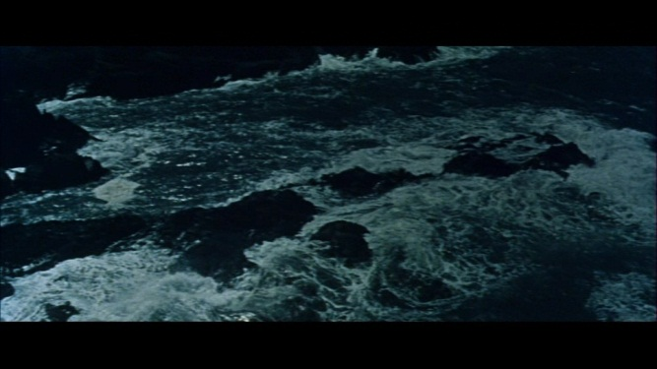
Figure 59. Rough seas, jagged rocks and muted nocturnal colours establish a foreboding tone.
This is then immediately replaced with a serene and pastoral scene of the coast from a cliff-top accompanied by a gentle pan across a pastoral landscape. The scene is light and sunny and the music placid as the credits roll. Camera placement and colour are crucial in this visual representation. In the first, the camera looks down from the position of a spectator from the edge of a cliff at night-time, signifying danger whilst the second is reminiscent of a picture postcard view that privileges the beauty of the tranquillity. Here we are reminded of Andrew Higson’s discussion of the importance of rural spaces in British film. Higson argues that ‘narrative space is never simply narrative space’ (2006: 240) but provides a space for spectacle and display within the diegesis. Invoking Raymond Williams and Martin Wiener, Higson suggests that the countryside is often deployed as shorthand for ‘tradition, stability and tranquillity’ and that as it can effortlessly signify a pre-industrial history, country films maintain ‘a sense of continuity with the national past’ (2006: 242). As we shall see though, the juxtaposition of the narrative themes against these interstitial spaces bound the narrative to a sense of identity and community that undermine the safe class hierarchy provided by, for example, the ‘heritage film.
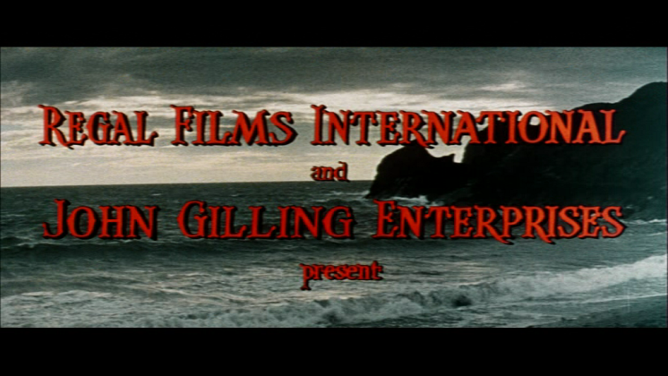
Figure 60. More serene seas follow.
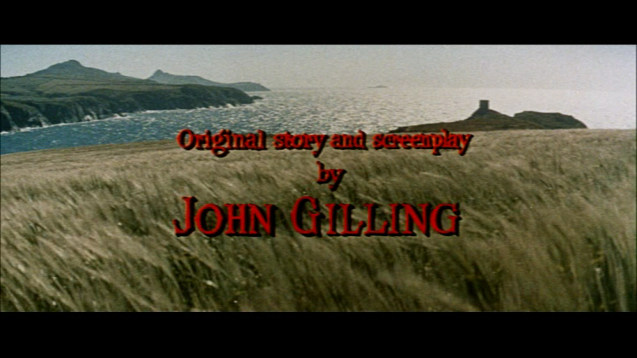
Figure 61. A Gentle pan across the coastline both a pastoral and maritime heritage.
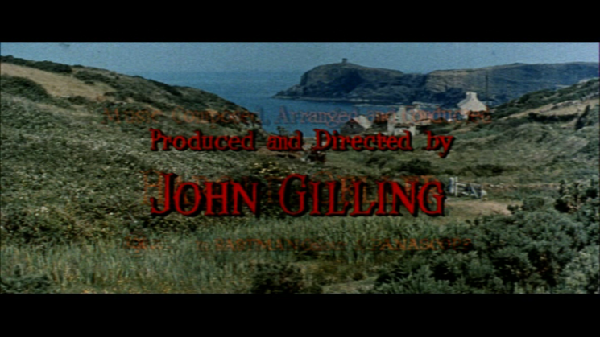
Figure 62. The aestheticized coastline.

The same pattern of tumult and serenity is repeated throughout the film, constructing an arresting visual dichotomy. This invests the visual landscape with emotional timbre, recalling the assertion of both Schama and Cioc that ‘landscapes are culture before they are nature’ (Scott, 2011: 189). The character of the landscape is the character of the nation, but scant attention has been given to such films in this regard, confirming what Pam Cook suggests of debates around identity that tend to ‘downplay the role of visual style’ (2006: 59).
Very often, the calming and serene is represented by the fishing community, foregrounding them as the ‘folk heroes’ of the tale, against the backdrop of their natural habitat the cliff-tops and shorelines of the coastal area. Again, placid sunshine accompanies their appearance as does a less tumultuous soundtrack. This is made explicit again towards the end whereby the final shootout at the beach and the death of the Squire is followed by a short montage of different shots of rough seas before fading again onto a serene shot of the gentle fisher folk at the shoreline and a series of calm and sunny coastal views similar to the opening titles. Here the suggestion is that the sea is becalmed by the return of the status quo, the juxtaposition of the rough and gentle sea and shorelines to the rhythm of the narrative from threat to restoration foreground its role in the identity of the community. Interestingly, the status quo that is achieved is not one of deference to class stratification and a municipal social order, but of the restoration of the sea folk to their simple way of life, unmolested by aristocratic or bureaucratic interference and the elevation of true love regardless of class divide. A sense of community and national identity is therefore rendered by proximity to the sea and legitimate maritime activities (fishing and smuggling) that does not adhere to institutional influence of naval obedience, law-making and established social order.
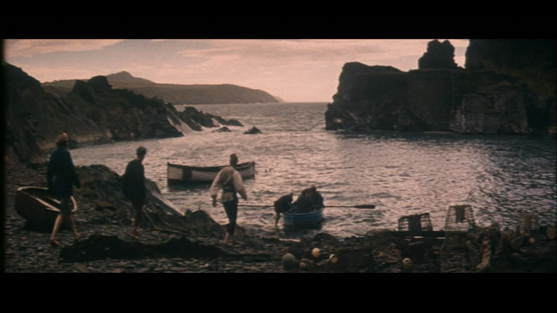
Figure 63. Fisherman and idyllic coastline.
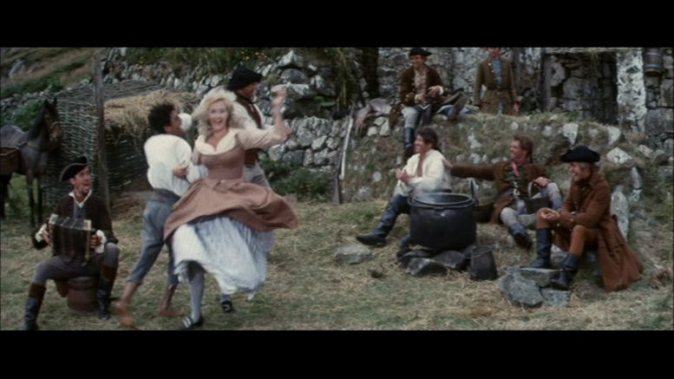
Figure 64. The folk community in a scene of utopian play.
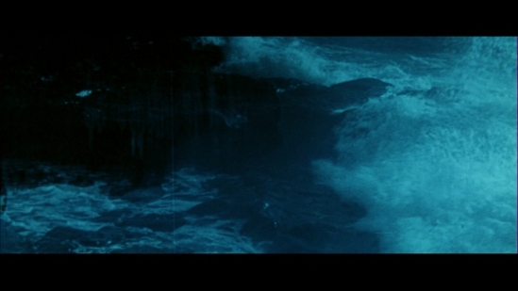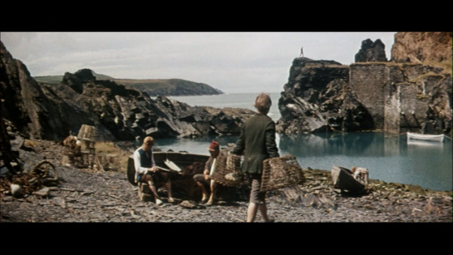
Figure 65-6. Dramatic contrast between stormy seas and calm community: the sea serving as metaphor for emotional conflict and utopian community.

Fury at Smugglers bay therefore presents an alternate conception of national identity to narratives of national unity and social order that are perhaps best exemplified by texts like Hornblower, where transgression is severely punished and fidelity to institution and social order are optimally expressed through patriotic fervour. That it was allowed to do so was perhaps due to its lowly status as a ‘swashbuckler’ or film aimed primarily at a juvenile audience. The ephemeral nature of the film is attested to by the paucity of critical response. Very few papers gave space to review it. The one exception was the trade paper Kinematograph Weekly (1961) which praised cinematographer Harry Waxman’s camerawork suggesting that it ‘beggars description’ and invests it with ‘a touch of class’. Kine also praised the location work which ‘reveal the English countryside at its best’ and that the ‘period atmosphere has been cleverly captured’. What was possibly unknown to these reviewers is the fact that the film, although set in Cornwall, was filmed entirely in Wales and so what the reviewers were praising was in fact a “constructed Englishness” (2006: 249) which creates a sense of familiarity with an imagined England. Thus the manipulation of community and identity is as constructed and phantom as the myths of Empire films, but the film’s message is not blunted, but enhanced by this artificiality. What we are left with therefore is a constructed myth of community and identity, but one which, by its rejection of societal norms and traditionally accepted values, stands in opposition to the myth of maritime empire which had dominated up until that point in British cultural history.

Conclusion
A remarkable consistency of representation is affirmed in comparison with the 1953 British-American Napoleonic era smuggling film Sea Devils (Like Hornblower RN, one of the ‘runaway’ Hollywood productions of the 1950s). This film also features a similarly worded prologue:
Guernsey in the Channel Islands near the coast of France in the year 1800, where fishermen, prevented from following their usual livelihood, turned to other occupations…
A Similar prologue also appears at the beginning of Hammer’s Captain Clegg (1962) which speaks of a ‘proud and independent people’ in defiance of the ‘revenue men’. It is clear that these films project smuggling as the only legitimate alternative for honest working-class figures against the oppression of taxes, war or general poverty, and Phillipson suggests that smuggling thrives in these areas as the people were perhaps ‘driven to the sea by the relative poverty of the region’ (1973: 86). Regional diversity therefore, long obscured up to this point in British cinematic history is also privileged which along with the transgression of establishment critique challenges the ‘parochial consensus’.

3:2 Piracy and Sea Change: Treasure Island 2012

The text of Robert Louis Stevenson’s Treasure Island carries with it many pre-conceptions. Firstly, it is often classified as ‘children’s literature’, and therefore seen to lack the emotional and psychological introspection that tend to mark out great works of fiction, and by extension, the film versions suffer from the same critical indifference. It is also, along with Robinson Crusoe (also commonly bracketed as children’s film and fiction), one of the ‘energising myths of Empire’ (Green, 1979: 3), thought to instil the common spirit, fortitude and aspiration of adventure’ traits that were thought to mark out the Englishman as particularly adept at building and maintaining Empires. These stories were said to embody the synonymous character that defined John Mackenzie’s ‘ideological cluster’ of empire, crown, race, armed forces and nation’ (Green, 1979). Allied to this, is the complicated relationship that texts produced in a particular nation state, share with the dominant cultural industries most likely to have the ability to render them filmically or televisually. Treasure Island is such a case, as the vast majority of versions of this have been Hollywood films or television adaptations, the most prominent of which were the 1934 MGM version with Wallace Beery and Jackie Cooper, and Disney’s version in 1950. British studios have ventured to project the myth, in an animated film version in 1950 and a live action version in 1972 with Orson Welles in the Long John Silver role.

The large budget British co-production of Treasure Island in 2012 provides fertile opportunity to re-assess the sea adventure myth in British film and television, as it demonstrates a new ambition and way of assessing the role that national identity plays in the complex web of mythology. The film was produced by Parallel films, MNG, RHI and Kindle entertainment for Sky 1 (and shown on SyFi in the US), and is a lavish production which features Donald Sutherland and Elijah Wood in its cast. Sky1 is a channel whose traditional demographic is an elusive young male audience, and this re-imagining presumably was intended to appeal to an audience who enjoyed The Pirates of the Caribbean.

Again, like the previous films discussed in this chapter, the metaphorical absence and presence of the sea in this story and the role of small community groups help to identify changes in the projection of national characteristics and the opaque boundaries between acceptable and unacceptable behaviour, challenging again the assumption that action is paramount over emotion or psychological complexity and Cawelti’s assertion about mystery that: ‘The moral fantasy of the adventure story is that the hero, individual or group- overcoming obstacles and dangers and accomplishing some important and moral mission’ (1976: 41-42). The character of the morality in relation to the adventure will be seen to disturb cherished notions of what the story represents, challenging the perception of a clear, national narrative.

The narrative of Treasure Island retains a surface fidelity to the plot of Stevenson’s novel, but changes character’s personality and motivation. The role of Jim Hawkins as a young man of about fourteen has varied, but in this version, he is certainly a young man rather than a child. Having recently lost his father, Jim (Toby Regbo) runs the isolated admiral Benbow Inn with his mother, Meg (Shirley Henderson). A mysterious sea captain, Billy Bones (David Harewood), visits the Inn and enchants Jim with tales of seafaring adventures, but scares him with excessive drinking, strange agues and warnings not to admit any other sea-farers to the inn. These men come to visit anyway, looking for a mysterious treasure map, but not before Jim and his mother escape with it after Bones dies of a heart attack. Confiding in Dr Livesey (Daniel Mays), Jim and he take the map to Squire Trelawney (Rupert Penry-Jones), to whom Jim’s father owed money. Promising untold riches, they decide to assemble a crew and sail to the East Indian Island the map details, assembling a crew under Captain Smollet (Philip Glenister) and sea cook Long John Silver (Eddie Izzard), who takes Jim under his instructive wing. It transpires that Bones, Silver and his men were all once part of pirate Captain Flint’s crew, who betrayed them for the treasure but died before claiming it. Trelawney then decides to deny Livesey and Jim’s part of the treasure, whilst Silver and his men wait to get to the island and stage a mutiny, seeking to claim the treasure as their own. Smollet, Trelawney and the remaining crew pitch up on a fort on the island and get the better of Silver’s men in a battle. Jim, vacillating between Silver’s men and the Squire takes his own initiative by murdering Israel hands and taking control of the ship for the Squire’s men. Silver’s men mutiny and he is captured by the Squire who locate the treasure and take it back to the ship. Upon setting sail for England, Jim decides the treasure is too much burden and they dump it overboard, despite the Squire’s protestation, who drowns attempting to recover it. Silver is set to hang but Jim takes pity on him and sets him free before being reunited with his mother at Bristol.

The film therefore makes a number of changes to the text, positioning Dr Livesey as a cowardly figure who eventually finds courage in battle, casting Billy Bones as a Jamaican and populating both the crew of the ship and the busy port of Bristol with black and Asian characters. A more prominent role is also given to Long John Silver’s Caribbean wife and Silver himself sports a tribal tattoo down his face, all suggesting that Britain’s seafaring history has not been the literally whitewashed vision of previous iterations of this text and similar projections of Britain’s seafaring history, but that British identity is currently in a state of revision, to give both prominence and voice to the myriad ethnicities which assembled the nation we have today. The energising myth of Empire is here re-energised as a multi-ethnic and multi-national enterprise. It is a small but important concession to redress the balance of what Stephen Bourne describes as ‘the near total exclusion’ (2002: 48) of black British history from British film. As Bourne describes, ‘Shockingly, the increasing awareness of Britain as a multicultural society in the present has little impact on British cinema’s acknowledgment of our multi-cultural past’ (2002: 48). This reminds us that the issue of national identity is still a crucial battleground, and one which is a long distance away from being equally representative of all sections of society.

It is the style and tone of the visual and narrative presentation that more definitively position this version of the text as darker, more psychologically complex and morally ambivalent than previous versions, presenting a conscious re-imagining of what has come to be viewed as a ‘children’s classic’ of ‘Empire building’. Stylistically, this version venerates kineticism over long takes and static camera shots. It also features an array of hyper-active camera styles, more contiguous with contemporary Hollywood vogue, including camera zooms and restless movement, zooms, close-ups, unusual and oblique camera angles and slowed-down and speeded-up sequences more akin to contemporary horror films. In short, this subverts the opinion of Perry Nodelman of John Hough’s 1973 version that, ‘Like many British TV versions of great classics, its careful and ostentatious craftsmanship constantly leeches away excitement’ (1983: 63).

If the excitement is not ‘leeched away’ in this version, nor does it supplant movement for emotion and psychological motivation. The mood is often downbeat and gritty, accented with de-saturated colour tones and different film stocks, and populated by mud and corpses, rotting apples and blood-letting. That this version is not aimed specifically at children is highlighted by the fact that we see Jim’s mother close to being forced into the murky world of prostitution when the Inn is repossessed by the Squire’s lackey’s (all of which do not appear in Stevenson’s novel). The film serves to fill in the gaps of previous versions by using flashback sequences to explain character motivation. The most prominent of which is Silver’s backstory which occurs as an explosive prologue to the film, in which he and his men are betrayed and set adrift by Captain Flint, and Silver’s leg is graphically decapitated by a cannonball, forcing him to hack off with a cleaver the mangled remains. This version certainly seeks to contradict Richard’s description of the genre as ‘anti-realism and anti-naturalism’ (1977: 10). Allayed with the different camera angles, the use of shadows, off-screen voices and nightmarish and ghostly images, the film has an expressionistic feel as landscape particularly the sea and shorelines again serve as visual metaphors for emotional and psychological turbulence. It would seem that Richard’s and others are perhaps wrong that these films cannot display emotional and psychological complexity, fully in evidence here (it should be noted that Richards was writing as far back as 1977 however).

If this text was traditionally seen as romantic, then this version serves to de-romanticise. The ‘energising myth of empire’ is also de-mythologised. It is worth considering the numerous parallels between these texts and the Hollywood western, its myth of strident male activity, manifest destiny, clash of civilisation and savagery and the taming of the frontier. The iconography of horses, isolated towns with saloons/inns at their centre and gunplay all chime with the traditional western. Similarly, some of the character archetypes share the same opposition of females as whores or homemakers, and lone masculine figures who either choose to exist on the margins or are marginalised by society. In both Fury at Smuggler’s Bay and Captain Clegg, the iconography and music echo that of a western and this was clearly not unrecognised by the makers. Peter Cushing described the former as a ‘British Western’:

The scenario contained all the traditional ingredients: lots of shootin’, the inevitable brawl in the saloon, a High Noon confrontation between duellists using swords instead of six-shooters and the cavalry charging to the rescue in the nick of time (2005: 55).

Cushing is expressing some of the surface similarities, but it is the civilisation creation myth that Treasure Island has traditionally been seen as sharing with western narratives, as well as Neale’s stress on the importance of ‘moving between spaces’ (2002: 56). Richards, Chapman, Cawelti and Cull all view the adventure films of British Empire as having commonality of purpose with westerns. The notion of ‘codes of chivalry’ being identical in all these is invoked, as Chapman describes the similarities as ‘the narrative of expansion, the taming of the frontier, the clash between civilisation and savagery and both feature outdoor action and spectacle’ (2009: 6-7). Here the pirate figure represents the lawless breed with their own internal rituals of behaviour and morality, much as the smugglers and wreckers in the smuggling narratives. The sense of morality and social responsibility is therefore immediately divergent from the dominant national narrative, and the idea of the sea hero, so clear cut in naval narratives, is problematized.

The sea therefore, and its relationship with the land presents a metaphorical masculine frontier for Jim, that he has to transgress and conquer on his way to becoming, in Silver’s words, “a fine gentleman”, or at least a ‘man’ in traditional cultural terms. In a scene during the voyage, in which Jim is shown literally learning the ropes of seamanship, he ascends the rigging with the crew, set against a picturesque and sunny landscape with shimmering blue seas and accompanied by triumphant music as the traditional male bonding in this disparate community presents the rare harmony of triumphant male endeavour. It is part of Jim’s rite of passage as a man. As Scott reminds us that in British history and traditional cultural association, ‘the discipline of the sea was inseparable from moral discipline more generally’ (2011: 66), suggesting that such ideas of masculine endeavour and societal recognition have not entirely been eradicated. The cultural residue of two hundred years of British male dominance at sea is perhaps inevitable.

Indeed, the metaphorical value of the sea tends to centre around the trajectory of Jim as he attempts to locate his place in the world, searching for a true morality and figure of masculinity amongst the various potential surrogate father figures. From the beginning, with the isolated Benbow inn set starkly against the coastline, Jim’s father’s funeral takes place against the sea with dull lighting and grungy atmosphere. Clearly a place to escape from and find a new father- figure, the sea presents this ominous opportunity. Later, when Silver’s men close in on Jim, these scenes are prefigured by shots of a dark and stormy sea, crashing against the rocks, again signalling the sea as a site of perilous and nefarious opportunity (it is after all, from where the pirates originate).
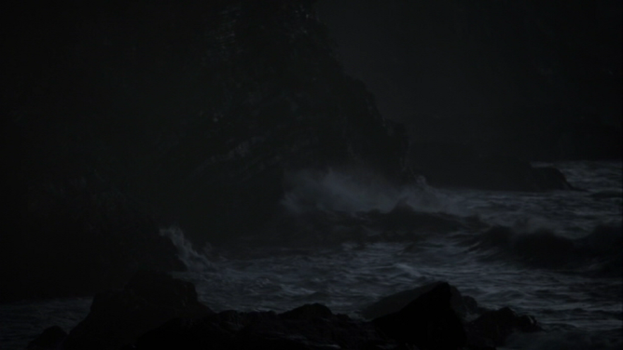
Figure 67. Rough seas again serve as a visual metaphor for situational torment.

As a dramatic juxtaposition to the previous scene in which Jim’s male rite of passage is configured against the sea, a scene in which the Squire effectively disinherits Jim and Dr. Livesey from their share of the treasure is set against a dark and stormy sea, concluding with Jim literally being seasick into it .
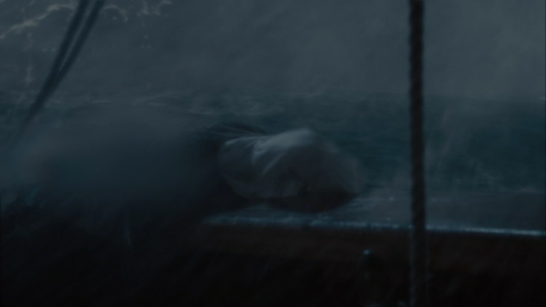
Figure 68. Stormy seas portend dark deeds by the aristocratic class.

Again, the rejection of both the Squire and the Doctor as suitable father figures is succeeded by rough seas and moral uncertainty. The polymorphous nature of the sea allows it to stand as a perpetual metaphor for the vacillating nature of morality and identity. This point is compounded when the Squire attempts to recover the treasure that Jim throws overboard. He ends up drowning and the sea provides an evocative visual metaphor for a character literally drowning in his own greed. Here, as Captain Ahab in Herman Melville’s Moby Dick, the sea engenders a peculiarly masculine form of self-destructive obsession.
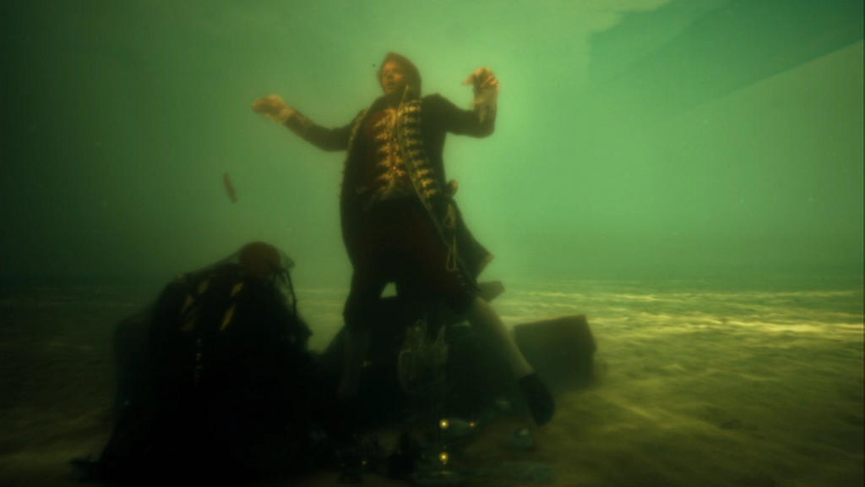Figure 69. Greed and ambition overcome the squire.

Piracy and the community are at odds here in this fantasy world, expressed visually in the narrative by the constant awkward juxtaposition of pirates on the periphery of social and domestic spaces, often captured against or looking out to sea. For example, compare the shot of Black John shot through the window of the Benbow Inn with the famous shot of John Wayne as Ethan Hunt in The Searchers (1956), often interpreted as a visual metaphor for the character’s perpetual existence on the liminal boundaries of civilisation.

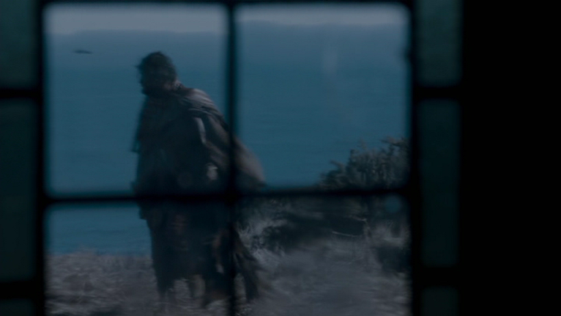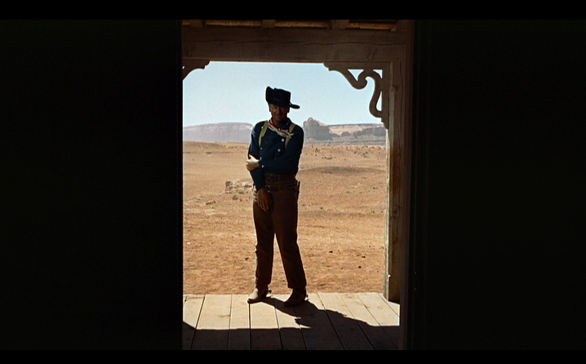
Figures 70-71. Framing the outsider. The similarity of Black John (top) and Ethan in The Searchers (1956) underlines the syntactical affinity between the pirate film and the western, and how the masculine outsider is product of his landscape.

Identity and morality are again represented by small maritime communities, often by duality and subterfuge. This classic text is an important site in which to interrogate this recurring principle. Kiely points out that such duality of purpose is inherent in the original text and that the author of Dr Jekyll and Mr Hyde, one of the most famous narratives of split personality, is a ‘literary enigma, changing his style, his face, his habitation, his genre, taunting his readers and daring his critics to give him a name that would cover all situations’ (1964: 19). Perry Nodelman also points out that ‘Almost everyone who talks about Treasure Island sees it as a combination of something and its opposite’ (1964: 59) As has been the case in all of the previous examples of this chapter, the nominal head of a small coastal community- usually the squire, is morally ambivalent, duplicitous and dangerous, invoking the theme of dual identity. The Squire here takes on particular contemporary and cultural resonance as a community leader driven purely by greed, willing to disinherit others and evict Jim’s mother. Again, this is at odds with a genre which Richards categorised as projecting an ‘emphasis on adventure and excitement rather than blood and greed’ and also that the interests of the ruling classes in these films ‘are identical with the interests of the people’ (1977: 23). As with the smuggling films, the duality of purpose, distrust of establishment and authority, and opaque shades of morality force us to re-assess the projection of national unity and identity in these films. Therefore Richards assertion that ‘imperialism was the dominant national ideology, transcending class and party divisions’ (1977: 24), appears less relevant than say, Jameson’s categorisation of the ‘obscure genesis of nationalism’ (2002: 24).

Such condemnation of the wealth imperative speaks to the global recession caused by reckless bankers and money lenders from 2008 onwards. Squire Trelawney’s greed is matched by that of Silver’s, who is equally murderous and single-minded. Whether intended by the producers or not, this is a discourse continually evoked in critical reception of the film on both sides of the Atlantic. In a positive review, The Wall Street Journal praises the ‘beautiful scenery’ but that after ‘the camp silliness of “Pirates of the Caribbean” there is a ‘refreshing authenticity in depicting the ‘hardships of seafaring life” (DE Wolf Smith, 2012). More explicitly, the review singles out the characterisation of Squire Trelawney as ‘a vile capitalist pig” even suggesting that the adaptation somewhat ‘plays out like “Treasure Island” as told by Che Guevara” These sentiments were echoed in The New York Times, which also described Trelawney as ‘a money-worshipping, back-stabbing weasel’ and that “the changes to Stevenson’s tale make this “Treasure Island” more clearly than ever a story about greed, and a very twenty first century take on greed at that” going on to draw distinctions with contemporary anti-capitalist movements:

The Occupy Wall Street movement will certainly find relevance here. Is the ownership of wealth defined by who earned it, without regard to how they earned it? How much money does one person, be he financier, pirate or boy, really need, anyway? (Neil Genzlinger, 2012)

In the United Kingdom, the reviews drew attention to the changes to the text, but stopped short in explicitly drawing a parallel between them and contemporary events. In an interesting reversal of proprietorial influence, the traditionally left-wing paper The Guardian opined the changes made to a classic text, suggesting that ‘It’s lavish, colourful, ambitious and very expensive. It looks fabulous, and swashbuckles along nicely’, but that ‘It’s also about changes for the worse’ (Woolaston, 2012). The review takes issue with Jim’s repudiation of wealth: …’and suddenly we’re all better, non-materialistic people…No, I’m sorry, that’s ridiculous’, before concluding that Stevenson and others would be ‘turning in their graves’. In contrast, the traditionally right-wing paper The Telegraph also repudiates the ‘moral epiphany’ that Jim has and warns of the changes to the text, but awards it three and a half stars out of five and concurs that ‘financier Squire Trelawney is turned into a greedy, double-crossing, aristocratic weasel’ (Ward, 2012).

Silver is also another character who betrays Jim’s confidence by displaying one side and embodying another. He is a sea-cook and a cutthroat at the same time, but is unhindered by the veneer of social respectability that accompanies Trelawney. He is afforded some sympathy though, partially through his attitude towards Jim and his determination to provide for his wife. They both aspire to a better life: “carriages and frock coats, our own pew in the church” as Silver articulates, an aspiration made poignantly clear in a fantasy sequence in which Mrs Silver imagines the two of them riding in a high society carriage dressed in expensive clothes. That this occurs just after the last of her money is taken by Black John, leaving her most likely reliant on prostitution to sustain her, exposes the manner in which aspiration in society is solely expressed in monetary terms, if that society does not respect other values.

Eventually Jim rejects in totality all the father figures available to him, and we assume is made a man by rejecting the brutal morality of ruthless individualism inherent in both Trelawney and Silver’s action, but embracing a moral individualism. The final scenes show him returning to the shoreline from whence he came, ready to go back to the community a moral man, made such by his adventures at sea. The immutability of the sea is conquered by his own masculine, moral certitude

Conclusion

Like Smuggling, therefore, piracy occupies a place in British history which draws the criminal into the configuration of identity, existing on the periphery yet seen to inform notions of the adventurous male spirit and enervating the spirit of Empire.

Piracy and the community are at odds here in this fantasy world, and the next chapter will demonstrate what happens to community and identity when the two are incestuously entwined in popular narrative.

3:3 On Her Majesty’s Service: Drake’s Venture (1980)

The two previous sections have focused on small communities and the role of criminality and duality on the fringes of society and the literal borders of Britain. This section will look at the more dominant narrative, of particularly, Queen and country and how criminality is woven into the fabric of the national story. The first case study will examine the 1980 HTV television drama Drake’s Venture featuring Sir Francis Drake’s circumnavigation around the globe. Finally, the last chapters will consider the action film North Sea Hijack (1979) and the James Bond franchise leading up to the character’s appearance in Skyfall and the Olympic Opening Ceremony in 2012, suggesting that Bond inherits the mantle of lone, maritime mercenary working for country, and more significantly ‘Queen’ as the ‘Mother England’ character becomes the ‘Mother Britain’ in these texts.

Drake’s Venture was a television movie produced by Westward television and subsequently broadcast on ITV in 1980 to coincide with Plymouth’s 400th Anniversary celebrations of the Drake’s circumnavigation. As with so many large- budgeted British costume dramas’, it was also broadcast on PBS ‘Masterpiece Theater’ in the United States in 1983. Directed by Lawrence Gordon Clark, best known for his BBC ‘Ghost stories for Christmas’ entries (he directed all but one in the 1970s from 1971-77) but who also directed the 1983 television smuggling adventure Jamaica Inn and a series, Captain James Cook, about another famous British sailor and adventurer, for Australian television in 1988. It was written by John Nelson-Burton who had written for Albert and Victoria (1970), ITV Playhouse and Armchair Theatre, thus establishing a canon of ‘quality’ television (not unlike I Remember Nelson). The series was cast and conceived on an epic scale, featuring John Thaw in the title role, and a replica of Drake’s ship The Golden Hind, not built exclusively for the series, but constructed seven years previously. It carries on a long tradition within British cultural history, including film and television, of portraying Drake as an iconic national hero- romantic and dashing as well as daring and resolute. As with Nelson, Drake was a popular figure in British films, appearing in the silent Drake’s Love Story (1913) and Sea Dogs of Good Queen Bess (1922) as well as the sound films Drake of England (1935) and Fire Over England (1937). These depictions migrated to British television in the early 1960s with the series Sir Francis Drake (ATV 1961-62) which fell within a cycle of televisual ‘swashbucklers’ including The Buccaneers (1956-57) and many based on real or ‘folk heroes’ including The Adventures of Robin Hood (1955-59), The Adventures of Sir Lancelot (1956-57) Ivanhoe (1958). Again, there is an echo of the Hollywood Western as American folk heroes of the Old West were migrating from film to television at the same time in such series as The Adventures of Jim Bowie (1956-58) and The Life and legend of Wyatt Earp (1955-61).

The film opens in Plymouth Sound as Tudor music heralds the successful return of Drake (John Thaw) to England after his successful circumnavigation of the globe (he became the first Englishman to achieve this and only the second Captain in the world) as he anticipates a meeting with Queen Elizabeth I (Charlotte Cromwell). The drama then recounts his voyage ending with his successful Knighthood. A meeting with the Queen reveals something of a special relationship between the two, with each dependent on the other, to a greater or lesser degree for their wealth and prosperity. Drake’s venture (this term, instead of ‘voyage’, perhaps prompts thoughts of business dealings) is successful as his ship is ‘swollen’ with treasure looted which will furnish the nation’s coffers for “a year, at least” meaning the trip was a success. As Ronald describes, ‘From the makeup of his investors it would certainly have been evident to the queen that Drake’s voyage had anti-Spanish and not trading or imperialistic motivations’ (2007: 203). The achievement of the circumnavigation is rarely mentioned, and the emphasis on Drake as a pirate or ‘El Draco’ (The Dragon) as the Spanish called him is a constant reference point for the drama. Drake’s proclamation to his crew “we go for exploration and Spanish treasure” belies the true intention of the voyage. This echoes Richard Hakluyt’s account of ‘The Voyage of Sir Francis Drake Around the Whole Globe’. One of the first sentences of the account of the voyage sets the tone for the rest, ‘we did descry certain Spanish fishermen to whom we gave chase and took three of them, and proceeding further we met with three caravels and took them also’ (2015: 1). It is an account also of greed and excess on almost every encounter, ‘we found great store of fowl which could not fly, of the bigness of geese, whereof we killed in less than one day 3,000 and victualled ourselves thoroughly therewith’ (2015: 6) and ‘Which being done, and they departed, we ransacked the town, and in one house we found a pot of the quantity of a bushel, full or reals of plate, which we brought to our ship’. There is also the theme of duality and duplicity, as Drake misleads the crew as to the true nature of the voyage, telling them instead that the ships are bound for Alexandria. Whereas Nelson’s men’s loyalty is based on admiration as much as the discipline of the navy in I Remember Nelson, Drake commands with an iron fist and tongue, but with the caveat of the promise of riches. It is this that provides the crux of the drama, as Drake’s relationship with the ‘treacherous’ Sir Thomas Doughty (Paul Darrow) ends in the latter’s execution. Doughty challenges Drake about his subterfuge, declaring that he speaks for the men. Drake then puts certain un-fortuitous events that subsequently occur down to Doughty’s ‘witchcraft’ and charges him with treason (thus partially establishing the accusations on the basis of a witch hunt). Doughty pleads his innocence and be permitted to stand trial back in England, but in another echo of both Billy Budd and I Remember Nelson, Drake insists that the ship must function as a microcosm for Elizabeth’s realm abroad (‘all things done in good order as near as might be to the course of our laws in England’, Hakluyt: 5), and presides over a makeshift court on the beach at Puerto San Julian, Argentina at which a gibbet stands, supposedly from the period from when Ferdinand Magellan had to execute mutinous members of his own crew (as a man who went before, Magellan’s name cast a shadow across many of Drake’s exploits in this production). The establishment of laws at sea are placed within an English context here, but is an internationally recognised system of codes, conventions and morality). Doughty is found guilty, and in a contrast to the condemnation of Carraciolo in I Remember Nelson, he is allowed to “die like a gentleman” as he requests. Drake happily accedes to this, stating “that I’ll do willingly…they’ll be no gibbet for you” (again, the ghostly creaking of the noose in Billy Budd and I Remember Nelson are echoed here).

By comparison to the series Sir Francis Drake, Drake’s Venture is a more sombre affair, being as much a tale of courtly intrigue and an examination of the challenges that faced Drake as it is an account of a heroic voyage. Similar to the critical reception for I Remember Nelson, the slightly more revisionist account of Drake was welcomed by the ‘quality’ press with the Times announcing that ‘the representation of Drake as a rough, tough sea dog is refreshingly original’ (1980) which was echoed by Sylvia Clayton in The Telegraph who wrote that the drama ‘managed to confirm his fearless brilliance as a navigator and his more dubious daring as a pirate’ (1980). For Chris Kenworthy in The Sun, after this show, no British Schoolboy is ever going to think that the Elizabethan Sailor’s only claims to fame were for playing bowls and conquering the Armada’ (Kenworthy, 1980).

However, the ship does function as a cipher for a scaled down England and the linkage between linear maritime voyage and onward national progress is emphasised in the nautical sailing chapters which are ever present, which function to convey romance and adventure, as ‘nautical panacea’ to the affairs of court and state and also an opportunity for reflection in the more languid and less triumphant tone they exhibit. The soundtrack, which employs Tudor instruments and arrangements helps to dictate the rhythm of this as the sparse nature of these arrangements tend to be less sweeping and orchestral as, for example, Khachaturian’s Spartacus from The Onedin Line, or Simon May’s orchestration for Howard’s Way, yet convey triumph in a similar, if less overbearing manner. The ‘triumph’ for Drake is less the feat of seamanship and adventure here, but more his ability to negotiate courtly and maritime politics, accumulate vast wealth for his Queen and also avoid her wrath and mortal condemnation. The drama thus ends with him being knighted aboard his ship with triumphant courtly and nautical pageantry ending with Drake’s oft- repeated command throughout the series to his crew “forrard”.

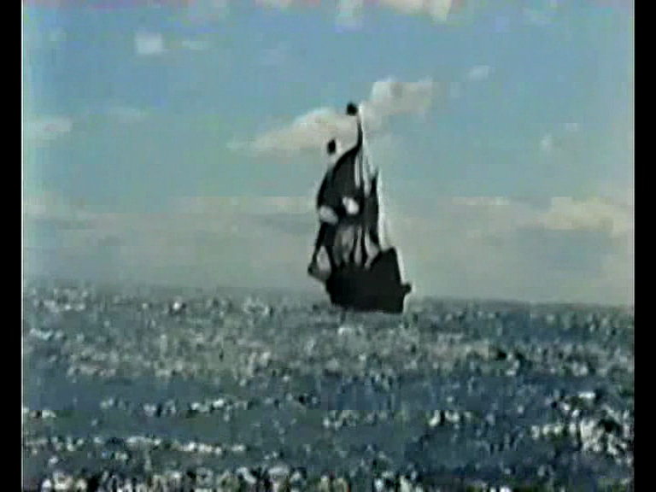
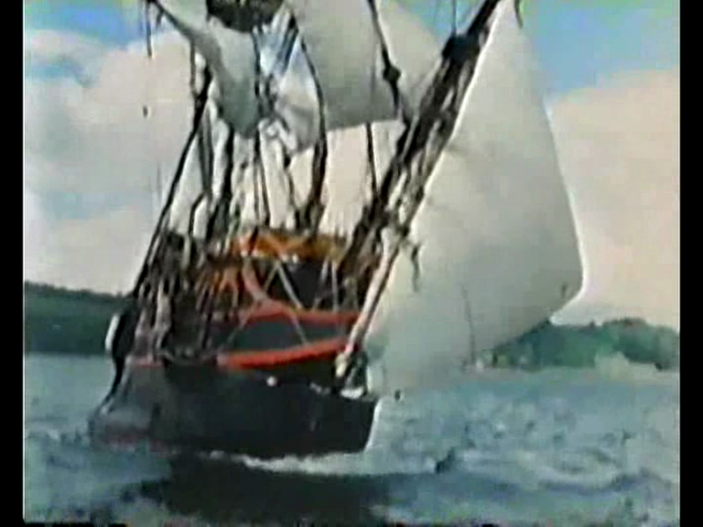
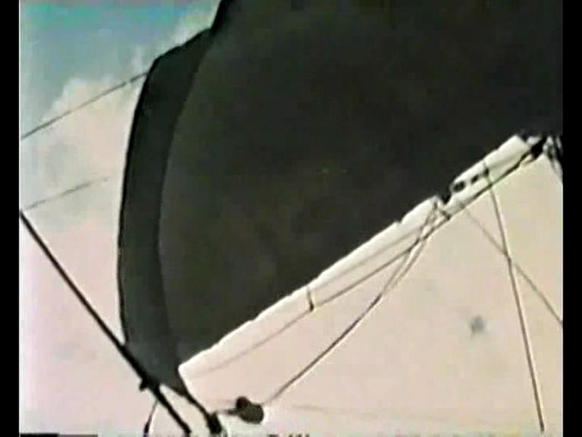
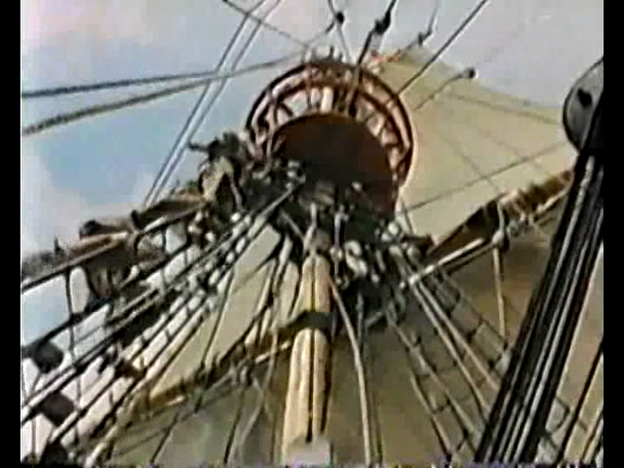
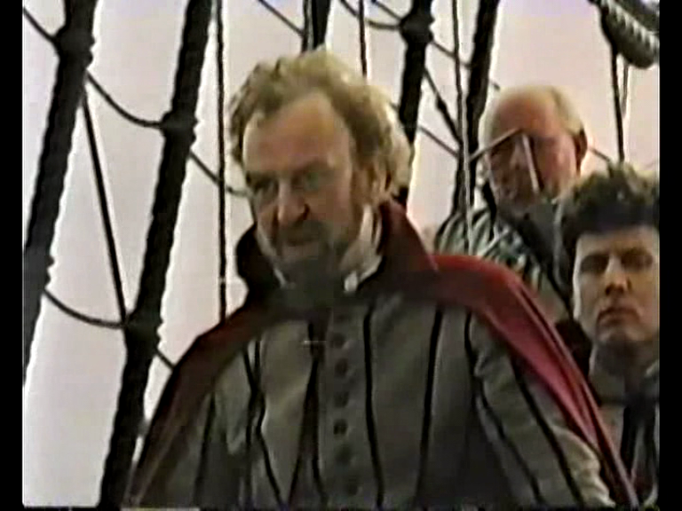Figures 72- 76. As in previous texts explored here, the spatial dynamics allude to nautical aesthetic pleasure, romance and onward progress and a strong Captain driving progress ‘forrard’.

Conclusion: Drake’s Venture and the National Sea Journey Metaphor

The repetition of “forrard” aligns Drake’s journey to the wealth and prosperity of England as the triumphal onward progress of the journey represents the progress of the nation itself. The narrative arc, thematic concerns and the visual style of Drake’s Venture continue a tradition of the sea journey metaphor which has been a constant in British culture for the past several hundred years. An obvious starting point would be Daniel Defoe’s Robinson Crusoe (1719), which also incorporated the ‘shipwreck’ metaphor for the break-up of old orders and new beginnings, as did Shakespeare in The Tempest and Twelfth Night. Such was the international success and resonance of Defoe’s text that it has been re-imagined and re-iterated in a number of national and cultural contexts. The story of Ernest Shackleton and Robert Falcon (Captain) Scott have also been consistently re-imagined, cleaving more assiduously to their British cultural context in extrapolating a national myth of adventure, determination and stoicism combined. There are several versions of Scott’s story, particularly during the silent era, Captain Scott RN to the South Pole, 1911 & 1912, and 90 Degrees South (1933). As Carolan (2012: 83) points out, when the documentary The Great White Silence (1924), about Scott’s failed expedition, was shown at Buckingham Palace, King George V was quoted as saying “I wish that every British boy could see this film for it would help to foster the spirit of adventure on which the Empire was founded” (echoing Green’s ‘energising myths of Empire’). The Ealing film Scott of the Antarctic (1948) carried the wartime notions of stoicism and defiant failure into the post-war era, resonating with the Dunkirk spirit of maritime adventure. Similarly, the BBC produced a four-part series based on the journey of Shackleton in 1983 and Channel Four co-produced a TV-movie in 2002. Defiance, whether against insurmountable odds, the elements, or bureaucracy are a constant theme in these texts, and it is a determined (even stubborn) and capable Captain that holds together the ship of state. The attack on institution and bureaucracy are more pronounced in a post-empire context and can be seen as well in the romantic comedy film Captain Jack (Robert Young, 1999). This film, which starred Bob Hoskins in the title role, is very loosely based on the real-life story of Captain Jack Lammiman, who in 1992 defied the Board of Trade and sailed to the Arctic with friends as crew in 1992, to commemorate the voyage of William Scoresby, a Whitby based sailor who sailed the Arctic attempting to find an elusive North-West passage. Lammimam not only defied the Board, but also thirteen maritime nations, The Royal Navy and NATO who all attempted to intervene and prevent his voyage (Observer, 1997, Guardian Supplement, 1998). A similar actual and metaphorical journey occurs in Channel Four’s Longitude (1999), a lavish Millennium inspired adaptation of author Dava Sobel’s non- fiction account of John Harrison’s struggle to both construct an accurate timepiece to measure longitude at sea and to force the English Parliament’s appointed Longitude Board to recognise his achievement (Sobel, 1998). It was directed, like Shackleton, by Charles Sturridge and like that text conflates the lone man’s struggle against bureaucracy and natural obstacles with national scientific progress and the navigational trope of keeping the nation on the correct course. In a similar conception, the lavish seven- part BBC drama The Voyage of Charles Darwin (directed by Martyn Friend with natural history sequences by Ned Kelly) from 1978 also presented a lone British hero or genius on a literal journey aboard the HMS Beagle, a metaphorical one in his formulation of the theory of evolution and a struggle against a Christian nation to which his theory was seen by many as an aberration. These examples suggest a number of important factors. Firstly, it demonstrates that both visual tropes and thematic and metaphorical conceptions of sea journeys within the national conscious migrated from literature to film and then to television. Secondly television facilitated the time and depth to deepen these conceptions within the serial form and further solidify them by habit and repetition. Thirdly, that a new pre-occupation with the successful achievements of scientists and inventors alongside adventurers and military figures demonstrates a shift in the national cultural barometer of achievement and value (this continues to be evidenced in British cinema and Television with highly successful biopics of Darwin (Creation, 2009, Alan Turing (The Imitation Game, 2014) and Stephen Hawking (The Theory of Everything, 2014). The paradigm of determined sea-captain or Englishman carried on the lineage of male maritime heroism and stoicism established in the expeditions of Scott and Shackleton and previously in the exploratory voyages of Drake, Raleigh and Cook. Similarly, the British public imagination was inflamed by the circumnavigational heroics of Sir Francis Chichester & Robin Knox-Johnston in the 1960s and Dame Ellen MacArthur in the early twenty-first century, similarly couched in patriotic terms. A continuance of tradition was therefore evident.

Drake’s Venture demonstrates that the notion of ‘privateering’, far from being on the periphery of British history, is integral to the birth of England and the foundation for wealth and success. Like the later film, Elizabeth: The Golden Age (2007) it exemplifies the notion of the Queen’s ‘Sea Dogs’: state sanctioned pirates or maritime mercenary’s whose success is woven into the character of the nation. Drake and Raleigh are national heroes, but in any other contexts they would be just as criminal as Long John Silver. Once again, analysis of these texts presents a duality in the national narrative, foregrounding a dark underbelly at the heart of national myth and identity.

The next example will demonstrate that this individualism continued to typify maritime national heroes four hundred years later, the difference being that by this time the Empire being protected was a ‘phantom empire’.

Chapter 3:4 On Her Majesty’s Secret Service: North Sea Hijack (1979) and James Bond

Introduction

This chapter will continue the themes of this section by looking at how those tropes of illegality and ambiguity in the national story and the themes of maritime ‘heroes’ and anti-heroes working for a mother England figure transpose into contemporary depictions and different generic forms and also how the matriarchal figure becomes mother ‘Britain’. The first part will analyse the action film North Sea Hijack (1979) and the relationship between hired ‘mercenaries’ (or irregular commandos) with and working on behalf of, ‘mother England’ figures, duality as a national metaphor and the various ways that visual projections of British maritime supremacy have migrated to less multilateral and authorised bodies than the Royal Navy since 1960. Lastly, it will then trace these factors through an examination of the James Bond franchise considering the lost provenance of 007 as Commander Bond of the Royal Navy through to the characters’ rejuvenation in Skyfall (2012) and the 2012 Olympics opening ceremony. At the same time, it will demonstrate how in essence, very little has actually changed over time.

By the late 1970s, the Elizabethan ‘Golden Age’ was a distant memory, as a stagnating economy, blackouts, prolonged labour strikes and a three-day week contributed to a sense of gloom around the old certainty of British supremacy. 1977 marked the 25th anniversary of Elizabeth II’s coronation, but the Jubilee celebrations were overshadowed by the rise of punk and a sense of inertia around young adults in particular that was to lead to hostility towards the establishment and old order. Class and social tensions were to exacerbate after the election of Margaret Thatcher in 1979 who tended to polarise opinion on the extreme left and right of the political spectrum.
The action adventure film North Sea Hijack (based on the book Esther, Ruth and Jennifer by Jack Davies, who also wrote the screenplay) released in 1980 is highly indicative of the social, political and economic climate that existed at the time, and was in fact particularly prescient of the Falklands conflict that followed (see section 1:4). It is a film which James Chapman (2001) places squarely within the remit of a ‘Boy’s Own’ adventure, with the hero saving what is left of the Empire, located within her maritime industry. As we shall see though, the film was aimed less at boys than it was men, with an anti-hero rather than a traditional hero at its core (indeed, the film carries a 15 certificate so is technically unavailable to juvenile audiences). The plot involves a team of multinational terrorists headed by the American Lou Kramer (Anthony Perkins), but including Japanese and Scottish amongst their number, who hijack a Norwegian fishing trawler, sail it to two British oil rigs, including ‘Jennifer’ which at 2000 million pounds is “the biggest and most expensive in the world”, rig them with explosives and threaten to blow them up unless they are paid a ransom of £25 million. Female Prime Minister (Faith Brook) and Admiral of the Royal Navy Sir Francis Brindsen (James Mason) enlist the advice and help of Rufus Excaliber ffolkes (Roger Moore), a freelance marine commando who leads a group of renegade aquatic commandos. He devises a plan to create an explosion that will lead Kramer to believe that they have unsuccessfully tampered with the explosives on Ruth, whilst ffolke’s men infiltrate the trawler and take out the hostages. The Prime Minister rewards ffolkes not with medals for bravery, but with three kittens, as per his self-declared preference for felines.
Roger Moore made this film at the height of his James Bond fame, and many interpreted his woman-hating, bearded anti-hero as the antithesis of his suave portrayal as a ladies man in the Bond films and The Saint television series (see for example, Interview with Mclaglen, Associated Press, 1980). It was part of a number of films in the 1970s and 1980s that starred Moore as part of a small team of mercenaries hired either by British companies or by the British government, which included The Wild Geese (1978) and the World War II maritime adventure The Sea Wolves (1980). This film, and the last example are predominantly masculine sea adventures, and Moore’s role is as an eccentric loner who hates women as he explains that he had five sisters, was raised by his aunt and married a woman who also had five sisters, although he has a fondness for kittens and tapestry. Such idiosyncrasies would serve to give the character depth if the frenetic plot allowed time for it. In this particular example, Richards would be correct in relating this film to action films whereby there is little attempt to define and extend psychological and emotional insight (1977: 248), which is largely jettisoned in favour of action. In this regard, it is not entirely dissimilar from Moore’s Bond adventures, a comparison that shall be further explored.
The film helps to exhibit to what extent British power and influence had waned since World War II, and in particular how the role of the navy had suffered a catastrophic decline by the early 1980s. The character of Admiral Brindsen is an uncertain figure, who suffers the indignity of relying on a civilian group to protect British maritime industry. He stands as a representation of the navy at this point, on the point of retirement, capable and brave but lacking in initiative. As he points out, much of this is due to funding cuts, “the navy and air forces are not big enough to keep an eye on them [the oil fields]”, and “our budget wouldn’t allow for it”, as a reflection of the contraction of the wooden walls. As suggested before, these events pre-figure the Falklands conflict in which a naval task force was sent to engage and protect the inhabitants of the Falklands Islands from the Argentine invasion. The timing was somewhat fortunate for the Royal Navy, who were only days away from de-commissioning vital warships in an already depleted navy. The victory was hugely significant for a number of reasons. Firstly, the tide of patriotism that followed the Argentine surrender on June 14th helped win support for a government most likely to lose the election the following year and ushered in a period of another fourteen years of Conservative government in Britain. It was seen as a victory for British naval power, and the first and (to this date) only successful unilateral British military action since World War II. It demonstrated to the world that Britain was still capable of punching above its weight and able to protect its ‘fantasy empire’. That it was also a naval expedition allowed Britain to retain the continuity of naval supremacy at a time when, as North Sea Hijack demonstrates, it appeared to be in inevitable decline. It is perhaps significant that the threat to Britain in North Sea Hijack is largely represented by American and Japanese terrorists, the two economic powerhouses that had displaced the British economy since World War Two (alongside Britain’s traditional enemies France and Germany). This fantasy allowed Britain to protect itself through covert operations instead of international conflict. Brindsen here represents the last wheeze of British naval power negotiating a new world order by the use of lone male figures.
The film was released in the autumn of 1979 several months after Margaret Thatcher was elected as Britain’s first female Prime Minister. As a reference to this, Faith Brook was cast as the female Prime Minister to whom ffolkes is hired to serve, but she is only ever referred to as Prime Minister (Thomas, 1980). Indeed, far from signalling a sea change in attitudes towards gender equality, the casting appears to be little more than opportunistic tokenism, and an atmosphere of paternal ascendency, and male ritualised fantasy pervade the film, hinting at a reactionary rebuke to female empowerment Brook’s Prime Minister is heavily reliant on her aides for advice on how to tackle the terrorists, as despite asserting “I do not propose to let a group of murderer’s hold the British nation to ransom”, the strategic planning is left up to the males and the ultimate say lies with ffolkes. As a character, ffolkes is actually only superficially different to his James Bond persona. In this film, he treats females with undisguised contempt and does not seem interested in sleeping with them. Likewise, although Bond is sexually active, the misogyny is no less well defined, and he turns acts of love into acts of conquest, moving on casually and indifferently to the next (the one vital exception being his ill-fated marriage in On Her Majesty’s Secret Service, 1969). Ffolkes role in this film is also not unlike the role of Drake and Raleigh in the previous examples, as both are essentially maritime mercenaries working on behalf of a female leader, although in this case, the role of the ‘mother England’ figure is subsumed by a lack of power. The phantom or fantasy empire had little room for this, as it was potentially a patriarchal construct.
James Chapman has suggested that the timing of Bond’s appearance in naval uniform in The Spy Who Loved Me (1977), coinciding with the ‘cod wars’ with Iceland (see chapter 1:5, were an attempt to project traditional British power culturally, by utilising the traditional concept of the navy, and filtering that through the lone figure of Bond (1999: 187). In North Sea Hijack, ffolkes represents the same figure, as despite his ambivalence to traditional institutions, he articulates to the Prime Minister the age old maritime threat to Britain’s security: “anyone with a rowing boat and a stick of dynamite could hold this country to ransom”. Indeed this threat to the economic lifeblood of Great Britain (Chapman, 2009) resonated from contemporary concerns. An article in The Times from 1976 reported:
A determined and well-organized terrorist would have little difficulty in getting on board a North Sea oil rig or platform, Rear-Admiral A.P. Besnard, Royal Netherlands Navy, Chief of Allied Staff, Channel Command, declares in a paper published today…The resources to deal with such a threat could come only from military forces (The Times, 1976)
However, military force was subservient to ffolkes in North Sea Hijack, and it is his daring heroics which ultimately restores Britain’s economic power and façade of military strength and security.

3:5 James Bond, the 2012 Olympics and ‘Mother Britain’

North Sea Hijack followed a pattern of cultural texts whereby the defence of the country is protected by a small group of outstanding individuals without the entire might of the British armed forces, but also by individuals who operate on the acceptable fringes of legality and morality. Again, the comparison to the James Bond franchise is marked, as well as the long history of England’s privateers. It is significant that the provenance of Bond’s character is of a naval Commander, recruited from the Navy by MI6, much like the creator Ian Fleming, and Ffolkes is also a character who has served in naval units. However, whilst the mercenary figure of ffolkes arguably provides a continuity of tradition with piracy, then Bond’s heritage is the gentleman heroes of John Buchan, Erskine Childers, Le Queux and E. Phillips Oppenheim (Cannadine, 2003: 286). According to Cannadine:

Of all great British institutions, Fleming most adored the Royal Navy. Bond himself, like his creator, is a former naval person; and so, too is M, Admiral Sir Miles Messervy…Naturally, M believes that the Senior is ‘the greatest of all Services clubs in the world’, and his house, ‘Quarterdeck’, is full of maritime mementoes, with its ‘treasured collection of naval prints. Everywhere there were mountainous seas, crashing cannon, bellying sails, tattered battle pennants.’ There M entertains 007 with his ‘stories about the Navy, to which Bond could listen all day- stories of battles, tornados, bizarre happenings, courts-martial, eccentric officers, neatly worded signals’ (2003: 293).

For Stock (2003), the space of M’s Office, filled with naval ephemera and artefacts of Empire, serve as a metonym for colonial times and a ‘stable point of departure’ (2003: 215) for Bond’s exploits on the liminal fringes of the Empire. When Bond meets M in a submarine in the Sea of Japan, Stock argues, ‘M is the administrator, as comfortable at home in the ocean as he is in London, as if the sea is a natural extension of an island nation’ (217).

Similarly, the Bond films have traditionally utilised imagery of the sea and shorelines within the narrative display and publicity material as exotic and penetrable spaces. In particular, Thunderball (1965) contains extensive underwater footage as does For Your Eyes Only (1981) and two of the most iconographical images in the series’ history include Honey Ryder (Ursula Andress) emerging from the sea in Dr No (1962) and Daniel Craig doing likewise in Casino Royale (2006). Similarly, the endless expanse of oceans, isolated islands and coastlines provide a de-nationalised territorial expanse in which global crime syndicates operate on the fringes of international law (Karl Stromberg’s maritime base in The Spy Who Loved Me, Scaramanga’s Lair in The Man With the Golden Gun and Silva’s abandoned island in Skyfall for example).

Just as significant as Bond’s heritage as a naval officer, is the almost entire absence of references to this after the early 1980s. It is indicative of a shift in priority in Britain’s world affairs and its symbol of national identity, and also how an institution such as the navy, once so prominent in discussions of Britain and what it means to be British could recede so precipitously into near insignificance. It indicates how the notion of national identity and imagined communities can be transitory and fragile, as well as deep-rooted and habitual. Writing as back as 1963, John Mander attempted to assess Britain’s changing role in world affairs. He concluded that a particular symptom of continuing to live in past glories is ‘mistaking the shadow of power for its substance’ (1963: 29), adding that ‘The Anglo-Saxons have come up against an immovable frontier which they cannot destroy without destroying themselves’ (1963: 37). Here, as in Elizabeth, the shadow of power is the visual images that make up the fantasy world of the cinema. Stock also argues that rather than shifting in emphasis to represent a post-colonial world, the Bond series continued to haunt the spaces of colonialism in subtler ways, ‘Nostalgia for colonialism betrays ‘colonialism by other means’, as does the culture of globalisation, exploiting the networks established by British naval prowess’ (2003: 229).

It is significant that Mander uses the term frontier to describe the metaphorical barrier against which he positioned post- Empire identity. In many ways, cultural imaginings allow the barrier to be temporarily suspended and the work of the lone hero to achieve the job of impoverished armies and navies is given freedom of expression. To widen the metaphor to include the environment of the sea- this is both literally constantly in motion and a metaphorical frontier of the imagination, much like the American Western frontier, which can be manipulated and utilised according to the needs of a particular narrative. It is also significant that North Sea Hijack was directed by the American Andrew V. Mclaglen, who was primarily known as a director of Westerns in the era in which the centrality of the genre to the habitual movie-going audience declined and was in some ways replaced by the revisionist strain of Western in which the values of the ‘old west’ were challenged and the genre acted as a cipher to explore the increasing fragmentation of American national identity and the values attendant to it. Mclaglen was also the son of the English actor of Irish ancestry Victor Mclaglen, who was a used by the director John Ford in his Westerns and other films (Voeltz, 2010). Mclaglen represented a tough rugged masculinity more akin to John Wayne and Gary Cooper in opposition to other ‘gentleman’ heroes embodied in Classical Hollywood by English actors such as David Niven, Ronald Coleman or Leslie Howard (see in particular Jeffrey Richards on Howard, 1997: 15, 21). There exists therefore an- inter and extra textual semiotic circularity between Britain and America here in the cultural exchange of personnel and subject matter. Mclaglen also directed the British film The Sea Wolves (1980) which focused on the true life World War Two story of a platoon of retired British servicemen in Goa who perform a covert operation to disable a German ship operating out of the neutral port of Goa which has been harming the British fleet in the Mediterranean. The cast list of this film also featured Roger Moore, David Niven and the American actor Gregory Peck, again providing an affinity to the respective roles these actors played in Westerns and war films amongst others.

The character of James Bond provides a link between the gentlemen adventurers of characters such as Biggles, Bulldog Drummond and Hornblower (incidentally played by Peck in the film version) and the anti-hero of Ffolkes in North Sea Hijack (although as Stock points out, Fleming conceived Bond as a ‘blunt instrument’ of British Foreign Policy, 2003, 1996) which mirrors Captain Vere’s speech in Billy Budd- “a crew that I shall mould into a weapon”. These gentlemen were still in evidence in British film as evinced by the 1979 version of Erskine Childers pre-WWI espionage novel The Riddle of the Sands starring Michael York as the sailor who uncovers a plot by Germany to invade Britain by the sea via a flotilla of floating barges. As with the Western, there is a focus on uni or bi-lateral masculine action to nullify a larger threat on behalf of others. This also suggests links with the famous Western The Magnificent Seven (1960- based on The Seven Samurai, itself influenced by Hollywood Westerns and providing more evidence of semiotic cultural circularity which here takes in Japan) and war films in which small groups of men, often mercenaries, criminals or others on the fringes of ‘civilisation’ band together to perform specific tasks in the fight against fascism. Hollywood examples here include The Dirty Dozen (1967) and Kelly’s Heroes (1970) and British counterparts the aforementioned The Wild Geese and The Sea Wolves.

Another context in which both Bond and Ffolkes operates is that of a series of secret service films, both connected to the maritime and other environs, which obfuscated the line between hero and anti-hero. At the height of Bond’s success in the 1960s, a number of films provided a spy figure whose character and actions stood in opposition to the glamour of Bond and the image of him as a suave and triumphant gentleman. As Shaw argues, these resonated with the political cold war climate of, particularly the Profumo Scandal, The Portland affair and the uncovering of the high profile Aristocratic Russian defectors Guy Burgess, Donald Maclean including No Love For Johnnie (1960) and Ring Of Spies (1963), the latter which dealt with the Portland Affair (2001: 58-62). Shaw describes both spying and the political establishment of being tainted by these and films ‘increasingly bore the marks of a dirty, contemptible business’ (57). Films such as The Ipcress File (1965) and The Spy Who Came in from the Cold (1965) infused the spy drama with a downbeat and murky existentialism which was evident in later films such as When Eight Bells Toll (1971) and Raise the Titanic (1980) and television dramas such as Tinker, Tailor, Soldier, Spy (1979). Similarly, films like the ‘disaster’ movie Juggernaut (1974) positioned threats maritime stability as coming from terrorism within as a disgruntled ex- naval officer places bombs on a cruise liner in retaliation for receiving a reduced pension. In a reversal of the real life threats to British unity and security from the renewed IRA, the bomb disposal expert is an Irishman portrayed by Richard Harris. The World War II drama Murphy’s War (1971) also depicted an Irish merchant sailor portrayed by the Irish actor Peter O’Toole (who had also portrayed the lone crusader T.E. Lawrence in Lawrence of Arabia), waging a one-man crusade to sink the German submarine which torpedoed the Merchant vessel he served on. These texts all operate within several different production trends and cycles within the 60s and 70s in both British and Hollywood filmmaking, suggesting their cultural relevance across a number of genres which linked masculinity and the maritime to a number of similar and conflicting conceptions. War films, westerns, disaster films, spy thrillers, mercenary films and existential dramas all exhibit a consistency of theme, presentation and setting which speak of a fragmentation of traditional myths and tropes, wider social malaise and the expression of a last ‘stand’ of an established masculine hierarchy in the face of this.

Against this backdrop, James Bond presented both a certain consistency and an adaptation to changing social mores. Yet within this, the casting of the character across the British Isles and Commonwealth hinted at an internal instability of the national (to purloin Higson’s terminology). In terms of Connery’s Bond, his character was harder and arguably more ruthless than the more ‘camp’ incarnation of Moore (see for example, Shail, 2008) and the brief portrayal by the Australian model turned actor George Lazemby. After Moore, Bond was portrayed by a Welshman, Timothy Dalton and Irishman, Pierce Brosnan before the franchise was re-vamped in 2006 with Englishman David Craig in the lead role. Craig’s Bond is physically imposing and his appearance occurred at a time whereby for the first time in Hollywood history, English actors were consistently cast in the type of masculine roles of enhanced physical presence once reserved for American actors (Cooper, Wayne, Stallone), those from the ‘Celtic’ fringes (Mclaglen, Connery, Baker) or émigrés from Europe (Schwarzenegger, Van Damme). English actors such as Jason Statham, Tom Hardy and Craig himself were cast as action heroes based on their bulked up, muscular physique marking a return to the 1980s when overly-muscular bodies were in vogue (See Tasker: 1993, Jeffords, 1993). Indeed, the period saw rejuvenation for these actors and the roles they played: Schwarzenegger (Terminator 3, 2003), Bruce Willis (Die Hard 4.0, 2007 and Stallone (John Rambo, 2008). Stallone’s The Expendables series (2010, 2012 & 2014) both gave role to a host of past and present action stars but also marked a throwback to the mercenary films of the 60s, 70s and 80s. If, as Jeffords claims, the hyper-masculisation of 80s movies stars reflected the hawkish, jingoistic and ultra-capitalist political ethos of the Reagan era, then a return to a similar political landscape under George. W. Bush (2000-2008) and his governments’ aggressive foreign policy may in part account for this regression.

Yet, as both the film Skyfall and the specially filmed Bond sequence for the London Olympic opening ceremony exemplifies, the more these factors changed, the more there was an irresistible pull to position Bond as a traditional character working within a traditional ‘British’ milieu despite the changing global context. Skyfall became the most successful film in British history (unadjusted for inflation) and was awash with Union Jack symbolism. Similarly, in conjunction with the national and cultural boost of the London Olympics, the Royal Wedding of 2011 and Queen Elizabeth’s Jubilee of 2012, the Union flag was a constant presence both in Britain and projected abroad, unprecedented after decades where it had been co-opted by the far- right National Front and supplanted by the flag of St. George to represent ‘Englishness’ in prominent sporting events, as opposed to the unifying totem of Great Britain.

Skyfall represents a post-modern bricolage of both Empire and the series itself. Classic cars from the series sit alongside J.M.W. Turner’s ‘The Fighting Temeraire’ and a union Jack bulldog. In common with Stock’s assertion that M’s metonymical office could stand for ‘museum’ in its nostalgia for the past (2003), Skyfall itself could offer the same living museum to a recent past. What is particularly revealing is the foregrounding of a maternal relationship between Bond and his superior ‘M’ (Judi Dench). The villain in the film, Silva (Javier Bardem) is one of ‘M’s former charges whom she abandoned when their cover was blown. His revenge is laced with feelings of anger at ‘M’ for abandoning him and he talks of Bond as though he were the favoured brother in a sibling relationship. Silva’s determination to eliminate ‘M’ forces the film to take an unusual step with Bond essentially operating as her personal bodyguard for a good portion of the film as it is made clear that her survival is essential to the health of the nation. It is interesting then to compare this with Fleming’s own relationship to his mother whom Cannadine describes as a ‘stern and dominant matriarch’ (2003: 282) and his own hatred of the Welfare State that made men want to be ‘nannied’ and women to ‘dominate’ creating in his view ‘pansies of both sexes everywhere’ (2003: 297). ‘Mother England’ here becomes ‘Mother Britain’ in the profusion of Union flags and the ‘metonymical M’ stands also for mother.

This linkage with a recent past is underscored by the fact that the denouement takes place at Bond’s childhood home in the Scottish highlands (reminding the viewer of Fleming’s original character as being of Scottish descent) thus extending the parameters of the realm beyond the Metropolitan centre. This ties in with some of the other texts discussed as ffolkes’ base is at a Scottish castle, the villain in When Eight Bells Toll has an underground lair beneath a Scottish Loch and in Madame Sin (1972), the titular villain (Bette Davis) is based on a remote Scottish island (both examples filmed in Mull) as she plots to steal a Polaris missile from the Royal Navy and sell it to the Cubans, (similar to the plot of For Your Eyes Only). As Cannadine points out, Fleming was also of Scottish descent and his Bond novels suggest a lineage to Robert Louis Stevenson as well as a fascination with piracy, adventure and hidden treasure (2003: 286-9). Like the fringes of Cornwall, Wales and the Channel Islands in the smuggling and piracy texts, Scotland is remote and liminal, dangerous and desolate yet part of the nation at large.

If the plot of Bond as protector of ‘Mother Britain’ in Skyfall were not explicit, the specially filmed sequence Daniel Craig filmed as Bond with Queen Elizabeth II for the Olympic opening ceremony foregrounded it at one of the biggest global media events and international exports of ‘Britishness’. In this short sequence, Bond is shown arriving at Buckingham Palace then escorting the Queen by helicopter to the Olympic Stadium, past London landmarks and a waving Churchill statue to the theme from The Dambusters (a bricolage of fictional and WWII myths). On arrival, they both parachute into the stadium with Union Jack parachutes (as in the intro to The Spy Who Loved Me) to Vic Flick’s bond theme. We therefore come full circle to the genesis of Englishness, as lone maritime mercenaries continue to protect the realm of Queen Elizabeth.

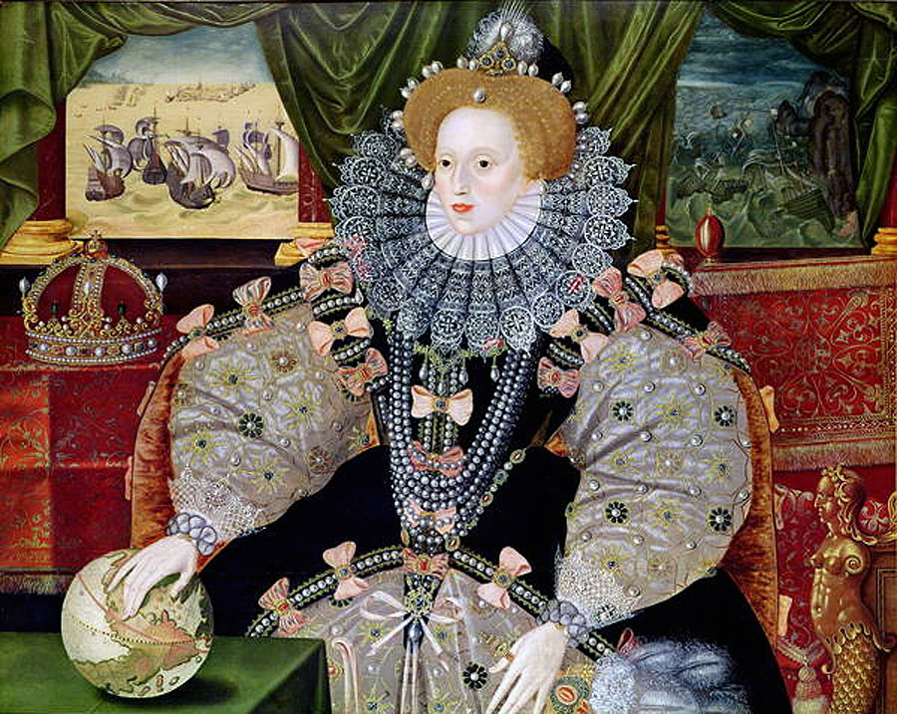
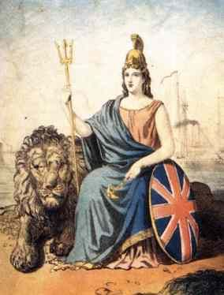
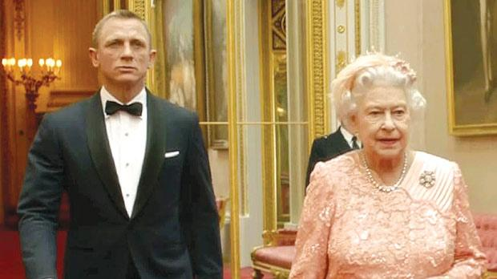
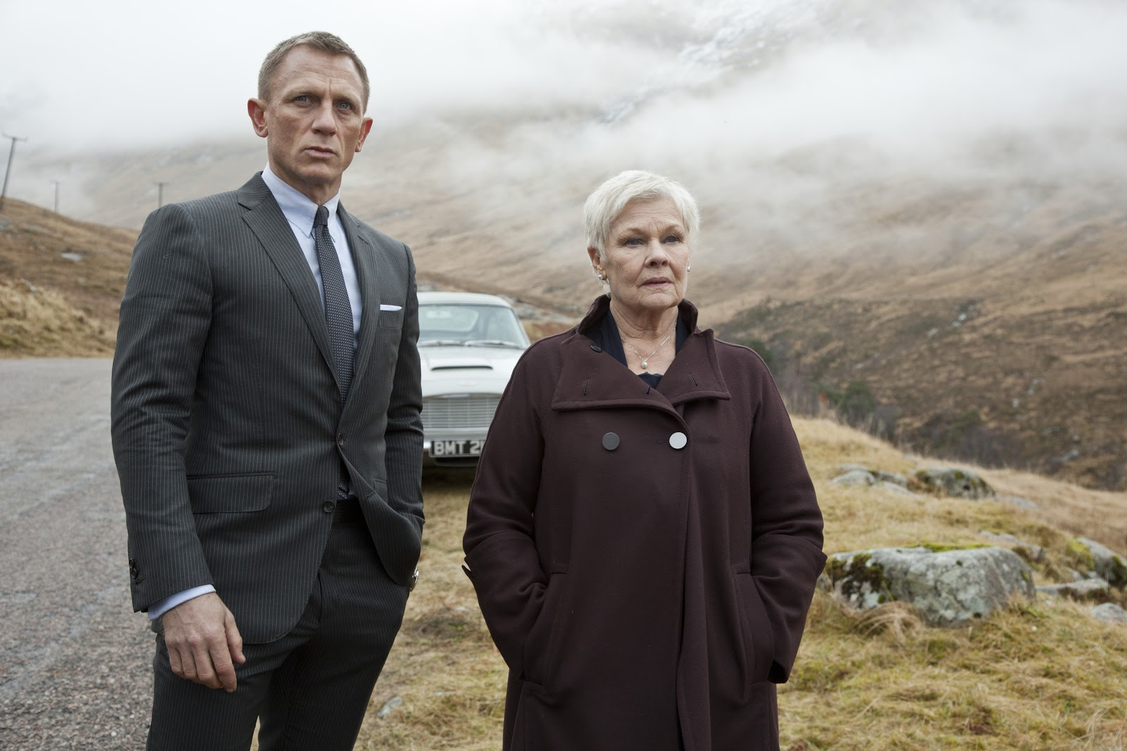
Figures 77-80. ‘M’ For mother England/Britain. Gower’s portrait of Elizabeth I with ships in the background and one hand one the globe, A 19th Century portrait of Britannia with ships in the background, Elizabeth II and Judi Dench’s ‘M’ with Daniel Craig’s James Bond as mercenary/ protector.

Conclusion

Both Ffolkes and Bond suggest a lineage of maritime heroes/mercenary’s protecting the nation that, as has been demonstrated, stretches back as far as Drake and Raleigh. In many ways, fantasy heroes protect a fantasy empire, and these figures haunt the colonial spaces of post-imperialism, suggesting how much of a shadow this casts over the contemporary environment. The use of these figures by Queens, a female Prime Minister and female heads of division suggest that Britain is at its most vibrant when it can claim a female matriarch presiding over the Kingdom, taking us up until the present day and the Cultural projection of Britain at the 2012 Olympics.

Section Conclusion

As we have seen, analysis of post 1960 maritime adventure films reveal a complicated projection of national identity that both challenges the dominant narrative and weaves itself into it. What these films share in common, apart from a paucity of critical response and scholarly attention, are themes of community and identity that transgresses legality, defiance of law enforcement, criticism and rejection of societal hierarchy, a distrust of traditional British Institutions (the navy, government, aristocracy) and dual identity as a common theme in leadership figures. If Joseph Conrad’s famous quote that ‘salt is in the blood’ of Englishmen is true, then it is clear that a number of other toxins also co-exist.

They all also utilise the sea and its surroundings as being both responsible for the character of the people who inhabit it and representative of the emotive response of those within it. As such, they represent vitally important texts in understanding the relationship Britain has with both its landscape, its people and its identity.
Piracy and smuggling films tend to be marked by the following themes. They are set in isolated maritime communities, whose affinity with the landscape and seascapes and their venerable maritime traditions suggest themselves as romantic portraits of those on the literal and metaphorical fringes of landscape and civilisation. Their themes and iconography and the clash between civilisation and barbarity in the wilderness of the maritime realm and the visual and aural depiction of landscape position them as similar to the Hollywood Western genre. They also commonly feature a person of high standing in a duplicitous and villainous role which all point towards a community both at odds with a national, metropolitan community and one in which illegality and darker deeds are woven into the tapestry of the national narrative.

Similarly, these traits are exhibited within other genres, including the heritage drama and historical drama in which the endeavours of privateers working for Elizabeth I provide the basis for the prosperity of the ‘Golden Age’ and the genesis of ‘Englishness’ as pre-eminent and victorious globally. This duality within the national story draws the fringe into the mainstream, moral certainty into question and the maritime realm into the heart of national identity.

Texts like North Sea Hijack and the James Bond series amongst others continue several of these traditions into the present age. They replicate the theme of lone maritime mercenary or small group of mercenaries acting on behalf of the nation as a whole in an era in which the navy has receded from prominence. They also highlight the conception of England and Britain as matriarchal in conception as they suggest that the genesis of English greatness was under the Reign of Elizabeth I the ‘Pirate Queen’, British greatness under Queen Victoria, her Merchant fleet and ‘Pax Britannica’ and the current incarnation of cultural or ‘phantom Empire’ under the stewardship of Queen Elizabeth II. The centrality of the maritime sphere, in an official and unofficial capacity continue to inform prominent conceptions of British national identity, just as the old shipping routes continue to provide a constant echo of past greatness and the residues of the maritime in the English language now spoken by over 800 million across the globe. They continue to inform national identity and the audio-visual language of film and television gives expression to this as a ghostly cultural echo of a phantom maritime empire in the same manner that James Bond haunts the routes and spaces of a colonial planet in a post-colonial era.

Thesis Conclusion

This thesis has yielded a number of important conclusions from its original remit and research questions which significantly contribute to the academic disciplines of film and television studies, cultural history and national identity. Emphasis on texts produced at ‘key historical moments’ in post- 1950s Britain emphasise a national identity on flux, whereby changes are highlighted alongside tradition and continuity. Perhaps foremost amongst these, and in more general terms, it has demonstrated the importance of the audio-visual form in constructions of myth and identity, the continuing importance of attempting to navigate through the notion of a national identity or identities and the importance of maritime landscapes and seascapes to notions of a specific national ‘belonging’, collective myth, memory and unity. The relationship between, first film and later television, with earlier artistic and literary forms of cultural maritime heritage provide a cultural continuity through new audio-visual and technological forms, whilst offering different spaces and environments in which to absorb and process national mythology and the relative challenges to these. In particular, the links between these texts and Britain’s artistic maritime heritage, particularly ways of ‘looking’ and ‘seeing’ the natural environment, with the addition of replicating it aurally, provide a cultural continuity which sits alongside the continuity of Imperial, martial and mercantile visual pageantry (as seen in The Falklands, Queen’s Jubilee’s and the 2012 Olympic opening ceremony).

The most consistent audio-visual consistency with regards to depictions of the maritime and British national identity is the commonplace conflation of romantic music with aesthetically motivated, constructed and composed sailing shots to create a nautical ‘panacea’, often, but not always employed as a narrative ellipsis connecting two chapters which works to assuage narrative elements of disharmony or to suggest the romance and adventure of the sea journey. Functioning within a national context, they provide a conduit for collective national pleasures and connect the sea, sailing and maritime environments to their historical conceptions of military, mercantile and exploratory triumph. This is evinced across the case studies looked at as Hornblower, HMS Defiant, Warship, The Onedin Line, Howards’ Way, Drake’s Venture and Treasure Island all exhibited the same tropes and iconography. They were also in evidence in a number of texts from the time period that the thesis did not cover in detail such as Sink the Bismarck!, Lord Jim, The Voyage of Charles Darwin, Jack Holborn, The Spy Who Loved Me, Captain Jack, Sir Francis Drake, High Tide, The Fishing Party, Kidnapped, The Master of Ballantrae, The Bounty, The Lifeboat numerous others. Of course, we have seen that there are also specific exceptions which prove the rule, most notably Billy Budd and To the Ends of the Earth which invert these tropes to suggest the opposite.

Allied to this is the identification of a ‘sea-journey’ motif itself as an audio visual trope or sub-genre that functions within this specific national context and also can be read in a similar fashion across media producing nations, rather like the more obviously explored ‘road movie’ genre or sub-genre. Again, within this context, the onward and linear sailing trope is a constant source of referral to the onward progress of nation: an audio-visual space in which the linear economic, scientific or moral progression of a nation is allied to the successful completion of a sea journey.

Within this construction, the importance of the ship as representative of state or nation is imperative. As Chapman identified within Master and Commander: The Far Side of the World (2003), the codes, moralities and hierarchies of (particularly) a naval warship reflect the ordering of classes and society in Britain, both at the time, and in many respects, to this day (see also Richards, 2003). Similarly, the ‘loss of the ship’ motif identified as a commonality in naval films (2007), is very much in evidence in the time period covered. The numerous iterations of the Titanic myth (S.O.S. Titanic, 1979, Raise the Titanic, 1980 & Titanic 2012) as well as other British productions which heavily feature the whole or partial loss of a ship (Britannic, 2000, The Wreck of the Mary Deare, 1960, Murphy’s War, 1970, Juggernaut, 1974, as examples) all suggest that the loss of a ship is still representative of a greater national loss, whether it be an old set of values, a national treasure, a beloved protagonist etc. Even texts which invert the myth still invoke the metaphorical ‘loss of the ship’ as representing a larger, more intangible loss (Billy Budd saying “goodbye” to the ‘Rights of Man’ or the breakdown of society and romance, held together with fragility by ropes in To the Ends of the Earth). Indeed, the story of the ship takes on an extra- textual significance for both audiences and critics alike. Audiences flocked to see the stars of The Onedin Line during the 1970s and 1980s and see the ‘Charlotte Rhodes’. The loss of ‘The Marques’ which also features in the show as wells as The Voyage of Charles Darwin, Jamaica Inn, Dracula and The Master of Ballantrae which sunk on June 3rd, 1984, was reported as a national loss (The Times,1984: 1, Daily Telegraph, 1985). Similarly, boat shows in the 1980s were boosted by the appearance of the boats that appeared on Howards’ Way, and like the ‘Charlotte’, the shows main boat ‘The Flying Fish’ was lamentably reported as having sunk in 2009 (Daily Echo, 2009). In particular, the manner in which critics reviewed or described shows were symptomatic with a close and personified relationship to the ships themselves, turning them into national treasures and minor celebrities in their own right. We have seen this in critical reception of Warship and Onedin particularly, and the following reviews of The Voyage of Charles Darwin is representative of a consistent critical reaction to films and programmes featuring ships:

The Voyage was the magnificent centrepiece of the whole production. We got to know that little ship as none other that has sailed across the TV screen (Daily Mail, 1978).

Chapter one concluded that the role of the navy in British cultural life has diminished with stark rapidity simultaneous with the loss of Empire from the same arena. The television shows Warship and Making Waves were rare instances of the contemporary navy being depicted in a contemporary post-1960s setting, again in contrast to its ubiquitous cinematic presence from 1895 until at least the 1950s. Therefore, the move to historic examinations of the Royal Navy, particularly in the genesis and mythic periods of Armada, Trafalgar and World War II era Britain suggest that maritime heritage is a valuable (and increasingly so) commodity to notions of collective memory, unity and identity. Indeed the brief eruptions of public and media interest in the role of the contemporary navy to Britain’s prosperity as evidenced by the metaphorical failure of the ‘Cod Wars’ in the 1970s and the success of the Falklands campaign in 1982 reflect the paucity of fictional depictions and again the continued presence of the historic navy acts as a ghostly echo of another era. The British fictional media landscape is haunted by the presence of square-rigged sailing warships which constantly re-iterate that which has been lost in a post 1960s or World War II environment.

Chapter Two concluded that depictions the Merchant Navy and the mercantile prosperity of the Victorian era is underpinned by the elegiac loss of particular environments and British ways of life which is compounded by depictions of dwindling maritime manufacturing industries and fisheries, again providing a ghostly reminder of the past and haunting metaphoric and cinematic landscapes. Dockyards, shipyards, trawlers and square-rigged merchant vessels all provide cultural ghosts that populate a cinematic ‘phantom empire’.

Chapter two also suggested a national shift from the production and manufacturing of goods to new industries such as leisure and tourism from the 1970s onwards underpinned by competition in global trade and emerging economic nation states and the continuing reliance on fossil fuels as sites in which the antecedents of sailing and romance, nautical panacea, male maritime working environments and rites of passage transpose somewhat into new forms. However, these themselves are overshadowed by a continuing obsession with the loss of or challenge to clearly defined spaces of masculine triumph and male identity within a national context. The decline of these industries and fragmentation of safe homo-social spaces is further challenged in different ways by the increasing role and visibility of women in male-dominated working contexts. Howards’ Way, Roughnecks and On a Clear Day all construct British maritime working contexts in which patriarchy is still in evidence but increasingly threatened by changing social contexts in unison with changing economic environments which are instructive of larger national changes. The disproportionate decline of regional areas which were overly reliant on the success of maritime industry and commerce create yet another haunted space in the British cultural and philosophical imagination.

Chapter two also introduced yet another haunted environment to the cultural projection of the maritime by introducing the concept of cultural, class, economic, ethnic and gender servitude. The Onedin Line in particular provided a flip-side to national nautical romance by invoking the ghosts of slavery across these concepts. These were matched by other productions which suggested that British maritime history is a complex site at which identity can be ascertained and explored in which the spectre of slavery ‘erupts’ into previously uncomplicated depictions of British maritime supremacy such as The Sailor’s Return, A Respectable Trade and Amazing Grace. These eruptions within the otherwise celebratory construction of Empire and modern Britain challenge their relative ‘colonial amnesia’. This all reflects a social environment in which a more diverse and ‘bottom-up’ conception of British history and identity could be culturally explored and critiqued.

A social environment in which the dark undercurrents of British national identity were projected is also vividly evoked in Ghosts and True North which both provided further evidence for the social fissures created by declining national industries and global economic pressures. They created a continuity of maritime slavery from the historic portrayals in The Onedin Line and other aforementioned texts and fused it with the elegiac depiction of the decline of fisheries apparent in texts such as Land of Green Ginger and Spyship to create a ghostly maritime environment of death, destruction and desperation further compounded by their links to a late twentieth century and contemporary concern with fragile and eroding coastlines and the pollution of maritime environments first depicted in texts like Doomwatch and later Flood (2007).

Chapter three further widened the interrogation into different maritime communities, concluding that the depiction of small fishing/smuggling communities and those on the fringes of piracy and other forms of maritime illegality presented a challenge to the homogenous conception of national community and identity. A critique of hegemony was more visible for several reasons. Firstly, they take place in fringe and isolated communities, often more Celtic than Anglo-Saxon. Secondly, they often take place in a Nineteenth century setting, so the social critique is largely ameliorated by the passage of time. Lastly, the critique was less marked as these were often targeted to juvenile audiences and so received little in the way of critical attention.
The communities also were presented as being part of the maritime landscapes and seascapes: their identity being synonymous both with the landscape and their maritime industry, much like the naval ratings, merchant sailors, ship and rig workers, fisher-folk and others in chapters two and three. Their association with romantic eighteenth and nineteenth century environments also invites comparison to the romantic portrayal of gypsies in early British films, whereby their ‘freer’ lives in the countryside on the fringes of ‘civilisation’ are seen as an escape from the complexities of modernity (see for example Crimes at the Dark House, 1944 Madonna of the Seven Moons, 1944).

These texts, featuring a maritime contrast between civilisation and savagery also bear comparison with the American Western in which texts often feature the contrast between honest farmers and brutal capitalist landowners (e.g. Shane, 1954, Open Range, 2004). Similarly, an iconography of guns, horse riding across the countryside and militia replacing the cavalry charge all bear at least a visual similarity with the Western. This is further exemplified by the constant theme of duality with institutions such as the church and respected Squires and dignitaries turning out to be duplicitous, villainous and criminal indicating the dual nature of national institution and therefore national identity.

The theme of duplicity in the depictions of Sir Francis Drake and Sir Walter Raleigh in Drake’s Venture and Elizabeth the Golden Age is also marked in famous maritime heroes who were pirates or privateers: maritime mercenaries on her majesty’s service (and by extension, on behalf of the nation). They suggest a duality in the national narrative in the same way as the piracy and smuggling texts which extends to the costume or heritage drama. These texts also set up a matriarchal paradigm with the males in the personal service of Queen Elizabeth I. This is also extended across other genres- the action adventure genre as exemplified by maritime ‘irregulars’ working on behalf of a female Prime Minister in North Sea Hijack and for both a female matriarch in ‘M’ and another Queen Elizabeth (II) in the James Bond series (particularly marked in Skyfall and the Olympics opening ceremony sequence. These texts also demonstrate a lone male individual working to protect the country as a last expression of soft power in the British Empire. The spectre of colonialism, post-empire environments and dwindling pre-eminence of the Royal Navy all inform these texts providing further examples of a national identity in flux as shifting international powers inform the necessity for a cathartic and phantom Empire.

Another key finding which emanated from the thesis is that the range and depth of British film and television with a maritime theme. Depictions of the sea within the national context is a significant area which challenges the pastoral and rural myth of British film and the construction on collective national memory and identity. The consistent romantic portrayal of the sea and seascapes across the time period and in different generic contexts attests to the romantic, exotic, adventurous and nostalgic appeal of the sea within notions of British identity positioning it as a traditional site of identification and reflection, and one which has been largely ignored especially within scholarly work on British medias which challenges the pastoral myth of British national identity. The manner in which film and television constructs, arranges and projects space is key to these conceptions. As has been demonstrated through close analysis of these texts, the sea is very much presented as an ‘Imperial Frontier’ in which, particularly, masculinity is tested and defined against the natural environment. These spaces are constructed and juxtaposed in different manners which speak to different periods of British post-imperial history and offer both competing and consistent conceptions of the maritime and British national identity. The early 1960s offered both a traditional conception of naval maritime triumph (Sink the Bismarck for example) whilst HMS Defiant provides a challenge to myths of naval unity whilst still engaging with the tropes of triumphalism. Billy Budd furthermore presents a more enclosed, claustrophobic and gothic conception of these maritime spaces which ponders the inhumanity of naval lore, the corruption and death of innocence and the eruption of homosexual undertones in a traditional masculine environment. This is complimented in a different manner by Carry on Jack, which suggests that comedy is a consistent and important metaphorical space in which homogenous national identity can be challenged and one in which sacred historical myths can be lampooned. The service, naval or maritime comedy film which had been a prevalent film genre until this period almost entirely disappears from the filmic landscape with the exception of the critical failures Carry On Columbus (1992) and Captain Jack (1999). It did sustain a longer outing on television in the form of Doctor at Sea, The Vital Spark, Para Handy-Master Mariner, The Tales of Para Handy, Don’t Rock the Boat and Thundercloud. However, as a genre, it has not appeared again in any form since the 1990s and appears to suggest that, as with the decline in popularity of the British seaside in the same period, the maritime sphere and seaside spaces have lost their association with frivolity and excess- the crumbling, dilapidated seaside town stands as a monument to the decline of Britain and loss of Empire and identity themselves. Another space of decline and a ghostly echo of a disappearing Britain.

The spaces offered by I Remember Nelson also suggest a British history of performance within domestic spaces, despite offering location filming, the action is dominated by oratory and performance in more claustrophobic settings, even the depiction of Trafalgar, whereby these attributes are foregrounded along with the strength of the writing offering a cerebral and partially revisionist de-construction of the myth of one of Britain’s most prominent ‘heroes’. Likewise, Hornblower constructs spaces of masculine maritime triumph and nostalgic catharsis in a time period in which its old-fashioned conceptions of gentlemanly, officer-class heroism provided a shield to the complexities of a Britain increasingly divided on and isolated within the European project. Again, the Nelson/Napoleonic era is suggestive as an important era in forging modern Britain. Warship was a rare example of the modern navy being depicted in a successful fictional context which constructed a world of Officer classes and lower class, lower ratings in a world in which women and the land represented another world to the safe, hierarchical and clearly defined homo-social space. As the opposite of this, Making Waves constructed a space in which the female presence on naval ships was every bit as important as the male presence. That it was not as successful as Warship was the result of a number of different factors but what it did suggest us that the modern navy operates in ‘unknown’ spaces, barely visible to the public and not a part of modern British cultural life.

The Onedin Line suggested that the historic depiction of maritime life (in this instance, Merchant) was a more visible and vibrant presence from the period of its broadcast up until the present day. It constructed a world of dramatic juxtapositions- the exotic opportunities of the sea as emphasised by the romantic sailing chapters and ‘nautical panaceas’ contrasted with the other, landed world of domestic, familial and trade matters with the dockyards facilitating a liminal space of transition in between. It also juxtaposed the romance of sailing and mercantile ascendancy with its discontents- class, ethnic and gender servitude and the harsh conditions of those not the beneficiary of capital success.

The Onedin Line arguably fulfilled a desire for sailing romance and maritime nostalgia whilst also exploring the lesser-known spaces of the Merchant Navy. It also provided a cathartic world in which Britain manufactured goods, built ships, mined and exported coal and successfully traded all over the world in a 1970s Britain seemingly perpetually on strike and negatively affected by oil crises and rampant inflation. Even more a product of its age was Howards’ Way which aligned sailing romance and the maritime sphere to a 1980s context of high finance, luxury goods and meritocratic aspiration. It constructed spaces and particularly the maritime sphere by its economic logic of monetary values, and actively excluded portions of society who could not afford the trappings of wealth or the pursuit of leisure.

As has already been expressed, the links to the Western film and maritime British film and television are marked and an important manner in which to compare myth, ideology, gender and environment through cultural texts. The sea and even coastlines function as a ‘frontier’ space where British Imperial destiny is enacted. The trajectory of national maritime myth follows that of the Western in many ways from the relative ubiquity of both in common generic form until the 1960s, a transferral to television followed by a period of re-examination and relative paucity. The link between authorship and gender in this process is particularly relevant in these cases. Like many genres, the Western has traditionally been associated with male authorship with John Ford, Howard Hawks, Sam Peckinpah and Clint Eastwood amongst the most prominent directors associated with the genre. Indeed, in the fallow period since the 1970s, it is often the work of older, male directors such as Clint Eastwood and Kevin Costner who produced major Western films which garnered critical and commercial success. The process continued in the noughties whereby the smattering of Westerns were generally made by male actors and directors old enough to have been raised on the Western films of the past. Kevin Costner made Open Range (2004), Ron Howard The Missing (2003), Tommy Lee Jones The Three Burials of Melquiades Estrada (2005) and The Homesman (2014), Ed Harris Appaloosa (2008) whilst the only significant female authored western was Meek’s Cutoff (2010) by Kelly Reichardt which took a rather different approach to the majority of these films. The majority of these films and others such as The Alamo (2004) and Seraphim Falls (2006) tended to lament the passing of masculine frontier values and were both enthusiastically spoken of by the directors who similarly lamented the lack of Westerns in the filmic landscape. The same process also occurred within British maritime film and television. Alongside the ease with which Western director Andrew V. Mclaglen switched to North Sea Hijack and The Sea Wolves, practically all the case studies were written and directed by men. Often, they were made by men who had a deep love or affinity with the sea and sailing or had served in the Royal or Merchant Navy during World War II or at other times. Lewis Gilbert, director of HMS Defiant, also made Albert R.N. (1953), The Sea Shall Not Have Them (1954) and Sink the Bismarck! (1960) as well as two of the Bond films with obvious naval references, You Only Live Twice (1967) and The Spy Who Loved Me (1977). Peter Graham Scott, director of Captain Clegg (1962) and Sir Francis Drake (1962) and producer/director of The Onedin Line (1971-4), Mogul (1965-68), The Doombolt Chase (1978) Kidnapped (1968) & Jamaica Inn (1983) similarly demanded maritime ‘verisimilitude’ on these projects and was joined in this endeavour by Onedin’s creator, ex-sailor Cyril Abraham. Director on Hornblower, Andrew Grieve also served in the Merchant Navy for four years. A more obvious example is producer and creator of Warship, Ian Mackintosh and his role as a Royal Navy Commander. Similarly, director Michael E. Briant who claimed to have originally conceived Howard’s Way and was later a director on the show (going so far as to insist on re-filming the opening and closing credits of the show for added nautical spectacle) also directed episodes of Warship and The Onedin Line as well as a BBC adaptation of Treasure Island (1977). Briant is a keen sailor who has written books on the subject as well as working on Smuggler’s Bay (1964) and directed the maritime themed Doctor Who episodes The Sea Devils (1972) which were produced with Royal Naval co-operation. A number of writers and directors also worked across Warship, Onedin and Howards’ Way including writer Alun Richards, who also wrote the Lifeboat drama Ennal’s Point (1982), Ian Curteis who worked on Onedin and wrote the Doomwatch episode Flood (1972) as well as The Falkland’s Play (2002). In the majority of cases, the authorship of these texts is male and therefore a conception of the maritime has a particular male association. Consideration of the cultural projection of national identity, class, economics and gender in audio-visual culture is therefore as important for what it conceals as for what it conveys.

Crucial to the findings of this thesis, has been the role that analysis of critical reception has figured. Cultural gatekeepers continue to construct meaning in cultural texts constructing ideals of national morality, identity and taste amongst many other factors. As the reception for Billy Budd, I Remember Nelson, Ghosts in particular showed, questions of ‘quality’ in a national context are as prevalent as Ellis’s ‘Quality film adventure’ of the 1940s. Similarly, I Remember Nelson and Drake’s Venture show that a correct handling of national heroes is important, but the context of production and broadcast can prove fluid and allow for more nuanced examination of revered national historic figures. The reception of Hornblower perhaps proves the opposite, proving again that time period and circumstance are crucial to the manner in which a text is reviewed but that these afford particular reviewers an opportunity to utilise the platform to rail against perceived social ideologies and socio-political contexts. The continued use of ‘island nation’ and nautical metaphor across these texts is instructive of the residues and power these myths still hold for Britain. Similarly, the gendered readings of both The Onedin Line and Roughnecks in particular are indicative of the attitudes to gender in both the 1970s and 1990s respectively. Overall, the critical reception of the texts in this thesis have provided a vital companion to the analysis of the texts themselves and the historical context which demonstrate attitudes, opinions and ideologies both resistant and in flux across a broad range of media and time period itself- suggestive itself of the need and importance of collective and national axis of identification.

Another commonality which bridged the thesis and the time period it covered was the manner in which television gradually replaces film as the preeminent conduit for disseminating myth and narrative, with its own distinctive features of production, construction and broadcast and reception contexts. This is particularly evident with regards to I Remember Nelson and The Onedin Line whereby the extended format of the televisual form enabled a more expansive, nuanced and arguably, penetrating depiction of national maritime myth and history. This is a factor which is only recently being acknowledged by scholars looking at the recent ability of TV to compete financially with film and a new ‘golden age’ particularly of American television within the last twenty years. Indeed, many of the features that marked out the difference, and by inference, superiority of ‘art film’ to mainstream Hollywood narratives famously identified by David Bordwell (1979), realism, open-ended narratives, ensemble casting, moral and motivational ambiguity, are evident within the serial televisual dramatic form, and the examples here demonstrate this. Television has become the dominant mythmaker and the maritime myth has migrated to this form

Further Study

Chapter three suggested that the role of children’s film and television, or at least those texts produced with an intended juvenile audience, is as important a site of cultural enquiry as other texts. Indeed, films such as Fury at Smuggler’s Bay and the James Bond series, as well as texts like Treasure Island and Hornblower (and the exploits of Raleigh, Nelson et al. as national heroes) all have a shared history of ‘swash-buckling’, ‘boys-own’ adventures and ‘energising’ myths of strident, masculine and martial endeavour, often linked to the service of the British nation (and Empire). However, what this thesis did not have full scope to allow for was a full consideration of a deeper, persistent and prevalent genre of children’s television programming which feature the maritime sphere at their centre. Several iterations of Swift’s famous satire Gulliver’s Travels (1977, 1996) have been produced by British Studio’s and seemingly stripped of the original text’s satirical colouring as adventure stories aimed at children. The Water Babies (1978) delineated the harsh Victorian society of the young orphan protagonist with a magical, animated underwater world populated by talking and singing sea creatures, in common with the animated adventures of Captain Pugwash (1957-1966, 1998-2001). Similarly, adaptations of Enid Blyton adventures and Swallows and Amazons (1963, 1974 & 1984) have been a consistently produced genre in children’s programming linking the youthful enthusiasm for sailing and adventure with a specific conception of national identity- all with their provenance in literary works. The Children’s film Foundation (which later migrated to television) produced a number of films in which children solve mysteries within a maritime context (Escape From the Sea, 1968, All at Sea, 1969) suggesting the exotic and adventure possibilities of this environment. Television, in particular, has also consistently produced original programming which utilises the maritime sphere for educative and/or entertainment purposes. Triton (1961 & 1968) and Pegasus (1969) were positively reviewed as ‘quality’ children’s naval adventures set during the Napoleonic eras, whilst The Doombolt Chase (1978) was a contemporary adventure made with the co-operation of the Royal Navy. For even younger audiences, programmes like the seaside set Balamory (2002-5) and Old Jack’s Boat (2013- ) continued a tradition of a venerable sea salt projecting an avuncular figure, spinning tales of adventure and morality for young children.

The sheer scale, number and different tone of these myriad productions suggest that they would serve a separate research project in their own right and provide material for a separate or larger post-thesis project. Of particular interest would be the process of adaptation over time periods, and how, as in the case of Treasure Island, they are re-imagined for a demographically and socially re-positioned Great Britain particularly with regards to notions of imperialism, national identity, class, race and gender.

Similarly, this thesis did not have scope to do justice to a number of fantasy themed films produced in Britain, particularly in the 1960s and 1970s, whereby the sea functioned as a conduit for imaginary worlds and giant monsters, including Mysterious Island (1961), War Gods of the Deep (1965), The Lost Continent (1967), The Land that Time Forgot (1975) and Warlords of Atlantis (1978). Again, these perhaps subsist in a separate sub-set of maritime films where ideas of British national identity are complicated by their trans-national personnel, production strategies and intended audiences, yet at the same time provide a competing and very important conception of the sea within British film. These have in part been addressed in an academic blog written for CST (Fryers, 2015). Further consideration of these films would lend themselves particularly to be analysed alongside a number of episodes of the programme Dr Who (1963) which include The Sea Devils, The Curse of Fenric, The Curse of the Black Spot etc. which feature fantasy creatures and the sea within a generic hybrid of fantasy, horror and science fiction.

The instances of horror and the gothic, and their connection to romanticism and the conception of the sublime was addressed in chapter 1.5 in connection with To the Ends of the Earth as a competing conception to the sea as a space of martial and mercantile triumph. Indeed, further examples exist within film and television including the ITV series Ghostboat (1996), The Children’s Film Foundation Haunters of the Deep (1984), Jonathan Miller’s 1967 Omnibus of M.R. James’ Whistle and I’ll Come to You as well as it’s remake in 2010 and other adaptations of his works that feature the sea, shorelines and spaces of death. Alongside this are the recent BBC horror programme Remember Me (2014) as well as film and televisual adaptations of The Woman in Black (TV, 1989, film, 2011), Dracula (TV, 1977, film 1979) and Frankenstein (1994) which feature haunted seascapes, doomed and gothic voyages as well as films like Death Ship (1980) which also position shorelines, ships and the sea as places of evil and death. Indeed, these conceptions of the maritime realm disrupt secure notions of physical environments and spaces and secure national identity, positioned as they are generically in opposition to many of the texts discussed at length in this thesis yet may be best considered alongside the fantasy and science fiction texts as belonging to a separate realm of the maritime in art, literature, film and television.

The other obvious omission from this study, which would certainly provide a fertile and complimentary area of research, is the role of the maritime in British documentary programming. In the time period that this thesis covers, the field of documentary programmes about Britain and its relationship to the sea has been prolific and has in recent years seen a particular surge, not least with the continuing popularity of the BBC series Coast (2005-), but also in recent years Britain and the Sea (2013), Harbour Lives (2013-) and studies of the navy which have their provenance in such programmes as Skipper Pitts Goes to War and before that in Radio programmes on similar maritime subjects. What is particularly interesting about these texts is the manner in which they still position institution (Royal and Merchant Navies) and industry (fishing, dockyards etc.) as being vital both to the economic and social life of the country but more importantly perhaps to a collective sense of community and British identity. They also tend to fetishise land and seascapes, sailing as a romantic national institution and British maritime history as integral to collective memory. In many ways, they fulfil the role that has become more diffuse and complicated in fictional film and television and so a more in-depth study of these programmes would both advance and compliment the research outcomes of this thesis.

Science and technology are also areas that have increasingly come to dominate the maritime sphere. This was suggested by the scale and success of the television mini-series The Voyage of Charles Darwin (1978) and Longitude (1999) which positioned these concerns as vital to the prosperity and prestige of Great Britain: a move away from the national, biographical journeys of war and adventure in a military context, to those where the more industrious and prosaic themes of endeavour are recognised and celebrated. Again, as chapter 2:5 and 2:6 also demonstrated, the sea as a site of natural danger: a dangerous and destructive element, has re-surfaced in British cultural life with rapidity in the time period that this thesis covers. Rising sea levels, global warming and extreme weather systems have all contributed to a pervasive sense of unease surrounding the sea. It is also a key site for exploring the despoliation of natural environments through pollution and unsustainable practices and the site of marine life engulfed by sticky oil from major oil disasters has been a major image in cultural life from the last half of the twentieth century onwards. Combined with these factors is also the degeneration of the coastline, floods and tidal surges which have shifted the focus away from the sea, sea-sides and coastal areas as sites of prosperity and security and seaside frivolity to those which highlight the fragility of the nation. Again, these factors which have been highlighted in the thesis could also be developed further in a more focused and sustained manner with regards to their role in shaping the collective conscious and identity of the nation through the natural environment. This is also evident in nature documentaries on the sea, which the numerous television programmes featuring Jacques Cousteau attest as well as landmark series such as BBC’s The Blue Planet (2001).

Perhaps the largest development that could conceivably build on the research outcomes of this thesis would be to extend the study of the maritime and national identities in filmic and televisual cultures around the world, comparing the manner in which the projection of the maritime sphere has similarly or convergently informed different national, ethnic and pan-continental cultures in a global sense, particularly with regards to other ‘island nation’ cultures like Japan, The Philippines or New Zealand who historically and culturally have had a different relationship with the sea.

This thesis has particularly sought to firstly demonstrate the continuing importance of conceiving national identity in a globalised era and secondly, the study of culture as an essential component in this. British or English national identity and national identity as a concept, for their obvious obfuscations, inconsistencies, exclusions and seeming resistance to adapt to changing internal and international changes remain a vitally important arena in which to investigate identity. Perhaps because of its historical imperative, it remains a vital arena of intellectual inquiry into how the past continues to inform the present and an understanding of the manner in which communities are culturally constructed and collective aims, ambitions, values, memory and other myriad factors are disseminated within the public sphere.

For Britain, the maritime arena, with its historic links to national identity, character and ambition is a specific cultural sphere in which to interrogate a community collectively dealing with loss and contraction of power in a post-Imperial context. Indeed, its relative familiarity and proximity to myths of national ‘greatness’ provide a space to not only explore, but also to help assuage change and precipitous decline. The fear of the sea’s power to destroy and erode, the ability of humankind to pollute and defile these areas, the decline of industry- shipbuilding, fishing and dock-working and the metaphorical ‘loss of the ship’ all provide rituals of coping with loss in this arena which point to a larger national bereavement. Interrogating culture and identity in this manner provides an illuminating exercise in how myriad strands of society coalesce around cultural projection.

Maritime spaces, and the sea in particular, continues to provide an environment in which Britain reflects back upon itself, its past in particular continues to cast a shadow over the present and future. If Britain ‘examines itself through its past’, then the sea creates a poly-semic metaphorical site in which to enact that. It can be harmonious or turbulent, predictable and un-tameable, it ebbs and flows but is a constant presence. It is a reminder of past glories and current malaise. It is the site of continuity but also change and the occasional eruption of the repressed. It harbours sunken treasures but also shipwrecks and skeletons of the past.

Bibliography

Books

Adkins, R. & L. (2008) Jack Tar: Life in Nelson’s Navy. London: Little, Brown.

Allen, R. C. & Hill, A. (eds.) (2004) The Television Studies Reader. London: Routledge.

Alter, Peter (1989) Nationalism. London: Edward Arnold.

Anderson, B. (2006) Imagined Communities. London: Verso.

Ashby, J. & Higson, A. (eds.) (2000) British Cinema, Past and Present. London: Routledge.

Barker, C. (1999) Television: Globalisation and Cultural Identities. Open University Press: Maidenhead.

Barnes, A & Hearn, M. (2001) The Hammer Story. London: Titan.

Barnes, J. (1998) The Beginnings of the Cinema in England 1894-1901, Volume 1 1894-1896. Exeter: University of Exeter Press.

Barr, C. (ed.) (1986) All Our Yesterdays: 90 Years of British Cinema. BFI: London.

Bell, M. (2010) Femininity in the Frame: Women and 1950s British Popular Cinema. NY; London: Routledge.

Berry, D. (1994) Wales and Cinema: The First Hundred Years. Cardiff: University of Wales Press.

Behrman, C. (1977) Victorian Myths of the Sea. Ohio: Ohio University Press.

Bignell, J. & Lacey, S. (eds.) (2014) British Television Drama: Past, Present and Future (2nd ed.). Basingstoke: Palgrave Macmillan.

Billig, M. (1995) Banal Nationalism, London: Sage.

Bingham, D. (2010) Whose lives are they anyway? The Biopic as Contemporary Film Genre. N.Y.; London: Rutgers University Press.

Bourdieu, P. (2010) Distinction: A Social Critique of the Judgement of Taste. New York: Routledge.

Bourne, S. (1998) Black in the British Frame: Black People in British Film and Television 1896-1996. London: Cassell.

Bratsis, P. (2000) Everyday Life and the State. Paradigm: Boulder.

Braudy, L. & Cohen, M. (eds.) (1999) Film Theory and Criticism: Introductory Readings (5th edition). Oxford: Oxford University Press.

Brook-Hart, D. (1981) 20th Century British Marine Painting. Antique Collectors Club Ltd: Woodbridge.

Bradley, C. H.J. (1998). Mrs Thatcher’s Cultural Policies: 1979-1990. New York: Columbia University Press.

Briant, M. E. (2012) WHO is Michael E. Briant? Cambridge: Classic TV Press.

Brown, T. & Vidal, B. (eds.) (2014) The Biopic in Contemporary Film Culture. London; NY: Routledge.

Bryson, B. (1998) Notes from a small island. London: Black Swan.

Burden, R. & Kohl, S. (eds.) (2006) Landscape and Englishness. Amsterdam: Rodopi.

Burton, A. (1994) The Rise and Fall Of British Shipbuilding. London: Constable.

Buscombe, E. (ed.) (2000) British Television: A Reader. Oxford: Clarendon Press.

Carrell, P., Day, M., Topping, K. (1996) The Guinness Book of British TV. Guinness Publishing: Enfield.

Carson, R. (1955) The Sea Around Us. London: Staples.

Carson, R. (1999) Silent Spring. London: Penguin.

Caughue, J. & Rockett, K. (1996) Companion to British and Irish cinema. London: BFI.

Cannadine, D. (ed.) (2007) Empire, the Sea and Global History. Basingstoke: Palgrave Macmillan.

Cannadine, D. (2003) In Churchill’s Shadow: Confronting the Past in Modern Britain. Oxford: Oxford University Press).

Carter, M. (2015) Myth of the Western: New Perspectives on the Hollywood Frontier Narrative. Edinburgh: Edinburgh University Press.

Castleden, R. (1994) British History: A Chronological Dictionary of Dates. London: Parragon.

Cawelti, J. G. (1976) Adventure, Mystery and Romance. Chicago: The University of Chicago Press.

Chapman, J. (2013) Film and History. London: Palgrave Macmillan.

Chapman, J. (1999) Licence to Thrill: A Cultural History of the James Bond Films. London: I.B. Tauris.

Chapman, J. (2005) National Identity and the British Historical Film. London: I.B. Tauris.

Chapman, J. & Cull, N. J. (eds.) (2009) Projecting Empire: Imperialism and Popular Cinema. London, I.B. Tauris.

Chapman, J., Glancy M. & Harper, S. (eds.) (2007) The New Film History; Sources, Methods, Approaches. Basingstoke: Palgrave Macmillan.

Chichester, F. (1989) The Romantic Challenge. London: Grafton Books.

Churchill, W. S. (1964) The Island Race. London: Cassell & Company.

Colley, L. (2003) Britons: Forging the Nation 1707-1837. London: Pimlico.

Colls, R. (2002) Identity of England. Oxford: Oxford University Press.

Cook, D. A. (1981) A History of Narrative Film (2nd ed.) New York; London: W.W. Norton & Company.

Cosgrove, D & Daniels, S. (Eds.). (1988) The Iconography of Landscape: Essays on the Symbolic Representation, Design and Use of Past Environments. Cambridge: Cambridge University Press.

Cockett, F.B. (1995) Early Sea Painters 1660-1730. Woodbridge: Antique Collectors Club Ltd.

Cordingly, D. (1979) Painters of the Sea. Bradford: Lund Humphries.

Corner, J. (1996) The Art of Record: A Critical Introduction to Television Documentary. Manchester: Manchester University Press.

Coyne, M. (1997) The Crowded Prairie: American National Identity in the Hollywood Western. London: I.B. Tauris.

Crane, N. (2010) Coast: Our Island Story. London: BBC Books.

Creeber, G. (ed.) (2001) The Television Genre Book. London: BFI.

Cubitt, G. (ed.) (1998) Imagining Nations. New York: Manchester University Press.

Custen, G. F. (1992) Biopics: How Hollywood Constructed Public History. New Brunswick: Rutgers University Press.

Darwin, C. (1906) Voyage of the Beagle. Bungay, Richard Class Ltd.

Davies, J. (1979) Esther, Ruth and Jennifer. W.H. Allen. London

Defoe, D. (1994) Robinson Crusoe. London: Penguin Books.

Dillon, R. (2010) History on Television: Constructing Nation, Nationality and Collective Memory. Manchester: Manchester University Press.

Dixon, W.W. (ed.) Re-viewing British Cinema, 1900-1992: Essays and Interviews. Albany: State University of New York Press.

Dobson, C. Miller, J. & Payne, R. (1982) The Falklands Conflict. Sevenoaks: Coronet.

Durgnat, R. (2011) A Mirror for England: British Movies from Austerity to Affluence. London: BFI.

Evans, R. and Glaister, G. (1987) Howard’s Way: The Story of the BBC TV Series. London: BBC Books.

Ferry, K. (2009) The British Seaside Holiday. Oxford: Shire.

Fish, R. (ed.) (2007) Cinematic Countrysides. Manchester: Manchester University Press.

Fiske, J. and Hartley, J. (eds.) (2003) Reading Television: 2nd Edition. London; NY: Routledge.

Foss, B. (2007) War Paint: Art, War, State and Identity, 1939-1945. London: Yale University Press.

Foster, K. (1999) Fighting Fictions, Narrative and National Identity London: Pluto Press.

Fowler, C. & Helfield, G. (eds.) (2006) Representing the Rural: Space, Place and Identity in Films about the Land. Detroit: Wayne State University Press.

Friel, I. (2003) Maritime History of Britain and Ireland. London: The British Museum Press.

Freeman, J. (2006) British Art: A Walk Round the Rusty Pier. London: Southbank Publishing.

Friedman, J. (2002) Reality Squared: Televisual Discourse on the Real. London: Rutgers University Press.

Furby, J & Hines, C (eds.) (2012) Fantasy NY: Routledge.

Gamble, A. & Wright, T. (2009) Britishness: Perspectives on the British Question. Oxford: The Political Quarterly Publishing Co.

Gardiner, J. (2010) The Thirties: An Intimate History. London: Harperpress.

Gellner, E. (1983) Nations and Nationalism. Oxford: Blackwell.

Geraghty, C. (2000) British Cinema in the Fifties: Gender, Genre and the ‘New Look’. London: Routledge.

Gifford, D. (2001) The British Film Catalogue, Vol.1: Fiction Film, 1895-1994. London: Fitzroy Dearborn.

Gilroy, P. (1993) The Black Atlantic: Modernity and Double Consciousness. Harvard University Press: Cambridge.

Green, M. (1979) Dreams of Adventure, Deeds of Empire. New York: Basic Books.

Gregor, I. & Kinkead-Weekes, M. (1984) William Golding: a Critical Study of the Novels. London: Faber and Faber.

Grenville, J.A.S. (1994) The Collins History of the World in the Twentieth Century. London: HarperCollins.

Griffiths, R. (ed.) (2006) British Queer Cinema. Oxford: Routledge.

Hakluyt, R. (2015) The Voyage of Sir Francis Drake Around the Whole Globe. Penguin Classics: London.

Hall, S. (1988) The Hard Road To Renewal: Thatcherism and the Crisis of the Left. London: Verso.

Harper, S. & Smith, J. (eds.) (2012) British Film Culture in the 1970s: The Boundaries of Pleasure. Edinburgh: Edinburgh University Press.

Harrison, J. E. (1913) Ancient Art and Ritual. London: Oxford University Press.

Harvey, D. (2006) Spaces of Global Capitalism. London; NY: Verso.

Harvey, D. (1973) Social Justice in the City. Athens: University of Georgia Press.

Hechter, M. (1975) Internal Colonialism: The Celtic Fringe in British National Development, 1536-1966. University of California Press: Berkeley.

Hibbert, C. (1994) Nelson- a Personal History. London: Penguin.

Hill, J. (1999) British Cinema in the 1980s: Issues and Themes. Oxford: Oxford University Press.

Higson, Andrew (ed.) (1996) Dissolving Views: Key Writings on British Cinema. London: Cassell.

Higson, Andrew (1995) Waving the Flag: Constructing a National Cinema in Britain. Oxford: Clarendon Press.

Hoosen, D. (1994) Geography and National Identity. Oxford: Blackwell.

Hunter, I.Q. & Porter, L. (eds.) (2012) British Comedy Cinema. London: Routledge.

Hutchings, Peter (1993) Hammer and Beyond: The British Horror Film. Manchester: Manchester University Press.

Hjorte, Mette & Mackenzie, Scott (eds.) (2000) Cinema and Nation. London: Routledge.

Iwabuchi, K. (1995) Recentering Globalization: Popular Culture and Japanese Transnationalism. Durham: Duke University Press.

Jeffords, Susan (1993) Hard Bodies: Hollywood Masculinity in the Reagan Era. New Brunswick, N.J: Rutgers University Press.

Johns, Richard & Riding, Christine (2014) Turner and the sea London: Thames & Hudson.

Jones, R. (2009) The American West: Competing Visions, Edinburgh: Edinburgh University Press.

Johnson, Paul (1995) The Offshore Islanders: A History of the British People. London: Phoenix Giant.

Kearney, Hugh (2006) The British Isles: a history of four nations (2nd ed.) Cambridge: Cambridge University Press.

Kiely, Robert (1964) Robert Louis Stevenson and the Fiction of Adventure. Cambridge: Harvard University Press.

Kinsey, W. (2005) Hammer Films: The Bray Studio Years. Richmond, Reynolds & Hearn Ltd.

Klein, B. & Mackenthun, G. (eds.) (2004) Sea Changes: Historicising the Ocean London: Routledge 2004.

Klein, B. (ed.) Fictions of the Sea: Critical Perspectives on the ocean in British Literature and Culture (Aldershot, Ashgate Publishing,

Knight, V. (1988) Trevor Howard: A Gentleman and a Player. London, Penguin.

Kumar, K. (2007) The Making of English National Identity. Cambridge: Cambridge University Press.

Landy, M. (1991) British Genres. Princeton: Princeton University Press.

Lapouge, G. (2011) Pirates. Excelsior: Rome.

Leggott, J. & Taddeo, J. A. (eds.) (2014) Upstairs and Downstairs: British Costume Television Drama from The Forsyte Saga to Downton Abbey. Lanham: Rowman and Littlefield.

Light, A. (1991) Forever England: Femininity, Literature and Conservatism Between the Wars. London: Routledge.

Linder, C. (ed.) (2003) The James Bond Phenomenon: A Critical Reader. Manchester University Press: Manchester.

Malinowski, B. (1947) Freedom and Civilization. London: George Allen & Unwin.

Mander, J. (1963) Great Britain or Little England? Middlesex: Penguin.

Marwick, A. (2003) British society Since 1945. London: Penguin.

Marwick, A. (1991) Culture in Britain Since 1945. Oxford: Basil Blackwell Ltd.

Maltby, R. (2003) Hollywood Cinema. (2nd ed.) Blackwell: Oxford.

McArthur, C. (2003) Brigadoon, Braveheart and the Scots: distortions of Scotland in Hollywood cinema. London: I.B. Tauris.

McGregor, T. (1998) The Making of Hornblower: The Official Companion to the ITV Series. London: Boxtree.

McGregor, T. (1995) Roughnecks: The official guide to the BBC drama series. London: Boxtree.

Mckay, S. (2008) The Man With the Golden Touch: How the Bond Films Conquered the World. London: Aurum.

Mckay, S. (2007) A Thing of Unspeakable Horror: The History of Hammer Films. London: Aurum.

McLuhan, M. & Powers, B. R. (eds.) (1989) The global village: transformations in world life and media in the 21st Century. Oxford: Oxford University Press.

McLeay, Alison (1977) The World of the Onedin Line Newton Abbot: David & Charles.

Melville, H. (2012) The Confidence-Man and Billy Budd, Sailor. London: Penguin.

Miller, D. (2005) The Complete Peter Cushing. London: Reynold and Hearn Ltd.

Mitchell, L. C. (1996) Westerns: Making the Man in Fiction and Film. London: University of Chicago Press.

Mulvey, L. (2009) Visual and Other Pleasures (2nd Ed.) Basingstoke: Palgrave.
Neale, Steve (2007) Genre and Hollywood. New York: Routledge.

Newman, G. (1997) The Rise of English Nationalism. 1740-1830 Basingstoke: Macmillan.

O’Morgan, K. (ed.) (1991) The Oxford History of Britain. Oxford: Oxford University Press.

Paperstergiadis. N. (2000) The Turbulence of Migration: Globalisation, Deterritorialization, and Hybridity. Cambridge: Polity.

Paxman, Jeremy (1999) The English: A Portrait of a People. London: Penguin.

Phillipson, D. (1973) Smuggling: A History 1700-1970. Newton Abbot: David & Charles.

Pirie, D. (2008) A New Heritage of Horror: The English Gothic Cinema. London: I.B. Tauris & Co Ltd.

Raban, J. (1992) The Oxford Book of the Sea. Oxford: Oxford University Press.

Rayner, J. (2007) The Naval War Film: Genre, History, National Cinema. Manchester: Manchester University Press.

Reed, J. R. (2011) The Army and Navy in Nineteenth- Century British Literature. New York: AMS.

Reynolds, Graham (1992) Turner. London: Thames and Hudson.

Richards, A. (1979) Ennal’s Point. Middlesex: Penguin.

Richards, J. (1984) The Age of the Dream Palace. London: Routledge.
Richards, J. (1997) Films and British National Identity: From Dickens to Dad’s Army. Manchester: Manchester University Press.

Richards, J. (1977) Swordsmen of the Screen: From Douglas Fairbanks to Michael York. London: Routledge.

Robinson, D. (1996) From Peep Show to Palace: The Birth of American Cinema. New York: Columbia University Press.

Rodger, N.A.M. (2004) The Command of the Ocean: A Naval History of Britain, 1649-1815. (London, Penguin, 2004).

Ronald, S. (2007) The Pirate Queen: Queen Elizabeth I, Her Pirate Adventurers, and the Dawn of Empire. Harper Collins: NY.

Rose, S. (2007) The Medieval Sea London: Continuum.

Rubenstein, J. M. (2013) The Cultural Landscape: An Introduction to Human Geography. Pearson: Essex.

Samuel, R. (1996) Theatres of Memory: Past and Present in Contemporary Culture. Verso: London.

Sargeant, A. (2005) British Cinema: A Critical History. London: BFI.

Scott, J. (2011) When the Waves Ruled Britannia: Geography and Political Identities, 1500-1800. Cambridge: Cambridge University Press.

Scott, P. G. (2000) British Television: An Insider’s History. Jefferson: McFarland & Co.

Schofield, B.B. (1967) British Sea Power in the Twentieth Century. London: B.T. Batsford.

Sedgewick, E. (1990) Epistemology of the Closet. Berkeley: University of California Press.

Shaw, T. (2001) British Cinema and the Cold War: The State, Propaganda and Consensus. London; New York: I.B. Tauris.

Sinclair, J., Jacka, E. & Cunningham, S. (eds.) (1996) New Patterns in Global Television: Peripheral Visions. Oxford: Oxford University Press.

Slotkin, R. (1985) The Fatal Environment: The Myth of the Frontier in the Age of Industrialisation 1800-1890. New York: Atheneum.

Slotkin, R (1998) Gunfighter Nation: The Myth of the Frontier in the 20th Century. Norman: University of Oklahoma Press.

Smith, A. D. (1991) National Identity. Reno: University of Nevada Press.

Sobel, D. (1998) Longitude: The True Story of a Lone Genius Who Solved the Greatest Scientific Problem of His Time. London: Fourth Estate.

Sorel, G. (1941) Reflections on Violence. New York: Peter Smith

Steemers, J. (2004) Selling Television: British Television in the Global Marketplace. London: BFI.

Stevenson, R. L. (2011) Treasure Island. Oxford: Oxford University Press.

Street, S. (2009) British National Cinema. NY; London: Routledge.

Strong, R. (2011) Visions of England. London: Bodley Head.

Sugden, J. (2012) Nelson: The Sword of Albion. London: Bodley Head.

Taplin, E.L. (1974) Liverpool Dockers and Seamen, 1870-1890. University of Hull: Hull.

Tasker, Y. (1993) Spectacular Bodies: Gender, Genre and the Action Cinema. London: Routledge.

Taves, B. (1993) The Romance of Adventure: The Genre of Historical Adventure Movies. Jackson: The University Press of Mississippi.

Thomas, T. (1989) The Cinema of the Sea: A Critical Survey and Filmography, 1925-1986. McFarlane.

Thompson E.P. (1991) The Making of the English Working Class Penguin: London.

Thornham, S. (1997) Passionate Detachments: An Introduction to Feminist Film Theory Hodder Headline Group: London.

Thornham S. & Purvis, T. (2004) Television Drama: Theories and Identities. London: Palgrave.

Tomlinson, J. (1999) Globalization and Culture. Cambridge: Polity.

Tompkins, J. (1992) West of Everything: The Inner Life of Westerns. Oxford: Oxford University Press.

Trevelyan, G.M. (2000) English Social History: A Survey of Six Centuries Chaucer to Queen Victoria. London: Penguin.

Turner, A. (2008) Crisis? What Crisis? Britain in the 1970s. London: Aurum Press.

Turner, A. (2010) Rejoice! Rejoice! Britain in the 1980s. London: Aurum Press.

Turner, A. (2014) A classless Society: Britain in the 1990s. Aurum Press: London.

Vahimagi, T. (1996) British Television: An Illustrated Guide (2nd Ed). London: BFI.

Walton, John k. (2000) The British Seaside: Holidays and Resorts in the Twentieth Century. Manchester: Manchester University Press.

Vidal, B. (ed.) (2014) The Biopic in Contemporary Film Culture. New York: Routledge.

Ward, S. (ed.) (2001) British Culture and the End of Empire. Manchester: Manchester University Press.

Williams, R. (1985) The Country and the City. London: The Hogarth Press.

Wilson, B. (2014) Empire of the Deep: The Fall and Rise of the British Navy. London: Phoenix.

Wheatley, H. (2006) Gothic Television. Manchester University Press: Manchester.

Wheatley, H. (ed.) Re-viewing Television History: Critical issues in television Historiography. London: I.B. Tauris.

Wrare, V. (2007) Who cares about Britishness? London: Arcadia.

Book Chapters

Altman, R. (1999) A Semantic/Syntactic Approach to Film Genre. In Braudy, L. & Cohen, M. (eds.) Film Theory and Criticism: Introductory Readings, 5th edition. New York: Oxford University Press.

Armstrong, T. (2004) Slavery, Insurance and Sacrifice in the Black Atlantic. In Klein, B. & Mackenthun, G. (eds.) Sea Changes: Historicising the Ocean London: Routledge.

Baron, Cynthia (2003) Doctor No: Bonding Britishness to Racial Sovereignty. In Linder, C. (ed.) The James Bond Phenomenon: A Critical Reader. Manchester University Press: Manchester.

Barsnett, S. (2002) Cabin’d Yet Unconfined: Heroic Masculinity in English seafaring Novels. In Fictions of the Sea: Critical Perspectives on the ocean in British Literature and Culture. Aldershot: Ashgate Publishing.

Bordwell, D. (1999) The Art Cinema as a Mode of Film Practice. In Braudy, L. & Cohen, M. (eds.) Film Theory and Criticism: Introductory Readings, 5th edition. New York: Oxford University Press.

Bourne, S. (2002) Secrets and Lies: Black Histories and British historical films. In Monk, C. & Sargeant, A.(eds.) British Historical Cinema. London: Routledge.

Braun, E. (2014) ‘‘What truth is there in this story?’ The Dramatisation of Northern Ireland. In Bignell, J. & Lacey, S. (eds.) (2014) British Television Drama: Past, Present and Future (2nd ed.). Basingstoke: Palgrave Macmillan.

Catlin, G. E. G. (1959) The meaning of community. In Friedrich, C. J. (ed.) Community Nomos II. The Liberal Arts Press: New York.

Caughie, J. (2014) What do Actors Do When they Act? In Bignell, J. & Lacey, S. (eds.) British Television Drama: Past, Present and future (2nd ed.) Basingstoke: Palgrave Macmillan.

Chapman, James (2009)) This ship is England: History, Politics and National Identity in Master and Commander: the far side of the world (2003). In: The New Film History: Sources, methods, Approaches. Chapman, J, Glancy, M & Harper, S. London: Palgrave.

Chapman, J. (2001) Action, Spectacle and the Boy’s Own Tradition in British Cinema. In Murphy, R. (ed.) The British Cinema Book (3nd edition). London: BFI.

Chapman, J. (2014) ‘Downton Abbey: Reinventing the British costume drama. In Bignell, J. & Lacey, S. (eds.) British Television Drama: Past, present and future (2nd ed.). Basingstoke: Palgrave Macmillan.

Cook, Pam (1996) Neither Here Nor There: National Identity in Gainsborough Costume Drama. In Higson, A. (ed.) Dissolving Views: Key Writings on British Cinema. London: Continuum.

Ellis, John (1996) The Quality Film Adventure: British Critics and the Cinema 1942-1948. In Dissolving Views: Key Writings on British Cinema. London: Continuum.

Fryers, M. (2015) “It’s not the Navy- We don’t Stand Back to Stand Upwards”- The Onedin Line and the Changing Waters of British Maritime identity. In Leggott, J. & Taddeo, J. A. (eds.) (2014) Upstairs and Downstairs: British Costume Television Drama from The Forsyte Saga to Downton Abbey. Lanham: Rowman and Littlefield.

Geraghty, C. (1981) Continuous serial- a definition. In Dyer, R. (ed.) Coronation Street. Series: Television monographs. London: BFI.

Geraghty, C. (2005) The Study of Soap Opera. In Wasko, J. (ed.) Companion to Television. Malden MA: Blackwell Publishing.

Green, M. (1989) The Robinson Crusoe Story. In Richards, J. (ed.) Imperialism and Juvenile Literature. Manchester: Manchester University Press.

Griffiths, R. (2006) Sad and Angry: Queers in 1960s British Cinema. In Griffiths, Richard (ed.) British Queer Cinema. Oxford: Routledge.

Hall, S. (2001) The Wrong Sort of Cinema: Refashioning the Heritage Film Debate in Murphy, R. (ed.) The British Cinema Book (2nd ed.) London: BFI.

Hanson, Barry (2014) The 1970s: Regional Variations. In Bignell, J. & Lacey, S. (eds.) British Television Drama: Past, present and future (2nd ed.). Basingstoke: Palgrave Macmillan.

Hennessey, P. (2009) Churchill’s Dover Speech. In Gamble, A. & Wright, T. (eds.), Britishness: Perspectives on the British Question. Oxford: The Political Quarterly Publishing Co.

Higson, A. (2006) A Green and Pleasant Land: Rural Spaces and British Cinema. In Fowler, C. & Helfield, G. (eds.) Representing the Rural: Space, Place, and Identity in Films About the Land. Detroit: Wayne State University Press.

Higson, A. (1989) The Limiting Imagination of the National. In Ezra, E. & Rowden, T. (eds.) Transnational Cinema: The Film Reader. London: Routledge.

Higson, A. (2000) The Instability of the National in Ashby, J. (ed.) British Cinema Past and Present. London: Routledge.

Hill, J. (2001) British Cinema as National Cinema; Production, Audience and Representation. In Murphy, R. (ed.) The British Cinema Book (2nd edition). London: BFI.

Hyem, J. (1987) Entering the Arena: Writing for Television. In Dyer, G. & Baehr, H. (eds.) Boxed in: Women and Television. London; NY: Pandora Press.

Hyem, Jill (1990) Television: Writing by Committee in Beck, J., Georgeson, V. & Robson, C. (eds.). The Women Writer’s Handbook. London: Aurora Metro.

Kramer, P. (2002) The Best Disney Film Disney Never Made: Children’s Films and the Family Audience in American Cinema since the 1960s. In Neale, S. (ed.) Genre and Contemporary Hollywood. London: BFI.

Kinzel, Ulrich (2002) Orientation as a Paradigm of Maritime Modernity in Klein, B. (ed.) Fictions of the Sea: Critical Perspectives on the ocean in British Literature and Culture Aldershot: Ashgate Publishing.

Krzywinska, Tanya (2007) Lurking Beneath the Skin: British pagan landscapes in popular cinema. In Fish, R. (ed.) Cinematic Landscapes. Manchester: Manchester University Press.

Marquand, D. (2009) Bursting with Skeletons: Britishness after Empire. In Gamble, A. & Wright, T. Britishness: Perspectives on the British Question, Oxford: The Political Quarterly Publishing Co.

Mckechnie, K. (2002) Taking Liberties With the Monarch: The Royal Bio-Pic in the 1990s in Monk, C. & Sargeant, A. (eds.) British Historical Cinema. London: Routledge.

Moran, A. (2004) The Pie and the Crust- Television Programme Formats. In Allen, R. C. & Hill, A. (eds.) The Television Studies Reader. London: Routledge.

Moss, S. (2002) ‘Class War and the Albatross: The Politics of Ships as Social Space and the Rime of the Ancient Mariner. In Klein, Bernhard (ed.) Fictions of the Sea: Critical Perspectives on the ocean in British Literature and Culture. Aldershot: Ashgate Publishing.

Nodelman, P. (1983)‘Searching for Treasure Island. In Street, S. (ed.) Children’s Novels and the Movies. New York: Frederick Ungar Publishing.

Panofsky, E. (1999) Style and Medium in the Motion Pictures. In Braudy, L. & Cohen, M. (eds.) Film Theory and Criticism: Introductory Readings. New York: Oxford University Press.

Pederson, C. (2004) The Sea is Slavery: Middle Passage Narratives. In Klein, B. & Mackenthun, G. (eds.) Sea Changes: Historicising the Ocean. London: Routledge.

Pidduck, J. (2004) The Woman in the Window. In Contemporary Costume Film: Space Place and the Past. London: BFI.

Petley, J. (1986) The Lost Continent. In Barr, C. (ed.) All our Yesterdays: 90 years of British Cinema. London: BFI.

Quilley, G. (1998) ‘All Ocean Is Her Own’: The Image of the Sea and the Identity of the Maritime Nation in Eighteenth Century British Art. In Cubitt, G. (ed.) Imagining Nations. New York: Manchester University Press.

Sargeant, A. (2002) Do We Need Another Hero? Ecce Homo and Nelson (1919). In Monk C. & Sargeant, A. (eds.) British Historical Cinema. London: Routledge.

Seaton, J. (2009) The BBC and Metabolising Britishness: Critical Patriotism. In Gamble & Wright (eds.) Britishness: Perspectives on the British Question. Oxford: The Political Quarterly Publishing Co.

Shail, Robert (2008) More, Much More: Roger Moore’s a Newer Bond for a New Decade. In Shail, R. (ed.) Seventies British Cinema. Basingstoke: Palgrave Macmillan.

Smith, A. (2000) Images of the Nation’ in Hjorte, M. & Mackenzie, S. (eds.) Cinema and Nation. London: Routledge.

Spicer, A. (1999) The Emergence of the British Tough Guy: Stanley Baker, Masculinity and the Crime Thriller. In Chibnall, S. & Murphy, R. (eds.) British Crime Cinema. London: Routledge.

Spicer, A. (2004) The “Other War”: Images of the Second World War in Service Comedies. In Bennet, S., Caunce, S., Mazierska, E., Sydeny-Smith. And Walton J., (eds.) Relocating Britishness. Manchester: Manchester University Press.

Stock, P. (2003) Dial ‘M’ for Metonym: Universal Exports, M’s Office Space and Empire. In Linder, C. (ed.) (2003) The James Bond Phenomenon: A Critical Reader. Manchester University Press: Manchester.

Terkenli, T. S. (2004) Tourism and Landscape. In Alan A. Lew, C. Michael Hall and Allan A. Williams (eds.). A Companion to Tourism, Oxford: Blackwell.

Vernon, J. (1998) Border Crossings: Cornwall and the English (imagi) Nation. In Cubitt, G. (ed.) Imagining Nations. New York: Manchester University Press.

Zwierlein, A. (2002) Satan’s Ocean Voyage and Eighteenth Century Seafaring. In Klein, B. Fictions of the Sea: Critical Perspectives on the Ocean in British literature and Culture. Aldershot: Ashgate.

Journal Articles

Allen, S. (2008) British cinema at the seaside: the limits of liminality. Journal of British Television. 5. 1. p. 53-71.

Anderson, C. & Lupo, J. (2008) Off-Hollywood lives: irony and its discontents in the contemporary biopic. Journal of Popular film and television. Vol. 36. 2. p.102-111.

Bromley, R. (2012) Undesirable and Placeless: Finding a Political Space for the Displaced in a cinema of destitution. Interventions: International Journal of Postcolonial Studies 14:3. p. 341-360.

Brunsdon, C. (1990) Problems with Quality. Screen. 31:1.p. 67-90.

Cannadine, D. (1979) James Bond and the Decline of England. Encounter. 53:3. p.46-54.

Carolan, V. (2011) The Shipping Forecast and British National Identity. Journal for Maritime Research. 13:2. p 104-116.

Day, A. & Lunn, K. (2003) British Maritime Heritage: Carried Along by the Currents? International Journal of Heritage Studies. 9:4. p289-305.

Clayton, T. (2002) Politics and Nationalism in Scotland: A Clydeside Case Study of Identity Construction. In Political Geography. 21.6. p. 813-843.

Curtis, T. (2001) Wales- The Imagined Nation. In The Literary Review. 44. 2. p.207-9.

Hallam, J. (2012) Civic Visions: Mapping the City Film, 1900-1960. Culture, Theory and Critique. 53. 1. p.37-58.

Hallam, J. (2007) Independent Women: Creating TV Drama in the UK in the 1990s. Critical Studies in Television. 2.1. p. 18-34.

Harrison, C. (2011) Redemptive Violence and Stuttering Across the Atlantic: The Who’s “My Generation” and Herman Melville’s Billy Budd in Historical Perspective. In Atlantic Studies: Cultural and Historical Perspectives.8.1 p. 49-68.

Higson, A. (1989) The concept of national cinema. Screen. 30.4. p.39-47.

Hobsbawm, E. (1991) The Perils of the New Nationalism. Nation. 253.15.p.537-556.

Hutchings, P. (2004) Uncanny Landscapes in British Film and Television. Visual Culture in Great Britain. 5. 2. p. 27-40.

Kinnvall, C. (2005) Globalization and Religious Nationalism: Self, Identity and the Search for Ontological Security. Political Psychology. 25. 5. p.741-767.

McNally, K. (2007) The Geordie and the American Hero: Revisiting Classic Hollywood Masculinity in When the Boat Comes In. The Journal of British Cinema and Television. 4.1. p.102-120.

Monk, C. (2005) The British ‘Heritage Film’ and its Critics. Critical Survey.7.2. p. 116-124.

Monks, A. (2010) Suffer a Sea- Change: Turner, Painting, Drowning, Tate Papers, 14. p.1-11.

Parker, G. (1988) Why the Armada failed. The Quarterly Journal of Military History. 1. 1. p. 26-33.

Rolinson, D. (2007) The Surprise of a Large Town- Regional Landscape in Alan Plater’s Land of Green Ginger. The Journal of British Cinema and Television. 12. 3. p. 285-386.

Skey, M. (2013) Why do nations matter? The Search for Belonging and Security in an Uncertain World. The British Journal of Sociology. 64. 1. p.81-98.

Stubbs, J. (2008) Blocked’ Currency, Runaway Production in Britain and Captain Horatio Hornblower (1951). Historical Journal of Film, Radio and Television. 28.3. p.335-351.

Summerfield, P. (2011) Divisions at Sea: Class, Gender, Race and Nation in Maritime Films of the Second World War, 1939-60. Twentieth Century British History. 22.3. p. 330-353.

Thompson, F. (2010) Coast and Spooks: On the Permeable National Boundaries of British Televison. Continuum Journal of Media and Cultural Studies. 24. 3.p.429-438.

Rayner, J. (2007) The Film Star of Trafalgar: Nelsonian Imagery and Allusion in Naval Films. The Trafalgar Chronicle. 17.p. 231- 242.

Voltz, R. A. (2010) Victor McLaglen, The British Empire, and the Hollywood Raj: Myth, Film and Reality. Journal of Historical Biography. 8. p. 39-61.

Wade, G. D. (2013) Elizabeth’s Sea Dogs. Military History. 30.4. p.56-63.

Wheatley, H. (2011) Beautiful Images in Spectacular Clarity: Spectacular Television, Landscape Programming and the Question of (tele)visual Pleasure. Screen. 52.2. p. 233-248.

Yuval-Davis, N. (2006) Belonging and the Politics of Belonging. Patterns of Prejudice. 40.3. pp.197-214.

Journals Online

Silva, D. (2006) Exploring Homo-Eroticism in Herman Melville’s Novella Billy Budd. Agora Journal. Available from http://mseffie.com/assignments/billy_budd/criticism/Sliva.pdf. Accessed 28th March 2014

Newspapers and Periodicals

Billings, J. (1962) Reviews for Showmen. Kinematograph Weekly. February 22nd. P.9.

Billings, J. (1962) Reviews for Showmen. Kinematograph Weekly. September 13th. pp.10 & 19.

Blacker, T. (2013) Does our national identity have to be so life affirming? The Independent. 12th March. p.23.

Dejevsky, M. (2013) My View: We all need national myths. The Independent 8th February. p.13.

Hatfield, S. (2014) Letter from the Executive Editor. The Independent. 2nd February. p3.

Kelner, S. (2013) By George! Mr Pickles wants a day of national pride. The Independent, 24th April. p16.

Kinematograph Weekly (1960) Brabourne is to make ‘Mutiny’ for Columbia, 7th July, p.8.

Moore, S. (2014) My Idea of Englishness is messy, funny, irrational and it needn’t be tainted by empire. The Guardian. 25th September. p5.

O’ Keeffe, A. (2006) ‘Lines in the sand?’ New Statesman. 6th November. pp17-18.

Radio Times (1973) The Onedin Line Special.

Reed, C. (2015) Dawn of the Plasticene. New Scientist. January 31st. pp.28-32.

Show. (1962) Billy Budd; Damn the Defiant! October. p.31.

Sugden, J. (2012) Nelson: The Unhappy Admiral. BBC History Magazine. 13:11. November. pp. 26-30.

Whittam-Smith, A. (2013) An Elegy to Western colonialism: born in Africa 600 years ago, died in Syria. The Independent. 11th September. pp. 16-17.

Newspaper Sources at The Times Database.

Crewe, Q. (1974) Looking for a Miracle. The Times. February 26th. P.9.

Dunkley, C. (1972) The Edwardians. The Times. November 22nd. P11.
Dunkley, C. (1972) Quatermass and Quixote in BBC Drama Plans. The Times. 15th November. P.19.

Jones, T. (1973) Sea of Troubles Behind Cod War. The Times. June 8th. P.18.

Reynolds, S. (1977) Warship. The Times. 5th January. P.9.
Staff Reporter (1976) NATO Chief Suggests Policing of Oilfields. The Times, January 12th. p.12.

The Times (1964) Gaol For Two Youths At Clacton. 28th April. P.5.

The Times (1964) Peers See More Pitfalls in Leisure Time. 14th May. P.6

The Times (1964) 40 Youths Arrested at Margate. 18th May. P. 8.

The Times (1964) 1,000 Youths In Fight At Brighton. 19th May. P.12
The Times (1984) One Dead, 18 Missing in Tall Ships Race. June 4th. p.1.

The Times (1973) Broadcasting. June 7th. P.35.

The Times (1973) Broadcasting. 28th June. P.31

The Times (1973) Broadcasting. 2nd August. P.31.

The Times (1973) Broadcasting. 9th August. P.25.

The Times (1973) Broadcasting. 15th October. P.31.

The Times (1980) ‘Broadcasting’, January 28th. P.7.
Witherow, J. (1982) A Close Run Thing, Says General. The Times. June 17th. p.1

Newspaper Sources at the British Film Institute (page numbers unknown unless indicated).

Alleyne, R. (2010) The Daily Express. 21st December.

Appleyard, B. (1982) Dramatic Strength. The Times. May 6th. P.15.

Bushell, G. (1999) On Last Night’s TV. The Sun. 25th February. p.34.

Clayton, S. (1980). The Telegraph, 29th December.
Coren, V. (1998) All the nice girls will love this. Evening Standard, 8th October 1998, pp.8-9.

Daily Worker (1962) Film Reviews. 22nd September.

Davidson, M. (1994) Cut the Cackle. The Telegraph. 17th June. P.19

Davies, H. (1994) Mail on Sunday Night and Day Magazine. 19th June.

Dent, A. (1962) Punishment and Crime, Sunday Telegraph. 23rd September.

Evening News (1975) 28th August.
Foxwood, M. (1982) The Sun, 22nd April.
Gill, A.A. (1998) The Times. 11th October 1998. P.31.
The Guardian (1998) No fanfare for Hornblower. 10th October. p.20

Guardian Supplement (1998) 14th May. P.9.

Hellen, N. (1990) Howards’ Way saves BBC cash. Evening Standard 19th July.

Higham, R. (1973) Evening News. 22nd October.
Hoggart, P. (2003) The Times, 6th January.

Lewis. S.J. (1971) Sea saga more like sheltered pool. The Daily Telegraph. 16th October.

Jenkins, L. (1985) Hurricane gust sank TV sailing ship ‘in two minutes’. 15th October.

Kenworthy, C. (1980) Thaw sails into history. The Sun. 27th December.

Kenworthy, C. (1982) Lord Nelson Takes a Nasty Turn. The Sun. 27th February 1982.

Kinematograph Weekly (1961) Reviews for Showmen. 2nd March.

Kretzmer, H. (1982) Betrayed by a national hero. The Daily Mail. 15th April 1982.

Lewis, J. (1962) The Lively Arts. Sunday Citizen. 23rd September.

Liddiment, D. (2004) The Guardian. 2nd August.

Marriot, J. (1994) Daily Mail. 17th June. P57.

Massingberd, H. (1995) A refreshing dip into North Sea drama. Daily Telegraph. 10th November. P.47.

McKay, P. (1979) The Evening Standard 25th September.

McKay, P. (1979) The Evening Standard. 2nd August.

Mosley, L. (1962) When Ustinov is given his head-hooray! The Daily Express, 20th September.

Naughton, J. (1994) The Observer. 26th June.

Nicholson, C. (1978) Daily Mail. 13th December.

The Observer (1997) 19th October. P.12.

O’Carroll, L. (1997) Rescue bid to stop £10m Hornblower sinking without trace. Evening Standard. 22nd August. p.3.

Powell, D. (1962) Ustinov’s Billy Budd. Sunday Times. 23rd September.

Phillips, G. (1994) Evening Standard. 10th June. P.31.

Rees, J. (1998) The Independent. 8th October 1998.

Robinson, D. (1962) Melville’s Handsome Sailor. The Financial Times. 21st September.

Shorter, E. (1963) Daily Telegraph. 4th June 1963.

Smith, N.B. (1994) The Guardian. 17th June 1994.

The Sun (1972) 16th September.

The Sun (1994) 1st July. p.1

Sunday Telegraph (1971) 17th October.

The Times (1962) HMS Defiant Review.[date illegible].

The Times, (1998) 8th October. p.57.

Usher, S. (1973) Daily Mail. 2nd June.

Usher, S. (1973) Daily Mail, 18th September 1972.

Walton, J. (1998) Daily Telegraph. 8th October. p.46
Walton, J. (1998) Daily Telegraph. 19th November.
Worsely, T.C. (1971) Period promises. Financial Times. 20th October.

Newspapers and Periodicals Accessed Online

Allen, V. (2010) White cliffs of Dover to be sold to the French to reduce government debt. The Daily Mail. [Online]. Available from http://www.lexisnexis.com/uk. [Accessed 4th May 2014].

Atwood, D. (2005) Strife on the ocean waves. The Times. [online]. 2nd July. Available from http://www.lexisnexis.com/uk. [Accessed 13th April 2014].

Bell, I. (2005) It was all shipshape in a voyage packed with every known emotion, The Glasgow Herald. [online].July 21st. Available from http://www.lexisnexis.com/uk. p.23. [Acessed 30th March 2104].

Boxwell, D. (2001) Review of Billy Budd. Senses of Cinema, 17. [online]. Available from http://sensesofcinema.com/2001/cteq/billy-2/. [Accessed 14th November 2013].

Bradshaw, P. (2005) On a clear day. The Guardian. [online]. 2nd September. Available from http://www.theguardian.com/theguardian/2005/sep/02/5. [Accessed 2nd May 2015].

Briggs, J. (2005) The Daily Telegraph. [online]. 2nd July. P.4 Available from http://www.lexisnexis.com/uk. [Accessed 30th March 2014].

Broadcast. (2005) To the ends of the earth appeals to 4.3m. Broadcast. [online]. July 7th. Available from http://www.lexisnexis.com/uk. [Accessed 30th March 2014].

Catsoulis, J. (2006) ‘On a Clear Day’ Fixing a life by swimming the English channel. The New York Times. [online]. April 7th. Available from http://www.nytimes.com/2006/04/07/movies/07clea.html?_r=0. [Accessed 2nd May 2015].

Courtauld, C. (2005) Television: Stranger things happen at sea; Olympic decision 2012 BBC 1 the bid five to the ends of the earth. Independent on Sunday. [online] July 10th, pp16-17. Available from http://www.lexisnexis.com/uk. [Accessed 27th March 2014].
Bradshaw, P. (2007) Ghosts. The Guardian. [Online]. 12th January 2007. Available from http://www.theguardian.com/film/2007/jan/12/drama.nickbroomfield. [Accessed 30th January 2014].
BBC Hampshire (2009) When Howards’ Way ruled the waves. Available from: http://news.bbc.co.uk/local/hampshire/hi/people_and_places/history/newsid_8159000/8159018.stm. [Accessed 14th October 2014].

BBC News (2014) How uninhabited islands soured China-Japan ties. [Online]. 10th November. Available from http://www.bbc.co.uk/news/world-asia-pacific-11341139.
[Accessed 15th June 2015].

Catchpole, C. (2004) TV Express; What Britain’s top TV Critic watched last night. The Express. [online]. July 15th. P.49. Available from http://www.Lexisnexis.com/uk. [Accessed 15th May 2015].

DE Wolf Smith, N. (2012) English treats for everyone. The Wall Street Journal. [online]. May 3rd. Available from
http://online.wsj.com/article/SB10001424052702304743704577382022170824972.html. [Accessed 25th February 2013].

Duff, S. (2008) Remembering Piper Alpha disaster. BBC. [online]. Available from http://news.bbc.co.uk/1/hi/scotland/7438774.stm. [Accessed 14th November 2014].

Edge, S. (2010) It Was Dynasty On-Sea. Daily Express. [online]. Available from http://www.lexisnexis.com/uk. May 7th. [Accessed 21st July 2014].

Ebert, R. (2006) Review. Available from http://www.rogerebert.com/reviews/on-a-clear-day-2006. [Accessed 3rd May 2015].

Entine, J. (2002) Body Flop: Anita Roddick proclaimed that business could be caring as well as capitalist. Today The Body Shop is struggling on both counts. Toronto Globe and Mail’s Report on Business. [online]. May 1st. Available at http://www.jonentine.com/articles/bodyflop.htm. [Accessed 5th January 2015].

The Economist. Crash Course: the origins of the financial crisis. 7th September 2013 [online]. Available at http://www.economist.com/news/schoolsbrief/21584534-effects-financial-crisis-are-still-being-felt-five-years-article. [Accessed 14th May 2015].

French, P. (2005) On a Clear Day. The Observer. [online]. 4th September. Available from http://www.theguardian.com/culture/2005/sep/04/features.review6. [Accessed 14th June 2014].

French, P. (2007) The Observer. [online]. 9th September. Available from http://www.theguardian.com/film/2007/sep/09/drama.reviews. [Accessed 3rd March 2014].

Garnett, J. (2002) Making Waves on the telly: Carlton series will dramatise life on a Type 23 Frigate. Plymouth Evening Herald. [online]. 3rd August. Available from http://www.lexisnexis.com/uk. Accessed 15th May 2015.

Gee-Smyth, A. (1987) Your own business: Boat builder on the crest of a wave. The Times. [online]. June 5th. Available at http://www.lexisnexis.com/uk. [Accessed 14th July 2014].

Genzlinger, N. (2012) Sifting through evil in a hunt for buried treasure. The New York Times. [online]. May 4th. Available at
http://tv.nytimes.com/2012/05/05/arts/television/treasure-island-tv-movie-on-syfy-stars-eddie-izzard.html?_r=0. [Accessed 25th February 2013].

Greenslade, R. (2002) A new Britain, a new kind of newspaper. The Guardian. [online]. 25th February. Available from
http://www.theguardian.com/media/2002/feb/25/pressandpublishing.falklands. [Accessed 1st June 2013].

Gritten, D. (2005) The new Full Monty. The Daily Telegraph. [online]. 24th January 2005. Available from http://www.telegraph.co.uk/culture/film/3635661/The-new-Full-Monty.html. [Accessed 3rd January 2015].

Heffernan, V. (2006) Ah, life at sea: Sweaty, sodden and light on nobility. The New York Times. [Online].October 20th. p.29. Available from http://www.Lexisnexis.com/uk. [Accessed 4th April 2014].

Hewitt, G. (2013) Gibraltar tensions strain UK-Spain ties. BBC News. [online]. 7th August. Available from http://www.bbc.co.uk/news/world-europe-23603950
[Accessed 15th June 2015].

Houston, M. (2006) Critics Choice: to the ends of the earth. Sunday Age. [Online]. p.38. Available from Ross, A. (2004) Making Waves. The Sun. [Online]. July 8th. Available from http://www.Lexisnexis.com/uk. [Accessed 14th August 2015). [Accessed 30th March 2014].

Key, Philip (2007) Ghost story played out on the killing fields. North Wales Daily Post. [Online]. 22nd February. Available from http://www.Lexisnexis.com/uk.
[Accessed 12th January 2014].

Macalister, T. (2012) White cliffs of Dover: locals repel buyout by the French. The Guardian. [online]. 20th December. Available from http://www.Lexisnexis.com/uk. [Accessed 21st March 2014].

Nathan, S. (2003) Thug Trev to star as navy hero. The Sun. [online]. March 28th. Available from http://www.Lexisnexis.com/uk. [Accessed 15th May 2015].

Paterson, P. (2005) Sail of the century, The Daily Mail. [online] July 21st. p.59. Available from http://www.lexisnexis.com/uk. [Accessed 17th March 2014].

Pickthall, B. (1987) Yachting: America’s Cup yachts head for Arctic Circle. The Times. [online]. 15th October. Available from http://www.lexisnexis.com/uk. [Accessed 21st July 2014].

Preece, R. (2004) Making Waves to boost Naval Ratings. Plymouth Evening Herald. [online] January 17th. Available from ttp://www.lexisnexis.com/uk. [Accessed 15th May 2015].

Quinn, A. (2005) On a Clear Day. The Independent. [online]. 2nd September. Available at http://www.independent.co.uk/arts-entertainment/films/reviews/on-a-clear-day-12abrred-eye-12abrthe-business-18brborn-into-brothels-calcuttas-red-light-kids-nc-505194.html. [Accessed 3rd May 2015].

Quinn, A. (2007) Ghosts. The Independent. [online]. 12th January. Available from http://www.independent.co.uk/arts-entertainment/films/reviews/ghosts-15--none-onestar-twostar-threestar-fourstar-fivestar-431703.html. [Accessed 3rd February 2014].

Rampton, J. (2003) Will this soap float the viewers boats? Sunday Express. [Online]. June 27th. Available from http://www.Lexisnexis.com/uk. [Accessed 14th August 2015].

Rodgers, P. (1989) OFT probe into marinas group. The Guardian. [online]. August 1st. Available from http://www.lexisnexis.com/uk. [Accessed 21st July 2014].

Romney, J. (2007) Pity the Poor Strugglers. ABC Magazine. [online] January 14th. Available from http://www.Lexisnexis.com/uk. [Accessed 12th February 2014].

Ross, A. (2004) Making Waves. The Sun. [Online]. July 8th. Available from http://www.Lexisnexis.com/uk. [Accessed 14th August 2015).

Thomas, B. (1980) Star Watch: Andrew V. Mclaglen and ffolkes. The Associated Press. [online]. April 25th. Available from http://www.Lexisnexis.com/uk. [Accessed July 4th 2015].

Smith, E. (2004) Making Waves. The Sun. [Online]. February 2nd. Available from http://www.Lexisnexis.com/uk. [Accessed 14th August 2015].

Sutcliffe, T. (2005) Last night’s TV. The Independent [online] 21st July. p48. Available from http://www.Lexisnexis.com/uk. Accessed 27th March 2014.

Usher, C. (2004) Navy’s star of new TV series sails in: warship is to host first screening. North Wales Daily Post. [Online]. February 4^{th.}. Available from http://www.Lexisnexis.com/uk. [Accessed 15th May 2015].

Miller, J. (2012) Skyfall sets record as the highest grossing film of all time in the UK. Vanity Fair. [Online]. 5th December Available at:
http://www.vanityfair.com/hollywood/2012/12/skyfall-james-bond-daniel-craig-most-profitable-film-uk. [Accessed 22nd February 2014].

Vercoe, R.L. (1987) Yachting (boat show diary): Crowds on crest of a wave. The Times. [online] January 13th. Available from http://www.lexisnexis.com/uk. [Accessed 14th July 2014].

Ward, R. (2012) Treasure Island DVD Review. The Telegraph. [online]. 15th March. Available at http://www.telegraph.co.uk/culture/tvandradio/9329301/Treasure-Island-DVD-review.html. [Accessed 30th March 2013].

Wollaston, S. (2012) Treasure Island; Endeavour. The Guardian. [online]. 2nd January. Available at http://www.guardian.co.uk/tv-and-radio/2012/jan/02/treasure-island-endeavour-tv-review. [Accessed 25th July 2013].

Websites

Byron, G. G. L (1900) The Works of Lord Byron- The Corsair. Project Gutenberg. Available from http://www.gutenberg.org/files/21811/21811-h/21811-h.htm. [Accessed 20th January 2013).

Coleridge, S. T. (1834) The Rime of the Ancient Mariner. Available from. [Accessed 20th March 2015].

Kipling, R.A (c.1890) Smuggler’s Song. Available from http://www.kiplingsociety.co.uk/poems_smuggler.htm.[Accessed 20th March 2015].

Shelley, P.B. Ozymandias. Available from http://www.poetryfoundation.org/learning/guide/238972 . [Accessed 20th March 2015].

Academic Blogs

Fryers, M. (2015) There’s Always Water- Water That Shouldn’t Be There. Remember Me (2014) and The Haunted Seascapes of British Television. Available from http://cstonline.tv/theres-always-water-water-that-shouldnt-be-there. [Accessed 4th June 2015].

PhD Thesis

Carolan, V. (2011) British Maritime History, National Identity and Film, 1900-1960. London. Queen Mary University.

Pressbooks at the BFI

Billy Budd 1963.
HMS Defiant 1963.
On a Clear Day 2004.

BBC Written Archives Files

Warship
T/65/232
T/65/233

The Voyage of Charles Darwin
T/64/472

Howard’s Way
T/66/11

Appendix 1.
Filmography

90o Degrees South (1933) D. Herbert G. Ponting

A High Wind in Jamaica (1965) D. Alexander Mackendrick

Aileen: Life and Death of a Serial Killer (1992) D. Nick Broomfield

The Alamo (2004) D. John Lee Hancock

Amazing Grace (2007) D. Michael Apted

The Amityville Horror (1979) D. Stuart Rosenberg

All at Sea (1969) D. Kenneth Fairbairn

Appaloosa (2008) D. Ed Harris

A Precious Cargo (1913) D. Hay Plumb

The Assassination of Jesse James by the Coward Bob Ford (2007) D. Andrew Dominik

The Baby and the Battleship (1956) D. Jay Lewis

The Battles of Coronel and Falkland Islands (1927) D. Walter Summers

The Battleship Potemkin (1925) D. Sergei Eisenstein

Beau Travail (1999) D. Clair Denis

Bequest to the Nation (1973) D. James Cellan Jones

Biggie and Tupac (2002) D. Nick Broomfield

Billy Budd (1962) D. Peter Ustinov

Billy Elliot (2000) D. Stephen Daldry

The Bounty (1984) D. Roger Donaldson

The Bowler and the Bun’net (1967) D. Sean Connery

Brandy for the Parson (1952) D. John Eldridge

Brassed Off (1996) D. Mark Herman

Brokeback Mountain (2005) D. Ang Lee

Calendar Girls (2003) D. Nigel Cole

Captain Clegg (1962) D. Peter Graham-Scott

Captain Jack (1999) D. Robert Young

Captain Scott RN to the South Pole (1911)

Captain Scott RN to the South Pole (1912)

Carry On Columbus (1992) D. Gerald Thomas

Carry on Cruising (1962) D. Gerald Thomas

Carry on Jack (1963) D. Gerald Thomas

Casino Royale (2006) D. Martin Campbell

Chicken Ranch (1983) D. Nick Broomfield

Citizen Kane (1941) D. Orson Welles

The Clue of the Cigar Band (1915) D. H.O. Martinek

Creation (2009) D. Jon Amiel

Crimes at the Dark House (1944) D. George King

The Cruel Sea (1952) D. Charles Frend

Cutthroat Island (1994) D. Renny Harlin

The Dambusters (1955) D. Michael Anderson

The Death of Nelson (1905) D. Lewin Fitzhammon

Death Ship (1980) D. Alvin Rakoff

Die Hard 4.0 (2007) D. Len Wiseman

The Dirty Dozen (1967) D. Robert Aldrich

Doomwatch (1972) D. Peter Sasdy

Drake of England (1935) D. Arthur Woods

Drake’s Love Story (1913) D. Hay Plumb

Drifters (1929) D. John Grierson

Dr No (1962) D. Terence Young

Dr Syn (1937) D. Roy William Neil

Dunkirk (1958) D. Leslie Norman

Dracula (1979) D. John Badham

Elizabeth: The Golden Age (2007) D. Shekhar Kapur

Escape From the Sea (1968) D. Peter Seabourne

The Expendables (2010) D. Sylvester Stallone

The Expendables 2 (2012) D. Sylvester Stallone

The Expendables 3 (2014) D. Sylvester Stallone

Floodtide (1949) D. Frederick Wilson

The Foreign Spy (1911) D. Bert Haldane

Fire Over England (1937) D. William K. Howard

Fisherman’s Luck (1913) D. Bert Haldane

Five Easy Pieces (1970) D. Bob Rafelson

For Your Eyes Only (1981) D. John Glen

Frankenstein (1994) D. Kenneth Branagh

Full Metal Jacket (1987) D. Stanley Kubrick

The Full Monty (1997) D. Peter Cattaneo

Fury at Smuggler’s Bay (1960) D. John Gilling

Ghosts (2006) D. Nick Broomfield

The Girl on the Boat (1961) D. Henry Kaplan

The Gorgon (1964) D. Terence Fisher

The Great German North Sea Tunnel (1914) D. Frank Newman

The Great White Silence (1924) D. Hebert G. Ponting

Gulliver’s Travels (1977) D. Peter Hunt

Harry Potter Series 2001-2011

Heart of a Fisher-Girl (1910) D. Lewin Fitzhammon

Heidi Fleiss: Hollywood Madam (1995) D. Nick Broomfield

Hell Boats (1969) D. Paul Wendkos

The Homesman (2014) D. Tommy Lee Jones

Hornblower R. N. (1951) D. Raoul Walsh

How Lieutenant Rose Spiked the Enemy’s Guns (1915) D. Percy Stow

HMS Defiant (1962) D. Lewis Gilbert

The Imitation Game (2014) D. Morten Tyldum

I’m Not There (2007) D. Todd Haynes

In Which We Serve (1942) D. Noel Coward/David Lean

The Ipcress File (1965) D. Sidney J. Furie

Jamaica Inn (1939) D. Alfred Hitchcock

John Rambo (2008) D. Sylvester Stallone

Josser Joins the Navy (1932) D. Norman Lee

Juggernaut (1974) D. Richard Lester

Juvenile Liason (1975) D. Nick Broomfield

Kelly’s Heroes (1970) D. Brian G. Hutton

Khartoum (1967) D. Basil Dearden

Kidnapped (1970) D. Delbert Mann

Kurt and Courtney (1998) D. Nick Broomfield

The King’s Speech (2010) D. Tom Hooper

Landfall (1949) D. Ken Annakin

The Land that Time Forgot (1975) D. Kevin Connor

Lawrence of Arabia (1962) D. David Lean

Letter to Brezhnev (1985) D. Chris Bernard

Lieutenant Daring RN and the Secret Service Agents (1911) D. Dave Aylott

Lieutenant Daring Quells a Rebellion (1912) D. H. O. Martinek

Lieutenant Daring and the Labour Riots (1913) D. Charles Raymond

Lieutenant Daring Avenges an Insult to the Union Jack (1912) D. Dave Aylott

Lieutenant Pimple and the Stolen Submarine (1914) D. Fred/Joe Evans

Lieutenant Rose and the Foreign Spy (1910) D. Percy Stow

Lieutenant Rose and the Stolen Submarine (1910) D. Percy Stow

Lieutenant Rose and the Stolen Code (1911) D. Percy Stow

Lieutenant Rose and the Stolen Ship (1912) D. Percy Stow

Little Big Man (1970) D. Arthur Penn

Local Hero (1983) D. Bill Forsyth

London’s Enemies (1916) D. Percy Moran

The Lord of the Rings series (2001-2003)

Lord Jim (1965) D. Richard Brooks

The Lost Continent (1967) D. Michael Carreras

Madame Sin (1972) D. David Greene

Madonna of the Seven Moons (1944) D. Arthur Crabtree

The Magnificent Seven (1960) D. John Sturges

Mansfield Park (1999) D. Patricia Rozema

The Man With the Golden Gun (1974) D. Guy Hamilton

The Manxman (1929) D. Alfred Hitchcock

Master and Commander: The Far Side of the World (2003) D. Peter Weir

McCabe and Mrs Miller (1971) D. Robert Altman

Meek’s Cutoff (2010) D. Kelly Reichardt

The Missing (2003) D. Ron Howard

Morning Departure (1950) D. George Roy Baker

Murphy’s War (1971) D. Peter Yates

The Mutiny on the Bounty (1935) D. Victor Fleming

The Mutiny on the Bounty (1962) D. Lewis Milestone/Carol Reed

Mysterious Island (1961) D. Cy Endfield

The Navy Lark (1959) D. Gordon Parry

Nelson’s Victory (1907) D. Max Darewski

Nelson: The Story of England’s Immortal Naval Hero (1918) D. Maurice Elvey

No Love For Johnnie (1960) D. Ralph Thomas

North Sea Hijack (1979) D. Andrew V. McLaglen

On a Clear Day (2004) D. Gabby Delal

On Her Majesty’s Secret Service (1969) D. Peter R. Hunt

Open Range (2003) D. Kevin Costner

Partners in Crime (1913) D. Warwick Buckland

Pat Garrett and Billy the Kid (1973) D. Sam Peckinpah

Perfect Strangers (1945) D. Alexandra Korda

The Peril of the Fleet (1909) D. S. Wormald

The Pirates (1904) D. Unknown

Pirates (1986) D. Roman Polanski

The Pirates! In an Adventure with Scientists (2012) D. Peter Lord/ Jeff Newitt

The Pirates of Blood River (1962) D. John Gilling.

Pirates of the Caribbean: The Curse of the Black Pearl (2003) D. Gore Verbinski

Pirates of the Caribbean: Dead Man’s Chest (2006) D. Gore Verbinski

Pirates of the Caribbean: At World’s End (2007) D. Gore Verbinski

Pirates of the Caribbean: On Stranger Tides (2011) D. Rob Marshall

Plague of the Zombies (1966) D. John Gilling

Pool of London (1950) D. Basil Dearden

The Poseidon Adventure (1972) D. Ronald Neame

The Private life of Henry VIII (1933) D. Alexander Korda

Queens Evidence (1919) D. Edward Godal

Raise the Titanic (1980) D. Jerry Jameson

Raising a Riot (1955) D. Wendy Toye

Red Ensign (1934) D. Michael Powell

Red River (1948) D. Howard Hawks

The Reptile (1966) D. John Gilling

Resurrected (1989) D. Paul Greengrass

Ruebs’s Little Girl (1913) D. H. O. Martinek

The Riddle of the Sands (1979) D. Tony Maylam

Ring of Spies (1963) D. Robert Tronson

Rough Sea at Dover (1896) D. Birt Acres

Saturday Night and Sunday Morning (1960) D. Karel Reisz

Saturday Night Out (1964) D. Robert Hartford-Davis

The Seven Samurai (1954) D. Akira Kurosawa

Scott of the Antarctic (1948) D. Charles Frend

Sea Devils (1953) D. Raoul Walsh

Sea Dogs of Good Queen Bess (1922) D. Edwin Greenwood

The Searchers (1956) D. John Ford

The Sea Shall Not Have Them (1954) D. Lewis Gilbert

The Sea Wolves (1980) D. Andrew V. Mclaglen

Seraphim Falls (2006) D. David Von Ancken

The Scarlet Blade (1964) D. John Gilling

Shane (1954) D. George Stevens

The Shining (1980) D. Stanley Kubrick

The Shipbuilders (1943) D. John Baxter

The Ship That Died of Shame (1955) D. Basil Dearden

The Silver Darlings (1947) D. Clarence Elder

Sink the Bismarck! (1960) D. Lewis Gilbert

Skimpy in the Navy (1949) D. Stafford Dickens

Skyfall (2012) D. Sam Mendes

The Smugglers (1904) D. Charles Raymond

The Smuggler’s Daughter (1913) D. Unknown

The Spy Who Came in from the Cold (1965) D. Martin Ritt

The Spy Who Loved Me (1977) D. Lewis Gilbert

Submarine X-1 (1968) D. William A. Graham

Swallows and Amazons (1974) D. Claude Whatman

A Taste of Honey (1961) D. Tony Richardson

Terminator 3: Rise of the Machines (2003) D. Jonathan Mostow

That Hamilton Woman (1941) D. Alexander Korda

The Theory of Everything (2014) D. James Marsh

The Three Burials of Melquiades Estrada (2005) D. Tommy Lee Jones

Thunderball (1965) D. Terence Young

Titanic (1997) D. James Cameron

Transfusion (1973) D. Mart Ambray

Treasure Island (1972) D. John Hough

True North (2007) D. Steve Hudson

Trust the Navy (1935) D. Lupino Lane

Tunes of Glory (1960) D. Ronald Neame

Unforgiven (1992) D. Clint Eastwood

The Valiant (1961) D. Roy Ward Baker

War Gods of the Deep (1965) D. Jacques Tourneur

Warlords of Atlantis (1978) D. Kevin Conner

The Water Babies (1978) D. Lionel Jeffries

Waterfront (1950) D. Robert Parrish

Waterworld (1995) D. Kevin Reynolds

When Eight Bells Toll (1971) D. Etienne Perier

Whiskey Galore! (1948) D. Alexander Mackendrick

Who Cares? (1971) D. Nick Broomfield

The Wild Geese (1978) D. Andrew V. Mclaglen

The Wild One (1953) D. Laslo Benedek

The Woman in Black (2011) D. James Watkins

The Wreck of the Mary Deare (1960) D. Michael Anderson

You Only Live Twice (1967) D. Lewis Gilbert

Appendix 2. Television Programmes

The Adventures of Jim Bowie (1956-58)

The Adventures of Robin Hood (1956)

The Adventures of Sir Lancelot (1956-57)

Albert and Victoria (1970)

Angels (1975-83)

Balamory (2002-5)

The Bill (1984- )

The Blue Planet (2001)

Britain and the Sea (2013)

Britannic (2000)

The Brothers (1972-3)

The Buccaneers (1956-57)

Captain James Cook (1988)

Captain Pugwash (1957-1966, 1998-2001)

Casualty (1986- )

Coast (2005 - )

Colditz (1972-4)

Coronation Street (1960- )

Cracker (1993-1996)

Dallas (1979-1981)

Deadwood (2004-2006)

Deckie Learner (1965)

Dockers (1999)

Dockers: Righting the Wrongs (1999)

Doctor at Sea (1974)

Doctor Who: The Sea Devils (1972

Don’t Rock the Boat (1982)

The Doombolt Chase (1978)

Doomwatch (1970-72

Dracula (1977)

Drake’s Venture (1980)

The Duchess of Duke Street (1976-7)

Dynasty (1981-9)

Eastenders (1985- )

The Edwardians (1972)

Elizabeth R (1971)

Ennal’s Point (1982)

Eyeless in Gaza (1971)

The Falklands Factor (1983)

The Falklands Play (2002)

The Fishing Party (1972)

Flood (2007)

The Fortunes and Misfortunes of Moll Flanders (1996)

The Gathering Storm (2002)

Ghostboat (1996)

Grange Hill (1978-2008)

Gulliver’s Travels (1996)

Harbour Lives (2013-)

Haunters of the Deep (1984)

Hill Street Blues (1981-1987)

Hornblower (1964)

Hornblower (1998-2003)

The Hound of the Baskervilles (2002)

HMS Brilliant (1995)

Howards’ Way (1985-1990)

I Remember Nelson: Recollections of a Hero’s Life (1982)

Ivanhoe (1958)

Jack Holborn (1982)

Jamaica Inn (1983) D. Lawrence Gordon Clark

Juliet Bravo (1982-3)

Kessler (1981)

Kidnapped (1968)

L.A. Law (1986-1994)

Land of Green Ginger (1973)

The Life and legend of Wyatt Earp (1955-61)

The Lifeboat (1994)

London’s Burning (1988-2002)

Longitude (1999)

Magnum P.I. (1980-1988)

Making Waves (2003)

The Master of Ballantrae (1962)

Minder (1979-1994)

Moll Flanders (1975)

Old Jack’s Boat (2013-)

The Onedin Line (1971-1980)

Para Handy- Master Mariner (1994-5)

Peak Practice (1993-2002)

Pegasus (1969)

Pride and Prejudice (1995)

The Quatermass Experiment (1953)

QED: Simon’s War (1983)

Rebecca (1979)

The Regiment (1972)

Remember Me (2014)

A Respectable Trade (1998)

Roughnecks (1994-5)

Sailor (1976)

The Sailor’s Return (1978)

Secret Army (1977-9)

Shackleton (1983)

Shackleton (2002)

Sharpe (1993-2008)

Sir Francis Drake (1961-1962)

The Shoals of Herring (1972)

Skipper Pitts Goes to War (1972)

Smiley’s People (1982)

Softly, Softly ( 1966-1976)

Soldier, Soldier (1991-7)

S.O.S. Titanic (1979)

Spyship (1983)

Supernanny (2005-2012)

The Tales of Para Handy (1994-5)

Teachers (2001-4)

Tinker, Tailor, Soldier, Spy (1979)

To The Ends of the Earth (2005)

That’s Life (1973-1994)

Triangle (1981-83)

Triton (1961)

Triton (1968)

The Troubleshooters (1965-1972)

Treasure Island (2012)

Tumbledown (1988)

An Ungentlemanly Act (2003)

Upstairs, Downstairs (1975)

The Vital Spark (1959, 1973)

The Voyage of Charles Darwin (1978)

Warship (1973-77)

When the Boat Comes In (1976-1981)

Whistle and I’ll Come to You (1967)

Whistle and I’ll Come to You (2010)

The Woman in Black (1989)

The Year of the Sex Olympics (1968)

