The Role of Serum Ficolins in the Innate Immune Response to Aspergillus species.

Stefan Bidula

This thesis is submitted for the degree of Doctor of Philosophy

University of East Anglia
Norwich Medical School
Biomedical Research Centre (BMRC)

June 2016

This copy of the thesis has been supplied on condition that anyone who consults it is understood to recognise that its copyright rests with the author and that use of any information derived there-from must be in accordance with current UK Copyright Law. In addition, any quotation or extract must include full attribution.
Table of Contents
List of figures 7
List of tables 12
Abstract 13
Acknowledgements 14
Chapter 1: Introduction 15
1. Introduction 16
1.1 Defence mechanisms of the lung against pathogen invasion 16
1.2 The complement system. 19
1.3 Cell signalling via mitogen-activated protein kinases (MAPKs). 24
1.4 The orchestration of inflammation in the lungs: the role of cytokines and chemokines 27
1.5 Innate pathogen recognition: ficolin types and structures. 29
1.6 The ligand recognition characteristics of ficolins. 32
1.7 The role of M-ficolin in the innate defence against pathogens. 35
1.8 The role of L-ficolin in the innate defence against pathogens. 36
1.9 The role of H-ficolin in the innate defence against pathogens. 38
1.10 The role of rodent ficolin-A and ficolin-B in the innate defence against pathogens. 39
1.11 The genus Aspergillus. 40
1.12 Aspergillosis. 41
1.13 Host phagocyte responses in the lung following Aspergillus exposure. 43
1.14 Oxidative responses and antimicrobial molecules in Aspergillus defence 44
1.15 Pathogen recognition molecules and receptors involved in Aspergillus defence. 46
1.16 Important cytokines in Aspergillus defence. 48
1.17 Aims of the thesis. 50
Chapter 2: Materials and Methods 52
2.1 Aspergillus spp. 53
2.2 Bacterial stimulants, target particles and the direct labelling of particles or pathogens with fluorochrome. 53
2.3 Isolation of peripheral blood mononuclear cells (PBMC’s) and granulocytes. 54
2.4 Collection of bronchoalveloar lavage (BAL) fluid from lung transplant patients and diagnosis of fungal infection. 55
2.5 Tissue culture. 55
2.6 Cells and culture conditions. 56
2.7 Purification of recombinant ficolin-A. 57
2.8 Enzyme-linked immunosorbent assays (ELISA) for the detection of ficolins in BAL fluid. 58
2.9 Characterisation of ficolin binding by flow cytometry. 59
2.10 Determination of ficolin-A binding to A. fumigatus conidia or hyphae by fluorescence microscopy. 61
2.11 Ficolin-A mediated agglutination assay. 62
2.12 Interaction of opsonised Aspergillus spp. or labelled beads with host cells 64
2.13 Complement-specific ELISA. 65
2.14 Killing of ficolin opsonised A. fumigatus conidia by host cells. 67
2.15 Detection of IL-8 by ELISA. 68
2.16 Detection of inflammatory cytokines by cytometric bead array (CBA). 68
2.17 Receiver operating curve (ROC) analysis 69
2.18 Statistical analysis 69
Chapter 3: The Role of H-ficolin in the Host Response Against Aspergillus fumigatus. 70
3.1 Introduction 71
3.2 Results 73
3.2.1 Binding characteristics of serum H-ficolin to A. fumigatus. 73
3.2.2 The role of H-ficolin opsonisation on the association of A. fumigatus with A549 lung epithelial cells. 76
3.2.3 The role of H-ficolin opsonisation on the killing of A. fumigatus by A549 lung epithelial cells. 76
3.2.4 The role of H-ficolin in lectin complement pathway activation on A. fumigatus. 79
3.2.5 The role of H-ficolin in cytokine modulation following A. fumigatus challenge. 79
3.2.6 The detection of H-ficolin in the BAL fluid of lung transplant recipients. 82
3.3 Discussion 85
Chapter 4: The Role of Human L-ficolin in the Host Response Against Aspergillus fumigatus. 93
4.1 Introduction 94
4.2 Results 99
4.2.1 Binding characteristics of serum L-ficolin to A. fumigatus conidia. 99
4.2.2 Effect of L-ficolin opsonisation on the association with and killing of A. fumigatus by A549 lung epithelial cells 103
4.2.3 Effect of L-ficolin opsonisation on the association with and killing of A. fumigatus by dTHP-1. 107
4.2.4 Effect of L-ficolin opsonisation on the association with and killing of A. fumigatus by MDM. 111
4.2.5 Effect of L-ficolin opsonisation on the association with and killing of A. fumigatus by human neutrophils. 115
4.2.6 Role of L- ficolin in cytokine modulation following A. fumigatus challenge. 119
4.2.7 Detection of L-ficolin in the BAL fluid of lung transplant recipients. 123
4.3 Discussion 129
Chapter 5: The Role of Rat Ficolin-A in the Host Response Against Aspergillus spp. 136
5.1 Introduction 137
5.2 Results 138
5.2.1 Binding characteristics of serum ficolin-A to conidia of Aspergillus spp. 138
5.2.2 Binding characteristics of serum ficolin-A to hyphae of A. fumigatus. 148
5.2.3 The role of ficolin-A in agglutination of A. fumigatus. 152
5.2.4 Effect of ficolin-A opsonisation on the association with and killing of A. fumigatus and A. flavus by A549 lung epithelial cells. 156
5.2.5 Effect of ficolin-A opsonisation on association of A. fumigatus with RAW 264.7 murine macrophages 160
5.2.6 Effect of ficolin-A opsonisation on the association with and killing of A. fumigatus by dTHP-1 macrophages. 164
5.2.7 Effect of ficolin-A opsonisation on the association with and killing of A. fumigatus by MDM. 168
5.2.8 The role of ficolin-A opsonisation in the association with and killing of A. fumigatus by human neutrophils. 173
5.2.9 The role of ficolin-A in lectin complement pathway activation on A. fumigatus. 173
5.2.10 The role of ficolin-A in cytokine modulation following A. fumigatus challenge. 178
5.3 Discussion 182
Chapter 6: Final discussion and conclusions 190
Appendices 199
Formulation of buffers and agars 199
Gating strategies for flow cytometry 202
List of abbreviations 205
Publications 209
References 211

List of figures
Page number
Figure 1.1. The complement system. | 21
Figure 1.2. Activation of the lectin complement pathway by ficolins. | 23
Figure 1.3. The activation of MAPK signalling pathways by TLRs and CLRs. | 26
Figure 1.4. Structures of innate immune collectins and ficolins. | 31
Figure 2.1. The characterization of purified recombinant ficolin-A by SDS-PAGE. | 60
Figure 3.1. Calcium binding dependency of H-ficolin to A. fumigatus. | 74
Figure 3.2. Carbohydrate specificity of H-ficolin binding to A. fumigatus conidia. | 75
Figure 3.3. pH dependent binding of H-ficolin to A. fumigatus conidia. | 77
Figure 3.4. The association of H-ficolin opsonised A. fumigatus conidia with A549 type II pneumocytes. | 78
Figure 3.5. Hyphal germination following incubation of H-ficolin opsonised A. fumigatus conidia with A549 type II pneumocytes. | 80
Figure 3.6. Fungal viability following incubation of H-ficolin opsonised A. fumigatus conidia with A549 type II pneumocytes. | 81
Figure 3.7. H-ficolin activates the lectin complement pathway on A. fumigatus conidia. | 83
Figure 3.8. Inflammatory cytokine release from A549 type II pneumocytes following challenge by un-opsonised or H-ficolin opsonised conidia. | 84
Figure 3.9. Inflammatory cytokine release from A549 type II pneumocytes following pre-incubation with MAPK inhibitors and a challenge with un-opsonised or H-ficolin opsonised conidia. | 86
Figure 3.10. H-ficolin in bronchoalveolar lavage (BAL) fluid of infected lung transplant recipients. | 87
Figure 4.1. Binding of L-ficolin to live and fixed conidia of A. fumigatus. | 96
Figure 4.2. Calcium binding dependency of L-ficolin to A. fumigatus. | 97
Figure 4.3. Carbohydrate specificity of L-ficolin binding to A. fumigatus conidia. | 98
Figure 4.4. pH dependent binding of L-ficolin to A. fumigatus conidia. | 100
Figure 4.5. Association of L-ficolin opsonised A. fumigatus conidia with A549 type II pneumocytes. | 101
Figure 4.6. Hyphal germination following incubation of L-ficolin opsonised A. fumigatus conidia with A549 type II pneumocytes. | 102
Figure 4.7. Fungal viability following incubation of L-ficolin opsonised A. fumigatus conidia with A549 pneumocytes. | 104
Figure 4.8. Association of L-ficolin opsonised A. fumigatus conidia with dTHP-1 macrophages. | 105
Figure 4.9. Hyphal germination following incubation of L-ficolin opsonised A. fumigatus conidia with dTHP-1 macrophages. | 106
Figure 4.10. Fungal viability following incubation of L-ficolin opsonised A. fumigatus conidia with dTHP-1 macrophages. | 108
Figure 4.11. Association of L-ficolin opsonised A. fumigatus conidia with MDM. | 109
Figure 4.12. Hyphal germination following incubation of L-ficolin opsonised A. fumigatus conidia with MDM. | 110
Figure 4.13. Fungal viability following incubation of L-ficolin opsonised A. fumigatus conidia with MDM. | 112
Figure 4.14. Intracellular and extracellular killing of L-ficolin opsonized conidia by MDM. | 113
Figure 4.15. Association of L-ficolin opsonised A. fumigatus conidia with human neutrophils. | 114
Figure 4.16. Hyphal germination following incubation of L-ficolin opsonised A. fumigatus conidia with human neutrophils. | 116
Figure 4.17. Fungal viability following incubation of L-ficolin opsonised A. fumigatus conidia with human neutrophils. | 117
Figure 4.18. Intracellular and extracellular killing of L-ficolin opsonized conidia by neutrophils | 118
Figure 4.19. Inflammatory cytokine release from A549 following challenge by un-opsonised or L-ficolin opsonised conidia. | 120
Figure 4.20. Inflammatory cytokine release from dTHP-1 cells following challenge by un-opsonised or L-ficolin opsonised conidia. | 121
Figure 4.21. Inflammatory cytokine release from MDM following challenge by un-opsonised or L-ficolin opsonised conidia. | 122
Figure 4.22. Inflammatory cytokine release from human neutrophils following challenge by un-opsonised or L-ficolin opsonised conidia. | 124
Figure 4.23. Inflammatory cytokine release from A549 type II pneumocytes following pre-incubation with MAPK inhibitors and a challenge with un-opsonised or L-ficolin opsonised conidia. | 125
Figure 4.24. L-ficolin in bronchoalveolar lavage (BAL) fluid of fungal infected lung transplant recipients. | 126
Figure 5.1. Flow cytometry analysis of ficolin-A binding to conidia of Aspergillus spp. | 139
Figure 5.2. Microscopic analysis of ficolin-A binding to conidia of A. fumigatus. | 140
Figure 5.3. Concentration-dependent binding of ficolin-A to Aspergillus spp. | 141
Figure 5.4. Binding of ficolin-A to live and formalin fixed conidia of A. fumigatus. | 142
Figure 5.5. Calcium binding dependency of ficolin-A to Aspergillus spp.. | 143
Figure 5.6. Carbohydrate specificity of ficolin-A binding to A. fumigatus conidia. | 145
Figure 5.7. pH dependent binding of ficolin-A to A. fumigatus conidia. | 146
Figure 5.8. Binding characteristics of ficolin-A to A. fumigatus hyphae. | 147
Figure 5.9. Immunofluorescence microscopy of ficolin-A binding to live unsonicated A. fumigatus hyphae. | 149
Figure 5.10. Ficolin-A is not involved in agglutination of A. fumigatus conidia. | 150
Figure 5.11. Association of ficolin-A opsonised A. fumigatus conidia with A549 type II pneumocytes. | 151
Figure 5.12. Association of ficolin-A opsonised A. flavus conidia with A549 type II pneumocytes. | 153
Figure 5.13. Association of ficolin-A labelled latex beads with A549 type II pneumocytes. | 154
Figure 5.14. Hyphal germination following incubation of ficolin-A opsonised A. fumigatus conidia with A549 type II pneumocytes. | 155
Figure 5.15. Fungal viability following incubation of ficolin-A opsonised A. fumigatus conidia with A549 type II pneumocytes. | 157
Figure 5.16. Association of ficolin-A opsonised A. fumigatus conidia with RAW 264.7 macrophages. | 158
Figure 5.17. Association of ficolin-A opsonised A. fumigatus conidia with dTHP-1 macrophages. | 159
Figure 5.18. Hyphal germination following incubation of ficolin-A opsonised A. fumigatus conidia with dTHP-1 macrophages. | 161
Figure 5.19. Fungal viability following incubation of ficolin-A opsonised A. fumigatus conidia with dTHP-1 macrophages. | 162
Figure 5.20. Association of ficolin-A opsonised A. fumigatus conidia with MDM. | 163
Figure 5.21. Hyphal germination following incubation of ficolin-A opsonised A. fumigatus conidia with MDM. | 165
Figure 5.22. Fungal viability following incubation of ficolin-A opsonised A. fumigatus conidia with MDM. | 166
Figure 5.23. Association of ficolin-A opsonised A. fumigatus conidia with human neutrophils. | 167
Figure 5.24. Hyphal germination following incubation of ficolin-A opsonised A. fumigatus conidia with human neutrophils. | 169
Figure 5.25. Fungal viability following incubation of ficolin-A opsonised A. fumigatus conidia with human neutrophils. | 170
Figure 5.26. Binding of the lectin pathway pattern recognition molecules (MBL-A and –C) to and activation of complement on A. fumigatus conidia. | 171
Figure 5.27. The detection of IL-8 in supernatants collected 8 hours and 24 hours after A549 challenge with ficolin-A opsonised A. fumigatus conidia. | 175
Figure 5.28. Inflammatory cytokine release from A549 cells following challenge by un-opsonised or ficolin-A opsonised conidia. | 176
Figure 5.29. Inflammatory cytokine release from dTHP-1 cells following challenge by un-opsonised or ficolin-A opsonised conidia. | 177
Figure 5.30. Inflammatory cytokine release from MDM following challenge by un-opsonised or ficolin-A opsonised conidia. | 179
Figure 5.31. Inflammatory cytokine release from human neutrophils following challenge by un-opsonised or ficolin-A opsonised conidia. | 180
Figure 6.1. Mechanistic overview for the role of human serum ficolins in Aspergillus fumigatus defence. | 197
Appendix P. Gating strategy used for experiments regarding association of conidia with A549 type II pneumocytes. | 202
Appendix Q. Gating strategy used for experiments regarding viability of conidia following incubation with A549 type II pneumocytes. | 202
Appendix R. Gating strategy used for experiments regarding association of conidia with monocyte-derived macrophages. | 203
Appendix S. Gating strategy used for experiments regarding viability of conidia following incubation with monocyte-derived macrophages. | 203
Appendix T. Gating strategy used for experiments regarding association of conidia by human neutrophils. | 204
Appendix U. Gating strategy used for experiments regarding viability of conidia following incubation with human neutrophils. | 204

List of tables
Page number
Table 1.1. Expression, sugar specificity and target pathogens of human and rodent ficolins. | 34
Table 2.1. Pathogen recognition molecules used in this study. | 63
Table 2.2. Antibodies used in this study. | 66
Table 3.1. Concentrations of H-ficolin in the BAL of lung transplant recipients in the presence or absence of post-transplant infection. | 89
Table 4.1. Concentrations of L-ficolin in the BAL of lung transplant recipients in the presence or absence of post-transplant fungal infection. | 128

Abstract
Aspergillus fumigatus is an opportunistic fungal pathogen that is capable of causing the devastating disease invasive aspergillosis (IA) in immunocompromised patients following the inhalation of airborne conidia. IA is associated with a mortality rate of up to 90% and is notoriously difficult to diagnose. We were therefore interested whether recently described pathogen recognition molecules, termed ficolins, could contribute to innate resistance against A. fumigatus and whether they could be used as novel biomarkers for fungal infection.
Serum ficolins from both humans (L- and H-ficolin) and rodents (ficolin-A) bound to A. fumigatus in a concentration-, calcium- and pH-dependent manner and binding was abolished by competition with defined carbohydrates. This ficolin opsonisation could augment the association of A. fumigatus conidia with A549 type II pneumocytes, monocyte-derived macrophages (MDM) and neutrophils. Additionally, ficolin opsonisation led to potentiation of the fungal killing response by MDM and neutrophils, but not by A549 cells. H-ficolin was observed to participate in lectin complement pathway activation on A. fumigatus but ficolin-A was not involved in complement activation. Challenging A549 cells with ficolin opsonised A. fiumigatus induced a significant increase in IL-8 production and this increase was abrogated by inhibition of MEK 1/2, p38 MAPK and JNK. Conversely, we indicated that ficolin opsonisation significantly downregulated IL-1β, IL-6, IL-8, IL-10 and TNF-α production by MDM and neutrophils, highlighting a novel anti-inflammatory function. Interestingly, we provided the first observation that L-ficolin could be found in the lung and was predominantly present during fungal infection. In addition, H-ficolin was also found in greater concentrations within infected lungs.
These observations demonstrated that the recognition of A. fumigatus by serum ficolins was important in induction of cell-mediated innate immune responses to A. fumigatus challenge. Moreover, the observations highlighted the potential of H- and L-ficolin as novel biomarkers in the diagnosis of fungal lung infections.

Acknowledgements
First and foremost I would like to thank my parents; for without their love and support, I wouldn’t be where I am today. I love you both.
My deepest gratitude goes out to my supervisors, Dr. Silke Schelenz and Dr. Darren Sexton for providing all the support and guidance I needed throughout the PhD and for their friendship. I thank them for seeing something in me that I didn’t and giving me the opportunity to conduct this PhD. I would also like to thank Dr. Samuel Fountain for providing me with the opportunity to take my first step into the whacky world of academia, for without this opportunity I wouldn’t have met Darren and Silke, the rest is history.
Additionally, I would also like to thank all my collaborators; Dr. Darius Armstrong-James, Alireza Abdolrasouli, Dr. Anand Shah, Dr Anna Reed, Prof. Russell Wallis, Prof. Wilhelm Schwaeble, Dr. Hany Kenawy and Dr. Youssif Ali. I would like to also thank the Royal Brompton Hospital NHS Foundation Trust microbiology laboratory and the Harefield Hospital NHS Foundation Trust radiology department for providing patient samples and data.
My appreciation also goes out to all of the blood donors that greatly propagated my research, the members of the Biomedical Research Centre for all their advice and reagents, and other external collaborators that contributed to my PhD.
A big thank you has to go out to the UEA badminton club and the Weds/Fri football group, as they played an integral role in the maintenance of my sanity whenever things got too much.
Although I cannot name them all here, I am greatly appreciative of all the support I have received from my friends along the way. When times were hard, you were always there and your contribution will never be forgotten. Most notably, I would like to thank Louise, Matt, Emily, Dan, James, Ross and Harry.
Finally, I would like to thank all of those I have loved and lost throughout the years, for the experiences we have had together have moulded me in to the person I’ve become.

Chapter 1: Introduction

Introduction

This thesis aims to describe innate immune defence mechanisms against the clinically relevant fungal pathogen, Aspergillus fumigatus (A. fumigatus) which causes a range of infections from fungal asthma to fatal invasive aspergillosis in the immunocompromised host. For this opportunistic pathogen, infection is initiated following inhalation of fungal spores (conidia) and therefore the introduction will predominantly describe innate defence within the lung. In particular, there will be an emphasis placed upon novel pattern recognition receptors (PRRs) in humans and rodents termed ficolins, and their role in orchestrating innate defence mechanisms, which forms the main focus of the thesis.

  - Defence mechanisms of the lung against pathogen invasion

The lung represents the largest epithelial surface in the human body with a surface area of around 100 m². This vast surface area allows the lung to effectively perform its role in gaseous exchange across the alveolar-capillary membrane, ensuring the host is oxygenated and CO₂ removed. During the process of inspiration, the lung is exposed to a plethora of potentially harmful agents including allergenic particles and pathogenic microorganisms. However, pulmonary infections in healthy people are uncommon, suggesting the existence of efficient defence mechanisms which allow the removal of any foreign particles without undue inflammation.

The nasopharyngeal anatomy and airway bifurcation represent key anatomical barriers that prevent the penetration of particles and organisms into the lower airways. Large particles (>20 µm) are impacted in the nose and the cough reflex generates sufficient force in the major bronchi and trachea to prevent aspiration of debris or infected mucus (Widdicombe, 1995). In addition, the luminal airway is coated in mucus composed of mucoglycoproteins and proteoglycans, which acts as a physical barrier for pathogens and particles, prior to their removal by mucociliary clearance. Not only does the mucus provide mechanical defence, it also contains enzymes such as lysozyme and the glycoprotein lactoferrin which have been demonstrated to have antimicrobial activity against bacteria and fungi (McKenzie et al., 1991, Sanchez et al., 1992).

The mucus serves to protect the epithelial cell layer by inhibiting cellular infiltration by pathogenic microorganisms. However, the lung epithelium itself can employ a number of tactics that limit infection and promote pathogen clearance. Epithelial cells are attached to one another via a range of structures: these include tight junctions, intermediate junctions, gap junctions and desmosomes, which create an effective mechanical barrier and limit the intercellular spaces (Plopper et al., 1983, Mercer et al., 1994). Additionally, the epithelium can release immunoglobulin A (IgA) which neutralizes viruses and bacteria following activation of the alternative pathway of complement, secrete antimicrobial β-defensins and lactoferrins, or produce chemokines to recruit inflammatory cells (Underdown et al., 1986, Eckmann et al., 1993, Singh et al., 1998).

In cooperation with the physical-mechanical barriers, upper airway immunity is also composed of blood-derived cells such as dendritic cells (DCs), T-cells, natural killer (NK) cells, B-lymphocytes, eosinophils, mast cells and basophils. There are 100’s of DCs per mm² of airway and they extend their dendrites between the epithelial cells in order to produce a network that samples inhaled antigens (Sertl et al., 1986). In particular, they possess cell surface PRRs that recognise carbohydrates on the microbial surface. Following which, they migrate to the paracortical T-cell zone of the draining lymph nodes of the lung and interact with T-cells (Nicod et al., 2000). γδT-cells and NK cells are part of the innate immune system and are suggested to have a crucial role in viral, fungal and bacterial lung immunity (Lopez et al., 2004, Small et al., 2008, Martin et al., 2009, Gonzales et al., 2012, Jost et al., 2013, Li et al., 2013). The predominant role of B lymphocytes is to produce antibodies against antigens following infections but recent evidence has highlighted that they may also have a potential immune regulatory function (Mauri et al., 2012). Rather than pathogen defence, eosinophils, mast cells and basophils are traditionally recognised to participate in hypersensitivity reactions and allergic diseases. However, there is increasing evidence of the involvement of all cell types in pathogen defence. It is now demonstrated that eosinophils (Rosenberg et al., 2001, Svensson et al., 2005, Rosenberg et al., 2009, Cadman et al., 2014) and mast cells (Malaviya et al., 1999, Varadaradjalou et al., 2003, Olynych et al., 2006, Ketavarapu et al., 2008, Sutherland et al., 2008, St John et al., 2011) play integral roles in pathogen defence, but the role of basophils are poorly understood.

Due to the small size of the inhaled microorganisms and particulate matter (<5 µm), even the tight defence mechanisms of the upper airway can be breached. Therefore, the lower airways also possess a range of non-specific defence mechanisms, including the complement pathways, recognition by opsonins and removal by resident cells such as epithelial cells, alveolar macrophages (AM) and neutrophils in the event that that the upper airway defences are evaded.

Type I epithelial cells and type II pneumocytes play a crucial role in pathogen defence either through direct phagocytosis or following the production of opsonins. Type II pneumocytes are major producers of the lung collectins (surfactant proteins (SP) SP-A and SP-D), in addition to H-ficolin, a member of the closely related ficolin family (Akaiwa et al., 1999). These secreted host proteins play an essential role in microbial defence whereby they act as opsonins and enhance the functions of the host cells, including the AM (Schelenz et al., 1995, Zacho et al., 2012).

AM form the predominant professional phagocyte in the lung and constitute the first line of defence against foreign particles reaching the lower airways, killing microorganisms via both oxidative and non-oxidative mechanisms. It is the AM that orchestrate the initial immune response to invading pathogens by phagocytosis or via the recruitment of neutrophils or mononuclear cells following cytokine production. However, they also reaffirm alveolar integrity by removing cell debris and exudates. In recent years, there has been an emphasis placed upon the importance of cell surface Toll-like receptors (TLRs) in the lung. Phagocytic cells have been shown to exhibit the broadest repertoire, with macrophages themselves expressing 11 of the 13 currently known TLRs, highlighting their importance (Aderem, 2001, Schneberger et al., 2011). These TLRs have been observed to be implicated in the defence against a variety of pathogens (Mogensen, 2009) where they can activate intracellular signalling pathways that dictate the immune function (Takeda et al., 2004). In addition to TLRs, macrophages express other pathogen receptors, including the mannose receptor, DC-SIGN (Dendritic Cell-Specific Intercellular adhesion molecule-3-Grabbing Non-integrin), complement receptors and other important C-type lectin receptors (CLRs), such as dectin-1 (Brown et al., 2002, Stafford et al., 2002). Once internalized, the microbe is packaged in a vesicular phagosome which fuses with a lysosome, forming an acidic phagolysosome. This leads to intracellular killing via the production of lysozymes and reactive oxygen intermediates (superoxide anion, hydrogen peroxide, hydroxyl radicals) which have essential roles in killing microorganisms (Stafford et al., 2002).

Neutrophils are another major component of the host response and usually represent around 2% of the cells in the bronchoalveolar lavage (BAL) fluid. However, if a situation occurs whereby AMs become overwhelmed by pathogens, neutrophil influx increases to help resolve the infection. In particular, the chemokine interleukin (IL)-8 (also referred to as neutrophil chemotactic peptide) is essential in the recruitment of neutrophils to the site of infection (Hammond et al., 1995). Like AM, neutrophils possess a number of pathogen recognition receptors, such as the TLRs, CLRs and nucleotide-binding oligomerization domain (NOD)-like receptors (NLRs) which aid recognition and enhance phagocytosis of particles and pathogens (Thomas et al., 2013). Neutrophils are also the most important source of reactive oxygen species (Robinson, 2009), antimicrobial molecules including enzymes, such as sialidase, β-glucoronidase and lysozyme and cytotoxic proteins, such as defensins and cathepsin G (Thomas et al., 1988), or release neutrophil extracellular traps that kill pathogens (Brinkmann et al., 2004). It is in these ways that neutrophils have been observed to be important in the defence against bacteria, viruses and fungi (Garvy et al., 1996, Tateda et al., 2001, Brinkmann et al., 2004, Jeyaseelan et al., 2006, Ermert et al., 2009, Jenne et al., 2013).

  - The complement system.

The complement system is an ancient component of innate immunity and can be found conserved across many species. It aids in pathogen removal either by opsonisation, enhancing leukocyte chemotaxis, eliciting cell lysis or pathogen agglutination. The complement system is a complex system composed of a number of small proteins (often produced by the liver) that circulate in the blood as inactive precursors. When the complement system is triggered by ligand bound opsonins such as C1q or ficolins, proteases cleave complement components into their activated forms, prompting a cascade of further cleavages that lead to the eventual removal of the pathogen either by direct lysis or following opsonisation. The complement system can be divided into three distinct but overlapping pathways: the classical complement pathway, the alternative complement pathway and the lectin pathway (Figure 1.1).

The classical pathway is antibody-dependent and is triggered following activation of the C1-complex, known as C1qrs. The C1-complex is composed of one molecule of C1q (a calcium-dependent sugar-binding protein belonging to the collectin family of proteins), combined with two molecules of C1s and two of C1r (two serine proteases). C1q can activate the pathway by binding to IgM or IgG complexed with antigens or via direct binding of C1q to the pathogen itself. This binding leads to conformational changes in the C1rC1s complex, inducing the enzymatic activity of C1r, which in turn, cleaves C1s to generate an active serine protease. Once, activated, C1s cleaves the next two components of the classical pathway, C4 and C2 to generate two fragments termed C4a and C2b, which make up the C3 convertase (C4aC2b). The role of the C3 convertase is to promote cleavage of C3 into C3a and C3b. C3a can initiate a local inflammatory response, whereas C3b itself can either coat the pathogen and act as an opsonin itself or join with the C3 convertase to make the C5 convertase (C4b2a3b), which is necessary for activation of the membrane attack complex (MAC) (Mathern et al., 2015).

The second complement pathway is the alternative pathway. Unlike the classical pathway, alternative pathway activation is the result of spontaneous C3 hydrolysis (C3 is mildly unstable in an aqueous environment). The C3b that is generated from this hydrolysis is rapidly inactivated by factor H and factor I, whose function is to ensure complement is directed towards pathogens and not host tissues (Pangburn, 2000, Rodriguez de Cordoba et al., 2004). However, once the C3b is covalently bound to the surface of a pathogen, it is then protected from factor H-mediated inactivation. This C3b is then able to bind factor B to form C3bB. In the presence of factor D, C3bB will be cleaved into Ba and Bb. Bb remains associated with C3b to form the alternative pathway C3 convertase (C3bBb), which further binds factor P to stabilize the C3 convertase. The stabilised C3 convertase acts to cleave more C3, which leads to an increase in C3b on the pathogen surface, increased recruitment of factors B, D and P and amplification of the complement activation.

The final complement pathway is the recently discovered lectin complement pathway (also called mannose-binding lectin [MBL] pathway) which can activate the complement system in an antibody-independent fashion.

Figure 1.1. The complement system.
There are three main pathways of complement activation; the classical, lectin and alternative pathways. The classical pathway is antibody-dependent and activated by the protein C1q, which together with C1r and C1s, cleave C4 and C2 to form the C3 convertase C4a2b. This results in cleavage of C3 into C3a and C3b. C3b then functions as an opsonin or enters into the alternative pathway forming an amplification loop. In the lectin pathway MBL, ficolins or CL-11 interact with MASPs to generate the C3 convertase and produce C3b. In the alternative pathway, C3 is converted to C3b via spontaneous hydrolysis and is regulated by factor B and factor D. Each pathway can also result in the formation of the membrane attack complex following cleavage of C5 by the C5 convertases C4a2aC3b or C3BbC3b.

This pathway is activated by our proteins of interest, termed ficolins, in addition to MBL and collectin-11 (CL-11) following the recognition of carbohydrates on the surface of pathogens (Neth et al., 2000, Liu et al., 2005a, Endo et al., 2007, Ali et al., 2012) (Figure 1.2). It is this pathway that our research will be most focused on. In this pathway, the equivalent of C1rC1s is known as mannose-binding lectin associated serine protease (MASP) and forms complexes with MBL, CL-11 and ficolins (Gaboriaud et al., 2007). In humans, three types of MASP (MASP-1, MASP-2 and MASP-3) and sMAP (small MBL-associated protein) exist as pro-enzymes. MASPs are structurally and functionally similar to C1s and once cleaved, they are enzymatically active. Activated MASP-1 is involved in the cleavage of C3 and C2, whereas MASP-2 cleaves C4 and C2 to form the C3 convertase, C4bC2b. The exact function of MASP-3 has not been fully elucidated. As in the classical pathway, C3 is then cleaved into C3a and C3b, potentiating the immune response.

In addition to the aforementioned functions, complement may also lead to the assembly of the MAC. The MAC is composed of a complex of four proteins (C5b, C6, C7 and C8) that bind to the plasma membrane and when joined by the complement protein C9, forms a pore in the membrane. The attack complex is initiated when the C5 convertase cleaves C5 into C5a and C5b. C6 then binds to C5b, which in turn is bound by C7 exposing a hydrophobic site on C7 that allows C7 into the phospholipid bilayer of the pathogen. When C8 and C9 bind to the complex, they act similarly to C7 and insert into the bilayer. C8 is composed of two proteins, C8-beta and C8 alpha-gamma, the latter capable of inducing the polymerisation of C9 into the pore-like structure known as the membrane attack complex. This allows the free diffusion of cellular components and ultimately leads to destruction of the pathogen (Sarma et al., 2011).

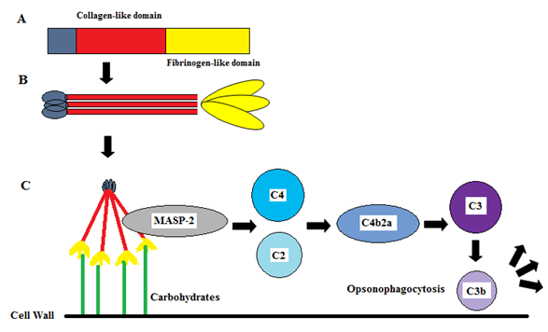

Figure 1.2. Activation of the lectin complement pathway by ficolins.
(A) Ficolins are composed of two key domains, the MASP interacting collagen-like domain on the N-terminal and carbohydrate interacting fibrinogen-like domain on the C-terminal. (B) Ficolins often assemble to form trimers via their collagen-like domains. These trimers then further assemble into a functional oligomeric form of four to twelve trimers. (C) The collagen-like domain of ficolins associate with MASP-2 leading to the cleavage of C4 and C2 to produce the C3 convertase C4b2a. C4b2a further cleaves C3 into C3b marking the pathogen for phagocytosis by leukocytes. Whereas the fibrinogen-like head associates with carbohydrates on the cell surface.

  - Cell signalling via mitogen-activated protein kinases (MAPKs).

Cell signalling is an intricate process that governs the basic cellular activities and coordinates the manner in which a cell responds to its environment. Furthermore, cell signalling pathways play important roles in many biological processes ranging from development and tissue repair, to the maintenance of normal tissue homeostasis and the immune response to infection. These cell signalling pathways involve the coordinated interaction of vast networks of proteins, of which there are many; albeit in this thesis we investigate one particular group of cell signalling proteins, called mitogen-activated protein kinases (MAPKs).

MAPKs are protein kinases that specifically phosphorylate serine, threonine and tyrosine residues in response to numerous stimuli including; mitogens, osmotic stress and inflammatory cytokines. Following activation, MAPKs regulate a diverse range of cellular functions and can play an integral role in the pathology of many diseases, including cancer (Arthur et al., 2013). The MAPK pathway is triggered (usually at the cell membrane) via the activation of MAP3Ks (such as c-Raf, MEKK4 and ML3). Moreover, MAP3Ks are allosterically-controlled enzymes and activation is regulated by small GTPases such as Ras and other small G-proteins. Activation of MAP2Ks and MAPKs is a much simpler affair and involves a cascade of phosphorylation events, which ultimately leads to the phosphorylation of transcription factors and regulation of gene expression.

There are a number of MAPK pathways; such as p38 MAPK and Jun amino-terminal kinase (JNK), but the best characterized of these is probably the ERK 1/2 pathway. The ERK signalling cascade is activated by receptors on the cell surface including receptor tyrosine kinases (RTKs), integrins and ion channels but the response differs based upon the stimuli. The common characteristics of this pathway includes a set of adaptors (e.g GRB2) which links the receptor to guanidine nucleotide exchange factors (i.e SOS), transducing the signal to small GTP-binding proteins (Ras), before activating the MAP3K (Raf), MAP2K (MEK1/2), and MAPK (ERK).

In contrast to ERK; p38 MAPK and JNK can be activated by proinflammatory stimuli, in addition to environmental stresses, growth factors and agonists of G-protein coupled receptors. They share many activators at the MAP3K level (including MEKK1, MEKK4 and MLK3) but they also possess unique activators such as MKK3 and MKK6 for p38 MAPK and MKK4 for JNK. Again, the outcome of these signalling pathways is the regulation of gene expression through transcription factor activation.

It is widely appreciated that activation of all three MAPK pathways discussed can be achieved via stimulation of CLRs and TLRs (Figure 1.3), receptors which are acknowledged to participate in the immune response to a plethora of pathogens, including fungal pathogens, where the CLR Dectin-1 has proven to be of great importance (Plato et al., 2015). The activation of TLR signalling arises from their cytoplasmic Toll/IL-1 receptor (TIR) domain which associates with the adaptor protein, MyD88. MyD88 is then involved in the recruitment of IL-1 receptor associated kinase-4 (IRAK-4), which is then phosphorylated and associates with TRAF6, activating the IKK complex and resultant activation of MAPKs (Akira et al., 2004). Conversely, CLRs signal through immunoreceptor tyrosine-based activation/inhibitory motifs (ITAMs/ITIMs) within their cytoplasmic regions, or via the association of ITAM-containing proteins such FcRγ. These signals are then transduced via Src and Syk kinases, resulting in activation of the CARD9, MALT1, Bcl10 complex and activation of downstream signalling pathways (Dambuza et al., 2015).

Figure 1.3. The activation of MAPK signalling pathways by TLRs and CLRs.
TLRs and CLRs are both important in antifungal immunity and can activate the MAPK pathways. TLRs can activate the MAPK pathways via activation of TRIF or MyD88-dependent pathways. This results in translocation of the transcription factors AP1 or CREB to the nucleus to regulate gene expression. CLRs activate the MAPK pathways via Syk-dependent activation of PLCγ. Dectin-1 can activate Syk directly via ITAM domains in its intracellular domain, whereas CLRs like Dectin-2 and Mincle have to cooperate with ITAM containing proteins such as FcRγ. This can result in translocation of NF-κβ to the nucleus.

  - The orchestration of inflammation in the lungs: the role of cytokines and chemokines.

Inflammation is a dynamic response to harmful stimuli such as pathogens, damaged cells or irritants and is integral in the removal of the stimulus and initiation of recovery. This complex response relies on a balanced production of both pro- and anti-inflammatory cytokines to ensure that inflammation is appropriately controlled. AM are the main producers of cytokines within the lung environment, however upon stimulation by an exogenous ligands other cells including type II pulmonary epithelial cells, neutrophils, type 1 and type 2 helper T cells, pulmonary innate lymphoid cells and mast cells are capable of producing cytokines (Xing et al., 1994, Gordon et al., 2002, Witherden et al., 2004, Forbes et al., 2008, Halim et al., 2012, Klein Wolterink et al., 2012, Urb et al., 2012). Sufficient cytokine production is required for the recruitment and activation of leukocytes at the inflammatory site but conversely, excessive inflammation can have detrimental effects.

Inflammation in the lung is therefore tightly regulated and involves a large range of cytokines including; tumour necrosis factor (TNF)-α, granulocyte-colony-stimulating factor (G-CSF), granulocyte-macrophage-colony-stimulating factor (GM-CSF), interferon (IFN)-γ, IL-1β, -5, -6 -8, -10, -12, -13, -17A and -23 (Toews, 2001). In particular, TNF-α, G-CSF and GM-CSF, IFN-γ, IL-10 and -12 and chemokines such as monocyte chemotactic protein (MCP)-1, macrophage inflammatory protein (MIP)-1α, IL-8 and RANTES (regulated on activation, normal T cell expressed and secreted) are important in the recruitment and activation of leukocytes to inflammatory sites; specific examples are highlighted below (Hammond et al., 1995, Toews, 2001, Strieter et al., 2002, Schroder et al., 2004).

TNF-α is an important component in the defence against pathogens whereby it controls activation and recruitment of neutrophils and macrophages, leading to protease release, production of respiratory burst and enhanced phagocytosis (Le et al., 1987, Gosselin et al., 1995, Huffnagle et al., 1996, Laichalk et al., 1996). IFN-γ is instrumental in the defence against a range of pulmonary pathogens enhancing the antimicrobial activity of macrophages and priming cells to release TNF-α (Kolls et al., 1993, Kolls et al., 1997, Rubins et al., 1997). Similarly, G-CSF and GM-CSF are important in neutrophil and macrophage functions, respectively. Whereby the former prolongs neutrophil survival, enhances phagocytosis, respiratory burst and augments neutrophil recruitment during infection (Kolls et al., 1993, Nelson, 1994) and the latter enhances activation of macrophages and pathogenic killing (Chen et al., 1994).

IL-12 promotes Th1-type immune responses while inhibiting Th2-type responses via the development of Th1 T cells and NK cells and induction of IFN-γ production. IL-12 can increase the cytolytic activity of T cells and NK cells and has demonstrated a role in antimicrobial immunity against a range of pathogens including Leishmania major, Toxoplasma gondii, Listeria monocytogenes, Mycobacterium tuberculosis, Klebsiella pneumoniae, C. neoformans and the influenza virus (Chehimi et al., 1994, Greenberger et al., 1996, Kawakami et al., 1996, Monteiro et al., 1998).

Chemokines play a crucial role in leukocyte recruitment with IL-8, MIP-1α and MCP-1 proving critical. IL-8 in particular is key for the recruitment of leukocytes in a variety of pulmonary infections (Harada et al., 1994) whereas neutralization of the effects of either MIP-1α or MCP-1 leads to significantly reduced influx of macrophages and T-cells to the site of infection (Huffnagle et al., 1995, Huffnagle et al., 1997).

IL-10 in the lungs is predominantly produced by macrophages and a Th2 subset of CD4⁺ helper cells, but it can also be produced by some activated B cells, Th1 cells and other non-haematopoietic sources (Asadullah et al., 2003, Freitas do Rosario et al., 2012). IL-10 has emerged as an important modulator of the immune response whereby it acts in an anti-inflammatory manner, up regulating Th-2 immune responses whilst down regulating Th-1 responses (Sabat et al., 2010). It can achieve this via the direct deactivation of inflammatory cells and by down regulating pro-inflammatory cytokine and chemokine production. Although IL-10 is important in ameliorating excessive inflammation, IL-10 induction has been implicated in a weaker and less effective immune response to pathogen invasion (Greenberger et al., 1995, Levitz et al., 1996, van der Poll et al., 1996, Antonini et al., 2004, Das et al., 2012).

  - Innate pathogen recognition: ficolin types and structures.

Originally identified as transforming growth factor (TGF)-β1 binding proteins in the porcine uterus (Ichijo et al., 1993), ficolins have since been identified as innate immune opsonins in a plethora of species, including human (Endo et al., 1996, Lu et al., 1996, Matsushita et al., 1996, Sugimoto et al., 1998), rodent (Fujimori et al., 1998, Ohashi et al., 1998), pig (Ichijo et al., 1993, Ohashi et al., 1998), birds (Lynch et al., 2005), fish (Huang et al., 2008), hedgehog (Omori-Satoh et al., 2000), Xenopus (Kakinuma et al., 2003), ascidian (Kenjo et al., 2001) and Drosophila (Middha et al., 2008). Their key roles within innate immunity are to recognize pathogens and enhance the function of the host cells or to activate the lectin complement pathway. They have been demonstrated to be structurally and functionally similar to the collagen-containing C-type lectin superfamily (collectins) which include the widely studied MBL and SP-A and SP-D, in addition to collectin liver 1 (CL-L1), collectin placenta 1 (CL-P1), collectin kidney 1 (CL-K1) and the bovine conglutinin and collectin 43 and 46 (CL-43 and CL-46) (Gupta et al., 2007, Hansen et al., 2010).

Collectins are composed of four main parts; a cysteine-rich N-terminus, a collagen-like domain, a coiled-coil neck domain and a carbohydrate recognition domain (CRD) that binds to its respective ligands in a calcium-dependent manner (Weis et al., 1991, Weis et al., 1992). In comparison, ficolin monomers also consist of an N-terminal rich in cysteine residues, a collagen-like domain composing of glycine-X-Y repeats and a neck region. However, the CRD found in the collectin family members is replaced by a C-terminal fibrinogen-like domain (FBG) in ficolins. In their native form, ficolin monomers assemble to form trimers via their collagen-like domains before further assembling into functional oligomeric bouquet-like structures of between 4 to 8 trimers.

In humans, there are three types of ficolins; the serum ficolins L-ficolin (ficolin-2) and H-ficolin (ficolin-3), in addition to the cell-associated M-ficolin (ficolin-1) which has also recently been detected at low levels in the serum (Honore et al., 2008, Wittenborn et al., 2010). Conversely, rodents only possess orthologues of L- and M-ficolin, which are termed ficolin-A and ficolin-B, respectively. H-ficolin is only present in rodents as a pseudogene (Endo et al., 2004).

The amino acid sequence homology between M-ficolin and L-ficolin is quite high at around 80% (Endo et al., 1996, Sugimoto et al., 1998). M-ficolin is encoded by the FCN-1 gene that can be located on chromosome 9q34. FCN1 is translated into a 35 kDa protein that is composed of 326 amino acids and glycosylated at the asparagine residue, Asn 305. M-ficolin is found in cells of the myeloid lineage and can be found associated with numerous cells including monocytes, DCs, natural killer cells, neutrophils and endothelial cells (Lu et al., 1996). Recent evidence has indicated it is also present in the serum in low concentrations of between 45.7 ng mL⁻¹ and 100.4 ng mL⁻¹, following its release from secretory stores within peripheral blood monocytes and granulocytes (Liu et al., 2005a, Honore et al., 2008, Rorvig et al., 2009). In rodents, M-ficolin is known as ficolin-B.

Similarly, L-ficolin is encoded by the FCN-2 gene that can be located on the same chromosome (9q34.3). FCN2 is translated into a 34 kDa protein that is composed of 313 amino acids and is also post-translationally glycosylated, albeit at the Asn 240 and Asn 300 residues. These proteins assemble into a 400 kDa ‘bundle-of-tulips’ structure composed of twelve polypeptide chains, assembled into four trimeric units that are disulphide-linked at the N-terminal (Le et al., 1998, Ohashi et al., 1998) However, in contrast to M-ficolin, L-ficolin is produced by the liver and is predominantly found in the serum at a concentration of between 1 to 7 µg mL⁻¹ (Le et al., 1998). In rodents, L-ficolin is termed ficolin-A.

Comparatively, H-ficolin only shares around 45% and 46% homology with L-ficolin and M-ficolin, respectively, and the gene that encodes it, FCN-3, is found on chromosome 1 (1p36.11) (Endo et al., 1996, Sugimoto et al., 1998). The FCN3 gene codes for a 33 kDa protein that is composed of around 299 amino acids and assembles via disulphide-links into oligomeric structures of around 700 kDa (Zacho et al., 2012). As seen for M- and L-ficolin, H-ficolin is post-translationally modified via glycosylation at the Asn 189 residue but it also has a blocked N-terminus (Akaiwa et al., 1999). Like L-ficolin, H-ficolin is produced in the liver and is found in the serum but in much greater concentrations of around 18.4 µg mL⁻¹. Not only is H-ficolin found in the serum, it is also present in the lungs where it is produced by bronchial epithelial cells and type II alveolar epithelial cells, and in the bile duct where it is produced by bile duct epithelial cells and hepatocytes (Yae et al., 1991, Akaiwa et al., 1999). H-ficolin in rodents is only present as a pseudogene (Endo et al., 2004).

Figure 1.4. Structures of innate immune collectins and ficolins.
The monomeric and multimetric structures of MBL (A), SP-A (B), SP-D (C) and ficolins (D). Collectins are composed of a cysteine-rich region (blue), collagenous region (red), neck domain (orange) and a carbohydrate-recognition domain (yellow). In ficolins the carbohydrate-recognition domain is replaced by a fibrinogen-like domain.

  - The ligand recognition characteristics of ficolins.

Ficolins play an integral role within innate immunity whereby they act as opsonins, preparing a target for phagocytosis and facilitating pathogen removal. In order to achieve this, ficolins are capable of recognizing a vast array of ligands on the microbial cell surface via their FBG. The FBG of ficolins are composed of a number of different binding sites that can work synergistically or alone in a complex interaction that allow ficolins to distinguish non-self structures from self.

Due to the observation of M-ficolin on the cell surface of monocytes and granulocytes it was first considered a phagocytic receptor. However, M-ficolin does not possess any characteristics that supported this claim. In recent years, it has been discovered that the binding range of M-ficolin is a lot broader than was first anticipated, with the tethering of M-ficolin to the leukocyte surface due to the recognition of sialic acid by the FBG, in particular 9-O-acetylated sialic acid (Teh et al., 2000, Garlatti et al., 2007b, Gout et al., 2010, Honore et al., 2010). M-ficolin has also been demonstrated to bind to a range of acetylated moieties including N-acetylglucosamine (GlcNAc), GlcNAc-BSA, N-acetylgalactosamine (GalNAc), N-acetyllactosamine (LacNAc)-BSA, N-acetylcysteine (CysNAc) and acetylated human serum albumin (Le et al., 1998, Teh et al., 2000, Fredriksen et al., 2005, Liu et al., 2005a). Further characterization by means of a glycan array exhibited recognition of gangliosides and sialylated biantennary N-linked type glucans, two novel ligands for M-ficolin (Gout et al., 2010). Recently, M-ficolin has also been observed to interact with the main membrane sialoprotein of neutrophils, CD 43, which led to functional consequences such as cell polarization, adhesion, aggregation and the activation of complement (Moreno-Amaral et al., 2012). The M-ficolin recognition domain has been studied in great detail. The structure is similar to the other ficolins, however within a predicted ligand-binding site the peptide bond between Asp282 and Cys283 is in a normal trans conformation, compared to the cis conformation exhibited by the other ficolins (Tanio et al., 2007b). Following investigation into the pH-dependent ligand binding activity of M-ficolin, the difference between active and non-active function was suggested to be due to a cis-trans isomerization of the Asp282 and Cys283 peptide bond (Tanio et al., 2007a). An acidic environment generally gearing M-ficolin towards the non-functional trans conformation. Using various histidine mutants, the protonation of His284 was found to be associated with the trans to cis change to a functional conformation and the ability to regulate GlcNAc binding (Tanio et al., 2009, Yang et al., 2011a).

L-ficolin is the best characterised of all of the ficolins and binds to a plethora of antigens which in turn allows the recognition of a wide range of microorganisms. L-ficolin shares a common binding specificity to GlcNAc and GalNAc but also binds to a wider range of structures such as lipotechoic acid (LTA), 1,3-β-D-glucan, N-glycans, hemagglutinin (HA) and neuraminidase (Le et al., 1998, Lynch et al., 2004, Ma et al., 2004, Liu et al., 2009, Pan et al., 2012). Due to the large recognition spectrum of L-ficolin, the incorporation of sites other than the S1 site, termed S2-S4 are of great importance. The S1 site, involved in the recognition of GlcNAc for other ficolins, contains a phenylalanine residue in place of a GlcNAc stabilising tyrosine and is less involved (Garlatti et al., 2007a). Instead, GlcNAc, CysNAc and neutral galactose were found in the S2 site, various N-acetylated structures in the S3 site and a cooperation of the S3 and S4 sites were involved in the recognition of 1,3-β-D-glucan: altogether producing a unique recognition surface for the recognition of pathogens (Garlatti et al., 2007a).

H-ficolin has been observed to share common binding specificities with the other ficolins, namely the recognition of the acetylated polysaccharides GlcNAc and GalNAc, in addition to D-fucose and galactose (Sugimoto et al., 1998, Garlatti et al., 2007a). Structurally, H-ficolin shares characteristics with L-ficolin such as the common cis conformation of the Asp282 and Cys283 peptide bond (Kairies et al., 2001, Garlatti et al., 2007a). Garlatti et al (Garlatti et al., 2007a) characterised the binding of H-ficolin and elucidated the S1 site was involved in binding to both D-fucose and galactose. As in the other ficolins, this site lies within the vicinity of the Ca²⁺ binding site and is homologous to the GlcNAc binding site in tachylectin 5A, involving Cys235, Tyr236, Tyr254 and Val264 residues (Garlatti et al., 2007a). Zacho et al (Zacho et al., 2012) have since further characterised the binding profile of H-ficolin, reporting binding to acetylsalicylic acid, N-acetylglycine (GlyNAc) and CysNAc, also reporting the Ca²⁺ dependence of H-ficolin binding. However, the sites involved in this recognition remain unknown.

 | Source | Place of expression | Sugar specificity | Pathogen interaction | Complement activation
Human  M-ficolin | Monocytes, Neutrophils, Type II alveolar epithelial cells | Cell surface, Serum (low conc.) | GlcNAc, GalNAc, LacNAc, SiaLacNAc, CysNAc, Sialic acid, Acetylated human albumin, Gangliosides, CD43 | S. agalactiae, S. aureus, S. pneumoniae, S. mitis, E. coli, T. cruzi | Yes
L-ficolin | Liver | Serum | GlcNAc, GalNAc, ManNAc, CysNAc, GlyNAc, NeuNAc, Acetylcholine, Elastin, Corticosteroids, 1, 3-β-D-glucan, N-glycans, HA, Neuraminidase, | S. aureus, S. pyogenes, S.agalactiae, B. subtilis, S. typhimurium, E. coli, S. pneumoniae, L. monocytogenes, Mycobacterium bovis, E. faecalis, A. fumigatus, HCV, IAV, T. cruzi, G. intestinalis | Yes
H-ficolin | Liver (Hepatocytes and bile epithelium), Type II alveolar cells | Serum, Bronchus, Alveolus, Bile | GlcNAc, GalNAc, fucose, glucose, Acetylsalicylic acid, Sialic acid, D-mannose, GlyNAc, CysNAc, LPS from S. typhimurium, PSA from A. viridians | S. typhimurium, S. minnesota, E.coli O111, Hafnia alvei, A. fumigatus, IAV, T. cruzi, G. intestinalis | Yes
Mouse/Rat  Ficolin-A | Liver and Spleen | Serum | GlcNAc, GalNAc, fibrinogen, | S. pneumoniae, S. aureus, E.coli O157:H7, LPS from P. auruginosa, C. neoformans, A. fumigatus. | Yes
Ficolin-B | BM and Spleen | Peritoneal macrophages | GlcNAc, GalNAc, LacNAc, SiaLacNAc, LDL, NeuNAc, fetuin, | Nk. | Yes
BM, Bone marrow; GlcNAc, N-acetylglucosamine; GalNAc, N-acetylgalactosamine; LacNAc, N-acetyllactosamine; SiaLacNAc, sialylated N-acetyllactosamine; CysNAc, N-acetylcysteine; ManNAc, N-acetylmannosamine; GlyNAc, N-acetylglycine; NeuNAc, N-acetylneuraminic acid; HA, hemagglutinin; LPS, lipopolysaccharide; IAV, influenza A virus; LDL, low-density lipoprotein; LTA, lipotechoic acid; HCV, hepatitis C virus; Nk, not known

Table 1.1 Expression, sugar specificity and target pathogens of human and rodent ficolins.

  - The role of M-ficolin in the innate defence against pathogens.

As a consequence of its recognition spectrum, it has been suggested that M-ficolin could be involved in the defence against pathogens. M-ficolin has been observed to co-precipitate with MASP-1 and MASP-2 and have functioning complement activating activity, whereby M-ficolin/MASP-2 complexes led to the cleavage of C4 on GlcNAc-coated microplates (Liu et al., 2005a). The ability of a recombinant M-ficolin/MASP-2 complex to activate the lectin pathway was also exhibited around the time, confirming the role of M-ficolin in complement activation (Fredriksen et al., 2005). Dose-dependent binding of serum M-ficolin has been observed to capsular Streptococcus agalacticae serotype VI, which presents sialic acid as the terminal side-chain residues of the capsular polysaccharides, but not to the non-capsulated strain B848/64 (Kjaer et al., 2011). This dose-dependent binding was inhibited following the addition of GlcNAc or sialic acid. In addition, recombinant M-ficolin exhibited the same binding preferences and following the addition of recombinant MASP-2 and purified C4, C4b deposition was observed only to serotype VI (Kjaer et al., 2011). The same group reported that M-ficolin was not able to bind to either the capsulated or non-capsulated strains of Staphylococcus aureus, contradicting a previous observation by Liu et al (Liu et al., 2005b) whereby binding to S. aureus was exhibited. To further characterize M-ficolin binding, more than 100 different strains of Streptococcus pneumoniae and Streptococcus mitis have been screened and M-ficolin was only observed to bind to three strains: the pneumococcal serotypes 19B and 19C and a single S. mitis strain (Kjaer et al., 2013). This binding exhibited the common characteristic of GlcNAc inhibition and in conjunction with MASP-2, mediated the cleavage of C4. Kjaer et al (Kjaer et al., 2013) postulated that binding to these pneumococcal strains was via an N-acetylmannosamine (ManNAc) residue linked by glycoside linkage only present in serotypes 19B and 19C. In addition, M-ficolin has also exhibited its ability to function as an opsonin and enhance the action of phagocytes, as phagocytosis of Escherichia coli (E. coli) by U937 cells was observed to be inhibited by antibodies against M-ficolin (Teh et al., 2000). Recent evidence has also suggested the ability of M-ficolin to bind to the parasite Trypanosoma cruzi (Cestari et al., 2009). Additionally a role in viral defence has been unveiled whereby M-ficolin interacting with the acute phase protein, pentraxin-3 (PTX3) has been observed to decrease the infectivity of the PR-8 and Phil82 strains of the influenza-A virus (IAV) (Verma et al., 2012).

The majority of studies have focused on binding to bacterial pathogens. However, the potential of M-ficolin to bind to sialic acid expressing fungi, viruses or parasites is still there to be elucidated.

  - The role of L-ficolin in the innate defence against pathogens.

Like M-ficolin, L-ficolin has been previously observed to interact with MASP-1, -2, MAp19, sMAP and MASP-3 and activate the lectin complement pathway (Matsushita et al., 2002b, Skoedt et al., 2010). Lys57 mutations in the collagen-like domain have highlighted the importance of this residue in the association with MASP-2 and an inability to activate complement (Lacroix et al., 2009). There is ever increasing evidence that L-ficolin is important within clinical bacterial infections, with L-ficolin polymorphisms and insufficiency associated with an increased risk of infections during kidney transplantation and acute B lymphoblastic leukaemia leading to an increased risk of sepsis (Bronkhorst et al., 2013, Wan et al., 2013, Pana et al., 2014). L-ficolin was first observed to enhance the opsonophagocytosis of Salmonella typhimurium (S. typhimurium) leading to complement activation and since then has been described to be important in defence against bacterial, viral, fungal and parasitic pathogens (Matsushita et al., 1996). L-ficolin recognises LTA expressed by a range of staphylococcal and streptococcal strains, including S. aureus serotypes 1, 8, 9, 11 and 12, S. pneumoniae serotypes 11A, 11D, 11F, 20, 35A and 35C, subsequently leading to activation of the lectin pathway on some serotypes (Krarup et al., 2004, Lynch et al., 2004, Krarup et al., 2005, Moller et al., 2007, Kjaer et al., 2013). This binding could be due to recognition of the pneumococcal surface virulence factors of the choline-binding protein family by the FBG domain (Stermann et al., 2012). Recent evidence has been provided which demonstrates that L-ficolin recognises O-acetylated epitopes on pneumococcal serotype 11A and contributes to reduced invasiveness (Brady et al., 2014).

Group B streptococci (GBS), in particular capsular polysaccharide from serotypes Ib, III, V, VI and VIII are also avidly recognised by L-ficolin, leading to a significant increase in opsonophagocytosis and C3b deposition via the lectin pathway working synergistically with the alternative complement pathway (Aoyagi et al., 2005, Fujieda et al., 2012). The binding of L-ficolin to GBS is suggested to be irrelevant of the amount of LTA or group B-specific polysaccharide content, but shows a directly proportional decrease in binding following the removal of N-acetylneuraminic acid (NeuNAc) (Aoyagi et al., 2008). L-ficolin and serotype-specific IgG from cord serum has been observed to increase opsonophagocytic killing of serotype III and V (Fujieda et al., 2012). However, recognition of GBS by L-ficolin is a result currently under debate as another group observed no binding to any serotypes investigated (Kjaer et al., 2011).

Additionally, L-ficolin has been observed to bind to mycobacteria. L-ficolin recognises Mycobacterium bovis, leading to complement activation and significant C3b deposition (Carroll et al., 2009). In this case, C3b deposition could be involved in the virulence of M. bovis to allow entry into macrophages where they reside. Recent research has also highlighted the importance of L-ficolin in M. tuberculosis infection in vivo, with ficolins exhibiting stronger binding than observed to M. bovis and a ficolin insufficiency proving detrimental in humans (Luo et al., 2013). L-ficolin also binds to Enterococcus faecalis, Listeria monocytogenes and E. coli; however the functional consequences have presently not been elucidated (Hummelshøj et al., 2012).

Evidence for a role of L-ficolin in viral defence has emerged in recent years. Liu et al (Liu et al., 2009) found that L-ficolin was elevated in patients with hepatitis C virus (HCV) and was able to bind to N-glycans of the envelope glycoproteins E1 and E2. Moreover, this interaction led to the activation of the lectin pathway. Recent evidence has been provided which displays the ability of L-ficolin to directly inhibit HCV entry into hepatocytes and has highlighted that apolipoprotein E3 (ApoE3) blocks this effect, mediating an immune escape (Hamed et al., 2014, Zhao et al., 2014). Additionally L-ficolin has been observed to bind to HA and neuraminidase via their FBG and has been shown to have an inhibitory effect on the invasion of kidney cells by IAV in vitro (Pan et al., 2012). Using mice deficient of the mouse orthologue of L-ficolin, ficolin-A, it was also observed that these mice portrayed a greatly decreased survival rate in comparison to wildtype (WT) animals. Chimeric lectins whereby part of the L-ficolin collagen-like domain was added in place of MBLs have proved beneficial in defence against both the IAV and the Ebola virus (Michelow et al., 2010, Chang et al., 2011).

Parasitic binding is also a characteristic of L-ficolin. L-ficolin has been observed to bind to glycosylated proteins on the cell surface of T. cruzi and recognise Giardia intestinalis, leading to complement activation (Cestari et al., 2009, Evans-Osses et al., 2010). Recent data has shown that T. cruzi is also able to manipulate L-ficolin as a virulence factor. T.cruzi calreticulin can bind L-ficolin directly and in doing so was observed to inhibit lectin pathway activation in a dose-dependent manner (Ferreira et al., 2010, Sosoniuk et al., 2014).

Fungi present a significant infective threat to immunocompromised patients and fungal infections are associated with high mortality rates. L-ficolin has recently been observed to bind to the opportunistic fungus A. fumigatus (Ma et al., 2009), However, very little is understood about the recognition of other pathogenic fungi by L-ficolin or the functional consequences of this recognition.

  - The role of H-ficolin in the innate defence against pathogens.

H-ficolin was the second ficolin that was observed to be able to activate the lectin pathway of complement (Matsushita et al., 2002a). MASP-1,-2,-3 and sMAP were isolated from the same fraction as H-ficolin. Recent observations have shown that MASP-3 in the serum primarily associates with H-ficolin and down-regulates H-ficolin mediated complement activation (Skoedt et al., 2010). H-ficolin also associates with MASP-2. Homologous to Lys57 of L-ficolin, Lys47 of H-ficolin is important in the association with MAp19 and MASP-2. Mutation in this lysine residue was inhibitory on the ability of H-ficolin to activate the lectin pathway (Lacroix et al., 2009).

Early work from Sugimoto et al (Sugimoto et al., 1998) characterised the ability of H-ficolin to induce agglutination of human erythrocytes by recognition of lipopolysaccharides (LPS) from S. typhimurium, S. minnesota and E. coli O111 coated on their surface. Binding to bacteria has proven to be restricted to only a few species, the most characterised of these is binding to PSA, a polysaccharide of Aerococcus viridians, which is now often used as a control for H-ficolin binding and complement activation (Matsushita et al., 2002a, Tsujimura et al., 2002, Krarup et al., 2005). However, even H-ficolin recognition of A. viridians and E.coli is strain specific as binding to A. viridians strain Ring 44 and E. coli 74285 was not observed (Krarup et al., 2005). Recent work by Swierzko et al (Swierzko et al., 2012) increased our current knowledge of H-ficolin-bacteria interactions. They showed that LPS from only four strains of Hafnia alvei was recognised by H-ficolin, in particular by their O-specific polysaccharides, leading to C4b deposition in a calcium – and magnesium-dependent manner. In stark contrast, H-ficolin has not been observed to recognise any S. pneumoniae, S. agalacticae S. mitis or S. aureus strains (Krarup et al., 2005, Kjaer et al., 2011, Kjaer et al., 2013). In addition, H-ficolin does not bind to other bacteria such as L. monocytogenes, Pseudomonas aeruginosa and Klebsiella pneumoniae and only weakly to the pathogenic mould A. fumigatus (Hummelshøj et al., 2012). However, observations regarding the role of H-ficolin in the defence against viruses are encouraging. Recent studies have exhibited the ability of recombinant H-ficolin, H-ficolin from human serum and from bronchoalveolar lavage to bind to IAV, the mouse-adapted PR-8H1N1 and a pandemic H1N1 strain. Following recognition, a decrease in the ability of IAV to cause infection and inhibit HA in vitro has been observed. The role of sialic acid in these mechanisms was important, as following sialidase treatments inhibition of IAV was abolished (Verma et al., 2012). In addition, H-ficolin was capable of activating the lectin pathway on a surface coated with IAV.

As for L-ficolin, H-ficolin has also recently been observed to bind to the parasites T. cruzi and G. intestinalis and play a role in complement activation (Cestari et al., 2009, Evans-Osses et al., 2010). Depletion of ficolins and MBL led to a 70% decrease in C3b and C4b deposition on T. cruzi (Cestari et al., 2010).

As observed for M- and L-ficolin, H-ficolin has the ability to interact with PTX3 in a dose dependent manner, although it exhibits the weakest binding of the three (Ma et al., 2009). The FBG of H-ficolin is not involved in this interaction, whereas recognition by both M- and L-ficolin incorporate their FBG, this could explain the comparatively weaker binding of H-ficolin. The H-ficolin-PTX3 interaction, as for M-ficolin, exhibited the ability to inhibit HA activity and infectivity of IAV (Verma et al., 2012).

  - The role of rodent ficolin-A and ficolin-B in the innate defence against pathogens.

Until recently, the recognition spectrum of ficolin-A with microorganisms was relatively unknown. However, there has been much progress in characterising the interaction of ficolin-A with pathogens. Hummelshoj et al (Hummelshøj et al., 2012) have greatly expanded current knowledge on the pathogen specificity. They have shown ficolin-A to recognise a plethora of microorganisms including pathogenic Gram-positive and –negative bacteria such as S. aureus and the pathogenic E. coli strain O157:H7, in addition to the clinically relevant fungus A. fumigatus, although fungal binding characteristics were not explored in any detail. They also exhibited the ability of ficolin-A to bind to LPS from E. coli and P. aeruginosa. Ficolin-A has been observed to partake in the activation of the lectin complement pathway via the association with MASPs. Further interactions with fibrinogen and thrombin have been observed to potentiate the activation of complement on S. aureus (Endo et al., 2010). It has also proven to be an essential activator of the lectin complement pathway in the defence against S. pneumoniae. Ficolin-A and –B can recognise S. pneumoniae, leading to complement deposition in the presence of ficolin-A and only weakly in its absence (Endo et al., 2012a). In the absence of ficolin-A alone, the survival of infected mice was observed to be comparable to WT, however knockout of both ficolin-A and –B affected the survival rate (Endo et al., 2012b). Similar to its human orthologue, ficolin-A is also important in the defence against parasites. In an in vivo mouse model, ficolin-A was shown to enhance the immunoprotective activity of the 19-kDa fragment of merozoite surface protein-1 of Plasmodium berghei which led to a reduction in invasion and an increase in mouse survival (Chen et al., 2013, Xiang et al., 2014).

The current knowledge on the role of ficolin-B in recognition and defence against pathogens is largely unkown but Endo et al (Endo et al., 2012a) have suggested a synergistic role of ficolin-A and –B in the defence against S. pneumoniae. In addition, the role of the lectin complement pathway in pneumococcal defence has been demonstrated to be important (Ali et al., 2012).

  - The genus Aspergillus.

Aspergillus spp. are filamentous fungi belonging to the ascomycetes. There are hundreds of recognized Aspergillus species, but only a small number of these are implicated in causing clinical disease. The most common species isolated from clinical specimens is A. fumigatus, but others, such as A. flavus, A. niger and A. terreus can also cause disease. Aspergilli are saprophytic fungi and are often found ubiquitously where it grows in soil and decaying organic matter. Aspergillus species are found in warm damp conditions within the home such as in mattresses and potted plants. In particular, Aspergillus infection poses an increased risk in the hospital environment, when building work leads to the expulsion of spore-bearing dust into the air (Falvey et al., 2007).

Aspergillus germinates to produce septate hyphae from which conidiophores arise. This leads to the production of up to 50,000 small aerosolized spores (~4 µm) which are released into the air and are readily inhaled by the host. As the spores are ubiquitous, it is suggested that people inhale hundreds of these spores on a daily basis but they are effectively and efficiently removed before harm is elicited to the host (Segal, 2009). The predominant role of Aspergillus is in nitrogen and carbon recycling but it also acts as an opportunistic pathogen, infecting the immunocompromised.

Aspergillus spp. are capable of growing in a range of conditions from 25°C up to 50°C and grows readily in the laboratory on SDA. In the presence of serum, 37°C temperatures and adequate nutrients, hyphae can begin germinating within the space of 8 hours.

The Aspergillus cell wall is important in pathogenesis and immune recognition. It is composed primarily of a core of branched β-(1,3)/(1,6)-glucan that is linked to chitin via a β-(1,4) linkage. In addition to chitin and β-glucans, the cell wall contains carbohydrates such as glucose, galactose, mannose, GlcNAc and small amounts of GalNAc (Johnston, 1965, Hearn et al., 1994, Bernard et al., 2001, Latgé et al., 2005). It is via these cell wall carbohydrates that Aspergillus can either mask or activate inflammatory responses.

  - Aspergillosis.

Aspergillosis was first described in humans in 1856 by Rudolph Virchow (Virchow, 1856) and is the general term for describing a variety of diseases following infection with fungi from the genus Aspergillus. The term encompasses a vast array of illnesses with varying levels of severity, ranging from superficial mycoses such as onychomycosis (nail infections) and fungal sinusitis, to life threatening invasive infections. The majority of aspergillosis cases are presented in the form of chronic pulmonary aspergillosis (CPA), aspergilloma or allergic bronchopulmonary aspergillosis (ABPA) (Thompson et al., 2011, Denning et al., 2013). These generally occur in patients who have previously had underlying lung illnesses, such as tuberculosis or chronic obstructive pulmonary disease (COPD), but have otherwise healthy immune systems.

However, in severely immunocompromised patients or those with low immunity, including those undergoing haematopoietic stem cell or whole organ transplantation, cancer patients with low white blood cell counts following chemotherapy, advanced HIV/AIDS patients or those with chronic granulomatous disease (CGD), Aspergillus inhalation can result in the devastating disease referred to as invasive aspergillosis (IA). There are roughly up to 500,000 cases of acute IA per year worldwide and it is now the most commonly diagnosed invasive mycosis in the developed world (Leventakos et al., 2010, Baddley et al., 2013). Symptoms of IA include fever, combined with respiratory symptoms such as a cough, chest pain or breathlessness that do not respond to standard antibiotics. In the high risk patient groups, the fungus can penetrate the lung tissue, invade the vasculature and enter the bloodstream. This can result in dissemination to the brain or other organs such as the eyes, heart, kidneys or the skin which often leads to death if not recognised and left untreated.

IA is associated with a high mortality rate of 30-90% but survival rates are improved if diagnosed early. Some diagnostic tests are available, but late recognition and treatment can result in 100% mortality (Brown et al., 2012). The current diagnostic tools are severely limited and often involve the use of X-rays or computed tomography scans, bronchoscopy, positive fungal culture or detection of Aspergillus-specific antigens in the blood such as galactomannan or β-1,3-glucans (Schelenz et al., 2015).

In addition to being difficult to diagnose, IA is also becoming increasingly difficult to treat with the emergence of antifungal resistant strains (Denning et al., 2011). Treatments usually include the polyenes (amphotericin B), the azoles (voriconazole, itraconazole, posaconazole) or the echinocandins (caspofungin, micafungin, anidulafungin).

  - Host phagocyte responses in the lung following Aspergillus exposure.

Invasive Aspergillus infection is not observed in persons with a normal functioning immune system despite continuous inhalation of airborne spores. This suggests that the host expresses effective defence mechanisms. Due to their small size, Aspergillus conidia can reach the alveolar space making the lung the primary focus of the infection although infections may also be caused by spore ingestion due to contaminated foodstuff. To date, the role of ficolins in the defence against these inhaled conidia is poorly characterised.

Following inhalation of Aspergillus conidia, the majority are actively removed via the beating of the cilia, whereby they are either swallowed or expectorated. However, due to the small size of the conidia, they can evade mucociliary clearance and penetrate the alveoli. In addition, in vitro evidence has demonstrated that A. fumigatus is capable of releasing factors that are detrimental to cilia function and that are damaging to the epithelium (Amitani et al., 1995). Once the conidia invade the alveoli they first encounter two types of lung epithelial cells: type I and type II pneumocytes. Type I pneumocytes cover approximately 97% of the alveolar surface and predominantly participate in gaseous exchange. Conversely, type II pneumocytes are the principle source of pulmonary surfactant that contains the important opsonins, SP-A and SP-D. The exact role of the lung epithelium in Aspergillus defence is currently debatable. Interestingly, A. fumigatus is not typically described as an intracellular pathogen but it has regularly been reported to survive in the organelles of the respiratory epithelium where it can germinate and prosper (Paris et al., 1997, Wasylnka et al., 2003, Wasylnka et al., 2005). These observations suggest a potential mechanism whereby A. fumigatus may exploit type II pneumocytes to evade the resident leukocytes. The predominant role of the lung epithelium may therefore be in the production of PRRs such as SP-A, SP-D and H-ficolin in an attempt to augment the functions of the resident AM.

The first line of effective defence against inhaled infectious agents is the AM. When A. fumigatus invades the host, conditions within the lung cause the inhaled conidia to swell, which modifies the exposure of cell wall components. These swollen conidia can then proceed to germinate if the immune response is evaded. AM are highly efficient at recognising and removing both swollen and resting conidia, whereby they are recognised by a range of cell surface receptors, most notably dectin-1, TLR-2 and TLR-4 (Brown, 2011). Once phagocytosed and internalized into the acidic phagolysosomes, the conidia swell, which in turn leads to the effective elimination of about 90% of these conidia (Schaffner et al., 1983, Philippe et al., 2003). However, Aspergillus culture filtrates and secreted toxins are detrimental to normal macrophage function. Following the addition of A. fumigatus culture filtrates to human AM, the phagocytic uptake within an hour was observed to decrease by over 50% (Murayama et al., 1996). The secreted A. fumigatus toxins provide an additional challenge to the AM by diminishing the respiratory burst and allowing A. fumigatus to persist in the lung (Slight et al., 1996). In this instance, the recruitment of neutrophils is paramount to successful amelioration of the infection.

Neutrophils constitute the largest population of phagocytes. During infection, neutrophils are rapidly recruited to the site of infection. The importance of neutrophils in Aspergillus infection is undeniable. Selective depletion of AM in the early stages of A. fumigatus infection neither had a detrimental effect on neutrophil recruitment or promoted hyphal invasion (Mircescu et al., 2009). Conversely, early neutrophil depletion was significantly linked with high mortality (Mircescu et al., 2009). Indeed, it is neutropenic patients that are at the greatest risk of IA. It is widely considered that neutrophils are absolutely essential for the elimination of Aspergillus hyphae, where they participate in extracellular killing via the release of antimicrobial toxins and the production of neutrophil extracellular traps (NETs). This will be discussed later in the section. Neutrophils are also appreciated to be important in phagocytosis and intracellular killing of conidia in vitro and in vivo (Levitz et al., 1985).

  - Oxidative responses and antimicrobial molecules in Aspergillus defence.

The primary function of phagocytes within the lung is phagocytosis. However, in order to maintain lung integrity, infectious agents must be eliminated. This can be achieved via oxidative mechanisms or by the production of various antimicrobial molecules. Oxidative mechanisms include the reactive oxygen species (ROS) and nitric oxide derived ROS. Two enzymes involved in the production of ROS have proven to be essential in elimination of A. fumigatus; myeloperoxidase and nicotinamide adenine dinucleotide phosphate (NADPH) oxidase. The importance of these enzymes have been validated by ex vivo and in vivo studies, as the absence of either enzyme in animal models or NADPH-deficient macrophages was demonstrated to be associated with higher mortality rate, increased susceptibility and reduced fungicidal activity (Aratani et al., 2002, Philippe et al., 2003). Antioxidants produced by A. fumigatus including; catalase, mannitol and superoxide dismutase, have not yet been observed to inhibit phagocytosis or oxidative mechanisms (Hamilton et al., 1999). However, recent evidence has highlighted that A. fumigatus gliotoxin can inhibit ROS production and phagocytosis by neutrophils but not mononuclear cells (Orciuolo et al., 2007).

Cells within the lung can release a large number of antifungal compounds. These can function by depleting the nutrients available to Aspergillus, by sequestration of siderophores or via direct action on the fungus or its cell wall. Lactoferrin is one such molecule produced by epithelial cells and neutrophils and its function is to bind to iron. This deprives the fungus of essential nutrients, thus, inhibiting growth (Zarember et al., 2007). Recent research has provided some interesting observations where dectin-1 dependent IL-6 production following Aspergillus infection is linked to expression of iron chelators and siderophore binding proteins (Leal et al., 2013). Lipocalin-1, a molecule produced from neutrophils following this interaction, sequesters fungal siderophores and restricts fungal growth in an in vivo model (Leal et al., 2013). In addition to secreting siderophore binding proteins, neutrophils can degranulate to release serine proteases. Elastase and cathepsin G have been demonstrated to be of great importance in fungal defence and mice lacking these enzymes have been proven to be more susceptible to A. fumigatus infection (Tkalcevic et al., 2000). Protease inhibitors released from respiratory cells such as the secretory leukoprotease inhibitor and the pre-elafin trappin-2-serine protease inhibtors have also been reported to have antimicrobial effects against A. fumigatus (Baranger et al., 2008). Furthermore, epithelial cells and macrophages can also express chitinases such as the endo-β-1,4-N-acetylglucosaminidases, which have a direct degrading effect on chitin in the A. fumigatus cell wall (Chen et al., 2009). An additional mechanism called netosis can be employed by neutrophils in Aspergillus defence (Bruns et al., 2010). The exact mechanisms are not fully understood but the process involves the deployment of NETs which are composed of nuclear DNA decorated with fungicidal proteins. Interestingly, PRRs are capable of interacting with these NETs and enhancing microbial defence (Douda et al., 2011).

  - Pathogen recognition molecules and receptors involved in Aspergillus defence.

Before an immune response can be mounted, the threat must first be recognised. This can be achieved by the recognition of pathogen-associated molecular patterns (PAMPs), molecular motifs on the surface of pathogens. To recognise these motifs, humans possess three main groups of PRRs based upon whether they are; secreted endocytic or induce cell signalling. Here I will describe the main PRRs that are implicated in fungal defence.

Secreted PRRs often function as opsonins; molecules that facilitate recognition by the phagocytes and potentiate phagocytosis by binding to the pathogen. Important secreted PRRs that can interact with A. fumigatus include PTX3, SP-A, SP-D, MBL, L-ficolin, H-ficolin, ficolin-A and C3b. PTX3 is an acute phase protein that is secreted by various cell types in response to inflammation. PTX3 itself binds to conidia of A. fumigatus and mice deficient in PTX3 cannot efficiently recognise conidia and provoke an appropriate type II response (Garlanda et al., 2002). Additionally, PTX3 can cooperate with other secreted PRRs, such as L-ficolin, which enhances the immune response to A. fumigatus (Ma et al., 2009).

SP-A, SP-D and MBL are secreted receptors belonging to the C-type lectin superfamily. They are involved in the recognition of glyconjugated structures found within the pathogen cell walls. In particular, SP-D and MBL have been shown to have the greatest role in the defence against A. fumigatus. SP-D can enhance phagocytosis and fungicidal action, modulate inflammation and it is protective in vivo, whereby it lowers blood eosinophilia, pulmonary infiltration and specific antibody levels (Schelenz et al., 1999, Madan et al., 2001). However, there is contrasting evidence regarding the role of MBL in A. fumigatus defence, as contradicting in vivo studies have shown that MBL may or may not be important (Hogaboam et al., 2004, Kaur et al., 2007).

Ficolins are structurally and functionally similar to the collectins, as outlined earlier. Previous studies had demonstrated binding to A. fumigatus, in addition to the role of L-ficolin in complement activation (Ma et al., 2009, Hummelshøj et al., 2012). These interactions were not characterised in much detail and we present further insight within this thesis.

C3 b is one of more than 35 complement related proteins and binds to A. fumigatus, inducing the involvement of the alternative pathway, formation of iC3b and phagocytosis by macrophages (Sturtevant et al., 1992a, Bouchara et al., 1994).

Endocytic PRRs are present on the cell surface of phagocytes and facilitate pathogen binding. Important endocytic PRRs in A. fumigatus recognition include DC-SIGN, the mannose receptor, dectin-1 and dectin-2. DC-SIGN is a C-type lectin that was originally appreciated to only be present on dendritic cells but its presence has now been confirmed on macrophages (Soilleux et al., 2002). DC-SIGN recognises high-mannose-containing glycoproteins on the pathogen surface and facilitates the internalisation of conidia (Serrano-Gomez et al., 2004). Similarly, the mannose receptor also recognises carbohydrates rich in mannose, facilitating phagocytosis (Persat et al., 2003).

Dectin-1 (formerly β-glucan receptor) is expressed by macrophages, neutrophils and dendritic cells and specifically recognises the major fungal cell wall component, β-1,3-glucans (Brown et al., 2002). It is undoubtedly one of the most important receptors in fungal defence and essential for phagocytosis of fungi by macrophages (Steele et al., 2005). Humans with dectin-1 polymorphisms and mice lacking dectin-1 exhibit increased susceptibility to fungal infections (Saijo et al., 2007, Taylor et al., 2007, Plantinga et al., 2009, Cunha et al., 2010). Dectin-1 primarily participates in the recognition of swollen or germinating conidia that express abundant β-1,3-glucans on their surface. Activation of this receptor enhances phagocytosis and stimulation of the production of ROS (Steele et al., 2005, Underhill et al., 2005, Gersuk et al., 2006). Dectin-1 also functions as a signalling receptor itself and can interact with TLRs to amplify the inflammatory response. In particular, dectin-1 cooperates with TLR-2 to contribute to the overall inflammatory response (Gantner et al., 2003, Gersuk et al., 2006). The intracellular domain of dectin-1 is responsible for triggering intracellular signalling and recruiting Syk kinase in order to induce the oxidative response (Underhill et al., 2005).

Signalling PRRs participate in the inflammatory response by strengthening the innate immune response and influencing the adaptive immune response. These signalling PRRs include the TLRs, NLRs and dectin-1. The majority of the TLRs are expressed by respiratory epithelial cells, AM and neutrophils. Some of these are expressed on the cell surface (TLR-1, 2, 4, 5 and 6) whereas others are located intracellularly (TLR-3, 7, 8 and 9). The cooperation of CD14 and TLR-4 highlighted the involvement of TLRs in fungal recognition (Wang et al., 2001). Further investigation demonstrated that TLR-4 was involved in the recognition of spores whereas TLR-2 could recognise both spores and hyphae (Netea et al., 2003). The importance of these two TLRs was later confirmed (Meier et al., 2003). The absence of TLRs in mouse models was not observed to be deleterious; however the roles of TLR-2 and TLR-4 were considered important in immunosuppressed mice (Bellocchio et al., 2004, Balloy et al., 2005b). These observations were supported by clinical studies indicating a polymorphism of TLR-4 that increased the susceptibility of allogeneic haematopoietic cell transplants to IA (Bochud et al., 2008). Recent studies have also illuminated the involvement of TLR-9 in the production of proinflammatory cytokines following A. fumigatus detection (Ramaprakash et al., 2009).

NOD-2 is an NLR that is expressed only on leukocytes, dendritic cells and epithelial cells. NOD-2 is generally considered a receptor for bacteria but recent evidence has indicated that A. fumigatus spores increase the levels of NOD-2 in alveolar epithelial cells and macrophages in vitro and in vivo (Zhang et al., 2008).

  - Important cytokines in Aspergillus defence.

Cytokines and chemokines play a key role in modulating the inflammatory environment during fungal defence. Following infection with Aspergillus, host cells release an array of cytokines including IL-1β, IL-2, IL-5, IL-6, IL-8, IL-13, IL-17A, IL-22, IFN-γ, TNF-α, GM-CSF and MCP-1 (Grazziutti et al., 1997, Schelenz et al., 1999, Koth et al., 2004, Zhang et al., 2005, Balloy et al., 2008, Werner et al., 2011, Gessner et al., 2012). The administration or inhibition of many of these cytokines in vivo has indicated their involvement in IA.

TNF-α is secreted primarily from AM and has been implicated in the host defence against A. fumigatus (Mehrad et al., 1999, Balloy et al., 2005a). Prior administration of TNF-α to neutropenic mice has been observed to increase resistance to A. fumigatus infection (Mehrad et al., 1999). Conversely, TNF-α neutralisation results in increased fungal load, decreased neutrophil recruitment and increased mortality (Mehrad et al., 1999). Despite its beneficial effects, TNF-α administration is too toxic to be used in clinical practice.

G-CSF and GM-CSF are growth factors used to treat neutropenia. G-CSF is secreted from fibroblasts and macrophages where it functions to increase neutrophil counts in the blood. GM-CSF can be secreted by fibroblasts, macrophages, T lymphocytes and endothelial cells and induces the proliferation and differentiation of myeloid cells into mononuclear and polymorphonuclear cells. Furthermore, GM-CSF could be found in the lungs after A. fumigatus infection and neutralisation led to decreased neutrophil recruitment and increased fungal load (Schelenz et al., 1999). Alternatively, administration of G-CSF increases the survival of neutropenic mice infected with A. fumigatus, potentially due to restoration of the oxidative response (Polak-Wyss, 1991, Roilides et al., 1993).

IL-10 is an anti-inflammatory cytokine and is capable of inhibiting the synthesis of pro-inflammatory cytokines such as IFN-γ, IL-2, IL-3, TNF-α and GM-CSF. IL-10 has been observed to inhibit anti-fungal responses and increase the susceptibility of mice to IA (Cenci et al., 1998). Additionally, mice lacking IL-10 exhibit increased resistance to IA and have lower fungal loads (Clemons et al., 2000). These observations have been supported by human studies where high IL-10 levels in patients correlated with fatality and genetic polymorphisms that led to weak IL-10 production contributed to IA resistance (Roilides et al., 2001, Sainz et al., 2007).

A. fumigatus induces IL-6 production from epithelial cells and has been demonstrated to be important in the defence against invasive pulmonary infection (Borger et al., 1999, Cenci et al., 2001). The study by Cenci et al., demonstrated that IL-6-deficient mice were more susceptible to pulmonary Aspergillus infection due to increased inflammatory pathology and decreased antifungal phagocyte responses. It has since been suggested that dectin-1 is important in this response (Camargo et al., 2015).

In humans, polymorphisms in IL-1β and β-defensin 1(DEFB1) have been linked to increased risk of invasive mould infection after solid organ transplantation (Wojtowicz et al., 2015). IL-1β can be found in the lung during Aspergillus infection where it elicits the release of chemokines from pulmonary epithelial cells leading to the recruitment of neutrophils (Gresnigt et al., 2014). Although this has recently been challenged and it’s now suggested that it is IL-1α rather than IL-1β that is critical for neutrophil recruitment, whereas IL-1β is critical for the antifungal effector functions of macrophages (Caffrey et al., 2015). Excessive IL-1β production is a hallmark of A. nidulans infection in chronic granulomatous disease patients, however blockade of IL-1β production in these patients appears to ameliorate disease pathology (de Luca et al., 2014).

IL-8 is a chemotactic peptide produced by type II epithelial cells and AM in pulmonary innate immunity and has a strong chemotactic effect on neutrophils in the lung (Kunkel et al., 1991). Not only does IL-8 elicit chemotactic potential, it also has effects on degranulation, the production of free radicals and expression of adhesion molecules (Finn et al., 1993, Carvalho et al., 1997). Mice do not express IL-8 but have close homologs in the form of KC and MIP-2, both of which are induced in response to intratracheal administration of A. fumigatus spores in neutropenic mice (Mehrad et al., 2002). Moreover, neutralisation of the receptor for these two cytokines has been linked to increased fungal burden, reduced neutrophil recruitment and an increased mortality rate (Mehrad et al., 2002). The production of IL-8 in humans is reported to increase in humans when challenged with A. fumigatus proteases or hyphal fragments in a TLR-2 and TLR-4 dependent manner (Braedel et al., 2004, Balloy et al., 2008).

  - Aims of the thesis.

The majority of clinically relevant fungi (except Candida spp.) are inhaled and enter the host via the lung. Here, they are either effectively removed via the hosts immune system or propagate to cause severe systemic infections, dependent upon the hosts immune status. The current knowledge on the role of serum ficolins in innate fungal defence is very limited. The work presented in this thesis has attempted to characterize the roles of the serum ficolins in the innate immune defence against the medically important mould, Aspergillus spp. The aims of each chapter are outlined here:

- H-ficolin is directly produced in the lung by the epithelium and bronchial cells. Therefore, chapter 3 was concerned with determining the role of this opsonin in the initial lung defences against A. fumigatus. We aimed to explore the binding characteristics of H-ficolin and determine its role in innate immune mechanisms and immune modulation, in addition to its potential as a biomarker for lung infection.

- In chapter 4, we aimed to investigate the role of the other serum ficolin, L-ficolin. L-ficolin is produced in the liver and found predominantly in the blood. We wanted to investigate whether L-ficolin could be found in the lung and whether L-ficolin opsonisation of A. fumigatus could enhance the cell mediated innate immune response to the fungus.

- In chapter 5 we aimed to investigate whether ficolin-A, the rodent orthologue of L-ficolin, could mimic the functions of L-ficolin in vitro with an aim to progressing research into in vivo models.

Chapter 2: Materials and Methods

2.1 Aspergillus spp.

Isolates of A. fumigatus, A. niger, A. terreus and A. flavus were obtained from clinical respiratory specimens and stored in sterile water at 4°C. Resting conidia were obtained after Aspergillus spp. were subcultured on SDA (Appendix A) at 37°C for 7 days and conidia were harvested using sterile physiological saline (Oxoid) supplemented with 0.05% Tween-80. Resting live conidia were used immediately or fixed in 4% PBS/formaldehyde for 10 min at RT, washed and re-suspended in PBS. Fixed Aspergillus spp. were stored at 4°C up to 1 month until further use.
For hyphal experiments, conidia were grown in 10 mL RPMI-1640 media containing 2.05 mM L-glutamine (Gibco) supplemented with 10% (v/v) heat-inactivated foetal calf serum (FCS; PAA Laboratories GmbH) and 50 U mL⁻¹ penicillin/50 µg mL⁻¹ streptomycin mix (Gibco) at 37°C for 24 h. Following growth, hyphae were either sonicated to produce fragments for 5 min in a XUBA 1 ultrasonic bath (Grant Scientific) or used unfragmented (pending on experiment) prior to two washes in PBS supplemented with 0.9 mM CaCl₂ and 0.1% (w/v) BSA before re-suspension in the same buffer.
The number of conidia or hyphal fragments was determined by flow cytometric analysis using a BD Accuri C6 flow cytometer with BD CFlow® Software (BD Accuri Cytometers) or a haemocytometer (Hausser Scientific). Unless stated otherwise, 5 x 10⁵ or 1 x 10⁶ Aspergillus conidia were used for each experiment.

2.2 Bacterial stimulants, target particles and the direct labelling of particles or pathogens with fluorochrome.

Sulfated fluorescent latex beads (Invitrogen) were 4 µm in diameter and there were approximately 8 x 10⁸ beads mL⁻¹. Zymosan (Sigma) particles are extracts from Saccharomyces cerevisiae cell walls that are rich in mannose. Concentration of particles was estimated to be 3 x 10⁷/mg. To fluorescently label target particles or organisms, up to 10⁹ particles were incubated for 24 h at RT with 0.5 mg mL⁻¹ of fluorescein isothiocyanate (FITC; Sigma) in FITC labelling buffer (Appendix B), washed repeatedly with PBS and centrifuged at 775 g for 4 min until the supernatant was clear in colour.

2.3 Isolation of peripheral blood mononuclear cells (PBMC’s) and granulocytes.

Ethical approval for blood donation by healthy participants was obtained from the Faculty of Health Research Ethics Committee (Ref. Mechanisms of airway disease – 2008042). Blood was acquired through venepuncture of healthy participants who gave informed consent at the time of collection. All donors were not on medication at the time of collection.
Neutrophils and mononuclear cells were isolated from human peripheral blood using dextran sedimentation and Percoll density gradient centrifugation. Briefly, blood was collected and transferred to centrifuge tubes containing sterile 3.8% sodium citrate at the manufacturer’s recommended ratio to whole blood. Tubes were centrifuged at 350g for 20 minutes, platelet-rich plasma (PRP) was removed and cells re-suspended in sterile PBS containing no Mg²⁺ or Ca²⁺. 6% isotonic Dextran solution was added to the re-suspended cells and sedimentation allowed to occur for 30 minutes. The supernatant was aspirated, diluted in sterile PBS containing no Mg²⁺ or Ca²⁺ and centrifuged at 220g for 10 minutes. Supernatant was poured off slowly leaving between 5-10 mL in the tube for pellet re-suspension. Cells were then layered onto a Percoll cushion (68%) and centrifuged at 700g for 20 minutes to resolve mononuclear cells and granulocytes.
Mononuclear cells at the Percoll:sample interface were aspirated, washed in PBS and re-suspended at a density of 2 x 10⁶ mL⁻¹ in RPMI-1640 supplemented with 10% (v/v) autologous serum from patients. These cells were plated into 24-well plates and incubated for 30 min at 37°C/5% CO₂/humidified air to allow adhesion of monocytes. Non-adhered mononuclear cells were removed by gentle washing and fresh RPMI-1640 supplemented with 10% (v/v) autologous serum was added to each well. Monocytes were differentiated to monocyte-derived macrophages (MDM) over 5-9 days with media changes every 2-3 days.
Pelleted granulocytes were re-suspended and washed in sterile PBS containing no Mg²⁺ or Ca²⁺. Granulocytes were differentially counted using a haemocytometer and Kimura staining (Appendix C). Viability was assessed by trypan blue exclusion. Polymorphonuclear preparations containing greater than 90% neutrophils and exhibiting >98% viability were placed in culture (37°C/5% CO₂/humidified air) at a concentration of 1 x 10⁶ mL⁻¹ in RPMI-1640 media containing 2mM L-glutamine and supplemented with 10% foetal calf serum and 5% penicillin/streptomycin (100 units/100 µg mL⁻¹, respectively).

2.4 Collection of bronchoalveloar lavage (BAL) fluid from lung transplant patients and diagnosis of fungal infection.

BAL fluid sampling of lung transplant patients from the Royal Brompton and Harefield NHS Trust was performed under Biomedical Research Unit ethics approval (RBH/AS1) for clinical purposes. BAL fluid was collected from lung transplant recipients by instilling 200 mL sterile saline into distal airway segments under flexible bronchoscopy. BAL return was centrifuged at 1500 rpm for 10 minutes. Aspergillus antigens, indicative of invasive aspergillosis, were detected via the lateral-flow device as previously described (Thornton, 2008) and/or via detection of galactomannan (GM) using a Platelia™ Aspergillus antigen kit (Bio-Rad). For BAL samples, an index of < 0.5 was considered negative, an index of ≥ 0.5 was considered positive for GM (D'Haese et al., 2012). Samples were tested by the Royal Brompton Hospital microbiology laboratory as part of routine diagnostics for a panel of respiratory viruses (multiplex polymerase chain reaction [PCR]) and bacteria by culture (B57, UK standard for microbiology investigations) (2014). High resolution computed tomography (HRCT) chest imaging was reviewed by the Harefield hospital radiology department as part of routine diagnostics for evidence of findings consistent with fungal infection (Schelenz et al., 2015). The presence of L-ficolin in the BAL fluid of lung transplant patients was detected using a ficolin-2 human ELISA kit (Hycult). Patients were categorised for possible, probable and proven invasive fungal infection according to revised European Organization for Research and Treatment of Cancer/Mycoses Study Group (EORTC/MSG) criteria (De Pauw et al., 2008). All BAL samples were collected, tested and kindly provided by Dr. Anna Reed (Harefield Hospital, Middlesex, UK), Dr. Anand Shah (Imperial College, London, UK), Alireza Abdolrasouli (Imperial College, London, UK) and Dr Darius Armstrong-James (Imperial College, London, UK).

2.5 Tissue culture.

For all tissue cultures, the following media were used unless stated otherwise: RPMI-1640 containing L-glutamine (2.05 mM), penicillin (50 I.U mL⁻¹), streptomycin (50 ug mL⁻¹) and 10% (v/v) FCS was used as complete medium RPMI-10 (R-10). To culture cell lines for purification of ficolin-A, cell lines were initially cultured in minimal essential medium (MEM-α) lacking nucleosides, containing penicillin (50 U mL⁻¹), streptomycin (50 µg mL⁻¹), methotrexate (MTX; 0.5 mM) and 10% (v/v) heat-inactivated FCS as complete medium MEM-α-10 (M-10). To harvest ficolin-A, cell lines were transferred to Chinese hamster ovary (CHO) serum-free (CSF) II medium containing N-2-hydroxyethylpiperazine-N’-2-ethanesulfonic acid (HEPES) buffer (50 mM), penicillin (50 U mL⁻¹), streptomycin (50 µg mL⁻¹) and MTX (0.5 mM) as complete medium CFS-10 (C-10). All media and supplements were acquired from GIBCO/Life Technologies/Sigma except for FCS which was obtained from PAA Laboratories. Culturing conditions were 37°C in a 5% CO₂ atmosphere unless stated otherwise.

2.6 Cells and culture conditions.

A549: The human lung type II cell line A549 is an adenocarcinomic human alveolar basal cell line first developed through the removal and culture of cancerous lung tissue in the explanted tumour of a human patient and was obtained from Dr. D. W. Sexton (University of East Anglia, Biomedical Research Centre, Norwich, UK). Cells were maintained in supplemented R-10 medium. Routine sub-culture of the adherent cells was conducted using 0.05% trypsin with 0.002% ethylenediaminetetraacetic acid (EDTA; GIBCO) for 5-7 min at 37°C prior to centrifugation at 300 g and re-suspension in R-10.
Raw 264.7: The Raw 264.7 cell line is a macrophage-like cell line established from the ascites of a tumour induced in a male BALB/c mouse by intraperitoneal injection of Abelson murine leukaemia virus and was obtained from the group of Dr. J. Gavrilovic (University of East Anglia, Biomedical Research Centre, Norwich, UK). Cells were maintained in supplemented R-10 medium. Routine sub-culture of the adherent cells was conducted using gentle scraping and pipetting at RT prior to re-suspension in R-10.
CHO: The Chinese hamster ovary (CHO) cell line (DXB11), is deficient in dihydrofolate reductase (DHFR) activity and is particularly useful in the production of proteins. The CHO-DXB11 cell line was obtained from Dr. R. Wallis (University of Leicester, Department of Biochemistry, Leicester, UK) following transfection with the mammalian expression plasmid, pED-4 (Kaufman et al., 1991) containing rat ficolin-A cDNA as described in a previously published method (Girija et al., 2007). In summary, the rat ficolin-A cDNA was cloned into the polylinker of mammalian expression plasmid pED-4 which contains the DHFR gene as a selectable marker. The resulting plasmid was used to transfect the DHFR deficient, CHO cell line DXB11 (Urblaub et al., 1980), using the calcium phosphate precipitation method. CHO-DXB11 cells are selected by their ability to grow in nucleoside free medium. Subsequent selective cycling in the presence of MTX, a potent inhibitor of DHFR function, results in amplification of the integrated DNA and increased expression of the desired protein. Cells were maintained in supplemented M-10. Routine sub-culture of the adherent cells was conducted using 0.05% trypsin with 0.002% EDTA for 5-7 min at 37°C prior to centrifugation at 300 g and re-suspension in M-10. To harvest and purify rat ficolin-A, cells were transferred to supplemented C-10 medium and the medium was collected and replaced every day for 4 days prior to centrifugation at 400 g to remove cell debris and storage at -20°C.
THP-1: The THP-1 cell line is a monocytic cell line derived from an acute monocytic leukaemia patient and was obtained from the lab of Prof. David McEwan (University of East Anglia, Biomedical Research Centre, Norwich, UK). Cells were maintained in supplemented R-10 medium. Routine sub-culture of the adherent cells was conducted by dilution in fresh supplemented R-10 medium. To produce differentiated THP-1 macrophages (dTHP-1), THP-1 cells were seeded at a density of 1 x 10⁶ mL⁻¹ in 24-well tissue culture plates (Nunc) prior to the addition of 50 ng mL⁻¹phorbol 12-myristate 13-acetate (PMA; Sigma) for 24 h. Following PMA stimulation the media was changed and cells left to differentiate for 2 days.
Human PBMCs and MDM: PBMCs and MDM were isolated from the blood of healthy donors and cultured in 24-well tissue culture plates (Nunc) at 1 x 10⁶ mL⁻¹ in supplemented R-10 medium lacking serum for 1 h at 37°C to allow monocyte adherence. Following adherence the media was replaced with supplemented R-10 containing 10% (v/v) autologous serum and differentiated to MDM with following incubation for 5-9 days with media changes and PBS washes every 2 days.
Human Neutrophils: Neutrophils were isolated from the blood of healthy donors and cultured in 6-well tissue culture plates (Nunc) at 1 x 10⁶ mL⁻¹ in supplemented R-10 medium, to be used shortly after isolation.

2.7 Purification of recombinant ficolin-A.

Rat ficolin-A was purified from harvested C-10 culture medium by affinity chromatography on GlcNAc-sepharose columns as described by Wallis and Drickamer (Wallis et al., 1999). In summary, C-10 medium containing ficolin-A was diluted 1:1 with high-salt loading buffer (Appendix D) and loaded on to a column containing 1 mL GlcNAc-sepharose pre-equilibrated with high-salt loading buffer. GlcNAc-sepharose was kindly provided from the group of Dr. R. Wallis and was prepared by the divinyl sulphone method (Fornstedt et al., 1975). The stock was stored in water containing 0.05% sodium azide and kept at 4°C until use. The column was then washed with 10 mL of high-salt loading buffer prior to washing with 10 mL of low-salt loading buffer (Appendix E). The ficolin was then eluted from the column with 10 mL elution buffer (Appendix F) and the eluate was collected separately in 1 mL fractions that were stored at 4°C.
The size of the purified ficolin-A was determined via reducing sodium dodecyl sulfate – polyacrylamide gel electrophoresis (SDS-PAGE) as previously described (Laemmli, 1970). A 15 µL aliquot of purified ficolin-A was re-suspended in 6 x sample loading buffer (Appendix G) in a ratio of 5:1. Samples were boiled for 3 min at 100°C prior to 15 µL being loaded on to a 12% acrylamide gel. The protein samples were resolved at 100 V for 2 h at RT in a BIO-RAD Mini-Gel System electrophoresis unit (BIO-RAD Laboratories). Following separation, the gel was washed 3 times in ultrapure water for 5 min each wash prior to staining with Simply Blue Safe Stain (Invitrogen) for 1 h on a rocker. Following staining the gel was washed with ultrapure water for 1 h at RT.
GlcNAc in the eluted fractions was still bound to ficolin-A, therefore fractions needed to be dialysed. Dialysis tubing with a molecular weight cut off of 3.5 kDa (Spectrum Laboratories) was cut to size and pre-incubated in dialysis buffer (Appendix H) for 30 min at 4°C. The fractions (1 mL) were then pipetted into the dialysis tubing and clamped on both sides. The tubing was then submerged in a beaker containing dialysis buffer in a ratio of 1:200 and samples were dialysed for 8 h at 4°C on a magnetic stirrer. The buffer was changed 3 times. Protein concentration was measured using a Bradford assay as outlined previously (Bradford, 1976).

2.8 Enzyme-linked immunosorbent assays (ELISA) for the detection of ficolins in BAL fluid.

L-ficolin and H-ficolin were detected in the BAL fluid of lung transplant recipients using an L-ficolin specific ELISA with L-ficolin coated wells or the H-ficolin equivalent (both Hycult). BAL samples had previously been frozen. Assays were conducted as outlined in the protocol. In brief, 100 µL of the samples or standards were added to the pre-coated wells and incubated for 1 h at RT. Wells were washed four times prior to the addition of 100 µL tracer solution and incubation for 1 h at RT. Following another washing step, 100 µL of streptavidin-peroxidase solution was added to the wells and incubated again for 1 h at RT. Wells were washed again prior to the addition of 3,3’,5,5’-tetramethylbenzidine (TMB) substrate, incubation for 30 min at RT in the absence of light and the addition of 100 µL of stop solution. Plates were read in a plate reader at Exλ 450 nm (Dynatech).

2.9 Characterisation of ficolin binding by flow cytometry.

All washes were conducted using ficolin binding buffer (FBB; Appendix I) when only using pathogens or FBB without Triton X-100 (FBBwT; Appendix J) when using primary cells or cell lines. Centrifugation was at 775 g for Aspergillus conidia and 1500 g for Aspergillus hyphae or 350 g for cell lines or isolated human cells for 4 min at RT unless stated otherwise. In all instances 5 x 10⁵ conidia/yeast/hyphal fragments and 1 x 10⁵ cells or cell lines were used for each experiment.
Organisms were washed once prior to re-suspension in FBB/FBBwT alone or supplemented with ficolins before incubation for 1 h at 37°C in a humidified 5% CO₂ atmosphere. The organisms were then washed twice before the organism-ficolin complex was re-suspended in 100 µL of polyclonal rabbit anti-ficolin-A (a kind gift of Dr. R. Wallis) at a dilution of 1:1000, mouse anti-L-ficolin (a kind gift of Dr. D. W. Sexton) or mouse anti-H-ficolin (R&D Systems) at a dilution of 1:100 and incubated for 30 min at 4°C. The organisms were washed twice more prior to the addition of secondary goat anti-rabbit Ig-FITC for ficolin-A or goat anti-mouse Ig-FITC for L-ficolin and H-ficolin (Beckman Coulter) at a dilution of 1:200 and incubation for 30 min at RT in the absence of light. The organisms were washed twice more, prior to fixation in 1 mL of 4% formaldehyde/PBS for 10 min at RT in the absence of light. Finally the complexes were washed and re-suspended in 75 µL PBS.

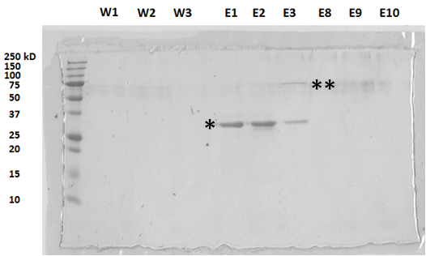

Figure 2.1. The characterization of purified recombinant ficolin-A by SDS-PAGE.
Supernatant from CHO cells over-expressing ficolin-A was run through a GlcNAc-sepharose column to purify the ficolin-A. The purified ficolin-A was washed in salt-containing buffers prior to elution with a buffer containing a high concentration of GlcNAc and collected in 10 1 mL fractions. The eluted fractions were separated via reducing SDS-PAGE (E1, 2, 3, 8, 9, 10); as were fractions collected from the wash step (W1-W3) (* Represents purified recombinant ficolin-A in monomeric form at ~35 kD; ** Represents purified recombinant ficolin-A in dimeric form at ~70 kD).

The binding of different concentrations of ficolin-A to conidia of Aspergillus spp. or to C. neoformans was assessed by incubating 0.1, 1, 10 or 100 µg mL⁻¹ of ficolin in 100 µL FBB with organsims for 1 h at 37°C in a humidified 5% CO₂ atmosphere. Ficolin binding was assessed via the ficolin binding assay outlined above.
The dependency of calcium for the binding of ficolins was assessed via the removal of calcium in FBB. This was achieved via the removal of CaCl₂ from the buffer and addition of 5 mM ethylene glycol tetraacetic acid (EGTA) or EDTA, which chelates calcium and is useful for creating buffers that mimic the environment inside living cells.
The carbohydrate recognition characteristics of ficolin-A, L-ficolin or H-ficolin were assessed using a ligand inhibition assay prior to binding. Differing concentrations (0.75-100 mM) of various carbohydrates (glucose (Glc), GlcNAc, galactose (Gal), GalNAc, L-fucose, D-mannose) and mannan were incubated with 5 µg mL⁻¹ ficolin-A or L-ficolin, or 18.4 µg mL⁻¹ H-ficolin for 2 h at RT. Following the ligand inhibition, 100 µL of the ficolin/carbohydrate complex was added to the organisms and ficolin binding was investigated as described above. For A. fumigatus hyphae, ficolin-A was pre-incubated with Glc, GlcNAc, Gal or GalNAc at a 100 mM concentration or mannan at a 100 µg mL⁻¹ concentration prior to binding assays.
To assess the influence of pH on the binding of ficolins, the pH of the binding buffer was adjusted from pH 3.7-10.7. To assess the influence of pH on the binding of ficolin-A to hyphae of A. fumigatus, FBB adjusted to pH 5.7 or pH 7.4 was used.
In all instances, ficolin binding was analysed by flow cytometry (Exλ 488 nm, Emλ 585/40nm) using BD Accuri C6 flow cytometer with BD CFlow® Software.

2.10 Determination of ficolin-A binding to A. fumigatus conidia or hyphae by fluorescence microscopy.

Conidia or hyphae were washed once in 1 mL FBB prior to centrifugation at 775 g and re-suspension in FBB containing 5 µg mL⁻¹ ficolin-A or ficolin-A pre-incubated with 100 mM GlcNAc. Conidia were incubated at 37°C for 1 h prior to staining with 100 µL of polyclonal rabbit anti-ficolin-A at a dilution of 1:1000 and incubated for 30 min at 4°C. The organisms were washed twice more as described above, prior to the addition of secondary chicken anti-rabbit AlexaFluor 594 (Invitrogen) at a dilution of 1:500 or goat anti-rabbit Ig-FITC at a dilution of 1:200 for 30 min at RT for conidia or hyphae, respectively. Following further washes, conidia were fixed for 10 min in 4% PBS/formaldehyde before conidia were mounted on to microscope slides using Fluoromount-G (Southern Biotech) and left in the absence of light until dry. Conidia were visualised using an Axiovert 40 CFL microscope (Zeiss).

2.11 Ficolin-A mediated agglutination assay.

The agglutination of conidia in the presence of ficolins was measured via a simple agglutination assay. Conidia from A. fumigatus were washed twice in FBB (pH 5.7) and centrifuged at 750 g for 4 min at RT. The conidia were then re-suspended in 100 µL of buffer at 10⁶ cells per well into a 96-well flat-bottom tissue culture plate (Nunc). The conidia were incubated for 2 h at 37°C with 5 µg mL⁻¹ or 20 µg mL⁻¹ ficolin-A or BSA and observed using an Axiovert 40 CFL microscope (Zeiss).

Pattern recognition molecule | Species and source | Working concentration | Obtained from
Ficolin-A | Rat, recombinant | 5 µg mL⁻¹ | Dr. R. Wallis¹
L-ficolin | Human, recombinant | 5 µg mL⁻¹ | Dr. D. W. Sexton²
H-ficolin | Human, recombinant | 18.4 µg mL⁻¹ | R&D Systems⁴
MBL-A | Mouse, serum | Serial dilutions | Prof. W. J. Schwaeble³
MBL-C | Mouse, serum | Serial dilutions | Prof. W. J. Schwaeble³
Antibody directed against
Rat ficolin-A | Rabbit, polyclonal | 1:1000 | Dr. R. Wallis¹
Human L-ficolin | Mouse, monoclonal | 1:100 | Dr. D. W. Sexton²
Human H-ficolin | Mouse, monoclonal | 1:100 | R&D Systems⁴
Mouse MBL-A | Rat, monoclonal | 1:2000 | Hycult⁵
Mouse MBL-C | Rat, monoclonal | 1:2000 | Hycult⁵
¹ University of Leicester, Department of Biochemistry, Leicester, UK
²University of East Anglia, Norwich Medical School, Norwich, UK
³University of Leicester, Department of Infection, Immunity and Inflammation, Leicester, UK
⁴R&D Systems, Abingdon, UK
⁵Hycult, Cambridge, UK
Table 2.1. Pathogen recognition molecules used in this study.

2.12 Interaction of opsonised Aspergillus spp. or labelled beads with host cells.

Cells of interest were seeded in 24-well/96-well flat bottom tissue culture plates (Nunc) in 300 µL/100 µL supplemented R-10 medium and incubated at 37°C in a 5% CO₂ atmosphere. Upon reaching semi-confluency, cells were washed once in 200 µL FBBwT and challenged with FITC-labelled A. fumigatus or A. flavus conidia as described below. In some experiments conidia were replaced with latex beads coated in 20 µg mL⁻¹ BSA or ficolin-A.
FITC-labelled Aspergillus spp. conidia or fluorescent latex beads were washed once in 1 mL FBBwT at 775 g for Aspergillus and beads for 4 min at RT. Conidia were opsonised with 5 µg mL⁻¹ BSA, ficolin-A or L-ficolin, or 18.4 µg mL⁻¹ H-ficolin (all made up in FBBwT) and incubated for 1 h at 37°C in a 5% CO₂ atmosphere. The conidia were washed in 1 mL FBBwT at pH 5.7 or pH 7.4 and centrifuged at 775 g for 4 min at RT. The supernatant was discarded and the conidia were re-suspended in 100 µL/ well FBBwT at either pH 5.7 or pH 7.4. The opsonised/un-opsonised conidia were then added in 100 µL aliquots to their respective wells containing semi-confluent adherent cells (challenge:cells = 5:1) and incubated for 2 h for Raw 264.7, dTHP-1, neutrophils and MDMs but 16 h for A549 cells at 37°C in a 5% CO₂ atmosphere.
Following incubation, the supernatant containing non-adherent conidia and cells were removed to clean Eppendorf tubes containing 100 µL 4% formaldehyde/PBS for 10 min at RT in the absence of light before being centrifuged at the appropriate speed for 4 min at RT and re-suspension in 75 µL PBS.
Adherent cells were washed in pre-warmed supplemented R-10 medium and observed by fluorescence microscopy to visualise internalisation using the inverted microscope, Axiovert 40 CFL with AxioVision Release 4.8 software (Zeiss). Adherent cells were removed from the tissue culture well using 100 µL 0.05% trypsin with 0.002% EDTA or gentle scraping. The cells were then fixed with 4% formaldehyde/PBS for 10 min at RT in the absence of light before being centrifuged at 775 g for 4 min at RT and re-suspension in 75 µL PBS. Samples were analysed by flow cytometry using a BD Accuri C6 flow cytometer (Exλ 488 nm, Emλ 585/40nm) with BD CFlow® Software.

2.13 Complement-specific ELISA.

To investigate the binding of pathogen recognition molecules to organisms or particles of interest, Maxisorb micro-titre 96-well plates (Nunc) were coated with A. fumigatus conidial suspensions (OD_{550 nm} of 0.5) or 10 µg/well zymosan (Sigma) in 100 µL of coating buffer (Appendix K). The plates were then incubated overnight at 4°C, prior to blocking residual protein binding sites in the coated wells with 1 % (w/v) BSA in Tris-buffered saline (TBS; Appendix L) for 2 h at RT. Plates were then washed 3 times with 250 µL/well of wash buffer (Appendix M).
To detect binding of MBL-A and MBL-C, serial dilutions of wild type serum in 100 µL of wash buffer were added prior to the plates being incubated for 90 min at RT. Plates were washed as above and the bound proteins were detected using monoclonal rat anti-mouse MBL-A (Hycult) or rat anti-mouse MBL-C (Hycult) in a 1:2000 dilution followed by rabbit anti-rat IgG-alkaline phosphatase conjugate (Sigma) in a 1:10000 dilution. Bound antibody was then detected using the colorimetric substrate p-nitrophenolphosphate (pNPP; Sigma).
To investigate the activation of complement and quantify the deposition of C3 or C4, Maxisorb micro-titre 96-well plates were coated with A. fumigatus conidial suspensions (OD_{550 nm} of 0.5), or 10 µg/well mannan (Sigma), N-acetylated BSA (N-BSA; Promega) or zymosan in 100 µL of coating buffer. The plates were then incubated, blocked and washed as described for the solid phase binding assays prior to the quantification of complement activation.
For some complement assays we removed endogenous ficolins from human serum by passing 5-10 mL of human serum through a GlcNAc-sepharose column overnight at 4°C. Ficolin-deficiency was confirmed using ficolin specific ELISAs.
To quantify C3c deposition, wild type, ficolin-deficient human serum or ficolin-deficient mouse serum was diluted in barbital buffered saline (BBS; Appendix N), added into antigen coated wells and incubated overnight at 4°C. Following a washing step, the primary antibody, polyclonal rabbit anti-human C3c complement antibody (Dako), was added at a dilution of 1:5000 or 1:500 and incubated for 1 h at 37°C. The wells were washed again. The secondary antibody, goat anti-rabbit IgG-alkaline phosphatase conjugate (Sigma), was added at a dilution of 1: or 1:5000 and incubated for 1.5 h at RT.

Antibody directed against | Species and source | Working conc. | Source
Rabbit Ig-FITC | Goat, polyclonal | 1:200 | Beckman Coulter¹
Mouse Ig-FITC | Goat, polyclonal | 1:200 | Beckman Coulter¹
Human C3c | Rabbit, polyclonal | 1:500 or 1:5000 | Dako²
Rabbit IgG-alkaline phosphatase | Goat, polyclonal | 1:5000 or 1:10000 | Sigma³
Human C4c | Chicken, polyclonal | 1:2000 | Agrisera⁴
Rabbit Alexafluor 594 | Chicken, polyclonal | 1:500 | Invitrogen⁵
Chicken IgY-alkaline phosphatase | Rabbit, polyclonal | 1:10000 | Sigma³

¹Beckman Coulter, High Wycombe, UK
²Dako, Ely, UK
³Sigma-Aldrich, Gillingham, UK
⁴Agrisera, Vännäs, SE
⁵Invitrogen, Paisley, UK
⁶New England Biolabs, Hitchin, UK
Table 2.2. Antibodies used in this study.

The wells were washed again and the assay was developed using pNPP. Mannan and zymosan coating were used as positive controls for C3 deposition by MBL-A and MBL-C. To quantify lectin pathway mediated C4 deposition, MBL-A and –C deficient serum (obtained from deficient mice) diluted in MBL-binding buffer (Appendix O) was added into antigen coated wells and incubated overnight at 4°C. On the following day, wells were washed and 1 µg/well of human C4 in BBS (pH 7.4) was added and incubated for 1.5 h at 37°C. Following washing, the primary antibody, chicken anti-human C4c antibody (Agrisera), was added at a dilution of 1:2000 and incubated for a further 1.5 h at 37°C. The plates were washed again prior to the addition of the secondary antibody (rabbit anti-chicken IgY-alkaline phosphatase conjugate; Sigma) at a dilution of 1:10,000 and incubated for 1 h at RT. The wells were washed again. The assay was developed using pNPP. N- BSA was used as a positive control for C4 deposition by ficolins. . Plates were read in a plate reader at Exλ 450 nm.

2.14 Killing of ficolin opsonised A. fumigatus conidia by host cells.

Freshly harvested live A. fumigatus conidia were either opsonised with 5 µg mL⁻¹ ficolin-A or L-ficolin, 18.4 µg mL⁻¹ H-ficolin, or left un-opsonised, as described for the binding assays. Following incubation in the presence or absence of ficolins, A. fumigatus conidia (5 x 10⁵) were added to the cells of interest (A549, dTHP-1, MDM or neutrophils) and incubated for 24 h. Microscopic analysis was conducted after 2, 4, 6, 8, 16, 20 and 24 h to assess the hyphal growth of the A. fumigatus conidia and the supernatants were collected after 8 h and 24 h time points prior to centrifugation and storage at -80°C to be used for cytokine analysis.
Fungal viability was measured using a LIVE/DEAD® Yeast Viability Kit (Invitrogen). Assays were conducted as outlined in the protocol. In brief, conidia from the host cell challenge were stained with 15 µM FUN-1 cell stain and incubated in the absence of light for 30 min at 30°C. FUN-1 stain is metabolised inside the fungus from yellow-green to orange-red fluorescence if the fungi are metabolically active and possess intact membranes. Dead fungi display diffuse bright green staining. Dead cells were visualised using an Axiovert 40 CFL microscope (Zeiss).
Following incubation, supernatants were aspirated and the cells were washed with warm supplemented RPMI-1640. Adherent cells were subsequently removed by the use of trypsin/EDTA and gentle trituration. Neutrophils in suspension were removed and washed in warm supplemented RPMI-1640 at 300 g for 5 min. Cells and supernatants were fixed in 4% PBS/formaldehyde for 10 min at RT. Fungal viability was quantitated by flow cytometry using a BD Accuri C6 flow cytometer (Exλ 488 nm, Emλ 585/40nm) with BD CFlow® Software.

2.15 Detection of IL-8 by ELISA.

Supernatants from the interactions between host cells and Aspergillus spp. conidia were collected and analysed initially via ELISA for the induction of IL-8 based upon the human IL-8 ELISA Ready-SET-Go!® kit protocol (eBioscience). In brief, Corning Costar 9018 ELISA plates were coated with 100 µL/well of capture antibody in 1x ELISA coating buffer (1:250) before the plate was sealed and incubated overnight at 4°C. The following day the wells were aspirated and washed 5 times with ~250 µL/well wash buffer, allowing a ~ 1min soaking time per wash. Wells were then blocked with 200 µL/well 1x assay diluent at RT for 1 h. Wells were washed as above prior to the addition of 100 µL/well of the IL-8 standards and sample supernatants and incubation at RT for 2 h. Wells were again washed as before prior to the addition to the addition of 100 µL/well detection antibody diluted in 1x assay diluent (1:250) and incubation at RT for 1 h. Following washes as before, 100 µL/well of avidin-horseradish peroxidase (HRP) conjugate diluted in 1x assay diluent (1:250) was added and incubated at RT for 30 min. Washes were conducted again as before prior to the addition of 1x TMB substrate for 15 min at RT. Following development, 50 µL/well of 2N H₂SO₄ was added to stop any further colour development before the absorbance at 450 nm was read in a mini-plate reader and IL-8 concentrations analysed.

2.16 Detection of inflammatory cytokines by cytometric bead array (CBA).

Cytokine expression from supernatants following cell challenge with ficolin-opsonised or un-opsonised conidia or following LPS stimulation (100 ng mL⁻¹) was quantitated using a BD CBA Human Inflammatory Cytokines Kit (IL-8, IL-1β, IL-6, IL-10, TNF-α and IL-12p70) (BD Biosciences). Assays were conducted as outlined in the protocol. In brief, capture beads for the measurement of cytokines were mixed together prior to their addition to the sample and standard tubes. Following the addition of capture beads to the samples, Human Inflammatory Cytokine PE Detection Reagent was added to all tubes and incubated for 3 h in the absence of light. Following incubation, samples were washed in wash buffer for 5 min at 200 g prior to aspiration of the supernatant, re-suspension in wash buffer and flow cytometric analysis (Exλ 488 nm, Emλ 585/40nm) and (Exλ 633 nm, Emλ 780/30 nm) using a BD Accuri C6 flow cytometer with BD CFlow® Software.
To investigate the role of MAPK signalling in IL-8 production, inhibitors of MEK 1/2 (U0126), p38 MAPK (SB202190) and JNK (SP600125) (all purchased from Tocris Biosciences) were added to host cells at a concentration of 10 µM for 1 h prior to and during A. fumigatus challenge.

2.17 Receiver operating curve (ROC) analysis

A receiver operating curve (ROC) analysis was conducted to determine the probability of transplant patients also harbouring post-transplant fungal diseases. In an ROC curve true positives (sensitivity) is plotted against false positives (100-specificity) for different cut-off points. Each point on an ROC curve represents sensitivity/specificity pairs and the area under the curve (AUC) measures how well you can distinguish between two diagnostic groups. The cut-off was determined using Youden’s index (sensitivity + specificity – 1). Each discrete point on the graph, called an operating point, is generated by using different cutoff levels for a positive test result, which results in curve that links the points obtained at all possible cutoff levels.

2.18 Statistical analysis

Results are expressed as mean ± SD. Descriptive and 2-tailed Students t-test analyses were performed using GraphPad prism software (version 5). One-way analysis of variance tests (ANOVA’s) were performed using SigmaStat software (version 3.5). A value of p<0.05 was considered statistically significant. Receiver operating characteristics (ROC) curve analysis was conducted using MedCalc (version 13.1.1).

Chapter 3: The Role of H-ficolin in the Host Response Against Aspergillus fumigatus.

3.1 Introduction

A. fumigatus is the most common mould pathogen in the developed world and is the primary causative species of the potentially fatal disease, invasive aspergillosis (IA) in immunocompromised patients. IA is an increasing problem due to the emergence of a number of antifungal resistant strains and even if treated effectively, harbours an infection associated mortality rate of up to 90% (Denning, 1998, Segal, 2009, Steinbach et al., 2012, Taccone et al., 2015). Transplant patients are at particular risk and it is estimated that up to 1 in 4 lung or heart transplant patients will succumb to IA. Infection is propagated via the inhalation of small hydrophobic spores (conidia) which penetrate deep into the alveolar space where they germinate, invade the vasculature and disseminate to other organs such as the brain and the skin (Schelenz et al., 2003, Martin et al., 2005). A. fumigatus can be found ubiquitously and is mostly omnipresent, making inhalation difficult to avoid. Fortunately, the innate immune system can provide robust and effective responses to aid in the removal of spores. The initial defence to the inhalation of A. fumigatus is mucociliary clearance but if this is evaded then an innate immune response comprising of type II pneumocytes, AM, neutrophils and serum pathogen recognising opsonins, can work synergistically to potentiate conidia recognition and removal. One such family of opsonins are coined ficolins.
Ficolins are novel serum opsonins comparable to the widely studied collectins, MBL, SP-A and SP-D. They are composed of two key domains; an N-terminal collagen-like domain and a C-terminal FBG domain with lectin activity highly specific for the acetylated carbohydrate, GlcNAc, a key component of the A. fumigatus cell wall (Hearn et al., 1994). Humans possess three types of ficolin; the membrane-bound M-ficolin and the serum opsonins, L- and H-ficolin. Ficolins primarily function as opsonins whereby they can enhance the phagocytosis of pathogenic microorganisms but they are also capable of activating the lectin complement pathway via association with MASPs (Matsushita et al., 1996, Matsushita et al., 2000). Novel immunomodulatory functions are also beginning to arise but mechanistic insights and cell signalling involved in these functions are in their infant stages (Bidula et al., 2013a, Luo et al., 2013, Ma et al., 2013a, Ma et al., 2013b). Although, mitogen-activated protein kinases (MAPKs) may be involved, based upon the observation that these were required for signalling pathways within the lung epithelium in response to A. fumigatus challenge (Balloy et al., 2008). These kinases are a highly conserved family of serine/threonine protein kinases involved in cellular processes such as the stress response, cellular proliferation, differentiation and motility, apoptosis and survival. These pathways are stimulated by a range of extracellular stimuli such as cytokines and environmental stressors, consequently leading to activation of MAPKK kinases, which phosphorylate and activate downstream MAPK kinase, which in turn activates MAPKs (Arthur et al., 2013)
Of the serum ficolins, H-ficolin is undoubtedly the most poorly understood, with the fewest pathogenic targets and a distinct lack of characterisation in comparison to L-ficolin. Whereas L-ficolin is not produced in the lung, H-ficolin can be secreted directly by resident type II epithelial cells (Akaiwa et al., 1999). In addition, previous observations have highlighted that H-ficolin can recognise A. fumigatus conidia but this interaction was not characterised in any detail (Hummelshøj et al., 2012). Therefore, we investigated whether opsonisation of A. fumigatus by H-ficolin could potentiate the functions of A549 cells, a cell line with characteristics of type II epithelial cells. Additionally, we investigated the role of H-ficolin in lectin complement pathway activation, cytokine modulation and measured H-ficolin concentrations in the BAL of lung transplant patients with, or without post-transplant infection. The aims of this chapter were to:
- Characterise H-ficolin binding to A. fumigatus.

- Determine the role of H-ficolin in opsonophagocytic killing, lectin complement pathway activation and cytokine modulation.

- Investigate the concentration of H-ficolin in lung transplant patients.

3.2 Results

3.2.1 Binding characteristics of serum H-ficolin to A. fumigatus.

H-ficolin had been reported to be produced by type II pulmonary epithelial cells and we observe that it is also present in the A549 type II epithelial cell line (not shown). It has been acknowledged that H-ficolin is capable of binding A. fumigatus, albeit weakly (Hummelshøj et al., 2012). We further characterise this binding and show that the recognition of A. fumigatus by H-ficolin occurs in a pH-dependent, Ca²⁺-dependent manner and is inhibited by L-fucose, D-mannose and GlcNAc.
Following opsonisation of A. fumigatus conidia (5 x 10⁵) with H-ficolin (18.4 µg mL⁻¹), significant binding was observed (for H-ficolin opsonised conidia versus un-opsonised and BSA opsonised conidia; median fluorescence intensities of 619±42.3 versus 207.7±1.5 and 215±1, respectively; p=4.01 x 10⁻⁶, Figure 3.1A-C). H-ficolin was observed to significantly bind to conidia, albeit much less avidly than serum L-ficolin or its rodent orthologue, ficolin-A.
When calcium was removed from the buffer and excess calcium was chelated by EGTA, H-ficolin binding was observed to significantly decrease to levels similar to the BSA control (median fluorescence intensities of 294.7±13.8 versus 215±1 for H-ficolin and BSA, respectively; p=2.02 x 10⁻⁵, Figure 3.1C).
To investigate H-ficolin carbohydrate-binding specificity, H-ficolin was pre-incubated with a range of carbohydrates (glucose, galactose, GlcNAc, L-fucose and D-mannose) prior to incubation with A. fumigatus conidia. L-fucose, GlcNAc and D-mannose exhibited the greatest binding inhibition (% inhibitions of 70% ±1.6%, 88.7% ±7% and 93.4% ±7% at maximal carbohydrate concentration of 100 mM for L-fucose, GlcNAc and D-mannose, respectively; Figure 3.2). Conversely, pre-incubation with glucose and galactose led to significantly lower percentage inhibitions (% inhibitions of 15.5% ±1.5% and 24.8% ±10.5% at maximal carbohydrate concentration of 100 mM for glucose and galactose, respectively; Figure 3.2).
Binding studies were conducted in a range of pH from pH 3.7 to pH 10.7. Here, binding occurred in a pH-dependent manner, with maximal binding observed in inflammatory (pH 5.7) conditions. Binding at pH 5.7 was significantly greater than binding in physiological

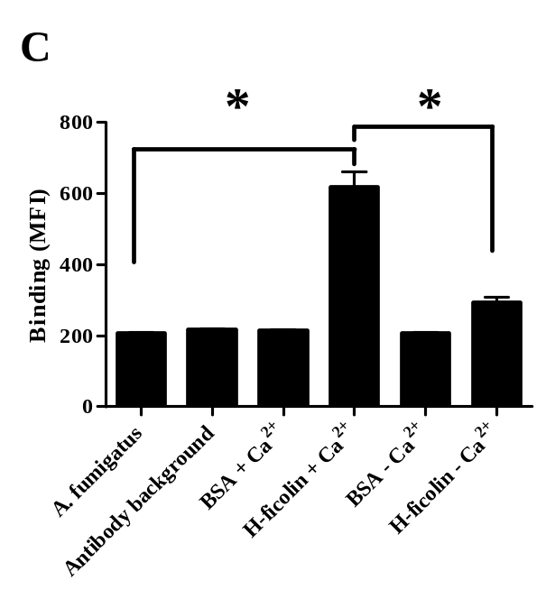
Figure 3.1. Calcium binding dependency of H-ficolin to A. fumigatus.
Conidia of A. fumigatus were incubated with 18.4 µg mL⁻¹ H-ficolin in the presence of calcium (A) or in the absence of calcium and the presence of 5 mM EGTA (B). (C) H-ficolin binding to A. fumigatus is Ca²⁺-dependent and comparable to non-specific protein controls. All results represent 5 x 10⁵ conidia stained with rabbit anti-H-ficolin and goat anti-rabbit Ig-FITC-labelled antibodies and are the average of all the data points gained from three independent experiments. Error bars represent the SD. Significance was determined by Student’s t-test (*p<0.05).

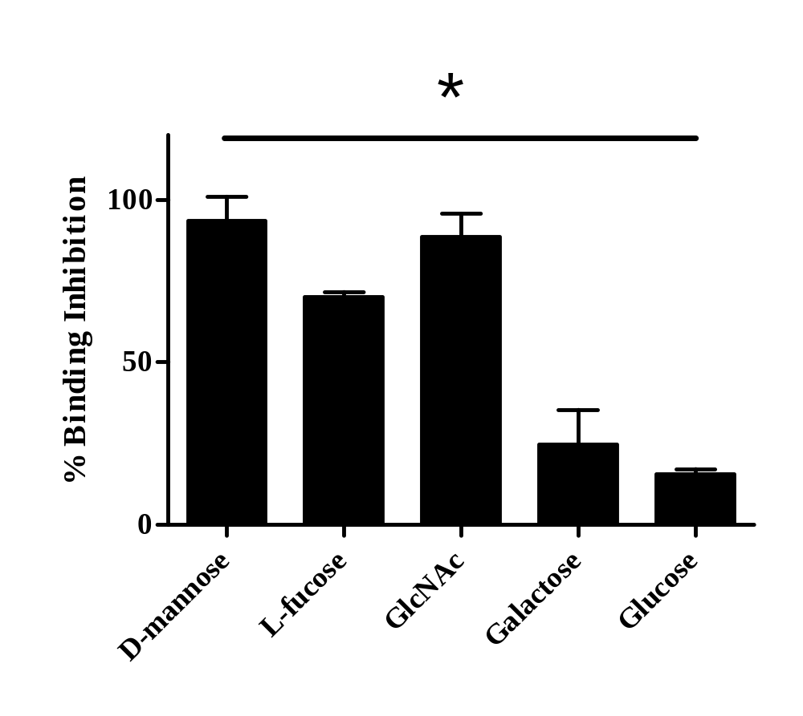

Figure 3.2. Carbohydrate specificity of H-ficolin binding to A. fumigatus conidia.
Conidia of A. fumigatus were incubated with 18.4 µg mL⁻¹ H-ficolin which was pre-incubated with a range of carbohydrates (glucose, galactose, L-fucose , D-mannose and GlcNAc) at 100 mM concentrations. All results represent 5 x 10⁵ conidia stained with rabbit anti-H-ficolin and goat anti-rabbit Ig-FITC-labelled antibodies and are the average of all the data points gained from three independent experiments. Error bars represent the SD. Significance was determined via two-way ANOVA and post-hoc analysis was conducted using the Tukey test (*p<0.05).

(pH 7.4) conditions (p=0.00398, Figure 3.3). However, binding in pH 7.4 conditions was still significant (p=1.09 x 10⁻⁶; Figure 3.3).

3.2.2 The role of H-ficolin opsonisation on the association of A. fumigatus with A549 lung epithelial cells.

H-ficolin is found in the lung mucosa, originating from bronchial epithelial cells and alveolar type II epithelial cells, therefore we were interested as to whether H-ficolin opsonisation of A. fumigatus could enhance fungal-host interactions (Akaiwa et al., 1999).
To investigate association, FITC-labelled A. fumigatus conidia were opsonised with H-ficolin prior to incubation with A549 cells for 16 hours in pH 5.7 or pH 7.4 conditions. A549 cells were gated (Figure 3.4A) and the percentage of FITC negative and positive were used to identify associated cells (Figure 3.4B). There was a uniform shift in the fluorescence of the A549 population meaning that all the A549 cells were associated. However, in the presence of H-ficolin, the number of conidia associated per A549 was significantly increased (based upon the median fluorescence intensity) but only in acidic (pH 5.7) conditions (p=0.00359, Figure 3.4C).

3.2.3 The role of H-ficolin opsonisation on the killing of A. fumigatus by A549 lung epithelial cells.

Cell-host microbe interactions were enhanced following H-ficolin opsonisation in acidic conditions but the fate of these conidia remained unknown. Therefore, we investigated whether H-ficolin could enhance fungal killing by A549 cells. To investigate fungal viability, growth of A. fumigatus hyphae was visualised via light microscopy prior to staining with FUN-1, a fluorescent probe for the detection of fungal viability. Light microscopy demonstrated that in both the presence and absence of H-ficolin, hyphal growth was unaffected (Figure 3.5A-C). Following FUN-1 staining, dead cells display bright diffuse yellow-green fluorescence, which we chose to quantify with flow cytometry. FUN-1 staining showed that there was no significant difference between the yellow-green fluorescence in the presence or absence of H-ficolin, suggesting that H-ficolin doesn’t

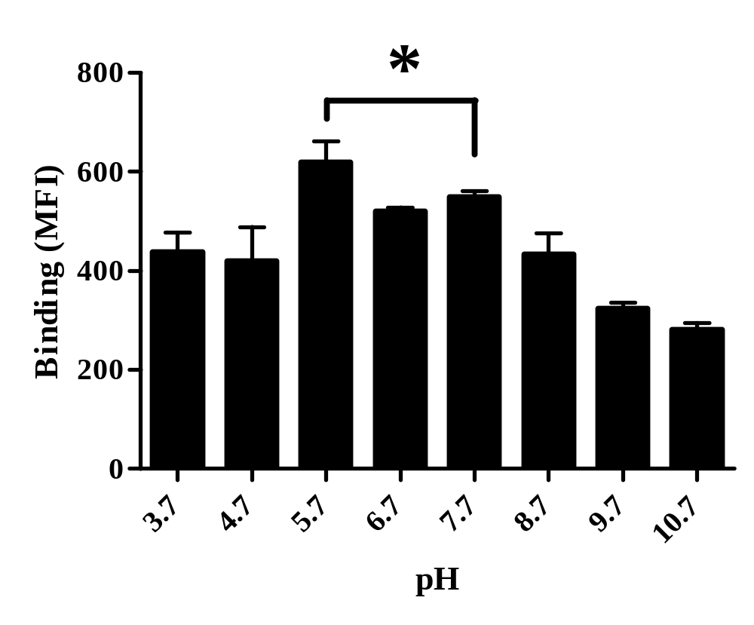
Figure 3.3. pH dependent binding of H-ficolin to A. fumigatus conidia.
A. fumigatus conidia were incubated with 18.4 µg mL⁻¹ H-ficolin at different pH values (3.7-10.7). All results represent 5 x 10⁵ conidia stained with rabbit anti-H-ficolin and goat anti-rabbit Ig-FITC-labelled antibodies and are the average of all the data points gained from three independent experiments. Error bars represent the SD. Significance was determined by Student’s t-test (*p<0.05).

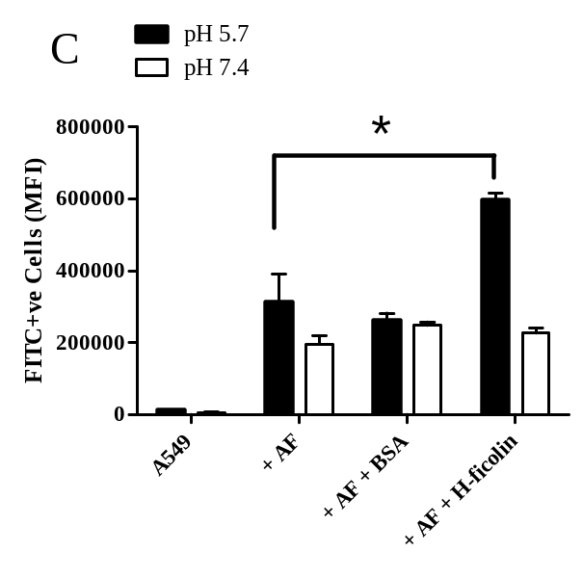
Figure 3.4. Association of H-ficolin opsonised A. fumigatus conidia with A549 type II pneumocytes.
Live freshly harvested conidia (1 x 10⁶) were opsonised with 18.4 µg mL⁻¹ H-ficolin prior to incubation with A549 cells (conidia:A549 ratio of 5:1) for 16 h in pH 5.7 conditions. (A) The gating strategy used to select the A549 population. 10,000 events were collected (B) Histogram depicting association of fluorescent conidia in the presence and absence of H-ficolin. (C) The relative number of A. fumigatus conidia associating with A549 cells as either un-opsonised A. fumigatus conidia, BSA opsonised A. fumigatus conidia or H-ficolin opsonised A. fumigatus conidia incubated in pH 5.7 conditions for 16 h (expressed as median fluorescence intensity; FL1-A). Data is representative of the average of all the data points gained from three independent experiments. 10,000 events were collected. Error bars represent the SD. Significance was determined by Student’s t-test (*p<0.05).
contribute to fungal killing by A549 cells and confirming the light microscopy observations (p=0.842, Figure 3.6).

3.2.4 The role of H-ficolin in lectin complement pathway activation on A. fumigatus.

Following the observation that H-ficolin could enhance association, we explored potential mechanisms to explain this augmentation. One way in which ficolins can enhance association is via the activation of the lectin pathway of complement.
To investigate H-ficolin activation of the lectin pathway on A. fumigatus conidia, human serum was either run through a GlcNAc-sepharose column to remove endogenous ficolins or left ficolin-sufficient. Following the removal of endogenous ficolins, there was moderately diminished C3 deposition on A. fumigatus but ficolin-sufficient serum maintained full complement activating activity (EC₅₀ of 1.15% serum versus an EC₅₀ of 0.32% serum for ficolin-deficient and ficolin-sufficient serum, respectively; Figure 3.7). Moreover, reconstitution of the ficolin-deficient serum with recombinant H-ficolin was capable of restoring the level of complement activation to normal levels (EC₅₀ of 0.34% serum; Figure 3.7).

3.2.5 The role of H-ficolin in cytokine modulation following A. fumigatus challenge.

Next, we utilised cytometric bead arrays to measure the concentration of IL-8, IL-1β, IL-6, IL-10 and TNF-α following challenge by H-ficolin opsonised A. fumigatus conidia.
From the cytokine panel tested, H-ficolin opsonisation induced a significant increase in the secretion of pro-inflammatory IL-8 compared to challenge with un-opsonised conidia after 24 h (IL-8 concentrations of 611.5 pg mL⁻¹ ±56.1 versus 1893.3 pg mL⁻¹ ±263 for un-opsonised and H-ficolin opsonised conidia, respectively; p=0.00117, Figure 3.8). H-ficolin
Figure 3.5. Hyphal germination following incubation of H-ficolin opsonised A. fumigatus conidia with A549 type II pneumocytes.
Live freshly harvested conidia (1 x 10⁶) were opsonised with 18.4 µg mL⁻¹ H-ficolin prior to incubation with A549 cells (conidia:A549 ratio of 5:1) for 24 h in pH 5.7 conditions (A) Hyphal germination following incubation of un-opsonised conidia. (B) Hyphal germination following incubation of BSA opsonised conidia (C) Hyphal germination following incubation of H-ficolin opsonised conidia. Hyphae were imaged using an Axiovert 40 CFL microscope at 10 x objective. Scale bars represent 50 µm. Images are representative of three independent experiments.

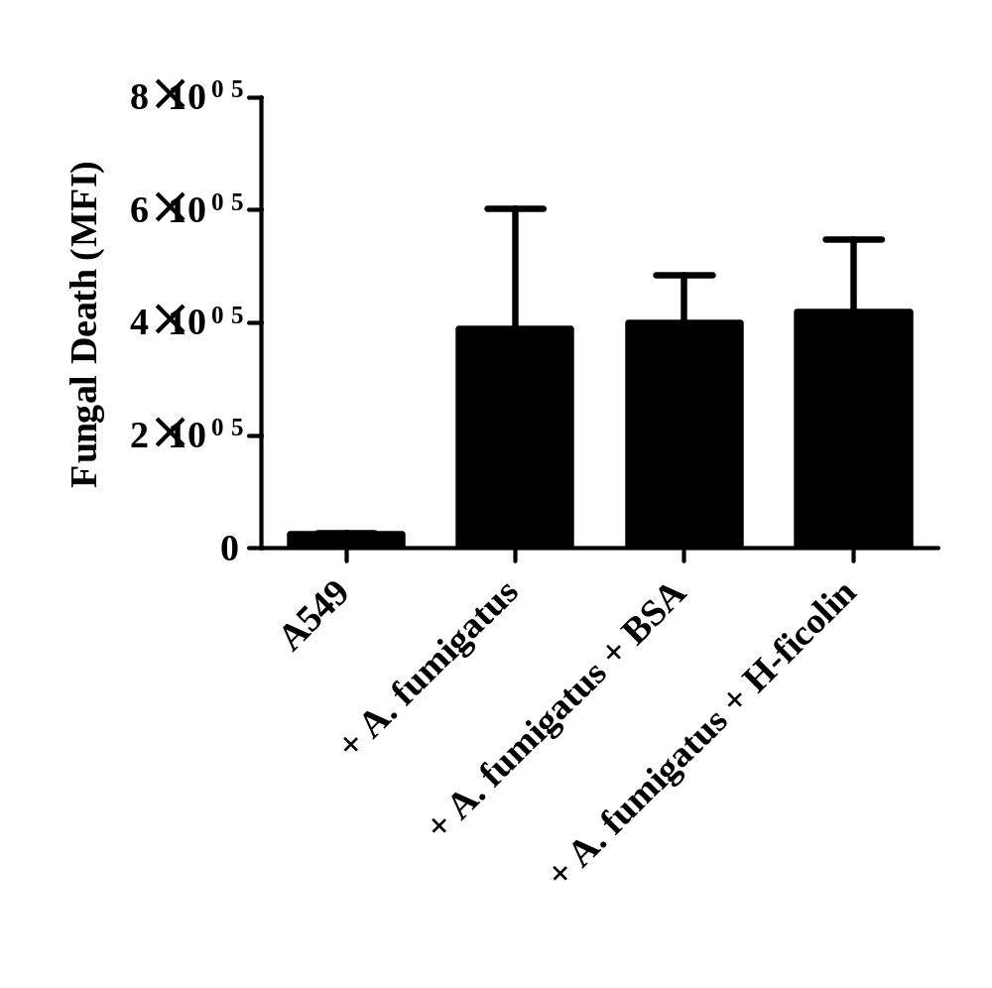
Figure 3.6. Fungal viability following incubation of H-ficolin opsonised A. fumigatus conidia with A549 type II pneumocytes.
Live freshly harvested conidia (1 x 10⁶) were opsonised with 18.4 µg mL⁻¹ H-ficolin prior to incubation with A549 cells (conidia:A549 ratio of 5:1) for 24 h in pH 5.7 conditions and staining with a LIVE/DEAD FUN-1 fungal viability stain. An increase in median fluorescence intensity (MFI) using the FL1-A filter depicts increased killing. Data is the average of all data points gained from three independent experiments. Error bars represent the SD.

in the absence of conidia induced an increase in IL-8 but this increase was not significant (p=0.06725, Figure 3.8).
In order to investigate the signalling pathways involved in the increase of IL-8 secretion from A549 cells following challenge by H-ficolin opsonised A. fumigatus, we used the MEK 1/2 inhibitor U0126, the p38 MAPK inhibitor SB202190 and the JNK inhibitor SP600125 prior to the quantification of IL-8 by bead array. It was observed that MEK 1/2 inhibition completely abrogated IL-8 production following challenge with un-opsonised or H-ficolin-opsonised conidia (p<0.001, Figure 3.9). Inhibition of p38 MAPK and JNK also significantly reduced IL-8 production both in the presence and absence of H-ficolin opsonisation (p<0.001; Figure 3.9).
The incremental increase of IL-8 from A549s that was induced by H-ficolin alone in the absence of A. fumigatus also appeared to be significantly reduced via inhibition of MEK 1/2 and JNK but less so by the p38 MAPK inhibitor SB202190 (p<0.001, Figure 3.9).

3.2.6 The detection of H-ficolin in the BAL fluid of lung transplant recipients.

H-ficolin can be released into the BAL fluid from bronchial epithelial cells and alveolar type II epithelial cells; therefore we chose to investigate the concentration of H-ficolin in the BAL fluid from transplant patients (a high risk group for invasive aspergillosis) with or without signs of lung infection.
Here, we utilised an H-ficolin-specific ELISA to detect the presence of H-ficolin in the BAL samples of lung transplant recipients. H-ficolin was observed to be present in both the lungs of healthy and infected transplant recipients (Table 3.1). However, in patients who were diagnosed with invasive pulmonary fungal infection based on EORTC/MSG criteria and/or positive GM/lateral-flow, fungal, bacterial or viral growth (Table 3.1), H-ficolin BAL concentration was significantly higher compared to healthy recipients (p=0.00726; Figure 3.10A). Out of the 15 infected lung transplant patients, one was infected with Penicillium, one with Staphylococcus aureus, one with rhinovirus, three with Pseudomonas aeruginosa, four with A. fumigatus and five without positive cultures but radiological imaging suggestive of invasive fungal infection or positive GM and/or lateral flow. Within these groups, patients infected with A. fumigatus had consistently higher

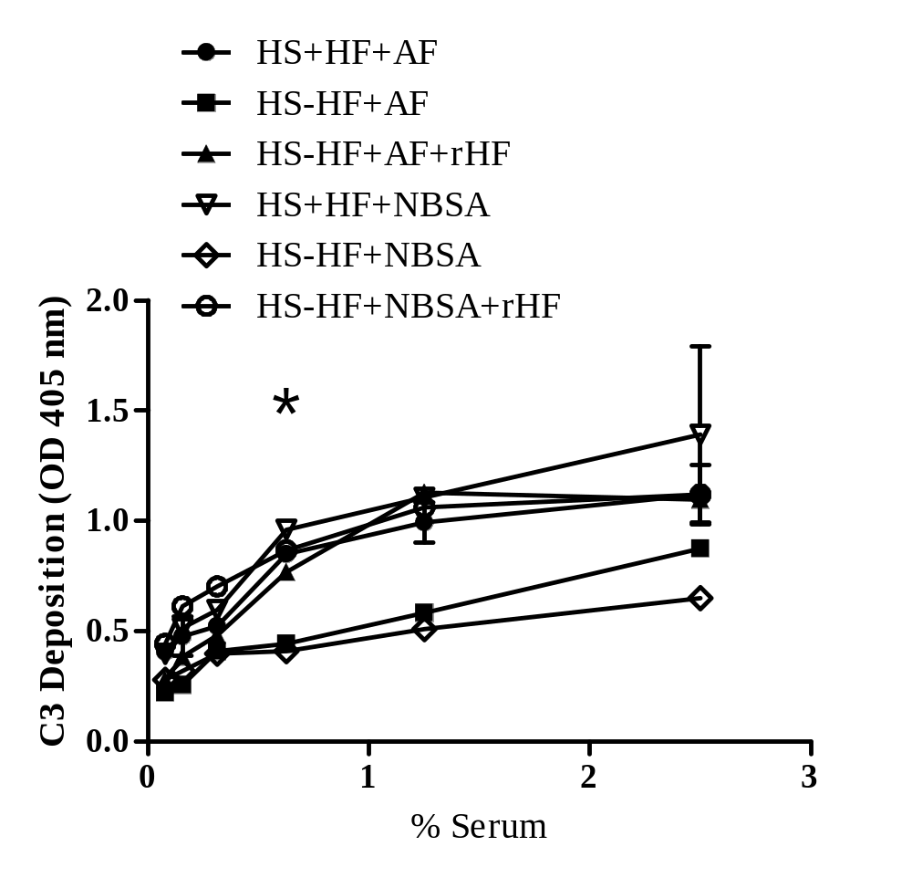
Figure 3.7. H-ficolin activates the lectin complement pathway on A. fumigatus conidia.
The restoration of lectin complement pathway C3 deposition was observed on A. fumigatus following the reconstitution of ficolin-depleted human serum (HS) with recombinant H-ficolin. Serum dilutions of HS were incubated in Maxisorb microtiter 96-well coated plates and deposited C3 was detected by using rabbit anti-human C3c complement antibodies and goat anti-rabbit IgG-alkaline phosphatase conjugate. N-acetyl BSA was used as a positive control for C3 deposition. Significant C3 deposition was observed at 0.6% serum (*p<0.05). HS+HF+AF represents human serum incubated with H-ficolin and A. fumigatus; HS-HF+AF represents human serum in the absence of H-ficolin and presence of A. fumigatus; HS-HF+AF+rHF represents human serum reconstituted with recombinant H-ficolin and incubated with A. fumigatus; all parameters were repeated with N-acetyl BSA (NBSA) as a non-specific protein control. All data points are represented as mean absorbance measured at 405 nm and are the data obtained from three independent experiments. Significance was determined via two-way ANOVA and post-hoc analysis was determined by the Student Newman-Keuls method.

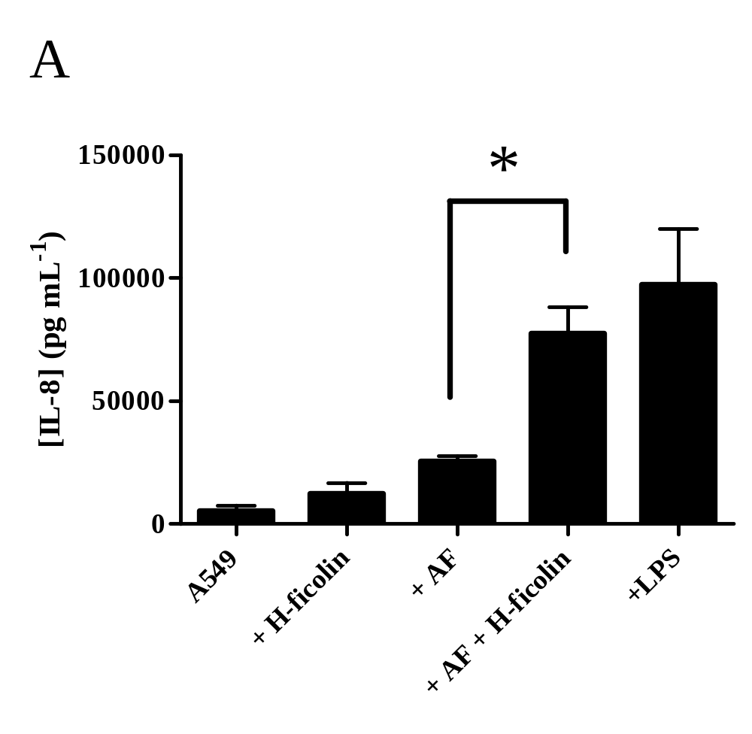
Figure 3.8. Inflammatory cytokine release from A549 type II pneumocytes following challenge by un-opsonised or H-ficolin opsonised conidia.
Cell supernatants were collected after 24 h time points during challenge with live A. fumigatus conidia (1 x 10⁶) un-opsonised or H-ficolin opsonised (18.4 µg mL⁻¹) prior to the conduction of cytometric bead arrays. LPS was used as a positive control. Error bars represent the SD. Significance was determined via one-way ANOVA and pair-wise comparisons were conducted using the Student-Newman-Keuls method. Results are the average of all data points gained from three independent experiments An asterisk indicates a significant difference: *p˂0.05.

concentrations of H-ficolin in the BAL (average concentration of 19.4 ng mL⁻¹; Figure 3.10B). The one patient with rhinovirus had a higher BAL H-ficolin concentration (average concentration of 24.1 ng mL⁻¹) but this was only data from one patient (Figure 3.10B). An ROC curve analysis was conducted to investigate whether the detection of H-ficolin could be used as a potential biomarker/diagnostic tool for fungal lung infection. The area under the curve (AUC) was calculated to be 0.841 which suggested there was an 84.1% chance that infected transplant patients would have H-ficolin present in their BAL fluid (p<0.0001; Figure. 3.10C).

3.3 Discussion

In this study, we focused on the role of H-ficolin in the innate immune recognition of A. fumigatus and its role in host-fungal interactions. This work led to a number of new observations. Firstly, H-ficolin was capable of recognising A. fumigatus conidia in a Ca²⁺-dependent and pH-dependent manner, in an interaction inhibited by D-mannose, L-fucose and GlcNAc. This recognition also led to enhanced association with epithelial cells. Secondly, H-ficolin opsonisation led to activation of complement on A. fumigatus. Thirdly, in the presence of H-ficolin, we observed an increase in the production of IL-8 which was abrogated following inhibition of MEK 1/2, p38 MAPK and JNK. Finally, H-ficolin concentration in the BAL fluid was greater in transplant recipients with post-transplant lung infections and may have the potential to become a novel host biomarker for the detection of viral and fungal lung infection. This work has therefore led us to postulate that following inflammation, H-ficolin recognizes conidia via its cell surface glycoproteins and enhances the immune function of lung epithelial cells in the defence against A. fumigatus.
To date, all of the known serum ficolins had been observed to be capable of binding to A. fumigatus conidia but of these serum ficolins, H-ficolin binding was poorly characterized (Ma et al., 2009, Hummelshøj et al., 2012, Bidula et al., 2013a). We therefore proceeded to investigate the manner in which H-ficolin recognised A. fumigatus conidia. H-ficolin was observed to significantly bind to conidia, albeit much less avidly than serum L-ficolin or its rodent orthologue, ficolin-A. This could be explained by H-ficolin’s much lower binding to GlcNAc compared to L-ficolin. Similarly to L-ficolin and the related collectins, MBL and the surfactant proteins, H-ficolin binding to A. fumigatus also required the presence of Ca²⁺ (Madan et al., 1997, Neth et al., 2000).

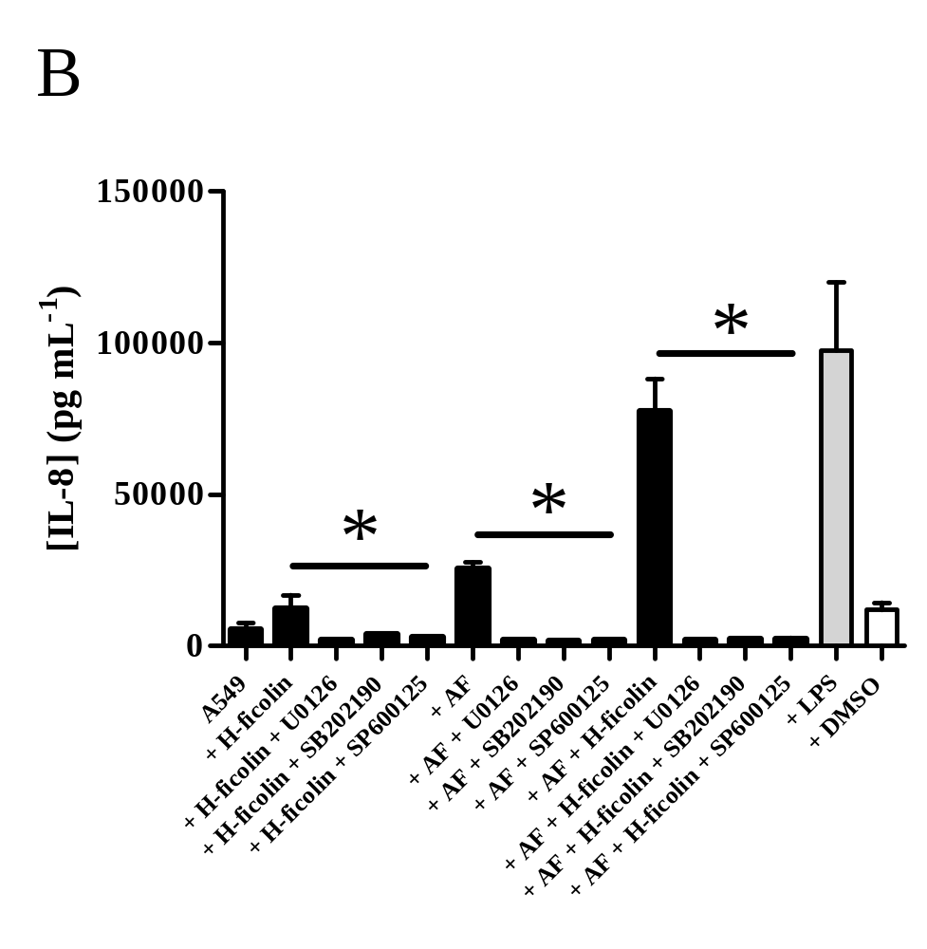
Figure 3.9. Inflammatory cytokine release from A549 type II pneumocytes following pre-incubation with MAPK inhibitors and a challenge with un-opsonised or H-ficolin opsonised conidia.
A549 type II pneumocytes were pre-incubated with 10 µM of the MEK 1/2 inhibitor (U0126), the p38 MAPK inhibitor (SB202190) or the JNK inhibitor (SP600125) prior to challenge with live A. fumigatus conidia (1 x 10⁶) un-opsonised or H-ficolin opsonised (18.4 µg mL⁻¹). Supernatants were collected after 24 h time points prior to the conduction of cytometric bead arrays. LPS was used as a positive control and DMSO was used as a vehicle control. Error bars represent the SD. Significance was determined via one-way ANOVA and pair-wise comparisons were conducted using the Student-Newman-Keuls method. Results are the average of all data points gained from three independent experiments An asterisk indicates a significant difference: *p˂0.05.

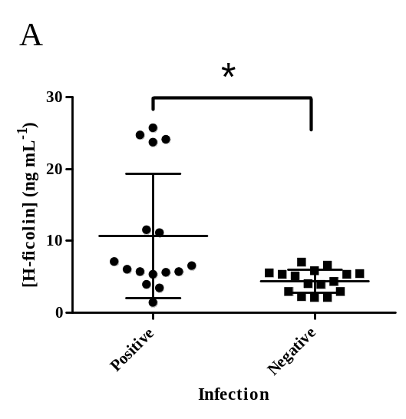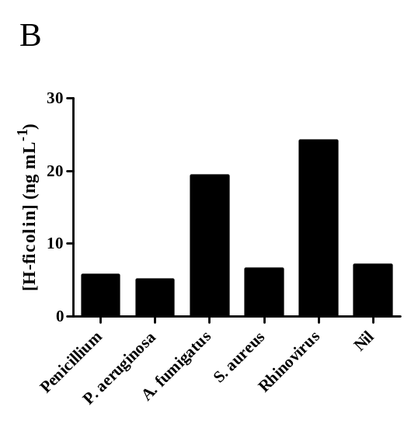
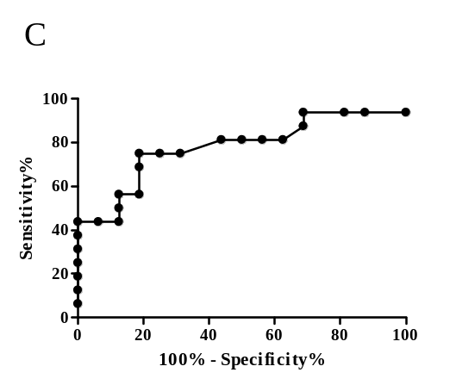
Figure 3.10. H-ficolin in bronchoalveolar lavage (BAL) fluid of infected lung transplant recipients.
BAL fluid was collected following bronchoscopies on lung transplant patients prior to the measurement of H-ficolin concentrations by ELISA. (A) The concentration of H-ficolin (ng mL⁻¹) in BAL samples. BAL samples were considered positive (n=15) or negative (n=16) for infection dependent upon patients classification according to EORTC/MSG criteria, Aspergillus antigen detection, radiology and bacterial, viral or fungal cultures (*p<0.05) (B) H-ficolin concentration in the BAL fluid of patients testing culture positive for Penicillium (Pen; n=1), P. aeuriginosa (PsA; n=3), A. fumigatus (AsF; n=4), S. aureus (StA; n=1), rhinovirus (Rhi; n=1) or culture negative (Nil; n=5). (C) ROC curve analysis for H-ficolin detection in infected transplant patients compared to non-infected transplant patients. Results are representative of the data points gained from three independent experiments (15 positive and 16 negative patients). Bars represent the median and significance was determined via two-tailed Students t-test.

Ficolins are capable of distinguishing between self and non-self carbohydrates on pathogenic microorganisms via their FBGs (Le et al., 1998) and their specificity for carbohydrates present on pathogen cell walls can be assessed via competitive inhibition of their FBG. Few studies to date have highlighted the carbohydrate recognition properties of H-ficolin, with binding previously only observed to a polysaccharide of Aerococcus viridians, acetylated forms of glucosamine, galactosamine, glycine and cysteine, D-fucose and very few pathogens (Matsushita et al., 2002a, Hummelshøj et al., 2012, Zacho et al., 2012). The cell wall of A. fumigatus is predominantly composed of glucan, chitin and galactomannan and these cell wall glycoproteins constitute part of the Aspergillus virulence factors (Latge et al., 1993). When further deconstructed, the cell wall is composed of glucose, glucosamine, galactose and mannose (Azuma et al., 1969, Hearn et al., 1994). In the present study, we indicate novel binding targets for H-ficolin in the shape of D-mannose and L-fucose while re-establishing the preference of ficolin binding to GlcNAc. Interestingly, neither D-mannose nor L-fucose was able to inhibit binding of H-ficolin in previous studies (Zacho et al., 2012). This implies that H-ficolin recognises its targets via multiple binding sites on the fibrinogen-like domain with additional sites for mannose and/or fucose as well as separate sites for GlcNAc. All in all, the binding of H-ficolin to a range of carbohydrate structures on the conidial surface is essential for efficient pathogen recognition. This could have the potential to influence Aspergillus infection via restricting fungal adhesion and masking inflammation induced by surface virulence factors. However, those fungi evading immune recognition can provoke an inflammatory response.
We have shown that the binding of H-ficolin to A. fumigatus is also significantly enhanced in inflammatory conditions (pH 5.7) compared to physiological conditions (pH 7.4). The pH is an important aspect of infection, with the pH at local sites of infection observed to drop to as low as pH 5.5 (Martinez et al., 2006). Therefore it is vital that the functions of innate recognition proteins are enhanced during host infection. Our findings suggest the acidic conditions found in inflammatory sites are capable of potentiating the opsonisation of A. fumigatus by H-ficolin. However, in hindsight, it might have been best to only investigate pH 5.7 to pH 7.7 as HEPES would only be able to buffer around these pH.
One of the key biological consequences of opsonisation is the enhancement of phagocytosis by host cells. Conidia are very small structures (2-4 µm in size) and because of this, they can penetrate deep into the alveolar space where they encounter the first line

Patient ID | Radiology  Features | Mycology Growth | Bacteriology Growth | Virology | [H-ficolin] (ng mL⁻¹)
1 | Nodule | Penicillium | Nil | Nil | 5.7
2 | Cavitation, Tree-in-bud | Nil | Nil | Nil | 11.5
3 | Consolidation | A. fumigatus | Nil | Nil | 23.7
4 | Nodular consolidation | A. fumigatus | Nil | Nil | 25.7
5 | Nil | Nil | Nil | Rhinovirus | 24.1
6 | Consolidation | Nil | Nil | Nil | 6
7 | Consolidation | Nil | P. aeruginosa | Nil | 5.7
8 | Tree-in-bud | Nil | Nil | Nil | 11.1
9 | Consolidation | Nil | P. aeruginosa | Nil | 3.9
10 | Tree-in-bud | A. fumigatus | Nil | Nil | 3.4
11 | Tree-in-bud | Nil | Nil | Nil | 5.3
12 | Consolidation | Nil | Nil | Nil | 7.1
13 | Consolidation | A. fumigatus | Nil | Nil | 24.7
14 | Nil | Nil | S. aureus | Nil | 6.5
15 | Consolidation | Nil | P. aeruginosa | Nil | 5.6
16 | Nil | Nil | Nil | Nil | 1.4
17 | Nil | Nil | Nil | Nil | 5.5
18 | Nil | Nil | Nil | Nil | 2.9
19 | Nil | Nil | Nil | Nil | 5.4
20 | Nil | Nil | Nil | Nil | 2.1
21 | Nil | Nil | Nil | Nil | 4.3
22 | Nil | Nil | Nil | Nil | 2.9
23 | Nil | Nil | Nil | Nil | 3.9
24 | Nil | Nil | Nil | Nil | 5.3
25 | Nil | Nil | Nil | Nil | 6.6
26 | Nil | Nil | Nil | Nil | 5.1
27 | Nil | Nil | Nil | Nil | 5.8
28 | Nil | Nil | Nil | Nil | 4.0
29 | Nil | Nil | Nil | Nil | 2.1
30 | Nil | Nil | Nil | Nil | 7.0
31 | Nil | Nil | Nil | Nil | 2.2
32 | Nil | Nil | Nil | Nil | 5.3

Table 3.1. Concentrations of H-ficolin in the BAL of lung transplant recipients in the presence or absence of post-transplant infection.

of defence in the shape of type II pneumocytes (DeHart et al., 1997). H-ficolin is secreted from type II pneumocytes (Akaiwa et al., 1999).
Additionally, patients homozygous for a truncated form of H-ficolin exhibit a recurrence of respiratory infections (Munthe-Fog et al., 2009). We were therefore interested in whether H-ficolin could modulate the association of A. fumigatus with the A549 airway epithelial cell line.
The important role of ficolins in phagocytosis is well documented. We have previously shown that L-ficolin and ficolin-A can function as opsonins and enhance association of A. fumigatus and the clinically relevant yeast, C. neoformans with the lung epithelium (Schelenz et al., 2012, Bidula et al., 2013a). Our current study indicates that H-ficolin is also capable of significantly increasing the association of conidia with A549 cells in comparison to un-opsonized or BSA-opsonized controls, suggesting an important role for H-ficolin in clearing the fungus following inhalation.
One such immune mechanism that can lead to enhanced association is complement. Complement activation can lead to the deposition of C3b, which, like H-ficolin, also functions as an opsonin. Ficolins are capable of activating the lectin pathway of complement following the association with MASPs. Therefore, we investigated whether H-ficolin could contribute to complement activation on A. fumigatus. Following the depletion of ficolins from the serum we observed a reduction of lectin-pathway complement activation with a residual amount of activation still being present. This is likely due to complement activation by the remaining MBL and CL-11 that was not removed by the depletion method. However, following reconstitution of ficolin depleted human serum with recombinant H-ficolin, we observed a restoration of the lectin-pathway activation to normal levels. Previous observations by Ma et al (Ma et al., 2009) demonstrated a lack of H-ficolin binding to a clinical sample of A. fumigatus and, thus, no complement activation. However, recognition of lectin-pathway activation may be species and strain specific, as highlighted for Pseudomonas aeruginosa (Kenawy et al., 2012). Therefore, future studies with a range of established strains and additional clinical isolates may be necessary to further illuminate the role of H-ficolin in lectin complement pathway activation.
Recent advances in the field have highlighted novel functions of ficolin-A, L-ficolin and M-ficolin in the immunomodulation of cytokines (Bidula et al., 2013a, Bidula et al., 2013b, Ma et al., 2013a, Ma et al., 2013b). Whether this could also be achieved following H-ficolin opsonisation was previously unknown. Therefore we conducted cytometric bead arrays to investigate whether this occurred in host cells following the challenge with H-ficolin opsonised Aspergillus. Indeed, as for ficolin-A previously (Bidula et al., 2013a), we observed potentiation of IL-8 production following A549 challenge with H-ficolin opsonized conidia. IL-8 is crucial in the recruitment of neutrophils, which play a key role in destruction of the invasive hyphal stage of infection (Hammond et al., 1995). A. fumigatus itself is not a strong stimulator of IL-8 production from the A549 cell line and dampening of the immune response could be a potential immune evasion mechanism (Zhang et al., 2005). Therefore, we postulated that H-ficolin performs an important role in the enhancement of the immune response and could be important for neutrophil recruitment. Unlike its serum counterparts, ficolin-A and L-ficolin, H-ficolin in the absence of A. fumigatus did not significantly enhance IL-8 production. As H-ficolin is produced directly in the lung, it would not be beneficial for it to increase inflammation in the absence of pathogen challenge, as excess inflammation is detrimental to normal lung function (Bidula et al., 2013a).
The mechanisms underlying this increase remain poorly understood, as cell surface receptors for the serum ficolins and signalling pathways involved are unknown. Therefore, we aimed to delineate at least some of the signalling pathways that may be involved. Based upon previous studies that showed that IL-8 secretion from respiratory cells following A. fumigatus challenge was governed by PI3K, p38 MAPK and ERK 1/2, we chose to inhibit key members within the MAPK signalling pathways (Balloy et al., 2008). Following inhibition of the ERK 1/2 activator, MEK 1/2, by the highly potent inhibitor U0126, inhibition of p38 MAPK by SB202190 and inhibition of JNK by SP600125, we observed almost complete abrogation of IL-8 production following A549 challenge with H-ficolin opsonized conidia. Of these, MEK 1/2 inhibition appeared to lead to the greatest inhibition. The ERK 1/2 pathway has been demonstrated to be important for IL-8 synthesis following challenge by pathogens and elucidating how H-ficolin activates this pathway could prove important in the understanding of its immunomodulatory function (Torok et al., 2005, Zhao et al., 2007, Balloy et al., 2008). Due to their importance in fungal immunity, potential cell surface receptor targets include TLRs and C-type lectin-like receptors of the dectin-1 cluster (Mambula et al., 2002, Meier et al., 2003, Steele et al., 2005, Werner et al., 2009, Rubino et al., 2012), but the signalling mechanisms involved require much greater investigation.
In addition to the in vitro studies, we were interested if in vivo observations could highlight an important role for H-ficolin against lung infections. To investigate this, we took lung transplant patients (a high risk group for invasive aspergillosis) and measured the concentration of H-ficolin in their BAL fluid. H-ficolin is normally secreted into the BAL fluid of healthy lungs regardless of infection (Akaiwa et al., 1999), but although the patient sample size was small, there were significantly higher concentrations of H-ficolin in the BAL of lung transplant recipients harbouring post-transplant infections compared to healthy recipients. Interestingly, the average BAL H-ficolin concentration was highest in the patients who were infected with A. fumigatus but the absolute concentration of H-ficolin in the lung is difficult to quantify due to dilution factors derived from the bronchoscopy. Recent in vivo observations have acknowledged that serum ficolins could play an important role in lung defence against pathogenic microorganisms, with serum L-ficolin present in the lung only during fungal infection (unpublished observation) and truncated forms of H-ficolin increasing susceptibility to respiratory infections (Munthe-Fog et al., 2009). Although the current sample size is small (31 patients), ROC analysis has indicated that the presence of H-ficolin in the lungs of transplant patients could be a potential human diagnostic biomarker for infection and in combination with fungal specific markers such as galactomannan, may be used in the diagnosis of fungal infection. However, this diagnostic potential will need to be further investigated in larger clinical trials.
In conclusion, H-ficolin could play a significant role in the defence against A. fumigatus via the activation of the lectin complement pathway, enhanced association and modulation of the immune response. Additionally, detection of H-ficolin in the lung may have the potential to be used as a novel biomarker when combined with established diagnostic methods for Aspergillus infection. In summary:

- H-ficolin recognises A. fumigatus via L-fucose, D-mannose and GlcNAc in a calcium-dependent and pH-dependent manner.

- H-ficolin enhances association of A.fumigatus conidia with A549 cells, doesn’t enhance killing but modulates IL-8 secretion via MEK 1/2, p38 MAPK and JNK activation.

- H-ficolin concentrations are increased in the BAL fluid of lung transplant patients with a post-transplant infection.

Chapter 4: The Role of Human L-ficolin in the Host Response Against Aspergillus fumigatus.

4.1 Introduction

Opportunistic fungal pathogens represent an ever-present threat within the developed world. Most notably in their facilitation of secondary infections in the immunocompromised such as those with blood borne cancers, haematopoietic and solid-organ transplants, HIV/AIDS or those who are neutropenic. A. fumigatus is the major mould pathogen within the developed world and is the primary cause of the devastating life threatening disease, invasive aspergillosis following inhalation of aerosolized spores. Following inhalation, A. fumigatus can germinate into filamentous hyphal structures which penetrate the vasculature. This can then lead to dissemination of the fungus to other organs such as the skin and brain, ultimately leading to death in between 30-90% of patients (Denning, 1998, Segal, 2009).
The immunocompetent are not at risk of infection, due to a robust immune response comprising of AM, neutrophils, the complement system and pathogen recognition opsonins such as the collectins and ficolins. Efficient mechanisms for the removal of Aspergillus are integral for maintaining infection-free lungs. The first line of defence against A. fumigatus is the lung epithelium, consisting mostly of type II pneumocytes. The process of phagocytosis by macrophages is an important aspect in the innate defence against A. fumigatus conidia (Luther et al., 2007, Ibrahim-Granet et al., 2010). Neutrophils have also been observed to be important in the early stages of conidial removal, but are essential in the destruction of the large hyphal structures following degranulation and the production of NETs (Aratani et al., 2002, Bruns et al., 2010, Segal et al., 2010, Branzk et al., 2014). Phagocytosis and killing of A. fumigatus are therefore critical in the defence against this potentially invasive pathogen. This vital innate response can also be achieved via the aid of ficolins.
In the previous Chapter, it was demonstrated that H-ficolin could play an important role in Aspergillus recognition and defence in the lung. H-ficolin opsonisation was shown to augment association with the lung epithelium, activating complement and modulating pro-inflammatory IL-8 production. Additionally, H-ficolin concentrations were observed to increase in the lung following infection, in particular, during aspergillosis. However, the protective roles of other serum ficolins in Aspergillus defence are still poorly characterised.
In this study, we were most interested in the role of the serum ficolin, L-ficolin, in Aspergillus defence as L-ficolin has been acknowledged to be important in the recognition of various other medically relevant pathogens (Matsushita et al., 1996, Krarup et al., 2004, Lynch et al., 2004, Carroll et al., 2009, Liu et al., 2009, Pan et al., 2012, Kjaer et al., 2013). Additionally, we were interested in detecting the presence of L-ficolin in the lungs as L-ficolin was only hypothesised to be present following inflammatory-induced release of serum components in to the alveolar space. Additionally, we discuss the recognition characteristics and functional consequences of human serum L-ficolin following recognition of A. fumigatus spores in vitro. The aims of this chapter were to:

- Characterise L-ficolin binding to A. fumigatus.

- Determine the role of L-ficolin in opsonophagocytic killing and immune modulation in A. fumigatus defence.

- Detect the presence of L-ficolin in the lungs.

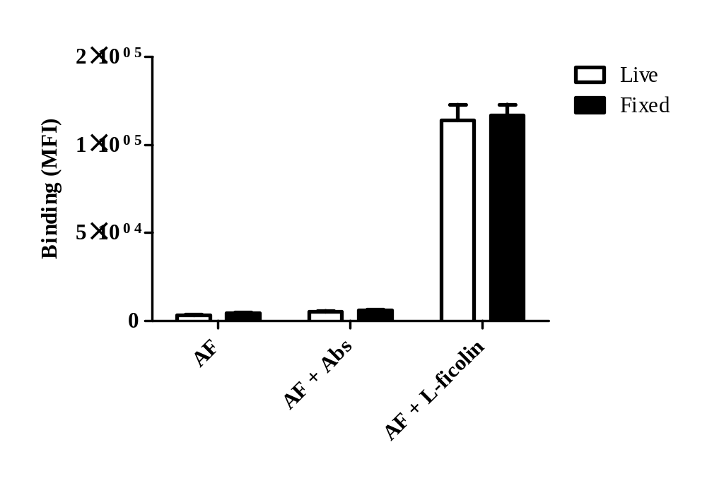

Figure 4.1. Binding of L-ficolin to live and fixed conidia of A. fumigatus.
Following conidial harvest, live or formaldehyde fixed resting A. fumigatus conidia were incubated alone (AF), stained with primary mouse anti-L-ficolin and goat anti-mouse Ig-FITC-labelled antibodies (AF + Abs) or incubated with 5µg mL⁻¹ L-ficolin prior to staining with mouse anti-L-ficolin and goat anti-mouse Ig-FITC-labelled antibodies (AF + Abs + L-ficolin). All results are the average of all data points gained from three independent experiments. Significance was determined by Student’s t-test (p>0.05).

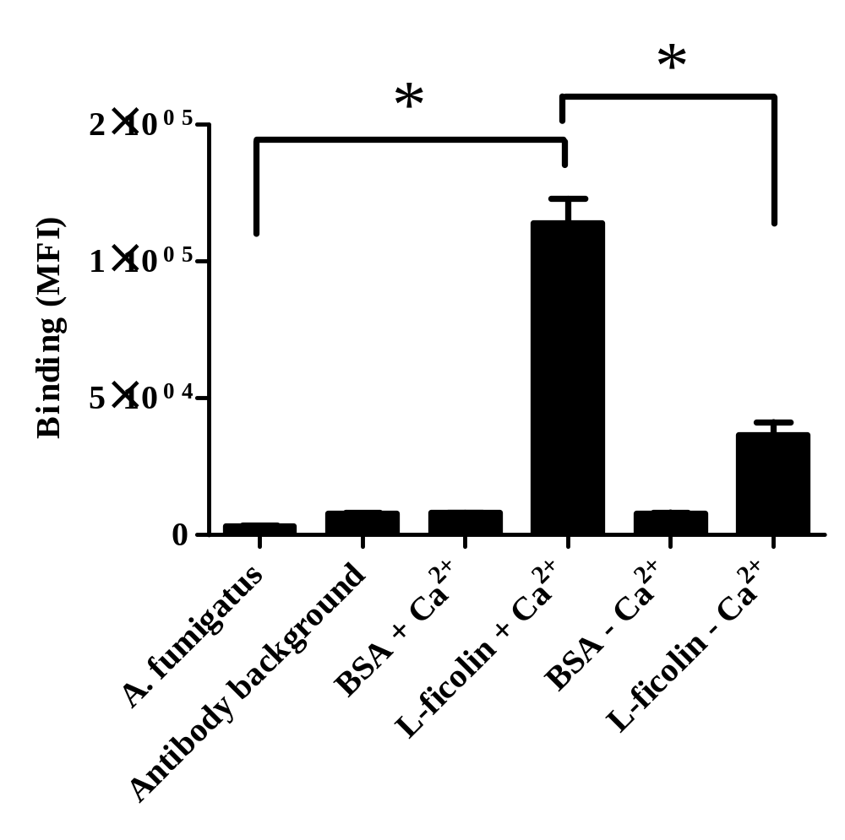

Figure 4.2. Calcium binding dependency of L-ficolin to A. fumigatus.
Conidia of A. fumigatus were incubated with 5 µg mL⁻¹ L-ficolin in the presence of calcium or in the absence of calcium and the presence of 5 mM EGTA. All results represent 5 x 10⁵ conidia stained with rabbit anti-L-ficolin and goat anti-rabbit Ig-FITC-labelled antibodies and are the average of all the data points gained from three independent experiments. Error bars represent the SD. Significance was determined by Student’s t-test (*p<0.05).

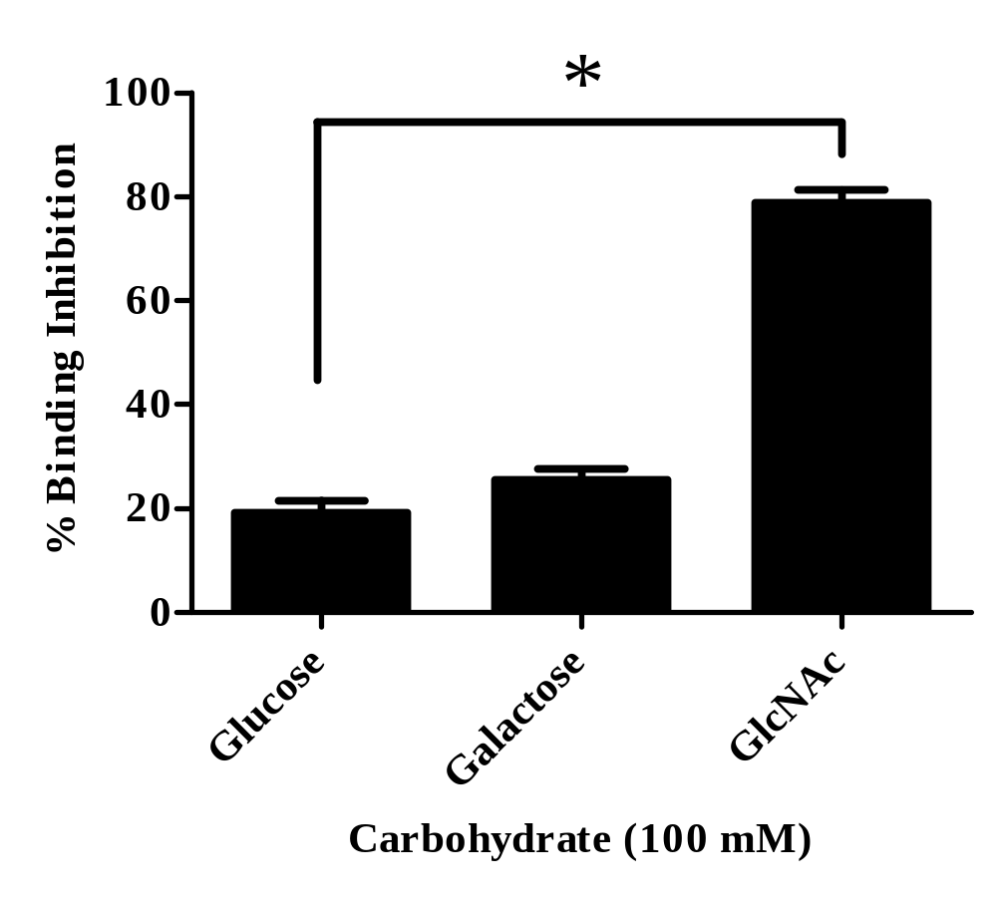

Figure 4.3. Carbohydrate specificity of L-ficolin binding to A. fumigatus conidia.
Conidia of A. fumigatus were incubated with 5 µg mL⁻¹ L-ficolin which was pre-incubated with a range of carbohydrates (glucose, galactose and GlcNAc). Results are representative of inhibition with 100mM carbohydrate. All results represent 5 x 10⁵ conidia stained with rabbit anti-L-ficolin and goat anti-rabbit Ig-FITC-labelled antibodies and are the average of all the data points gained from three independent experiments. Error bars represent the SD. Significance was determined via one-way ANOVA and post-hoc analysis was conducted using the Tukey test (*p<0.05).

4.2 Results

4.2.1 Binding characteristics of serum L-ficolin to A. fumigatus conidia.

Flow cytometry was used to investigate the binding characteristics of L-ficolin to A. fumigatus as it is a very sensitive method for detecting surface characteristics on pathogens or cells. As the primary infective form of conidia upon initial inhalation is in the ‘resting’ state and not ‘swollen’, conidia were fixed instantly in the resting state in PBS/formaldehyde once harvested or used live within 4 hours following harvest.
Fixed, resting A. fumigatus conidia were incubated with L-ficolin and the bound ficolin-Aspergillus complex was detected using a monoclonal mouse anti-L-ficolin antibody followed by a goat anti-mouse Ig-FITC-conjugated antibody. Flow cytometry analysis demonstrated a significant shift in the fluorescence and prior formaldehyde fixation of A. fumigatus conidia did not alter L-ficolin binding (p=0.6719; Figure 4.1).
L-ficolin binding was observed to be significant (p=0.00324; Figure 4.2). Incubation of L-ficolin in the absence of calcium and in the presence of 5 mM EGTA had a statistically significant effect on L-ficolin binding to conidia of A. fumigatus confirming a calcium dependent interaction (p=0.00018; Figure 4.2).
To assess the carbohydrate binding specificity of the L-ficolin FBG domain with the carbohydrate rich cell wall of A. fumigatus, L-ficolin was pre-incubated with a range of carbohydrate ligands at concentrations from 0.75 mM to 100 mM prior to binding to the fungus. The acetylated carbohydrate GlcNAc demonstrated a concentration dependent inhibition of L-ficolin binding to conidia with significant inhibition of L-ficolin binding occurring at inhibitor concentrations of 3.25 mM and 0.75 mM in comparison to galactose and glucose (p=0.063 and p=0.031, respectively; not shown). L-ficolin binding to A. fumigatus conidia was maximally inhibited at a carbohydrate concentration of 100 mM, with inhibitions of 78.7%, for GlcNAc (Figure 4.3). Glucose and galactose demonstrated almost a 4-fold lower inhibition compared to GlcNAc (at carbohydrate concentrations of 100 mM) (Figure 4.3).

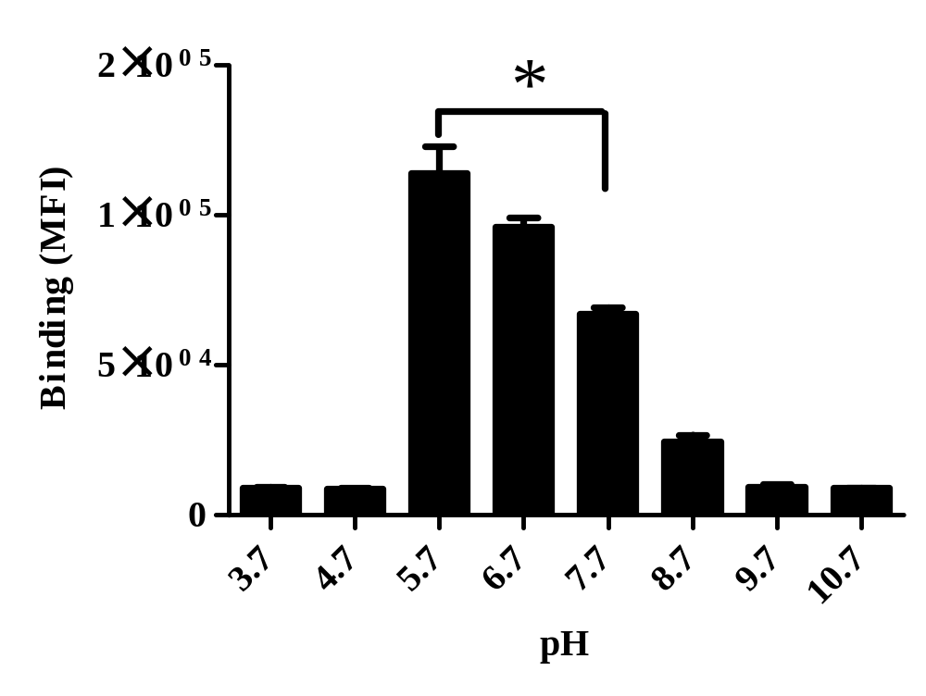
Figure 4.4 pH dependent binding of L-ficolin to A. fumigatus conidia.
A. fumigatus conidia were incubated with 5 µg mL⁻¹ L-ficolin at different pH values (3.7-10.7). All results represent 5 x 10⁵ conidia stained with rabbit anti-L-ficolin and goat anti-rabbit Ig-FITC-labelled antibodies and are the average of all the data points gained from three independent experiments. Error bars represent the SD. Significance was determined by Student’s t-test (*p<0.05).

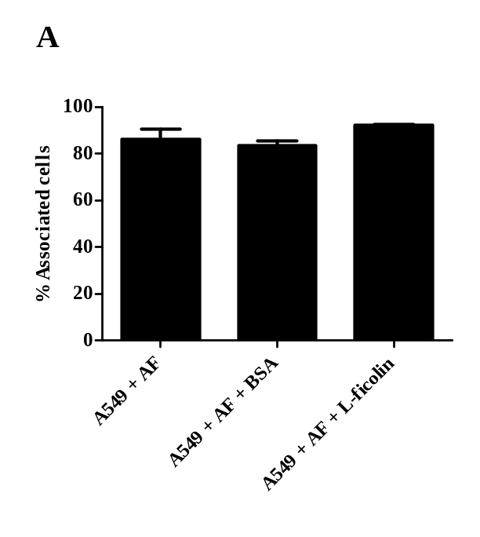
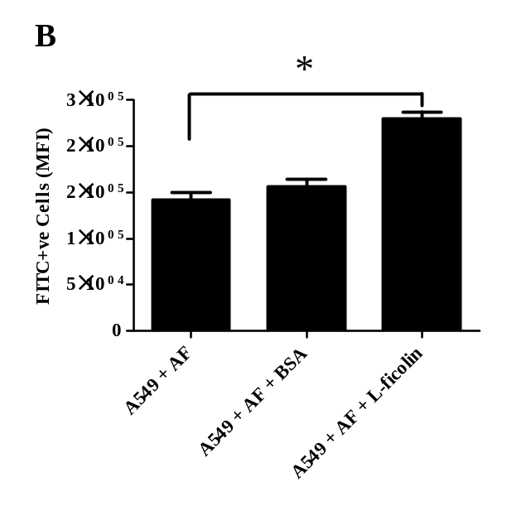
Figure 4.5. Association of L-ficolin opsonised A. fumigatus conidia with A549 type II pneumocytes.
Live freshly harvested conidia (1 x 10⁶) were opsonised with 5 µg mL⁻¹ L-ficolin prior to incubation with A549 cells (conidia:A549 ratio of 5:1) for 24 h in pH 5.7 conditions (A) The percentage of A549 cells associated with A. fumigatus conidia alone (A549 + AF), BSA opsonised A. fumigatus conidia (A549 + AF + BSA) or with L-ficolin opsonised A. fumigatus conidia (A549 + AF + L-Ficolin). (B) The relative number of A. fumigatus conidia associated with A549 cells as either unopsonised A. fumigatus conidia (A549 + AF), BSA opsonised A. fumigatus conidia (A549 + AF+ BSA) or L-ficolin opsonised A. fumigatus conidia (A549 + AF + L-Ficolin) incubated at pH 5.7 for 16 h (expressed as median fluorescence intensity) (*p<0.05). Data is the average of all data points gained from three independent experiments. Error bars represent the SD. Significance was determined by Student’s t-test.

Figure 4.6. Hyphal germination following incubation of L-ficolin opsonised A. fumigatus conidia with A549 type II pneumocytes.
Live freshly harvested conidia (1 x 10⁶) were opsonised with 5 µg mL⁻¹ L-ficolin prior to incubation with A549 cells (conidia:A549 ratio of 5:1) for 24 h in pH 5.7 and pH 7.4 conditions (A) Hyphal germination following incubation of un-opsonised conidia in pH 5.7 or. (B) in pH 7.4. (C) Hyphal germination following incubation of L-ficolin opsonised conidia in pH 5.7 or. (D) in pH 7.4. Hyphae were imaged using an Axiovert 40 CFL microscope at 10 x objective. Scale bars represent 50 µm. Images are representative of three independent experiments.

Ficolins interact with pathogens at the local site of infection and the pH at the site of this interaction often becomes more acidic due to increased inflammation. Therefore, we analysed whether L-ficolin binding to the most pathogenic species, A. fumigatus, was affected under different pH conditions. The binding of L-ficolin to A. fumigatus increased significantly by almost 2-fold in acidic pH of 5.7, compared to binding in physiological conditions (pH 7.4) (p=0.00089; Figure 4.4).

4.2.2 Effect of L-ficolin opsonisation on the association with and killing of A. fumigatus by A549 lung epithelial cells

Aspergillus spp. primarily infects via the inhalation of small hydrophobic conidia in the environment and therefore come into contact with the lung epithelium in the early stages of infection. The lung epithelial cells therefore play an important role in initiating host defences. Here we have investigated whether L-ficolin plays an important modulatory role in the association of Aspergillus conidia with human A549 type II pneumocytes. FITC-labelled A. fumigatus conidia were opsonised with 5 μg mL⁻¹ L-ficolin prior to incubation with adherent A549 type II pneumocytes.
The association of A. fumigatus conidia with A549’s was investigated under physiological conditions of pH 7.4 in addition to acidic pH of 5.7 to mimic inflammatory conditions prior to analysis by flow cytometry. Here, the number of cells associating with the conidia was not significantly increased by L-ficolin opsonisation in comparison to un-opsonised conidia (p=0.07328; Figure 4.5A).However, the number of L-ficolin opsonised conidia associated per A549 was significantly increased in comparison to both un-opsonised and BSA opsonised conidia (p=0.00013 and p=0.00028, respectively; Figure 4.5B).
Next, we investigated whether the increased binding of A. fumigatus with A549’s led to increased fungal killing and increased inhibition of hyphal growth. Prior to conidial challenge some A549’s were stimulated with 10 ng mL⁻¹ IL-1β, to stimulate inflammatory cytokines and promote an inflammatory environment, while others were left un-stimulated. The cells were observed via light microscopy and supernatants were collected for cytokine analysis after 8 and 24 hours of incubation. After 8 h the first signs of conidial germination were present (data not shown). After 24 hours the vast majority of conidia had

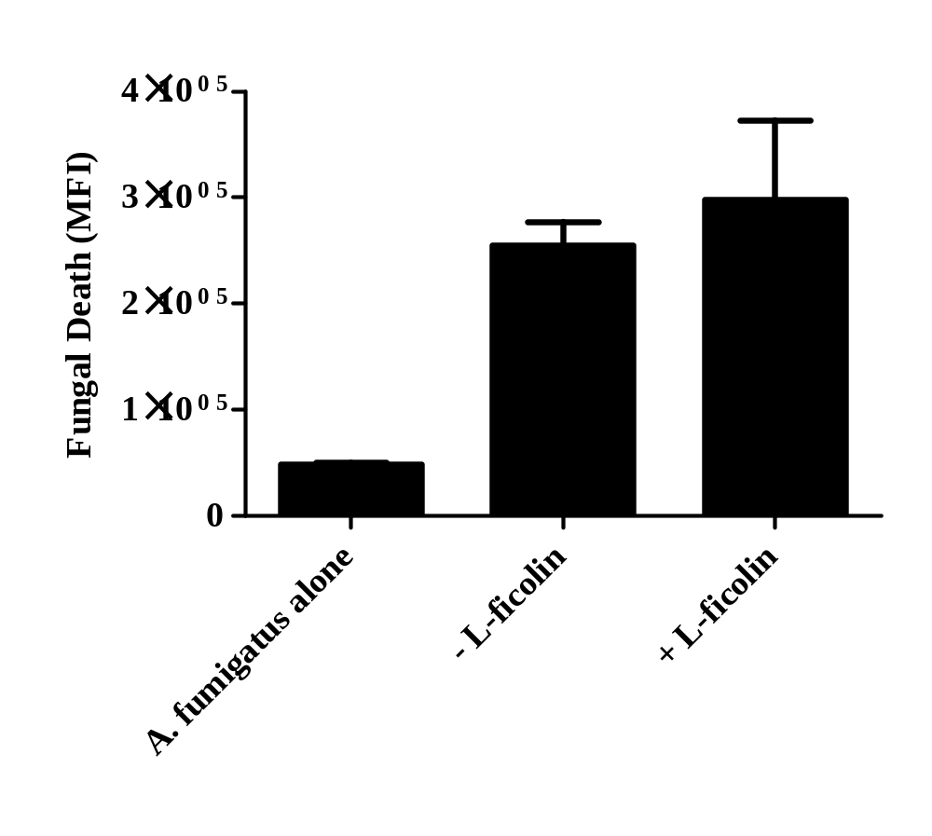

Figure 4.7. Fungal viability following incubation of L-ficolin opsonised A. fumigatus conidia with A549 pneumocytes.
Live freshly harvested conidia (1 x 10⁶) were opsonised with 5 µg mL⁻¹ L-ficolin prior to incubation with A549 cells (conidia:A549 ratio of 5:1) for 24 h in pH 5.7 conditions and staining with a LIVE/DEAD FUN-1 fungal viability stain. Viability of conidia alone (A. fumigatus alone), un-opsonised conidia (- L-ficolin) or L-ficolin opsonised conidia (+ L-ficolin) after incubation with A549s. An increase in median fluorescence intensity (MFI) using the FL1-A filter depicts increased killing. Data is the average of all data points gained from three independent experiments. Error bars represent the SD.

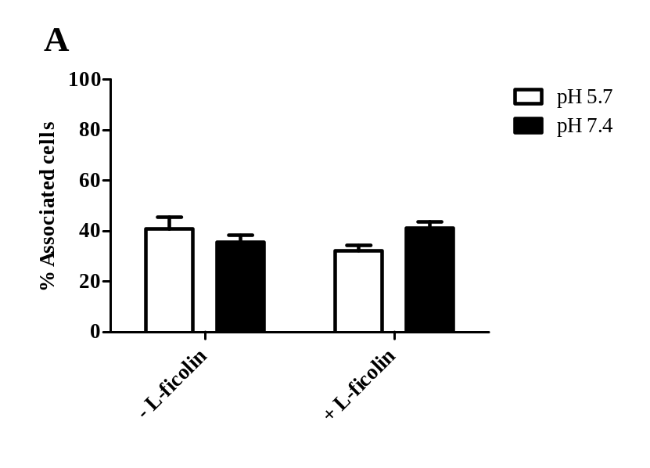
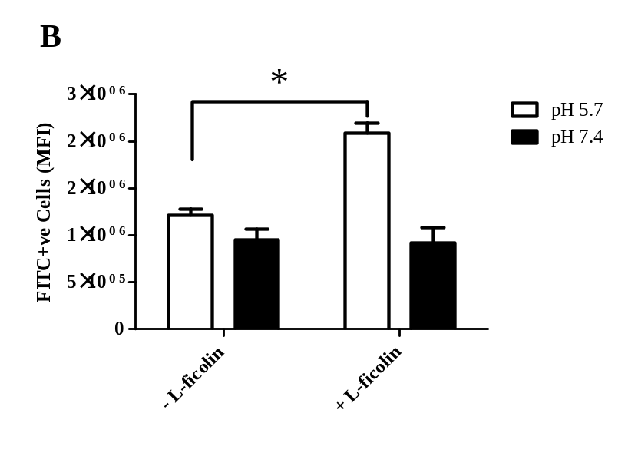
Figure 4.8. Association of L-ficolin opsonised A. fumigatus conidia with dTHP-1 macrophages.
(A) Live freshly harvested conidia (1 x 10⁶) were opsonised with 5 µg mL⁻¹ L-ficolin prior to incubation with dTHP-1 cells (conidia:dTHP-1 ratio of 5:1) for 2 h in pH 5.7 and pH 7.4 conditions The percentage of dTHP-1 cells associated with un-opsonised A. fumigatus conidia (- L-ficolin) or with L-ficolin opsonised A. fumigatus conidia (+ L-ficolin) following incubation at pH 5.7 or pH 7.4 for 2 h. (B) The relative number of A. fumigatus conidia associating with dTHP-1 cells as either un-opsonised A. fumigatus conidia (- L-ficolin) or L-ficolin opsonised A. fumigatus conidia (+ L-ficolin) incubated at pH 5.7 or pH 7.4 for 2 h (expressed as median fluorescence intensity; FL1-A). Data is the average of all the data points gained from three independent experiments. Error bars represent the SD. Significance was determined by Student’s t-test (*p<0.05).

Figure 4.9. Hyphal germination following incubation of L-ficolin opsonised A. fumigatus conidia with dTHP-1 macrophages.
Live freshly harvested conidia (1 x 10⁶) were opsonised with 5 µg mL⁻¹ L-ficolin prior to incubation with dTHP-1 cells (conidia:dTHP-1 ratio of 5:1) for 24 h in pH 5.7 and pH 7.4 conditions (A) Hyphal germination following incubation of un-opsonised conidia in pH 5.7 or. (B) in pH 7.4. (C) Hyphal germination following incubation of L-ficolin opsonised conidia in pH 5.7 or. (D) in pH 7.4. Hyphae were imaged using an Axiovert 40 CFL microscope at 10 x objective. Scale bars represent 50 µm. Images are representative of three independent experiments.

germinated regardless of epithelial cell stimulation or conidial opsonisation L-ficolin (Figure. 4.6A-D; data not shown for IL-1β pre-stimulation). Also, the majority of A549 cells appeared to dissociate from the plastic-ware, potentially inhibiting the function of the pneumocytes.
The viability of the Aspergillus was then quantified using a LIVE/DEAD yeast viability assay and flow cytometry. It was observed that opsonisation by L-ficolin in optimal binding conditions of pH 5.7 did not increase killing of A. fumigatus (Figure 4.7).

4.2.3 Effect of L-ficolin opsonisation on the association with and killing of A. fumigatus by dTHP-1.

The effect of L-ficolin opsonisation has on the associations with human cell line-derived macrophages is poorly understood. Therefore we utilised dTHP-1 cells, an immortalised leukaemia cell line differentiated to a macrophage lineage to investigate how ficolin opsonisation alters association with these cells. Association studies were conducted as for the A549s but incubation time was reduced to 2 hours.
The percentage of phagocytosing dTHP-1 was not significantly altered and was independent of physiological (pH 7.4) or acidic conditions (pH 5.7) (Figure 4.8A). Flow cytometry analysis again displayed significantly enhanced association of conidia with the dTHP-1 cells following L-ficolin opsonisation in pH 5.7 conditions (p=4.2 x 10⁻⁵; Figure 4.8B).
The lung epithelium was not observed to be capable of inhibiting hyphal germination of A. fumigatus conidia, therefore we investigated the importance of ficolin opsonisation in the enhancement of conidial killing by macrophages. dTHP-1 were seeded in 24-well plates prior to challenge with un-opsonised or ficolin opsonised A. fumigatus conidia.
Light microscopy demonstrated that dTHP-1 cells inhibited hyphal formation following opsonisation by L-ficolin in acidic conditions (Figure 4.9A-D). In addition to this, viability assays demonstrated a significant decrease in fungal viability following opsonisation by L-ficolin in these conditions, as observed by fluorescence microscopy and flow cytometry (p=0.02166; Figure 4.10).

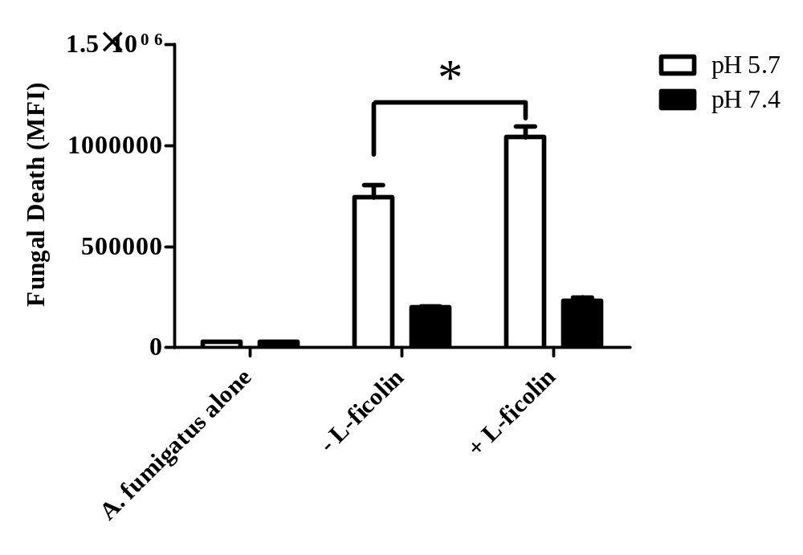
Figure 4.10. Fungal viability following incubation of L-ficolin opsonised A. fumigatus conidia with dTHP-1 macrophages.
Live freshly harvested conidia (1 x 10⁶) were opsonised with 5 µg mL⁻¹ L-ficolin prior to incubation with dTHP-1 cells (conidia:dTHP-1 ratio of 5:1) for 24 h in pH 5.7 conditions and staining with a LIVE/DEAD FUN-1 fungal viability stain. Viability of conidia alone (A. fumigatus alone), un-opsonised conidia (- L-ficolin) or L-ficolin opsonised conidia (+ L-ficolin) after incubation with dTHP-1 cells. An increase in median fluorescence intensity (MFI) using the FL1-A filter depicts increased killing. Data is the average of all data points gained from three independent experiments. Error bars represent the SD and significance was determined by Student’s t-test (*p<0.05).

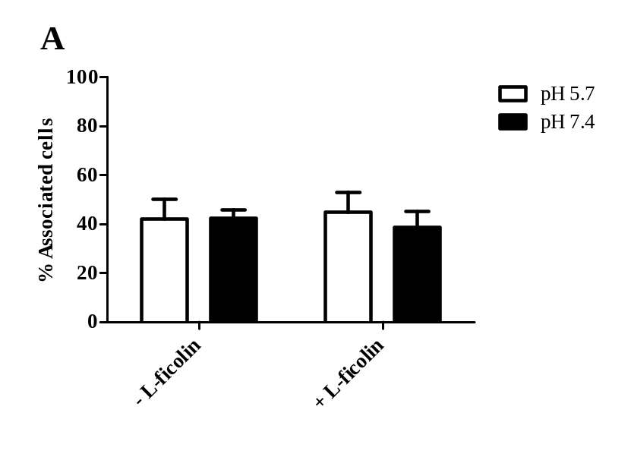
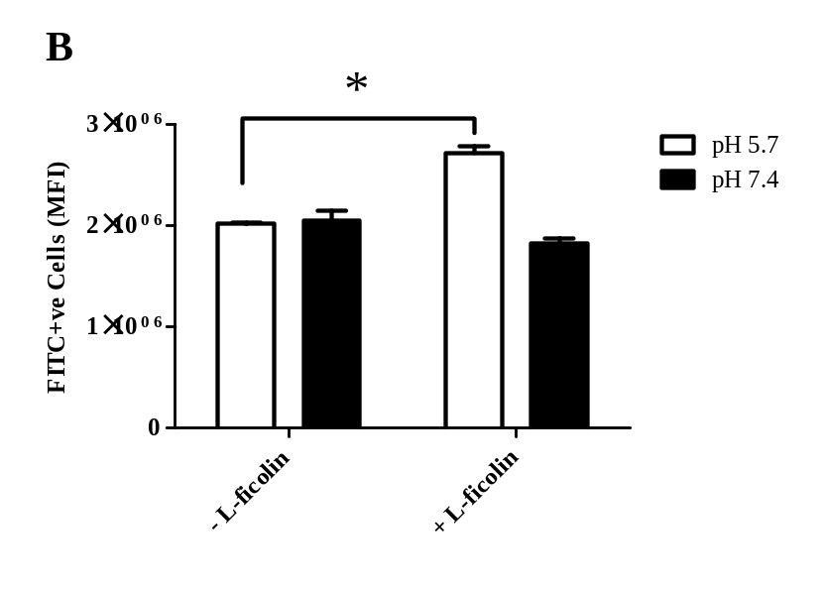
Figure 4.11. Association of L-ficolin opsonised A. fumigatus conidia with MDM.
(A) Live freshly harvested conidia (1 x 10⁶) were opsonised with 5 µg mL⁻¹ L-ficolin prior to incubation with MDM (conidia:MDM ratio of 5:1) for 2 h in pH 5.7 and pH 7.4 conditions The percentage of MDM associated with un-opsonised A. fumigatus conidia (- L-ficolin) or with L-ficolin opsonised A. fumigatus conidia (+ L-ficolin) following incubation at pH 5.7 or pH 7.4 for 2 h. (B) The relative number of A. fumigatus conidia associating with MDM as either un-opsonised A. fumigatus conidia (- L-ficolin) or L-ficolin opsonised A. fumigatus conidia (+ L-ficolin) incubated at pH 5.7 or pH 7.4 for 2 h (expressed as median fluorescence intensity; FL1-A). Data is the average of all the data points gained from three independent experiments. Error bars represent the SD. Significance was determined by Student’s t-test (*p<0.05).

Figure 4.12. Hyphal germination following incubation of L-ficolin opsonised A. fumigatus conidia with MDM.
Live freshly harvested conidia (1 x 10⁶) were opsonised with 5 µg mL⁻¹ L-ficolin prior to incubation with MDM (conidia:MDM ratio of 5:1) for 24 h in pH 5.7 and pH 7.4 conditions (A) Hyphal germination following incubation of un-opsonised conidia in pH 5.7 or. (B) in pH 7.4. (C) Hyphal germination following incubation of L-ficolin opsonised conidia in pH 5.7 or. (D) in pH 7.4. Hyphae were imaged using an Axiovert 40 CFL microscope at 20 x objective. Arrows point towards MDM and the white triangles outline representative hyphae. Scale bars represent 100 µm. Images are representative of three independent experiments.

4.2.4 Effect of L-ficolin opsonisation on the association with and killing of A. fumigatus by MDM.

The data gained with cell lines provoked the use of primary human cells, therefore monocytes were isolated and differentiated to MDM prior to association assays outlined as for the dTHP-1s. The percentage of phagocytosing MDM was not significantly altered and was independent of physiological (pH 7.4) or acidic conditions (pH 5.7) (Figure. 4.11A). Additionally, the number of FITC-labelled conidia phagocytosed by each MDM was significantly enhanced following L-ficolin opsonisation (p=6.6 x 10⁵; Figure 4.11B).
Light microscopy demonstrated that MDM inhibited hyphal germination following opsonisation by L-ficolin in acidic conditions (Figure 4.12A-D). In addition to this, fungal viability assays demonstrated a significant increase in fungal killing following opsonisation by L-ficolin in these conditions, as observed by fluorescence microscopy and flow cytometry (p=0.00249; Figure 4.13). When the ingested A. fumigatus and free A. fumigatus populations were gated separately, the death-associated green-yellow fluorescence emitted by A. fumigatus within MDM was observed to be significantly greater compared to the un-associated fungi, highlighting potent intracellular killing in pH 5.7 conditions (p= 5.8 x 10⁻⁵; Figure 4.14A). The fluorescence of the free A. fumigatus in the presence of MDM was not significantly different when compared to A. fumigatus alone, indicating MDMs played no significant role in extracellular killing (p=0.06142; Figure 4.14B).

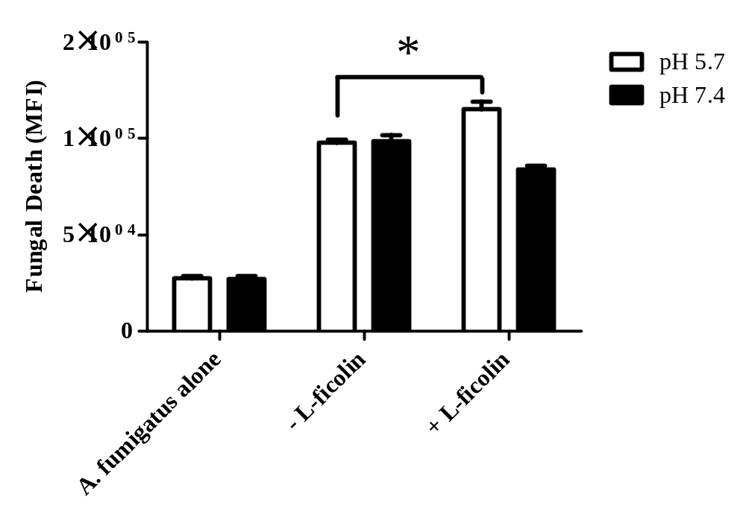

Figure 4.13. Fungal viability following incubation of L-ficolin opsonised A. fumigatus conidia with MDM.
Live freshly harvested conidia (1 x 10⁶) were opsonised with 5 µg mL⁻¹ L-ficolin prior to incubation with MDM (conidia:MDM ratio of 5:1) for 24 h in pH 5.7 conditions and staining with a LIVE/DEAD FUN-1 fungal viability stain. Viability of conidia alone (A. fumigatus alone), un-opsonised conidia (- L-ficolin) or L-ficolin opsonised conidia (+ L-ficolin) after incubation with MDM cells. An increase in median fluorescence intensity (MFI) using the FL1-A filter depicts increased killing. Data is the average of all data points gained from three independent experiments. Error bars represent the SD and significance was determined by Student’s t-test (*p<0.05).

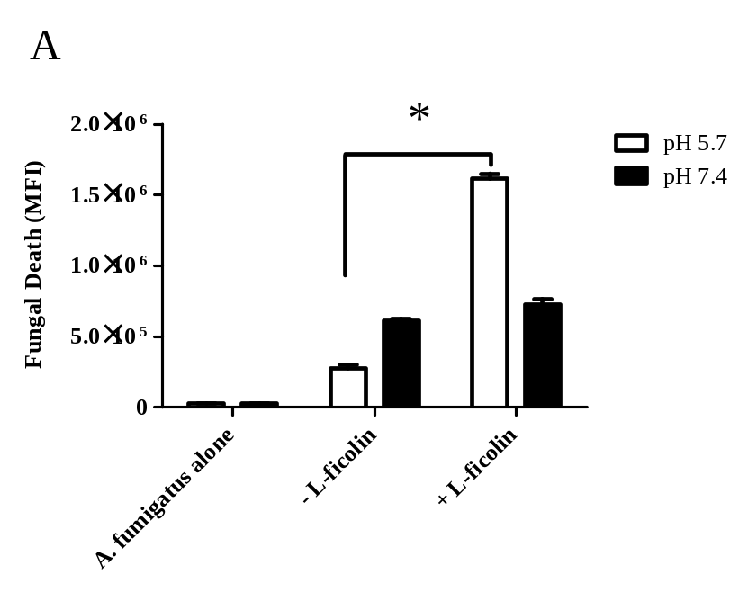
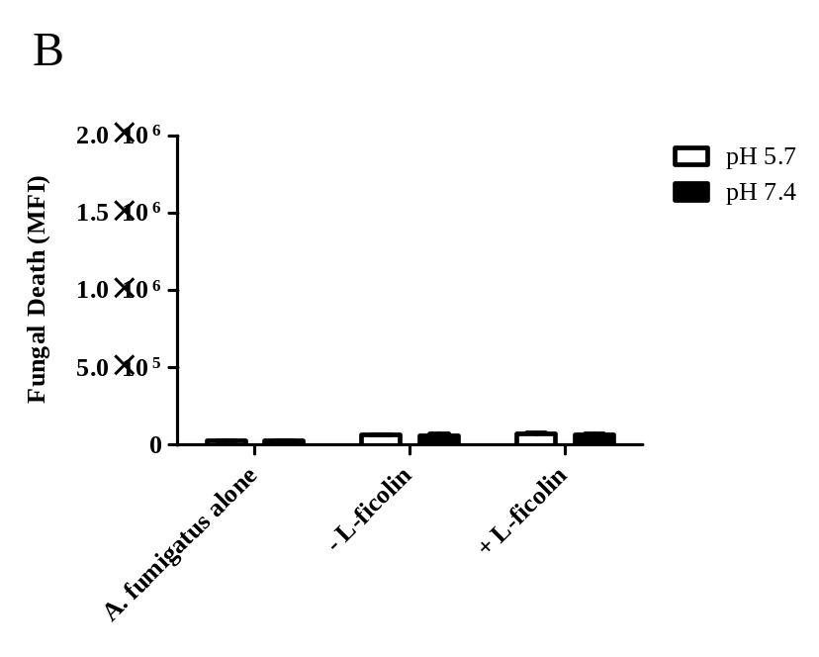
Figure 4.14. Intracellular and extracellular killing of L-ficolin opsonized conidia by MDM.
Live freshly harvested A. fumigatus conidia (5 x 10⁵) were opsonized with 5 µg ml⁻¹ L-ficolin prior to incubation with MDM (conidia:MDM ratio of 5:1) in pH 5.7 and pH 7.4 conditions for 24 h. (A) The death-associated green-yellow fluorescence emitted by intracellular L-ficolin opsonized or un-opsonized A. fumigatus, after incubation with MDM. (B) The death-associated green-yellow fluorescence emitted by extracellular L-ficolin opsonized or un-opsonized A. fumigatus, after incubation with MDM. Results are the average of all the data points gained from three independent experiments. Error bars represent the SD and significance was determined via two-tailed Students t-test. An asterisk indicates a significant difference (*p˂0.05).

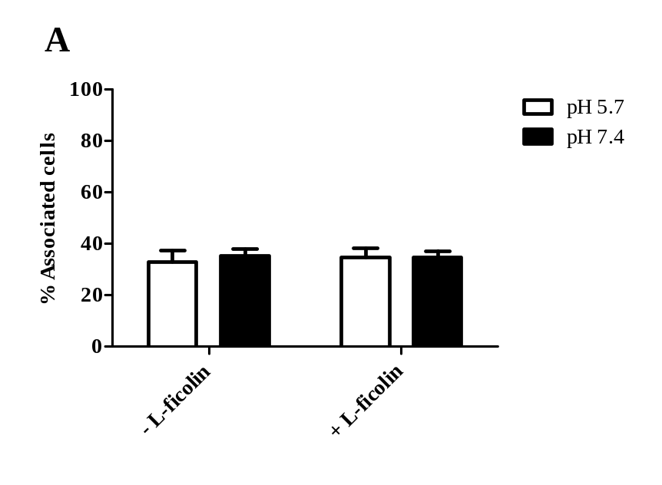
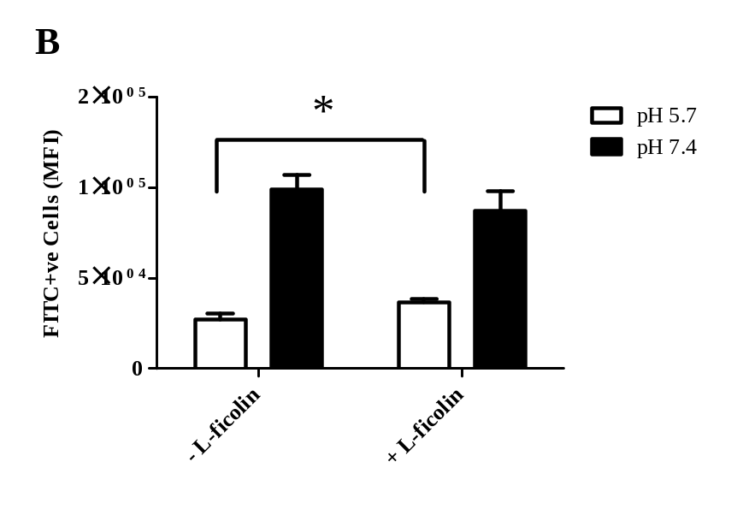
Figure 4.15. Association of L-ficolin opsonised A. fumigatus conidia with human neutrophils.
(A) Live freshly harvested conidia (1 x 10⁶) were opsonised with 5 µg mL⁻¹ L-ficolin prior to incubation with neutrophils (conidia:neutrophil ratio of 5:1) for 2 h in pH 5.7 and pH 7.4 conditions The percentage of neutrophils associated with un-opsonised A. fumigatus conidia (- L-ficolin) or with L-ficolin opsonised A. fumigatus conidia (+ L-ficolin) following incubation at pH 5.7 or pH 7.4 for 2 h. (B) The relative number of A. fumigatus conidia associating with neutrophils as either un-opsonised A. fumigatus conidia (- L-ficolin) or L-ficolin opsonised A. fumigatus conidia (+ L-ficolin) incubated at pH 5.7 or pH 7.4 for 2 h (expressed as median fluorescence intensity; FL1-A). Data is the average of all the data points gained from three independent experiments. Error bars represent the SD. Significance was determined by Student’s t-test (*p<0.05).

4.2.5 Effect of L-ficolin opsonisation on the association with and killing of A. fumigatus by human neutrophils.

Neutropenia poses a significant risk factor for developing aspergillosis which led us to investigate the importance of neutrophils in recognition and removal of A. fumigatus conidia following ficolin opsonisation.
The association of L-ficolin opsonised conidia with isolated human neutrophils was investigated under physiological and acidic conditions as for the macrophages and A549 cell lines. Following 2 hours of incubation in both pH 5.7 and pH 7.4 conditions, opsonisation by L-ficolin did not increase the number of phagocytosing cells (Figure 4.15A). However, flow cytometry analysis indicated a significant increase in the number of conidia phagocytosed per neutrophil following L-ficolin opsonisation, but only in pH 5.7 conditions (p=0.011; Figure 4.15B).

Neutrophils are traditionally recognised to be integral in the defence against the hyphae of Aspergillus, therefore we also investigated the potential role of ficolins to enhance this interaction. Neutrophils were seeded in 24-well plates prior to challenge with un-opsonised or ficolin opsonised A. fumigatus conidia. Light microscopy demonstrated that in the absence of ficolin opsonisation but presence of neutrophils, hyphal growth appeared very dense (Figure. 4.16A and B). In contrast, following opsonisation by L-ficolin, hyphal growth appeared significantly less dense (Figure 4.16C). This effect was pronounced in inflammatory conditions but there appeared to be some inhibition of hyphal growth observed in physiological conditions (Figure 4.16D). In addition to this, viability assays demonstrated a significant decrease in fungal viability following opsonisation by L-ficolin in acidic conditions, as observed by flow cytometry (p=0.04324; Figure 4.17). None of the ficolins investigated in this thesis were capable of killing on their own (data not shown).

Figure 4.16. Hyphal germination following incubation of L-ficolin opsonised A. fumigatus conidia with human neutrophils.
Live freshly harvested conidia (1 x 10⁶) were opsonised with 5 µg mL⁻¹ L-ficolin prior to incubation with neutrophils (conidia:neutrophil ratio of 5:1) for 24 h in pH 5.7 and pH 7.4 conditions (A) Hyphal germination following incubation of un-opsonised conidia in pH 5.7 or. (B) in pH 7.4. (C) Hyphal germination following incubation of L-ficolin opsonised conidia in pH 5.7 or. (D) in pH 7.4. Hyphae were imaged using an Axiovert 40 CFL microscope at 10 x objective. Scale bars represent 50 µm. Images are representative of three independent experiments.

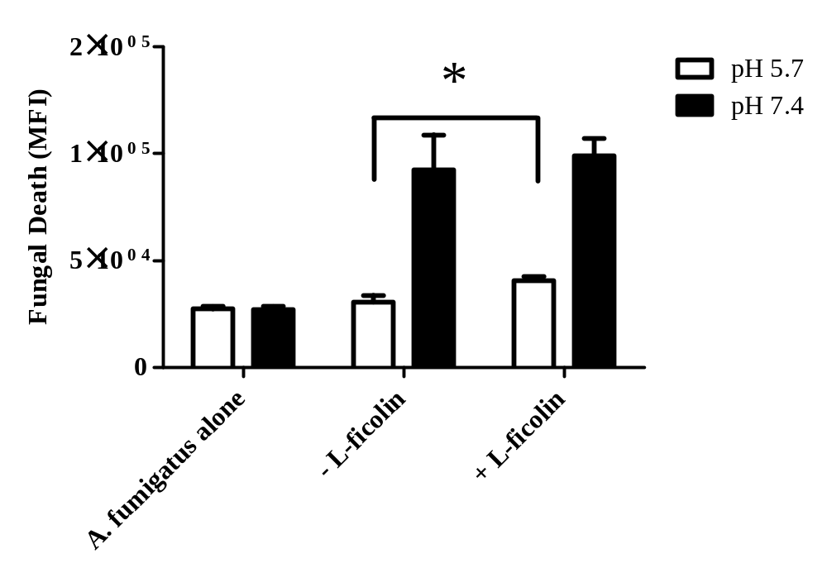
Figure 4.17. Fungal viability following incubation of L-ficolin opsonised A. fumigatus conidia with human neutrophils.
Live freshly harvested conidia (1 x 10⁶) were opsonised with 5 µg mL⁻¹ L-ficolin prior to incubation with neutrophils (conidia:neutrophil ratio of 5:1) for 24 h in pH 5.7 conditions and staining with a LIVE/DEAD FUN-1 fungal viability stain. Viability of conidia alone (A. fumigatus alone), un-opsonised conidia (- L-ficolin) or L-ficolin opsonised conidia (+ L-ficolin) after incubation with neutrophils. An increase in median fluorescence intensity (MFI) using the FL1-A filter depicts increased killing. Data is the average of all data points gained from three independent experiments. Error bars represent the SD and significance was determined by Student’s t-test (*p<0.05).

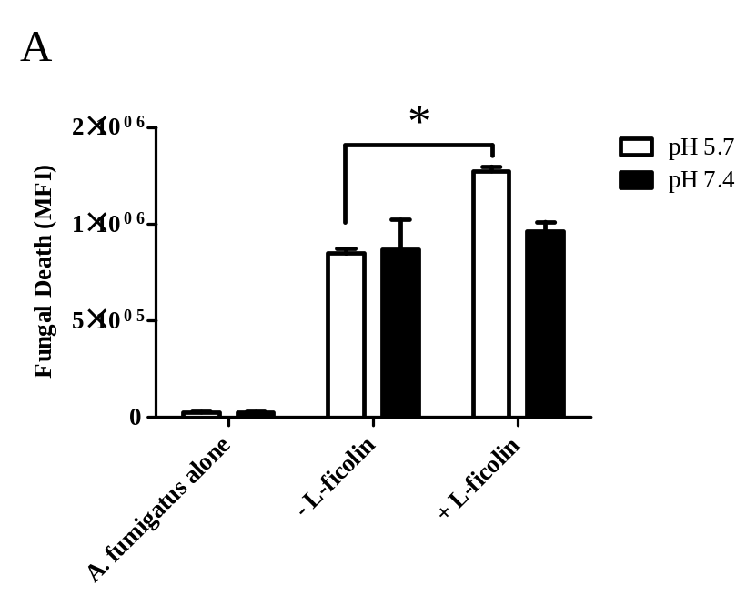
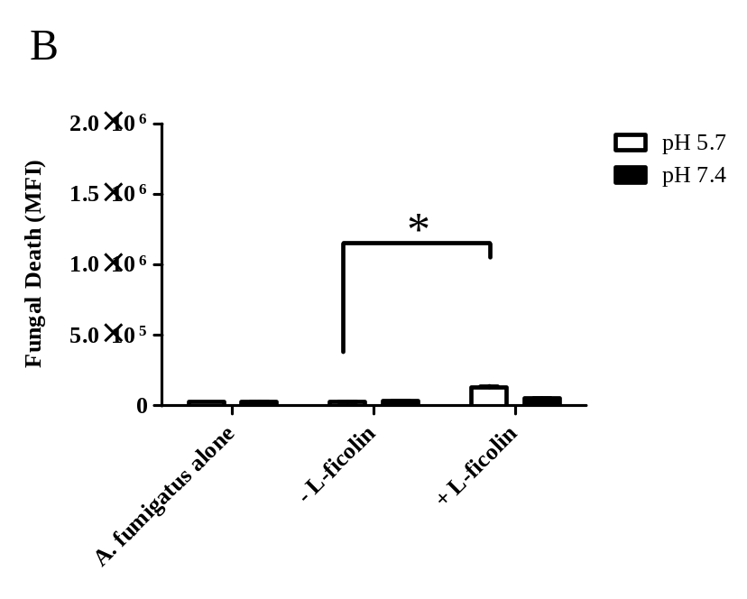
Figure 4.18. Intracellular and extracellular killing of L-ficolin opsonized conidia by neutrophils.
Live freshly harvested A. fumigatus conidia (5 x 10⁵) were opsonized with 5 µg ml⁻¹ L-ficolin prior to incubation with neutrophils (conidia:neutrophil ratio of 5:1) in pH 5.7 and pH 7.4 conditions for 24 h. (A) The death-associated green-yellow fluorescence emitted by intracellular L-ficolin opsonized or un-opsonized A. fumigatus, after incubation with neutrophils. (B) The death-associated green-yellow fluorescence emitted by extracellular L-ficolin opsonized or un-opsonized A. fumigatus, after incubation with neutrophils. Results are the average of all the data points gained from three independent experiments. Error bars represent the SD and significance was determined via two-tailed Students t-test. An asterisk indicates a significant difference (*p˂0.05).
When the ingested A. fumigatus and free A. fumigatus populations were gated separately, the death-associated green-yellow fluorescence emitted by A. fumigatus within neutrophils was observed to be significantly greater compared to the un-associated fungi, again highlighting potent intracellular killing (p=2.57 x 10⁻⁵; Figure 4.18A). Additionally, the fluorescence of the free A. fumigatus in the presence of neutrophils was significantly greater when compared to A. fumigatus in the absence of neutrophils, suggesting augmentation of extracellular killing mechanisms (p=0.00019; Figure 4.18B).

4.2.6 Role of L- ficolin in cytokine modulation following A. fumigatus challenge.

Cytokine production is an important aspect of inflammatory regulation following pathogen challenge. Therefore, to investigate whether L-ficolin could modulate cytokine production, we utilised cytometric bead arrays and measured the concentration of IL-8, IL-1β, IL-6, IL-10 and TNF-α secreted from A549 type II alveolar cells, MDM and human neutrophils following challenge by L-ficolin-opsonised A. fumigatus conidia.
From the cytokine panel tested, IL-8 was the only cytokine significantly modulated in A549 cells in response to L-ficolin (Figure 4.19). L-ficolin opsonisation induced a significant increase in the secretion of pro-inflammatory IL-8 compared to challenge with un-opsonised conidia after 8 h and 24 h (Figure 4.19). L-ficolin in the absence of conidia induced a significant spike in IL-8 secretion at 8 h which was maintained up to 24 h (Figure 4.19). All other measured cytokines were not significantly affected by L-ficolin opsonisation (data not shown).
Ficolin opsonisation modulated cytokine secretion from dTHP-1. Following dTHP-1 challenge with conidia opsonised by L-ficolin an anti-inflammatory effect was observed. The secretion of IL-8, IL-1β, IL-6, IL-10 and TNF-α from dTHP-1 cells 24 h following ficolin-opsonised conidial challenge were all significantly decreased in comparison to un- opsonised conidia (p<0.05) (Figure 4.20). The concentration of IL-12p70 was unaffected. Ficolins themselves appeared capable of significantly increasing the cytokine concentrations of IL-6 and IL-10 (p<0.05) (Figure 4.20C and D). L-ficolin opsonisation also modulated cytokine secretion from MDM. Following MDM challenge with conidia opsonised by L-ficolin an anti-inflammatory effect was observed. The secretion of IL-8, IL-1β, IL-6, IL-10 and TNF-α from MDM cells 24 h post-infection

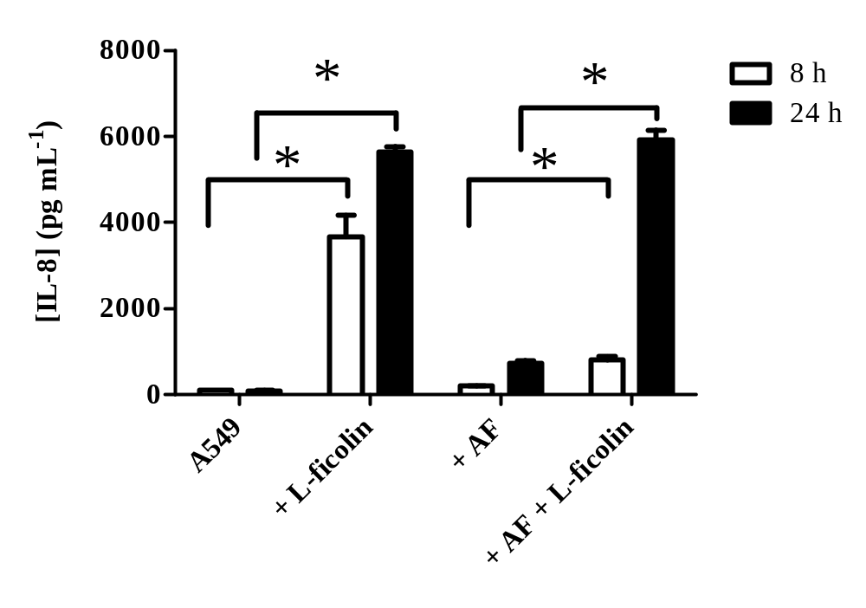
Figure 4.19 Inflammatory cytokine release from A549 following challenge by un-opsonised or L-ficolin opsonised conidia.
Supernatants were collected after 8h and 24 h time points during challenge with live A. fumigatus conidia (1 x 10⁶) un-opsonised or L-ficolin opsonised (5 µg mL⁻¹) prior to the conduction of cytometric bead arrays. (A) The concentration of IL-8 secretion following A. fumigatus conidia challenge. A549 is representative of A549 cells alone. + L-ficolin represents A549 cells in the presence of L-ficolin alone. +AF and +AF + L-ficolin are representative of un-opsonised A. fumigatus or L-ficolin opsonised conidia, respectively. Error bars represent the SD and significance was determined via one-way ANOVA and pair-wise comparisons were conducted using the Student-Newman-Keuls method. Results are the average of all data points gained from three independent experiments An asterisk indicates a significant difference (*p˂0.05).
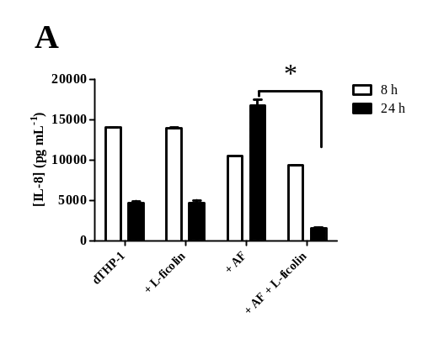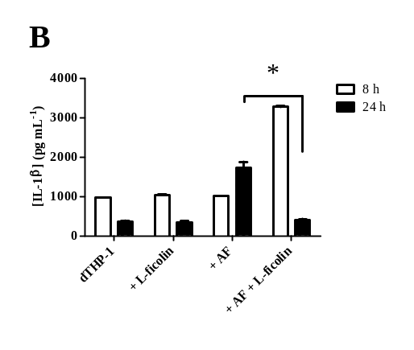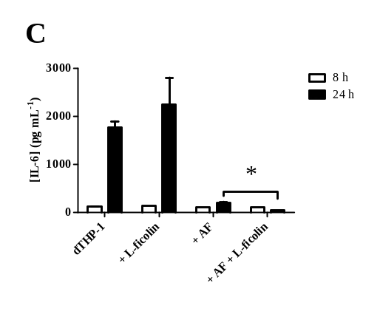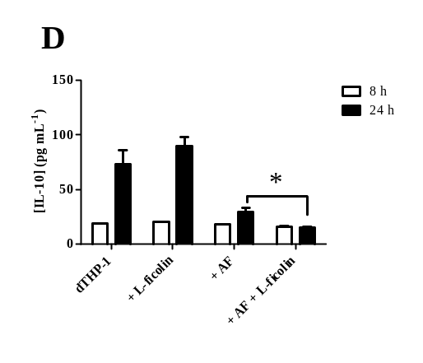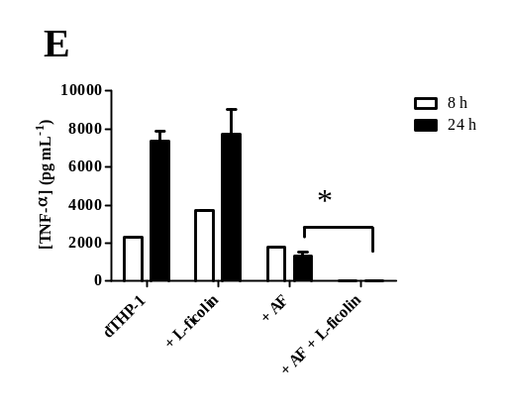
Figure 4.20. Inflammatory cytokine release from dTHP-1 cells following challenge by un-opsonised or L-ficolin opsonised conidia.
Supernatants were collected after 8h and 24 h time points during challenge with live A. fumigatus conidia (1 x 10⁶) un-opsonised or L-ficolin opsonised (5 µg mL⁻¹) prior to the conduction of cytometric bead arrays. Concentrations of (A) IL-8 (B) IL-1β (C) IL-6 (D) IL-10 (E) TNF-α. dTHP-1 is representative of dTHP-1 cells alone. + L-ficolin represents dTHP-1 cells in the presence of L-ficolin alone. +AF and +AF + L-ficolin are representative of un-opsonised A. fumigatus or L-ficolin opsonised conidia, respectively. Error bars represent the SD and significance was determined via one-way ANOVA and pair-wise comparisons were conducted using the Student-Newman-Keuls method. Results are the average of all data points gained from three independent experiments. An asterisk indicates a significant difference (*p˂0.05).
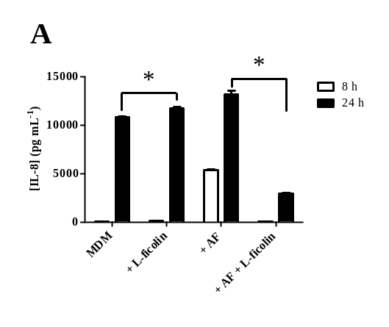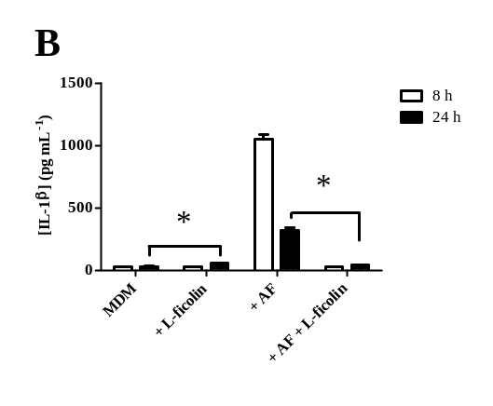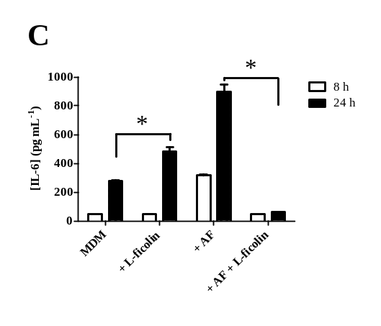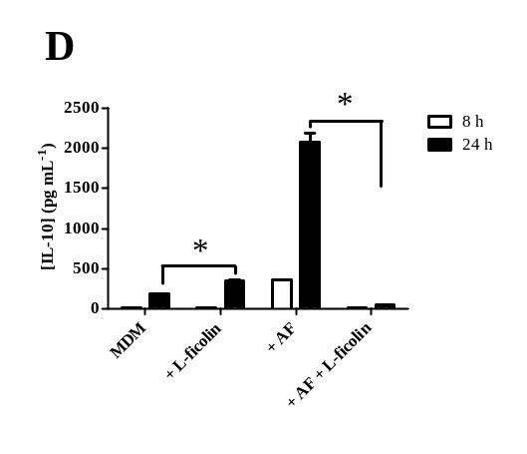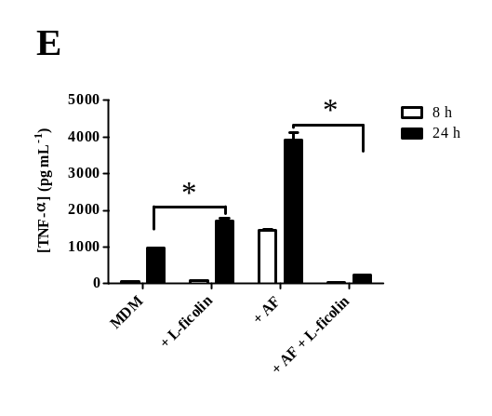
Figure 4.21. Inflammatory cytokine release from MDM following challenge by un-opsonised or L-ficolin opsonised conidia.
Supernatants were collected after 8h and 24 h time points during challenge with live A. fumigatus conidia (1 x 10⁶) un-opsonised or L-ficolin opsonised (5 µg mL⁻¹) prior to the conduction of cytometric bead arrays. Concentrations of (A) IL-8 (B) IL-1β (C) IL-6 (D) IL-10 (E) TNF-α. MDM is representative of MDM alone. + L-ficolin represents MDM in the presence of L-ficolin alone. +AF and +AF + L-ficolin are representative of un-opsonised A. fumigatus or L-ficolin opsonised conidia, respectively. Error bars represent the SD and significance was determined via one-way ANOVA and pair-wise comparisons were conducted using the Student-Newman-Keuls method. Results are the average of all data points gained from three independent experiments. An asterisk indicates a significant difference (*p˂0.05).
were decreased (Figure 4.21). Again L-ficolin alone appeared capable of significantly increasing the cytokine concentrations of all tested (Figure 4.21). We also investigated the effects of L-ficolin opsonisation on the modulation of cytokines from neutrophils. L-ficolin opsonisation led to significantly decreased secretion of IL-8, IL-1β, IL-6 and TNF-α compared to un-opsonised conidia (Figure 4.22). We observed that IL-10 was only secreted at baseline levels regardless of any challenges (Figure 4.22D). Additionally, L-ficolin was observed to have the ability to increase the secretion of IL-8, IL-1β and TNF-α in the absence of A. fumigatus (Figure 4.22A, B, E).

In order to investigate the pathways involved in the increase of IL-8 secretion from A549 cells following challenge by L-ficolin opsonised A. fumigatus, we used the MEK 1/2 inhibitor U0126, the p38 MAPK inhibitor SB202190 and the JNK inhibitor SP600125 prior to the quantification of IL-8 by bead array. It was observed that MEK 1/2 inhibition inhibited IL-8 production following challenge with L-ficolin-opsonised conidia (p<0.001, Figure 4.23). Inhibition of p38 MAPK and JNK also significantly reduced IL-8 production following L-ficolin opsonisation (p<0.001; Figure 4.23).

The incremental increase of IL-8 from A549s that was induced by L-ficolin alone in the absence of A. fumigatus also appeared to be significantly reduced via inhibition of MEK 1/2 (p<0.001, Figure 4.23).

4.2.7 Detection of L-ficolin in the BAL fluid of lung transplant recipients.

Based upon our recent observations of L-ficolin interacting with A. fumigatus and lung epithelial cells in vitro (Bidula et al., 2013a) it was important to investigate whether L-ficolin was detectable in the lungs of patients with invasive fungal infections, particularly as L-ficolins have never formally been described to be present in lungs.
Here, we utilised an L-ficolin-specific ELISA to detect the presence of L-ficolin in the BAL samples of lung transplant recipients. In patients who were diagnosed with probable
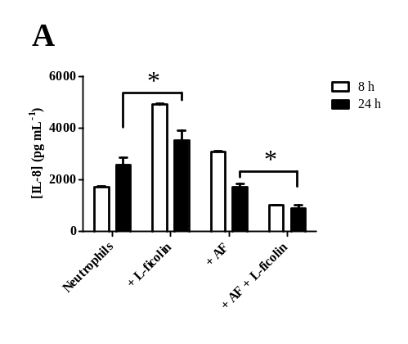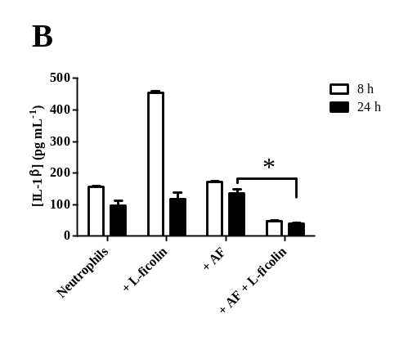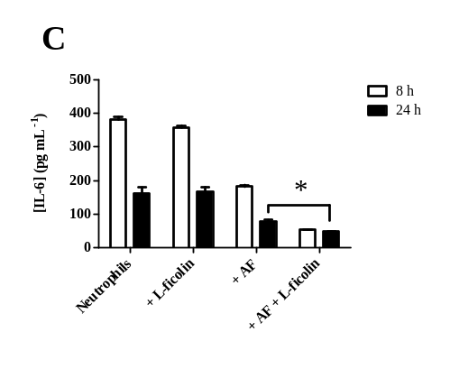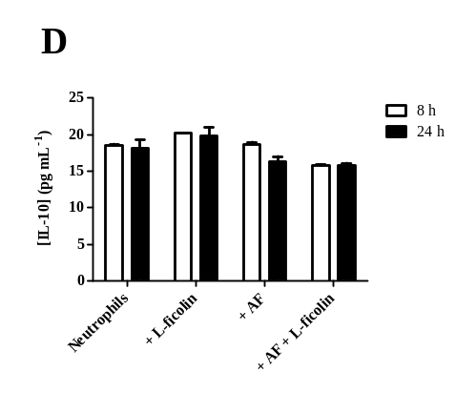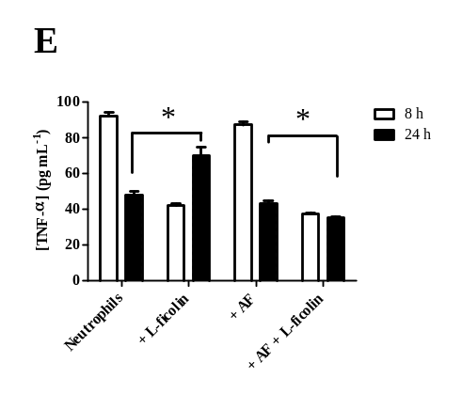
Figure 4.22. Inflammatory cytokine release from human neutrophils following challenge by un-opsonised or L-ficolin opsonised conidia.
Supernatants were collected after 8h and 24 h time points during challenge with live A. fumigatus conidia (1 x 10⁶) un-opsonised or L-ficolin opsonised (5 µg mL⁻¹) prior to the conduction of cytometric bead arrays. Concentrations of (A) IL-8 (B) IL-1β (C) IL-6 (D) IL-10 (E) TNF-α. Neutrophils is representative of neutrophils alone. + L-ficolin represents neutrophils in the presence of L-ficolin alone. +AF and +AF + L-ficolin are representative of un-opsonised A. fumigatus or L-ficolin opsonised conidia, respectively. Error bars represent the SD and significance was determined via one-way ANOVA and pair-wise comparisons were conducted using the Student-Newman-Keuls method. Results are the average of all data points gained from three independent experiments. An asterisk indicates a significant difference (*p˂0.05).

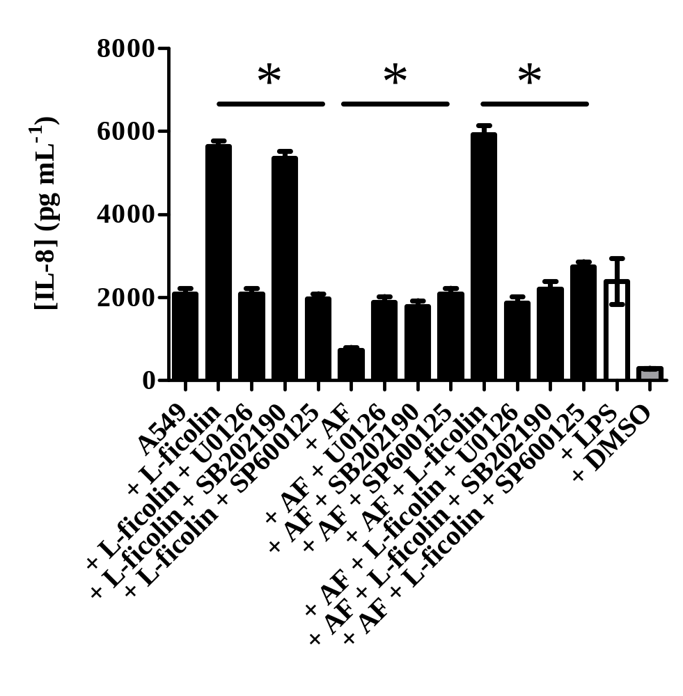
Figure 4.23. Inflammatory cytokine release from A549 type II pneumocytes following pre-incubation with MAPK inhibitors and a challenge with un-opsonised or L-ficolin opsonised conidia.
A549 type II pneumocytes were pre-incubated with 10 µM of the MEK 1/2 inhibitor (U0126), the p38 MAPK inhibitor (SB202190) or the JNK inhibitor (SP600125) prior to challenge with live A. fumigatus conidia (1 x 10⁶) un-opsonised or L-ficolin opsonised (5 µg mL⁻¹). Supernatants were collected after 24 h time points prior to the conduction of cytometric bead arrays. LPS was used as a positive control and DMSO was used as a vehicle control. Error bars represent the SD. Significance was determined via one-way ANOVA and pair-wise comparisons were conducted using the Student-Newman-Keuls method. Results are representative of the average of all data points gained from three independent experiments An asterisk indicates a significant difference (*p˂0.05).

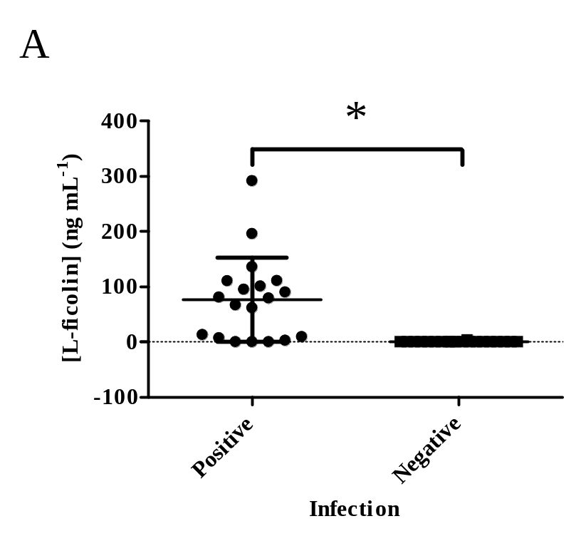
Figure 4.24. L-ficolin in BAL fluid of fungal infected lung transplant recipients.
BAL fluid was collected following bronchoscopies on lung transplant recipients. The samples were tested for fungal infection via the lateral-flow device, for galactomannan, fungal radiology or the growth of fungal pathogens. (A) The concentration of L-ficolin in the BAL fluid of lung transplant patients. (B) ROC analysis of L-ficolin in the BAL fluid of lung transplant patients. BAL samples were considered positive or negative dependent upon if they tested positive or negative for signs of fungal infection. Results are representative of the data points gained from three independent experiments (19 positive and 20 negative). Bars represent the mean and significance was determined by Students t-test (p<0.05).
or proven invasive pulmonary fungal infection based on EORTC/MSG criteria and/or positive fungal biomarkers (GM/lateral-flow, see Table 4.1), L-ficolin was detected at significantly higher concentrations (p= 0.00087; Figure 4.24A) compared to uninfected control patients. L-ficolin was only detected once in the BAL samples that tested negative for fungal growth or radiological imaging suggestive of invasive fungal infection, albeit at a very low concentration (Figure 4.24A). An ROC curve analysis was conducted to investigate whether the detection of L-ficolin could be used as a potential biomarker/diagnostic tool for fungal infection in the lung. The area under the curve (AUC) was calculated to be 0.842 which suggested there was an 84.2% chance that the fungal infected transplant patients would also have the presence of L-ficolin in their BAL fluid (p<0.0001; Figure 4.24B).

Patient ID | Radiology Features | Pathogen Growth | EORTC Diagnosis | BAL GM | BAL LFD | [L-ficolin] (ng mL⁻¹)
1 | Consolidation, Tree-in-bud | A. fumigatus | Proven | 3.69 | 1+ | 136.2
2 | Consolidation | A. flavus | Probable | 0.97 | Neg | 9.3
3 | Nil | A. fumigatus | Probable | 0.51 | Neg | 13.1
4 | Nodule | Penicillium | Probable | 0.32 | 2+ | 79.2
5 | Cavitation | Acremonium spp. | Probable | 0.18 | Neg | 110.5
6 | Consolidation | A. fumigatus | Probable | 0.2 | Neg | 0
7 | Tree-in-bud | A. fumigatus | Probable | 0.39 | Neg | 0
8 | Tree-in-bud | Nil | Possible | 0.19 | Neg | 0
9 | Consolidation | Nil | Possible | 0.19 | Neg | 0
10 | Nodular consolidation | A. fumigatus | Probable | 2.56 | Neg | 101
11 | Cavitation | A. fumigatus | Probable | 0.17 | Neg | 110.9
12 | Consolidation | S. apiospermum | Probable | 0.19 | Neg | 7.4
13 | Nil | Nil | Proven | - | - | 80.9
14 | Tree-in-bud | Nil | Possible | 0.19 | 1+ | 0
15 | Consolidation | Nil | Possible | 0.45 | Neg | 0
16 | Nodule, Tree-in-bud | A. fumigatus | Probable | 0.21 | 1+ | 90.4
7 | Cavitation, Tree-in-bud | Nil | Possible | 0.48 | 3+ | 292
18 | Consolidation | A. fumigatus | Probable | 0.34 | 1+ | 95
19 | Nil | Nil | Possible | 0.16 | 1+ | 2.7
20 | Nil | Ni | None | 0.2 | Neg | 0
21 | Nil | Nil | None | 0.33 | Neg | 0
22 | Nil | Nil | None | 0.17 | Neg | 0
23 | Nil | Nil | None | 0.17 | Neg | 0
24 | Nil | No BAL | None | 0.2 | Neg | 0
25 | Nil | Nil | None | 0.2 | Neg | 0
26 | Nil | Nil | None | 0.16 | Neg | 0
27 | Nil | Nil | None | 0.21 | Neg | 0
28 | Nil | Nil | None | 0.29 | Neg | 0
29 | Nil | Nil | None | 0.19 | Neg | 0
30 | Nil | Nil | None | 0.17 | Neg | 0
31 | Consolidation | P. aeruginosa | Possible | 0.2 | Neg | 0
32 | Consolidation | P. aeruginosa | Possible | 0.17 | Neg | 0
33 | Consolidation | P. aeruginosa | Possible | 0.2 | Neg | 0
34 | Tree-in-bud | Nil | Possible | 0.19 | 1+ | 0
35 | Nil | Nil | None | 0.21 | Neg | 0
36 | Consolidation | Nil | Possible | 0.45 | Neg | 0
37 | Nil | Nil | None | - | - | 0
38 | Nil | Nil | None | 0.2 | 1+ | 0
39 | Nil | Nil | None | 0.21 | Neg | 0
40 | Nil | S. aureus | None | 0.19 | Neg | 3.5
Table 4.1. Concentrations of L-ficolin in the BAL of lung transplant recipients in the presence or absence of post-transplant fungal infection. EORTC; European Organization for Research and Treatment of Cancer. BAL; Bronchoalveolar lavage. GM; Galactomannan. LFD; Lateral flow device.

4.3 Discussion

Our study focused on the recognition and functional consequences of L-ficolin opsonisation of A. fumigatus; in particular, its effect on Aspergillus-host interactions. In order to translate our in vitro findings to clinical infections, we also investigated whether L-ficolin is present in human lungs during fungal pneumonia. This work led to a number of observations. Firstly, L-ficolin was capable of recognising A. fumigatus conidia in a Ca²⁺-dependent and pH-dependent manner, in an interaction inhibited by GalNAc and GlcNAc. This recognition also led to enhanced association with epithelial cells, MDM and neutrophils. Secondly, L-ficolin opsonisation led to increased fungal killing and modulation of the inflammatory response following A. fumigatus challenge of lung epithelial cells, macrophages and neutrophils. Finally, for the first time L-ficolin protein was detected in the human lung and may have the potential to become a novel host biomarker for the detection of viral and fungal lung infection. This work has therefore led us to postulate that following inflammation, L-ficolin enters the alveolar space and recognizes conidia via its cell surface glycoproteins, enhancing the immune function of host cells in the defence against A. fumigatus.
There are now a number of studies confirming that L-ficolin is integral in the initial defence to several bacteria and viruses (Matsushita et al., 1996, Liu et al., 2009, Fujieda et al., 2012, Pan et al., 2012). Previous research has highlighted that following L-ficolin opsonisation of the bacteria S. typhimurium and S. agalactiae enhanced phagocytosis and lectin complement pathway activation have been observed (Matsushita et al., 1996, Fujieda et al., 2012). Whilst ficolins have also been shown to interact with viruses such as IAV and HCV by inhibiting their replication or leading to complement activation, the role of ficolins in the defence against medically important fungal pathogens has not been greatly investigated to date (Liu et al., 2009, Pan et al., 2012).
Involved in innate host defences, ficolins are able to recognise carbohydrate moieties on the cell surface of invading pathogens, consequently facilitating recognition and removal of pathogens by the host immune system. We therefore investigated whether human L-ficolin may play a role in the innate recognition of conidia from clinical isolates of A. fumigatus.
L-ficolin demonstrated significant recognition and binding to A. fumigatus conidia, as observed previously (Hummelshøj et al., 2012). To ensure pre-fixation of the conidia with formaldehyde didn’t lead to artefact, half of the same batch was left live and the other half fixed prior to binding. Here, binding of L-ficolin was observed to be unaffected by pre-fixation.
It still remains controversial whether the recognition of pathogens by the ficolin FBG is Ca²⁺ dependent or not. Our results indicate that the binding of L-ficolin to conidia of A. fumigatus is Ca²⁺ dependent but others have shown that removal of Ca²⁺ and the addition of EDTA has been shown to have no effect on the binding of L-ficolin to GlcNAc, leaving the subject open to debate (Garlatti et al., 2007a, Schelenz et al., 2012).

The cell wall of the fungi are composed of a core of branched-β (1,3)/(1,6)-glucan that is linked to chitin via a β (1,4) linkage, in addition to the carbohydrates glucose, galactose, mannose, GlcNAc and a small amount of GalNAc (Johnston, 1965, Hearn et al., 1994, Bernard et al., 2001, Latgé et al., 2005). X-ray crystallography on L-ficolin has revealed a number of sites (S1-S4) that work together to recognise both acetylated and neutral carbohydrates (Garlatti et al., 2007a, Garlatti et al., 2010). It is the inner binding sites that are shown to be responsible for carbohydrate binding, with the S3 site being responsible to bind acetylated structures and the S2 site having a preference for galactose and GlcNAc (Thomsen et al., 2011).
Following a pre-incubation of L-ficolin with a number of sugars, our data shows that GlcNAc in the cell wall of Aspergillus conidia is likely to be important in the recognition of conidia by L-ficolin and that non-acetylated carbohydrates potentially play a lesser role. The binding of L-ficolin to GlcNAc has been well characterised previously and has also been shown to recognise β (1, 3)-glucan (Matsushita et al., 1996, Matsushita et al., 2000, Krarup et al., 2004, Lynch et al., 2004).
Here, we show that L-ficolin binding to conidia of A. fumigatus was significantly higher in an acidic pH 5.7 environment in comparison to a physiological pH of 7.4. The ability of such pattern recognition molecules to function at decreased pH is important in the defence against microorganisms, with pH at the local site of infection being observed to drop as low as pH 5.5 during inflammation (Martinez et al., 2006). Our findings suggest that acidic conditions observed at the site of inflammation and infection may be essential for optimising L-ficolin binding and opsonisation.
A pH dependent interaction has previously been observed for human L- and M-ficolins, which share high levels of homology. For M-ficolin, this interaction is attributed to a trans-to-cis isomerisation of the Asp282-Cys283 peptide bond in the FBG shown to regulate GlcNAc binding, whereas L-ficolin has been observed to bind to the acute phase protein, CRP, more effectively in acidic pH following a change in conformation (Garlatti et al., 2007a, Zhang et al., 2009, Yang et al., 2011b). Interestingly, another acute phase protein produced in response to infection by macrophages and epithelial cells, PTX3, has been observed to act synergistically with L-ficolin to boost innate immune recognition at physiological pH (Ma et al., 2009). PTX3 itself binds to conidia of A. fumigatus and mice deficient of PTX3 cannot efficiently recognise conidia and provoke an appropriate type II response (Garlanda et al., 2002). However, the association of L-ficolin with PTX3 and conidia under acidic conditions has not been investigated and could prove important. These results therefore indicate the ability of ficolins to be regulated by pH and indicate an altered function under inflammatory conditions.
Previous research has highlighted that L-ficolin is able to function as an opsonin and enhance phagocytosis of S. typhimurium and type III and IV GBS (Matsushita et al., 1996, Fujieda et al., 2012). Due to the small size of the conidia, they can penetrate deep into the alveoli where they initially encounter the lung epithelium, in particular type II pneumocytes (DeHart et al., 1997). Much like MBL, L-ficolin is observed to be present in the BAL fluid, but only following inflammation (Summerfield, 1993). L-ficolin gene polymorphisms and insufficiencies have been acknowledged to have implications on allergic inflammation and recurrent respiratory infections (Cedzynski et al., 2007, Cedzynski et al., 2009). We therefore investigated whether L-ficolin could modulate the association of A. fumigatus conidia with A549 airway epithelial cells. Our study has demonstrated that L-ficolin significantly increases the association of conidia with A549 cells in acidic conditions. Opsonisation with L-ficolin specifically increased the number of conidia phagocytosed by each A549 cell in comparison to unopsonised or BSA opsonised controls suggesting that ficolins may aid in the immobilisation of the fungus in the lung.
Evidence indicated that opsonisation by L-ficolin enhanced the binding of A. fumigatus conidia with the type II pneumocyte cell line, A549 (Bidula et al., 2013a). However, the fate of these opsonised conidia was not known. Following opsonisation of A. fumigatus by L-ficolin, we observed no significant decrease in fungal viability in optimal ficolin binding (pH 5.7) conditions. Interestingly, fungal viability in physiological conditions was decreased but the reasons underlying this are unknown.
Scanning electron microscopy has shown that viable conidia become clustered on the pneumocyte surface, prior to hyphal penetration (DeHart et al., 1997). Following invasion, conidia have been observed to co-localize with endosomal markers, residing in the phagosomes and acidic lysosomes where they then evade killing and continue to germinate (Wasylnka et al., 2002, Wasylnka et al., 2003, Wasylnka et al., 2005). Also, the majority of A549 cells appeared to dissociate from the plastic-ware, potentially inhibiting the function of the pneumocytes. This could be due to toxins released from A. fumigatus. Recent research has suggested that A. fumigatus conidia can release trypacidin, which is cytotoxic to A549 cells and results in increased cell lysis and decreased cell viability (Gauthier et al., 2012). This could potentially explain the capability of some A. fumigatus to escape and continue to germinate following phagocytosis by A549 pneumocytes but further studies are needed to confirm this theory.
Another key participant during the early stages of infection induced inflammation is the macrophage, which is the most prominent phagocyte in the lung in the early stages of A. fumigatus infection (Schelenz et al., 1999, Romani, 2004). Subsequently, we have demonstrated here that L-ficolin enhances conidial association with primary MDM from healthy donors. Association was enhanced at inflammatory pH, which is also optimal for ficolin binding. The other essential phagocyte in the defence against Aspergillus is the neutrophil which is known to prevent fungal growth, although the mechanism has not been fully elucidated (Mircescu et al., 2009). We have shown here that L-ficolin enhances neutrophil function by increasing conidial association following opsonisation.
Our observations are adding to the knowledge of previous reports on L-ficolin enhancing the opsonophagocytosis of not only bacteria such as S. typhimurium and Streptococcus agalactiae, but also of fungi (Matsushita et al., 1996, Fujieda et al., 2012). It is likely that ficolins work together with other pattern recognition molecules (SP-A, SP-D and MBL) and receptors (dectin-1 and TLR-2), which have also been observed to bind A. fumigatus conidia and enhance phagocytic uptake (Madan et al., 1997, Allen et al., 1999, Madan et al., 2001, Kaur et al., 2007, Luther et al., 2007, Aimanianda et al., 2009, Bidula et al., 2013a). Although binding and phagocytosis is important, ultimately, killing of the fungi is crucial in order to sterilize infected tissues.
Macrophages are usually able to kill conidia in their acidic phagolysosomes (Ibrahim-Granet et al., 2003), but if conidia escape this process and germinate into hyphae, they become too large a structure to be phagocytosed. Neutrophils are then recruited to the site of infection (in response to IL-8) where they assist the inhibition of fungal invasion by degranulation and the production of fungistatic NETs following adherence to the hyphal cell wall (Schelenz et al., 1999, Bianchi et al., 2009, Bruns et al., 2010).
In our study we observed that L-ficolin opsonisation potentiated the ability of macrophages and neutrophils to significantly enhance fungal killing. Macrophages appeared more capable of inhibiting overall germination of conidia in comparison to neutrophils. This observation is in keeping with previous reports that macrophages are involved in early conidial phagocytosis and killing whereas neutrophils are recruited for help at a later stage (Schaffner, 2002).
This represents the first observation of the ability of ficolins to enhance killing of A. fumigatus by phagocytes which is supporting observations of others who have reported this as a characteristic of the related surfactant proteins (Madan et al., 1997). The importance of surfactant proteins was further highlighted by their protective role against A. fumigatus in an in vivo model (Madan et al., 2001). Additionally, MBL has been observed to be a key component in systemic Aspergillus infections, where it has been observed to promote resistance to aspergillosis in a pulmonary model, further emphasizing that humoral pattern recognition molecules play an important role in the defence against fungi (Kaur et al., 2007, Lambourne et al., 2009). However, we are planning to investigate the role of L-ficolin in the in vivo defence against aspergillosis.
It is known that in response to A. fumigatus, a plethora of cytokines are secreted from various host cells, including; IL-2, IL-5, IL-6, IL-8, IL-13, IL-17A, IL-22, IFN-γ, TNF-α, GM-CSF and MCP-1 (Grazziutti et al., 1997, Schelenz et al., 1999, Koth et al., 2004, Zhang et al., 2005, Balloy et al., 2008, Werner et al., 2011, Gessner et al., 2012). In the present study, we found that L-ficolin was capable of inducing an increase in IL-8 from epithelial cells. However, none of the other cytokines investigated were affected by ficolin opsonisation. In contrast, opsonisation of A. fumigatus by L-ficolin led to a significant decrease in IL-8, IL-1β, IL-6, IL-10 and TNF-α production from MDM and neutrophils.
It has been observed recently that the rodent orthologue, ficolin-A, is able to act in an anti-inflammatory manner, binding to lipopolysaccharide (LPS) and inhibiting LPS-mediated pro-inflammatory responses on murine mast cells (Ma et al., 2013b). Additionally, M-ficolin (a cell-associated ficolin) is known to function synergistically with pentraxin-3 to remove altered self-cells in an anti-inflammatory manner (Ma et al., 2013a). In support of the anti-inflammatory argument, the pattern recognition proteins SP-A and -D also modulate an anti-inflammatory cytokine profile in response to viruses, LPS-induced cytokine and nitric oxide production, and allergens (Harrod et al., 1999, Borron et al., 2000, Schleh et al., 2012).
All in all, our work represents the first observations that unbound ficolins may have the potential to increase cytokine secretion. The mechanisms of this interaction are still not fully understood but it most likely depends on the orientation of ficolin binding. Interestingly, both SP-A and -D have been observed to function in both an anti- and pro-inflammatory manner, dependent upon the interaction of their globular heads with SIRPα or their collagenous tails with calreticulin/CD91, respectively (Gardai et al., 2003). Some data suggests that L-ficolin binds to calreticulin but there has been no demonstrable binding to SIRPα (Kuraya et al., 2005). This is an area of research that is currently ongoing in our laboratory.
In the previous chapter, we described preliminary evidence that demonstrated the involvement of the MAPK signalling pathways in H-ficolin induced secretion of IL-8 from A549 cells. L-ficolin opsonisation could also induce an increase in IL-8 from A549 cells; therefore we chose to investigate if the MAPK pathways were involved in this response. As for H-ficolin, we observed abrogation of IL-8 production following inhibition of the MAPK signalling pathways, complimenting the findings of H-ficolin presented in the previous chapter.
The most important clinical observation of our study is the detection of the serum L-ficolin in BAL of patients lungs diagnosed with invasive Aspergillus infection. This ficolin has up to now, not been reported to be present in the lung. We postulate that L-ficolin, which is normally produced by the liver, enters the alveolar space during infection from the bloodstream similarly to the related acute phase protein, MBL (a serum collectin), which has also been found in the BAL fluid from infected lungs (Summerfield, 1993). Although the current sample size is small (39 patients), ROC analysis has indicated that the presence of L-ficolin in the lungs of transplant patients could be a potential human diagnostic biomarker for fungal infection in combination with fungal specific markers such as galactomannan. This diagnostic potential will need to be further investigated in larger clinical trials.
This work has therefore led us to postulate that following the release of L-ficolin into the alveolar space during fungal infection, L-ficolin may play an important role in the innate defence against A. fumigatus by enhancing association, increasing fungal killing and modulating inflammatory cytokine responses post-infection. Future research will be concerned with understanding the signalling pathways involved in immune defence and utilizing ficolin-deficient transgenic animal models to elucidate the function of ficolins in the defence against Aspergillus in vivo. In summary:
- L-ficolin recognises A. fumigatus, enhancing association with A549 epithelial cells, neutrophils and macrophages. This promotes intracellular killing by macrophages, and both intracellular and extracellular killing by neutrophils.

- Opsonisation by L-ficolin can manifest an anti-inflammatory response from macrophages and neutrophils but a pro-inflammatory response from A549 epithelial cells.

- L-ficolin is present in the lung during fungal infection but is not found in healthy lungs.

Chapter 5: The Role of Rat Ficolin-A in the Host Response Against Aspergillus spp.

5.1 Introduction
In the previous chapter we demonstrated that L-ficolin was present in the lung following fungal infections of lung transplant recipients and suggested a potential role for L-ficolin in fungal defence. However, before research could progress into transgenic in vivo animal models, we first needed to understand the in vitro role of ficolin-A and determine whether it was functionally comparable to its rodent orthologue, L-ficolin.
In contrast to L-ficolin, the role of ficolin-A is poorly characterised, especially within fungal defence where there have been no characterised interactions to date. Additionally, the importance of ficolin-A in lectin pathway complement activation is not greatly understood. Therefore, we utilised ficolin-A and investigated its role in the innate defence against various Aspergillus species.
As aforementioned, ficolins are activators of the lectin pathway of complement on pathogens. This is achieved mainly following the association with MASP-2, although other MASPs (MASP-1 and MASP-3) may also be involved (Moller-Kristensen et al., 2007). The binding of the ficolin-MASP complexes to carbohydrates on the microbe surface consequently leads to the conversion of MASP-2 from an inactive proenzyme to an enzyme with proteolytic activity for C2 and C4 (Fujita, 2002, Holmskov et al., 2003, Sim et al., 2004, Sorensen et al., 2005). This generates C4bC2a which acts as a C3 convertase, cleaving C3 into C3a and the important opsonin C3b, which can enhance phagocytosis (Gasque, 2004). Lectin pathway activation can also lead to the production of the C5 convertase (C2aC4bC3b) which is involved in activation of the remaining complement proteins C5b, C6, C7, C8 and C9, key components of the MAC that destroys pathogens (Peitsch et al., 1991, Pangburn et al., 2002).
In this chapter, we characterise ficolin-A binding to Aspergillus spp. and explore the functional consequences of this interaction. The aims of this chapter were to:
- Characterise ficolin-A binding to Aspergillus spp..

- Investigate the role of ficolin-A in association and killing of A. fumigatus.

- Determine the role of ficolin-A in lectin-pathway complement activation and immune modulation in A. fumigatus defence.

5.2 Results

5.2.1 Binding characteristics of serum ficolin-A to conidia of Aspergillus spp.

Recent studies in our laboratory have demonstrated that ficolin-A binds to the acapsular forms of C. neoformans: CAP59 and B4131.However, the primary objective of this thesis was to analyze whether host ficolins also interact with clinically relevant fungi of the genus Aspergillus. Four species of Aspergillus; A. fumigatus, A flavus, A. terreus and A. niger cultured from clinical isolates, were utilised to assess ficolin-A binding to Aspergillus conidia. As the primary form of conidia upon initial inhalation are in the ‘resting’ state and not ‘swollen’, conidia were therefore fixed instantly following harvest in PBS/formaldehyde. Although swollen conidia of A. fumigatus were also used to observe whether there would be any difference in ficolin-A binding in comparison to resting conidia. Fixed resting conidia or swollen A. fumigatus conidia were incubated with purified rat recombinant ficolin-A and the bound ficolin-Aspergillus complex was detected using polyclonal rabbit anti-ficolin-A antibody followed by a goat anti-rabbit Ig-FITC-conjugated antibody.
Flow cytometry analysis demonstrated a significant shift in the fluorescence for conidia from all of the fungal isolates indicating that 74.0%, 94.2%, 60.4% and 78.2% for A. fumigatus, A. flavus, A. terreus and A. niger respectively, stained positive for ficolin-A binding (Figure 5.1).
This binding on A. fumigatus was also demonstrated by fluorescent microscopy (Figure 5.2). The binding of ficolin-A to conidia of all Aspergillus spp. tested was observed to be concentration dependent (Figure 5.3). Binding was detected at low ficolin-A concentrations (0.1 µg mL⁻¹) and increased for all species in a dose dependent manner. A. flavus conidia were recognised the best when compared with the other three Aspergillus species. Ficolin-A binding to Aspergillus spp. demonstrated saturated binding at 100 µg mL⁻¹ ficolin-A and significant binding was observed following incubation of conidia with 0.1 µg mL⁻¹ ficolin-A for all Aspergillus strains (p<0.001; Figure 5.3). In addition, prior formaldehyde fixation of A. fumigatus conidia did not significantly affect ficolin-A binding, with ficolin-A observed to bind preferentially to live conidia (p=0.00128; Figure 5.4).

Figure 5.1. Flow cytometry analysis of ficolin-A binding to conidia of Aspergillus spp.
Ficolin-A (5 µg mL⁻¹) was incubated with 5 x 10⁵ conidia from clinical isolates of four Aspergillus species. Unstained Aspergillus spp. controls (a). Aspergillus spp. was stained with polyclonal rabbit anti-ficolin-A antibodies followed by secondary goat anti-rabbit Ig-FITC labelled antibodies (b) ficolin opsonised Aspergillus spp. were stained with the primary and secondary antibodies (c). (A: A. fumigatus; B: A. flavus; C: A. terreus; D: A. niger). The data shows results representative of the average of all the data points gained from ten independent experiments. Error bars represent the SD. Significance was determined by Student’s t-test. P-values are representative of the difference between stained un-opsonised conidia and stained ficolin-A opsonised conidia (*p<0.05).

Figure 5.2. Microscopic analysis of ficolin-A binding to conidia of A. fumigatus.
A. fumigatus conidia (5 x 10⁵) were incubated in the presence or absence of ficolin-A prior to staining and observation at x40 magnification with an exposure time of 86 ms and oil immersion (A: Represents conidia alone in the absence of ficolin-A and staining; B: Represents conidia in the absence of ficolin-A and stained with both rabbit anti-ficolin-A and anti-rabbit alexafluor 594. The arrow denotes the faint outline of conidial staining; C and D: Represent conidia opsonised with 5 µg mL⁻¹ ficolin-A for 1 h and stained with both rabbit anti-ficolin-A and chicken anti-rabbit alexafluor 594).

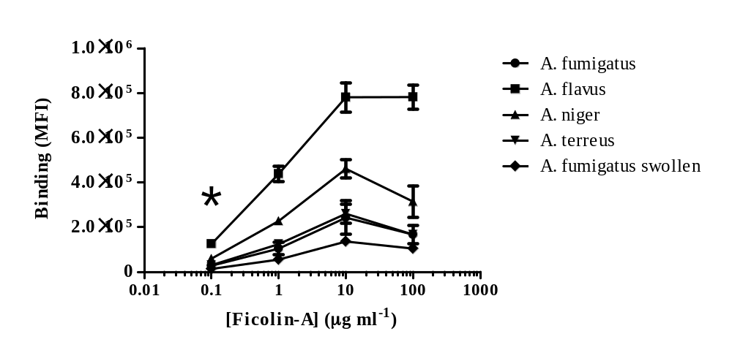

Figure 5.3. Concentration-dependent binding of ficolin-A to Aspergillus spp.
Conidia of A. fumigatus, A. flavus, A. terreus , A. niger and A. fumigatus swollen were incubated with various concentrations (0.1, 1, 10 and 100 µg mL⁻¹) of ficolin-A. Unstained A. fumigatus, A. flavus, A. terreus, A. niger and A. fumigatus swollen negative controls had median fluorescence intensities of 0.1 x 10⁴, 0.3 x 10⁴, 0.1 x 10⁴, 0.8 x 10³ and 0.4 x 10³, respectively. All results represent 5 x 10⁵ conidia stained with rabbit anti-ficolin-A and goat anti-rabbit Ig-FITC-labelled antibodies and are representative of the average of all the data points gained from three independent experiments. Error bars represent the SD. Significance was determined via one-way ANOVA and post-hoc analysis was conducted using the Tukey test. Significance was observed at 0.1 µg mL⁻¹ (*p<0.05).

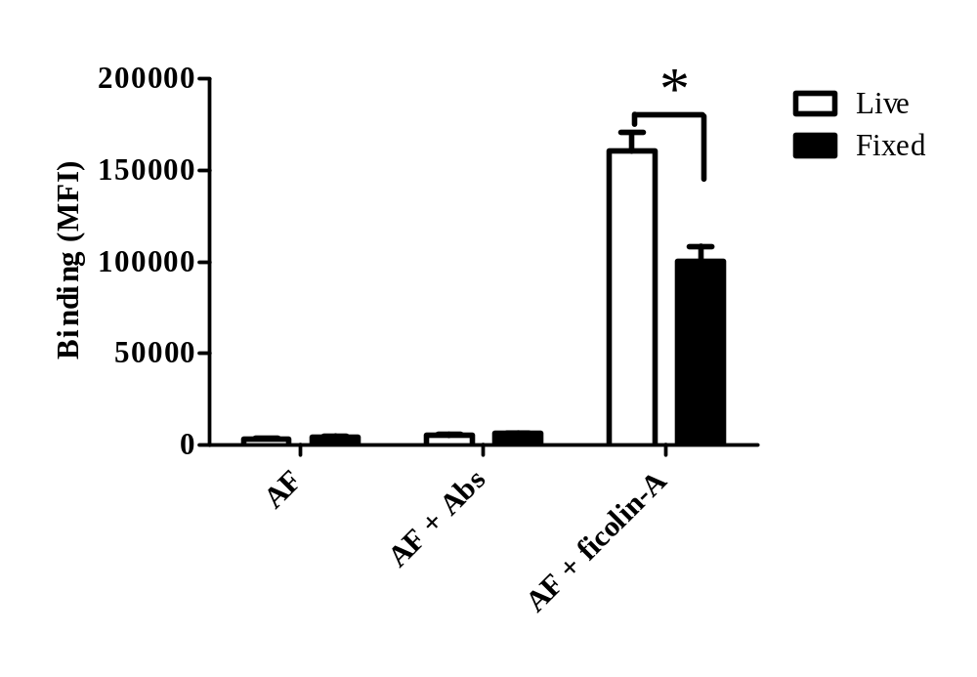

Figure 5.4. Binding of ficolin-A to live and formalin fixed conidia of A. fumigatus.
Following conidial harvest, live or formaldehyde fixed resting A. fumigatus conidia were incubated alone (AF) or stained with primary rabbit anti-ficolin-A and secondary goat anti-rabbit Ig-FITC-labelled antibodies (AF + Abs) or incubated with 5 µg mL⁻¹ ficolin-A prior to staining with rabbit anti-ficolin-A and goat anti-rabbit Ig-FITC-labelled antibodies (AF + Abs + Ficolin-A) and analysed by flow cytometry. All results are the average of all data points gained from three independent experiments. Error bars represent the SD. Significance was determined by Student’s t-test (*p<0.05).

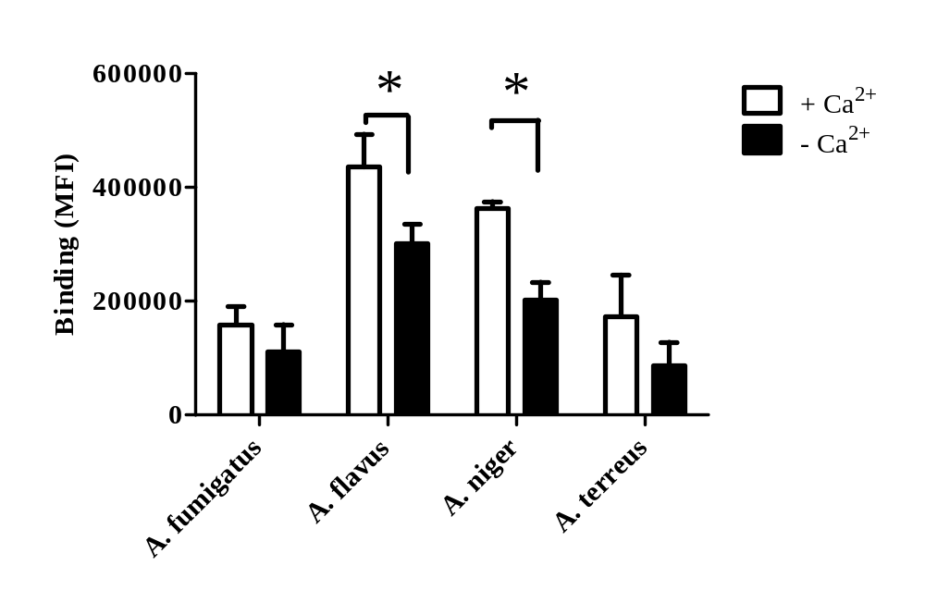

Figure 5.5. Calcium binding dependency of ficolin-A to Aspergillus spp..
Conidia of A. fumigatus (A. fum), A. flavus (A. fla), A. niger (A. nig) and A. terreus (A.ter) were incubated with 5 µg mL⁻¹ ficolin-A in the presence (+Ca²⁺) or absence of calcium (-Ca²⁺) and addition of 5 mM EGTA. All results represent 5 x 10⁵ conidia stained with rabbit anti-ficolin-A and goat anti-rabbit Ig-FITC-labelled antibodies and are the average of all the data points gained from three independent experiments. Error bars represent the SD. Significance was determined by Student’s t-test (*p<0.05).

Incubation of ficolin-A in the absence of calcium and in the presence of 5 mM EGTA had no statistically significant effect on binding of ficolin-A to conidia of A. fumigatus and A. terreus confirming a calcium independent interaction (p=0.223 and p=0.147, respectively; Figure 5.5). However, the absence of calcium had a statistically significant effect on binding of ficolin-A to conidia of A. flavus and A. niger suggesting a calcium dependent interaction (p=0.025 and p=0.001, respectively; Figure 5.5).

To assess the carbohydrate binding specificity of the ficolin-A FBG domain with the carbohydrate rich cell wall of Aspergillus spp., ficolin-A was pre-incubated with a range of carbohydrate ligands at concentrations from 0.75 mM to 100 mM prior to binding to the fungus. The acetylated carbohydrates GlcNAc and GalNAc demonstrated a concentration dependent inhibition of ficolin-A binding to conidia from all species of Aspergillus with significant inhibition of ficolin-A binding occurring at inhibitor concentrations of 12.5 mM for A. fumigatus and A. flavus (p=0.029 and p=<0.001, respectively; Figure 5.6) and at inhibitor concentrations of 3.15 mM for A. terreus and A. niger (p=0.009 and p=0.010, respectively; Figure 5.6). Ficolin-A binding to A. fumigatus, A. flavus, A. terreus and A. niger conidia was maximally inhibited at a carbohydrate concentration of 100 mM, with inhibitions of 92.3 ±4.7%, 85.3 ±2.3%, 91.9 ±2.6% and 86.8 ±3.4%, respectively, for GlcNAc and 93 ±1.2%, 85.6 ±1.7%, 95.2 ±0.6% and 88.4 ±1%, respectively, for GalNAc (Figure 5.6).
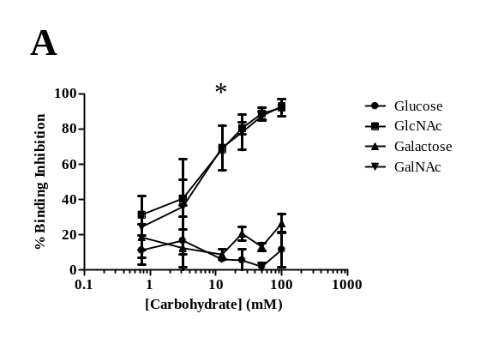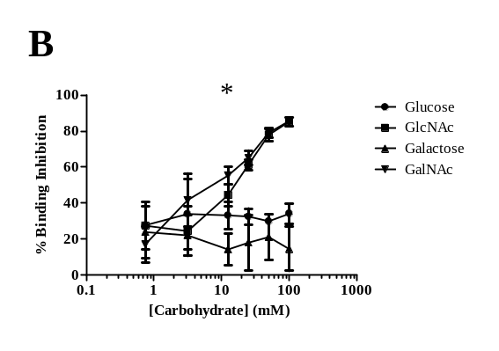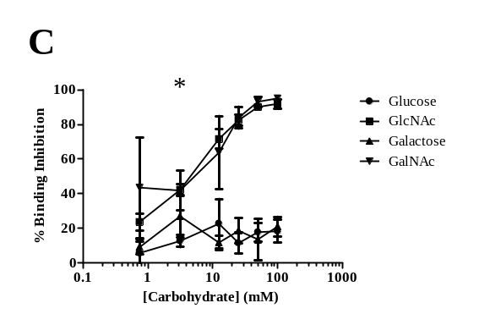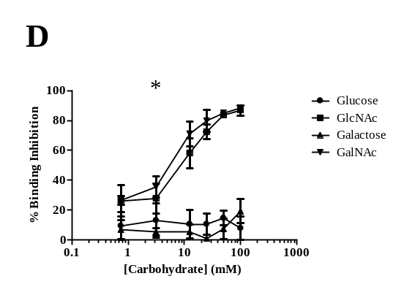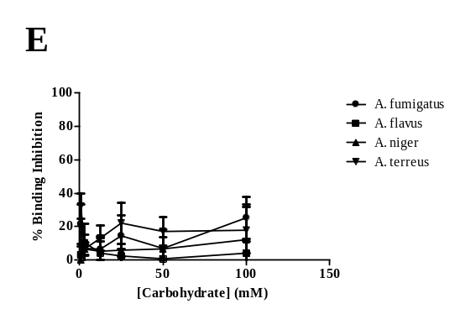

Figure 5.6. Carbohydrate specificity of ficolin-A binding to A. fumigatus conidia. Conidia of Aspergillus spp. were incubated with 5 µg mL⁻¹ ficolin-A which was pre-incubated with different carbohydrates or mannan at various concentrations. (A: A. fumigatus; B: A. flavus; C: A. terreus; D: A. niger; E: All Aspergillus spp. and mannan). All results represent 5 x 10⁵ conidia stained with rabbit anti-ficolin-A and goat anti-rabbit Ig-FITC-labelled antibodies and are the average of all the data points gained from three independent experiments. Error bars represent the SD. Significance was determined via one-way ANOVA and post-hoc analysis was conducted using the Tukey test. Significant inhibition was observed following 12.5 mM of inhibitor for A. fumigatus and A. flavus and significant inhibition was observed following 3.15 mM of inhibitor for A. terreus and A. niger (*p<0.05).

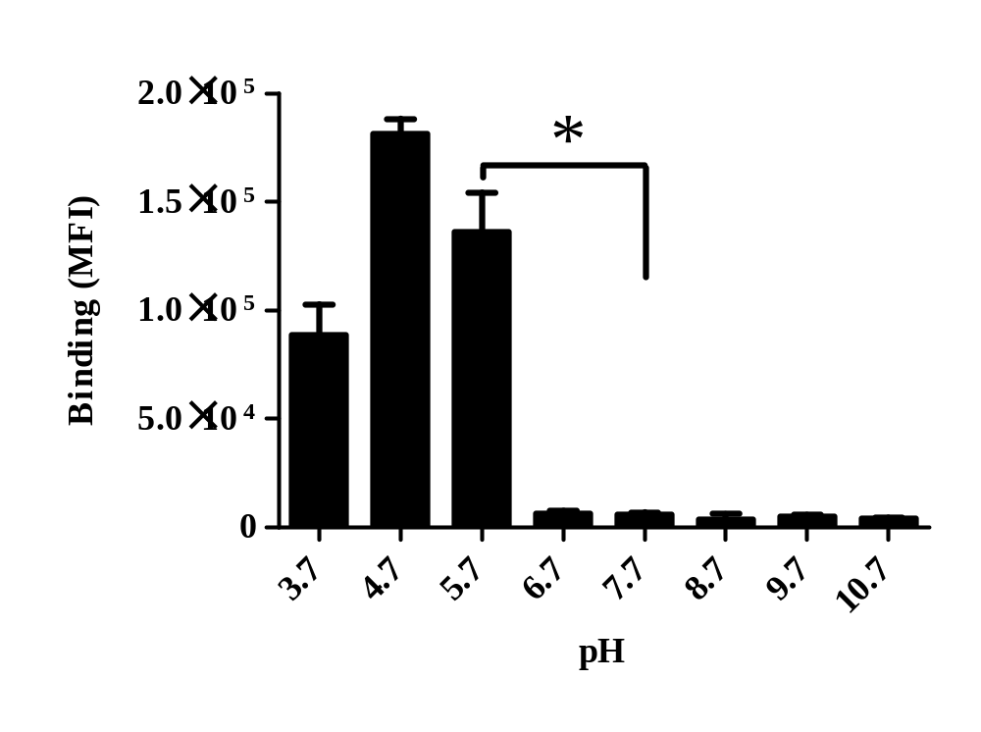

Figure 5.7. pH dependent binding of ficolin-A to A. fumigatus conidia.
A. fumigatus conidia were incubated with 5 µg mL⁻¹ ficolin-A at different pH values (3.7-10.7). All results represent 5 x 10⁵ conidia stained with rabbit anti-ficolin-A and goat anti-rabbit Ig-FITC-labelled antibodies and are the average of all the data points gained from three independent experiments. Error bars represent the SD. Significance was determined by Student’s t-test (*p<0.05).

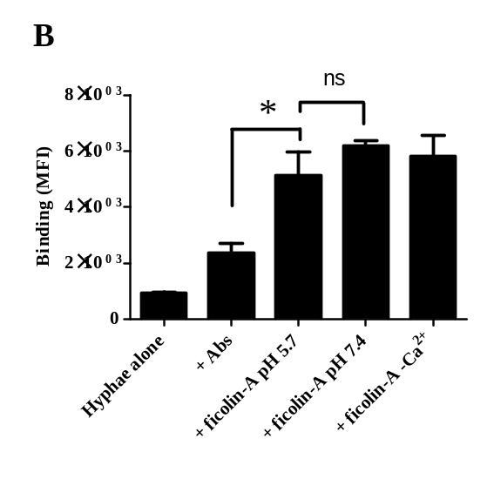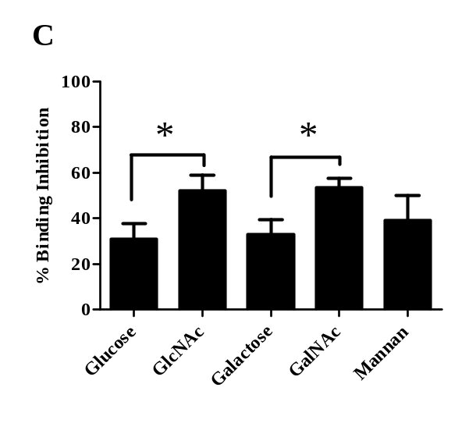
Figure 5.8. Binding characteristics of ficolin-A to A. fumigatus hyphae.
A1: Unstained A. fumigatus control (a), A. fumigatus stained with antibodies alone (b) and ficolin opsonised A. fumigatus stained with antibodies (c) were analysed by flow cytometry (FL1-A = fluorescence). A2: Hyphae were gated on P4 and debris removed (FSC-A =forward scatter; SSC-A = side scatter). B: Ficolin-A was incubated with hyphal fragments under pH 5.7, pH 7.4 or Ca²⁺ deficient conditions. Unstained controls had a median fluorescence of 9 x 10² (*p<0.05; ^{ns} p>0.05). C: Hyphal fragments were incubated with ficolin-A which was pre-incubated with 100 mM glucose, GlcNAc, galactose, GalNAc or 100 µg mL⁻¹ mannan (* p<0.05). All results represent 5 x 10⁵ conidia ± ficolin-A (5 µg mL⁻¹) stained with rabbit anti-ficolin-A and goat anti-rabbit Ig-FITC-labelled antibodies and are the average of all the data points gained from three independent experiments. All data is representative of median fluorescence intensity observed except for sugar specificity assays which represent percentage inhibition of ficolin-A binding compared to maximal ficolin binding in the absence of inhibitors. Error bars represent the SD. Significance was determined by Student’s t-test.
Glucose and galactose demonstrated on average a 5-fold lower inhibition compared to their N-acetylated-amine counterparts (11.6 ±10.1% and 26.6 ±5.6%, respectively, for A. fumigatus; 34.2 ±5.5% and 7.6 ±2.1%, respectively, for A. flavus; 18.4 ±6.6% and 21.1 ±5.6%, respectively, for A. terreus; 8 ±7.8% and 19.4 ±7.9%, respectively, for A. niger at carbohydrate concentrations of 100 mM) (Figure 5.6). Similar inhibitions were observed for the control, mannan, only inhibiting ficolin binding by 25.4 ±12.5%, 4.1 ±6.8%, 17.9 ±13.9% and 12.2 ±21.2% for A. fumigatus, A. flavus, A. terreus and A. niger, respectively at high concentrations of 100 µg mL⁻¹ (Figure 5.6).

Ficolins interact with pathogens at the local site of infection and the pH at the site of this interaction often becomes more acidic due to increased inflammation. Therefore, we analysed whether ficolin-A binding to the most pathogenic species, A. fumigatus, was affected under different pH conditions. The binding of ficolin-A to A. fumigatus increased significantly by almost 23 fold in acidic pH of 5.7, compared to binding in physiological conditions (pH 7.4) (p=0.00025; Figure 5.7). Maximal ficolin-A binding was observed at a pH of 4.7 but was observed to decrease sharply to almost negligible levels for pH > 6.7 (Figure 5.7).

5.2.2 Binding characteristics of serum ficolin-A to hyphae of A. fumigatus.

The binding characteristics of ficolin-A to A. fumigatus conidia were well demonstrated by others but binding of ficolin-A to A. fumigatus during the invasive hyphal stage was previously uncharacterised. Therefore, to investigate this, live A. fumigatus conidia cultured from clinical isolates were harvested and allowed to produce hyphae. The hyphae were sonicated and washed to produce fragments which were then incubated with purified rat ficolin-A and stained with both polyclonal rabbit anti-ficolin-A and goat anti-rabbit Ig-FITC-conjugated antibodies to assess the binding characteristics of ficolin-A to hyphae, as described previously for the conidial binding studies.
Flow-cytometry analysis showed significant binding of ficolin-A to A. fumigatus hyphae and a shift in fluorescence upon binding to hyphal fragments indicating that 72.5% positively stained for ficolin-A binding (p=0.00592; Figure 5.8A). This binding was confirmed by immunofluorescence microscopy, whereby a high intensity of fluorescence

Figure 5.9. Immunofluorescence microscopy of ficolin-A binding to live unsonicated A. fumigatus hyphae.
A. fumigatus hyphae were cultured in 96-well plates in supplemented RPMI-1640 media for 24 h prior to ficolin-A opsonisation and antibody staining, or antibody staining alone. (A) Represents the hyphal mass (far right) and individual hyphae on the periphery of the mass (far left) following opsonisation with ficolin-A (5 µg mL⁻¹) and staining with primary rabbit anti-ficolin-A and anti-rabbit FITC labelled antibodies. (B) Represents a phase-contrast image of hyphae. (C) Represents an image focussing on the peripheral hyphae observed in A. (D) Represents image B stained with rabbit anti-ficolin-A and anti-rabbit FITC labelled antibodies in the absence of ficolin-A. (E) Represents a phase-contrast image of C with fluorescence overlain. (F) Represents an overexposed image of D. All images were acquired at x10 objective. Images A-E were taken with an exposure time of 434 ms. Image F was taken with an exposure time of 2642 ms.

Figure 5.10. Ficolin-A is not involved in agglutination of A. fumigatus conidia.
Ficolin-A (5 µg mL⁻¹ or 20 µg mL⁻¹) was incubated with A. fumigatus conidia (5 x 10⁵) for 1 h prior to imaging by light microscopy at x10 objective. (A and B) Represent conidia alone in the absence of opsonins before incubation and after incubation for A and B, respectively. (C and D) Represent conidia opsonised with BSA (5 µg mL⁻¹) before incubation and after incubation for C and D, respectively. (E and F) Represent conidia opsonised with ficolin-A (5 µg mL⁻¹) before incubation and after incubation for E and F, respectively. (G and H) Represent conidia opsonised with ficolin-A (20 µg mL⁻¹) before incubation and after incubation for G and H, respectively. Data is representative of three independent experiments.
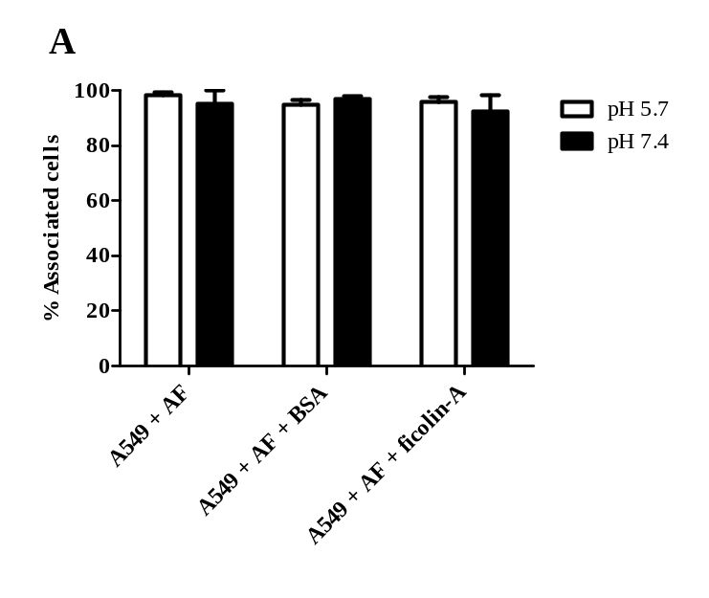
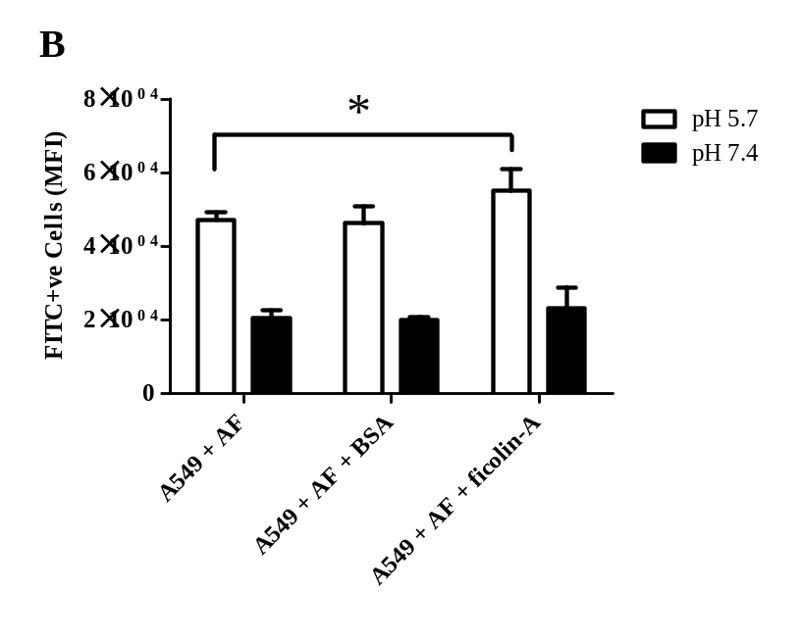
Figure 5.11. Association of ficolin-A opsonised A. fumigatus conidia with A549 type II pneumocytes.
Live freshly harvested conidia (1 x 10⁶) were opsonised with 5 µg mL⁻¹ ficolin-A prior to incubation with A549 cells (conidia:A549 ratio of 5:1) for 16 h in pH 5.7 and pH 7.4 conditions (A) The percentage of A549 cells associated with A. fumigatus conidia alone (A549 + AF), BSA opsonised A. fumigatus conidia (A549 + AF + BSA) or with ficolin-A opsonised A. fumigatus conidia (A549 + AF + Ficolin-A) following incubation at pH 5.7 or pH 7.4 for 16 h. (B) The relative number of A. fumigatus conidia associating with A549 cells as either un-opsonised A. fumigatus conidia (A549 + AF), BSA opsonised A. fumigatus conidia (A549 + AF + BSA) or ficolin-A opsonised A. fumigatus conidia (A549 + AF + Ficolin-A) incubated at pH 5.7 or pH 7.4 for 16 h (expressed as median fluorescence intensity; FL1-A). Data is the average of all the data points gained from three independent experiments. Error bars represent the SD. Significance was determined by Student’s t-test (*p<0.05).
was observed within the hyphal mass and on individual hyphae following opsonisation with ficolin-A in comparison to un-opsonised hyphae (Figure 5.9).
The binding detected by flow-cytometry analysis was calcium-independent (p=0.3397) but unlike recognition of conidia, was unaffected by a change in pH conditions (p=0.16331; Figure 5.8B).
Following pre-incubation with 100 mM of glucose, galactose, GlcNAc, GalNAc or 100 µg mL⁻¹ mannan prior to ficolin-A-hyphae binding, GlcNAc and GalNAc demonstrated the greatest inhibition of ficolin-A binding to hyphae with inhibitions of 52.2 ±6.8% and 53.4 ±4.1% for GlcNAc and GalNAc, respectively, which correlates with the observation of reduced ficolin binding (Figure 5.8C). Non-acetylated glucose and galactose demonstrated a significantly lower inhibition compared to their N-acetylated-amine counterparts (30.8 ±6.8% and 32.8 ±6.8% for glucose and galactose, respectively; p=0.01842 and p=0.01068 compared to their acetylated counterparts; Figure 5.8C). Similar inhibitions were observed for mannan, inhibiting ficolin binding by 39 ±11% (Figure 5.8C).

5.2.3 The role of ficolin-A in agglutination of A. fumigatus.

Agglutination is a functional characteristic observed amongst other C-type lectins such as MBL and SP-A and -D (Schelenz et al., 1995, Ip et al., 2004, Heinrich et al., 2010).We therefore investigated whether ficolin-A also possessed this characteristic in the defence against A. fumigatus.
Following incubation of the conidia with 5 µg mL⁻¹ ficolin-A or BSA it was observed that no agglutination occurred (Figure 5.10). Consequently, the experiment was repeated with an excess of ficolin-A (20 µg mL⁻¹) to confirm that ficolin-A does not possess agglutinating properties in the defence against Aspergillus. Again it was observed that no agglutination had occurred (Figure 5.10).

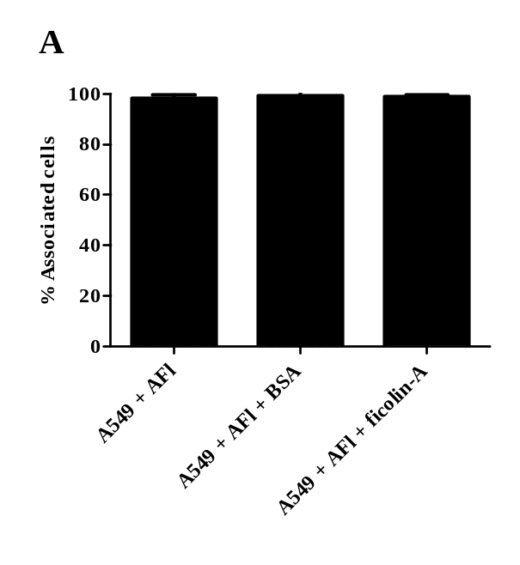
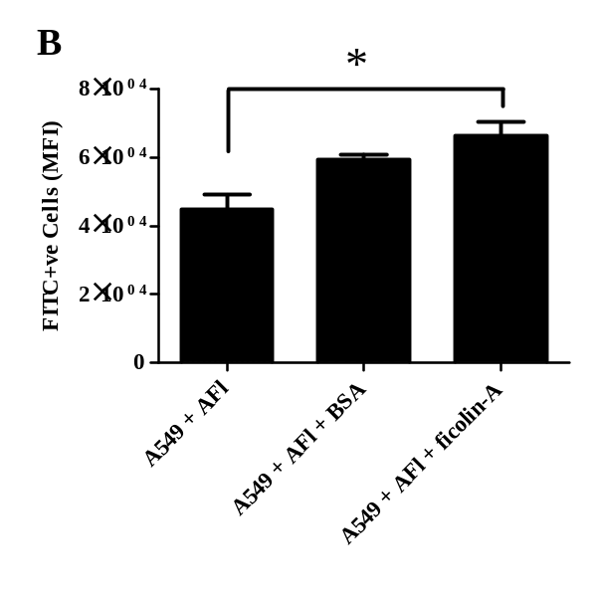
Figure 5.12. Association of ficolin-A opsonised A. flavus conidia with A549 type II pneumocytes.
Live freshly harvested conidia (1 x 10⁶) were opsonised with 5 µg mL⁻¹ ficolin-A prior to incubation with A549 cells (conidia:A549 ratio of 5:1) for 16 h in pH 5.7 and pH 7.4 conditions (A) The percentage of A549 cells associated with A. flavus conidia alone (A549 + AFl), BSA opsonised A. flavus conidia (A549 + AFl + BSA) or with ficolin-A opsonised A. flavus conidia (A549 + AFl + Ficolin-A) following incubation at pH 5.7 for 16 h. (B) The relative number of A. flavus conidia associating with A549 cells as either un-opsonised A. flavus conidia (A549 + AFl), BSA opsonised A. flavus conidia (A549 + AFl + BSA) or ficolin-A opsonised A. flavus conidia (A549 + AFl + Ficolin-A) incubated at pH 5.7 for 16 h (expressed as median fluorescence intensity; FL1-A). Data is the average of all the data points gained from three independent experiments. Error bars represent the SD. Significance was determined by Student’s t-test (*p<0.05).

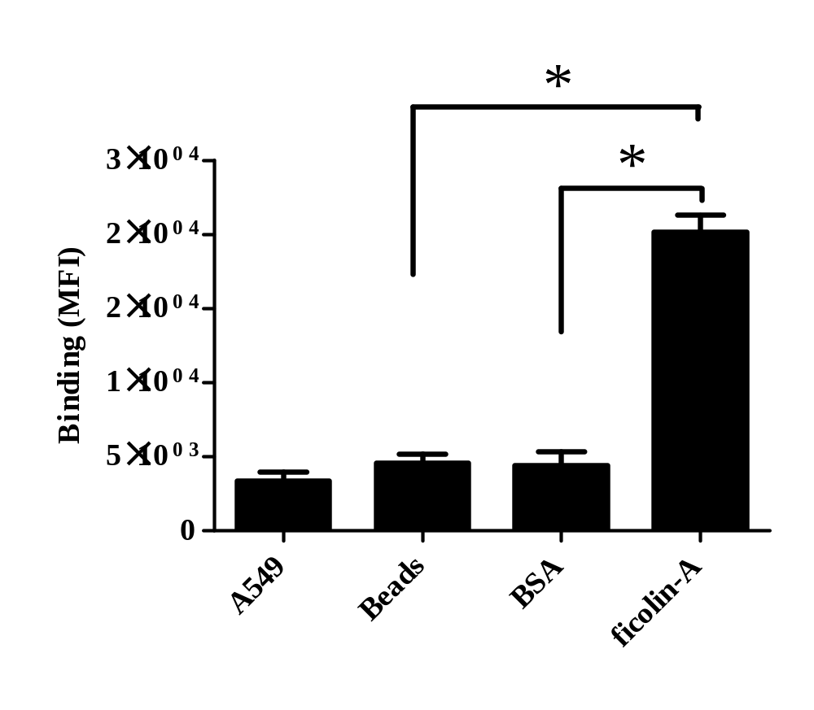

Figure 5.13. Association of ficolin-A labelled latex beads with A549 type II pneumocytes.
Latex beads 4 µm in diameter were left unlabelled or labelled with 20 µg mL⁻¹ ficolin-A or BSA before incubation with A549 cells for 16 h and flow cytometry analysis to investigate beads associating with A549’s. A549 is representative of A549 cells alone in the absence of beads. Beads is representative of A549 cells challenged with unlabelled beads. BSA is representative of A549 cells challenged with BSA labelled beads. Ficolin-A is representative of A549 cells challenged with ficolin-A labelled beads. Results are the average of all the data points gained from three independent experiments and are indicative of the median fluorescence intensity (FL3-A). Error bars represent the SD. Significance was determined by Student’s t-test (*p<0.05).

Figure 5.14. Hyphal germination following incubation of ficolin-A opsonised A. fumigatus conidia with A549 type II pneumocytes.
Live freshly harvested conidia (1 x 10⁶) were opsonised with 5 µg mL⁻¹ ficolin-A prior to incubation with A549 cells (conidia:A549 ratio of 5:1) for 24 h in pH 5.7 and pH 7.4 conditions (A) Hyphal germination following incubation of un-opsonised conidia in pH 5.7 or. (B) in pH 7.4. (C) Hyphal germination following incubation of ficolin-A opsonised conidia in pH 5.7 or. (D) in pH 7.4. Hyphae were imaged using an Axiovert 40 CFL microscope at 10 x objective. Scale bars represent 50 µm. Images are representative of three independent experiments.

5.2.4 Effect of ficolin-A opsonisation on the association with and killing of A. fumigatus and A. flavus by A549 lung epithelial cells.

As before we investigated whether ficolin-A plays an important modulatory role in the association of Aspergillus conidia with human A549 type II pneumocytes. FITC-labelled A. fumigatus or A. flavus conidia were opsonised with 5 μg mL⁻¹ ficolin-A prior to incubation with adherent A549 type II pneumocytes.
The association of A. fumigatus conidia with A549’s was investigated under physiological conditions of pH 7.4 in addition to acidic pH of 5.7 to mimic inflammatory conditions prior to analysis by flow cytometry. Following 16 hours of incubation in both pH 7.4 and pH 5.7, the majority of A549 cells were associated with un-opsonised A. fumigatus (93.7% and 96.8%, respectively) and ficolin-A opsonised A. fumigatus (93.3% and 94.2%, respectively) (Figure 5.11A). However, the number of Aspergillus conidia phagocytosed by the A549’s (based on the median fluorescence intensity) was significantly lower at pH 7.4 than pH 5.7. Based on the median fluorescence observed at pH 5.7, there was a statistically significant increase in ficolin-A opsonised conidia phagocytosed by A549’s compared to un-opsonised conidia (p=0.014; Figure 5.11B). A control of BSA pre-incubated A. fumigatus conidia did not significantly increase the association of conidia by A549 cells (p=0.861) and at physiological pH of 7.4, there was no significant difference between opsonised or un-opsonised A. fumigatus conidia per A549 (p=0.470; Figure 5.11B).
We were interested as to whether ficolin-A could also enhance association of lesser pathogenic Aspergillus species. Therefore, the association of A. flavus conidia with A549s was investigated under the pH 5.7 conditions in which increased association with ficolin-A opsonised A. fumigatus was observed, prior to flow cytometric analysis.
Following 16 hours of incubation in pH 5.7 conditions, the majority of A549 cells were associated with un-opsonised and ficolin-A opsonised A. flavus conidia (97.5 ±1.3 and 98.1 ±1.4, respectively; Figure 5.12A). However, the number of A. flavus conidia phagocytosed per A549 (based on the median fluorescence intensity) was significantly increased following opsonisation with ficolin-A (p=0.00321; Figure 5.12B).
Interestingly, 4 µm latex beads coated with 20 µg mL⁻¹ ficolin-A also led to increased association of the beads with A549 cells in comparison to unlabelled beads or beads pre-labelled with BSA (p= 2.8 x 10⁻⁵ and 4.7 x 10⁻⁵, respectively; Figure 5.13).

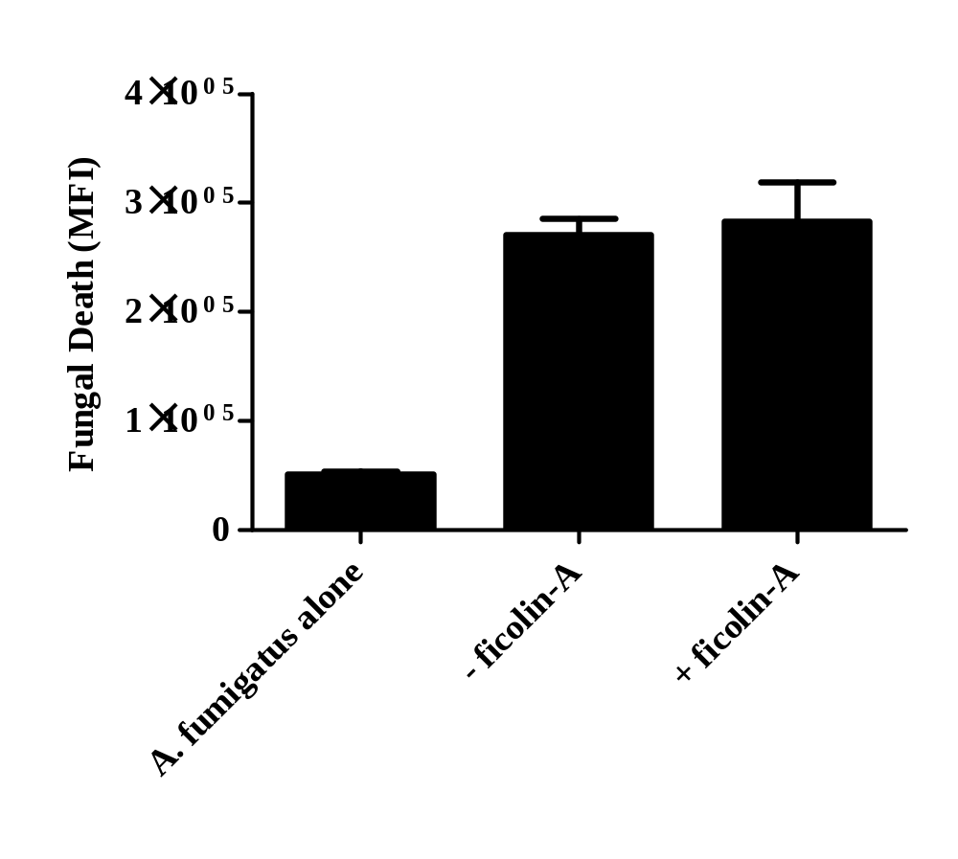

Figure 5.15. Fungal viability following incubation of ficolin-A opsonised A. fumigatus conidia with A549 type II pneumocytes.
Live freshly harvested conidia (1 x 10⁶) were opsonised with 5 µg mL⁻¹ ficolin-A prior to incubation with A549 cells (conidia:A549 ratio of 5:1) for 24 h in pH 5.7 conditions and staining with a LIVE/DEAD FUN-1 fungal viability stain. Viability of conidia alone (A. fumigatus alone), un-opsonised conidia (- Ficolin-A) or ficolin-A opsonised conidia (+ Ficolin-A) after incubation with A549s. An increase in median fluorescence intensity (MFI) using the FL1-A filter depicts increased killing. Data is the average of all data points gained from three independent experiments. Error bars represent the SD.

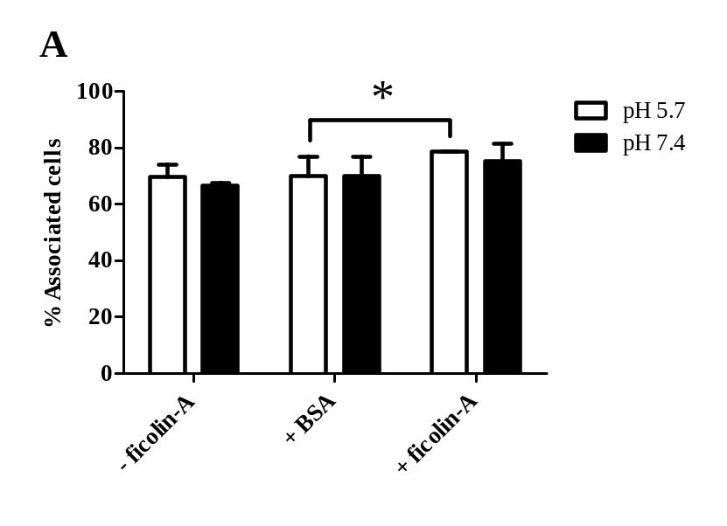
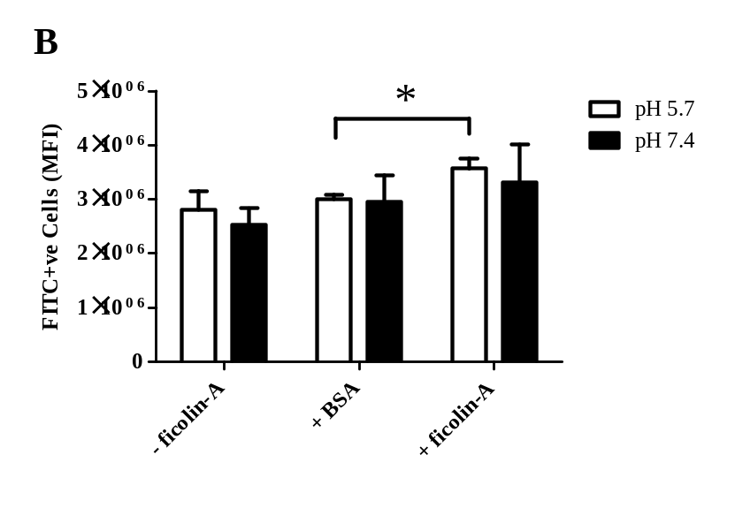

Figure 5.16. Association of ficolin-A opsonised A. fumigatus conidia with RAW 264.7 macrophages.
(A) Live freshly harvested conidia (1 x 10⁶) were opsonised with 5 µg mL⁻¹ ficolin-A prior to incubation with RAW 264.7 cells (conidia:RAW 264.7 ratio of 5:1) for 2 h in pH 5.7 and pH 7.4 conditions The percentage of RAW 264.7 cells associated with un-opsonised A. fumigatus conidia (- Ficolin-A), BSA opsonised A. fumigatus conidia (+ BSA) or with ficolin-A opsonised A. fumigatus conidia (+ Ficolin-A) following incubation at pH 5.7 or pH 7.4 for 2 h. (B) The relative number of A. fumigatus conidia associating with RAW 264.7 cells as either un-opsonised A. fumigatus conidia (- Ficolin-A), BSA opsonised A. fumigatus conidia (+ BSA) or ficolin-A opsonised A. fumigatus conidia (+ Ficolin-A) incubated at pH 5.7 or pH 7.4 for 2 h (expressed as median fluorescence intensity; FL1-A). Data is the average of all the data points gained from three independent experiments. Error bars represent the SD. Significance was determined by Student’s t-test (*p<0.05).
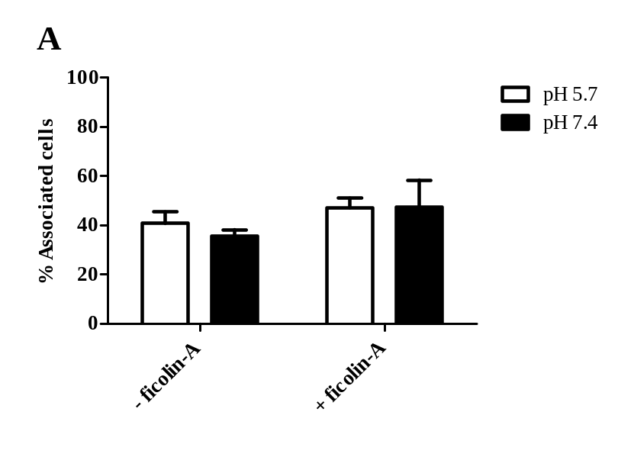
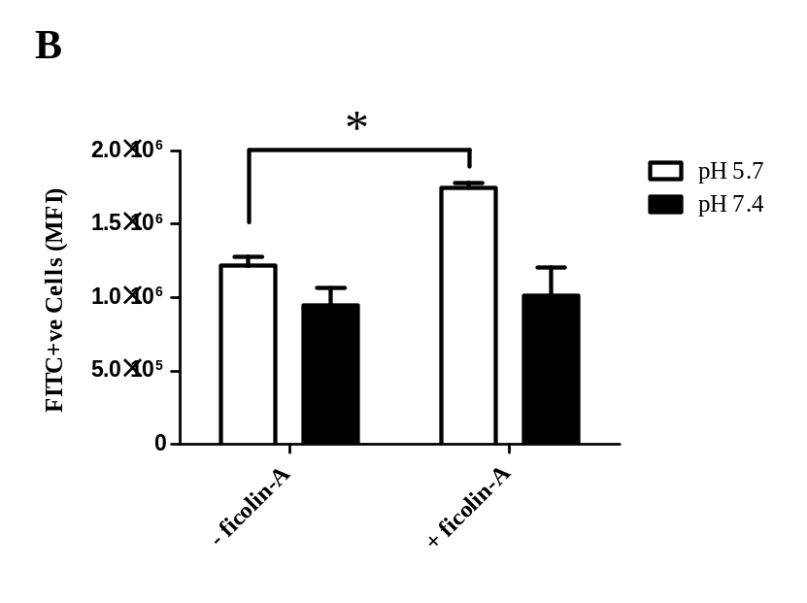

Figure 5.17. Association of ficolin-A opsonised A. fumigatus conidia with dTHP-1 macrophages.
(A) Live freshly harvested conidia (1 x 10⁶) were opsonised with 5 µg mL⁻¹ ficolin-A prior to incubation with dTHP-1 cells (conidia:dTHP-1 ratio of 5:1) for 2 h in pH 5.7 and pH 7.4 conditions The percentage of dTHP-1 cells associated with un-opsonised A. fumigatus conidia (- Ficolin-A) or with ficolin-A opsonised A. fumigatus conidia (+ Ficolin-A) following incubation at pH 5.7 or pH 7.4 for 2 h. (B) The relative number of A. fumigatus conidia associating with dTHP-1 cells as either un-opsonised A. fumigatus conidia (- Ficolin-A) or ficolin-A opsonised A. fumigatus conidia (+ Ficolin-A) incubated at pH 5.7 or pH 7.4 for 2 h (expressed as median fluorescence intensity; FL1-A). Data is the average of all the data points gained from three independent experiments. Error bars represent the SD. Significance was determined by Student’s t-test (*p<0.05).
We also investigated whether the increased association of A. fumigatus with A549’s led to decreased conidial viability and increased hyphal inhibition. Prior to conidial challenge some A549’s were stimulated with 10 ng mL⁻¹ IL-1β, to stimulate inflammatory cytokines and promote an inflammatory environment, while others were left un-stimulated. The cells were observed via light microscopy and supernatants were collected for cytokine analysis after 8 and 24 hours of incubation. After 8 h the first signs of conidial germination were present (data not shown). After 24 hours the vast majority of conidia had germinated regardless of epithelial cell stimulation or conidial opsonisation by ficolin-A (Figure. 5.14; data not shown for IL-1β stimulation).
The viability of the Aspergillus was then quantified using a LIVE/DEAD yeast viability assay and flow cytometry. It was observed that opsonisation by ficolin-A in optimal binding conditions of pH 5.7 did not increase killing of A. fumigatus, which confirmed the microscopy observations (Figure 5.15).

5.2.5 Effect of ficolin-A opsonisation on association of A. fumigatus with RAW 264.7 murine macrophages

We have shown that the association of conidia with the airway epithelial cell line, A549, is enhanced following opsonisation by ficolin-A. Another integral cell type involved in immune response to pathogens are macrophages. Macrophages are key phagocytic cells involved in the removal of smaller particles such as conidia but less so in the removal of larger structures such as hyphae. Here we have investigated whether opsonisation of A. fumigatus conidia by ficolin-A increases the association of conidia with the murine macrophage cell line RAW 264.7. FITC-labelled A. fumigatus conidia were opsonised with 5 µg mL⁻¹ ficolin-A prior to incubation with adherent RAW 264.7 macrophages. The association of A. fumigatus with RAW 264.7 macrophages was investigated under pH 7.4 in addition to acidic pH of 5.7 prior to analysis by flow cytometry.

Figure 5.18. Hyphal germination following incubation of ficolin-A opsonised A. fumigatus conidia with dTHP-1 macrophages.
Live freshly harvested conidia (1 x 10⁶) were opsonised with 5 µg mL⁻¹ ficolin-A prior to incubation with dTHP-1 cells (conidia:dTHP-1 ratio of 5:1) for 24 h in pH 5.7 and pH 7.4 conditions (A) Hyphal germination following incubation of un-opsonised conidia in pH 5.7 or. (B) in pH 7.4. (C) Hyphal germination following incubation of ficolin-A opsonised conidia in pH 5.7 or. (D) in pH 7.4. Hyphae were imaged using an Axiovert 40 CFL microscope at 10 x objective. Scale bars represent 50 µm. Images are representative of three independent experiments.

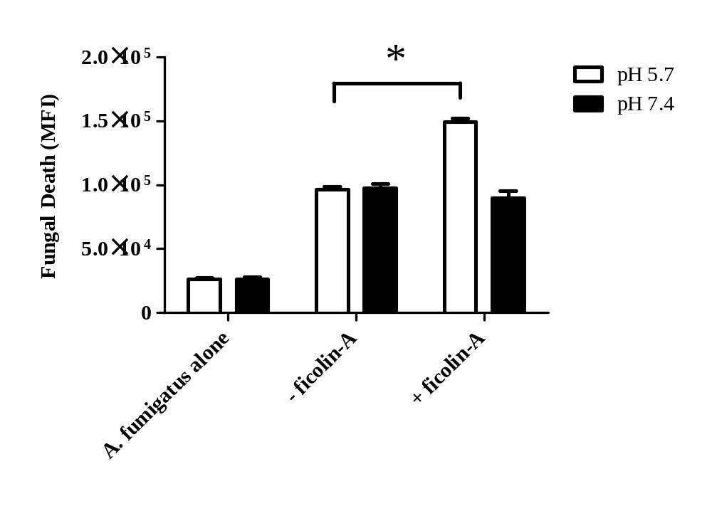

Figure 5.19. Fungal viability following incubation of ficolin-A opsonised A. fumigatus conidia with dTHP-1 macrophages.
Live freshly harvested conidia (1 x 10⁶) were opsonised with 5 µg mL⁻¹ ficolin-A prior to incubation with dTHP-1 cells (conidia:dTHP-1 ratio of 5:1) for 24 h in pH 5.7 conditions and staining with a LIVE/DEAD FUN-1 fungal viability stain. Viability of conidia alone (A. fumigatus alone), un-opsonised conidia (- ficolin-A) or ficolin-A opsonised conidia (+ ficolin-A) after incubation with dTHP-1 cells. An increase in median fluorescence intensity (MFI) using the FL1-A filter depicts increased killing. Data is the average of all data points gained from three independent experiments. Error bars represent the SD and significance was determined by Student’s t-test (*p<0.05).

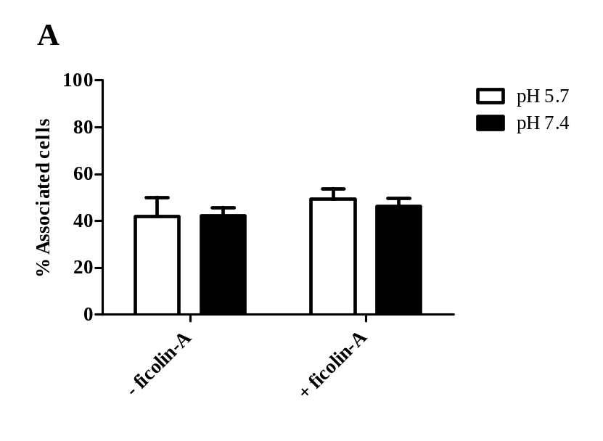
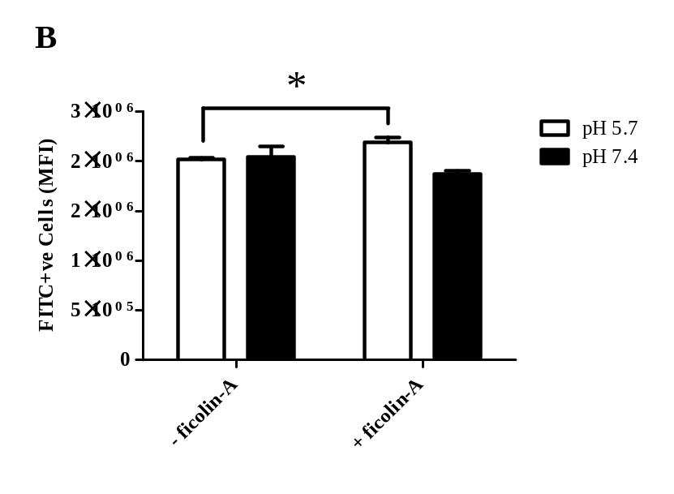
Figure 5.20. Association of ficolin-A opsonised A. fumigatus conidia with MDM.
(A) Live freshly harvested conidia (1 x 10⁶) were opsonised with 5 µg mL⁻¹ ficolin-A prior to incubation with MDM (conidia:MDM ratio of 5:1) for 2 h in pH 5.7 and pH 7.4 conditions The percentage of MDM associated with un-opsonised A. fumigatus conidia (- ficolin-A) or with ficolin-A opsonised A. fumigatus conidia (+ ficolin-A) following incubation at pH 5.7 or pH 7.4 for 2 h. (B) The relative number of A. fumigatus conidia associating with MDM as either un-opsonised A. fumigatus conidia (- ficolin-A) or ficolin-A opsonised A. fumigatus conidia (+ ficolin-A) incubated at pH 5.7 or pH 7.4 for 2 h (expressed as median fluorescence intensity; FL1-A). Data is the average of all the data points gained from three independent experiments. Error bars represent the SD. Significance was determined by Student’s t-test (*p<0.05).
Following 2 hours of incubation in both pH 5.7 and pH 7.4, the majority of RAW 264.7 cells were associated with un-opsonised A. fumigatus (69.7 ±4.5% and 66.6 ±1.2%, respectively) and ficolin-A opsonised A. fumigatus (78.6 ±0.3% and 75.2 ±6.3%, respectively) (Figure 5.16A). Based on the median fluorescence intensity observed at pH 5.7, there was a statistically significant increase in ficolin-A opsonised conidia phagocytosed by RAW 264.7 compared to un-opsonised conidia (p=0.02853; Figure 5.16B), but in physiological pH of 7.4 association was not significantly altered following ficolin-A opsonisation (p=0.394; Figure 5.16B). A control of BSA pre-incubated A. fumigatus conidia also did not significantly increase the association of conidia with RAW 264.7 cells (p=0.392; Figure 5.16B).

5.2.6 Effect of ficolin-A opsonisation on the association with and killing of A. fumigatus by dTHP-1 macrophages.

Ficolin-A was observed to increase the association of A. fumigatus conidia with RAW 264.7 macrophages. However, the effect ficolin-A opsonisation has on the interactions with human cell line-derived macrophages is poorly understood. Therefore we utilised dTHP-1 cells, an immortalised leukaemia cell line differentiated to a macrophage lineage in order to investigate how ficolin-A opsonisation alters association of A. fumigatus with these cells. To investigate this, FITC-labelled A. fumigatus conidia (conidia:macrophage ratio of 5:1) were opsonised with 5 µg mL⁻¹ ficolin-A prior to incubation with adherent macrophages for 2 hours.
The percentage of phagocytosing dTHP-1 was not significantly altered and was independent of physiological (pH 7.4) or acidic conditions (pH 5.7) (Figure 5.17A). Flow cytometry analysis displayed significantly enhanced association of conidia by dTHP-1 cells following ficolin-A opsonisation in pH 5.7 conditions, as observed for RAW 264.7 cells (p=0.00027; Figure 5.17B).
The lung epithelium was not observed to be capable of inhibiting the killing of A. fumigatus conidia but whether ficolin-A opsonisation could enhance the functions of professional phagocytes was previously unknown. Therefore, we investigated the importance of ficolin-A opsonisation for the enhancement of conidial killing by

Figure 5.21. Hyphal germination following incubation of ficolin-A opsonised A. fumigatus conidia with MDM.
Live freshly harvested conidia (1 x 10⁶) were opsonised with 5 µg mL⁻¹ ficolin-A prior to incubation with MDM (conidia:MDM ratio of 5:1) for 24 h in pH 5.7 and pH 7.4 conditions (A) Hyphal germination following incubation of un-opsonised conidia in pH 5.7 or. (B) in pH 7.4. (C) Hyphal germination following incubation of ficolin-A opsonised conidia in pH 5.7 or. (D) in pH 7.4. Hyphae were imaged using an Axiovert 40 CFL microscope at 10 x objective. Scale bars represent 50 µm. Images are representative of three independent experiments.

Figure 5.22. Fungal viability following incubation of ficolin-A opsonised A. fumigatus conidia with MDM.
Live freshly harvested conidia (1 x 10⁶) were opsonised with 5 µg mL⁻¹ ficolin-A prior to incubation with MDM (conidia:MDM ratio of 5:1) for 24 h in pH 5.7 conditions and staining with a LIVE/DEAD FUN-1 fungal viability stain. Viability of conidia alone (A. fumigatus alone), un-opsonised conidia (- ficolin-A) or ficolin-A opsonised conidia (+ ficolin-A) after incubation with MDM cells. An increase in median fluorescence intensity (MFI) using the FL1-A filter depicts increased killing. Data is the average of all data points gained from three independent experiments. Error bars represent the SD and significance was determined by Student’s t-test (*p<0.05).

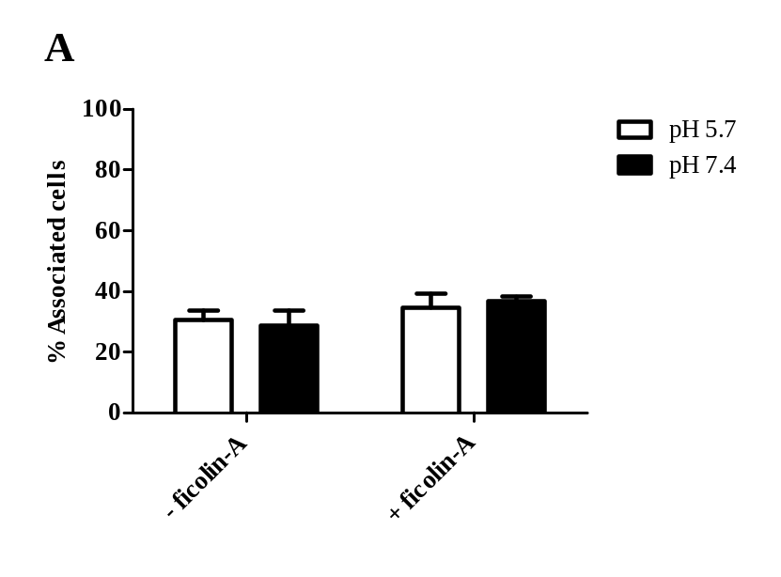
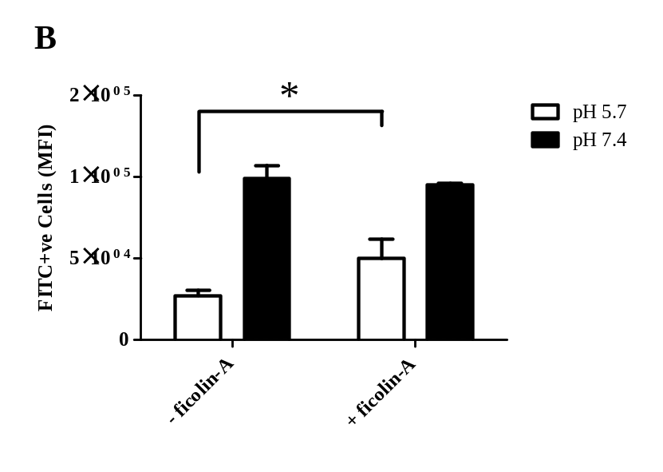

Figure 5.23. Association of ficolin-A opsonised A. fumigatus conidia with human neutrophils.
(A) Live freshly harvested conidia (1 x 10⁶) were opsonised with 5 µg mL⁻¹ ficolin-A prior to incubation with neutrophils (conidia:neutrophil ratio of 5:1) for 2 h in pH 5.7 and pH 7.4 conditions The percentage of neutrophils associated with un-opsonised A. fumigatus conidia (- ficolin-A) or with ficolin-A opsonised A. fumigatus conidia (+ ficolin-A) following incubation at pH 5.7 or pH 7.4 for 2 h. (B) The relative number of A. fumigatus conidia associating with neutrophils as either un-opsonised A. fumigatus conidia (- ficolin-A) or ficolin-A opsonised A. fumigatus conidia (+ ficolin-A) incubated at pH 5.7 or pH 7.4 for 2 h (expressed as median fluorescence intensity; FL1-A). Data is the average of all the data points gained from three independent experiments. Error bars represent the SD. Significance was determined by Student’s t-test (*p<0.05).
macrophages. dTHP-1 were seeded in 24-well plates prior to challenge with un-opsonised or ficolin opsonised A. fumigatus conidia for 2 hours.
Light microscopy demonstrated that dTHP-1 cells inhibited hyphal growth following opsonisation by ficolin-A in acidic conditions (Figure 5.18). In addition to this, viability assays demonstrated a significant decrease in fungal viability following opsonisation by ficolin-A in these conditions, as observed by fluorescence microscopy and flow cytometry (p=0.0387; Figure 5.19).

5.2.7 Effect of ficolin-A opsonisation on the association with and killing of A. fumigatus by MDM.

The macrophage cell line, dTHP-1, exhibited enhanced association with conidia in the presence of ficolin-A which prompted the use of primary human cells. Monocytes from donor blood were therefore differentiated to MDM prior to challenge with un-opsonised or ficolin-A opsonised A. fumigatus conidia for 2 hours.
As for the dTHP-1, the percentage of phagocytosing MDM was not significantly altered and was independent of physiological (pH 7.4) or acidic conditions (pH 5.7) (Figure. 5.20A). However, the number of FITC-labelled conidia phagocytosed by each MDM was significantly enhanced following ficolin-A opsonisation as indicated by an increase in median fluorescence intensity (p=0.00728; Figure 5.20B).
As investigated previously for the interactions of A. fumigatus conidia with the RAW 264.7 and dTHP-1 cell lines, fungal viability was investigated via light microscopy and flow cytometry following staining with FUN-1. Here, light microscopy demonstrated that MDM inhibited hyphal growth following opsonisation by ficolin-A in acidic conditions (Figure 5.21). In addition to this, fungal viability assays demonstrated a significant increase in fungal killing following opsonisation by ficolin-A in these conditions, as observed by fluorescence microscopy and flow cytometry (p=2.2 x 10⁻⁵; Figure 5.22).

Figure 5.24. Hyphal germination following incubation of ficolin-A opsonised A. fumigatus conidia with human neutrophils.
Live freshly harvested conidia (1 x 10⁶) were opsonised with 5 µg mL⁻¹ ficolin-A prior to incubation with neutrophils (conidia:neutrophil ratio of 5:1) for 24 h in pH 5.7 and pH 7.4 conditions (A) Hyphal germination following incubation of un-opsonised conidia in pH 5.7 or. (B) in pH 7.4. (C) Hyphal germination following incubation of ficolin-A opsonised conidia in pH 5.7 or. (D) in pH 7.4. Hyphae were imaged using an Axiovert 40 CFL microscope at 10 x objective. Scale bars represent 50 µm. Images are representative of three independent experiments.

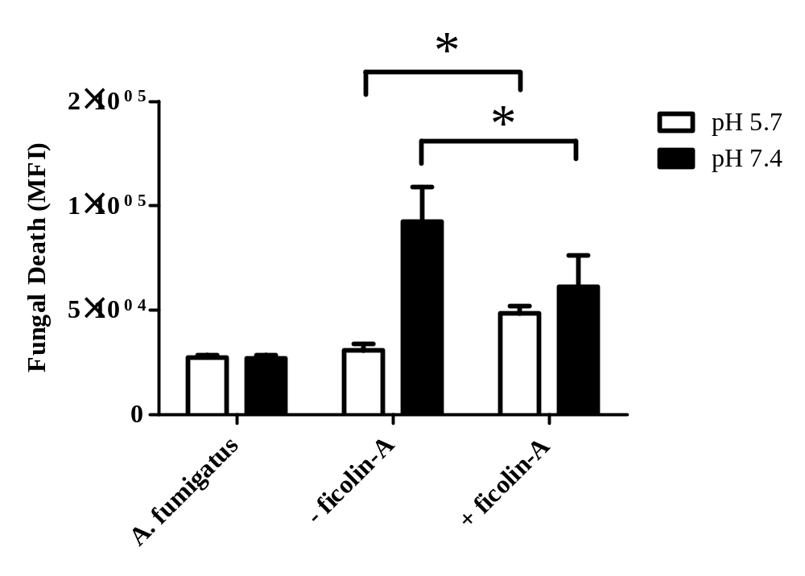

Figure 5.25. Fungal viability following incubation of ficolin-A opsonised A. fumigatus conidia with human neutrophils.
Live freshly harvested conidia (1 x 10⁶) were opsonised with 5 µg mL⁻¹ ficolin-A prior to incubation with neutrophils (conidia:neutrophil ratio of 5:1) for 24 h in pH 5.7 conditions and staining with a LIVE/DEAD FUN-1 fungal viability stain. Viability of conidia alone (A. fumigatus alone), un-opsonised conidia (- ficolin-A) or ficolin-A opsonised conidia (+ ficolin-A) after incubation with neutrophils. An increase in median fluorescence intensity (MFI) using the FL1-A filter depicts increased killing. Data is the average of all data points gained from three independent experiments. Error bars represent the SD and significance was determined by Student’s t-test (*p<0.05).

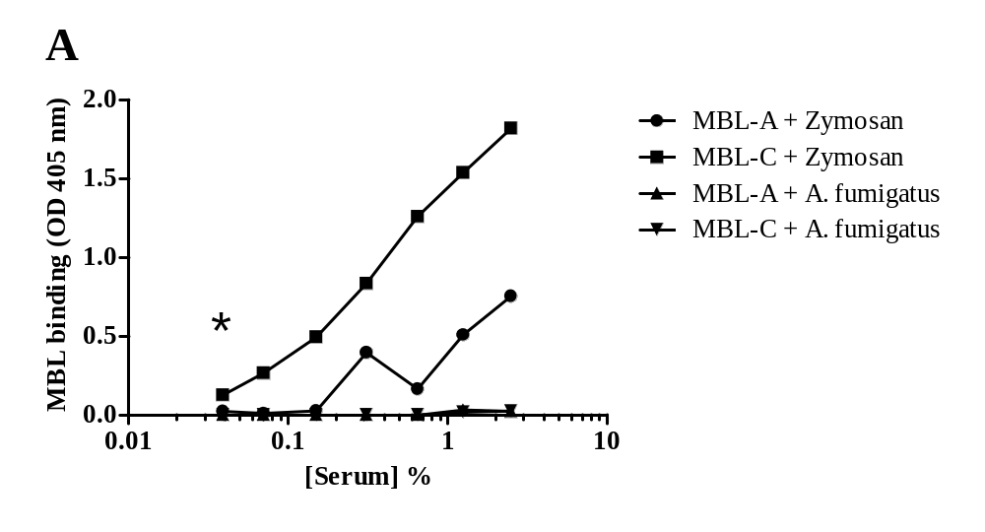
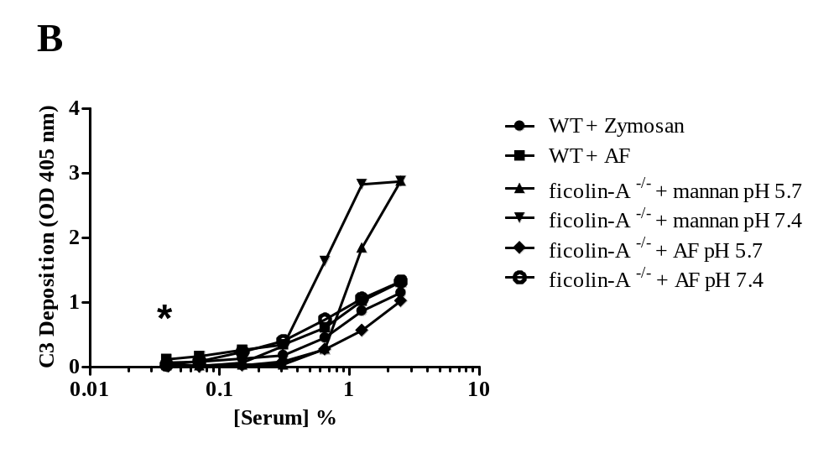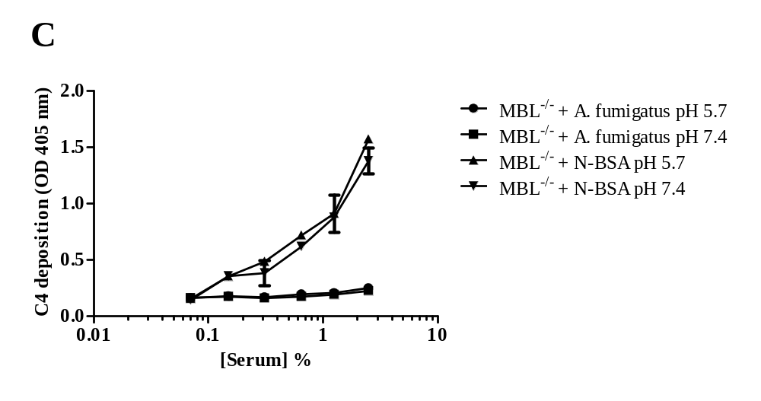
Figure 5.26. Binding of the lectin pathway pattern recognition molecules (MBL-A and –C) to and activation of complement on A. fumigatus conidia.
(A) MBL-C, but not MBL-A, of WT murine serum was able to bind to A. fumigatus. Zymosan coating was used as a positive control. Significant binding was observed at the lowest concentration of serum used (*p<0.05). (B) C3 deposition was observed on A. fumigatus in the absence or presence of serum ficolin-A. Serum dilutions were incubated with Maxisorb micro-titer 96-well coated plates and deposited C3 was detected by using rabbit anti-human C3c complement antibody and goat anti-rabbit IgG-alkaline phosphatase conjugate Mannan and zymosan coating were used as positive controls for C3 deposition. Significant C3 deposition was observed at the lowest concentration of serum used (*p<0.05). (C) C4 deposition on A. fumigatus in the absence of MBL-A and -C. using MBL-A and –C double deficient mouse serum. Serum dilutions were incubated with Maxisorb micro-titer 96-well coated plates prior to the addition of human C4 (1 µg/well). C4 deposition was not observed on A. fumigatus at pH 5.7 or at pH 7.4, however, C4 was deposited on the positive control coated wells. N-BSA was used as a positive control for C4 deposition by ficolins. All data are represented as mean absorbance measured at 405 nm and are the average of all data points gained from three independent experiments. Significance was determined via one-way ANOVA and pair-wise comparisons were conducted using the Tukey test.

5.2.8 The role of ficolin-A opsonisation in the association with and killing of A. fumigatus by human neutrophils.

Neutropenia poses a significant risk factor for developing aspergillosis which led us to investigate the importance of neutrophils in recognition and removal of A. fumigatus conidia following ficolin-A opsonisation. The association of ficolin-A opsonised conidia with isolated human neutrophils was investigated under physiological and acidic conditions as for the macrophages and A549 cell lines.
Following 2 hours of incubation in either pH 5.7 and pH 7.4 conditions, opsonisation by ficolin-A did not increase the number of associated neutrophils (Figure 5.23A). However, flow cytometry analysis indicated a significant increase in the number of conidia phagocytosed per neutrophil following ficolin-A opsonisation, but only in pH 5.7 conditions (p=0.032; Figure 5.23B).
Neutrophils are traditionally recognised to be integral in the defence against the hyphae of Aspergillus, therefore we also investigated the potential role of ficolin-A to enhance this interaction. Neutrophils were seeded in 24-well plates prior to challenge with un-opsonised or ficolin-A opsonised A. fumigatus conidia. Light microscopy demonstrated that in the absence of ficolin-A opsonisation but presence of neutrophils, hyphal growth appeared very dense (Figure. 5.24). In contrast, following opsonisation by ficolin-A, hyphal growth appeared significantly less dense (Figure 5.24). This effect was pronounced in inflammatory conditions but there appeared to be some inhibition of hyphal growth observed in physiological conditions (Figure 5.24D). In addition to this, viability assays demonstrated a significant decrease in hyphal viability following opsonisation by ficolin-A in acidic conditions, as observed by flow cytometry (p=0.00262; Figure 5.25).

5.2.9 The role of ficolin-A in lectin complement pathway activation on A. fumigatus.

We have observed binding of ficolin-A to both conidia and hyphae of A. fumigatus but MBL has also been shown to bind to and activate complement upon A. fumigatus. Mice have been shown to possess two MBLs, MBL-A and MBL-C, and it was observed that both MBL-A and MBL-C were observed to bind to zymosan. However, interestingly only MBL-C was observed to bind to A. fumigatus (Figure 5.26A).
Observation of C3 deposition on the microbial cell surface is a key indicator towards the extent of complement activation. Following coating of micro well plates with harvested A. fumigatus from clinical isolates, ELISA was used to assess C3c deposition and therefore complement activation using both wild type mouse sera and sera deficient in ficolin-A but containing MBLs. C3 deposition was observed in all cases, regardless of whether ficolin-A was absent and regardless of whether pH 5.7 or pH 7.4 conditions were used (Figure 5.26B). C3 deposition observed when using ficolin-A-deficient serum in pH 7.4 conditions was also highly comparable to C3 deposition using wild type serum (Absorbance at 405 nm of 1.33 and 1.3 when using 0.025 µg mL⁻¹ serum, for ficolin-A-deficient and wild type serum respectively) (Figure 5.26B).

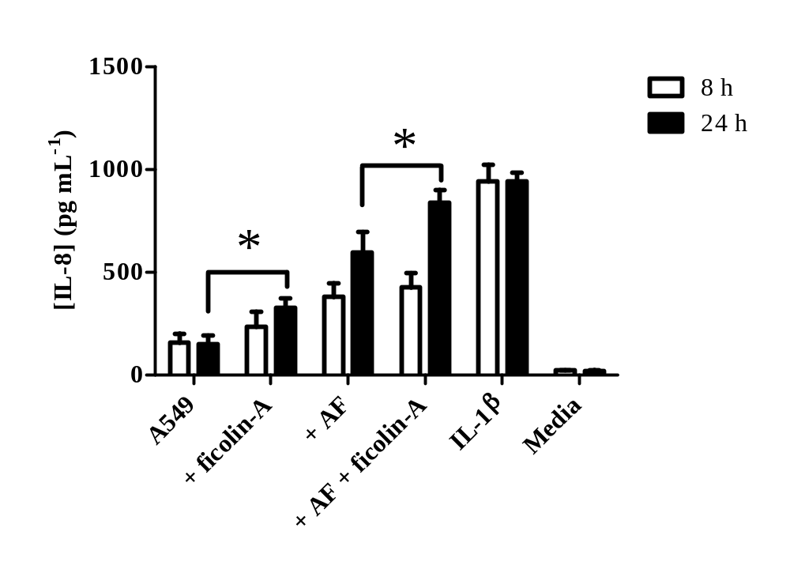
Figure 5.27. The detection of IL-8 in supernatants collected 8 hours and 24 hours after A549 challenge with ficolin-A opsonised A. fumigatus conidia quantified by ELISA.
Supernatants from A549 cells were tested for IL-8 by ELISA after 8 and 24 hours challenge with ficolin-A (5 µg mL⁻¹) alone (+ Ficolin-A), conidia (10⁵) alone (+ AF) or ficolin-A (5 µg ml⁻¹) opsonised A. fumigatus (10⁵ conidia) (+ AF + Ficolin-A). Media from A549 cells without stimulus (A549) or following prior stimulation with IL-1β (10 ng mL⁻¹ for 24 h) (IL-1β) or culture media in the absence of A549 (Media) were used as controls. All data is represented as the average concentration of IL-8 produced (pg mL⁻¹) and are the average of all data points gained from three independent experiments. Error bars represent the SD. Significance was determined by paired Students t-test (* p<0.05).

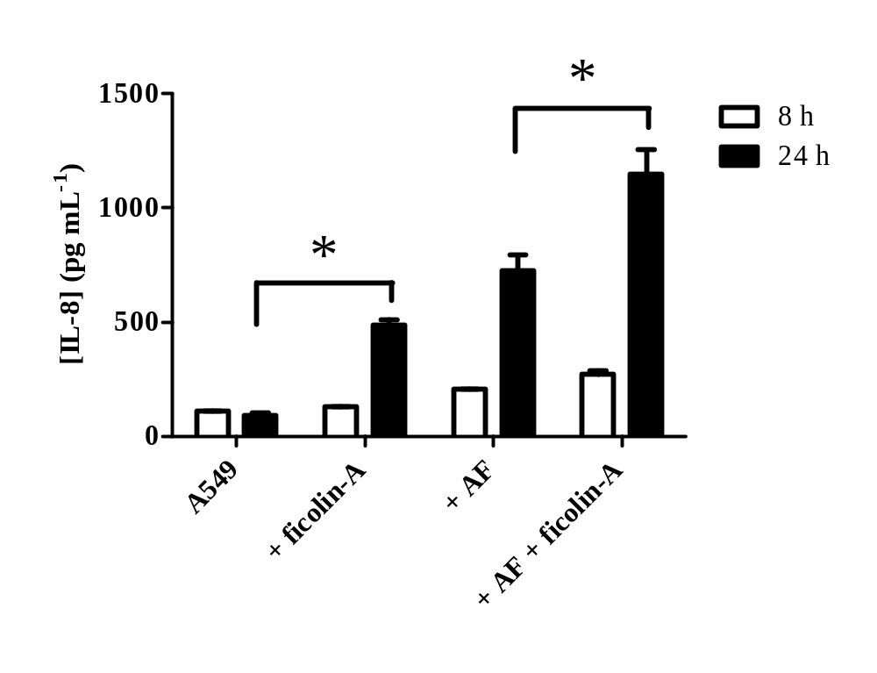
Figure 5.28. Inflammatory cytokine release from A549 cells following challenge by un-opsonised or ficolin-A opsonised conidia quantified by CBA.
Supernatants were collected after 8h and 24 h time points during challenge with live A. fumigatus conidia (1 x 10⁶) un-opsonised or ficolin-A opsonised (5 µg mL⁻¹) prior to the conduction of cytometric bead arrays. (A) The concentration of IL-8 secretion following A. fumigatus conidia challenge. A549 is representative of A549 cells alone. + Ficolin-A represents A549 cells in the presence of ficolin-A alone. +AF and +AF + Ficolin-A are representative of un-opsonised A. fumigatus or ficolin-A opsonised conidia, respectively. Error bars represent the SD and significance was determined via one-way ANOVA and pair-wise comparisons were conducted using the Student-Newman-Keuls method. Results are the average of all data points gained from three independent experiments An asterisk indicates a significant difference (*p˂0.05).

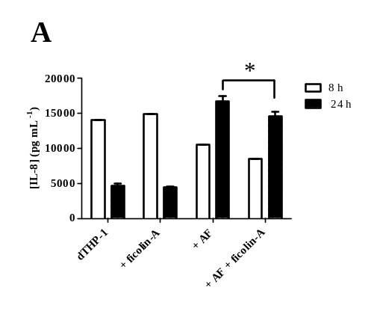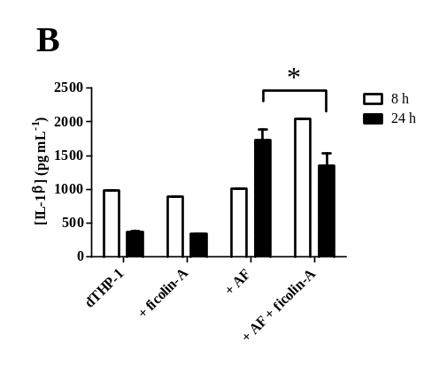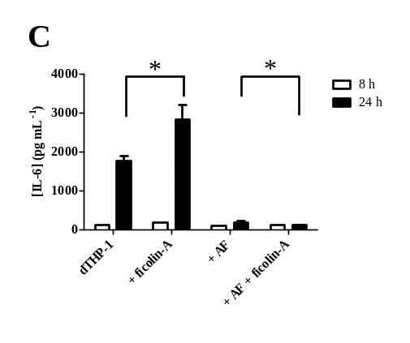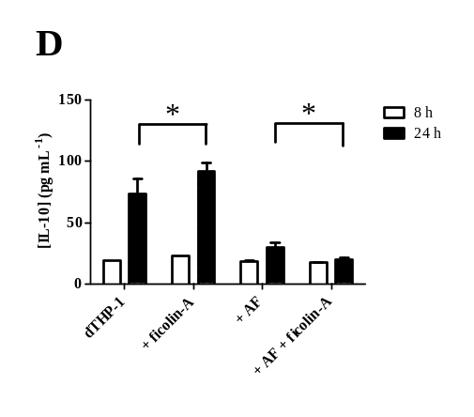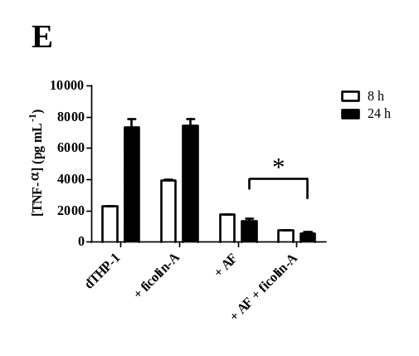
Figure 5.29. Inflammatory cytokine release from dTHP-1 cells following challenge by un-opsonised or ficolin-A opsonised conidia.
Supernatants were collected after 8h and 24 h time points during challenge with live A. fumigatus conidia (1 x 10⁶) un-opsonised or ficolin-A opsonised (5 µg mL⁻¹) prior to the conduction of cytometric bead arrays. Concentrations of (A) IL-8 (B) IL-1β (C) IL-6 (D) IL-10 (E) TNF-α. dTHP-1 is representative of dTHP-1 cells alone. + Ficolin-A represents dTHP-1 cells in the presence of ficolin-A alone. +AF and +AF + Ficolin-A are representative of un-opsonised A. fumigatus or ficolin-A opsonised conidia, respectively. Error bars represent the SD and significance was determined via one-way ANOVA and pair-wise comparisons were conducted using the Student-Newman-Keuls method. Results are the average of all data points gained from three independent experiments. An asterisk indicates a significant difference (*p˂0.05).
To further define the role of ficolins and indeed their role of the lectin pathway in complement activation on A. fumigatus, a C4c deposition assay was used in the presence of high salt concentrations (to inhibit the involvement of the classical pathway) using serum that was deficient in both MBL-A and MBL-C but containing ficolin-A and potentially CL-11. C4 deposition was observed on acetylated BSA in both pH 5.7 and pH 7.4 conditions (Figure 5.26C). However, there was no C4 deposition observed on A. fumigatus and this occurred regardless of the pH conditions used (Figure 5.26C).

5.2.10 The role of ficolin-A in cytokine modulation following A. fumigatus challenge.

Cytokine activation is a key step in the regulation of inflammatory pathways and recruitment of leukocytes upon challenge by Aspergillus spp. Therefore, we investigated whether ficolin-A opsonisation could be important in the regulation of the pro-inflammatory cytokine and neutrophil chemotactic factor, IL-8 upon challenge of A549 cells by live A. fumigatus conidia.

After 8 hours, the first signs of IL-8 production became present, which also coincided with conidial germination. Although, by this stage the conidia that were opsonised by ficolin-A did not lead to a significant increase in the production of IL-8 when compared to un-opsonised conidial controls (p=0.45524; Figure 5.27). After 24 hours it was observed that opsonisation by ficolin-A did lead to the production of significantly more IL-8 by A549 lung epithelial cells compared to un-opsonised controls (p=0.02197; Figure 5.27). Interestingly, ficolin-A itself was observed to stimulate significant quantities of IL-8 production following an incubation of ficolin-A alone with A549 cells (p=0.00826; Figure 5.27). A549 cells stimulated with 10 ng mL⁻¹ IL-1β were positive for IL-8 production and the media was devoid of significant amounts of IL-8 (Figure 5.27).

We had observed that ficolin-A was capable of enhancing the secretion of IL-8 from A549 cells following a live conidial challenge. However, whether ficolins were capable of modulating other cytokines following conidial challenge from A549’s, in addition to professional phagocytes such as macrophages and neutrophils, was poorly understood. To 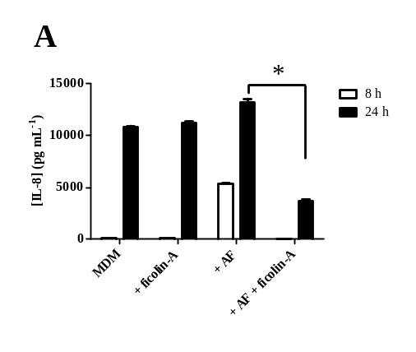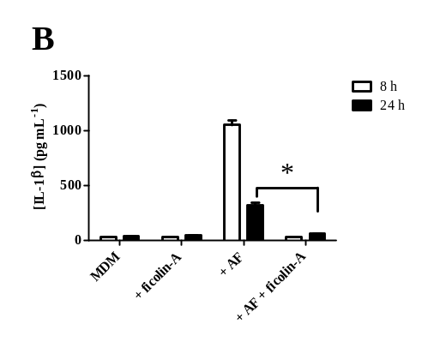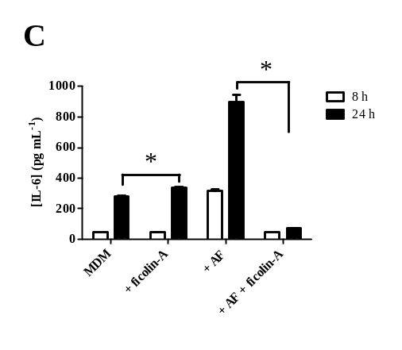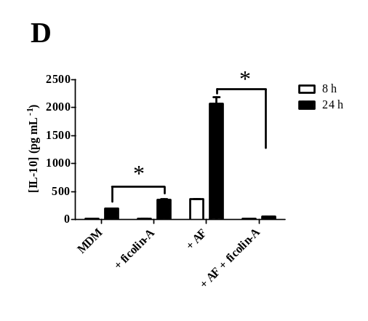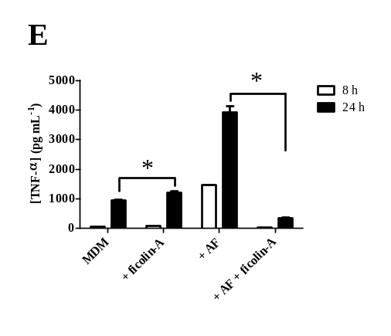
Figure 5.30. Inflammatory cytokine release from MDM following challenge by un-opsonised or ficolin-A opsonised conidia.
Supernatants were collected after 8h and 24 h time points during challenge with live A. fumigatus conidia (1 x 10⁶) un-opsonised or ficolin-A opsonised (5 µg mL⁻¹) prior to the conduction of cytometric bead arrays. Concentrations of (A) IL-8 (B) IL-1β (C) IL-6 (D) IL-10 (E) TNF-α. MDM is representative of MDM alone. + Ficolin-A represents MDM in the presence of ficolin-A alone. +AF and +AF + Ficolin-A are representative of un-opsonised A. fumigatus or ficolin-A opsonised conidia, respectively. Error bars represent the SD and significance was determined via one-way ANOVA and pair-wise comparisons were conducted using the Student-Newman-Keuls method. Results are the average of all data points gained from three independent experiments. An asterisk indicates a significant difference (*p˂0.05).
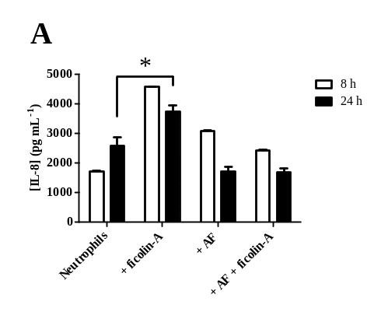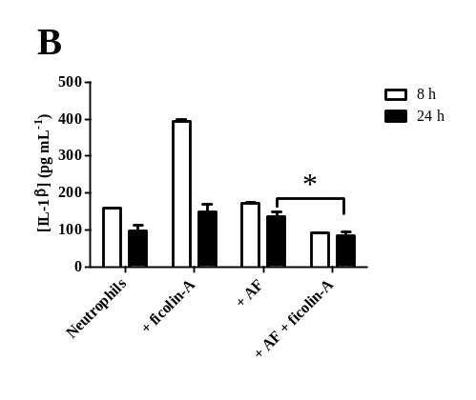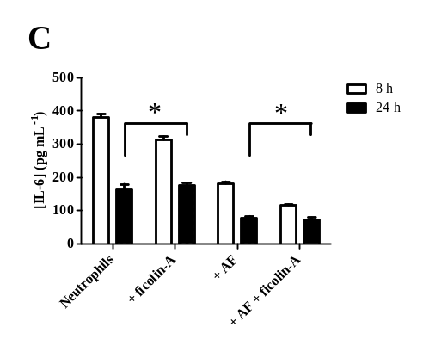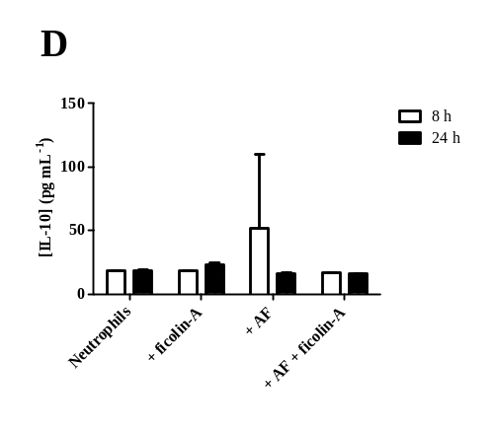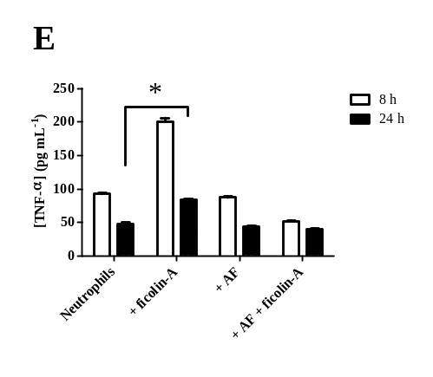
Figure 5.31. Inflammatory cytokine release from human neutrophils following challenge by un-opsonised or ficolin-A opsonised conidia.
Supernatants were collected after 8h and 24 h time points during challenge with live A. fumigatus conidia (1 x 10⁶) un-opsonised or ficolin-A opsonised (5 µg mL⁻¹) prior to the conduction of cytometric bead arrays. Concentrations of (A) IL-8 (B) IL-1β (C) IL-6 (D) IL-10 (E) TNF-α. Neutrophils is representative of neutrophils alone. + Ficolin-A represents neutrophils in the presence of ficolin-A alone. +AF and +AF + Ficolin-A are representative of un-opsonised A. fumigatus or ficolin-A opsonised conidia, respectively. Error bars represent the SD and significance was determined via one-way ANOVA and pair-wise comparisons were conducted using the Student-Newman-Keuls method. Results are the average of all data points gained from three independent experiments. An asterisk indicates a significant difference (*p˂0.05).
investigate this we utilised cytometric bead arrays and measured the concentration of IL-8, I-1β, IL-6, IL-10, TNF-α and IL-12p70 secreted from A549 type II alveolar cells, dTHP-1, MDM and human neutrophils following challenge by ficolin-A opsonised A. fumigatus conidia.
It was demonstrated that IL-8 was the only modulated cytokine from A549 cells in response to ficolins. Ficolin-A opsonisation induced a significant increase in the secretion of pro-inflammatory IL-8 compared to challenge with un-opsonised conidia after 8 h (p<0.05; Figure 5.28). This inflammation had been somewhat resolved following 24 hours but the concentrations of IL-8 following ficolin opsonisation were still significantly higher (p<0.05; Figure 5.28). All other cytokines remained at baseline level (data not shown).
Ficolin-A opsonisation also modulated cytokine secretion from dTHP-1. Following dTHP-1 challenge with conidia opsonised by both ficolin-A an anti-inflammatory effect was observed. The secretion of IL-8, IL-1β, IL-6, IL-10 and TNF-α from dTHP-1 cells 24 h following ficolin-opsonised conidial challenge were all significantly decreased in comparison to un-opsonised conidia (p<0.05; Figure 5.29). The concentration of IL-12p70 was unaffected. Ficolins themselves appeared capable of significantly increasing the cytokine concentrations of IL-6 and IL-10 (p<0.05) (Figure 5.29C and D).
Ficolin-A opsonisation also modulated cytokine secretion from MDM. Following MDM challenge with conidia opsonised by ficolin-A an anti-inflammatory effect was observed. The secretion of IL-8, IL-1β, IL-6, IL-10 and TNF-α from MDM’s 24 h following ficolin-opsonised conidial challenge were all significantly decreased in comparison to un-opsonised conidia (p<0.05; Figure 5.30). The concentration of IL-12p70 was unaffected. Again ficolin-A itself appeared capable of significantly increasing the cytokine concentrations of all but IL-12p70 (p<0.05; Figure 5.30).
We also investigated the effects of ficolin-A opsonisation on the modulation of cytokines from neutrophils. Here we observed that IL-10 was only secreted at baseline level regardless of any challenges (Figure 5.31D). After 24 h, ficolin-A opsonisation of conidia led to significantly decreased secretion of IL-1β, IL-6 and TNF-α compared to un-opsonised conidia (p<0.05) (Figure 5.31B, C and E). Additionally, ficolin-A itself had the ability to increase the secretion of IL-8, IL-1β and TNF-α in the absence of A. fumigatus (p<0.05) (Figure 5.31A, B and E).

5.3 Discussion

In the current study, we examined the opsonising properties of ficolin-A to species of the medically relevant mould Aspergillus which has the potential to cause opportunistic systemic disease in immunosuppressed humans with a high risk of mortality dependent upon the hosts immune status (Mitchell et al., 1995, Denning, 1998, Sun et al., 2009). Aspergillus primarily invades the host following inhalation of small hydrophobic conidia from the environment, prior to conidial swelling and the production of hyphal structures that facilitate infection (Pitt, 1994).
This work led to a number of observations. Firstly, ficolin-A was capable of recognising A. fumigatus conidia in a Ca²⁺-dependent and pH-dependent manner, in an interaction inhibited by GalNAc and GlcNAc. This recognition also led to enhanced association with epithelial cells, MDM and neutrophils. Secondly, ficolin-A opsonisation led to increased fungal killing and modulation of the inflammatory response following A. fumigatus challenge of lung epithelial cells, macrophages and neutrophils. This work therefore led us to postulate that, like L-ficolin, ficolin-A recognizes conidia via its cell surface glycoproteins, enhancing the immune function of host cells in the defence against A. fumigatus.
Involved in innate host defences, ficolins are able to recognise carbohydrate moieties on the cell surface of invading pathogens, consequently facilitating recognition and removal of pathogens by the host immune system. We therefore investigated whether rat ficolin-A may play a role in the innate recognition of conidia from clinical isolates of Aspergillus spp.
We observed that resting conidia from all Aspergillus species investigated were recognised by the FBG domains of ficolin-A with high affinity. As resting conidia are the form in which conidia are primarily inhaled from the environment before becoming infectious, this suggests that ficolin-A may also be involved in the early stages of innate host defence against Aspergillus infection. This binding was further demonstrated to be concentration dependent occurring at levels within normal physiological serum ranges for L-ficolin (Taira et al., 2000, Munthe-Fog et al., 2007). Our data is in keeping with our recent C. neoformans observations (Hummelshøj et al., 2012, Schelenz et al., 2012).
Interestingly, the intensity of this binding was different dependent upon the Aspergillus species. The strongest binding was observed to the conidia of A. flavus and A. niger, which are less commonly involved in invasive infections. However, binding to the most common invasive species, A. fumigatus, was the weakest. This could potentially be due to the expression of cell wall polysaccharides expressed by the different strains, or due to factors on the cell surface of A. fumigatus conidia that allow them to evade immune recognition.
To ensure these binding differences were not down to pre-fixation of the conidia with formaldehyde, half of the same batch was left live and the other half fixed prior to binding. Binding was observed to be unaffected by pre-fixation, with ficolin-A actually binding greater to live A. fumigatus conidia.
As ficolins predominantly recognise cell surface moieties, it would be most likely that any differences would be due to cell surface carbohydrate expression. The cell wall of all the fungi are composed of a core of branched-β (1,3)/(1,6)-glucan that is linked to chitin via a β (1,4) linkage, in addition to the carbohydrates glucose, galactose, mannose, GlcNAc and a small amount of GalNAc (Johnston, 1965, Hearn et al., 1994, Bernard et al., 2001, Latgé et al., 2005). Following a pre-incubation of ficolin-A with a number of sugars, our data shows that GlcNAc and GalNAc in the cell wall of Aspergillus conidia are likely to be important in the recognition of conidia by ficolin-A and that non-acetylated carbohydrates potentially play a lesser role. The binding of L-ficolin to GlcNAc has been well characterised previously and has also been shown to recognise β (1, 3)-glucan (Matsushita et al., 1996, Matsushita et al., 2000, Krarup et al., 2004, Lynch et al., 2004). Recently, the binding of mouse ficolin-A to GlcNAc and rat ficolin-A to GlcNAc in the cell wall of C. neoformans has also been shown (Endo et al., 2005, Schelenz et al., 2012).
Previous observations have highlighted there is a high expression of GlcNAc in the cell walls of clinical isolates from A. flavus and A. niger removed from the brain and lungs of invasive aspergillosis patients (Leal et al., 2011). Following comparison of the cell wall of A. fumigatus with the less clinically relevant species A. nidulans, it was observed that both fungi contain similar levels of the neutral carbohydrates glucose, galactose and mannose. However, A. fumigatus contains half as much GlcNAc and low levels of GalNAc in the cell wall in comparison to other less pathogenic species, A. flavus and A. niger (Guest et al., 2000). Therefore it seems likely to be the expression of GlcNAc and GalNAc in the conidial cell walls of different Aspergillus species that determines the differing binding intensities of ficolin-A to the conidia and could be potentially important in the immune evasion by A. fumigatus.

As aforementioned, it still remains controversial whether the recognition of GlcNAc and GalNAc by the FBG of ficolins is Ca²⁺ dependent or not. Our results indicate that the binding of ficolin-A to conidia of A. fumigatus and A. terreus is Ca²⁺ independent but binding to A. flavus and A. niger was observed to be dependent upon the presence of Ca²⁺. Previously, the removal of Ca²⁺ and the addition of EGTA has been shown to have an effect on the binding of L-ficolin, but no effect on binding of ficolin-A, to GlcNAc and C. neoformans, respectively, leaving the subject in debate (Garlatti et al., 2007a, Schelenz et al., 2012, Bidula et al., 2013a).
As for H- and L-ficolin, we demonstrated that ficolin-A binding to conidia of A. fumigatus was significantly greater in an acidic pH 5.7 environment in comparison to a physiological pH of 7.4. As previously mentioned, a pH dependent interaction with GlcNAc and acute phase proteins has also been observed for human L- , H- and M-ficolins, which share high levels of homology with each other and therefore ficolin-A (Garlatti et al., 2007a, Ma et al., 2009, Zhang et al., 2009, Yang et al., 2011b). However, as for L-ficolin, the association of ficolin-A with acute phase proteins and conidia under acidic conditions has not been investigated and could prove important. These findings suggest that acidic conditions observed at the site of inflammation and infection may be essential for optimising ficolin-A binding and opsonisation.
Although our data suggests that ficolin-A primarily recognises conidia in their resting state, very little is known about the interactions between ficolins and hyphae of A. fumigatus. Interestingly, once the inhaled resting conidia escape immune recognition and start to germinate into filamentous hyphae (which then invade tissue and blood vessels) we found that ficolin-A binding was less intense and independent of pH, suggesting that ficolin-A may play a lesser role at a later stage of this infection. In addition, microscopy indicated that not all hyphae appeared to be stained, in particular the longer hyphal filaments. This diminished binding may be due to the changing expression of GlcNAc and GalNAc in the constantly remodelled polar growing hyphal tips (Momany et al., 2010). Nevertheless, our observations are the first to characterise the binding of ficolins to hyphae of a clinically relevant fungus. The importance of this binding in a clinical sense has yet to be explored further but it may be that other groups of pattern recognition molecules such as the collectins SP-D may play an additional role in immune modulation as they have also been found to bind to A. fumigatus hyphae (Madan et al., 2005, Geunes-Boyer et al., 2010).
Ficolin-A mRNA has been observed to be most highly expressed in the liver and spleen but it has also been observed to be expressed in the lung (Fujimori et al., 1998). Additionally, human L-ficolin has recently been found in fungal infected lungs, suggesting potential for its role in lung defence (Bidula et al., 2015a).
Previous research has highlighted that ficolin-A is able to function as an opsonin and enhance phagocytosis of C. neoformans by the lung epithelium, while additionally L-ficolin can enhance fungal-epithelium interactions (Schelenz et al., 2012, Bidula et al., 2013a). We therefore investigated whether ficolin-A could modulate the association of A. fumigatus conidia with the A549 airway epithelial cell line. Our study demonstrated that ficolin-A significantly increased the association of conidia with A549 cells in acidic conditions suggesting that ficolins may aid in the immobilisation of the fungus in the lung and prevent dissemination. As before, the fate of these phagocytosed conidia were investigated which led to the same observations as previously observed with L-ficolin. There was no decrease in fungal growth and a large amount of fungi remained viable. As previously mentioned, conidia have been observed to co-localize with endosomal markers, residing in the phagosomes and acidic lysosomes where they then evade killing and continue to germinate, potentially explaining the capability of some A. fumigatus to escape epithelial immunity. (Wasylnka et al., 2002, Wasylnka et al., 2003, Wasylnka et al., 2005).
Following these observations we investigated the interactions of ficolin-A opsonized A. fumigatus with professional phagocytes as the consequences of this interaction were unknown. Therefore, we investigated the role of ficolin-A in modulating Aspergillus-phagocyte interactions.
Following inhalation of A. fumigatus, macrophages are essential at ameliorating the early stages of infection whereby conidia are phagocytosed and destroyed in acidic phagolysosomes (Ibrahim-Granet et al., 2003, Romani, 2004). Conversely, neutrophils are traditionally recognised to be recruited to the site of infection during the later stages (in response to IL-8) where they assist the inhibition of fungal invasion by degranulation and the production of fungistatic NETs following adherence to the hyphal cell wall (Schelenz et al., 1999, Bianchi et al., 2009, Bruns et al., 2010).
Initial observations indicated that ficolin-A was capable of enhancing conidial association with the murine macrophage cell line RAW 264.7 which prompted the use of primary cells. Additionally, ficolin-A was also capable of enhancing the association of conidia with both human MDM and neutrophils but only in acidic conditions. We have recently described that the binding of ficolin-A to A. fumigatus is greatest in acidic conditions, therefore functional enhancement in these conditions comes as no surprise (Bidula et al., 2013a). Potentiation of phagocytosis is not uncommon amongst serum opsonins, as the human orthologue of ficolin-A, L-ficolin, in addition to the functionally and structurally similar molecules MBL, SP-A and SP-D, have all been observed to enhance phagocytosis of pathogenic microorganisms by macrophages and polymorphonuclear cells (Matsushita et al., 1996, Madan et al., 1997, Allen et al., 1999, Madan et al., 2001, Kaur et al., 2007, Fujieda et al., 2012, Bidula et al., 2013a).
Although phagocytosis is important, conidial killing is even more crucial to sterilize infected tissues. Therefore we utilised fungal viability assays and investigated the contribution of ficolin-A to opsonophagocytic killing. In our study, we demonstrated that ficolin-A opsonisation enhanced the ability of macrophages and neutrophils to significantly inhibit hyphal growth and reduce fungal viability. The most striking observation was how significantly ficolin-A opsonisation reduced hyphal density following incubation with neutrophils. Conversely, the presence of ficolin-A almost completely inhibited germination when incubated with MDM. This correlates with previous reports describing the importance of macrophages and neutrophils during the conidial and hyphal stages, respectively (Schaffner, 2002).
Recent in vitro and patient evidence has highlighted that L-ficolin can also enhance opsonophagocytic killing by human MDM in addition to neutrophils and is present in the fungally infected lung, but to date, no in vivo studies have been conducted confirming the importance of ficolin-A in opsonophagocytosis and defence against A. fumigatus. However, there is a body of evidence describing the integral role of the related opsonins, SP-D and MBL, in airway immunity in vivo (Madan et al., 2001, Kaur et al., 2007, Lambourne et al., 2009). Deficiencies in human L-ficolin have also been observed to exacerbate susceptibility to recurrent respiratory bacterial infections, suggesting that its rodent orthologue, ficolin-A, could also potentially play a significant role in airway immunity in a transgenic mouse model, although this model was not available to us at the time (Cedzynski et al., 2009).
Innate immunity is known to be a key participant in the host defence against aspergillosis (Madan et al., 2005). However, the complement activating roles of ficolins and the MBLs -A and -C in the defence against fungal pathogens is poorly understood and could provide potential therapeutic insights. Binding of MBL has been observed to microorganisms such as S. aureus, C. albicans, C. neoformans, Haemophilus influenza and A. fumigatus (Neth et al., 2000, Jack et al., 2001, Asbeck et al., 2008). Our results show that it was only mouse MBL-C that was able to bind to A. fumigatus but both MBL-A and MBL-C that were able to bind to zymosan. Wild type mouse serum and mouse serum deficient in ficolin-A were also observed to lead to significant C3 deposition on the surface of A. fumigatus. The binding of MBL has been previously observed to promote lectin pathway complement deposition on various clinically relevant microorganisms such as S. aureus, C. albicans and C. neoformans (Neth et al., 2000, Asbeck et al., 2008). The activation of complement by MBL on conidia of A. fumigatus has also been previously acknowledged (Kozel et al., 1989, Sturtevant et al., 1992b). However, this has been primarily attributed to activation of the alternative pathway or via a recently proposed fourth pathway involving the alternative pathway that bypasses C2 of the lectin pathway and leads directly to C3 deposition (Selander et al., 2006, Dumestre-Pérard et al., 2008, Harboe et al., 2009).
The association with MASPs and potential activation of complement by human L-, M- and H- ficolins in addition to the CL-11 and murine ficolin-B has also been documented (Matsushita et al., 2000, Hansen et al., 2010, Girija et al., 2011, Endo et al., 2012a). More recently, complement deposition on acetylated-BSA and GlcNAc by recombinant ficolin-A and an increased susceptibility of ficolin-A knockout mice to S. pneumoniae and S. aureus has been observed suggesting a potential importance of ficolin-A in innate defence (Endo et al., 2007, Endo et al., 2010). Therefore, we further analysed the role of ficolin-A in activation of the lectin pathway of complement upon binding to conidia of A. fumigatus, in vitro.
It was observed that using MBL-A and MBL-C deficient double KO murine sera containing just ficolin-A and potentially CL-11, there was no C4 deposition detected on A. fumigatus. The classical pathway was inhibited by the use of a high salt buffer that disrupts the C1qrs complex and therefore the involvement of this pathway can be discarded. Similar results to what we observed were shown for C. neoformans suggesting that complement activation was not detected in the absence of MBL-A and –C proteins (Mershon-Shier et al., 2011) However, in opposition to this, L-ficolin has been shown to activate complement on A. fumigatus working synergistically with acute phase proteins (Ma et al., 2009).
As previously mentioned, studies have also highlighted that upon binding of proteins from normal sera that A. fumigatus primarily activates the alternative pathway of complement, potentially via a C2 bypass mechanism, and no detection of C4 is observed (Kozel et al., 1989, Selander et al., 2006, Dumestre-Pérard et al., 2008). As we have observed ficolin-A binding to conidia of A. fumigatus but no lectin pathway activation, this would suggest that ficolins alone in the absence of MBL’s are not sufficient to activate complement, that the activation of the lectin pathway of complement by ficolin-A is not involved in the removal of A. fumigatus or there is involvement of alternative complement pathways.
The role of the lectin pathway in P. aeruginosa infection has recently been investigated. Here, it was observed that there was no significance of the lectin pathway in fighting P. aeruginosa as MASP-2 deficient mice unable to activate the lectin pathway of complement were at no additional risk to infection and that opsonising activity was not hindered in comparison to MASP-2 sufficient mice (Kenawy et al., 2012). In contrast, the lectin pathway has been observed to be critical in defence to pneumococcal infection (Ali et al., 2012). It was also observed that around 50% of the P. aeruginosa clinical isolates were able to activate the lectin pathway of complement. Therefore lectin pathway activation of complement by Aspergillus may also be strain/species specific.
Recently there has also been increasing evidence of pathogens, including A. fumigatus conidia, binding to regulatory components of the complement system such as factor H, four and a half LIM domains-1, Complement factor H-related protein 1 and C4b-binding protein leading to down regulation of the complement cascade (Behnsen et al., 2008, Vogl et al., 2008). A lectin pathway specific complement inhibitor has also been discovered known as MBL/ficolin-associated protein 1 (MAP-1) (Skjøedt et al., 2010). It would prove interesting as to whether A. fumigatus or other pathogenic species could also exploit MAP-1 in their evasion of the host immune system.
Therefore, it could be likely that A. fumigatus doesn’t activate the lectin-pathway of complement when opsonised by ficolin-A and survival of Aspergillus infection may be due to the involvement of other complement pathways such as the alternative pathway. However, the in vitro results that we have observed suggests the importance of using mice models as a means of determining the in vivo role of ficolin-A in the lectin pathway in the defence against A. fumigatus.
As indicated for L-ficolin, we observed that ficolin-A opsonisation leads to an increase in IL-8 secretion from A549 cells, a cytokine that is crucial for the recruitment of neutrophils during Aspergillus infection. Cytokines are key regulators of inflammation and play an essential role in the defence against fungal challenge. Conidial challenge can induce the production of a wide array of cytokines and chemokines including IL-1β, IL-2, IL-5, IL-6, IL-8, IL-10, IL-13, IL-17A, IL-22, IFN-γ, TNF-α, GM-CSF and MCP-1 (Grazziutti et al., 1997, Schelenz et al., 1999, Koth et al., 2004, Zhang et al., 2005, Balloy et al., 2008, Werner et al., 2011, Gessner et al., 2012, Bidula et al., 2013a). In this study we highlighted that MDM and neutrophils challenged with ficolin-A opsonized conidia produced significantly less IL-8, IL-1β, IL-6, IL-10 and TNF-α. Ficolins have been described to have the potential to be both pro- or anti-inflammatory, dependent upon the cell type involved (Bidula et al., 2013a, Luo et al., 2013, Ma et al., 2013a, Ma et al., 2013b). We have previously observed that L-ficolin opsonisation can modulate an anti-inflammatory response from MDM and neutrophils, while additionally, others have reported that ficolin-A can dampen LPS-induced inflammatory responses on mast cells (Ma et al., 2013b). In addition, we again show that unbound ficolin-A can increase cytokine production. The mechanisms by which these effects are achieved are currently unknown but preliminary studies in our lab have indicated the potential importance of the MAPK signalling cascades and TLRs.
In conclusion, we demonstrate that ficolin-A plays an important role in potentiating innate immune defence mechanisms against A. fumigatus challenge in vitro and functions similarly to L-ficolin. Additionally, we highlight that ficolin-A may be important in the resolution of inflammation post-infection but relevant ficolin-A in vivo studies are lacking. In summary:

- Ficolin-A binds strongly to all Aspergillus strains tested.

- Opsonisation by ficolin-A enhances association to the lung epithelium, macrophages and neutrophils. Moreover, opsonisation promotes Aspergillus killing by neutrophils and macrophages.

- Like L-ficolin, ficolin-A can manifest an anti-inflammatory response from macrophages and neutrophils but a pro-inflammatory response from lung epithelial cells.

Chapter 6: Final discussion and conclusions

Fungal infections pose a significant medical problem in the developed world, particularly for immunocompromised patients. Inhalation of opportunistic fungi such as C. neoformans and A. fumigatus can result in severe systemic mycoses. Considering both fungi are regularly inhaled and yet the immunocompetent rarely succumb to any ill effect suggests the presence of effective innate defence mechanisms towards these fungi. The collectins MBL, SP-A and SP-D have been widely studied and are appreciated to be involved in host defence against opportunistic fungi. Recent studies indicated that proteins of the related ficolin family were also capable of recognising fungi but these interactions were poorly characterised. Therefore, the aim of this thesis was to investigate fungal recognition by serum ficolins and analyse their role in modulation of the host immune response.
H-ficolin is the only ficolin that is directly found in the lung where it is secreted by resident type II alveolar and bronchial cells (Akaiwa et al., 1999). Based upon this observation, it seemed plausible to begin our investigation with H-ficolin. Chapter 3 demonstrates data on the characterisation of both the recognition characteristics and functional implications of H-ficolin in A. fumigatus defence. Previous studies had highlighted that H-ficolin could bind A. fumigatus but the investigators had not characterised this interaction in any detail (Hummelshøj et al., 2012). We further demonstrated that this interaction was dependent upon the presence of calcium, was enhanced by inflammatory pH and occurred via the FBG of H-ficolin. These binding characteristics are not uncommon for ficolins and had previously been observed for the other serum ficolins L-ficolin and ficolin-A following the recognition of fungi (Schelenz et al., 2012, Bidula et al., 2013a, Bidula et al., 2013b). Our knowledge of the carbohydrate recognition spectrum of H-ficolin is currently limited and very few pathogen interaction studies have been published to date (Sugimoto et al., 1998, Garlatti et al., 2007a, Swierzko et al., 2012). However, here we demonstrated two novel ligands for H-ficolin recognition of A. fumigatus in the form of D-mannose and L-fucose.
An important question to be addressed is the implication of H-ficolin pathogen binding for the host. As H-ficolin is produced directly into the alveolar space, it would seem reasonable to suggest that it is the first ficolin to encounter the inhaled conidia and is important at recognising conidia at a very early stage prior to conidial swelling and germination. Unexpectedly, the binding of H-ficolin to A. fumigatus was significantly lower than observed for L-ficolin; a ficolin produced in the liver that makes its way in to the lung following inflammation (Bidula et al., 2015a, Bidula et al., 2015b). Although, binding of both H-ficolin and L-ficolin were not compared in the same experiment.
However, even limited recognition of A. fumigatus was capable of activating the lectin complement pathway and significantly enhancing the association of conidia with the type II lung epithelium. These were the first observations that H-ficolin could activate complement on A. fumigatus and opposed previous observations that suggested that H-ficolin was incapable of complement activation following interaction with this fungus (Ma et al., 2009). It could be argued that lectin pathway activation is species-specific and considering we both utilised different strains isolated from clinical specimens, could have made contrasting observations. Moreover, species-specific complement activation is a phenomena that has been noted previously for bacterial pathogens such as P. aeuriginosa (Kenawy et al., 2012).
Although it was likely that complement activation was the reason for the observed increase in conidial association, it is still debateable whether or not increased uptake is beneficial. As previously reported by others (Wasylnka et al., 2003, Zhang et al., 2005), we also indicated that the lung epithelium was not capable of eliciting a sufficient intracellular killing response, allowing A. fumigatus to germinate within the cells. Others have suggested that internalisation by the lung epithelium may be used as a means of escaping immune recognition and killing by the resident alveolar macrophages. This raises the question whether ficolin recognition is essential or whether A. fumigatus just exploits ficolin binding as a means of immune evasion.
However, when we investigated the interaction in more detail and analysed the cytokine release from the lung epithelium, we discovered some important observations. H-ficolin opsonisation significantly augmented the release of IL-8 from the lung epithelium. IL-8 is crucial in the recruitment of neutrophils (Hammond et al., 1995), which, as I have previously discussed, is integral in ameliorating the invasive stages of infection. A. fumigatus itself is not a strong stimulator of IL-8 production from the A549 cell line and dampening of the immune response could be a potential immune evasion mechanism (Zhang et al., 2005). Therefore, H-ficolin may play an important role in augmentation of cytokine responses in early infection. Interestingly, unlike its serum counterparts, ficolin-A and L-ficolin, unbound H-ficolin did not significantly enhance IL-8 production. Considering H-ficolin is produced directly in the lung, it would not be beneficial for it to increase inflammation in the absence of pathogen challenge as excess inflammation is detrimental to normal lung function.
The underlying mechanism to this observation is currently being investigated by our group. Studies have indicated that the MAPK pathways are significantly involved in IL-8 production (Balloy et al., 2008). Preliminary studies in our laboratory indicated that pharmacological inhibition of specific MAPK components (MEK 1/2, p38 MAPK and JNK) could completely abrogate the IL-8 increase induced by H-ficolin opsonisation. There are currently no known receptors for H-ficolin on the cell surface of lung epithelial cells but these results provide some insight into the receptors which may be involved. Due to their importance in fungal defence, it could be likely that H-ficolin may interact with C-type lectins of the dectin-1 cluster, as epithelial cells display increased expression of these receptors in response to A. fumigatus exposure, or alternatively TLRs could be involved (Sun et al., 2012). Future studies will therefore be concerned with elucidating the pathways involved in this increase in IL-8 production.
The most clinically important observation from our studies was that H-ficolin concentrations in the BAL of lung transplant patients were significantly increased in recipients with viral and fungal lung infections. This is a significant observation and in combination with current diagnostic markers for fungal infection (galactomannan and β-glucans) could provide an additional and novel biomarker for lung infections. As current diagnostic tools for fungal lung infection are limited, any additional means of early detection of fungal infection in patients would be beneficial and could potentially reduce mortality rates. As this was only a small scale study, much larger clinical studies must be conducted before any conclusions can be made. Ideally, further investigation would be conducted using in vivo mouse models but, as H-ficolin is not produced in mice, this would not be possible.
The other human serum ficolin, L-ficolin is also produced in rodents and is termed ficolin-A. In Chapter 4 initial data is based on utilising the human orthologue, L-ficolin to demonstrate its importance in A. fumigatus defence. The recognition of A. fumigatus by L-ficolin is in keeping with previous observations by others (Ma et al., 2009), but the functional outcomes of this recognition, other than complement activation, had not been provided in any detail. We confirmed the binding characteristics observed previously, showing demonstrable binding by the FBG in a calcium-dependent manner. As observed for H-ficolin, we show that this interaction is enhanced by pH but this increase is greater for L-ficolin than for H-ficolin. As L-ficolin is not produced in the lung but can be found there during infection, it is likely that L-ficolin is more important at a slightly later stage of infection whereby the acidity augments L-ficolins function. H-ficolin binding is less affected by acidity and is probably more important for initial recognition.
L-ficolin recognition led to increased association with the lung epithelium, MDM and neutrophils. The same argument applies for the importance of enhanced conidial association with the lung epithelium that was proposed for H-ficolin, considering L-ficolin opsonisation did not lead to enhanced intracellular fungal killing either. However, we provided the first observations that L-ficolin binding could augment the fungal killing responses of MDM and neutrophils. This was not unexpected as the ability of opsonins to enhance fungal killing has been well documented, with SP-D in particular enhancing the functions of polymorphonuclear cells in Aspergillus defence (Madan et al., 1997). Interestingly, L-ficolin opsonisation could only enhance intracellular killing by MDM but both intracellular and extracellular killing by neutrophils. These observations were supported by previous reports demonstrating that macrophages are involved in early conidial phagocytosis and killing whereas neutrophils are recruited for help at a later stage whereby extracellular killing mechanisms are integral (Schaffner, 2002). Yet the mechanisms that underlie these mechanisms still need to be elucidated and it would prove interesting to investigate whether these increases in killing are related to the induction of ROS.
Similarly to H-ficolin, L-ficolin opsonisation could augment IL-8 production by the lung epithelium and this was observed to be induced upon MAPK activation. Surprisingly however, L-ficolin opsonisation promoted a novel anti-inflammatory mechanism from MDM and neutrophils following challenge with opsonised conidia. In stark contrast to the increase in IL-8 observed by lung cells, levels of IL-1β, IL-6, IL-8, IL-10 and TNF-α were significantly decreased 24 hours post-infection. During our studies, we also indicated that ficolin-A and L-ficolin were involved in the recognition of apoptotic cells and could also function homeostatically, although this was not the focus of the thesis. These observations illuminate a role for L-ficolin in the resolution of inflammation post-infection but whether the same observations can be presented in vivo must still be elucidated. The mechanistic insights into this interaction are not currently understood. There are a few candidate receptors, such as leukocyte-associated immunoglobulin-like receptor 1 which has recently been highlighted as a novel inhibitory receptor for the collagenous domains of SP-D (Olde Nordkamp et al., 2014) or the TLRs. Conversely, unbound L-ficolin is capable of eliciting pro-inflammatory responses from MDM and neutrophils. As the recombinant form of L-ficolin we used for these in vitro studies is in its active form these observations may not be fully representative of in vivo responses. However, these studies indicate that it is very likely that the orientation of ficolin binding determines whether an interaction is pro- or anti-inflammatory and is dependent upon whether ficolins present their FBG ‘heads’ or collagenous ‘tails’ to the receptors. Future studies will be concerned with further pharmacological inhibition or ligand agonism/antagonism of candidate receptors and using in vivo models of infection to measure cytokine production.
The most interesting observation from our study was that L-ficolin could be found in the lungs. More importantly, L-ficolin was only observed to be present in lungs that were infected by fungi. Unlike H-ficolin, L-ficolin is produced by the liver and is not usually found in the lungs. However, following fungal induced damage/inflammation in the lungs, L-ficolin can be secreted from the blood into the alveolar space. Furthermore, this is an observation that has previously been made for the related protein MBL in response to infection (Summerfield, 1993). Considering L-ficolin was only present in the lungs during fungal infection, it raises the potential of L-ficolin detection as a diagnostic tool when combined with established fungal detection tools. However, as for the H-ficolin observations, no definitive conclusions can be made until larger scale clinical studies have been undertaken.
All in all, together with the current literature, the observations made with H- and L-ficolin provide us with a theoretical mechanism for the role of these ficolins in fungal defence within the human lung (Figure 6.1). Following inhalation of A. fumigatus spores, increased concentrations of H-ficolin could be secreted from the alveolar epithelium, where it plays an important role in the early recognition of resting conidia. This interaction leads to activation of the lectin complement pathway which consequently enhances the uptake of conidia by the lung epithelium. Although not involved in the enhancement of fungal killing, H-ficolin could modulate an increase in the important chemokine, IL-8, leading to the recruitment of neutrophils, which play an integral role in destruction of the hyphal filaments. Whether H-ficolin can influence the actions of polymorphonuclear cells or macrophages remains a question that must be asked in the future.
If the fungal burden becomes too large, the fungus can germinate, penetrating the lung epithelium and vasculature, in addition to generating large scale inflammation. This allows serum components to leak into the alveolar space, such as L-ficolin. The increased acidity at the site of infection due to inflammation is capable of significantly enhancing recognition of conidia by L-ficolin. Following recognition, L-ficolin can also activate the lectin complement pathway, increase association with the lung epithelium and stimulate IL-8 for neutrophil recruitment. Moreover, L-ficolin can also enhance the actions of the resident macrophages and recruited neutrophils, enhancing phagocytosis by both cell types and augmenting both intracellular and extracellular killing mechanisms. Once the lung has been cleared from the offending pathogen, L-ficolin opsonisation then plays an important role in re-establishing alveolar integrity and down regulates pro-inflammatory responses post-infection.
The overall mechanism requires much greater investigation and this theoretical mechanism is based purely on in vitro observations and may not be accurately representative of in vivo interactions. The role of H-ficolin cannot be studied in mouse models as it is a pseudogene (Endo et al., 2004).
Therefore, as a first step to in vivo studies, we utilised the rodent orthologue of L-ficolin, ficolin-A, and determined the functional similarity of the two proteins in vitro. Ficolin-A was able to recognise the resting, swollen and hyphal forms of A. fumigatus, in addition to other Aspergillus spp. (A. flavus, A. terreus, A. niger). Binding characteristics were similar to those observed for L-ficolin. The most interesting observation was that ficolin-A could recognise the hyphal form of A. fumigatus, yet the functional consequences of this binding is unknown and will have to be elucidated in the future. Similarly to L-ficolin, ficolin-A was also capable of eliciting all of the same responses from lung epithelial cells, MDM and neutrophils that were reported for L-ficolin, including increased association, enhancement of fungal killing and cytokine modulation. Whether or not ficolin-A can be found in the lungs of fungal infected mice is something which we are yet to investigate.
The observations to date have raised some important questions and significantly contributed to our overall understanding of serum ficolins within innate immune defence following A. fumigatus infection. Our future studies will be concerned with using transgenic ficolin-A knockout mice to elucidate the functional outcomes of ficolin-A recognition in vivo and to highlight if ficolin-A is essential for defence. Furthermore, we will conduct larger scale human clinical studies to further confirm that the presence of L-ficolin and increased concentrations of H-ficolin are linked with fungal infection and lung infection, respectively, and whether they can be used as a biomarker of infection. Moreover, it would be interesting to investigate the concentrations of ficolins in other fungal related infections such as allergic fungal rhinosinusitis or allergic bronchopulmonary aspergillosis.

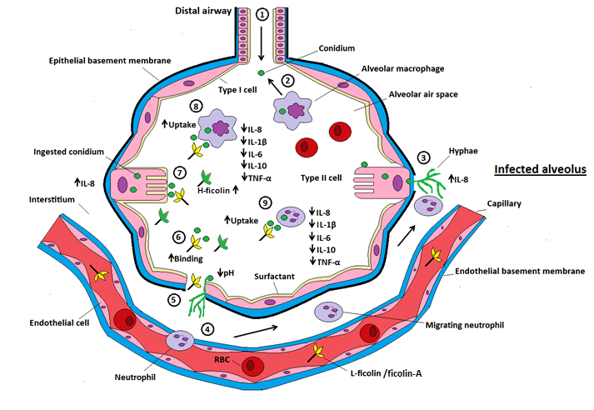

Figure 6.1. Mechanistic overview for the role of human serum ficolins in Aspergillus fumigatus defence.
1) Conidia are inhaled and reach the alveolar space. 2) Inhaled conidia are recognised and removed by resident macrophages. 3) Type II alveolar cells can internalise conidia but conidia can germinate and penetrate the vasculature, inducing IL-8 secretion and recruiting neutrophils. 4) Neutrophils can enter the alveolus from the vasculature to aid the immune response. 5) Damage to the alveolar cell membrane allows serum components such as L-ficolin and MBL to gain entry into the alveolar space. This damage induces a change in the local pH due to tissue necrosis. Infection also induces secretion of H-ficolin by type II epithelial and bronchial cells. 6) Decreased pH at the site of infection enhances the recognition of conidia by L-ficolin and H-ficolin. 7) Recognition by ficolins enhances association by A549, MDM and neutrophils in addition to potentiating the killing mechanisms of MDM and neutrophils. 8) Interaction of ficolin-opsonised conidia with A549 cells induces an increase in IL-8 but interactions with MDM and neutrophils leads to reduced production of inflammatory cytokines.

Additionally, we will endeavour to delineate the signalling mechanisms involved in both the upregulation of IL-8 production from lung epithelial cells and the down-regulation of cytokines from MDM and neutrophils. We should also investigate whether the increased fungal killing is due to the induction of ROS. It is also very important that further studies be undertaken to distinguish cell surface receptors for both H-ficolin and L-ficolin, as acknowledgement of these receptors could provide novel drug targets for the upregulation or downregulation of inflammation during fungal infection.
Finally, an interesting caveat to investigate would be whether or not ficolin-opsonised A. fumigatus could modulate the responses of other cell types (T-cells, dendritic cells, natural killer cells) or interact with antibodies to drive adaptive immune responses.
To conclude, this thesis highlighted that serum ficolins may play an important role in antifungal cell-mediated immunity where they were found in the lung during infection and they enhanced the functions of the lung epithelium, macrophages and neutrophils. In addition, we illuminated novel immunomodulatory functions of ficolins and raised key questions which we hope to answer in future studies revolving around delineation of receptor-mediated signalling pathways and in vivo studies.

Appendices

Formulation of buffers and agars

- Sabouraud Dextrose Agar

Glucose  Peptone  Agar  dH₂O | 20 g  10 g  15 g  1000 mL
B) FITC Labelling Buffer
NaHCO₃  Na₂CO₃  NaCl | 500 mM (8 parts)  500 mM (1 part)  0.9% w/v (27 parts)

C) Kimura Stain
Toluidine Blue  Light Green  Saponin  Phosphate Buffer | 0.03% w/v  Saturated in 50% EtOH  1/15 M
pH 6.4

D) High-Salt Loading Buffer
Tris-HCl  CaCl₂  NaCl  pH 7.5 | 50 mM  25 mM  1.25 M

E) Low-Salt Loading Buffer
Tris-HCl  CaCl₂  NaCl  pH 7.5 | 50 mM  25 mM  150 mM

F) Ficolin Elution Buffer
Tris-HCl  NaCl  GlcNAc  pH 7.5 | 50 mM  150 mM  300 mM

G) 6x Sample Loading Buffer
Tris-HCl  NaCl  GlcNAc  pH 7.5 | 50 mM  150 mM  300 mM

H) Dialysis Buffer
Tris-HCl  NaCl  pH 7.5 | 50 mM  150 mM

I) Ficolin Binding Buffer
CaCl₂  NaCl  HEPES  BSA  Triton X-100  pH 5.7 | 5 mM  155 mM  25 mM  0.5% w/v  0.1% v/v

J) Ficolin Binding Buffer without Triton X-100
CaCl₂  NaCl  HEPES  BSA  pH 5.7 | 5 mM  155 mM  25 mM  0.5% w/v
K) Coating Buffer
Na₂CO₃  NaHCO₃  pH 9.6 | 15 mM  35 mM

L) Tris-Buffered Saline
Tris  NaCl | 10 mM
M) Wash Buffer
TBS  Tween-20  CaCl₂ | 0.05%  5 mM
N) Barbital-Buffered Saline
Barbital  NaCl  MgCl₂  CaCl₂  pH 7.4 | 4 mM  145 mM  1 mM  2 mM

O) MBL-Binding Buffer
Tris-HCl  CaCl₂  NaCl  pH 7.4 | 20 mM  10 mM  1 M

Gating strategies for flow cytometry
P) Gating strategy used for experiments regarding association of conidia with A549 type II pneumocytes. The A549 population was determined by side-scatter and forward-scatter parameters. A549 cells are highlighted.
Q) Gating strategy used for experiments regarding viability of conidia following incubation with A549 type II pneumocytes. The A549 and fungal populations were determined by side-scatter and forward-scatter parameters. A549 cells and A. fumigatus are highlighted.

R) Gating strategy used for experiments regarding association of conidia with monocyte-derived macrophages. The MDM population was determined by side-scatter and forward-scatter parameters. MDM are highlighted.

S) Gating strategy used for experiments regarding viability of conidia following incubation with monocyte-derived macrophages. The MDM and fungal populations were determined by side-scatter and forward-scatter parameters. MDM and A. fumigatus are highlighted.
T) Gating strategy used for experiments regarding association of conidia with human neutrophils. The neutrophil population was determined by side-scatter and forward-scatter parameters. Neutrophils are highlighted.

U) Gating strategy used for experiments regarding viability of conidia following incubation with human neutrophils. The neutrophil and fungal populations were determined by side-scatter and forward-scatter parameters. Neutrophils and A. fumigatus are highlighted.

List of abbreviations

AM | Alveolar Macrophage
ANOVA | Analysis of Variance
ApoE3 | Apolipoprotein E3
AUC | Area Under Curve
BAL | Bronchoalveolar Lavage
BBS | Barbital Buffered Saline
BSA | Bovine Serum Albumin
CBA | Cytometric Bead Array
CHO | Chinese Hamster Ovary
CL-11 | Collectin 11
CL-43/46 | Conglutinin and Collectin 43/46
CL-K1 | Collectin Kidney 1
CL-L1 | Collectin Liver 1
CL-P1 | Collectin Placenta 1
CLR | C-type Lectin Receptor
CRD | Carbohydrate Recogntion Domain
CRP | C Reactive Protein
CSF | CHO serum-free
CysNAc | N-acetylcysteine
DC | Dendritic Cell
DC-SIGN | Dendritic Cell-specific Intercellular Adhesion Molecule-3 Grabbing Non-integrin
DHFR | Dihydrofolate Reductase
dTHP-1 | PMA Differentiated THP-1 Cells
EDTA | Ethylenediaminetetraacetic Acid
EGTA | Ethylene Glycol Tetraacetic Acid
ELISA | Enzyme-linked Immunosorbent Assay
EORTC | European Organisation for Research and Treatment of Cancer
FBB | Ficolin Binding Buffer
FBG | Fibrinogen-like
FBBwT | Ficolin Binding Buffer Without Triton X-100
FCN | Ficolin
FCS | Foetal Calf Serum
FITC | Fluorescein Isothiocyanate
FL | Fluorescence
FSC-A | Forward Scatter
Gal | Galactose
GalNAc | N-acetylgalactosamine
GalXM | Galactoxylomannan
GBS | Group B Streptococci
G-CSF | Granulocyte-colony Stimulating Factor
Glc | Glucose
GlcNAc | N-acetylglucosamine
GlyNAc | N-acetylglycine
GM | Galactomannan
GM-CSF | Granulocyte-macrophage Colony-stimulating Factor
GXM | Glucuronoxylomannan
HA | Hemagglutinin
HCV | Hepatitis C Virus
HEPES | 4-(2-Hydroxyethyl)-1-Piperazineethanesulfonic Acid
HRCT | High Resolution Computed Tomography
HRP | Horseradish Peroxidase
IA | Invasive Aspergillosis
IAV | Influenza A Virus
IFN | Interferon
Ig | Immunoglobulin
IL | Interleukin
LacNAc | N-acetyllactosamine
LPS | Lipopolysaccharide
LTA | Lipotechoic Acid
MAC | Membrane Attack Complex
ManNAc | N-acetylmannosamine
MAp | MBL/Ficolin Associated Protein
MAPK | Mitogen-Activated Protein Kinase
MASP | Mannose-binding Lectin Associated Serine Protease
MBL | Mannose Binding Lectin
MCP | Monocyte Chemotactic Protein
MDM | Monocyte-derived Macrophage
MEM | Minimal Essential Medium
MIP | Macrophage Inflammatory Protein
MSG | Mycoses Study Group
MTX | Methotrexate
NADPH | Nicotinamide Adenine Dinucleotide Phosphate
N-BSA | N-Acetylated Bovine Serum Albumin
NET | Neutrophil Extracellular Trap
NeuNAc | N-acetylneuraminic Acid
NK | Natural Killer
NLR | NOD-like Receptor
NOD | Nucleotide-binding Oligomerization Domain
PAMP | Pathogen Associated Molecular Pattern
PBMC | Peripheral Blood Mononuclear Cells
PBS | Phosphate Buffered Saline
PMA | Phorbol 12-Myristate 13-Acetate
pNPP | p-Nitrophenyl Phosphate
PRP | Platelet-rich Plasma
PRR | Pattern Recognition Receptor
PTX3 | Pentraxin-3
RANTES | Regulated On Activation, Normal T-cell Expressed and Secreted
ROC | Receiver Operating Characteristics
ROS | Reactive Oxygen Species
RPMI | Roswell Park Memorial Institute
RT | Room Temperature
SD | Standard Deviation
SDA | Sabouraud Dextrose Agar
SDS | Sodium Dodecyl Sulfate
SDS-PAGE | Sodium Dodecyl Sulfate – Polyacrylamide Gel Electrophoresis
sMAP | Small MBL-associated Protein
SP | Surfactant Protein
SSC-A | Side Scatter
TBS | Tris-Buffered Saline
TGF | Transforming Growth Factor
TLR | Toll-Like Receptor
TMB | 3,3’, 5, 5’-Tetramethylbenzidine
TNF | Tumour Necrosis Factor
Tris | Tris-(Hydroxymethyl)-aminomethane
WT | Wildtype

Publications

Serum opsonin ficolin-A enhances host-fungal interactions and modulates cytokine expression from human monocyte-derived macrophages and neutrophils following Aspergillus fumigatus challenge.
Bidula S, Sexton DW, Schelenz S.
Medical Microbiology and Immunology. 2015. Doi 10.1007/s00430-015-0435-9

H-ficolin binds Aspergillus fumigatus leading to activation of the lectin complement pathway and modulation of lung epithelial immune responses.
Bidula S, Sexton DW, Yates M, Abdolrasouli A, Shah A, Wallis R, Reed A, Armstrong-James D, Schelenz S.
Immunology. 2015. doi 10.1111/imm.12501

The serum opsonin L-ficolin is detected in lungs of human transplant recipients following fungal infection and modulates inflammation and killing of Aspergillus fumigatus.
Bidula S, Sexton DW, Abdolrasouli A, Shah A, Reed A, Armstrong-James D, Schelenz S.
Journal of Infectious Diseases. 2015. 212(2):234-46. doi: 10.1093/infdis/jiv027

Role of ficolin-A and lectin complement pathway in the innate defence against pathogenic Aspergillus species.
Bidula S, Kenawy H, Ali YM, Sexton D, Schwaeble WJ, Schelenz S.
Infection and Immunity. 2013. 81(5):1730-40 doi: 10.1128/IAI.00032-13

Opsonizing properties of rat ficolin-A in the defence against Cryptococcus neoformans.
Schelenz S, Kirchof N, Bidula S, Wallis R, Sexton DW.
Immunobiology. 2013. 218(4):477-83 doi:10.1016/j.imbio.2012.06.006.

References

Aderem, A. (2001). Role of Toll-like receptors in inflammatory response in macrophages. Crit Care Med 29, S16-18.
Aimanianda, V., Bayry, J., Bozza, S., Kniemeyer, O., Perruccio, K., Elluru, S.R., et al. (2009). Surface hydrophobin prevents immune recognition of airborne fungal spores. Nature 460, 1117-1121.
Akaiwa, M., Yae, Y., Sugimoto, R., Suzuki, S.O., Iwaki, T., Izuhara, K. and Hamasaki, N. (1999). Hakata antigen, a new member of the ficolin/opsonin p35 family, is a novel human lectin secreted into bronchus/alveolus and bile. J Histochem Cytochem 47, 777-786.
Akira, S. and Takeda, K. (2004). Toll-like receptor signalling. Nature reviews. Immunology 4, 499-511.
Ali, Y.M., Lynch, N.J., Haleem, K.S., Fujita, T., Endo, Y., Hansen, S., et al. (2012). The lectin pathway of complement activation is a critical component of the innate immune response to pneumococcal infection. PLoS. Pathog. 8, e1002793.
Allen, M.J., Harbeck, R., Smith, B., Voelker, D.R. and Mason, R.J. (1999). Binding of rat and human surfactant proteins A and D to Aspergillus fumigatus conidia. Infect Immun 67, 4563-4569.
Amitani, R., Taylor, G., Elezis, E.N., Llewellyn-Jones, C., Mitchell, J., Kuze, F., et al. (1995). Purification and characterization of factors produced by Aspergillus fumigatus which affect human ciliated respiratory epithelium. Infect Immun 63, 3266-3271.
Antonini, J.M., Taylor, M.D., Millecchia, L., Bebout, A.R. and Roberts, J.R. (2004). Suppression in lung defense responses after bacterial infection in rats pretreated with different welding fumes. Toxicol Appl Pharmacol 200, 206-218.
Aoyagi, Y., Adderson, E., Min, J., Matsushita, M., Fujita, T., Takahashi, S., et al. (2005). Role of L-ficolin/ mannose-binding lectin-associated serine protease complexes in the opsonophagocytosis of type III group B streptococci. J. Immunol. 174, 418-425.
Aoyagi, Y., Adderson, E., Rubens, C., Bohnsack, J., Min, J., Matsushita, M., et al. (2008). L-ficolin/mannose-binding lectin-associated serine protease complexes bind to group B streptococci primarily through N-acetylneuraminic acid of capsular polysaccharide and activate the complement pathway. Infect. Immun. 76, 179-188.
Aratani, Y., Kura, F., Watanabe, H., Akagawa, H., Takano, Y., Suzuki, K., et al. (2002). Relative contributions of myeloperoxidase and NADPH-oxidase to the early host defense against pulmonary infections with Candida albicans and Aspergillus fumigatus. Med Mycol 40, 557-563.
Arthur, J.S. and Ley, S.C. (2013). Mitogen-activated protein kinases in innate immunity. Nature reviews. Immunology 13, 679-692.
Asadullah, K., Sterry, W. and Volk, H.D. (2003). Interleukin-10 therapy--review of a new approach. Pharmacol Rev 55, 241-269.
Asbeck, E.C., Hoepelman, A.I.M., Scharringa, J., Herpers, B.L. and Verhoef, J. (2008). Mannose binding lectin plays a crucial role in innate immunity against yeast by enhanced complement activation and enhanced uptake of polymorphonuclear cells. BMC. Microbiol. 8, 229.
Azuma, I., Kimura, H., Hirao, F., Tsubura, E. and Yamamura, Y. (1969). Biochemical and immunological studies on aspergillus. II. Immunological properties of protein and polysaccharide fractions obtained from Aspergillus fumigatus. Mycopathol Mycol Appl 37, 289-303.
B57 (2014) Investigation of Bronchoalveolar Lavage, Sputum and Associated Specimens. UK Standards for Microbiology Investigations. http://www.hpa.org.uk/SMI/pdf.Date accessed 24/05/16
Baddley, J.W., Stephens, J.M., Ji, X., Gao, X., Schlamm, H.T. and Tarallo, M. (2013). Aspergillosis in Intensive Care Unit (ICU) patients: epidemiology and economic outcomes. BMC Infect Dis 13, 29.
Balloy, V., Huerre, M., Latge, J.P. and Chignard, M. (2005a). Differences in patterns of infection and inflammation for corticosteroid treatment and chemotherapy in experimental invasive pulmonary aspergillosis. Infect Immun 73, 494-503.
Balloy, V., Sallenave, J., Wu, Y., Touqui, L., Latgé, J., Si-Tahar, M. and Chignard, M. (2008). Aspergillus fumigatus -induced Interleukin-8 synthesis by respiratory epithelial cells is controlled by the phosphatidylinositol 3-kinase, p38 MAPK, and ERK 1/2 pathways and not by the toll-like receptor-MyD88 pathway. J.Biol. Chem. 283, 30513-30521.
Balloy, V., Si-Tahar, M., Takeuchi, O., Philippe, B., Nahori, M.A., Tanguy, M., et al. (2005b). Involvement of toll-like receptor 2 in experimental invasive pulmonary aspergillosis. Infect Immun 73, 5420-5425.
Baranger, K., Zani, M.L., Chandenier, J., Dallet-Choisy, S. and Moreau, T. (2008). The antibacterial and antifungal properties of trappin-2 (pre-elafin) do not depend on its protease inhibitory function. FEBS J 275, 2008-2020.
Behnsen, J., Hartmann, A., Schmaler, J., Gehrke, A., Brakhage, A.A. and Zipfel, P.F. (2008). The opportunistic human pathogenic fungus Aspergillus fumigatus evades the host complement system. Infect. Immun. 76, 820-827.
Bellocchio, S., Montagnoli, C., Bozza, S., Gaziano, R., Rossi, G., Mambula, S.S., et al. (2004). The contribution of the Toll-like/IL-1 receptor superfamily to innate and adaptive immunity to fungal pathogens in vivo. J Immunol 172, 3059-3069.
Bernard, M. and Latgé, J.P. (2001). Aspergillus fumigatus cell wall: composition and biosynthesis. Med. Mycol. 39, 9-17.
Bianchi, M., Hakkim, A., Brinkmann, V., Siler, U., Seger, R.A., Zychlinsky, A. and Reichenbach, J. (2009). Restoration of NET formation by gene therapy in CGD controls aspergillosis. Blood 114, 2619-2622.
Bidula, S., Kenawy, H., Ali, Y., Sexton, D., Schwaeble, W. and Schelenz, S. (2013a). Role of ficolin-A and lectin complement pathway in the innate defense against pathogenic Aspergillus species. Infect. Immun. 81, 1730-1740.
Bidula, S., Sexton, D. and Schelenz, S. (2013b). Serum ficolins enhance phagocytosis and killing of Aspergillus fumigatus leading to modulation of the pro-inflammatory cytokine response. Immunology 140, 121.
Bidula, S., Sexton, D.W., Abdolrasouli, A., Shah, A., Reed, A., Armstrong-James, D. and Schelenz, S. (2015a). Serum opsonin, L-ficolin, is detected in human lungs of transplant patients following fungal infections and modulates inflammation and killing of A. fumigatus. J. Infect. Dis. 212(2):234-46.
Bidula, S., Sexton, D.W., Yates, M., Abdolrasouli, A., Shah, A., Wallis, R., et al. (2015b). H-ficolin binds Aspergillus fumigatus leading to activation of the lectin complement pathway and modulation of lung epithelial immune responses. Immunology. 146(2):281-91.
Bochud, P.Y., Chien, J.W., Marr, K.A., Leisenring, W.M., Upton, A., Janer, M., et al. (2008). Toll-like receptor 4 polymorphisms and aspergillosis in stem-cell transplantation. N Engl J Med 359, 1766-1777.
Borger, P., Koeter, G.H., Timmerman, J.A., Vellenga, E., Tomee, J.F. and Kauffman, H.F. (1999). Proteases from Aspergillus fumigatus induce interleukin (IL)-6 and IL-8 production in airway epithelial cell lines by transcriptional mechanisms. The Journal of infectious diseases 180, 1267-1274.
Borron, P., McIntosh, J.C., Korfhagen, T.R., Whitsett, J.A., Taylor, J. and Wright, J.R. (2000). Surfactant-associated protein A inhibits LPS-induced cytokine and nitric oxide production in vivo. Am J Physiol Lung Cell Mol Physiol 278, L840-847.
Bouchara, J.P., Tronchin, G. and Chabasse, D. (1994). [Mechanisms and implications of the adhesion phenomenon in Aspergillus fumigatus]. Pathol Biol (Paris) 42, 640-646.
Bradford, M.M. (1976). A rapid and sensitive method for the quantitation of microgram quantities of protein utilizing the principle of protein-dye binding. Anal Biochem 72, 248-254.
Brady, A.M., Calix, J.J., Yu, J., Geno, K.A., Cutter, G.R. and Nahm, M.H. (2014). Low Invasiveness of Pneumococcal Serotype 11A Is Linked to Ficolin-2 Recognition of O-acetylated Capsule Epitopes and Lectin Complement Pathway Activation. J. Infect. Dis. 210(7):1155-65.
Braedel, S., Radsak, M., Einsele, H., Latge, J.P., Michan, A., Loeffler, J., et al. (2004). Aspergillus fumigatus antigens activate innate immune cells via toll-like receptors 2 and 4. Br J Haematol 125, 392-399.
Branzk, N., Lubojemska, A., Hardison, S.E., Wang, Q., Gutierrez, M.G., Brown, G.D. and Papayannopoulos, V. (2014). Neutrophils sense microbe size and selectively release neutrophil extracellular traps in response to large pathogens. Nat Immunol. 15(11):1017-25.
Brinkmann, V., Reichard, U., Goosmann, C., Fauler, B., Uhlemann, Y., Weiss, D.S., et al. (2004). Neutrophil extracellular traps kill bacteria. Science 303, 1532-1535.
Bronkhorst, M.W., Lomax, M.A., Vossen, R.H., Bakker, J., Patka, P. and van Lieshout, E.M. (2013). Risk of infection and sepsis in severely injured patients related to single nucleotide polymorphisms in the lectin pathway. Br J Surg 100, 1818-1826.
Brown, G.D. (2011). Innate antifungal immunity: the key role of phagocytes. Annu Rev Immunol 29, 1-21.
Brown, G.D., Denning, D.W. and Levitz, S.M. (2012). Tackling human fungal infections. Science 336, 647.
Brown, G.D., Taylor, P.R., Reid, D.M., Willment, J.A., Williams, D.L., Martinez-Pomares, L., et al. (2002). Dectin-1 is a major beta-glucan receptor on macrophages. J Exp Med 196, 407-412.
Bruns, S., Kniemeyer, O., Hasenberg, M., Aimanianda, V., Nietzsche, S., Thywissen, A., et al. (2010). Production of extracellular traps against Aspergillus fumigatus in vitro and in infected lung tissue is dependent on invading neutrophils and influenced by hydrophobin RodA. PLoS pathogens 6, e1000873.
Cadman, E.T., Thysse, K.A., Bearder, S., Cheung, A.Y., Johnston, A.C., Lee, J.J. and Lawrence, R.A. (2014). Eosinophils are important for protection, immunoregulation and pathology during infection with nematode microfilariae. PLoS pathogens 10, e1003988.
Caffrey, A.K., Lehmann, M.M., Zickovich, J.M., Espinosa, V., Shepardson, K.M., Watschke, C.P., et al. (2015). IL-1alpha signaling is critical for leukocyte recruitment after pulmonary Aspergillus fumigatus challenge. PLoS pathogens 11, e1004625.
Camargo, J.F., Bhimji, A., Kumar, D., Kaul, R., Pavan, R., Schuh, A., et al. (2015). Impaired T cell responsiveness to interleukin-6 in hematological patients with invasive aspergillosis. PloS one 10, e0123171.
Carroll, M., Lack, N., Sim, E., Krarup, A. and RB, S. (2009). Multiple routes of complement activation by Mycobacterium bovis BCG. Mol. Immunol. 46, 3367-3378.
Carvalho, G.L., Wakabayashi, G., Shimazu, M., Karahashi, T., Yoshida, M., Yamamoto, S., et al. (1997). Anti-interleukin-8 monoclonal antibody reduces free radical production and improves hemodynamics and survival rate in endotoxic shock in rabbits. Surgery 122, 60-68.
Cedzynski, M., Atkinson, A., Swierzko, A., MacDonald, S., Szala, A., Zeman, K., et al. (2009). L-ficolin (ficolin-2) insufficiency is associated with combined allergic and infectious respiratory diseases in children. Mol. Immunol. 47, 415-419.
Cedzynski, M., Nuytinck, l., Atkinson, A., Swierzko, A., Zeman, K., Szemraj, J., et al. (2007). Extremes of L-ficolin concentration in children with recurrent infections are associated with single nucleotide polymorphisms in the FCN2 gene. Clin. Exp. Immunol. 150, 99-104.
Cenci, E., Mencacci, A., Casagrande, A., Mosci, P., Bistoni, F. and Romani, L. (2001). Impaired antifungal effector activity but not inflammatory cell recruitment in interleukin-6-deficient mice with invasive pulmonary aspergillosis. The Journal of infectious diseases 184, 610-617.
Cenci, E., Mencacci, A., Fe d'Ostiani, C., Del Sero, G., Mosci, P., Montagnoli, C., et al. (1998). Cytokine- and T helper-dependent lung mucosal immunity in mice with invasive pulmonary aspergillosis. The Journal of infectious diseases 178, 1750-1760.
Cestari, I., Krarup, A., Sim, R., Inal, J. and Ramirez, M. (2009). Role of early lectin pathway activation in the complement-mediated killing of Trypanosoma cruzi. Mol. Immunol. 47, 426-437.
Cestari, I. and Ramirez, M. (2010). Inefficient complement system clearance of Trypanosoma cruzi metacyclic trypomastigotes enables resistant strains to invade eukaryotic cells. PloS one 5, e9721.
Chang, W., Hartshorn, K., White, M., Moyo, P., Michelow, I., Koziel, H., et al. (2011). Recombinant chimeric lectins consisting of mannose-binding lectin and L-ficolin are potent inhibitors of influenza A virus compared with mannose-binding lectin. Biochem. Pharmacol. 81, 388-395.
Chehimi, J. and Trinchieri, G. (1994). Interleukin-12: a bridge between innate resistance and adaptive immunity with a role in infection and acquired immunodeficiency. J Clin Immunol 14, 149-161.
Chen, F., Liu, Q., Xue, Y., Huang, Y., Huang, F., Lin, Y., et al. (2013). Ficolin-A Enhances Inhibition of the C-Terminal 19 kDa Region of Merozoite Surface Protein-1 of Plasmodium berghei Using Test In Vivo. Iran J Parasitol 8, 33-39.
Chen, G.H., Curtis, J.L., Mody, C.H., Christensen, P.J., Armstrong, L.R. and Toews, G.B. (1994). Effect of granulocyte-macrophage colony-stimulating factor on rat alveolar macrophage anticryptococcal activity in vitro. J Immunol 152, 724-734.
Chen, L., Shen, Z. and Wu, J. (2009). Expression, purification and in vitro antifungal activity of acidic mammalian chitinase against Candida albicans, Aspergillus fumigatus and Trichophyton rubrum strains. Clin Exp Dermatol 34, 55-60.
Clemons, K.V., Grunig, G., Sobel, R.A., Mirels, L.F., Rennick, D.M. and Stevens, D.A. (2000). Role of IL-10 in invasive aspergillosis: increased resistance of IL-10 gene knockout mice to lethal systemic aspergillosis. Clin Exp Immunol 122, 186-191.
Cunha, C., Di Ianni, M., Bozza, S., Giovannini, G., Zagarella, S., Zelante, T., et al. (2010). Dectin-1 Y238X polymorphism associates with susceptibility to invasive aspergillosis in hematopoietic transplantation through impairment of both recipient- and donor-dependent mechanisms of antifungal immunity. Blood 116, 5394-5402.
D'Haese, J., Theunissen, K., Vermeulen, E., Schoemans, H., De Vlieger, G., Lammertijn, L., et al. (2012). Detection of galactomannan in bronchoalveolar lavage fluid samples of patients at risk for invasive pulmonary aspergillosis: analytical and clinical validity. J Clin Microbiol 50, 1258-1263.
Dambuza, I.M. and Brown, G.D. (2015). C-type lectins in immunity: recent developments. Current opinion in immunology 32, 21-27.
Das, A., Ellis, G., Pallant, C., Lopes, A.R., Khanna, P., Peppa, D., et al. (2012). IL-10-producing regulatory B cells in the pathogenesis of chronic hepatitis B virus infection. J Immunol 189, 3925-3935.
de Luca, A., Smeekens, S.P., Casagrande, A., Iannitti, R., Conway, K.L., Gresnigt, M.S., et al. (2014). IL-1 receptor blockade restores autophagy and reduces inflammation in chronic granulomatous disease in mice and in humans. Proceedings of the National Academy of Sciences of the United States of America 111, 3526-3531.
De Pauw, B., Walsh, T.J., Donnelly, J.P., Stevens, D.A., Edwards, J.E., Calandra, T., et al. (2008). Revised definitions of invasive fungal disease from the European Organization for Research and Treatment of Cancer/Invasive Fungal Infections Cooperative Group and the National Institute of Allergy and Infectious Diseases Mycoses Study Group (EORTC/MSG) Consensus Group. Clin Infect Dis 46, 1813-1821.
DeHart, D.J., Agwu, D.E., Julian, N.C. and Washburn, R.G. (1997). Binding and germination of Aspergillus fumigatus conidia on cultured A549 pneumocytes. J. Infect. Dis. 175, 146-150.
Denning, D.W. (1998). Invasive aspergillosis. Clin. Infect. Dis. 26, 781-803.
Denning, D.W., Park, S., Lass-Florl, C., Fraczek, M.G., Kirwan, M., Gore, R., et al. (2011). High-frequency triazole resistance found In nonculturable Aspergillus fumigatus from lungs of patients with chronic fungal disease. Clin Infect Dis 52, 1123-1129.
Denning, D.W., Pleuvry, A. and Cole, D.C. (2013). Global burden of allergic bronchopulmonary aspergillosis with asthma and its complication chronic pulmonary aspergillosis in adults. Med Mycol 51, 361-370.
Douda, D.N., Jackson, R., Grasemann, H. and Palaniyar, N. (2011). Innate immune collectin surfactant protein D simultaneously binds both neutrophil extracellular traps and carbohydrate ligands and promotes bacterial trapping. J Immunol 187, 1856-1865.
Dumestre-Pérard, C., Lamy, B., Aldebert, D., Lemaire-Vielle, C., Grillot, R., Brion, J.P., et al. (2008). Aspergillus conidia activate the complement by the mannan-binding lectin C2 bypass mechanism. J. Immunol. 181, 7100-7105.
Eckmann, L., Kagnoff, M.F. and Fierer, J. (1993). Epithelial cells secrete the chemokine interleukin-8 in response to bacterial entry. Infect Immun 61, 4569-4574.
Endo, Y., Iwaki, D., Ishida, Y., Takahashi, M., Matsushita, M. and Fujita, T. (2012a). Mouse ficolin-B has an ability to form complexes with mannose-binding lectin associated serine proteases and activate complement through the lectin pathway. J. Biomed. Biotech. 2012:105891
Endo, Y., Liu, Y., Kanno, K., Takahashi, M., Matsushita, M. and Fujita, T. (2004). Identification of the mouse H-ficolin gene as a pseudogene and orthology between mouse ficolins A/B and human L/M ficolins. Genomics 84, 737-744.
Endo, Y., Nakazawa, K., Kanno, K., Liu, Y., Iwaki, D. and Matsushita, M. (2007). Ficolin-A functions to eliminate pathogens through the lectin complement pathway. Mol. Immunol. 44, 166.
Endo, Y., Nakazawa, N., Kanno, K., Iwaki, D., Takahashi, M. and Matsushita, M. (2010). Establishment of three lineages of ficolin-deficient mice and their phenotypes. Int. Immunol. 22 (supplement), 57.
Endo, Y., Nakazawa, N., Liu, Y., Iwaki, D., Takahashi, M., Fujita, T., et al. (2005). Carbohydrate-binding specificities of mouse ficolin A, a splicing variant of ficolin A and ficolin B and their complex formation with MASP-2 and sMAP. Immunogen. 57, 837-844.
Endo, Y., Sato, Y., Matsushita, M. and Fujita, T. (1996). Cloning and characterization of the human lectin P35 gene and its related gene. Genomics 36, 515-521.
Endo, Y., Takahashi, M., Iwaki, D., Ishida, Y., Nakazawa, N., Kodama, T., et al. (2012b). Mice deficient in ficolin, a lectin complement pathway recognition molecule, are susceptible to Streptococcus pneumoniae infection. J. Immunol. 189, 5860-5866.
Ermert, D., Zychlinsky, A. and Urban, C. (2009). Fungal and bacterial killing by neutrophils. Methods Mol Biol 470, 293-312.
Evans-Osses, I., Ansa-Addo, E., Inal, J. and Ramirez, M. (2010). Involvement of lectin pathway activation in the complement killing of Giardia intestinalis. Biochem. Biophys. Res. Comms. 395, 382-386.
Falvey, D.G. and Streifel, A.J. (2007). Ten-year air sample analysis of Aspergillus prevalence in a University hospital. J. Hosp. Infect. 67, 35-41.
Ferreira, A., Ramirez, G., Sanchez, G., Ribeiro, C., Lopez, N., Maldonado, I., et al. (2010). Trypanosoma cruzi calreticulin inhibits the complement lectin pathway activation by direct interaction with L-ficolin. 60(1):80-5.
Finn, A., Naik, S., Klein, N., Levinsky, R.J., Strobel, S. and Elliott, M. (1993). Interleukin-8 release and neutrophil degranulation after pediatric cardiopulmonary bypass. J Thorac Cardiovasc Surg 105, 234-241.
Forbes, E.K., Sander, C., Ronan, E.O., McShane, H., Hill, A.V., Beverley, P.C. and Tchilian, E.Z. (2008). Multifunctional, high-level cytokine-producing Th1 cells in the lung, but not spleen, correlate with protection against Mycobacterium tuberculosis aerosol challenge in mice. J Immunol 181, 4955-4964.
Fornstedt, N. and Porath, J. (1975). Characterization studies on a new lectin found in seeds of Vicia ervilia. FEBS Lett. 57, 187-191.
Fredriksen, P., Thiel, S., Larsen, C. and Jensenius, J. (2005). M-ficolin, an innate immune defence molecule binds patterns of acetyl groups and activates complement. Scan. J. Immunol. 62, 462-473.
Freitas do Rosario, A.P. and Langhorne, J. (2012). T cell-derived IL-10 and its impact on the regulation of host responses during malaria. Int J Parasitol 42, 549-555.
Fujieda, M., Aoyagi, Y., Matsubara, K., Takeuchi, Y., Fujimaki, W., Matsushita, M., et al. (2012). L-ficolin and capsular polysaccharide-specific IgG in cord serum contribute synergistically to opsonophagocytic killing of serotype III and V group B streptococci. Infect. Immun. 80, 2053-2060.
Fujimori, Y., Harumiya, S., Fukumoto, Y., Miura, Y., Yagasaki, K., Tachikawa, H. and Fujimoto, D. (1998). Molecular cloning and characterization of mouse ficolin-A. Biochem. Biophys. Res. Comm. 244, 796-800.
Fujita, T. (2002). Evolution of the lectin-complement pathway and its role in innate immunity. Nature reviews. Immunology 2, 346-353.
Gaboriaud, C., Teillet, F., Gregory, L.A., Thielens, N.M. and Arlaud, G.J. (2007). Assembly of C1 and the MBL- and ficolin-MASP complexes: structural insights. Immunobiology 212, 279-288.
Gantner, B.N., Simmons, R.M., Canavera, S.J., Akira, S. and Underhill, D.M. (2003). Collaborative induction of inflammatory responses by dectin-1 and Toll-like receptor 2. J Exp Med 197, 1107-1117.
Gardai, S.J., Xiao, Y.Q., Dickinson, M., Nick, J.A., Voelker, D.R., Greene, K.E. and Henson, P.M. (2003). By binding SIRPalpha or calreticulin/CD91, lung collectins act as dual function surveillance molecules to suppress or enhance inflammation. Cell 115, 13-23.
Garlanda, C., Hirsch, E., Bozza, S., Salustri, A., Acetis, M.d., Nota, R., et al. (2002). Non-redundant role of the long pentraxin PTX3 in anti-fungal innate immune response. Nature. 420, 182-186.
Garlatti, V., Belloy, N., Martin, L., Lacroix, M., Matsushita, M., Endo, Y., et al. (2007a). Structural insights into the innate immune recognition specificities of L- and H-ficolins. EMBO. J. 26, 623-633.
Garlatti, V., Martin, L., Gout, E., Reiser, J., Fujita, T., Arlaud, G., et al. (2007b). Structural basis for innate immune sensing by M-ficolin and its control by a pH-dependent conformational switch. J. Biol. Chem. 282, 35814-35820.
Garlatti, V., Martin, L., Lacroix, M., Gout, E., Arlaud, G.J., Thielens, N.M. and Gaboriaud, C. (2010). Structural insights into the recognition properties of human ficolins. J. Innate. Immun. 2, 17-23.
Garvy, B.A. and Harmsen, A.G. (1996). The importance of neutrophils in resistance to pneumococcal pneumonia in adult and neonatal mice. Inflammation 20, 499-512.
Gasque, P. (2004). Complement: a unique innate immune sensor for danger signals. Mol Immunol 41, 1089-1098.
Gauthier, T., Wang, X., Sifuentes Dos Santos, J., Fysikopoulos, A., Tadrist, S., Canlet, C., et al. (2012). Trypacidin, a spore-borne toxin from Aspergillus fumigatus, is cytotoxic to lung cells. PloS one 7, e29906.
Gersuk, G.M., Underhill, D.M., Zhu, L. and Marr, K.A. (2006). Dectin-1 and TLRs permit macrophages to distinguish between different Aspergillus fumigatus cellular states. J Immunol 176, 3717-3724.
Gessner, M.A., Werner, J.L., Lilly, L.M., Nelson, M.P., Metz, A.E., Dunaway, C.W., et al. (2012). Dectin-1-dependent interleukin-22 contributes to early innate lung defense against Aspergillus fumigatus. Infect Immun 80, 410-417.
Geunes-Boyer, S., Heitman, J., Wright, J.R. and Steinbach, W.J. (2010). Surfactant protein D binding to Aspergillus fumigatus hyphae is calcineurin-sensitive. Med. Mycol. 48, 580-588.
Girija, U.V., Dodds, A.W., Roscher, S., Reid, K.B.M. and Wallis, R. (2007). Localization and characterisation of the mannose-binding lectin (MBL)-associated-serine-protease-2 binding site in rat ficolin-A; equivalent binding sites within the collagenous domains of MBLs and ficolins. J. Immunol. 179, 455-462.
Girija, U.V., Mitchell, D.A., Roscher, S. and Wallis, R. (2011). Carbohydrate recognition and complement activation by rat ficolin-B. Eur. J. Immunol 41, 214-223.
Gonzales, C.M., Williams, C.B., Calderon, V.E., Huante, M.B., Moen, S.T., Popov, V.L., et al. (2012). Antibacterial role for natural killer cells in host defense to Bacillus anthracis. Infect Immun 80, 234-242.
Gordon, S.B. and Read, R.C. (2002). Macrophage defences against respiratory tract infections. Br Med Bull 61, 45-61.
Gosselin, D., DeSanctis, J., Boule, M., Skamene, E., Matouk, C. and Radzioch, D. (1995). Role of tumor necrosis factor alpha in innate resistance to mouse pulmonary infection with Pseudomonas aeruginosa. Infect Immun 63, 3272-3278.
Gout, E., Garlatti, V., Smith, D., Lacroix, M., Dumestre-Perard, C., Lunardi, T., et al. (2010). Carbohydrate recognition properties of human ficolin: glycan array screening reveals the sialic acid binding specificity of M-ficolin. J. Biol. Chem. 285, 6612-6622.
Grazziutti, M.L., Rex, J.H., Cowart, R.E., Anaissie, E.J., Ford, A. and Savary, C.A. (1997). Aspergillus fumigatus conidia induce a Th1-type cytokine response. The Journal of infectious diseases 176, 1579-1583.
Greenberger, M.J., Kunkel, S.L., Strieter, R.M., Lukacs, N.W., Bramson, J., Gauldie, J., et al. (1996). IL-12 gene therapy protects mice in lethal Klebsiella pneumonia. J Immunol 157, 3006-3012.
Greenberger, M.J., Strieter, R.M., Kunkel, S.L., Danforth, J.M., Goodman, R.E. and Standiford, T.J. (1995). Neutralization of IL-10 increases survival in a murine model of Klebsiella pneumonia. J Immunol 155, 722-729.
Gresnigt, M.S. and van de Veerdonk, F.L. (2014). The role of interleukin-1 family members in the host defence against Aspergillus fumigatus. Mycopathologia 178, 395-401.
Guest, G.M. and Momany, M. (2000). Analysis of cell wall sugars in the pathogen Aspergillus fumigatus and the saprophyte Aspergillus nidulans. Mycologia. 92, 1047-1050.
Gupta, G. and Surolia, A. (2007). Collectins: sentinels of innate immunity. Bioessays 29, 452-464.
Halim, T.Y., Krauss, R.H., Sun, A.C. and Takei, F. (2012). Lung natural helper cells are a critical source of Th2 cell-type cytokines in protease allergen-induced airway inflammation. Immunity 36, 451-463.
Hamed, M.R., Brown, R.J., Zothner, C., Urbanowicz, R.A., Mason, C.P., Krarup, A., et al. (2014). Recombinant Human L-Ficolin Directly Neutralizes Hepatitis C Virus Entry. J Innate Immun. 6(5):676-84.
Hamilton, A.J. and Holdom, M.D. (1999). Antioxidant systems in the pathogenic fungi of man and their role in virulence. Med Mycol 37, 375-389.
Hammond, M., Laptoine, G., Feucht, P., Hilt, S., Gallegos, C., Gordon, C., et al. (1995). IL-8 induces neutrophil chemotaxis predominantly via type I IL-8 receptors. . J. Immunol. 155, 1428-1433.
Hansen, S., Selman, L., Palanivar, N., Ziegler, K., Brandt, J., Kliem, A., et al. (2010). Collectin 11 (CL-11. CL-K1) is a MASP-1/3-associated plasma collectin with microbial-binding activity. J. Immunol. 185, 6096-6104.
Harada, A., Sekido, N., Akahoshi, T., Wada, T., Mukaida, N. and Matsushima, K. (1994). Essential involvement of interleukin-8 (IL-8) in acute inflammation. J Leukoc Biol 56, 559-564.
Harboe, M., Garred, P., Karlstrom, E., Lindstad, J.K., Stahl, G.L. and Mollnes, T.E. (2009). The down-stream effects of mannan-induced lectin complement pathway activation depend quantitively on alternative pathway amplification. Mol. Immunol. 47, 373-380.
Harrod, K.S., Trapnell, B.C., Otake, K., Korfhagen, T.R. and Whitsett, J.A. (1999). SP-A enhances viral clearance and inhibits inflammation after pulmonary adenoviral infection. Am J Physiol 277, L580-588.
Hearn, V.M. and Sietsma, J.H. (1994). Chemical and immunological analysis of the Aspergillus fumigatus cell wall. Microbiol. 140, 789-795.
Heinrich, S.M. and Griese, M. (2010). Assessment of surfactant protein (SP-A) dependent agglutination. BMC. Pulmon. Med. 10, 59.
Hogaboam, C.M., Takahashi, K., Ezekowitz, R.A., Kunkel, S.L. and Schuh, J.M. (2004). Mannose-binding lectin deficiency alters the development of fungal asthma: effects on airway response, inflammation, and cytokine profile. J Leukoc Biol 75, 805-814.
Holmskov, U., Thiel, S. and Jensenius, J.C. (2003). Collections and ficolins: humoral lectins of the innate immune defense. Annu Rev Immunol 21, 547-578.
Honore, C., Rorvig, S., Hummelshoj, T., Skoedt, M., Borregaard, N. and Garred, P. (2010). Tethering of ficolin-1 to cell surfaces through recognition of sialic acid by the fibrinogen-like domain. J. Leuk. Biol. 88, 145-158.
Honore, C., Rorvig, S., Munthe-Fog, L., Hummelshoj, T., Madsen, H.O., Borregaard, N. and Garred, P. (2008). The innate pattern recognition molecule Ficolin-1 is secreted by monocytes/macrophages and is circulating in human plasma. Mol Immunol 45, 2782-2789.
Huang, S., Yuan, S., Guo, L., Yu, Y., Li, J., Wu, T., et al. (2008). Genomic analysis of the immune gene repertoire of amphioxus reveals extraordinary innate complexity and diversity. Genome Res 18, 1112-1126.
Huffnagle, G.B., Strieter, R.M., McNeil, L.K., McDonald, R.A., Burdick, M.D., Kunkel, S.L. and Toews, G.B. (1997). Macrophage inflammatory protein-1alpha (MIP-1alpha) is required for the efferent phase of pulmonary cell-mediated immunity to a Cryptococcus neoformans infection. J Immunol 159, 318-327.
Huffnagle, G.B., Strieter, R.M., Standiford, T.J., McDonald, R.A., Burdick, M.D., Kunkel, S.L. and Toews, G.B. (1995). The role of monocyte chemotactic protein-1 (MCP-1) in the recruitment of monocytes and CD4+ T cells during a pulmonary Cryptococcus neoformans infection. J Immunol 155, 4790-4797.
Huffnagle, G.B., Toews, G.B., Burdick, M.D., Boyd, M.B., McAllister, K.S., McDonald, R.A., et al. (1996). Afferent phase production of TNF-alpha is required for the development of protective T cell immunity to Cryptococcus neoformans. J Immunol 157, 4529-4536.
Hummelshøj, T., Ma, Y.J., Munthe-Fog, L., Bjarnsholt, T., Moser, C., Skjødt, K., et al. (2012). The interaction pattern of murine serum ficolin-A with microorganisms. PLoS. ONE. 7(5):e38196.
Ibrahim-Granet, O., Jouvion, G., Hohl, T.M., Droin-Bergere, S., Philippart, F., Kim, O.Y., et al. (2010). In vivo bioluminescence imaging and histopathopathologic analysis reveal distinct roles for resident and recruited immune effector cells in defense against invasive aspergillosis. BMC Microbiol 10, 105.
Ibrahim-Granet, O., Philippe, B., Boleti, H., Boisvieux-Ulrich, E., Grenet, D., Stern, M. and Latge, J.P. (2003). Phagocytosis and intracellular fate of Aspergillus fumigatus conidia in alveolar macrophages. Infect Immun 71, 891-903.
Ichijo, H., Hellman, U., Wernstedt, C., Gonez, L., Claesson-Welsh, L., Heldin, C. and Miyazono, K. (1993). Molecular cloning and characterization of ficolin, a multimeric protein with fibrinogen- and collagen-like domains. J. Biol. Chem. 268, 14505-14513.
Ip, W.K. and Lau, Y.L. (2004). Role of mannose-binding lectin in the innate defense against Candida albicans: Enhancement of complement activation, but lack of opsonic function in phagocytosis by human dendritic cells. J. Infect. Dis. 190, 632-640.
Jack, D.L., Klein, N.J. and Turner, M.W. (2001). Mannose-binding lectin:targeting the microbial world for complement attack and opsonophagocytosis. Immunol. Rev. 180, 86-99.
Jenne, C.N., Wong, C.H., Zemp, F.J., McDonald, B., Rahman, M.M., Forsyth, P.A., et al. (2013). Neutrophils recruited to sites of infection protect from virus challenge by releasing neutrophil extracellular traps. Cell Host Microbe 13, 169-180.
Jeyaseelan, S., Young, S.K., Yamamoto, M., Arndt, P.G., Akira, S., Kolls, J.K. and Worthen, G.S. (2006). Toll/IL-1R domain-containing adaptor protein (TIRAP) is a critical mediator of antibacterial defense in the lung against Klebsiella pneumoniae but not Pseudomonas aeruginosa. J Immunol 177, 538-547.
Johnston, I.R. (1965). The composition of the cell wall of Aspergillus niger. Biochem. J. 96, 651-658.
Jost, S. and Altfeld, M. (2013). Control of human viral infections by natural killer cells. Annu Rev Immunol 31, 163-194.
Kairies, N., Beisel, H., Fuentes-Prior, P., Tsuda, R., Muta, T., Iwanaga, S., et al. (2001). The 2.0-A crystal structure of tachylectin 5A provides evidence for the common origin of the innate immunity and the blood coagulation systems. Proc. Natl. Acad. Sci. 98, 13519-13524.
Kakinuma, Y., Endo, Y., Takahashi, M., Nakata, M., Matsushita, M., Takenoshita, S. and Fujita, T. (2003). Molecular cloning and characterization of novel ficolins from Xenopus laevis. Immunogenetics 55, 29-37.
Kaufman, R.J., Davies, M.V., Wasley, L.C. and Michnick, D. (1991). Improved vectors for stable expression of foreign genes in mammalian cells by use of the untranslated leader sequence from EMC virus. Nucl. Acids. Res. 19, 4485-4490.
Kaur, S., Gupta, V.K., Thiel, S., Sarma, P.U. and Madan, T. (2007). Protective role of mannan-binding lectin in a murine model of invasive pulmonary aspergillosis. Clin Exp Immunol 148, 382-389.
Kawakami, K., Tohyama, M., Xie, Q. and Saito, A. (1996). IL-12 protects mice against pulmonary and disseminated infection caused by Cryptococcus neoformans. Clin Exp Immunol 104, 208-214.
Kenawy, H.I., Ali, Y.M., Rajakumar, K., Lynch, N.J., Kadioglu, A., Stover, C.M. and Schwaeble, W.J. (2012). Absence of the lectin activation pathway of complement does not increase susceptibility to Pseudomonas aeruginosa infections. Immunobiol. 217, 272-280.
Kenjo, A., Takahashi, M., Matsushita, M., Endo, Y., Nakata, M., Mizuochi, T. and Fujita, T. (2001). Cloning and characterisation of novel ficolins from the solitary ascidian, Halocynthia roretzi. J. Biol. Chem. 276, 19959-19965.
Ketavarapu, J.M., Rodriguez, A.R., Yu, J.J., Cong, Y., Murthy, A.K., Forsthuber, T.G., et al. (2008). Mast cells inhibit intramacrophage Francisella tularensis replication via contact and secreted products including IL-4. Proceedings of the National Academy of Sciences of the United States of America 105, 9313-9318.
Kjaer, T., Hansen, A., Hansen, G., Sorensen, U., Holm, A., Sorensen, G., et al. (2013). M-ficolin binds selectively to the capsular polysaccharides of Streptococcus pneumoniae serotypes 19B and 19C and of a Streptococcus mitis strain. Infect. Immun. 81, 452-459.
Kjaer, T., Hansen, A., Sorensen, U., Nielsen, O., Thiel, S. and Jensenius, J. (2011). Investigations on the pattern recognition molecule M-ficolin: quantitative aspects of bacterial binding and leukocyte association. J. Leuk. Biol. 90, 1-13.
Klein Wolterink, R.G., Kleinjan, A., van Nimwegen, M., Bergen, I., de Bruijn, M., Levani, Y. and Hendriks, R.W. (2012). Pulmonary innate lymphoid cells are major producers of IL-5 and IL-13 in murine models of allergic asthma. Eur J Immunol 42, 1106-1116.
Kolls, J.K., Lei, D., Nelson, S., Summer, W.R. and Shellito, J.E. (1997). Pulmonary cytokine gene therapy. Adenoviral-mediated murine interferon gene transfer compartmentally activates alveolar macrophages and enhances bacterial clearance. Chest 111, 104S.
Kolls, J.K., Nelson, S. and Summer, W.R. (1993). Recombinant cytokines and pulmonary host defense. Am J Med Sci 306, 330-335.
Koth, L., Rodriguez, M., Bernstein, X., Chan, S., Huang, X., Charo, I., et al. (2004). Aspergillus antigen induces robust Th2 cytokine production, inflammation, airway hyperreactivity and fibrosis in the absence of MCP-1 or CCR2. Resp. Res. 5, 12.
Kozel, T.R., Wilson, M.A., Farrell, T.P. and Levitz, S.M. (1989). Activation of C3 and binding to Aspergillus fumigatus conidia and hyphae. Infect. Immun. 57, 3412-3417.
Krarup, A., Sorensen, U.B., Matsushita, M., Jensenius, J.C. and Thiel, S. (2005). Effect of capsulation of opportunistic pathogenic bacteria on binding of the pattern recognition molecules mannan-binding lectin, L-ficolin and H-ficolin. Infect. Immun. 73, 1052-1060.
Krarup, A., Thiel, S., Hansen, A., Fujita, T. and Jensenius, J.C. (2004). L-ficolin is a pattern recognition molecule specific for acetyl groups. J. Biol. Chem. 279, 47513-47519.
Kunkel, S.L., Standiford, T., Kasahara, K. and Strieter, R.M. (1991). Interleukin-8 (IL-8): the major neutrophil chemotactic factor in the lung. Exp Lung Res 17, 17-23.
Kuraya, M., Ming, Z., Liu, X., Matsushita, M. and Fujita, T. (2005). Specific binding of L-ficolin and H-ficolin binding to apoptotic cells leads to complement activation. Immunobiology 209, 689-697.
Lacroix, M., Dumestre-Perard, C., Schoehn, G., Houen, G., Cesbron, J., Arlaud, G. and Thielens, N. (2009). Residue Lys57 in the collagen-like region of human L-ficolin and it's counterpart Lys47 in H-ficolin play a key role in the interaction with the mannan-binding lectin-associated serine proteases and the collectin receptor calreticulin. J. Immunol. 182, 456-465.
Laemmli, U.K. (1970). Cleavage of structural proteins during the assembly of the head of bacteriophage T4. Nature. 227, 680-685.
Laichalk, L.L., Kunkel, S.L., Strieter, R.M., Danforth, J.M., Bailie, M.B. and Standiford, T.J. (1996). Tumor necrosis factor mediates lung antibacterial host defense in murine Klebsiella pneumonia. Infect Immun 64, 5211-5218.
Lambourne, J., Agranoff, D., Herbrecht, R., Troke, P.F., Buchbinder, A., Willis, F., et al. (2009). Association of mannose-binding lectin deficiency with acute invasive aspergillosis in immunocompromised patients. Clin Infect Dis 49, 1486-1491.
Latge, J.P., Debeaupuis, J.P., Sarfati, J., Diaquin, M. and Paris, S. (1993). Cell wall antigens in Aspergillus fumigatus. Arch Med Res 24, 269-274.
Latgé, J.P., Mouyna, I.T., Tekaia, F., Beauvais, A., Debeapuis, J.P. and Nierman, W. (2005). Specific molecular features in the organization and biosynthesis of the cell wall of Aspergillus fumigatus Med. Mycol. 43, S15-S22.
Le, J. and Vilcek, J. (1987). Tumor necrosis factor and interleukin 1: cytokines with multiple overlapping biological activities. Lab Invest 56, 234-248.
Le, Y., Lee, S., Kon, O. and Lu, J. (1998). Human L-ficolin: plasma levels, sugar specificty, and assignment of its lectin activity to the fibrinogen-like (FBG) domain. FEBS Letts. 425, 367-370.
Leal, A.F.G., Lopes, N.E.P., Clark, A.T.R., Filho, N.T.D.P., Beltrão, E.I.C. and Neves, R.P. (2011). Carbohydrate profiling of fungal cell wall surface glycoconjugates of Aspergillus species in brain and lung tissues using lectin histochemistry. Med. Mycol. Early Online 1-4.
Leal, S.M., Jr., Roy, S., Vareechon, C., Carrion, S., Clark, H., Lopez-Berges, M.S., et al. (2013). Targeting iron acquisition blocks infection with the fungal pathogens Aspergillus fumigatus and Fusarium oxysporum. PLoS pathogens 9, e1003436.
Leventakos, K., Lewis, R.E. and Kontoyiannis, D.P. (2010). Fungal infections in leukemia patients: how do we prevent and treat them? Clin Infect Dis 50, 405-415.
Levitz, S.M. and Diamond, R.D. (1985). Mechanisms of resistance of Aspergillus fumigatus Conidia to killing by neutrophils in vitro. The Journal of infectious diseases 152, 33-42.
Levitz, S.M., Tabuni, A., Nong, S.H. and Golenbock, D.T. (1996). Effects of interleukin-10 on human peripheral blood mononuclear cell responses to Cryptococcus neoformans, Candida albicans, and lipopolysaccharide. Infect Immun 64, 945-951.
Li, S.S., Kyei, S.K., Timm-McCann, M., Ogbomo, H., Jones, G.J., Shi, M., et al. (2013). The NK receptor NKp30 mediates direct fungal recognition and killing and is diminished in NK cells from HIV-infected patients. Cell Host Microbe 14, 387-397.
Liu, J., Ali, M.A., Shi, Y., Zhao, Y., Luo, F., Yu, J., et al. (2009). Specifically binding of L-ficolin to N-glycans of HCV envelope glycoproteins E1 and E2 leads to complement activation. Cell. Mol. Immunol. 6, : 235-244.
Liu, Y., Endo, Y., Iwaki, D., Nakata, M., Matsushita, M., Wada, I., et al. (2005a). Human M-ficolin is a secretory protein that activates the lectin complement pathway. J Immunol 175, 3150-3156.
Liu, Y., Endo, Y., Iwaki, D., Nakata, M., Matsushita, M., Wada, I., et al. (2005b). Purification and binding properties of a human ficolin-like protein. J. Immunol. 175, 3150-3156.
Lopez, M.C., Duckett, N.S., Baron, S.D. and Metzger, D.W. (2004). Early activation of NK cells after lung infection with the intracellular bacterium, Francisella tularensis LVS. Cell Immunol 232, 75-85.
Lu, J., Tay, P.N., Kon, O.L. and Reid, K.B. (1996). Human ficolin: cDNA cloning, demonstration of peripheral blood leucocytes as the major site of synthesis and assignment of the gene to chromosome 9. Biochem J 313 ( Pt 2), 473-478.
Luo, F., Sun, X., Wang, Y., Wang, Q., Wu, Y., Pan, Q., et al. (2013). Ficolin-2 Defends against Virulent Mycobacteria Tuberculosis Infection In Vivo, and Its Insufficiency Is Associated with Infection in Humans. PloS one 8, e73859.
Luther, K., Torosantucci, A., Brakhage, A.A., Heesemann, J. and Ebel, F. (2007). Phagocytosis of Aspergillus fumigatus conidia by murine macrophages involves recognition by the dectin-1 beta-glucan receptor and Toll-like receptor 2. Cell Microbiol 9, 368-381.
Lynch, N.J., Khan, S.U., Stover, C.M., Sandrini, S.M., Marston, D., Presanis, J.S. and Schwaeble, W.J. (2005). Composition of the lectin pathway of complement in Gallus gallus: absence of mannan-binding lectin-associated serine protease-1 in birds. J Immunol 174, 4998-5006.
Lynch, N.J., Roscher, S., Hartung, T., Morath, S., Matsushita, M., Maennel, D.N., et al. (2004). L-ficolin specifically binds to lipoteichoic acid, a cell wall constituent of Gram-positive bacteria, and activates the lectin pathway of complement. J. Immunol. 172, 1198-1202.
Ma, Y.G., Cho, M.Y., Zhao, M., Park, J.W., Matsushita, M., Fujita, T. and Lee, B.L. (2004). Human mannose-binding lectin and L-ficolin function as specific pattern recognition proteins in the lectin activation pathway. J. Biol. Chem. 279, 25307-25312.
Ma, Y.J., Doni, A., Hummelshøj, T., Honore, C., Bastone, A., Mantovani, A., et al. (2009). Synergy between ficolin-2 and pentraxin 3 boosts innate immune recognition and complement deposition. J. Biol. Chem. 284, 28263-28275.
Ma, Y.J., Doni, A., Romani, L., Jurgensen, H.J., Behrendt, N., Mantovani, A. and Garred, P. (2013a). Ficolin-1-PTX3 complex formation promotes clearance of altered self-cells and modulates IL-8 production. J Immunol 191, 1324-1333.
Ma, Y.J., Kang, H.J., Kim, J.Y., Garred, P., Lee, M.S. and Lee, B.L. (2013b). Mouse mannose-binding lectin-A and ficolin-A inhibit lipopolysaccharide-mediated pro-inflammatory responses on mast cells. BMB Rep 46, 376-381.
Madan, T., Eggleton, P., Kishore, U., Strong, P., Aggrawal, S.S., Sarma, P.U. and Reid, K.B. (1997). Binding of pulmonary surfactant proteins A and D to Aspergillus fumigatus conidia enhances phagocytosis and killing by human neutrophils and alveolar macrophages. Infect Immun 65, 3171-3179.
Madan, T., Kaur, S., Saxena, M., Singh, U., Kishore, U., Thiel, S., et al. (2005). Role of collectins in innate immunity against aspergillosis. Med. Mycol. 43, S155-S163.
Madan, T., Kishore, U., Singh, M., Strong, P., Hussain, E.M., Reid, K.B. and Sarma, P.U. (2001). Protective role of lung surfactant protein D in a murine model of invasive pulmonary aspergillosis. Infect Immun 69, 2728-2731.
Malaviya, R., Gao, Z., Thankavel, K., van der Merwe, P.A. and Abraham, S.N. (1999). The mast cell tumor necrosis factor alpha response to FimH-expressing Escherichia coli is mediated by the glycosylphosphatidylinositol-anchored molecule CD48. Proceedings of the National Academy of Sciences of the United States of America 96, 8110-8115.
Mambula, S.S., Sau, K., Henneke, P., Golenbock, D.T. and Levitz, S.M. (2002). Toll-like receptor (TLR) signaling in response to Aspergillus fumigatus. J Biol Chem 277, 39320-39326.
Martin, B., Hirota, K., Cua, D.J., Stockinger, B. and Veldhoen, M. (2009). Interleukin-17-producing gammadelta T cells selectively expand in response to pathogen products and environmental signals. Immunity 31, 321-330.
Martin, T.R. and Frevert, C.W. (2005). Innate immunity in the lungs. Proc. Am. Thorac. Soc. 2, 403-411.
Martinez, D., Vermeulen, M., Trevani, A., Ceballos, A., Sabatte, J., Gamberale, R., et al. (2006). Extracellular acidosis induces neutrophil activation by a mechanism dependent on activation of phosphatidylinositol 3-kinase/Akt and ERK pathways. J. Immunol. 176, 1163-1171.
Mathern, D.R. and Heeger, P.S. (2015). Molecules Great and Small: The Complement System. Clinical journal of the American Society of Nephrology : CJASN 10, 1636-1650.
Matsushita, M., Endo, Y. and Fujita, T. (2000). Cutting edge: complement-activating complex of ficolin and mannose-binding lectin-associated serine protease. J. Immunol. 164, 2281-2284.
Matsushita, M., Endo, Y., Taira, S., Sato, Y., Fujita, T., Ichikawa, N., et al. (1996). A novel human serum lectin with collagen- and fibrinogen-like domains that functions as an opsonin. J. Biol. Chem. 271, 2448-2454.
Matsushita, M., Kuraya, M., Hamasaki, N., Tsujimura, M., Shirai, H. and Fujita, T. (2002a). Activation of the lectin complement pathway by H-ficolin (Hakata antigen). J. Immunol 168, 3502-3506.
Matsushita, M., Kuraya, M., Hamasaki, N., Tsujimura, M., Shiraki, H. and Fujita, T. (2002b). Activation of the lectin complement pathway by H-ficolin (Hakata antigen). J Immunol 168, 3502-3506.
Mauri, C. and Bosma, A. (2012). Immune regulatory function of B cells. Annu Rev Immunol 30, 221-241.
McKenzie, H.A. and White, F.H., Jr. (1991). Lysozyme and alpha-lactalbumin: structure, function, and interrelationships. Adv Protein Chem 41, 173-315.
Mehrad, B., Strieter, R.M. and Standiford, T.J. (1999). Role of TNF-alpha in pulmonary host defense in murine invasive aspergillosis. J Immunol 162, 1633-1640.
Mehrad, B., Wiekowski, M., Morrison, B.E., Chen, S.C., Coronel, E.C., Manfra, D.J. and Lira, S.A. (2002). Transient lung-specific expression of the chemokine KC improves outcome in invasive aspergillosis. Am J Respir Crit Care Med 166, 1263-1268.
Meier, A., Kirschning, C.J., Nikolaus, T., Wagner, H., Heesemann, J. and Ebel, F. (2003). Toll-like receptor (TLR) 2 and TLR4 are essential for Aspergillus-induced activation of murine macrophages. Cell Microbiol 5, 561-570.
Mercer, R.R., Russell, M.L., Roggli, V.L. and Crapo, J.D. (1994). Cell number and distribution in human and rat airways. Am J Respir Cell Mol Biol 10, 613-624.
Mershon-Shier, K.L., Vasuthasawat, A., Takahashi, K., Morrison, S.L. and Beenhouwer, D.O. (2011). In vitro C3 deposition on Cryptococcus capsule occurs via multiple complement activation pathways. Mol. Immunol. 48, 2009-2018.
Michelow, I., Dong, M., Mungall, B., Yantosca, L., Lear, C., Ji, X., et al. (2010). A novel L-ficolin/mannose-binding lectin and L-ficolin function as specific pattern recognition proteins in the lectin activation pathway of complement. J. Biol. Chem. 285, 24729-24739.
Middha, S. and Wang, X. (2008). Evolution and potential function of fibrinogen-like domains across twelve Drosophila species. BMC Genomics 9, 260.
Mircescu, M.M., Lipuma, L., van Rooijen, N., Pamer, E.G. and Hohl, T.M. (2009). Essential role for neutrophils but not alveolar macrophages at early time points following Aspergillus fumigatus infection. The Journal of infectious diseases 200, 647-656.
Mitchell, T.G. and Perfect, J. (1995). Cryptococcosis in the era of AIDS-100 years after discovery of Cryptococcus neoformans. Clin. Microbiol. Rev. 8(4):515-48.
Mogensen, T.H. (2009). Pathogen recognition and inflammatory signaling in innate immune defenses. Clin Microbiol Rev 22, 240-273, Table of Contents.
Moller-Kristensen, M., Thiel, S., Sjoholm, A., Matsushita, M. and Jensenius, J.C. (2007). Cooperation between MASP-1 and MASP-2 in the generation of C3 convertase through the MBL pathway. Int Immunol 19, 141-149.
Moller, C., Svendsen, A., Jakobsen, L., Sorensen, U., Jensenius, J. and Thiel, S. (2007). Binding of MBL, L-ficolin and H-ficolin to purified capsular polysaccharides from Streptococcus pneumoniae. Int Immunol 19, supp.
Momany, M., Lindsey, R., Hill, T.W., Richardson, E.A., Momany, C., Pedreira, M., et al. (2010). The Aspergillus fumigatus cell wall is organized in domains that are remodelled during polarity establishment. Microbiol. 150, 3261-3268.
Monteiro, J.M., Harvey, C. and Trinchieri, G. (1998). Role of interleukin-12 in primary influenza virus infection. J Virol 72, 4825-4831.
Moreno-Amaral, A., Gout, E., Daniella-Polli, C., Tabarin, F., Lesavre, P., Pereira-da-Silva, G., et al. (2012). M-ficolin and leukosialin (CD43): new partners in neutrophil adhesion. . J. Leuk. Biol. 91, 469-474.
Munthe-Fog, L., Hummelshøj, T., Hansen, B.E., Koch, C., Madsen, H.O., Skjødt, K. and Garred, P. (2007). The impact of FCN2 polymorphisms and haplotypes on the ficolin-2 serum levels. Scan. J. Immunol. 65, 383-392.
Munthe-Fog, L., Hummelshoj, T., Honore, C., Madsen, H.O., Permin, H. and Garred, P. (2009). Immunodeficiency associated with FCN3 mutation and ficolin-3 deficiency. N Engl J Med 360, 2637-2644.
Murayama, T., Amitani, R., Ikegami, Y., Nawada, R., Lee, W.J. and Kuze, F. (1996). Suppressive effects of Aspergillus fumigatus culture filtrates on human alveolar macrophages and polymorphonuclear leucocytes. Eur Respir J 9, 293-300.
Nelson, S. (1994). Role of granulocyte colony-stimulating factor in the immune response to acute bacterial infection in the nonneutropenic host: an overview. Clin Infect Dis 18 Suppl 2, S197-204.
Netea, M.G., Warris, A., Van der Meer, J.W., Fenton, M.J., Verver-Janssen, T.J., Jacobs, L.E., et al. (2003). Aspergillus fumigatus evades immune recognition during germination through loss of toll-like receptor-4-mediated signal transduction. The Journal of infectious diseases 188, 320-326.
Neth, O., Jack, D.L., Dodds, A.W., Holzel, H., Klein, N.J. and Turner, M.W. (2000). Mannose-binding lectin binds to a range of clinically relevant microorganisms and promotes complement deposition. Infect. Immun. 68, 688-693.
Nicod, L.P., Cochand, L. and Dreher, D. (2000). Antigen presentation in the lung: dendritic cells and macrophages. Sarcoidosis Vasc Diffuse Lung Dis 17, 246-255.
Ohashi, T. and Erickson, H.P. (1998). Oligomeric structure and tissue distribution of ficolins from mouse, pig and human. Arch Biochem Biophys 360, 223-232.
Olde Nordkamp, M.J., van Eijk, M., Urbanus, R.T., Bont, L., Haagsman, H.P. and Meyaard, L. (2014). Leukocyte-associated Ig-like receptor-1 is a novel inhibitory receptor for surfactant protein D. J Leukoc Biol 96, 105-111.
Olynych, T.J., Jakeman, D.L. and Marshall, J.S. (2006). Fungal zymosan induces leukotriene production by human mast cells through a dectin-1-dependent mechanism. J Allergy Clin Immunol 118, 837-843.
Omori-Satoh, T., Yamakawa, Y. and Mebs, D. (2000). The antihemorrhagic factor, erinacin, from the European hedgehog (Erinaceus europaeus), a metalloprotease inhibitor of large molecular size possessing ficolin/opsonin P35 lectin domains. Toxicon 38, 1561-1580.
Orciuolo, E., Stanzani, M., Canestraro, M., Galimberti, S., Carulli, G., Lewis, R., et al. (2007). Effects of Aspergillus fumigatus gliotoxin and methylprednisolone on human neutrophils: implications for the pathogenesis of invasive aspergillosis. J Leukoc Biol 82, 839-848.
Pan, Q., Chen, H., Wang, F., Jeza, V.T., Hou, W., Zhao, Y., et al. (2012). L-ficolin binds to the glycoproteins hemagglutinin and neuraminidase and inhibits influenza A virus infection both in vitro and in vivo. J. Innate. Immun. 4, 312-324.
Pana, Z.D., Samarah, F., Papi, R., Antachopoulos, C., Papageorgiou, T., Farmaki, E., et al. (2014). Mannose binding lectin and ficolin-2 polymorphisms are associated with increased risk for bacterial infections in children with B acute lymphoblastic leukemia. Pediatr Blood Cancer 61, 1017-1022.
Pangburn, M.K. (2000). Host recognition and target differentiation by factor H, a regulator of the alternative pathway of complement. Immunopharmacology 49, 149-157.
Pangburn, M.K. and Rawal, N. (2002). Structure and function of complement C5 convertase enzymes. Biochem Soc Trans 30, 1006-1010.
Paris, S., Boisvieux-Ulrich, E., Crestani, B., Houcine, O., Taramelli, D., Lombardi, L. and Latge, J.P. (1997). Internalization of Aspergillus fumigatus conidia by epithelial and endothelial cells. Infect Immun 65, 1510-1514.
Peitsch, M. and Tschopp, J. (1991). Assembly of macromolecular pores by immune defense systems. Curr. Opin. Cell. Biol. 3, 710-716.
Persat, F., Noirey, N., Diana, J., Gariazzo, M.J., Schmitt, D., Picot, S. and Vincent, C. (2003). Binding of live conidia of Aspergillus fumigatus activates in vitro-generated human Langerhans cells via a lectin of galactomannan specificity. Clin Exp Immunol 133, 370-377.
Philippe, B., Ibrahim-Granet, O., Prevost, M.C., Gougerot-Pocidalo, M.A., Sanchez Perez, M., Van der Meeren, A. and Latge, J.P. (2003). Killing of Aspergillus fumigatus by alveolar macrophages is mediated by reactive oxidant intermediates. Infect Immun 71, 3034-3042.
Pitt, J.I. (1994). The current role of Aspergillus and Penicillium in human and animal health. J. Med. Vet. Mycol. 32, 17-32.
Plantinga, T.S., van der Velden, W.J., Ferwerda, B., van Spriel, A.B., Adema, G., Feuth, T., et al. (2009). Early stop polymorphism in human DECTIN-1 is associated with increased candida colonization in hematopoietic stem cell transplant recipients. Clin Infect Dis 49, 724-732.
Plato, A., Hardison, S.E. and Brown, G.D. (2015). Pattern recognition receptors in antifungal immunity. Semin Immunopathol 37, 97-106.
Plopper, C.G., Mariassy, A.T., Wilson, D.W., Alley, J.L., Nishio, S.J. and Nettesheim, P. (1983). Comparison of nonciliated tracheal epithelial cells in six mammalian species: ultrastructure and population densities. Exp Lung Res 5, 281-294.
Polak-Wyss, A. (1991). Protective effect of human granulocyte colony-stimulating factor (hG-CSF) on Cryptococcus and Aspergillus infections in normal and immunosuppressed mice. Mycoses 34, 205-215.
Ramaprakash, H., Ito, T., Standiford, T.J., Kunkel, S.L. and Hogaboam, C.M. (2009). Toll-like receptor 9 modulates immune responses to Aspergillus fumigatus conidia in immunodeficient and allergic mice. Infect Immun 77, 108-119.
Robinson, J.M. (2009). Phagocytic leukocytes and reactive oxygen species. Histochem Cell Biol 131, 465-469.
Rodriguez de Cordoba, S., Esparza-Gordillo, J., Goicoechea de Jorge, E., Lopez-Trascasa, M. and Sanchez-Corral, P. (2004). The human complement factor H: functional roles, genetic variations and disease associations. Mol Immunol 41, 355-367.
Roilides, E., Sein, T., Roden, M., Schaufele, R.L. and Walsh, T.J. (2001). Elevated serum concentrations of interleukin-10 in nonneutropenic patients with invasive aspergillosis. The Journal of infectious diseases 183, 518-520.
Roilides, E., Uhlig, K., Venzon, D., Pizzo, P.A. and Walsh, T.J. (1993). Prevention of corticosteroid-induced suppression of human polymorphonuclear leukocyte-induced damage of Aspergillus fumigatus hyphae by granulocyte colony-stimulating factor and gamma interferon. Infect Immun 61, 4870-4877.
Romani, L. (2004). Immunity to fungal infections. Nature reviews. Immunology 4, 1-23.
Rorvig, S., Honore, C., Larsson, L.I., Ohlsson, S., Pedersen, C.C., Jacobsen, L.C., et al. (2009). Ficolin-1 is present in a highly mobilizable subset of human neutrophil granules and associates with the cell surface after stimulation with fMLP. J Leukoc Biol 86, 1439-1449.
Rosenberg, H.F. and Domachowske, J.B. (2001). Eosinophils, eosinophil ribonucleases, and their role in host defense against respiratory virus pathogens. J Leukoc Biol 70, 691-698.
Rosenberg, H.F., Dyer, K.D. and Domachowske, J.B. (2009). Eosinophils and their interactions with respiratory virus pathogens. Immunol Res 43, 128-137.
Rubino, I., Coste, A., Le Roy, D., Roger, T., Jaton, K., Boeckh, M., et al. (2012). Species-specific recognition of Aspergillus fumigatus by Toll-like receptor 1 and Toll-like receptor 6. The Journal of infectious diseases 205, 944-954.
Rubins, J.B. and Pomeroy, C. (1997). Role of gamma interferon in the pathogenesis of bacteremic pneumococcal pneumonia. Infect Immun 65, 2975-2977.
Sabat, R., Grutz, G., Warszawska, K., Kirsch, S., Witte, E., Wolk, K. and Geginat, J. (2010). Biology of interleukin-10. Cytokine Growth Factor Rev 21, 331-344.
Saijo, S., Fujikado, N., Furuta, T., Chung, S.H., Kotaki, H., Seki, K., et al. (2007). Dectin-1 is required for host defense against Pneumocystis carinii but not against Candida albicans. Nat Immunol 8, 39-46.
Sainz, J., Hassan, L., Perez, E., Romero, A., Moratalla, A., Lopez-Fernandez, E., et al. (2007). Interleukin-10 promoter polymorphism as risk factor to develop invasive pulmonary aspergillosis. Immunol Lett 109, 76-82.
Sanchez, L., Calvo, M. and Brock, J.H. (1992). Biological role of lactoferrin. Arch Dis Child 67, 657-661.
Sarma, J.V. and Ward, P.A. (2011). The complement system. Cell Tissue Res 343, 227-235.
Schaffner, A. (2002). Host-parasite relation in invasive aspergillosis. Nihon Ishinkin Gakkai Zasshi 43, 161.
Schaffner, A., Douglas, H., Braude, A.I. and Davis, C.E. (1983). Killing of Aspergillus spores depends on the anatomical source of the macrophage. Infect Immun 42, 1109-1115.
Schelenz, S., Barnes, R.A., Barton, R.C., Cleverley, J.R., Lucas, S.B., Kibbler, C.C., et al. (2015). British Society for Medical Mycology best practice recommendations for the diagnosis of serious fungal diseases. Lancet Infect Dis 15, 461-474.
Schelenz, S. and Goldsmith, D.J. (2003). Aspergillus endophthalmitis: an unusual complication of disseminated infection in renal transplant patients. J Infect 47, 336-343.
Schelenz, S., Kirchhof, N., Bidula, S., Wallis, R. and Sexton, D.W. (2012). Opsonizing properties of rat ficolin-A in the defence against Cryptococcus neoformans. Immunobiol. 218(4):477-83.
Schelenz, S., Malhotra, R., Sim, R.B., Holmskov, U. and Bancroft, G.J. (1995). Binding of host collectins to the pathogenic yeast Cryptococcus neoformans: human surfactant protein D acts as an agglutinin for acapsular yeast cells. Infect. Immun. 63, 3360-3366.
Schelenz, S., Smith, D.A. and Bancroft, G.J. (1999). Cytokine and chemokine responses following pulmonary challenge with Aspergillus fumigatus: obligatory role of TNF-alpha and GM-CSF in neutrophil recruitment. Med Mycol 37, 183-194.
Schleh, C., Rothen-Rutishauser, B.M., Blank, F., Lauenstein, H.D., Nassimi, M., Krug, N., et al. (2012). Surfactant protein D modulates allergen particle uptake and inflammatory response in a human epithelial airway model. Resp. Res. 13, 8.
Schneberger, D., Aharonson-Raz, K. and Singh, B. (2011). Monocyte and macrophage heterogeneity and Toll-like receptors in the lung. Cell Tissue Res 343, 97-106.
Schroder, K., Hertzog, P.J., Ravasi, T. and Hume, D.A. (2004). Interferon-gamma: an overview of signals, mechanisms and functions. J Leukoc Biol 75, 163-189.
Segal, B.H. (2009). Aspergillosis. N Engl J Med 360, 1870-1884.
Segal, B.H., Han, W., Bushey, J.J., Joo, M., Bhatti, Z., Feminella, J., et al. (2010). NADPH oxidase limits innate immune responses in the lungs in mice. PloS one 5, e9631.
Selander, B., Martensson, U., Weintraub, A., Holmstrom, E., Matsushita, M., Thiel, S., et al. (2006). Mannan binding lectin activates C3 and the alternative complement pathway without involvement of C2. J. Clin. Invest. 116, 1425-1434.
Serrano-Gomez, D., Dominguez-Soto, A., Ancochea, J., Jimenez-Heffernan, J.A., Leal, J.A. and Corbi, A.L. (2004). Dendritic cell-specific intercellular adhesion molecule 3-grabbing nonintegrin mediates binding and internalization of Aspergillus fumigatus conidia by dendritic cells and macrophages. J Immunol 173, 5635-5643.
Sertl, K., Takemura, T., Tschachler, E., Ferrans, V.J., Kaliner, M.A. and Shevach, E.M. (1986). Dendritic cells with antigen-presenting capability reside in airway epithelium, lung parenchyma, and visceral pleura. J Exp Med 163, 436-451.
Sim, R.B. and Tsiftsoglou, S.A. (2004). Proteases of the complement system. Biochem Soc Trans 32, 21-27.
Singh, P.K., Jia, H.P., Wiles, K., Hesselberth, J., Liu, L., Conway, B.A., et al. (1998). Production of beta-defensins by human airway epithelia. Proceedings of the National Academy of Sciences of the United States of America 95, 14961-14966.
Skjøedt, M.O., Hummelshøj, T., Palarasah, Y., Honore, C., Koch, C., Skjodt, K. and Garred, P. (2010). MBL/Ficolin associated protein-1 (MAP-1) may function as a local lectin pathway specific complement inhibitor. Mol. Immunol. 47, 2229-2230.
Skoedt, M., Hummelshoj, T., Palarasah, Y., Honore, C., Koch, C., Skjodt, K. and Garred, P. (2010). A novel mannose-binding lectin/ficolin associated protein is highly expressed in heart and skeletal muscle tissues and inhibits complement activation. J. Biol. Chem. 285, 8234-8243.
Slight, J., Nicholson, W.J., Mitchell, C.G., Pouilly, N., Beswick, P.H., Seaton, A. and Donaldson, K. (1996). Inhibition of the alveolar macrophage oxidative burst by a diffusible component from the surface of the spores of the fungus Aspergillus fumigatus. Thorax 51, 389-396.
Small, C.L., McCormick, S., Gill, N., Kugathasan, K., Santosuosso, M., Donaldson, N., et al. (2008). NK cells play a critical protective role in host defense against acute extracellular Staphylococcus aureus bacterial infection in the lung. J Immunol 180, 5558-5568.
Soilleux, E.J., Morris, L.S., Leslie, G., Chehimi, J., Luo, Q., Levroney, E., et al. (2002). Constitutive and induced expression of DC-SIGN on dendritic cell and macrophage subpopulations in situ and in vitro. J Leukoc Biol 71, 445-457.
Sorensen, R., Thiel, S. and Jensenius, J.C. (2005). Mannan-binding-lectin-associated serine proteases, characteristics and disease associations. Springer Semin Immunopathol 27, 299-319.
Sosoniuk, E., Vallejos, G., Kenawy, H., Gaboriaud, C., Thielens, N., Fujita, T., et al. (2014). Trypanosoma cruzi calreticulin inhibits the complement lectin pathway activation by direct interaction with L-Ficolin. Mol Immunol 60, 80-85.
St John, A.L., Rathore, A.P., Yap, H., Ng, M.L., Metcalfe, D.D., Vasudevan, S.G. and Abraham, S.N. (2011). Immune surveillance by mast cells during dengue infection promotes natural killer (NK) and NKT-cell recruitment and viral clearance. Proceedings of the National Academy of Sciences of the United States of America 108, 9190-9195.
Stafford, J.L., Neumann, N.F. and Belosevic, M. (2002). Macrophage-mediated innate host defense against protozoan parasites. Crit Rev Microbiol 28, 187-248.
Steele, C., Rapaka, R.R., Metz, A., Pop, S.M., Williams, D.L., Gordon, S., et al. (2005). The beta-glucan receptor dectin-1 recognizes specific morphologies of Aspergillus fumigatus. PLoS pathogens 1, e42.
Steinbach, W.J., Marr, K.A., Anaissie, E.J., Azie, N., Quan, S.P., Meier-Kriesche, H.U., et al. (2012). Clinical epidemiology of 960 patients with invasive aspergillosis from the PATH Alliance registry. J Infect 65, 453-464.
Stermann, E., Lacroix, M., Gout, E., Laffly, E., Pedersen, C., Schmidt, R., et al. (2012). Molecular and functional characterization of the interaction of L-ficolin with Streptococcus pneumoniae. Immunobiology 217(11):1188-1189.
Strieter, R.M., Belperio, J.A. and Keane, M.P. (2002). Cytokines in innate host defense in the lung. J Clin Invest 109, 699-705.
Sturtevant, J.E. and Latge, J.P. (1992a). Interactions between conidia of Aspergillus fumigatus and human complement component C3. Infect Immun 60, 1913-1918.
Sturtevant, J.E. and Latgé, J.P. (1992b). Interactions between conidia of Aspergillus fumigatus and human complement component C3. Infect. Immun. 60, 1913-1918.
Sugimoto, R., Yae, Y., Akaiwa, M., Kitajima, S., Shibata, Y., Sato, H., et al. (1998). Cloning and characterization of the Hakata antigen, a member of the ficolin/opsonin p35 lectin family. J. Biol. Chem. 273, 20721-20727.
Summerfield, J.A. (1993). The role of mannose-binding protein in host defence. Biochem Soc Trans 21, 473-477.
Sun, H.Y., Wagner, M.M. and Singh, N. (2009). Cryptococcosis in solid-organ, haematopoietic stem cell and tissue transplant recipients:evidence-based evolving trends. Clin. Infect. Dis. 48, 1566-1576.
Sun, W.K., Lu, X., Li, X., Sun, Q.Y., Su, X., Song, Y., et al. (2012). Dectin-1 is inducible and plays a crucial role in Aspergillus-induced innate immune responses in human bronchial epithelial cells. Eur J Clin Microbiol Infect Dis 31, 2755-2764.
Sutherland, R.E., Olsen, J.S., McKinstry, A., Villalta, S.A. and Wolters, P.J. (2008). Mast cell IL-6 improves survival from Klebsiella pneumonia and sepsis by enhancing neutrophil killing. J Immunol 181, 5598-5605.
Svensson, L. and Wenneras, C. (2005). Human eosinophils selectively recognize and become activated by bacteria belonging to different taxonomic groups. Microbes Infect 7, 720-728.
Swierzko, A., Lukasiewicz, J., Cedzynski, M., Maciejewska, A., Jachymek, W., Niedziela, T., et al. (2012). New functional ligands for ficolin-3 among lipopolysaccharides of Hafnia alvei. Glycobiology 22, 267-280.
Taccone, F.S., Van den Abeele, A.M., Bulpa, P., Misset, B., Meersseman, W., Cardoso, T., et al. (2015). Epidemiology of invasive aspergillosis in critically ill patients: clinical presentation, underlying conditions, and outcomes. Crit Care 19, 7.
Taira, S., Kodama, N., Matsushita, M. and Fujita, T. (2000). Opsonic function and concentration of human serum ficolin/P35. J. Med. Sci. 46, 13-23.
Takeda, K. and Akira, S. (2004). TLR signaling pathways. Semin Immunol 16, 3-9.
Tanio, M. and Kohno, T. (2009). Histidine-regulated activity of M-ficolin. Biochem. J. 417, 485-491.
Tanio, M., Kondo, S., Sugio, S. and Kohno, T. (2007a). Trimeric structure and conformational equilibrium of M-ficolin fibrinogen-like domain. J. Synchrotron. Rad. 15, 243-245.
Tanio, M., Kondo, S., Sugio, S. and Kohno, T. (2007b). Trivalent recognition unit of innate immunity system. Crystal structure of trimeric human M-ficolin fibrinogen-like domain. J. Biol. Chem. 282, 3889-3895.
Tateda, K., Moore, T.A., Deng, J.C., Newstead, M.W., Zeng, X., Matsukawa, A., et al. (2001). Early recruitment of neutrophils determines subsequent T1/T2 host responses in a murine model of Legionella pneumophila pneumonia. J Immunol 166, 3355-3361.
Taylor, P.R., Tsoni, S.V., Willment, J.A., Dennehy, K.M., Rosas, M., Findon, H., et al. (2007). Dectin-1 is required for beta-glucan recognition and control of fungal infection. Nat Immunol 8, 31-38.
Teh, C., Le, Y., Lee, S. and Lu, J. (2000). M-ficolin is expressed on monocytes and is a lectin binding to N-acetyl-D-glucosmaine and mediates monocyte adhesion and phagocytosis of Escherichia coli Immunology 101, 225-232.
Thomas, C.J. and Schroder, K. (2013). Pattern recognition receptor function in neutrophils. Trends Immunol 34, 317-328.
Thomas, E.L., Lehrer, R.I. and Rest, R.F. (1988). Human neutrophil antimicrobial activity. Rev Infect Dis 10 Suppl 2, S450-456.
Thompson, G.R., 3rd and Patterson, T.F. (2011). Pulmonary aspergillosis: recent advances. Semin Respir Crit Care Med 32, 673-681.
Thomsen, T., Schlosser, A., Holmskov, U. and Sorensen, G.L. (2011). Ficolins and FIBCD1: Soluble and membrane bound pattern recognition molecules with acetyl group selectivity. Mol. Immunol. 48, 369-381.
Thornton, C.R. (2008). Development of an immunochromatographic lateral-flow device for rapid serodiagnosis of invasive aspergillosis. Clin Vaccine Immunol 15, 1095-1105.
Tkalcevic, J., Novelli, M., Phylactides, M., Iredale, J.P., Segal, A.W. and Roes, J. (2000). Impaired immunity and enhanced resistance to endotoxin in the absence of neutrophil elastase and cathepsin G. Immunity 12, 201-210.
Toews, G.B. (2001). Cytokines and the lung. Eur Respir J Suppl 34, 3s-17s.
Torok, A.M., Bouton, A.H. and Goldberg, J.B. (2005). Helicobacter pylori induces interleukin-8 secretion by Toll-like receptor 2- and Toll-like receptor 5-dependent and -independent pathways. Infect Immun 73, 1523-1531.
Tsujimura, M., Miyazaki, T., Kojima, E., Sagara, Y., Shiraki, H., Okochi, K. and Maeda, Y. (2002). Serum concentrations of Hakata antigen, a member of the ficolins, is linked with inhibition of Aerococcus viridians growth. Clin. Chim. Acta. 325, 139-146.
Underdown, B.J. and Schiff, J.M. (1986). Immunoglobulin A: strategic defense initiative at the mucosal surface. Annu Rev Immunol 4, 389-417.
Underhill, D.M., Rossnagle, E., Lowell, C.A. and Simmons, R.M. (2005). Dectin-1 activates Syk tyrosine kinase in a dynamic subset of macrophages for reactive oxygen production. Blood 106, 2543-2550.
Urb, M. and Sheppard, D.C. (2012). The role of mast cells in the defence against pathogens. PLoS pathogens 8, e1002619.
Urblaub, G. and Chasin, L.A. (1980). Isolation of Chinese hamster cell mutants deficient in dihydrofolate reductase activity. Proc. Natl. Acad. Sci. USA 77, 4216-4220.
van der Poll, T., Marchant, A., Keogh, C.V., Goldman, M. and Lowry, S.F. (1996). Interleukin-10 impairs host defense in murine pneumococcal pneumonia. The Journal of infectious diseases 174, 994-1000.
Varadaradjalou, S., Feger, F., Thieblemont, N., Hamouda, N.B., Pleau, J.M., Dy, M. and Arock, M. (2003). Toll-like receptor 2 (TLR2) and TLR4 differentially activate human mast cells. Eur J Immunol 33, 899-906.
Verma, A., White, M., Vathipadiekal, V., Tripathi, S., Mbianda, J., Ieong, M., et al. (2012). Human H-ficolin inhibits replication of seasonal and pandemic influenza A viruses. J. Immunol. 189, 2478-2487.
Virchow, R. (1856). Beiträge zur Lehre von den beim Menschen vorkommenden pflanzlichen Parasiten. Virchow's Arch. Pathol. Anat. Physiol. 9, 557-593.
Vogl, G., Lesiak, I., Jensen, D.B., Perkhofer, S., Eck, R., Speth, C., et al. (2008). Immune evasion by acquisition of complement inhibitors: the mould Aspergillus binds both factor H and C4b binding protein. Mol. Immunol. 45, 1485-1493.
Wallis, R. and Drickamer, K. (1999). Molecular determinants of oligomer formation and complement fixation in mannose-binding proteins. J Biol Chem 274, 3580-3589.
Wan, Q.Q., Ye, Q.F. and Zhou, J.D. (2013). Mannose-binding lectin 2 and ficolin-2 gene polymorphisms influence the susceptibility to bloodstream infections in kidney transplant recipients. Transplant Proc 45, 3289-3292.
Wang, J.E., Warris, A., Ellingsen, E.A., Jorgensen, P.F., Flo, T.H., Espevik, T., et al. (2001). Involvement of CD14 and toll-like receptors in activation of human monocytes by Aspergillus fumigatus hyphae. Infect Immun 69, 2402-2406.
Wasylnka, J. and Moore, M. (2002). Aspergillus fumigatus conidia survive and germinate in acidic organelles of A549 epithelial cells. J. Cell. Sci. , 1579-1587.
Wasylnka, J.A., Hissen, A.H., Wan, A.N. and Moore, M.M. (2005). Intracellular and extracellular growth of Aspergillus fumigatus. Med Mycol 43 Suppl 1, S27-30.
Wasylnka, J.A. and Moore, M.M. (2003). Aspergillus fumigatus conidia survive and germinate in acidic organelles of A549 epithelial cells. J Cell Sci 116, 1579-1587.
Weis, W.I., Crichlow, G.V., Murthy, H.M., Hendrickson, W.A. and Drickamer, K. (1991). Physical characterization and crystallization of the carbohydrate-recognition domain of a mannose-binding protein from rat. J Biol Chem 266, 20678-20686.
Weis, W.I., Drickamer, K. and Hendrickson, W.A. (1992). Structure of a C-type mannose-binding protein complexed with an oligosaccharide. Nature 360, 127-134.
Werner, J.L., Gessner, M.A., Lilly, L.M., Nelson, M.P., Metz, A.E., Horn, D., et al. (2011). Neutrophils produce interleukin 17A (IL-17A) in a dectin-1- and IL-23-dependent manner during invasive fungal infection. Infect Immun 79, 3966-3977.
Werner, J.L., Metz, A.E., Horn, D., Schoeb, T.R., Hewitt, M.M., Schwiebert, L.M., et al. (2009). Requisite role for the dectin-1 beta-glucan receptor in pulmonary defense against Aspergillus fumigatus. J Immunol 182, 4938-4946.
Widdicombe, J. (1995). Relationships among the composition of mucus, epithelial lining liquid, and adhesion of microorganisms. Am J Respir Crit Care Med 151, 2088-2092; discussion 2092-2083.
Witherden, I.R., Vanden Bon, E.J., Goldstraw, P., Ratcliffe, C., Pastorino, U. and Tetley, T.D. (2004). Primary human alveolar type II epithelial cell chemokine release: effects of cigarette smoke and neutrophil elastase. Am J Respir Cell Mol Biol 30, 500-509.
Wittenborn, T., Thiel, S., Jensen, L., Nielsen, H.J. and Jensenius, J.C. (2010). Characteristics and biological variations of M-ficolin, a pattern recognition molecule, in plasma. J Innate Immun 2, 167-180.
Wojtowicz, A., Gresnigt, M.S., Lecompte, T., Bibert, S., Manuel, O., Joosten, L.A., et al. (2015). IL1B and DEFB1 Polymorphisms Increase Susceptibility to Invasive Mold Infection After Solid-Organ Transplantation. The Journal of infectious diseases 211, 1646-1657.
Xiang, T., Liu, G., Dai, W.A., Li, Z.Q. and Chen, F. (2014). [Study on Ficolin-A against infection of Plasmodium berghei in mouse model]. Zhongguo Ji Sheng Chong Xue Yu Ji Sheng Chong Bing Za Zhi 32, 42-45.
Xing, Z., Jordana, M., Kirpalani, H., Driscoll, K.E., Schall, T.J. and Gauldie, J. (1994). Cytokine expression by neutrophils and macrophages in vivo: endotoxin induces tumor necrosis factor-alpha, macrophage inflammatory protein-2, interleukin-1 beta, and interleukin-6 but not RANTES or transforming growth factor-beta 1 mRNA expression in acute lung inflammation. Am J Respir Cell Mol Biol 10, 148-153.
Yae, Y., Inaba, S., Sato, H., Okochi, K., Tokunaga, F. and Iwanaga, S. (1991). Isolation and characterization of a thermolabile beta-2 macroglycoprotein ('thermolabile substance' or 'Hakata antigen') detected by precipitating (auto) antibody in sera of patients with systemic lupus erythematosus. Biochim Biophys Acta 1078, 369-376.
Yang, L., Zhang, J., Ho, B. and Ding, J. (2011a). Histidine-mediated pH-sensitive regulation of M-ficolin: GlcNAc binding activity in innate immunityexamined by molecular dynamics simulations. PloS one 6, e19647.
Yang, L., Zhang, J., Ho, B. and Ding, J.L. (2011b). Histidine-mediated pH-sensitive regulation of M-ficolin: GlcNAc binding activity in innate immunity. PLoS. ONE. 6, e19647.
Zacho, R., Jensen, L., Terp, R., Jensenius, J. and Thiel, S. (2012). Studies of the pattern recognition molecule H-ficolin: specificity and purification. J. Biol. Chem. 287, 8071-8081.
Zarember, K.A., Sugui, J.A., Chang, Y.C., Kwon-Chung, K.J. and Gallin, J.I. (2007). Human polymorphonuclear leukocytes inhibit Aspergillus fumigatus conidial growth by lactoferrin-mediated iron depletion. J Immunol 178, 6367-6373.
Zhang, H.J., Qu, J.M., Shao, C.Z., Zhang, J., He, L.X. and Yuan, Z.H. (2008). Aspergillus fumigatus conidia upregulates NOD2 protein expression both in vitro and in vivo. Acta Pharmacol Sin 29, 1202-1208.
Zhang, J., Koh, J., Lu, J., Thiel, S., Leong, B.S.H., Sethi, S., et al. (2009). Local inflammation induces complement crosstalk which amplifies the antimicrobial response. PLoS. Pathog. 5, e1000282.
Zhang, Z., Liu, R., Noordhoek, J. and Kauffman, H. (2005). Interaction of airway epithelial cells (A549) with spores and mycelium of Aspergillus fumigatus J. Infect. 51, 375-382.
Zhao, Y., Ren, Y., Zhang, X., Zhao, P., Tao, W., Zhong, J., et al. (2014). Ficolin-2 Inhibits Hepatitis C Virus Infection, whereas Apolipoprotein E3 Mediates Viral Immune Escape. J Immunol. 15;193(2):783-96.
Zhao, Y., Yokota, K., Ayada, K., Yamamoto, Y., Okada, T., Shen, L. and Oguma, K. (2007). Helicobacter pylori heat-shock protein 60 induces interleukin-8 via a Toll-like receptor (TLR)2 and mitogen-activated protein (MAP) kinase pathway in human monocytes. J Med Microbiol 56, 154-164.

