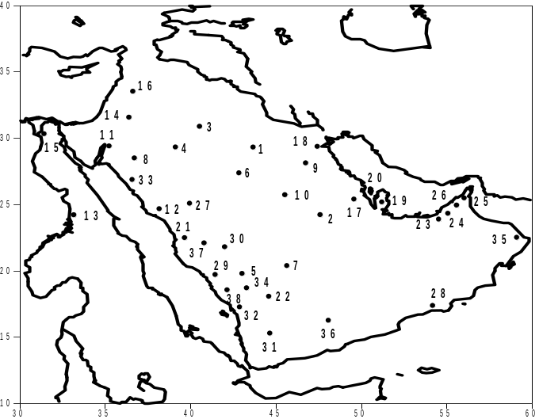
(E. Q.)
Figure 1. Locations of meteorological weather stations across the study area, E.Q. ( Empty Quarter Desert).
ID | Station | WMO | Lat. | Long. | Elevation (m) | Data | ID | Station | WMO | Lat. | Long. | Elevation (m) | Data
 |  | Code |  |  |  | presence |  |  | Code |  |  |  | presence
1 | Rafha | 403620 | 29.61 | 43.5 | 445 | 88% | 20 | Bahrain | 411500 | 26.26 | 50.7 | 2 | 100%
2 | Alriyadh | 404370 | 24.93 | 46.7 | 612 | 99.60% | 21 | Jeddah | 410240 | 21.7 | 39.2 | 18 | 100%
3 | Arar | 403570 | 30.9 | 41.1 | 550 | 72.50% | 22 | Najran | 411280 | 17.61 | 44.4 | 1213 | 88.70%
4 | Aljouf | 403610 | 29.78 | 40.1 | 670 | 84% | 23 | Abu Dhabi | 412170 | 24.43 | 54.7 | 27 | 99.50%
5 | Bisha | 410840 | 19.98 | 42.6 | 1167 | 85% | 24 | Dubai | 411940 | 25.25 | 55.4 | 10 | 100%
6 | Hail | 403940 | 27.43 | 41.7 | 1000 | 93.30% | 25 | Ras Alkhamah | 411840 | 25.61 | 55.9 | 31 | 95%
7 | Wadi Aldawaser**** | 410620/610 | 20.5 | 45.3 | 615 | 72.20% | 26 | Sharjah | 411960 | 25.32 | 55.5 | 34 | 100%
8 | Tabuk | 403750 | 28.38 | 36.6 | 770 | 95% | 27 | Almadinah | 404300 | 24.55 | 39.7 | 630 | 99.80%
9 | Alqaisumah | 403730 | 28.32 | 46.1 | 360 | 93.50% | 28 | Salalah | 413160 | 17.04 | 54.1 | 23 | 100%
10 | Gassim | 404050 | 26.3 | 43.8 | 648 | 91.00% | 29 | Albaha | 410550 | 20.3 | 41.7 | 1655 | 82%
11 | Aqabah* | 403400 | 29.55 | 35 | 51 | 56% | 30 | Altaif | 410360 | 21.48 | 40.6 | 1455 | 91.80%
12 | Yenbo | 404390 | 24.13 | 38.1 | 8 | 93.20% | 31 | Sanaa** | 413440/414040 | 15.52 | 44.2 | 2200 | 59%
13 | Asswan | 624140 | 23.96 | 32.8 | 194 | 68.50% | 32 | Gizan | 411400 | 16.88 | 42.6 | 4 | 95%
14 | Amman | 402700 | 31.98 | 36 | 780 | 84.10% | 33 | Alwejh | 404000 | 26.2 | 36.5 | 20 | 93.60%
15 | Cairo | 623660 | 30.1 | 31.4 | 74 | 100% | 34 | Khamis Mushait | 411140 | 18.3 | 42.8 | 2047 | 94%
16 | Damascus | 400800 | 33.41 | 36.5 | 609 | 90.50% | 35 | Sur* | 412680 | 22.53 | 59.5 | 13 | 100%
17 | Alhasa | 404200 | 25.4 | 49.5 | 180 | 86% | 36 | Seiyon*** | 413960/360/363 | 15.98 | 49 | 650 | 52%
18 | Kuwait | 405820 | 29.21 | 48 | 48 | 93% | 37 | Makkah | 410300 | 21.43 | 39.8 | 273 | 91.50%
19 | Doha | 411700 | 25.26 | 51.6 | 10 | 100% | 38 | Abha | 411120 | 18.23 | 42.7 | 2100 | 92.50%
Table 1. Detailed information on the stations used in regionalization. Stations with (*) Transmit every 3 hrs, i.e. only 8 observations were sent to archives, unlike other stations where hourly observations were sent to archives. Stations with (**) Station 1 (1983/92) and Station 2 (1993/2014) distance between stations less than 20 km. Stations with (***) A combination has been constructed from three different stations that were approximately 10 km away from each other. All stations have the same name but different WMO number and by investigating the data, it is apparent that the operators rotated the operation between the three stations in an alternative manner. Stations with (****) Station 1 (1983/90) and Station 2 (1991/2014) distance between stations less than 50 km.

Figure 2. The process of regionalising has been experimented through all the steps mentioned above. However, the bold white font represents what is found to be the most appropriate and was used to finalise the regionalisation process
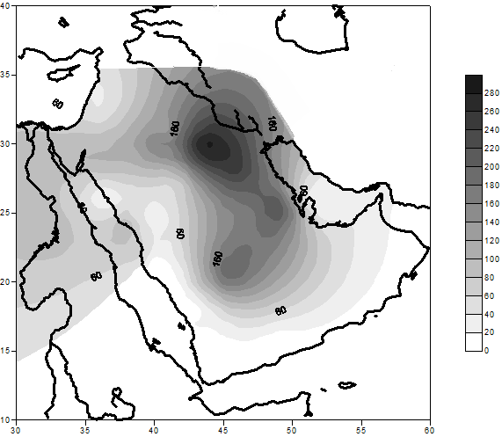
Figure 3. Wet season climatology of Sand storms of AP, based on the total number of days for each station between (1983-2013).
Statoin ID | Stations | PC-1 | PC-2 | PC-3 | Statoin ID | Stations | PC-1 | PC-2 | PC-3
1 | Rafha | 5.68 | 3.66 | 3.89 | 20 | Bahrain | 0.86 | 1.05 | 0.34
2 | Alriyadh | 2.79 | 2.29 | 2.40 | 21 | Jeddah | 0.18 | 0.82 | 1.17
3 | Arar | 2.10 | 0.51 | 1.15 | 22 | Najran | 0.44 | 0.28 | 0.57
4 | Aljouf | 1.28 | 0.50 | -0.66 | 23 | Abu Dhabi | 0.39 | 0.31 | 0.61
5 | Bisha | 0.69 | 0.34 | 0.51 | 24 | Dubai | .20 | .07 | .02
6 | Hail | 0.71 | 0.50 | 0.38 | 25 | Ras Alkhamah | .21 | -.09 | .10
7 | Wadi Aldawaser | 4.65 | 0.91 | 1.49 | 26 | Sharjah ** | .06 | .01 | .01
8 | Tabuk | 0.92 | -0.10 | 0.88 | 27 | Almadinah ** | .16 | -.14 | -.09
9 | Alqaisumah | 4.35 | 3.48 | 1.55 | 28 | Salalah ** | .29 | -.35 | -.04
10 | Gassim | 0.67 | 2.49 | 0.80 | 29 | Albaha ** | .12 | .09 | .07
11 | Aqabah | 0.85 | 0.25 | 0.46 | 30 | Altaif ** | .11 | -.05 | -.01
12 | Yenbo | 0.85 | 0.27 | 0.06 | 31 | Sanaa ** | .05 | .03 | .04
13 | Asswan | 0.54 | 0.53 | 0.20 | 32 | Gizan ** | .03 | .05 | .03
14 | Amman ** | .36 | -.04 | .01 | 33 | Alwejh ** | .02 | .04 | .02
15 | Cairo ** | .15 | .00 | -.06 | 34 | Khamis Mushait ** | .02 | .03 | .00
16 | Damascus ** | .11 | .14 | .00 | 35 | Sur ** | .01 | .01 | .03
17 | Alhasa | 2.97 | 5.20 | 1.83 | 36 | Seiyon ** | .01 | .00 | .00
18 | Kuwait | 1.92 | 3.62 | 2.73 | 37 | Makkah ** | .01 | -.01 | .00
19 | Doha | 0.28 | 0.98 | 0.17 | 38 | Abha ** | .00 | .00 | .00
Table 2. PC loadings for each station where the grey shaded scores indicate the highest loading score for each significant station. And (**) indicates stations that are not significant and were removed.
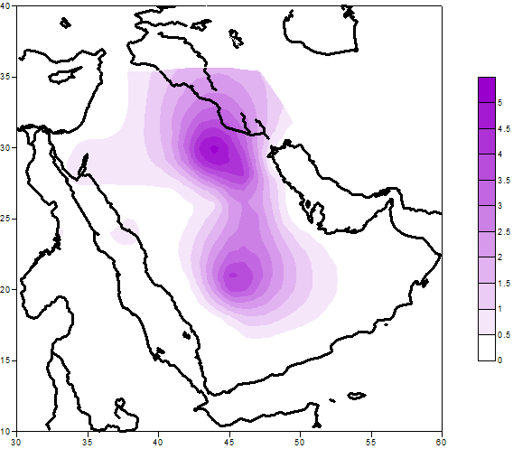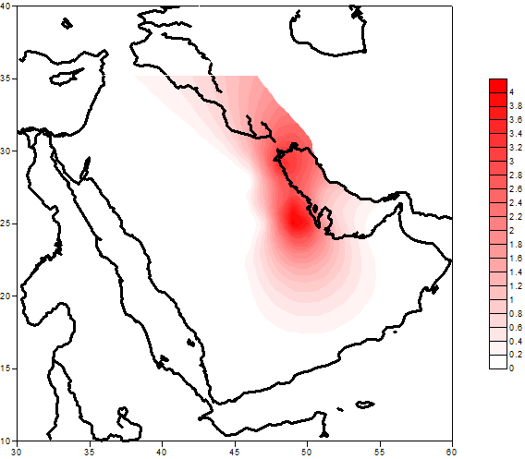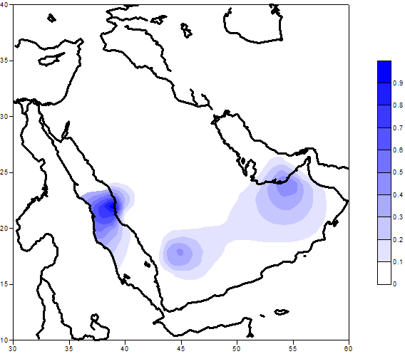
Figure 4. . Score patterns of the four retained components (Promax rotation); percentage of the total variance explained for each component is given. (a) PC1 - Purple (48.6%), PC2 - Red (13.7%) and PC3 - Blue (8.1%).

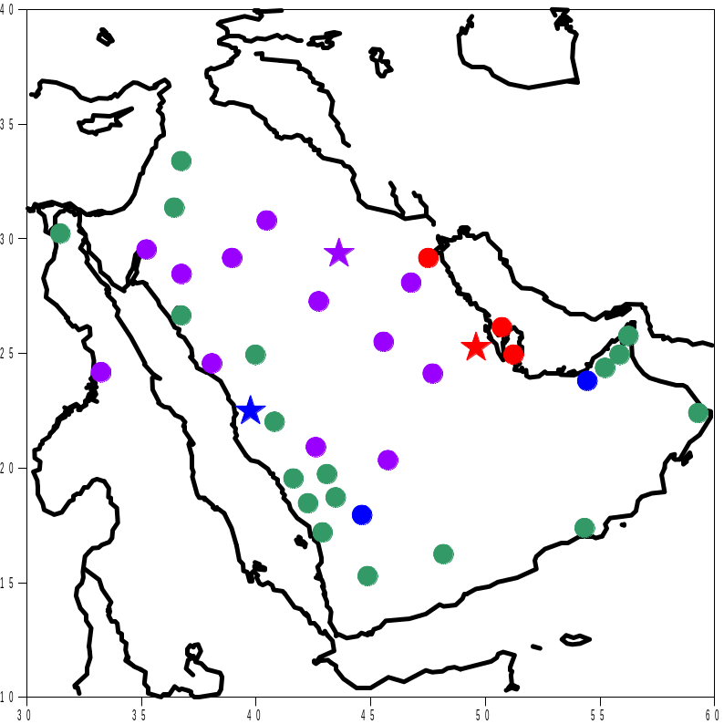
Figure 5. Preliminary DSA climatic groups are identified based on PCA, where Purple = PC1, Red = PC2, Blue = PC3 and Green = unclassified.
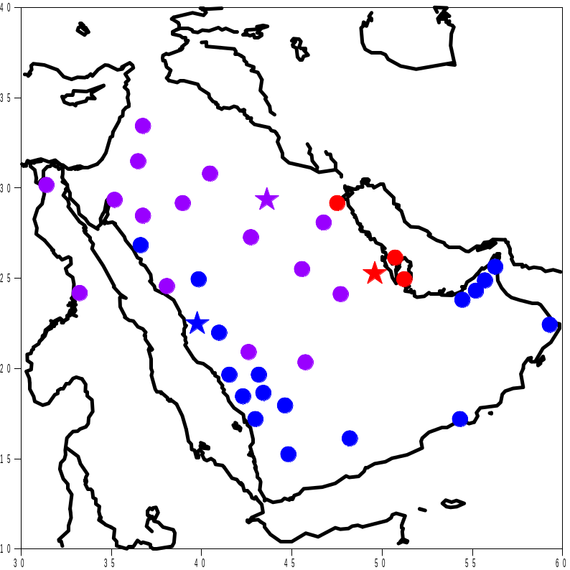
Figure 6. Final DSA climatic groups, where PCs (sub regions) were named after their geographical locations: Purple = PC1 (North, Western and Central “NWC”), Red = PC2 (North East “NE”) and Blue = PC3 (South, West and Coastal areas “SWC”).

Figure 7. Sub regions monthly mean DSA, Purple = PC1 (NWC) (95% confidence interval of 2.9, 8.4), Red = PC2 (NE) (95% confidence interval of 2.2, 5.9), Blue = PC3 (SWC) (95% confidence interval of 0.01, 2.1) and dashed black regional arithmetic average (95% confidence interval of 2.7, 5.6).
Sub region | Stations | Name | Main characteristics
PC1 | Rafha, Alriyadh, Alqaisumah, Arar, Aljouf, Gassim, Hail, Yenbo, Tabuk, Asswan, Bisha, Wadi Aldawaser, Aqabah, Cairo, Amman and Damascus | North, West and Central (NWC) | - Max peak in April.  - Sub regional average greater than regional average after February
PC2 | Alhasa, Kuwait, Bahrain and Doha. | North East (NE) | - Two peaks in March and May  - Sub regional average greater than regional average between November and March.
PC3 | Jeddah, Abu Dhabi, Altaif, Dubai, Sharjah, Ras Alkhamah, Sur, Alwejh, Najran, Salalah, Abha, Khamis Mushait, Albaha, Almadinah, Makkah, Gizan, Seiyon and Sanaa | Southern and Western Coastal areas (SWC) | - Max peak in March  - Sub regional average always below the regional average
Table 3. Characteristics of the final climatic sub regions and formal naming based on geographical locations.

Wet Seasonal | Rafha | Alhasa | Jeddah
Abha ** | -0.10 | -0.11 | -0.19
Abu Dhabi | 0.42 | 0.24 | 0.36
Albaha * | 0.20 | 0.15 | 0.26
Alhasa | 0.65 | 1.00 | 0.20
Aljouf | 0.37 | 0.27 | -0.24
Almadinah * | -0.08 | -0.03 | 0.34
Alqaisumah | 0.66 | 0.56 | 0.26
Alriyadh | 0.71 | 0.72 | 0.40
Altaif * | 0.27 | 0.38 | 0.45
Alwejh * | 0.10 | 0.08 | 0.33
Amman * | 0.33 | 0.22 | -0.13
Aqabah | 0.27 | 0.30 | 0.00
Arar | 0.60 | 0.52 | 0.05
Asswan | 0.23 | 0.21 | 0.10
Bahrain | 0.42 | 0.59 | 0.14
Bisha | 0.43 | 0.36 | 0.10
Cairo ** | 0.03 | 0.23 | -0.01
Damascus ** | -0.16 | -0.12 | -0.08
Doha | 0.24 | 0.30 | 0.23
Dubai ** | 0.08 | -0.32 | -0.10
Gassim | 0.32 | 0.33 | 0.33
Gizan ** | -0.23 | -0.16 | -0.23
Hail | 0.43 | 0.33 | -0.07
Jeddah | 0.24 | 0.20 | 1.00
Khamis Mushait * | 0.24 | -0.09 | 0.28
Kuwait | 0.59 | 0.52 | 0.49
Makkah * | -0.01 | 0.00 | 0.14
Najran | 0.48 | 0.36 | 0.34
Rafha | 1.00 | 0.65 | 0.24
Ras Alkhamah ** | 0.35 | 0.34 | 0.20
Salalah * | 0.09 | 0.16 | 0.22
Sanaa * | 0.17 | 0.05 | -0.19
Seiyon * | 0.00 | 0.03 | 0.21
Sharjah * | -0.03 | -0.25 | 0.28
Sur * | 0.40 | -0.01 | -0.07
Tabuk | 0.26 | 0.31 | -0.08
Wadi Aldawaser | 0.46 | 0.24 | 0.54
Yenbo | 0.09 | 0.33 | 0.00
Table A-1 Correlation Coefficients between all stations and Key stations. Grey shading indicates to stations that were not included in the final PCA (disqualified) where single (*) indicates to stations that were assigned statistically (significantly correlated with a Key stations) and double (**) indicates to stations that failed to correlate with any Key station and were assigned subjectively
Key Station | 30 years linear slope value | Remarks
PC1 (Rafha) | -0.000001 | Non significant
PC2 (Alhasa) | 0.003 | Significant at 95% Confidence Interval
PC3 (Jeddah) | -0.0022 | Significant at 95% Confidence Interval
 | 1st 15 years linear slope value
PC1 (Rafha) | -0.003 | Non significant
PC2 (Alhasa) | -0.002 | Non significant
PC3 (Jeddah) | -0.009 | Significant at 95% Confidence Interval
 | 2nd 15 years linear slope value
PC1 (Rafha) | 0.006 | Significant at 95% Confidence Interval
PC2 (Alhasa) | 0.01 | Significant at 95% Confidence Interval
PC3 (Jeddah) | 0.003 | Non significant
 | 1st 10 years linear slope value
PC1 (Rafha) | 0.012 | Significant at 95% Confidence Interval
PC2 (Alhasa) | 0.007 | Non significant
PC3 (Jeddah) | -0.006 | Non significant
 | 2nd 10 years linear slope value
PC1 (Rafha) | -0.005 | Non significant
PC2 (Alhasa) | -0.0008 | Non significant
PC3 (Jeddah) | 0.001 | Non significant
 | 3rd 10 years linear slope value
PC1 (Rafha) | 0.0014 | Non significant
PC2 (Alhasa) | 0.013 | Significant at 95% Confidence Interval
PC3 (Jeddah) | 0.001 | Non significant
Table A-2 Key stations wet season dust events linear slope analysis results and their significance.

Key Station | 30 years linear slope value | Remarks
PC1 (Rafha) | -0.004 | Significant at 95% Confidence Interval
PC2 (Alhasa) | -0.005 | Significant at 95% Confidence Interval
PC3 (Jeddah) | -0.00008 | Non significant
 | 1st 15 years linear slope value
PC1 (Rafha) | 0.0065 | Non significant
PC2 (Alhasa) | 0.0024 | Significant at 95% Confidence Interval
PC3 (Jeddah) | 0.0062 | Significant at 95% Confidence Interval
 | 2nd 15 years linear slope value
PC1 (Rafha) | 0.0002 | Non significant
PC2 (Alhasa) | 0.0156 | Significant at 95% Confidence Interval
PC3 (Jeddah) | -0.00004 | Non significant
 | 1st 10 years linear slope value
PC1 (Rafha) | 0.0009 | Non significant
PC2 (Alhasa) | 0.0199 | Significant at 95% Confidence Interval
PC3 (Jeddah) | 0.0125 | Significant at 95% Confidence Interval
 | 2nd 10 years linear slope value
PC1 (Rafha) | -0.0034 | Non significant
PC2 (Alhasa) | -0.0042 | Significant at 95% Confidence Interval
PC3 (Jeddah) | -0.006 | Significant at 95% Confidence Interval
 | 3rd 10 years linear slope value
PC1 (Rafha) | -0.00003 | Significant at 95% Confidence Interval
PC2 (Alhasa) | 0.0096 | Significant at 95% Confidence Interval
PC3 (Jeddah) | -0.001 | Non significant
Table A-3 Key stations wet season mean monthly wind linear slope analysis results and their significance.

Statoin ID | Stations | Desert soild source | Soil Type | Minimum wind speed threshold | Statoin ID | Stations | Desert soild source | Soil Type | Minimum wind speed threshold
1 | Rafha | Desert flat sand covered | sand, silt and clay | 11 m/s | 20 | Bahrain | Desert flat sand covered | sand, silt and clay | 11 m/s
2 | Alriyadh | Desert flat sand covered | sand, silt and clay | 11 m/s | 21 | Jeddah | Crusted surface | Medium to coarse sand | 15 m/s
3 | Arar | Desert flat sand covered | sand, silt and clay | 11 m/s | 22 | Najran | Crusted surface | Medium to coarse sand | 15 m/s
4 | Aljouf | Desert flat sand covered | sand, silt and clay | 11 m/s | 23 | Abu Dhabi | Desert flat sand covered | sand, silt and clay | 11 m/s
5 | Bisha | Desert flat sand covered | medium sand |  | 24 | Dubai | Crusted surface | Medium to coarse sand | 15 m/s
6 | Hail | Loose packed desert roads | Loose sand | 6 m/s | 25 | Ras Alkhamah | Crusted surface | Medium to coarse sand | 15 m/s
7 | Wadi Aldawaser | Desert flat sand covered | sand, silt and clay | 11 m/s | 26 | Sharjah | Crusted surface | Medium to coarse sand | 15 m/s
8 | Tabuk | Desert flat sand covered | sand, silt and clay | 11 m/s | 27 | Almadinah | Loose packed desert roads | Loose sand | 6 m/s
9 | Alqaisumah | Desert flat sand covered | sand, silt and clay | 11 m/s | 28 | Salalah | Crusted surface | Medium to coarse sand | 15 m/s
10 | Gassim | Desert flat sand covered | sand, silt and clay | 11 m/s | 29 | Albaha | Crusted surface | Medium to coarse sand | 15 m/s
11 | Aqabah | Loose packed desert roads | Loose sand | 6 m/s | 30 | Altaif | Crusted surface | Medium to coarse sand | 15 m/s
12 | Yenbo | Desert flat sand covered | sand, silt and clay | 11 m/s | 31 | Sanaa | Crusted surface | Medium to coarse sand | 15 m/s
13 | Asswan | Loose packed desert roads | Loose sand | 6 m/s | 32 | Gizan | Crusted surface | Medium to coarse sand | 15 m/s
14 | Amman | Dry washes | Loose sand/silt | 10 m/s | 33 | Alwejh | Crusted surface | Medium to coarse sand | 15 m/s
15 | Cairo | Dry washes | Loose sand/silt | 10 m/s | 34 | Khamis Mushait | Crusted surface | Medium to coarse sand | 15 m/s
16 | Damascus | Crusted surface | Medium to coarse sand | 15 m/s | 35 | Sur | Loose packed desert roads | Loose sand | 6 m/s
17 | Alhasa | Desert flat sand covered | sand, silt and clay | 11 m/s | 36 | Seiyon | Crusted surface | Medium to coarse sand | 15 m/s
18 | Kuwait | Desert flat sand covered | sand, silt and clay | 11 m/s | 37 | Makkah | Crusted surface | Medium to coarse sand | 15 m/s
19 | Doha | Desert flat sand covered | sand, silt and clay | 11 m/s | 38 | Abha | Crusted surface | Medium to coarse sand | 15 m/s
Table A-4 Soil types and minimum wind threshold needed to suspend dust for each location.
Year | Abha | Abu Dhabi | Albaha | Alhasa | Aljouf | Almadinah | Alqaisumah | Alriyadh | Altaif | Alwejh | Amman | Aqabah
1983 | 0 | 3 | 0 | 4 | 3 | 0 | 10 | 11 | 1 | 0 | 1 | 4
1984 | 0 | 2 | 0 | 12 | 4 | 0 | 6 | 7 | 2 | 0 | 0 | 3
1985 | 0 | 4 | 2 | 10 | 4 | 1 | 7 | 9 | 0 | 1 | 4 | 2
1986 | 0 | 1 | 0 | 4 | 5 | 1 | 6 | 5 | 0 | 0 | 1 | 2
1987 | 0 | 2 | 0 | 8 | 3 | 1 | 9 | 5 | 1 | 1 | 1 | 1
1988 | 0 | 1 | 0 | 5 | 3 | 4 | 11 | 10 | 2 | 0 | 0 | 2
1989 | 0 | 0 | 0 | 7 | 9 | 0 | 8 | 2 | 0 | 0 | 1 | 4
1990 | 0 | 0 | 4 | 7 | 11 | 0 | 17 | 4 | 1 | 1 | 0 | 0
1991 | 0 | 2 | 0 | 16 | 7 | 0 | 22 | 10 | 1 | 0 | 0 | 0
1992 | 0 | 1 | 0 | 7 | 8 | 0 | 8 | 5 | 0 | 0 | 0 | 0
1993 | 0 | 1 | 0 | 6 | 4 | 1 | 12 | 5 | 0 | 0 | 2 | 2
1994 | 0 | 1 | 0 | 1 | 5 | 0 | 1 | 3 | 0 | 0 | 1 | 0
1995 | 0 | 0 | 0 | 1 | 7 | 1 | 0 | 0 | 0 | 0 | 2 | 8
1996 | 0 | 1 | 0 | 2 | 4 | 0 | 6 | 2 | 1 | 0 | 1 | 6
1997 | 0 | 0 | 0 | 0 | 4 | 0 | 2 | 1 | 0 | 0 | 2 | 2
1998 | 0 | 2 | 0 | 1 | 3 | 0 | 2 | 1 | 0 | 0 | 0 | 0
1999 | 1 | 0 | 0 | 4 | 5 | 1 | 11 | 4 | 0 | 1 | 3 | 2
2000 | 0 | 1 | 0 | 1 | 4 | 1 | 3 | 1 | 0 | 0 | 1 | 2
2001 | 0 | 1 | 0 | 4 | 3 | 1 | 4 | 2 | 0 | 0 | 0 | 4
2002 | 0 | 4 | 0 | 13 | 12 | 0 | 14 | 6 | 1 | 0 | 4 | 6
2003 | 0 | 1 | 0 | 5 | 7 | 1 | 3 | 2 | 0 | 0 | 3 | 3
2004 | 0 | 0 | 1 | 6 | 2 | 1 | 4 | 2 | 0 | 0 | 1 | 5
2005 | 0 | 2 | 0 | 7 | 6 | 2 | 7 | 4 | 1 | 0 | 2 | 4
2006 | 0 | 2 | 0 | 5 | 10 | 0 | 14 | 3 | 0 | 0 | 3 | 6
2007 | 0 | 1 | 0 | 5 | 1 | 0 | 12 | 6 | 1 | 0 | 0 | 8
2008 | 0 | 4 | 0 | 15 | 4 | 0 | 14 | 10 | 1 | 0 | 2 | 8
2009 | 0 | 2 | 0 | 14 | 6 | 0 | 11 | 13 | 0 | 1 | 4 | 6
2010 | 0 | 1 | 0 | 16 | 9 | 1 | 13 | 11 | 1 | 0 | 4 | 4
2011 | 0 | 0 | 1 | 27 | 6 | 1 | 12 | 11 | 1 | 0 | 1 | 8
2012 | 0 | 1 | 0 | 12 | 4 | 1 | 4 | 8 | 0 | 0 | 2 | 3
2013 | 0 | 0 | 0 | 7 | 3 | 0 | 3 | 0 | 0 | 0 | 0 | 0
Table A-5 Stations wet season DSA time series.
Year | Arar | Asswan | Bahrain | Bisha | Cairo | Damascus | Doha | Dubai | Gassim | Gizan | Hail | Jeddah
1983 | 9 | 1 | 1 | 4 | 3 | 0 | 0 | 3 | 5 | 1 | 2 | 5
1984 | 8 | 1 | 0 | 3 | 8 | 0 | 0 | 0 | 3 | 3 | 4 | 1
1985 | 5 | 2 | 1 | 4 | 2 | 1 | 0 | 1 | 4 | 0 | 0 | 6
1986 | 5 | 5 | 0 | 0 | 3 | 0 | 0 | 1 | 0 | 1 | 2 | 4
1987 | 2 | 4 | 0 | 2 | 4 | 1 | 0 | 0 | 6 | 0 | 2 | 6
1988 | 2 | 5 | 2 | 0 | 0 | 0 | 5 | 1 | 15 | 0 | 1 | 5
1989 | 4 | 0 | 0 | 0 | 2 | 0 | 0 | 0 | 3 | 1 | 0 | 1
1990 | 6 | 6 | 2 | 3 | 3 | 0 | 3 | 0 | 6 | 1 | 2 | 3
1991 | 7 | 4 | 4 | 5 | 5 | 0 | 3 | 0 | 4 | 0 | 1 | 3
1992 | 12 | 7 | 0 | 4 | 2 | 0 | 0 | 2 | 2 | 0 | 0 | 0
1993 | 6 | 4 | 0 | 5 | 0 | 1 | 0 | 2 | 3 | 0 | 4 | 0
1994 | 1 | 2 | 0 | 0 | 2 | 0 | 0 | 2 | 2 | 0 | 3 | 0
1995 | 4 | 2 | 0 | 1 | 2 | 0 | 0 | 0 | 1 | 2 | 0 | 1
1996 | 3 | 4 | 0 | 1 | 2 | 0 | 0 | 1 | 3 | 1 | 0 | 1
1997 | 3 | 3 | 0 | 1 | 4 | 2 | 0 | 3 | 0 | 0 | 1 | 0
1998 | 2 | 0 | 1 | 3 | 1 | 2 | 0 | 2 | 4 | 1 | 0 | 0
1999 | 2 | 1 | 3 | 2 | 4 | 5 | 2 | 0 | 6 | 1 | 4 | 0
2000 | 1 | 3 | 0 | 2 | 4 | 3 | 0 | 3 | 2 | 1 | 1 | 1
2001 | 1 | 6 | 1 | 2 | 1 | 3 | 0 | 1 | 1 | 1 | 1 | 1
2002 | 5 | 8 | 2 | 3 | 5 | 3 | 2 | 3 | 8 | 0 | 7 | 2
2003 | 2 | 4 | 1 | 1 | 3 | 0 | 2 | 2 | 2 | 1 | 4 | 0
2004 | 0 | 2 | 3 | 1 | 2 | 1 | 0 | 0 | 1 | 0 | 2 | 1
2005 | 6 | 1 | 0 | 2 | 6 | 3 | 1 | 2 | 5 | 1 | 2 | 5
2006 | 6 | 1 | 3 | 0 | 4 | 1 | 2 | 1 | 8 | 4 | 5 | 0
2007 | 3 | 1 | 4 | 1 | 0 | 3 | 2 | 2 | 6 | 0 | 3 | 4
2008 | 5 | 6 | 5 | 1 | 4 | 1 | 2 | 2 | 4 | 0 | 2 | 2
2009 | 3 | 2 | 3 | 2 | 2 | 1 | 0 | 1 | 2 | 0 | 4 | 2
2010 | 8 | 1 | 1 | 4 | 4 | 0 | 1 | 1 | 9 | 2 | 0 | 0
2011 | 9 | 5 | 6 | 3 | 2 | 1 | 2 | 0 | 7 | 0 | 5 | 3
2012 | 8 | 1 | 0 | 0 | 2 | 2 | 1 | 1 | 8 | 0 | 2 | 1
2013 | 1 | 3 | 1 | 2 | 0 | 0 | 1 | 1 | 7 | 3 | 1 | 3
Table A-5 Continued.
Year | Khamis Mushait | Kuwait | Makkah | Najran | Rafha | Ras Alkhamah | Salalah | Sanaa | Seiyon | Sharjah | Sur | Tabuk | Wadi Aldawaser | Yenbo
1983 | 1 | 11 | 0 | 1 | 18 | 1 | 1 | 0 | 0 | 1 | 0 | 4 | 15 | 0
1984 | 0 | 5 | 0 | 1 | 9 | 0 | 1 | 0 | 1 | 1 | 0 | 7 | 19 | 8
1985 | 0 | 6 | 0 | 3 | 16 | 2 | 0 | 0 | 0 | 1 | 1 | 4 | 18 | 0
1986 | 0 | 7 | 0 | 2 | 10 | 1 | 1 | 0 | 0 | 1 | 0 | 2 | 10 | 8
1987 | 0 | 6 | 1 | 1 | 5 | 0 | 3 | 0 | 3 | 0 | 0 | 2 | 9 | 2
1988 | 0 | 15 | 0 | 3 | 10 | 1 | 0 | 0 | 0 | 1 | 0 | 2 | 13 | 3
1989 | 0 | 2 | 0 | 2 | 13 | 0 | 0 | 1 | 2 | 0 | 0 | 4 | 0 | 1
1990 | 1 | 5 | 0 | 0 | 13 | 1 | 0 | 1 | 1 | 1 | 0 | 1 | 3 | 8
1991 | 0 | 11 | 0 | 1 | 10 | 0 | 1 | 2 | 0 | 0 | 0 | 7 | 7 | 3
1992 | 0 | 2 | 1 | 3 | 14 | 1 | 3 | 0 | 1 | 1 | 1 | 9 | 8 | 0
1993 | 0 | 6 | 0 | 1 | 21 | 0 | 0 | 2 | 0 | 0 | 2 | 3 | 10 | 2
1994 | 0 | 0 | 0 | 0 | 6 | 1 | 0 | 0 | 0 | 1 | 0 | 1 | 2 | 1
1995 | 0 | 0 | 0 | 0 | 2 | 0 | 0 | 0 | 0 | 0 | 0 | 3 | 8 | 7
1996 | 0 | 1 | 0 | 1 | 0 | 0 | 0 | 1 | 0 | 1 | 0 | 1 | 2 | 2
1997 | 0 | 0 | 0 | 0 | 0 | 0 | 0 | 1 | 0 | 1 | 0 | 4 | 4 | 3
1998 | 0 | 2 | 0 | 0 | 1 | 0 | 0 | 0 | 0 | 1 | 0 | 1 | 1 | 4
1999 | 0 | 3 | 0 | 0 | 6 | 0 | 0 | 0 | 0 | 0 | 0 | 1 | 2 | 5
2000 | 0 | 7 | 0 | 0 | 3 | 0 | 0 | 0 | 0 | 0 | 0 | 2 | 3 | 1
2001 | 0 | 1 | 0 | 0 | 0 | 0 | 0 | 0 | 0 | 0 | 0 | 3 | 3 | 3
2002 | 0 | 12 | 0 | 0 | 21 | 4 | 0 | 0 | 0 | 1 | 0 | 3 | 8 | 0
2003 | 0 | 2 | 0 | 1 | 5 | 4 | 1 | 0 | 0 | 0 | 0 | 8 | 6 | 1
2004 | 0 | 6 | 0 | 1 | 5 | 1 | 0 | 0 | 0 | 0 | 0 | 4 | 4 | 1
2005 | 0 | 1 | 0 | 1 | 7 | 2 | 0 | 0 | 0 | 2 | 0 | 2 | 5 | 3
2006 | 0 | 4 | 0 | 2 | 11 | 0 | 0 | 1 | 0 | 0 | 0 | 2 | 7 | 1
2007 | 0 | 12 | 0 | 2 | 12 | 1 | 0 | 0 | 0 | 0 | 0 | 6 | 12 | 3
2008 | 0 | 11 | 0 | 0 | 18 | 0 | 0 | 1 | 0 | 0 | 0 | 7 | 7 | 11
2009 | 0 | 3 | 0 | 2 | 16 | 1 | 0 | 0 | 0 | 0 | 0 | 0 | 7 | 4
2010 | 0 | 10 | 0 | 2 | 16 | 0 | 0 | 0 | 0 | 0 | 0 | 3 | 3 | 5
2011 | 0 | 12 | 0 | 3 | 21 | 3 | 1 | 0 | 0 | 0 | 0 | 5 | 10 | 7
2012 | 0 | 4 | 0 | 0 | 7 | 2 | 0 | 0 | 0 | 0 | 0 | 3 | 2 | 4
2013 | 0 | 7 | 0 | 0 | 4 | 0 | 0 | 0 | 0 | 0 | 0 | 0 | 3 | 1
Table A-5 Continued.
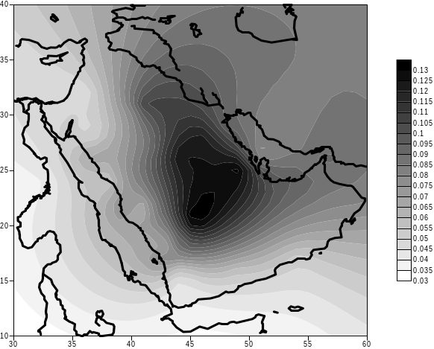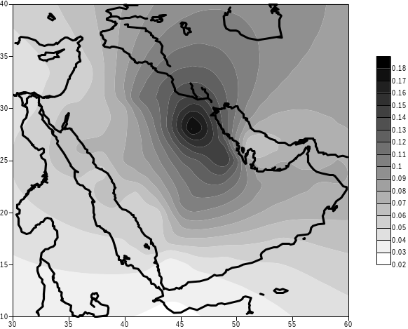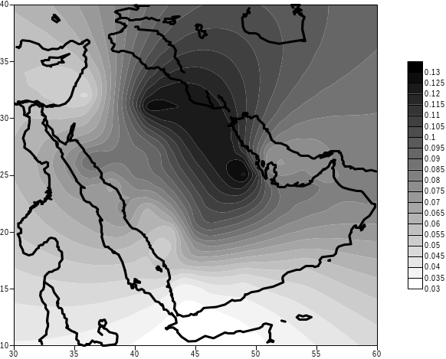
PC-1 Explained variance 60.9% (MISR data 2000 – 2013) PC-2 Explained variance 6% (MISR data 2000 – 2013) PC-3 Explained variance 4% (MISR data 2000 – 2013)

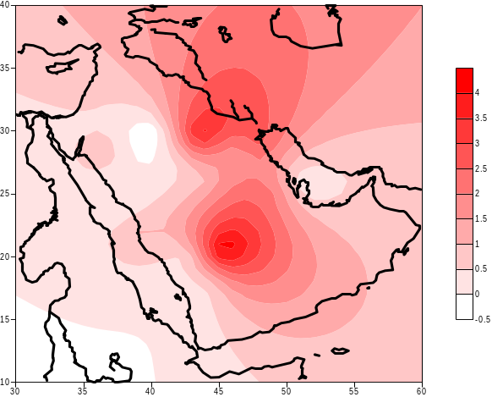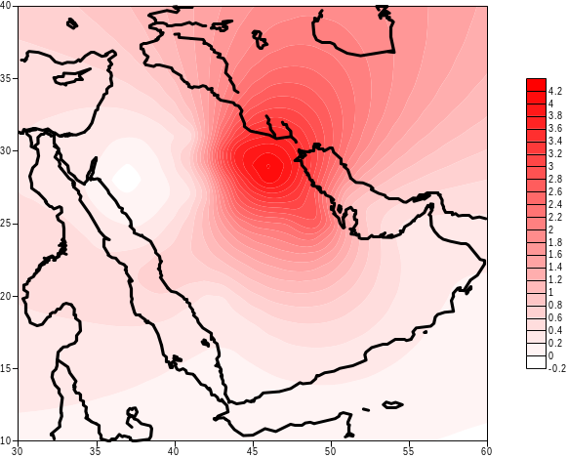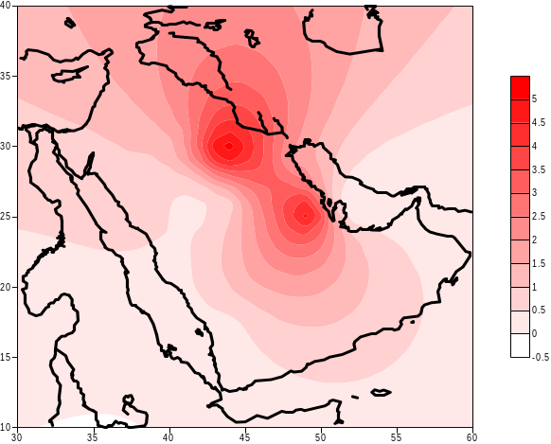
PC-1 Explained variance 53.1% (Observation data 2000 – 2013) PC-2 Explained variance 13.4% (Observation data 2000 – 2013) PC-3 Explained variance 6% (Observation data 2000 – 2013)

Figure A-6 Plots of the first three modes of point AOD MISR (top) and station observations (bottom)

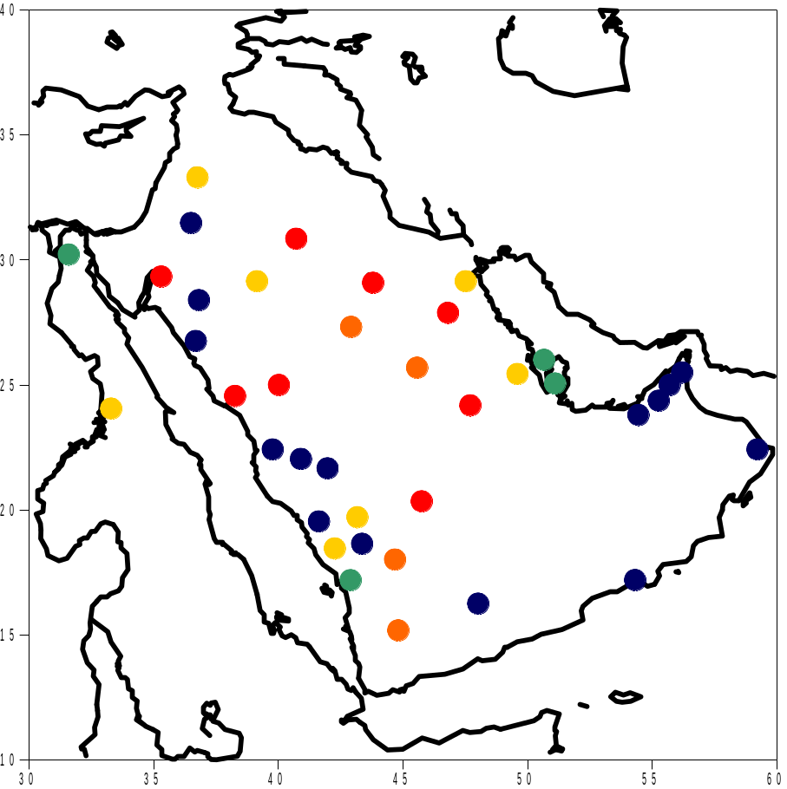
0.4 – 0.5 (Significant at 95% Confidence Interval).
0.3 - 0.4 (Significant at 95% Confidence Interval).
0.2 – 0.3 (Significant at 95% Confidence Interval).
0.165 - 0.2 (Significant at 95% Confidence Interval).
Non Significant

Figure A-7 Temporal correlation coefficient between point MISR AOD data and station dust storm index

