Driving forces of Chinese primary air pollution emissions: an index decomposition analysis
Wanning LYU¹, Yuan Li^{2, 3,}*, Dabo Guan^{2, 4}, Zhu Liu^{3,}*, Hongyan Zhao⁴, Qiang Zhang⁴
¹ Department of Civil and Environmental Engineering, the Hong Kong Polytechnic University, Hung Hom, Kowloon, Hong Kong
² School of International Development, University of East Anglia, Norwich, NR4 7TJ, UK
³ School of Environment, Tsinghua University, Beijing 100084, People’s Republic of China
Resnick Sustainability Institute, California Institute of Technology, Pasadena, California 91125, USA
⁴ Ministry of Education Key Laboratory for Earth System Modeling, Center for Earth System Science, Tsinghua University, Beijing, 100084, China

* Correspondence emails: yuan.li4@uea.ac.uk or zhuliu@caltech.edu

Abstract
Emissions of the fine particulate matters (diameter of 2.5 micrometers or less) caused by both the primary particle emissions and the precursor emission sources such as sulphur dioxide (SO₂) and nitrogen oxides (NO_{x}), have contributed significantly to poor urban air quality in China, and have attracted tremendous public attention over the past few years. This study provides an interdisciplinary study to investigate the key contributors driving air pollution emissions changes in China from 1997 to 2012, by applying the Logarithmic Mean Divisia Index (LMDI) method. The decomposition results are presented in both multiplicative and additive approaches to show the relative and absolute contribution of each factor in affecting emission changes. Changes in total particulate matter emissions are attributed to variations in primary particle, sulphur dioxide and nitrogen oxides emissions. It is manifested that the economic growth effect and energy intensity effect have always been the two key drivers in affecting the changes in air pollutant emissions over the period. The effects of emission efficiency, production structure and population growth contribute less significantly to overall emission changes, and the impacts of different factors on total particulate matter emissions vary among different pollutants. Since current strategies and policies in combatting particulate matter emissions are inefficient, this paper provides a guideline for the Chinese Government to deal with the air pollution problem for sustainable development in China.

Keywords: China, PM_{2.5,} emission drivers, index decomposition analysis, Divisia index

INTRODUCTION
China is among the most rapidly urbanizing countries in the world. The economic growth-driven urbanization process in China, and its relationship with the continuous industrialization, has led to numerous problems such as urban sprawl, severe environmental degradation and pollution. Specifically, urban air pollution is of major environmental concern (Wang, 2009).
The rampant smog that appeared more frequently in past years has revealed problems associated with China’s urbanization. In the winter of 2013, the heavy smog covered 70 major cities in the north of China, veiling 15% of the national territory in total (Xinhua News, 2013). The Chinese government has striven to resolve the issue, but effects, to date are currently not as positive as had been hoped. The adverse weather conditions have to some extent contributed to forming the smoggy days, but fundamentally, the phenomenon is primarily due to the pollution as a consequence of China’s industrialization and urbanization. Over exploitation of resources, considerable reliance on industrial sectors (Appendix Figure A1) and coal (Appendix Figure A2), the blind pursuit of high GDP growth and mass population migration that further increases the density of urban areas have resulted in unsustainable urbanization in China.
Partly encouraged by the worldwide drive for clean air, by the end of 2014, Beijing’s leaders had done all that was currently possible to ensure the capital’s skies were clean for the Asia-Pacific Economic Co-operation (APEC) summit and to ensure the world that the problem was receiving intensive consideration. During APEC, thousands of factories surrounding Beijing were commanded to close, car volume was restricted and millions of people were forced to take a mandatory holiday. The use of the newly coined phrase ‘APEC blue’ for the occasion, firmly underlined China’s clean air intentions. Clearly the smog control could not be achieved “over night” and the current measures in place were still embryonic. It is believed that potential effects of the massive scale of urbanization in China will stimulate more daring and radical smog abatement strategies and emission targets in the future.
This study quantified the socioeconomic drivers of PM_{2.5} emissions. PM_{2.5} (particulate matter smaller than 2.5 micrometers) is the major component of smog. It is well noted that urbanization has considerable impact on national PM_{2.5} concentrations (Han et al., 2014), hence production-related PM_{2.5} emissions are used as the indicator of China’s urban sustainability. PM_{2.5} is both a primary and secondary air pollutant. The primary sources of PM_{2.5} emission are from industrial process, diesel vehicles, and coal combustion (Guan et al., 2014). According to Zheng et al. (2005), a substantial proportion of ambient PM_{2.5} concentration in China is contributed by primary sources of PM_{2.5} emissions. The secondary sources are the results of oxidation of other chemicals such as sulfur dioxide (SO₂), nitrogen oxides (NO_{x}), volatile organic compounds (VOCs), and ammonia (NH₃) (Megaritis et al., 2013). It is difficult to directly analyze secondary PM_{2.5} emissions due to the uncertainties of association with atmospheric chemistry modeling. In this study, therefore, SO₂ and NO_{x} emissions are considered as precursors of the total PM_{2.5} emissions. SO₂ is predominately emitted from coal combustion due to the high sulfur content, while NO_{x} is primarily contributed by traffic exhaust.
This study is built upon the research conducted by Chong et al. (2009). In this study, there are five key driving forces of the change of PM_{2.5} emissions: emission efficiency (10 kilo-ton/PJ), energy intensity (PJ/10 thousand yuan), production pattern, economic growth (10 thousand yuan/10 thousand people) and population growth (10 thousand people). The magnitude of each factor in driving PM_{2.5} emission changes is quantified by Index Decomposition Analysis (IDA) using the Logarithmic Mean Divisia Index (LMDI) method (Ang, 2004), so that potential bottom-up smog mitigation policies can be initiated to facilitate sustainable urbanization in China.
This study first reviews the historical and current situation of world urbanization, with particular focus on China. Air pollution problems, especially smog, resulting from urbanization process are summarized and illustrated by worldwide cases. Next, a review of previous studies on China’s PM_{2.5} emissions and researches on the change of SO₂ emissions in China through the LMDI method are given. Socioeconomic factors affecting China’s primary PM_{2.5,} SO₂ and NO_{x} emissions changes between 1997 and 2007 are quantified, and results are then presented and discussed. At the end of the study, conclusions are drawn and recommendations on a suitable path for urbanization in China are made, based on the effect of each socioeconomic driver of PM_{2.5} emissions.

LITERATURE REVIEW
There have been numerous studies on airborne particulate matters in China. Some Chinese scholars have measured the chemical composition as well as the possible sources of PM_{2.5} in order to reduce the emissions in some cities of China, especially in more developed areas such as Beijing and Shanghai (Zhao et al., 2013; Chen et al., 2013; Watson et al., 2012; Duan et al., 2006; Huang et al., 2006). An overview of the formation mechanism and control measures of combustion particulate matters in China is given in Yao et al. (2010). Other researchers have focused on the human health impacts of fine particle matter (Huang et al., 2015; Zhang et al., 2012). Recently, there has been an increasing number of studies investigating the spatial-temporal variations of PM2.5 concentrations in Chinese cities (Hao and Liu, 2016; Yang and Christakos, 2015; Chai et al., 2014). Zhang et al. (2015) and Guan et al. (2014) have studied the socioeconomic drivers of China’s primary PM_{2.5} emissions by conducting structural decomposition analysis on a consumption basis. In spite of these progresses, there is a lack of knowledge of the socioeconomic drivers of PM_{2.5} emissions from a production perspective.
Identification and quantification of the socioeconomic factors contributing to PM_{2.5} emission variations in China can be essential not only for PM_{2.5} mitigation and human health impact control, but also for making recommendations regarding sustainable development in China. Techniques available for conducting such analyses include structural decomposition analysis (SDA) (Rose and Casler, 1996) and index decomposition analysis (IDA) (Ang, 2004), both of which have been applied extensively in analyzing socioeconomic drivers of energy consumption variations and CO₂ emission changes in China (Guan et al., 2009; Dhakal, 2009; Liu et al., 2012b; Feng et al., 2012; Chong et al., 2012), yet barely for other air pollutant emissions. Input-output tables are needed to perform the input-output structural decomposition analysis (SDA), and it is not as simple and flexible as index decomposition analysis (IDA). IDA is an analytical tool originated from energy studies, which has been applied in several energy-related fields, such as energy demand analysis, national energy efficiency monitoring, and energy-related gas emission analysis (Ang, 2004). In the literature, a variety of index decomposition methods have been developed, most of which can be classified into Laspeyres index and Divisia index methods (Ang, 2004). According to Ang (2004), the LMDI method which is developed based on Divisia index is the most preferred method, as it passes a number of basic tests for a good index number. The decomposition is perfect, which means that there is no residual term that other methods may produce. The multiplicative and additive decomposition results are linked by a simple formula, and they are also consistent in aggregation (Ang, 2005). It can also deal with zero value better than other methods (Ang and Liu, 2007).
Up to date, there have been some studies on the socioeconomic drivers of air pollutant emissions in China employing the Index Decomposition Analysis. For example, Zhao et al. (2010) applied LMDI (I) and (II) methods, decomposing the change in SO₂ intensity (emission volume per unit of gross industrial output) during 1998 to 2006 into industrial structure shift effect, production intensity effect and government control effect effect. They discovered that the SO₂ emission intensity declined despite an increase in the total SO₂ emission volume during the period. The main driver reducing SO₂ emissions intensity was the decline in SO₂ production intensity, which may be attributed to technological improvement. Industrial structural adjustment and governmental emission control needed to be intensified to further reduce SO₂ emissions intensity in the future. Han et al. (2011) included the scale effect into their decomposition analysis to quantify the underlying drivers of SO₂ emission changes between 2005 and 2008. They concluded that the scale effect did not help to reduce SO₂ emissions while structural variation did. Zhang (2013) decomposed the SO₂ emission intensity between 2001 and 2010, and attributed the reduction in emissions intensity to the improvement in energy efficiency, process-integrated prevention and end-of-pipe control. He concluded that during the decade the reduction of SO₂ emission density was primarily due to end-of-pipe treatment, which did not require change in the production process but relied on relatively mature technology. However, China needs to enhance the whole process treatment by such as utilizing more clean energy and green raw materials and upgrading processing technology for emissions reduction. However, the research subjects of these studies focused predominantly on SO2 emissions, and a lack of study has been done on primary PM2.5 and NOx emission changes.
As a result, comparing with previous studies, this paper has four main contributions. First, to the best of our knowledge, this study is the first investigation of the socioeconomic drivers of the primary PM2.5, SO2 and NOx emission changes in China by applying the Index Decomposition Analysis method. Second, our decomposition analysis provides both additive and multiplicative results, which helps to identify the absolute and relative effect of each factor in driving emission changes. Third, this paper uses the ‘time series decomposition’ approach, which, according to Ang et al. (2010), is able to improve the decomposition results. Lastly, this article provides sectorial results to pinpoint the effects of developments of primary, secondary and tertiary industries in driving emission changes at national level.

METHODS AND DATA
The calculations of emission contributions are based on index decomposition analysis. According to Ang (2005), let V be an energy or environmentally related aggregate. Assume that there are n factors driving the changes in V over time and each is associated with a quantifiable variable whereby there are n variables: X₁, X₂, …X_{n}. Let subscript i be a sub-category of the aggregate, and V_{i} is expressed as the product of X_{1,i}, X_{2,i}, … and X_{n,i}. Therefore, the general index decomposition analysis (IDA) identity is given by:
$V=\sum_{i}{V_{i}}=\sum_{i}{X_{1,i}X_{2,i}…X_{n,i}}$ (1)
In multiplicative approach, the ratio of the aggregate between period 0 and T is decomposed, as shown in Eq. (2):
D_{tot} = V^{T}/V⁰ = D_{x1}D_{x2}…D_{xn} (2)
The product of the relative changes driven by each factor should be equal to the total relative change of the aggregate.
In additive approach, the difference of the aggregate between period 0 and T is decomposed, as shown in Eq. (3):
ΔV_{tot} = V^{T}-V⁰ = ΔV_{x1} + ΔV_{x2} +…+ ΔV_{xn} (3)
The sum of the absolute change driven by each variable should be equal to the total absolute change of the aggregate.
The terms on the right-hand side of Eq. (2) and (3) are the effects associated with respective factors in Eq. (1).
According to Chong et al. (2012), changes in CO₂ emissions from production processes can be studied by quantifying the impacts of changes in five different factors: sectorial emission efficiency, sectorial energy intensity, production pattern, economics and population. This approach is extended in this study to analyze PM_{2.5} emissions changes. The changes in each factor help to quantify the change in PM_{2.5} emissions from fuel mix, technological advancement, production pattern, economic growth and population growth aspects. While the urbanization process may substantially alter the layout of vegetation and pose other negative impacts, which tend to subsequently cause air pollution, the effects are excluded from the paper. The sub-category of the aggregate is industrial sector. The index decomposition (IDA) identity in Eq. (1) may be written as
$C=\sum_{i}{C_{i}}=\sum_{i}{\frac{C_{i}}{E_{i}}\frac{E_{i}}{Y_{i}}\frac{Y_{i}}{Y}\frac{Y}{P}P}=\sum_{i}{U_{i}I_{i}A_{i}QP}$ (4),
where C is the total production related air pollutant emission, C_{i} represents the air pollutant emission from sector i. 36 industrial sectors were included and analyzed in this paper. E is the total production-related energy consumption, E_{i} stands for the energy consumption of sector i, Y is the total gross domestic product (GDP), Y_{i} is the gross domestic product (GDP) contribution of sector i, and P represents the national population in respective years.
As shown in Eq. (4), total change in production-related air pollutant emissions is represented by quantifying the contributions driven by five different factors mentioned above:
- U_{i} = C_{i}/E_{i} (sectorial pollutant emission factor) measures the amount of air pollutant emitted per unit of energy consumption in sector i, representing the emission efficiency effect.
- I_{i} = E_{i}/Y_{i} (sectorial energy intensity) measures the energy consumption per unit of GDP in sector i, representing the energy intensity effect.
- A_{i} = Y_{i}/Y (production pattern) stands for the structure effect. For example, an increasing share in production by energy-intensive sectors would lead to a shift to more energy-intensive industrial structure.
- Q = Y/P (GDP per capita) measures the economic growth effect.
- P stands for the population effect.
As mentioned, the changes of aggregated production-related air pollutant emissions can be expressed by either multiplicative or additive approach. The multiplicative form shows the power for each factor in driving the emission changes from relative aspect, while the additive form gives direct information about the magnitude of emission changes by decomposed factors. Both approaches were adopted in this paper so that results can be generated from different aspects to enhance the analysis.
Following equations (2) and (3),
D_{total} = C^{T}/C⁰ = D_{e} × D_{int} × D_{str} × D_{eco} × D_{pop} (5),
and
ΔC_{total} = C^{T}-C⁰ = ΔC_{e} + ΔC_{int} + ΔC_{str} + ΔC_{eco} + ΔC_{pop} (6)
The subscripts e, int, str, eco and pop denote the impacts concerned with emission efficiency, energy intensity, production pattern, economics and population. The effect of a factor is computed through letting that factor change over time with all the other factors remaining at their respective base year values (Ang, 2004).
According to the literature review, the LMDI is the preferred method since it avoids the allocation of unexplained residual terms, which makes the results simple to interpret. It is also consistent in aggregation, which means industry activities can be grouped into sub-groups for further effect estimation. Therefore, the LMDI method was applied in this study. The effect of decomposition factors on the right hand side of equation (5) and (6) are quantified by the following equations by using the LMDI method:
$D_{x_{n}}=exp⁡\left(\sum_{i}{\frac{\left(V_{i}^{T}-V_{i}^{0}\right)/\left(\ln{V_{i}^{T}-\ln{V_{i}^{0}}}\right)}{\left(V^{T}-V^{0}\right)/\left(\ln{V^{T}-\ln{V^{0}}}\right)}} × \ln\left(\frac{X_{n,i}^{T}}{X_{n,i}^{0}}\right)\right)$ (7)
$∆V_{x_{n}}= \sum_{i}{\frac{\left(V_{i}^{T}-V_{i}^{0}\right)}{\left(\ln{V_{i}^{T}-\ln{V_{i}^{0}}}\right)}} × \ln\left(\frac{X_{n,i}^{T}}{X_{n,i}^{0}}\right)$ (8)
The national primary PM_{2.5,} SO₂ and NO_{x} emissions data was acquired from the Multi-resolution Emission Inventory for China (MEIC: http://www.meicmodel.org), developed by Tsinghua University. Sectorial energy consumption, Gross Domestic Product (GDP) contribution and population data were collected from the Chinese Statistical Yearbook (1997-2013). Due to limited research resources and time constraint, the analysis was conducted during 1997-2007 in this study.

Results
In terms of the emission change trends of all pollutants, three time periods can be distinguished. The first period if from 1997 to 2002, where the changes were smooth and nominal. The second period is from 2002 to 2010, where either the total emission or the impact of a factor changes drastically. The third period is from 2010 to 2012, when the emission changes plateaued. Figure 4.1 presents the additive decomposition results of different time periods (i.e. 1997-2002, 2002-2010, 2010-2012), and the impact of each effect is further broken down into the contribution from three major sectors: the primary (agriculture) sector, the secondary (industrial and construction) sector, and the tertiary (service, transport and commercial) sector. This facilitates the understanding of how individual sectors affect each driving factor and provides a comparative analysis between each sector (Chong et al., 2012). The additive decomposition results at the sectorial level are shown in Appendix B. Figure 4.2 shows the time series decomposition analysis results with respect to the five socio-economic factors.
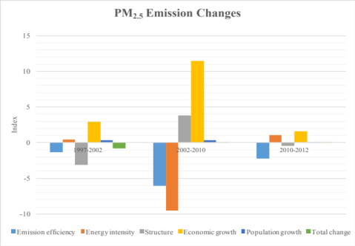
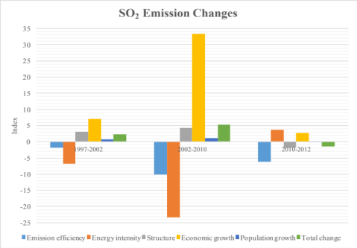
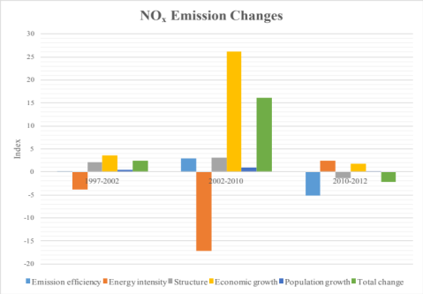

Figure 4.1 Results of air pollutant emissions decomposition: additive decomposition at the national level. Top: PM_{2.5}. Bottom (left to right): SO₂, NO_{x}.

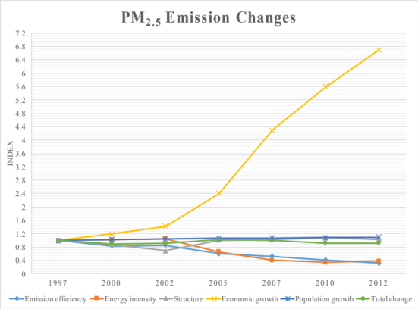
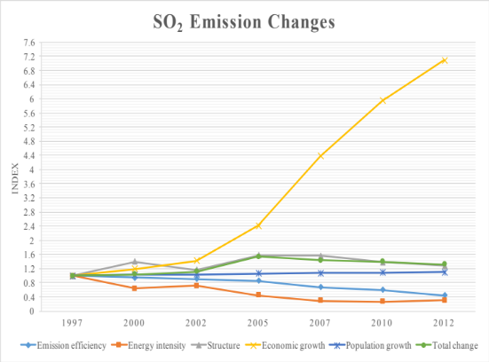
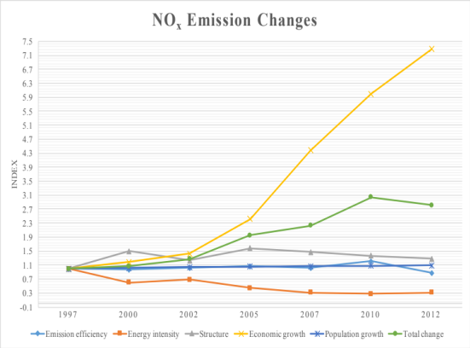

Figure 4.2 Time series decomposition multiplicative decomposition of air pollutant emissions at the national level. Top: PM_{2.5}. Bottom (left to right): SO₂, NO_{x}.

Analysis during 1997 – 2002
During this period, while the national PM_{2.5} emissions decreased by 10%, the SO2 and NOx emissions in China experienced an increase by 12% and 26%, respectively. The economic growth effect was the dominant factor contributing to the change in all three pollutant emissions in this period, and there was an upward trend in the economic growth effect. It contributed to 2.93Mt, 7.09Mt and 3.60Mt increases in PM_{2.5}, SO2 and NOx emissions, respectively, compared with -0.84Mt, 2.26Mt, and 2.40Mt net total changes, respectively. The population growth effect also contributed positively to all air pollutant emissions during this period, although to a lesser extent than the economic growth. Between 1997 and 2002, the population growth effect would have caused 3.90%, 3.88% and 3.89% increase to PM_{2.5}, SO2 and NOx emissions, if the impacts of other factors remained unchanged at the 1997 level. The energy intensity effect contributed to and increase (0.29Mt) in PM_{2.5} emissions, whereas a significant decrease in both SO2 (-6.80Mt) and NOx (-3.89Mt) emissions. Interestingly, the impact of structure effect on the emission changes of three air pollutants showed a different pattern from the energy intensity effect. It reduced PM_{2.5}emissions by 3.14Mt while increased SO2 and NOx emissions by 3.04Mt and 2.14Mt, respectively over the same time period. With respect to the emission efficiency factor, it drove a 1.34Mt and 1.84Mt decrease in both PM_{2.5} and SO2 emissions, while leading to a rise in NOx emission changes by 0.16Mt.

Analysis during 2002 – 2010
From 2002 to 2010, there was a slight increase in PM_{2.5}emissions (0.10Mt). The SO2 and NOx emissions experienced a dramatic increase during this period, 5.30Mt and 16.14Mt respectively. The economic growth effect remains to be the most significant contributor to the increase in all three air pollutant emissions, contributing to 11.49Mt, 33.12Mt, and 26.24Mt to PM_{2.5}, SO2 and NOx emissions, respectively. The contribution from the secondary sector was more than from the tertiary sector at national level. The structure effect is the second largest contributor to the NOx and SO2 emission changes, and in contrast to the previous time period, it contributed to an increase in PM_{2.5}emissions by 3.82Mt from 2002 to 2010. That structure effect leading to an increase in pollutant emissions can be explained by the heavy reliance on the industrial sector in China. Population growth effect still contributes positively to all emission changes, but less significantly than the economic growth effect and structure effect. The increase in PM_{2.5}, SO2 and NOx emissions is tempered by a decrease in energy intensity due to technological advancement in industrial, commercial and residential sectors. The energy intensity effect is the most important factor to combat the increase in air pollutant emissions, accounting for 66%, 74% and 72% of emission reduction in PM_{2.5}, SO2 and NOx emissions, respectively, if other factors were at their particular base year level. Reductions of energy intensity in the secondary sector are more noticeable than the tertiary sector for all three air pollutants. While the emission efficiency effect also contributes to reductions in PM_{2.5} and SO2 emissions in this period, it still leads to an increase in NOx emission levels by 2.95Mt, which might be caused by less nitrogen removal during the energy production process.

Analysis during 2010-2012
The emission levels of PM2.5, SO2 and NOx remained nearly stable during this period of time, with a net increase in PM2.5 emissions (0.05Mt), and decreases in SO2 (-1.37Mt) and NOx (-2.12Mt) emissions. The economic growth and population growth during the two-year period still contributed to the increases in all three air pollutant emissions. They jointly led to an increase by 1.65Mt, 2.93Mt and 1.80Mt of PM2.5, SO2 and NOx emissions. Contrary to the earlier period, the structure effect contributed to a decline in all emission levels, and the energy intensity effect was favorable to the growth of the pollutant emissions. The emission efficiency effect on all pollutant emissions is found to contribute towards decreasing the PM2.5, SO2 and NOx emissions in this period, thus resulting in a decline in SO2 and NOx levels. Although the total PM2.5 emissions in 2012 was not as much as the that in 1997, the SO2 and NOx emissions were higher than the 1997 levels.

DISCUSSION
Although the primary PM_{2.5} emissions have decreased slightly between 1997 and 2012, the increase in SO₂ and NO_{x} emissions may result in a rise in secondary PM_{2.5} formations, thus causing severe urban air pollution.
The decomposition results identified the economic growth effect as the primary factor in driving the growth of primary PM_{2.5}, SO₂ and NO_{x} emissions in China, especially since 2002. A new phase of rapid economic development has started since the second half year of 2002 after China’s accession to the WTO, and the process of industrialization and urbanization has been expedited (Liao et al., 2007). Economic activities from the secondary sector contributed most to the growth in all air pollutant emissions, which shows the national economic reliance on the manufacturing and construction industries. The economic growth effect from the tertiary sector has become more prominent in recent years, particularly on the NO_{x} emission changes, which might stem from the explosive expansion of the transportation sector.
The results have also shown that improvements in energy intensity have been the key factor in decreasing the overall PM_{2.5}, SO₂ and NO_{x} emissions from 1997 to 2012, although it contributed positively to all three air pollutants after 2010. However, the increasing economic effect is more significant than the energy intensity effect, such that the economic-growth-driven pollutant emissions cannot be completely offset by technological advancement.
There has been improvement in the emission efficiency effect in reducing all pollutant emissions, due to an energy mix shift at the national level. This was achieved by the increasing percentage of electricity and natural gas in energy consumption, a rising proportion of renewable energy, and a reduction in the share of coal in energy production.
The structural change in the economy has led to increases in emission levels of all three air pollutants from 1997 to 2010, with varying extent. However, the structure effect has started to contributed to a decline in pollutant emissions since 2010, which can be attributed to the national’ efforts in structural optimization.
The population effect has also played an essential role in growing PM_{2.5}, SO₂ and NO_{x} emissions, which implied an increasing proportion of people that are engaged in less technical and more pollution-intensive production.

CONCLUSIONS
The study of PM_{2.5} emissions includes three pollutants: primary PM_{2.5} , SO₂ and NO_{x}, with the latter two being the precursors. The results show that emissions of primary PM2.5 remained nearly stable from 1997 to 2012, and the emission level of the other two air pollutants increased during the same period, most of which was induced by the economic growth effect. If other factors remain at their base year (1997) levels, the economic growth would lead to around a sixfold increase in PM_{2.5}, SO₂ and NO_{x} emissions. Structural variations and population growth also contributed to more pollutant emissions, but to a lesser extent and with varying impacts on the three pollutants. The emission efficiency and energy intensity effect should be intensified to further facilitate a reduction in pollution emissions.
China has formulated and implemented regulations and targets for PM_{2.5} mitigation, including both primary PM_{2.5} and the precursor chemicals. For instance, the “Ten Measures of Air Pollution Reduction” implemented by the State Council in 2013 emphasized the weeding out of industrial boilers with low efficiency, energy structure optimization, promoting cleaner production pattern, fuel quality improvement, regulatory enhancement, and economic incentives for green energy development (Guan et al., 2014). While all these approaches intend to reduce direct emissions from industrial production, rectification of the underlying socioeconomic drivers that cause emission increases is also of great significance if sustainable development is to be achieved in China. Although strict policies in strengthening low emission production technologies have been implemented in China, yet more effort is required to improve economic development patterns, optimize industrial sectors, and adjust energy supply structures.

POLICY IMPLICATIONS
Sustainable urbanization consists of urban development processes without deterioration of the environment, while still providing an urban life in accordance with the desires of people (World Bank, 2014). Reforms that provide impetus to urban environmental improvement would contribute to sustainable urbanization. Therefore, in the future, China should consider environmental sustainability as a policy goal possessing the same weight as economic growth and social inclusion.
With regard to the considerable contribution of economic growth effect to PM_{2.5}, SO₂ and NO_{x} emissions, government should control the GDP growth to limit environmental degradation and pollution. Many local governments are still blindly pursuing the economic growth and constructing “image and administrative achievement” projects, without fully understanding the significance of environmental protection. As a result, the pollution levels increase as the economy develops. China should emphasize economic efficiency and quality rather than quantity, scale and speed.
To effectively address the smog issue, China should also gradually phase out energy-intensive, pollution-intensive and emission-intensive industries. Though bringing challenges to China’s economy, the reform will introduce opportunities for production structure optimization. A decrease in pollution-intensive industries there will provide more development space for the environmentally friendly enterprises. The essence of tackling smog is to eliminate bubbles in China’s economy, and to regard environmental protection as a key component in China’s economic growth.
Urban production patterns should be based on a city’s environmental capacity, factor endowments and comparative advantages. A shift in production structure to low energy consumption and low pollution is also necessary for sustainable urbanization in China. China should intensify the structural adjustment, including stimulating the tertiary industry and curtailing the share of secondary industry, to cut primary PM_{2.5} , SO₂ and NO_{x} emissions in pursuit of improvement in urban air quality. China should also encourage an increase in the proportion of light industry in the secondary sector, for instance, biology and electronics, while slimming down the size of heavy industry sectors, especially those high energy consumers. There is, however, an enormous domestic demand for automobiles and real estates now in China, which inevitably reflects the need for energy-intensive products, for instance, cement, steel and suchlike (Zhao, 2010). Under this situation, changes in international trade pattern could be considered. Products requiring higher levels of technology but less energy consumption should be encouraged to be produced more domestically in exchange of high-energy-intensive commodities manufactured in foreign markets. This will not only satisfy the domestic demands for development, but provide a stimulus to industrial structure alteration as well.
Promoting technological advancement is crucial to improve emission efficiency. Technological advancement is considerably correlated with PM_{2.5}, SO₂ and NO_{x} emissions. In order to improve emission efficiency, it is necessary to upgrade technological advancement from both macro and micro aspects. On a macro basis, large-scale and more efficient factories should replace small-scale and less efficient ones. Small and scattered coal-fired units, for instance, should be replaced by large and central ones to improve the overall efficiency of coal-fired plants. From a micro perspective, it is necessary to advance the technology dealing with dust, SO₂ and NO_{x} emissions. All key industries such as coal-fired power plants and metal smelting plants should install sulphur reducing measures as well as nitrogen and dust emission control facilities. The costs of pollutant reduction facilities need to be reduced so the penetration rate of these facilities in relevant industries can be enhanced. Exhaust purification device should be legally required on vehicles to effectively reduce mobile sources of pollutant emissions.
Lowering coal consumption and improving coal quality are also crucial to the control of energy intensity driven emissions. The Chinese government should stimulate the development of hydroelectricity, promote utilization of geothermal energy, wind energy, solar energy and biomass energy provision and safely develop nuclear energy. The rate of coal dressing should be increased. The import of high-dust and high-sulphur content coal should be prohibited. The efficiency of energy utilization should also be aligned with international standards to gradually reduce energy intensity.
Smog is threatening sustainable development in China and PM_{2.5} emission control is a tough and challenging task. China should implement stringent environmental policies and regulations as well as empower the Environmental Protection Bureau to ensure relevant standards are complied with, and targets met. Though there is still a long way to go, China is determined and committed to providing a better quality of life to its citizens.

REFERENCES
Ang, B. W. (2004). Decomposition analysis for policymaking in energy: which is the preferred method? Energy policy, 32(9), 1131-1139.
Ang, B. W. (2005). The LMDI approach to decomposition analysis: a practical guide. Energy policy, 33(7), 867-871.
Ang, B. W., & Liu, N. (2007). Energy decomposition analysis: IEA model versus other methods. Energy policy, 35(3), 1426-1432.
Ang, B. W., & Liu, N. (2007). Handling zero values in the logarithmic mean Divisia index decomposition approach. Energy Policy, 35(1), 238-246.
Chai, F., Gao, J., Chen, Z., Wang, S., Zhang, Y., Zhang, J., ... & Ren, C. (2014). Spatial and temporal variation of particulate matter and gaseous pollutants in 26 cities in China. Journal of Environmental Sciences, 26(1), 75-82.
China Statistical Yearbook. 1997-2008. National Statistical Bureau, People’s Republic of China: China Statistics Press
Chong, W. H. B., Guan, D., & Guthrie, P. (2012). Comparative analysis of carbonization drivers in China's megacities. Journal of Industrial Ecology, 16(4), 564-575.
Dhakal, S. (2009). Urban energy use and carbon emissions from cities in China and policy implications. Energy Policy, 37(11), 4208-4219.
Duan, F. K., He, K. B., Ma, Y. L., Yang, F. M., Yu, X. C., Cadle, S. H., ... & Mulawa, P. A. (2006). Concentration and chemical characteristics of PM _{2.5} in Beijing, China: 2001–2002. Science of the Total Environment, 355(1), 264-275.
Feng, K., Siu, Y. L., Guan, D., & Hubacek, K. (2012). Analyzing drivers of regional carbon dioxide emissions for China. Journal of Industrial Ecology, 16(4), 600-611.
Guan, D., Peters, G. P., Weber, C. L., & Hubacek, K. (2009). Journey to world top emitter: An analysis of the driving forces of China's recent CO2 emissions surge. Geophysical Research Letters, 36(4).
Guan, D., Su, X., Zhang, Q., Peters, G. P., Liu, Z., Lei, Y., & He, K. (2014). The socioeconomic drivers of China’s primary PM2. 5 emissions. Environmental Research Letters, 9(2), 024010.
Han, Y., Xiong, X., Liu, Y., Pan, Y. R., & Zhang, Y. B. (2011, May). The Analysis of Factors Affecting SO2 Emission of Chinese Industry. In Computer and Management (CAMAN), 2011 International Conference on (pp. 1-11). IEEE.
Huang, X. F., He, L. Y., Hu, M., & Zhang, Y. H. (2006). Annual variation of particulate organic compounds in PM _{2.5} in the urban atmosphere of Beijing. Atmospheric Environment, 40(14), 2449-2458.
International Institute for Sustainable Development (2004). An environmental impact assessment of China’s WTO accession: An analysis of six sectors.
L. Han, W. Zhou, W. Li, Li Li (2014). Impact of urbanization level on urban air quality: a case of fine particles (PM_{2.5} ) in Chinese cities. Environmental Pollution, 194 (2014), 163–170
Liao, H., Fan, Y., & Wei, Y. M. (2007). What induced China's energy intensity to fluctuate: 1997–2006?. Energy Policy, 35(9), 4640-4649.
Liu, Z., Geng, Y., Lindner, S., Zhao, H., Fujita, T., & Guan, D. (2012). Embodied energy use in China's industrial sectors. Energy policy, 49, 751-758.
Megaritis, A. G., Fountoukis, C., Charalampidis, P. E., Pilinis, C., & Pandis, S. N. (2013). Response of fine particulate matter concentrations to changes of emissions and temperature in Europe. Atmospheric Chemistry and Physics, 13(6), 3423-3443.
R. Wang (2009). Sustainable Urban Development in China: A Literature Review on Issues, Policies, Practices, and Effects
Rose, A., & Casler, S. (1996). Input–output structural decomposition analysis: a critical appraisal. Economic Systems Research, 8(1), 33-62.
United Nations, Department of Economic and Social Affairs, Population Division (2014). World Urbanization Prospects: The 2014 Revision, Highlights (ST/ESA/SER.A/352).
World Bank, Development Research Center of the State Council. Urban China: Toward Efficient, Inclusive, and Sustainable Urbanization. Washington, DC, USA: World Bank Publications, 2014
Xie, Y., Zhao, B., Zhang, L., & Luo, R. (2015). Spatiotemporal variations of PM2. 5 and PM10 concentrations between 31 Chinese cities and their relationships with SO2, NO2, CO and O3. Particuology, 20, 141-149.
Xinhua News (2013), 70 Chinese cities suffer serious air pollution in Q3, retrieved from Xinhua Net, edited, Beijing
Yang, Y., & Christakos, G. (2015). Spatiotemporal Characterization of Ambient PM2. 5 Concentrations in Shandong Province (China). Environmental science & technology, 49(22), 13431-13438.
Yao, Q., Li, S. Q., Xu, H. W., Zhuo, J. K., & Song, Q. (2010). Reprint of: Studies on formation and control of combustion particulate matter in China: A review. Energy, 35(11), 4480-4493.
Zhang, F. (2013). Rapid urbanization contributes to air pollution, retrieved from China.org.cn
Zhang, P. (2013). End-of-pipe or process-integrated: evidence from LMDI decomposition of China’s SO2 emission density reduction. Frontiers of Environmental Science & Engineering, 7(6), 867-874.
Zhang, Y., Wang, H., Liang, S., Xu, M., Zhang, Q., Zhao, H., & Bi, J. (2015). A dual strategy for controlling energy consumption and air pollution in China's metropolis of Beijing. Energy, 81, 294-303.
Zhao, P. S., Dong, F., He, D., Zhao, X. J., Zhang, X. L., Zhang, W. Z., ... & Liu, H. Y. (2013). Characteristics of concentrations and chemical compositions for PM _{2.5} in the region of Beijing, Tianjin, and Hebei, China. Atmospheric Chemistry and Physics, 13(9), 4631-4644.
Zhao, X.L., Xu H. W., Yang J., & Zhe C. (2010) Study on Chinese Industrial SO2 Emission Intensity Based on LMDI I and LMDI II Method. IEEE.
Zheng, M., Salmon, L. G., Schauer, J. J., Zeng, L., Kiang, C. S., Zhang, Y., & Cass, G. R. (2005). Seasonal trends in PM2. 5 source contributions in Beijing, China. Atmospheric Environment, 39(22), 3967-3976

Appendix A
Figure A1 Total Energy Consumption by Sector of China, 2007

Source: Chong et al. (2012)
Figure A2 Total Energy Consumption by Fuel of China, 2007
Source: Chong et al. (2012)

Source: Chong et al. (2012)

Appendix B Sectorial emission contributions

Table B1 PM_{2.5}
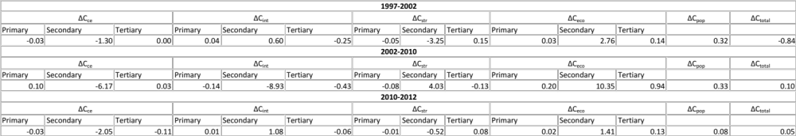

Table B2 SO₂
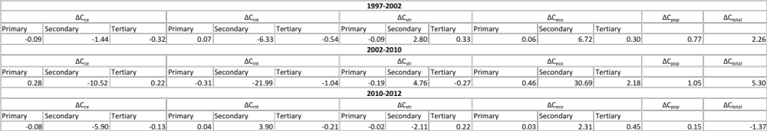

Table B3 NO_{x}
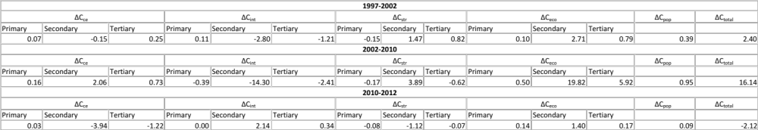

Source: Self calculations

