Running Head: SPACE-TIME INTERACTION IN THE INTERNAL CLOCK

On magnitudes in memory: An internal clock account of space-time interaction

Zhenguang G. Cai ^{a, b} Louise Connell ^{c, b}

ª Department of Experimental Psychology, University College London, London, UK
^{b} School of Psychological Sciences, University of Manchester, Manchester, UK
^{c} Department of Psychology, Lancaster University, Lancaster, UK

Word count (incl. abstract, tables, figure captions, footnotes): 9366

Author Note:
This work was funded in part by a research grant from the ESRC (ES/L010224/1) to the first author and a research grant from the Leverhulme Trust (F/00 120/CA) to the second author. We thank Ruiming Wang and Wenjuan Liu from South China Normal University for assistance in data collection for Experiment 2.
Correspondence concerning this article should be addressed to Zhenguang G Cai, Department of Experimental Psychology, University College London, 26 Bedford Way, London, WC1H 0AP. Email: zhenguangcai@gmail.com

Abstract
Traditionally, research on time perception has diverged into a representational approach that focuses on the interaction between time and non-temporal magnitude information like spatial distance, and a mechanistic approach that emphasizes the workings and timecourse of components within an internal clock. We combined these approaches in order to identify the locus of space-time interaction effects in the mechanistic framework of the internal clock model. In three experiments, we contrasted the effects of spatial distance (a long- vs. short-distance line) on time perception with those of visual flicker (a flickering vs. static stimulus) in a duration reproduction paradigm. We found that both a flickering stimulus and a long-distance line lengthened reproduced time when presented during time encoding. However, when presented during time reproduction, a flickering stimulus shortened reproduced time but a long-distance line had no effect. The results thus show that, while visual flickers affects duration accumulation itself, spatial distance instead biases the memory of the accumulated duration. These findings are consistent with a clock-magnitude account of space-time interaction whereby both temporal duration and spatial distance are represented as mental magnitudes that can interfere with each other while being kept in memory, and places the locus of interaction between temporal and non-temporal magnitude dimensions at the memory maintenance stage of the internal clock model.
Keywords: Time perception, space-time interaction, magnitude, internal clock, memory interference
1. Introduction
Time is a paradox to the human mind. It is a ubiquitous psychological experience but imperceptible to our senses. That is, there does not seem to be a physical medium for time (like light for vision) or a bodily faculty that tunes into time (like the eye for vision). For instance, we can perceive the empty interval between two clicks and have some memory of its duration, even though none of our bodily senses appear to register the emptiness. Thus, research on time perception has focused on the cognitive processes and memory representations that underlie our capacity to perceive time, and has historically split into two largely parallel but related literatures with separate theoretical emphases and empirical effects: the representational approach and the mechanistic approach.
Since time perception does not appear to rely on any particular bodily sense, the representational approach to time perception concerns the mental or conceptual representational format of temporal durations and investigates how our perception of an event’s duration is influenced by other dimensions of the same event (e.g., DeLong, 1981; Piaget, 1969; Xuan, Zhang, He, & Chen, 2007). One such dimension that has been heavily investigated in time representation research is spatial distance. It has been repeatedly demonstrated that perceived duration increases as a function of concurrent spatial distance (Cai, Connell, & Holler, 2013; Casasanto & Boroditsky, 2008; Merritt, Casasanto & Brannon, 2010). For instance, Casasanto and Boroditsky (2008) displayed a line of a particular length onscreen for a particular duration and then asked participants to reproduce the duration: they showed that participants’ reproduced durations increased as a function of concurrent line length. Similarly, Cai et al. (2013) showed that participants reproduced a longer duration for a sung note if the singer in the video made a concurrent long-distance horizontal gesture compared to a short-distance one. Indeed, the ability of space to distort time relies on having a reliable, high-acuity representation of spatial distance. Cai and Connell (2015) showed that when spatial distance is perceived via low-acuity haptics (rather than high-acuity vision), it has no effect on reproduced duration; instead, the relationship flipped so that time distorted space, and reproduced distance increased with duration. These space-time interaction effects suggest a close relationship between the representations of spatial distance and temporal duration. Further work also suggests that time perception is influenced by other dimensions such as digit magnitude (Cai & Wang, 2014; Chang, Tzeng, Hung, & Wu, 2011; Oliveri et al., 2008; Xuan et al., 2007), numerosity (Dormal, Seron, & Pesenti, 2006; Javadi & Aichelburg, 2012; Xuan et al., 2007), and spatial size (DeLong, 1981; Rammsayer & Verner, 2014; Xuan et al., 2007).
To account for these non-temporal effects on time, some researchers have proposed that temporal durations are encoded and represented as some kind of nonverbal magnitudes, as are other quantifiable dimensions such as distance, size and numerosity (Bueti & Walsh, 2009; de Hevia, Izard, Coubart, Spelke, & Streri, 2014, Gallistel & Gelman, 2000; Walsh, 2003, 2014). These magnitudes from different dimensions share a common representational format (e.g., Lambrechts, Walsh, & van Wassenhove, 2013) and appear to be processed in the same neural circuits (e.g., Bonato, Zorzi, & Umiltà, 2012; see Bueti & Walsh, 2009, for a review). Due to the noise inherent in these representations (Gallistel & Gelman, 2000; Petzschner, Glasauer, & Stephan, 2015), it is possible for concurrently-perceived magnitudes to pull on each other such that a larger magnitude representation of a non-temporal dimension (e.g., a long line versus a short line, or a large number versus a small number) can increase the magnitude representation of a duration. In addition to accounting for the effects of nontemporal dimensions on time perception, the magnitude representation account also helps to explain recent findings that time can also exert influence on the perception of other physical dimensions such as spatial distance and numerosity (Cai & Connell, 2015; Javadi & Aichelburg, 2012; Merrit et al., 2010; Roitman, Brannon, Andrews, & Platt, 2007).
The notion of time being represented as mental magnitudes has its root in an earlier mechanistic approach to time perception, which stipulates that temporal durations are perceived and stored as accumulative quantities (e.g., Gibbon, Church, & Meck, 1984; Meck & Church, 1983; Treisman, 1963). The mechanistic approach has focused on how temporal durations are registered, memorized, and retrieved (see Grondin, 2010, for a review). Perhaps the most influential theory of the mechanistic approach to time perception is scalar expectancy theory (Gibbon, 1977). While the theory is incorporated in most current models of time perception (e.g., Gu, van Rijn, & Meck, 2015; Matell & Meck, 2000; Wackmann, 2011, it is probably best known as the internal clock model (Gibbon et al., 1984; Treisman, 1963; Wearden, 1991; see Allman, Teki, Griffiths, & Meck, 2014, for review). The internal clock model stipulates a timing mechanism with an internal clock system (a pacemaker and accumulator), a memory store, and a comparator. The pacemaker, a continuously-running timing device, emits signals or pulses at a certain rate. When timing begins, the pacemaker is connected, via a switch, to the accumulator which collects the pulses. The accumulated pulses register the perceived duration, which may be stored and maintained in memory for later reference. When a temporal judgment is to be made, the comparator then compares the perceived duration (i.e., pulses in the accumulator) with a reference duration (i.e., pulses kept in reference memory). For example, a comparison task may require the participant to decide whether a new perceived duration is longer or shorter than a memorized reference duration, while a reproduction task may require the participant to terminate a new, ongoing duration when the accumulated pulses reach a record that is equivalent to the memorized reference duration (for formal formulations of these processes, see Gibbon, 1977; Gibbon et al., 1984).
Because perceived durations are assumed to be the accumulated quantity of pulses that are collected from the pacemaker during the accumulation stage, and stored in working memory during the maintenance stage, the internal clock model predicts that the amount of time perceived can vary as a function of pulse accumulation and memory processes. Indeed, external manipulations such as rapid repetitive stimulation (e.g., auditory click train, visual flicker) have been found to increase perceived duration of a stimulus (Droit-Volet & Wearden, 2002; Herbst, Javadi, van der Meer, & Busch, 2013; Ortega & Lopez, 2008; Penton-Voak, Edwards, Percival, & Wearden, 1996; Wearden, Philpott, & Win, 1999). Ortega and Lopez (2008), for instance, asked people to decide whether a target duration resembled a short or a long reference duration they had previously learnt and showed that the target duration was more often perceived to be short when the reference duration had been accompanied by a flickering dot, but perceived to be long when the target duration itself was accompanied by a flickering dot. These timecourse-dependent reverse effects support the idea that visual flicker leads to more pulses being accumulated, and hence a larger amount of perceived time for whichever duration it accompanies. Such effects may arise as result of visual flicker accelerating the pacemaker speed (Droit-Volet & Wearden, 2002; Ortega & Lopez, 2008), increasing attentional allocation to duration monitoring and allowing more pulses to be registered (Herbst et al., 2013; Zakay & Block, 1995, 1997; see also Lejeune, 1998), or triggering earlier switch-on and/or delayed switch-off of the accumulator (Penney, Gibbon, & Meck, 2000; Wearden, O’Rourke, Matchwick, Min, & Maeers, 2010). While different, these mechanisms all localize visual flicker effects in the accumulation stage of the internal clock model (we will return to this point in the general discussion).
Time perception can also be affected at the later stage of memory maintenance. Perceived durations may also change as a result of reference memory interference or mixing (Grondin, 2005; Gu & Meck, 2011; Jazayeri & Shadlen, 2010; Jones & Wearden, 2004; Penney, Allan, Meck, & Gibbon, 1998; Taatgen & Van Rijn, 2011). Jazayeri and Shadlen (2010), for example, showed that when multiple durations have to be remembered, reproduced durations show regression towards the mean, with long stimulus durations under-reproduced and short ones over-reproduced. Such inter-duration interference, in the internal clock model, can be attributed to the mixing or blending between different records of accumulated pulses (i.e., different durations) within reference memory (Gu & Meck, 2011; Penney et al., 1998; Taatgen & Van Rijn, 2011). Nonetheless, while these studies did examine memory representations of duration, their focus was on interaction within the dimension of time, rather than interactions between time and non-temporal dimensions (i.e., cross-dimensional interference). One exception is Moon, Fincham, Betts and Anderson (2015), who argued that distance and duration information may cue each other in memory and potentially lead to cross-dimensional interference. However, Moon et al.’s paradigm was unusual in that it required participants to learn and remember mappings between four different colours, response fingers, and reference distances/durations. It is therefore not clear to what extent their effects are purely distance-duration interference, or at what processing stage distance and duration interact with each other.
The above overview illustrates that, despite their shared topic, the representational and mechanistic approaches to time perception each have their own research agenda, theoretical underpinnings, and empirical effects, with little cross-reference to each other’s research. The recent comprehensive review of the mechanistic approach by Grondin (2010), for instance, has no reference to theoretical accounts or empirical reports of representational interference between time and non-temporal dimensions (e.g., Casansanto & Boroditsky, 2008; Walsh, 2003; Xuan et al., 2007). The oversight of the representational approach in the mechanistic literature may be attributed to the fact that proponents of the representational approach to time perception have rarely specified the mechanisms of a detailed process model whereby time and non-temporal dimensions interact. For instance, the magnitude representation account does not detail when and where in the timecourse of time perception that non-temporal dimensions exert their effects (Walsh, 2003); even very recent reviews of the account fails to touch upon the issue (Walsh, 2014; Winter, Marghetis & Matlock, 2015).
In the present paper, we aim to combine the representational and mechanistic approaches in order to better understand the mechanism of interference between time and non-temporal dimensions. To this end, we focus on identifying a possible locus of space-time interactions within a well-studied mechanistic framework of time perception, the internal clock model. We conducted three experiments using a time reproduction paradigm in which participants perceived a stimulus duration and then reproduced it (e.g., Cai et al., 2013; Cai & Connell, 2015; Casasanto & Boroditsky, 2008; Wearden, 2003). In theoretical terms, participants need to first encode the stimulus duration and maintain it in memory; when they are to reproduce the duration, they first retrieve the stimulus duration, then initiate an unfolding reproduced duration which they terminate when it reaches subjective equality with the retrieved stimulus duration (for theoretical treatment of duration reproduction, see Riemer et al., 2012; Wackermann & Ehm, 2006; Wearden, 2003).
We compared the effect of visual flicker and spatial distance on duration reproduction when they were concurrently presented during time encoding (i.e., participants saw spatial distance or visual flicker during perception of a stimulus duration and then reproduced the duration) or time reproduction (i.e., participants perceived a stimulus duration and then saw spatial distance or visual flicker while they were reproducing the duration). As we reviewed above, temporal representations can be biased during the accumulation or memory maintenance stage in the internal clock; thus, either of these stages can be the potential locus of space-time interaction effects.
If space-time interaction occurs during the accumulation stage, spatial distance may operate like visual flicker in biasing time accumulation (i.e., the clock-accumulator account). A visually flickering stimulus (compared to a static, non-flickering stimulus) is believed to increase the number of pulses that are stored in the accumulator (e.g., by altering the speed of the pacemaker, or the timing of the switch operation), resulting in a longer perceived duration (Ortega & Lopez, 2008; Penton-Voak et al., 1996; Wearden et al., 1999). If longer spatial distance likewise biases time accumulation, then we should expect a long-distance line (compared to a short-distance line) to lead to more accumulated pulses and therefore a longer perceived duration. Critically, such a clock-accumulator account means that any effects should reverse when the stimulus is presented during time reproduction instead of time encoding (Droit-Volet & Wearden, 2002; Ortega & Lopez, 2008). Specifically, if more pulses are accumulated while a participant retrieves and reproduces a particular duration from reference memory, it will make time appear to pass more quickly during the reproduction task itself and lead participants to terminate the reproduced duration earlier. Hence, both a visually flickering stimulus and a longer spatial distance should lead to shorter reproduced durations than a static (non-flickering) stimulus or a shorter spatial distance, respectively. In summary, if the locus of space-time interaction lies in the accumulation stage of the internal clock model (as the clock-accumulator account assumes), then a concurrent longer-distance line, compared to a shorter-distance line, should lead to longer reproduced durations when presented during time encoding, but shorter reproduced durations when presented during time reproduction.
Alternatively, if space-time interaction occurs during the memory maintenance stage, spatial distance may bias the magnitude representation of a perceived duration while it is being maintained in memory (i.e., a clock-magnitude account). In this case, we would expect spatial distance to exert a different pattern of effects on time reproduction compared to visual flicker (which will lead to longer reproduced durations if presented at the encoding stage and to shorter reproduction durations if presented at the reproduction stage, as outlined above). When a spatial line is presented for a particular duration during time encoding, the spatial distance information in the line should interfere with the representation of that duration as it resides in reference memory because they share a common magnitude format (Gallistel & Gelman, 2000; Walsh, 2003, 2014), such that long-distance lines, compared to short-distance ones, will make the duration seem subjectively longer (Cai et al., 2013; Cai & Connell, 2015; Casasanto & Boroditsky, 2008). Critically, such a clock-magnitude account means that spatial distance presented during time reproduction will not affect reproduced duration as it does not have the opportunity to interfere with its magnitude representation in reference memory. Because the magnitude representation of the duration does not experience any spatial interference as it resides in reference memory, it can be accessed and reproduced regardless of what spatial information might be concurrently perceived during the reproduction task itself. In summary, if the locus of space-time interaction lies in the memory maintenance stage of the internal clock model (as the clock-magnitude account assumes), then a longer-distance line will lead to longer reproduced durations when presented during time encoding, but have no effect when presented during time reproduction.

2. Experiments 1a and 1b
2.1. Method
2.1.1. Participants. Twenty-six volunteers from the University of Manchester community took part in the experiment (13 for Experiment 1a and 13 for Experiment 1b). All had normal or corrected-to-normal vision and were paid £4 for their participation.
2.1.2. Design and materials. Experiment 1a and 1b followed the same basic design (though they differed slightly in the stimulus durations used; see below). The experiments first manipulated the type of stimulus (visual flicker or spatial distance) that was concurrently presented with the stimulus duration (Experiment 1a) or the reproduced duration (Experiment 1b). In addition, within each stimulus type, we further contrasted two levels (the control vs. manipulated stimulus; see Fig. 1). The control stimulus for visual flicker was a static dot (i.e., onscreen constantly) that was black and 60 pixels (approx. 1.35 cm onscreen) in diameter; the corresponding manipulated stimulus was a flickering dot at a frequency of 7.5 Hz (i.e., alternating presentation of the black dot and a blank white screen for 66.7 ms each). The control stimulus for spatial distance stimulus was a line 6 pixels thick (approx. 0.14 cm onscreen) that extended horizontally for a short distance of 100 pixels (approx. 2.25 cm onscreen); the corresponding manipulated stimulus was a line of the same thickness that extended for a long distance of 400 pixels (approx. 9.00 cm onscreen). Thus, the experiments adopted the design of 2 (stimulus type: visual flicker vs. spatial distance) * 2 (manipulation: control vs. manipulated). Both factors were within participants.
In Experiment 1a, each critical stimulus (i.e., flickering/static dot or long/short line) was presented for a particular duration, and participants subsequently reproduced the duration while a neutral visual stimulus appeared onscreen (see Fig. 1 upper panel). Eight stimulus durations were chosen in order to ensure that the flickering stimulus always began and ended with the black dot (i.e., the visible component of the cycle) on a 60 Hz LCD monitor (which was used to display the stimuli): 867 ms, 1133 ms, 1533 ms, 1800 ms, 2067 ms, 2333 ms, 2733 ms, and 3000 ms. All stimuli appeared for all durations in random order across a block, and each block was presented four times, resulting in 128 trials in total in each experiment.
Experiment 1b was the same as Experiment 1a except that the stimulus duration was presented using a neutral visual stimulus, and participants subsequently reproduced the duration while the visual flicker or spatial distance stimulus appeared onscreen (see Fig. 1 lower panel). In addition, because this experiment used asterisks rather than a flickering dot to present the stimulus durations (see below), we used the following evenly-spaced durations: 900 ms, 1200 ms, 1500 ms, 1800 ms, 2100 ms, 2400 ms, 2700 ms, and 3000 ms.
2.1.3. Procedure. In both experiments (and Experiment 2 below), participants were individually tested in a cubicle using a 60Hz LCD monitor. After giving their written consent, participants began with a practice session of 4 trials before starting the main experiment. Figure 1 illustrates the trial structure for the two experiments. In Experiment 1a, each trial began with a critical stimulus (long/short-distance line or flickering/static dot) being presented for a particular duration. After a blank screen of 400 ms, a fixation cross appeared. To reproduce the duration, participants held down the spacebar, at which point the fixation cross was replaced by three asterisks (***). Participants released the spacebar when they felt that the asterisks had stayed onscreen for as long as the stimulus duration. An inter-stimulus interval (ISI) of 1000 ms followed the key release. Experiment 1b was similar to Experiment 1a except that a trial began with three asterisks (***) being presented for a particular duration. When participants held down the spacebar to reproduce the duration, these three asterisks were replaced by a critical stimulus (i.e., long/short-distance line or flickering/static dot), until participants released the spacebar. See the lower panel in Fig. 1 for the trial schematic. The experiment was run on SuperLab and lasted for approximately 15 minutes.
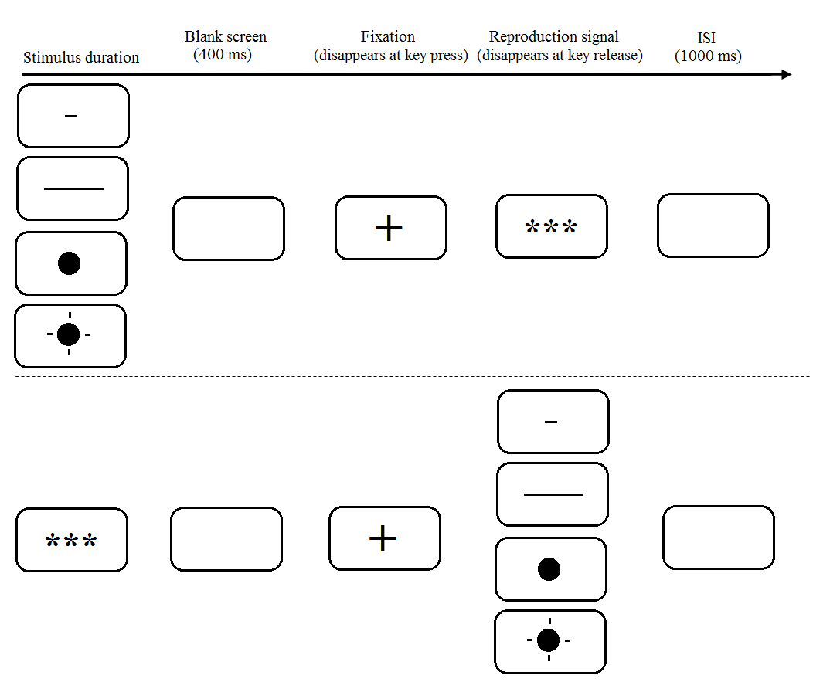
Figure 1: Trial structure for Experiment 1a (upper panel) and Experiment 1b (lower panel), showing where each stimulus type and manipulation (short-distance line, long-distance line, static dot, flickering dot) was presented in each trial.

2.2. Results and discussion
For each experiment, we excluded outliers that were more than 2 standard deviations away from the mean per condition at each duration (e.g., long-distance manipulation of the spatial distance stimulus type at 1800 ms), resulting in the removal of 4.0% of the data (70 out of 1664 trials) from each experiment. For each participant, we computed the average reproduced duration per combination of stimulus type, manipulation and stimulus duration (e.g., 900 ms stimulus duration presented in the long spatial distance condition). The analyses were conducted using the aov package in R, with average reproduced durations as the dependent variable and stimulus type (visual flicker vs. spatial distance), manipulation (manipulated vs. control stimulus), stimulus duration, and their interactions, as independent predictors. Contrast-coding was applied to the categorical variables of stimulus type (flicker = -0.5, distance = 0.5) and manipulation (control = -0.5, manipulated = 0.5). The same statistical method was used also used in Experiment 2. As an illustration of effect sizes, we also reported generalized eta-square (η_{G}²) (Lakens, 2013).
Results for Experiment 1a are presented in Table 1. As predicted, manipulating stimuli during time encoding led to longer reproduced durations than control stimuli. In addition, the visual-flicker stimulus type (static or flickering dots) generally led to longer reproduced durations than did the spatial distance type (long- or short-distance lines). Stimulus type and manipulation interacted, with larger effects for visual flicker (i.e., flickering vs. static dot) than for spatial distance (i.e., long- vs. short-distance line) (see Figure 2). Finally, reproduced duration increased as a function of stimulus duration, as did the difference between stimulus types and (marginally) the overall manipulation effect.
To establish the independence of each manipulation effect, we conducted planned comparisons, using manipulation, stimulus duration, and their interaction, as independent variables, separately for visual flicker and spatial distance. The predicted effect emerged for visual flicker (see Fig. 2A), with the flickering stimulus during time encoding leading to longer reproductions than the static (control) stimulus (M_{diff} = 522 ms, 95% CI = [368, 676], F(1,12) = 68.64, p < .001, η_{G}² = .489). This effect appeared to increase as a function of stimulus duration, as suggested by the significant interaction (F(1,12) = 4.86, p = .048, η_{G}² = .008). Reproduced durations overall increased as a function of stimulus duration (F(1,12) = 150.20, p < .001, η_{G}² = .743). For spatial distance (see Fig. 2B), the long-distance line led to longer reproduced durations than the short-distance (control) line (M_{diff} = 154 ms, 95% CI: [68, 240], F(1,12) = 21.75, p < .001, η_{G}² = .068), with the effect appearing to be constant across stimulus durations (F(1,12) = 1.70, p = .217, η_{G}² = .005). Reproduced durations again increased as a function of stimulus duration (F(1,12) = 139.10, p < .001, η_{G}² = .725).

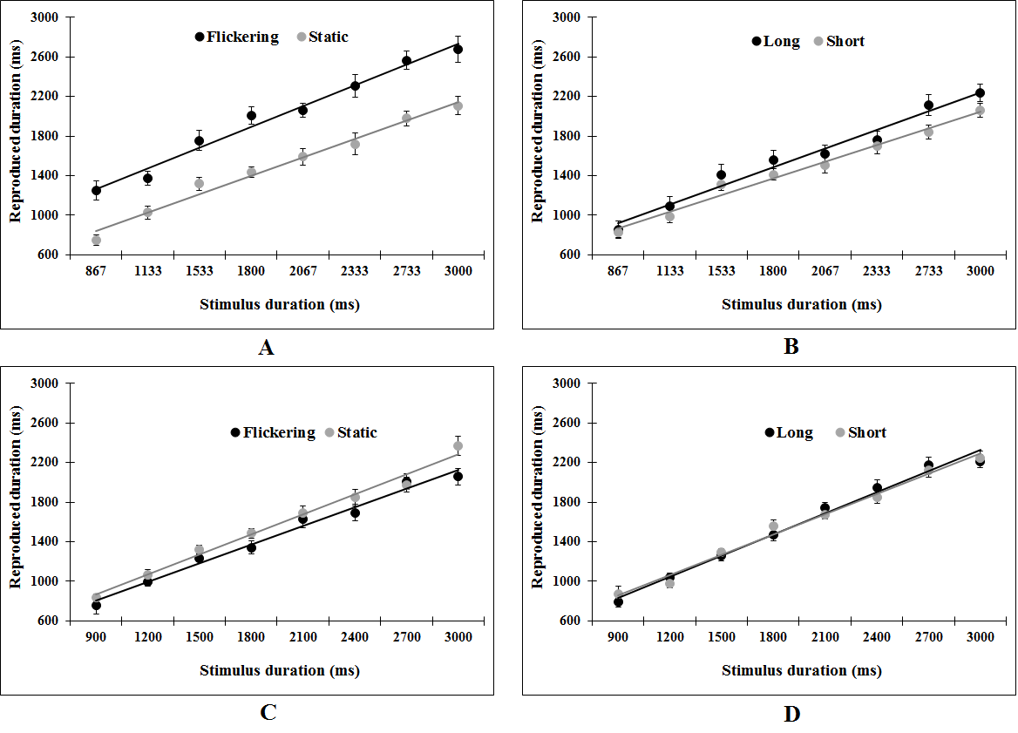
Figure 2: Effects of visual flicker and spatial distance on reproduced duration, when presented during time encoding in Experiment 1a (A and B) and during time reproduction in Experiment 1b (C and D). Error bars show SEs.

Table 1: Statistical results for Experiments 1a and 1b.
 |  |  | F | p | η_{G}²
Experiment 1a
 | Stimulus type |  | 31.57 | < .001 | .152
 | Manipulation |  | 67.47 | < .001 | .287
 | Stimulus duration |  | 157.50 | < .001 | .734
 | Stimulus type * Manipulation |  | 46.21 | < .001 | .122
 | Stimulus type * Stimulus duration |  | 5.07 | .044 | .008
 | Manipulation * Stimulus duration |  | 4.64 | .052 | .006
 | Stimulus type * Manipulation * Stimulus duration |  | 0.26 | .623 | < .001
Experiment 1b
 | Stimulus type |  | 5.94 | .031 | .027
 | Manipulation |  | 4.67 | .052 | .025
 | Stimulus duration |  | 668.20 | < .001 | .881
 | Stimulus type * Manipulation |  | 5.08 | .044 | .033
 | Stimulus type * Stimulus duration |  | 7.33 | .019 | .010
 | Manipulation * Stimulus duration |  | 0.25 | .627 | < .001
 | Stimulus type * Manipulation * Stimulus duration |  | 3.52 | .085 | .008
Note: df = (1, 12) for all effects.

The results of Experiment 1b (see Table 1) show that manipulated stimuli during time reproduction led to shorter reproduced durations than control stimuli, and visual flicker stimuli resulted in shorter reproduced durations than spatial distance stimuli. These observations were the reverse of those in Experiment 1a, where the critical stimuli were presented during encoding rather than reproduction. As before, the manipulation effect was larger for visual flicker stimuli than for spatial distance. Reproduced durations increased as a function of stimulus duration, as did the difference between stimulus types.
We next conducted separate analyses to examine the manipulation effects for each stimulus type. For visual flicker at the time reproduction stage (see Fig. 2C), the flickering stimulus led to shorter reproduced durations than the static (control) stimulus (M_{diff} = -117 ms, 95% CI = [-206, -27], F(1,12) = 8.74, p = .012, η_{G}² = .102). Inspection of Figure 2C seemed to suggest that the difference between the flickering and static dot increased as a function of stimulus duration, though the interaction between manipulation and stimulus duration was non-significant (F(1,12) = 2.74, p = .124, η_{G}² = .013). Reproduced duration increased as a function of stimulus duration (F(1,12) = 459.10, p < .001, η_{G}² = .867). For spatial distance at the reproduction stage (see Figure 2D), the long-distance and short-distance lines led to almost identical reproduced durations (M_{diff} = 10 ms, 95% CI = [-80, 101], F(1,12) = 0.06, p = .817, η_{G}² < .001), and this pattern appeared to be true for all stimulus durations (F(1,12) = 0.89, p = .365, η_{G}² = .005). Reproduced duration again increased as a function of stimulus duration (F(1,12) = 788.60, p < .001, η_{G}² = .894).
The above findings show that visual flicker produced stage-dependent reverse effects on duration reproduction: participants reproduced longer durations if visual flicker was manipulated during time encoding but shorter durations if it was manipulated during time reproduction. Spatial distance, however, affected duration reproduction only when it was presented during time encoding but not during time reproduction. A caveat is in order, however. Since reduced attention may lead to fewer pulses being passed through to the accumulator (Zakay & Block, 1995, 1997), it could be argued that the nontemporal stimulus (visual flicker or spatial distance) might exert a smaller effect on time if it is presented during time reproduction than during time encoding. After all, while participants in our experiments would have to closely attend to the stimulus at time encoding (in order to perceive the duration), they may not necessarily attend quite as closely to the stimulus during time reproduction because they must also allocate attention to button-pressing actions and to accessing the stored duration in memory. Such a possibility is supported by our observation that visual flicker produced a smaller effect size during time reproduction than time encoding (η_{G}² = .489 vs. η_{G}² = .102). This inattention-related reduction in effect size might render the effect of spatial distance, which was smaller than that of visual flicker during time encoding, too small to reach significance during time reproduction. That is, since absence of evidence does not in itself establish evidence of absence, and we cannot conclude from a non-significant effect there is no effect of spatial distance at time reproduction.
We therefore turned to Bayes factor (BF) in order to distinguish whether there is evidence for or against a small effect of spatial distance at time reproduction. BFs are ratios of the likelihoods of competing hypotheses (e.g., the alternative hypothesis that spatial distance exerting a real effect at time reproduction and the null hypothesis that spatial distance exerting no effect at time reproduction) on the basis of the observed data (Jeffreys, 1961; Kass & Raftery, 1995; Wagenmakers, 2007), and can be expressed either as evidence in favour of the alternative hypothesis (BF₁₀) or evidence in favour of the null hypothesis (BF₀₁). Following Wagenmakers (2007) and Masson (2011), we calculated BFs using Bayesian Information Criterion (BIC) approximation; such a method has been argued to yield more objective BFs as it does not involve the subjective specification of priors (Kass & Raftery, 1995; Wagenmakers, 2007). To do this, we first estimated the difference in BICs (ΔBIC) between an alternative hypothesis (e.g., spatial distance manipulation affects reproduced duration in Experiment 1a) and the corresponding null hypothesis (e.g., spatial distance manipulation does not affect reproduced durations), using the sum of squares and residual sum of squares associated with the critical effect, and then calculated the BF on basis of ΔBIC (for a details for this calculation we refer readers to Masson, 2011). For visual flicker at time encoding (Experiment 1a), BF₁₀ = 66227.1, meaning that the data were 66227 times more likely to occur under a model with visual flicker than a model without it, which constitutes very strong evidence (Kass & Raftery, 1995; Wagenmakers, 2007) that a visually flickering stimulus during time encoding led to longer reproduced durations. Conversely, there is positive evidence that visual flicker at time reproduction (Experiment 1b) led to shorter reproduced durations (BF₁₀ = 9.7). For spatial distance at time encoding (Experiment 1a), there is very strong evidence that the long-distance lines led to longer reproduced durations than short-distance lines (BF₁₀ = 230.0). Critically, when the lines were presented during time reproduction (Experiment 1b), there is positive evidence that long- and short-distance lines did not lead to different reproduced durations (BF₀₁ = 3.5). That is, BF analysis shows evidence of absence of spatial distance effects during time reproduction.
To summarize, both visual flicker and spatial distance affected time perception when they were presented concurrently with the stimulus duration at the point of time encoding (Experiment 1a). More specifically, when the stimulus duration was presented as a flickering dot, people reproduced it as longer than when it was presented as a static dot. Similarly, when the stimulus duration was presented as a long-distance line, people reproduced it as longer than when it was presented as a short-distance line. However, visual flicker and spatial distance each exerted very different effects on time perception when presented concurrently at the point of time reproduction (Experiment 1b). The effect of visual flicker flipped: when people saw a flickering dot while they reproduced a stimulus duration, they shortened the duration compared to when they saw a static dot. On the other hand, the effect of spatial distance disappeared: whether people saw a long- or short-distance line while they reproduced a stimulus duration, they reproduced the same duration regardless. These results are thus consistent with the clock-magnitude account of space-time interaction that places the locus of effects at the memory maintenance stage of the internal clock model, whereby visual flicker biases time accumulation but leaves temporal memory intact, and spatial distance does not affect time accumulation but instead interferes with memory of a perceived duration. In this account, a flickering stimulus results in more pulses being accumulated and therefore lengthens whichever duration that it accompanies, thus leading to longer reproduced durations when presented during time encoding but shorter reproduced durations when presented during time reproduction itself. In contrast, because temporal duration is stored in memory as magnitude information (e.g., quantity of pulses from the pacemaker), spatial distance has the ability to bias its representation while they reside concurrently in memory (i.e., when it is presented during time encoding but not time reproduction).

3. Experiment 2
Experiments 1a and 1b showed that visual flicker affects time perception by biasing the actual process of duration accumulation while spatial distance does so by biasing the memory of the accumulated duration. However, these conclusions are based on findings from different experiments using different participants. Experiment 2 aimed to replicate these findings using a within-participant design. That is, we compared the effect of visual flicker and spatial distance between the time encoding stage (i.e., concurrently presented with the stimulus duration) and the time reproduction stage (i.e., concurrently presented with the reproduced duration).
3.1. Method
3.1.1. Participants. Eighteen participants from the South China Normal University community (Guangzhou, China) were paid to take part in the experiment.
3.1.2. Design and procedure. The experiment consisted of an encoding-stage block (where target stimuli were manipulated during the time encoding stage) and a reproduction-stage block (where target stimuli were manipulated during the time reproduction stage). Setup of the encoding-stage block was exactly as in Experiment 1a, while the setup of the reproduction-stage block was exactly as in Experiment 1b. Thus, the experiment adopts a 2 (stage: encoding vs. reproduction) * 2 (stimulus type: visual flicker vs. spatial distance) * 2 (manipulation: control vs. manipulated) design. All factors were within participants and the order of blocks was counterbalanced across participants.
In order to mitigate potential fatigue effects from this longer blocked design, we reduced the number of stimulus durations from 8 to 6 by selecting the middle 6 durations used in Experiment 1a (i.e., 1133, 1533, 1800, 2067, 2333, and 2733 ms). These stimulus durations ensured that the flickering stimulus always began and ended with the visible component of the cycle.
3.1.3. Procedure. The procedure for each block was the same as Experiments 1a and 1b. Block order was counterbalanced across participants. The experiment was run on E-Prime and lasted for about 30 min.
3.2. Results and discussion
We excluded outliers as before, resulting in the removal of 4.1% of the data (106 out of 2592 trials). As in Experiments 1a and 1b, average reproduced means were analysed using stage (encoding vs. reproduction), stimulus type (visual flicker vs. spatial distance), manipulation (manipulated vs. control), stimulus duration, and their interactions, as independent predictors. Table 2 presents the results. Overall, reproduced durations were longer when target stimuli were presented during the encoding stage than during the reproduction stage, and for the manipulated stimulus than for the control stimulus, though they were similar for the two stimulus types. Reproduced duration increased with stimulus duration. There were also several two-way and three-way interactions which largely mirror those found in Experiment 1a, and which we further explore below by conducting separate analyses per stimulus type of visual flicker and spatial distance.

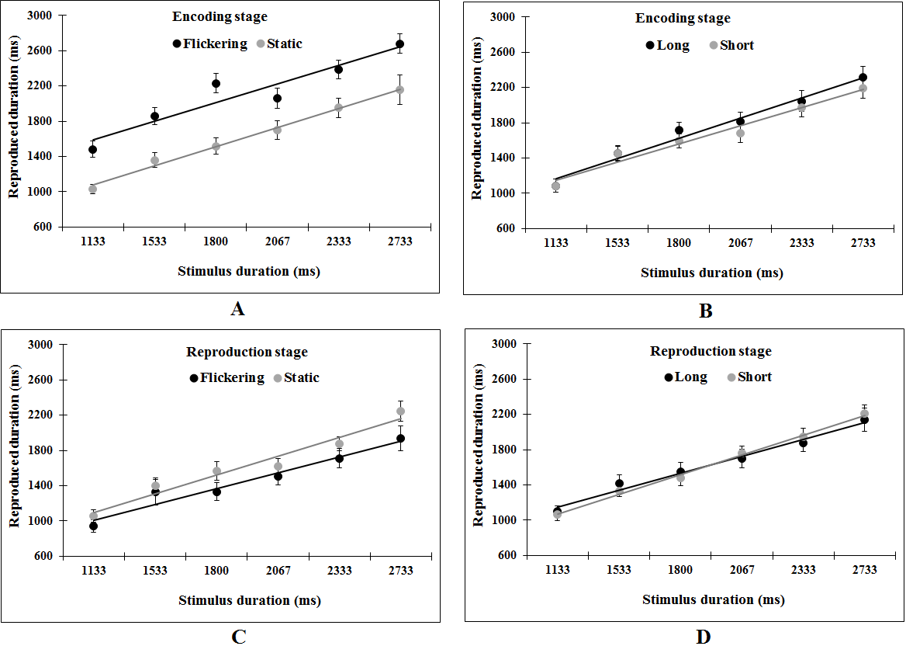
Figure 3: Effects of visual flicker and spatial distance on reproduced duration, when presented during time encoding (A and B) and during time reproduction (C and D) in Experiment 2. Error bars show SEs.

Table 2: Statistical results for Experiment 2.
Effect | F | p | η_{G}²
Stage | 9.37 | .007 | .065
Stimulus type | 2.53 | .130 | .002
Manipulation | 34.26 | < .001 | .018
Stimulus duration | 145.70 | < .001 | .482
Stage * Stimulus type | 31.61 | < .001 | .029
Stage * Manipulation | 41.58 | < .001 | .058
Stimulus type * Manipulation | 16.01 | < .001 | .007
Stage * Stimulus duration | 1.49 | .239 | .001
Stimulus type * Stimulus duration | 0.34 | .566 | < .001
Manipulation * Stimulus duration | 2.64 | .123 | < .001
Stage * Stimulus type * Manipulation | 38.62 | < .001 | .038
Stage * Stimulus type * Stimulus duration | 0.17 | .684 | < .001
Stage * Manipulation * Stimulus duration | 8.28 | .010 | .002
Stimulus type * Manipulation * Stimulus duration | 0.42 | .528 | < .001
Stage * Stimulus type * Manipulation * Stimulus duration | 0.53 | .477 | < .001
Note: df = (1, 17) for all effects.

The results for visual flicker are shown in Table 3. Reproduced durations were overall longer when visual flicker was presented at the time encoding rather than time reproduction stage, and increased as a function of stimulus duration. More importantly, while reproduced durations were generally longer for the flickering than static dot, such an effect was further qualified by the stage in which the visual flicker was presented. Separate planned analyses per stage showed that, when visual flicker was manipulated during time encoding, the flickering dot led to longer reproduced durations than the static dot (M_{diff} = 493 ms, 95% CI = [369, 618], F(1,17) = 68.64, p < .001, η_{G}² = .281), and this effect appeared to be constant across stimulus durations (F(1,17) = 0.02, p = .893, η_{G}² < .001; see also Figure 3A); reproduced durations also increased as a function of stimulus duration (F(1,17) = 153.00, p < .001, η_{G}² = .464). In contrast, when visual flicker was manipulated during time reproduction, the flickering dot led to shorter reproduced durations than the static dot (M_{diff} = -171 ms, 95% CI = [-258, -84], F(1,17) = 12.33, p = .003, η_{G}² = .045), and there is a marginal indication that this effect increased as a function of stimulus duration (F(1,17) = 4.03, p = .061, η_{G}² = .005; see also Figure 3C); again, reproduced durations increased as a function of stimulus duration (F(1,12) = 77.89, p < .001, η_{G}² = .432).
The reverse effects of visual flicker at time encoding and time reproduction thus replicates the findings of Experiments 1a and 1b. Indeed, BF analyses revealed strong support for the conclusions that, compared to the static dot, the flickering dot led to longer reproductions when presented at encoding (BF₁₀ = 492227.7) but shorter reproductions when presented at reproduction (BF₁₀ = 31.9).
Analyses for spatial distance (see Table 3) showed that long-distance lines led to longer reproduced durations than short-distance lines, and this effect did not appear to vary with stimulus duration or stage of presentation, but did increase as a function of both together (i.e., a three-way interaction between manipulation, stimulus duration, and stage). We next conducted separate planned analyses for the encoding and reproduction stages. As expected, spatial distance affected time perception when presented at the encoding stage, with longer reproduced durations for long-distance compared to short-distance lines (M_{diff} = 71 ms, 95% CI = [6, 137], F(1,17) = 4.57, p = .047, η_{G}² = .011; see also Figure 3B), and this effect remained constant across the stimulus durations (F(1,17) = 1.79, p = .198, η_{G}² = .003); reproduced durations also increased as a function of stimulus duration (F(1,17) = 131.70, p < .001, η_{G}² = .514). On the other hand, when spatial distance was presented at the reproduction stage, reproduced durations did not differ between the long- and short-distance lines (M_{diff} = 1 ms, 95% CI = [-53, 55], (F(1,17) = 0.00, p = .995, η_{G}² < .001), though they did, as usual, increase as a function of stimulus duration (F(1,17) = 117.70, p < .001, η_{G}² = .526). There was also an interaction between manipulation and stimulus duration (F(1,17) = 5.45, p = .032, η_{G}² = .006), which reflects the observation that the long-distance line led to longer reproduced durations for the lower range of stimulus durations but shorter reproduced durations for the higher range of stimulus durations (see Figure 3D). In other words, this interaction does not suggest an increasingly large effect size for longer stimulus durations, as observed for visual flicker, but rather reflects a change in the actual direction of the effect. These findings are thus consistent with the observations in Experiments 1a and 1b that spatial distance affected time perception when presented during time encoding but not during time reproduction. Indeed, BF analyses showed that the data were weakly in favour of an effect of spatial distance at time encoding (BF₁₀ = 2.0); but the data support the null hypothesis (i.e., no effect of spatial distance) at time reproduction (BF₀₁ = 4.2).

Table 3: Separate analyses for visual flicker and spatial distance in Experiment 2.
 |  |  | F | p | η_{G}²
Visual flicker
 | Stage |  | 20.89 | < .001 | .146
 | Manipulation |  | 33.51 | < .001 | .042
 | Stimulus duration |  | 124.90 | < .001 | .449
 | Stage * Manipulation |  | 51.53 | < .001 | .152
 | Stage * Stimulus duration |  | 1.29 | .272 | .001
 | Manipulation * Stimulus duration |  | 1.93 | .183 | .002
 | Stage * Manipulation * Stimulus duration |  | 1.27 | .276 | .001
Spatial distance
 | Stage |  | 1.12 | .305 | .010
 | Manipulation |  | 4.94 | .040 | .003
 | Stimulus duration |  | 143.40 | < .001 | .519
 | Stage * Manipulation |  | 2.26 | .151 | .003
 | Stage * Stimulus duration |  | 0.51 | .483 | < .001
 | Manipulation * Stimulus duration |  | 0.06 | .815 | < .001
 | Stage * Manipulation * Stimulus duration |  | 11.17 | .004 | .005
Note: df = (1, 17) for all effects.

In summary, Experiment 2 replicated the findings of Experiments 1a and 1b. Visual flicker affected time perception at both encoding and reproduction stages, whereas spatial distance affected the encoding stage only. These effects support the clock-magnitude (rather than clock-accumulator) account of space-time interaction that localizes spatial distance effects in the memory maintenance stage of the internal clock model, due to interference between magnitude-based representations of duration and distance in the reference memory component.

4. General Discussion
In the present paper, we examined how temporal information experiences interference from information from other magnitude-based dimensions within a mechanistic framework of time perception, using space-time interaction as the test case. In theory, many current models of time perception (e.g., the internal clock model) allow for cross-dimensional interference at the stage in time processing when pulses from the pacemaker are accumulated as a measure of duration, or the stage when these accumulated pulses are maintained in reference memory for later retrieval. If the locus of space-time interaction were at the accumulation stage, then spatial distance effects would have followed the same pattern as visual flicker effects, which increase the subjective time being accumulated (e.g., Droit-Volet & Wearden, 2002; Ortega & Lopez, 2008; Wearden et al., 1999). Alternatively, if the locus of space-time interaction were at the memory maintenance stage of time processing, then spatial distance effects would differ from visual flicker effects in failing to emerge when distance stimuli were presented during time reproduction (i.e., after the maintenance stage has passed). Our experiments showed that a flickering visual stimulus (relative to a static one) led to longer reproduced durations when it accompanied the encoding of stimulus duration but shorter reproduced durations when it accompanied the reproduced duration, consistent with previous findings (Ortega & Lopez, 2008; Wearden et al., 1999). For spatial distance, a long-distance line (relative to a short-distance one) led to longer reproduced durations when it accompanied the encoding of stimulus duration, consistent with previous demonstrations of the space-on-time effect (Cai et al., 2013; Cai & Connell, 2015; Casasanto & Boroditsky, 2008; Merritt et al., 2010). Critically, we demonstrated for the first time that this space-on-time effect disappears when the line accompanies the reproduced duration. These findings suggest that concurrent spatial distance biases the representation of temporal duration in memory rather than biasing the way in which time is accumulated (i.e., as does visual flicker). That is, concurrent spatial distance presented during time encoding has the opportunity to influence the representation of the perceived stimulus duration because both are kept in memory as mental magnitudes (Walsh, 2003, 2014). Our results are therefore consistent with the clock-magnitude account of space-time interaction that places the locus of interaction between temporal and non-temporal dimensions of magnitude at the memory maintenance stage of the internal clock model.
While our stage-dependent effects of visual flicker were consistent with previous research (Droit-Volet & Wearden, 2002; Ortega & Lopez, 2008; Penton-Voak et al., 1996; Wearden et al., 1999), we also found that the effects were considerably smaller at time reproduction than at time encoding. Such an attenuation of effect size would not be predicted by a change in pacemaker speed, because, if a flickering stimulus accelerated the pulse rate of the internal clock (Droit-Volet & Wearden, 2002; Ortega & Lopez, 2008), then it would be expected to bring about the same acceleration every time it was presented. Nor would an attenuation of effect size be predicted by switch latency, because, if a flickering stimulus led the accumulator to be switched on earlier and/or off later (Gibbon & Church, 1984; Penney et al., 2000), then it would be expected to trigger the same switching behavior every time it was presented. That is, either a pacemaker speed or switch latency effect should affect every initiation of timing equally, regardless of whether it takes place at the encoding or reproduction stage, which did not occur. Such a conclusion is consistent with more recent studies suggesting that repetitive stimulation, such as visual flickers and auditory click trains, may not accelerate the speed of the pacemaker speed as previously believed (Droit-Volet, 2013; Droit-Volet, Clement, & Fayol, 2008; Herbst et al., 2013; Herbst, Chaumon, Penney, & Busch, 2014).
The effect size attenuation of visual flicker is instead consistent with the notion of attentional allocation modulating the number of pulses that are registered by the accumulator (Zakay & Block, 1995, 1997). In this account, an attentional “gate” acts as a filter between the pacemaker and the switch in the accumulation stage of the internal clock model (cf. Lejeune, 1998). In a timing task, people may divide their attentional resources between attending to external and executive events and attending to time; the more attention is allocated to monitoring time, the wider the attentional gate opens, and the more pulses pass through to the accumulator. During time encoding, participants’ only task is to monitor duration by watching the onscreen stimulus and so can attend closely to time; hence, the attentional gate should be wide open and allow many pulses to be accumulated. During time reproduction, however, participants must not only monitor duration via the onscreen stimulus but also simultaneously execute button-pressing actions and access reference duration in memory, and so cannot attend wholly to time; hence, the attentional gate will be partly closed and allow fewer pulses to be accumulated. Regardless of whether a flickering stimulus accelerates pacemaker speed (Droit-Volet & Wearden, 2002; Ortega & Lopez, 2008), triggers earlier switch-on (or delayed switch-off) latency (Gibbon & Church, 1984; Lejeune, 1998; Penney et al., 2000), helps to prevents registered pulses from “leaking” from the accumulator (Wackermann, 2011; Wackermann & Ehm, 2007), or attracts more attention to monitoring time than a static stimulus, the attentional gate exerts an effect: if a flickering stimulus receives less attention during time reproduction than during time encoding, then its effects will be attenuated. Hence, while our findings cannot determine precisely why visual flicker increases the number of accumulated pulses, they support the idea that an attentional gate plays an important role in the accumulation stage of the internal clock model (see Herbst et al., 2013, for a similar conclusion; but cf. Herbst et al., 2014). Indeed, other studies suggest that external stimuli such as click trains and emotional content affects duration accumulation in memory rather than biasing the speed of the encoding mechanism (e.g., the pacemaker) (Droit-Volet, 2010, 2013; Droit-Volet et al., 2008).
In contrast, the spatial distance effects we observed cannot be explained by such attentional interference mechanisms. For example, if long-distance lines caused participants to devote more attention to monitoring time, then the attentional gate would open wider and more pulses would pass through to the accumulator. Hence, long-distance lines presented during time encoding would result in longer durations (e.g., more pulses) being stored in memory compared to short-distance lines, and therefore lead to longer reproduced durations. However, long-distance lines presented during time reproduction would lead participants to subjectively experience time as passing more quickly (e.g., more pulses are passed through to the accumulator within a given objective duration) compared to short-distance lines, and therefore lead them to terminate the reproduction task earlier, producing shorter reproduced durations. This effect did not occur. Rather, the absence of spatial distance effects during time reproduction suggests that distance and duration must co-reside in memory for interference to take place, as the clock-magnitude account proposes. Moreover, this conclusion is consistent with other findings of non-temporal magnitude effects on time perception. In particular, Cai and Wang (2014) showed that people perceived a larger-magnitude number (e.g., 8) to have a longer duration than a smaller-magnitude number (e.g., 2), a parallel finding to the current effects of distance on time. Critically, they further showed that numerical magnitude, like distance in the current study, did not affect reproduced durations when presented during time reproduction, not even when they explicitly required participants to attend to the number presented at the reproduction stage by having them to later reproduce that number. It is therefore unlikely that the effects of spatial distance in the present paper could have arisen due to attentional interference.
The lack of spatial distance effect at the reproduction stage also helps to rule out some other accounts of time-space interaction effects. Yates, Loetscher, and Nicholls (2012) claimed that magnitude information, such as spatial distance, biases people’s decisions about duration rather than affecting the perceived duration itself. One could argue that a temporal reproduction task also requires a decision, in that a participant must decide on the optimal point in time to terminate the task that minimises the difference between the current trial’s target duration and the unfolding reproduced duration. However, the nature of that decision is fundamentally different to the type of categorical choice employed in a temporal decision task of the kind employed by Yates et al., where the participant must make a binary judgement of whether the current trial’s target duration is longer or shorter than a previously learned threshold duration. This latter task is subject to a number of possible biases, where the decision to choose the “longer” (or “shorter”) response key can be primed by similarity to other magnitude information (Yates et al., 2012) or by linguistic cues within the task (see Cai, Connell, & Holler, 2013). However, if these kinds of biases were to operate on the (arguable) decision component of a temporal reproduction task, then they would exert their influence regardless of when they were presented. A long line presented during time encoding would prime the participant to hold down the key for “longer” when deciding to terminate the reproduced duration, and likewise a long line presented during time reproduction would prime the participant to hold down the key for “longer” when deciding to terminate the reproduced duration. That is, if the spatial distance effect in our studies only reflected a decision bias, then it should have exerted the same bias at both encoding and reproduction stages, which did not occur. Hence, the ability of magnitude information to affect timing in our temporal reproduction paradigm – but only at the point of encoding – cannot be explained by decision bias (see also Rammsayer & Verner, 2014).
Recent findings add further support to the central position of the clock-magnitude account that space-time interaction arises as memory interference due to a common representational format (Cai & Connell, 2015; Cai, Wang, Shen, & Speekenbrink, unpublished results). Our current findings that space-time interaction were not observed to arise during the accumulation stage of time perception (Experiments 2 and 3) are complemented by the observations in Cai et al. (unpublished results) that space-time interactions arise from memory interference. These authors presented two line segments (red and blue) of different distances for a particular duration, and asked participants to reproduce first the duration and then one of the distances. When participants were cued which segment distance they would shortly need to reproduce (i.e., red or blue) before duration reproduction, the usual effect of space on time appeared. But when participants were cued at the start of duration reproduction, space had no effect on time. Consistent with the clock-magnitude account of space-time interaction, these effects can be attributed to interference in reference memory: space affected time only when both representations had an opportunity to co-reside in memory for a short while.
Moreover, Cai and Connell (2015) showed that the ability of time and space to influence one another as they co-reside in memory depends on the spatial acuity of the representations in question. Cai and Connell used a similar paradigm to that employed in Experiment 1a, where spatial distance (i.e., the length of a physical stick) was presented at the encoding stage for a particular duration before participants were asked to reproduce either the distance or duration. Rather than presenting spatial distance in the high-acuity modality of vision, however, Cai and Connell presented it in the lower-acuity modality of touch. They found that the typical direction of space-time effects was reversed; the effect of time on haptic space was substantially stronger than the effect of haptic space on time. That is, relatively low-acuity spatial representations fail to bias the representation of temporal duration, but are instead prone to interference from duration itself as both reside together in memory. Consistent with the clock-magnitude account, Cai and Connell’s findings support the idea that time and space share a common (magnitude) representational format, and further illustrate that the memory interference can work both ways depending on the spatial acuity of the modality used to perceive distance.
Our conclusion that physical magnitudes and temporal duration share a common representational format in memory is further supported by observations that both temporal durations and other physical magnitudes are subject to systematically similar memory effects. First, representations of physical magnitudes, such as spatial distance and numerosity, tend to diminish while being held in memory, leading to underestimation in later retrieval (Bradley & Vido, 1984; Zhao & Turk-Browne, 2011); so too do representations of temporal durations (Wearden & Ferrara, 1993; Wearden, Goodson, & Foran, 2007). For instance, Bradley and Vido (1984) showed that people underestimated spatial distance between two objects when they based their judgment on memory of the objects, whereas Wearden and Ferrara (1993) showed that people tended to underestimate a sample duration that they had memorized a few (1-16) seconds beforehand (see also Casasanto & Boroditsky, 2008). Second, the representations of time and other physical magnitudes are both susceptible to regression towards the mean (also known as the contraction bias, Poulton, 1979, or Vierordt’s law, Gu & Meck, 2011), with overestimation for magnitudes under the mean and underestimation for magnitudes above the mean (Ashourian & Loewenstein, 2011; Jou et al., 2004; Tresilian, Mon-Williams, & Kelly, 1999). For example, Tresilian et al. (1999) showed that, when asked to reproduce the distance of an object, people over-reproduced distances for objects that were near but under-reproduced distances for objects that were further away, while Jazayeri and Shadlen (2010) similarly found that people respectively over- and under-reproduce short and long durations. Though the diminishing effect may be attributed to (working) memory decay, the regression-to-the-mean effect cannot because it affects different magnitudes differently. A more plausible explanation is that memories of spatial distance and temporal duration are subject to similar patterns of representational distortion because they are fundamentally magnitude-based.
In summary, the present paper brings together the representational and mechanistic approaches to time perception by showing that the interaction between time and space (and possibly also other magnitude-based dimensions such as numerosity) emerge as a result of interference between perceived temporal durations and spatial distances, which are both kept in reference memory as mental magnitudes. This conclusion is based on the experimental findings that, though visual flicker exerted inverse effects on reproduced durations when presented at time encoding and time reproduction, spatial distance only affected time perception at time encoding but had no effect at time reproduction. By integrating the representational approach with the mechanistic approach of time perception, the present paper therefore provides a detailed timecourse of when and where the mental representation of time can be altered by spatial distance information.

References
Allman, M. J., Teki, S., Griffiths, T. D., & Meck, W. H. (2014). Properties of the internal clock: first-and second-order principles of subjective time. Annual review of psychology, 65, 743-771.
Ashourian, P., & Loewenstein, Y. (2011). Bayesian Inference Underlies the Contraction Bias in Delayed Comparison Tasks. PLoS ONE, 6, e19551.
Bonato, M., Zorzi, M., & Umiltà, C. (2012). When time is space: evidence for a mental time line. Neuroscience & Biobehavioral Reviews, 36, 2257–2273.
Bradley, D. R., & Vido, D. (1984). Psychophysical functions for perceived and remembered distance. Perception, 13, 315-320.
Bueti, D., & Walsh, V. (2009). The parietal cortex and the representation of time, space, number and other magnitudes. Philosophical Transactions of the Royal Society B: Biological Sciences, 364, 1831-1840.
Cai, Z. G., & Connell, L. (2015). Space-time interdependence: Evidence against asymmetric mapping between time and space. Cognition, 136, 268-281.
Cai, Z. G., Connell, L., & Holler, J. (2013). Time does not flow without language: Spatial distance affects temporal duration regardless of movement or direction. Psychonomic Bulletin & Review, 20, 973-980.
Cai, Z. G., & Wang, R. (2014). Numerical magnitude affects temporal memories but not time encoding. Plos One, 9(1), e83159.
Cai, Z. G., Wang, R., Shen, M., & Speekenbrink, M. (unpublished results). Space-time interaction arises from memory interference. Manuscript in preparation.
Casasanto, D., & Boroditsky, L. (2008). Time in the Mind: Using space to think about time. Cognition, 106, 579-593.
Chang, A. Y. C., Tzeng, O. J. L., Hung, D. L., & Wu, D. H. (2011). Big Time Is Not Always Long: Numerical Magnitude Automatically Affects Time Reproduction. Psychological Science, 22, 1567-1573.
de Hevia, M. D., Izard, V., Coubart, A., Spelke, E. S., & Streri, A. (2014). Representations of space, time, and number in neonates. Proceedings of the National Academy of Sciences, 111, 4809-4813.
DeLong, A. J. (1981). Phenomenological space-time - toward an experiential relativity. Science, 213, 681-683.
Dormal, V., Seron, X., & Pesenti, M. (2006). Numerosity-duration interference: A Stroop experiment. Acta Psychologica, 121, 109-124.
Droit-Volet, S. (2010). Speeding up a master clock common to time, number and length? Behavioural Processes, 85, 126-134.
Droit-Volet, S. (2013). Emotion and magnitude perception: number and length bisection. Frontiers in Neurorobotics, 7: 24.
Droit-Volet, S., Clément, A., & Fayol, M. (2008). Time, number and length: Similarities and differences in discrimination in adults and children. The Quarterly Journal of Experimental Psychology, 61, 1827-1846.
Droit-Volet, S., & Wearden, J. (2002). Speeding up an internal clock in children? Effects of visual flicker on subjective duration. Quarterly Journal of Experimental Psychology Section B: Comparative and Physiological Psychology, 55, 193-211.
Gallistel, C. R., & Gelman, R. (2000). Non-verbal numerical cognition: from reals to integers. Trends in Cognitive Sciences, 4, 59-65.
Gibbon, J. (1977). Scalar expectancy theory and Weber's law in animal timing. Psychological Review, 84, 279.
Gibbon, J., & Church, R. M. (1984). Sources of variance in an information processing theory of timing. In H. L. Roitblat, T. G. Bever & H. S. Terrace (Eds.), Animal Cognition (pp. 465-488). HiUsdale, NJ: Erlbaum.
Gibbon, J., Church, R. M., & Meck, W. H. (1984). Scalar Timing in Memory. Annals of the New York Academy of Sciences, 423, 52-77.
Grondin, S. (2005). Overloading temporal memory. Journal of Experimental Psychology-Human Perception and Performance, 31, 869-879.
Grondin, S. (2010). Timing and time perception: A review of recent behavioral and neuroscience findings and theoretical directions. Attention Perception & Psychophysics, 72, 561-582.
Gu, B. M., & Meck, W. H. (2011). New perspectives on Vierordt’s law: memory-mixing in ordinal temporal comparison tasks. In A. Vatakis et al. (Eds.) Multidisciplinary aspects of time and time perception (pp. 67-78). Springer Berlin Heidelberg.
Gu, B. M., van Rijn, H., & Meck, W. H. (2015). Oscillatory multiplexing of neural population codes for interval timing and working memory. Neuroscience & Biobehavioral Reviews, 48, 160-185.
Herbst, S. K., Chaumon, M., Penney, T. B., & Busch, N. A. (2014). Flicker-induced time dilation does not modulate EEG correlates of temporal encoding. Brain Topography, 15, 559-569.
Herbst, S. K., Javadi, A. H., van der Meer, E., & Busch, N. A. (2013). How long depends on how fast—perceived flicker dilates subjective duration. PLoS ONE 8(10): e76074. doi:10.1371/journal.pone.0076074
Javadi, A. H., & Aichelburg, C. (2012). When time and numerosity interfere: the longer the more, and the more the longer. PLoS ONE, 7, e41496.
Jazayeri, M., & Shadlen, M. N. (2010). Temporal context calibrates interval timing. Nature Neuroscience, 13, 1020-1026.
Jeffreys, H. (1961). The theory of probability (3rd ed.). Oxford, UK: Clarendon Press / Oxford University Press.
Jones, L. A., & Wearden, J. H. (2004). Double standards: Memory loading in temporal reference memory. Quarterly Journal of Experimental Psychology Section B: Comparative and Physiological Psychology, 57, 55-77.
Jou, J., Leka, G. E., Rogers, D. M., & Matus, Y. E. (2004). Contraction bias in memorial quantifying judgment: Does it come from a stable compressed memory representation or a dynamic adaptation process? American Journal of Psychology, 117, 543-564.
Kass, R. E., & Raftery, A. E. (1995). Bayes factors. Journal of the American Statistical Association, 90, 773-795.
Lakens, D. (2013). Calculating and reporting effect sizes to facilitate cumulative science: a practical primer for t-tests and ANOVAs. Frontiers in Psychology, 4, article 863.
Lambrechts, A., Walsh, V., & van Wassenhove, V. (2013). Evidence accumulation in the magnitude system. Plos One, 8(12), e82122.
Lejeune, H. (1998). Switching or gating? The attentional challenge in cognitive models of psychological time. Behavioural Processes, 44, 127-145.
Masson, M. E. (2011). A tutorial on a practical Bayesian alternative to null-hypothesis significance testing. Behavior Research Methods, 43, 679-690.
Matell, M. S., & Meck, W. H. (2000). Neuropsychological mechanisms of interval timing behavior. Bioessays, 22, 94-103.
Matell, M. S., & Meck, W. H. (2004). Cortico-striatal circuits and interval timing: coincidence detection of oscillatory processes. Cognitive Brain Research, 21, 139-170.
Meck, W. H., & Church, R. M. (1983). A mode control model of counting and timing processes. Journal of Experimental Psychology: Animal Behavior Processes, 9, 320-334.
Merritt, D. J., Casasanto, D., & Brannon, E. M. (2010). Do Monkeys Think in Metaphors? Representations of Space and Time in Monkeys and Humans. Cognition, 117, 191-202.
Miall, C. (1989). The storage of time intervals using oscillating neurons. Neural Computation, 1, 359-371.
Moon, J. A., Fincham, J. M., Betts, S., & Anderson, J. R. (2015). End effects and cross-dimensional interference in identification of time and length: Evidence for a common memory mechanism. Cognitive, Affective, & Behavioral Neuroscience, 15, 680-695.
Oliveri, M., Vicario, C. M., Salerno, S., Koch, G., Turriziani, P., Mangano, R., et al. (2008). Perceiving numbers alters time perception. Neuroscience Letters, 438, 308-311.
Ortega, L., & Lopez, F. (2008). Effects of visual flicker on subjective time in a temporal bisection task. Behavioural Processes, 78, 380-386.
Penney, T. B., Allan, L. G., Meck, W. H., & Gibbon, J. (1998). Memory mixing in duration bisection. In D. A. Rosenbaum & C. E. Collyer (Eds.), Timing of behavior: Neural, psychological, and computational perspectives (pp. 165–193). Cambridge, MA: MIT Press.
Penney, T. B., Gibbon, J., & Meck, W. H. (2000). Differential effects of auditory and visual signals on clock speed and temporal memory. Journal of Experimental Psychology: Human Perception and Performance, 26, 1770-1787.
Penton-Voak, I. S., Edwards, H., Percival, A., & Wearden, J. H. (1996). Speeding up an internal clock in humans? Effects of click trains on subjective duration. Journal of Experimental Psychology: Animal Behavior Processes, 22, 307-320.
Petzschner, F. H., Glasauer, S., & Stephan, K. E. (2015). A Bayesian perspective on magnitude estimation. Trends in Cognitive Sciences, 19, 285-293.
Piaget, J. (1969). The child's conception of time. London, UK: Routledge.
Poulton, E. C. (1979). Models for biases in judging sensory magnitude. Psychological Bulletin, 86, 777-803.
Rammsayer, T. H., & Verner, M. (2014). The effect of nontemporal stimulus size on perceived duration as assessed by the method of reproduction. Journal of Vision, 14(5):17, 1-10.
Riemer, M., Trojan, J., Kleinböhl, D., & Hölzl, R. (2012). A “view from nowhen” on time perception experiments. Journal of experimental psychology: Human Perception and Performance, 38, 1118-1124.
Roitman, J. D., Brannon, E. N., Andrews, J. R., & Platt, M. L. (2007). Nonverbal representation of time and number in adults. Acta Psychologica, 124, 296-318.
Taatgen, N., & van Rijn, H. (2011). Traces of times past: representations of temporal intervals in memory. Memory & cognition, 39, 1546-1560.
Treisman, M. (1963). Temporal Discrimination and the Indifference Interval - Implications for a Model of the Internal Clock. Psychological Monographs, 77, 1-31.
Tresilian, J. R., Mon-Williams, M., & Kelly, B. M. (1999). Increasing confidence in vergence as a cue to distance. Proceedings of the Royal Society of London Series B: Biological Sciences, 266, 39-44.
van Rijn, H., Gu, B-M., & Meck, W.H. (2014) Dedicated clock/timing-circuit theories of interval timing and timed behavior. Advances in Experimental Medicine and Biology 829, 75-99.
Wackermann, J. (2011). On clocks, models and metaphors. In A. Vatakis et al. (Eds.), Multidisciplinary aspects of time and time perception (pp. 246-257). Springer Berlin Heidelberg.
Wackermann, J., & Ehm, W. (2006). The dual klepsydra model of internal time representation and time reproduction. Journal of Theoretical Biology, 239, 482-493.
Wagenmakers, E. J. (2007). A practical solution to the pervasive problems of p values. Psychonomic Bulletin & Review, 14, 779-804.
Walsh, V. (2003). A theory of magnitude: common cortical metrics of time, space and quantity. Trends in Cognitive Sciences, 7, 483-488.
Walsh, V. (2014). A Theory of Magnitude: The parts that sum to number. In R. Cohen Kadosh, & A. Dowker (Eds.). Oxford Handbook Online, DOI: 10.1093/oxfordhb/9780199642342.013.64.
Wearden, J. H. (1991). Do humans possess an internal clock with scalar timing properties? Learning and Motivation, 22, 59-83.
Wearden, J. H. (2003). Applying the scalar timing model to human time psychology: Progress and challenges. In H. Helfrich (Ed.), Time and Mind II: Informationprocessing perspectives (pp. 21−39). Gottingen: Hogrefe & Huber.
Wearden, J. H., & Ferrara, A. (1993). Subjective Shortening in Humans Memory for Stimulus-Duration. Quarterly Journal of Experimental Psychology Section B: Comparative and Physiological Psychology, 46, 163-186.
Wearden, J. H., Goodson, G., & Foran, K. (2007). Subjective shortening with filled and unfilled auditory and visual intervals in humans? Quarterly Journal of Experimental Psychology, 60, 1616-1628.
Wearden, J. H., O'Rourke, S. C., Matchwick, C., Min, Z., & Maeers, S. (2010). Task switching and subjective duration. The Quarterly Journal of Experimental Psychology, 63, 531-543.
Wearden, J. H., Philpott, K., & Win, T. (1999). Speeding up and (... relatively ...) slowing down an internal clock in humans. Behavioural Processes, 46, 63-73.
Winter, B., Marghetis, T., & Matlock, T. (2015). Of magnitudes and metaphors: Explaining cognitive interactions between space, time, and number. Cortex, 64, 209-224.
Xuan, B., Zhang, D., He, S., & Chen, X. (2007). Larger stimuli are judged to last longer. Journal of Vision, 7, 2.1-5.
Yates, M. J., Loetscher, T., & Nicholls, M. E. R. (2012). A generalized magnitude system for space, time, and quantity? A cautionary note. Journal of Vision, 12(7):9, 1-7.
Zakay, D., & Block, R. A. (1995). An attentional-gate model of prospective time estimation. In M. Richelle, V. De Keyser, G. d'Ydewalle, & A. Vandierendonck (Eds.), Time and the dynamic control of behavior (pp. 167-178). Liège, Belgium: Universite de Liege.
Zakay, D., & Block, R. A. (1997). Temporal cognition. Current Directions in Psychological Science, 6, 12-16.
Zhao, J., & Turk-Browne, N. B. (2011). Incidental encoding of numerosity in visual long-term memory. Visual Cognition, 19, 928-955.

While we focus on the internal clock model in the present paper, other neurobiological models have theorized that timing is driven by coincidence detection in oscillating neurons rather than by a pacemaker-accumulator mechanism (e.g., Matell & Meck, 2000, 2004; Miall, 1989). Our hypotheses and findings are consistent with both the pacemaker-accumulator and oscillating-neuron view, as they are functionally highly similar (van Rijn, Gu, & Meck, 2014). We thank Hedderik van Rijn for this suggestion.
Duration judgements can also be affected by biases at the decision stage of certain tasks (e.g., Riemer, Trojan, Kleinböhl, & Hölzl, 2012; Yates, Loetscher, & Nicholls, 2012); we return to this point in the general discussion.
We thank an anonymous reviewer for this suggestion.

