Received 00th January 20xx,
- School of Pharmacy, University of East Anglia, Norwich Research Park, Norwich NR4 7TJ. email: m.searcey@uea.ac.uk. Phone 01603 592026, fax 01603 592003.
- Department of Biological Chemistry, John Innes Centre, Norwich Research Park, Norwich NR4 7UH, Norfolk. email:tony.maxwell@jic.ac.uk. Phone 01603 450771
Electronic Supplementary Information (ESI) available: Full experimental and characterisation data can be found in the ESI. See DOI: 10.1039/x0xx00000x
Accepted 00th January 20xx
DOI: 10.1039/x0xx00000x
www.rsc.org/
A natural product inspired fragment-based approach towards the development of novel anti-bacterial agents
Michael J. Austin,ª Stephen J. Hearnshaw,^{b} Lesley A Mitchenall,^{b} Paul J. McDermott,ª Lesley A. Howell,ª Anthony Maxwell^{b*} and Mark Searcey^{a*}
The discovery of new antibiotics with novel modes of action to combat antimicrobial resistance (AMR) is of vital importance. The natural product simocyclinone D8 (SD8) is a potent inhibitor of DNA gyrase. Its bi-functional structure and novel mode of action serve as an inspiring lead for antibiotic development. Herein we describe a proof of principle fragment-based approach towards the development of a new class of coumarin-quinolone hybrids. We demonstrate that the coumarin moiety is required for the observed inhibitory activity (IC₅₀ ~3 μM) of the hybrid compound, which is in part mediated through stabilisation of a cleaved-DNA intermediate.
Antimicrobial resistance and the emergence of drug-resistant pathogens is a major health concern that threatens the society that we live in.¹ Consequently, there is an urgent need to identify compounds with novel modes of action to treat drug-resistant infections. Fragment-based drug design has been utilised in the design and development of new anti-microbial agents and is a technique based upon the use of small molecular weight fragments, typically with low binding affinities for their targets, that can be combined to generate selective and high affinity molecules with therapeutic potential.² The main drawback to this approach is the requirement for access to techniques such as crystallography or high field protein NMR in order to identify the fragments.
Nature has provided a number of compounds that appear to derive from a natural “fragment-based” approach to inhibitor design. The MDM2/p53 inhibitor chlorofusin combines an azaphilone and a cyclic peptide structure, neither of which bind to their target individually but which together generated the first natural product identified through a screen for inhibitors for this protein-protein interaction.³ This has led to the development of further inhibitors that target this interaction and take their inspiration from chlorofusin.^{4,5}
Simocyclinone D8 (SD8, 1, Fig 1) is a further example of nature’s use of fragments to generate a new molecule, in this case an antibiotic that acts as an inhibitor of DNA gyrase.⁶ DNA gyrase is a type IIA topoisomerase that regulates the topology of DNA.⁷ All topoisomerases can relax supercoiled DNA but DNA gyrase is unique in its ability to introduce negative supercoils at the expense of ATP hydrolysis.⁸ The enzyme is exclusively found in bacterial cells and thus is a rational drug target. ⁹
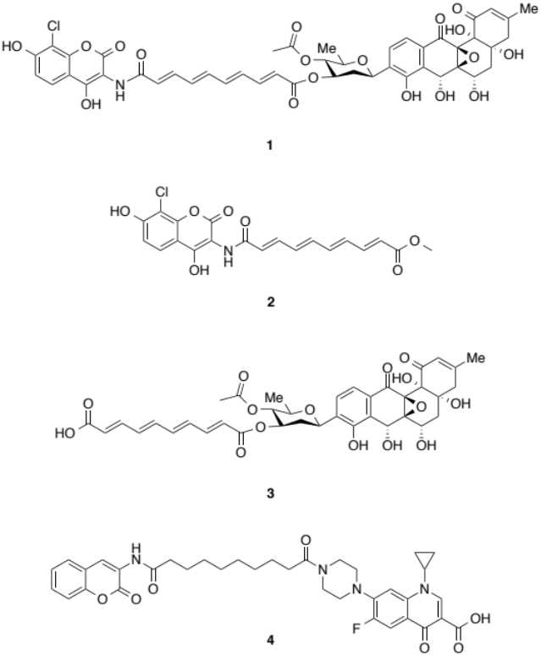
Figure 1. SD8 1 and constituent fragments 2 and 3. Compound 4 designed in this study and inspired by SD8

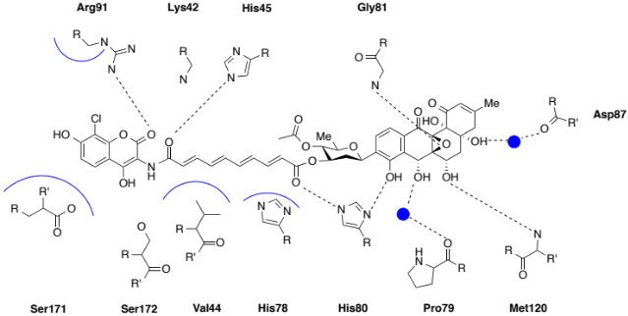

Figure 2. Key bonding interactions for SD8, dashed lines represent hydrogen bonds, blue lines hydrophobic interactions and blue circles water molecules.¹⁶ For clarity the hydrogen atoms are not shown on amino acid residue
Classical DNA gyrase inhibitors such as the fluoroquinolones, stabilise the enzyme-DNA cleavage complex by intercalating into double strand breaks.¹⁰ Conversely, the aminocoumarin antibiotics inhibit the ATPase activity of the GyrB subunit.¹¹
SD8, 1, isolated from the mycelium of Streptomyces antibioticus Tü 6040,⁶ consists of an aminocoumarin (AC) attached through an amide linkage to a rigid polyene chain, which, in turn, is connected to an angucyclic polyketide (PK) through a D-olivose sugar moiety. It works as a DNA gyrase inhibitor through a novel mechanism preventing the binding of DNA to the N-terminus of GyrA.¹² DNA gyrase comprises two subunits GyrA (97 kDa in E. coli) and GyrB (90 kDa in E. coli). The enzyme binds to DNA as an A₂B₂ complex.¹³ DNA binds to the N-terminal domain of GyrA and the TOPRIM domain of GyrB comprising a ‘Gate’ segment (G-segment).¹⁴ A crystal structure of the 59-kDa GyrA N-terminal domain complexed to SD8 showed two binding pockets in GyrA that could accommodate the AC and PK moieties (Fig 2 and 3).¹⁵ A subsequent structure of a 55-kDa GyrA N-terminal fragment revealed two SD8 molecules were responsible for binding to the GyrA55 dimer and inhibiting the topoisomerase enzyme. The AC and the PK lie in distinct binding pockets joined through the tetraene linker, each PK spans the GyrA55 dimer interface.¹⁶
SD8 itself is not drug-like due to poor solubility and cell permeability. However, its novel mode of action serves as an exciting lead for drug development as an example of nature’s approach to fragment-based chemistry. Individual mono-functional fragments 2 (Fig. 1, IC₅₀ ~70 μM) and 3 (IC₅₀ ~50 μM) were shown to be considerably less effective as DNA gyrase inhibitors than the parent compound 1. Crucially, when used together there was no increased inhibition, signifying that unification is vital for the observed potent activity.¹⁶ Analysis of the structure of ciprofloxacin with DNA bound to S. aureus gyrase (PDB ref 2XCT) revealed the quinolone binding pocket is in close proximity to the D-olivose sugar of SD8 (Fig. 3), as it has previously been shown that close sequence similarity exists between S. aureus and E. coli gyrase.¹⁷

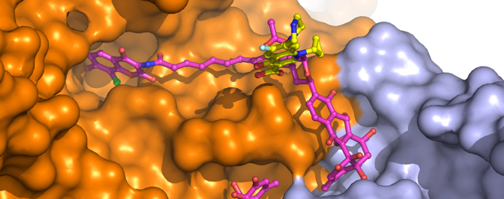
Figure 3. Crystal structure of SD8 (magenta) in complex with GyrA55.¹⁶ The position of ciprofloxacin (yellow), from the S. aureus gyrase structure, is obtained by superposition of the E. coli and S. aureus gyrase structures.¹⁴
Using an SD8-inspired fragment-based approach to the design of new DNA gyrase inhibitors, it was predicted a simple coumarin could be tethered via a 15-Å linker to ciprofloxacin to generate an asymmetric hybrid. The unfunctionalised coumarin was hypothesised to still be able to form a hydrogen bond with Arg91 present in the coumarin pocket on GyrA as well as a hydrophobic interaction with Ser171 (Fig. 2). It was theorised that synthetic analogue 4 (Fig. 1) would be able to adopt a favourable conformation to take advantage of both binding sites.
The synthesis of 4 began from the simple salicylaldehyde 5 (Scheme 1). A modified Perkin condensation afforded the acetate-protected 3-aminocoumarin 6 without the need for purification.¹⁸ Deprotection of the acetate was achieved through heating 6 in concentrated HCl and ethanol as previously described.¹⁹ After cooling, the pH was adjusted to neutral giving the free amine 7 in a 54% yield. The mono-functionalised product 8 was obtained using previously reported conditions in pyridine, with sebacoyl chloride and 7.²⁰ The piperazine ring on commercially available ciprofloxacin 9 serves as a useful functional handle for coupling. To prevent undesired side reactions from the carboxylic acid and to enhance the solubility of the parent compound in organic solvents the carboxylic acid of ciprofloxacin 9 was protected as an ester 10.²¹ Coupling of the protected ciprofloxacin fragment using standard peptide coupling conditions provided 11 in a 45% yield. Deprotection of the ester under basic conditions gave hybrid 4 in a 40% yield.
To establish the effect of the coumarin on DNA gyrase inhibitory activity, two controls were synthesised using the same peptide coupling conditions (schemes 2 & 3). Aniline 12 was chosen to ensure the binding affinity of 4 was driven by the ability of the coumarin to hydrogen bond to GyrA (through the lactone). Aniline 12 was coupled with the mono-protected sebacic acid to give 13 in 83% yield and then deprotected under basic conditions to generate the free carboxylic acid 14. Subsequent attachment to the ethyl ester of ciprofloxacin 10 and a final deprotection gave compound 16 in 64% yield.²²

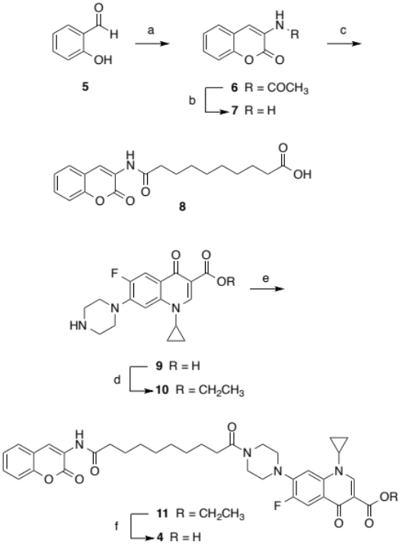
Scheme 1. Synthesis of asymmetric coumarin-quinolone hybrid. (a) Ac₂O, NaOAc, N-acetylglycine, reflux, 5 h, 14%; (b) conc. HCl, EtOH, Reflux, 5 h, 54%; (c) pyridine, sebacoyl chloride, 7, reflux, 16 h, 26% (d) SOCl₂, EtOH, reflux, 30 h, 60%; (e) 8, EDC, 30% pyridine/DCM, 12 h, 45% (f) LiOH monohydrate, THF/MeOH/H₂O (3:2:1), 73 h, 40%

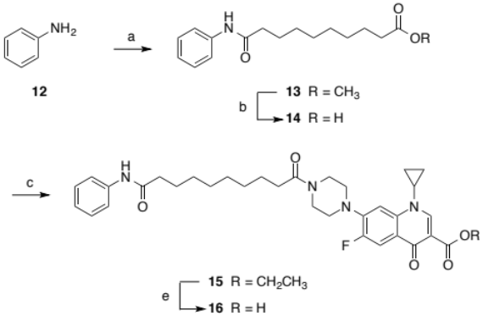
Scheme 2. Synthesis of aniline control. (a) EDC, sebacic acid monomethyl ester, 30% pyridine/DCM, 19 h, 83%; (b) LiOH monohydrate, EtOH, H₂O (2:1), 20 h, 66%; (c) 10, EDC, 30% pyridine/DCM, 19 h, 22%; (e) LiOH monohydrate, THF/MeOH/H₂O (3:2:1), 20.5 h, 64%
Conversely ciprofloxacin with an unsubstituted linker served as a quinolone control. Coupling of the ester protected fragment 10 to monomethyl sebacate gave the penultimate compound 17 in a 65% yield. Ester hydrolysis with base gave the control 18 in a 64% yield. All final compounds had greater than 95% purity as assessed by NMR and RP-HPLC prior to performing biological work (supporting information).

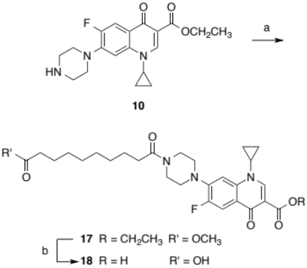
Scheme 3. (a) EDC, monomethyl sebacate, 30% pyridine/DCM, 21 h, 65%; (b) LiOH monohydrate, EtOH/H₂O (2:1) 168 h, 51%.
Compounds 4, 6, 7, 10, 11, 15, 16, 17 and 18 were evaluated for their ability to inhibit DNA supercoiling. DNA gyrase activity is determined using a supercoiling assay. The individual A and B gyrase subunits can be overexpressed, purified and mixed together to give an active species.²³ The A₂B₂ heterotetramer is incubated with relaxed plasmid DNA in the presence of 1 mM of ATP. In the absence of an inhibitor, the enzyme will supercoil the relaxed DNA, altering the linking number and therefore changing the topological state. The supercoiled form of plasmid DNA has a different mobility through the gel; the condensed arrangement allows the DNA to migrate more quickly compared to its relaxed counterpart. Thus the level of supercoiling or lack thereof can be visually determined by separating relaxed and supercoiled DNA, staining with ethidium bromide and imaging under UV light. The (~4.3-Kb) plasmid pBR322 is derived from E. coli and has become a standard substrate for the assay.²⁴
The inhibition of DNA supercoiling by compounds 4, 16 and 18 is shown in Fig 4. The aniline control 16 still had significantly poor inhibition at 100 μM, suggesting that it cannot make favourable contacts in the AC binding site.
Figure 4. Effects of Compounds, 4, 16 and 18 on DNA supercoiling by wild type E. coli gyrase. Relaxed pBR322 plasmid DNA is used as a negative control (-), and incubated in the presence of gyrase as a positive control (+). SD8 is used as a comparator at a concentration of 1 μM. NC indicates nicked circle DNA; R, relaxed DNA; SC, supercoiled.
The efficacy of ciprofloxacin 9 (IC₅₀ 0.5 μM) was severely attenuated with the introduction of the linker onto the piperazine ring, with complete supercoiling observable at 25 μM for compound 18. A restoration of activity is observed when the coumarin is present with an IC₅₀ of 3 μM for compound 4, comparable to SD8 (Figure 4). These results demonstrate a favourable interaction when fragments 7 and 18 are combined that is not seen with a simple aromatic ring. This is in contrast to the poor inhibition displayed by each fragment individually; indicating a synergistic effect is vital for the observed activity. The coumarins 6 and 7 showed no appreciable effect at 50 μM. Furthermore, the free amine 7 failed to cause inhibition at physiologically irrelevant concentrations of 300 μM (data not shown). Of the ester protected analogues 10, 11, 15 and 17, only the esterified ciprofloxacin fragment 10 retained inhibition, albeit with attenuated efficacy. Supercoiling was inhibited from 3-50 μM with an IC₅₀ of ~10 μM (Supplementary Information Fig. 1S). Compounds 11, 15 and 17 showed no effect at maximal concentrations of 100 μM (supplementary information Figure 1S).
To study the mode of action, we investigated the effect of the compounds 4, 16 and 18 on the gyrase cleavage-religation equilibrium (Fig 5). This would demonstrate that the compounds were able to inhibit gyrase through the same mechanism as ciprofloxacin. If a reaction between gyrase and DNA in the presence of ciprofloxacin is terminated by the addition of SDS and proteinase K, cleaved DNA is revealed. This is a manifestation of the covalent bonds formed between the enzyme and the DNA, which are stabilised by intercalation of the quinolone drug into strand breaks.²⁵ Experimentally, when supercoiled DNA is used as the substrate, this is represented by the presence of a linear band. SD8 was used as a negative control, no linear band being visible due to its ability to block DNA binding and prevent strand passage cycle taking place. Ciprofloxacin 9 was used as positive control with strong linear bands visible down to 0.3 μM. Linear bands are visible only at 100 μM for 16 and from 100 μM to 50 μM for 18.
Figure 5. Effects of compounds 4, 16 and 18 on cleavage-complex formation by wild type E. coli gyrase in the absence of ATP. Supercoiled pBR322 plasmid (DNA) is used as a negative control (-), and incubated in the presence of gyrase as a positive control (+). SD8 is used as an additional negative control at a concentration of 1 μM. Ciprofloxacin (9) is used as a comparator. NC, nicked circle; L, linear band; SC, supercoiled.
Compound 4 displays a strong linear band from 100 μM to 10 μM with a faint band occurring at 3 μM (Fig. 5).The loss of the linear band occurs at approximately the same concentration as inhibition in the corresponding supercoiling assay (Fig. 4). This is consistent with observations of ciprofloxacin, which exhibits a correlation between supercoiling and cleavage stabilisation inhibitory concentrations.
These results illustrate that the coumarin fragment contributes to the inhibitory efficacy of hybrid 4. The poor inhibition displayed by each constituent fragment of 4 shows a synergistic effect is vital for the observed activity. Moreover, it preserves the ability to stabilise the gyrase-DNA covalent complex. The unfunctionalised scaffold will act as a suitable template from which future structure activity relationships can be explored. This proof of concept work serves as an example of a natural product-guided fragment-based approach to developing novel inhibitors of DNA gyrase.
Acknowledgements

MJA was funded by a Dean’s studentship. SJH was funded by BBSRC (Grant no. BB/I002049/1). Work in AM’s lab is supported by grant BB/J004561/1 from BBSRC and the John Innes Foundation. We thank the EPSRC Mass spectrometry service (Swansea) for HRMS.
Notes and references

- H. W. Boucher, G.H. Talbot, J. S. Bradley, J. E. Edwards, D. Gilbert, L. B. Rice, M. Scheld, B. Spellberg, and J. Bartlett, Clin Infect Dis 2009, 48, 1; World Health Organization Antimicrobial Resistance: Global Report on Surveillance; Geneva, Switzerland, 2014; pp 1-256.
- J. B. Cross, J. Zhang, M. F. Mesleh, J. A. Romero, B. Wang, D. Bevan, K. M. Poutsiaka, F. Epie, T. Moy, A. Daniel, J. Shotwell, B. Chamberlain, N. Carter, O. Andersen, J. Barker, M. D. Ryan, C. A. Metcalf 3rd, J. Silverman, K. Nguyen, B. Lippa, R. E. Dolle, ACS Med. Chem. Lett. 2016, 7, 374.
- R. C. Clark, S. Y. Lee, M. Searcey, D. L. Boger, Nat. Prod. Rep. 2009, 26, 465.
- M. M.Cominetti, S. A. Goffin, E. Raffel, K. D. Turner, J. C. Ramoutar, M .A. O'Connell, L. A. Howell, M. Searcey. Bioorg. Med. Chem. Lett. 2015, 25, 4878.
- H. B. Qiu, X. Y. Chen, Q. Li, W. J. Qian, S. M. Yu, G. L. Tang, Z. J. Yao, Tetrahedron Lett., 2014, 55, 6055.
- J. Schimana, H. P. Fiedler, I. Groth, R. Sussmuth, W. Beil, M. Walker and A. Zeeck, J. Antibiot. 2000, 53, 779.
- J. J. Champoux, Annu. Rev. Biochem. 2001, 70, 369.
- M. Gellert, K. Mizuuchi, M. H. O'Dea, and H. A. Nash, P. Natl. Acad. Sci. USA 1976, 73, 3872
- F. Collin, S. Karkare and A. Maxwell, Appl. Microbiol. Biot. 2011, 92, 479.
- A. Wohlkonig, P. F. Chan, A. P. Fosberry, P. Homes, J. Huang, M. Kranz, V. R. Leydon, T. J. Miles, N. D. Pearson, R. L. Perera, A. J. Shillings, M. N. Gwynn, B. D. Bax, Nat. Struct. Mol. Biol. 2010, 17, 1152; I. Laponogov, M. K. Sohi, D. A. Veselkov, X. S. Pan, R. Sawhney, A. W. Thompson, K. E. McAuley, L. M. Fisher and M. R. Sanderson, Nat. Struct. Mol. Biol. 2009, 16, 667; I. Laponogov, X.-S Pan, D. A. Veselkov, K. E. McAuley, L. M. Fisher and M. R. Sanderson, PloS One 2010, 5, e11338.
- M. Gellert, M. H. O'Dea, T. Itoh and J. Tomizawa, J., Proc. Natl. Acad. Sci. 1976, 73, 4474; K. Mizuuchi, M. H. O'Dea, and M. Gellert, Proc. Natl. Acad. Sci. 1978, 75, 5960; A. Sugino, N. P. Higgins, P. O. Brown, C. L. Peebles and N. R. Cozzarelli, Proc. Natl. Acad. Sci. 1978, 75, 4838.
- R. H. Flatman, A. J. Howells, L. Heide, H. P. Fiedler and A. Maxwell, Antimicrob. Agents Chemother. 2005, 49, 1093.
- R. J. Reece, A. Maxwell and J. C. Wang, Crit. Rev. Biochem. Mol. 1991, 26, 335.
- B. D. Bax, p. F. Chan, D. S. Eggleston, A. Fosberry, D. R. Gentry, F. Gorrec, I. Giordano, M. M. Hann, A. Hennessy, M. Hibbs, J. Huang, E. Jones, J. Jones, K. K. Brown, C. J. Lewis, E. W. May, M. R. Saunders, O. Singh, C. E. Spitzfaden, C. Shen, A. Shillings, A. J. Theobald, A. Wohlkonig, N. D. Pearson, and M. N. Gwynn, Nature 2010, 466, 935.
- M. J. Edwards, R. H. Flatman, L. A. Mitchenall, C. E. M. Stevenson, T. B. K. Le, T. A. Clarke, A. R. McKay, H. -P. Fiedler, M. J. Buttner, D. M. Lawson and A. Maxwell, Science 2009, 326, 1415.
- S. J. Hearnshaw, M. J. Edwards, C. E. Stevenson, D. M. Lawson and A. Maxwell, J. Mol. Biol. 2014, 426, 2023.
- R. Hopewell, M. Oram, R. Briesewitz, and L. M. Fisher, J. Bacteriol. 1990, 172, 3481.
- A. A. Kudale, J. Kendall, C. C. Warford, N. D. Wilkins, and G. J. Bodwell, Tetrahedron Lett. 2007, 48, 5077.
- H. Y. Li, S. Gao and Z. Xi, Inorg. Chem. Commun. 2009, 12, 300.
- K. C. Ellis, L. M. Gaskell, C. J. Bottonel and H. Hiasa, H., Abstr. Pap. Am. Chem. Soc. 2009, 238.
- J. I. Ambrus, Development of Potential Dual-action Antibacterial Agents. Ph.D. Thesis. University of Wollongong, Australia 2008.
- S. –K Anandan, J. S. Ward, R. D. Brokx, M. R. Bray, D. V. Patel, and X. -X Xiao, Bioorg. Med. Chem. Lett. 2005, 15, 1969.
- P. Hallett, A. J. Grimshaw, D. B. Wigley, and A. Maxwell, Gene 1990, 93, 139.
- N. Osheroff, M. -A Bjornsti, Methods in Molecular Biology, Walker, J., Ed. Humana Press: 2001; Vol. 95, pp 25-33.
- M. Gellert, K. Mizuuchi, M. H. O'Dea, T. Itoh and J. –I. Tomizawa, Proc. Natl. Acad. Sci. 1977, 74, 4772; A. Sugino, C. L. Peebles, K. N. Kreuzer, and N. R. Cozzarelli, Proc. Natl. Acad. Sci. 1977, 74, 4767; (c) H. Hiasa, D. O. Yousef, and K. J. Marians, J. Biol. Chem. 1996, 271, 26424.

