Towards a Pragmatic Category of Conditionals
Chi-Hé Elder and Kasia M. Jaszczolt

- Rationale and objectives

In the history of semantics and pragmatics, the label ‘conditional’ has been used for a variety of constructions and phenomena and has been delimited in a number of ways. In this paper we focus on what we call a ‘pragmatic category of conditionals’. We propose to tie the notion of ‘conditionality’ to the property of expressed thoughts and at the same time explain conditionality so understood using a version of post-Gricean truth-conditional contextualist semantics. So, our primary interest is how speakers express conditional meanings in discourse and how the diversity of forms that can be used to express such conditional meanings can be accounted for in a theory of discourse meaning. One of the strengths of our approach lies in its methodology. We start with extensive empirical data and use the rather uncontroversial assumptions that (i) we will find examples of conditional sentences – sentences of the form ‘if p, q’ – that express conditional or non-conditional thoughts, and equally that (ii) there will be conditional thoughts that are expressed by other, non-conditional sentence forms. In other words, our pragmatic category of conditionality will not be constrained by the sentence form, and yet our analysis will yield itself to a truth-conditional treatment, and as such, to a contextualist semantic representation. While it has been observed in the literature that there are conditionals which are expressed through non-conditional sentence forms, to our knowledge there has been no fully developed semantic/pragmatic unified account of conditionality that would incorporate them. As will be evident throughout the paper, our approach will be founded on accepting the assumption of a relaxed approach to compositionality called ‘interactive compositionality’; that is, compositionality predicated of acts of communication rather than sentence structures – the topic to which we turn in Section 4. The advantage of our analysis lies in offering a treatment of this pragmatically construed category in a formal framework that enjoys predictive power and normativity.
The structure of the paper is as follows. In Section 2 we attend to the distinction between conditional sentences, utterances and thoughts, and motivate our pragmatic stance. In Section 3, we attend to the mismatches between forms and meanings in expressing conditionality in more detail, and to their theoretical consequences. In Section 4, we justify adopting Default Semantics (Jaszczolt 2005, 2010, 2016), a radical contextualist approach to representing meaning, demonstrating how representation of conditionality across a broad spectrum of structures can be achieved in this framework. Section 5 concludes and indicates remaining questions and possible further directions.

- Conditional sentences, conditional utterances, and conditional thoughts

The meanings of conditionals have given rise to many discussions and controversies in formal semantics, cognitive semantics and post-Gricean pragmatics. In formal semantics, pragmatic considerations have often been appealed to in order to demonstrate that conditional sentences in natural language do, or do not, essentially stem out of material conditionals on the level of their logical form. On the other hand, various classifications of conditional sentences have emphasised a battery of criteria by means of which, allegedly, one ought to distinguish qualitatively different categories of what superficially appears to be merely an instance of ‘if p, q’. Our objective in this paper is a little different from just adding a voice to these disputes, and is, we think, more positive in its outlook. We attempt to offer an argument for a unified pragmatic category of conditionals that is not based on the syntactic form of the expression, the presence of a relevant connective, or even a conditional meaning as it is understood in minimalist semantic accounts. In other words, the object of study is not how uttered sentences map onto their underlying logical forms, but rather the main intended meanings that speakers use these utterances to convey. For that purpose, we show that by adopting Default Semantics, a radical contextualist approach to natural language meaning, one can bring together various uses of conditional sentences on the one hand, and various (overt and covert) means of expressing conditional thought in natural language on the other.
To repeat, the resultant object of study is what we term a ‘pragmatic category of conditionals’; we appeal to pragmatic processes to recover (i) conditional meanings that may be expressed either overtly or covertly, and (ii) utterances whose conditionality constitutes either the primary intended meaning of the speaker as it is understood in Default Semantics, or some secondary meaning – that is the meaning that does not pertain to the main intended speech act. In other words, we are left with a cognitively plausible pragmatic category which at the same time yields itself to a truth-conditional treatment.
It is an interesting albeit unsurprising fact about the English language that there is no bi-unique relation between the form of a conditional sentence and conditional meaning. ‘Unsurprising’ in that the lack of such bi-uniqueness is also pervasive in other domains, such as those of other sentential vis-à-vis logical connectives, temporal reference (where we find tense-time mismatches), or of illocutionary forces and their realisations by illocutionary verbs. With reference to conditionals, on the one hand, (i) conditional sentences are not the only way to express conditional thoughts, as (1) and (2) demonstrate, and on the other, (ii) conditional sentences can be put to a variety of uses other than expressing conditional thoughts, as shown in (3) and (4)., Approximations at the main intended meaning are given in (1a)-(4a) respectively.

- Touch her iPad and she’ll scream.
  - If you touch her iPad, she’ll scream.
- Your money or your life.
  - If you don’t give me your money, I will take your life.
- If you wouldn’t mind, could you close the door?
  - Please close the door.
- If that’s a real diamond I’ll eat my hat!
  - That is definitely not a real diamond.

This discrepancy in the primary intended meanings of conditional sentences provides the first warning sign for delimiting an object of study for a pragmatic, and on our contextualist account also semantic, analysis. Perhaps, to make use of Kratzer’s (1991/2012: 106) famous dictum, “[t]he history of the conditional is the story of a syntactic mistake”, but, what is of greater interest to us is that it is also a story of a semantic and a pragmatic mistake, in that the assumption that conditional sentences should drive semantic investigation has largely persisted to this day. Some breakthrough can be noticed in Horn’s (2000: 292) critical discussion of Geis and Zwicky’s (1971) proposal of conditional perfection (CP) in which he points out that neither is the strengthening to ‘if and only if’ limited to conditional structures, nor is the presence of a conditional structure sufficient for its occurrence. Moreover, rather than a brand new species, CP appears to be simply a case of Gricean strengthening, easily explicable through any of the post-Gricean principles such as Horn’s (e.g. 1984, 1988, 2004) R- and Q- principles governing scalar implicatures. So, the exclusivity of ‘if p, q’ as far as this type of pragmatic enrichment is concerned, and its status as an object of analysis in its own right, appear to merit challenging.
It appears that the implications of the ‘syntactic mistake’ go much further than were originally observed. It seems to us that the most methodologically prudent way to delimit conditionality in a theory of meaning is to break away from the ‘if p, q’ requirement altogether. As we demonstrate, there are various uses of conditional sentences that have little claim to the conditionality of the corresponding thought and, on the other hand, there are various natural language expressions that strongly convey conditional thoughts as their primary intended meanings, despite being far removed from the syntactic form of a two-clause ‘if p, q’ sentence. If one adopts the requirement of cognitive plausibility, it is evident that the object of study of what counts as a conditional has to be extended. The explanatory advantages to this move are that we are able to (i) capture the variety of expression types that give rise to conditional thoughts as primary meanings, (ii) systematise the diversity of uses to which ‘if p, q’ sentences can be put, as well as (iii) provide a uniform representation of conditional meaning that extends to these non-‘if p, q’ sentences on the one hand, and differentiates between the conditional meanings expressed by ‘if p, q’ sentences as either primary or secondary meanings on the other.
Before we move on with the task, a terminological explanation is in order. What we will be calling the ‘primary meaning’, that is, the primary speech act performed by the utterance of the sentence (or, on some occasions, a sentence fragment), may correspond to the explicit or implicit content. On the standard analysis of conditional sentences, if the conditional meaning pertains to the non-‘if p, q’ sentence such as (1) or (2) above, it will be classified as implicit, i.e. as a strong implicature. Instead, in agreement with the distinctions drawn in Default Semantics that are discussed in Section 4, we propose to use the term ‘primary meaning’ that cuts across the explicit/implicit divide and corresponds to the main, intended content, where secondary intended meanings are also independent of the explicit/implicit boundary. As a result, on this understanding of the term ‘primary’ that captures the main intended speech-act content, non-conditional sentence structures can be used to express conditional primary meanings.
A cross-linguistic perspective adds further support to the decision to delimit the category of conditionals using pragmatic principles. Guugu Yimithirr, an Australian Aboriginal language spoken in Queensland, has no overt conditionals. Instead, it uses irrealis markers resulting in a pair of modal statements with the antecedent-consequent relationship between eventualities as in (5) (from Evans & Levinson 2009: 443).

- The dog might bark. The postman might run away.

Mauri and van der Auwera (2012) also give examples from a Sino-Tibetan language Caodeng, spoken in China, in which the irrealis marker occurs only in the antecedent, and Hua, a language spoken in Papua New Guinea, in which the antecedent is formulated as a polar question as in (6) (from Mauri and van der Auwera 2012: 398).

- Will he come? I will stay.

This variety of means that languages have to express the antecedent-consequent relation provides a strong argument for extending the semantic analysis of conditionals beyond specific sentence structures. To quote von Fintel & Matthewson (2008: 170),

…while perhaps none of the logical connectives are universally lexically expressed, there is no evidence that languages differ in whether or not logical connectives are present in their logical forms.

As we demonstrate in Section 4, this diversity constitutes no threat to our object of analysis in that our semantics includes aspects of meaning that are pragmatically triggered, and these aspects of meaning can even extend beyond the modulation of the logical form. To repeat, a uniform analysis is possible when semantics is construed along radical contextualist principles, where ‘radical’ is understood as in Default Semantics, allowing for information from different linguistic and non-linguistic sources in communication to contribute to the truth-conditional representation.
Radical contextualism has been defined in a variety of (often related) ways. For the purpose of this paper we mean by it a view according to which (i) context plays an essential role in determining the truth-conditional content of an utterance (cf. Recanati 2004, 2010) but moreover a view in which (ii) context has an additional role of helping to identify the main speech act intended by the speaker, irrespective of the logical form of the uttered sentence (Jaszczolt 2005, 2010). In itself it is not so surprising that we can include such a diverse use of conditionals in our account, insofar that such a contextualist account will, by definition, make substantial use of information that is not encoded in the structure or the lexicon. The significant advantage of our outlook on the category of conditionals becomes apparent when it is supported with the possibility of a uniform representation. This allows us to include utterances for which conditional thought is not the primary communicated content, such as Austin’s (1961) famous ‘biscuit conditional’ (7) and metalinguistic comments such as ‘if you like’ exemplified in (8).

- If you’re thirsty, there’s some beer in the fridge.
- I went in with a bone of complaint, if you like. ICE-GB S1A-064 142

- Our account thus offers a complete picture of how conditionality can arise in the mind, going beyond those accounts that acknowledge that conditional thoughts can be expressed without using the canonical ‘if p, q’ sentence form, but that ignore the uses of ‘if p, q’ in which the conditional thought is not intended as primary.
Now, any pragmatic analysis of conditional sentences has to establish the communicative reason for asserting a conditional thought. The intuition that natural language conditionals exhibit some connection between p and q is what Grice (1967/1989: 58) aptly captures as the Indirectness Condition that “p would, in the circumstances, be a good reason for q”. The ‘if p, q’ sentence typically indicates a “passage of thought” (p. 77) from the antecedent to the consequent and

in standard cases to say ‘if p then q’ is to be conventionally committed to (to assert or imply in virtue of the meaning of ‘if’) both the proposition that p → q and the Indirectness Condition.

(Grice 1967/1989: 58). In other words, the Indirectness Condition functions as a generalised conversational implicature and as such as a fairly strong, predictable, but at the same time cancellable, aspect of meaning. Grice (1967/1989: 62) offered (9) as an example in which the Indirectness Condition is allegedly not present.

- If he was surprised, he didn’t show it.

In a similar vein relaxing the relation between p and q, Stalnaker (1975/1999) adopts the notion of ‘reasonable inference’ – a pragmatic relation between speech acts that is different from semantic entailment, where ‘reasonable’ means that if the premises can be accepted in a given context, then so must the conclusions. Acceptance relies on the common ground: the assumptions that are made available to both speaker and hearer in the discourse. Then,

a conditional statement, if A, then B, is an assertion that the consequent is true, not necessarily in the world as it is, but in the world as it would be if the antecedent were true

(Stalnaker 1975/1999: 68).
These two seminal treatments of natural language conditionals have a strong pragmatic flavour. While Grice adopts material implication, enriching it with the generalised implicature, Stalnaker makes use of pragmatic presuppositions (‘common ground’) and pragmatic relations between speech acts (‘reasonable inference’) to move the semantics of conditionals away from material implication. It is not our aim to review the vast literature on conditionals in natural language. But it seems important to point out that the relevant pragmatics- and cognition-oriented approaches seem to fall in four very broad categories, where the object of study is constant and is confined, rather traditionally from our proposed perspective, to what we term ‘ordinary conditional sentences’. The categories can be represented and exemplified as in Table 1.

Object of analysis | Theoretical tools | Some representatives
‘ordinary conditional sentences’ | material conditional, (scalar) implicature | Grice (1967)
‘ordinary conditional sentences’ | possible worlds, pragmatic presuppositions | Stalnaker (1975)
‘ordinary conditional sentences’ | mental models, reasoning strategies | Byrne & Johnson-Laird (2010)
‘ordinary conditional sentences’ | hypothetical thought, sequences of inferences | Over et al. (2010), Evans & Over (2004)

Table 1. Conditionals: Objects of analysis and adopted theoretical tools
The first approach pertains to the Gricean account on which the explanatory power of material implication from propositional logic is recognised in the truth-conditional account but is supplemented with the account of a generalised conversational implicature. The second, Stalnakerian account is not very remote in spirit but draws on the concept of pragmatic presuppositions to yield more intuitive truth conditions, and on the utility of possible worlds as a semantic tool. The third proposal comes from a very different tradition and is included here because it will prove useful in our broadening of the category of conditionals. In discussing conditionals, Byrne and Johnson-Laird (2010: 55) use the tool of mental models and exploit the idea that “human thinking rests on the ability to imagine possibilities”. As they argue, the meanings of conditionals cannot be explained in terms of truth conditions but instead require an analysis in terms of the various strategies that interlocutors have at their disposal for processing conditional sentences. The fourth row of Table 1 also comes from the cognitive science tradition. However, dissociating themselves from mental models, Over et al. (2010) and Evans and Over (2004) focus on the psychology of processing of conditionals, and in particular on the principles of building inferential chains pertaining to hypothetical thought. These inferences can be of different provenance: they can be deductive, probabilistic or non-monotonic (‘pragmatic’). In this manner the authors revive Ramsey’s (1929) proposal, exploited in Stalnaker’s account, to the effect that in processing a natural language sentence of the form ‘if p, q’, people rely on their own probability judgements concerning q, assuming p as given. In other words, they form a hypothesis that p is true and then add q to the set of their beliefs, with a qualifier that this belief is founded on such a hypothetical foundation.
In view of the facts discussed earlier in this section, namely that (i) conditional sentences express a variety of different conditional links; (ii) the conditional meaning is not necessarily the primary one; and that (iii) a conditional sentence form is not necessary to express a conditional thought, we propose to extend the scope of analysis in two directions: to ‘non-ordinary conditional sentences’ such as biscuit conditionals and the formulaic expression ‘if you like’, and to conditional thoughts expressed in a non-conditional form. Concerning the theoretical tools, the way we see it is this. Since our overall objective is to provide a formal (or at least formalisable) representation of discourse meaning, we will utilise truth conditions but apply them to a unit understood in a radical contextualist way: a unit that constitutes the main intended meaning of a given utterance, or the main intended speech act – following the practice adopted in Default Semantics (Jaszczolt, e.g. 2005, 1010). This unit is formed through an interaction of the logical form of the uttered sentence with aspects of the given context – a process we call ‘interactive compositionality’. In short, the fifth (and adopted here) row of Table 1, represented by the current authors, will look as in Table 2.

Object of analysis | Theoretical tools
‘ordinary conditional sentences’, ‘non-standard conditional sentences’, conditional thoughts | truth conditions, speaker intentions, interactive compositionality

Table 2: Object of analysis and theoretical tools on our proposed account

This combination of tools will allow us to propose a pragmatics-based delimitation of the category of conditionals, paired with an analysis in terms of truth-conditional contextualist semantics.

- Evidence for a pragmatic category of conditionals

3.1 Criteria for pragmatic conditionality
In view of our broadly conceived object of study, we need to provide some rationale for inclusion in the class to stop the category from over-generating. As we are not limited by grammatical forms or specific lexical items, the class of conditionals will be delineated by pragmatic criteria. But before we proceed, a terminological remark is in order. As is standardly the case, for a conditional sentence of the form ‘if p, q’, p and q – the ‘antecedent’ and ‘consequent’ of the conditional, respectively – are syntactically realised and correspond to the ‘if’-clause and the main clause of the sentence. Now, when we discuss conditional thoughts expressed in discourse via either a conditional or non-conditional sentence, we also use the terms ‘antecedent’ and ‘consequent’ in that the antecedent and the consequent as we understand them will also be realised on the level of thoughts. As we are concerned with conditional thoughts that are expressed in natural language, we maintain the ‘two-clause’ view of conditionality; this is opposed to Kratzer’s (1991/2012) syntactic one-clause proposal that ‘if’-clauses restrict the domain of modal operators.
Following (Elder 2012, 2014), we take the view that the antecedent has to fulfil two criteria in order to count as contributing to a conditional thought. First, the antecedent takes the responsibility of forming a supposition. This supposition is translated as a requirement that the consequent be restricted to those situations that are invoked by the antecedent. This is to be understood as a restriction on context, such as for example that achieved by Stalnaker’s (1975, 1998, 2014) ‘context set’ which corresponds to selecting relevant possible worlds. The criterion of supposition may be realised in terms of truth and falsity, as in Stalnaker’s possible-worlds account. Where we diverge from Stalnaker is that we also allow this criterion to extend beyond conditional assertion, to encompass the notion of felicity with respect to the consequent. This allows us to include also non-standard conditional structures (such as ‘biscuit conditionals’) that may convey some conditional thought but at best as secondary, additional meanings.
The criterion that there ought to be a supposition (expressed in some form or other) is not sufficient alone, in that it would make the category of conditionals over-generate. We want to prevent factual antecedents – ‘factual’ as far as the speaker is concerned – from entering the class of conditionals, for example those using ‘since’ or factual ‘when’. Such a move can be traced back to Grice’s (1967) acceptability criterion which states that if a speaker deems the antecedent to be true, he/she should either have used ‘since’ instead of ‘if’, or asserted the consequent outright. The second criterion for inclusion in the class of conditionals thus appeals to the idea of remoteness, requiring that the antecedent be in some sense remote from the actual world. It should be noted that remoteness is not equivalent to a belief in the falsehood of the antecedent, but can be realised in a variety of ways. For example, we acknowledge that there are cases where the antecedent of a standard ‘if’-conditional may appear to be true, either by echoing another utterance in the discourse, or because it is assumed to be true for the purpose of the discussion. In (10), when the speaker tries to convince the addressee that his being in Paris necessarily means that he is in France, the truth of the antecedent is presupposed.

- If (as you say) you are in Paris, then you are in France.

The speaker is presenting the antecedent as true, while at the same time communicating remoteness by presenting it as a hypothetical situation in order to abstract from the speaker’s own assessment of the actual state of affairs. This is similarly the case in so-called ‘counterfactuals with true antecedents’, such as Anderson’s (1951: 37) seminal example (11).

- If Jones had taken arsenic, he would have shown just exactly those symptoms which he does in fact show.

This criterion of remoteness from reality thus requires us to consider the speaker’s epistemic stance towards the truth of the antecedent in order to judge whether a given utterance counts as conditional. This moves us away from a grammatical definition of conditionals to a pragmatic definition, taking aspects of the context of utterance, including the speaker’s epistemic state, into consideration.
Any utterance that fulfils these two criteria will enter the pragmatic category of conditionals. Defining conditionals by these pragmatic criteria allows us to appeal to the properties of corresponding thoughts; conditional sentences whose primary meaning is not conditional, as well as conditional thoughts expressed by non-conditional sentences, can now be included in the category.
It should be borne in mind that combining any data-based corpus study with these pragmatic criteria for conditionality will necessitate carefully tailor-made methodology in that they will inevitably lead to problems when utilising automated search facilities. Searching for lexical items or even grammatical forms will not be sufficient to generate a full list of conditional expressions (although Declerck & Reed 2001 have attempted this). This is so for two reasons, namely that (i) when we go beyond structures to thoughts, there is possibly an endless number of ways of expressing conditionals, and (ii) any morphosyntactic properties of a particular expression in the language system which may be used to express a conditional, may also be used to other ends. So, our database of examples is composed of the results of automatic searching as well as a manual search for conditional meanings in randomly selected conversations in the corpus, adhering to the criteria for conditionality.
With these caveats in mind, the following sections turn to the question of how these two criteria can be used to recognise cases of conditional thoughts. Section 3.2 details some of the ways in which utterances instantiating the ‘if p, q’ structure adhere to the criteria for conditionality, and Section 3.3 provides a sample of the ways in which conditional thoughts may be expressed in English when they do not use the standard ‘if p, q’ sentence form. Including all these categories in the study allows for an attempt at a classification of the pragmatic category of conditionals in Section 4.

3.2. Conditional sentences with conditional (primary or secondary) meaning

It goes without saying that conditional thoughts expressed by ordinary conditional sentence forms (‘if p, q’) will fulfil the two criteria for conditionality. These are the standard cases, usually expressing causal or inferential relations between p and q. What is not immediately obvious is whether, and if so, how conditional sentences used to express non-conditional primary meanings – such as (7) and (8) repeated below – fulfil the criteria for conditionality.

- If you’re thirsty, there’s some beer in the fridge.
- I went in with a bone of complaint, if you like. ICE-GB S1A-064 142

Such cases have traditionally been discarded from semantic analyses of conditionals. However, as we argue, in such cases, the conditional form will pertain to a secondary meaning which provides part of the input to the primary, non-conditional, meaning. This will mean that the criteria for conditionality (to repeat, of supposition and remoteness) will be preserved at some level of interpretation. Let us start with the classic biscuit conditional (7). The existence of beer in the fridge is not contingent on the hearer’s thirst; instead, as in standard interpretations, p provides a felicity condition of relevance on asserting q. Indeed, the primary meaning is likely to be that of an offer, as in (7a).

  - Please help yourself to some beer.

Since the antecedent in (7) does not seem to contribute to the primary meaning of the utterance, the question is whether there it has any implicit conditional relation with the consequent. We maintain that there is. Under contextualist assumptions, the illocutionary goal can be made explicit by enriching the consequent to highlight the intended conditional relationship between p and q; if we enrich the consequent of (7), the conditional meaning can be made overt, as in (7b).

  - There is beer in the fridge which you may have if you want some.

It is now clear that (7) fulfils the criteria for conditionality: the speech act expressed by the consequent is restricted to the eventuality expressed in the antecedent, which is only supposed and as such remote. But, to repeat, this conditional meaning remains only secondary to (7a).
Now, hedges in conditional sentences can be used in two ways. Sentence (13) exemplifies a conventionalised way of hedging an assertion, indicating that the speaker is not completely committed to the truth of q.

- If I remember rightly you had jaundice, didn’t you? ICE-GB S1A-028 051

Given that p is used to hedge q, it is perhaps not too surprising that p fulfils the criteria for conditionality: q is only asserted on the assumption that p is true, but p in its role as a hedging device makes it clear that the speaker is not committed to the truth of p. This way of hedging, i.e. hedging of the propositional content, is in contrast to that of metalinguistic conditionals, where the antecedent comments not on the content of the consequent, but on the appropriateness of the linguistic form of the consequent as in (14).

- Very short skirt on if you don’t mind me saying. ICE-GB S1A-040 089

In (14), the ‘if’-clause is used to hedge the illocutionary force, and in particular the appropriateness or felicity of making the utterance. Unlike ‘if I remember’ cases, the speaker cannot retract the assertion as it is already ‘out there’, and if the hearer rejects the antecedent, for example by asking (14a), the speaker is only able to retract the acceptability of the assertion, not the assertion itself.

  - What if I do mind?

Rather than to hedge the speaker’s belief in q, p softens the force of the assertion made by q by both invoking the hearer’s agreement or opinion (remoteness), as well as supplying a condition on which the expression is felicitously used (supposition). An analogous structure is that of the metalinguistic phrase ‘if you like’, given in (8).

(8) I went in with a bone of complaint, if you like. ICE-GB S1A-064 142

As with other metalinguistic comments, ‘if you like’ comments on the appropriateness of the words uttered, not on the propositional content of the consequent: by hedging the non-propositional content via a conditional form, the hearer is provided with an opportunity not to accept the assertion into the discourse. This is in contrast to non-conditional metalinguistic phrases such as ‘so to speak’ and ‘as it were’ which also hedge the illocutionary force but do not allow the hearer an opening to reject the appropriateness of the words uttered.
Finally, it is worth pointing out that there are cases where an ‘if’-clause has no uttered consequent, as these cases illustrate an extreme case of appealing to speakers’ intentions in recovering the conditional meaning, as in (15).

- Now if you’d like to put on your helmet. ICE-GB S2A-054 063

In (15) there is no uttered consequent to indicate the speech-act type, yet via the conventionalised opening ‘if you’, the hearer understands the primary meaning to be (15a).

  - Please put on your helmet.

If any consequent could be recovered, (e.g. ‘…that’d be great’ or ‘…you’ll be safer’), it would provide the rationale for the hearer taking the action p. In such cases we acknowledge that there may not be one single intended consequent which is recoverable from the context, or that, at the level of thoughts, there may not even be an intended consequent. Irrespective of the content of q, a standalone ‘if’-clause can still fulfil the requirements for expressing a conditional secondary meaning as a result of the structure itself: whatever q may be, the ‘if’-clause is responsible for implicating some positive (conditional) consequence, which in turn induces the hearer to take the action specified in p.
To wrap up, we have detailed here some of the ways in which conditional sentences may be used. We include all these types in our object of study not only because they pertain to different degrees of intentions associated with conditional meaning, but also because, on our construal, recoverability of the conditional relationship is independent of whether the conditional meaning is the primary meaning of the utterance.

3.3. Non-conditional sentences with conditional meaning

3.3.1. Non-conditional sentences with conditional primary meaning

We now move to providing some examples that fit in the class of non-conditional sentences expressing conditional thoughts, explaining the conditions under which they would fulfil the pragmatic criteria for conditionality. Given our pragmatic criteria, there is no obvious restriction on the types of non-conditional sentences that express conditional thoughts. Nevertheless, we can fit such expressions into two broad categories. First, there is the intermediate class of lexical items that yield so-called “sentences of implied condition” (Humberstone 2011: 948), such as ‘unless’, ‘provided’, ‘in case’, and so forth, as in examples (16)-(19) below. Similarly, ‘when’ (20), ‘given that’ (21), ‘supposing’ (22), ‘assuming’ (23) and their imperative or exhortative versions (24)-(25) may also express conditional thoughts.

- You’re very unlikely to get someone to commission you to write something unless you’ve already written and published quite a lot. ICE- GB S1A-066 117
- The quickest way into the West End from there is Gospel Oak, provided you know the times of the trains. ICE- GB S1A-023 210
- In case you have any problems, your enumerator has been trained to help.
ICE- GB S2B-044 068
- In case you’re wondering, that’s not to the loo. ICE- GB S1A-010 057
- When you follow that through you’ve got the means to give rise to a change in the method. ICE- GB S2A-037 122
- Given that linguistics is not democratic, we can’t necessarily accept that.
ICE- GB S1B-002 215
- Supposing she’d said that to a psychiatrist, what would they say? ICE- GB S1A-031 128
- That is correct assuming his face was pointing forwards. ICE- GB S1B-068 090
- Suppose you hadn’t been able to raise finance at all. ICE- GB S1B-061 001
- Let’s assume that was a noun phrase. ICE- GB S1B-002 131

These examples bear different degrees of resemblance to the form of ‘if-then’ sentences, with some appearing obviously conditional by the subordinate-main clause structure, while the exhortative and imperative versions of ‘suppose’ and ‘assume’ in (24) and (25) form syntactically independent clauses, requiring two independent sentences to make up the conditional thought. Each of these lexical items intuitively expresses a condition in the same way as the antecedents of standard conditional sentences that use ‘if’. But more importantly, what all of these examples have in common is that the two criteria for conditionality are satisfied.
While each of these examples contains a particular lexical item that can invoke a conditional sense, it goes without saying that the conditional meaning only arises when the pragmatic criteria are fulfilled by appealing to extra-linguistic information regarding the relation between eventualities described and the speaker’s epistemic stance towards the antecedent. That is, for each lexical item listed, there are other non-conditional uses of that word. We will not detail them all here but, for example, it is only conjunctive ‘when’ that may introduce a conditional which is in contrast to ‘when’ signalling factuality, as in (26).

- Of course everybody thought he was quite mad but when he lifted a huge block of stone and lifted it above his head then they realised that he was inspired by a great force. ICE-GB S2B-027 071

Similarly, ‘in case’ does not always express a condition; it may only be classed as conditional when ‘in case’ can be substituted for ‘if it is the case that’ as in (18), as the antecedent specifies the situation where the consequent may occur, or when ‘in case’ provides a felicity condition for the consequent as in (19), drawing a parallel with biscuit conditionals detailed in the previous section. However, ‘in case’ in its precautionary use, such as (27), does not restrict the situations where the main clause holds. Instead, ‘in case’ provides there the justification for the action described in the main clause, and so does not fall into the class of conditionals.

- I will take an umbrella in case it rains.

The second option is to find particular sentence structures that can express conditional meanings, but which are not of the standard ‘if-then’ form. A well-known example is that of ‘conditional conjunction’ as in (1), repeated below.

(1) Touch her iPad and she’ll scream.

Klinedinst & Rothschild (2012) propose that ‘and’ is lexically ambiguous between the truth-tabular conjunctive use and its conditional use, where in a conditional use of ‘and’ there is a (possibly unpronounced) necessity modal present in the second conjunct which gives rise to the conditional reading. We agree that such uses of ‘and’ do give rise to conditional readings, but in the same way as we do not restrict conditionality to ‘if’, we prefer not to put the onus on the lexical item ‘and’. Rather, they can be identified by applying the conditionality criteria. The criterion of supposition is easy to identify: it is only when the eventuality described in p obtains that the eventuality in q can obtain. With regard to the second criterion (the criterion of remoteness), one could argue that it is the hypothetical status of the imperative of p that indicates that p is not being put forward as a statement of truth. But note that while an imperative in p typifies these conditional conjunctions, we still have to appeal to speakers’ intentions to recognise the remoteness element. Equally it is clearly not the conjunction ‘and’ that is responsible for the conditional reading either, as we can also obtain conditional readings of so-called ‘enthymematic conditionals’ (cf. Horn 2013) such as (29) and (30) where the conditional relation is not specified by any specific lexical item but the conditional sense must be extrapolated through pragmatic inference.

- You call the cops, I break her legs.
- No pain, no gain.
- You like it? It’s yours.

We maintain that these examples essentially work in the same way, but to exemplify the case of (30), the remoteness criterion is borne out of the polar question that gives rise to alternatives, while q is conditional on the assumption of the affirmative.
Needless to say, there are many other ways in which conditional thoughts may be externalised by different syntactic forms. For example, relative or infinitival clauses may signal conditionality (see Wen-Li 1983 for a longer list). However, since such grammatical forms can also express non-conditional thoughts, and, moreover, conditionality is not limited to particular structures, it is futile to attempt a full list. To repeat, once we classify conditionals using pragmatic as opposed to lexical or grammatical criteria, there is no restriction on the types of sentence form in which conditionality may arise.

3.3.2. Non-conditional sentences with conditional secondary meaning

So far we have focussed on cases where the uttered sentence provides some condition p for a (overtly or covertly expressed) consequent q. But when we adopt conditional thought as the object of analysis, then not only can we include conditional thoughts that are expressed as primary meaning through non-conditional sentences (Section 3.3.1) but also, arguably, cases where conditional thought is conveyed but does not pertain to the main intended content. This final class we tentatively propose is included principally for the sake of completeness as a logically possible, and at the same time empirically attestable, option. This is the category of non-conditional sentences with conditional thoughts as their secondary meanings. This category is of a lesser interest in the analysis of discourse (at the same time, possibly of a greater interest to a psycholinguist or a philosopher of action) but ought to be included in that assumptions pertaining to such hypothetical thoughts can be present in our reasoning patterns even when they are not expressed either in the sentence structure or as primary meaning.
For example, the conditional conjunction (1) repeated below can be enriched to reveal the associated conditional meaning as in (1a) and hence it was discussed in Section 3.3.1. However, arguably, the primary intended meaning can also be that of (1b), advising the hearer not to move.

(1) Touch her iPad and she’ll scream.
(1a) If you touch her iPad, she’ll scream.
(1b) Don’t touch her iPad.

In this case, the non-conditional expression has the conditional thought (1a) as a secondary meaning.
We can go further. Once we look at non-conditional primary meanings of conditional sentences, we can work backwards to suggest that if it were the case that the primary meaning had been uttered, the conditional thought would nevertheless have been present; it is this conditional thought that provides the rationale for the assertion of that primary meaning. Example (15) and its primary meaning (15a) are repeated below.

(15) Now if you’d like to put on your helmet. ICE-GB S2A-054 063
(15a) Please put on your helmet.

Let us assume that (15a) was the uttered material. It has the primary meaning that the hearer should put on his/her helmet. However, implicit in such an utterance will be, in some contexts and for some addressees, the associated context-dependent conditional thought of (15b).

  - If you put on your helmet, you’ll be safer.

To emphasise our disclaimer at this point, we do not endeavour to assess the cognitive reality of such a category of conditionals: conditional secondary meanings such as (15b) will be activated in some contexts but not in others, and for some addressees but not for others. We merely conjecture that when we go this far into pragmatic inference, hypothetical thought is present in our everyday reasoning patterns and thus has a place in a full spectrum of conditional thoughts. But not including the category of non-conditional utterances with secondary conditional meanings would have no repercussions on the remainder of the proposal.

- Conditionals in Default Semantics

Following our aim to provide a uniform representation of the meaning of utterances expressing a conditional thought, we now turn to the merits of contextualist accounts, and in particular the account on which semantics acquires a very broad understanding, namely Default Semantics. Contextualism comes in many different strengths and flavours (see e.g. Recanati 2012; Jaszczolt 2012, 2015 for up-to-date introductions) but the general assumptions uniting this group of approaches are that (i) semantics and pragmatics both contribute to truth-conditional content; and (ii) context-sensitivity is not reduced to a basic set of expressions (indexicals) but is rather unpredictable: in different contexts, different expressions may require contextual modification. This view is to be contrasted with so-called semantic minimalism (Borg 2004, 2012; Cappelen and Lepore 2005) according to which there is only a very limited set of expressions that require contextual resolution.
Some contextualists claim that all pragmatic effects that contribute to truth-conditional content have to be attributable to context-sensitive elements in the logical form of the sentence. This variant is called indexicalism (e.g. Stanley 2000). A more radical variant claims that pragmatic contribution to truth-conditional content can be not only ‘bottom-up’ as Recanati (2010) calls it, but also ‘top-down’, not requiring a ‘go-ahead’ from a respective slot in the logical form. The next question that these variants of contextualism have to address is where to place the cut-off point for this contextual resolution of meaning. For some theorists, the logical form of the uttered sentence can be developed freely (‘top-down’) until it reaches the stage at which it represents the meaning intended by the speaker and/or recovered by the addressee. Here relevance theorists (see e.g. Carston 2002) and truth-conditional pragmaticists (see e.g. Recanati 2010) vary in their adopted perspectives but this issue is tangential to our current concern. In the most radical version, and the one that we subscribe to, the logical form of the uttered sentence can not only be modified, but on some occasions can also be overridden. In the terminology of Speech Act Theory, this is the case when the message is communicated indirectly and the indirect speech act is the main intended meaning.
We subscribe to the view that there is nothing to stop a radical contextualist from adopting this indirect but primary, main message as the object of a truth-conditional representation. In fact, this strategy seems the most satisfactory one in that it allows us to formally represent the main meaning intended by the speaker and recovered by the addressee. This line of argument is pursued in Default Semantics (Jaszczolt, e.g. 2005, 2010, 2016) which aims at modelling the primary meaning intended by the Model Speaker (‘model’ in that the procedures have to be generalisable) and recovered by the Model Addressee (‘and’ in that it aims at general heuristics and as such is not concerned with communication breakdown, leaving that problem to psycholinguistic research). Such primary meanings are then represented in truth-conditional merger representations that we use below to represent the meanings of overt and covert conditionals.
It should be immediately obvious that a radical contextualist account of this kind is a particularly appropriate framework for handling the broad class of conditionals we opted for in the previous sections. We will be able to represent conditional sentences that exhibit different kinds of relations between the antecedent and the consequent, including ‘biscuit’ conditionals and other non-standard conditionals, in that information that contributes to the truth-conditional content can come from a variety of sources that can be jointly called ‘pragmatic’ insofar that they are external to the structure and the lexicon. We will also be able to represent the conditional meaning of sentences whose form is not conditional in that the primary meaning that is represented in the merger representation need not resemble the logical form of the uttered sentence. To repeat, in the case of indirect communication, the logical form of the sentence can be overridden and the merger representation of the indirect (but primary) meaning can be constructed relying on various extralinguistic sources of information. All in all, the diversity of ways of expressing conditional meaning, as well as the diversity of uses to which conditional ‘if’ can be put, are not a problem for a radical contextualist theory. In short, we propose to view the conditional as a semantic and cognitive universal that is operative in human thought and is present in the semantic representation of natural language sentences as they are used in communication.
Default Semantics (henceforth DS) is a compositional approach to natural language meaning but it assumes that compositionality is to be predicated not of the natural language sentences like a minimalist semantic account would, but rather of the level at which information coming from different sources in conversation interacts. We can call this an assumption of interactive compositionality. The general idea of interactive, or ‘Gestaltist’ compositionality is adapted from Recanati (2004: 132):

The meaning of the whole is influenced by top-down, pragmatic factors, and through the meaning of the whole the meanings of the parts are also affected. So we need a more ‘interactionist’ or even ‘Gestaltist’ approach to compositionality.

But DS goes further in that it accommodates indirect primary meanings: merger representations are compositional structures (in the sense of ‘interactive compositionality’) but, to repeat, they are not always built out of the logical forms of the uttered sentences. In this respect, it departs from the original Fregean compositionality used in standard Montagovian formal semantics. As such, compositionality has here the status of a methodological assumption and comes part-way towards the cognitive-semantic idea that compositionality of language strongly relies on the compositionality of thought as developed for example in Embodied Construction Grammar (see e.g. Feldman 2010). Unlike cognitivists, however, we adhere to truth conditions as our explanatory tool and, so to speak, ‘kick’ the truth-conditional analysis higher up to the level of primary intended meanings.
The sources of meaning identified in DS are presented diagrammatically in Fig. 1 (adapted from Jaszczolt 2010: 198). For readers who are not familiar with the framework, the description of the sources can either be regarded as tangential to our main concern, or alternatively the reader is referred to a range of publications on DS (especially Jaszczolt 2005, 2010, 2016 for a comprehensive account). Σ is a symbol used for merger representation and it stands for the summation of information coming from the identified sources.

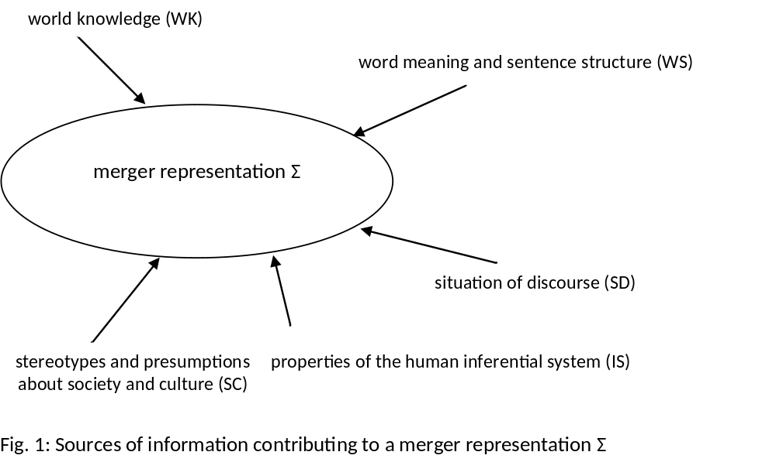

The source WS pertains to the logical form of the sentence. Contextualist theories that retain the logical form as the semantic baseline prioritise WS, allowing some or all of the remainder of the sources of information, which can be jointly termed ‘context of utterance’, to (i) enrich the logical form to produce an adequately intuitive truth-conditional unit and to (ii) produce implicatures. In DS, WS plays a slightly different role. First, as in all semantic theories, it serves as the input to a pragmatic process of recovering the primary meaning. The difference is that when looking at truth conditions of primary meanings, WS no longer has such a privileged role in meaning recovery. Instead, to repeat, WS contributes to the merger representation on an equal footing with the other sources, and in different contexts may or may not take precedence in informing the proposition corresponding to that primary meaning.
Next, DS identifies a range of processes that operate on the sources of information identified in Fig. 1, which in turn contribute to the formation of a merger representation. These processes are given diagrammatically in Fig. 2.

combination of word meaning

and sentence structure (WS)

conscious pragmatic inference_{pm}

(from situation of discourse, social and

social, cultural and

cognitive defaults (CD)

cultural assumptions, and world

world
-
knowledge defaults

(SCWD
)

knowledge) (CPI
)

Fig. 2: Utterance interpretation according to the processing model of DS

merger representation Σ

DS makes use of this processing model and in the representations of conditionals below we index the components of each Σ with a subscript standing for the type of processing.
We are now in a position to construct merger representations for conditionals. To exemplify, conditional perfection from ‘if’ to ‘iff’ (Geis and Zwicky 1971; see also Horn 2000) in the seminal sentence (31) would be represented in DS as in Fig. 3.

- If you mow the lawn, I will give you five dollars.

The language of the representations is an adapted and extended version of that used in Discourse Representation Theory (Kamp and Reyle 1993): x, y, z, e₁ and e₂ used in Fig. 3 stand for discourse referents, the formulae below them are discourse conditions, the square brackets encase the material on which a given DS-process operates, and the type of the process is indicated in the subscript (see Fig. 2). ACC stands for the modal operator of acceptability with which temporality of events is represented, the subscript Δ for the degree of epistemic commitment to the truth of the eventuality, and the superscripts ‘tf’ and ‘rf’ for tenseless future and regular future respectively.

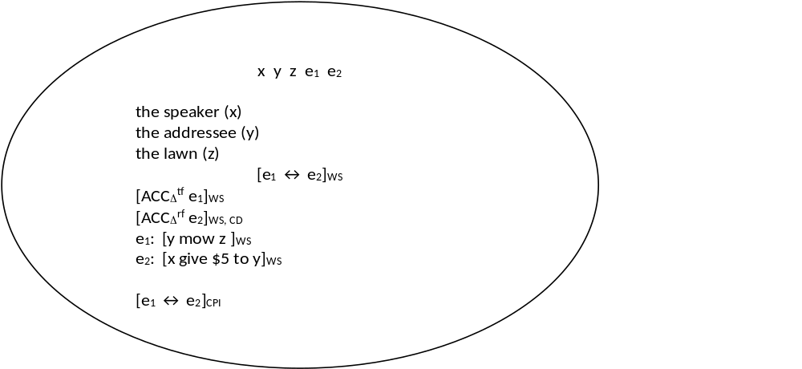

Fig. 3. Σ for the ‘perfected’ reading of ‘If you mow the lawn, I will give you five dollars.’
In the case of Fig. 3, the content of the two eventualities e₁ and e₂ comes directly from the source WS, while the primary meaning of the bi-conditional is attributed to the process of CPI (conscious pragmatic inference).
We now move to representing a wider range of expressions that fall into our class of conditionals, pragmatically defined as expressions that are used for representing conditional thought. We consider six different types of examples: (C1) is the typical case: a standard, overt conditional with a strong, primary conditional meaning; (C2) is a conditional sentence with a primary meaning that is not conditional; (C3) is an example of a sentence that does not have a conditional form but whose primary meaning is conditional; (C4) is again an example of a sentence that does not have a conditional form but whose primary meaning is not conditional either; instead, it has a secondary conditional meaning; (C5) is an instance of an incomplete conditional sentence where the conditional meaning is primary; and finally (C6) is an instance of an incomplete conditional sentence where the conditional meaning is secondary. To repeat, (C4) could have easily been excluded from this analysis but since it is possible for conditional thought to be communicated as secondary meaning, we decided to include it for the sake of completeness.
We use two dimensions for identifying these six categories. The first dimension pertains to the source of information that is responsible for generating the conditional meaning. There are conditional meanings that arise out of the structure of the sentence alone (WS), as in (C1) and (C2), and conditional meanings whose computation requires merger representations (Σ) as in (C3)-(C6), where (C4) corresponds to the tentatively included category of secondary conditional meanings, and (C5)-(C6) represent incomplete sentences where the consequent is missing and has to be recovered. The second dimension pertains to the status of conditional meaning as primary or secondary. The conditional meanings can be main, primary meanings of the utterances (PM) as in (C1), (C3) and (C5), or additional, secondary meanings (SM) as in (C2), (C4) and (C6). These two dimensions are indicated for each of the types listed by the relevant subscripts.

(C1) (p → q)_{WS, PM}
‘If it rains, we will stay at home.’
=PM

(C2) (p → q)_{WS, SM}
‘If you are hungry, there is food in the fridge.’
=SM
(PM: ‘Help yourself to food from the fridge.’)

(C3) ( p → q)_{Σ, PM}
‘Touch his iPad and he will scream.’
PM: ‘If you touch his iPad, he will scream.’

?(C4) (p → q)_{Σ, SM}
‘Please put on your helmet.’
SM: ‘If you put on your helmet, you will be safer.’
(PM: ‘Please put on your helmet.’)

(C5) (p → ?)_{Σ, PM}
‘If you leave the tea on a wobbly table…’
PM: e.g. ‘If you leave the tea on a wobbly table, you will spill it.’

(C6) (p → ?)_{Σ, SM}
‘If you’d like to put on your helmet.’
SM: e.g. ‘If you put on your helmet you will be safer.’
(PM: ‘Please put on your helmet.’)

Let us consider an example of ‘Σ + PM’, that is (C5). The merger representation for (C5) can now be constructed as in Fig. 4.

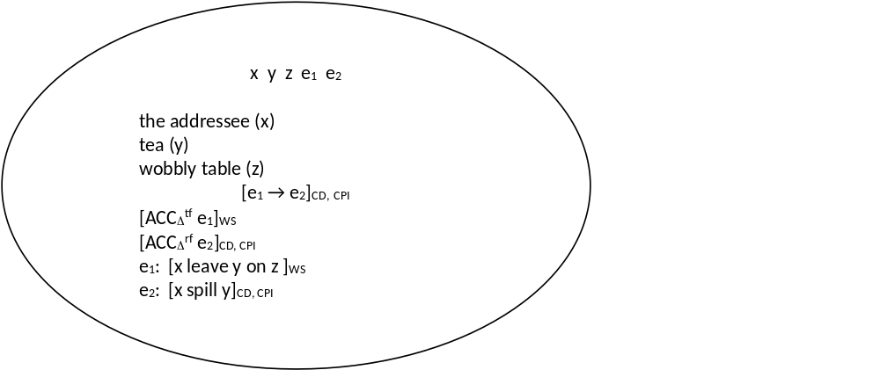

Fig. 4. Σ for (C5): p → ?_{PM} ‘If you leave the tea on a wobbly table…’
In this case, the conditional primary meaning is constructed from the merger of information that requires input from the context of utterance. Specifically, the content of the antecedent comes directly from WS, but the content of the consequent has to be recovered via a cognitive default (CD) with conscious pragmatic inference (CPI). Note that this example also uses the modal operator of acceptability (ACC) to represent the futurity of the events.
Next, Fig. 5 represents the primary, non-conditional meaning of (C6).

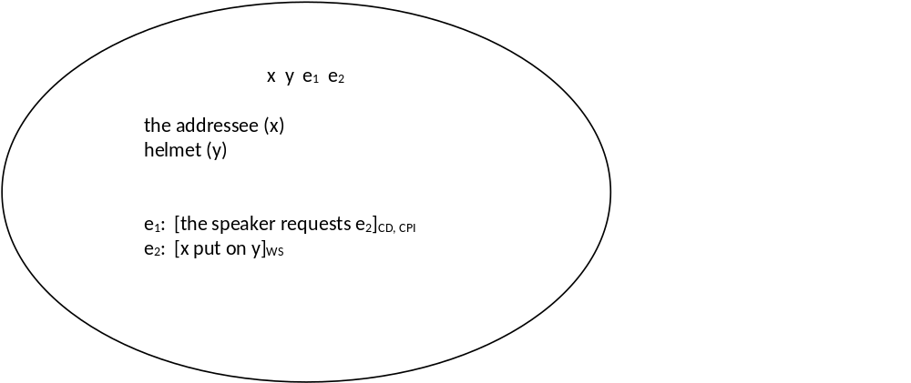

Fig. 5. Σ for the PM of (C6): p → ?_{SM} ‘If you’d like to put on your helmet.’ (PM: ‘Please put on your helmet.’)
Here, the speaker’s request is borne out of a cognitive default (CD) coupled with conscious pragmatic inference (CPI), while the content of the request e₂ is attributed to WS. The secondary, conditional meaning would be represented in a standard way.
Finally, Fig. 6 represents the primary conditional meaning of the non-conditional sentence (C3).

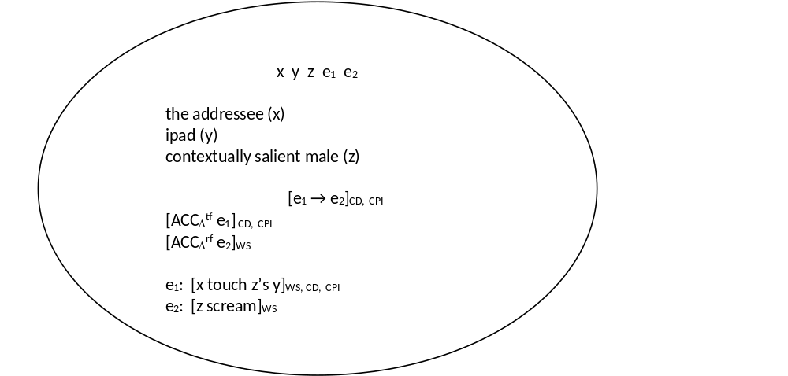

Fig. 6. Σ for the PM of (C3): p → q _{Σ, PM} ‘Touch his iPad and he will scream.’ (PM: ‘If you touch his iPad, he will scream.’)
As in the case of (C5), the conditional primary meaning is borne out of the merger of information via the processes CD and CPI, but in this case, WS contributes both to the antecedent and the consequent. Other identified types are represented in an analogous way.
Finally, in Section 3 we also identified various categories of conditionals depending on the semantic properties of the link between the antecedent and the consequent, for example sentences in which the antecedent is used to hedge the propositional content, as in (13), or to hedge the illocutionary force, as in (14), both repeated below.

(13) If I remember rightly you had jaundice, didn’t you? ICE-GB S1A-028 051
(14) Very short skirt on if you don’t mind me saying. ICE-GB S1A-040 089

The next step will be to test DS as regards its ability to represent the semantic (in the sense of the contextualist semantics adopted here) properties of this link. In some cases, the task will be to represent the primary meaning that is not itself conditional but instead, for example, pertains to a speech act of reproaching or reprimanding; in others the primary meaning will pertain to a conditional structure but the representation of the antecedent will have to reflect its hedging role. But this is a task for a separate project.

- Concluding remarks

We hope to have provided compelling arguments in favour of a pragmatic category of conditionals that encompasses our categories (C1)-(C6) and yields itself a uniform truth-conditional contextualist analysis in terms of merger representations of DS. Only when the object of study is conceived broadly and includes various ways of externalising conditional thought can we be hopeful of arriving at a comprehensive, explanatorily successful account. We have demonstrated here that adopting a version of the radical contextualist approach to meaning allows one to formally represent conditionality, conceived here as a universal conceptual category. This radical contextualist outlook comes with a rethinking of the principle of compositionality of meaning and reallocating it to an interaction of information about meaning that comes from different aspects of the situation of discourse. In this way we are able to go beyond the syntactic category of conditionals to talk about a conceptual representation of conditionality, which allows us to propose what we call a ‘pragmatic category of conditionals’: ‘pragmatic’ in the sense that pragmatics plays a core role in arriving at the truth-conditional representation. We have demonstrated how this composition works in merger representations of DS for different ways of expressing conditional thought in natural language. In short, we hope to have provided arguments for a uniform treatment of expressing conditional thoughts in discourse, irrespective of whether they are expressed overtly or covertly in communication and irrespective of their primary or secondary status.
Representing conditional meanings of utterances in preference to conditional structures alone comes with some negative consequences in that although the phenomenon appears unified, cognitively plausible and justified to a pragmaticist, it may not appear so to linguists who prefer to divide the subject matter by grammatical structures. But the advantages outweigh the shortcomings in that we are investigating the conceptual category that, as we discussed earlier, has a strong claim to the status of a semantic universal. In this way we are able to include constructions from languages in which conditionality does not correspond to a syntactic category but instead is realised as an irrealis marker or a polar question. And, as this paper has demonstrated, there are also significant advantages for the analysis of languages that do have a designated conditional structure but in addition use a variety of different means to convey conditional meaning in discourse. Moreover, since formal analyses have demonstrated that the conditional is not a syntactic category in its own right but instead ‘if’-clauses are adverbial clauses and “[t]he history of the conditional is the story of a syntactic mistake” (Kratzer 1991/2012: 106), it is prudent to take this finding further into the pragmatic and cognitive domain and investigate whether the cognitive counterpart of this claim would not simply be a conceptual category of supposition that one has to accept before assessing the proposition dependent on it. And this conceptual link, as we have seen in the pragmatic categories we propose, is best approached from the pragmatic perspective, taking the discourse realisation of the conditional thought as the object to be represented. In short, conditional thoughts seem to give rise to a clearly delineable, pragmatic phenomenon that yields to a uniform contextualist analysis.
References

Anderson, Alan R. 1951. ‘A note on subjunctive and counterfactual conditionals’. Analysis 12. 35–38.
Austin, John L. 1961. ‘Ifs and Cans.’ In: J. O. Urmson & G. J. Warnock (eds). Philosophical Papers. Oxford: Oxford University Press. 153–180.
Borg, Emma. 2004. Minimal Semantics. Oxford: Clarendon Press.
Borg, Emma. 2012. Pursuing Meaning. Oxford: Oxford University Press.
Byrne, Ruth M. J. and Philip N. Johnson-Laird. 2010. ‘Conditionals and possibilities’. In: M. Oaksford & N. Chater (eds). Cognition and Conditionals: Probability and Logic in Human Thinking. Oxford: Oxford University Press. 55-68.
Cappelen, Herman and Ernest Lepore. 2005. Insensitive Semantics: A Defense of Semantic Minimalism and Speech Act Pluralism. Oxford: Blackwell.
Carston, Robyn. 2002. Thoughts and Utterances: The Pragmatics of Explicit Communication. Oxford: Blackwell.
Declerck, Renaat and Susan Reed. 2001. Conditionals: A Comprehensive Empirical Analysis. Berlin, New York: Mouton de Gruyter.
Edgington, Dorothy. 2008. ‘Counterfactuals’. Proceedings of the Aristotelian Society 108. 1–21.
Elder, Chi-Hé. 2012. ‘The underlying conditionality of conditionals which do not use if’. Cambridge Occasional Papers in Linguistics 6. 177-200.
Elder, Chi-Hé. 2014. ‘On the forms of conditionals and the functions of if’. PhD thesis, University of Cambridge.
Elder, Chi-Hé. 2015. ‘Classifying conditionals: The case of metalinguistic if you like’. Cambridge Occasional Papers in Linguistics 7. 61-82.
Evans, Jonathan St B. T. and David E. Over. 2004. If. Oxford: Oxford University Press.
Evans, Nicholas and Stephen C. Levinson. 2009. ‘The myth of language universals: Language diversity and its importance for cognitive science’. Behavioral and Brain Sciences 32. 429-492.
Feldman, Jerome. 2010. ‘Embodied language, best-fit analysis, and formal compositionality’. Physics of Life Reviews 7. 358-410.
von Fintel, K. 2001. ‘Conditional strengthening’. Unpublished manuscript.
von Fintel, Kai and Lisa Matthewson. 2008. ‘Universals in semantics’. The Linguistic Review 25. 139-201.
Geis, Michael L. and William G. Lycan. 1993. ‘Nonconditional Conditionals’. Philosophical Topics 21. 35-56.
Geis, Michael L. and Arnold M. Zwicky. 1971. ‘On invited inferences’. Linguistic Inquiry 2. 561-66.
Grice, H. Paul. 1967. ‘Indicative conditionals’. Reprinted in 1989, Studies in the Way of Words. Cambridge, MA: Harvard University Press. 58-85.
Horn, Laurence R. 1984. ‘Toward a new taxonomy of pragmatic inference: Q-based and R-based implicature’. In: D. Schiffrin (ed.). Georgetown University Round Table on Languages and Linguistics 1984. Washington, DC: Georgetown University Press. 11-42.
Horn, Laurence R. 1988. ‘Pragmatic theory’. In: F. J. Newmeyer (ed.). Linguistics: The Cambridge Survey. Vol. 1. Linguistic Theory: Foundations. Cambridge: Cambridge University Press. 113-145.
Horn, Laurence R. 2000. ‘From if to iff: Conditional perfection as pragmatic strengthening’. Journal of Pragmatics 32. 289-326.
Horn, Laurence R. 2004. ‘Implicature’. In: L. R. Horn and G. Ward (eds). The Handbook of Pragmatics. Oxford: Blackwell. 3-28.
Horn, Laurence 2013. ‘Ifs, ands, and buts about pragmatics’. Paper presented at the 19th International Congress of Linguists, Geneva.
Humberstone, Lloyd. 2011. The Connectives. Cambridge, MA: MIT Press.
Jaszczolt, Kasia M. 2005. Default Semantics: Foundations of a Compositional Theory of Acts of Communication. Oxford: Oxford University Press.
Jaszczolt, Kasia M. 2009. ‘Cancellability and the primary/secondary meaning distinction’. Intercultural Pragmatics 6. 259-289.
Jaszczolt, Kasia M. 2010. ‘Default Semantics’. In: B. Heine and H. Narrog (eds). The Oxford Handbook of Linguistic Analysis. Oxford: Oxford University Press. 215-246.
Jaszczolt, Kasia M. 2012. ‘Semantics/pragmatics boundary disputes’. In: C. Maienborn, K. von Heusinger, and P. Portner (eds). Semantics. An International Handbook of Natural Language Meaning. Vol. 3. Berlin: Mouton de Gruyter. 2333-2360.
Jaszczolt, Kasia M. 2015. ‘Contextualism’. In: K. Jungbluth & F. Da Milano (eds). Manual of
Deixis in Romance Languages. Berlin: Walter de Gruyter. 407-424.
Jaszczolt, Kasia M. 2016. Meaning in Linguistic Interaction: Semantics, Metasemantics, Philosophy of Language. Oxford: Oxford University Press.
Johnson-Laird, Philip N. & Tagart, Joanna. 1969. ‘How implication is understood’. The Journal of American Psychology 82. 367-373.
Kamp, Hans and Uwe Reyle. 1993. From Discourse to Logic: Introduction to Model-theoretic Semantics of Natural Language, Formal Logic and Discourse Representation Theory. Dordrecht: Kluwer Academic Publishers.
Klinedinst, Nathan and Daniel Rothschild. 2012. ‘Connectives without truth tables’. Natural Language Semantics 20. 137-175.
Kratzer, Angelika. 1991. ‘Conditionals’. Reprinted revised edition in 2012, Modals and Conditionals. Oxford: Oxford University Press. 86-108.
Lewis, David. 1973. Counterfactuals. Oxford: Blackwell.
Lewis, David. 1979. ‘Attitudes de dicto and de se’. The Philosophical Review 88. 513-543.
Lycan, William G. 2001. Real Conditionals. Oxford: Clarendon Press.
Mauri, Caterina and Johan van der Auwera. 2012. ‘Connectives’. In: K. Allan and K, M, Jaszczolt (eds). The Cambridge Handbook of Pragmatics. Oxford: Oxford University Press. 377-401.
Over, David E., Jonathan St B. T. Evans and Shira Elqayam. 2010. ‘Conditionals and non-constructive reasoning’. In: M. Oaksford & N. Chater (eds). Cognition and Conditionals: Probability and Logic in Human Thinking. Oxford: Oxford University Press. 135-151.
Predelli, Stefano. 2005. Contexts: Meaning, Truth, and the Use of Language. Oxford: Oxford University Press.
Ramsey, Frank P. 1929. ‘General Propositions and Causality’. Reprinted in D. H. Mellor (ed). 1990. F. P. Ramsey: Philosophical Papers. Cambridge: Cambridge University Press. 145–63.
Recanati, François. 2004. Literal Meaning. Cambridge: Cambridge University Press.
Recanati, François. 2010. Truth-Conditional Pragmatics. Oxford: Clarendon Press.
Recanati, François. 2012. ‘Contextualism: Some varieties’. In: K. Allan and K. M. Jaszczolt (eds). The Cambridge Handbook of Pragmatics. Cambridge: Cambridge University Press. 135-149.
- Rescher, Nicholas. 2007. Conditionals. Cambridge, MA: MIT Press.
de Saussure, Louis. 2013. ‘Background relevance’. Journal of Pragmatics 59. 178-189.
Stalnaker, Robert C. 1975. ‘Indicative conditionals’. Reprinted in 1999 in: Context and Content. Oxford: Oxford University Press. 63-77.
Stalnaker, Robert C. 1998. ‘On the representation of context’. Reprinted in 1999 in: Context and Content. Oxford: Oxford University Press. 96-113.
Stalnaker, Robert C. 2012. ‘On the so-called subjunctive’. Paper presented at the Semantics and Pragmatics Research Cluster Workshop, University of Cambridge, 15 June 2012.
Stalnaker, Robert C. 2014. Context. Oxford: Oxford University Press.
Stanley, Jason. 2000. ‘Context and logical form’. Linguistics and Philosophy 23. 391-434.
- Sztencel, Magdalena. 2013. ‘Meaning and individual minds: the case of if’. PhD thesis, Newcastle University.
Wen-Li, Ke. 1983. ‘Sentences of implied condition’. ELT Journal 37. 85-87.

Acknowledgements

We would like to thank the participants of PhiLang13, Łódź; ICL19 Geneva; The 88th Joint Session of the Aristotelian Society and the Mind Association, Cambridge; the University of Cambridge Semantics and Pragmatics Research Cluster; our colleagues Keith Allan, Johan van der Auwera, Minyao Huang, Napoleon Katsos, John Maier, Louis de Saussure and Joseph Tyler, as well as anonymous reviewers, for their comments on an earlier draft of this paper.

It has to be pointed out that the conditional meaning associated with the conjunction in (1) intuitively appears stronger than that associated with the disjunction in (2). However, this does not affect our argument. We thank Louis de Saussure for drawing our attention to this point.
This is not to say that in (3) and (4) conditionality is absent altogether on the conceptual level. We return to this point in Sections 3.2 and 4.
It has to be remembered that our object of study as well as the research questions are tangential to the concerns of a formal semantic account of a particular sentence structure.
As is evident from this discussion, we dissociate ourselves from minimalist, sentence-based accounts of semantics (e.g. Borg 2004, 2012; Cappelen & Lepore 2005), and adopt an assumption that semantic theory be strongly permeated with context-dependent intention-driven meanings (as it is in Default Semantics adopted below).
For arguments and linguistic evidence in favour of the primary/secondary distinction that cuts across the explicit/implicit divide see especially Jaszczolt (2009).
It is a matter of terminological decision as to whether to call this approach truth-conditional pragmatics and leave semantics as a more narrow enterprise, relying on the structure of the sentence and on indexicals (see Recanati 2010, 2012) or to give it a label of a truth-conditional, albeit radically contextualist, semantics. In agreement with Default Semantics (Jaszczolt, e.g. 2005, 2010, 2016), we opt for the latter alternative.
Austin’s (1961) original example was “If you’re hungry there are some biscuits on the sideboard”, hence the term ‘biscuit conditional’. As Horn (2000: 317 fn) notes, the example has morphed, resulting in (7) as the locus classicus.
We take many of our examples from the British component of the International Corpus of English (ICE-GB). These are referenced using the standard notation from the spoken portion of that corpus, namely of the form (S00-000 #000).
Rescher (2007), for example, develops an account of conditionals that would allow non-‘if’-conditionals into the analysis, but constrains his attention to what he terms “assertorically consequential conditionals” (Rescher 2007: 3); in Section 3.2 we argue that ‘if’-conditionals which express non-conditional thoughts can nevertheless express conditionality as a secondary meaning, and thus should be included in the analysis. We thank an anonymous reviewer for drawing our attention to this reference.
Grice maintained that the semantics of conditionals was informed by the material conditional. It has long been acknowledged that natural language conditionals do not behave as material conditionals, and in particular, that people do not use the logic of material conditionals in their everyday reasoning strategies (see e.g. Johnson-Laird and Taggart (1969) and Evans & Over (2004)). We thank an anonymous reviewer for drawing our attention to these references.
Intuitions concerning the presuppositions in this example vary. In addition, it is possible that the presence of negation in the consequent is responsible for (9)’s failure to adhere to the Indirectness Condition. We thank Louis de Saussure and an anonymous reviewer for discussing this case with us.
We are not extending the present analysis to the discussions of indicative versus counterfactual conditionals presented by Lewis (e.g. 1973) or Edgington (e.g. 2008) among others, or to Lycan’s (2001) syntactic approach to the ‘if…then’ operator. To repeat, neither do we include, apart from cursory references, Kratzer’s (1991/2012) proposal according to which the object of analysis would have to be extended to adverbial clauses. These are tangential to our current objective.
But Over et al. (2010) and Evans and Over (2004) also appeal to Stalnakerian-style semantics for counterfactuals, as is discussed below. We thank an anonymous reviewer for reminding us of this.
We attend to this theoretical discussion in Section 4.
We note that Sztencel (2013) also maintains that the object of analysis for conditionality has to be located at the level of thoughts, but we depart from her assumption that conditionality is linked to the material conditional. We thank an anonymous referee for drawing our attention to this reference.
We are grateful to the anonymous referee for making us clarify this point.
The requirement can equally be explained in terms of Horn’s (e.g. 1984) scalar implicature.
Example paraphrased from John Maier (p.c.). We thank John Maier and Joseph Tyler for discussing these cases with us.
‘Remoteness’ can either be understood in terms of possible worlds (e.g. Lewis 1979, 1973) or in terms of circumstances of evaluation (Predelli 2005). See also de Saussure (2013) on discursive, pragmatically determined presuppositions.
Stalnaker (2012) defends the analogous case for counterfactuals.
ICE-GB, see fn 8. See Elder (2012, 2014) for a description of this manual corpus search.
Geis & Lycan (1993) provide examples to show that ‘non-conditional conditionals’ lie on a continuum with respect to the extent that they adhere to syntactic and (minimalist) semantic criteria for conditionality stemming from the sentence form. By taking on board pragmatic criteria, we are able to include the full spectrum of conditional sentences in the overarching category of conditionals on the basis that while such ‘non-conditional conditionals’ do not always express conditional thoughts as primary, they nevertheless express conditional secondary meanings. We thank an anonymous reviewer for directing us to this reference.
It must be noted that we are not making claims about the psychology of processing of indirect conditionals, and are not proposing that (7b) is a step in the inference from (7) to (7a), but merely that we can re-evaluate (7) as a direct conditional in the form of (7b) and that (7b) is one of the plausible secondary messages conveyed in uttering (7).
See Elder (2015) for a defence of including utterances using ‘if you like’ in the category of conditionals.
Recall it is not our purpose here to create a database of sentence types that may express conditional meanings, but rather to put forward the criteria that will delimit the pragmatic category of conditionality.
It is for this reason that an utterance of ‘I will touch her iPad and she will scream’ is unlikely to receive the conditional interpretation: p is put forward as a statement of intention, and so no remoteness is associated with it. We thank an anonymous reviewer for pointing out such cases to us.
A question arises at this point as to whether such a radically contextualist approach to truth-conditional content still falls in the domain of semantics or is better situated in pragmatics. Recanati (2012: 148) tries to salvage grammar-controlled semantics while advocating contextualist truth-conditional content: “Is semantic interpretation a matter of holistic guesswork (like the interpretation of kicks under the table), rather than an algorithmic, grammar-driven process as formal semanticists have claimed? Contextualism: Yes. Literalism: No. (…) Like Stanley and the formal semanticists, I maintain that the semantic interpretation is grammar-driven.” This stance relies on the assumption that the truth-conditional content corresponding to the main intended speech act cannot be algorithmically computed. However, merger representations of Default Semantics utilised here demonstrate that linguists may not be far away from such an algorithmic treatment of the contextualist content.
At this point we include the disclaimer that we do not aim to provide an account of how the sources of information interact to generate the primary meaning, but acknowledge that they interact in line with the methodological assumption of interactive compositionality.
For readers more interested in the details of the approach, it may be pointed out that one can identify a mapping, albeit not a bi-unique one, between the sources and the processes: WK SCWD or CPI SC SCWD or CPI WS WS (logical form) SD CPI IS CD
The representation of the temporal reference is included in the Σs for the sake of completeness but it is not relevant for the present considerations. The theory of temporality as modality has been developed in Jaszczolt (2009) and interested readers are referred there for a detailed account.
These are allocated to WS with the proviso that the contextual resolution of the indexicals has to take place.
As noted by von Fintel (2001) and discussed in Elder (2014), the example ‘If you mow the lawn I will give you five dollars’ would not always give rise to a perfected reading.
It is also possible for this sentence to have the primary meaning to the effect ‘Don’t leave your tea on the wobbly table’, depending on the scenario. Mutatis mutandis for (C4).

