MicroRNA-10 modulates Hox genes expression during Nile tilapia embryonic development

Juliana Giustiª, Danillo Pinhal ^{b}, Simon Moxon^{c}, Camila Lovaglio Campos^{b}, Andrea Münsterberg^{d} and Cesar Martins^{a*}

^{a-} Institute of Biosciences, Department of Morphology - Sao Paulo State University, Botucatu, Brazil. jugiusti@gmail.com; cmartins@ibb.unesp.br
^{b-} Institute of Biosciences, Department of Genetics - Sao Paulo State University, Botucatu, Brazil. dlpinhal@ibb.unesp.br; camilalovaglio@gmail.com
^{c-} The Genome Analysis Centre, Norwich Research Park - Norwich - UK. simon.moxon@tgac.ac.uk
^{d-} School of Biological Sciences, University of East Anglia, Norwich Research Park - Norwich - UK. a.munsterberg@uea.ac.uk

*Corresponding author: E-mail: cmartins@ibb.unesp.br, cmartinsunesp@gmail.com
Abstract
Hox gene clusters encode a family of transcription factors that govern anterior-posterior axis patterning during embryogenesis in all bilaterian animals. The time and place of Hox gene expression are largely determined by the relative position of each gene within its cluster. Furthermore, Hox genes were shown to have their expression fine-tuned by regulatory microRNAs (miRNAs). However, the mechanisms of miRNA-mediated regulation of these transcription factors during fish early development remain largely unknown. Here we have profiled three highly expressed miR-10 family members of Nile tilapia at early embryonic development, determined their genomic organization as well as performed functional experiments for validation of target genes. Quantitative analysis during developmental stages showed miR-10 family expression negatively correlates with the expression of HoxA3a, HoxB3a and HoxD10a genes, as expected for bona fide miRNA-mRNA interactions. Moreover, luciferase assays demonstrated that HoxB3a and HoxD10a are targeted by miR-10b-5p. Overall, our data indicate that the miR-10 family directly regulates members of the Hox gene family during Nile tilapia embryogenesis.

Keywords: Oreochromis niloticus; embryos; HoxA3a; HoxB3a; HoxD10a; miRNA

1. Introduction
The development of a multicellular organism from a single cell is a complex process involving many molecules including transcription factors, which must be present in specific cells at the right time (Montavon et al., 2011). A group of master transcription factors are encoded by the Hox gene clusters that have conserved roles in patterning the anterior-posterior axis during embryogenesis in all bilaterian animals (Alexander et al., 2009). The mechanisms of transcriptional regulation of these molecules are dictated by the organization of the genes in clusters within the genome (Duboule et al., 2007). This type of genomic organization allows for sharing nuclear space, chromatin structure, common regulatory elements, such as enhancers, and even promoters. Furthermore, it provides time and spatial colinearities during development, because Hox genes located closer to the enhancers are transcribed earlier (Andrey et al., 2013). As a result, the time and place of Hox gene expression are largely determined by the relative position of each gene within its cluster (Duboule et al., 2007).
Hox genes from the same group (transparalogous or paralogues genes) arose from duplication and share more similarity in protein sequence and expression pattern than other genes within a cluster. In mice and other mammals there are 39 Hox genes arranged in four clusters (A, B, C and D) located on four different chromosomes, whereas teleost fishes have at least 48 Hox genes in eight clusters (Aa, Ab, Ba, Bb, Ca, Cb, Da and Db) that resulted from a whole genome duplication (Amores et al., 2004). Intriguingly elasmobranchs (sharks and rays) have only 3 Hox clusters (A, B and D) as consequence of a genomic deletion of their entire HoxC cluster (King et al., 2011). The Nile tilapia Oreochromis niloticus has 51 Hox genes arranged in seven clusters, (Figure 1). Several studies have compared Hox gene organization, and Hox of Nile tilapia seems to be more similar to orthologues of pufferfish (Tetraodon nigrovirides) and medaka (Oryzias latipes) than to zebrafish (Santini & Bernardi, 2005).
The observed complexity of Hox genes regarding paralogs diversity and arrangement patterns in teleost fish is a consequence of three rounds of genome duplications that these animals are believed to have undergone during vertebrate evolution. Following the first duplication (500 My), the AB cluster lost the Hox12 gene and the CD cluster lost the Hox2 and Hox7 genes. After the second duplication, the A cluster lost the Hox8 gene, the B cluster lost the Hox11 gene, the C cluster lost the Evx gene and the D cluster lost the Hox6 gene. The divergence of the tetrapod lineage followed the second duplication (400 My) and tetrapods underwent specific gene losses while the ancient ray-finned fish (teleosts) ancestor underwent the third duplication (350 My) and lost several genes in all the clusters. The organization of the “a” clusters appears to be very conserved, whereas “b” clusters have lost more genes (Santini & Bernardi, 2005).
Paralogous Hox genes often perform distinct biological roles, as evidenced by their mutant phenotypes, but may also show extensive redundancy and functional overlap. In fruit flies and mice, deletion of a single Hox gene leads to altered axial identities and transformation of specific embryonic structures into more anterior ones (Rijli et al., 1973; Kaufman et al., 1978; Gendron-Maguire et al., 1993). Conversely, ectopic expression of a single Hox gene can also result in a posterior transformation or loss of the body structures (Denell et al., 1981; Van de Ven et al., 2011), thereby interfering permanently with organismal development.
Development is a complex process requiring several events to be accurately temporally and spatially regulated. In this sense, microRNAs (miRNAs) were reported as key regulatory elements for proper organism development based on their ability to modulate gene expression, including the expression of transcriptional factors (Mallo & Alonso, 2013). As members of an abundant class of small noncoding RNAs, miRNAs repress gene expression by preferentially binding to complementary target sequences in the 3'UTRs of mRNAs leading to mRNA degradation and/or translational repression (Bartel, 2009; Lee & Shin, 2012).
MiRNA-mediated regulation of Hox genes has been previously reported in Drosophila (Bender, 2008), mouse (Mansfield & McGlinn, 2012), chick (Wong et al., 2015) and human (Lund, 2010) implying that regulation via miRNAs comprises an extra tier in the complex molecular regulatory circuit controlling Hox gene expression. For instance, downregulation of miR-10 in zebrafish embryos leads to overexpression of HoxB1a and HoxB3a (Woltering & Durston, 2008) and in humans, miR-10 downregulation was negatively correlated with HoxA1 overexpression (Garzon et al., 2006). These data suggests that the same miRNA may target paralogous genes from distinct Hox clusters.
Notably, several Hox-regulating miRNAs of vertebrates are encoded within the Hox clusters, as observed for miR-10 and miR-196. In mammals, miR-10a resides upstream of HoxB4 and miR-10b is upstream of HoxD4. This intronic genomic arrangement might provide an effective mechanism for the co-expression of miRNAs and their Hox mRNA targets in a temporal and spatial manner (Tanzer et al., 2005; Mallo & Alonso, 2013). In addition, zebrafish and human genomes have intergenic miRNAs encoded outside of the Hox clusters such as mir-99a, mir-99b and mir-100, highly homologous to mir-10a and mir-10b, that despite nucleotide difference within seed region, may have overlapping targets (Tehler et al., 2011; Woltering & Durston, 2008). These data shows that miRNAs encoded/associated with Hox clusters can differentially modulate the expression of Hox during vertebrate development. In Nile tilapia, however, the spatiotemporal expression profiles of miR-10 family and their modulation over Hox genes remain poorly investigated.
Although significant evidence has been generated regarding the biological roles of miR-10 family members, further experiments are required to determine the specific genes they target, which in turn, will reveal the physiological functions regulated by them. Moreover, given the dynamism of fish genomes, particularly of cichlid species, and the complex evolutionary history of gene birth and death of Hox clusters in vertebrates, the correct description of miRNA regulation over these transcription factors in Nile tilapia requires a detailed inspection of miR-10 family genomic organization.
In this paper, we investigate the role of miR-10 family members in the regulation of a number of Hox genes (HoxA3a, HoxB3a and HoxD10a) during the ontogenesis of Nile tilapia fish. For this purpose, we firstly predicted miR-10 family targets through bioinformatics approaches. Subsequently, we quantified and correlated the expression profiles of both miR-10 family members and target genes at several embryonic developmental stages. Lastly, we validated miRNA-target interactions by functional in vitro assays and examined miR-10 genomic organization. Our results demonstrated that HoxB3a and HoxD10a are regulated by miR-10b-5p during the early development of Nile tilapia, providing input for future research in vertebrates and in fish development.

2. Materials and Methods
2.1. Samples and RNA purification
All procedures involving animals were performed according to principles set by the Ethics Committee for Animal Experimentation –Institute of Biosciences – São Paulo State University (protocol 34/08). All fish were anesthetized with benzocaine (100mg/L of water) before being euthanized in liquid nitrogen.
Nile tilapia embryos (1, 3, 5 and 7 days post fertilization - dpf) and 30 dpf juveniles of both sexes were collected in the Royal Fish Farm, Jundiaí, São Paulo, Brazil. Embryos were removed from the female mouth and selected based on morphology (Fujimura & Okada, 2007) with a stereomicroscope. These sampling periods were based on cell differentiation stage of the embryonic development cycle of O. niloticus (Fujimura & Okada, 2007; Ijiri et al., 2008). The 30 dpf period represents sex-differentiated animals. All specimens were placed in a solution of benzocaine, frozen in liquid nitrogen and stored in -80°C until RNA isolation.
RNA isolation was performed using TRIZOL kit (Invitrogen) according to the manufacturer's instructions. RNA recovered from samples was quantified by spectrophotometry (NanoVue, GE Healthcare Life Sciences) and checked for quality through the RNA integrity number (RIN) analysis. RNA samples were treated with DNA FreeTM Kit (Ambion) to remove genomic DNA contamination.

2.2. qRT-PCR of miRNAs
Expression of five selected miR-10 family members (Table 1) was measured in embryos at 1, 3, 5 and 7 dpf life stages and in 30 dpf juveniles by qRT-PCR. These miRNAs were preferentially chosen based on previous small RNA deep sequencing data of our research group, which verified that they are 6-fold more higly expressed in Nile tilapia embryos than other miRNAs (Pinhal et. al, unpublished data).
From total RNA, mature miRNAs were converted into cDNA using TaqMan MicroRNA reverse transcription kit (Life Technologies) following the manufacturer's instructions. Subsequently, qRT-PCR was carried out using TaqMan 2x Universal Master Mix 1x, TaqMan MicroRNA Assay Mix 1x, 2ng/uL cDNA and the volume was completed to 20µL with nuclease-free water. In these experiments, the endogenous U6 snRNA was used as a reference gene.

2.3. Target prediction and quantitative expression analysis
Among several Hox genes known to be in Nile tilapia genome, HoxB3a and HoxD10a were found to be potentially targeted by miR-10b-5p, miR-10 family members, based on TargetScan (Grimson et al., 2007), Pictar (Krek et al., 2005) and miRanda (Enright et al., 2003) prediction tools outputs. These genes were then quantified by qRT-PCR on samples from 5 animals of both sexes and three experimental replicates for each developmental period. Reverse transcription of total mRNA was performed using the High Capacity RNA-to-cDNA Master Mix kit (Life Technologies) according to the manufacturer's guidelines. qRT-PCR was performed using 1xGoTaq® probe qPCR master mix based on SYBR Green chemistry (Promega), 40ng/uL of RT reaction, 900nM of primers (forward and reverse) (Table 1) to 10 mM and the final volume was completed to 20µL with nuclease-free water.
Thermocycling was performed on a Step-one PCR System (Applied Biosystems) and reaction conditions were 2 min at 50°C, 10 min at 95°C to polymerase activation, followed by 40 cycles of 15 sec of 95°C and 1 min at 60°C. The relative expression of target genes was evaluated using the comparative quantification method and the hypoxanthine phosphoribosyltransferase gene (HPRT) was used as an endogenous control.

2.4. Luciferase reporter constructs

Functional validation of miR-10b-5p action on HoxB3a and HoxD10a genes were based on the luciferase gene reporter assay. Four plasmids were constructed including two wildtype with the pGL-3 vector + 3'UTR of their respective genes (HoxB3a or HoxD10a) and two mutants with the pGL-3 vector + 3'UTR with restriction enzyme site at the seed position of their respective genes (HoxB3a or HoxD10a). The 3'UTR regions of two genes - HoxB3a and HoxD10a - from tilapia cDNA were PCR amplified (primers described in Table 1) and individually cloned into the pGL3 vector (Promega) by directional cloning. Fragments were 700bp long (HoxB3a: ENSONIT00000007801 and HoxD10a: ENSONIT00000010838).

Negative controls were constructed mutating the seed region of the miRNA target gene transcripts as described in Table 2. The mutant constructions were built using the wildtype plasmids as template. PCR reactions were performed using the primer set consisting of a primer forward with the desired enzyme site (Table 2) and reverse primer to a specific region at the plasmid pGL3. To ensure that the mutant plasmids were precisely generated with the correct nucleotide sequence, we used the Phusion® High-Fidelity DNA Polymerase (New England BioLab) for the PRC reactions.

2.5. Target validation by luciferase reporter assays
Luciferase reporter assays consist of the following steps. Chick dermal fibroblasts, DF1 cells, were counted and seeded in 24-well plates (Costar) at 7x10³ cells per well and were maintained for 24 hours in a liquid medium (DMEM with 10% FBS) in the presence of antibiotic in a CO₂ incubator at 37 °C for the perfect adaptation of the plate. Prior to transient transfection, the medium was replaced with fresh medium without antibiotic. Transfection of 0.4 mg of firefly luciferase reporter vector and 0.02 mg of the control vector containing Renilla luciferase was performed using lipofectamine 2000 (Invitrogen). Following transfection DF1 cells were maintained for 24 hours. The next day cells were washed with PBS and harvested for Dual Luciferase Reporter Assays (Promega) following the manufacturer's protocol. Each transfection was performed in four wells and repeated three times independently in different plates. Firefly luciferase activity was normalized to Renilla luciferase activity.
Assays were quantified using the brightness luciferase. The tests were measured as follows, wildtype: negative control (plasmid only); plasmid + miRNA of interest; and positive control (plasmid + miRNA mimic). Mutant test: Negative control (Plasmid-only with the mutant 3'UTR region); plasmid (mutant 3'UTR region) + miRNA of interest; and positive control (plasmid with mutant 3'UTR region + miRNA mimic). Renilla luciferase was used as the control in all the samples.

2.6. In silico analysis of genome organization of miRNA genes
All five miRNAs were analyzed regarding localization and arrangement. For precursor annotation, mature miRNA sequences were mapped against the Nile tilapia genome (UCSC, Broad, OreNil1.1) without permitting any mismatches. Retrieved precursor sequences were both aligned to zebrafish and human homologs and subjected to analysis by the RNAfold program (http://rna.tbi.univie.ac.at/cgi-bin/RNAfold.cgi) to confirm they fold into stable stem-looped secondary structures. Then we determined the physical position of pre-miRNAs in the linked groups (LGs) and classified them according to their host region and strand orientation.

2.7. Statistical Analysis
The data of quantitative PCR were expressed as median ± standard error. The qRT-PCR and Luciferase gene reporter assay data distribution were parametric then the Two-way ANOVA test was used. Significant differences were checked by running Bonferroni multiple comparison tests. Statistical significance was defined as p < 0.05.

3. Results
3.1. Negative correlation between expression profiles of miR-10 family members and Hox genes
QPCR experiments were sensitive to detect differences between miRNAs and putative target Hox genes expression signatures throughout distinct developmental stages.
For the miRNAs, the expression of miR-10a-5p, miR-10b-5p, miR-10d-5p, miR-99a-5p and miR-100-5p generally increased during Nile tilapia embryo development. The profiles of miR-100-5p and miR-99a-5p were similar, with low expression at 1 dpf and an 8-fold increase by 3 dpf or 7 dpf respectively (P<0.001). Very similar expression patterns were observed for miR-10-5p, miR-10b-5p, and miR-10d-5p, which were lowly expressed in 1dpf, followed by an increase at 3, 5 and 7 dpf and down again at 30 dpf (Figure 2a). By contrast, the miR-100-5p and miR-99a-5p, gradually increased expression from 3 dpf and remained highly expressed until 30 dpf (Figure 2a).
For target Hox genes, inversely correlated expression profiles were recovered in relation to the aforementioned miRNAs. Both HoxA3a HoxB3a and HoxD10a showed high expression in 1 dpf embryos (P<0.001), followed by decreasing expression during the subsequent developmental stages with low levels detected at 7 dpf. Interestingly, HoxA3a and HoxB3a showed a posterior increase in expression at 30 dpf juveniles (P<0.01) (Figure 2b).
Overall, the strikingly contrasting expression signatures of miR-10 and Hox genes suggested a strong regulatory relationship (Supplementary material – Figure S1).

3.2. Validation of miR-10 family targets in vitro
Luciferase reporter gene analyses were used to confirm the action of miR-10b-5p on Hox genes. The results confirmed the in silico prediction and expression profiles detected by qPCR. We observed in DF1 cells transfected with lipofectamine and miR-10b-5p mimics that both HoxB3a and HoxD10a reactive signal dropped to 50% and 70% of control, respectively, with no significant change in the mutant constructs (Figures 3a and b). These results are consistent with the qPCR data, and thus reinforcing that miR-10b-5p mediate regulation of both HoxB3a and HoxD10a.

4. Discussion
4.1. Interaction of miR-10 family members and Hox genes during Nile tilapia development and maturation
In vertebrates, several miRNAs are known to regulate Hox gene expression (Bender, 2008; Mansfield & McGlinn, 2012). Particularly, the miR-10 miRNA family has a primordial role in shaping Hox genes expression profiles (Garzon et al., 2006; Woltering & Durston, 2008).
In our analysis, the miR-10 family, as well as Hox genes (HoxA3a, HoxB3a, and HoxD10a) showed opposite expression patterns in different stages of development. The miRNAs displayed increased expression in 3, 5 and 7 dpf while Hox genes were decreased in their expression level. This inverse relationship is important because experimental conditions have shown that the timing of Hox gene activation produces phenotypic alterations, even in cases when the final Hox expression patterns are preserved (Zákány et al., 1997; Kondo & Duboule, 1999). This makes sense when we consider the existence of distinct functional activities associated with early and late phases of vertebrate Hox gene expression (Carapuço et al., 2005). It has also been suggested that during early vertebrate development the usually repressed state of the Hox cluster keeps the late regulatory elements in a "silent state", and only after global repression is erased these elements become accessible to transcriptional regulators and, therefore, functional (Tschopp & Duboule, 2011).
At the onset of early development, all three Hox genes were highly expressed (1 dpf) with HoxA3a exhibiting the highest level of expression from 1 to 3dpf. This finding reinforces the predominant role of HoxA3a at the early onset of embryonic differentiation and it is compliant to the collinear expression of body segmentation. HoxA3a is required in patterning the anterior body plan during embryogenesis process and also for the development of endodermal, mesodermal, and ectodermal derivatives, cell migration, proliferation, apoptosis and differentiation, all in mouse (Chen et al., 2010). Moreover the higher expression of HoxA3a in relation to its paralog HoxB3a here documented match to previous observations at early segmentation stages of Nile tilapia, where paralog variations in anterior boundaries of expression were reported (Le Pabic et al., 2009). At the embryonic timing of 3dpf, after the different germ layers are defined and organogenesis begins, neural tube, heart and somites are formed under high peaks of Hox genes expression and still low expression of miR-10. Our findings also have shown a remarkable decrease in HoxB3a expression in embryos from 3dpf to 7dpf, which is in agreement with a rapid fade in HoxB3a expression during organogenesis of pharyngeal segmentation in tilapia (Le Pabic et al., 2009). HoxB3a was also implicated in the spinal cord formation (Minoux et al., 2009) and was shown to be repressed by miR-10 in zebrafish (Woltering & Durston, 2008). Both data are consistent with similar temporal domains of expression detected for HoxB3a co-ortologs between tilapia and zebrafish (Miller et al., 2000). Our experimental data also suggest that HoxB3a regulation is constrained in fish since both orthologs from Nile tilapia and zebrafish are regulated by miR-10b-5p.
Furthermore, we have shown miR-10b-5p can also modulate a second Hox target gene and from a distinct cluster, the HoxD10a (Figures 4a and b). In fact, the repression of two or more Hox genes by a single miRNA was previously observed in zebrafish, where miR-10 represses the nearby HoxB1a and HoxB3a genes and its overexpression also induces the associated loss of function phenotypes for both (Woltering & Durston, 2008). Also, the miRNA-mediated regulation of two Hox genes belonging to different clusters was previously reported in cell lineages in vitro (Chambeyron & Bickmore, 2004; Morey et al., 2007). However in this work we bring as novelty the detection of miR-10b control over two Hox genes belonging to distinct clusters in embryos at distinct developmental stages. Therefore, given the constrained function of Hox clusters in vertebrates, we can presume that both in Nile tilapia and in zebrafish the formation and specification of fins along the body axis is dependent of the modulation of HoxD10a expression by the miR-10b-5p.
Another interesting point is that the collinearity of Hox genes expression (spatial, temporal and quantitative), a common feature of vertebrates (Andrey et al., 2013), implies that HoxD10a is expressed after other HoxD genes (i.e., HoxD3a, HoxD4a and HoxD9a, in this order) that are closer to 3' regions. Furthermore, we found that in Nile tilapia the mir-10b is encoded in the D cluster, upstream HoxD4a gene (Figure 1), a characteristic that can help its repressive activity over HoxD10a.
A considerable part of metazoan miRNA genes were reported in introns of protein-coding genes (Rodriguez et al., 2004). miR-10 paralogs in tilapia were not palindromic and, therefore, cannot be generated from an antisense transcript (Supplementary material - Figure S2). This strongly suggests that mir-10b paralogs behave as intronic sense-oriented miRNAs in relation to their encoded Hox genes and are spliced out of the transcript and further processed into mature miRNAs (Lin et al., 2006). Sense-oriented intronic miRNAs are thought to be processed as part of their host genes and their expression correlates with that of their hosts (Bartel, 2004; Berezikov, 2011), although they may also have own promoters located at intronic upstream regions (Ozsolak et al., 2008). In zebrafish, miR-10 paralogs associated with Hox4 genes have similar patterns of expression (Woltering & Durston, 2008). In tilapia, we have accessed miR-10 regulation over Hox3 genes rather than in relation to their host Hox4 genes. Thus, the negatively correlated expression patterns between miR-10 and Hox3 genes makes sense because miR-10 loci are not physically encoded within introns of HoxA3a, HoxB3a, and HoxD3a, meaning that they would not behave as co-expressed intronic miRNAs.

4.2. MicroRNAs expression along the development of the Nile tilapia
Overall, the constrained expression pattern component of Hox genes is fundamental to keep a stable ontogenetic process during embryos development. In this sense, we sought to compare specific developmental patterning among tilapia and other fishes regarding the expression of Hox genes and miRNAs, since we have generated profiles that covered basic early developmental stages of Nile tilapia. Noteworthy, a documented overall slower embryonic development was reported for tilapia relative to zebrafish, whereas the timing of formation of diverse body structures is similar in the two species regardless of their respective sizes (Kimmel et al., 1995; Fujimura and Okada, 2007). In our analysis of miRNAs and target gene expression profiles from 1, 3 and 5 dpf, we found that all miR-10 family members were lowly expressed at 1dpf, the time of zygote cleavage, blastula, and early gastrula, precisely where Hox genes were highly expressed. It is likely that at early developmental stages miR-10 family low expression may help to keep the primordial high expression of Hox genes and consequently, the correct development of the embryo. In the comparison of the early embryonic development of zebrafish and medaka to Nile tilapia, embryos of these three species were shown to share the same characteristics along to first stages of the developmental course (from 1 to 5dpf), including formation of the embryonic shield, the cerebellar primordium, the pectoral fin bud and the aortic arches (Fujimura and Okada, 2007). From this data, one can speculate, that the miR-10 expression signature seen in Nile tilapia is probably retained in both zebrafish and medaka species.
Conversely, in the later development, after the transition from the embryonic to the larval stage, the ontogenesis of Nile tilapia in comparison to the zebrafish and medaka is slightly accelerated. In Nile tilapia, the transition from embryo to larva at ~7dpf predates yolk absorption and subsequently the juvenile stage is reached in a shorter time period compared to these fishes (Fujimura and Okada, 2007). At this stage (7dpf), in which organogenesis was ended and major body patterning is well defined, the down-regulation of Hox genes was accompanied by a considerable increase in the expression of miR-10 family members clearly suggesting a miRNA-mediated inhibition. Therefore in the interval from the larva (7dpf) to juvenile (30dpf) we see a retake in Hox genes expression and a corresponding decrease in miR-10b. At the later developmental stages, Hox gene expression may be important for keep body patterning throughout the growth of the whole body and structures already formed. This late expression of Hox genes was shown to be important in mammals, where HoxA10 was expressed in the uterus of healthy adult mice female, with absolute levels ranging along the reproductive cycle. But the absence of HoxA10 expression in the endometrium of these animals led to infertility due to a failure of embryo implantation (Bagot et al., 2000). Possibly the Hox gene expression in juvenile and subsequently in adult closely mimics embryonic expression, but might be involved in cell renewal, as well as, in normal physiological changes that happen in mature life (Morgan, 2006).

5. Conclusion
In conclusion, miR-10 family members have shown to be important during Nile tilapia initial development and seem to have a direct effect in modulating the expression of Hox genes. The balance between expression of miRNAs and Hox genes is coordinated as in an orchestra, where each element must have its peak at a specific time and the interaction between its modulations that leads to the perfect compass of development (Tanzer et al., 2005). In Nile tilapia genetic orchestra, the miR-10b-5p proved to be a potent regulator, coordinating HoxB3a and HoxD10a expression (Figure 4), genes that in turn known to encode DNA binding proteins that specify cells in the spinal cord and in the development of members of vertebrate embryos. Also, we experimentally evidenced that miR-10 may regulate not only Hox genes co-located at the same cluster but also paralogs from other Hox gene clusters. For instance, the miR-10b precursor is encoded in the HoxD but was demonstrated to target a paralog gene at HoxB.
Another important element refers to the genomic localization of miRNAs and target genes. The physical proximity between the elements facilitates their interaction allowing the control the primordial body segmentation in a chronological order during Nile tilapia early developmental process, assuring the perfect formation of the organism. Furthermore, the evolutionary constrained processes appear to underlie the complexity of the miRNA-mediated regulation of Hox genes mechanisms, which includes multiple global and local transcriptional elements. Overall, our results contribute to clarify the molecular pathways underlying early development in teleosts, especially in Nile tilapia fish.

Acknowledgements
We would like to thanks Sao Paulo Research Foundation (FAPESP) and Higher Education Personnel Training Coordination (CAPES) for financial support, Dr Alexandre Wagner Silva Hilsdorf and Dr David Penman and Royal Fish Farm for providing Nile tilapia embryos, and Camille Viaut for the support with the luciferase essays.

References
Alexander, T., Nolte, C., Krumlauf, R. 2009. Hox genes and segmentation of the hindbrain and axial skeleton. Ann. Rev. Cell. Dev. Biol. 25, 431–56.
Amores, A., Suzuki, T., Yan, Y.L., Pomeroy, J., Singer, A., Amemiya, C., Postlethwait, J.H., 2004. Developmental roles of pufferfish Hox clusters and genome evolution in ray-fin fish. Genome Res. 14, 1–10.
Andrey, G., Montavon, T., Mascrez, B., Gonzalez, F., Noordermeer, D., Leleu, M., 2013. A switch between topological domains underlies HoxD genes collinearity in mouse limbs. Science 340, 6137.
Bagot, C.N., Troy, P.J., Taylor, H.S., 2000. Alteration of maternal Hoxa10 expression by in vivo gene transfection affects implantation. Gene Ther. 7, 1378-1384.
Bartel, D.P., 2009. MicroRNAs: target recognition and regulatory functions. Cell 136, 215-233.
Bender, W., 2008. MicroRNAs in the Drosophila bithorax complex. Genes Dev. 22, 14-19.
Berezikov, E., 2000. Evolution of microRNA diversity and regulation in animals. Nat. Rev. Genet. 12, 846-860.
Carapuço, M., Nóvoa, A., Bobola, N., Mallo, M., 2005. Hox genes specify vertebral types in the presomitic mesoderm. Genes Dev. 19, 2116-2121.
Chambeyron, S., Bickmore, W.A., 2004. Chromatin decondensation and nuclear reorganization of the HoxB locus upon induction of transcription. Genes Dev. 10, 1119-30.
Chen, L., Zhao, P., Wells, L., Amemiya, C.T., Condie, B.G., Manley, N.R., 2010. Mouse and zebrafish Hoxa3 orthologues have nonequivalent in vivo protein function. Proc. Natl. Acad. Sci. USA. 107, 10555–10560.
Denell, R.E., Hummels, K.R., Wakimoto, B.T., Kaufman, T.C., 1981. Developmental studies of lethality associated with the antennapedia gene complex in Drosophila melanogaster. Dev Biol. 81, 43–50.
Duboule, D., 2007. The rise and fall of Hox gene clusters. Development 134, 2549–60.
Enright, A.J., John, B., Gaul, U., Tuschl, T., Sander, C., Marks, D.S., 2003. miRanda algorithm: MicroRNA targets in Drosophila. Genome Biol. 5,R1.
Fujimura, K., Okada, N., 2007. Development of the embryo, larva and early juvenile of Nile tilapia Oreochromis niloticus (Pisces: Cichlidae), developmental staging system. Dev. Growth Differ. 49,301-24.
Garzon, R., Pichiorri, F., Liu, C.G., Bloomfield, C.D., Andreeff, M., Croce, C.M., 2006. MicroRNA fingerprints during human mega karyocytopoiesis. Proc. Natl. Acad. Sci. USA. 103, 5078–5083.
Gellon, G., McGinnis,W., 1998. Shaping animal body plans in development and evolution by modulation of Hox expression patterns. BioEssays 20, 116–125.
Gendron-Maguire, M., Mallo, M., Zhang, M., Gridley, T., 1993. Hoxa-2 mutant mice exhibit homeotic transformation of skeletal elements derived from cranial neural crest. Cell 75, 1317–31.
Griffiths-Jones, S., 2004. The microRNA registry. Nucleic Acids Res. 32,D109–D111.
Grimson, A., Farh, K.K., Johnston, W.K., Garrett-Engele, P., Lim, L.P., Bartel, D.P. 2007. MicroRNA targeting specificity in mammals: determinants beyond seed pairing. Mol. Cell 27, 91-105.
Ijiri, S., Kaneko, H., Kobayashi, T., Wang, D., Sakai, F., Paul-Prasanth, B., Nakamura, M., Nagahama, Y., 2008. Sexual dimorphic expression of genes in gonads during early differentiation of a teleost fish, the Nile tilapia Oreochromis niloticus. Biol.Reprod. 78, 333–341.
Kaufman ,T.C., 1978. Cytogenetic analysis of chromosome 3 in Drosophila melanogaster: isolation and characterization of four new alleles of the proboscipedia (pb) locus. Genetics 90, 579–96.
Kimmel, C.B., Ballard, W.W., Kimmel, S.R., Ullmann, B., Schilling, T.F., 1995. Stages of embryonic development of the zebrafish. Dev. Dyn. 203, 2553-2563.
King, B.L., Gillis, J.A.,Carlisle, H.R., Dahn, R.D., 2011. A natural deletion of the HoxC cluster in elasmobranch fishes. Science 1517, 334-350.
Kondo, T., Duboule, D., 1999. Breaking colinearity in the mouse HoxD complex. Cell 97, 407-417.
Krek, A., Grün, D., Poy, M.N., Wolf , R., Rosenberg, L., Epstein, E.J., MacMenamin, P., Gunsalus, K.C., Rajewsky, M., 2005. Combinatorial microRNA target predictions. Nat. Gen. 37, 495-500.
Le Pabic, P., Stellwag, E.J., Scemama, J.L., 2009. Embryonic development and skeletogenesis of the pharyngeal jaw apparatus in the cichlid Nile Tilapia (Oreochromis niloticus). Anat. Rec. 292, 1780-1800.
Lee, D., Shin, C., 2012. MicroRNA-target interactions: new insights from genome-wide approaches. Ann. N. Y. Acad. Sci. 1271, 118-128.
Lin, S.L., Miller, J.D., Ying, S.Y., 2006. Intronic MicroRNA (miRNA). J. Biomed. Biotechnol. 6, 26818
Lung AH (2010). miR-10 in development and cancer. Cell Death Differ. 17, 209–214.
Mallo, M., Alonso, C.R., 2013. The regulation of Hox gene expression during animal development. Development 140, 3951–63.
Mansfield, J.H., McGlinn, E., 2012. Evolution, expression, and developmental function of Hox-embedded miRNAs. Curr. Top. Dev. Biol. 99, 31-57.
Miller, C.T., Schilling, T.F., Lee, K.H., Parker, J., Kimmel, C.B., 2000. Sucker encodes a zebrafish Endothelin-1 required for ventral pharyngeal arch development. Development 127, 3815–3828.
Minoux, M., Antonarakis, G.S., Kmita, M., Duboule, D., Rijli, F.M., 2009. Rostral and caudal pharyngeal arches share a common neural crest ground pattern. Development 136, 637–645.
Montavon, T., Soshnikova, N., Mascrez, B., Joye, E., Thevenet, L., Splinter, E., De Laat, W., Spitz, F., Duboule, D., 2011. A regulatory archipelago controls Hox genes transcription in digits. Cell 147, 1132-1145.
Morey, C., Da Silva, N.R., Perry, P., Bickmore, W.A., 2007. Nuclear reorganization and chromatin decondensation are conserved, but distinct, mechanisms linked to Hox gene activation. Development. 134, 909-919.
Morgan, R., 2006. Hox genes: a continuation of embryonic patterning?. Trends Genet. 22, 67-69.
Ozsolak, F., Poling, L.L., Wang, Z., Liu, H., Liu, X.S., Roeder, R.G., Zhang, X., Song, J., Fisher, D.E., 2008. Chromatin structure analyses identify miRNA promoters. Genes and Development 22, 3172-3183.
Rijli, F.M., Mark, M., Lakkaraju , S., Dierich, A., Dolle, P., Chambon, P., 1993. A homeotic transformation is generated in the rostral branchial region of the head by disruption of Hoxa-2, which acts as a selector gene. Cell 75, 1333–1382.
Rodriguez, A., Griffiths-Jones, S., Ashurst, J.L., Bradley, A., 2004. Identification of mammalian microRNA host genes and transcription units. Genome Res. 14, 1902–1910.
Santini, S., Bernardi, G., 2005. Organization and base composition of tilapia Hox genes: implications for the evolution of Hox clusters in fish. Gene 346, 51–61.
Tanzer, A., Amemiya, C.T., Kim, C.B., Stadler, P.F., 2005. Evolution of microRNAs located within Hox gene clusters. J Exp Zool B Mol Dev Evol. 304, 75-85.
Tehler, D., Høyland-Kroghsbo, N.M., Lund, A.H., 2011. The miR-10 microRNA precursor family. RNA Biol. 8, 728-734.
Tschopp, P., Duboule, D., 2011. A genetic approach to the transcriptional regulation of Hox gene clusters. Annu. Rev. Genet. 45,145-166.
Van de Ven, C., Bialecka, M., Neijts, R., Young, T., Rowland, J.E., Stringer, E.J., 2011. Concerted involvement of Cdx/Hox genes and Wnt signaling in morphogenesis of the caudal neural tube and cloacal derivatives from the posterior growth zone. Development 138, 3451–62.
Zákány, J., Gérard, M., Favier, B., Duboule, D., 1997. Deletion of a HoxD enhancer induces transcriptional heterochrony leading to transposition of thesacrum. EMBO J. 16, 4393-4402.
Zákány, J., Duboule, D., 2007. The role of Hox genes during vertebrate limb development. Curr. Opin. Genet. Dev. 17, 359–66.
Woltering, J.M., Durston, A.J., 2008. MiR-10 Represses HoxB1a and HoxB3a in zebrafish. PLoS One 1, e1396.
Wong, S.F.L., Agarwal, V., Mansfield, J.H., Denansh, N., Schwartzf, M.G., Prosseri, H.M., Pourquié, O., Bartel, D.P., Tabin, C.J., McGlinn, E., 2015. Independent regulation of vertebral number and vertebral identity by microRNA-196 paralogs. Proc. Natl. Acad. Sci. USA 112, 4884–4893.

Tables

Table 1. MicroRNA assays and Hox genes primers used for qPCR analyzes

miRNA ID |  | Mature miRNA Sequence
hsa-miR-10a-5p |  | ACCCUGUAGAUCCGAAUUUGU
hsa-miR-10b-5p |  | UACCCUGUAGAACCGAAUUUGU
dre-miR-10d-5p |  | UACCCUGUAGAACCGAAUGUGUG
hsa-miR-99a-5p |  | AACCCGUAGAUCCGAUCUUGUG
hsa-miR-100-5p |  | AACCCGUAGAUCCGAACUUGUG
RNU6B |  | CGCAAGGAUGACACGCAAAUUCGUGAAGCGUUCCAUAUUUUU
mRNA |  | Primer Sequence
HoxA3a | Forward: TAACCGAACGGCAGGTGAAA
 | Reverse: TGTCGCTGGATTCATGGCTT
HoxB3a | Forward: TCTGGAAGCCGTTTTCCTCC
 | Reverse: ACGTGACGGTGTCTTTCCAA
HoxD10a | Forward: CTGAATCGTGTCCGGTCGAT
 | Reverse: TGCTTCCCGTTCGCATAA
HPRT | Forward: GACATCATGGATGACATGGGGG
 | Reverse: GTAGTCGAGCAGGTCTGCAAAAA

Table 2. Mutant seed region created by SmaI restriction site insertion (italics underlined) in the Hox genes investigated.

Gene | Seed sequence in 3'UTR region
HoxA3a | TTACGGCATCGGGGTGCTCTGACCCCGGGGCGGCTCGTCACTCTCCGCCGGCGTTGG
HoxB3a | ACGGCATCGGGGTGCTCTGTCCCCGGGGCGCCTCGTCACTCTCCGCCGG
HoxD10a | GCGTCCTGTATTTGTTTTGTTTCATCCCCGGGTAACACTTTGTGGTCTTAAATTATT

Figures
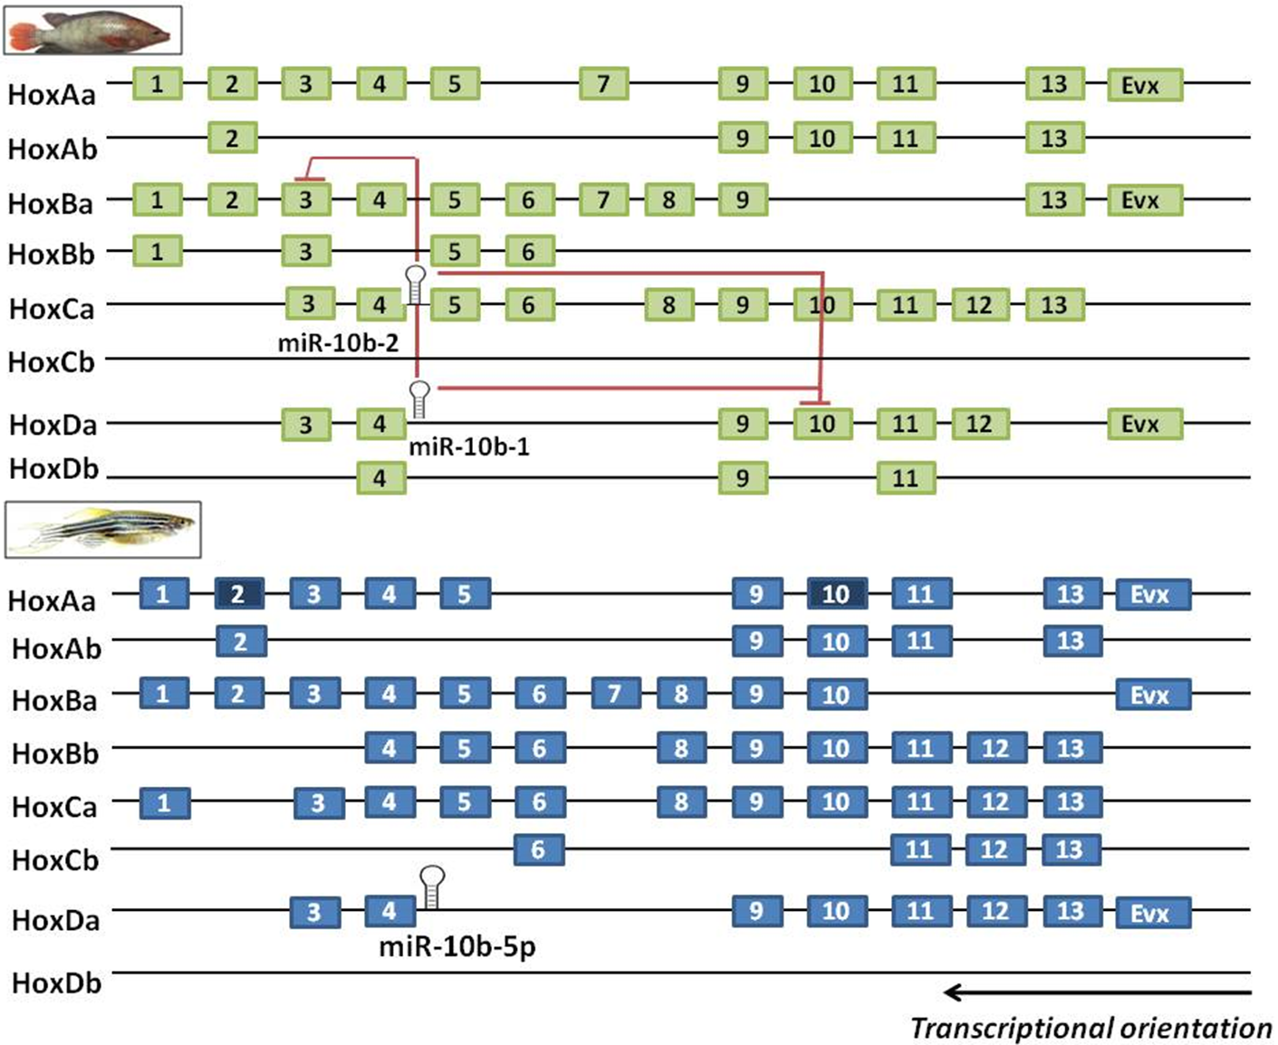
Figure 1. Hox gene clusters and their organization in Oreochromis niloticus (green boxes) and Danio rerio (blue boxes). MicroRNAs encoded by the Hox cluster are indicated and red lines in O. niloticus represent the components of the Hox gene family regulated by miRNA. Dark blue squares in D. rerio represent pseudogenes.

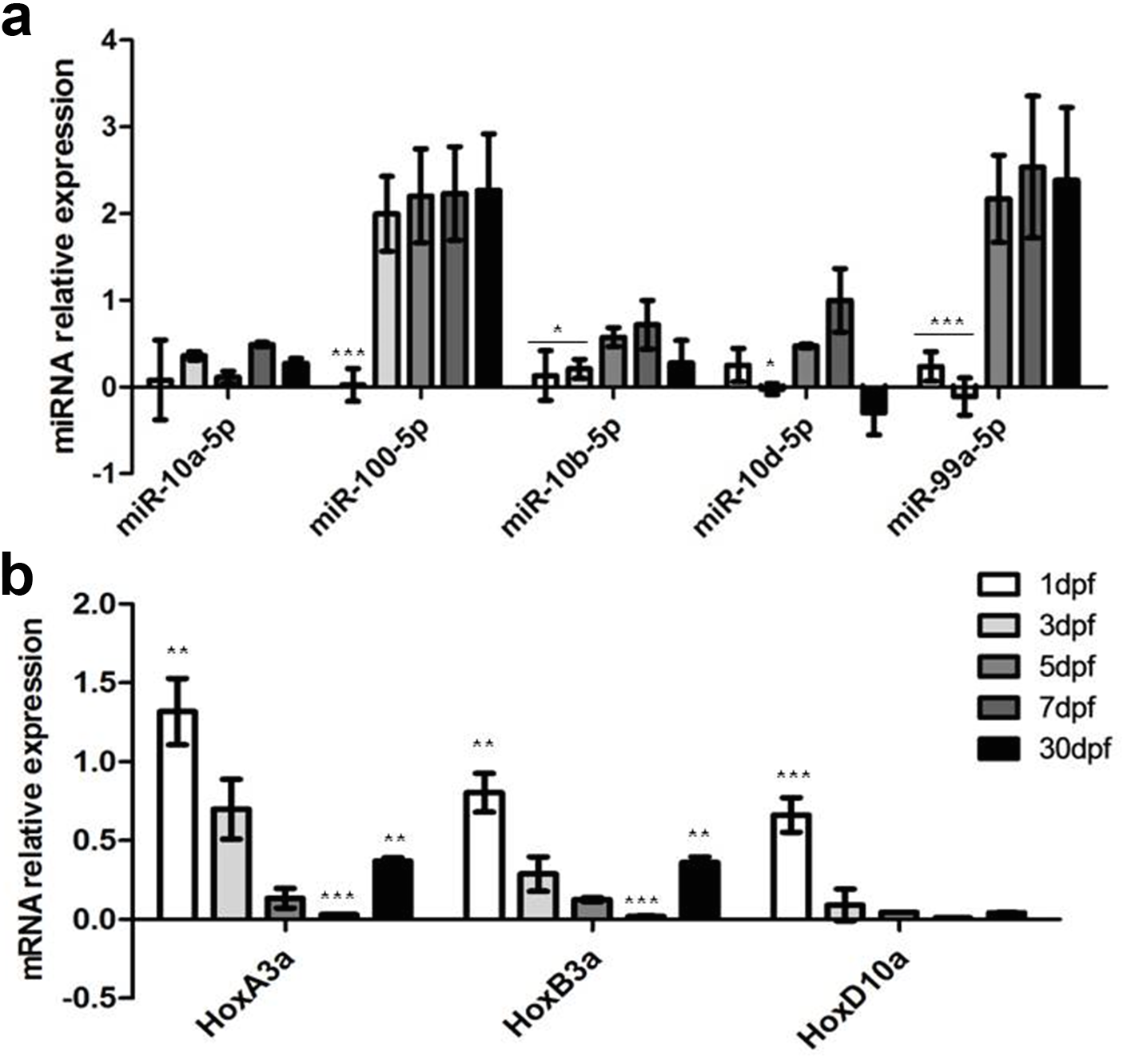
Figure 2. Relative quantification of microRNA (a) and mRNA transcripts (b) expression during Nile tilapia development based on qRT-PCR (log₁₀). Relative expression was normalized against U6 snRNA to miRNAs and HPRT to mRNA. ***P<0.001, **P<0.01 and *P<0.05 as assessed by Two-way ANOVA test with Bonferroni correction.

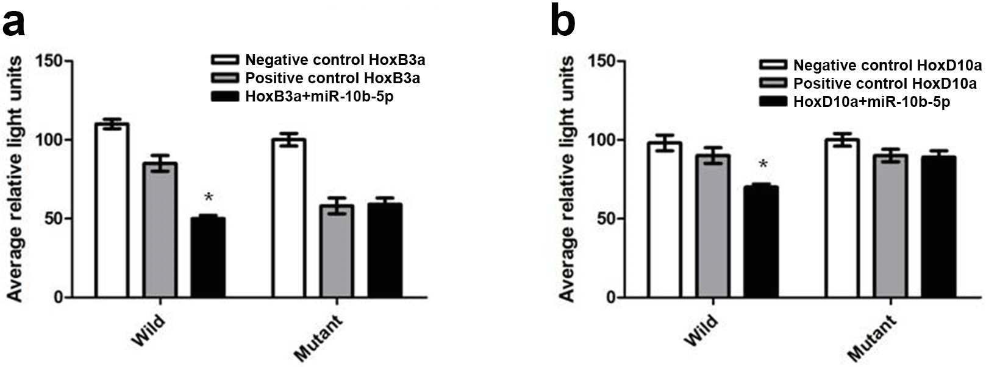
Figure 3. Luciferase assay with the Pgl-3 vector with the 3'UTR of HoxB3a (a) and HoxD10a (b) under the action of miR-10b-5p (a and b). The first section demonstrates the relative level of luciferase activity after transfection of DF-1 cells with 3'UTR region wild only (Negative control); 3'UTR wild+mimic control (Positive control) and 3'UTR wild+miR mimic. Second section: 3'UTR mutant only (Negative control); 3'UTR mutant+mimic control (Positive control) and 3'UTR mutant+miR mimic. Bars represent the normalized average of relative luciferase units. *P<0.05 as assessed by Two-way ANOVA test with Bonferroni correction.

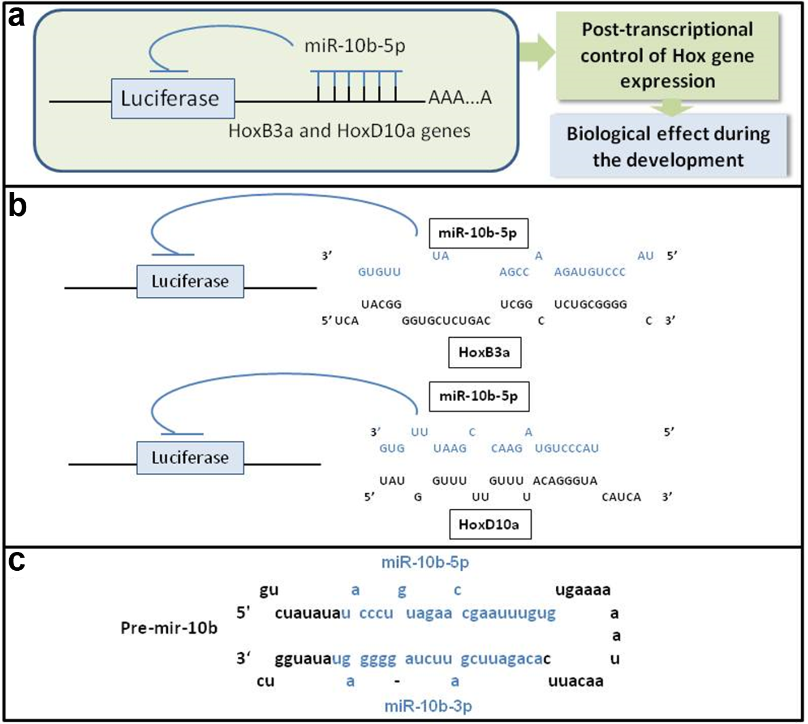
Figure 4. Synthetic view of miRNA action in the control of Hox genes expression in Nile tilapia (a). The detailed alignment between the miRNA and its target mRNA (b) can be observed. The hairpin structure of pre-miR-10b-5p is highlighted in black and the mature sequences 3p and 5p of the miRNA are highlighted in blue (c).

