Improving oceanic primary production estimates using vertical irradiance and chlorophyll profiles from ocean gliders

Victoria S. Hemsley*^{1,2}, , Timothy J. Smyth³, Adrian P. Martin², Eleanor Frajka-Williams¹, Andy Thompson⁴ Gillian Damerell⁵ and Stuart C. Painter²

¹ University of Southampton, National Oceanography Centre, European Way, Southampton, SO14 3ZH, UK

² National Oceanography Centre, Southampton, SO14 3ZH, UK

³ Plymouth Marine Laboratory, Prospect Place, The Hoe, Plymouth, PL1 3DH, UK

⁴Environmental Science & Engineering,California Institute of Technology, Pasadena, US

⁵School of Environmental Sciences, University of East Anglia, Norwich, UK

Contact details

Victoria Hemsley

vsh1g12@soton.ac.uk

Abstract

An autonomous underwater vehicle (Seaglider) has been used to estimate marine primary production (PP) using a combination of irradiance and fluorescence vertical profiles as input into a PP model. We describe techniques to correct for known issues associated with long autonomous deployments such as sensor calibration drift and fluorescence quenching. Comparisons were made between the Seaglider stable isotope (¹³C) and satellite estimates of PP. The Seaglider observations provide high temporal resolution estimates of PP. The Seaglider-based PP estimates further suggest that satellite estimates may be biased low in this region due to inaccurate representation of subsurface chlorophyll maxima. This method for improving PP estimates using underwater autonomous vehicles will allow investigations into depth-resolved and temporally evolving PP on fine spatial scales in the absence of ship-based calibrations.

Keywords: AUV, glider, primary production, fluorescence profiles, North Atlantic.

Introduction
Primary production (PP) is a measure of the carbon fixed by plants through photosynthesis, the basis of almost all terrestrial and marine food webs. Marine phytoplankton fix 45-50 Gt C yr⁻¹, approximately half of global PP.^{1,2} PP is critical for regulating the drawdown of atmospheric carbon dioxide³ and the air-sea exchange of radiatively important trace gases.⁴⁻⁶ Therefore accurate estimates of its magnitude and variability are important.

In situ measurements of PP rates in the open ocean are sparse; research cruises focus on specific areas of interest, avoiding winter, making it difficult to resolve and separate spatial and temporal variability.¹ Regular fixed-point sampling is difficult to extrapolate beyond the immediate area due to spatial variability. Satellite Earth Observation (EO) allows global estimates of oceanic PP over a range of spatial and temporal scales⁷⁻¹¹. While EO-derived surface chlorophyll fields capture the variability in PP better than any other remotely sensed parameter,¹² they rely on cloud free skies and only observe the first optical depth of the euphotic zone (approximately 10 m in temperate latitudes), thereby omitting features such as subsurface chlorophyll maxima (SCM).¹³ As a result, PP estimates derived exclusively from satellite data typically underestimate spatial and temporal variability.¹ Methods have been developed to accommodate SCM,¹⁴ but do not fully represent the chlorophyll distribution with depth.¹⁵

Significant improvements in PP estimates from satellite surface chlorophyll fields are possible when simultaneous in situ chlorophyll and PAR profiles are used.¹² The inclusion of subsurface chlorophyll and irradiance information is therefore key to improving estimates of marine PP. Underwater gliders improve the vertical and temporal resolution of observations.^{16,17} However, while glider-based measurements of fluorescence provide a common proxy for chlorophyll distributions in the ocean¹⁹, long-duration glider missions are often run without in situ calibration.^{18,20}

We describe a method for estimating PP at high vertical and temporal resolution, using chlorophyll fluorescence and irradiance profiles obtained from a glider. The primary improvements of this method include the use of irradiance measurements to calibrate fluorescence, and to reduce fluorescence quenching effects. This method allows continuous estimates of PP, offering the possibility of capturing a full seasonal cycle of PP at depths that are unobservable by satellites.

2. Datasets
2.1 Area of Study
Data used in this analysis were collected between April and September 2013 in the northeast Atlantic Ocean study site ($\sim$48º 41’ N, 16º 11’ W) . This site is approximately 40 km southeast of the Porcupine Abyssal Plain sustained observatory.^{19,20}

Currents in this area are generally weak²³ with low but significant lateral advection speeds.²⁴ Patchy phytoplankton distributions with fine spatial scales (much less than 100 km) have been observed in this region.²⁵ Diatoms dominate the spring bloom, succeeded by prymnesiophytes and dinoflagellates.^{26, 27} In summer, Diatoms form a subsurface chlorophyll maxima at the base of the mixed layer.^{28, 29} Due to the patchy nature of the phytoplankton distribution, advection of spatial variability can result in apparent variations in the phytoplankton community structure on daily timescales.³⁰

2.2 Seaglider data
A Seaglider is an autonomous, buoyancy driven vehicle that profiles to a depth of 1000 m with a 0.5-1 m vertical sampling resolution along a saw-tooth trajectory.³¹⁻³³ Seaglider SG566 was deployed in April to September 2013 sampling a 20 km² area, following a figure-of-eight path with an average time of 2.6 hours per 1000 m profile (Figure S1).

SG566 was equipped with an unpumped Seabird SBE13 CT sail (conductivity-temperature; Seabird Electronics, Bellevue, USA), a Paine pressure sensor (Paine Electronics, East Wenatchee, USA), a Triplet Ecopuck (Wetlabs, Philomath, USA) measuring chlorophyll fluorescence and optical back scatter, and a broadband 4π cosine Photosynthetically Active Radiation (PAR) sensor (400-700 nm; Biospherical Instruments, San Diego, USA). Raw measurements from the CT sail were initially calibrated using manufacturer-supplied coefficients, with further corrections to account for thermal lag.³⁴ Glider salinities were calibrated against cruise data.³⁵ Pressure measurements were corrected to remove long term drift and to account for pressure hysteresis within each dive.

Manufacturer calibrations were initially applied to data from the Wetlabs Triplet and 4π PAR by subtracting the instrument blank and applying a scaling factor. The manufacturer’s calibration for chlorophyll fluorescence is based on the sensor’s response to a culture of the phytoplankton species Thalassiosira weissflogiiat at a known chlorophyll-a concentration (http://www.wetlabs.com/sites/default/files/documents/WETLabsECOAllEN_0.pdf). Our secondary calibration methodology is outlined below. Other empirical methods have been developed to calibrate fluorescence profiles,³⁶ but by using in situ PAR data a scale factor can be derived which may indicate changes in community composition (see discussion section 4.2). The manufacturer’s PAR sensor calibration uses a traceable 1000 watt type FEL Spectral Irradiance Standard and is reported in units of µEinsteins cm⁻². All data were aggregated into 2 m depth intervals. Taking the median value in each bin reduced spikes.

To obtain estimates of PP we used calibrated chlorophyll fluorescence, temperature and PAR (Figure 1). Optical backscatter measurements were used to correct for fluorescence quenching,³⁷ and temperature, salinity and density were used to estimate mixed layer depths.

2.3 In situ samples
Three cruises to the survey region were conducted by the RRS James Cook: glider deployment (JC085; April 14-29), mid-mission (JC087; June 1- 18) and glider recovery (JC090; September 1-16).

Water samples for chlorophyll-a were collected on all cruises from up to six depths across the euphotic zone using a Seabird 911 plus CTD-Niskin rosette system. Chlorophyll-a concentrations were measured using 250 ml water samples filtered onto 25 mm Whatman glass fibre filters (GF/F; nominal pore size 0.7 μm). This involved chlorophyll-a pigment extraction in 6 ml of 90% acetone at 4ºC in the dark for ~20 hours before measurement on a Turner Designs Trilogy fluorometer calibrated against a pure chlorophyll standard (spinach extract, Sigma Aldritch).³⁸

Measurements of PP using the ¹³C method³⁹ were made between 30th May and 18th June on JC087 only. Water samples were collected from pre-dawn CTD casts at five depths corresponding to 55%, 20%, 7%, 5% and 1% of surface irradiance based on profiles obtained from previous midday CTD casts and an estimate of the diffuse attenuation coefficient obtained by linear regression of the natural log of PAR against depth. Each 1 litre water sample was added to an acid-rinsed Nalgene polycarbonate bottle, which was wrapped with optical filters (Lee Filters, Hampshire, UK) to replicate the appropriate irradiance levels. Each bottle was spiked with 200 μL of ¹³C labelled sodium bicarbonate (0.65g in 50 ml of pH adjusted milli-Q water), corresponding to an addition of 255μmol L⁻¹ (or $\sim$1% of ambient (~2084μmol L⁻¹) dissolved inorganic carbon concentrations). Sealed sample bottles were placed in on-deck incubators which were flushed with running surface seawater for 24 hours. After incubation, each sample was filtered onto an ashed (450ºC, 6 hours) 25mm GF/F (Whatman) filter and rinsed with a weak HCl solution (1-2%) to remove inorganic carbon before being stored frozen at -20ºC. Filters were oven dried and encapsulated in tin capsules. Samples were analysed for ¹³C isotopic enrichment at the Scottish Association for Marine Science (OBAN, Scotland) using an ANCA NT preparation system coupled to a PDZ 20-20 Stable Isotope Analyser (PDZ Europa Scientific Instruments, Northwich, UK). PP rates were calculated from the stable isotope results using standard equations.⁴⁰ A pair of cosine collectors (Skye Instruments, Powys, UK) measured incident PAR.

2.4 Satellite ocean colour data and primary production estimates
We obtained 1 km resolution daily chlorophyll composites of MODIS Aqua data from the NERC Earth Observation Data Acquisition and Analysis Service (NEODAAS). For each Seaglider surfacing the satellite data pixel that matched the position and date was extracted. Cloud cover resulted in data gaps in satellite coverage and surface match ups; these time periods were omitted from the analysis.

Full depth profiles were calculated using relationships derived by Morel and Berthon relating satellite chlorophyll to the shape of the profile at depth (Supporting Information).¹⁴ This was done for profiles after year day 180 when a SCM was present, before this time the water column is well mixed and a homogenous profile of chlorophyll to the base of the euphotic zone is assumed.

For an alternative estimate of PP for comparison to the glider based estimates, the profiles of MODIS Aqua satellite chlorophyll and PAR data were also used as inputs to the PP algorithm developed by Smyth and others.⁴¹ This model couples the photosynthesis model⁴² (section 3.3) to the Hydrolight radiative transfer code,⁴³ allowing for the inclusion of CDOM, suspended particulate matter, sea surface temperature, PAR and day length to more accurately estimate irradiance with depth.

2.5. Irradiance corrections, calibrations and calculation

PP is best parameterised using spectral irradiance, as irradiance attenuates preferentially from red to blue wavelengths.⁴⁴ Non-spectral methods can overestimate PP by as much as 50% if only broadband PAR is used.¹⁰ A number of calculations are necessary to spectrally resolve the glider broadband PAR observations.

The glider only records subsurface PAR, so we first estimate surface irradiance for comparison with a surface irradiance model. We then decompose the surface irradiance into spectral components. Irradiance at depth was calculated using spectrally-weighted algorithms.⁴⁵ These methods are described in detail below.

SG566 returned 1325 simultaneous profiles of chlorophyll and PAR. Profiles where PAR intensity increased with depth (due to passing cloud cover and/or glider rolls)⁴⁶ were excluded from the analysis (319). We also excluded night-time profiles (417) leaving a total of 589 simultaneous profiles to be used for analysis.

2.5.1 Estimating surface irradiance from subsurface glider measurements
The fraction of solar irradiance entering the water column depends on the amount reflected by the sea surface. This is calculated by separating the diffuse and direct components of irradiance using determinations of the Fresnel reflectance and the amount of foam (see Supporting Information). The total reflectance ${(r}_{tot})$ is the direct $\left(r_{d}\right)$ plus the diffusive reflectance $(r_{diff})$.
$r_{tot}=r_{d}+ r_{diff}$ [1]

As the precise depth of glider measurements may vary, PAR was extrapolated to just below the surface by assuming exponential attenuation. The following equation was then applied to calculate PAR just above the surface, $E\left(0^{+}\right)$
$E\left(0^{+}\right)= \frac{E\left(0^{-}\right)\left(1-R\overline{r}\right)}{( 1- r_{tot} )}$ [2]
where $E\left(0^{-}\right)$ is the irradiance just below the surface and $R$ the irradiance reflectance (usually < 0.1 in ocean waters). The water-air Fresnel reflection for the whole diffuse upwelling radiation$(\overline{r})$ has a value of 0.48.⁴⁴ $R$ and $\overline{r}$ are needed to obtain the upwelling irradiance flux which is subsequently reflected back down upon reaching the water surface.⁴⁴

2.5.2. Calculating spectral irradiance
Surface PAR from the Seaglider (Eq. 2) was spectrally decomposed into 5 nm wavelengths, $E_{0}\left(λ\right),$ using a look-up table⁴⁰ created by generating a clear sky run of a radiative transfer model,³⁷ which is specific for oceanographic applications and adapted to include the effects of cloud cover.⁴⁸ For a given day, this model is run for noon using the glider surfacing position and relevant meteorological parameters to attenuate irradiance through the atmosphere (British Atmospheric Data Centre, BADC). The model outputs a spectrally resolved, full day irradiance time series just above the surface of the ocean for the location of interest. The integrated irradiance over all wavelengths for the time of the glider measurements was calculated in μmol quanta m⁻² s⁻¹. The ratio between $E\left(0^{+}\right)$ from Eq. 2 and the integrated clear sky run is used to scale the spectral values for the day in question using each profile in that day to get spectral irradiance over the whole day at half hour intervals.

2.5.3. Spectral irradiance through the water column
To calculate spectral irradiance (E(z,λ)) at a given depth in the water column we used the equation,⁴⁹
$E\left(z,λ\right)= E_{0}\left(λ\right)\int_{z}^{0}{exp}( [-K_{w}\left(λ\right)+K_{c }({λ)}] z ),$ [3]
where${ K}_{w}\left(λ\right)$is the attenuation coefficient associated with water and $K_{c }(λ)$ is the attenuation coefficient associated with chlorophyll and other dissolved material at specific wavelengths, λ. Morel et al.⁴⁶ calculate $K_{c}(λ)$ as
$K_{c}\left(λ\right)=χ_{c}\left(λ\right){Chl}^{e\left(λ\right)}.$ [4]
The coefficient $χ_{c}$ and the exponent e(λ) are both functions of wavelength and Chl is chlorophyll concentration in mg m⁻³. Wavelengths within the PAR broadband range are used at 5 nm intervals.

2.6. Chlorophyll Corrections and calibrations
As the manufacturer’s calibration is often insufficient in obtaining chlorophyll,^{36,50} to calibrate the fluorescence profiles, first the data is corrected for quenching. Secondly a scale factor for the chlorophyll is estimated from modelled irradiance attenuation compared with observed attenuation from the glider. These methods are described in full below (Figure 1).

2.6.1 Quenching Corrections
Daytime chlorophyll fluorescence exhibited fluorescence quenching in the top 20 m with low fluorescence during high irradiance. To correct for quenching we have used the night-time relationship between fluorescence and optical backscatter (see Supporting Information for details).^{37,51} We call the result the uncorrected-chlorophyll.

2.6.2 PAR-based chlorophyll calibrated
Following an approach based on the method of Xing et al.,⁴⁶ we calibrated the chlorophyll fluorescence sensor using the PAR measurements and Eq. (3)⁴⁹ to model the irradiance attenuation due to chlorophyll. The uncorrected-chlorophyll profile (with dives and climb treated separately) was divided by a scaling factor ranging from 0.2-25 in intervals of 0.2 and the spectral irradiance profile recalculated each time based on the resulting scaled chlorophyll concentration profile and surface irradiance (Eq. 3 and 4). Modelled values of spectral irradiance were then integrated over all wavelengths (400-700 nm) to compare to glider PAR measurements. A root mean squared error (RMSE) was calculated between the modelled and measured PAR values, over all depths (typically 50 points), for each scale factor.

For each profile the scale factor with the lowest RMSE was then used to scale the uncorrected-chlorophyll concentration. This approach produces an independent scaling factor for each dive/climb, allowing for drift in the fluorometer to be corrected. The method assumes Case I water characteristics where seawater constituents, such as CDOM and particulates, co-vary with phytoplankton.^{51,52} This method can be used if the glider PAR sensor is uncalibrated provided any correction to the PAR data is linear as we are only calculating attenuation rather than absolute PAR.

Variation in the scaling factor over a deployment period may result from poorly resolved PAR profiles (e.g. significant glider rolls or cloud cover). Profile-to-profile variability was reduced by using the median scaling factor calculated for a 10-day moving window. A 10-day window was picked arbitrarily, but no significant difference was seen using 6, 8 or 10 days. Longer time intervals resulted in over-smoothing of the scaling factor.

Final PAR-corrected chlorophyll concentrations for each profile were obtained using the appropriate 10-day median scale factor (Figure 2). These calibrated chlorophyll profiles (Figure S3) were used as input into the PP model, along with the spectral downwelling PAR (section 3.1).

2.7. Calculating Primary Production
PP was calculated with the glider profiles of irradiance and PAR-corrected chlorophyll using the depth, time and wavelength resolved formulation of Morel.⁴² PP is represented by a triple integral, integrating over day length (L), depth (D) and wavelength λ from λ₁=400nm to λ₂=700 nm,

$PP=12 \int_{0}^{L}{\int_{0}^{D}{\int_{λ_{2}}^{λ_{1}}{Chl\left(Z\right)PAR\left(λ,Z,t\right)a^{*}\left(λ\right)ϕ_{μ}\left(λ,Z,t\right)dλdZdt}}}$ [5]
where$a^{*}$ is the absorption cross section per unit of chlorophyll (m⁻¹),${ ϕ}_{μ}$ is the net growth rate (mol C (mol quanta)⁻¹). These values are parameterised following Morel et al.,⁵⁴ as 0.033 m⁻¹ and 0.06mol C (mol quanta)⁻¹ respectively. Each dive and climb were treated separately and given an average time and position (latitude and longitude) for the profile. To run the model, surface downwelling spectral irradiance (Wm⁻² nm⁻¹) is required, provided by the glider PAR sensor (Section 3.1.3.). Temperature from the glider CTD is used to parameterise $ϕ_{μ}$.⁴²

3. Results

3.1 Glider chlorophyll
3.1.1. PAR-Corrected Chlorophyll data
The scale factor used to calibrate the chlorophyll data (Figure 2) has a mean of 3, with a range of 0.6 – 11. In May there is a peak of 5. However there were only 4 profiles with which to calculate this scale factor (range 1.2-8.8), as the sensors were turned off for a time to save battery, suggesting the scale factor is not as well constrained as in other months, when more profiles were available. In July the scale factor became less variable and was 1.2 - 1.8 for the remainder of the deployment.

The chlorophyll profiles are shown in Figure 3 for the whole deployment period. Concentrations were <1.5 mg Chl-a m⁻³ from May until July, when they increased to >2 mg Chl-a m⁻³. Before July the chlorophyll concentration varied little within the top 30 m. A SCM started to form towards the end of July, with maximum chlorophyll concentrations >4 mg Chl-a m⁻³ at a depth of 30 m. Surface concentrations during August were very low, <0.6 mg Chl-a m⁻³. By the end of August the SCM deepened to 40 m and maximum concentrations in the SCM decreased to <2.5 mg Chl-a m⁻³, with surface concentrations <0.4 mg Chl-a m⁻³.

3.1.2 Comparison of glider and bottle-sample estimates of chlorophyll
Figure 4 compares discrete bottle-sample chlorophyll and PAR-corrected glider chlorophyll for the 3 cruises. In late April (JC085) and prior to the spring bloom the discrete chlorophyll concentrations were comparable to the PAR-corrected chlorophyll concentrations. Surface concentrations ranged from 0.25 – 0.7 mg Chl-a m⁻³ and 0.15 – 0.8 mg Chl-a m⁻³ for the discrete samples and glider estimates respectively. The range in glider-based chlorophyll concentrations was slightly larger; likely due to the greater number of glider profiles detecting a wider range of concentrations. At depths between 75 - 150 m, below the euphotic depth at 60 m, bottle samples were approximately 0.1 – 0.2 mg Chl-a m⁻³ higher than the glider, which effectively measured close to zero at these depths.

In June the majority of discrete chlorophyll measurements were elevated compared to the glider estimates, particularly throughout the upper 50 m. Surface concentrations ranged from 0.05 - 1.2 mg Chl-a m⁻³ for the glider compared with 0.08 - 1.8 mg Chl-a m⁻³ from bottle samples (Figure 4). There was no offset between the glider and discrete measurements below 75-150 m, suggesting no systematic error. Chlorophyll values below 100 m were <0.4 mg Chl-a m⁻³, with the majority of the glider and discrete measurements <0.2 mg Chl-a m⁻³.

For the final cruise in September (JC90) discrete and glider chlorophyll estimates were comparable (Figure 4). Surface values ranged between 0.4 and 1 mg Chl-a m⁻³ in the discrete water samples, whereas the glider chlorophyll ranged from <0.1 to 0.75 mg Chl-a m⁻³. An SCM around 40 m was measured by both data sets, with similar maximum values (3.3 mg Chl-a m⁻³).

The lateral distance between CTD profiles and the glider were compared with the differences in surface chlorophyll concentrations (Figure S4, Supporting Information, Spearman⁵⁵ R² = 0.53, p <0.001, n = 19). Over shorter distances, the surface chlorophyll differences are smaller, suggesting that spatial differences remain an important consideration in the comparison of glider and in situ data. Many of the CTD profiles were located >30 km away from the glider making it possible that spatial variability associated with the onset of the spring bloom at this time affects the comparison. Cloud cover hinders examining this from satellite images.

3.2 Depth Integrated Primary Production
3.2.1 Depth integrated glider estimates of primary production
Glider based estimates of PP ranged from 0.377 to 30 gC m⁻² d⁻¹ over the 5 months, displaying strong temporal variability. These estimates have been compared to ship-based ¹³C measurements and 1 km satellite estimates (Figure 5a-c).

The ¹³C PP estimates from June are compared to glider estimates in Figure 5a. Glider profiles on the same day were averaged together for comparison. ¹³C PP increased from day 157 to 165, with values ranging from 0.5 – 1.9 gC m⁻² d⁻¹, whereas the glider estimates of PP were relatively consistent, varying from 1.1 to 1.6 gC m⁻² d⁻¹ over the same time period. Glider PP measurements were higher on average by 0.17 gC m⁻² d⁻¹, (or 39%) but offsets were also highly variable (Figure 5a).

PP estimates obtained using the uncorrected-chlorophyll profiles are also presented in Figure 5a. On average this resulted in productivity estimates over two fold higher than the ¹³C observations (>200%).

In Figure 5b we present a time series of water column integrated PP over the five month glider deployment, in conjunction with ¹³C measurements as already shown in Figure 5a. The glider estimates were higher than the ¹³C measurements but not unreasonably so. Integrated PP rates from late April to May were ~1 gC m⁻² d⁻¹ increasing to a maximum of 3 gC m⁻² d⁻¹ in July. Towards the end of July and through August rates decreased to 1.5 gC m⁻² d⁻¹ but remained highly variable, fluctuating by $±$0.6 gC m⁻² d⁻¹. Due to the high level of cloud cover there were no pixel matches during the time period when the in situ measurements were taken and therefore a comparison with satellite and ship-based measurements was not possible.

Integrated PP estimates from the glider and satellite were also compared (section 2.3, Figure 5c). The correlation between the satellite and glider estimates of surface PP was modest but nevertheless statistically significant (Figure S5, Supporting Information; Spearman⁵⁵, R² = 0.374, P < 0.0001, n=122). In general the glider shows higher integrated estimates of PP than the satellite. Dissimilarity between estimates is likely due to differences in the PAR values and between the modelled and observed SCM. The mean root mean squared error between the modelled and observed profiles was 0.9 mg Chl-a m⁻³ (range 0.58–1.36 mg Chl-a m⁻³).

Figure 5c shows that the satellite and glider have reasonably good agreement during the deployment with similar variability, trends and magnitude in PP. Both datasets show an increase in production from May to June (spring bloom) and a production maximum in July, with maximum rates of 3 and 2 gC m⁻² d⁻¹ for the glider and satellite respectively. Both data sets then show a decrease in primary production during late July. However glider estimates of PP are on average 16% higher than satellite estimates. We believe that the modelled satellite data may be underestimating PP in this region due to the failure to capture the depth and/or magnitude of the SCM.

3.2.2 Glider estimates of seasonal primary production vs literature estimates
Due to the limited number of ¹³C in situ measurements we also present a comparison with productivity estimates from the literature for the same region (Table 1).^{25,56-59} The literature values range from 0.3 – 2 gC m⁻² d⁻¹, which is comparable with our ¹³C measurements. However, towards the end of June and July the literature observations are lower than those estimated from the glider and our ¹³C measurements. This may be attributed to inter-annual variability. Overall our ¹³C values are within the range of literature values supporting the use of this data to compare to the glider estimates.

3.3 Depth resolved primary production
Depth resolved PP over the deployment (Figure 6) shows that throughout May and June PP was highest at the surface and decreased with depth due to irradiance attenuation. In July, as chlorophyll and irradiance concentrations increased PP also increased with maximum surface rates of 0.45 gC m⁻³ d⁻¹. In late July a subsurface production maximum formed with PP rates of 0.2 – 0.3 gC m⁻³ d⁻¹. The production maximum deepened throughout August from 15 to 30 m. The productivity maximum was located just beneath the mixed layer but also below the optical sampling depth for remote sensing.

The euphotic depth was 60-80 m throughout May and June, with variable mixed layer depths (MLD) of between 40 and 130 m. The euphotic depth shoaled to 35 m in July coincident with increasing chlorophyll concentrations and greater irradiance attenuation⁵³ and a shoaling of the MLD due to stratification. The subsurface production maximum in late July and August was around the same depth as the mixed layer. However the SCM was deeper by 10 m than the production maximum, and below the mixed layer, suggesting that the SCM was preferentially located where nutrient concentrations were higher. In August the SCM was located between the MLD and the euphotic depth (Figure 3).

Depth profiles of the ¹³C productivity measurements are shown in Figure S6 (Supporting Information) alongside the range and mean of the coincident glider profiles. Although the ¹³C productivity rates were lower than the mean glider profile, they lie mostly within the range of glider data. Some of the ¹³C profiles show a production maximum around 30 m whereas the glider estimated profiles do not. Two profiles also show higher production at depth than estimated from the glider.

4. Discussion
4.1 Advantages of calculating Primary Production using gliders
Fine scale measurements are important as submesoscale features are present, such as highly productive filaments.²⁵ Furthermore, PP may change over daily time scales due to changes in irradiance and mixed layer depth. Such short timescales (hours) are not resolved by remote sensing, but with several profiles a day from a glider these changes can be observed. Early June saw differences in integrated production rates between sequential dives of between 0.3 and 1 gC m⁻² d⁻¹. The average daily production was <2 gC m⁻² d⁻¹, so this difference was significant. Small scale temporal variations in PP may be important in determining the carbon budget,²⁵ especially in areas of high variability of phytoplankton.

A key advantage of using gliders is the ability to resolve subsurface features, previously only possibly using ship-based measurements. Satellite production estimates are generally not well vertically resolved and it has been shown that including fluorescence profiles significantly improves estimates.¹² Knowing the distribution of chlorophyll at depth is considered vital for ecological studies.⁶⁰ Glider production rates were 16% higher than satellite estimates during the deployment suggesting that satellite-based estimates of production may be significantly underestimating PP during summer months in this region. Subsurface chlorophyll maxima contribute significantly to integrated PP in temperate latitudes⁶¹ so implementation of subsurface glider profiles will improve regional estimates. Subsurface production maxima are common globally and this contribution is often modelled incorrectly for specific regions when using satellite colour to estimate PP.^{15,62,63} Therefore gliders have considerable potential to improve satellite estimates.¹²

Gliders also have the benefit of being able to continuously sample in all weather conditions. Ship-based measurements are often weather and time dependent. Satellite coverage is restricted by cloud cover, which can introduce sampling bias.^{64,65} During this deployment 467 profiles out of 589 (79 %) had no direct satellite matchup due to high levels of cloud cover, equating to a loss of 105 days of satellite coverage over the whole deployment of 141 days.

4.2 Limitations of glider estimated primary production
The spectral constants for chlorophyll used in the irradiance attenuation calculations (Eq. 4), differ compared to other literature values due to regional differences in community composition and/or temperature.^{66,67} Additional uncertainty is introduced when broadband PAR is split spectrally. The method assumes that clouds, changes in atmospheric absorption and season, influence spectral values of PAR linearly⁴⁰. In the PP algorithm itself the photosynthetic rate per unit of biomass (Eq. 5) remains the largest unknown because of its high variability in the ocean.⁶⁸

Fluorescence measurements themselves can be difficult to interpret as fluorescence is only a proxy for chlorophyll-a. The fluorescence yield per unit of chlorophyll is known to change in response to changes in community structure.⁶⁹ The changing scale factor used to calibrate glider chlorophyll and the rapid decrease in the scale factor seen in July (Figure 2), may therefore be indicative of post bloom changes to the community composition. We cannot verify this with the data available but a means to probe community structure is itself of interest.

Measurements from autonomous platforms present their own challenges. Sensor calibrations may drift with time or due to biofouling.¹⁸ Additional samples collected at deployment and recovery could indicate this. For this deployment, no biofouling was noted at recovery and there was no drift in dark counts at depth, so fouling is unlikely. Discrepancies were seen between bottle data and the PAR-corrected glider chlorophyll. As few CTD casts were made near the glider and this area is known to display patchy chlorophyll distributions,²⁵ comparisons can be complicated. However the data are broadly consistent suggesting that glider productivity rates are generally appropriate for the region.

4.3 Future applications
While we have used gliders to quantify PP in a region of the North Atlantic, this approach will allow improved estimates of PP more widely in the future. We have demonstrated the suitability of gliders for capturing small-scale temporal changes in production over seasonal time scales. Gliders allow simultaneous measurements of physical parameters, including density, temperature, oxygen and vertical water velocity.^{70,71} The coincident analysis of the physical environment allows an improved understanding of influences on phytoplankton growth. Small-scale physical processes may account for a significant amount of new production.^{50,72-73} Several recent studies have used high resolution data from gliders to analyse biological and physical connections.⁷⁴⁻⁷⁶ Simultaneous estimates of PP will further resolve biological and physical connections.

An unexpected result of this study was the post bloom change in the scaling factor (Figure 2). This clearly shows that use of a single scaling factor for long deployments is insufficient when interpreting chlorophyll from fluorescence profiles, and may result from a change in phytoplankton community composition.

Acknowledgements
Funding was provided by the Natural Environmental Research Council (NERC) through the Sensors on Gliders program GLISNEX (NE/J020184/1), the Ocean Surface Boundary Layer (OSMOSIS) project (NE/I020083/1), and NERC National Capability (cruises JC85, JC87). Additional funding was provided by EU Framework 7 project EuroBASIN (FP7-ENV-2010; cruise JC87). We would like to thank the captains and crew aboard the RRS James Cook. ECMWF Operational Analyses were obtained by Tim Smyth from the British Atmospheric Data Centre. The authors thank the NERC Earth Observation Data Acquisition and Analysis Service (NEODAAS) for supplying data for this study.

Additional Content
Supporting Information
Extended Methods, specifically quenching corrections, validation of PAR and surface irradiance calculations and, Figures S1-S6.This material is available free of charge via the Internet at http://pubs.acs.org

References
1 Carr, M. E.; Friedrichs M. A. M.; Schmeltz, M.; Aita, M. N.; Antoine, D.; Arrigo, K. R.; Asanuma, I.; Aumont, O.; Barber, R.; Behrenfeld, M.; Bidigare, R.; Buitenhuis, E. T.; Campbell, J.; Ciotti, A.; Dierssen, H.; Dowell, M.; Dunne, J.; Esaias, W.; Gentili, B.; Gregg, W.; Groom, S.; Hoepffner, N.; Ishizaka, J.; Kameda, T.; Le Quéré, C.; Lohrenz, S.; Marra, J.; Mélin, F.; Moore, K.; Morel, A.; Reddy, T. E.; Ryan, J.; Scardi, M.; Smyth, T.; Turpie, K.; Tilstone, G.; Waters, K.; Yamaznaka, Y. A comparison of global estimates of marine primary production from ocean color. Deep Sea Research Part II, 2006, 53 (5-7), 741–770; DOI:10.1016/j.dsr2.2006.01.028
2 Field, C. B. Primary Production of the Biosphere: Integrating Terrestrial and Oceanic Components. Science, 1998. 281 (5374), 237–240; DOI:10.1126/science.281.5374.237
3 Parekh, P.; Follows, M.J.; Dutkiewicz, S.; Ito, T. Physical and biological regulation of the soft tissue carbon pump. Paleoceanography, 2006, 21, PA3001; DOI:10.1029/2005PA001258.
4 Nightingale, P.D.; Malin, G.; Law, C.S.; Watson, A.J.; Liss, P.S.; Liddicoat, M.J.; Boutin, J.; Upstill-Goddard, R.C. 2000: In situ evaluation of air-sea gas exchange parameterizations using novel conservative and volatile tracers. Global Biogeochemical Cycles, 2000, 14 (1), 373-387.
5 Wanninkhof, R. Relationship between wind speed and gas exchange over the ocean. J. Geophys. Res., 1992, 97 (C5), 7373-7382.
6 Liss, P.S.; Merlivat, L. Air-sea gas exchange rates: introduction and synthesis, in The Role of Air-Sea Exchange in Geochemical Cycling, edited by P. Buat-Ménart, 113-129, D. Reidel, Hingham, Mass, 1986.
7 Eppley, R.W.; Stewart, E.; Abbott, M.R.; Heyman, U. Estimating ocean production from satellite chlorophyll: introduction to regional difference and statistics in the southern California bight. Journal of Plankton Research, 1985, 7 (1), 57-70; DOI: 10.1093/plankt/7.1.57
8 Bidigare, R.R.; Smith, R. C.; Baker, K. S.; Marra, J. Oceanic primary production estimates from measurements of spectral irradiance and pigment concentrations, Global Biogeochemical Cycles, 1987, 1 (3), 171-186
9 Platt, T.; Sathyendranath, S. Oceanic primary production: estimation by remote sensing at local and regional scales. Science, 1988, 241 (4873), 1613-1620. DOI:10.1126/science.241.4873.1613
10 Sathyendranath, S.; Platt, T.; Caverhill, C.; Warnock, R.; Lewis, M. 1989: Remote sensing of oceanic primary production: computations using a spectral model. Deep Sea Research, 1989, 36(3), 431-453; DOI:10.1016/0198-0149(89)90046-0
11 Behrenfeld, M. J.; Falkowski, P. G. A consumer’s guide to phytoplankton primary productivity models, Limnology and Oceanography, 1997, 42, 1479-1491.
12 Jacox, M.G.; Edwards, C.; Kahru, M.; Rudnick, .D.L.; Kudela, R.M. The potential for improving remote primary productivity estimates through subsurface chlorophyll and irradiance measurement. Deep Sea Research Part II, 2015, 112, 107-116; DOI:10.1016/j.dsr2.2013.12.008
13 Gordon, H.R.; Clark, K. Remote sensing optical properties of a stratified ocean: an improved interpretation. Applied Optics, 1980, 19 (20), 3428-3430; DOI:10.1364/AO.19.003428.
14 Morel A.; Berthon, J. Surface pigments, algal biomass profiles and potential production of the euphotic layer: relationships reinvestigated in view of remote-sensing applications. Limnology and Oceanography, 1989, 34, 1545-1562.
15 Cullen J.J, 2015: Subsurface chlorophyll maximum layers: enduring enigma or mystery solved. Annual Review of Marine Science, 2015, 7, 207-239; DOI: 10.1146/annurev-marine-010213-135111.
16 Eriksen, C. C. and Perry, M.J., "The Nurturing of Seagliders By the National Oceanographic Partnership Program". School of Marine Sciences at DigitalCommons@UMaine.Marine Sciences Faculty Scholarship. 2009, Paper 133
17 Rudnick, D. L.; Cole, S.T. On sampling the ocean using underwater gliders. J. Geophys. Res., 2011, 116, C08010; DOI:10.1029/2010JC006849.
18 Perry, M.J.; Sackmann, B.S.; Eriksen, C.C.; Lee, C.M. 2008: Seaglider observations of blooms and subsurface chlorophyll maxima off the Washinton coast. Limnology and Oceanography, 2008, 53 (5, part 2), 2169-2179; DOI: 10.4319/lo.2008.53.5_part_2.2169
19 Lorenzen, C.J. A method for the continuous measurement of in vivo chlorophyll concentration. Deep Sea Research, 1966, 13, 223-227.
20 Mignot, A.; Claustre, H.; D'Ortenzio, F.; Xing, X.; Poteau, A.; Ras., J. From the shape of the vertical profile of in vivo fluorescence to Chlorophyll-a concentration. Biogeosciences, 2011, 8, 2391–2406
21 Lampitt, R. S.; Favali, P.; Barnes, C. R.; Church, M. J.; Cronin, M. F.; Hill, K. L.; Kaneda, Y.; Karl, D. M.; Knap, A. H.; McPhaden, M. J. Nittis, K. A.; Priede, I. G.; Rollin, J-F.; Send, U.; Teng, C-C.; Trull, T. W.; Wallace, D.W. R.; Weller, R. A. In situ sustained Eulerian observatories. In, Hall, J., Harrison, D.E. and Stammer, D. (eds.) Proceedings of OceanObs’09: Sustained Ocean Observations and Information for Society, Vol. 1. OceanObs’09: Sustained Ocean Observations and Information for Society Noordwijk, The Netherlands, European Space Agency, 2010, 395-404. (ESA Special Publication WPP-306).

22 Hartman, S. E.; Lampitt, R. S.; Larkin, K. E.; Pagnani, M.; Campbell, J.; Gkritzalis, T.; Jiang, Z-P.; Pebody, C. A.; Ruhl, H. A.; Gooday, A. J.; Bett, B. J.; Billett, D. S. M.; Provost, P.; McLachlan, R.; Turton, J. D.; Lankester, S. The Porcupine Abyssal Plain fixed-point sustained observatory (PAP-SO): variations and trends from the Northeast Atlantic fixed=point time-series. ICES Journal of Marin Science, 2012, 69 (5), 776-783; DOI:10.1093/icesjms/fss077
23 Lampitt, R. S.; Bett, B. J.; Kiriakoulis, K.; Popova, E. E.; Ragueneau, O.; Vangriesheim, A.; Wolff, G. A. Material supply to the abyssal seafloor in the Northeast Atlantic. Progress in Oceanography, 2010, 50, 27-63.
24 Hartman, S. E.; Larkin, K. E.; Lampitt, R. S.; Lankhorst, M.; Hydes, D.J. Seasonal and inter-annual biogeochemical variations in the Porcupine Abyssal Plain 2003-2005 associateds with winter mixing and surface circulation. Deep Sea Research Part II, 2010, 57 (15), 1303-1312; DOI:10.1016/j.dsr2.2010.01.007
25 Painter, S. C.; Pidcock, R. E.; Allen, J. T. A mesoscale eddy driving spatial and temporal heterogeneity in the productivity of the euphotic zone of the northeast Atlantic. Deep Sea Research Part II, 2010, 57 (15), 1281-1292; DOI: 10.1016/j.dsr2.2010.01.005
26 Barlow, R. G.; Mantoura, R. F. C.; Gough, M. A.; Fileman, T. W. Pigment signatures of phytoplanktoncomposition in the northeast Atlantic during the 1990 spring bloom. Deep-Sea Research II, 1993, 40 (1/2), 459-477.
27 Henson, S.; Lampitt, R.; Johns, D. Variability in phytoplankton community structure in response to the North Atlantic Oscillation and implications for organic carbon flux. Limnology and Oceanography, 2012, 57 (6), 1591-1601; DOI:10.4319/lo.2012.57.6.1591.
28 Lochte, K.; O. Pfannkuche, O. Cyclonic cold-core eddy in the eastern North Atlantic. II. Nutrients, phytoplankton and bacterioplankton. Marine Ecology Progress Series, 1987, 39, 153-164.
29 Painter, S. C.; Lucas, M. I.; Stinchcombe, M. C.; Bibby, T. S.; Poulton, A. J. Summertime trends in pelagic biogeochemsity at the Porcupine Abyssal Plain study site in the nothereast Atlantic. Deep Sea Research Part II, 2010, 57 (15), 1313-1323; DOI:10.1016/j.dsr2.2010.01.008
30 Smythe-Wright, D.; Boswell, S.; Kim, Y-N.; Kemp, A. Spatio-temporal changes in the distribution of phytopigments and phytoplanktonicgroups at the Porcupine Abyssal Plain (PAP) site. Deep Sea Research Part II, 2010, 57 (15), 1324-1335. doi:10.1016/j.dsr2.2010.01.009
31Eriksen, C. C.; Osse, T. J.; Light, R. D.; Wen, T.; Lehman, T. W.; Sabin, P. L.; Chiodi, M. Seaglider: a long-range autonomous underwater vehicle for oceanographic research. IEEE Journal of Oceanic Engineering, 2001, 26 (4), 424–436. doi:10.1109/48.972073

32 Rudnick, D. L.; Davis, R. E.; Eriksen, C. C.; Fratantoni, D. M.; Perry, M. J. Underwater Gliders for Ocean Research. Marine Technology Society Journal, 2004, 37 (2) 73-84; DOI:10.4031/002533204787522703.
33 Davis, R. E.; Eriksen, C. C.; Jones, C. P. Autonomous Buoyancy-Driven Underwater Gliders. In G. Grifﬁths, editor, The Technology and Applications of Autonomous Underwater Vehicles. Taylor and Francis, London, U.K., 2002.
34 Garau, B.; Ruiz, S.; Zhang, W. G.; Pascual, A.; Heslop, E.; Kerfoot, J.; Tintoré, J. Thermal lag correction on Slocum CTD glider data. Journal of Atmospheric and Oceanic Technology, 2011, 28 (9), 1065-1071.
35 Damerell, G. M.; Heywood, K. J.; Thompson, A. F. Ocean Glider Observations of the Seasonal Evolution of the Upper Ocean in the north-east Atlantic. Geophys. Res. Lett., in preparation.
36 Mignot, A.; Claustre, H.; D’Ortenzio, F.; Xing, X.; Poteau, A.; Ras, J. From the shape of the vericalt profile of in vivo fluorescence to chlorophyll-1 concentration. Biogeosciences, 2011, 8, 2391-2406; DOI:10.5194/bg-8-2391-2011
37 Stramski, D.; Boss, E.; Bogucki, D.; Voss, K. J. The role of seawater constituents in light backscattering in the ocean. Progress in Oceanography, 2004, 61, 27-56; DOI:10.1016/j.pocean.2004.07.001
38 Welschmeyer, N. Fluorometric analysis of chlorophyll a in the presence of chlorophyll b and pheopigments. Limnology and Oceanography, 1994, 39 (8), 1985–1992; DOI:10.4319/lo.1994.39.8.1985
39 Slawyk, G.; Collos, Y.; Auclair, J.C. The use of the 13C and 15N isotopes for the simultaneous measurement of carbon and nitrogen turnover rates in marine phytoplankton. Limnology and Oceanography, 1977, 22, 925-932.
40 Legendre, L.; Gosselin, M., 1996: Estimation of N and C uptakes rates by phytoplankton using 15N and 13C: revisiting the usual computation formulae. Journal of Plankton Research, 1996, 19 (2), 263-271.
41 Smyth, T. J.; Tilstone, G. H.; Groom, S. B. Integration of radiative transfer into satellite models of ocean primary production. J. Geophys. Res., 2005, 110 (C10), C10014; DOI:10.1029/2004JC002784
42 Morel, A. Light and marine photosynthesis : a spectral model with geochemical and climatological implications. Progress in Oceanography, 1991, 26, 263–306; DOI:10.1016/0079-6611(91)90004-6
43 Mobley, C. D. Hydrologht 3.0 Users’ Guide. SRI International, Menlo Park, California, U.S.A., 1995.
44 Kirk, J. T. O. Light and Photosynthesis in Aquatic Ecosystems, Cambridge University Press, Cambridge, U.K., 2011.
45 Morel, A.; Maritorena, S. Bio-optical properties of oceanic waters: A reappraisal. J. Geophys. Res., 2001, 106 (C4), 7163–7180; DOI:10.1029/2000JC000319.
46 Xing, X.; Morel, A.; Clausre, H.; Antoine, D.; D’Ortenzio, F.; Poteau, A.; Mignot, A. Combined processing and mutual interpretation of radiometry and fluorimetry from automonous profiling Bio-Argo floats: Chlorophyll a retrieval. J. Geophys. Res., 2011, 116, C06020; DOI:10.1029/2010JC006899.
47 Gregg, W.; Carder, K. A simple spectral solar irradiance model for cloudless maritime atmospheres. Limnology, 1990, 35 (8), 1657–1675.
48 Reed, R. On estimating insolation over the ocean. Journal of Physical Oceanography, 1977, 7, 482–486; DOI:10.1175/1520-0485
49 Carr, M.R., 1986: Modelling the Attenuation of Broad Band Light Down a Water Column. Journal of the Royal Statistical Society, Series D (The Statistician), 1986, 35 (3), 325-33; DOI:10.2307/2987748.
50 Frajka-Williams, E.; Rhines, P. B.; Eriksen, C. Physical controls and Mesoscale variability in the Labrador Sea spring phytoplankton bloom observed by Seaglider. Deep-Sea Research I, 2009, 56, 2144-2161; DOI:10.1016/j.dsr.2009.07.008
51 Boss, E.; Swift, D.; Taylor, L.; Brickley, P.; Zaneveld, R.; Riser, S.; Perry, M.J. Robotic in situ and satellite- based observations of pigment and particle distributions in the Western North Atlantic. Limnology and Oceanography, 2008, 53, 2112-2122; DOI:10.4319/lo.2008.53.5_part_2.2112

52 Morel, A. Optical modelling of the upper ocean in relation to its biogenous matter content (case 1 water). J. Geophys. Res., 1988, 93 (C9), 10749-10769; DOI: 10.1029/JC093iC09p1074953 Bricaud, A.; Morel, A.; Babin, M.; Allali, K.; Claustre, H. Variations of light absorption by suspended particles with chlorophyll a concentration in oceanic (case 1) waters: Analysis and implications for bio-optical models. J. Geophys. Res., 1998, 103, 31,033–031,044.
54 Morel, A.; Antoine, D.; Babin, M.; Dandonneau, Y. Measured and modelled primary production in the northeast Atlantic (EUMELI JGOFS program): the impact of natural variations in the photosynthetic parameters on model predictive skill. Deep-Sea Research, 1996, 43 (8), 1273-1304.
55 Spearman C. The proof and measurement of association between two things. Amer. J. Psychol. 1904, 15, 72–101; DOI:10.2307/1412159.
56 Chipman, D.W.; Marra, J.; Takahashi, T. Primary production at 47oN and 20oW in the North Atlantic Ocean: a comparison between the 14C incubation method and mixed layer carbon budget. Deep Sea Research Part II, 1993, 40, 151-169; DOI:10.1016/0967-0645(93)90011-B
57 Marra, J.; Langdon, C.; Knudson, C. A. Primary production, water column changes, and the demise of a Phaeocystis bloom at the Marine Light‐Mixed Layers site (59° N, 21° W) in the northeast Atlantic Ocean. J. Geophys. Res., 1995, 100 (C4), 6633-6643.
58 Savidge, G.; Boyd, P.; Pomroy, A.; Harbour, D.; Joint, I. Phytoplankton production and biomass estimates in the northeast Atlantic Ocean, May–June 1990. Deep Sea Research Part I, 1995, 42 (5), 599-617.
59 Bury, S. J.; Boyd, P. W.; Preston, T.; Savidge, G.; Owens, N. J. P. Size-fractionated primary production and nitrogen uptake during a North Atlantic phytoplankton bloom: implications for carbon export estimates. Deep Sea Research Part I, 2001, 48 (3), 689-720.
60 Uitz, J.; Claustre, H.; Morel, A.; Hooker, S.B. Vertical distribution of phytoplankton communities in open ocean: An assessment based on surface chlorophyll. J. Geophys. Res., 2006, 111, C08005; DOI:10.1029/2005JC003207.
61 Anderson, G.C. Subsurface chlorophyll maximum in the northeast Pacific Ocean. Limnology and Oceanography, 1969, 14, 386-391.
62 Weston, K.; Fernand, L.; Mills, D.K.; Delahunty, R.; Brown, J. Primary production in the deep chlorophyll maximum of the central North Sea. Journal of Plankton Research, 2005, 27 (9), 909-922; DOI: 10.1093/plankt/fbi064
63 Martin, J.; Tremblay, J.; Gagnon, J.; Tremblay, G.; Lapoussière, A.; Jose, C.; Poulin, M.; Gosselin, M.; Gratton, Y.; Michel, C. 2010: Prevalence, structure and properties of subsurface chlorophyll maxima in Canadian Arctic waters. Marine Ecology Progress Serie,s 2010, 412, 69-84; DOI:10.3354/meps08666
64Longhurst, A.; Sathyenranath, S.; Platt, T.; Caverhill C. An estimate of global primary production in the ocean from satellite radiometer data. Journal of Plankton Research, 1995, 17 (6), 1245-1271; DOI:10.1093/plankt/17.6.1245
65 Gregg, W. W.; Casey, N. W. Sampling biases in MODIS and SeaWiFS ocean chlorophyll data. Remote Sensing of Environment, 2007, 111 (1), 25-35; DOI:10.1016/j.rse.2007.03.008
66 Carder, K. L.; Chen, F. R.; Lee, Z. P.; Hawes, S. K. Semianalytic moderate-resolution imaging spectrometer algorithms for chlorophyll a and absorption with bio-optical domains based on nitrate-depletion temperatures. J. Geophys. Res., 1999, 104 (C3), 5403-5421; DOI: 10.1029/1998JC900082
67 Werdell, P. J.; Proctor, C. W.; Boss, E.; Leeuw, T.; Ouhssain, M. Underway sampling of the marine inherent optical properties on the Tara Oceans expedition as a novel resource for the ocean color satellite data production validation. Methods in Oceanography, 2013, 7, 40-51.
68 Huot, Y.; Brown, C. A.; Cullen, J. J. Retrieval of phytoplankton biomass from simultaneous inversion of reflectance, the diffuse attenuation coefficient, and sun-induced fluorescence in coastal waters. J. Geophys. Res., 2007, 112, C06013; DOI:10.1029/2006JC003794
69 Falkowski, P. G.; Kolber, Z. Variations in Chlorophyll Fluorescence Yields in Phytoplankton in the World Oceans. Australian Journal of Plant Physiology, 1995, 22, 341–355; DOI:10.1071/PP9950341
70 Merckelbach, L., Smeed, D., & Griffiths, G., 2010: Vertical Water Velocities from Underwater Gliders. Journal of Atmospheric and Oceanic Technology, 27(3), 547–563. doi:10.1175/2009JTECHO710.1
71 Frajka-Williams, E.; Eriksen, C. C.; Rhines, P. B.; Harcourt, R. R. Determining Vertical Water Velocities from Seaglider. Journal of Atmospheric and Oceanic Technology, 2011, 28 (12), 1641–1656; DOI:10.1175/2011JTECHO830.1
72, Lévy , M.; Klein, P.; Treguier, A. M. Impact of sub-mesoscale physics on production and subduction of phytoplankton in an oligotrophic regime. Journal of Marine Research, 2001, 59 (4), 535-565.
73 Lévy, M. The modulation of biological production by oceanic mesoscale turbulence. Transport and Mixing in Geophysical Flows. Springer: Berlin Heidelberg, Germany, 2008. 219-261. doi:10.1007/978-3-540-75215-8
74 Klein, P.; Lapeyre, G., The oceanic vertical pump induced by mesoscale and submesoscale turbulence. Annual Review of Marine Science, 2009, 1, 351-375; DOI: 10.1146/annurev.marine.010908.163704.
75 Pietri, A.; Testos, P.; Echevin, V.; Chaigneau, A.; Mortier, L.; Eldin, G.; Grados, C. Finescale vertical structure of the upwelling system off southern Peru as observed from glider data. Journal of Physical Oceanography, 2013, 43, 631-646; DOI: 10.1175/JPO-D-12-035.1
76 Webber, B. G. M.; Matthews, A. J.; Heywood, K. J.; Kaiser, J.; Schmidtko, S. 2014: Seaglider observations of equatorial Indian Ocean Rossby waves associated with the Madden-Julian Oscillation. J. Geophys. Res. Oceans, 2014, 119, 3714-3731; DOI:10.1002/2013JC009657
77 Smyth, T.J., 2011: Penetration of UV irradiance into the global ocean. Journal of Geophysical Research, 116, C11020. doi:10.1029/2011JC007183.

Tables
Table 1
Reference | Position | Integration depth (m) | N | Mean (±Standard deviation)  (g C m⁻² d⁻¹)
13C | 48ºN 16ºW | Euphotic Zone | 6 | 1.16 (0.5)
Chipman et al., May (1993)⁵⁵ | 47ºN 20ºW | Euphotic Zone | 11 | 0.84 (0.19)
Marra et al., June (1995)⁵⁶ | 59.5ºN 21ºW | Euphotic Zone | 4 | 1 (0.46)
Savidge et al., May/June (1995)⁵⁷ | 47-60ºN 20ºW | Euphotic Zone | 25 | 0.70 (0.32)
Bury et al., May (2001)⁵⁸ | 47ºN 20ºW | Euphotic Zone | 8 | 0.84 (0.50)
Painter et al., July (2010)²⁵ | 49ºN 16ºW | Euphotic Zone | 3 | 0.55 (0.22)

Table 1: Mean productivity rates from the NE Atlantic as reported in the literature. All estimates were made using the ¹³C stable isotope method.

Figures

Figure 1: Flow diagram explaining the steps needed to be taken to calibrate and subsequently calculate primary production from a glider.

Figure 2: The scale factors calculated by optimisation of modelled attenuation of irradiance against measured attenuation of irradiance (black X) with the 10 day moving window (black line) and the standard deviation for each moving window (grey dashed line).

Figure 3: Time series of PAR corrected chlorophyll profiles, solid white line shows the mixed layer depth (m) and the dashed white line shows the euphotic depth (m), calculated from the glider PAR profiles.

Figure 4: Glider profiles of chlorophyll, uncorrected and PAR-corrected, compared to ship based bottle samples of chlorophyll from acetone extracts. For cruises a. JC85, b. JC87 and c. JC90

Figure 5:
- Daily mean PP from Seaglider dives compared with in situ ¹³C estimates of production. Error bars are the standard deviation of the PP calculated from all the dives in one day. Water samples for the incubations were taken at dawn, a 12 hour day for production is assumed.
- Differences between integrated PAR-corrected glider primary production and the uncorrected glider primary production compared with ¹³C primary production measurements.
- Primary production estimates for the duration of glider deployments for SG566 and NEODAAS 1 km daily product.

Figure 6: time series of PAR-corrected primary production profiles for SG566 for the entire deployment, the solid white line is the mixed layer depth (m) and dashed white line as the euphotic depth (1% of surface irradiance levels).
Figure 1

Figure 2
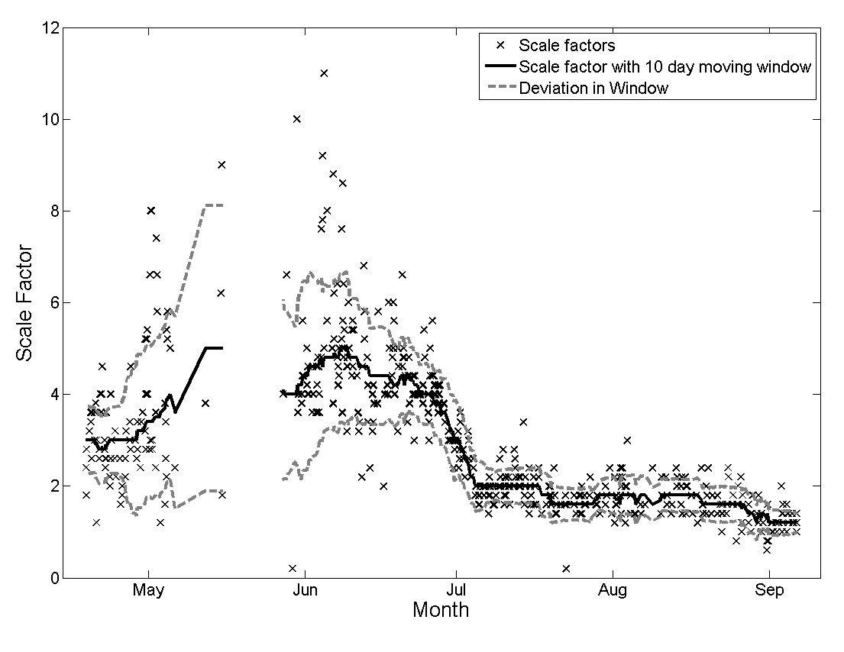

Figure 3
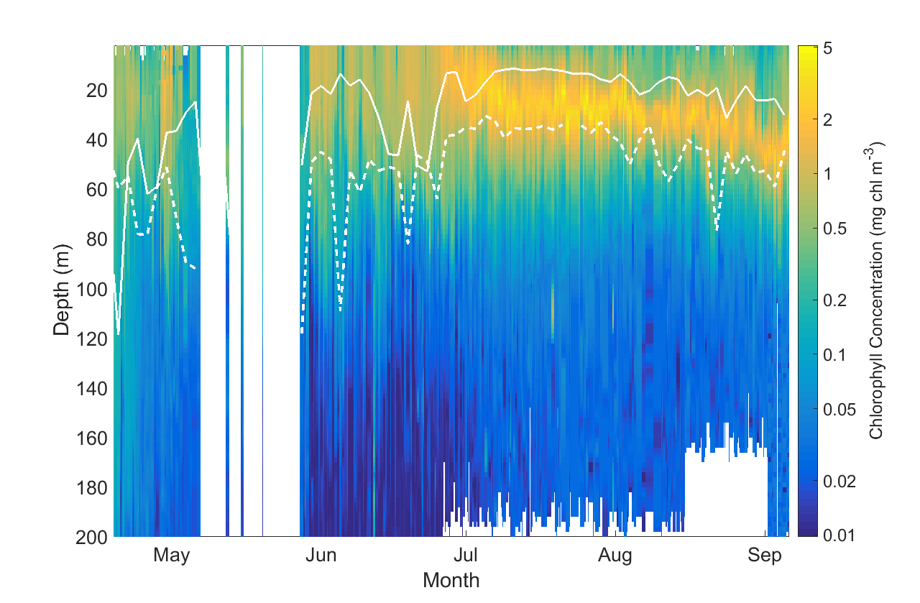

Figure 4
a.
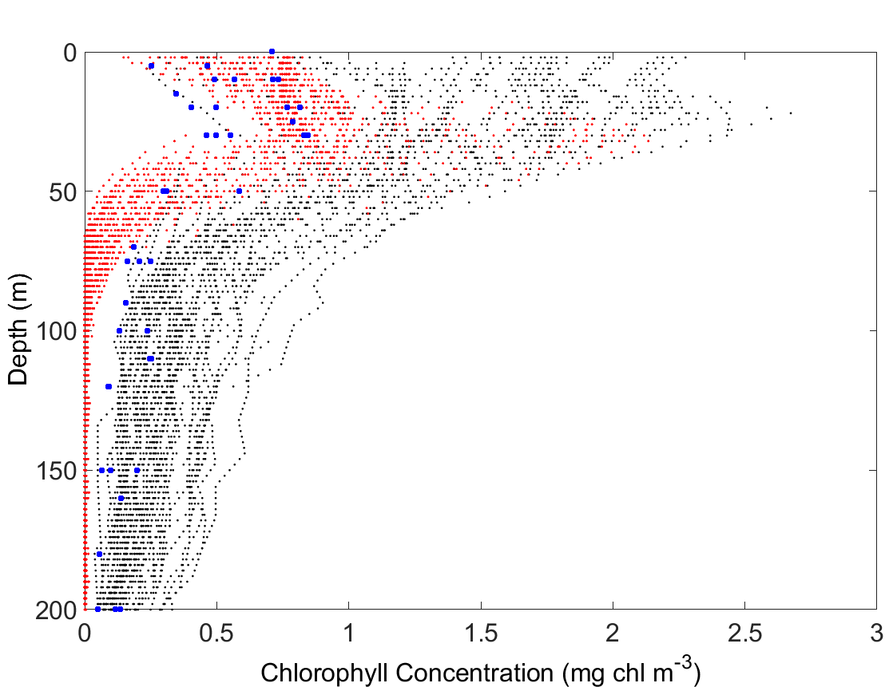
b.
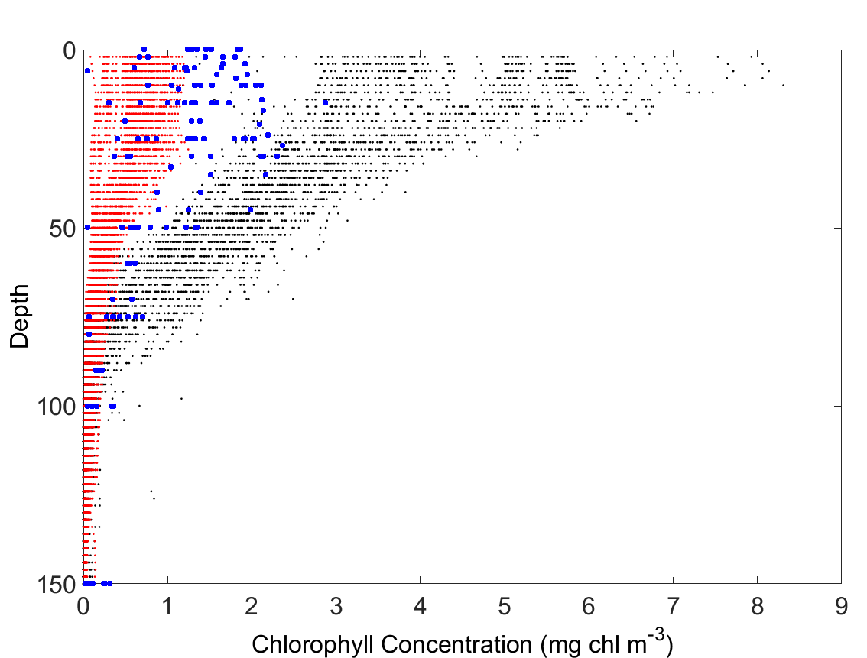
c.
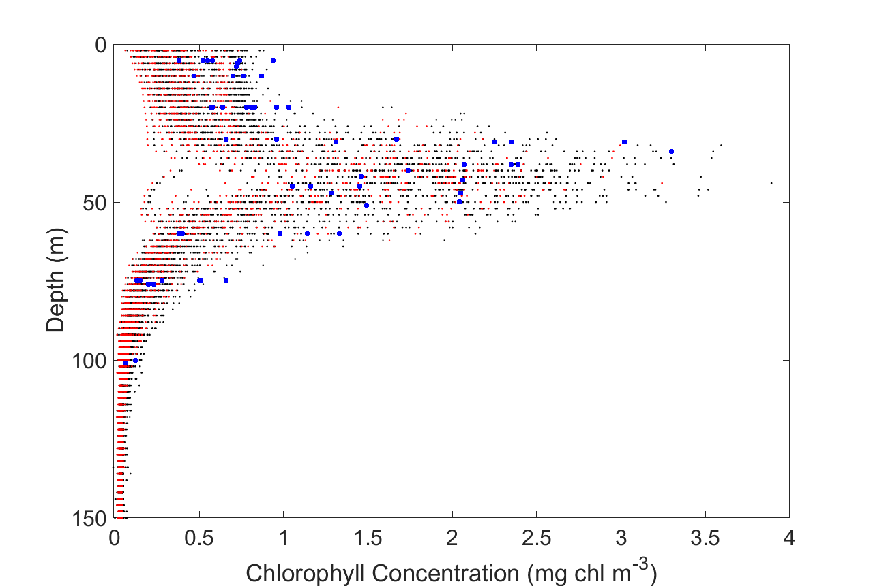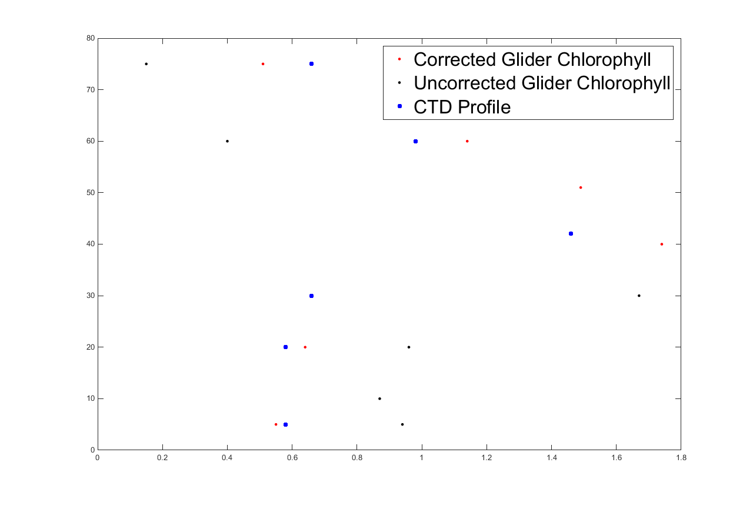

Figure 5
(a.)
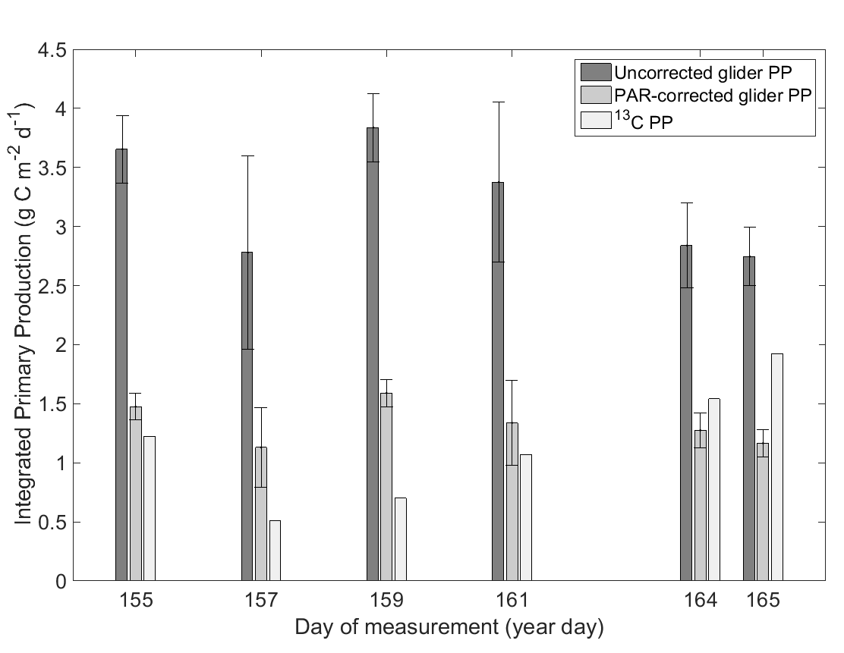
(b.)
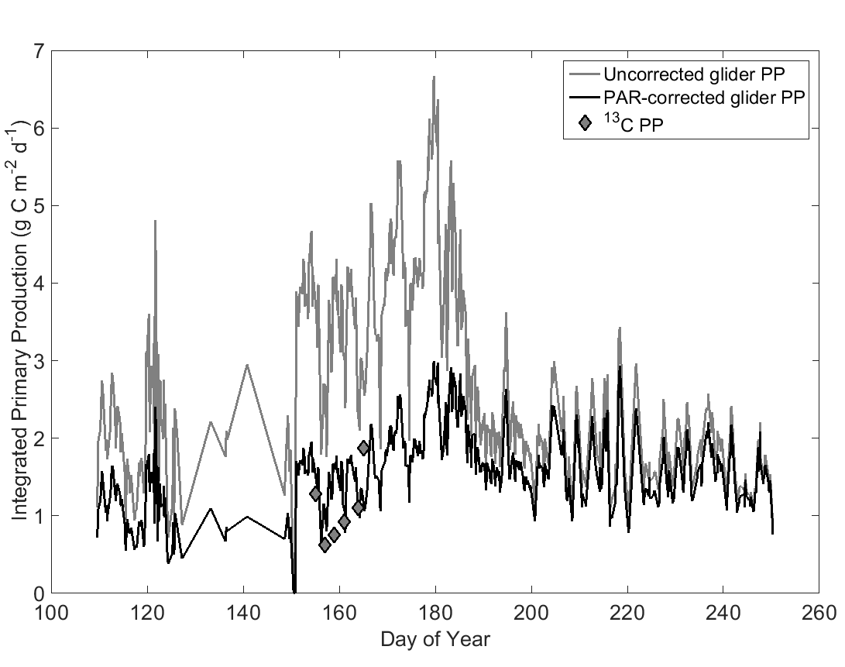
(c.)
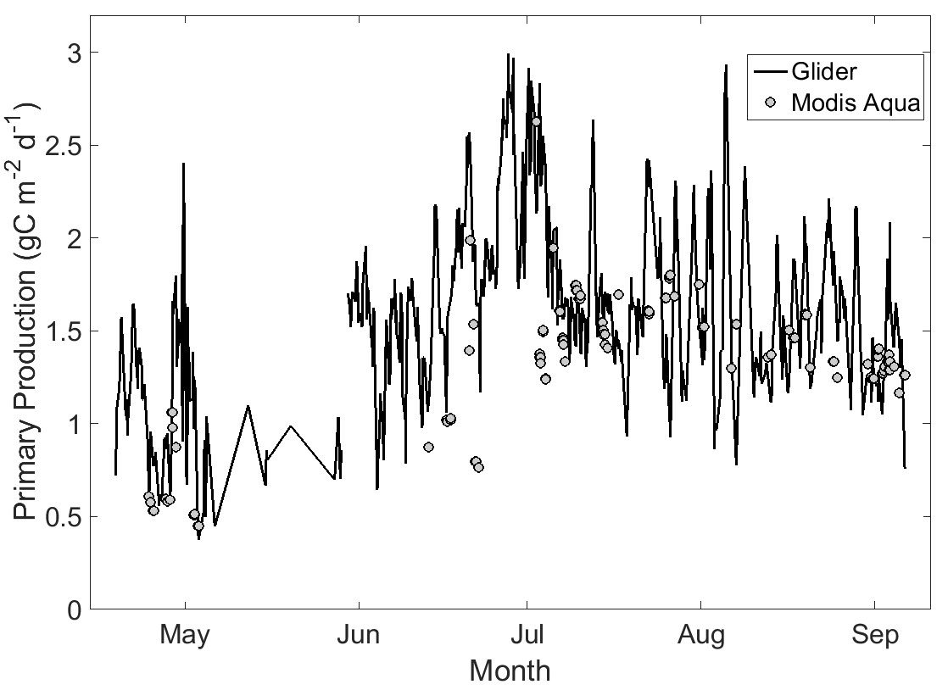

Figure 6
