Supporting Information

Time Resolved Structural Dynamics of Butadiyne-Linked Porphyrin Dimers
Franco V. A. Camargo,^{1,3} Christopher R. Hall,¹ Harry L. Anderson,² Stephen R. Meech¹ and Ismael A. Heisler^{1,*}
¹School of Chemistry, Norwich Research Park, University of East Anglia, Norwich NR4 7TJ, United Kingdom
²Department of Chemistry, University of Oxford, Chemistry Research Laboratory, Oxford OX1 3TA, United Kingdom
³CAPES Foundation, Ministry of Education of Brazil, Brasilia - DF 70040-202, Brazil

*Corresponding author. Email: i.heisler@uea.ac.uk, phone: +44 01603 591880.

Table of Contents
Figure S1 Porphyrin monomer and dimer linear absorption and fluorescence spectra S2
Figure S2 Evolutionary associated spectra S3
Figure S3 Comparison between measured data and fit for 13513 cm⁻¹ excitation S4
Figure S4 Comparison between measured data and fit for 15037 cm⁻¹ excitation S5
Figure S5 Time resolved transient absorption spectra for various excitations S6
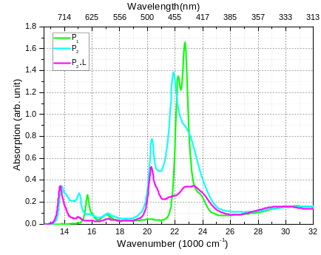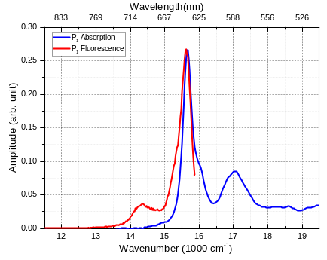
(a) (b)
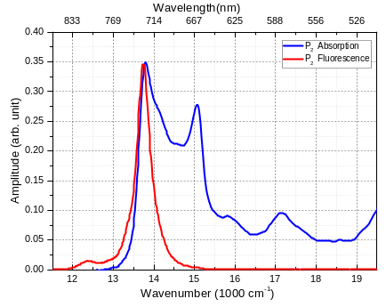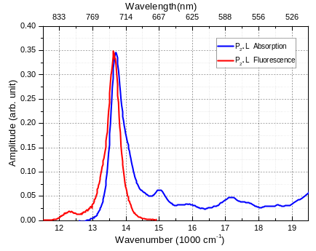
(c) (d)
Figure S1. (a) UV-Vis linear absorption spectrum of the porphyrin monomer (P₁ – green line), porphyrin dimer (P₂ – cyan line) and porphyrin dimer plus ligand (P₂•L – magenta line). Molecular structures are shown in Figure 1(a) in the manuscript. The graphs shown in (b), (c) and (d) are the fluorescence (red line) and linear absorption (blue line) spectra for the porphyrin monomer (P₁), porphyrin dimer (P₂) and porphyrin dimer plus ligand (P₂•L), respectively. All the spectra were recorded in pentane containing 1% pyridine at 298 K. For the Fluorescence spectra, the excitation was at 20284 cm⁻¹ (493 nm) for P₂ and P₂•L, whereas for P₁ it was at 16129 cm⁻¹ (620 nm).
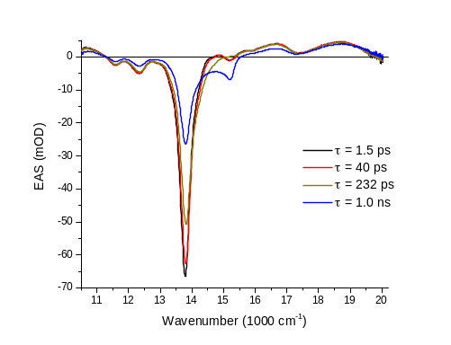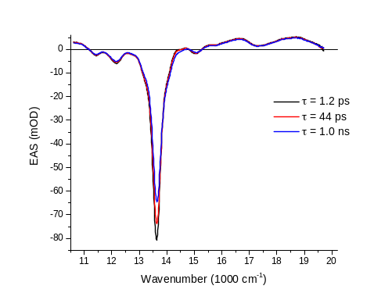
(a) (b)

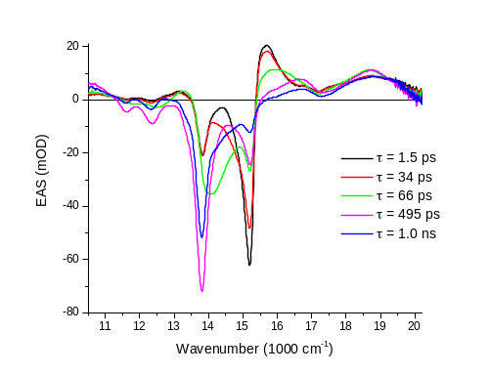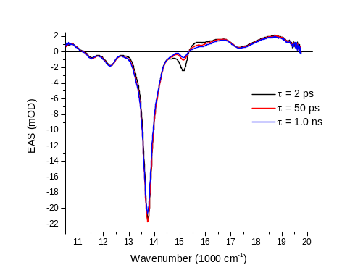
(c) (d)
Figure S2. Evolutionary associated spectra (EAS) resulting from the global analysis fitting procedure for (a) P₂ excited at 13513 cm⁻¹, (b) P₂.L excited at 13513 cm⁻¹, (c) P₂ excited at 15037 cm⁻¹ and (d) P₂.L excited at 15037 cm⁻¹.

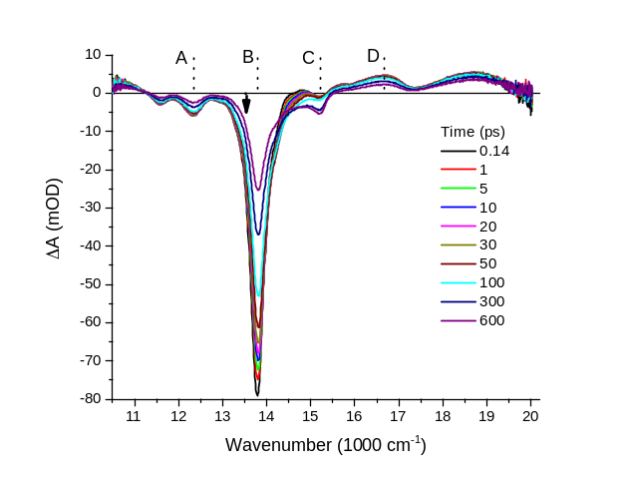
(a)
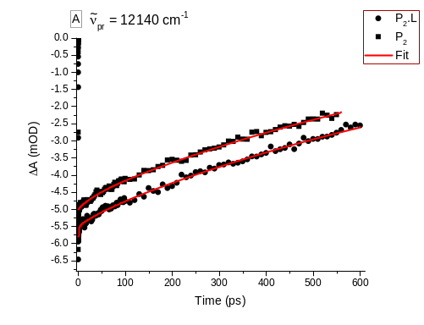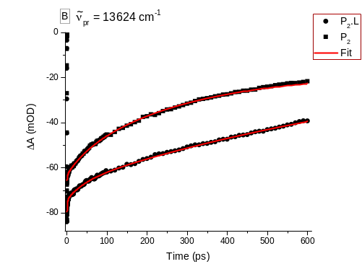
(b) (c)
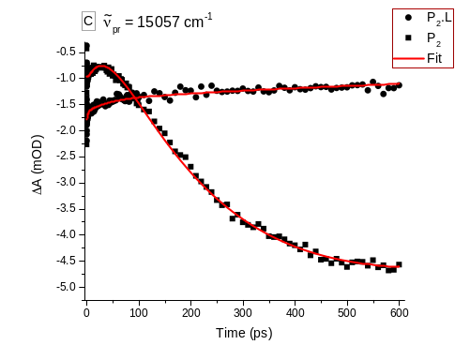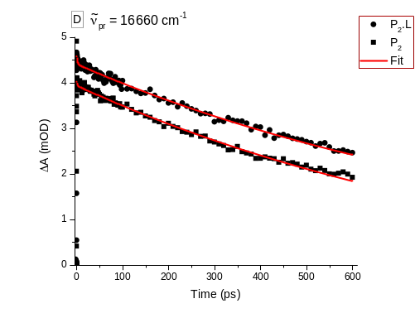
(d) (e)
Figure S3. (a) Time resolved transient absorption spectra for P₂ in pentane (containing 1% pyridine at 298 K) excited at 13513 cm⁻¹ (black arrow) for population times shown in the graph. Labels A to D point to spectral positions for which specific time traces are compared to equivalent time traces obtained for P₂•L and shown in figures (b) for position A, (c) for position B, (d) for position C and (e) for position D. The red line in figures (b), (c), (d) and (e) correspond to fits obtained by fitting each time trace independently.

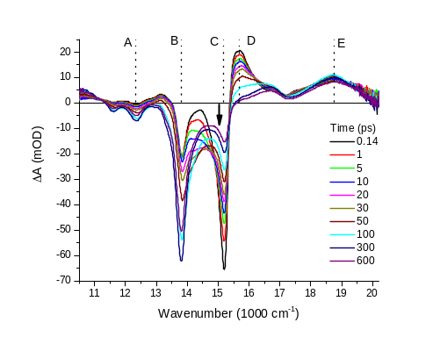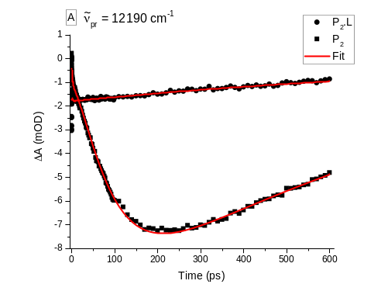
(a) (b)
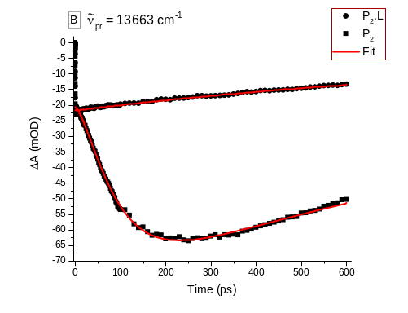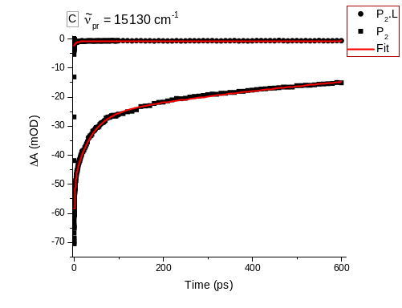
(c) (d)
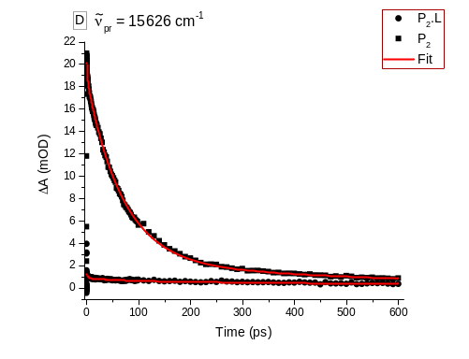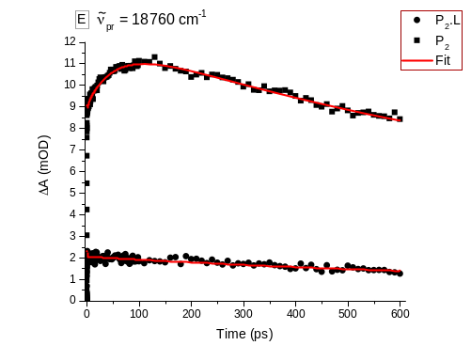
(e) (f)
Figure S4. (a) Time resolved transient absorption spectra for P₂ in pentane (containing 1% pyridine at 298 K) excited at 15037 cm⁻¹ (black arrow) for population times shown in the graph. Labels A to E point to spectral positions for which specific time traces are compared to equivalent time traces obtained for P₂•L and shown in figures (b) for position A, (c) for position B, (d) for position C, (e) for position D and (f) for position E. The red line in figures (b), (c), (d), (e) and (f) correspond to fits obtained by fitting each time trace independently.

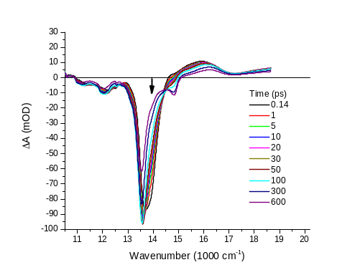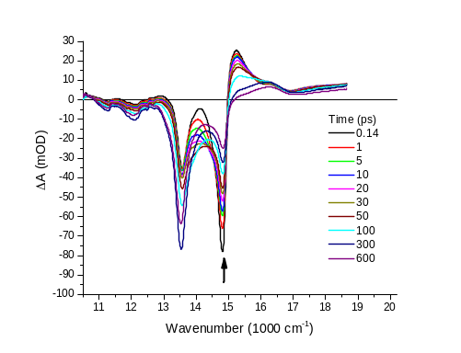
(a) (b)
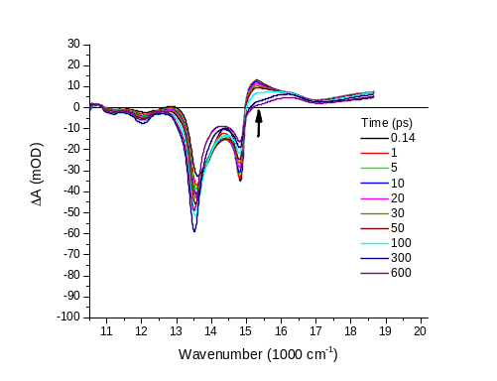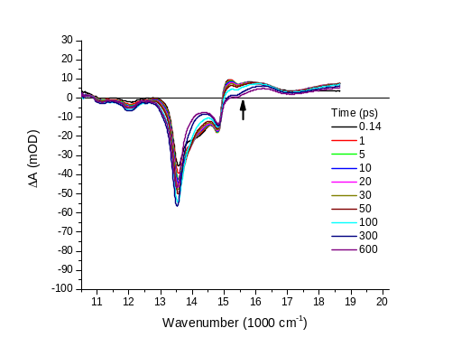
(c) (d)
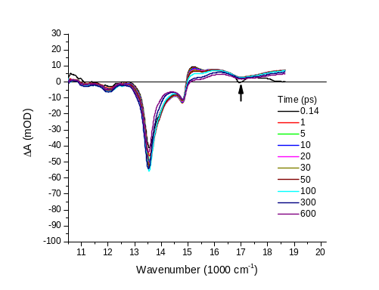
(e)
Figure S5. Time resolved transient absorption spectra for P₂ in pentane (containing 1% pyridine at 298 K) excited at different wavenumbers as shown by the black arrows. The population times are shown in the graph.

