Anabaptism and the World of Printing in Sixteenth-Century Germany

In 1527 the Augsburg printer Philip Ulhart published a work entitled A Christian Instruction, How the Godly Scriptures are to be Compared and Interpreted. The author, Hans Hut, was not named on the title page (possibility a security measure), and Hut may not have approved or even known about the publication. The former Augsburg Carmelite and pamphleteer Johannes Landsperger was responsible for preparing and delivering the work to Ulhart, claiming in his preface that he did not know the author but that the book was clearly inspired by the spirit of God and could be of use to others. There was little to distinguish it from the other works that Ulhart produced that year, which included material from Luther, and the Lutheran preachers, Urbanus Rhegius and Johannes Agricola. The typeset was identical, as was Ulhart’s recognisable inverted pyramid arrangement for the concluding paragraph with small decorative symbols underneath to bring the text to a neat apex. Ulhart had even used exactly the same title page decoration for his edition of Zwingli’s response to Jakob Strauss, a reformer in Eisenach, on the question of the Lord’s Supper, also printed in 1527. Nothing about this work as a physical object betrayed its radicalism.

Ulhart and Landsperger’s collaboration was surprising since we would expect Hans Hut to be on the blacklist of any respectable sixteenth-century publisher.

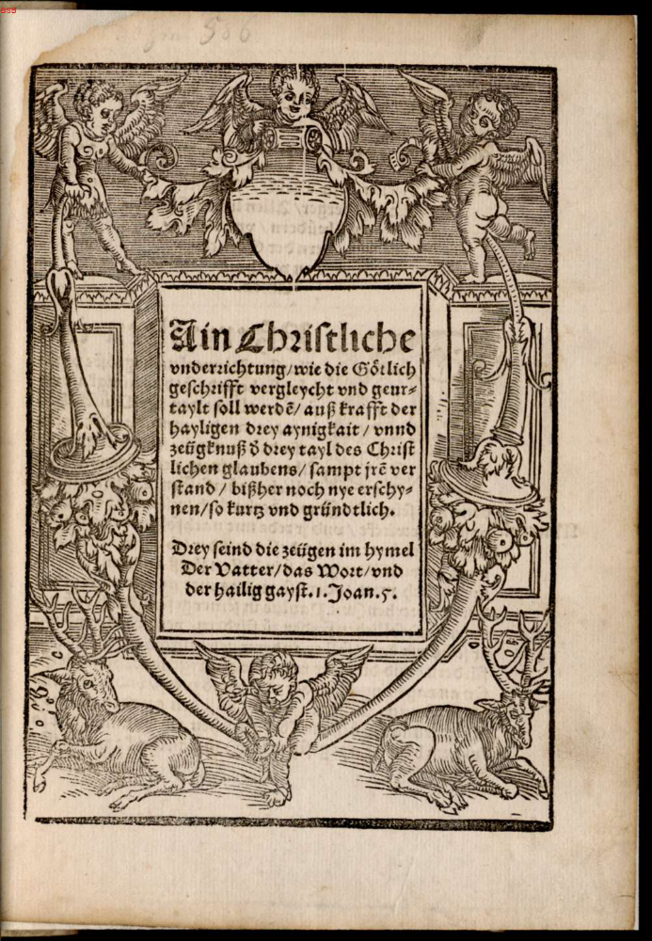
Fig. 1 Title page of A Christian Instruction (Philip Ulhart, Augsburg, 1527)

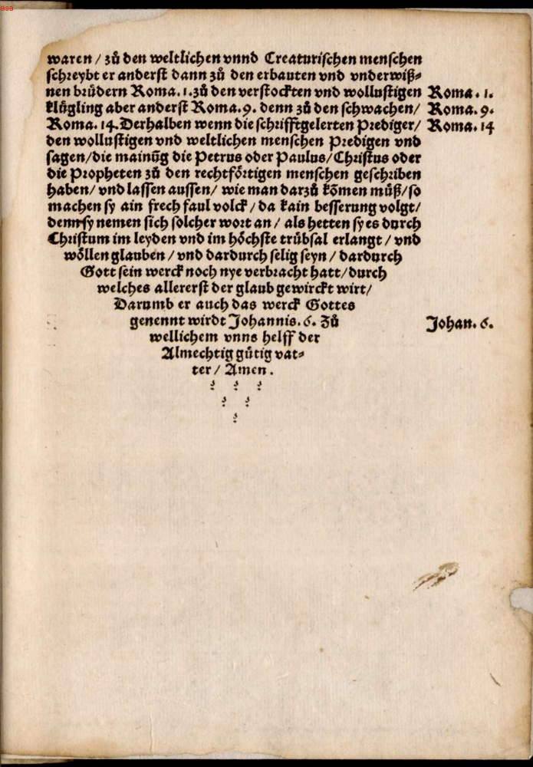

`

Fig. 2 Folio from A Christian Instruction (Philip Ulhart, Augsburg, 1527)

He was an Anabaptist who had peddled works by Thomas Müntzer, was arrested in Augsburg in 1527, and died in prison later that year. But somehow his work ended up on the open market. Until now scholarly interest in the publication of this tract has focused on the translations Hut’s original text underwent as it was edited and re-edited for production and distribution, for the Anabaptist preacher bemoaned the fact that his work had been ‘falsified’ in at least twenty places. Just as interesting are the questions of: how Landsperger got it to Ulhart; why Ulhart decided to publish it; and if he sold many copies. Whether Hut wanted the work printed or not, someone had transcribed it, and Landsperger – probably not an Anabaptist himself - had acquired the manuscript and had spent some time editing it before deciding it was worth his while taking it to the Augsburg printer. If Landsperger was not an Anabaptist, he and Ulhart must have printed the tract because they thought it had appeal to a wider market, not because they were promoting the Anabaptist cause. And printing was after all a business and Ulhart a businessman.

***

In theory, bringing out any work by a radical like Hut should have been difficult and dangerous, for Anabaptists were risky people to know, persecuted by Catholic and Protestants alike. From 1525 onwards, in the aftermath of the Peasants’ War, territories all over the Holy Roman Empire promulgated ordinances which condemned the seditious heresy of the “Wiedertäufer”, those who refused to baptise children and embraced adult baptism. In 1529 at the Diet of Speyer, the Anabaptist Mandate reanimated the old Codex Justinianus, which declared that anyone who rejected infant baptism would be put to death. Traditionally historians have suggested that those who dared to produce Anabaptist works would be forced to operate covertly on the fringes of their industry and that they would expose themselves to fierce judicial reprisals if they were discovered. Even recent scholarship which has emphasised the fluid nature of confessional categories, the diversity of the early modern book market, and the difficulties associated with effectively enforcing censorship of printed matter has still tended to argue that Anabaptists rarely printed, and that when they did, this was only possible because printers disguised works, or authors relied on a network of radically inclined print-shops. In an excellent study of the way in which concerns over print and dangerous talk intersected in Reformation Germany, Allyson F. Creasman claims that printers often felt that the financial gamble on illicit texts was worth taking, but that most Anabaptist works were simply too risky and generally only circulated in manuscript form. Hitherto scholarship has had little sense of how often, where, and with whom Anabaptists published, nor what types of work they produced. Indeed our overwhelming impression of Anabaptism is of a movement that relied on preaching, word of mouth, and divine revelation, not the ‘dead word’ of the printed book.

Yet the reality of who was printing what and when tells a different story. Many Anabaptists did publish, exploiting a network, composed of various authors and workshops, spread over a wide area and was surprisingly successful. Not every Anabaptist chose to or was able to print their work, some preferring oral dissemination or distribution of hand-written manuscripts, but surveying the printed output of the major figures of the Anabaptist movement who did publish in the sixteenth century, we discover that 71 printers produced 279 works in a total of 29 towns across Germany. A small group of illustrious printers lay at the heart of this publishing network: twelve workshops produced well over half the works catalogued. These were busy publishing houses in Strasbourg, Augsburg, Zurich, Worms, Nuremberg, and Nikolsburg, owned by distinguished names like the Froschauer family, Philip Ulhart, Silvan Otmar, and Melchior Ramminger.

Such a survey has only been made possible by the development of VD16, the online catalogue of printed works in the German speaking lands in the sixteenth century. An imperfect resource since it only documents what has survived in libraries not what was actually printed, VD16 nevertheless allows us to investigate printing networks in an unprecedented manner. The surprising patterns illuminated by such a study raise fundamental questions about how we approach an old chestnut of Reformation historiography: the nature of the relationship between the mainstream and the radical reforming movements. The concept of a clearly defined and distinct ‘left-wing’ of the Reformation no longer rings true. Scholars of the Reformation era have become used to the idea that categories of mainstream or radical, Zwinglian, or Lutheran, were fluid, especially in the early years of reform, but Anabaptism does not fit easily into our narratives of the early Reformation in Germany.

Much of the problem stems from the quandary in which confessionally driven history has left Anabaptist studies. The weight of traditional scholarship sought to defend a vision of normative Anabaptism that was a peaceful strain of the movement which evolved from the Swiss groups. Bound up with contemporary debates about the place of Mennonites on the world scene in the face of anti-German sentiment after World War Two, any link to the perceived deviancy of extreme radical groups, such as the Anabaptists who took over the town of Münster in 1534, was rejected. So whilst East German scholarship lauded Thomas Müntzer as a hero of the common man, American Mennonites eschewed any connection with his apocalypticism and violence. Normative Anabaptism lost its sway as an analytical category in the 1970s as scholars, particularly James M. Stayer, Klaus Deppermann, and Werner O. Packull, demanded that we think about Anabaptism in more dynamic terms with multiple points of origin and in many forms. In recent years the rigid demarcations of this famous ‘polygenesis’ thesis have been relaxed and softened, and historians of Anabaptism have diversified their approaches geographically and methodologically. We know much more about the ideas of ‘ordinary’ Anabaptists, about gender dynamics within the movement, about the networks that supported Anabaptist communities, and of how Anabaptism played out in men and women’s everyday lives. Yet Anabaptist scholarship has still struggled to break free of the terms of the debate which defined it, caught up with the question of origins and starting points, and it still only remains in the peripheral vision of scholars of the continental Reformation as a whole. Since Anabaptist and Reformation historians alike recognise that religious categories were altogether muddier than they once seemed, reintegrating radicals is a necessary part of the Reformation story. How to achieve this remains the challenge.

What might a printing history of Anabaptism add to our understanding of the movement? How might print culture help us to rethink these categories of radical and mainstream in the early decades of the Reformation? The story of the Reformation is inextricably interwoven with the history of the book, as new ideas circulated in published form and battles were waged across the printed page. In 1530, Luther himself waxed lyrical that printing was the final and greatest gift of God, specifically intended to spread the truth of religion to the ends of the earth, which would be translated into all languages. However, the relationship between the published word and confessional identity was never straightforward. Books were vehicles for expressing ideas in theological debate, but there were varied reasons why people might buy books and various ways in which they used them. In recent years scholars such as Andrew Pettegree, Hans-Jӧrg Künast, and Jean-Francois Gilmont have illuminated our understanding of the way books were produced; how books were handled as material artefacts; how the publishing market functioned; what role books played in the dissemination of religious ideas and the formation of religious identities alongside other media such as preaching and singing; and how authorities attempted to control printing and eliminate dangerous literature. As physical objects that were manufactured and sold, books can tell us as much about early modern culture as the ideas that appeared on their folios. Focus on the ideas contained in books has been replaced by accounts of who made these items, how books were stored, and what was written in the margins, and sensitivity to the size of volumes, publishing styles, the role of images, and the use of colour on the printed page.

Printing involved collaborative processes. First, getting the manuscript work to the printer’s workshop and turning it into a type-set book required a range of people who could offer the essential skills and funding. This meant that printing created personal relationships which cut across religious groups, since Anabaptists worked with and for people who might be labelled Lutherans or Zwinglians. Secondly, printed matter had to be sold and marketed to a buying public. Printers always had an eye on profit, so it was unlikely that confessional interest alone motivated them to produce Anabaptist works; we should consider the possibility that there might have been an audience for the work Anabaptists published. As the market for printed books exploded in the early years of the Reformation, works by radicals like Hut did not necessarily represent a peripheral section of the market. Often not discernibly distinct from other literature available for purchase, they were one of a range of products available in a dynamic business, and the official reaction to Anabaptist literature was not indiscriminate repression. Rather than avoiding or getting round censors, there is another, more nuanced, story to be told about why not all works printed by Anabaptists were treated as equally inflammatory, and why printers were not punished even when they published these works.

Printing or purchasing an Anabaptist book did not necessarily make someone an Anabaptist. Understanding print culture and problematizing the ‘book’ as an object in Anabaptist history, an object which was made, traded, and stood for more than just a set of theological principles, opens a window onto the dynamism of early Reformation culture and Anabaptism’s place within it. Examining printing networks allows us to map the connections that helped Anabaptism to function, charting the way in which Anabaptists interacted with the world of knowledge in Reformation Europe across the space of the workshop and webs of personal relationships.

***

Philip Ulhart’s presses in Augsburg hummed with activity in the decisive early years of the Reformation, and a diverse range of material appeared from his workshop across a career that spanned over four decades from 1522-1567. His seemingly eclectic output in 1527 was nothing out of the ordinary. In 1524 he published 72 items covering a broad spectrum of work: sermons preached by Luther; tracts by Philip Melanchthon; an edition of a psalm by the north German reformer, Johannes Bugenhagen; Luther’s German translation of the Eucharistic liturgy; material from the pen of Hans Sachs, the famous ‘Meistersinger’ from Nuremberg; and even work by the Catholic Johannes Eck, although that was printed with a reply by Huldrych Zwingli. Mixed in with all these heavy-weights of the Reformation era (Ulhart continued to print for them throughout his career), Ulhart plumped for some more risky choices such as writings by the Eisenach reformer Jakob Strauss, whose independent line on usury had caused a bitter rift with the Wittenberg party; and an address to the nuns in Kentzingen by Katharina Zell, the fiercely independent reformer from Strasbourg who would later call herself the ‘Church Mother’, reflecting her sense of responsibility to the poor and needy. He even dared to print work by Andreas Karlstadt, Luther’s former colleague, but now a hated opponent after the pair’s bitter dispute over the Eucharist.

Ulhart’s catalogue also featured a striking number and range of works by Anabaptist authors. From 1525-1540 he printed a total of eight works by Hans Denck, seven by Jacob Dachser, a work by Hans Hut, two by Michael Sattler, and one by Melchior Hoffman, two works by Leonhard Freisleben, six by Christian Entfelder, seven by Eitelhans Langenmantel, and Ludwig Hätzer’s translation of the twenty-seventh Psalm, as well as other various items. More Anabaptist works were printed in Augsburg than in any other German town, even Strasbourg, despite the fact that Strasbourg had a higher number of active printers than Augsburg over the course of the sixteenth century. Ulhart was clearly the outstanding figure but works also appeared courtesy of other printers such as Heinrich Steiner, Melchior Ramminger, and Silvan Otmar, with the result that over the course of the sixteenth century the Augsburg workshops between them produced 87 items by authors who, at one time or another, could be called Anabaptists.

Although Strasbourg did not produce the same volume of Anabaptist works, its tolerant religious atmosphere was also fertile ground for less mainstream authors. Strasbourg permitted a heady mix of diverse attitudes to reform, exploiting its status as an imperial town to follow a more independent tack, whilst the men at the centre of the reforming movement in the 1520s, Wolfgang Capito and Martin Bucer, were known for their broad-minded approach to religious affairs. The Swiss reformer Heinrich Bullinger even invented a verb, bucerisare, to describe Bucer’s conciliatory approach to variant views on the Lord’s Supper. Control of the printing trade was correspondingly lenient. Although the ruling magistrates and patricians had laid down seemingly strict censorship regulations in 1524, enforcement was lax since there was no focused policy about what constituted a work of religious unorthodoxy or how to deal with it. If anywhere was prepared to permit the publication of radical works, the relatively unhindered presses of Strasbourg were surely as safe a bet as any.

Approximately 40 printers were active in Strasbourg in the first half of the sixteenth-century, eleven of whom produced Anabaptist works. Miriam Usher Chrisman suggests that it was essentially the Prüss family, both Johan Prüss the Younger and his sister Margarethe Prüss, along with her husband Balthasar Beck, who acted out of religious conviction to drive forward the publication of books by radical authors. Johann Prüss printed three works for the Anabaptist Johannes Bünderlin and one for Hans Denck, as well as tracts by other non-conformists, and Margarethe and Balthasar seem to have been a formidable team, notably printing seven works for Melchior Hoffmann, as well as being the only other workshop to publish Hut’s A Christian Instruction in 1530. But connections between Anabaptists and the Strasbourg print shops extended beyond the Prüss family. Numerous printers, whose backgrounds were diverse, produced similar material. This included Matthias Schürer’s workshop, which was run by his widow but retained his name after his death in 1519; the educated son of a cobbler, Jakob Cammerlander, who had once been imprisoned by the Archbishop of Mainz for his apparent Lutheranism; Johann Knobloch, who was a major player in the Strasbourg printing trade and employed artists such as Hans Baldung Grien and Urs Graf to carve wood cuts; a former Franciscan, Johann Schwann; and Wolfgang Köpfel, Capito’s nephew. Through these workshops, Anabaptists had access to the main arteries of the Strasbourg printing trade, for these printers were not small-time traders, not men like Johann Schwintzer or Konrad Kerner whose premises were only open for a year.

Even outside Augsburg and Strasbourg, the Anabaptist printing scene was surprisingly healthy. Peter Schöffer, who had first set up shop in Mainz before moving to Worms and had turned out many editions of Luther’s writings, was particularly active in producing the works of Denck and Hätzer, but also printed one treatise by Michael Sattler in the same year that the Swiss reformer was brutally executed. In 1528 the Hagenau printer Wilhelm Seltz published Denck and Hätzer’s translation of the Old Testament Prophets, and an edition of Hätzer’s German version of the Theologia Deutsch came off the presses of Cyriacus Jacob in Frankfurt am Main as late as 1546. Similar scattered examples can be found for Zurich, Cologne, Basel, Speyer, and Nuremberg, which all witnessed the production of more than one specimen of Anabaptist literature. There were other isolated editions, such as Kaspar Libisch’s publication of Hätzer’s A Judgement from God Our Bridegroom, How One should Deal with Idols and Images in Breslau in 1524. Furthermore, with the exception of Simprecht Froschauer who printed almost exclusively for Balthasar Hubmaier, these publishers generally printed a broad spectrum of works and shared the task of issuing works by the key authors such as Denck, Hoffman, Sattler, and Hätzer.

Simprecht Froschauer’s fruitful partnership with Hubmaier (he printed nineteen of the theologian’s works) operated out of Nikolsburg in Moravia. Hubmaier had settled here after fleeing Switzerland and enjoyed the protection of the feudal lord, Leonhard von Liechtenstein. Simprecht Froschauer was also known by the surname Sorg but little wonder that he chose to trade under a name which had such cachet in early modern Germany. He was symptomatic of a wider phenomenon, whereby Anabaptists and radicals took control over the publication of their works, some even establishing their own presses, including Melchior Hoffman in Kiel, Menno Simons in Fresenburg, Thomas Müntzer in Allstedt, and Sebastian Franck in Ulm. Even Andreas Karlstadt, who undoubtedly struggled to get his work published when he quarrelled with Luther, finally being forced out of Wittenberg and ending up in Orlamünde, had found a reliable printer in Jena by 1523, Michael Buchfürer. When the Anabaptists in Münster seized power in the city in 1534-35 and established a kingdom in preparation for the apocalypse, they did not entirely lose sight of worldly concerns. They established their own press in the cellar of the house which they used for gatherings, belonging to the mayor, Beernhard Knipperdollinck, after plundering the materials of Dietrich Tzwyvel’s press, the most important printing workshop in Münster. It seemed that for the Münster Anabaptists printing possessed a symbolic as well as practical function, for the location they selected for their press invested it with authoritative significance.

Anabaptist printing was not restricted to one town or city, but was connected to an industry that itself paid little heed to regional boundaries. Basel was a prime example of a town whose market and authors were truly international, whilst the Frankfurt and Leipzig book fairs were opportunities for distributing books as well as networking. Moreover printers were not necessarily native to the town in which they worked, although many retained connections with their place of origin, but travelled extensively as they learnt and plied their trade, taking business contacts and materials with them when they moved. The Augsburg workshops had a long list of business partners in other German towns, including Knobloch in Strasbourg and Christoph Froschauer in Zürich. Two of the Strasbourg printers who printed Anabaptist works, Jakob Cammerlander and Wolfgang Köpfel, had very strong associations with Hagenau, for Köpfel was born in the town, and Cammerlander worked in Wilhelm Seltz’s workshop from 1528, founding his own business using printing equipment from Seltz’s workshop. Köpfel had also worked in Basel, where he had been apprenticed under Thomas Wolff. Wolff and, through him, his Strasbourg apprentice Köpfel were associated with other Basel printers, notably Andreas Cratander. A citizen of Basel and Strasbourg, Cratander was connected to the Zürich reformation through the work he printed for the humanist scholar, Joachim Vadian, the pastor of the reformed church at St. Gallen in Switzerland, and a former teacher of Anabaptist Conrad Grebel. Vadian was also in close contact with the Strasbourg reformers through his friendship with Wolfgang Capito, Köpfel’s uncle. We could play almost endlessly with these connections of family, friendship, and business, for it is possible, like six degrees of separation, to get from one Anabaptist to another through their printing contacts. Clearly Anabaptism was not only intimately linked to the printers of Strasbourg or Augsburg, but to a German-wide trade book trade.

***

Behind the networks lie the everyday realities of the print-shop and the practicalities of the printing process. Their complexities have been explored by historians such as Hans-Jörg Künast, giving us a detailed analysis of the economic structures of printing in sixteenth-
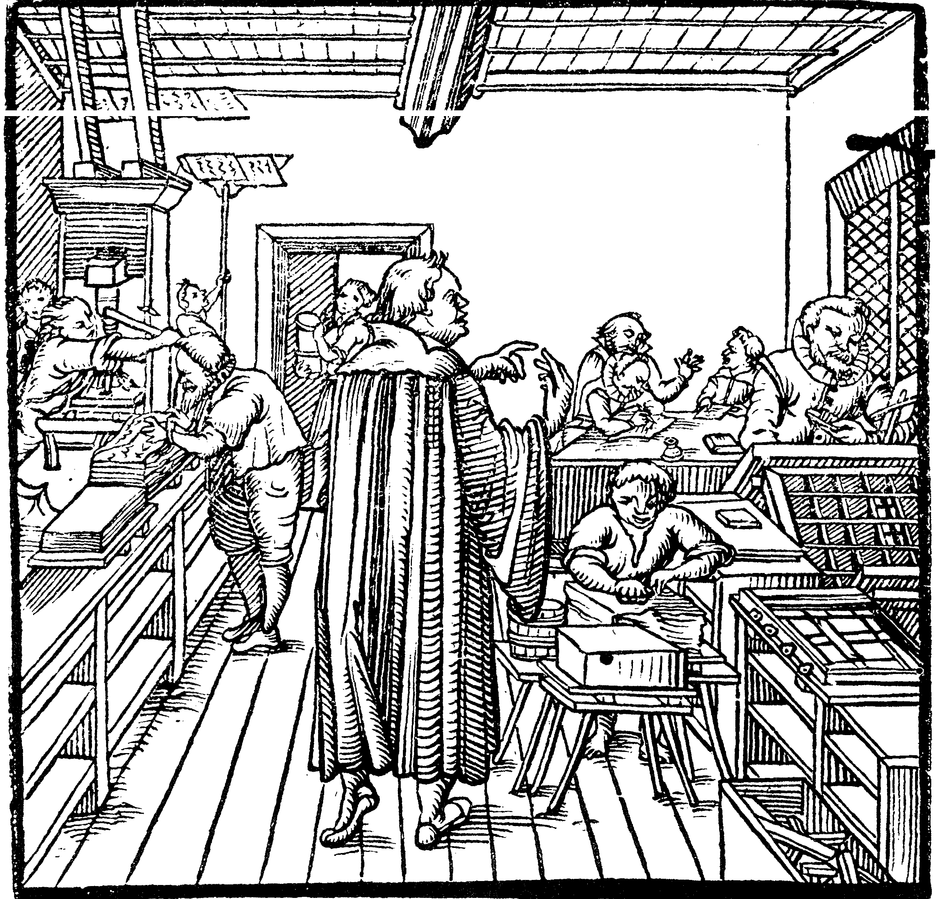

Fig. 3 Title illustration for Hieronymus Hornschuch’s Orthotypographia (Leipzig, 1608)
century Augsburg. Involved in the endeavour were pressmen, illustrators, engravers, proof-readers, stockists, dealers, paper providers, type-setters, and, perhaps most importantly, publishers and financiers. They supplied the capital to take something to print and were an integral element of the intellectual printing community. Printing required man-power, space, and at least a certain amount of money (the larger-scale workshops of Strasbourg with two presses would have as many as ten to twelve workers), although details on the economics of printing often remain elusive. Getting a written manuscript to publication necessitated concerted negotiations between networks of people. If an author wanted to print a work he would have to convince a printer that it was commercially viable, for no workshop wanted to make a loss; translations required talented proof-readers and correctors; if there were illustrations or tricky typefaces further specialist skills were needed; booksellers and distributors were a pre-requisite for dissemination, especially if something was to end up on stalls at the prestigious book fairs.

Participation in the commercial and social world of publishing, therefore, exposed Anabaptists and future Anabaptists to a range of people, although their first contact with the print shop may well have been as employees not authors. Hut famously worked as a book peddler, and Hätzer, Denck and Grebel were all university trained, so it is not surprising that their path differed little from many other scholars and theologians who put their skills to use in the printing trade. These three men all worked as proof-readers and correctors. Grebel spent a brief period in the workshop of Andreas Cratander in Basel in the autumn of 1521, where Denck joined him sometime in 1521 or 1522, going on to work for Valentin Curio, whilst Hätzer worked for Silvan Otmar in Augsburg in 1525 as a proof-reader. Correcting work obviously required close attention to the text if you were scrupulous about your labours. Hieronymus Hornschuch in his manual for proof-readers published in 1608, Orthotypographia, warned that not everyone could be a corrector because pre-requisites were knowledge of languages, good-eyesight, precision, and a sober disposition. Despite Hornschuch’s concerns, the speed and accuracy with which texts were turned around in early modern Europe is impressive. Jean Calvin complained that it took the printers Thomas Platter and Balthasar Lasius in Basel too long to publish the first edition of his Institutes – Calvin arrived in the city in 1535 and the book was published in 1536 – but at 500 folios it was not a slim volume: checking it would have required considerable labour.

Whilst we do not know how attentive any of these men were to their duties, Grebel and Denck may have laboured on corrections for any number of classical and patristic texts which appeared in Cratander’s workshop in the early 1520s: a compendium of Latin authors, Cornvcopiae sive lingvae latinae (printed in September of 1521), a volume of the collected works of John Chrysostom (1522), or Erasmus’s edition of the New Testament (1522). We know that Denck edited Theodore Gaza’s Greek grammar, printed by Cratander in 1523, even providing a Greek distichon and a Latin hexastichon in the introduction. In 1520 Grebel had written a preface to Vadian’s edition of a work of Roman geography, Pomponius Mela’s De situ orbis, which was published in December 1522, and continued to be involved in editing the work at Cratander’s. Kin connections were important here too: Vadian was Grebel’s brother-in-law, having married Grebel’s sister Dorothea in 1519. Denck probably also contributed a world map by Petrus Apian to Mela’s work, so the two men may have had some degree of collaboration in the production process. As well as Latin classics and humanist texts, from 1521 to 1523 Cratander also printed works by Luther, Philip Melanchthon, Urbanus Rhegius, Andreas Karlstadt, and Oecolampadius, with the result that Grebel and Denck were, in all likelihood, reading at least some of this literature in their professional capacity. Harold S. Bender maintains that the time Grebel spent in Cratander’s workshop was too short to have had any effect. He may be right in so far that the brief period was too fleeting to be the definitive and formative intellectual influence on Grebel, but through working in print shops, he and other radicals were exposed to a range of intellectual stimuli.

Such ideological influences are hard to prove, and tracing the lineage of ideas can be a thankless task as Tom Scott has indicated in the case of Müntzer and his allusions to mustard seeds. Where we can be on more certain ground is examining the close-knit networks that Anabaptists were able to exploit. Printing was dependent on personal ties that linked printers and authors, and printing itself was often a family business. Presses were frequently next to or actually in domestic quarters, and like weaving, where people tended to make their marital choices with the intention of keeping the expensive loom in the family, the relationships between printers were close. In Augsburg many of the printers lived within a few streets of one another, in the district of St. Ulrich and Afra, which had strong links with the publishing industry from the trade’s inception, for one of the presses that produced books in the incunabula age was situated inside the walls of the imperial abbey of St. Ulrich and Afra. It was in this area, in Church Street to be precise, that Ulhart set up shop. So too did Otmar, close to the walls of the Benedictine abbey, whilst Melchior Ramminger’s workshop was in St Afra Gässlein not far from Ulhart; and Heinrich Steiner, after using a property owned by Ramminger, moved to a workshop in the vicinity of the not too distant Vogeltor. In Strasbourg the printers knew one another, worked for one another, intermarried, and shared materials, so they must also have talked about their work and business decisions.

Hätzer seems to have been particularly effective at exploiting contacts with the Augsburg printers to his profit, familiar as he was with the names and locations of the workshops. After finishing his translations of Johannes Bugenhagen’s commentary of St Paul’s Epistles in 1524, complete with a foreword, Hätzer travelled to Silvan Otmar’s workshop in Augsburg to deliver the manuscript himself and oversee its publication, initiating a relationship which was to prove extremely advantageous. Hätzer came to know these streets well, for he lived with Otmar in his workshop near the cloister of St. Ulrich; in a letter to Zwingli in September 1525 he said his letters should be addressed to Otmar’s dwelling. And it was Otmar who produced Hätzer’s inflammatory work, On the Evangelical Ordinances and on Christian Speech, from the Holy Scriptures in the summer of 1525, which criticised the reform-minded, guild meetings which were common in the city. Even after being expelled from Augsburg in 1525 following a confrontation with Urbanus Rhegius, Hätzer commissioned his former employer to print his biblical commentaries and translations. Hätzer’s ability to get these published in a city where he was no longer welcome must have been due in no small part to the relationship between the two men.

These networks were not exclusive to men; women too were able to exploit contacts to their advantage. Daughters and widows occupied a position of special importance in the printing world as they were key figures in property transfers and sat at the heart of the familial networks. Chrisman counts seven instances when the press was inherited by the widow on her husband’s death, and from her passed to the second husband. Margarethe Prüss for example, the daughter of Johann Prüss the Elder, was widowed twice. After Reinhard Beck died, she was able to carry on trading independently for a while, but restrictions on women operating businesses in Strasbourg induced her to marry her second printing husband, Johann Schwann; after his demise, she took as her third partner yet another printer, Balthasar Beck. Margarethe Prüss’s friendship with Ursula Jost, the prophetess who was part of a group associated with the Anabaptist visionary and leader in north Germany, Melchior Hoffman, enabled Ursula to publish her visions in 1530 under Beck’s mark. It is doubtful whether Ursula, whose husband Lienhard was merely a butcher from the village of Illkirch south of Strasbourg, would have been able to see her name in print without such a determined and influential friend. Ursula derived her status as a prophet who heard the word of God and preached, but she also chose to publish her radical visions. Her decision indicates that even when Anabaptists did rely on oral communication, printing could be a complimentary strategy for disseminating ideas and reaching out to a much broader audience.

Sometimes these printing collaborations looked as if they sprang from a non-conformist clique - radical works written by extremist authors printed by risk-taking printers, especially when Anabaptists set up their own presses. However, the nature of printing meant it could never be carried on in complete isolation. Getting works to print, even on presses that might be sympathetic to more non-conformist ideas, required contacts and negotiation. Even Anabaptists who established presses would have required capital and equipment, as well as labour and know-how, impossible without pre-existing relationships within the printing trade. Hoffman claimed that after he was expelled from Kiel in 1529, his house was plundered, and books and the press worth 1000 gulden were taken. He clearly had no small stock in the business, and must have relied on some outside support.

In the main, Anabaptists who published came from southern and west Germany or the Swiss territories; aside from Hut’s works, central German Anabaptism is barely represented in the figures. This may have had something to do with the stranglehold which the Lutherans had on Wittenberg and printing in electoral Saxony, but it is more obviously explained by the different characteristics of the movement in the regions and the backgrounds of those who led Anabaptism in southern Germany, mostly educated men with existing contacts. Hubmaier, for example, had studied under Eck in Freiburg, and by the early 1520s had several years as a successful clergyman behind him, most notably as cathedral pastor in Regensburg at the time the Jews were expelled from the city in 1519. Hubmaier's acquaintances spread far. He enjoyed a friendship with the reformer in Mühlhausen, Nikolaus Prugener, and in 1524 their ideas on certain points of faith were published under the title Thirty Eight Conclusions Regarding a Completely Christian Life. Yet neither Mühlhausen nor Waldshut was the place of publication; it was produced in Strasbourg by Johann Schwan, Margarethe Prüss’s second husband. It is not surprising that men such as Denck and Hubmaier were part of the same intellectual and commercial world as Catholics and other reformers with whom they had studied and worked. But what is revealing is the way in which Anabaptists continued to be able to tap into these networks, even when it seemed that persecution would preclude such interaction. Rather than isolating them in sectarian pockets, the invisible webs which linked these men across distant cities and towns made them part of a shared cultural community.

Hätzer, for example, enjoyed a close relationship with Capito, his former teacher who received him in Strasbourg, and consequently he was immediately immersed in a dynamic intellectual and commercial world. In all likelihood it was Capito who introduced Hätzer to his nephew who worked in the printing trade, Köpfel, and either through the printer Peter Schöffer or Balthasar Beck, Hätzer may have had the opportunity to meet Sebastian Franck. To many of the more conservative reformers Capito himself was a suspicious figure. His worryingly good relationships with radicals and his free attitude to alternative ideas made others fret that he might go native and adopt Anabaptist ideas. Whether or not their fears were justified, figures like Capito, who was high profile, as well as well-educated and well-connected, could facilitate publication. The business relationships and friendships that linked the printing world took Anabaptist printing beyond the bounds of radical cliques.

***

For all the contacts that Anabaptist authors established, which undoubtedly influenced decisions about what was taken to the presses, in the end it was the printers themselves who had to decide that it was worth their while to produce Anabaptist works. One might argue that printing radical works made you a radical, or at least a sympathiser. The Strasbourg printer Johann Prüss had connections to individuals like Sebastian Franck, Katharina Schütz, her husband Matthias Zell, Caspar Schwenckfeld, and Clemens Ziegler, all considered non-conformists of one sort or another, and it would be easy to conclude that Prüss was a supporter of a ‘radical’ movement based on the body of work he printed. But identifying Prüss as a radical printer reflects a tendency to assimilate the works of Schwenckfeld, Zell, Denck, Bünderlin, and other Anabaptists and radicals under that one label of ‘left-wing’, separate from the print culture of the Reformation proper. In such a model the only market for radical books would be other radicals, and the only motivation for printing them confessional interest, not commercial practicalities. The papal supporter, Alexander Weißenhorn, printed two works by Christian Entfelder, but this publication of Protestant or Anabaptist works by a Catholic Augsburg printer is seen as nothing more than economic interest. Printers who were supposedly non-conformist also printed a range of books. Johann Prüss seemed to favour radical works but he also sold the story of the Lutheran Reformation, producing for example Luther’s account of the martyrdom of the former Wittenberg student Leonhard Keiser in 1527; Köpfel printed two works by Schwenckfeld but also produced literature by Luther, Bucer, Capito, the Swabian reformer Johannes Brenz, and the famous Bavarian noblewoman Argula von Grumbach. Radical books cannot have been the only exception to the rule that financial gain was important.

When examining the reasons why printers chose to publish a particular work, weighing up the balance of personal and business investment is always tricky. Did printers publish an item because it would make them money? Because they were friends with the author? Or because they believed in what was written in the text? The reality could be a combination of all three, and whilst religious conviction certainly had some role to play in production, it was not the only consideration. The close relationships that existed between men like Otmar and Hätzer were undoubtedly crucial but did not necessarily signify that they agreed on religious ideas; personal interaction is more complex and close bonds based on more than shared ideals. Printing material by apparently non-conformist authors and being radical did not go hand in hand.

Andrew Pettegree has suggested a more nuanced view. He argues that at times when there was an astounding upsurge in printed literature, what he calls a ‘pamphlet moment,’ new and smaller printers in particular might be attracted by ‘the frisson of danger’ associated with producing controversial or banned works of non-conformists, further spurred on by the expectation that profit for slim books and pamphlets on controversial, interesting topics could be high, a conclusion echoed by Creasman. This was true in some instances, and the volatile markets created in times of rapid religious change produce surprising opportunities and unpredictable patterns. Yet well-known individuals like the Froschauers and Ulharts of this world did not need to take risks simply to create income and advance their career prospects. Furthermore such interest from printers extended beyond the years of the pamphlet moment. The greater proportion of works by Anabaptist writers appeared on the market after 1526. Even as late as the 1540s, the Strasbourg printer, Theobold Berger, produced many Anabaptist songs. Working out who bought and read early modern books is never straightforward. Library and book fair catalogues provide invaluable clues, and rare treasures such as the notebook of the book dealer Michael Harder, which records everything he bought at the 1569 Frankfurt fair and what he paid for it, give us exceptional insights into the book trade. However, most of these records only began to be created in the second half of the sixteenth century, and precise documentation on consumers of Anabaptist works is extremely rare. We know that Augsburg attracted individuals who wanted to buy Anabaptist writings; exactly what they purchased and who they were is less clear. Although the records do not enable us to pick out individual readers, it is possible to get a clearer sense of the dynamics behind the decisions of printers who published Anabaptist works and the market for Anabaptist literature through a more precise analysis of what was actually being printed.

Broadly speaking Anabaptist publishing falls into three categories: translations and commentaries (mainly of biblical texts), theological tracts, and songs and hymns. The first of these made up the greatest proportion of Anabaptist printing, and the demand for such works in the 1520s was very high: copies of Luther’s first translation of the New Testament, known as the September Testament, which came out in 1522 in time for the Leipzig book fair in September and October, had sold out by Christmas. Publishing Hätzer and Denck’s translations of biblical literature, therefore, was probably a profitable enterprise. As Luther was slow to follow his vernacular New Testament with an accompanying Old Testament, a gap opened in the market for anyone who could provide translations; some might even have welcomed work coming from a more local author that challenged the domination of the Wittenberg circle. Denck and Hӓtzer’s vernacular version of the Old Testament Prophets appeared in three editions in Worms from 1527-28 off Peter Schӧffer’s presses. The last was unadorned and simple. Subsequent editions in Hagenau and Augsburg were much more elaborate, with decorative frontispieces, although no mention of the translators’ names, suggesting that that book had sold well and had been worth some time and attention. In 1529 Schöffer even published a ‘compilation Bible’ consisting of Luther’s first part of the Old Testament, Denck and Hӓtzer’s Prophets, the Apocrypha of Leo Jud, and Luther’s New Testament. Cobbled together, this conglomerate Bible was a startling conjunction of standard reformers and Anabaptists, and remarkably, it was published at the height of Anabaptist persecutions. By printing Denck and Hätzer’s work on the Prophets, Schöffer was not endorsing dangerous radicalism, but cashing in on the popularity of Luther’s endeavour to put scripture into the vernacular.

Riding on the wave of Luther’s success was, as Pettegree has shown, a driving force of market dynamics in the 1520s, but the demand for vernacular translations persisted. In 1532 Jakob Cammerlander printed Denck’s commentary on the prophet Micah, and it is not hard to suppose such a work would have sold well. Denck himself had died in 1527, but the work had come to Cammerlander through Jakob Vielfeld, Denck’s friend and a fellow reformer, although not an Anabaptist himself. Vielfeld even wrote a foreword for the book. Once more it had been the print trade which had initiated the relationship between Cammerlander and Vielfeld, since Vielfeld had been employed as a corrector for the workshop, Denck and Hätzer’s most famous non-biblical translation, the German edition of the great mystical work entitled the Theologia Deutsch, which Luther had likewise translated, was also a success. Various versions were published throughout the sixteenth century, including an edition as late as 1597, printed in Halberstadt, which was a testament to its enduring popularity.

Seen in this context even more ostensibly theological works, undeniably a riskier bet, could cater to a broader market. Ulhart and Landsperger certainly thought that Hut’s A Christian Instruction would be of interest to an audience which lapped up works on reforming ideas. Two editions of the tract were produced by Ulhart, and although the print run for this pamphlet has yet to be established, the survival of eight copies of one edition and four of the second suggests that the number produced was not insubstantial. As debates over religious change gathered momentum, they did so in a public forum via the medium of print, as well as in person, through letters, and at disputations. Dialogue pamphlets were everywhere in early modern Germany as readers were invited to place themselves in the shoes of real or imagined disputants. Michael Buchführer in Jena who printed for Karlstadt presumably counted on the fact that he could make money off the high-profile argument between Luther and his former colleague. Hubmaier’s works which narrated his split from the more mainstream reformers in Zürich, in particular Zwingli, also appealed to anyone who took an interest in these reforming disputes. Printers produced what they knew would sell and targeted an audience interested in contemporary theological and social issues, so we should see Anabaptist works as part of a vigorous, shifting pamphleteering debate.

By the 1530s and 40s it was hymns and song books that the formed the bulk of published Anabaptist literature, as opposed to biblical commentaries or theological treatises. Some were individual songs, others whole hymnals. They catered to a changing market, for as the liturgical life of communities was transformed and became more settled, materials were needed to support reformed religious life. Vernacular psalms were an important part of this new ritual framework. In Augsburg, the prominent Anabaptist, Jakob Dachser, who had led the Augsburg Anabaptists in 1527 with Sigmund Salminger, played an indispensable role in getting Augsburg congregations singing from a German song-sheet. Ulhart was well acquainted with Jakob Dachser, printing seven of a total eleven published editions of works by him. Even though Dachser was arrested and imprisoned at the end of the 1520s for three and half years, only being released in May 1531 after recanting, Ulhart continued to print his works, producing three editions of Dachser’s Form and Ordinance of Spiritual Songs in 1529, 1531 and 1533. Despite being a convicted Anabaptist, Dachser’s songs seemed to be more important than his previous religious affiliations. He went on to play an active role in Augsburg’s reforming endeavours, whilst his musical efforts continued to be the basis of an Augsburg psalter, which contained all the psalms as well as other popular songs, as late as 1557.

Numerous Anabaptist songs were also produced in Lutheran Nuremberg by various authors and included in diverse hymnals. Valentin Neuber and the Gutknecht family owned two of the most important print shops specialising in music, and whilst they produced Lutheran hymns and songs by Hans Sachs, between them they also printed almost twenty songs by Anabaptists. Music was often a shared commodity. Songs and lyrics were borrowed, adapted, and re-used to find musical settings that worked and hymns and tunes that people might know. Thus even after 1555 and the peace of Augsburg, when confessionalisation supposedly came to bear fully on issues of discipline and religious conformity, we see astonishing diversity and exchange in the market for musical literature, as demand often superseded confessional concerns.

***

Even if printers thought they might make money out of Anabaptist works, we might well ask why they were allowed to appear at all. Two issues surrounded censorship: pinpointing radical or troublesome works in the first place, and then working out an appropriate punitive response for printers who did contravene rules. Neither was straightforward. Censorship and control of printing became a particular issue in the first part of the sixteenth century, and it may have been that risky works could be printed without reprisal more easily when the market boomed in the 1520s, facilitating the publication of all sorts of different books and pamphlets, including those by Anabaptists. Indices of prohibited books did not appear in the German lands until the 1540s, and the Empire’s political fragmentation prevented concerted measures of control.

Keeping track of all that was being published and who was producing it could be tricky for the authorities. By law printers were supposed to include author, publisher, and place of publication but they would often neglect to put their mark on works which could be controversial, thereby washing away the tell-tale finger-print by which they were normally distinguished, or the author might not be named on the title page, as was the case with Ulhart’s version of Hut’s work. There were other tricks too. Reprints might retain the name of the original publisher and place of publication to fool the authorities into thinking this was an import. However, such clues can be misleading. Creasman argues that when Ulhart printed a tract by the radical Eitelhans Langenmantel in 1526 it was not only anonymous but carefully set in lower case letters so Ulhart could not be identified by his decorative letters and initials. But Ulhart produced three works by Langenmantel that year, and although none gave a name or place of publication some had decorative letters and titles. Ulhart’s 1527 edition of Langenmantel’s refutation of Luther’s exegesis had a decorative border and Langenmantel’s name emblazoned clearly across the front. Ulhart was clearly not making consistent decisions about masking these works. Before making assumptions, therefore, about what these stylistic choices meant we would need a more thorough analysis of patterns of decoration. For example a reprint of the Lutheran Johannes Agricola’s refutation of Thomas Müntzer was published without an author and unadorned; are we to assume that this was a measure designed to counteract censorship rules? An unlikely conclusion. Perhaps it was haste; in other cases names may have been left off due to ignorance about authorship. There is more to the story than avoidance tactics.

Indeed stylistic choices suggest Anabaptists and their printers may have been consciously associating their work with the contemporary market rather than hiding away. Anyone buying Ulhart’s copy of A Christian Lesson might have been forgiven for thinking that they were acquiring something from the presses of the Wittenberg printer Lucas Cranach. Not only had the Augsburg publisher used the design for the title page before; he had stolen it from Cranach, who was so important to the story of Luther’s success. The pattern, with little cherubs framing the title and stags resting on the ground below, was fairly typical of the designs favoured by the Wittenberg workshop and other reformation printers which often combined motifs from nature with divine or mythical beings. Ulhart’s version was shoddier than the Cranach but the layout and details were identical. Undoubtedly it may have made it harder for anyone to identify this work as Anabaptist but Ulhart’s choice suggests that he saw this as just one in a series of reforming tracts, not something to be disguised.

When Anabaptists worked in print shops, in addition to meeting people and reading books, they got a flavour for the new medium of print, thinking about how to present a work with borders, embellishments, images and carefully arranged text. In 1528, Hoffman, produced a copy of his second bitter tirade against Nicolas Amsdorff, who had refused to host Hoffman in Magdeburg as he made his way to Wittenberg. On the front page there was a vignette which looked very much like the Luther rose, aside from the fact that at the centre there was a depiction of Christ rather than a cross. Hoffman may have somehow gained possession of an engraving which Luther’s printers had used, or he possibly found someone to design the image himself. Either way he not only have had access to printing equipment from one source or another but sought to capitalise on the iconography of Lutheran printing.

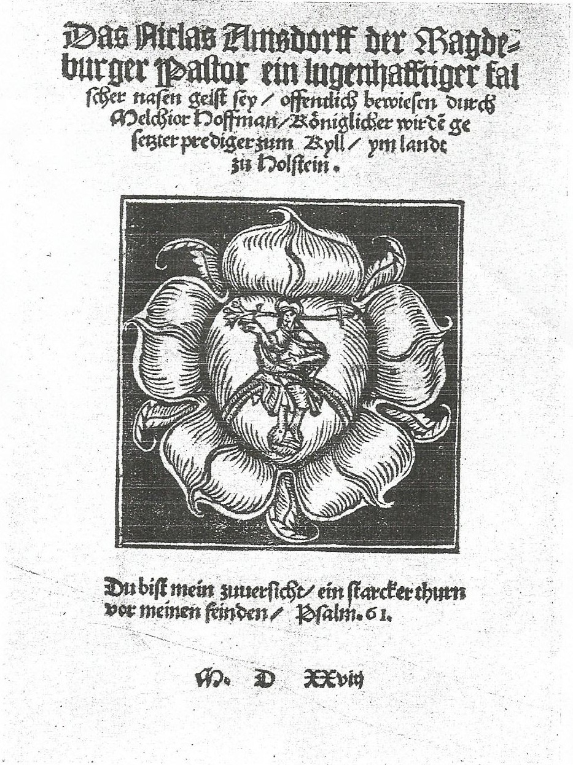

Fig. 4 Frontispiece for Melchior Hoffman, That Nicolas Amsdorff the Magdeburg Pastor is a deceitful false ‘Spirit of the Nose’ (Kiel, 1528)
Anabaptist literature was, therefore, not simply slipping under the radar, especially since many Anabaptist printers were illustrious figures – Froschauer in Zürich, Ulhart in Augsburg, Cratander in Basel, Schöffer in Worms, and Schürer in Strasbourg. It is possible that these printers were prepared to take significant risks and got away with them, but their publications were unlikely to be hidden under the swamp of printing activity. Sometimes the regulations were enacted with full severity when it was felt printers had crossed the line. Hans Hergot was executed in 1527 in Leipzig, in Catholic ducal Saxony, for the publication (and possibly the authorship of) Concerning the New Transformation of Christian Living, although it seems that the Leipzig-based printer Michael Blum actually printed the work for him. Hergot’s case was not the norm, however. Hut was even compensated when the authorities in Nuremberg seized the works by Müntzer he was importing, eager to get them off the market but reluctant to punish the foreign bookseller too harshly. At times this market did come under scrutiny, but on the whole it often proceeded with relative freedom.

Printers, especially the more important ones, knew to a large extent that they would be protected by their position. Creasman and François both indicate that those in power were unwilling to upset the printing trade which was so profitable. Furthermore if the authorities tried to extirpate those who produced unorthodox works, they were placed in something of a quandary. Many of the printers who produced Anabaptist works were also commissioned by the authorities to promulgate their vision of faith and discipline, publish official communications, and produce the responses to Anabaptist ideas. Ulhart was arrested in 1528 for printing an Anabaptist book, probably Dachser’s tract A Godly and Thorough Revelation of the True Anabaptists. When he was interrogated, he said in his defence that he had not initially wanted to print the work. The author, he claimed, returned the next day to assure him that the book had been checked and that ‘he [Philip] was allowed to print it and did not need to be afraid of the authorities.’ Surprisingly he managed to persuade the censorship committee to take no action on the basis of this assertion that the work had already been passed for publishing, but also by claiming that he had printed such works before without reprisal. It is particularly startling that Ulhart was not punished given that 1527-28 witnessed the series of imprisonments and executions of Anabaptists in Augsburg following the so-called Martyrs’ Synod. However, eliminating or severely crippling Ulhart’s workshop would have been a blow to the authorities and those who opposed Anabaptism, as much as to the Anabaptists themselves. Ulhart for example printed several works for Urbanus Rhegius who preached against the Anabaptist community in Augsburg. He also produced the Reformed response to events in March 1531, when two Anabaptists slipped into the city to preach, Wolfgang Musculus’s A Peaceful and Christian Discussion, an Evangelical on One Side and an Anabaptist on the Other, When they Swore an Oath with Each Other (1533). A catch-all policy simply would not work.

Ruling authorities did not, therefore, blindly censor all woks by radical authors. The market was too complicated so the approach had to be more nuanced; not all work could or even needed to be censored, as Dachser’s popular songbooks proved. Even when censorship did occur, it was rarely straightforward. In what would appear to be a classic case of repression, all editions of the works of Melchior Hoffman printed by Strasbourg-based Balthasar Beck were confiscated in 1530. But other issues were involved in this case. Beck himself was an easy target, something of a loose cannon (his printing offices were conveniently located close to the river so that he could beat a hasty retreat when needed), and the character of his workshop may have had as much to do with his punishment, as the desire of the Strasbourg authorities to target radical influences. Throughout his career Beck’s lack of disregard for official protocol landed him in trouble. The apparent technicality which resulted in his punishment for the Hoffman work was his failure to secure a licence, not his dissemination of unorthodoxy. He was reprimanded again in 1544 with Walter Rivius for forging a printing privilege for a book about plants and fruits, and he was put in prison for his activities. If the authorities in Strasbourg simply looked to quash religious dissidence, there seems no reason why they would have allowed Jakob Cammerlander to print two works for Hoffman in 1531. Presumbaly Cammerlander, unlike Beck, had been issued with a licence.

When Beck was apprehended for printing Franck’s Cronica in 1531, several pressures aside from the danger of radicalism pushed the council into action. Erasmus complained to the magistrates that he had been classified as a heretic by Franck in the text, whilst the anti-imperialist, anti-Hapsburg representation of the Caroline eagle in the work as a bloody bird further soured attitudes towards the Cronica. It seems that the authorities acted only when they had to, after Franck had overstepped the mark and caused personal offence to Erasmus, and when Beck seemed to be flouting rules to challenge imperial authority itself. Behind apparently clear-cut decisions about censorship there was always a bigger picture. The Basel printer, Johannes Oporinus, was apprehended in 1543 for his planned publication of Theodore Bibliander’s Latin edition of the Koran. Ostensibly opposition stemmed from conservative academics who feared the dangerous theological impact of such a work. However, hostility also came from Sebastian Münster and the printer Heinrich Petri; their complaints seemed to have grown out of commercial jealousy that they had not been allowed to print a translation of the Koran in 1536. As Pettegree indicates internal market controls of this sort, as much as top-down control, shaped the market. Certainly punishment of printers was inconsistent, and a slap on the wrist did not put an end to a career. Singling out Anabaptist authors, printers, publishers, or indeed correctors from the tangle of personal networks was often not possible or even desirable.

***

The essentially permeable and contingent nature of religious identity has become a common enough theme in cultural histories of religious change in the sixteenth century, but what did this mean in practice? And how might it alter our view of Anabaptism in particular? It is impossible to be certain whether Johannes Landsperger was lying or telling the truth when he claimed that he did not know the author of the work he brought to Ulhart in 1527. What is clear is that the omission of Hut’s name made the book a complicated object. The readers and authorities would not immediately identify it as a radical work; possibly even the printer and editor did not either. The reality of print culture was equally as hazy as the polyglot religious identities that emerged in the sixteenth century, and we should not make simplistic suppositions about the fixedness of demarcated confessional categories such as ‘Anabaptist’, ‘Lutheran’, or ‘Spiritualist.

It has been assumed that radical movements sustained themselves by separatist networks which could operate outside the bounds of normal society. Print culture contradicts these assumptions. Anabaptists who did publish their work used the same printers as mainstream reformers; they were deeply connected to the personal networks of the printing community which allowed them to get work published; there was a market for their books; and censorship was not as strictly enforced as we might presume. Furthermore Anabaptist intellectual culture did not simply look back towards medieval mysticism or inwards to exclusive radical traditions; Anabaptist theology evolved from the same intellectual influences as other early reformers, through creative engagement with Latinate culture and the new medium of print. Unless we appreciate that not every radical wrote visibly radical treatises, and not every printer who printed them was a non-conformist, the Anabaptist works run off by presses like that of Ulhart and Prüss, will continue to seem like diverting oddities, curios of the story of the Reformation and its printing revolution. In reality they are central to understanding the dynamism of cultural exchange in the German Reformation.

Gottfried Seebaß, Hut’s biographer, suggests that Hut never intended his works to be published; Gottfried Seebaß, Müntzers Erbe: Werk, Leben und Theologie des Hans Hut (Gütersloh, 2002), 25. Alejandro Zorzin similarly concludes that Swiss Anabaptists deliberately chose not to publish; Alejandro Zorzin, ‘Reformation Publishing and Anabaptist Propaganda: Two Contrasting Communication Strategies for the Spread of the Anabaptist Message in the Early Days of the Swiss Brethren’, Mennonite Quarterly Review 82.3(2008), 503-16. On this pamphlet see also Karl Schottenloher, Philipp Ulhart: Ein Augsburger Winkeldrucker und Helfershelfer der “Schwärmer” und “Wiedertäufer” (1523-1529) (Munich and Friesing, 1921), 60-64.
Landsperger said that the pamphlet clearly came from ‘the spirit of God, although I do not know the name of the author’; foreword in Ain Christliche underrichtung wie die Götlich geschrifft vergleycht und geurtaylt soll werde[n] (Augsburg, 1527); fo. A1v-A2r. Seebaß claims that Landsperger knew Hut was the author but suppressed his name to give the tract wider appeal, for his authorship was not automatically clear from the content; Seebaß, Müntzers Erbe, 26-27.
Seebaß, Müntzers Erbe, 27-33, 533. Another version of the work, taken from a Hutterite codex, was published by Lydia Müller (ed.), Quellen zur Geschichte der Täufer, vols. 2-3: Glaubenszeugnisse oberdeutscher Taufgesinnter, vol. 1, (Leipzig, 1938), 28-37.
Seebaß, Müntzers Erbe, 26.
Claus-Peter Clasen indicated that approximately 845 Anabaptists were executed in the German territories; Clasen, ‘Executions of Anabaptists, 1525-1618: A Research Report’, Mennonite Quarterly Review, 47.2 (1973), 115-152. Alastair C. Duke estimates another 1300 executions for the Dutch regions; Duke, Reformation and Revolt in the Low Countries (London and New York, 2003), 108.
Miriam Usher Chrisman, Lay Culture, Learned Culture: Books and Social Change in Strasbourg, 1480-1599 (New Haven, 1982), 30; Karl Schottenloher, Philipp Ulhart: Ein augsburger Winkeldrucker und Helfershelfer der 'Schwärmer' und 'Wiedertäufer', 1523-1529 (1921; reprint, Nieuwkoop, 1967); Keith L. Sprunger, ‘Dutch Anabaptists and the Telling of Martyr Stories’, Mennonite Quarterly Review 80.2 (2006), 151-2.
Allyson F. Creasman, Censorship and Civic Order in Reformation Germany, 1517-1648 (Farnham, 2012), 44.
Arnold Snyder, ‘Orality, Literacy and the Study of Anabaptism’, Mennonite Quarterly Review 65.4 (1991), 371-92; Zorzin, ‘Reformation Publishing and Anabaptist Propaganda’. For an alternative view which emphasises the importance of printing to spiritualist groups see Paul Brand, ‘Print and the Knowledge of God: The Development of a Spiritualist Epistemology in the Early German Reformation’, PhD Thesis, University of York, 2007.
This includes co-authored and edited works, translations, and individual Anabaptist songs, but not work that was reprinted as part of refutations by opponents.
Sigmund Bosch, Johannes Bünderlin, Jakob Dachser, Hans Denck, Christian Entfelder, Christoph Freisleben, Leonhard Freisleben, Oswald Glaidt, Georg Grünwald, Ludwig Hätzer, Melchior Hoffman, Balthasar Hubmaier, Hans Hut, Jakob Hutter, Ursula Jost, Jakob Kautz, Hans Krüsi, Eitelhans Langenmantel, Pilgram Marpeck, Lienhart Müller, Adam Reißner, Wilhelm Reublin, Hans Rogel, Bernhard Rothmann, Sigmund Salminger, Michael Sattler, Leonhard Schiemer, Hans Schlaffer, Menno Simons, Wolfgang Vogel.
Ten workshops printed five or more works by these authors: Philip Ulhart (Augsburg), Balthasar Beck (Strasbourg), Christoph Froschauer (Zürich), Simprecht Froschauer (Nikolsburg), Valentin Neuber (Nuremberg), Peter Schöffer (Worms), Heinrich Steiner (Augsburg), Silvan Otmar (Augsburg) and Jakob Cammerlander (Strasbourg). There were also printing families who printed a substantial amount of works, such as the Friedrich/Christoph Gutknecht press (Nuremberg) and the Melchior/Narziß Ramminger press (Augsburg).
Verzeichnis der im deutschen Sprachbereich erschienenen Drucke des 16. Jahrhunderts; see http://www.bsb-muenchen.de/16th-Century-VD-16.180.0.html.
An exemplar of this approach is Harold S. Bender, ‘The Anabaptist Vision’, Church History 13 (1944), 3-24.
James M. Stayer, Werner O. Packull, and Klaus Deppermann, ‘From Monogenesis to Polygenesis: The Historical Discussion of Anabaptist Origins’, Mennonite Quarterly Review 49.2 (1975), 83-121
See for example the recent collection of essays Anselm Schubert, Astrid von Schlachta, and Michael Driedger (eds), Grenzen des Täufertum/Boundaries of Anabaptism: Neue Forschungen (Gütersloh, 2009).
There is a wide range of literature on Reformation printing. See for example, Hans Joachim Bremme, Buchdruscker und Buchhändler zur Zeit des Glaubenskämpfe: Studien zur Genfer Druckgeschichte 1565-1580 (Geneva, 1969); Miriam Usher Chrisman, Lay Culture, Learned Culture: Books and Social Change in Strasbourg, 1480-1599 (New Haven and London, 1982); Helmut Claus, ‘Wittenberg als Druckerstadt’, in Recht lehren ist nicht die geringste Wohltat: Wittenberg als Bildungszentrum, 1502-2002 (Wittenberg, 2002), 75-201; Richard G. Cole, ‘Reformation Printers: Unsung Heroes’, Sixteenth Century Journal 15.3 (Autumn, 1984), 327-39; Mark U. Edwards, Jr., Printing, Propaganda, and Martin Luther (Berkeley and London, 1994); Jean-François Gilmont (ed.), The Reformation and the Book, ed. and trans. Karin Maag (Aldershot, 1998); Andrew Pettegree, Reformation and the Culture of Persuasion (Cambridge, 2005), see especially 102-27, 156-70; Ulinka Rublack, Reformation Europe (Cambridge, 2005), 36-61, 146-9.
Luthers Werke: Weimarer Ausgabe. Tischreden, vol. 1: Sammlungen Veit Dietrichs und Rörers (1. Hälfte 30er Jahre), 523 (No. 1038).
For some of the extensive and varied work on the history of the book see: Sabrina Alcorn Baron, Eric N. Lindquist, and Eleanor F. Shevlin (eds.), Agent of Change: Print Culture Studies After Elizabeth L. Eisenstein; Elizabeth L. Eisenstein, The Printing Press as an Agent of Change: Communications and Cultural Transformations in Early-Modern Europe , 2 vols, (Cambridge, 1979); Creasman, Censorship and Civic Order; Adrian Johns, The Nature of the Book: Print and Knowledge in the Making (Chicago, 1998); Jean-François Gilmont, John Calvin and the Printed Book, trans. Karin Maag (Kirksville, 2005); Hans-Jörg Künast, “Getruckt zu Augspurg”: Buchdruck und Buchhandel in Augsburg zwischen 1468 und 1555 (Tübingen, 1997); Ian Maclean, Learning and the Market Place: Essays in the History of the Early Modern Book (Brill, 2009); Andrew Pettegree, The Book in the Renaissance ( New Haven, 2011); Malcolm Walsby and Graeme Kemp (eds.), The Book Triumphant: Print in Transition in the Sixteenth and Seventeenth Centuries (Leiden, 2011).
David J. Davies, Seeing Faith, Printing Pictures: Religious Identity During the English Reformation (Leiden, 2013); Anthony Grafton, The Culture of Correction in Renaissance Europe (London, 2011); William H.J. Sherman, Used Books: Marking Readers in Renaissance England (Philadelphia, 2009); Ad Stijnman and Elizabeth Upper, Printing Colour, 1400-1800: Histories, Techniques, Functions, and Receptions (Forthcoming).
For details of these individuals see Amy Burnett, Karlstadt and the Origins of the Eucharistic Controversy: A Study in the Circulation of Ideas (Oxford, 2011); Gustav Schmidt, Jakob Strauß: Der erste evangelische Prediger in Eisenach (Eisenach, 1863); Kirsi Stjerna, Women and the Reformation (Oxford, 2009), 109-131.
Schottenloher, Philipp Ulhart, explores the non-conformist side to Ulhart’s career.
See John L Flood, ‘The Book in Reformation Germany’, in Gilmont (ed.), Reformation and the Book, 33.
On these printers see Christoph Reske, Die Buchdrucker des 16. und 17. Jahrhunderts im Deustchen Sprachgebiet: auf der Grundlage des gleichnamigen Werkes von Josef Benzing (Wiesbaden, 2007), 32-33, 34-35.
Lorna Jane Abray, The People's Reformation: Magistrates, Clergy, and Commons in Strasbourg, 1500-1598 (Ithaca, 1985); Abray, ‘Confession, Conscience and Honour: The Limits of Magisterial Toleration in Sixteenth-Century Strassburg’, in Ole Peter Grell and Bob Scribner (eds.), Tolerance and Intolerance in the European Reformation (Cambridge, 1996), 94-107; Thomas Brady, Protestant Politics : Jacob Sturm (1489-1553) and the German Reformation (Atlantic Highlands, 1995); Brady, Ruling Class, Regime and Reformation at Strasbourg 1520-1555 (Leiden, 1978); Chrisman, Lay Culture; Chrisman, Strasbourg and the Reform: A Study in the Process of Change (New Haven, 1967); Lee Palmer Wandel, Voracious Idols and Violent Hands: Iconoclasm in Reformation Zürich, Strasbourg, and Basel (Cambridge, 1994); Marc Lienhard, Un temps, une ville, une Réforme: la Réformation à Strasbourg, Studien zur Reformation in Strassburg (Aldershot, 1990).
Brian Lugioyo, Martin Bucer's Doctrine of Justification: Reformation Theology and Early Modern Irenicism (Oxford, 2010), 15.
Chrisman, Lay Culture, 27; Creasman, Censorship and Civic Order, 34-5.
Chrisman, ‘Reformation Printing in Strasbourg, 1519-60’, in Gilmont (ed.), Reformation and the Book, 214-34.
Reske, Buchdrucker, 886-889.
Reske, Buchdrucker, 879, 883.
Claus-Peter Clasen, Anabaptism: A Social History, 1525-1618: Switzerland, Austria, Moravia, South and Central Germany (Ithaca, 1972), 210-13.
Burnett, Karlstadt, 55-6; The Essential Carlstadt: Fifteen Tracts by Andreas Bodenstein (Carlstadt) from Karlstadt, ed. and trans. E.J. Furcha (Waterloo, Ont., 1995), 169.
Reske, Die Buchdrucker, 631-633; Henrich Grimm, Deutsche Buchdruckersignete des XVI. Jahrhunderts: Geschichte, Sinngehalt und Gestaltung kleine Kulturdokumente (Wiesbaden, 1965), 87, 120.
Künast, “Getruckt zu Augspurg", 18; John D. Fudge, Commerce and Print in the Early Reformation (Leiden and Boston, 2007).
Peter G. Bietenholz, ‘Printing and the Basle Reformation, 1517-65’, in Gilmont (ed.), Reformation and the Book, 241; Pettegree, Book in the Renaissance, 75-82.
Christoph Froschauer for example was the Zürich printer par excellence but his family were from Augsburg, and he had travelled to Zürich to train in the workshop of Hans Rüegger; Reske, Buchdrucker, 1039. See also Clive Griffin, Journeymen Printers: Heresy and the Inquisition in Sixteenth-Century Spain (Oxford, 2005), 75-91.
Künast, “Getruckt zu Augspurg”, 140-149.
Reske, Buchdrucker, 67-69, 322, 880, 884-85.
Grafton, Culture of Correction; Johns, Nature of the Book, 3, 19-20; Kunäst, “Getruckt zu Augspurg”.
Martin Brecht, ‘Kaufpreis und Kaufdaten einiger Reformationsschriften’, Gutenberg Jahrbuch 47 (1972), 169-173; Bremme, Buchdrucker und Buchhändler, 28-40; Künast, “Getruckt zu Augspurg”, 185-96; Pettegree, Culture of Persuasion, 149-152.
Clarence Bauman, The Spiritual Legacy of Hans Denck: Interpretation and Translation of Key Texts (Leiden, 1990), 8; Harold S. Bender, Conrad Gebel c. 1498-1526: The Founder of the Swiss Brethren , Sometimes Called Anabaptists (Goshen, 1950), 61-3; Bender, ‘Conrad Grebel, the Founder of Swiss Anabaptism’, Church History 7.2 (1938),157-78, here 162-5; J.F. Gerhard Goeters, Ludwig Hätzer (ca. 1500 bis 1529): Spiritualist und Antitrinitarier: Eine Randfigur der frühen Täuferbewegung (Gütersloh, 1957), 56-7; Ludwig Keller, Die Reformation und die ältesten Reformparteien: In ihren Zusammenhange (Leipzig, 1885), 329-30; Karl Schottenloher, ‘Silvan Otmar in Augsburg. Der Drucker der schwäbischen Bundes 1519-1535’, Gutenberg Jahrbuch 15 (1940), 282.
Hornschuch’s Orthotypographia, 1608, ed. and trans. Philip Gaskell and Patricia Bedford (Cambridge, 1972), 8-10. See also Grafton, ‘The Importance of Being Printed: The Printing Press as an Agent of Change: Communications and Cultural Transformations in Early-Modern Europe by Elizabeth L. Eisenstein. Review’, 265.
Gilmont, Calvin and the Printed Book, 181.
Keller, Die Reformation, 331-32. He identified himself in the Latin hexastichon as ‘Graecarum Literarum studiosis Johannes Dengkius’.
At the beginning of the work a short address to the reader was included, ‘Conradus Grebelius Tigrinus Helveticus, vero candide lectori’; see POMPONII MELAE DE ORBIS SITV LIBRI TRES, ACCVRATIS sime emendati, unà cu[m] Comme[n]tariis Ioachimi Vadiani Heluetii castigatioribus, & multis in locis auctioribus factis (Basel, 1522).
Bender, Grebel, 62; The Sources of Swiss Anabaptism: The Grebel Letters and Related Documents, ed. Leland Harder (Scottdale, 1085). 150.
Denck, Spiritual Legacy, 8.
Works published included Urbanus Rhegius, ARGVMENTVM LIBELLI. SIMON HESSVS LVTHERO OSTENdit caussas, quare Lutherana opuscula à Coloniẽsibus & Louaniensibus sint combusta (1521); Johannes Oecolampadius, QVOD NON SIT ONEROSA CHRISTIANIS CONFESSIO (1521); Andreas Karlstadt, DE COELIBATV, MONACHATV, ET VIDVITATE; Martin Luther, IN EPISTOLAM PAVLI AD Galatas, D. Martini Lutheri Augustiniani co[m]mentarius (1523); Philip Melanchthon, IN EVANGELIVM IOANNIS, ANNOTATIONES PHILIPPI MELANCHTHNIS (1523).
Bender, Grebel, 16.
Tom Scott, ‘Müntzer and the Mustard-Seed: A Parable as Paradox?’, in Tom Scott, The Early Reformation in Germany: Between Secular Impact and Radical Vision (Farnham, 2013), 247-56.
Johns, Nature of the Book, 75-77,
Ferdinand Geldner, Die Deutschen Inkunabeldrucker: Ein Handbuch der Deutschen des XV. Jahrhunderts nach Druckorten, 2 vols (Stuttgart, 1968-1970), vol. 1: Das Deutsche Sprachgebiet, 138-139. The abbot, Melchior von Stamhaim, inherited 5 presses from fellow printers Johann Schüßler and was permitted to set up a complete print shop, which on the evidence of typefaces involved other incunabula printers such as Anton Sorg and Günther Zainer.
Reske, Buchdrucker, 32-36.
Goeters, Hätzer, 42-43.
Huldreich Zwinglis sämtliche Werke, vol. 8 (Leipzig, 1914), Letter No. 383, p. 364. ‘Literas tuas mitte Silvano Othmar calchographo. Curabit ille, ut habeam.’ See also Goeters, Hätzer, 56.
Goeters, Hätzer, 57.
Josef Benzing, ‘Die Druckerei der Matthias Schürer Erben zu Straßburg (1520-1525)’, Archiv für Geschichte des Buchwesens 2 (1960), 170-174; Chrisman, Lay Culture, 22-23; Albrecht Classen, ‘Frauen als Buchdruckerinnen im deutschen Sprachraum des 16. und 17. Jahrhunderts’, Gutenberg Jahrbuch 75 (2000), 181-195; Reske, Buchdrucker, 878, 880-881.
Stjerna, Women and the Reformation, 17-22; C. Arnold Snyder and Linda A. Huebert Hecht, Profiles of Anabaptist Women: Sixteenth-Century Reforming Pioneers (Waterloo, Ont., 1996), 258-78.
Gerhard Ficker (ed.), Melchior Hoffman gegen Nicolaus von Amsdorff, Kiel 1528 (Kiel, 1928), Anmerkungen, p. II.
This contrasts, for example, with the more sectarian use of the press by English Familists, which did appear to rely on covert and sectarian networks, or works produced by exiled evangelicals from England in the later years of the reign of Henry VIII; Christopher Marsh, The Family of Love in English Society, 1550-1630 (Cambridge, 1994), 17-18; Alec Ryrie, The Gospel and Henry VIII: Evangelicals in the Early English Reformation (Cambridge, 2003), 103-111.
Alejandro Zorzin, ‘Ludwig Hätzer’s “Kreuzgang” (1528/29): Ein Zeugnis täuferischer Bildpropaganda’ in Archiv für Reformationsgeschichte 97 (2006), 140-42; Goeters, Hätzer, 95.
James M. Kittelson, Wolfgang Capito: From Humanist to Reformer (Leiden, 1975), 176-187; The Correspondence of Wolfgang Capito, 2 vols, ed. and trans. Erika Rummel (Toronto, 2005-9), vol. 2: 1524-1531, Letter 258, p. 168.
Chrisman, Lay Culture, 11.
These works by Schwenckfeld were: Gebett. Jn gegenwertiger not zů Christo (1546) and Vonn der himlischen artzney des waren artzets Christ (1551).
Pettegree, Culture of Persuasion, 147-55, 163-170; Creasman, Censorship and Civic Order, 37-40.
See also Ryrie, Gospel and Henry VIII, 112-19, 271.
Although a one-man shop, Chrisman classifies Berger as a major printer, Chrisman, Lay Culture, 4, 10.
Die Messkatalog des sechzehnten Jarhhunderts, 1564-1600, ed. Bernhard Fabian (Hildesheim and New York, 1972-2001); Ernst Kelchner and Richard Wülcker, Mess-Memorial des Frankfurter Buchhändlers Michel Harder, Fastenmesse 1569 (Frankfurt am Main, 1873).
Creasman, Censorship and Civic Order, 94.
John L. Flood, ‘Martin Luther’s Bible Translation in its German and European Context’, in Richard Griffiths (ed.), The Bible in the Renaissance: Essays on Bible Commentary and Translation in the Fifteenth and Sixteenth Centuries (Aldershot, 2001), 45-70, here 60-61. On editions of Bibles in the sixteenth century see also Stefan Strohm, with Peter Amelung, Irmgard Schauffler, and Eberhard Zwink, Die Bibelsammlung der Württembergischen Landesbibliothek Stuttgart (2 parts, Stuttgart -Bad Cannstatt, 1987-1993), part 2, vol. 1, Deustche Bibeldrucke 1466-1600.
Pettegree, Book in the Renaissance, 93-8.
Ludwig Keller, ‘Vielfeld, Jacob’, in Allgemeine Deutsche Biographie 39 (1895), 677-678 [Online version]; URL: http://www.deutsche-biographie.de/pnd102176078.html?anchor=adb.
Copies of one edition survive in the Bayerische Staatsbibliothek München, the Bibliothek der Ludwig-Maximilians-Universität München , the Universitätsbibliothek Würzburg, in Berlin in the Staatsbibliothek, in Wolfenbüttel in the Herzog August Bibliothek, in Vienna in the Österreichische Nationalbibliothek, in Zürich in the Zentralbibliothek and in the Universitätsbibliothek Eichstätt; for the other there are extant volumes in the Sächsische Landes- und Universitätsbibliothek in Dresden, the Lutherhalle library in Wittenberg, Bayerische Staatsbibliothek München and in Wolfenbüttel. Of the two separate entries that exist in the VD16 catalogue, it is not clear which came first.
Peter Matheson, The Rhetoric of the Reformation (New York, 2004), 81-110.
Schottenloher, Philipp Ulhart, 72-81; Werner O. Packull, ‘A Reformed-Anabaptist Dialogue in the Augsburg in the early 1530s’, in Werner O. Packull and Geoffrey L .Dipple (eds.), Radical Reformation Studies. Essays Presented to James M. Stayer (Aldershot, 1999), 25.
Reske, Buchdrucker, 678-81. The songs they printed included some by Schlaffer, Georg Grünwald, and Wolff Gernold, who all had hymns in the Anabaptist hymnal, the Ausbund.
Creasman, Censorship and Civic Order, 41-44.
Creasman, Censorship and Civic Order, 44
Eitelhans Langenmantel, Ain Kurtzer anzayg, wie Do. Martin Luther ain zeyt h#[oe]r, hatt etliche schriften lassen außgeen, vom Sacramẽt, die doch stracks wider ainander, wie wirt dañ sein, vnd seiner anhenger Reych bestehen (Augsburg, 1527).
Tom Scott, ‘Johannes Agricola’s Ein nutzlicher Dialogus as a Source for the Peasants’ War in Central Germany’, in Scott, Early Reformation in Germany, 229.
Many thanks to Professor Andrew Pettegree for noticing this and for providing me with examples from Cranach’s workshop. See Cranach im Detail: Buchschmuck Lucas Cranachs des Älteren und seiner Werkstätt (Wittenberg, 1994), 49-51.
Pettegree, Book in the Renaissance, 99-100.
Melchior Hoffman, Das Niclas Amsdorff der Magdeburger Pastor ein lugenhafftiger falscher nasen geist sey, offentlich bewiesen durch Melchior Hoffman, Koeniglicher wirde[n] gesetzter prediger zum Kyll, ym landt zu Holstein (Kiel, 1528); Klaus Deppermann, Melchior Hoffman: Social Unrest and Apocalyptic Visions in the Age of the Reformation, trans. Malcolm Wren, ed. Benjamin Drewery (Edinburgh, 1987), 110-114.
Ficker (ed.), Melchior Hoffman, Anmerkungen, p. II.
Reske, Buchdrucker, 519. See also Classen, ‘Frauen als Buchdruckerinnen’, for details of Hans Hergot and his wife Kunigunde, 186.
Creasman, Censorship and Civic Order, 90-91.
Creasman, Censorship and Civic Order, 41; Wim François, ‘The Antwerp Printers Christoffel and Hans (I) van Ruremund, Their Dutch and English Bibles, and the Intervention of the Authorities in the 1520s and 1530s, Archiv für Reformationsgeschichte 101 (2010), 13.
Künast, “Getruckt zu Augspurg”, 205; Schottenloher, Philipp Ulhart, 76-78. ‘Morgens [sei] Jecklin wieder zu ihm kommen und [hab] gesagt, er hat das Büchlein lessen lassen, er [Philipp] mecht es wohl drucken und bederft sich vor keener Oberkeit ferchten.’
There is some confusion over whether the Hoffman works were confiscated in 1530 for publishing without a license or as a result of Beck’s publication of Franck’s Cronica in 1531. Chrisman advocates the latter, while the Mennonite Encyclopaedia suggests that the original issue in 1530 was the missing license; Chrisman, Lay Culture, 28, and Christian Neff and Werner O. Packull, ‘Hoffman, Melchior (ca. 1495-1544?)’, Global Anabaptist Mennonite Encyclopaedia Online (1987): http://www.gameo.org/encyclopedia/contents/H646.html. Deppermann supports the view that Beck initially was issued with an arrest warrant in 1530 for the Hoffman works, and the further controversy then presumably resulted in 1531; Deppermann, Melchior Hoffman, 218.
Snyder, Profiles, 258, 267-8.
Schottenloher, ‘Die Druckpriviligien des 16. Jahrhunderts’ Gutenberg Jahrbuch 8 (1933), 92.
Matthew Mclean, ‘Between Basel and Zurich: Humanist Rivalries and the Works of Sebastian Münster’, in Walsby and Kemp (eds.), The Book Triumphant, 282-4.

