Supplementary Material for:

Pace of life, predators and parasites: predator-induced life history evolution in Trinidadian guppies predicts decrease in parasite tolerance

J. F. Stephenson^{1,2}*, C. van Oosterhout³ and J. Cable¹

¹ School of Biosciences, Cardiff University, Cardiff, United Kingdom
² Present address: EAWAG, Swiss Federal Institute of Aquatic Science and Technology, 8600 Dübendorf, Switzerland and Institute of Integrative Biology, ETH Zürich, 8092 Zürich, Switzerland
³ School of Environmental Sciences, University of East Anglia, Norwich Research Park, Norwich, United Kingdom
* Corresponding author: jfrstephenson@gmail.com

S1.1 Data collection methodology
Sexually mature adult guppies (n = 2998) were collected at 23 upper course and 28 lower course sites of 24 rivers in Trinidad between 2003 and 2009. Whole shoals were enclosed in the river by a seine net, and individual fish were scooped out of the water using small buckets to avoid dislodging any ectosymbionts. Fish standard length, weight and sex were recorded. The fish were killed on site with an overdose of 0.02% tricaine methanesulfonate (MS222; PHARMAQ Ltd., UK) and preserved individually in 90% molecular grade ethanol. All fish, and the ethanol in which they had been transported, were then examined using a dissection microscope with fibre optic illumination for externally visible symbionts. The prevalence of species other than Gyrodactylus spp. in our sample was low (Trichodina spp. = 0.061; Ichthyophthirius spp. = 0.010; Apiosoma spp. = 0.004; digenean metacercariae = 0.006; Camallanus spp. = 0.0004; fungal infection = 0.007), and therefore only the results for Gyrodactylus spp. infections are reported. Gyrodactylus spp. (hereafter Gyrodactylus) were not identified to species level.

S1.2 The use of course as a proxy for predation regime
Throughout the analyses we use the watercourse, ‘course’, (upper or lower) the fish were sampled from as a proxy for the predation regime faced by guppies at each site. During sampling, we recorded the presence of fish species known to predate upon guppies, including Anablepsoides hartii, Aequidens pulcher, Cichlasoma taenia, Polycentrus schomburgkii, Crenichla alta, Hoplias malabaricus and Gobiomorous dormitor. Presence of predatory species is a recognised measure of predation pressure in this system (e.g. [1]), but this metric includes no information on predator density and, as noted by Magurran ([2]; page 24), an increase in predator species richness could theoretically increase or decrease predation risk via interactions between predator species. Additionally, for some predator species there is little evidence that they are important guppy predators at all; some are certainly more important than others. To confirm that our ‘course’ variable, which reflected the location of the site within the rivers, was correlated with predator fauna, we calculated the species richness of the major guppy predators (P. schomburgkii, C. alta, H. malabaricus and G. dormitor) at each site. Each of these species has a trophic level of greater than 3.5 (Fishbase; www.fish-base.org), indicating that they are generally ichthyophagous [2]. We used a t-test to test for differences in major guppy predator species richness between sites in each of our four categories. Sites categorized as ‘upper’ had significantly lower mean predatory species richness than those categorised ‘lower’ (t₄₇ = 3.78, p = 0.0004). Overall, therefore, the levels of our course variable differed significantly in mean predator species richness, but there was variation between sites within each course (mean score±SEM for lower course sites = 2.62±0.25; for upper course sites = 1.49±0.16). Consequently, we used the ‘course’ variable in further models rather than predator species richness because the latter is less accurate; we may have missed the predators at some sites, and they may move between sites within course. Additionally, the ‘course’ variable reflects the presence of waterfall migration barriers and, hence, which sites these predators could access. Guppy traits driven by predation pressure change over evolutionary time (e.g.[1]), and are therefore not dependent on the presence of predators on our sampling day. In summary, the overall differences in predation pressure between courses, confirmed by our own predator species richness score, more accurately represents the predator-driven traits, such as life history, of the guppies in our sample.

S1.3 Spatial scale of the random term in our models
The sampling was conducted over different spatial scales. This was incorporated into the model as a hierarchical random factor: sample site was nested within course, nested within river, nested within drainage. During model simplification we used Likelihood Ratio Tests to examine the importance of each level of this nested term. We included these factors as random terms because we wanted to be able to generalize these results to other sites across other rivers. Gyrodactylus infection was highly spatially variable and most variation (61%) occurred between sample sites, i.e. on the smallest spatial scale. Differences between drainages, between rivers within drainages, and between courses within rivers did not significantly contribute to differences in prevalence, and these factors were all removed from the random model, following [3]. Comparison of the AIC values between models with and without each of these nested random terms confirmed that models containing just sample site as a random term were superior.

S1.4 Further analysis and discussion of the parasite count data
The Gyrodactylus count data and all interactions including this term were removed from the full model described in the main text because the model was superior without them (as assessed using Akaike’s Information Criteria, AIC). However, because tolerance is defined as the host’s ability to mitigate the costs of a given infection, it is important to fully assess how condition might change with the number of parasites a host is infected with (‘infection load’). To this end, we conducted further analyses using the Gyrodactylus load data.

S1.4.1 The main result is supported using infection load instead of parasite prevalence
Using the same software and starting model structure as presented in the main text (General Linear Mixed Model, GLMM: Gaussian error family and identity link function), we used SMI (scaled mass index) as the response variable, and again included sample site as the random term to account for the multiple fish sampled at each site. We included the following as fixed effects: the log transformed number of Gyrodactylus infecting each fish (‘log Gyrodactylus load’), course, fish sex, fish weight (as a measure of size), and the two-way interactions between these terms. We also included the three-way interaction between fish sex, course, and log Gyrodactylus load. We simplified this starting model by removing the non-significant terms to minimize AIC. The final model included the two-way interaction between fish sex and fish weight (F_{1,2982.4} = 42.47, p < 0.0001; discussed below). The three-way interaction between course, fish sex and log Gyrodactylus load was also marginally significant (Fig. S1; F_{1,2955.4} = 3.97, p = 0.046), indicating that there was a difference between males and females from upper and lower courses in how their condition changed with Gyrodactylus load. Given the high p-value, we reran the model without this term and found a significant difference both between the sexes (Fig. S1; F_{1,2959.4} = 5.34, p = 0.021), and between the courses (Fig. S1; F_{1,2984.9} = 12.37, p = 0.0004) in how condition changed with Gyrodactylus load. These results therefore show that the pattern we report in the main text based on the presence of Gyrodactylus is also well supported when Gyrodactylus load is used instead.

S1.4.2 Infection load does not explain variation in condition among infected fish
We next investigated how condition changed with Gyrodactylus load among infected fish by running the same model described above on data from these fish only. The final model included course, log Gyrodactylus load (both non-significant), and fish sex, fish weight and their interaction (interaction term: F_{1,1090} = 6.571, p = 0.01). As above, large females were of a higher condition than smaller females, whereas there was no relationship between size and condition among males. This result likely reflects that the SMI (and all other condition indices based on length-weight relationships) does not account for how female reproductive allocation (i.e. the ratio of female to offspring weight) changes with age and therefore size. The lack of a significant interaction between Gyrodactylus load and course in this analysis (Fig. S2) suggests that there was no difference between guppies from upper and lower courses in how condition was correlated with infection load. This finding indicates that the significant results reported in S1.4.1 are driven by differences between infected and uninfected fish.

S1.4.3 The main effect cannot be explained by a difference in infection load between the upper and lower courses
In order to confirm that our main result (i.e. how fish condition correlated with the presence of Gyrodactylus changed between these populations of guppies) was not, therefore, simply due to differences in the Gyrodactylus load between upper and lower courses, we used the log Gyrodactylus load from infected fish only as a response variable in a further GLMM (Gaussian error family, identity link function). Sample site was included as a random term, and fixed terms were course, fish weight and fish sex. The model was simplified as above, and revealed that there was no consistent difference in Gyrodactylus load between the upper and lower course populations. The only term remaining in the final model was fish weight (F_{1,1099.3} = 21.07, p < 0.0001), with larger fish carrying more parasites. The reasons behind this pattern have been discussed extensively elsewhere (e.g. [4]).

S1.4.4 Summary
Together, these analyses indicate that: i) the correlation between Gyrodactylus load and fish condition changes between upper and lower course guppy populations (and between the sexes) in the same way as that between condition and Gyrodactylus presence; ii) among infected fish, however, Gyrodactylus load does not explain variation in condition; but iii) our main effect is not driven by population differences in number of parasites: we found no evidence that infection loads differ consistently between upper and lower course populations.
These analyses provide further support for the argument we posit in the main text: counts of Gyrodactylus from surveys of wild populations represent ‘snapshots’ of infection loads and cannot provide information about the resistance or tolerance of the individual host. For example, a host with few parasites may have just become infected (and therefore be in relatively good condition), or may have been infected very heavily until recently (and therefore be in poor condition). This limitation of these data likely explains why, among infected fish, we found neither an overall correlation between condition and infection load, nor a difference between upper and lower course populations in the slope of the relationship (Fig. S2). We suggest that carefully designed, appropriately controlled laboratory experiments would be necessary to reveal differences between upper and lower course populations in the correlation between infection load and condition; field data are not suited to this purpose.

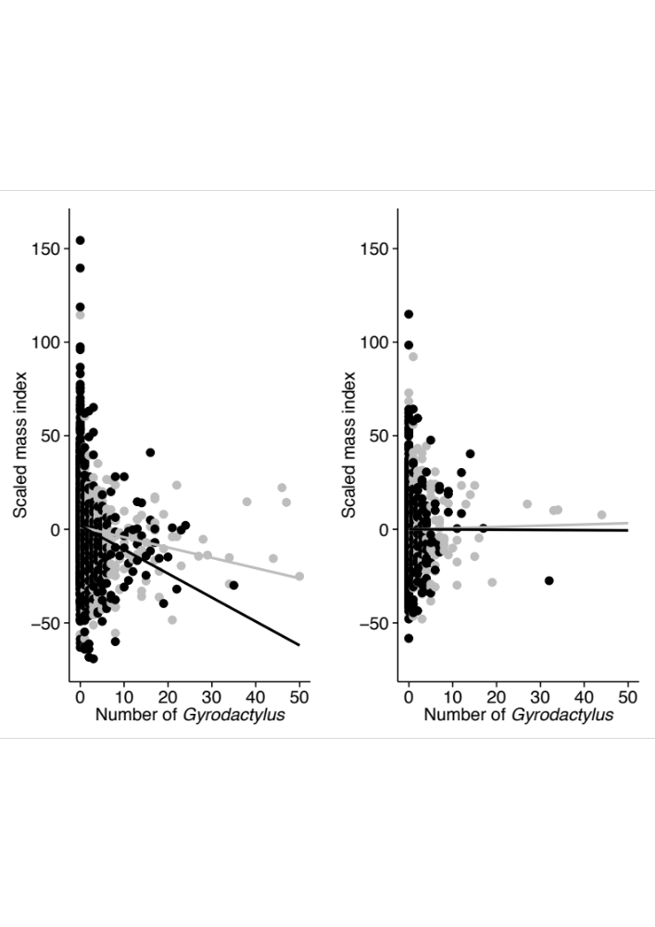

Fig. S1 Among infected and uninfected fish in our sample, and exclusively in lower course, high predation populations (left panel), Gyrodactylus infection load was negatively correlated with body condition and this effect was more pronounced in males (black) than females (grey). There was no correlation, nor difference between the sexes, among guppies from upper course, low predation populations (right panel).

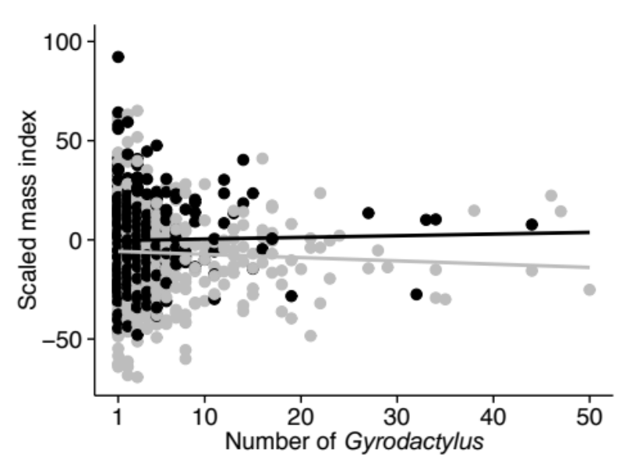
Fig. S2 Among the infected fish in our sample, there was no correlation between the number of Gyrodactylus they were infected with, and their condition. Additionally, there was no difference in this correlation between fish from the upper courses (in black) and those from the lower courses (in grey).

References

[1] Reznick, D.N., Shaw, F.H., Rodd, F.H. & Shaw, R.G. 1997 Evaluation of the rate of evolution in natural populations of guppies (Poecilia reticulata). Science 275, 1934-1937.
[2] Magurran, A.E. 2005 Evolutionary ecology: the Trinidadian guppy. New York, Oxford Univeristy Press.
[3] Bolker, B., Brooks, M.E., Clark, C.J., Geange, S.W., Poulsen, J.R., Stevens, M.H.H. & White, J.-S.S. 2009 Generalized linear mixed models: a practical guide for ecology and evolution. Trends in Ecology and Evolution 24, 127-135.
[4] Cable, J. & van Oosterhout, C. 2007 The impact of parasites on the life history evolution of guppies (Poecilia reticulata): The effects of host size on parasite virulence. Int. J. Parasitol. 37, 1449-1458.

Table S1: Summary of the dataset

Drainage | River | Course | Site | Years Sampled | UTM (20P) |  | Sample size | Gyrodactylus prevalence | Gyrodactylus mean intensity
 |  |  |  |  | GPS E | GPS N | Sample size | Gyrodactylus prevalence | Gyrodactylus mean intensity
Caroni | Arima | Lower | 1 | 2006 | 689982 | 1173762 | 50 | 0 | -
Caroni | Arima | Lower | 2 | 2003 | 689016 | 1176837 | 53 | 0.84 | 6.69
Caroni | Arima | Upper |  | 2003 | 687672 | 1178320 | 64 | 0.14 | 2.44
Caroni | Aripo | Lower |  | 2003, 06, 08 | 694410 | 1177783 | 291 | 0.40 | 5.44
Caroni | Aripo | Upper | 1 | 2006, 08 | 694030 | 1182128 | 73 | 0.08 | 1.00
Caroni | Aripo | Upper | 2 | 2008 | 692771 | 1182303 | 30 | 0.38 | 3.90
Caroni | Aripo | Upper | 3 | 2006, 08 | 693230 | 1182328 | 145 | 0.67 | 1.10
Caroni | Aripo | Upper | 4 | 2006 | 693221 | 1181917 | 56 | 0.07 | 2.64
Caroni | Aripo | Upper | 5 | 2003 | 693277 | 1181843 | 4 | 0.00 | -
Caroni | Aripo | Upper | 6 | 2003 | ? | ? | 56 | 0.50 | 1.54
Caroni | Aripo | Upper | 7 | 2003 | ? | ? | 24 | 0.43 | 2.50
Caroni | Aripo | Upper | 8 | 2003 | 693277 | 1181843 | 102 | 0.62 | 3.29
Caroni | Aripo | Upper | 9 | 2006 | 693823 | 1180613 | 48 | 0.02 | 2.00
Caroni | Caura | Lower |  | 2003 | 678436 | 1177236 | 227 | 0.00 | -
Caroni | Caura | Upper | 1 | 2003, 04 | 699539 | 1182054 | 153 | 0.24 | 1.81
Caroni | Caura | Upper | 2 | 2003 | 679627 | 1182692 | 110 | 0.00 | -
Caroni | Caura | Upper | 3 | 2003 | 679757 | 1182475 | 77 | 0.19 | 1.47
Caroni | Dyke | Lower | 1 | 2003, 04, 06 | 674748 | 1177894 | 92 | 0.10 | 26.56
Caroni | Dyke | Lower | 2 | 2003, 06 | 675080 | 1177892 | 184 | 0.61 | 4.71
Caroni | Dyke | Lower | 3 | 2003, 04 | 674869 | 1177433 | 177 | 0.21 | 1.81
Caroni | Guanapo | Lower |  | 2003, 04, 06 | 691385 | 1174569 | 232 | 0.23 | 2.68
Caroni | Guanapo | Upper |  | 2003 | 690247 | 1182015 | 91 | 0.11 | 1.80
Caroni | Lopinot | Lower |  | 2003, 04, 06 | 683553 | 1175663 | 453 | 0.60 | 5.00
Caroni | Lopinot | Upper |  | 2003, 04, 06 | 683520 | 1182443 | 187 | 0.38 | 2.80
Caroni | Maracas | Upper |  | 2003 | 671265 | 1183604 | 145 | 0.44 | 9.05
Coffee | Coffee | Lower |  | 2009 | 651072 | 1132467 | 41 | 0.00 | -
Cunupia | Dyke | Lower | 1 | 2006 | 678485 | 1168663 | 22 | 0.23 | 1.00
Cunupia | Dyke | Lower | 2 | 2006 | 673445 | 1165676 | 50 | 0.02 | 1.00
Guapo | Guapo | Lower | 1 | 2006 | 646956 | 1124820 | 1 | 1.00 | 5.00
Guapo | Guapo | Lower | 2 | 2006 | 646609 | 1125009 | 10 | 0.80 | 1.63
La Seiva | La Seiva | Lower |  | 2006 | ? | ? | 61 | 0.08 | 1.40
Lizard | Lizard | Lower |  | 2004 | 715789 | 1122959 | 12 | 0.00 | -
Marianne | Marianne | Lower |  | 2003, 04 | 685890 | 1193642 | 70 | 0.71 | 3.10
Marianne | Marianne |  | 2 | 2006 | ? | ? | 31 | 0.00 | -
Marianne | Marianne | Upper |  | 2003, 04 | 685891 | 1192747 | 171 | 0.13 | 1.59
Matura | Matura | Lower |  | 2006 | 713012 | 1181533 | 49 | 0.39 | 1.47
Mayaro | Pilote | Lower |  | 2004 | 711697 | 1121927 | 16 | 0.00 | -
Mayaro | Tributary | Lower | 1 | 2006 | 719160 | 1138112 | 20 | 1.00 | 10.50
Mayaro | Tributary | Lower | 2 | 2006 | 719153 | 1137295 | 20 | 0.95 | 16.89
Nariva | Manzanilla | Lower |  | 2006 | ? | ? | 3 | 1.00 | 1.33
North East | Toco | Lower |  | 2006 | 727327 | 1198431 | 3 | 0.00 | -
Oropuche | Oropuche | Lower |  | 2006 | ? | ? | 45 | 0.60 | 1.85
Oropuche | Oropuche | Upper |  | 2006 | ? | ? | 52 | 0.67 | 2.46
Oropuche | Turure | Lower |  | 2003, 04 | 700333 | 1178556 | 158 | 0.22 | 1.47
Oropuche | Turure | Upper | 1 | 2003 | ? | ? | 56 | 0.00 | -
Oropuche | Turure | Upper | 2 | 2006 | 700442 | 1183253 | 16 | 0.00 | -
Oropuche | Turure | Upper | 3 | 2003, 04 | 700494 | 1180614 | 91 | 0.00 | -
Oropuche | Visigney | Lower |  | 2009 | 650110 | 1129992 | 28 | 0.11 | 1.00
Silverstream | Silverstream | Lower |  | 2006 | 657517 | 1129995 | 25 | 0.00 | -
Silverstream |  | Upper |  | 2009 | 649751 | 1127459 | 42 | 0.02 | 1.00
Yarra | Yarra | Lower |  | 2003 | 680414 | 1194065 | 58 | 0.52 | 2.07
Yarra |  | Upper |  | 2004, 06 | 683427 | 1189518 | 59 | 0.14 | 2.63
TOTAL |  |  |  |  |  |  | 2998

