Time-Resolved Twisting Dynamics in a Porphyrin Dimer Characterized by Two-Dimensional Electronic Spectroscopy
Franco V. A. Camargo,^{1,3} Harry L. Anderson,² Stephen R. Meech¹ and Ismael A. Heisler^{1,*}
¹School of Chemistry, Norwich Research Park, University of East Anglia, Norwich NR4 7TJ, United Kingdom
²Department of Chemistry, University of Oxford, Chemistry Research Laboratory, Oxford OX1 3TA, United Kingdom
³CAPES Foundation, Ministry of Education of Brazil, Brasilia - DF 70040-202, Brazil

*Corresponding author. Email: i.heisler@uea.ac.uk, phone: +44 01603 591880.

Abstract
Molecular conformational changes in electronic excited states play a key role in numerous light-activated processes. In the case of porphyrin oligomers intramolecular twisting influences energy and charge transport dynamics. Here we address the twisting reaction in both ground and excited states in a model porphyrin dimer, employing two-dimensional electronic spectroscopy (2D ES). By spreading the information over excitation and detection frequencies, cross-peaks reveal the twisting reaction both in the ground and excited states unambiguously and distinctly from other dynamics. A quasi-barrierless planarization reaction is observed in the excited state on a tens of picosecond (ps) time-scale. This is accompanied by a spectral narrowing, indicative of a reduction in conformational disorder. The reverse reaction is suppressed in the excited state due to a steep activation energy barrier. However in the ground state the barrier is within the thermal energy distribution and therefore contributions from reverse and forward reactions could be observed on the sub-nanosecond time-scale. Crucially 2D ES enables simultaneous assessment of ground and excited state reactions through analysis of different spectral regions on the 2D spectral maps.
Keywords: Chromophore, Reaction, Nonlinear Spectroscopy, Ultrafast Dynamics, Global Analysis.

I. Introduction
Conjugated molecular structures composed of porphyrin chromophores are of great interest in a wide range of applications.¹⁻⁴ These include: novel optical materials for improved solar cells; nanowires for molecular electronics; photosensitizers for photodynamic therapy.^{1, 5-6} In particular, newly synthesized conjugated molecular structures that mimic artificial light harvesting complexes have recently attracted great interest.⁷ Specifically, butadiyne-linked porphyrin nanorings, composed of up to 40 units, show ultrafast excitation delocalization related to electronic coupling and high structural order.⁸⁻⁹ Key to the exploitation of porphyrin nanorings is a full understanding of the electronic delocalization process and how it is affected by molecular conformational changes.¹⁰⁻¹¹ The study of ultrafast conformational or structural dynamics per se is very important as it plays a significant role in many fundamental molecular reactions such as photo-isomerization processes - which underlies the early events in vision - and, as shown more recently, in the dynamics of light-driven molecular motors able to convert light into mechanical energy through excited-state reactions.¹²⁻¹³
Butadiyne-linked porphyrin oligomers show inter-porphyrin conjugation, which is apparent in the large red shift of their lowest singlet absorption band (Q-band).¹⁴ However, the electronic coupling is significantly affected by the dihedral angle between the porphyrin macrocycles. The maximum coupling (largest red shift) occurs when the rings are co-planar.¹⁴ Previous investigations found that there exists a continuous distribution of dihedral angles, indicating that the butadiyne-linker provides a low energy barrier to rotation of the porphyrin rings. ¹⁵ Important unresolved questions related to the twisting dynamics, such as its rate and activation energy in excited and ground electronic states are addressed below.
2D spectroscopy is a powerful tool for the investigation of chemical exchange, including conformational reactions.¹⁶ So far, this technique has been applied to study structural dynamics mainly in the IR region¹⁶⁻¹⁷ but also very recently to study photochemical dynamics in the visible region.¹⁸⁻¹⁹ Further examples include a phase-modulation fluorescence approach to 2D electronic spectroscopy, which was used to characterize the exciton coupling of a porphyrin dimer as a function of its conformation.²⁰⁻²¹ In this work we combine 2D ES and time-resolved transient absorption to a model butadiyne-linked porphyrin dimer. This allows us to fully dissect its twisting dynamics in excited and ground electronic states. 2D ES, an optical analog to 2D NMR, can be described as a third order nonlinear optical signal dependent on two time delays (described in detail elsewhere).²²⁻²³ Importantly, 2D ES provides correlations between excitation and detection frequencies, and is thus ideally suited to observing molecular dynamics on excited and ground state potential energy surfaces. Consequently, torsional dynamics can be isolated from other dynamical effects and the rate constants of forward and reverse reactions can be determined.¹⁷
II. Experimental Methods
The detailed description of our 2D experimental setup has been presented before.²³ Briefly, the light source was a commercial amplified laser system plus a noncollinear parametric amplifier (NOPA). The pulses were recompressed close to the Fourier transform limit at the sample position and were characterized by transient grating frequency resolved optical gating (TG-FROG) using a 1 mm fused silica window. The 2D setup is based on a scheme using two beamsplitters to generate the four phase coherent beams located on the corners of a 2.5 cm square. During the measurements, the coherence time was scanned in the range from −150 fs to 150 fs in steps of 4 fs. The transient absorption measurements were performed with the same setup by blocking beams 1 and 3 and using the LO beam as the probe beam.
The porphyrin chromophore structure is shown in Figure 1a and was synthesized as reported previously.²⁴ The porphyrin dimer was dissolved in pentane with a concentration of 50 µM for a 1 mm pathlength static cell producing an OD around 0.3. In order to avoid aggregation, 1 % vol pyridine was added to the solution. Measurements were also done by circulating the solution in a flow cell system, which had a pathlength of 200 µm and a porphyrin concentration of 250 µM; the results were identical to those in the 1 mm pathlength cell. The advantage of working with smaller pathlengths is the suppression of contributions from the solvent, but greater dilution in longer pathlength cells reduces the possibility of aggregation; no evidence of aggregation was observed even for the highest concentrations studied.
III. Results and Discussion
The porphyrin dimer structure is shown in Figure 1a and the corresponding visible to near UV absorption spectrum is shown in Figure S1 (supplementary material); the strongest absorption band (at 22000 cm⁻¹) corresponds to the Soret band and the broad high energy band (above 27000 cm⁻¹) is usually known as N-band.²⁵ Figure 1b presents the absorption spectrum focusing on the Q-band region. Previous studies suggested that this comprises absorption of both the planar (0º) and fully twisted (90º) conformers of the dimer at 740 nm (13513 cm⁻¹) and 669 nm (14948 cm⁻¹), respectively.¹⁵ Further contributions to the linear absorption spectrum are due to vibronic transitions that appear as shoulders at 720 nm (13884 cm⁻¹) - due to a 380 cm⁻¹ mode strongly coupled to the Q-band transition - plus weaker contributions at 698 nm (14333 cm⁻¹) and 673 nm (14863 cm⁻¹).²⁶
A series of absorptive (real part of the sum of rephasing and nonrephasing contributions)²⁷ 2D ES spectra is shown in Figure 2a covering population times from 0.1 to 600 ps. At early population times the amplitude of the 2D spectrum is concentrated along the diagonal. Cross peaks are also clearly present at the earliest measured population time (50 fs) as shown more clearly in Figure S2. Through careful analysis of the oscillatory behavior, as a function of population time, the origin of these cross peaks can be identified as due to vibronic transitions with frequencies (marked on Figure S2) at 380 cm⁻¹ (CR_{A}), 820 cm⁻¹ (CR_{B}) and 1350 cm⁻¹ (CR_{C}). The vibronically related cross peaks are present throughout all later population times, although their amplitude (apart from that of CR_{A} that appears at lower detection frequencies) is weak and the oscillations are fully decayed by 1.2 ps (Figure S2).
The two strongly absorbing features, marked by shaded rectangles in Figure 1b, are assigned to planar (lower frequency, red shade) and twisted (higher frequency, blue shade) conformations, where the latter has also an underlying vibronic shoulder contribution. However, conformers with different dihedral angles are excited and detected over a broad frequency region as shown by the absorbance at intermediate frequencies and by the stretched diagonal amplitude distribution at early times in the 2D ES (Figures 1 and 2), which will be discussed in detail below. In Figure 2a the positive signals (red color) correspond to ground-state bleaching (GSB) and/or stimulated emission (SE) whereas the negative (blue color) correspond to excited state absorption (ESA). The ESA contribution arises from broad Q-band to N-band transitions (Figure S1). Strikingly, at early times, apart from weak vibronic cross-peaks between high and low energy bands (Figure S2), there are no significant features below and above the diagonal, indicating a distribution of independent transitions associated with a range of torsional angles. If these transitions shared a common ground state cross-peaks would necessarily appear at early population times.²⁸
As shown in Figure 2a, the stretched diagonal amplitude distribution at early times evolves into a broad structure over a period of 600 ps. A significant amplitude increase is seen in the spectral region below diagonal and less so in the spectral region above diagonal. In what follows we will show that the main mechanism accounting for such a spectral reshaping has to do with the porphyrin dimer twisting reaction. But first we need to discuss how the 2D spectral evolution can account for an equilibrium twisting reaction. This requires the laser electric field interaction with the molecular transition dipole moment to be tracked, which is best represented by Feynman diagrams.²⁸ Figure S3a presents a (non-exhaustive) list of eight Feynman diagrams, which is sufficient to describe the dynamics of the twisting reaction observed in this work. Figure S3b presents a cartoon showing the corresponding positions on a 2D map of where the Feynman diagrams will contribute. The diagonal contributions A and B (Figure S3a and b) are described by Feynman diagrams where the excitation and detection frequencies are degenerate, meaning that no reaction occurs during population time (T – the time constants are defined in Figure S3c). However off diagonal contributions C and D (Figure S3a and b) are described by Feynman diagrams where during the population time (T) a reaction from planar (twisted) to twisted (planar) occurred, meaning that a planar (twisted) conformation is excited during coherence time (τ) and a twisted (planar) conformation is detected during the last time period (t). It is important to notice that the Feynman diagrams always appear in pairs: one describing the bleach, or ground state population, evolution (also called the ground state hole),²⁹ and another describing the stimulated emission, or excited state population, evolution. The effect of the ultrashort laser pulse is to create a perturbation in the ground and excited population distribution, which then relaxes back to thermal equilibrium. Given a small enough perturbation to the system (linear response), the fluctuation-dissipation theorem dictates that the non-equilibrium perturbation will relax back with the same dynamics as equilibrium thermal fluctuations. Thus, cross-peaks below the diagonal (high frequency excitation/low frequency detection) correspond to a twisted to planar reaction (twisted conformations absorb at higher excitation frequencies than planar conformations). In contrast, cross-peaks above the diagonal are related to the opposite (planar to twisted, energetically uphill) reaction. Viewing the data over the 600 ps population time recorded here, the twisted to planar reaction dominates the 2D signal. However, the reverse reaction is also clearly resolved, as indicated by the appearance of amplitude above diagonal, most evident for population times longer than 100 ps. Further illustration of this effect can be captured by plotting the amplitude obtained by integrating a 150 cm⁻¹ x 150 cm⁻¹ square area of the 2D spectra for a specific excitation-detection region selected to capture the forward or reverse reactions as a function of population time. Shown in Figure 2b and c are the curves obtained for the squares marked as A and B in Figure 2a. The amplitude evolution of the integral of square A (Figure 2b) shows a slow rise which could be fitted mainly to a rising exponential function with a time constant of 250 ps (the full fit comprised of a further 3 ps rising component plus a slow decay of 1.5 ns, see below). Even though this is the region where the planar to twisted reaction dynamics is captured, the fitted time constant corresponds to the total reaction rate constant, i. e., the sum of the forward and reverse reaction rates. Figure 2c shows the amplitude evolution of the integral of square B where a significant rising amplitude over the first 100 ps is apparent. This curve could be fit mainly to a rising exponential function with a time constant of 62 ps (plus 3 ps rising component and decay of 1.5 ns). This spectral position corresponds to the twisted to planar reaction. Given that, as mentioned above this time constant corresponds to the total reaction rate, the question arises as to why regions above and below diagonal produce different reaction rates. As will be shown below, the reason for this is that the spectral region below diagonal (in our specific case) reports mainly on the one way twisted to planar excited state reaction whereas the spectral region above diagonal reports on the ground state twisting reaction. However, due to the fact that multiple excitation-detection frequencies are measured simultaneously and coherently, isolated pairs of frequencies should not be analyzed independently by single fits, but rather the whole 2D spectrum should be fit globally to a single relaxation model.
In order to quantify the temporal evolution of the complete series of 2D spectra a global analysis procedure was applied to the data.³⁰ In this analysis, population time dependent curves for all the different pairs of excitation-detection frequencies are fitted simultaneously to a parallel decaying scheme consisting of five exponential terms. The recovered fits are the 2D decay-associated spectra (2D-DAS) where for each exponential time constant the corresponding pre-exponential factors generate one 2D-DAS.³⁰ The quality of the fit for a selection of excitation-detection frequency pairs is shown in Figure S4. To further validate our fitting procedure we also obtained the evolution associated spectra (2D-EAS), shown in Figure S5. The model for 2D-EAS assumes a sequential decay mechanism and is obtained by a matrix operation performed on the previously obtained 2D-DAS.³¹⁻³² Even though ultimately this might not be the correct relaxation mechanism, it provides an intuitive visualization of the 2D spectral evolution.
The fastest component resolved with a time constant around 100 fs, accounts for the subpicosecond spectral diffusion dynamics induced by the solvent reorganization (solvation), which in this study was pentane, a nonpolar low viscosity solvent (η = 0.21 cP at 25º C). This fast contribution is not relevant to the torsional dynamics and is not discussed further. The other four 2D-DAS describe slower porphyrin dimer population dynamics. Recovered time constants were 2.7 ps, 62 ps, 250 ps and 1.5 ns. The pre-exponential factors (2D-DAS maps) associated with these four time constants are shown in Figure 3.
The longest contribution of 1.5 ns (2D-DAS 4, Figure 3) is dominated by a positive amplitude with the cross-peak regions fully formed. This indicates that solvation and conformational dynamics are mostly relaxed and 2D-DAS 4 is assigned to population relaxation of the first singlet excited state with relaxation time 1.5 ns; this compares well with the 1.2 ns porphyrin dimer fluorescence lifetime reported in literature.¹⁵ The remaining 2D-DAS are assigned to conformational dynamics as discussed next.
The fastest contribution of τ = 2.7 ps (2D-DAS 1, Figure 3), shows significant negative amplitude both above and below the diagonal, in a region where the 2D spectra have positive amplitude (Figure 3); the negative amplitude corresponds to a rising component. In contrast, along the diagonal this 2D-DAS is positive, corresponding to a decaying population contribution. This indicates a broadening in the overall 2D spectra on the picosecond time-scale, which can be quantified by determining the width of the antidiagonal cut with time. An example of this antidiagonal broadening is shown in Figure S6. Further evidence is provided by the calculated 2D-EAS. The main spectral reshaping in the evolution of 2D-EAS 1 into 2D-EAS 2, on a 2.7 ps timescale, is given by an antidiagonal spectral broadening (Figure S5). The symmetric broadening revealed in 2D-DAS 1 is reminiscent of spectral diffusion. However, the associated time constant is too long to be assigned to solvent (pentane) induced spectral diffusion. On the other hand, such a time constant corresponds to a frequency of around 12 cm⁻¹ which we speculate could be associated with an overdamped oscillation of a torsional motion. Torsional vibrations about a single bond typically have very low frequencies as reported, for example, for substituted anthracenes and biaryls (23 to 190 cm⁻¹).³³ Given that the porphyrin dimer studied here is much heavier when compared to biaryls, the torsional frequency is expected to be smaller and heavily damped in solution. Another possibility is that the origin of this 2D-DAS contribution is an excited state driven conformational restructuring involving relatively small-scale changes in molecular structure, leading to a spectral broadening on the picosecond timescale. However to fully explain the origin of this contribution further detailed calculations of the dimer intramolecular dynamics will be required.
The next component with a time constant of τ = 62 ps (2D-DAS 2, Figure3) is assigned to the twisted to planar reaction. Significant decay all along the diagonal and a rising signal below it indicate planarization of the dimer. Any excitation above 13600 cm⁻¹ is detected mainly in the lowest frequency region around 13700 cm⁻¹ (dashed line L1, Figure 3) while for excitations around 14950 cm⁻¹ a signal is detected over a broad region extending from 14700 cm⁻¹ to 13200 cm⁻¹ (dashed line L2, Figure 3). This spectral reshaping is quite evident in the evolution of 2D-EAS 2 into 2D-EAS 3, on a 62 ps timescale, where the main modification is given by the appearance of amplitude below the diagonal (indicated by a blue arrow in Figure S5). A further effect produced by this spectral reshaping is a spectral narrowing and shift towards lower frequencies, indicative of the relaxation of conformational disorder (Figure S7). The 62 ps time constant of 2D-DAS 2 represents a contribution which is too long to be assigned to solvent induced spectral diffusion, considering the low viscosity and polarity of pentane. On the other hand, the early 2D spectra (Figure 2a, 0.1 ps) clearly reveal a distribution of absorbing frequencies along the diagonal. This shows that these transitions correspond to a distribution of structures with different absorption frequencies. An alternative explanation for the spectral reshaping in 2D-EAS 2 to 3 is energy transfer from high to low frequency absorbing states, which could in principle account for a rising lower diagonal cross-peak. However, the 50 µM concentration used here, is too low for a diffusion controlled process to account for the picosecond risetime. Intermolecular energy transfer in aggregates can also be discarded because aggregation is suppressed in the solutions studied by addition of a small amount of pyridine (≈1 vol%).¹⁵ A distribution of dimeric structures with different dihedral angles with angle related transition energy readily explains the early population time diagonally stretched 2D spectra, while the twisting reaction between structures with differing angles can explain the rising cross-peaks.
Further, the twisting reaction revealed by 2D-DAS 2 can be can be assigned specifically to an excited state reaction. This is supported by time-resolved transient absorption (discussed below) and fluorescence measurements (reported by Anderson et al) as well as by calculations.^{15, 34} Winters et al carried out quantum mechanical calculations to determine the ground and excited potential energy surfaces (PES) as a function of porphyrin dimer torsion angle. ¹⁵ Figure 4 presents an energy level scheme based on the calculated PES and on our experimental findings. The ground-state energies were obtained for several torsion angles between 0° and 90°, whereas the first singlet excited state PES was inferred through excitation energies of the planar and twisted conformers. The calculations indicate that the ground state PES exhibits a low barrier for rotation (~kT) and should thus have a broad distribution of dihedral angles at room temperature. This is consistent with our 2D spectra at early times which show an extended distribution of frequencies along the diagonal (Figure 2a, 0.1 ps spectrum). In contrast, the barrier for rotation from a planar towards a twisted conformation in the excited state is calculated to be about six times higher (~6kT). In order to check for any barrier impeding the planarization rotation in the excited state, we performed transient absorption temperature dependent measurements and generated the Arrhenius plot shown in Figure S8a. The activation energy obtained is E_{a} = 2.36 kcal/mol. However, an Arrhenius plot for pentane viscosity over the same temperature range produces an activation energy E_{a} = 1.74 kcal/mol (Figure S8b). Therefore the effective planarization reaction activation energy in the excited stated is given by E_{a} = 0.62 kcal/mol (~kT), which is within the thermal energy range. Therefore, the twisted to planar conformational relaxation occurs on a quasi-barrierless PES in the excited state whereas the reverse reaction is strongly suppressed due to a high energy barrier. This is in accordance with our experimental 2D spectra where the lower diagonal rising cross peak exposed by 2D-DAS 2 can be unequivocally assigned to an energetically downhill quasi-barrierless twisting reaction and the absence (on a 100 ps timescale) of above diagonal rising cross-peaks indicates that the reverse reaction is strongly suppressed.
The final component with a time constant of τ = 250 ps (2D-DAS 3, Figure 3) shows an altogether different picture. The main signal is comprised of positive contributions at low and high detection frequencies whereas a significant negative contribution appears in the intermediate detection region, from 14250 cm⁻¹ to 14900 cm⁻¹, highlighted in Figure 3 by dashed lines. Rising cross peaks appear both above and below the diagonal. This indicates that both forward and reverse reactions are happening on this time-scale. Further, the broad negative contribution which also covers the intermediate diagonal frequency region points to significant twisting dynamics between neighboring angles on this time-scale. Importantly, as discussed above, the excited state reaction is a planarization reaction and therefore contributes no signal for the above diagonal spectral region. Consequently, this spectral region offers an ideal, background free, probe for the ground state reaction. The lower diagonal cross peak in 2D-DAS 3 (CR_{T->P}, Figure 3) shows a rising contribution due to the twisted to planar reaction whereas the above diagonal rising component (Figure 3, CR_{P->T}) corresponds to the reverse, i.e., planar to twisted, reaction. Further, the ground state reaction is very clearly captured in the spectral reshaping that is observed in the evolution of 2D-EAS 3 into 2D-EAS 4, on a 250 ps timescale, where the most significant modification is given by the appearance of amplitude in the above diagonal spectral region (as highlighted by green arrow in Figure S5).
In the ground state both forward and reverse reactions are allowed and therefore the time constant associated with 2D-DAS 3 (250 ps) corresponds to the total rate constant. As described above, in the ground state, the torsional barrier is calculated to be ca. kT, therefore, this component can be assigned to the re-equilibration of a distribution of dimers with different dihedral angles, perturbed by electronic excitation to the long lived excited state. The equilibrium constant for this distribution was recently measured experimentally to be K_{eq} = 2.33.³⁵ The equilibrium constant is related to the forward and reverse reaction rates through K_{eq} = k_{f} / k_{r}, where k_{f} and k_{r} are the forward and reverse reaction rates, respectively. Further, by knowing the total reaction rate, k_{t} = k_{f} + k_{r} = (250 ps)⁻¹, it is possible to determine the time constants τ_{f} = 357 ps and τ_{r} = 832 ps, inversely related to the forward and reverse reaction rates respectively.
Further support for the ground and excited state twisting reactions, identified in the 2D spectra, was obtained from transient absorption spectra shown in Figure S9 for times ranging from 1 to 600 ps. A clear isosbestic point is visible at 14920 cm⁻¹, pointing to population interconversion. The main features exposed by this sequence of spectra are: ESA decay (around 15450 cm⁻¹) on a sub 100 ps timescale; spectral narrowing of the GSB/SE signal in the 14000 to 15000 cm⁻¹ region; GSB/SE (around 13750 cm⁻¹) signal increasing on a 100 ps timescale followed by a bi-exponential relaxation. All these features can be rationalized in terms of the previously discussed 2D spectra and the schematic PES (shown in Figure 4). The ESA corresponds to twisted Q-band to N-band transition at 645 nm (15500 cm⁻¹). This ESA disappears with a time constant equivalent to the twisting reaction, whereas SE appears due population of the long lived (1.5 ns) planar Q-band, consistent with the increasingly negative signal around 727 nm (13750 cm⁻¹). At the same time, there is a narrowing of the transient absorption spectrum due to planarization of the dimer (disorder relaxation). We also applied global analysis to these data;³⁰ the resulting DAS are shown in Figure S9b. The recovered time constants are very similar to those obtained for 2D–DAS. The first two DAS (2.7 ps and 67 ps) show a progressive decay of the ESA, a rising GSB/SE in the region of planar conformation absorption (13750 cm⁻¹) and a GSB/SE decay in the intermediate spectral region (14000 to 15000 cm⁻¹). The DAS associated with the 250 ps time constant is negative in the GSB/SE region of the planar absorption conformation and slightly positive in the twisted conformer’s absorption region. This is consistent with the assignment of 2D-DAS 3 to the twisting reaction in the ground state.
IV Conclusion
In summary, a porphyrin dimer twisting reaction was studied in detail by time-resolved 2D ES and transient absorption spectroscopy. Based on the analysis of the experimental results described in this work it is possible to conclude that the studied porphyrin dimer is driven towards planarization over a quasi-barrierless energy potential in the excited state and, therefore, the twisting reaction shows a high rate of (62 ps)⁻¹ in pentane. Due to a high-energy barrier, the reverse reaction (twisted to planar) is highly suppressed in the excited state. However, in the ground state the energy barrier between twisted and planar conformations of the porphyrin dimer is within the thermal energy distribution and, therefore, forward and reverse reactions are expected to occur. Those were determined as k_{f} = (357 ps)⁻¹ and k_{r} = (832 ps)⁻¹ for the forward and reverse reaction rates, respectively, significantly lower when compared to the excited planarization reaction. In this work, the use of 2D ES was crucial to access simultaneously both ground and excited state reactions, enabled by the analysis of different spectral regions on the 2D ES spectral maps. Given the fact that the excited state twisting pathway is energetically forbidden, it was possible to isolate ground state pathways above the diagonal directly related to the twisting reaction. Whereas for the spectral region below diagonal, ground and excited state contributions could be isolated due to their distinct timescales and due to the high signal over noise achieved experimentally.

Acknowledgments
This work was supported by EPSRC grants EP/J009148/1 and J021431/1. FVAC is supported by Brazilian Funding Agency CAPES doctoral studentship (BEX 9527/13-3). We would like to thank Dr Valentyn Prokhorenko for kindly providing Matlab routines for Global Analysis 2D - DAS calculation and Dr Siarhei Laptenok for the 2D - EAS calculation routines and Dmitry V. Kondratuk for preparing the sample of porphyrin dimer used in this work.

Supporting Information
Additional figures including: UV-Vis absorption, vibrational contributions to 2D signal, extra global analysis results, antidiagonal FWHM plot, transient absorption data, Arrhenius plots, integral over excitation curve comparison and Feynman diagrams. This information can be found free of charge on the internet at http://pubs.acs.org.

Figure Captions
Figure 1. (a) Porphyrin dimer structure where R = hexyl and Ar = 3,5-bis(octyloxy)phenyl. (b) Q-band region linear absorption spectrum of the porphyrin dimer in pentane containing 1% pyridine at 298 K. The red (blue) shaded area highlights the spectral where planar (twisted) conformations are expected to absorb.
Figure 2. (a) 2D ES evolution, where scales correspond to excitation (${\tilde{ν}}_{1}$) and detection (${\tilde{ν}}_{3}$) wavenumber. Each 2D plot is normalized to its maximum and the amplitude (z axis) has 21 evenly spaced contour lines. Population time is indicated by red numbers and the top panels show the linear absorption (blue line) and the laser (red line) spectra. (b) and (c) show the population time dependence of the amplitude (obtained by integrating a 150 cm⁻¹ x 150 cm⁻¹ square area) of marked regions A and B in (a), respectively.
Figure 3. 2D-DAS maps associated with exponential time constants. The amplitude color scheme is analogous to Figure 2a. The color scheme ranges in the following way: 2D-DAS 1=> −0.3 (blue) to +0.3 (red); 2D-DAS 2 => −0.57 (blue) to +0.57 (red); 2D-DAS 3 => −0.53 (blue) to +0.53 (red); 2D-DAS 4 => −1.1 (blue) to +1.1 (red).
Figure 4. Schematic representation of the porphyrin dimer potential energy surface (PES) as a function of the twisting coordinate. The constants $k_{R}^{e}$and $k_{R}^{g}$ represent the excited state and ground state twisting reaction rates respectively. In the excited state, due to a high energy barrier, only the planarization reaction is observed whereas in the ground state forward and reverse reactions are detected.

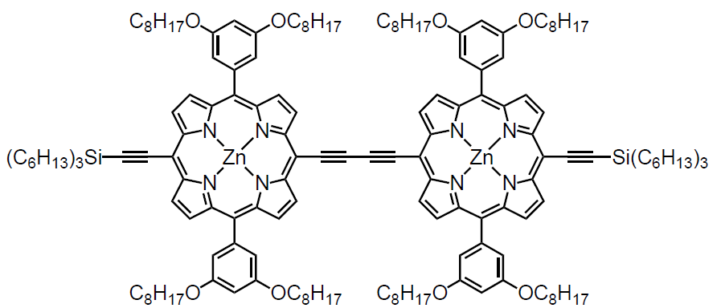
(a)
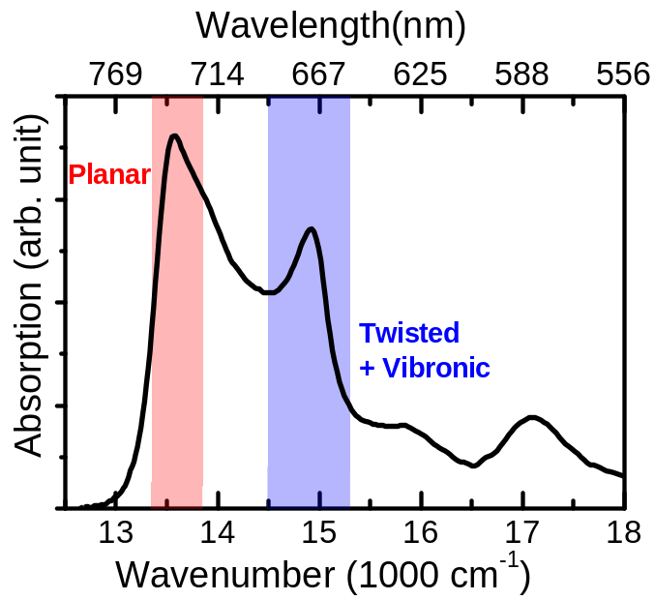
(b)
Figure 1

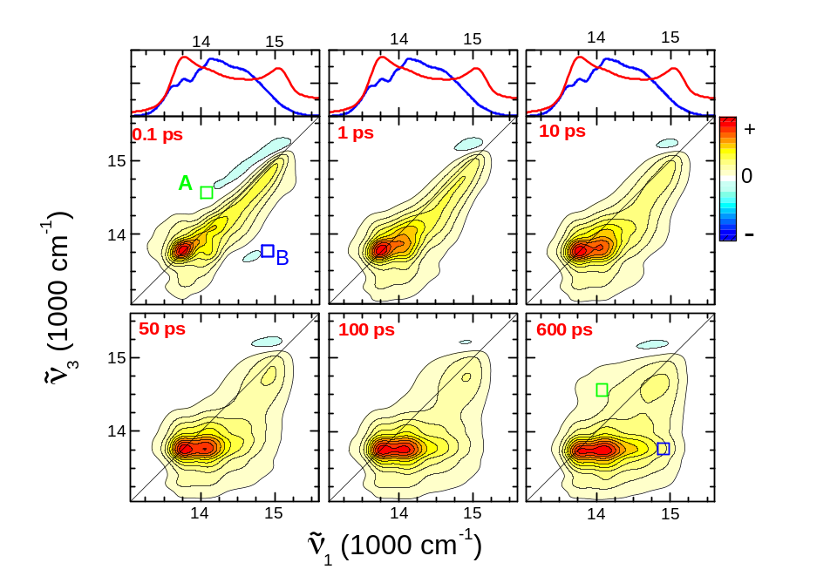
(a)
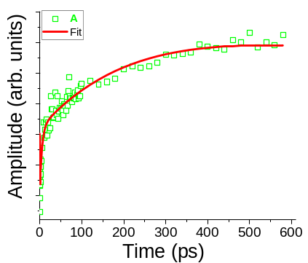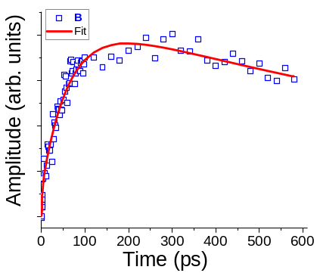
(b) (c)
Figure 2

Figure 3

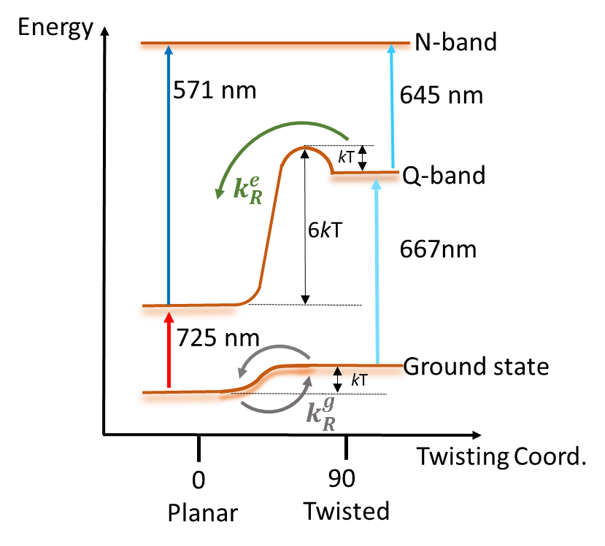
Figure 4

References
(1) Woller, J. G.; Hannestad, J. K.; Albinsson, B. Self-Assembled Nanoscale DNA-Porphyrin Complex for Artificial Light Harvesting. J. Am. Chem. Soc. 2013, 135, 2759-2768.
(2) Aratani, N.; Kim, D.; Osuka, A. Discrete Cyclic Porphyrin Arrays as Artificial Light-Harvesting Antenna. Acc. Chem. Res. 2009, 42, 1922-1934.
(3) Anderson, H. L. Building Molecular Wires from the Colours of Life: Conjugated Porphyrin Oligomers. Chem. Commun. 1999, 23, 2323-2330.
(4) Marder, S. R.; Kippelen, B.; Jen, A. K. Y.; Peyghambarian, N. Design and Synthesis of Chromophores and Polymers for Electro-Optic and Photorefractive Applications. Nature 1997, 388, 845-851.
(5) Facchetti, A. pi-Conjugated Polymers for Organic Electronics and Photovoltaic Cell Applications. Chem. Mater. 2011, 23, 733-758.
(6) Sedghi, G.; Garcia-Suarez, V. M.; Esdaile, L. J.; Anderson, H. L.; Lambert, C. J.; Martin, S.; Bethell, D.; Higgins, S. J.; Elliott, M.; Bennett, N. et al. Long-Range Electron Tunnelling in Oligo-Porphyrin Molecular Wires. Nat. Nanotechnol. 2011, 6, 517-523.
(7) Yong, C. K.; Parkinson, P.; Kondratuk, D. V.; Chen, W. H.; Stannard, A.; Summerfield, A.; Sprafke, J. K.; O'Sullivan, M. C.; Beton, P. H.; Anderson, H. L.; et al. Ultrafast Delocalization of Excitation in Synthetic Light-Harvesting Nanorings. Chem. Sci. 2015, 6, 181-189.
(8) Parkinson, P.; Knappke, C. E. I.; Kamonsutthipaijit, N.; Sirithip, K.; Matichak, J. D.; Anderson, H. L.; Herz, L. M. Ultrafast Energy Transfer in Biomimetic Multistrand Nanorings. J. Am. Chem. Soc. 2014, 136, 8217-8220.
(9) Parkinson, P.; Kondratuk, D. V.; Menelaou, C.; Gong, J. Q.; Anderson, H. L.; Herz, L. M. Chromophores in Molecular Nanorings: When Is a Ring a Ring? J. Phys. Chem. Lett. 2014, 5, 4356-4361.
(10) Chang, M. H.; Hoffmann, M.; Anderson, H. L.; Herz, L. M. Dynamics of Excited-State Conformational Relaxation and Electronic Delocalization in Conjugated Porphyrin Oligomers. J. Am. Chem. Soc. 2008, 130, 10171-10178.
(11) Ramanan, C.; Gruber, J. M.; Maly, P.; Negretti, M.; Novoderezhkin, V.; Kruger, T. P. J.; Mancal, T.; Croce, R.; van Grondelle, R. The Role of Exciton Delocalization in the Major Photosynthetic Light-Harvesting Antenna of Plants. Biophys. J. 2015, 108, 1047-1056.
(12) Conyard, J.; Addison, K.; Heisler, I. A.; Cnossen, A.; Browne, W. R.; Feringa, B. L.; Meech, S. R. Ultrafast Dynamics in the Power Stroke of a Molecular Rotary Motor. Nature Chem. 2012, 4, 547-551.
(13) Polli, D.; Rivalta, I.; Nenov, A.; Weingart, O.; Garavelli, M.; Cerullo, G. Tracking the Primary Photoconversion Events in Rhodopsins by Ultrafast Optical Spectroscopy. Photochem. Photobiol. Sci. 2015, 14, 213-228.
(14) Anderson, H. L. Conjugated Porphyrin Ladders. Inorg. Chem. 1994, 33, 972-981.
(15) Winters, M. U.; Karnbratt, J.; Eng, M.; Wilson, C. J.; Anderson, H. L.; Albinsson, B. Photophysics of a Butadiyne-Linked Porphyrin Dimer: Influence of Conformational Flexibility in the Ground and First Singlet Excited State. J. Phys. Chem. C 2007, 111, 7192-7199.
(16) Fayer, M. D. Dynamics of Liquids, Molecules, and Proteins Measured with Ultrafast 2D IR Vibrational Echo Chemical Exchange Spectroscopy. Annu. Rev. Phys. Chem. 2009, 60, 21-38.
(17) Anna, J. M.; Baiz, C. R.; Ross, M. R.; McCanne, R.; Kubarych, K. J. Ultrafast Equilibrium and Non-Equilibrium Chemical Reaction Dynamics Probed with Multidimensional Infrared Spectroscopy. Int. Rev. Phys. Chem. 2012, 31, 367-419.
(18) Ruetzel, S.; Diekmann, M.; Nuernberger, P.; Walter, C.; Engels, B.; Brixner, T. Multidimensional Spectroscopy of Photoreactivity. Proc. Natl. Acad. Sci. U. S. A. 2014, 111, 4764-4769.
(19) Nuernberger, P.; Ruetzel, S.; Brixner, T. Multidimensional Electronic Spectroscopy of Photochemical Reactions. Angew. Chem. 2015, 54, 11368-11386.
(20) Lott, G. A.; Perdomo-Ortiz, A.; Utterback, J. K.; Widom, J. R.; Aspuru-Guzik, A.; Marcus, A. H. Conformation of Self-Assembled Porphyrin Dimers in Liposome Vesicles by Phase-Modulation 2D Fluorescence Spectroscopy. Proc. Natl. Acad. Sci. U. S. A. 2011, 108, 16521-16526.
(21) Widom, J. R.; Lee, W.; Perdomo-Ortiz, A.; Rappoport, D.; Molinski, T. F.; Aspuru-Guzik, A.; Marcus, A. H. Temperature-Dependent Conformations of a Membrane Supported Zinc Porphyrin Tweezer by 2D Fluorescence Spectroscopy. J. Phys. Chem. A 2013, 117, 6171-6184.
(22) Brixner, T.; Mancal, T.; Stiopkin, I. V.; Fleming, G. R. Phase-Stabilized Two-Dimensional Electronic Spectroscopy. J. Chem. Phys. 2004, 121, 4221-4236.
(23) Heisler, I. A.; Moca, R.; Camargo, F. V. A.; Meech, S. R. Two-Dimensional Electronic Spectroscopy Based on Conventional Optics and Fast Dual Chopper Data Acquisition. Rev. Sci. Instrum. 2014, 85, 063103.
(24) Koszelewski, D.; Nowak-Krol, A.; Drobizhev, M.; Wilson, C. J.; Haley, J. E.; Cooper, T. M.; Romiszewski, J.; Gorecka, E.; Anderson, H. L.; Rebane, A.; et al. Synthesis and Linear and Nonlinear Optical Properties of Low-Melting pi-Extended Porphyrins. J. Mater. Chem. C 2013, 1, 2044-2053.
(25) Drobizhev, M.; Stepanenko, Y.; Dzenis, Y.; Karotki, A.; Rebane, A.; Taylor, P. N.; Anderson, H. L. Extremely Strong Near-IR Two-Photon Absorption in Conjugated Porphyrin Dimers: Quantitative Description with Three-Essential-States Model. J. Phys. Chem. B 2005, 109, 7223-7236.
(26) Camargo, F. V. A.; Anderson, H. L.; Meech, S. R.; Heisler, I. A. Full Characterization of Vibrational Coherence in a Porphyrin Chromophore by Two-Dimensional Electronic Spectroscopy. J. Phys. Chem. A 2015, 119, 95-101.
(27) Hybl, J. D.; Albrecht, A. W.; Faeder, S. M. G.; Jonas, D. M. Two-Dimensional Electronic Spectroscopy. Chem. Phys. Lett. 1998, 297, 307-313.
(28) Hamm, P.; Zanni, M., Concepts And Methods Of 2D Infrared Spectroscopy. Cambridge University Press: Cambridge, 2011.
(29) Loring, R. F.; Yan, Y. J.; Mukamel, S. Time-Resolved Fluorescence and Hole-Burning Line-Shapes of Solvated Molecules - Longitudinal Dielectric-Relaxation and Vibrational Dynamics. J. Chem. Phys. 1987, 87, 5840-5857.
(30) Prokhorenko, V. I. Global Analysis of Multi-Dimensional Experimental Data. EPA Newsletter 2012, 21-23.
(31) Ostroumov, E. E.; Mulvaney, R. M.; Anna, J. M.; Cogdell, R. J.; Scholes, G. D. Energy Transfer Pathways in Light-Harvesting Complexes of Purple Bacteria as Revealed by Global Kinetic Analysis of Two-Dimensional Transient Spectra. J. Phys. Chem. B 2013, 117, 11349-11362.
(32) van Stokkum, I. H. M.; Larsen, D. S.; van Grondelle, R. Global and Target Analysis of Time-Resolved Spectra. Biochimica Et Biophysica Acta-Bioenergetics 2004, 1657, 82-104.
(33) Werst, D. W.; Gentry, W. R.; Barbara, P. F. The S0 and S1 Torsional Potentials of 9-Phenylanthracene. J. Phys. Chem. 1985, 89, 729-732.
(34) Kumble, R.; Palese, S.; Lin, V. S. Y.; Therien, M. J.; Hochstrasser, R. M. Ultrafast Dynamics of Highly Conjugated Porphyrin Arrays. J. Am. Chem. Soc. 1998, 120, 11489-11498.
(35) Peeks, M. D.; Neuhaus, P.; Anderson, H. L. Experimental and Computational Evaluation of the Barrier to Torsional Rotation in a Butadiyne-Linked Porphyrin Dimer. Submitted 2015.

TOC graphics
