Supporting Information
Time-Resolved Twisting Dynamics in a Porphyrin Dimer Characterized by Two-Dimensional Electronic Spectroscopy
Franco V. A. Camargo,^{1,3} Harry L. Anderson,² Stephen R. Meech¹ and Ismael A. Heisler^{1,*}
¹School of Chemistry, Norwich Research Park, University of East Anglia, Norwich NR4 7TJ, United Kingdom
²Department of Chemistry, University of Oxford, Chemistry Research Laboratory, Oxford OX1 3TA, United Kingdom
³CAPES Foundation, Ministry of Education of Brazil, Brasilia - DF 70040-202, Brazil

Table of Contents
Figure S1 Porphyrin dimer linear absorption spectrum S2
Figure S2 2D spectrum plus vibrational oscillations S3
Figure S3 Feynman diagrams S4
Figure S4 Comparison between measured data and fit S5
Figure S5 2D – EAS maps associated with exponential time constants S6
Figure S6 Antidiagonal cut full width at half maximum S7
Figure S7 Comparison of curves obtained by integrating 2D maps over excitation S8
Figure S8 Arrhenius plots S9
Figure S9 Time-resolved transient absorption spectra plus DAS S10

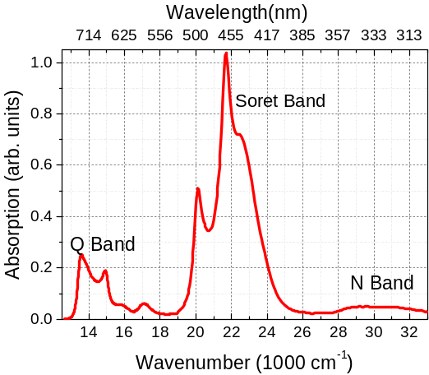
Figure S1. UV-Vis linear absorption spectrum of the porphyrin structure shown in Figure 1(a) in the manuscript. This was recorded in pentane containing 1% pyridine at 298 K. The labels show the assignment to known electronic transitions.

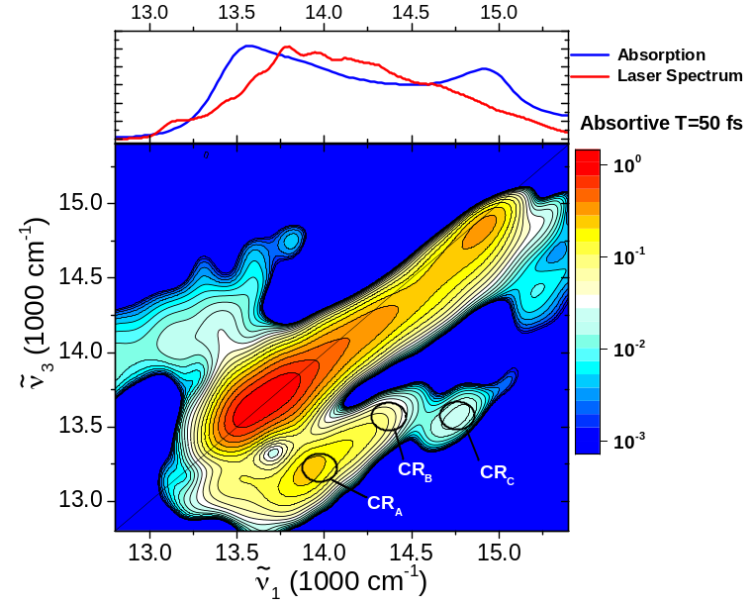
(a)
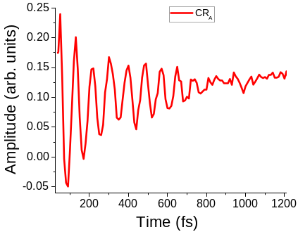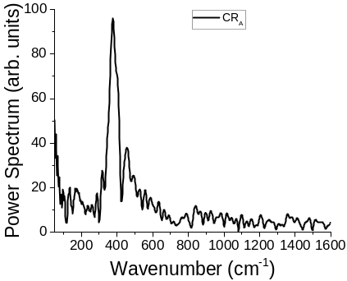
(b) (c)
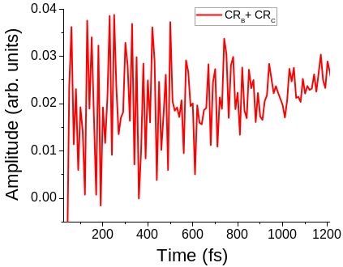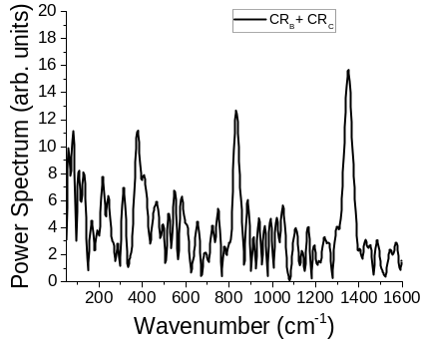
(d) (e)
Figure S2. Vibrational contributions to 2D spectra. (a) T = 50fs 2D ES spectrum with z scale shown in log₁₀ scale in order to highlight low amplitude contributions. Main vibronic contributions appear as cross peaks marked by CR_{A} ($\tilde{ν}$= 380 cm⁻¹), CR_{B} ($\tilde{ν}$= 820 cm⁻¹) and CR_{c} ($\tilde{ν}$= 1350 cm⁻¹). (b) Amplitude temporal evolution of cross peak A (CR_{A}) and the corresponding power spectrum (c) where the main contribution is a peak at 380 cm⁻¹. (d) Same as (b) for cross peaks B and C with power spectrum shown in (d) where contributions at 380 cm⁻¹, 820 cm⁻¹ and 1350 cm⁻¹ can be clearly observed.

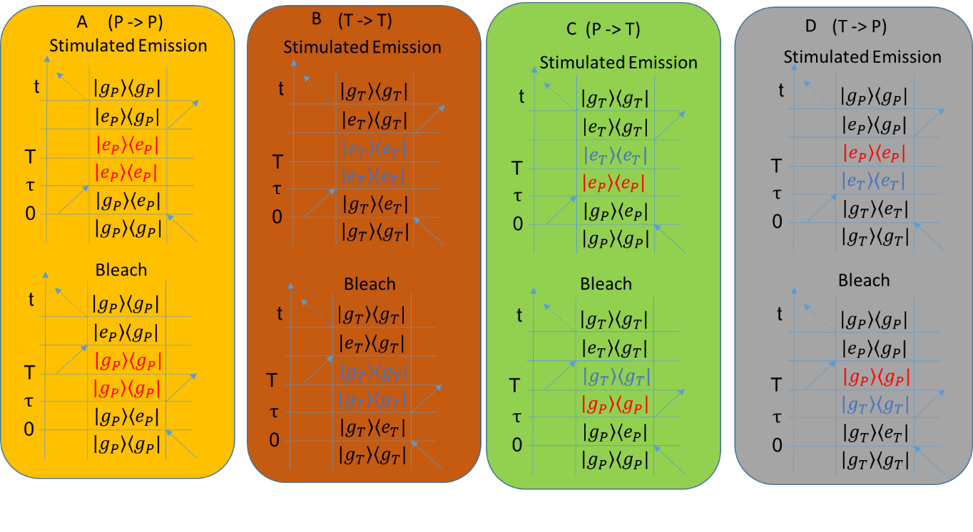
(a)

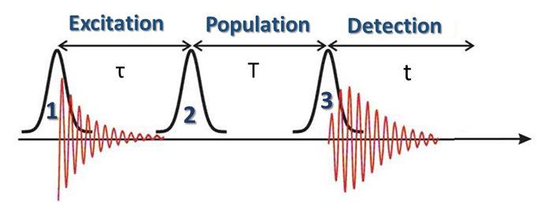
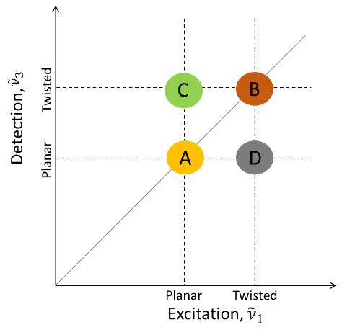
(b) (c)

Figure S3. (a) Feynman diagrams describing twisting reaction. (b) Cartoon illustrating the position of Feynman diagrams listed in (a) as a function of excitation and detection frequencies. In (b) the symbol P->T (for example) means that the Planar conformation turns into a Twisted conformation for those Feynman diagrams. (c) Delay time definition.

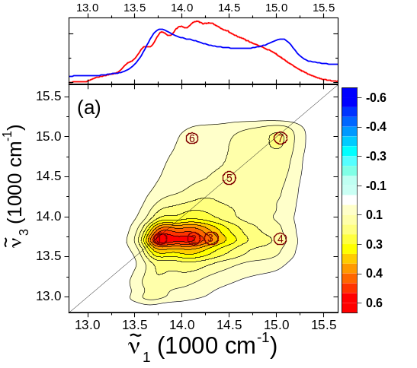
(b)
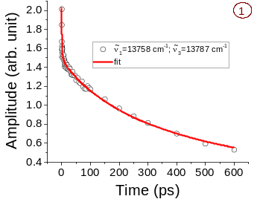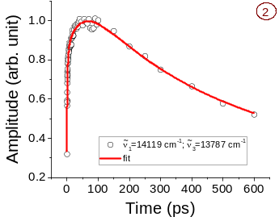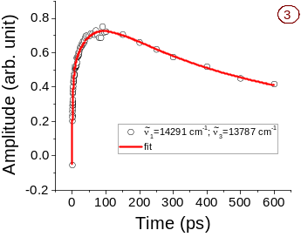
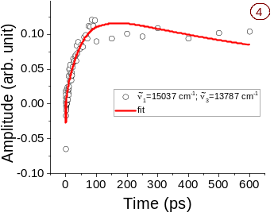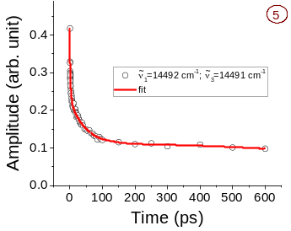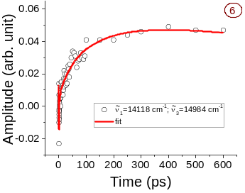
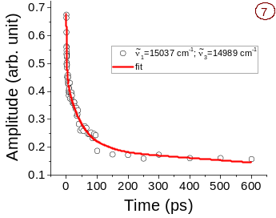
Figure S4. (a) The 2DES spectrum measured for porphyrin dimer in pentane, recorded in pentane containing 1% pyridine at 298 K, for a population time T = 100 ps. Top panels show the absorption (blue line) and the laser (red line) spectra. (b) Comparison between measured data and fit (obtained by global analysis) for specific excitation-detection points numbered 1 to 7 in (a).

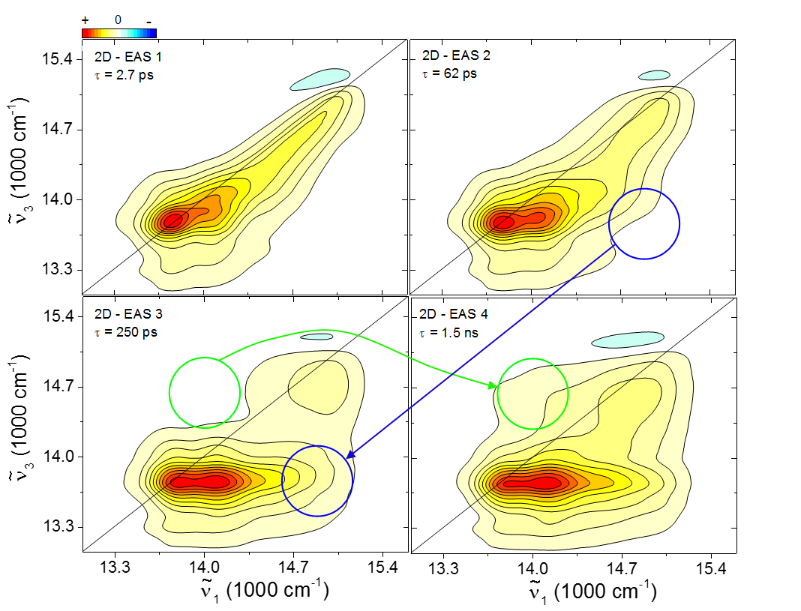
Figure S5. 2D – EAS maps associated with exponential time constants obtained from a matrix operation on the 2D - DAS. The amplitude (z axis) has 21 evenly spaced contour lines and the color scheme ranges in the following way: 2D – EAS 1=> −1.7 (blue) to +1.7 (red); 2D – EAS 2 => −1.6 (blue) to +1.6 (red); 2D – EAS 3 => −1.4 (blue) to +1.4 (red); 2D – EAS 4 => −0.85 (blue) to +0.85 (red). The blue (green) arrow highlights the appearance of amplitude in a region were the twisted to planar (planar to twisted) reaction is expected.

Figure S6. (a) Full Width at Half Maximum (FWHM) obtained by fitting the antidiagonal cuts through 2D spectra up to T = 4ps. Each point on the graph is obtained through the procedure shown on graphs (b) and (c), exemplified for the 4ps point. Graph (b) shows the 2D spectrum for a population time equal to T = 4 ps and where the antidiagonal cut is located. Graph (c) shows the antidiagonal cut (black circles) and the corresponding fit (red line) from which the FWHM Is extracted.
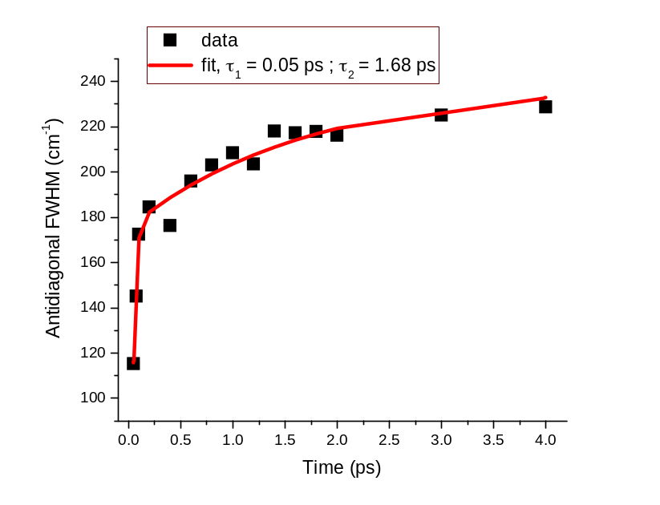
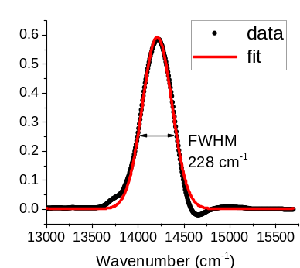
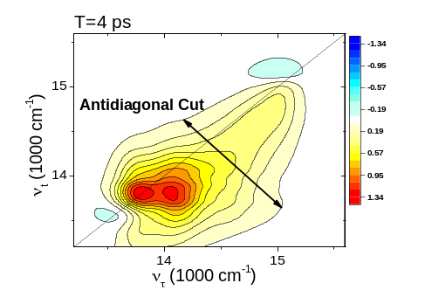
(a)
(b)
(c)

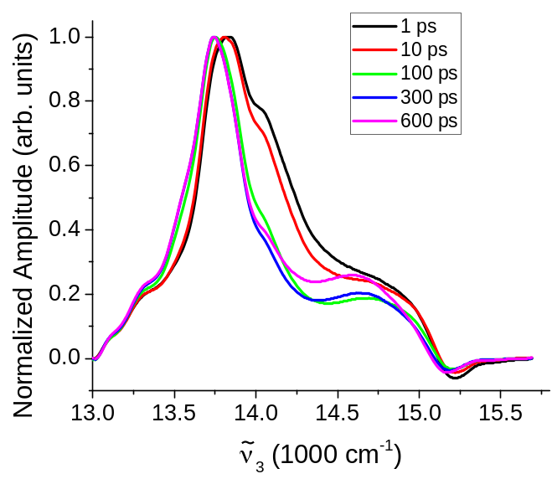
Figure S7. Integral over excitation axis of 2D spectra for population times T = 1, 10, 100, 300 and 600 ps. There is a clear spectral narrowing and slight shift towards lower frequencies.

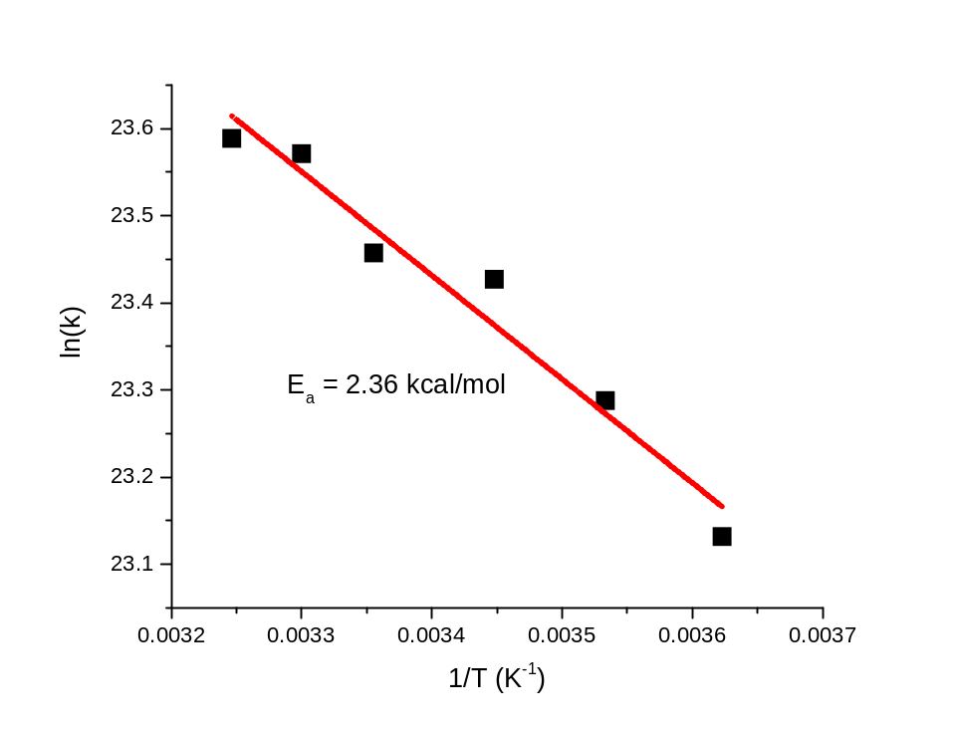
(a)
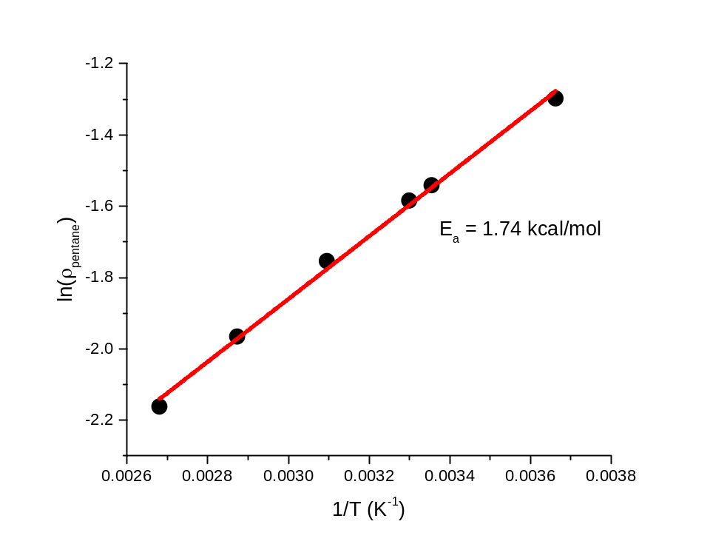
(b)
Figure S8. (a) Arrhenius plot obtained for the excited state reaction rate constant, which was obtained from the pump-probe measurements. (b) Arrhenius plot for pentane viscosity. The temperature dependent viscosity values where obtained from NIST webbook (webbook.nist.gov)

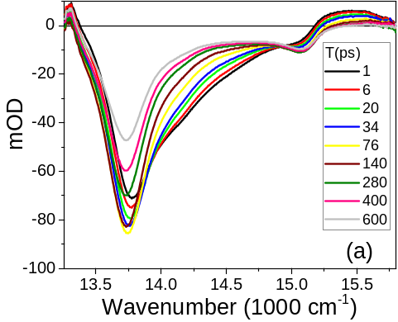
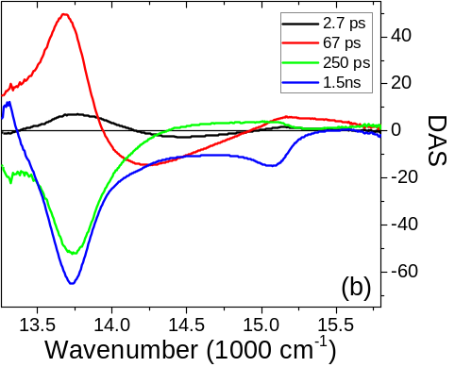
Figure S9. (a) Time-resolved transient absorption spectra. (b) DAS after global analysis of transient absorption spectra.

