Dibotermin alfa is a cost-effective substitute for autologous iliac crest bone graft in single level lumbar interbody spine fusion

This is an original research article.

Axel Svedbom^{1,2}, Daniel Paech¹, Catherine Leonard³, David Donnell⁴, Fujian Song⁵, Bronek Boszcyk⁶, Dominique A. Rothenfluh⁷, Andrew Lloyd⁸, Benny Borgman⁹
- Mapi, Level 6, Hus D, Klarabergsviadukten 90, Stockholm, 11164, Sweden
- Unit of Dermatology and Venereology, Department of Medicine, Karolinska Institute, 171 76 Stockholm, Sweden
- Medtronic Ltd, Building 9, Croxley Green Business Park, Watford, WD18 8WW, UK
- Medtronic BioPharma B.V., Earl Bakkenstraat 10, 6422 PJ Heerlen, Netherlands
- Norwich Medical School, University of East Anglia, Norwich, Norfolk, NR4 7TJ, UK
- Nottingham University Hospital, Centre for Spinal Studies and Surgery, D Floor, West Block, Queens Medical Centre, Derby Road, Nottingham, NG7 2UH, UK
- Nuffield Orthopaedic Centre, Oxford University Hospitals NHS Trust, Windmill Rd., Oxford, OX3 7HE, UK
- Bladon Associates Ltd., 3 Kings Meadow, Oxford OX2 0DB, UK.
- Medtronic International Trading SARL, Route du Molliau 31, CP 1131 Tolochenaz, Switzerland

Corresponding author:
Mr. Axel Svedbom
Mapi, Klarabergsviadukten 90, Hus D
111 64, Stockholm, Sweden
Phone: +46 731 506 046
E-mail: axel.svedbom@mapigroup.com

Key words: rhBMP-2, bone morphogenetic protein-2, ICBG, spinal fusion, autograft, lumbar arthrodesis, health utility

Short title
The cost-effectiveness of dibotermin alfa for use in spinal fusion
Abstract

Objectives
To evaluate the cost-effectiveness of dibotermin alfa compared with autologous iliac crest bone graft (ICBG) for patients undergoing single level lumbar interbody spinal fusion in a UK hospital setting.

Methods
An individual patient data (IPD) meta-analysis of six randomised controlled clinical trials and two single arm trials compared dibotermin alfa on an absorbable collagen implantation matrix (ACIM) (n=456) and ICBG (n=244) on resource use, re-operation rates, and SF-6D (Short form 6-dimension) health utility (total N=700). Failure-related second surgery, operating time, post-operative hospital stay, and quality-adjusted life years (QALYs) derived from the IPD meta-analysis were included as inputs in an economic evaluation undertaken to assess the cost-effectiveness of dibotermin alfa/ACIM versus ICBG for patients undergoing single level lumbar interbody spinal fusion fusion. A four year time horizon and the United Kingdom (UK) National Health Service (NHS) and Personal Social Services (PSS) perspective was adopted in the base case, with sensitivity analyses performed to gauge parameter uncertainty.

Results
In the base case analysis, patients treated using dibotermin alfa/ACIM (12 mg pack) accrued 0.055 incremental QALYs at an incremental cost of £737, compared with patients treated with ICBG. This resulted in an Incremental Cost-Effectiveness Ratio (ICER) of £13,523, indicating that at a willingness-to-pay threshold of £20,000, dibotermin alfa/ACIM is a cost-effective intervention relative to ICBG from the NHS and PSS perspective.

Conclusions
In a UK hospital setting, dibotermin alfa/ACIM is a cost-effective substitute for ICBG for patients who require lumbar interbody arthrodesis.
INTRODUCTION
Age-related degeneration of the spinal intervertebral discs can result in deterioration of their composition and operation, resulting in low back pain. Persistent low back pain is associated with impairment of physical and mental health and is a significant economic burden¹. In the UK, the direct health costs of back pain were estimated to be £1.6 billion in 1998². However, the addition of informal care and employment-related costs substantially increases the estimated total cost of back pain (range from £6.6 billion to £12.3 billion), and it is one of the most costly diseases for which an economic assessment has been conducted in the UK².

Conservative approaches to treating disc degeneration include physical therapy, chiropractic therapy and pharmaceutical therapy (e.g. anti-inflammatories and pain medication). If pain persists despite conservative therapy, surgical approaches such as spinal fusion may be considered³. Fusion of the vertebrae of the affected lumbar segment prevents motion and thereby reduces pain. Bone growth at the fusion site is facilitated with bone grafts or substitutes, which may be bone harvested from the patient undergoing the procedure (autograft, usually from the iliac crest), bone from another individual (allograft), or synthetic alternatives. Autologous iliac crest bone graft (ICBG) is considered the gold standard⁴. However, harvesting ICBG can result in pain and complications related to the donor site⁵, with infection, seroma, haematoma, postoperative pain, scar sensitivity, and meralgia paraesthetica all reported⁶. Additionally, some patients may have limited bone available for harvesting⁶. Consequently, alternatives to ICBG have been developed. In Europe, dibotermin alfa/ACIM (rhBMP-2; InductOs* implantation matrix, Medtronic BioPharma B.V.) is the only commercially available medicinal product licensed for use as a substitute for autogenous bone graft in the treatment of lumbar interbody fusion in adults with disc degeneration⁷.

Previously, the safety and efficacy of dibotermin alfa/ACIM had not been established with spinal implants other than the LT-CAGE* device, implantation at locations other than L4-S1 in the lower lumbar spine, and using surgical techniques other than anterior open or anterior laparoscopic approaches. However, In December 2014, the indication for dibotermin alfa/ACIM in lumbar interbody spinal fusion was broadened. Dibotermin alfa/ACIM is indicated for single-level lumbar interbody spine fusion (L1-S1) as a substitute for autogenous bone graft in adults with disc degeneration who have had at least six months of non-operative treatment for this condition using any approved interbody fusion device implanted using the appropriate surgical technique.

To date, economic evidence of lumbar interbody fusion using dibotermin alfa/ACIM compared with ICBG is limited, particularly in a European setting. A study performed in the US found that the cost of dibotermin alfa/ACIM may be entirely offset by reductions in the use of other medical resources^{8, 9}. An economic evaluation performed in the UK in 2007 found unfavourable cost-effectiveness of dibotermin alfa/ACIM compared with ICBG¹⁰.

Since the UK analysis¹⁰ was conducted, additional trials and pooled analyses have been conducted comparing dibotermin alfa/ACIM and ICBG. Two independent systematic reviews were published in 2013 examining the safety and effectiveness of dibotermin alfa/ACIM for spinal fusion based on individual patient data (IPD) from Medtronic sponsored trials and other published studies^{11, 12}. Although the reviews were comprehensive and methodologically rigorous, the research questions warranted the inclusion of a wide range of clinical trials, including some that used unlicensed investigational products (giving doses several times higher than the approved dose) and others that recruited patients outside of the currently approved indication for dibotermin alfa/ACIM (e.g. applying the product outside the lumbar spine). Therefore a need was identified for meta-analysis of all IPD derived from clinical trials relating to the safety and efficacy of the current dibotermin alfa/ACIM indication.

The results of the IPD meta-analysis, which were the evidentiary basis for the broadening of the indication for dibotermin alfa/ACIM, have instigated the need to re-evaluate the cost-effectiveness of dibotermin alfa/ACIM versus ICBG. The objective of this study was to utilise the findings of the IPD meta-analysis to estimate the cost-effectiveness of dibotermin alfa/ACIM compared with ICBG in patients undergoing single level lumbar interbody spinal fusion fusion.

MATERIAL AND METHODS
This economic evaluation is reported according to the Consolidated Health Economic Evaluation Reporting Standards (CHEERS) Statement¹³.

Meta-analysis
An IPD meta-analysis was undertaken comparing dibotermin alfa/ACIM and ICBG on resource use, re-operation rates, and SF-6D (Short form 6-dimension) health utility. Eligible studies were company-sponsored trials using dibotermin alfa/ACIM for single-level lumbar interbody fusion. There were no restrictions on surgical approach, lumbar segment treated, composition of interbody fusion device, dose of dibotermin alfa or pack size, technique used to harvest autograft bone, or the site of autograft harvest. All patients were 19–70 years of age and had symptomatic degenerative disc disease between L1 and S1. Prior to surgery, all had experienced low back pain for at least six months that was recalcitrant to nonoperative treatment modalities (such as physical therapy, bed rest, and anti-inflammatory medication). Patients were included in these studies if their plain radiographic findings documented single-level disc disease, and they had undergone at least one additional confirmatory neuroradiographic study, such as MRI, CT-enhanced myelography, or discography. All patients were considered candidates for a single-level lumbar interbody fusion. Minimum duration of follow up was 24 months. For all clinical studies, protocols were approved by an independent ethics committee, all patients provided written informed consent prior to study commencement, and studies were performed in accordance with the Declaration of Helsinki and other applicable regulatory requirements¹⁴.

A total of eight trials met the inclusion criteria for the IPD meta-analysis. Six comparative randomised controlled trials (RCTs) were included: 3100N3-117¹⁵, 3100N3-303¹⁶, C-9703¹⁷, C-9806¹⁸, P00-01¹⁹and C-9804 (data on file). This efficacy dataset (six RCTs) comprised 536 patients, including 292 patients receiving dibotermin alfa/ACIM and 244 receiving ICBG. Two additional studies of dibotermin alfa/ACIM (3100N3-304²⁰ and P01-07 (data on file)) were included in safety and supplementary efficacy analyses. Study 3100N3-304 was not included in the efficacy dataset because the comparator was a concurrent control taken from another study, and Study P01-07 was not included because there was no comparator. In total, the safety dataset (eight trials) comprised 700 patients, including 456 patients receiving dibotermin alfa/ACIM and 244 receiving ICBG.

The primary analysis dataset included all patients who received the study implants and completed surgical procedures. Primary statistical comparisons were based on the observed data, and missing data (due to lost-to follow-up or invalid radiographic assessments) were not imputed.

A two-stage approach ²¹ was used for all outcomes in the meta-analysis except health utility. In the two-stage analyses, first the effects of dibotermin alfa/ACIM compared with ICBG were estimated separately within each of the included trials, after which the results across trials were combined using random-effects meta-analysis²². Heterogeneity across individual trials was assessed using the I² and Q statistics²³. For health utility, linear mixed-effects models were used on the pooled IPD. The models compared outcomes in the intervention and control groups after adjusting for individual study effects, assuming random intercepts, fixed slopes, and heterogeneous residual variance across studies. The analyses were performed separately at 3, 6, 12 and 24 months follow-up. In addition, health utility analyses were stratified by (i) radiographic fusion status at two years; and (ii) failure related reoperation status at two years. Mean difference was the primary effect measure for continuously distributed outcomes, and for binary outcomes, odds ratio, risk ratio and risk difference were reported. Statistical tests were two-tailed, and considered statistically significant when the p value was less than 0.05. Stata/IC 13 was used to conduct statistical analyses.

Markov Model
A Markov model was developed in Microsoft Excel and Visual Basic Applications (VBA), which sought to estimate the cost-effectiveness of dibotermin alfa/ACIM relative to ICBG for patients who had at least six months of non-operative treatment and required a lumbar interbody spinal fusion fusion procedure. The model target patient population was aligned with the population included in the IPD meta-analysis and the indication for dibotermin alfa/ACIM. The mean (± standard deviation) age of patients included in the meta-analysis (all eight trials) was 43.4 ± 10.4 years and 43.3 ± 9.5 years for dibotermin alfa/ACIM and ICBG, respectively. The proportion of males was similar in each treatment (46.5% and 46.3% for dibotermin alfa/ACIM and ICBG, respectively).

The setting for the study was a United Kingdom (UK) hospital. For the base case analysis, the UK National Healthcare System (NHS) and Personal Social Services (PSS) perspective was adopted. The cost-effectiveness of dibotermin alfa/ACIM was also assessed from a societal perspective in sensitivity analysis, including indirect costs due to lost work productivity. The model cycle length was six months and the base case model time horizon was four years.

The primary outcome measure was cost per quality-adjusted life years (QALYs) gained. A two health state model structure was implemented. The improvements in health utility from baseline to two years for respective treatment were derived from the meta-analysis of SF-6D ²⁴ data, with extrapolation of health benefit beyond two years modelled. SF-6D was considered an appropriate measure of health utility as it is a generic, preference-based measure, as recommended by the National Institute of Health and Care Excellence²⁵. Beyond the meta-analysis period (two years), health utility for patients treated with dibotermin alfa/ACIM was assumed to remain constant. In the base case analysis, the health utility difference between dibotermin alfa/ACIM and ICBG was assumed to decline to zero over a period of two years (“the offset period”).

A four year base case time horizon was considered adequate to capture all relevant costs, the proportion of patients requiring a second surgery, and difference in health utility over time. It was assumed that patients were only re-operated once during the modelled time horizon, two years after their initial surgery. Costs and effects were discounted 3.5% per year for all patients, consistent with published guidelines²⁵. All costs are reported in 2014 pounds sterling (£).

Model inputs
Inputs derived from the IPD meta-analysis included operative parameters (operation time, post-operative hospital stay) (Table 1), failure-related second surgery (Table 3), the proportion of patients returning to work (Figure 1), and QALYs based on SF-6D (Figure 2).

The mean difference in operative time was 0.38 hours (approximately 23 minutes) (p<0.001), and the mean difference in post-operative hospital stay was 0.28 days (approximately 7 hours) (p=0.013), for patients treated with dibotermin alfa/ACIM versus ICBG (Table 1, six RCTs). The rate of failure-related secondary surgery at 24 months was 6.58% for dibotermin alfa/ACIM and 11.07% for ICBG (p=0.04; Table 2; all eight trials).

Of those who were classified as working prior to surgery, 83.5% of patients treated with dibotermin alfa/ACIM and 73.4% of ICBG patients returned to work within 24 months (RR [95% CI]: 1.14 [1.02 to 1.27]; p=0.02; Figure 1, six RCT). In the societal perspective analysis, the proportion of patients who did not return to work was multiplied by the average six monthly earnings in the UK to calculate the cost of lost productivity (i.e. the human capital approach)²⁶. After 24 months, the proportion of patients who returned to work was assumed to remain the same as at 24 months.

Based on only randomized trials, the mean difference in mean change in SF-6D at 24 months for patients treated with dibotermin alfa/ACIM versus ICBG was 0.027 (p=0.03; Figure 2, six RCT). Based on these SF-6D data, the difference in QALYs gained at 24 months between dibotermin alfa/ACIM and ICBG was 0.040 (p=0.06).

Unit costs
Resource use and unit costs were collected from publicly available sources and previously published literature (Table 3). The cost of dibotermin alfa/ACIM was £1,720 (excluding value added tax), with the price per 12 mg pack varied in sensitivity analyses. The surgical interventions had two additional cost components; the length of time in the operating room and the length of stay in hospital. The cost of one hour of operating room time was £1,125, as reported by the Information Services Division, Scotland²⁷. The cost of a hospital bed day was £308.50, based on the UK National Reference Cost for a revision procedure (HC03Z)²⁸.

A general cost for second surgery (£11,262) was obtained from the National Schedule of Reference Costs, based on code HRG03Z²⁹. Average six monthly earnings (£12,454) were calculated from the average weekly wages reported by the Office of National Statistics³⁰. In the base case, it was assumed that there were no other differences in costs related to the interventions. The effect of including outpatient visit costs (£2,796) for patients requiring a failure-related secondary surgery was evaluated in a sensitivity analysis.³¹

Model outcomes
The primary health outcome was the QALY. An incremental cost effectiveness ratio (ICER) was calculated as (Cost dibotermin alfa/ACIM - Cost ICBG) / (QALY dibotermin alfa/ACIM – QALY ICBG).
Sensitivity analyses

A probabilistic sensitivity analysis (PSA) was also conducted. The model was run 10,000 times as a Monte Carlo simulation, using randomly drawn sets of inputs. The possible inputs were defined by assigning a statistical distribution around the mean value of each parameter, reflecting the extent and nature of dispersion around the mean (Table 4). For each model run, values were sampled at random from each distribution, and the decision tree was rolled back to obtain a (cost, effectiveness) pair. Each pair is represented as a point plotted on the cost-effectiveness plane and results can be summarised using a cost-effective acceptability curve (CEAC). In addition to the base case analysis, several one-way sensitivity analyses were conducted to test the impact of parameter uncertainty on the model result (Table 5).

RESULTS
As demonstrated in the IPD meta-analysis, use of dibotermin alfa/ACIM was associated with less health care resource use compared with ICBG with respect to operating room time (Table 1), hospital bed days (Table 1), failure-related secondary surgeries (Table 1). In addition, dibotermin alfa/ACIM was associated with less blood loss than ICBG (Table 1), albeit this outcome was not incorporated into the model. A higher proportion of dibotermin alfa patients than ICBG patients had returned to work by 24 months (83.5% and 73.4%, respectively, Figure 1). The cost savings resulting over four years (£983) did not entirely offset the additional cost of dibotermin alfa/ACIM, as overall the dibotermin alfa/ACIM treatment strategy remained more expensive than ICBG (incremental cost £737). Patients treated with dibotermin alfa/ACIM achieved higher mean health utility following surgery relative to ICBG (Figure 2) and therefore over four years, accrued an additional 0.055 QALYs. These findings resulted in an incremental cost per QALY gained of £13,523.

Change in patient health utility following primary surgery is one of the key determinants of cost-effectiveness. QALY results stratified by radiographic fusion status and failure-related secondary surgery status at two years were investigated to provide additional insight into a probable link between clinical outcomes and health utility; albeit not incorporated cost-effectiveness model. The IPD meta-analysis showed that patients who experienced radiographic fusion on average accrued 0.112 additional QALYs over two years compared to patients who did not experience radiographic fusion (p<0.01; Figure 3). Similarly, patients who did not experience failure-related secondary surgery accrued 0.134 additional QALYs over two years compared to patients who experienced radiographic fusion (p<0.001; Figure 4).

The incremental cost-effectiveness ratios generated by each of the 10,000 PSA simulations are shown in Figure 5. Almost all simulations fell in the north eastern quadrant, indicating that with very low uncertainty, dibotermin alfa/ACIM is expected to be more expensive, but also more effective for patients in terms of QALYs, than ICBG. The CEAC is shown in Figure 6. The graph shows that there is a high probability of dibotermin alfa/ACIM being cost-effective when compared with ICBG for a willingness to pay interval above £15,000 per QALY gained. At a willingness-to-pay threshold of £20,000 per QALY gained, the probability that dibotermin alfa/ACIM was cost-effective was 71.8%.

One-way sensitivity analyses were performed to determine the change in cost per QALY after varying key inputs in the model (Table 5). Overall, the tornado diagram shows that the ICER remained stable while varying a range of inputs in deterministic sensitivity and scenario analyses (Figure 7). The result was most sensitive to the perspective of the evaluation; the health utility offset period and the cost of dibotermin alfa/ACIM. However, the ICER did not exceed £20,000 per QALY gained in any analysis. There was no change in the ICER when a 5 year time horizon was modelled.

DISCUSSION
This study estimated the cost-effectiveness of dibotermin alfa/ACIM compared with ICBG for single-level lumbar interbody spinal fusion in adults treated for disc degeneration in the UK. A new IPD meta-analysis showed that, compared with ICBG, patients treated with dibotermin alfa/ACIM experienced significantly shorter operative time and post-operative hospital stay, and at 24 months had a significantly lower rate of failure-related secondary surgery, and a significantly higher return to work rate. A Markov cohort model, populated with clinical and health utility data from the IPD meta-analysis and UK-specific cost data, showed that although the overall cost of lumbar interbody spinal fusion using dibotermin alfa/ACIM exceeded that of ICBG, patients treated with dibotermin alfa achieved higher health utility over the model time horizon. Based on these results, the base case ICER was below the commonly applied threshold range of £20,000 per QALY gained, indicating that dibotermin alfa/ACIM is cost-effective for use in lumbar interbody fusion in the UK.

The assumptions regarding change in patient health utility over time were considered conservative from a dibotermin alfa/ACIM cost-effectiveness perspective. Beyond two years, health utility for patients treated with dibotermin alfa/ACIM was assumed to remain constant, however, there is evidence showing a sustained increase in SF-6D score for patients over five years³². In addition, the base case analysis assumed the mean health utility in the ICBG arm increased to the same level as dibotermin alfa/ACIM over two years. This also appears conservative, given that a decrease in mean health utility was observed between 12 and 24 months for patients treated with ICBG in the IPD meta-analysis.

Change in patient health utility following primary surgery is one of the key determinants of cost-effectiveness. Evidence from the IPD meta-analysis showed that patients treated with dibotermin alfa/ACIM experienced higher health utility gains than patients treated with ICBG. These benefits may be driven by the lower failure related reoperation rates observed with dibotermin alfa/ACIM compared with ICBG in the IPD meta-analysis (Table 2). Another potential driver is the higher radiographic fusion rates observed with dibotermin alfa/ACIM compared with ICBG ³³. Meta-analysis of the six comparative RCTs included in this study showed that dibotermin alfa/ACIM was associated with a higher fusion success rate at 24 months post-surgery compared with ICBG³³: The odds ratio for fusion success with dibotermin alfa/ACIM compared to ICBG was estimated at 3.26 (95 % CI: 1.17, 9.08; p = 0.024) whereas the absolute difference in fusion success rate was estimated at 11.7 % (95 % CI: 8.0 %, 22.5 %; p = 0.035)³³. Radiographic fusion may result in improved health utility because it reduces the likelihood of the pain and disability associated with pseudarthrosis ³⁴. In this context it may be noted that the definition of radiographic fusion was stringent. Fusion was assessed using radiographs (CT scans). Fusion success required evidence of bridging trabeculae, no evidence of motion (<3-mm difference in translation and<5-degree difference in angular motion), and no evidence of radiolucency surrounding >50% of the interbody device. The notion that the differences in health utility between dibotermin alfa/ACIM and ICBG partially reflect differences in radiographic fusion and failure-related reoperation rates are provided in the analyses of health utility improvements from baseline stratified by those outcomes (Figure 3 and Figure 4).

The stability of the incremental cost per QALY (£13,523) was robust when tested in deterministic and probabilistic sensitivity analyses, with all ICERs below £20,000 per QALY gained (Figure 7). The ICER was most sensitive to the utility offset period assumption, with analyses showing no utility offset would increase the ICER to £19,356. Without an increase in the health utility offset period to three years, there was no change in the ICER for a 5 year time horizon, as all costs and effects were captured within four years. Analyses showed that a lower price of dibotermin alfa/ACIM would improve the cost-effectiveness, suggesting that a smaller pack size would improve the cost-effectiveness further, all else equal. The PSA indicated that dibotermin alfa/ACIM had a 88.9% chance of being cost-effective when the willingness to pay was £30,000 and 71.8% chance of being cost-effective at a willingness-to-pay threshold of £20,000 (Figure 6).

Indirect costs associated with absenteeism due to low back pain are known to be substantial, and improvements in employment levels following spinal surgery have been suggested to provide long-term economic benefits³⁵. When evaluated from a societal perspective, dibotermin alfa/ACIM provided incremental QALYs (0.055) at a cost differential of -£7,492 compared with ICBG, and was therefore the dominant treatment strategy. The cost savings were attributable to an increased proportion of patients who returned to work in the dibotermin alfa/ACIM group relative to the ICBG group, in combination with the faster return to work following surgery.

The findings of the present study differ from the previously conducted cost-effectiveness evaluation of dibotermin alfa/ACIM versus ICBG, which generated an ICER of approximately £120,000 per QALY gained¹⁰. That evaluation, however, was based on fewer clinical data, and a more restrictive dibotermin alfa/ACIM indication that relied on evidence from a single randomised clinical trial¹⁷. More comparative clinical and resource use data are now available from the current IPD meta-analysis, based on RCTs relevant to the current dibotermin alfa/ACIM indication. The current analysis showed a greater difference with respect to QALYs gained, secondary surgery rates related to treatment failure and resource use (length of hospital stay), favouring the dibotermin alfa/ACIM arm.

One strength of the present economic evaluation is the low level of uncertainty in the model, which is due to robust data (clinical, resource use, health-related quality of life, and cost). Few assumptions were required for the economic analysis, and dibotermin alfa/ACIM remained cost-effective compared with ICBG when key model parameters and assumptions were varied in sensitivity analyses. These are the best quality data available to date for the comparison of dibotermin alfa/ACIM and ICBG in lumbar interbody spinal fusion surgery, and incorporated into this new economic analysis the outcomes indicate that dibotermin alfa/ACIM is cost effective in a UK setting.

There were some limitations in the current analysis. It was assumed that there were no differences in other resources consumed related to the interventions. Potential differences may have existed with respect to the use of bone fillers, complication management, and physician care. Furthermore, no comparative data were available on health utility after two years of follow-up. Therefore the relative health utility trajectory for patients treated with dibotermin alfa/ACIM and ICBG beyond this period is uncertain.

Long term comparative data on failure-related secondary surgery and patient return to work status are also limited. Data from a non-comparative six-year follow up study of 128 patients treated with dibotermin alfa/ACIM indicated that the rate of failure-related second surgery reduced from 6.7% during the first 24 months to 3.7% during the period 2-6 years; and the percentage of patients working at six months (63%) was higher than pre-operation (52%), which was sustained at six years (68%)³⁶. Nevertheless, further research is required to study the long-term costs and health benefits of dibotermin alfa/ACIM. It should also be noted that it has been suggested that the human capital approach may overestimate the costs of productivity losses³⁷, albeit a contentious issue²⁶.

CONCLUSIONS
A robust economic analysis based on new comparative clinical, resource use and health utility data available from an IPD meta-analysis, illustrate the benefits of dibotermin alfa/ACIM relative to ICBG over a four year time horizon. Based on these findings, this economic evaluation concluded that dibotermin alfa/ACIM is cost-effective compared with ICBG in single level lumbar interbody fusion in adults being treated for disc degeneration in the UK, within currently accepted cost-effectiveness thresholds.
.
TRANSPARENCY
Declaration of funding
The study was sponsored by Medtronic BioPharma B.V.

Declaration of financial/other relationships
C Leonard, D Donnell and B Borgman are employees of Medtronic BioPharma B.V, the sponsor of the study.
D Paech and A Svedbom are employees of Mapi. Medtronic BioPharma provided funding to Mapi for the independent health economic analyses and production of this manuscript.
F Song is a consultant for UEA Consulting Limited. Medtronic BioPharma provided funding to UEA Consulting Limited for the independent statistical analyses in this manuscript.
B Boszcyk is a paid consultant for NHS Research & Innovation Division. The NHS Research & Innovation Division received payment from the study sponsor for clinical review and guidance.

Acknowledgments
The authors gratefully acknowledge Professor Michael Drummond (University of York) and Professor Alistair McGuire (London School of Health Economics) for helpful advice in the preparation of this manuscript.

Reference List

1. L Manchikanti, V Singh, S Datta, SP Cohen. Comprehensive review of epidemiology, scope and impact of spinal pain. Pain physician. 2009;12(4):E35-70.
2. N Maniadakis, A Gray. The economic burden of back pain in the UK. Pain. 2000;84(1):95-103.
3. Phillips F.M., Slosar P.J., Youssef J.A., Andersson G., Papatheofanis F. Lumbar spine fusion for chronic low back pain due to degenerative disc disease: a systematic review. Spine (Phila Pa 1976). 2013;38(7):E409-E22.
4. H Singh, AD Levi. Bone Graft and Bone Substitute Biology. Spine Surgery Basics: Springer-Verlag Berlin Heidelberg; 2014. p. 147-52.
5. Koyonos R. Lumbar Degenerative Spondylolisthesis. In: VV P, editor. Spine Surgery Basics: Springer-Verlag Berlin Heidelberg; 2014. p. 221-7.
6. MK Sen, T Miclau. Autologous iliac crest bone graft: should it still be the gold standard for treating nonunions? Injury. 2007;38(Suppl 1):S75-80.
7. BioPharma Medtronic. InductOs Summary of Product Characteristics. 2014 2014. Report No.
8. Ackerman S.J., Mafilios M.S., Polly D.W., Jr. Economic evaluation of bone morphogenetic protein versus autogenous iliac crest bone graft in single-level anterior lumbar fusion: an evidence-based modeling approach. Spine (Phila Pa 1976). 2002;27(16 Suppl 1):S94-S9.
9. Polly D.W., Jr., Ackerman S.J., Shaffrey C.I., Ogilvie J.W., Wang J.C., Stralka S.W., et al. A cost analysis of bone morphogenetic protein versus autogenous iliac crest bone graft in single-level anterior lumbar fusion. Orthopedics. 2003;26(10):1027-37.
10. KR Garrison, S Donell, Ryder J, I Shemilt, M Mugford, Harvey I, et al. Clinical effectiveness and cost-effectiveness of bone morphogenetic proteins in the non-healing of fractures and spinal fusion: a systematic review. Health Technol Assess. 2007;11(30):1-150.
11. R Fu, S Selph, M McDonagh, K Peterson, A Tiwari, R Chou. Effectiveness and Harms of Recombinant Human Bone Morphogenetic Protein-2 in Spine Fusion. Annals Intern Medicine. 2013;158:890-902.
12. MC Simmonds, JVE Brown, MK Heirs, JPT Higgins, RJ Mannion, MA Rodgers, et al. Safety and Effectiveness of Recombinant Human Bone Morphogenetic Protein-2 for Spinal Fusion. Annals Internal Medicine. 2013;158:877-89.
13. D Husereau, M Drummond, S Petrou, C Carswell, D Moher, D Greenberg, et al. Consolidated Health Economic Evaluation Reporting Standards (CHEERS) statement. European Journal of Health Economics. 2013;14(3):367-72.
14. Association World Medical, inventorWMA Declaration of Helsinki - Ethical Principles for Medical Research Involving Human Subjects2013.
15. Boden S.D., Zdeblick T.A., Sandhu H.S., Heim S.E. The use of rhBMP-2 in interbody fusion cages. Definitive evidence of osteoinduction in humans: a preliminary report. Spine (Phila Pa 1976). 2000;25(3):376-81.
16. Burkus J.K., Gornet M.F., Dickman C.A., Zdeblick T.A. Anterior lumbar interbody fusion using rhBMP-2 with tapered interbody cages. JSpinal DisordTech. 2002;15(5):337-49.
17. Burkus J.K., Transfeldt E.E., Kitchel S.H., Watkins R.G., Balderston R.A. Clinical and radiographic outcomes of anterior lumbar interbody fusion using recombinant human bone morphogenetic protein-2. Spine (Phila Pa 1976). 2002;27(21):2396-408.
18. Haid R.W., Jr., Branch C.L., Jr., Alexander J.T., Burkus J.K. Posterior lumbar interbody fusion using recombinant human bone morphogenetic protein type 2 with cylindrical interbody cages. Spine J. 2004;4(5):527-38.
19. Burkus J.K., Sandhu H.S., Gornet M.F., Longley M.C. Use of rhBMP-2 in combination with structural cortical allografts: clinical and radiographic outcomes in anterior lumbar spinal surgery. JBone Joint SurgAm. 2005;87(6):1205-12.
20. Burkus J.K., Heim S.E., Gornet M.F., Zdeblick T.A. Is INFUSE bone graft superior to autograft bone? An integrated analysis of clinical trials using the LT-CAGE lumbar tapered fusion device. JSpinal DisordTech. 2003;16(2):113-22.
21. GB Stewart, DG Altman, LM Askie, L Duley, MC Simmonds, LA Stewart. Statistical analysis of individual participant data meta-analyses: a comparison of methods and recommendations for practice. PLoS One. 2012;7(10):e46042.
22. JJ Deeks, Higgins PT, Altman DG. Analysing data and undertaking meta-analysis. In: JPT H, S G, editors. Cochrane Handbook for Systematic Reviews of Interventions Version 502 (Updated September 2009): The Cochrane Collaboration; 2009.
23. JP Higgins, SG Thompson, JJ Deeks, DG Altman. Measuring inconsistency in meta-analyses. BMJ. 2003;327(7414):557-60.
24. J Brazier, J Roberts, M Deverill. The estimation of a preference-based measure of health from the SF-36. Journal of Health Economics. 2002;21:271-92.
25. NICE. Guide to the methods of technology appraisal 2013. 2013 2013. Report No.
26. A Larg, JR Moss. Cost-of-illness studies: a guide to critical evaluation. Pharmacoeconomics. 2011;29(8):653-71.
27. 2014 ISD Scotland National Statistics: December. Net cost per theatre hour used. ISD Scotland [Internet]. 2014. Available from: http://www.isdscotland.org/Health-Topics/Finance/Costs/Detailed-Tables/Theatres.asp.
28. Health UK Department of. National Reference Costs 2011-12. 2014 2014. Report No.
29. Health UK Department of. National Tariff 2014-15 HRG Category 4 Code: HR03Z. 2015 1/1/2015. Report No.
30. Statistics Office for National. Average Weekly Earnings. Office for National Statistics [Internet]. 2014. Available from: http://www.ons.gov.uk/ons/search/index.html?pageSize=50&sortBy=none&sortDirection=none&newquery=average+weekly+earnings.
31. A Lloyd, A Casey. Counting the cost of failed spinal fusion for relief of low back pain; Does primary fusion with bone morphogenetic protein make economic sense from a primary payer and societal perspective? Journal of Spinal Disorders and Techniques. 2015;Epub ahead of print.
32. SD Glassman, DW Polly, JR Dimar, LY Carreon. The Cost Effectiveness of Single-Level Instrumented Posterolateral Lumbar Fusion at Five Years After Surgery. Spine(Phila Pa 1976). 2012;37(9):769-74.
33. Agency European Medicines. InductOs EPAR Product Information 2015 [updated 2011]. Available from: http://www.ema.europa.eu/docs/en_GB/document_library/EPAR_-_Product_Information/human/000408/WC500032317.pdf.
34. Herkowitz H.N., Sidhu K.S. Lumbar Spine Fusion in the Treatment of Degenerative Conditions: Current Indications and Recommendations. JAmAcadOrthopSurg. 1995;3(3):123-35.
35. R Fayssoux, NI Goldfarb, AR Vaccaro, J Harrop. Indirect Costs Associated with Surgery for Low Back Pain—A Secondary Analysis of Clinical Trial Data. Population health management. 2010;13(1):9-13.
36. JK Burkus, MF Gornet, TC Schuler, TJ Kleeman, TA Zdeblick. Six-Year Outcomes of Anterior Lumbar Interbody Arthrodesis with Use of Interbody Fusion Cages and Recombinant Human Bone Morphogenetic Protein-2. J Bone Joint Surg Am. 2009;91(5):1181-9.
37. Koopmanschap M.A., Rutten F.F. Indirect costs in economic studies: confronting the confusion. Pharmacoeconomics. 1993;4(6):446-54.

TABLES
Table 1: Operative parameters (IPD meta-analysis, based on six RCTs)
 | Dibotermin alfa/ACIM |  | ICBG |  | Mixed effects
 | n | Mean (SE) | n | Mean (SE) | Mean difference (95% CI) | p-value
Operative time (hours) | 292 | 1.70 (-0.04) | 246 | 2.12 (-0.05) | -0.38 (-0.52,-0.23) | <0.001
Postoperative hospital stay (days) | 292 | 3.02 (0.08) | 245 | 3.53 (0.23) | -0.28 (-0.50,-0.06) | 0.01
Blood loss (mL) | 293 | 127.5 (8.9) | 248 | 190.4 (13.7) | -51.54  (-74.64, 28.45) | <0.001
Abbreviations: ACIM: Absorbable collagen implantation matrix; CI: Confidence interval; ICBG: iliac crest bone graft; IPD: individual patient data; RCT: randomised controlled trial; SE: Standard error. Note that the number of patients in this analysis is slightly higher than in the analyses of outcomes during follow-up. The reason for this includes withdrawal of consent during study follow-up.

Table 2: Patients requiring failure-related secondary surgery up to 24 months (IPD meta-analysis)
 | Dibotermin alfa/ACIM |  | ICBG |  | Mixed effects
 | n | Proportion | n | Proportion | RR (95% CI) | p-value
All eight studies | 456 | 6.58% | 244 | 11.07% | 0.59 (0.36, 0.97) | 0.04
Six RCT only | 292 | 7.19% | 244 | 11.07% | 0.65 (0.37, 1.13) | 0.13
Abbreviations: ACIM: Absorbable collagen implantation matrix; CI: Confidence interval; ICBG: iliac crest bone graft; IPD: individual patient data; RCT: Randomised controlled trial; RR: Relative risk
Table 3: Cost inputs for the base case economic economic evaluation
Variable | Base case value | Source
Dibotermin alfa/ACIM product (12 mg pack) | £1,720 | Medtronic NHS Acquisition Cost
Hospital bed day | £308.50 | National Reference Cost 2011/12: Code HR03Z, inflated to 2014 ²⁸
One hour of operating room time | £1,125 | ISD Scotland National Statistics, average cost of one hour of theatre operating time, inflated to 2014 ²⁷
Second surgery | £11,262 | Final PBR Tariff 2014-15: Code HR03Z ²⁹
Average salary for six months | £12,454 | UK Office of National Statistics 2014 ³⁰
Abbreviations: ACIM: Absorbable collagen implantation matrix; ISD: Information services division; mg: Milligrams; PBR: Payment by results; UK: United Kingdom
Table 4: Variables and distributions used in probabilistic sensitivity analysis
Variable | Base case value | Standard Error | Distribution | α | ß
QALY difference at 2 years | 0.04 | 0.02 | Normal | 0.05 | 0.02
Difference in operating time | -0.38 | 0.07 | Normal | -0.38 | 0.07
Difference in post-operative stay | -0.28 | 0.11 | Normal | -0.28 | 0.11
Probability of second surgery Dibotermin alfa/ACIM | 0.07 | 0.01 | Beta | 30 | 456
Probability of second surgery ICBG | 0.11 | 0.01 | Beta | 27 | 456
Cost of second surgery | 11,262.00 | 2815.50* | Gamma | 16.00 | 703.88
Hospital bed day | 308.50 | 77.13* | Gamma | 16.00 | 19.28
Cost of one hour operating room time | 1125.00 | 281.25* | Gamma | 16.00 | 70.31
Abbreviations: ACIM: Absorbable collagen implantation matrix; ICBG: iliac crest bone graft; mL: millilitres; QALY: Quality adjusted life year; * Assumed to be 25% of the mean.

Table 5: Model inputs changed in deterministic sensitivity analyses
Model input |  | Value
Model time horizon (years) | Base case | 4 years
Model time horizon (years) | RCT period | 2 years
Model time horizon (years) | Upper limit | 5 years
Model perspective | Base case | NHS & PSS
Model perspective | Alternative | Societal
Discount rates (%) | Base case | 3.5%
Discount rates (%) | No discount | 0%
Discount rates (%) | High discount | 5%
Failure-related second surgery with dibotermin alfa/ACIM (%) | Base case | 6.58%
Failure-related second surgery with dibotermin alfa/ACIM (%) | Alternative (RCTs only) | 7.19%
QALY difference at 2 years | Base case | 0.0401
QALY difference at 2 years | Alternative (all trials) | 0.0452
Outpatient costs related to secondary surgery | Base case | No costs
Outpatient costs related to secondary surgery | Alternative | £2,796
Health utility offset period (years) | Base case | 2 years
Health utility offset period (years) | No offset | None
Health utility offset period (years) | Longer offset | 3 years
Difference in operating time (hours) | Base case | -0.377
Difference in operating time (hours) | Lower bound 95% CI | -0.519
Difference in operating time (hours) | Upper bound 95% CI | -0.234
Difference in post-operative hospital length of stay (days) | Base case | -0.281
Difference in post-operative hospital length of stay (days) | Lower bound 95% CI | -0.503
Difference in post-operative hospital length of stay (days) | Upper bound 95% CI | -0.059
Cost of dibotermin alfa/ACIM (£) | Base case | £1,720
Cost of dibotermin alfa/ACIM (£) | 10% cost decrease | £1,548
Cost of dibotermin alfa/ACIM (£) | 10% cost increase | £1,892
Abbreviations: ACIM: Absorbable collagen implantation matrix: CI: Confidence interval; ICBG: iliac crest bone graft; NA: Not applicable; NHS: National Health Service; PSS: Personal Social Services; QALY: Quality adjusted life year; RCT: Randomised controlled trial; SE: Standard error

FIGURE 1
Figure 1. Proportion of patients who returned to work within two years post-surgery (IPD meta-analysis, based on six RCT)

* p= 0.02
Abbreviations: ACIM: Absorbable collagen implantation matrix: ICBG: iliac crest bone graft; IPD, individual patient data; RCT, randomised controlled trial

Figure 2. Change from baseline in SF-6D (IPD meta-analysis, based on six RCT) and mean QALY difference during two years of follow-up post-surgery for patients treated with dibotermin alfa/ACIM and ICBG
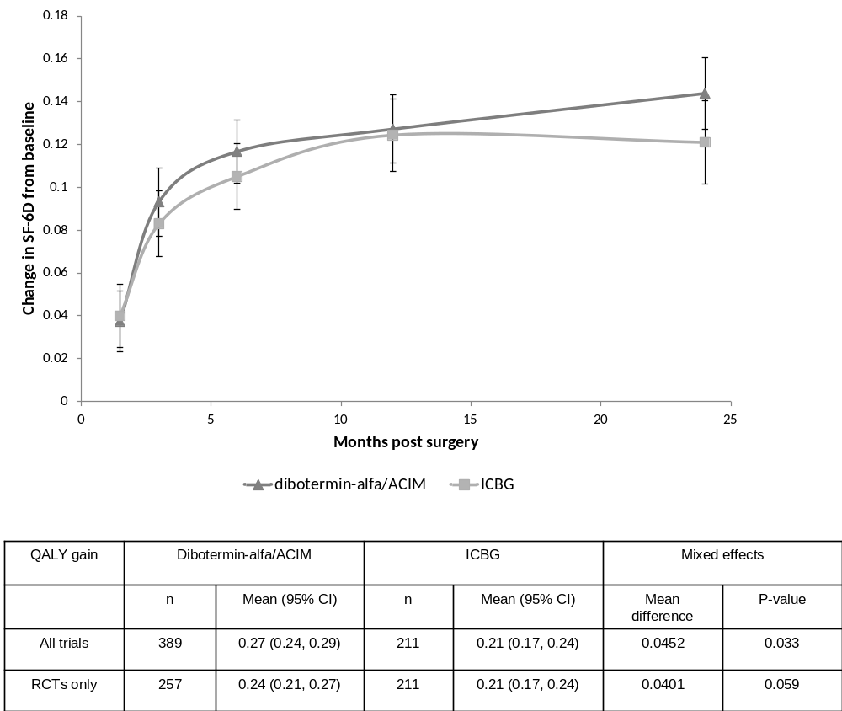

Abbreviations: ACIM: absorbable collagen implantation matrix; CI: Confidence interval; ICBG: Iliac crest bone graft; IPD: individual patient data; RCT: randomised controlled trial; SF-6D: Short form 6-dimension; QALY: Quality-adjusted life year

Figure 3. Change from baseline in SF-6D (IPD meta-analysis, based on all trials) and mean QALY difference during two years of follow-up post-surgery stratified by radiographic fusion status at two years
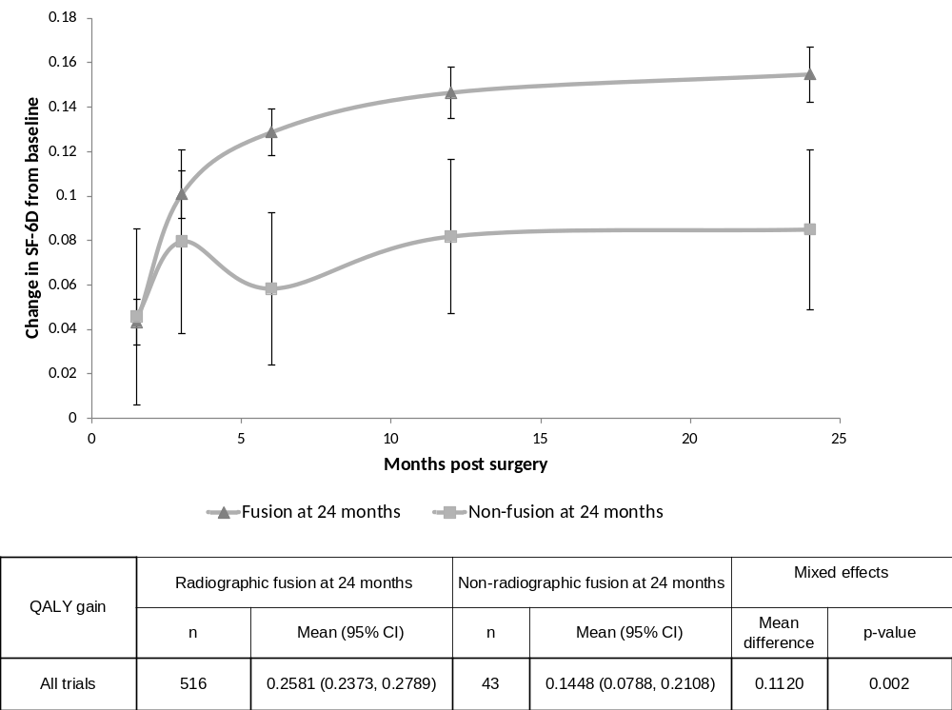Abbreviations: CI: Confidence interval; IPD: individual patient data; SF-6D: Short form 6-dimension; QALY: Quality-adjusted life year

Figure 4. Change from baseline in SF-6D (IPD meta-analysis, based on all trials) and mean QALY difference during two years of follow-up post-surgery stratified by radiographic fusion status at two years
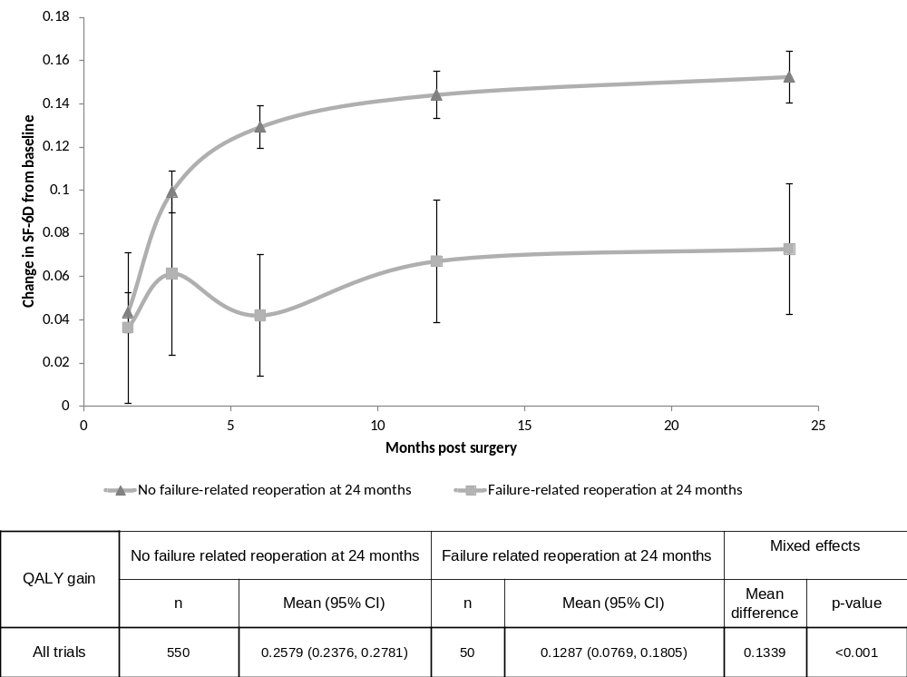
Abbreviations: CI: Confidence interval; IPD: individual patient data; SF-6D: Short form 6-dimension; QALY: Quality-adjusted life year

Figure 5. Scatterplot of incremental cost-effectiveness values generated by the PSA
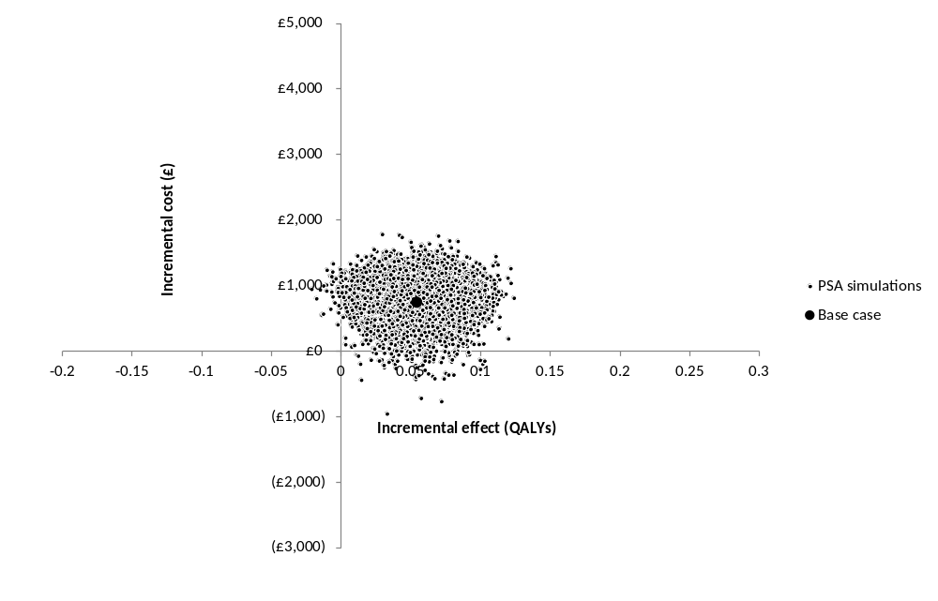
Abbreviations: PSA: Probability sensitivity analysis; QALYs: Quality adjusted life years
Figure 6: Cost-effectiveness acceptability curve for the base case analysis of dibotermin-alfa/ACIM and ICBG
ICBG

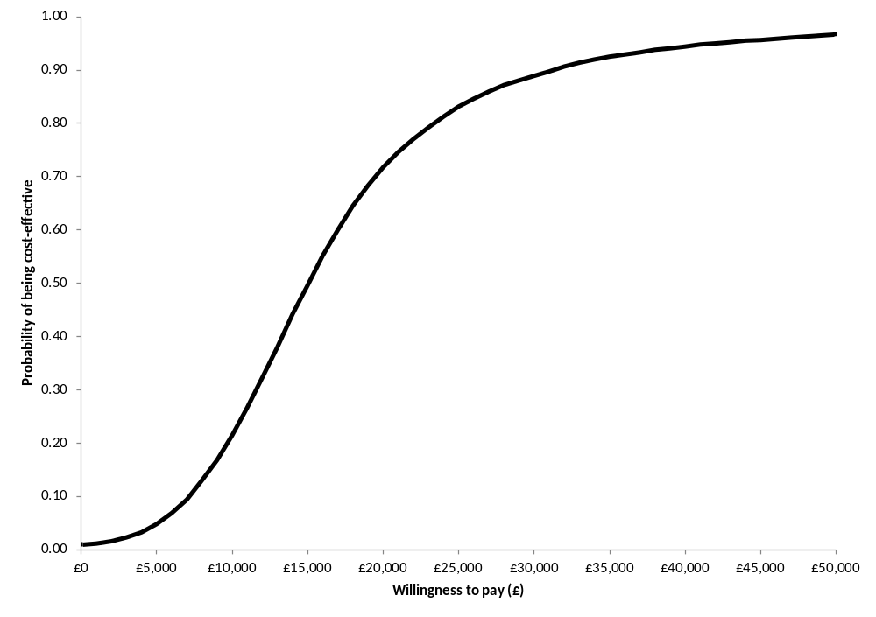
Abbreviations: ACIM: Absorbable collagen implantation matrix; ICBG: autologous iliac crest bone graft

Figure 7: Tornado diagram showing the effect of altering base case model inputs in one way sensitivity analyses (incremental cost/QALY)
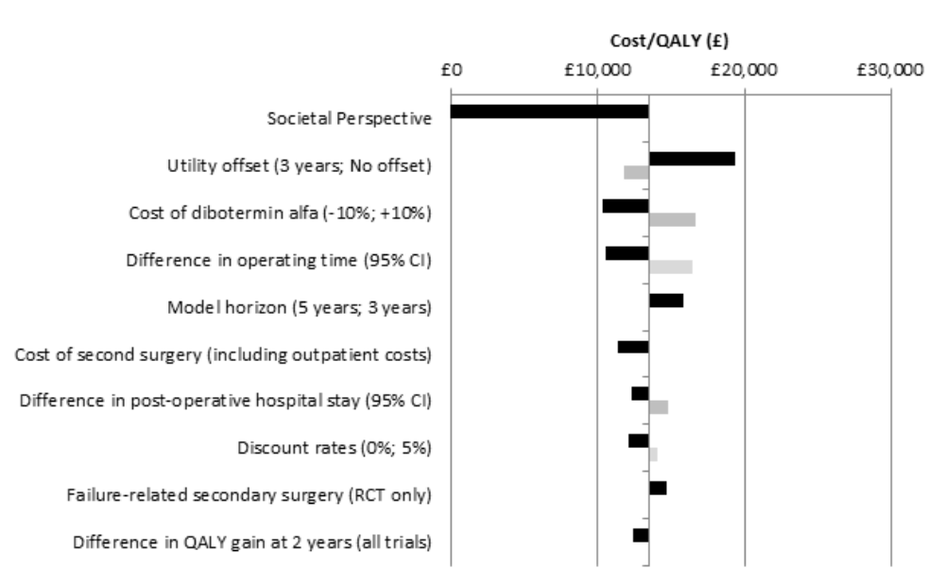
Abbreviations: CI: Confidence interval; QALY: Quality adjusted life year; RCT: Randomised controlled trial

* Medtronic BioPharma B.V., Earl Bakkenstraat 10, 6422 PJ Heerlen, Netherlands

