Title
Cost-effectiveness of using array-CGH for diagnosing learning disability
Authors
GS Sagoo^{1,2}, S Mohammed², G Barton³, G Norbury², JW Ahn⁴, CM Ogilvie⁴, M Kroese¹.
Affiliations
- PHG Foundation, 2 Worts Causeway, Cambridge, UK
- Clinical Genetics Department, Guy’s and St Thomas’ NHS Foundation Trust, London, UK.
- University of East Anglia, Norwich Medical School, Norwich Research Park, Norwich, UK.
- Cytogenetics Department, Guy’s and St Thomas’ NHS Foundation Trust, London, UK.
Corresponding author:
Dr GS Sagoo, gurdeep.sagoo@phgfoundation.org - +44(0)1223761905
Abstract
Objective
To undertake a cost-effectiveness analysis of using array-CGH as a first-line test versus as a second-line test for the diagnosis of causal chromosomal abnormalities in patients referred to a NHS clinical genetics service in the UK with idiopathic learning disability, developmental delay and/or congenital anomalies.
Perspective and setting
The perspective is that of a UK NHS clinical genetics service provider (with respect to both costs and outcomes). A cohort of patients (n = 1590) referred for array-CGH testing of undiagnosed learning disability and developmental delay by a single NHS regional clinical genetics service (South East Thames Regional Genetics Service), were split into a before-and-after design where 742 patients had array-CGH as a second-line test (before group – comparator intervention) and 848 patients had array-CGH as a first-line test (after group – evaluated intervention).
Methods
A cost-effectiveness study was conducted. The mean costs were calculated from the clinical genetics testing pathway constructed for each patient including the costs of genetic testing undertaken and clinical appointments scheduled. The health outcome was the number of diagnoses each intervention produced so that a mean cost-per diagnosis could be calculated. The cost-effectiveness of the two interventions was calculated as an incremental cost-effectiveness ratio to produce an incremental cost-per-diagnosis. Sensitivity analyses were conducted by altering both costs and effects to check the validity of the outcome.
Results
The incremental mean cost of testing patients using the first-line testing strategy was -£241.56 (95% CIs: -£256.93 to -£226.19) and the incremental mean gain in the percentage diagnoses was 0.39% (95% CIs: -2.73% to 3.51%) which equates to an additional 1 diagnosis per 256 patients tested. This cost-effectiveness study of comparing these two strategies estimates that array-CGH first-line testing dominates second-line testing because it was both less costly and as effective. The sensitivity analyses conducted (adjusting both costs and effects) supported the adoption or dominance of the first-line testing strategy (i.e. lower cost and as effective).
Conclusions
The first-line testing strategy was estimated to dominate the second-line testing strategy because it was both less costly and as effective. These findings are relevant to the wider UK NHS clinical genetics service with two key strengths of this study being the appropriateness of the comparator interventions and the direct applicability of the patient cohort within this study and the wider UK patient population.
Keywords
Array CGH, learning disability, cost-effectiveness analysis
Words
~5,300

Key Messages
- Genetic factors are known to play an important etiological role in learning disability
- Technological advances have improved the capability to diagnose these genetic causes

- This study shows the potential cost savings per diagnosis that can be made using array-CGH as a first diagnostic test versus as a second-line test if the approach reported in this study was used across the NHS

Introduction
Learning disability (LD) or intellectual disability, a common condition affecting around 1 to 3% of the population worldwide [1], is defined as a significant impairment of an individual’s cognitive and social adaptive functions with onset before the age of 18 years [2]. The British Institute of Learning Disabilities estimates that nearly 1.2 million people in England have LD, which is around 2% of the population [3]. Mencap, the UK’s leading LD charity, broadly agree with this although they estimate 1.5 million people in the UK are affected by LD [4]. From the phenotypic descriptions used in ICD-10 [2], it is easy to see that there are vast economic consequences from a life-long condition such as LD which impacts not only on the health of the individual, but also their economic well-being and welfare, their quality of life and their interactions with family, friends and the wider society, notwithstanding the impact on family members and the other wider community services required.
The clinical assessment of LD involves examination by a clinician usually a paediatrician for children or a neurologist for adults followed by biochemical and genetic tests to diagnose the underlying cause. For younger children (under the age of 3) a diagnosis of LD is difficult to establish and referral is made with a clinical diagnosis of global developmental delay. Being able to identify the underlying cause of suspected LD can aid the diagnosis of LD and allow better management of the patient. The development of LD is influenced by genetic, environmental, infectious and perinatal factors with the underlying cause estimated to be genetic in around 50% of patients with severe LD and 15% of patients with milder forms of LD [5]. It has been possible to genetically diagnose specific chromosomal causes of LD for several decades since G-banded karyotyping (karyotyping) analysis was introduced into clinical practice. For a long-time this was the gold standard cytogenetic test but it has low resolution, low negative predictive value and a low diagnostic rate. Microarray-based comparative genomic hybridisation (array-CGH) is a method for identifying copy-number variations (amplifications or deletions) by comparing reference (control) and test (patient) DNA samples. Array-CGH has increased the ability to detect significantly smaller chromosomal abnormalities and can analyse several thousand DNA sequences in an automated process. Brady and Vermeesch [6] have produced an overview of array-CGH for further details of how the technology works. Array-CGH is able to provide an increase of 10% (95% CIs: 8% to 12%) in the number of diagnoses compared to karyotyping [7].
Whilst there is compelling recent evidence from two systematic reviews [7,8] that suggest array-CGH is clinically effective in routine clinical genetics practice for diagnosing idiopathic (without known cause) LD, clinical or diagnostic evidence is not the only factor when making decisions to implement new diagnostic technologies into routine NHS clinical practice. With constrained financial resources, it is important to consider both the cost-effectiveness and clinical effectiveness of any intervention. Health economic evaluation attempts to explicitly compare the costs and effectiveness of two or more courses of action so that an informed decision can be made [9]. The introduction of array-CGH testing into routine clinical genetics services as a first-line test has been slow due to the perceived high cost of the test and also because of the long established acceptance in routine clinical practice of karyotyping as the first-line test for LD [10].
Wordsworth et al. [12] have previously investigated the cost-effectiveness of array-CGH versus standard routine (karyotyping) cytogenetic analysis for diagnosing idiopathic LD in the NHS and concluded that using it is likely to be cost-saving regardless of the diagnostic outcome whether through earlier positive diagnoses saving the cost of additional diagnostic tests or negative results minimising follow-up test choice. However, this study compared the then-current standard practice of karyotyping versus using array-CGH. In practice, the NHS genetics service laboratories have used array-CGH as a second-line diagnostic test after initial karyotyping in a step-wise fashion. Current consensus clinical opinion does however recommend array-CGH as a first-tier genetic test to replace karyotyping for patients with unexplained LD [13,14].
Despite clinical evidence reporting a greater diagnostic rate versus karyotyping alone and limited but compelling evidence supporting the cost-effectiveness of this technology, array-CGH has not been implemented across the whole of the NHS as a routine first-line test but is still often being used as a second-line test following a negative initial karyotype analysis in many laboratories and services. According to a UK survey of the regional genetics services in 2012, it was estimated that only 68% of patients referred for unexplained LD, development delay and/or congenital anomalies received an array-CGH test although this was not broken down by whether the array-CGH was used as the first-line test or second-line test [15].
In this paper, we report a cost-effectiveness analysis of using array-CGH as a first-line test versus as a second-line test for the diagnosis of causal chromosomal abnormalities in idiopathic LD patients from the perspective of a NHS clinical genetics service provider within the UK where array-CGH has been available as a first-line test since mid-2009.
Methods
Participants from Ahn et al. [10] study.
In this study we analysed a retrospective cohort of patients (N= 2,414) with idiopathic LD and developmental delay consecutively tested by the regional clinical genetics service at Guy’s and St Thomas’ NHS Foundation Trust hospital laboratories (GSTT) as previously reported [10]. In the study by Ahn et al. [10] the use of array-CGH was validated over an approximately two year period (from 06/2006 to 03/2008). Patients tested after this period (from 04/2008 onwards) were eligible for inclusion in the comparator intervention where array-CGH was used as a second-line test (n= 1,245). These patients had karyotyping followed by array-CGH. Once the testing procedures and pathway were approved by the local NHS genetics services commissioners, array-CGH was introduced as a first-line test from 05/2009. Patients tested after 05/2009 were eligible for inclusion in the evaluated intervention arm where array-CGH was used as a first-line test (n= 1,169). These patients had array-CGH. No power calculation was conducted to determine sample size because the study is estimating cost and effect differences and assessing whether an intervention is cost-effective rather than testing a particular hypothesis concerning cost-effectiveness [16]. An underpowered study would produce wider confidence intervals than an appropriately powered study and as Briggs stated would mean that “readers will not be misled” [16].
Patients were excluded if they already have a known clinical diagnosis (e.g. Down’s syndrome). Patients are referred for testing on the basis of having undiagnosed LD plus one or more of the following:
- A family history of LD
- Overgrowth or growth failure
- Behavioural problems
- Facial dysmorphism or clinical or radiological evidence of brain, body trunk, or limb anomalies.
GSTT was selected because they currently use array-CGH as a first-line test and have previously used array-CGH as a second-line test. This allowed the use of a before-and-after study design where the patients with array-CGH as a second line test (following a karyotype) are the before group (comparator intervention) and the patients with array-CGH as a first-line test are the after group (evaluated intervention). We assume that all patients at this laboratory would have fulfilled the same clinical referral criteria and would be directly comparable on this basis in the before-and-after groups but also more generally to the patients referred to the wider clinical genetics services within the UK NHS given that the GSTT service covers a population of over 5 million.
In this study it was only necessary to present anonymised data in an aggregated fashion and so no patients were identifiable. Patients did not require any additional or new tests, or any new or additional samples taken, or needed any clinical information fed-back to them as a direct result of this study. The Research and Development Governance Manager at GSTT determined that this work would not require specific ethical approval under the harmonised GAfREC (Governance arrangements for Research Ethics Committees) for research limited to use of previously collected, non-identifiable information provided that the data is anonymised or pseudonymised in conducting the research.
Evaluated intervention
The evaluated intervention is the intervention arm in which array-CGH was used as a first-line test. Positive diagnostic results are followed by an additional confirmatory test using a different technology (for example the use of fluorescence in situ hybridisation - FISH - to confirm that the identified genetic variation exists by using a specific probe to that chromosomal region). The testing pathway will start with a blood sample arriving at the laboratory and conclude with the diagnostic result being reported back to the patient. The testing pathway similar to that previously reported by Wordsworth et al. [12] can be seen in Figure 1. When a variation of unknown significance is detected, parental samples are requested and tested (using eg FISH) in the confirmation stage to determine causality.
Comparator intervention
The comparator intervention takes karyotype as the first-line test and then array-CGH as a second-line test when a diagnosis was not achieved with the use of karyotyping. A diagnosis is again followed by a confirmatory test (using FISH) as per the evaluated intervention arm. The testing pathway will again start with a blood sample arriving at the laboratory and conclude with the diagnostic result being reported to the patient as per the intervention arm. The testing pathway similar to that previously reported by Wordsworth et al. [12] can be seen in Figure 2. This testing pathway is identical to evaluated intervention with the exception of the use of karyotyping.
Identification, measurement and valuation of resource use and costs
Costing in economic evaluation is the important aspect of quantifying the different types of resources that are used in each intervention, identifying resource unit costs and then multiplying the quantities by their respective unit costs. Market prices used were NHS prices for testing at GSTT taken from the NHS test directory hosted by the UKGTN website (ukgtn.nhs.uk) and are reported in UK £s using prices as listed in 2013. The costs of the consultant clinical geneticist and genetic counsellor were assumed to be the same as similar level posts in PSSRU [17] with costs converted into 2013 prices using the CCEMG-EPPI-Centre Cost Converter [18]. All cost data collected are reported in Table 1.
The testing pathway (including resource use) was constructed for each patient by searching through clinical and laboratory records (both electronic and paper-based) to determine which tests the patients actually received and their results and whether any additional tests were conducted either pre- or post-arrayCGH. This was done from the perspective of the clinical genetics service and included not only the testing pathways as described in the previous section for each patient but also the number (and duration) of appointments with consultant clinical geneticists and/or genetic counsellors and which other tests were undertaken including whether follow-up testing was done in the parents to confirm diagnoses. These individual patient pathways allowed the quantification of resource use for each patient, thus allowing unit cost allocation to determine the cost for each patient’s testing pathway. There were no differences in the two pathways other than the use of karyotyping in the comparator intervention.
Outcomes
The main outcome of interest for this study is the number of diagnoses each intervention produces so that a cost-per-diagnosis can be calculated. The number of diagnoses made was calculated from the patient data in 2013 (the same year as the cost data). A diagnosis was defined as a patient who has a clinically significant variant detected by either array-CGH or karyotyping (and confirmed using FISH) that is judged to be causal based on best practice guidelines [19]. Because a single regional genetics laboratory service is being used, both the clinical and bioinformatics-analysis judgement required to infer causality will be consistent between the two treatment arms. For the purposes of this study the uncertainty yield which can be defined as the number of variants detected that are of unclear clinical significance divided by the total number of patients tested was assumed to be the same in both testing strategies. There were no instances of abnormalities being detected by array-CGH the existence of which was subsequently not confirmed by another follow-up test such as FISH or karyotyping. The following patient data were extracted on an individual patient level:
- Patient sex, age
- Whether the array-CGH was first-line or second-line
- Patient age when the array-CGH was conducted
- Whether karyotyping was conducted and result
- Whether array-CGH was conducted and result
- Whether the sample was received as blood so that DNA needed to be extracted
- Whether any additional tests were conducted other than karyotyping and array-CGH and their results (but not their order)
- How many clinical appointments the patient required, how long the appointment was for and whether it was with a consultant clinical geneticist, genetic counsellor or both.
Once the above patient data were extracted, treatment pathways for each patient along with resource use and the main health outcome of diagnosis were constructed that would provide single-study patient data for the cost-effectiveness analysis.
Cost-effectiveness analysis
Cost-effectiveness analysis is a full form of economic evaluation where both the costs and consequences of an intervention are evaluated. The cost-effectiveness of the two interventions will be calculated as an incremental cost-effectiveness ratio (ICER) which is defined as the difference between the mean costs of the two testing pathways divided by the difference in the mean effects (number of diagnoses made).
The ICER uses the formula 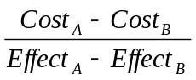 where Cost_{A} is the mean cost of treatment group A, Cost_{B} is the mean cost of treatment group B, Effect_{A} is the mean effect for group A and Effect_{B} is the mean effect for group B [20]. The uncertainty due to sampling variation was calculated using a nonparametric bootstrapping technique. This was done to avoid making assumptions about the underlying distributions in the ICER and involves resampling from the original data to build up an empirical estimate of the sampling distribution of the ICER [9]. The bootstrap estimation was based on random sampling with 1,000 replications with replacement of all participants using the original data. ICERs were calculated for each bootstrap replication and are plotted graphically on a cost-effectiveness plane where the incremental cost is plotted against the incremental effect (Y and X axes, respectively). All data analyses were conducted in Microsoft Excel 2010 (Microsoft Corporation, Redmond, WA).
Sensitivity analyses
Sensitivity analyses allow insight into which assumptions or restrictions on the data included are important to the overall result or conclusion drawn from the analysis. A pragmatic approach to conducting one-way sensitivity analyses was undertaken to explore the impact of changing the effectiveness of the intervention and also the individual test costs within the testing pathway on the total cost of the pathway. Dunlop et al. [22] undertook a simple sensitivity analysis strategy that involved increasing and decreasing key variables by 25% as this magnitude of change would likely indicate any trends. The following variables were adjusted in a similar manner in order to determine their impact on the ICER and decision of cost-effectiveness:
- Adjust the cost of array-CGH by +/-25%
- Adjust the total pathway cost of array-CGH by +/-25%
- Adjust the total consultation time of the array-CGH first-line testing pathway by +/-25%
- Remove the Fragile X testing costs from both pathways due to a change in the referral for this test
- Replace the effectiveness data from the single study to effectiveness data from the published literature
- Replace the effectiveness data from the single study patients extracted to the overall effectiveness data as originally reported by Ahn et al. [10]
Results
Of the 2,414 patients potentially eligible to be included in this cost-effectiveness study, data were extracted for both clinical outcome data and resource use data on 1,590 patients (742 patients in the second-line testing strategy and 848 in the first-line test strategy). This was down to time constraints as this study was conducted as an MSc dissertation. Patients were consecutively included and data extracted in blocks of 100 based on patient ID alternating between the two intervention strategies in order to maintain comparable sizes for both intervention arms. At time of selecting which patient to extract, the data extractor (GS) was able to see only the patient ID and to which intervention the patient was allocated. All other data was blinded and required extracting following the decision to include a patient. Once all resource data had been extracted the diagnostic outcome data were extracted for the patients. Basic demographic characteristics are presented in Table 2. Looking at the two testing strategies, there are more males in the array-CGH first-line strategy arm than in the array-CGH second-line strategy arm (p <0.05). However, this difference should not impact on the health outcome as sex is not known to influence the ability to diagnose chromosomal abnormalities on the population group within this study. The age of patients at time of array-CGH was not found to be statistically different between the two testing strategies (P = 0.80). The before group (second-line testing) were tested between 04/2008 and 04/2009 and the after group (first-line testing) were tested between 05/2009 and 12/2009. As knowledge about the clinical significance of newly identified variants accumulates, a variant of unclear significance today may become a variant with a known pathological or benign impact in the future. Because both intervention arms received testing by array-CGH we would not expect this time difference to benefit one arm over the other with respect to the resolution of variants of unclear clinical significance into a diagnosis or no diagnosis. Furthermore, we have used diagnostic data from a common year (2013). Summary data for mean costs and effect results as well as resource use are in Table 3.
Costs
For the patients in the array-CGH second-line test strategy, the mean cost-per-test pathway was £532.61 (ranging from £390 to £1424.03). The mean cost-per-test pathway in the array-CGH first-line test strategy was £291.05 (ranging from £190 to £1257.92). There was a statistically significant difference between the costs of these two interventions (p = 6.78 x 10⁻¹⁶⁴). The main cost driver of the overall test pathway was the clinical consultation cost per patient ranging from £0 to £1,028 (mean £82) and £0 to £994 (mean £121) for the first-line and second-line test pathways respectively. The figure of £0 represents the scenario of testing a patient sample from a clinic other than clinical genetics at GSTT (incurring a cost for the test) with the result returned to the referring clinic and no clinical follow-up at GSTT (incurring no clinical consultation cost at GSTT). The mean incremental cost was -£241.56 (95% CIs: -£256.93 to -£226.19) which meant that using array-CGH as a first-line test was cost saving.
Outcomes
The main health outcome of interest for this study was the number of diagnoses each intervention produced so that a cost-per-diagnosis could be calculated. Data were extracted on diagnoses for the 848 patients in the array-CGH first-line test strategy and for 742 in the array-CGH second-line test strategy (Figure 3). In the 1,590 patients, 179 diagnoses (11.26%) were identified as causal. In the array-CGH first-line test strategy, 97 diagnoses (11.44%) were identified as causal with 82 diagnoses (11.05%) identified as causal in the array second-line test strategy. The mean incremental gain in the percentage diagnoses was 0.39% (95% CIs: -2.73% to 3.51%). However, this increase in the number of diagnoses was not statistically significant (t = 0.24; df = 1588; p = 0.807).
Cost-effectiveness analysis
When one intervention is shown to be cheaper and also more effective than another then it is said to ‘dominate’ and represents a cost-effective use of scare resources. Using the array-CGH first-line testing strategy is statistically significantly cheaper and although it is marginally more effective, this increased effectiveness is not statistically significant based on this cohort of patients. The cost-per-diagnosis for first-line testing is £2,544.42 versus £4,819.44 for second-line testing showing that first-line testing is £2,275.02 cheaper per diagnosis. The ICER was calculated to be -£62,342.94. Although the point estimate ICER is negative, because we know that the array-CGH first-line strategy is both cheaper and as effective, this would sit within the South-East quadrant of the cost-effectiveness plane suggesting that the array-CGH first-line strategy dominates. The bootstrap replications of the ICER were also plotted on the cost-effectiveness plane (Figure 4). Of the 1,000 replications, 596 sat within the South-East quadrant suggesting that 59.6% of the time the array-CGH first-line testing strategy dominates the array-CGH second-line testing. 100 percent of the replications sit below the horizontal axis confirming that the array-CGH first-line strategy is cost-saving.

Sensitivity analyses
Table 4 shows the results of the key sensitivity analyses conducted. We used simple percentage adjustments to some key cost variables and used effectiveness estimates derived from the published literature to test whether changing these variables would change the decision. Because the first-line array-CGH testing strategy showed a lower mean cost estimate and a higher effectiveness estimate based on this study, the sensitivity analyses focused on adjusting variables that would impact on that testing strategy in a negative manner. The ICER was insensitive to increasing the cost of the consultant clinical geneticist by 25% in the first-line array testing strategy, increasing the cost of the array-CGH NHS test price by 25% in the first-line array testing strategy and increasing the cost of the entire first-line array-CGH testing strategy by 25%.
Due to a change in the referral criteria for Fragile X testing and a reduction in the number of Fragile X tests being undertaken as a consequence, a sensitivity analysis was conducted to include this change by removing this cost in both testing strategies. The ICER and adoption decision were both insensitive to this change. The literature-based estimates of effectiveness for both array-CGH testing strategies were applied and again the ICER was insensitive to this as the array-CGH first-line test strategy is still both less costly and as effective. All these sensitivity analyses conducted showed the array-CGH first-line testing strategy as dominant over the array-CGH second-line testing strategy. If the whole cohort of 2,414 patients as reported originally by Ahn et al. [10] are taken and the overall percentage diagnoses of abnormal patients (de novo and inherited) identified by the two testing strategies (array second-line = 11.97% vs array first-line = 7.1%) are used as the effectiveness estimates, adoption of the first-line testing strategy would still be favoured using the willingness-to-pay threshold of £7,862.38 indicating that this is a cost-effective use of resources.
Discussion
Previous research has shown array-CGH to be clinically effective in diagnosing idiopathic LD including a systematic review and meta-analysis of nearly 14,000 patients [7]. However, clinical effectiveness is not the only factor when making decisions to implement new tests, interventions or treatments into routine NHS clinical practice. It is always important to consider both the clinical and cost-effectiveness of any intervention and an economic evaluation explicitly attempts to assess both the costs and the benefits of two or more competing uses of scarce resources. Health economic evaluations allow a means of establishing whether an intervention is ‘value for money’ against an alternative intervention.
The aim of this study was to answer the question of whether the clinical and laboratory work-up of array-CGH as a first-line test is cost-effective compared to as a second-line test following standard karyotyping analysis for the diagnosis of causal chromosomal abnormalities in patients referred to the NHS clinical genetic services in the UK with idiopathic LD, developmental delay and/or congenital anomalies.
Summary of findings
In this cost-effectiveness study the use of array-CGH as a first-line testing strategy was compared against the usual routine care of using array-CGH as a second-line testing strategy following karyotyping in a cohort of 1,590 patients on whom data was available (n = 848 in the first-line arm and n = 742 in the second-line arm). The mean cost of using array-CGH in the first-line strategy was £291.05 (ranging from £190 to £1,257.92) compared to £532.61 (ranging from £390.00 to £1,424.03) for the second-line strategy. The incremental mean cost of testing patients using the first-line testing strategy was -£241.56 (95% CIs: -£256.93 to -£226.19) and was statistically significant which meant that this test strategy was cost saving. The mean effectiveness of using array-CGH in the first-line strategy was 11.44% in terms of the diagnostic yield compared to 11.05% for the second-line strategy. The incremental mean gain in the percentage diagnoses was 0.39% (95% CIs: -2.73% to 3.51%) suggesting that the first-line test strategy was as effective as the second-line testing strategy. Furthermore, there was no evidence of any diagnoses missed using array-CGH as a first-line test.
Array-CGH used as a first-line testing strategy was shown to dominate the second-line testing strategy taking a deterministic approach because it was less costly and as effective. All the sensitivity analyses conducted supported the adoption or dominance of the first-line testing strategy over the second-line testing strategy (i.e. lower cost and as effective). The difference in effectiveness estimates reported in the Ahn et al. [10] article can be partly explained by the resolution of any variants of unclear significance in the intervening three year period, the resolution of any parental sample testing that had not been conducted at the time the article was published, and also the partial data collected in this study with data on a further 824 patients available across the two intervention arms. Two strengths of this current study include the appropriateness of the interventions that were compared as both are currently being undertaken within the NHS and also the direct applicability of the patient cohort within the study to the wider UK patient population.
Limitations
There are several limitations to this study. First, the present study involved a cohort of patients that were tested by a single regional clinical genetics service and although this service is one of the largest within the UK NHS in terms of the number of people it serves (approx. five million) it is possible that these results are still not applicable across the UK. This may be due to the clinical and laboratory expertise developed within this regional centre and therefore the costs may be cheaper and the effects may be higher in this setting than the rest of the UK. It may also be that because of the expertise of this group, the referrals may be more complex than seen in other parts of the country. Second, data were not extracted on all the patients within the original cohort of patients as reported by Ahn et al. [10]. If data were extractable on all the participants it is possible that this may have resulted in a change to the mean costs and effects across both groups. However, reported estimates of effectiveness (defined as inherited and de novo imbalances in abnormal patients) across both groups of patients were included in the sensitivity analyses and this would not have changed the decision to adopt array-CGH in a first-line testing strategy. The number of diagnoses may have also increased slightly from those originally reported in the article as additional parental samples that were requested at that time have now been tested and diagnoses made although this would not expect to favour the effectiveness of one intervention over the other as both intervention arms had array-CGH tests. Also, although the data extractor (GS) was aware of the study question, he was blinded to the diagnostic outcome when selecting and extracting patient data across the two intervention arms with outcome data extracted once all other resource data had been collected. It is not possible to truly exclude selection bias and so this is a further limitation of this study.
Third, the outcome was limited to the number of diagnoses provided by the two testing strategies and the timeframe for both the costs and benefits to the point of diagnosis. It is possible that receiving a diagnosis may result in more appropriate care being delivered for that individual and that this may reduce the need for inappropriate and unneeded further testing which may save costs and harmful/painful testing for the patient. However, an earlier diagnosis may also result in additional screening tests or additional treatment costs being incurred. Furthermore, no disbenefits were assigned to those patients that did not receive a diagnosis and continue on their diagnostic odyssey to find a cause of their condition. The perspective used in this study was also very narrow and focused on the clinical genetics service. Fourth, the outcome used in this study was not measured using QALYs which is the preferred metric to inform resource allocations and recommended by the National Institute for Health and Care Excellence (NICE) and would allow comparison to other interventions using the QALY-based approach. However, a review of over 46,000 postnatal patients tested using array-CGH by Ellison et al. [insert ref] suggested evidence of clinical utility following diagnosis. The disorders diagnosed using array-CGH frequently allowed specific clinical actions leading to changes in the management of these patients leading to more appropriate care which in turn would be expected to improve the health of these patients.
Another limitation of this study was the assumption that all diagnoses identifiable using karyotyping analysis would also be picked up using array-CGH. Array-CGH has been shown to be able to identify a substantial proportion of so-called balanced translocations diagnosed by karyotyping, as they actually contain sub-microscopic deletions and are therefore unbalanced and detectable by the array-CGH [25]. Also, a clinical audit of a 10-year period of post-natal karyotyping results showed only 4 de novo reciprocal translocations were found in 36,663 samples tested (0.0001%) at GSTT which could potentially be missed by array-CGH [10]. However, truly balanced translocations will not be detected by array-CGH, and the possibility that the breakpoints disrupt important disease genes remains.
Conclusions
In conclusion, this cost-effectiveness study compared using array-CGH as a first-line testing strategy against the usual care of using array-CGH as a second-line testing strategy following karyotyping in a cohort of 1,590 NHS patients. The incremental mean cost of testing patients using the first-line testing strategy was -£241.56 (95% CIs: -£256.93 to -£226.19) and meant that this test strategy was cost-saving. The incremental mean gain in the percentage diagnoses was 0.39% (95% CIs: -2.73% to 3.51%) which equates to an additional 1 patient diagnosed per 256 patients tested suggesting that this test strategy is as effective. The use of array-CGH as a first-line testing strategy for the diagnosis of causal chromosomal abnormalities in LD was shown to dominate the second-line testing strategy because it was both less costly and as effective.
Acknowledgements
The authors would like to acknowledge the input, help and support of the regional genetics service based at Guy’s and St Thomas’ NHS Foundation Trust (GSTT) and the UK Genetic Testing Network (UKGTN). GS would like to acknowledge a travel grant from UKGTN to assist in the expenses of attending GSTT to undertake this study. The authors would like to thank the anonymous reviews for their helpful comments during the peer-review process. The authors are not aware of any conflicts of interest.

References
1. Roeleveld N, Zielhuis GA, Gabreels F: The prevalence of mental retardation: a critical review of recent literature. Dev Med Child Neurol 1997, 39: 125-132.
2. World Health Organization: The ICD-10 classification of mental and behavioural disorders. Clinical descriptions and diagnostic guidelines. Geneva: World Health Organization 1992.
3. Holland K. Factsheet: Learning Disabilities. Available from www.bild.org.uk accessed 11th September 2013.

4. Mencap: About learning disability. http://www mencap org uk/all-about-learning-disability/about-learning-disability, accessed 11th September 2013
5. Hagberg B, Kyllerman M: Epidemiology of mental retardation--a Swedish survey. Brain Dev 1983, 5: 441-449.
6. Brady PD, Vermeesch JR: Genomic microarrays: a technology overview. Prenat Diagn 2012, 32: 336-343.
7. Sagoo GS, Butterworth AS, Sanderson S, Shaw-Smith C, Higgins JP, Burton H: Array CGH in patients with learning disability (mental retardation) and congenital anomalies: updated systematic review and meta-analysis of 19 studies and 13,926 subjects. Genet Med 2009, 11: 139-146.
8. Subramonia-Iyer S, Sanderson S, Sagoo G, Higgins J, Burton H, Zimmern R et al.: Array-based comparative genomic hybridization for investigating chromosomal abnormalities in patients with learning disability: systematic review meta-analysis of diagnostic and false-positive yields. Genet Med 2007, 9: 74-79.
9. Drummond MF, Sculpher MJ, Torrance GW, O'Brien BJ, Stoddart GL: Methods for the economic evaluation of health care programmes., Third ed. Oxford: Oxford University Press; 2005.
10. Ahn JW, Mann K, Walsh S, Shehab M, Hoang S, Docherty Z et al.: Validation and implementation of array comparative genomic hybridisation as a first line test in place of postnatal karyotyping for genome imbalance. Mol Cytogenet 2010, 3: 9.
11. Sagoo GS, Wright C, Burton H: ArrayCGH for the diagnosis of learning disability: reassessing the evidence for the UKGTN. www phgfoundation org/file/9333/ accessed on 1st August 2013
12. Wordsworth S, Buchanan J, Regan R, Davison V, Smith K, Dyer S et al.: Diagnosing idiopathic learning disability: a cost-effectiveness analysis of microarray technology in the National Health Service of the United Kingdom. Genomic Med 2007, 1: 35-45.
13. Miller DT, Adam MP, Aradhya S, Biesecker LG, Brothman AR, Carter NP et al.: Consensus statement: chromosomal microarray is a first-tier clinical diagnostic test for individuals with developmental disabilities or congenital anomalies. Am J Hum Genet 2010, 86: 749-764.
14. UKGTN. Proposal form for the evaluation of a genetic test for NHS Service Gene Dossier for Learning disability. Available at http://ukgtn.nhs.uk/uploads/tx_ukgtn/aCGH_First_Line_LD_DD_CA_GD_Sept_10.pdf accessed on 11th September 2013.

15. Association for Clinical Cytogenetics. Association for Clinical Cytogenetics UK array CGH Survey 2012/13 to be available at http://www.cytogenetics.org.uk/ in due course.

16. Briggs A: Economic evaluation and clinical trials: size matters. BMJ 2000, 321: 1362-1363.
17. Curtis L. Unit costs of health and social care 2012. Available at: http://www.pssru.ac.uk/pdf/uc/uc2012/uc2012.pdf accessed 11th September 2013.

18. Shemilt I, Thomas J, Morciano M: A web-based tool for adjusting costs to a specific target currency and price year. Evidence and Policy 2010, 6: 51-59.
19. Kearney HM, Thorland EC, Brown KK, Quintero-Rivera F, South ST: American College of Medical Genetics standards and guidelines for interpretation and reporting of postnatal constitutional copy number variants. Genet Med 2011, 13: 680-685.
20. Glick HA, Doshi JA, Sonnad SS, Polsky D: Comparing cost and effect: point estimates for cost-effectiveness and net monetary benefit. In Economic Evaluation in Clinical Trials. Oxford: Oxford University Press.; 2007.
21. Gray AM, Clarke PM, Wolstenholme JL, Wordsworth S: Presenting cost-effectiveness results. In Applied Methods of Cost-effectiveness Analysis in Health Care. Oxford: Oxford University Press.; 2011.
22. Dunlop W, Uhl R, Khan I, Taylor A, Barton G: Quality of life benefits and cost impact of prolonged release oxycodone/naloxone versus prolonged release oxycodone in patients with moderate-to-severe non-malignant pain and opioid-induced constipation: a UK cost-utility analysis. J Med Econ 2012, 15: 564-575.
23. Regier DA, Friedman JM, Marra CA: Value for money? Array genomic hybridization for diagnostic testing for genetic causes of intellectual disability. Am J Hum Genet 2010, 86: 765-772.
24. De CM, Regier D, Alamgir AH, Anis AH, Fitzgerald MJ, Marra CA: Evaluating health-related quality-of-life studies in paediatric populations: some conceptual, methodological and developmental considerations and recent applications. Pharmacoeconomics 2005, 23: 659-685.
25. Schluth-Bolard C, Delobel B, Sanlaville D, Boute O, Cuisset JM, Sukno S et al.: Cryptic genomic imbalances in de novo and inherited apparently balanced chromosomal rearrangements: array CGH study of 47 unrelated cases. Eur J Med Genet 2009, 52: 291-296.

Tables:
Table 1: Estimated resources, test unit costs and assumptions.
Resource | Array-CGH test | DNA extraction | Fragile X test | Karyotyping | FISH | Consultant clinical geneticist | Genetic counsellor
Unit cost | £250 | £85 | £178.50 | £125 | £90 | £2.26 | £1.11
Unit description | NHS test price at GSTT clinical genetics service. | NHS test price at GSTT clinical genetics service. | NHS test price at GSTT clinical genetics service. | NHS test price at Addenbrooke’s hospital. | NHS test price at Addenbrooke’s hospital. | Medical consultant unit cost per hour of client contact divided by 60 for a cost per minute. | Counsellor unit cost per hour of client contact divided by 60 for a cost per minute.
Source | GSTT* | GSTT* | UKGTN Website** | Addenbrooke’s Hospital*** | Addenbrooke’s Hospital*** | Curtis [17] | Curtis [17]
Assumptions | Unit price includes the cost of all test procedures, reagents, staff costs, overheads and bioinformatics analysis required to result in the report that the consultant clinical geneticist receives. | Unit price includes the cost of the extraction procedure, reagents, staff costs, overheads and any analysis involved to process a blood sample into a DNA sample. | Unit price includes the cost of all test procedures, reagents, staff costs, overheads and bioinformatics analysis required to result in the report that the consultant clinical geneticist receives. | Unit price includes the cost of all test procedures, reagents, staff costs, overheads and bioinformatics analysis required to results in the report for the consultant. | Unit price includes the cost of all test procedures, reagents, staff costs, overheads and bioinformatics analysis required to result in the report for the consultant. | Consultant clinical geneticist assumed equivalent to Consultant: Medical. Unit costs to not include cost of qualifications. Costs per hour recalculated to bring in line with other costs using a Cost Convertor [18]. | Genetic counsellor assumed equivalent to counsellor in “Counselling services in primary medical care”. Costs per hour recalculated to bring in line with other costs using a Cost Convertor [18].
Price year | 2013 | 2013 | 2013 | 2013 | 2013 | 2013 | 2013
* http://www.guysandstthomas.nhs.uk/resources/our-services/grida/genetics/aCGH-service.pdf
** http://ukgtn.nhs.uk/find-a-test/search-by-disorder-gene/test-service/fragile-x-mental-retardation-syndrome-513/?tx_llcatalog_pi%5Bfilters%5D%5Bservice_ level%5D=4&tx_llcatalog_pi%5Bfilters%5D%5Breferral_categories%5D=1#c3594
*** http://www.cuh.org.uk/addenbrookes/services/clinical/genetics/genetics_labs/services_test/services_test_index.html

Table 2: Basic demographic data for all study patients and also grouped by array-CGH first-line test strategy and array-CGH second-line test strategy.
 | Overall study patients | Array-CGH first-line test strategy | Array-CGH second-line test strategy
Number of patients | 1,590 | 848 | 742
Average age, yr (range) | 10.41 (3 to 84) | 10.28 (3 to 73) | 10.54 (3 to 84)
Average age at time of array test, yr (range) | 6.44 (0 to 79) | 6.39 (0 to 69) | 6.50 (0 to 79)
Number of male patients (%) | 992 (62.39%) | 566 (66.75%) | 426 (57.41%)
Number of female patients (%) | 598 (37.61%) | 282 (33.25%) | 316 (42.59%)

Table 3: Study results for mean cost and effect, and resource use.
 | first-line array-CGH n = 848 (range) |  | second-line array-CGH n = 742 (range)
Variable | Average resource use | Average cost (£) | Average resource use | Average cost (£)
Array-CGH test | 1 | £250 | 1 | £250
DNA extraction | 0.167 (0 to 1) | £14.20 (£0 to £85) | 0.237 (0 to 1) | £20.15 (£0 to £85)
Fragile X test | 0.535 (0 to 1) | £95.50 (£0 to £178.50) | 0.237 (0 to 1) | £42.30 (£0 to £178.50)
Karyotyping | 0.011 (0 to 1) | £1.38 (£0 to £125) | 1 | £125
FISH | 0.017 (0 to 1) | £1.53 (£0 to £90) | 0.255 (0 to 1) | £22.95 (£0 to £90)
Parental FISH | 0.295 (0 to 5) | £26.55 (£0 to £450) | 0.326 (0 to 3) | £29.34 (£0 to £270)
Number of clinical appointments | 0.805 (0 to 13) | NA | 1.252 (0 to 19) | NA
Consultant clinical geneticist (minutes) | 35.48 (0 to 455) | £78.06 (£0 to £1001) | 52.85 (0 to 440) | £116.27 (£0 to £968)
Genetic counsellor (minutes) | 1.474 (0 to 120) | £1.59 (£0 to £129.6) | 1.624 (0 to 65) | £1.75 (£0 to £70.2)
Mean cost (£) | £469 (£250 to £1336) |  | £608 (£375 to £1506)
Percentage diagnoses | 11.44% (97/848) |  | 11.05% (82/742)

Table 4: Results of key sensitivity analyses.
Sensitivity analysis | Incremental cost (£) | Incremental effectiveness | ICER (£)
Increase consultant clinical geneticist time by 25% in first-line strategy | -£120.10 | 0.00387 (0.387%) | first-line dominant
Increase array-CGH cost by 25% in first-line strategy | -£77.64 | 0.00387 (0.387%) | first-line dominant
Increase total cost of first-line strategy by 25% | -£22.43 | 0.00387 (0.387%) | first-line dominant
Removal of Fragile X test from both testing strategies | -£193.36 | 0.00387 (0.387%) | first-line dominant
Use of literature-based effectiveness for both testing strategies | -£140.14 | 0.0620 (6.2%) | first-line dominant

Figures:
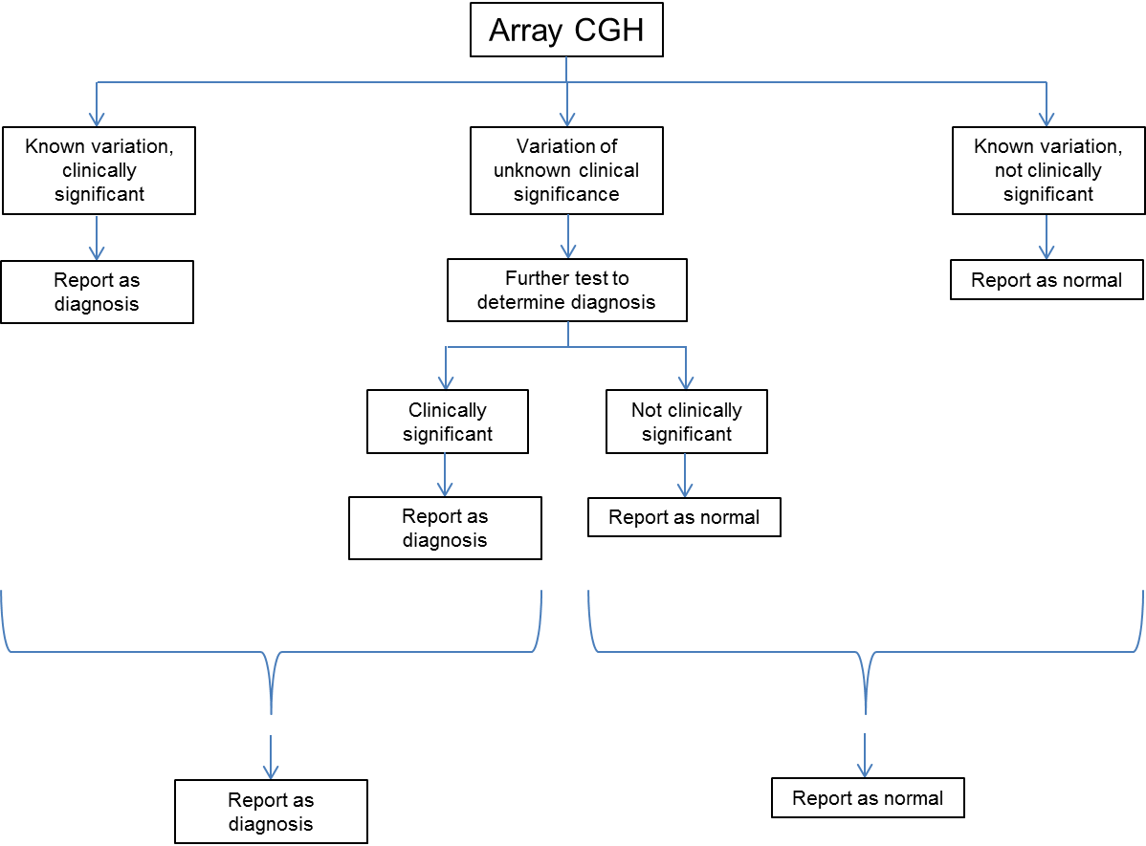
Figure 1: Simplified flowchart of the array-CGH testing pathway to be used in this evaluation for health outcomes. The “known variation, not clinically significant” arm includes to those patients in whom no variant was detected.
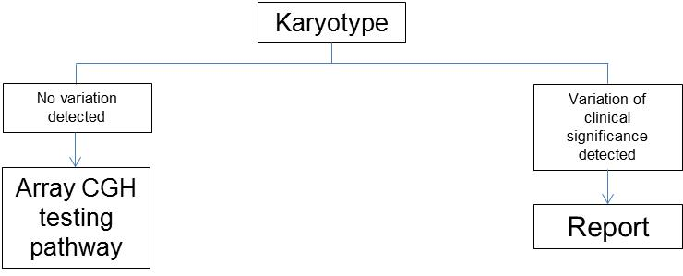
Figure 2: Simplified flowchart of the karyotype testing pathway (comparator intervention).

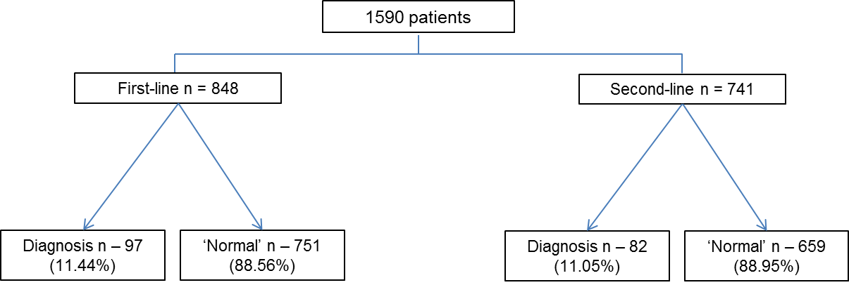

Figure 3: A flowchart to show how many diagnoses were made in the two intervention arms.

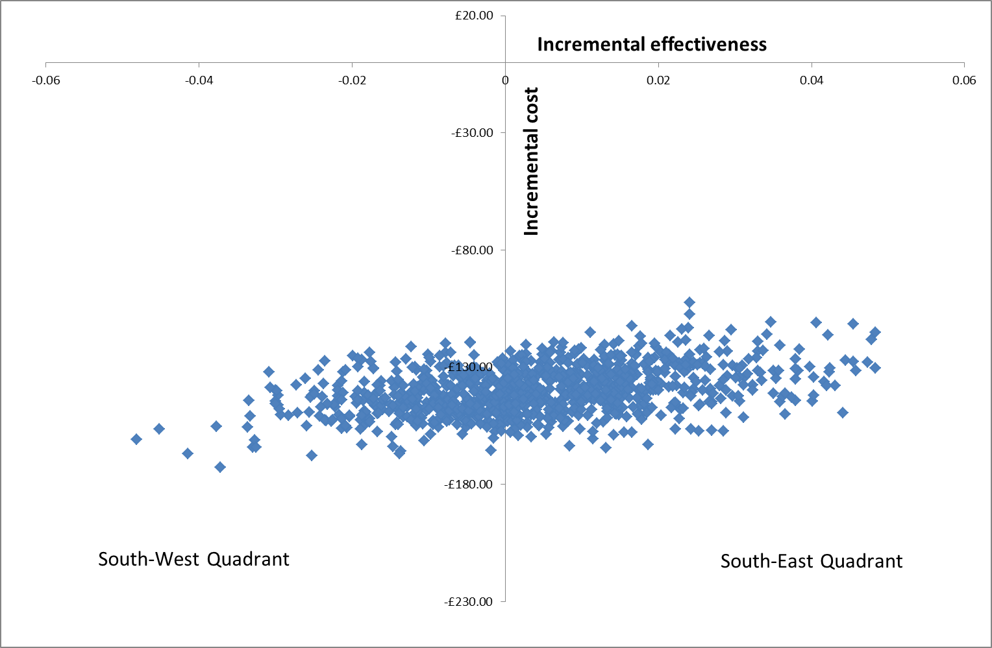
Figure 4: Bootstrap replications on the cost-effectiveness plane showing the South-East and South-West quadrants.

