Catalytic Protein Film Electrochemistry Provides a Direct Measure of the Tetrathionate/Thiosulfate Reduction Potential
Julia M. Kurth*¹, Christiane Dahl¹, Julea N. Butt*²
¹Institut für Mikrobiologie & Biotechnologie, Rheinische Friedrich-Wilhelms-Universität Bonn, Meckenheimer Allee 168, D-53115 Bonn, Germany.
²Centre for Molecular and Structural Biochemistry, School of Chemistry and School of Biological Sciences, University of East Anglia, Norwich Research Park, Norwich NR4 7TJ, U.K.

ABSTRACT: The tetrathionate/thiosulfate interconversion is a two-electron process: S₄O₆²⁻ + 2 e⁻ ↔ 2 S₂O₃²⁻. Both transformations can support bacterial growth since S₂O₃²⁻ provides an energy source while S₄O₆²⁻ serves as respiratory electron acceptor. Interest in the corresponding S₂O₃²⁻ oxidation also arises from its widespread use in volumetric analysis of oxidizing agents and bleach neutralization during water-treatment. Here we report protein film electrochemistry that defines the reduction potential of the S₄O₆²⁻/S₂O₃²⁻ couple. The relevant interconversion is not reversible at inert electrodes. However, facile reduction of S₄O₆²⁻ to S₂O₃²⁻ and the reverse reaction are catalyzed by enzymes of the thiosulfate dehydrogenase, TsdA, family adsorbed on graphite electrodes. Zero-current potentials measured with different enzymes, at three pH values, and multiple S₄O₆²⁻ and S₂O₃²⁻ concentrations together with the relevant Nernst equation resolved the tetrathionate/thiosulfate reduction potential as +198 ± 4 mV versus SHE. This potential lies in the approximately 250 mV window encompassing previously reported values calculated from parameters including the free energy of formation. However, the value is considerably more positive than widely used in discussions of bacterial bioenergetics. As a consequence anaerobic respiration by tetrathionate reduction is likely to be more prevalent than presently thought in tetrathionate-containing environments such as marine sediments and the human gut.

There are numerous sulfur oxoacids and many of those compounds have industrial significance¹. Perhaps the most well-known is sulfuric acid. This chemical is a key constituent of lead-acid batteries and the production of phosphate fertilizers. However, other sulfur oxoanions are valuable reducing agents. A case in point is thiosulfate (S₂O₃²⁻). This ion instantly neutralizes bleach in a reaction frequently exploited during water-treatment and paper-making. The final products of the reaction are tetrathionate (S₄O₆²⁻), higher polythionates and sulfate². Tetrathionate is formed by oxidative conjugation of two molecules of thiosulfate with two electrons released in the corresponding half-reaction (Eq. 1).
$${\left(1\right) S}_{4}{O_{6}}^{2-}+2 e^{-} ↔ 2 S_{2}{O_{3}}^{2-}$$
This half-reaction also underpins the wide-spread use of thiosulfate in analytical chemistry whereby stoichiometric reaction with I₂ produces 2 I⁻. The corresponding color change is widely used for volumetric analysis of oxidizing agents in aqueous solutions of ecological and recreational interest. However, in other contexts, e.g., the extraction of gold and silver by ammoniacal thiosulfate leaching, the oxidation of thiosulfate to tetrathionate is detrimental and aims to be minimized³.
In addition to the industrial and analytical importance of the thiosulfate/tetrathionate interconversion this reaction has considerable significance in the global biogeochemical cycling of sulfur^{4–6}. Certain prokaryotes in aquatic and terrestrial habitats obtain energy by the oxidation of thiosulfate to tetrathionate. Other prokaryotes use the reverse reaction, namely tetrathionate reduction, to support anaerobic respiration. In this latter context two prominent examples are the human gut pathogens Salmonella typhimurium⁷ and Campylobacter jejuni⁸. S. typhimurium reduces tetrathionate produced by vertebrate intestinal mucosa during inflammation and this may confer a competitive growth advantage on the pathogen by supporting increased transmission through the faecal-oral route⁷.
The processes mentioned above have focused attention on the reduction potential (E_{TT/TS}) of the tetrathionate/thiosulfate couple. Pourbaix (reduction potential-pH) diagrams including this value have been presented^{3,9}. E_{TT/TS} is also included in redox towers. These compare the reduction potentials of different redox couples as a guide to the respiratory electron transfer processes that may support bacterial colonization of a particular environment. However, there is ambiguity in the E_{TT/TS} values that appear in such resources as they span a window exceeding 250 mV; from +24 to +300 mV versus SHE^{10–13}. This variation stems largely from the irreversible nature of the thiosulfate/tetrathionate interconversion at an inert electrode^{9,14}. The resulting behavior is inconsistent with the relevant Nernst equation and this precludes direct measurement of E_{TT/TS}. As a consequence previously reported values relied completely on calculations from relevant thermodynamic data. However, free energies of formation for thiosulfate and tetrathionate are themselves constantly re-evaluated and published values cover ranges from approximately -510 to -600 kJ mol⁻¹ and -1020 to -1055 kJ mol⁻¹, respectively^{12,15–18}. Over the last four decades, an E_{TT/TS} value of +24 mV has been most widely cited in the field of microbiology. This value was calculated based on free energies of formation published in the 1950s^{15,17} and released in a highly influential seminal work on energy conservation in chemotrophic anaerobic bacteria¹⁰.
In order to address this situation by providing a direct measure of E_{TT/TS} we have performed catalytic protein film electrochemistry of enzymes from the thiosulfate dehydrogenase, TsdA, family¹⁹. The TsdA proteins are c-type cytochromes carrying two heme groups^{19,20}. An axial histidine/cysteine ligation of the central iron atom is characteristic for the active site heme. This type of ligation is rare among prokaryotes and appears to be of special importance in sulfur-based energy metabolism²⁰. In many cases, TsdA is accompanied by another diheme cytochrome c (TsdB) that serves as the redox partner for TsdA¹⁹. In some instances, TsdA and TsdB form a fusion protein. All TsdA enzymes characterized to date catalyze both the oxidation of thiosulfate to tetrathionate and the reduction of tetrathionate to thiosulfate at measurable rates^{8,19}. This reversibility is of crucial importance for the work presented here.
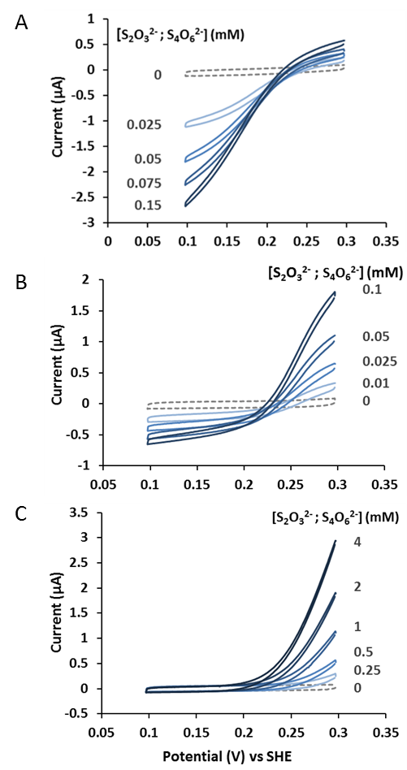
Figure 1. Representative protein film cyclic voltammetry of A) CjTsdA, B) MpTsdBA and C) AvTsdA in solutions containing equal concentrations of thiosulfate and tetrathionate as indicated (blue continuous lines) and prior to substrate addition (grey broken lines). Scan rate 10 mV s⁻¹, electrode rotation 500 rpm in 100 mM ammonium acetate, 50 mM NaCl, pH 5 at 25 ºC for MpTsdBA, AvTsdA and at 42 °C for CjTsdA.
Samples of the purified TsdA enzymes from Campylobacter jejuni (Cj) and Allochromatium vinosum (Av) as well as the TsdBA fusion protein from Marichromatium purpuratum (Mp) were adsorbed as separate electrocatalytically active films on graphite electrodes. Cyclic voltammetry revealed clear catalytic currents when the enzyme coated electrodes were placed in pH 5 solutions of equimolar tetrathionate and thiosulfate, Fig. 1. These currents were absent when either the enzyme or the substrates were omitted from the experiment. Thus, the catalytic currents arise exclusively from enzyme catalyzed tetrathionate reduction and/or thiosulfate oxidation and with that catalysis sustained by direct electron exchange between the enzyme and electrode.
For CjTsdA the reductive (negative) catalytic currents have significantly larger magnitude than their oxidative (positive) counterparts, Fig. 1A. As a consequence it is immediately apparent that CjTsdA is biased towards tetrathionate reduction relative to thiosulfate oxidation. By contrast MpTsdBA displays higher catalytic rates for thiosulfate oxidation than tetrathionate reduction which reveals this enzyme’s bias to oxidative catalysis, Fig. 1B. However, AvTsdA displays the greatest bias towards thiosulfate oxidation of the enzymes studied here, Fig. 1C. No evidence could be found for reductive catalysis by AvTsdA and this was despite all three enzymes displaying comparable current magnitudes for thiosulfate oxidation. This agrees with results from colorimetric solution assays of AvTsdA activity that found a strong bias towards thiosulfate oxidation with very low specific activity for tetrathionate reduction^{8,20}. Electrochemical resolu-tion of catalytic reduction by AvTsdA is most likely to be precluded by the intrinsically low rate of tetrathionate reduction combined with low electrocatalytic coverage of the electrode by the enzyme. Indeed, none of the enzymes display detectable non-turnover waves in the absence of substrate and this is consistent with low electrocatalytically active enzyme populations.
At high overpotentials the majority of the catalytic waves from all three enzymes fail to attain values that are independent of driving force for the relevant reaction. This is behavior that suggests heterogeneously oriented enzyme molecules displaying a range of interfacial electron transfer kinetics²¹. Never the less it is clear that films of CjTsdA and MpTsdBA catalyze rapid bidirectional interconversion of tetrathionate and thiosulfate. By visualizing such catalysis the protein film electrochemistry defines a zero-current potential (E_{ZCP}) from which E_{TT/TS} can be calculated using the relevant Nernst equation (Eq. 2)
$$\left(2\right) E_{TT/TS} =E_{ZCP}-\frac{RT}{2F}\ln\left(\frac{\left[S_{4}O_{6}^{2-}\right]}{{[S_{2}O_{3}^{2-}]}^{2}}\right)$$
where R, F and T have their usual meaning^{22–24}. A number of factors contribute to defining catalytic bias^{25,26} but their resolution for the TsdA enzymes lies beyond the scope of the present work.
Values for E_{ZCP} were obtained by two methods as detailed in the Supporting Information. In one approach E_{ZCP} was defined as the points of intersection for cyclic voltammograms recorded in the presence and absence of substrates (averaged for each scan direction), e.g., Fig. 1A and B. In the second approach the potential required to maintain zero current through the cell was measured directly. For all experiments the thiosulfate/tetrathionate mixtures were prepared immediately prior to use and with concentrations chosen to minimize the likelihood of any significant reaction between tetrathionate and thiosulfate^{27,28}. Measurements by the second method were typically complete within 3 minutes while those using the first method took approximately 15 minutes. No systematic differences were detected between E_{ZCP} values determined by the two approaches so the initial substrate concentrations were taken as those defining E_{ZCP}. The corresponding values of E_{TT/TS} lie between +187 and +205 mV versus SHE, Fig. 2 (black solid circles and triangles).
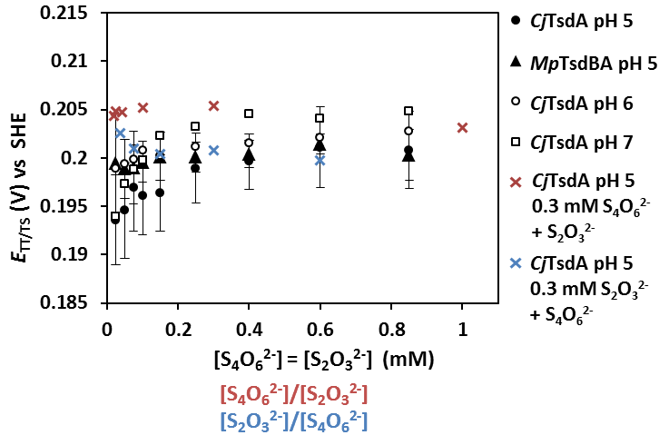
Figure 2. Values for the formal potential of the tetrathionate/thiosulfate couple, E_{TT/TS}, defined by protein film electrochemistry. Equal concentrations of S₂O₃²⁻ and S₄O₆²⁻ (black: symbols and x-axis title). Different concentrations of S₂O₃²⁻ with [S₄O₆²⁻] = 0.3 mM (red: crosses and x-axis title). Different concentrations of S₄O₆²⁻ with [S₂O₃²⁻] = 0.3 mM (blue: crosses and x-axis title). See text for details. Error bars were generated when at least two independent measurements were made.
Our analysis makes two assumptions. First, that the enzymes are true catalysts, changing the rate of attainment of equilibrium but not the position of equilibrium. Second, that the activities of thiosulfate and tetrathionate equate to their respective concentrations under our experimental conditions. Further experiments performed with CjTsdA confirmed the validity of our approach. Thiosulfate was introduced to a solution that contained 0.3 mM tetrathionate but initially no thiosulfate, Fig. 3A. Cyclic voltammetry quantified an increase in the ratio of oxidative relative to reductive catalysis on increasing the thiosulfate concentration from 0.3 to 12 mM. In addition E_{ZCP} was displaced by approximately -100 mV. In a separate experiment the tetrathionate concentration was increased from 0.05 to 0.5 mM in a solution containing initially 0.3 mM thiosulfate, Fig. 3B. Here E_{ZCP} was displaced by approximately +30 mV. However for both data sets the values of E_{TT/TS} calculated from Eq. 2 were essentially independent of the thiosulfate:tetrathionate ratio, Fig. 2 (red and blue crosses). The values were also in accord with those defined from the measurements with equal concentrations of both substrates.
The cyclic voltammograms presented above contain a wealth of information on the catalytic properties of TsdA enzymes. For example, thiosulfate is seen to inhibit tetrathionate reduction, Fig. 3A, and tetrathionate to inhibit thiosulfate oxidation, Fig. 3B. However, these features of the catalytic properties of CjTsdA will be described more fully elsewhere (JK, CD, JB manuscript in preparation). Here we retain a focus on the experimental resolution of E_{TT/TS} and a final series of experiments that address the pH dependence of this parameter. Neither thiosulfate nor tetrathionate change their protonation state between pH 5 and pH 7⁹. As a consequence E_{TT/TS} will be independent of pH in this range. Measurements in solutions of equal concentrations of thiosulfate and tetrathionate with CjTsdA at pH 6 or at pH 7 generated E_{TT/TS} values with the predicted behavior, Fig. 2 (open circles and squares). Taking the average of the 111 data points represented in Fig. 2 we determine a value for E_{TT/TS} of +198 ± 4 mV versus SHE.
Figure 3. Protein film cyclic voltammetry for CjTsdA in A) 0.3 mM S₄O₆²⁻ and B) 0.3 mM S₂O₃²⁻ with increasing concentration of the second substrate as indicated. Cyclic voltammetry recorded prior to substrate addition (grey broken lines). Scan rate 10 mV s⁻¹, electrode rotation, 500 rpm in 100 mM ammonium acetate, 50 mM NaCl, pH 5, 42 ºC.
The range of oxidation states (-2 to +8) available to sulfur and the abundance of compounds containing multiple sulfurs with different oxidation states leads to a rich and complex chemistry of aqueous sulfur oxoanions^{1,2,29}. By exploiting enzymes as selective catalysts for the tetrathionate/thiosulfate interconversion we have been able to provide experimental resolution of a key thermodynamic parameter contributing to the description of such systems. The experimentally measured value of E_{TT/TS} lies within the range of values calculated previously^{10–13}. However, it is 174 mV more positive than the value of +24 mV¹⁰ widely cited in the construction of redox towers. As a consequence more free energy is available to be harnessed during the respiratory reduction of tetrathionate than was previously recognized. At +198 mV the formal reduction potential of the tetrathionate/thiosulfate couple is more positive than the corresponding values for several prevalent terminal respiratory electron acceptor couples at neutral pH. These include fumarate/succinate (+33 mV)¹⁰, trimethylamine oxide/trimethylamine (+130 mV)³⁰ and dimethylsulfoxide/dimethylsulfide (+160 mV)³¹. This can explain why Salmonella enterica grows by oxidation of propanediol or ethanolamine in the presence of tetrathionate, but not dimethylsulfoxide, trimethylamine oxide or fumarate, as terminal respiratory electron acceptor. This is despite S. enterica having capacity to respire on these alternate terminal electron acceptors when more reduced electron donor(s) such as glycerol are used³². Indeed tetrathionate may provide the respiratory electron acceptor in many more contexts than presently recognized. The lifestyles of pathogenic and commensal gut bacteria may benefit from respiratory reduction of the tetrathionate produced in the human intestine during inflammation⁶. In addition, for marine microbiota at neutral pH the tetrathionate in sediments represents a more favorable electron acceptor than the high abundance compounds dimethylsulfoxide and trimethylamine oxide³³.
An exact, experimentally achieved E_{TT/TS} value as provided here will also contribute to a better understanding of industrial applications involving thiosulfate. One prominent example is the use of thiosulfate instead of the hazardous cyanide as a lixiviant for gold. Despite extensive research work in this area, neither commercialization of the thiosulfate processes nor full knowledge of the underlying mechanism have been achieved^{3,34,35}. This is due largely to the complexity of the chemical reactions accompanying the process and which include the formation of tetrathionate and other polythionates from the oxidation of thiosulfate in aqueous solutions.
ASSOCIATED CONTENT
Supporting Information. Overproduction, purification and preparation of the thiosulfate dehydrogenases. Electrochemical procedures, resolution of E_{ZCP} and quantification of catalytic bias resolved from Fig. 1. This material is available free of charge via the Internet at http://pubs.acs.org.
AUTHOR INFORMATION
Corresponding Authors
* j.butt@uea.ac.uk
* julia-kurth@gmx.de
Notes
The authors declare no competing financial interest.
ACKNOWLEDGMENTS
We thank Jula Reuter for cloning pET_marpuDRAFT_1194, Alexander Flegler for preparation of MpTsdBA and AvTsdA, Sam Rowe and Colin Lockwood for assistance with the electrochemical measurements and Myles Cheesman for helpful discussion. Funding was from the Deutsche Forschungsgemeinschaft (DA351/7-2) to CD, a scholarship to JK from the Aventis Foundation awarded by the Association of the Chemical Industry (scholarship 700051) and the UK Biotechnology and Biological Sciences Research Council grants K009885 and L022176 to JNB.

REFERENCES
(1) Harding, C.; Janes, R.; Johnson, D. Elements of the P Block; Royal Society of Chemistry: Cambridge, 2002.
(2) Varga, D.; Horváth, A. K.; Nagypál, I. J. Phys. Chem. B 2006, 110, 2467–2470.
(3) Aylmore, M. G.; Muir, D. M. Miner. Eng. 2001, 14, 135–174.
(4) Trudinger, P. A. J. Bacteriol. 1967, 93, 550–559.
(5) Barrett, E. L.; Clark, M. A. Microbiol. Rev. 1987, 51, 192–205.
(6) Podgorsek, L.; Imhoff, J. F. Aquat. Microb. Ecol. 1999, 17, 255–265.
(7) Winter, S. E.; Thiennimitr, P.; Winter, M. G.; Butler, B. P.; Huseby, D. L.; Crawford, R. W.; Russell, J. M.; Bevins, C. L.; Adams, L. G.; Tsolis, R. M.; Roth, J. R.; Bäumler, A. J. Nature 2010, 467, 426–429.
(8) Liu, Y. W.; Denkmann, K.; Kosciow, K.; Dahl, C.; Kelly, D. J. Mol. Microbiol. 2013, 88, 173–188.
(9) Pourbaix, M.; Pourbaix, A. Geochim. Cosmochim. Acta 1992, 56, 3157–3178.
(10) Thauer, R. K.; Jungermann, K.; Decker, K. Bacteriol. Rev. 1977, 41, 100–180.
(11) Kaprálek, F. J. Gen. Microbiol. 1972, 71, 133–139.
(12) Cobble, J. W.; Stephens, H. P.; McKinnon, I. R.; Westrum, E. F. Inorg. Chem. 1972, 11, 1669–1674.
(13) Williamson, M. A.; Rimstidt, J. D. Geochim. Cosmochim. Acta 1992, 56, 3867–3880.
(14) Bard, A. J.; Parsons, R.; Jordan, J. Standard potentials in aqueous solution; Marcel Dekker: New York, 1985.
(15) Mel, H. C.; Hugus, Z. Z.; Latimer, W. M. J. Am. Chem. Soc. 1956, 78, 1822–1826.
(16) Wagman, D. D.; Evans, W. H.; Parker, V. B.; Schumm, R. H.; Halow, I.; Bailey, S. M.; Churney, K. L.; Nuttall, R. L. Phys. Chem. Ref. Data 1982, 11, Supplement No. 2.
(17) Latimer, W. M. Oxidation potentials, 2nd ed.; Prentice-Hall: New York, 1952.
(18) Oelkers, E. H.; Helgeson, H. C.; Shock, E. L.; Sverjensky, D. A.; Johnson, J. W.; Pokrovskii, V. A. J. Phys. Chem. Ref. Data 1995, 24, 1401–1560.
(19) Denkmann, K.; Grein, F.; Zigann, R.; Siemen, A.; Bergmann, J.; van Helmont, S.; Nicolai, A.; Pereira, I. A. C.; Dahl, C. Environ. Microbiol. 2012, 14, 2673–2688.
(20) Brito, J. A.; Denkmann, K.; Pereira, I. A. C.; Archer, M.; Dahl, C. J. Biol. Chem. 2015, 290, 9222–9238.
(21) Léger, C.; Jones, A. K.; Albracht, S. P. J.; Armstrong, F. A. J. Phys. Chem. 2002, 106, 13058–13063.
(22) Hirst, J.; Sucheta, A.; Ackrell, B. A. C.; Armstrong, F. A. J. Am. Chem. Soc. 1996, 118, 5031–5038.
(23) Zu, Y.; Shannon, R. J.; Hirst, J. J. Am. Chem. Soc. 2003, 125, 6020–6021.
(24) Parkin, A.; Seravalli, J.; Vincent, K. A.; Ragsdale, S. W.; Armstrong, F. A. J. Am. Chem. Soc. 2007, 129, 10328–10329.
(25) Hexter, S. V; Esterle, T. F.; Armstrong, F. A. Phys. Chem. Chem. Phys. 2014, 16, 11822–11833.
(26) Abou Hamdan, A.; Dementin, S.; Liebgott, P. P.; Gutierrez-Sanz, O.; Richaud, P.; De Lacey, A. L.; Roussett, M.; Bertrand, P.; Cournac, L.; Léger, C. J. Am. Chem. Soc. 2012, 134, 8368–8371.
(27) Zhang, H.; Jeffrey, M. I. Inorg. Chem. 2010, 49, 10273–10282.
(28) Fava, A.; Bresadola, S. J. Am. Chem. Soc. 1955, 77, 5792–5794.
(29) Xu, L.; Horváth, A. K. J. Phys. Chem. A 2014, 118, 6171–6180.
(30) Jones, C. W. Bacterial respiration and photosynthesis; Thomas Nelson and Sons, Ltd.: Walton-on-Thames, 1982.
(31) Wood, P. M. FEBS Lett 1981, 124, 11–14.
(32) Price-Carter, M.; Tingey, J.; Bobik, T. A.; Roth, J. R. J. Bacteriol. 2001, 183, 2463–2475.
(33) Barrett, E. L.; Kwan, H. S. Ann. Rev. Microbiol. 1985, 39, 131–149.
(34) Grosse, A. C.; Dicinoski, G. W.; Shaw, M. J.; Haddad, P. R. Hydrometallurgy 2003, 69, 1–21.
(35) Feng, D.; Van Deventer, J. S. J. Hydrometallurgy 2010, 105, 120–126.

TOC Graphic
