Supporting Information.
Catalytic Protein Film Electrochemistry Provides a Direct Measure of the Tetrathionate/Thiosulfate Reduction Potential
Julia M. Kurth*¹, Christiane Dahl¹, Julea N. Butt*²
¹Institut für Mikrobiologie & Biotechnologie, Rheinische Friedrich-Wilhelms-Universität Bonn, Meckenheimer Allee 168, D-53115 Bonn, Germany.
²Centre for Molecular and Structural Biochemistry, School of Chemistry and School of Biological Sciences, University of East Anglia, Norwich Research Park, Norwich NR4 7TJ, U.K.

Overproduction AND purification Of recombinant THiosulfate dehydrogenases
The c8j_0815 (tsdA) gene was amplified from the C. jejuni 81116 genome with primers pET-N-TsdACj_fw (CCGGATCCTTAGATCCAAATTTG) and pET-N-TsdACj_rev (CCGAAGCTTCTACTTCTTGATCA) carrying BamHI and HindIII restriction sites, respectively. The digested PCR product was cloned into a modified pET22b vector encoding an N-terminal Strep-tag (pETStrepDsrJ), resulting in pET-N-Strep-TsdACj. pETStrepDsrJ (Fabian Grein, Bonn, unpublished work) contains the A. vinosum dsrJ¹ gene with a sequence encoding a N-terminal Strep-tag between the NcoI and HindIII sites of pET22b (Novagen). A BamHI site resides between the Strep-tag and DsrJ encoding sequences.
Single colonies of E. coli BL21(DE3) containing pET-N-Strep-TsdACj and pEC86² were inoculated in 800 ml batches of LB medium containing 100 mg ml⁻¹ ampicillin and 25 mg ml⁻¹ chloramphenicol and incubated at 37 °C and 180 rpm. Cells were harvested by centrifugation after 15 to 17 h, resuspended in 100 mM Tris-HCl, pH 8.0, and lysed by sonication. Insoluble material was removed by centrifugation; 17 700 g for 30 min at 4 °C. Then CjTsdA (37103 Da; without signal peptide, with hemes) was purified by Strep-Tactin affinity chromatography according to the manufacturer’s instructions (IBA GmbH, Göttingen, Germany).
The marpu_02550 (tsdBA) gene was amplified from the M. purpuratum 984 genome with primers MarpuDR1194_for (CGGAGGGATCCTCATATGACGCATCTC) and MarpuDR1194_rev (GACCTGCTCGAGATCCTTGGC) carrying NdeI and XhoI restriction sites, respectively. The fragment was cloned into pET-22b(+) (Novagen) containing the sequence for a C-terminal His-tag, resulting in pET_marpuDRAFT_1194. 700 ml batches of LB medium with 100 mg ml⁻¹ ampicillin and 25 mg ml⁻¹ chloramphenicol were inoculated (2 % v/v) with a preculture of E. coli BL21 (DE3) cells containing pET_marpuDRAFT_1194 and pEC86². Cultures were grown at 37 °C and 180 rpm until an OD₆₀₀ of 0.6 was reached, followed by overnight incubation at 25 °C and 180 rpm. The cells were harvested by centrifugation, resuspended in 50 mM NaH₂PO₄, 300 mM NaCl, 10 mM imidazole; pH 7.5 and lysed by sonication. Insoluble material was removed by centrifugation; 17 700 g for 30 min at 4 °C. MpTsdBA (58151 Da; without signal peptide, with hemes) was purified via nickel-chelate affinity chromatography according to the manufacturer's instructions (Qiagen, Hilden, Germany). AvTsdA (28142 Da; without signal peptide, with hemes) was overproduced and purified as described previously³.
The purity of the proteins was assessed by sodium dodecyl sulfate-polyacrylamide gel electrophoresis (SDS-PAGE) performed as described in Dahl et al. (2005)⁴ and heme staining in acrylamide gels was done as described by Thomas et al. (1976)⁵. The proteins used for electrochemistry were judged to be at least 95 % pure on the basis of SDS-PAGE, SI Fig. 1. Protein concentrations were determined with the BCA-Kit from Pierce (Rockford, USA). Aliquots of the purified proteins were stored frozen at -80 ºC.
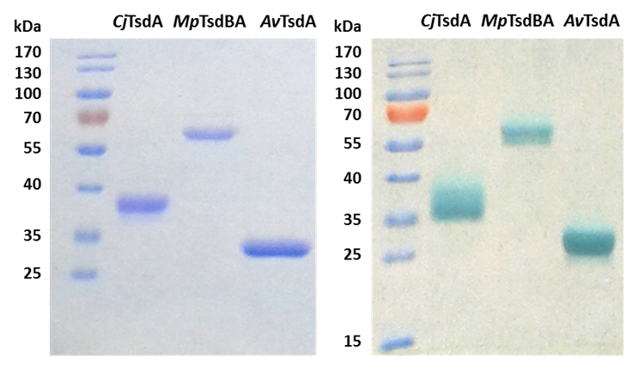
SI Figure 1: SDS-PAGE demonstrating purity of samples used for protein film electrochemistry. Gels loaded with 3 to 6 µg CjTsdA, MpTsdBA and AvTsdA as indicated. Protein visualized by Coomassie blue staining (left panel) and heme staining (right panel).
Protein film electrochemistry
Reagents were of Analar quality or higher and the water was of resistivity > 18 MΩ cm. Stock solutions of Na₂S₂O₃ (0.5 M) and Na₂S₄O₆ (0.5 M) were prepared as needed for each day of experiments by dissolution of the required mass in an appropriate volume of water. Solutions for electrochemical analysis were prepared immediately prior to measurement by appropriate dilution of the stock solution(s) into the desired buffer-electrolyte. The buffer-electrolyte at pH 5 was 100 mM ammonium acetate, 50 mM NaCl, at pH 6 was 50 mM potassium phosphate, 50 mM NaCl and at pH 7 was 50 mM HEPES, 50 mM NaCl. For AvTsdA, higher current magnitudes were observed when 2 mM neomycin was included in the enzyme solution used to coat the electrode and in the electrochemical cell.
Protein-film electrochemistry was performed using a previously described non-isothermal three-electrode cell configuration⁶. The reference electrode was Ag/AgCl, saturated KCl. Measured potentials were converted to values vs SHE by addition of 197 mV. Immediately prior to use pyrolytic graphite edge working electrodes (3 mm diameter) were polished with an aqueous slurry of 0.3 μm Al₂O₃, sonicated, rinsed and dried with a tissue. The polished electrode was exposed to a solution of the desired enzyme; 103 µM CjTsdA in 50 mM HEPES pH 7, 50 mM NaCl or 60 µM MpTsdBA in 20 mM Tris-HCl pH 7.5, 150 mM NaCl or 129 µM AvTsdA in 50 mM Bis-Tris pH 6.5, 2 mM neomycin. After ca. 3 minutes the enzyme solution was removed from the electrode surface, which was then rinsed with room temperature buffer-electrolyte to remove any loosely bound enzyme. Excess buffer-electrolyte was carefully removed from the electrode with a tissue taking care not to dry the electrode surface. The electrode was then placed in the electrochemical cell and measurement commenced. Electrochemical measurements were performed with an Autolab electrochemical analyzer under the control of GPES software. Electrode rotation was with an EG&G Model 636 electrode rotator. Catalytic currents were independent of electrode rotation at ≥ 500 rpm and so free from limitation by mass transfer of substrate (product) to (from) the adsorbed enzyme. For these conditions the catalytic currents of the forward and reverse sweeps were essentially superimposable and proved to be remarkably robust. There was no detectable loss of magnitude over 30 minutes of continuous cyclic voltammetry. The electrochemical sample was maintained at 42 ºC for studies of CjTsdA because this is the optimal growth temperature of C. jejuni. Measurements with MpTsdBA and AvTsdA were performed with the sample at 25 ºC.
Values for E_{TT/TS} were derived from measurements made in the presence of CjTsdA or MpTsdBA since both enzymes displayed clear catalytic currents for thiosulfate oxidation and tetrathionate reduction. The catalytic bias of both enzymes at pH 5 is quantified in SI Figure 2. Values for E_{TT/TS} were calculated using the Nernst equation and E_{ZCP} values measured in a range of conditions. From cyclic voltammetry, E_{ZCP} values were defined from the points of intersection of voltammograms recorded in the presence and absence of substrates and averaged for each scan direction (as an example see SI Figure 3). E_{ZCP} values were also measured directly with the electrochemical analyzer operated in the galvanostat mode. Values of E_{TT/TS} calculated from these two methods conform very well (SI Figure 4). For Figure 2 of the main text and in reporting the error range, average values and standard deviations were calculated from the appropriate data sets in Microsoft Excel 2010.

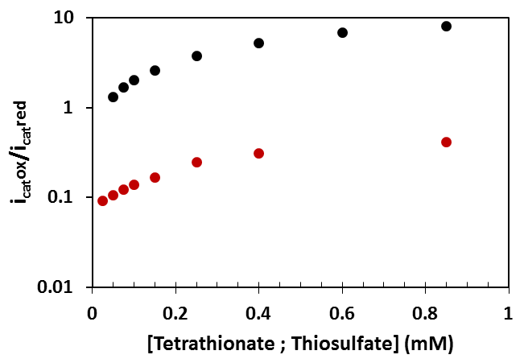

SI Figure 2. The catalytic bias of CjTsdA (red) and MpTsdBA (black) at pH 5 in equal concentrations of tetrathionate and thiosulfate. The catalytic current magnitudes were measured at +275 mV for thiosulfate oxidation (i_{cat}ox) and +175 mV for tetrathionate reduction (i_{cat}red). These values were extracted from the cyclic voltammograms of Figure 1 that were performed with a scan rate of 10 mV s⁻¹ and electrode rotation at 500 rpm. Buffer-electrolyte 100 mM ammonium acetate, 50 mM NaCl, pH 5 at 42 °C for CjTsdA and 25 ºC for MpTsdAB.
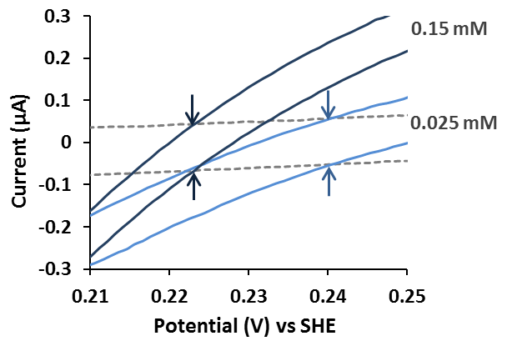
SI Figure 3. Representative protein film cyclic voltammetry of CjTsdA in solutions containing equal concentrations of thiosulfate and tetrathionate as indicated (blue continuous lines) and prior to substrate addition (grey broken line). The points of zero current for each scan direction are indicated with arrows and the corresponding E_{ZCP} values are 0.223 V at 0.15 mM substrates and 0.240 V at 0.025 mM substrates. Scan rate 10 mV s⁻¹, electrode rotation 500 rpm in 100 mM ammonium acetate, 50 mM NaCl, pH 5 at 42 ºC. This graphic is an extract of Figure 1 of the main text.
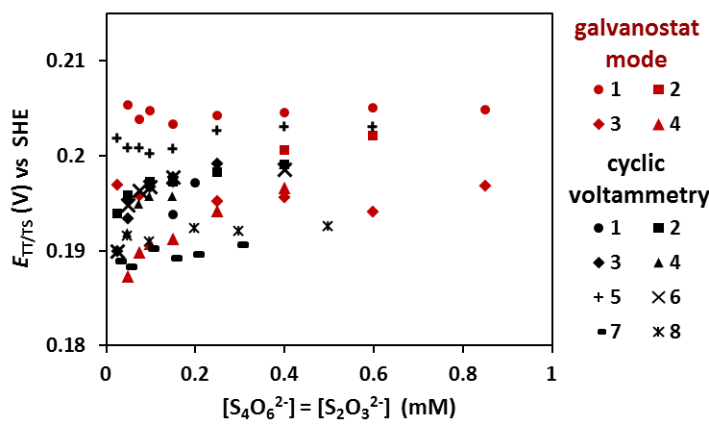
SI Figure 4. E_{TT/TS} values defined by protein film electrochemistry of CjTsdA at pH 5 and equal concentrations of S₂O₃²⁻ and S₄O₆²⁻. The E_{ZCP} values used for calculation of E_{TT/TS} were either measured by cyclic voltammetry (black symbols) or directly with the electrochemical analyzer operated as a galvanostat (red symbols).The average E_{TT/TS} value determined by cyclic voltammetry is 196 ± 4 mV and the average value derived from measurements in the galvanostat mode is 198 ± 5 mV.

REFERENCES
(1) Grein, F.; Venceslau, S. S.; Schneider, L.; Hildebrandt, P.; Todorovic, S.; Pereira, I. A. C.; Dahl, C. Biochemistry 2010, 49, 8290–8299.
(2) Arslan, E.; Schulz, H.; Zufferey, R.; Künzler, P.; Thöny-Meyer, L. Biochem. Biophys. Res. Commun. 1998, 251, 744–747.
(3) Denkmann, K.; Grein, F.; Zigann, R.; Siemen, A.; Bergmann, J.; van Helmont, S.; Nicolai, A.; Pereira, I. A. C.; Dahl, C. Environ. Microbiol. 2012, 14, 2673–2688.
(4) Dahl, C.; Engels, S.; Pott-Sperling, A. S.; Schulte, A.; Sander, J.; Lübbe, Y.; Deuster, O.; Brune, D. C. J. Bacteriol. 2005, 187, 1392–1404.
(5) Thomas, P. E.; Ryan, D.; Levin, W. Anal. Biochem. 1976, 75, 168–176.
(6) Anderson, L. J.; Richardson, D. J.; Butt, J. N. Biochemistry 2001, 40, 11294–11307.

