New azepinium salt epoxidation organocatalysts derived from amino alcohols: Novel diastereo- and atropo- selective approach to a tetracyclic biphenyl core

Philip C. Bulman Page,ª* Christopher A. Pearce,ª Yohan Chan,ª Phillip Parker,^{b} Benjamin R. Buckley,^{b} Gerasimos A. Rassias,^{c} and Mark R. J. Elsegood ^{b}

ª School of Chemistry, University of East Anglia, Norwich Research Park, Norwich, Norfolk NR4 7TJ, UK
^{b} Chemistry Department, Loughborough University, Loughborough, Leicestershire LE11 3TU, UK
^{c} Department of Chemistry, University of Patras, 26504 Patras, Greece

p.page@uea.ac.uk

Abstract
A range of new biphenylazepinium salt organocatalysts effective for asymmetric epoxidation has been developed incorporating an additional substituted oxazolidine ring, and providing improved enantiocontrol in alkene epoxidation over the parent structure. Starting from enantiomerically pure amino-alcohols, tetracyclic iminium salts were obtained as single diastereoisomers through an atroposelective oxazolidine formation.

Introduction
Epoxides are versatile building blocks widely used in synthesis.¹ The past thirty years have seen the development of many methodologies capable of efficient asymmetric epoxidation of various types of alkene.2 Dioxiranes,3 and oxaziridinium salts, first reported by Lusinchi,⁴ and generated in situ from the corresponding iminium salts⁵ or amines,⁶ have proven to be two of the most effective types of organocatalyst for asymmetric oxygen transfer to weakly nucleophilic substrates such as unfunctionalized alkenes. Over the past ten years we have developed a range of enantiopure iminium salts effective as organocatalysts for highly enantioselective asymmetric epoxidation in the presence of Oxone as stoicheiometric oxidant. We have reported that the most reactive and selective iminium salt catalysts discovered to date are based on (S,S)-acetonamine derivative 1 and a biphenyl backbone such as 2, 3 and 4, or a binaphthyl backbone such as 5. For example, iminium species 2a catalyses the oxidation of 1-phenylcyclohexene to its corresponding epoxide in less than 4 minutes inducing up to 60% enantioselectivity,⁷ while catalyst 5a affords the same epoxide in 91% ee after 15 min.⁸ The use of alternative oxidants, such as bleach or hydrogen peroxide, has also been explored,⁹ and the successful development of non-aqueous conditions using tetraphenylphosphonium monoperoxysulfate¹⁰ (TPPP) has allowed us to access highly enantioenriched epoxides (up to 99% ee).¹¹
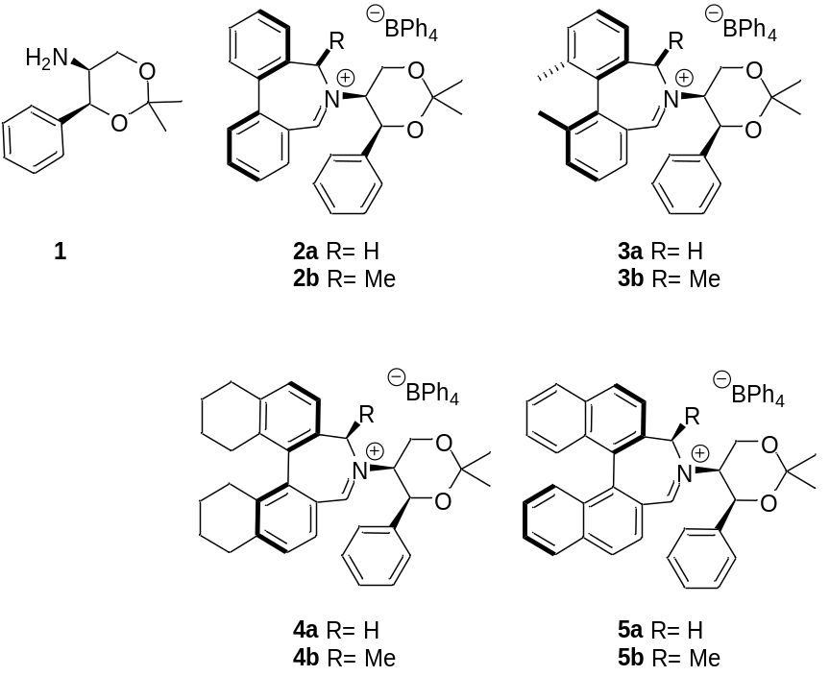
Figure 1. Iminium salt catalysts for asymmetric epoxidation

A potential issue concerning cyclic biaryl structures is their ability to rotate through the aryl/aryl bond generating two interconverting atropoisomers.¹² Using biaryl azepine 6 as a model substrate, Wallace showed that asymmetric introduction of an alkyl group at C(7) could induce a strong conformational preference for one atropoisomer.¹³ Lacour has used derivatization at the 3,3’-positions on the aromatic rings to prevent such interconversion, as in 3a/3b.¹⁴ We have shown that the introduction of an axial substituent at the C(7) position by nucleophilic addition to 2a to create a new chiral centre adjacent to the iminium nitrogen, followed by reoxidation, generates ‘second generation’ iminium salt catalysts such as 2b, 3b, 4b and 5b, which provide increased enantiocontrol in the epoxidation of alkene substrates.¹⁵

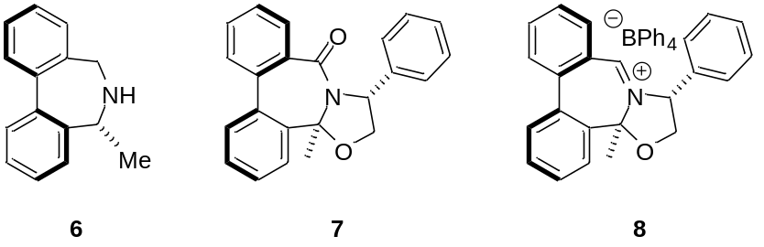

Meyers’ bicyclic lactam methodology has been widely used in the stereoselective construction of five-, six- and seven-membered ring nitrogen heterocycles from enantiopure amino alcohols.¹⁶ Particularly of interest to us, the methodology has been applied to prepare a range of axially chiral biaryl lactams such as 7.¹⁷ We postulated that structurally related iminium salts such as 8 might impart increased levels of enantioselectivity when used as an asymmetric epoxidation catalyst by imparting additional rigidity and structural elements in the transition state compared to catalysts such as 4.

Results and Discussion
Our initial hypothesis was that the 7,5-fused bicyclic lactam sub-structure 7 could be used to generate amine 9, a suitable precursor to iminium species 8, by reduction of the lactam unit (Scheme 1). However, reduction of compound 7 is known to lead to amino-alcohol 10 using literature procedures.¹⁸ We have previously shown that oxidation of such azepines occurs preferentially at the least substituted adjacent position, ruling out the possibility to use this pathway, because 10 would not be oxidized to 11.¹⁵ We therefore devised an alternative pathway based upon a biaryl coupling of a suitably functionalized oxazolidinone using an adaptation of Fagnou’s methodology¹⁹ by Wallace (Scheme 1).²⁰ Synthesis of the cyclization precursor 12 would be achieved by Suzuki-Miyaura coupling of a suitably functionalized amino-alcohol 14 with 2-acetylphenylboronic acid to give 13, and subsequent hydrolysis of the oxazolidinone protecting group. Cyclocondensation of 12 to form the iminium species 11 would result in concomitant cyclization to the oxazolidine 9 by intramolecular attack of the hydroxyl group. We have previously observed diastereoselective formation of oxazolidines in a related binaphthyl system when generating iminium species bearing an alcohol moiety.²¹ Finally, oxidation of 9 under our standard conditions would give iminium salt catalyst 8.

This methodology would allow the use of a wide variety of enantiomerically pure amino-alcohol precursors. Accordingly, alkylation of (R)-phenyl oxazolidinone 15 with 2-iodobenzylbromide afforded N-substituted oxazolidinone 14 in 98% yield. N-Benzyl oxazolidinone 14 was coupled with 2-acetylphenyl boronic acid under conditions used by Levacher.^{17a} Hydrolysis of the crude oxazolidinone 13 was completed with aqueous sodium hydroxide in dichloromethane; the solvent was removed and tert-butylmethyl ether (TBME) added. The resulting solution of aminoalcohol 12 was treated with aqueous HCl to generate the desired tetracyclic amine 9 via 11 as a single diastereoisomer in 12% yield over the three steps. Finally, the iminium salt 8 was generated by oxidation of the amine using NBS in chloroform in 80% yield.

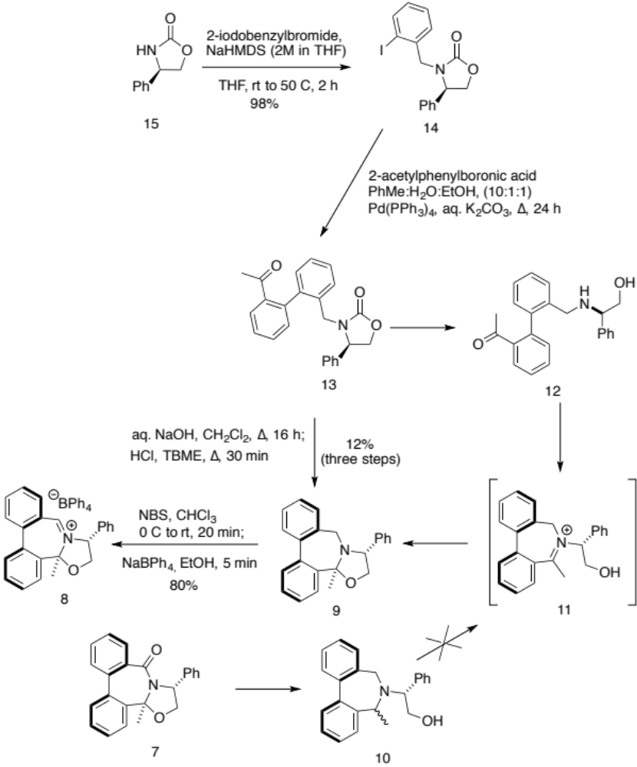
Scheme 1

We tested iminium salt 8 for its efficacy as an epoxidation catalyst, using 1-phenylcyclohexene as our test substrate under our standard Oxone oxidative conditions. Catalyst 8 gave 100% conversion within thirty minutes, imparting a fair 55% ee for 1-phenylcyclohexene oxide (Scheme 2).

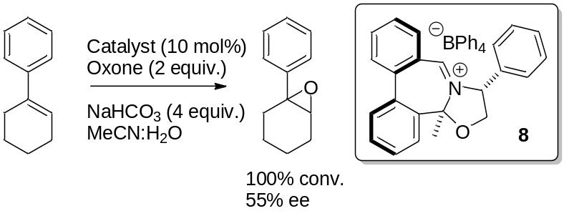
Scheme 2

While this result established a new sub-structure of iminium salts active for the catalytic asymmetric epoxidation of alkenes, the overall yield of this synthetic route, particularly in the conversion of 14 into 9, coupled with the problematic purification of the unstable oxazolidinone 13 led us to seek an alternative.

We reasoned that a change of aminoalcohol protecting group from oxazolidinone to a much more readily hydrolysed oxaminal might improve the process, and so targeted dimethyloxazolidine 18 (Scheme 3). Reductive amination of 2-iodobenzaldehyde with (R)-phenyl glycinol 16 gave the N-benzyl amino alcohol 17 in 81% yield. Protection of the aminoalcohol functionality with dimethoxypropane gave the oxazolidine 18 in 96% yield.

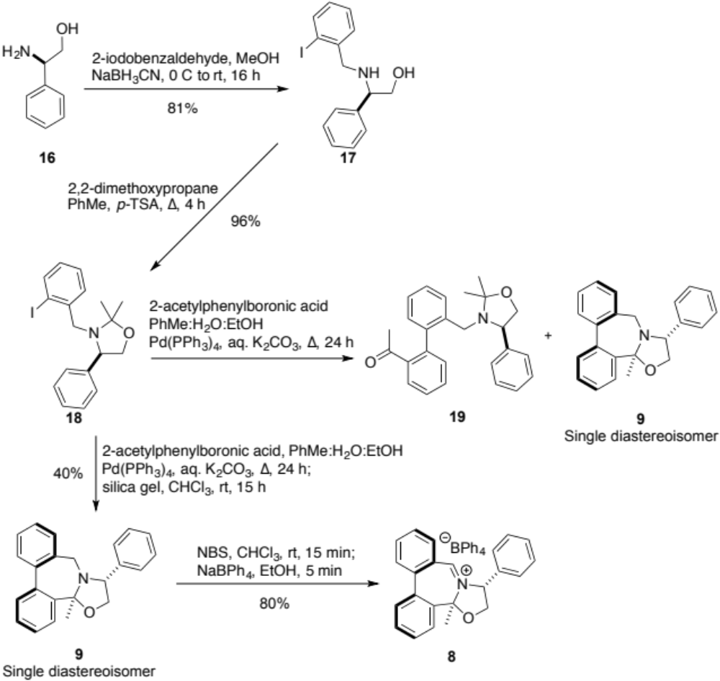
Scheme 3

Oxazolidine 18 was coupled with 2-acetylphenylboronic acid under the conditions described above. Attempted purification using column chromatography on silica gel of the crude coupled product led to the isolation of a mixture of two inseparable compounds. Upon inspection of the ¹H NMR spectrum of the mixture, the two products were identified as the desired Suzuki adduct 19 and the target tetracyclic 6,6,7,5 material 9 as a single diastereoisomer.

Following our conjecture that silica gel had effected a deprotection to expose the aminoalcohol, which then condensed in situ with the pendent ketone generating the desired tetracycle, we subjected the crude reaction mixture from the Suzuki coupling to silica gel in chloroform over 15 h (Scheme 3), so generating tetracycle 9 as a single diastereoisomer in a somewhat improved 40% yield. The absolute configuration of 9 was confirmed by single crystal X-ray analysis. The tetracylic tertiary amine 9 was readily converted into iminium salt 8 in 80% yield. To test the need for the protection/deprotection steps, a Suzuki coupling between unprotected amino-alcohol 17 and 2-acetylphenylboronic acid was attempted.

Anticipating the deactivation of the palladium-phosphine catalyst by the aminoalcohol, we expected to observe poor conversion. To our delight, however, we observed the Suzuki coupling followed by in situ intramolecular cyclization, generating the 6,6,7,5-tetracyclic core 9 as a single diastereoisomer in 40% yield (Scheme 4).
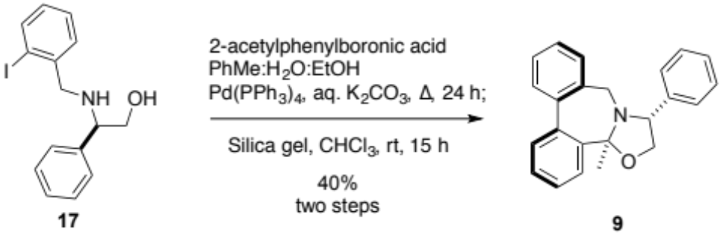
Scheme 4

The phenyl substituted azepinium bromide salt 8 was thus obtained in just four steps in 26% overall yield from (R)-phenyl glycinol 16. A number of aminoalcohols - (S)-alaninol, (S)-valinol, and (R)- & (S)-phenylalaninol - were subjected to the same reaction sequence to prepare a selection of potential catalysts with different substituents at the oxazolidine ring, to give the cyclized products 8 and 28-31, each again generated as single diastereoisomers (Table 1; Figure 2).

Table 1. Isolated yields of the key intermediates in generating six tetracyclic iminium salt catalysts
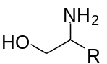 | 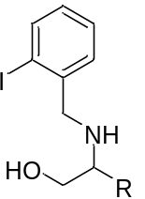 | 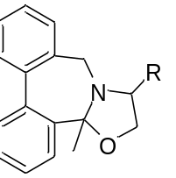 | 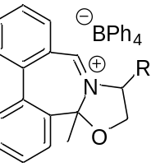
R = (S)-Me | 83% (20) | 22% (24) | 74% (28)
R = (S)-^{i}Pr | 16% (21) | 47% (25) | 81% (29)
R = (R)-Ph | 81% (17) | 40% (9) | 80% (8)
R = (R)-Bn | 90% (22) | 60% (26) | 82% (30)
R = (S)-Bn | 86% (23) | 30% (27) | 75% (31)

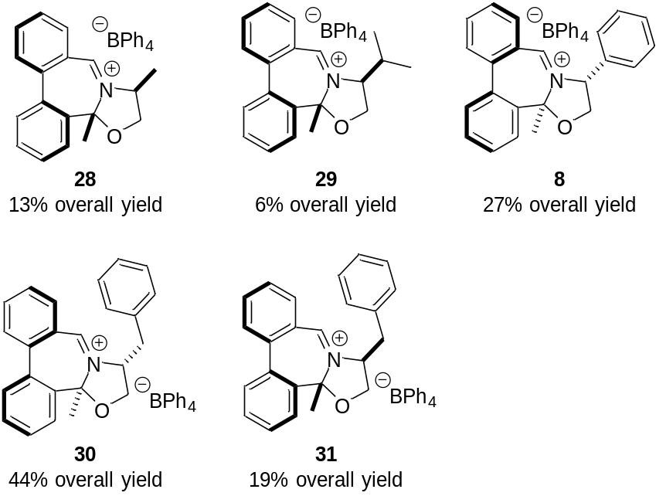
Figure 2. New iminium salts

Single crystal X-ray structure determination carried out on the (R)-phenyl 9 and (S)-benzyl 27 derivatives (Figure 3) show the cis-relationship between the methyl groups and the oxazolidine ring phenyl and benzyl substituents derived from the parent aminoalcohols, the pseudo-equatorial placement of these phenyl and benzyl substituents, the axial orientation of the methyl groups, and the chirality of the atropoisomeric biaryl units.
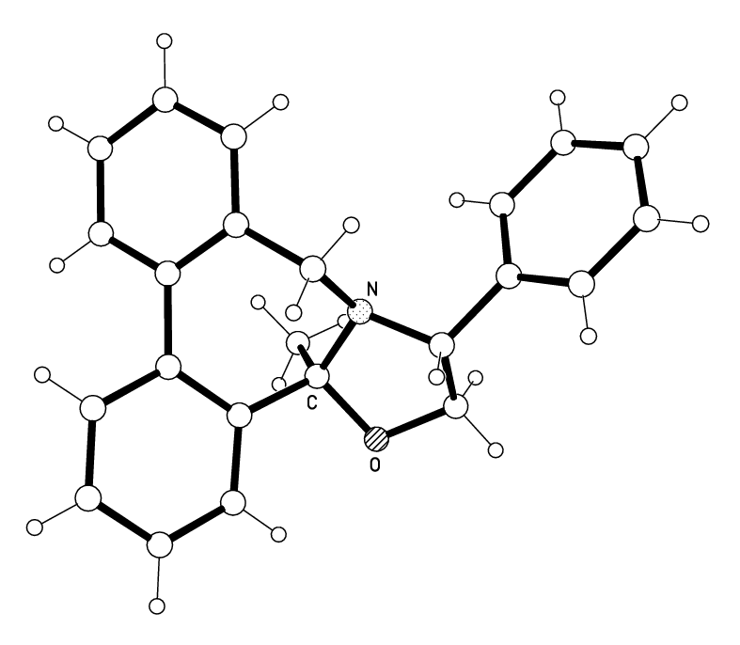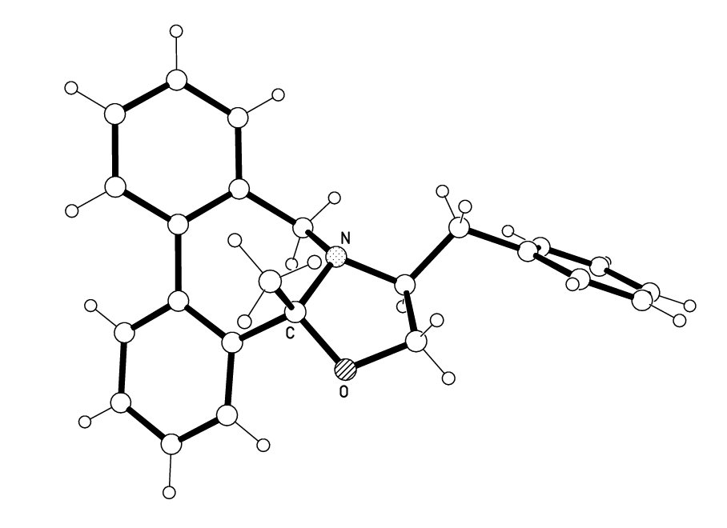
(aR,3R,13bS)-amine 9 (aS,3S,13bR)-amine 27
Figure 3. Single crystal X-ray structural determination of 9 and 27

The stereoselectivity of the cyclization of the aminoalcohol functionality in the intermediate iminium species 11 may be driven by preferred placement of the smaller methyl substituent in the pseudo-axial orientation (Scheme 5), perhaps through an equilibrium process.^{17a}

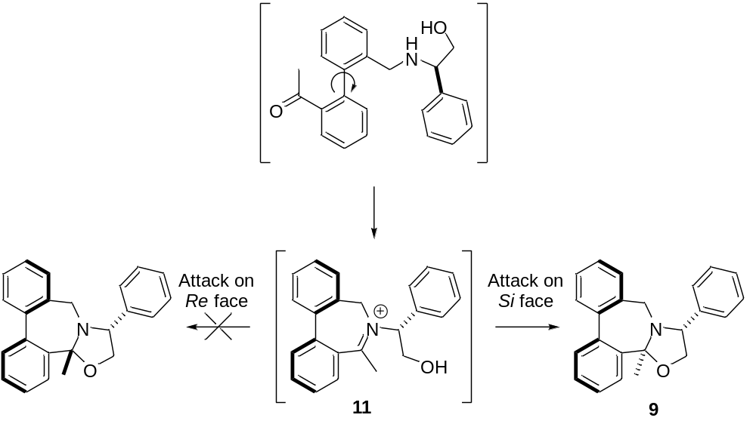
Scheme 5

Catalysts 8 and 28-31 were tested for catalytic activity under our standard conditions using oxone as oxidant, and compared to the simple biphenyl azepinium catalyst 2a (Table 2).

Table 2. Asymmetric Epoxidation of a range of alkenes by catalysts 8 and 28-31ª
Epoxide | Catalyst | Conversion/% ^{c, d} | ee/% ^{b, c} | Major enantiomer ^{f}
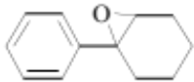 | 2a | 100 | 60 | (–)-1S,2S
 | 8 | 100 | 55 | (+)1R,2R
 | 28 | 100 | 30 | (–)-1S,2S
 | 29 | 100 | 30 | (–)-1S,2S
 | 30 | 100 | 64 | (+)1R,2R
 | 31 | 100 | 64 | (–)-1S,2S
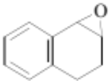 | 2a | 100 | 32 | (+)1S,2R
 | 8 | 100 | 76 | (–)1R,2S
 | 30 | 100 | 46 | (–)1R,2S
 | 31 | 100 | 47 | (+)1S,2R
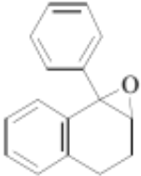 | 2a | 34 | 41 | (–)1R,2S
 | 8 | 20 | 64 | (+)1S,2R
 | 30 | 47 | 52 | (+)1S,2R
 | 31 | 39 | 55 | (–)1R,2S
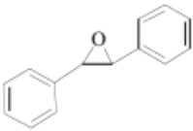 | 2a | 90 | 15 | (–)1S,2S
 | 8 | 100 | 22 | (+)1R,2R
 | 30 | 98 | 18 | (+)1R,2R
 | 31 | 95 | 13 | (–)1S,2S
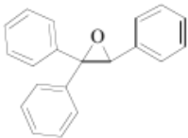 | 2a | 90 | 24 | (–)1S
 | 8 | 100 | 30 | (+1R
 | 30 | 100 | 23 | (+)1R
 | 31 | 100 | 19 | (–)1S
ª Epoxidation conditions: Iminium salt catalyst (5 mol%), Oxone® (2 equiv.). Na₂CO₃ (4 equiv.), MeCN:H₂O 1:1 (5 ml), 0 ºC, 1-6 h. ^{b} Enantiomeric excesses were determined by chiral GC chromatography on a Chiraldex B-DM column by comparison of the two epoxide peak areas. ^{c} Conversions were evaluated from the chiral GC–FID spectra by comparison of the alkene and epoxide peak areas. ^{d} Enantiomeric excess determined by Chiral HPLC on a Chiracel OD-H column. ^{e} Conversions were evaluated from the ¹H-NMR spectra by integration of alkene and epoxide signals. ^{f} Absolute configurations of the major enantiomers were determined by comparison of both optical rotation and GC-FID of samples of known configuration.

Catalysts 8, 30, and 31 provide greater enantioselectivity in the oxidation of 1-phenylcyclohexene than catalysts 28 and 29, and this pattern is repeated for the other alkene substrates tested. Observed enantioselectivities are comparable with or superior to the simple azepinium catalyst 3a. Highest enantioselectivities were observed with the cyclic cis-alkene dihydronaphthalene substrates, where catalysts 8, 30, and 31 outperformed catalyst 2a by a considerable margin.

      - Conclusion
To conclude, we have successfully developed a new sub-structure of iminium salt catalyst containing a 6,6,7,5-ring tetracyclic core. The synthesis of these novel iminium salts can be completed within four steps in good yields from the corresponding amino-alcohols. We have postulated that the cyclization occurs through one favoured atropoisomer, giving rise to a favoured diastereoisomer in all the iminium salt catalysts generated, that where the methyl group is pseudo-axial. Catalysts 8, 30 and 31 generally provide enantioselectivities better than or equal to the parent azepinium catalyst 2a.

Experimental Section
General Experimental Detail
All infrared spectra were obtained using; thin films on sodium chloride plates. All ¹H and ¹³C NMR spectra were measured at 400.13 and 100.62 MHz respectively, or at 500.21 and 125.79 MHz respectively, in deuteriochloroform solution unless otherwise stated, using TMS (tetramethylsilane) as the internal reference. Mass spectra were recorded utilizing electron–impact (EI), fast atom bombardment (FAB) or electrospray (ESI) techniques and an ion trap mass analyser. Optical rotation values were measured at λ=589 nm, corresponding to the sodium D line, at the temperatures indicated. All chromatographic manipulations used silica gel as the adsorbent. Reactions were monitored using thin layer chromatography (TLC) on aluminium–backed plates coated with F254 silica gel. TLC plates were visualized by UV irradiation at a wavelength of 254 nm, or stained by exposure to an ethanolic solution of phosphomolybdic acid (acidified with concentrated sulfuric acid), followed by charring where appropriate. Reactions requiring anhydrous conditions were carried out using glassware dried overnight at 150 ºC, under a nitrogen atmosphere unless otherwise stated. Reaction solvents were used as obtained commercially unless otherwise stated. Light petroleum (b.p. 40–60 ºC) was distilled from calcium chloride prior to use. Ethyl acetate was distilled over calcium chloride. Dichloromethane was distilled over calcium hydride. Tetrahydrofuran and diethyl ether were distilled under a nitrogen atmosphere from the sodium/benzophenone ketyl radical. Acetone was dried over 4Å Linde molecular sieve, and distilled under a nitrogen atmosphere. Enantiomeric excesses were determined by chiral HPLC using a Chiracel OD and OD-H columns with an ultra–violet absorption detector set at 254 nm, by chiral GC using a Chiraldex B-DM column and a flame ionization detector, or by proton nuclear magnetic resonance spectroscopy in the presence of europium (III) tris[3–(heptafluropropylhydroxymethylene)–(+)–camphorate] as the chiral shift reagent.

General procedure A: Reductive amination using 2-iodobenzaldehyde and aminoalcohols
The amino alcohol and 2-iodobenzaldehyde (1.1 equiv.) were dissolved in methanol (10 mL per g of aminoalcohol) and agitated over 5 to 16 h. The mixture was cooled to 0 °C, sodium cyanoborohydride (1.1 equiv.) added, and the mixture stirred at ambient temperature for 16 h. Saturated aqueous ammonium chloride (1 mL per g of aminoalcohol) was added and the solvent removed under reduced pressure. The residue was dissolved in tert-butyl methyl ether (10 mL per g of aminoalcohol) and the solution washed with saturated brine and dried over magnesium sulphate. The solvents were removed and the crude oil purified by column chromatography using CH₂Cl₂/MeOH (100:0-95:5) as eluent to yield the desired secondary amine.

General procedure B: Suzuki coupling between 2-iodobenzyl aminoalcohols and 2-acetyl phenylboronic acid
The aminoalcohol and 2-acetyl phenylboronic acid (3 equiv.) were dissolved in toluene (10 mL per g of aminoalcohol) and ethanol (1 mL per g of aminoalcohol) and saturated aqueous potassium carbonate (1 mL per g of aminoalcohol) added. The mixture was degassed with nitrogen over 30 min. Pd(PPh₃)₄ (10 mol%) was added and the mixture degassed for a further 15 min. The mixture was stirred at reflux under a nitrogen atmosphere with monitoring by HPLC; once complete consumption of the starting material was observed, the mixture was allowed to cool to ambient temperature and filtered through a plug of celite. The organic layer was separated, washed with water, dried over magnesium sulphate, and the solvents were removed under reduced pressure. The residue was dissolved in chloroform (10 mL per g of aminoalcohol and silica gel (0.5 g per g of aminoalcohol) added. The mixture was stirred for 15 hours at room temperature to achieve cyclization. The suspension was filtered through a plug of celite and the solvent removed under reduced pressure. The residue was purified using flash chromatography on silica gel using ethyl acetate:heptane (1-5%) as eluent.

General procedure C: Oxidation of tertiary cyclic amines using N-bromosuccinimide
The amine was dissolved in chloroform (5 mL per g of amine) and the mixture cooled to 0 °C. N-Bromosuccinimide (2 equiv.) was added. The reaction mixture was removed from the ice bath and stirred for 15-20 min with monitoring by HPLC/TLC. Upon completion, water (10 mL per g of amine) was added, and the organic layer separated and dried over magnesium sulphate. The solvent was removed under reduced pressure to yield the corresponding bromide salt. The residue was dissolved in ethanol (50 mL per g of bromide salt) and a solution of sodium tetraphenylborate (1 equiv.) in the minimum amount of acetonitrile to enable dissolution added. The solvents were removed under reduced pressure and the residue was recrystallized from ethanol to yield the desired tetracyclic imnium tetraphenylborate salts.

General procedure for the formation of racemic epoxides for ee determinations
The alkene was dissolved in dichloromethane (10 mL per g of alkene) and cooled to 0 ºC. m-CPBA (2 equiv.) was added as a solution in dichloromethane (10 mL per g of alkene). The mixture was allowed to attain ambient temperature and stirred until complete consumption of the substrate was observed by TLC. Saturated aqueous NaHCO₃ (20 mL per g of alkene) was added and the layers separated. The organic layer was washed with NaOH (1.0 M, 20 mL per g of alkene), and dried (MgSO₄). The solvents were removed under reduced pressure and the product purified by column chromatography, eluting with ethyl acetate/light petroleum (1:99).

General procedure for catalytic asymmetric epoxidation of simple alkenes mediated by iminium salts using Oxone
Oxone (2 equiv.) was added to an ice cooled solution of Na₂CO₃, (4 equiv.) in water (8 mL per g of Na₂CO₃), and the resulting foaming solution stirred for 5-10 min. The iminium salt (10 mol%) was added as a solution in acetonitrile (4 mL per g of Na₂CO₃ used), followed by the alkene substrate, also as a solution in acetonitrile (4 mL per g of Na₂CO₃ used). The mixture was stirred at 0 °C until the alkene substrate was completely consumed as observed by TLC. The mixture was dissolved in ice-cooled diethyl ether (20 mL per 100 mg substrate), and the same volume of water added. The aqueous phase was washed four times with diethyl ether, and the combined organic layers were washed with saturated brine and dried over magnesium sulphate. Filtration and evaporation of the solvents gave a yellow/brown residue, which was purified by column chromatography, eluting with ethyl acetate/light petroleum (1:99).

3-(2’-Iodobenzyl)-4R-phenyloxazolidin-2-one 14
(R)-(–)-4-phenyl-2-oxazolidinone (0.20 g, 1.23 mmol, 1.0 equiv.) was dissolved in THF (2 mL) at room temperature under a nitrogen atmosphere. NaHMDS (2M in THF, 0.68 mL, 1.35 mmol, 1.1 equiv.) was added and the reaction mixture stirred for 30 min. A solution of 2-iodobenzylbromide (0.40 g, 1.35 mmol, 1.1 equiv.) in THF (2 mL) was added and the reaction monitored by HPLC. On complete consumption of the starting material, saturated aqueous potassium carbonate (10 mL per g of oxazolidinone) and tert-butyl methyl ether (20 mL per g of oxazolidinone) were added. The organic layer was separated, washed with brine (10 mL per g of oxazolidinone), dried over anhydrous magnesium sulphate, and the solvents removed under reduced pressure to yield the desired alkylated oxazolidinone (0.46 g, 1.21 mmol, 98%); ν_{max}(film) /cm⁻¹ 2960, 1749, 1428, 1240, 1081, 1012, 751, 668. [α]²⁰_{D} −7.8 ° (c 1.0, CH₂Cl₂), ¹H NMR (400 MHz; CDCl₃) δ_{H} 4.00 (1 H, d, J 15.6 Hz), 4.17 (1 H, dd. J 5.6, 8.4 Hz), 4.56 (1 H, dd, J 5.2, 9.2 Hz), 4.63 (1 H, t, J 8.3 Hz), 4.80 (1 H, d, J 15.4 Hz), 6.97 (1 H, td, J 1.5, 7.5 Hz), 7.14 - 7.20 (3 H, m), 7.29 (1 H, td, J 1.2, 7.5 Hz), 7.35 - 7.40 (3 H, m), 7.79 (1 H, dd, J 1.2, 7.9 Hz). ¹³C NMR (100 MHz; CHCl₃) δ_{C} 50.7, 59.3, 70.1, 99.0, 127.2, 128.6, 129.2, 129.4, 129.7, 130.0, 137.8, 137.9, 140.0, 158.4; m/z found for [M+H]⁺ 380.0145; [C₁₆H₁₄NO₂I+H]⁺ requires 380.0142.

2-(2’-Iodobenzylamino)-2(R)-phenylethanol 17
(R)-Phenylglycinol (1.32 g, 9.60 mmol, 1.1 equiv.) in MeOH (25 mL), 2-iodobenzaldehyde (2.20 g, 9.50 mmol, 1.0 equiv.) and NaBH₃CN (0.60 g, 9.60 mmol, 1.1 equiv.) were treated using general procedure A to yield the desired product (2.77 g, 7.80 mmol, 81%); [α]²⁰_{D} −49.7 ° (c 1.0, CH₂Cl₂). ¹H NMR (400 MHz; CDCl₃) δ_{H} 3.58 (1 H, dd, J 8.6, 10.8 Hz), 3.66 (1 H, d, J 13.2 Hz), 3.73 (1 H, dd, J 4.4, 10.8 Hz), 3.78 (1 H, d, J 13.2 Hz), 3.81 (1 H, dd, J 4.4, 8.4 Hz), 6.93-6.98 (1 H, m), 7.26-7.40 (7 H, m), 7.80-7.83 (1 H, m); ¹³C NMR (100 MHz; CHCl₃) δ_{C} 55.8, 64.0, 67.0, 100.0, 127.5, 127.9, 128.4, 128.8, 129.1, 130.2, 139.8, 140.3, 142.2; m/z found for [M+H]⁺: 354.0363; [C₁₅H₁₆INO+H]⁺ requires 354.0355.

3-(2’-Iodobenzyl)-2,2-dimethyl-(4R)-phenyloxazolidine 18
(2R)-2-(2’-Iodo-benzylamino)-2-phenyl-ethanol 17 (650 mg, 1.84 mmol, 1 equiv.) was dissolved in toluene (10 mL). Dimethoxypropane (2.25 mL, 18.40 mmol, 10 equiv.) and p-TSA (70.0 mg, 0.37 mmol, 0.2 equiv.) were added, and the mixture heated under reflux using a Dean-Stark apparatus. The reaction was monitored by TLC and the azeotropic removal of solvents. Upon completion, the mixture was allowed to reach ambient temperature. Saturated brine (3 x 20 mL) was added and the organic phase separated, dried over MgSO₄, and the solvents removed under reduced pressure. Purification using column chromatography on silica gel (washed with 4% TEA) using ethylacetate/light petroleum (10%) as eluent yielded the desired acetal as a yellow low-melting solid (694 mg, 1.76 mmol, 96%); ν_{max}(film) /cm⁻¹ 3420, 2972, 1455, 1362, 1255, 1187, 1054, 1011, 753, 700; [α]²⁰_{D} −60.2 (c 1.19, CHCl₃); ¹H NMR (400 MHz; CDCl₃) δ_{H} 1.34 (3 H, s), 1.37 (3 H, s), 3.67 (1 H,d, J 14.4 Hz), 3.75 (1 H, t, J 8.0 Hz), 3.88 (1 H, d, J 14.8 Hz), 4.08 (1 H, t, J 7.6 Hz), 4.21 (1 H, t, J 7.2 Hz), 6.75 (1 H, dt, J 1.6, 7.6 Hz), 7.09-7.14 (2 H, m), 7.15-7.20 (2 H, m), 7.32-7.36 (2 H, m), 7.43 (1 H, dd, J 1.6, 7.6 Hz), 7.61 (1 H, dd, J 1.2, 8.0 Hz); ¹³C NMR (100 MHz; CHCl₃) δ_{C} 21.6, 28.7, 56.8, 67.8, 72.1, 96.4, 99.6, 127.5, 127.7, 128.1, 128.2, 128.5, 131.3, 139.1, 140.5, 141.2; m/z found for M⁺: 393.0583; [C₁₈H₂₀INO]⁺ requires 393.0590.

(aR,3R,13bS)-13b-Methyl-3-phenyl-2,3-dihydro-13bH-dibenz[c,e]oxazolo[3,2-a]azepine 9
First method: from oxazolidinone 14
(4R)-3-(2’-Iodo-benzyl)-4-phenyl-oxazolidin-2-one 14 (0.46 g, 1.21 mmol) was dissolved in toluene (5 mL) and ethanol (7.5 mL). 2-Acetyl phenylboronic acid (0.20 g, 1.21 mmol, 1 equiv.) and saturated aqueous potassium carbonate (5 mL) were added. The mixture was degassed with nitrogen over 30 min. Pd(PPh₃)₄ (0.07 g, 0.06 mmol, 5 mol%) was added, and the mixture was degassed with nitrogen for a further 15 min. The mixture was stirred under reflux under a nitrogen atmosphere with monitoring by HPLC. Once complete consumption of the starting material was observed, the mixture was allowed to cool to ambient temperature. The mixture was filtered through a plug of celite, and the solvents were removed under reduced pressure. tert-Butyl methyl ether (10 mL) and water (5 mL) were added to the residue. The organic layer was separated, washed with water (5 mL), and dried over MgSO₄. The solvents were removed under reduced pressure, and the residue dissolved in ethanol (5 mL) and aqueous NaOH (2M, 5 mL) added. The mixture was heated under reflux for 16 h to remove the protecting goup, then allowed to cool to ambient temperature. The organic solvent was removed under reduced pressure, the residue was dissolved in tert-butyl methyl ether (5 mL), and aqueous HCl (5M, 1 mL) added. The mixture was stirred for 30 min to achieve cyclization, and the organic layer separated, dried over magnesium sulphate and the solvents removed under reduced pressure. The residue was purified using flash chromatography on silica gel using ethyl acetate:heptane (1 – 5%) as eluent to give the desired product (0.049 g, 0.15 mmol, 12%).

Second method: from oxazolidine 18
(4R)-3-(2-Iodo-benzyl)-2,2-dimethyl-4-phenyl-oxazolidine 18 (0.69 g, 1.76 mmol) was dissolved in toluene (10 mL) and ethanol (15 mL). 2-Acetyl phenylboronic acid (0.29 g, 1.76 mmol, 1 equiv.) and saturated aqueous potassium carbonate (10 mL) were added. The mixture was degassed with nitrogen over 30 min. Pd(PPh₃)₄ (0.10 g, 0.09 mmol, 5 mol%) was added, and the mixture degassed with nitrogen for a further 15 min. The mixture was stirred under reflux under a nitrogen atmosphere for 4 h. The mixture was allowed to cool to ambient temperature, filtered through a plug of celite, and the solvents were removed under reduced pressure. tert-Butyl methyl ether (10 mL) and water (5 mL) were added to the residue. The organic layer was separated, washed with water (5 mL) and dried over MgSO₄. The solvents were removed under reduced pressure, and the residue dissolved in chloroform (10 mL) and silica gel added. The mixture was stirred at room temperature for 30 min and the suspension filtered through a pad of celite. The solvent was removed under reduced pressure and the residue purified using flash chromatography on silica gel using ethyl acetate:heptane (1-5%) as eluent to give the desired product (0.23 g, 0.70 mmol, 40%).

Third method: from amino alcohol 17
(2R)-(2’-Iodobenzylamino)-2-phenylethanol 17 (2.29 g, 6.50 mmol) and 2-acetyl phenylboronic acid (3.20 g, 19.5 mmol, 3 equiv.) were treated using general procedure B to yield the desired product (0.85 g, 2.60 mmol, 40%); ν_{max}(film) /cm⁻¹ 2963, 1449, 1260, 1153, 1038, 897, 802, 758, 740, 701. [α]²⁰_{D} –15.6° (c 1.0, CH₂Cl₂). ¹H NMR (400 MHz; CDCl₃) δ_{H} 1.11 (3 H, s), 3.09 (1 H, d, J 10.8 Hz), 3.58 (1 H, d, J 10.8 Hz), 3.86 (1 H, dd, J 7.6, 9.2 Hz), 3.94 (1 H, dd, J 6.0, 9.6 Hz), 4.37 (1 H, t, J 6.8 Hz), 7.25 (1 H, d, J 6.8 Hz), 7.30-7.37 (2 H, m), 7.38-7.45 (3 H, m), 7.46-7.53 (6 H, m), 7.86-7.92 (1 H, m); ¹³C NMR (100 MHz; CHCl₃) δ_{C} 30.6, 52.5, 69.3, 72.8, 97.3, 125.8, 127.6, 127.8, 127.9, 128.00, 128.04, 128.1, 128.5, 128.8, 129.1, 128.2, 135.3, 137.0, 139.1, 140.4, 142.1; m/z found for M⁺ 327.1626; [C₂₃H₂₁NO]⁺ requires 327.1623.

2S-(2’-Iodobenzylamino)-propan-1-ol 20
(S)-Alaninol (1.3 mL, 16.38 mmol) and 2-iodobenzaldehyde (3.8 g, 16.38 mmol, 1 equiv.) were dissolved in toluene (100 mL) in a round-bottomed flask fitted with a Dean-Stark apparatus. Acetic acid (0.5 mL) was added and the solution heated under reflux for 16 h. The reaction mixture was allowed to reach room temperature and the solvents were removed under reduced pressure. The residue was dissolved in methanol (50 mL), NaBH₃CN (1.23 g, 19.66 mmol, 1.2 equiv.) and acetic acid (1 mL) were added, and the solution was stirred for 16 h. Saturated aqueous NH₄Cl (20 mL) was added, and the aqueous layer washed with Et₂O (3 x 20 mL). The combined organic layers were washed with a saturated solution of aqueous NH₄Cl (20 mL). The aqueous layers were combined and the pH of the solution was brought to 8-9 using a saturated solution of Na₂CO₃. The resulting solution was extracted using dichloromethane (3 x 20 mL) and the combined organic layers were washed with water and brine, dried over MgSO₄, filtered, and the solvents removed to yield the product (4.0 g, 13.75 mmol, 83%); ν_{max}(film) /cm⁻¹ 3324, 2956, 1563, 1435, 1045, 1011, 750, 648. [α]²⁰_{D} +10.8 ° (c 1.0, CH₂Cl₂). ¹H NMR (500 MHz; CDCl₃) δ_{H} 1.08 (3 H, d, J 6.0 Hz), 2.78-2.85 (1 H, m), 3.29 (1 H, dd, J 7.0, 11.0 Hz), 3.58 (1 H, dd, J 4.0, 11.0 Hz), 3.74 (1 H, d, J 13.5 Hz), 3.87 (1 H, d, J 13.5 Hz), 6.94 (1 H, dt, J 1.5, 7.5 Hz), 7.30 (1 H, dt, J 1.0, 7.5 Hz), 7.35 (1 H, dd, J 1.5, 7.5 Hz), 7.81 (1 H, dd, J 1.2, 8.0 Hz). ¹³C NMR (125 MHz; CHCl₃) δ_{C} 17.1, 53.9, 55.6, 65.6, 99.8, 128.4, 129.0, 129.8, 139.6, 142.2; m/z found for [M+H]⁺: 292.0204; [C₁₀H₁₄NOI+H]⁺ requires 292.0198.

2S-(2’-Iodobenzylamino)-3-methyl-butan-1-ol 21
(S)-Valinol (2.56 g, 24.8 mmol) in MeOH (50 mL), 2-iodobenzaldehyde (6.33 g, 27.3 mmol, 1.1 equiv.) and NaBH₃CN (1.71 g, 27.3 mmol, 1.1 equiv.) were treated using general procedure A to yield the product (1.30 g, 4.09 mmol, 16%); ν_{max}(film) /cm⁻¹ 3321, 2956, 1563, 1464, 1435, 1045, 1011, 750, 648. [α]²⁰_{D} −16.7 ° (c 1.5, CHCl₃). ¹H NMR (400 MHz; CDCl₃) δ_{H} 0.93 (3 H, d, J 6.8 Hz), 0.99 (3 H, d, J 6.8 Hz), 1.81 (1 H, sextet, J 6.8 Hz), 2.41 (1 H, dt, J 4.0, 6.4 Hz), 3.40 (1 H, dd J 6.8, 10.8 Hz), 3.68 (1 H, dd, J 4.0, 10.8 Hz), 3.78 (1 H, d, J 13.2 Hz), 3.88 (1 H, d, J 13.2 Hz), 6.97 (1 H, dt, J 2.0, 7.6 Hz), 7.32 (1 H, dt, J 1.2, 7.2 Hz), 7.36 (1 H, dd, J 1.6, 7.6 Hz), 7.83 (1 H, dd, J 0.8, 8.0 Hz); ¹³C NMR (100 MHz; CHCl₃) δ_{C} 18.7, 19.8, 29.1, 56.0, 60.6, 64.1, 100.0, 128.6, 129.2, 130.1, 139.7, 142.5; m/z found for [M+H]⁺ 320.0511; [C₁₂H₁₈INO+H]⁺ requires 320.0511.

2R-(2’-Iodobenzylamino)-3-phenyl-propan-1-ol 22
(2R)-2-Amino-3-phenylpropan-1-ol (2.92 g, 19.6 mmol) in MeOH (50 mL), 2-iodobenzaldehyde (3.00 g, 21.5 mmol, 1.1 equiv.) and NaBH₃CN (1.35 g, 21.5 mmol, 1.1 equiv.) were treated using general procedure A to yield the product (6.47 g, 17.6 mmol, 90%); ν_{max}(film) /cm⁻¹ 3441, 2359, 1652, 1635, 1113, 743, 699, 668. [α]²⁰_{D} +20.0° (c 1.5, CHCl₃). ¹H NMR (400 MHz; CDCl₃) δ_{H} 2.81 (2 H, qd, J 7.2, 14.0 Hz), 2.93-3.00 (1 H, m), 3.38 (1 H, dd, J 5.2, 10.8 Hz), 3.71 (1 H, dd, J 4.0, 10.8 Hz), 3.80 (2 H, s), 6.95 (1 H, dt, J 1.6, 7.6 Hz), 7.14-7.18 (2 H, m), 7.19-7.24 (2 H, m), 7.25-7.31 (3 H, m), 7.79 (1 H, dd, J 1.2, 8.0 Hz); ¹³C NMR (100 MHz; CHCl₃) δ_{C} 38.4, 55.7, 59.5, 62.6, 100.0, 126.7, 128.5, 128.8, 129.2, 129.4, 129.9, 138.4, 139.7, 142.0; m/z found for [M+H]⁺ 368.0506; [C₁₆H₁₈NOI+H]⁺ requires 368.0510.

2S-(2’-Iodobenzylamino)-3-phenyl-propan-1-ol 23
(2S)-2-Amino-3-phenylpropan-1-ol (2.92 g, 19.6 mmol) in MeOH (50 mL), 2-iodobenzaldehyde (3.00 g, 21.5 mmol, 1.1 equiv.) and NaBH₃CN (1.35 g, 21.5 mmol, 1.1 equiv.) were treated using general procedure A to yield the product (6.19 g, 16.9 mmol, 86%); ν_{max}(film) /cm⁻¹ 3450, 2358, 1645, 1112, 745, 670, 668. [α]²⁰_{D} −22.8° (c 1.3, CHCl₃). ¹H NMR (400 MHz; CDCl₃) δ_{H} 2.81 (2 H, qd, J 7.2, 14.0 Hz), 2.93-3.00 (1 H, m), 3.38 (1 H, dd, J 5.2, 10.8 Hz), 3.70 (1 H, dd, J 3.6, 10.8 Hz), 3.80 (2 H, s), 6.95 (1 H, dt, J 2.0, 8.0 Hz), 7.14-7.18 (2 H, m), 7.19-7.24 (2 H, m), 7.26-7.31 (3 H, m), 7.79 (1 H, dd, J 1.2, 8.0 Hz); ¹³C NMR (100 MHz; CHCl₃) δ_{C} 38.4, 55.7, 59.5, 62.7, 100.0, 126.7, 128.5, 128.8, 129.1, 129.4, 129.9, 138.4, 139.7, 142.0; m/z found for [M+H]⁺ 368.0506; [C₁₆H₁₈INO+H]⁺ requires 368.0510.

(aS,3S,13bR)-3,13b-Dimethyl-2,3-dihydro-13bH-dibenz[c,e]oxazolo[3,2-a]azepine 24
(2S)-2-(2’-Iodo-benzylamino)-propan-1-ol 20 (1.05 g, 3.60 mmol) and 2-acetyl phenylboronic acid (1.77 g, 10.8 mmol, 3 equiv.) were treated using general procedure B to yield the product (0.21 g, 0.80 mmol, 22%); ν_{max}(film) /cm⁻¹ 3377, 2966, 1448, 1365, 1217, 1161, 1097, 1046, 756, 738. [α]²⁰_{D} −69.2 ° (c 0.96, CHCl₃); ¹H NMR (400 MHz; CDCl₃) δ_{H} 0.98 (3 H, s), 1.22 (3 H, d, J 6.0 Hz), 2.85-2.94 (1 H, m), 3.01 (1 H, d, J 10.8 Hz), 3.68 (1 H, dd, J 7.6, 9.6 Hz), 3.86 (1 H, d, J 11.2 Hz), 4.20 (1 H, dd, J 6.4, 7.6 Hz), 7.32-7.46 (7 H, m), 7.74-7.79 (1 H, m); ¹³C NMR (100 MHz; CHCl₃) δ_{C} 15.9, 30.5, 52.9, 59.7, 71.7, 97.5, 121.8, 125.9, 127.6, 127.7, 128.1, 128.7, 129.0, 129.3, 134.9, 136.9, 142.4; m/z found for [M+H]⁺ 266.1542; [C₁₈H₁₉NO+H]⁺ requires 266.1539.

(aS,3S,13bR)-13b-Methyl-3-isopropyl-2,3-dihydro-13bH-dibenz[c,e]oxazolo[3,2-a]azepine 25
(2S)-2-(2’-Iodobenzylamino)-3-methyl-butan-1-ol 21 (1.30 g, 4.09 mmol) and 2-acetyl phenylboronic acid (2.01 g, 12.3 mmol, 3 equiv.) were treated using general procedure B to yield the product (0.54 g, 1.90 mmol, 47%); ν_{max}(film) /cm⁻¹ 3419, 2954, 2871, 1459, 1365, 1213, 1160, 1043, 756, 730. [α]²⁰_{D} – 98.8 ° (c 1.21, CHCl₃). ¹H NMR (400 MHz; CDCl₃) δ_{H} 0.96 (3 H,s), 0.99 (6 H, d, J 6.8 Hz), 1.88 (1 H, octet, J 6.8 Hz), 2.82 (1 H, q, J 6.0 Hz), 3.24 (1 H, d, J 11.2 Hz), 3.74 (1 H, d, J 11.2 Hz), 3.86 (1 H, dd, J 6.0, 8.0 Hz), 4.02 (1 H, dd, J 7.0, 8.0 Hz), 7.34-7.37 (2 H, m), 7.38-7.43 (3 H, m), 7.44-7.48 (2 H, m), 7.69-7.74 (1 H, m); ¹³C NMR (100 MHz; CHCl₃) δ_{C} 17.1, 19.6, 30.2, 30.5, 54.3, 65.8, 70.1, 98.2, 125.2, 127.6, 127.90, 127.91, 128.0, 128.3, 129.1, 135.8, 137.4, 140.5, 142.1; m/z found for [M+H]⁺: 294.1857 [C₂₀H₂₃NO+H]⁺ requires 294.1852.

(aR,3R,13bS)-13b-Methyl-3-benzyl-2,3-dihydro-13bH-dibenz[c,e]oxazolo[3,2-a]azepine 26
(2R)-2-(2’-Iodobenzylamino)-3-phenyl-propan-1-ol 22 (1.00 g, 2.70 mmol) and 2-acetyl phenylboronic acid (1.34 g, 8.20 mmol, 3 equiv.) were treated using general procedure B to yield the product (0.51 g, 1.60 mmol, 60%); (ν_{max}(film) /cm⁻¹ 2926, 1493, 1452, 1365, 1215, 1158, 1069, 1043, 761, 738, 700. [α]²⁰_{D} −130.1° (c 0.99, CHCl₃); ¹H NMR (500 MHz; CDCl₃) δ_{H} 0.93 (3 H, s), 2.60-2.67 (1 H, m), 2.99-3.06 (2 H, m), 3.09 (1 H, d, J 11 Hz), 3.66 (1 H, d, J 11 Hz), 3.75 (1 H, t, J 7.5 Hz), 3.93 (1 H, dd, J 6.5, 8.0 Hz). 7.11-7.16 (3 H, m), 7.18-7.24 (3 H, m), 7.24-7.27 (1 H, m), 7.27- 7.32 (2 H, m), 7.32-7.39 (3 H, m), 7.63 (1 H, dd, J 1.5, 7.5 Hz); ¹³C NMR (125 MHz; CHCl₃) δ_{C} 30.6, 39.7, 53.5, 66.2, 69.9, 98.1, 125.4, 126.4, 127.5, 127.8, 128.0, 128.5, 129.0, 129.1, 129.2, 135.0, 137.1, 138.8, 140.1, 142.0; m/z found for [M+H]⁺: 342.1853; [C₂₄H₂₃NO+H]⁺ requires 342.1858.

(aS,3S,13bR)-13b-Methyl-3-benzyl-2,3-dihydro-13bH-dibenz[c,e]oxazolo[3,2-a]azepine 27
(2S)-2-(2’-Iodobenzylamino)-3-phenylpropan-1-ol 23 (1.00 g, 2.70 mmol) and 2-acetyl phenylboronic acid (1.34 g, 8.20 mmol, 3 equiv.) were treated using general procedure B to yield the product (0.27 g, 0.80 mmol, 30%); ν_{max}(film) /cm⁻¹ 2926, 1493, 1452, 1365, 1215, 1158, 1069, 1043, 761, 738, 700. [α]²⁰_{D} +130.9° (c 1.10, CHCl₃). ¹H NMR (400 MHz; CDCl₃) δ_{H} 1.01 (3 H, s), 2.68-2.76 (1 H, m), 3.07-3.19 (3 H, m), 3.75 (1 H, d, J 10.8 Hz), 3.83 (1 H, t, J 7.6 Hz), 4.02 (1 H, dd, J 6.2, 7.6 Hz), 7.20-7.26 (3 H, m), 7.27-7.33 (3 H, m), 7.34-7.41 (3 H, m), 7.42-7.48 (3 H, m), 7.68-7.72 (1 H, m); ¹³C NMR (100 MHz; CHCl₃) δ_{C} 30.7, 39.7, 53.6, 66.3, 70.0, 98.2, 125.5, 126.5, 127.6, 127.9, 128.0, 128.6, 129.1, 129.2, 129.3, 135.0, 137.1, 138.9, 140.1, 142.1; m/z [M+H]⁺: 342.1853; [C₂₄H₂₃NO+H]⁺ requires 342.1858.

(aS,3S,13bR)-3,13b-Dimethyl-2,3-dihydro-13bH-dibenz[c,e]oxazolo[3,2-a]azepin-5-ium tetraphenylborate salt 28
Compound 24 (0.21 g, 0.80 mmol) in dichloromethane (2 mL) and N-bromosuccinimide (0.29 g, 1.60 mmol, 2 equiv.) were treated using general procedure C to yield the product (0.20 g, 0.59 mmol, 74%); ν_{max}(film) /cm⁻¹ 2965, 1704, 1652, 1558, 1259, 1184, 1102, 1017, 763, 615. [α]²⁰_{D} 107.6 ° (c 10.3, CHCl₃); ¹H NMR (500 MHz; d6-acetone) δ_{H} 1.56 (3 H, s), 1.90 (3 H, d, J 6.8 Hz), 4.48 (1 H, dd, J 2.9, 9.5 Hz), 4.54 (1 H, dd, J 5.3 & 9.5 Hz), 4.96-5.03 (1 H, m), 6.74-6.78 (4 H, m), 6.91 (8 H, t, J 7.4 Hz), 7.31-7.35 (8 H, m), 7.71 (1 H, dt, J 1.5, 7.5 Hz), 7.76 (1 H, dt, J 1.4, 7.5 Hz), 7.84-7.89 (2 H, m), 7.91 (1 H, dd, J 1.1, 7.6 Hz), 8.10 (1 H, dt, J 1.2, 7.4 Hz), 8.16-8.20 (2 H, m), 9.67 (1 H, s); ¹³C NMR (125 MHz; d6-acetone) δ_{C} 19.7, 23.4, 65.8, 71.5, 100.4, 122.3, 124.6, 126.0 (q, 3 Hz), 129.9, 131.4, 131.5, 131.7, 132.6, 134.6, 136.0, 137.0, 137.9, 139.3, 143.1, 164.4, 164.8, 165.1, 165.5, 165.7; m/z found for iminium cation: 264.1385; C₁₈H₁₈NO⁺ requires 264.1383.

(aS,3S,13bR)-13b-Methyl-3-isopropyl-2,3-dihydro-13bH-dibenz[c,e]oxazolo[3,2-a]azepin-5-ium tetraphenylborate salt 29
Compound 25 (0.54 g, 1.90 mmol) in dichloromethane (2 mL) and N-bromosuccinimide (0.68 g, 3.80 mmol, 2 equiv.) were treated using general procedure C to yield the product (0.57 g, 1.50 mmol, 81%); ν_{max}(film) /cm⁻¹ 3055, 2998, 1639, 1596, 1579, 1559, 1479, 1425, 1377, 1184, 1031, 734. [α]²⁰_{D} +236.8 ° (c 2.0, CHCl₃); ¹H NMR (500 MHz; d6-acetone) δ_{H} 1.24 (3 H, d, J 7.0 Hz), 1.26 (3 H, d, J 7.0 Hz), 1.54 (3 H, s), 2.64 (1 H, sextet, J 7.0 Hz), 4.47 (1 H, dd, J 5.0, 10.0 Hz), 4.60 (1 H, tt, J 1.5, 6.5 Hz), 4.72 (1 H, dd, J 2.0, 10.0 Hz), 6.79 (4 H, t, J 7.2 Hz), 6.93 (8 H, t, J 7.5 Hz), 7.33-7.37 (8 H, m), 7.73 (1 H, td, J 1.5, 7.5 Hz), 7.77 (1 H, td, J 1.5, 7.5 Hz), 7.83-7.87 (2 H, m), 7.92 (1 H, dd, J 1.5, 7.5 Hz), 8.09 (1 H, td, J 1.5, 7.5 Hz), 8.14 (1 H, dd, J 1.5, 7.5 Hz), 8.18 (1 H, d, 7.5 Hz), 9.50 (1 H, s); ¹³C NMR (125 MHz; d6-acetone) δ_{C} 17.8, 19.2, 22.2, 31.9, 67.4, 73.6, 100.3, 122.0, 124.3, 125.6, 125.73, 125.75, 125.77, 125.80, 129.7, 131.0, 131.2, 131.4, 132.4, 134.4, 135.6, 136.75, 136.76, 137.6, 139.2, 142.7, 164.1, 164.5, 164.9, 165.3, 166.2; m/z found for M⁺ (iminium cation) 292.1704; [C₂₀H₂₂NO]⁺ requires 292.1701.

(aR,3R,13bS)-13b-Methyl-3-phenyl-2,3-dihydro-13bH-dibenz[c,e]oxazolo[3,2-a]azepin-5-ium tetraphenylborate salt 8
Compound 9 (0.43 g, 1.32 mmol) in dichloromethane (2 mL) and N-bromosuccinimide (0.47 g, 2.64 mmol, 2 equiv.) were treated using general procedure C to yield the product as a pair of diastereoisomers (0.27 g, 0.66 mmol, 50%); ν_{max}(film) /cm⁻¹ 3055, 1709, 1641, 1596, 1579, 1557, 1479, 1426, 1361, 1222, 731, 703. [α]²⁰_{D} – 9.2 ° (c 1.3, acetone). ¹H NMR (500 MHz; d6-acetone) δ_{H} 1.65 (3 H, s), 4.85 (1 H, dd, J 5.0, 10.0 Hz), 4.89 (1 H, dd, J 6.5, 10.0 Hz), 5.79 (1 H, dt, J 1.0, 5.8 Hz), 6.72-6.77 (4 H, m), 6.88 (8 H, t, J 7.5 Hz), 7.28-7.34 (8 H, m), 7.57-7.60 (3 H, m), 7.68-7.72 (2 H, m), 7.72-7.75 (2 H, m), 7.80 (1 H, dt, J 1.5, 7.5 Hz), 7.90 (2 H, dt, J 1.5, 7.5 Hz), 7.95 (1 H, dd, J 1.0, 8.0 Hz), 8.05 (1 H, dt, J 1.5, 8.0 Hz), 8.16 (1 H, d, J 7.5 Hz), 9.27 (1 H, d, J 1.5 Hz); ¹³C NMR (125 MHz; d6-acetone) δ_{C} 21.4, 71.08, 71.15, 99.8, 121.4, 124.0, 125.1 (q, J 3Hz), 128.6, 128.8, 129.1, 129.9, 130.4, 130.6, 130.7, 130.9, 131.8, 135.6, 136.2 (q, J 1 Hz), 137.4, 142.5, 163.5, 163.9, 164.3, 164.7, 165.7. m/z found for M⁺ (iminium cation) 326.1549; [C₂₃H₂₀NO]⁺ requires 326.1545.

(aR,3R,13bS)-13b-Methyl-3-benzyl-2,3-dihydro-13bHdibenz[c,e]oxazolo[3,2-a]azepin-5-ium; tetraphenylborate salt 30
Compound 26 (0.26 g, 0.80 mmol) in dichloromethane (2 mL) and N-bromosuccinimide (0.29 g, 1.60 mmol, 2 equiv.) were treated using general procedure C to yield the product (0.28 g, 0.66 mmol, 82%); ν_{max}(film) /cm⁻¹ 3051, 3013, 1642, 1598, 1581, 1557, 1481, 1426, 1381, 1183, 1031, 1016, 767, 755, 716, 714. [α]²⁰_{D} – 30.3 ° (c 1.4, CHCl₃); ¹H NMR (500 MHz; d6-acetone) δ_{H} 1.59 (3 H, s), 3.61 (2 H, dq, J 7.5, 13.5 Hz), 4.49 (1 H, dd, J 5.0, 10.0 Hz), 4.66 (1 H, dd, J 1.5, 10.0 Hz), 5.06-5.13 (1 H, m), 6.76 (4 H, t, J 7.0 Hz), 6.91 (8 H, t, J 7.0 Hz), 7.30-7.35 (8 H, m), 7.44-7.52 (5 H, m), 7.70 (1 H, td, J 1.5, 7.5 Hz), 7.71 (1 H, dd, J 1.5, 8.0 Hz), 7.75 (1 H, td, J 1.5, 7.5 Hz), 7.82 (1 H, td, J 1.0, 8.0 Hz), 7.85 (1 H, td, J 1.5, 7.5 Hz), 7.89 (1 H, dd, J 1.5, 8.0 Hz), 8.08 (1 H, td, J 1.5, 7.5 Hz), 8.16 (1 H, d, J 7.5 Hz), 8.91 (1 H, s); ¹³C NMR (125 MHz; d6-acetone) δ_{C} 23.3, 40.2, 70.1, 70.5, 100.9, 122.2, 124.4, 125.5, 125.98, 126.00, 126.02, 126.04, 128.9, 130.0, 130.3, 130.9, 131.4, 131.5, 131.7, 132.7, 134.6, 135.3, 136.0, 137.04, 137.05, 138.0, 139.2, 143.0, 134.4, 164.8, 165.2, 165.5, 165.8; m/z found for M⁺ (iminium cation) 340.1707; [C₂₄H₂₂NO]⁺ requires 340.17014.

(aS,3S,13bR)-13b-Methyl-3-benzyl-2,3-dihydro-13bHdibenz[c,e]oxazolo[3,2-a]azepin-5-ium, tetraphenylborate salt 31
Compound 27 (0.51 g, 1.60 mmol) in dichloromethane (5 mL) and N-bromosuccinimide (0.57 g, 3.20 mmol, 2 equiv.) were treated using general procedure C to yield the product (0.62 g, 1.20 mmol, 75%); ν_{max}(film) /cm⁻¹ 3445, 2358, 1714, 1654, 1616, 1558, 1454, 1404, 1257, 1182, 1104, 744, 701, 668; [α]²⁰_{D} +15.0 ° (c 1.07, CHCl₃); ¹H NMR (400 MHz; d6-acetone) δ_{H} 1.58 (3 H, s), 3.58 (2 H, dq, J 7.6, 13.6 Hz), 4.45 (1 H, dd, J 5.2, 10.0 Hz), 4.62 (1 H, dd, J 1.2, 10.0 Hz), 4.98-5.06 (1 H, m), 6.76 (4 H, t, J 7.2 Hz), 6.90 (8 H, t, J 7.6 Hz), 7.30-7.36 (8 H, m), 7.43-7.52 (5 H, m), 7.67 (1 H, dd, J 1.2, 7.6 Hz), 7.70 (1 H, td, J 1.6, 7.6 Hz), 7.75 (1 H, td, J 1.6, 7.6 Hz), 7.80 (1 H, td, J 1.2, 7.6 Hz), 7.85 (1 H, td, J 1.6, 8.0 Hz), 7.88 (1 H, dd, J 1.6, 7.6 Hz), 8.06 (1 H, td, J 1.2, 8.0 Hz), 8.14 (1 H, d, J 7.2 Hz), 8.84 (1 H, s); ¹³C NMR (125 MHz; d6-acetone) δ_{C} 23.4, 40.3, 70.1, 70.5, 101.0, 122.4, 124.5, 125.5, 126.10, 126.12, 126.15, 126.18, 129.0, 130.1, 130.4, 131.0, 131.5, 131.6, 131.8, 132.8, 134.7, 135.5, 137.13, 137.15, 139.3, 143.1, 164.3, 164.8, 165.8, 165.9; m/z found for M⁺ (iminium cation) 340.1701; [C₂₄H₂₂NO]⁺ requires 340.1701.

1-Phenylcyclohexene oxide ²⁴
Isolated as a colourless oil: ν_{max}(neat)/cm⁻¹ 3083, 1602, 1495, 1445, 1359, 1248, 1174, 1133, 1078, 1030, 993, 974; ¹H NMR (300 MHz; CDCl₃) δ_{H} 1.20-1.33 (1 H, m), 1.51-1.62 (3 H, m), 1.97-2.05 (2 H, m), 2.16-2.18 (1 H, m), 2.24-2.31 (1 H, m), 3.10 (1 H, t, J = 2.0 Hz), 7.26-7.41 (5 H, m).

1-Phenyldihydronaphthalene oxide ²⁴
Isolated as a colourless crystalline solid: ν_{max}(neat)/cm⁻¹ 3087, 1601, 1493, 1284, 1176, 1158, 1094, 1072, 1028; ¹H NMR (300 MHz; CDCl₃) δ_{H} 2.10 (1 H, td, J = 15.5 Hz, 5.6 Hz) 2.48-2.59 (1 H, m), 2.76 (1 H, dd, J = 15.5 Hz, 5.5 Hz) 2.96-3.07 (1 H, m), 3.70 (1 H, d, J = 3.0 Hz), 7.09-3.29 (4 H, m), 7.45-7.60 (5 H, m). HPLC conditions-hexane/2-propanol (90:10), oven temp 20 °C, column Chiracel OD-H 01 250 × 4.6 mm, 5 μm particle size, flow rate 1 mL/min, 254 nm: t_{r}-4.51 min (–)-(1S,2R), 5.94 min (+)-(1R,2S).

(E)-Stilbene oxide ²⁴
Isolated as a colourless crystalline solid: ν_{max}(neat)/cm⁻¹ 3081, 1776, 1602, 1485, 1336, 1155, 1074, 1042, 953; ¹H NMR (400 MHz; CDCl₃) δ_{H} 3.87 (2 H, s), 7.29-7.39 (10 H, m); δ_{C} (75 MHz; CDCl₃) 63.3, 126.0, 128.6, 129.3, 137.6. HPLC conditions-hexane/2-propanol (80:20), oven temp 20 °C, column Chiracel OD-H 01 250 × 4.6 mm, 5 μm particle size, flow rate 1 mL/min, 254 nm: t_{r}-4.98 min (–)-(1S,2S), 6.54 min (+)-(1R,2R).

Dihydronaphthalene oxide ⁸
Isolated as a colourless oil: ν_{max}(neat)/cm⁻¹ 3058, 3028, 2931, 2850, 1602, 1492, 1314, 1129, 1088, 1031, 965; ¹H NMR (400 MHz; CDCl₃) δ_{H} 1.65-1.84 (1 H, m), 2.33-2.42 (1 H, m), 2.52 (1 H, dd, J = 15.5 Hz, 5.5 Hz), 2.67-2.85 (1 H, m), 3.71-3.80 (1 H, m), 3.81-3.89 (1 H, m), 7.05 (1 H, d, J = 7.2 Hz), 7.18-7.35 (2 H, m), 7.40 (1 H, d, J = 7.1 Hz).

Triphenylethylene oxide ⁸
Isolated as a colourless crystalline solid: ν_{max}(neat)/cm⁻¹ 3061, 3031, 2956, 2924, 2857, 1604, 1595, 1498, 1471, 1448, 1262, 1220, 741, 699; ¹H NMR (400 MHz; CDCl₃) δ_{H} 4.42 (1 H, s), 7.13- 5.50 (15H, m). HPLC conditions-hexane/2-propanol (90:10), oven temp 20 °C, column Chiracel OD-H 01 250 × 4.6 mm, 5 μm particle size, flow rate 1 mL/min, 254 nm: t_{r} – 4.26 min (+)-(S), 7.47 min (–)-(R).

Crystallography
For 9 and 27 diffraction data were collected at 150(2)K and corrections were made for absorption, Lorentz, and polarization factors. Both structures were solved by direct methods and were routine in nature. The absolute structures could not be determined reliably from the diffraction data, so were set from unchanging chiral centres. For 9: C₂₃H₂₁NO, M = 327.41, monoclinic, P2₁, a = 8.4016(5), b = 9.9253(6), c = 10.5431(7) Å, β = 97.2928(9)°, V = 872.06(9) Å³, Z = 2, colourless crystal, 0.32 × 0.29 × 0.10 mm³, D_{calc} = 1.247 g/cm³, μ(Mo-Kα) = 0.076 mm^{–1}, 9089 data measured, R_{int} = 0.020, wR₂ = 0.090 for all 4258 unique data, R1 = 0.037 for 3932 data with F² ≥ 2σ(F²). For 27: C₂₄H₂₃NO, M = 341.43, monoclinic, P2₁, a = 8.5648(4), b = 9.8551(5), c = 11.1777(5) Å, β = 98.4207(7)°, V = 933.30(8) Å³, Z = 2, colourless crystal, 0.52 × 0.38 × 0.36 mm³, D_{calc} = 1.247 g/cm³, μ(Mo-Kα) = 0.073 mm^{–1},11151 data measured, R_{int} = 0.022, wR₂ = 0.119 for all 5541 unique data, R1 = 0.044 for 4987 data with F² ≥ 2σ(F²). CCDC 1400420-1400421 contain supplementary crystallographic data in cif format. These data can be obtained free of charge via www.ccdc.cam.ac.uk/conts/retrieving.html (or from the CCDC, 12 Union Road, Cambridge, CB2 1EZ, UK. Fax +44 1223 336033, e-mail: deposit@ccdc.cam.ac.uk.).

Acknowledgments
This investigation has enjoyed the support of Loughborough University, the EPSRC, the University of East Anglia, and the ERDF (ISCE-Chem & INTERREG IVa programme 4061). We are indebted to the Royal Society for an Industry Fellowship (to PCBP) and the EPSRC national mass spectrometry service at the University of Wales, Swansea.

Supporting Information
Supporting Information: ¹H and ¹³C NMR spectra; Displacement ellipsoid plots of 9 and 27. This material is available free of charge via the Internet at http://pubs.acs.org/.

References

1) (a) Behrens, C.H.; Sharpless, K. B. Aldrichimica Acta 1983, 16, 67; (b) Gorzynski Smith, J. Synthesis 1984, 629; (c) Katsuki, T. Coord. Chem. Rev. 1995, 140, 189; (d) Paquette, L. A.; Gao, Z.; Ni, Z.; Smith, G. F. J. Am. Chem. Soc. 1998, 120, 2543; (e) Amano, S.; Ogawa, N.; Ohtsuka, M.; Chinda, N. Tetrahedron 1999, 55, 2205; (f) Wong, O. A.; Shi, Y. Chem. Rev. 2008, 108, 3958.
2) See for example: (a) Johnson, R. A.; Sharpless, K. B. In Catalytic Asymmetric Synthesis, Ojima, I., Ed.; VCH: New York, 1993; (b) Katsuki, T. In Comprehensive Asymmetric Catalysis, Jacobsen, E. N., Pfaltz, A., Yamamoto, H., Eds., Springer: Berlin, 1999, Vol. 2, p 621.; (c) Jacobsen, E. N.; Wu, M.H. In Comprehensive Asymmetric Catalysis, Jacobsen, E. N.; Pfaltz, A.; Yamamoto, H., Eds.; Springer: Berlin, 1999; Vol. 2, p 649; (d) Julia, S.; Masana, J.; Vega, J. C. Angew. Chem. Int. Ed. Engl. 1980, 19, 929; (e) Allen, J. V.; Bergeron, S.; Griffiths, M. J.; Mukherjee, S.; Roberts, S. M.; Williamson, N. M.; Wu, L. E. J. Chem. Soc., Perkin Trans. 1 1998, 3171; (f) Katsuki, T.; Sharpless, K. B. J. Am. Chem Soc. 1980, 102, 5974; (g) Michaelson, R. C; Palermo, R. E.; Sharpless, K. B. J Am. Chem. Soc. 1977, 99, 1990; (h) Groves, J. T.; Nemo, T. E.; Myers, R. S. J. Am. Chem. Soc., 1979, 101, 1032; (i) Groves, J. T.; Myers, R. S. J. Am. Chem. Soc., 1983, 105, 5791; (j) Cavallo, L.; Jacobsen, H. Inorg. Chem. 2004, 43, 2175; (k) Irie, R.; Noda, K.; Ito, Y.; Matsumoto, N.; Katsuki, T. Tetrahedron Lett. 1990, 31, 7345; (l) Kawai, H.; Okusu, S.; Yuan, Z.; Tokunaga, E.; Yamano, A.; Shiro, M.; Shibata, M. Angew. Chem. Int. Ed. 2013, 52, 2221.
3) See for example; (a) Tu, Y.; Wang, Z.-X.; Shi, Y. J. Am. Chem. Soc. 1996, 118, 9806; (b) Wang, Z.-X.; Tu, Y.; Frohn, M.; Shi, Y. J. Org. Chem. 1997, 62, 2328; (c) Wang, Z.-X.; Shi, Y. J. Org. Chem. 1998, 63, 3099; (d) Wang, Z.-X.; Shi, Y. J. Org. Chem. 1997, 62, 8622; (e) Cao, G. A.; Wang, Z.-X.; Tu, Y.; Shi, Y. Tetrahedron Lett. 1998, 39, 4425; (f) Zhu, Y.; Tu, Y.; Yu, H.; Shi, Y. Tetrahedron Lett. 1998, 39, 7819; (g) Yong, T.; Wang, Z. X.; Frohn, M.; He, M.; Yu, H.; Tang, Y.; Shi, Y. J. Org. Chem. 1998, 63, 8475; (h) Warren, J. D.; Shi, Y. J. Org. Chem. 1999, 64, 7675; (i) Frohn, M.; Zhou, X.; Zhang, J.-R.; Tang, Y.; Shi, Y. J. Am. Chem. Soc. 1999, 121, 7718; (j) Shu, L.; Shi, Y. Tetrahedron Lett. 1999, 40, 8721; (k) Shu, L.; Shi, Y. J. Org. Chem. 2000, 65, 8807; (l) Tian, H.; She, X.; Xu, J.; Shi, Y. Org. Lett. 2001, 3, 1929; (m) Tian, H.; She, X.; Yu, H.; Shu, L.; Shi, Y. J. Org. Chem. 2002, 67, 2435; (n) Wu, X.-Y.; She, X.; Shi, Y. J. Am. Chem. Soc. 2002, 124, 8792; (o) Denmark, S. E.; Wu, Z. Synlett 1999, 847; (p) Denmark, S. E.; Forbes, D. C.; Hays, D. S.; DePue, J. S.; Wilde, R. G. J. Org. Chem. 1995, 60, 1391; (q) Denmark, S. E.; Matsuhashi, H. J. Org. Chem. 2002, 67, 3479; (r) Yang, D.; Yip, Y.-C.; Tang, M.-W.; Wong, M.-K.; Zheng, J.-H.; Cheung, K.-K. J. Am. Chem. Soc. 1996, 118, 491; (s) Yang, D.; Wang, X. C.; Wong, M.-K.; Yip, Y.-C.; Tang, M.-W. J. Am. Chem. Soc. 1996, 118, 11311; (t) Yang, D.; Wong, M.-K.; Yip, Y.-C.; Wang, X. C.; Tang, M.-W.; Zheng, J.-H.; Cheung, K.-K. J. Am. Chem. Soc. 1998, 120, 5943; (u) Yang, D.; Yip, M. C.; Tang, M. M.; Wong, M. K.; Cheung, K. K. J. Org. Chem. 1998, 63, 9888; (v) Armstrong, A.; Hayter, B. R. Chem. Commun. 1998, 621; (w) Armstrong, A.; Ahmed, G.; Dominguez-Fernandez, B.; Hayter, B. R.; Wailes, J. S. J. Org. Chem. 2002, 67, 8610; (x) Curci, R.; Fiorentino, M.; Serio, M. R. Chem. Commun. 1984, 155.
4) Picot, A.; Milliet, P.; Lusinchi, X. Tetrahedron Lett. 1976, 17, 1573; Milliet, P.; Picot, A.; Lusinchi, X. Tetrahedron Lett. 1976, 17, 1577.
5) (a) Hanquet, G.; Lusinchi, X.; Milliet, P. Tetrahedron Lett., 1987, 28, 6061; (b) Hanquet, G.; Lusinchi, X.; Milliet, P. Tetrahedron Lett. 1988, 29, 3941; (c) Bohé, L.; Hanquet, G.; Lusinchi, M.; Lusinchi, X. Tetrahedron Lett. 1993, 34, 7271; (d) Bohé, L.; Lusinchi, M.; Lusinchi, X. Tetrahedron, 1999, 55, 141; (e) Lacour, J.; Monchaud, D.; Marsol, C. Tetrahedron Lett. 2002, 43, 8257; (f) Bohé, L.; Kammoun, M. Tetrahedron Lett. 2002, 43, 803; g) Bohé, L.; Kammoun, M. Tetrahedron Lett. 2004, 45, 747; (h) Aggarwal, V. K.; Wang, M. F. Chem. Commun. 1996, 191; (i) Armstrong, A.; Ahmed, G.; Garnett, I.; Gioacolou, K. Synlett 1997, 1075; (j) Armstrong, A.; Ahmed, G.; Garnett, I.; Gioacolou K.; Wailes, J. S. Tetrahedron 1999, 55, 2341; (k) Gluszynska, A.; Mackowska, I.; Rozwadowska, M. D.; Sienniak, W. Tetrahedron: Asymmetry 2004, 15, 2499; (l) Biscoe, M. R.; Breslow R. J. Am. Chem. Soc. 2005, 127, 10812; (m) Minakata, S.; Takemiya, A.; Nakamura, K.; Ryu, I.; Komatsu, M. Synlett, 2000, 1810; (n) Wong, M.-K.; Ho, L.-M.; Zheng, Y.-S.; Ho, C.-Y.; Yang, D. Org. Lett. 2001, 16, 2587; (o) Crosthwaite, J. M.; Farmer, V. A.; Hallett, J. P.; Welton, T. J. Mol. Catal. A 2008, 279, 148; (p) Novikov, R.; Lacour, J. Tetrahedron: Asymmetry 2010, 21, 1611; (q) Novikov, R.; Vachon, J.; Lacour, J. Chimia, 2007, 61, 236; (r) Vachon, J.; Lauper, C.; Ditrich, K.; Lacour, J. Tetrahedron: Asymmetry 2006, 17, 2334; (s) Vachon, J.; Rentsch, S.; Martinez, A.; Marsol, C.; Lacour, J. Org. Biomol. Chem. 2007, 5, 501; (t) Novikov, R.; Bernardinelli, G.; Lacour, J. Adv. Synth. Catal. 2009, 351, 596.
6) (a) Gonçalves, M.-H.; Martinez, A.; Grass, S.; Bulman Page, P. C.; Lacour, J. Tetrahedron Lett. 2006, 47, 5297; (b) Adamo, M. F. A.; Aggarwal, V. K.; Sage, M. A. J. Am. Chem. Soc. 2000, 122, 8317; (c) Adamo, M. F. A.; Aggarwal, V. K.; Sage, M. A. J. Am. Chem. Soc. 2002, 124, 11223; (d) Aggarwal, V. K.; Lopin, C.; Sandrinelli, F. J. Am. Chem. Soc. 2003, 125, 7596; (e) Ho, C.-Y.; Chen, Y.-C.; Wong, M.-K.; Yang, D. J. Org. Chem. 2005, 70, 898.
7) Farah, M. M.; Page, P. C. B.; Buckley, B. R.; Blacker, A. J.; Elsegood, M. R. J. Tetrahedron 2013, 69, 758.
8) (a) Page, P. C. B.; Buckley, B. R.; Farah, M. M.; Blacker, A. J. Eur. J. Org. Chem. 2009, 3413; (b) Page, P. C. B.; Bartlett, C. J.; Chan, Y.; Day, D. P.; Parker, P.; Buckley, B. R.; Rassias, G. A.; Slawin, A. M. Z.; Allin, S. M.; Lacour, J.; Pinto, A. J. Org. Chem. 2012, 77, 6128.
9) (a) Bulman Page, P. C.; Parker, P.; Buckley, B. R.; Rassias, G. A.; Bethell, D. Tetrahedron, 2009, 65, 2910; (b) Buckley, B. R.; Chan, Y.; Dreyfus, N.; Elliott, C. E.; Marken, F.; Page, P. C. B. Green Chem. 2012, 14, 2221 and references therein; (c) Buckley, B. R.; Elliott, C. E.; Chan, Y.; Dreyfus, N.; Bulman Page, P. C. Synlett, 2013, 2266 and references therein.
10) Campestrini, S.; Di Furia, F.; Labat, G.; Novello, F. J. Chem. Soc. Perkin Trans. 2 1994, 10, 2175.
11) (a) Page, P. C. B.; Buckley, B. R.; Barros, D.; Blacker, J. A.; Marples, B. A.; Elsegood, M. R. J. Tetrahedron. 2007, 63, 5386; (b) Bartlett, C. J.; Day, D. P.; Chan, Y.; Allin, S. M.; McKenzie, M. J.; Slawin, A. M. Z.; Bulman Page, P. C. J. Org. Chem. 2012, 77, 772; (c) Bulman Page, P. C.; Appleby, L. F.; Chan, Y.; Day, D.; Buckley, B. R.; Slawin, A. M. Z.; Allin, S. M.; McKenzie, M. J. J. Org. Chem. 2013, 78, 8074; (d) Page, P. C. B.; Chan, Y.; Day, D. P.; Eur. J. Org. Chem., 2014, 8029.
12) (a) Bringmann, G.; Price Mortimer, A. J.; Keller, P. A.; Gresser, M. J.; Garner, J.; Breuning, M. Angew. Chem. Int. Ed. 2005, 44, 5384; (b) Baudoin, O. Eur. J. Org. Chem. 2005, 4223; (c) Wallace, T. W. Org. Biomol. Chem. 2006, 4, 3197.
13) Wallace, T. W; Pira, S. L.; Graham, J. P. Org. Lett. 2009, 11, 1663.
14) Novikov, R.; Bernardinelli, G.; Lacour, J. Adv. Synth. Catal. 2008, 350, 1113.
15) Bulman Page, P. C.; Bartlett, C. J.; Chan, Y.; Day, D.; Parker, P.; Buckley, B. R.; Rassias, G. A.; Slawin, A. M. Z.; Allin, S. M.; Lacour, J.; Pinto, A. J. Org. Chem. 2012, 77, 6128.
16) (a) Meyers, A. I.; Brengel, G. P. Chem. Commun. 1997, 1; (b) Amat, M.; Canto, M.; Llor, N.; Ponzo, V.; Perez, M.; Bosch, J. Angew. Chem., Int. Ed. 2002, 41, 335; (c) Amat, M.; Canto, M.; Llor, N.; Escolano, C.; Molins, E.; Espinosa, E.; Bosch, J. J. Org. Chem. 2002, 67, 5343; (d) Amat, M.; Llor, N.; Hidalgo, J.; Escolano, C.; Bosch, J. J. Org. Chem. 2003, 68, 1919; (e) Ennis, M. D.; Hoffman R. L.; Ghazal, N. B.; Old, D. W.; Mooney, P. A. J. Org. Chem. 1996, 61, 5813; (f) Allin, S. M.; James, S. L.; Elsegood, M. R. J.; Martin, W. P. J. Org. Chem. 2002, 67, 9464; (g) Houpis, J. N.; Molina, A.; Reamer, R. A.; Joseph, J. E.; Volante, R. P.; Reider, P. J. Tetrahedron Lett. 1993, 34, 2593; (h) Penhoat, M.; Leleu, S.; Dupas, G.; Papamicaël, C.; Marsais, F.; Levacher, V. Tetrahedron Lett. 2005, 46, 8385; (i) Husain, S. M.; Heim, M. T.; Schepmann, D.; Wünsch, B. Tetrahedron: Asymmetry, 2009, 20, 1383; (j) Penhoat, M.; Bohn, P.; Dupas, G.; Papamicaël, C.; Marsais, F.; Levacher, V. Tetrahedron: Asymmetry, 2006, 17, 281; (k) Husain, S. M.; Fröhlich, R.; Wünsch B. Tetrahedron: Asymmetry, 2008, 19, 1613; (l) Bouet, A.; Oudeyer, S.; Dupas, G.; Marsais, F.; Levacher, V. Tetrahedron: Asymmetry, 2008, 19, 2396.
17) (a) Penhoat, M.; Levacher, V.; Dupas, G. J. Org. Chem. 2003, 68, 9517; (b) Ried, W.; Conte, R. Chem. Ber. 1971, 104, 1573; (c) Edwards, D. J.; Pritchard, R. G.; Wallace, T. W. Tetrahedron Lett. 2003, 44, 4665; (d) Edwards, D. J.; House, D.; Sheldrake, H. M.; Stone, S. J.; Wallace, T. W. Org. Biomol. Chem. 2007, 5, 2658; (e) Postikova, S.; Sabbah, M.; Wightman, D.; Nguyen, I. T.; Sanselme, M.; Besson, T.; Brière, J.-F.; Oudeyer, S.; Levacher, V. J. Org. Chem. 2013, 78, 8191.
18) (a) Burgess, L. E.; Meyers, A. I. J. Org. Chem. 1992, 57, 1656; (b) Meyers, A. I.; Sowning, S. V.; Weiser, M. J. J. Org. Chem. 2001, 66, 1413; (c) Husain, S. M.; Fröhlich, R.; Schepmann, D.; Wünsch, B. J. Org. Chem. 2009, 74, 2788; (d) Wallace, T. W; Pira, S. L.; Graham, J. P. Org. Lett. 2009, 11, 1663.
19) (a) Campeau, L.-C.; Parisien, M.; Leblanc, M.; Fagnou, K. J. Am. Chem. Soc. 2004, 126, 9186; (b) Leblanc, M.; Fagnou, K. Org. Lett. 2005, 7, 2849; (c) Lafrance, M.; Lapointe, D.; Fagnou, K. Tetrahedron, 2008, 64, 6015.
20) Cheetham, C. A.; Massey, R. S.; Pira, S. L.; Pritchard, R. G.; Wallace, T. W. Org. Biomol. Chem. 2011, 9, 1831.
21) Bulman Page, P. C.; Farah, M. M.; Buckley, B. R.; Blacker, A. J.; Lacour, J. Synlett, 2008, 1381.
22) APEX 2 and SAINT (2006), software for CCD diffractometers. Bruker AXS Inc., Madison, USA.
23) (a) Sheldrick, G. M. Acta Cryst., 2015, C71, 3; (b) Sheldrick, G. M. SHELXTL user manual, version 6.12. Bruker AXS Inc., Madison, WI, USA, 2001.
24) Bulman Page, P. C.; Rassias, G. A.; Bethell, D.; Schilling, M. B. J. Org. Chem. 1998, 63, 2774.
TOC Graphic

