The solid phase synthesis of duocarmycin analogues and the effect of C-terminal substitution on biological activity.

Michael J. Stephenson,¹ Lesley A. Howell,¹ Maria A. O’Connell,¹ Keith R. Fox,³ Claire Adcock,⁴ Jenny Kingston,⁴ Helen Sheldrake,³ Klaus Pors,³ Stephen P. Collingwood⁴ and Mark Searcey^{1,2*}

Schools of ¹Pharmacy and ²Chemistry, University of East Anglia, Norwich Research Park, Norwich, NR4 7TJ, UK, ³Centre for Biological Sciences, Life Sciences Building 85, University of Southampton, Southampton SO17 1BJ, UK, ⁴Novartis Institutes for Biomedical Research, Novartis Pharmaceuticals UK Limited, Horsham Research Centre, Wimblehurst Road, Horsham, West Sussex RH12 5AB, UK, ⁵Institute for Cancer Therapeutics, University of Bradford, Bradford, West Yorkshire BD7 1DP, UK.
m.searcey@uea.ac.uk

Abstract
The duocarmycins are potent antitumour agents with potential in the development of antibody drug conjugates (ADCs) as well as being clinical candidates in their own right. In this paper, we describe the synthesis of a duocarmycin monomer (DSA) that is suitably protected for utilisation in solid phase synthesis. The synthesis was performed on a large scale and the resulting racemic protected Fmoc-DSA subunit was separated by supercritical fluid chromatography (SFC) into the single enantiomers. Application to solid phase synthesis methodology gave a series of monomeric and extended duocarmycin analogues with amino acid substituents. The DNA sequence selectivity was similar to previous reports for both the monomeric and extended compounds. The substitution at the C-terminus of the duocarmycin caused a decrease in antiproliferative activity for all of the compounds studied. An extended compound containing an alanine at the C-terminus was converted to the primary amide or to an extended structure containing a terminal tertiary amine but this had no beneficial effects on biological activity.

Introduction
The duocarmycin family of natural products incorporates the parent molecule duocarmycin SA (1, Figure 1),¹ several naturally occurring analogues² and the extended and sandwiched compounds CC-1065³ (2) and yatakemycin (3).⁴ The mode of action of these compounds, involving reversible alkylation of the N3 of adenine through shape dependant activation on binding to the minor groove of DNA, has been the subject of extensive investigation⁵ and has led to the design and synthesis of numerous analogues.⁶⁻¹² Most recently, research has focussed on prodrugs that are reductively^{13,14} or oxidatively-activated^{15,16} (4-6) or that carry glycosidic linkages.^{17,18} This desire to generate prodrug structures is due to the ultrapotent activity of the drug molecules, which significantly narrows the therapeutic window for this class of compound as alkylation and subsequent anti-proliferative effects occur in all dividing cells, as with classical antitumour cytotoxics.
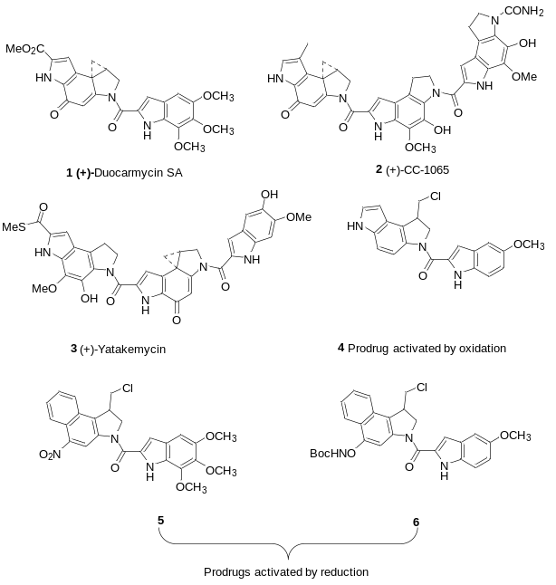
Figure 1. Duocarmycin SA, and biooxidative and bioreductive prodrugs
One route into the design of new molecular entities with therapeutic potential whilst minimising cytotoxicity is via tumour cell targeting, rather than prodrug design. Antibody-drug conjugates, in which the antibody targets a highly cytotoxic molecule to the tumour site of action, have met with recent success in the clinic.¹⁹ The enediyne antibiotic calicheamicin was conjugated to an anti-CD33 antibody to generate the clinically utilised agent gemtuzumab ozogamicin for the treatment of acute myelogenous leukemia (AML).²⁰ Although this was subsequently withdrawn due to toxicity problems, it paved the way for brentuximab vedotin²¹ and trastuzumab emtansine,²² which are used in the treatment of Hodgkins lymphoma and breast cancer, respectively. Key to the design of antibody drug conjugates is the linker between the cytotoxic drug and the antibody. In gemtuzumab ozogamicin, the linker was cleaved under the acidic conditions that are formed in the endosomal compartment when the antibody is internalised in the cell.^{[11]} Brentuximab vedotin utilises a cathepsin cleavable linker to the antimitotic agent monomethylauristatin E.²³ Trastuzumab emtansine contains a non-cleavable linker, such that as the protein is degraded in the environment of the endosome, the small molecule is released with the linker and a lysine residue still attached, nevertheless still exerting a cytotoxic effect.²⁴
These latter two approaches require the attachment of the potent drug molecule through a peptidic linker. The ability to prepare multiple analogues via solid phase peptide chemistry is thus particularly attractive for ADC design. The duocarmycin SA alkylation subunit (termed (+)-DSA) is an amino acid ester and so is ideally placed to be incorporated into peptide synthesis. To our knowledge, there have been no descriptions to date of the incorporation of (+)-DSA directly into solid phase peptide methodology and we describe here the synthesis of a monomer 7 that is suitably protected for Fmoc-based solid phase synthesis. We also describe preliminary studies of the incorporation of the subunit onto the solid phase with a peptide moiety at the C-terminus for both a simple alkylating agent (8-13) and an extended DSA analogue (14-18). The effects of the presence of the differing side chains on DNA binding and biological activity are shown. Particularly striking was the discovery that substitutions at this position have a profound effect on the antiproliferative activity of the compounds. Hydrolysis of the simple ester 30 to give the free acid 31 completely eliminates the activity whereas the presence of a free amino acid demonstrates considerable variability. The combination of a free amino acid with an extended group on the N-terminus increases the antiproliferative activity but incorporation of a terminal amine or amide has little effect on activity.
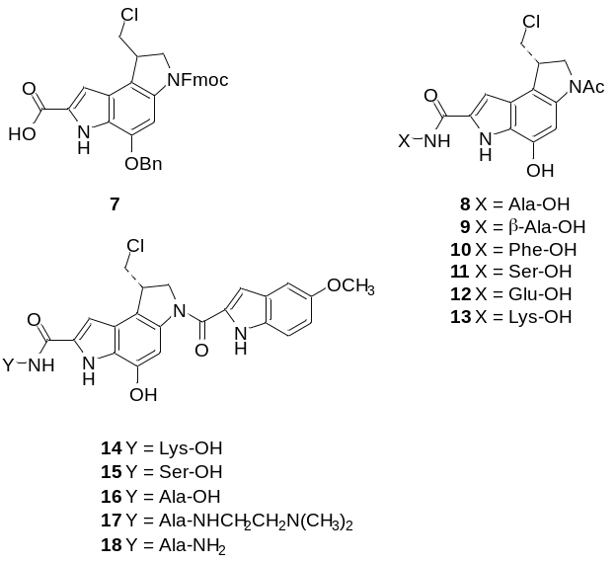
Figure 2. Compounds 7-18 made in this study.
Results and Discussion
Synthesis of the monomer for Fmoc-chemistry
Several synthetic routes to the (+)-DSA subunit have been described,²⁵⁻²⁸ but key to success in this project was the scalability, so that large amounts of a protected form were available for application to the solid phase. There are also a smaller number of stereoselective routes to the target compound and analogs,^{4d,} ²⁸ but in this instance, it was felt a late stage separation of the enantiomers, on a large scale, would be useful as it was felt that the seco form of DSA that would be generated from the planned racemic route would serve as a suitable solid phase building block. This is because the halide leaving group allows in vivo spiro-cyclisation, thus providing compounds of biological interest in fewer synthetic steps post cleavage. Our synthesis began with 50 g of commercially available 2-hydroxy-4-nitroaniline 19 which was protected as the benzyl ether 20 in two batches (BnBr, K₂CO₃, DMF, RT, 99%, Scheme 1) and then regioselectively iodinated, again in two batches, using N-iodosuccinimide (NIS) and catalytic acid to give over 100 g of the iodo compound 21 in 92% yield overall. This set the stage for investigation of cross-coupling reactions to introduce an alkyne substrate and potentially to induce cyclisation to the indole in one pot as described previously.²⁹ The Negishi coupling worked smoothly (methyl propiolate, Pd(PPh₃)₂Cl₂, ZnBr₂, N,N-Diisopropylethylamine (DIPEA), DMF, 66 °C, 77%) but we had elected on the large scale not to use the dimesylation/mesylation approach²⁹ as it increased the number of manipulations required. As such, in spite of several attempts under differing conditions, we could not induce the cyclization of 22 to occur. As a consequence, the coupling was followed by cyclisation using tetrabutylammonium fluoride,³⁰ which generated the indole 23 and this was immediately protected as the N1-Boc compound 24 (Boc₂O, 4-dimethylaminopyridine (DMAP), CH₂Cl₂). The two steps were conducted on a 60 g (184 mmol) scale and gave a modest 39% yield of the pure protected indole 24 after purification by flash column chromatography. We also investigated a Sonogashira route to the same indole, which gave similar yields on a small scale but could not be scaled up due to problems associated with the purification. The rest of the synthesis to the di-Boc protected indole followed published methodology³¹ and utilized the 5-exo-trig free radical cyclisation reaction^{32,33} to introduce the dihydropyrrole ring structure. Hydrolysis of the ester 28 was followed by Boc-removal under acidic conditions to generate a substrate that was regioselectively Fmoc protected with Fmoc-Cl to give the substrate for peptide synthesis. The final yield for the full synthesis was 3% over 13 steps and generated over 8 g of the Fmoc protected monomer 7 as a racemic mixture.
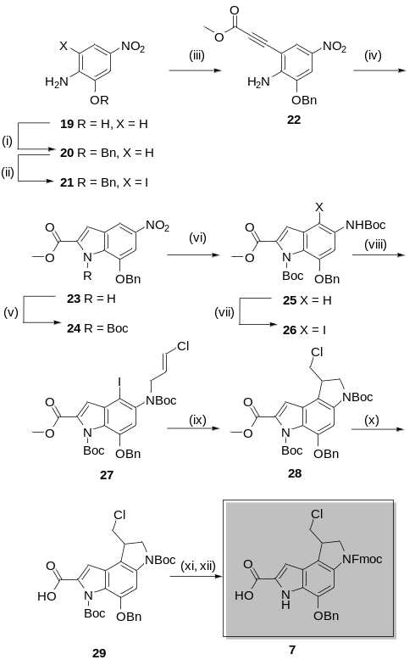
Scheme 1. i: BnBr, K₂CO₃, DMF, 98.5% (mean 2 batches). ii: NIS, H₂SO₄, DMF, 92% (mean 2 batches). iii: ZnBr₂, Pd(PPh₃)₂Cl₂, DIPEA, Methyl propiolate, DMF, 66 °C, N₂, 77%. iv: TBAF, THF, 66 °C. v: Boc₂O, DMAP, CH₂Cl₂, 39% (2 steps). vi: Zn, NH₄Cl, Boc₂O, DMAP, THF:Water. vii: NIS, H₂SO₄, DMF, 59% (3 steps). viii: Potassium tert-butoxide, 1,3-dichloropropene, DMF, 62%. ix: AIBN, Tris(trimethylsilyl)silane (TTMSS), Toluene, 90 °C, N₂, 70% x: LiOH, THF:MeOH:Water, 100%. xi: 4M HCl in Dioxane. xii: Fmoc-Cl, NaHCO₃, THF:Water, 80% (2 Steps).
Separation of enantiomers using supercritical fluid chromatography.
The application of supercritical fluid chromatography for the chiral resolution of racemic mixtures is well established.^{34,35} Supercritical fluids combine the density, and dissolution character of a liquid, with a viscosity, and diffusion behaviour more comparable to a gas. The low viscosity improves mass-transfer kinetics, and permits the use of fast flow rates with high acuity columns. These properties make them ideal mobile phases, and allow for highly efficient separations. As such this technique is particularly attractive for preparative scale work, and was employed here for the isolation of each enantiomer of 7.
Separation was affected using a Chiralpak AD-H column (250 x 30 mm, 5 micron), and an isocratic flow of 50% CO₂, and 50% IPA containing 0.1% TFA, at 45 mL per min. The back pressure was regulated at 10 MPa, and column temperature controlled at 40 ºC. A racemate of 7 (9.8 g) was dissolved in THF:MeOH 1:1 (100 mL), and 1.25 mL (125 mg) injected every 9 min. Fractions were monitored by UV (220 nm), collected, combined and dried to afford 2.82 g of peak 1 (5.5 min), and 3.1 g of peak 2 (7 min), both as cream solids (α = 1.27).
Analytical supercritical fluid chromatography of peak 1, showed a 7% impurity with similar retention time to peak 2. The mass of this peak suggested the loss of Cl as opposed to racemisation. NMR analysis showed no evidence of this impurity, with the ¹H NMR of both enantiomers being identical to that of the racemate, with the exception of a small amount of residue IPA. We propose that the observed impurity may be an artefact of supercritical fluid chromatography, and represent a transient alternative spirocyclisation through the indole nitrogen,³⁶ perhaps promoted by the pressure and acidic buffer.
Peak 1 was assigned as the natural enantiomer based on the sign of specific rotation matching that of the well characterised seco-Boc-DSA derivative.³⁷ Peak 1 [α]²⁵_{D} –20° (c 0.05, DMF), Peak 2 [α]²⁵_{D} +20° (c 0.05, DMF). This assignment was further confirmed by the DNA alkylation sequence selectivity of the extended agent 14, which matches that found for the natural products (i.e. alkylation of an A at the 3’-end of an AT sequence).¹⁰
Application of Fmoc-protected monomer to solid phase peptide synthesis.
The suitability of 7 to serve as a building block for Fmoc-based solid phase synthesis was initially explored using a racemic batch of the compound accessed from a small scale pilot synthesis. In this preliminary study (Scheme 2), a commercially available Wang supported alanine resin was first prepared for coupling by swelling in CH₂Cl₂ for 30 min, followed by DMF for a further 30 min. Subsequent treatment with 40% piperidine in DMF for 10 min, and 20% piperidine in DMF for 5 min twice, removed the alanine’s Fmoc protection. A positive Kaiser Test confirmed the present of the free amine. The resin was then treated with a modest excess of 7 (1.1 eq. based on the manufacture’s resin loading) which had been pre-activated for 30 s prior to addition, by treatment with an equimolar quantity of N,N,N′,N′-tetramethyl-O-(1H-benzotriazol-1-yl)uronium hexafluorophosphate (HBTU), and a twofold excess of both hydroxybenzotriazole (HOBt.H₂O) and DIPEA in DMF. After two hours of shaking, the Kaiser test was repeated. A negative result was observed, and suggested complete coupling of 7 to the Wang supported alanine. The resin was treated again with piperidine in DMF as previously described, affecting removal of Fmoc protection from the indoline nitrogen. This allowed coupling of a further alanine residue, using a fivefold excess of Fmoc-protected alanine for 45 min, which had been preactivated for 30 s with equimolar quantities of HBTU and HOBT.H₂O, and a twofold excess of DIPEA in DMF. The resin was then prepared for cleavage by removal of the final Fmoc group and extensive washing with CH₂Cl₂, followed by drying under a stream of N₂.
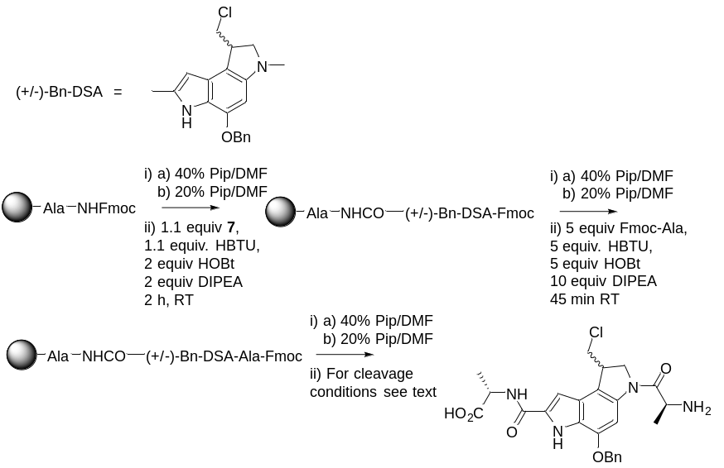
Scheme 2. Preliminary solid phase synthesis studies using racemic 7
The resin was cleaved using standard conditions for peptide synthesis.³⁸ The dried resin was treated with a solution of 95% TFA, 2.5% triisopropylsilane (TIPS), and 2.5% H₂O for 2 h. The cleavage mixture was filtered and concentrated, followed by precipitation with the addition of cold Et₂O. HPLC analysis of the crude product (Figure 3a) revealed the formation of several significant side products. It was suspected that these products may have resulted from degradation during cleavage as opposed to representing problems during the synthesis. As a result the synthesis was repeated to allow optimisation of the cleavage conditions.
The dried resin was divided into 10 mg portions, and subjected to different cleavage conditions. The results of the HPLC analysis of the crude products are shown in Figure 3. Reducing the concentration of TFA to 50% in CH₂Cl₂ and omission of the scavengers (TIPS, H₂O), led to a reduction in the number of side products (Figure 3b versus 3a). However the product peak at 9 min was still accompanied by two significant side products at 9.5 and 9.7 min. Cleavage with 95% TFA and 5% CH₂Cl₂ in the absence of scavengers (Figure 3c) led to almost complete absence of the product peak with the HPLC trace now being dominated by the side products at 9.5 and 9.7 min. Finally, reducing the concentration of TFA and including the scavengers (Figure 3d, 47.5% TFA, 47.5% CH₂Cl₂, 2.5% TIPS, 2.5% H₂O) produced an HPLC trace dominated by the product peak at 9 min. Mass spec analysis confirmed this peak to be the desired product.
Interestingly closer inspection of the HPLC trace under the most destructive cleavage conditions (Figure 3c) revealed that, not only did the product peak no longer dominate, but there was also a large decrease in intensity compared to the other conditions despite the crudes having been analysed in the same volume of methanol. This suggested that the amount of material recovered from the resin had been reduced. Repeating the cleavage did not lead to recovery of more material. This led to the proposal that Wang resin may not be the most appropriate choice for syntheses incorporating 7. Indeed, Wang resin has previously been suggested to be problematic for peptides containing the indole side chain of tryptophan.³⁹ The Wang linker can be cleaved at more than one position leading to free benzyl cations that can attack the nucleophilic positions of the indole. Furthermore, resin-bound cations have been speculated to undergo an irreversible back alkylation with the tryptophan side chain leading to reduced yields.⁴⁰ Considering that in the indole structure of 7, it is the more nucleophilic 3- position that is unsubstituted in comparison to the 2-position of the tryptophan side chain, it may be particularly susceptible to such side reactions.
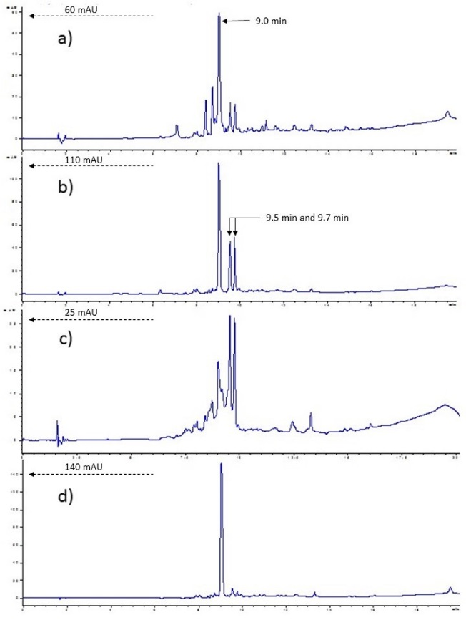
Figure 3: HPLC analysis of crude HO-Ala-DSA-Ala-NH₂ after cleavage under varying conditions. a) 95% TFA, 2.5% TIPS, 2.5% H₂O. b) 50% TFA, 50% CH₂Cl₂. c) 95% TFA, 5% CH₂Cl₂. d) 47.5% TFA, 47.5% CH₂Cl₂, 2.5% TIPS, 2.5% H₂O. 10 mg of dried resin was cleaved under either conditions a, b, c, or d with 5 mL of the respective cleavage cocktail for 2 h. The cleavage mixture was filtered and evaporated to dryness. The crude was dissolved in 1 mL of CH₃OH and analysed by HPLC at 254 nm. Agilent Eclipse XDB-C18 column, 4.8 x 150 mm, 5 µM. Solvent A: [Water and 0.05% TFA], Solvent B: [ACN and 0.05% TFA]. Gradient: 0% [B] to 95% [B], from 0 min to 15 min, 95% [B] to 0% [B] from 15 to 20 min. Monitored UV 254 nM.

As a result of these concerns a qualitative analytical screen of available resins was conducted. For these tests the C-terminal alanine was replaced with lysine and the indoline nitrogen capped with 5 equiv. of AcCl and 10 equiv. of DIPEA in DMF for 45 min (Scheme 3). This synthesis was carried out on the same 0.038 mM scale with identical reaction times, on four different resins: 2Cl-Trt resin, Rink amide resin, Wang resin, and Novo Syn Wang resin. All were cleaved using 47.5% TFA, 47.5% CH₂Cl₂, 2.5% TIPS, 2.5% H₂O at the same volume for 2 h. The crude cleavage mixtures were filtered, evaporated to dryness, and dissolved in the same volume of CH₃OH (1 mL) for HPLC analysis. The area of the product peak for each of the crudes was compared. As the same volume of CH₃OH was used to dissolve the crudes, the area of the peak doses give a qualitative indication of the quantity of product recovered from each resin. Both Wang resins appeared to perform the worst and gave the same level of product as judged by peak area. The best performing was 2-Cl-Trt resin, and Rink amide resin fell between the two extremes. 2-Cl-Trt resin can only be cleaved at the desired position, and the cation formed is more sterically hindered by the surrounding linker structure, making any potential back alkylation less likely. As 2-Cl-Trt resin has the further advantage of allowing cleavage to be effective with as little as 1% TFA, it was chosen as the resin of choice for further work.
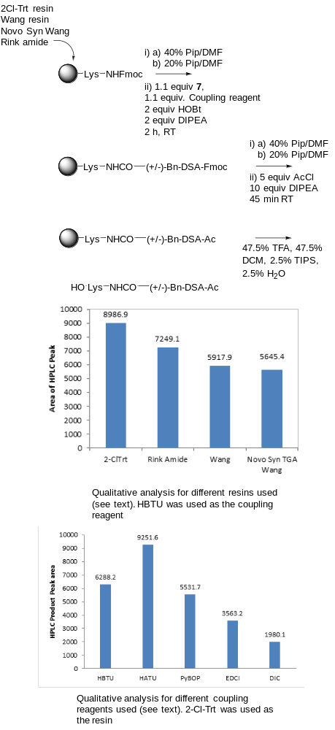
Scheme 3. Qualitative analysis of the best resins and coupling reagents for addition of 7 to the solid phase.
A similar test was used to compare available coupling reagents (Scheme 3). The same analogue was synthesised at a 0.016 mM scale on 2-Cl-Trt resin. The only variation being the reagents used to couple 7 to the resin-bound lysine. Again, a qualitative comparison of the area of the product peak on HPLC was carried out. -[Bis(dimethylamino)methylene]-1H-1,2,3-triazolo[4,5-b]pyridinium-3-oxid hexafluorophosphate (HATU) appeared to be the best performing coupling reagent followed by HBTU, (Benzotriazol-1-yloxy)tripyrrolidinophosphonium hexafluorophosphate (PyBop), 1-Ethyl-3-(3-dimethylaminopropyl)carbodiimide (EDCI), and N,N′-Diisopropylcarbodiimide (DIC). As a result, HATU was used as the coupling reagent for further work.
Following these initial experiments, the natural enantiomer of 7, accessed from the large scale synthesis, was used to generate the library of analogues shown in Figure 2. Full details of their synthesis and isolated yields can be found in the experimental section (yields were 8 69%, 9 81%, 10, 56%, 11 48%, 12 38%, 13 19%, 14 20%, 15 16%, 16 35%, 17 17%, 18 34% based upon resin-loading). All analogues where synthesised on 2-Cl-Trt resin, with the exception of 18, where Rink amide was employed to provide a neutral terminal amide after cleavage. When using 2-Cl-Trt resin, the cleavage concentration of TFA was reduced further to 1% for analogues not requiring t-butyl side chain deprotection, increasing to 10 or 20% and extended reaction times for those that did. It was found when the TFA concentration was reduced to this level, H₂O no longer served as an effective scavenger, presumably as it was not miscible with the larger volumes of dichloromethane now being used. This was resolved by increasing the concentration of TIPS to 10%. Interestingly, if 10% H₂O was also included, t-butyl side chain deprotection did not occur. This might be as the immiscible water layer was acting as a proton sink, reducing the acidity of the CH₂Cl₂ layer.
The benzyl protecting group was removed via transfer hydrogenation using Pd-C/HCO₂NH₄ on crude cleavage products, and the active compounds purified by either preparative reverse phase HPLC, or silica gel Flash chromatography, depending on the polarity of the side chain. This reaction proceeded smoothly for all but one of the molecules synthesised in this study. Compound 14, containing the lysine side chain and the extended DNA binding structure, required careful monitoring as an alternative product, which had undergone dehalogenation, began to form and became the predominant species. The reason for the susceptibility of 14 to this side reaction is unknown. It was observed that the reaction was unusually slow compared to the other analogues and required greater quantities of Pd-C and ammonium formate. Suspicion that the amine of the lysine side chain might be poisoning the catalyst, or promoting dehalogenation, led to attempts to perform benzyl deprotection prior to removal of lysine side chain protection. This was achieved by cleaving in 1% TFA to give the protected lysine product. However this made no difference and the side reaction was still encountered. The highest yield and optimum purity of the target compound was obtained when the reaction was carefully carried out and quenched after 1 h.
DNA alkylation studies
(+)-Duocarmycin SA binds to the minor groove and alkylates the N3 of adenine at the 3’-end of an AT rich sequence, with the unnatural enantiomer displaying a similar sequence preference but with alkylation occurring at the 5’-end of the sequence, suggesting productive binding is in the other orientation, as might be expected.³⁷ The alkylation subunit (+)-Boc-DSA displays a similar sequence selectivity to the unnatural enantiomer, essentially alkylating any A within a truncated AT sequence, down to two bases.⁴¹ This can be rationalised by models of both compounds in the minor groove that allow for productive alkylation of the same site, regardless of the binding orientation. It was expected that the C-terminal amino acid-linked seco-DSA compounds 8 – 13 would display a similar alkylation profile to the simple alkylation subunit 30 (figure 4), although it was also considered that the presence of the free acid may affect DNA binding, so the compounds were also analysed alongside the hydrolysed derivative 31.

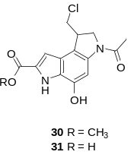
Figure 4. Structures of 30 and 31
Compounds 8-13 were incubated at 37 °C for 16 h with the 3’-³²P-end-labeled MS1 DNA fragment (a fragment approximately 166 base pairs in length designed to contain all possible tetranucleotide sequences).⁴² The resulting solutions were heated to 100 °C for 3 min in order to generate cleavage¹ and were then subjected to denaturing polyacrylamide gel electrophoresis and developed on a phosphoimager. Examples of the results are shown in the left hand panel of Figure 5. It is clear that the sequence selectivity of compounds 8-13 closely matches that for the controls 30 and 31 (which were analysed as the racemic mixtures) with little evidence for sequence selectivity other than the alkylation of an A in short AT runs, as previously suggested,⁴¹ and as shown in the open bars in the lower panel of Figure 5. An indication of the relative reactivity of the compounds towards DNA alkylation and thermal-induced cleavage is given by the intensity of the full length DNA band (at the top of the gel) at similar concentrations. The presence of significant cleavage for compound 31 suggests that the presence of a carboxylic acid does not affect the DNA alkylating ability of the subunit, as the reactivity of 31 closely matches that for 30. For most of the amino acid compounds, the reactivity towards DNA is decreased relative to 30 and 31, with lower levels of cleavage at 5 µM concentration. The exception is the serine derivative 11, which maintains similar reactivity to the controls. This suggests that the presence of the amino acid group has a negative effect on DNA binding, though this effect is unlikely to be a consequence of the presence of the terminal carboxylic acid.
The lysine functionality in 13 does not enhance the binding of the monomeric subunit, which was unexpected as the amino acid was incorporated so that it would enhance interactions with the sugar-phosphate backbone. This appears not be the case and might suggest that the lysine and other side chains lie along the floor of the groove on binding, rather than extending out into the solvent environment close to the alkylation site.
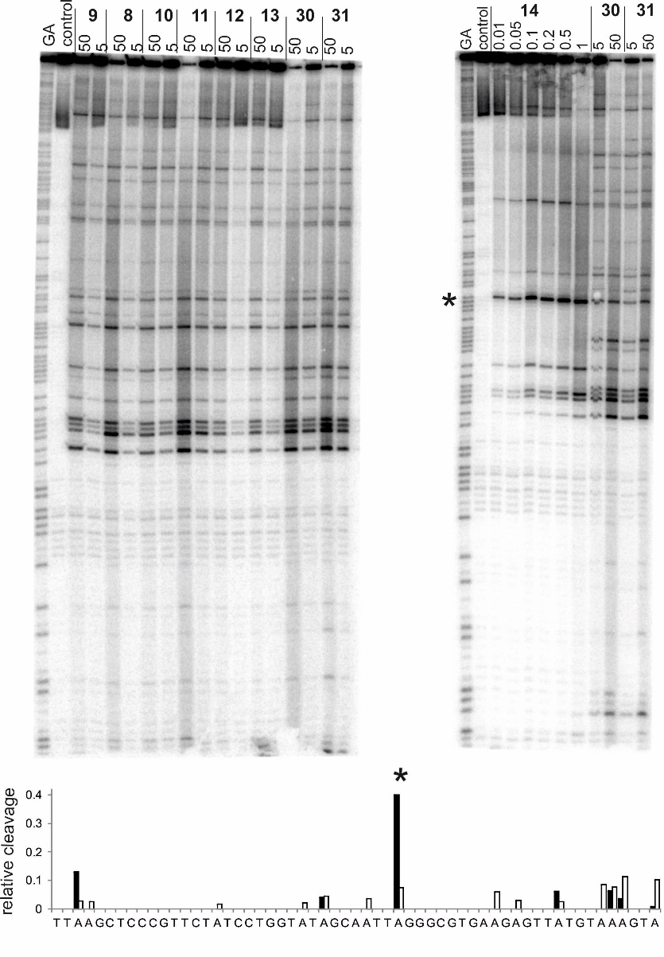
Figure 5. DNA cleavage of DNA fragment MS1 by duocarmycin derivatives. Left hand panel compounds 9-13 and control compounds 30 and 31. Right hand panel 14, compared with compounds 30 and 31. Tracks labelled GA are sequence markers for purines; control is DNA in the absence of added ligand. Ligand concentrations (µM) are indicated at the top of each gel lane. The lower panel shows the relative cleavage (compared with control lane) at each position for 14 (filled bars) and 31 (open bars) for a section of the MS1 fragment that incorporates the site of best cleavage for 14. The asterisk indicates the location of the best cleavage with 14.

The extended agent 14, which is more similar in structure to the full natural product duocarmycin SA than to the simple alkylation subunit, displayed significantly enhanced DNA alkylation activity compared with the other compounds (Figure 5, right hand panel) producing cleavage products at much lower concentrations. As expected, 14 reacted predominantly with As at the 3’-end of AT sequences, with fewer cleavage sites than the other compounds. The major cleavage on this fragment is observed at AATTA, (asterisk in Figure 5) demonstrating a sequence selectivity that is closer to that expected for the natural product. The enhancement of the alkylation seen with 14 compared with 13 was significant with clear alkylation at 10 nM compared with 5 μM for the latter.
Antiproliferative activity
The antiproliferative activity of the compounds was measured using the human leukaemia cell line HL60 and an MTS assay (Table1). An initial, striking, observation with the control compounds 30 and 31 is the difference in biological activity. While racemic 30 maintains an anti-proliferative effect that is close to that seen with L1210 mouse leukaemia cells in the literature ((+)-N-Boc-DSA, 6 nM, (-)-N-Boc-DSA, 60 nM, ³⁷ this study (±)-N-Ac-DSA 30, 25 nM), hydrolysis of the ester to give racemic 31 effectively removes all antitumour effects. The DNA cleavage studies clearly showed that there is no difference in alkylation ability between these two compounds, strongly suggesting that the presence of the carboxylic acid does not affect DNA binding. The lack of activity is likely to derive from the free carboxylic acid, even with the benzoic acid-type of group in the DSA subunit, being substantially ionised at physiological pH and that cellular uptake with this compound is not achieved. Bearing in mind that the pKa of the amino acid carboxylic acid groups appended to the duocarmycin subunit might be expected to be lower than that of 31 and that, with the exception of 11, all compounds displayed a lower affinity for DNA under the alkylation experimental conditions, we expected the new agents to similarly lack antiproliferative activity. Surprisingly, this was not the case with only the Lys and β-alanine compounds showing a complete lack of activity against HL60, although all compounds were between approximately 1000-10000 fold less active than 30.
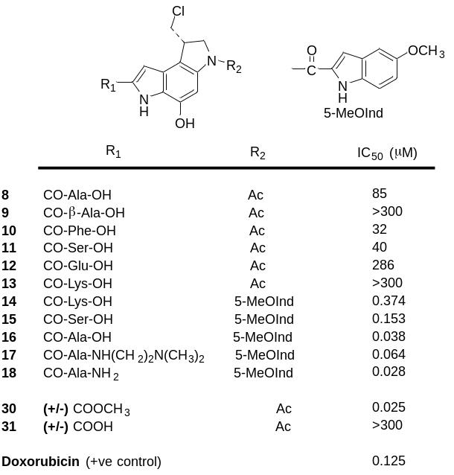
Table 1. Antiproliferative activity of the duocarmycin compounds. Activity was assessed in HL60 human leukaemia cell lines and was measured using the MTS assay. For details, see the experimental section.
It seems unlikely that there is a simple explanation for the increased activity of the simple amino acid derivatives. The activity of 8 and 10 may be due to increased hydrophobic nature of the side chains increasing passive diffusion into cells in spite of the presence of the free acid group or indicate a role for transport mediated uptake. The Ser analogue 11 may display better uptake but also benefit from its more efficient DNA alkylation ability once in the cell. The lysine derivative 13 will form a zwitterion in solution and this may explain its complete inactivity, due to the lack of cellular uptake, although this is then countered by the more hydrophobic extended structure of 14, which has reasonable activity. Compound 12, with two acid groups has low activity and it is unclear why the presence of the linear β-ala in 9 would lead to complete inactivity.
The introduction of extended hydrophobic structure of the 5-methoxyindole derivatives significantly enhanced the biological activity of the compounds with the lysine derivative 14 now having an activity of 374 nM and the serine and alanine derivatives 15 and 16 displaying a 260 and 2200 fold increase in activity, respectively. As the lysine derivative 14 displayed enhanced activity on binding to DNA compared with 30, the decreased cytotoxicity is likely to derive from what is still a limited uptake for these compounds, with only the alanine compound 16 having activity that approaches that of the simple analogue 30. In other studies, albeit in different cell lines, neutral duocarmycin analogues have low pM antiproliferative activity.³⁷
In order to further investigate the effect of the carboxylic acid and it derivatives on cytotoxicity, we also synthesised the N,N-dimethylamino- compound 17 and the neutral compound 18. Minor groove binders based upon distamycin often carry a positively charged end group similar to this, which enhances solubility and DNA binding. The inclusion of the amino-end group for 17 is to the detriment of its biological activity, with a 2-fold decrease in activity compared with the free acid compound 16, although this remains the relatively potent. Finally, the uncharged analogue 18 was synthesised using Rink amide resin to directly generate the amide. This compound was found to have similar, albeit slightly enhanced activity compared with the other compounds.
Conclusions
The duocarmycins have great potential as antitumour agents but have yet to progress to clinic use. Their utility in ADCs has been widely recognised, with recent disclosures focussed on the design of conjugates.^{43,44} In this paper, we show that the duocarmycin alkylation subunit is suitable for solid phase synthesis methods and can be added directly to a peptide-based linker for incorporation into a targeting construct. It would be possible to block the reactivity of the duocarmycin linker through phenol protection, either of a bioreductive, biooxidative or simple enzymatic or chemical cleavage nature, but with the exquisite targeting potential of antibodies, it remains to be seen if this is really necessary, as the duocarmycins tend to be activated only in the presence of DNA. This methodology also has potential in the design of, for example, covalent analogues of polyamide minor groove binders or other DNA binding peptides.
The work here also clearly demonstrates that small changes in the duocarmycin structure, even of the extended analogues, can have profound effects on the antitumour activity of the compound and that this is more likely related to uptake than to DNA alkylation ability. Secondary amides of the C-terminus of the duocarmycin structure have been described that maintain their potent antitumour activity,²⁸ whereas in this study, we demonstrated that the presence of an OH or NH on C-terminus, either with a carboxylic acid or a amide, leads to a decrease in activity such that the extended compounds only just match the antiproliferative activity of the truncated compound 30. That this is likely to be due to uptake is demonstrated by the difference in 31, where DNA alkylation ability is similar to that for 30, and for the lysine analogue 14, which alkylates DNA with far more efficiency than 30, but still has lower antitumour activity.
Work is ongoing to explore the attachment of duocarmycins to antibodies and other proteins through their incorporation into peptidic linker structures and will be reported in due course.
Experimental Section.
All chemicals were reagent grade. HPLC mobile phases were prepared using HPLC grade solvents. THF and DMF where specified as dry were bought as such and assumed to conform to the manufacturer’s standards. All water used was distilled. All DMF for solid phase synthesis was purchased as peptide grade.
¹H and ¹³C-NMR spectra were recorded in Fourier Transform mode operating at a nominal ¹H NMR frequency of 400 MHz, using the specified deuterated solvent. The chemical shifts for both ¹H and ¹³C-spectra were recorded in ppm and were referenced to the residual solvent peak. Multiplicities in the NMR spectra are described as: s = singlet, d = doublet, dd = doublet of doublets, t = triplet, q = quartet, m = multiplet, br = broad, appt = apparent; coupling constants are reported in Hz. High resolution mass spectra were obtained using a quadrupole MS. Ionisation by nano-electrospray. Infrared spectra were recorded as neat samples. Thin layer chromatography was performed on aluminium plates coated with 0.2 mm silica gel-60 F₂₅₄. After elution, the TLC plates were visualised under UV light. Flash chromatographic separations were performed on silica gel for column chromatography (particle size 60 µm). Unless otherwise stated analytical RP-HPLC was performed using a C18 column, 4.6 x 150mm, 5µM and a flow rate of 1 mL/min. Solvent A = H₂O + 0.05% TFA and Solvent B = MeOH + 0.05% TFA. Gradient 5% B 95% B over 15 min, 95% B 5 % B over 5 min. Detection wavelength 254 nm. Unless otherwise stated preparative RP-HPLC was performed using a C18 column, 21.2 x 150 mm, 5 µM and a flow rate of 20 mL/min and a flow rate of 20 mL/min. Solvent A = 95% H₂O 5% MeOH + 0.05% TFA and Solvent B = 95% MeOH 5% H₂O + 0.05% TFA. Gradient 0 % B 100% B over 15 min, 100% B 0% B over 5 min. Detection wavelength 254 nm. Unless otherwise stated RP-Flash chromatography was performed using a pre-packed 12 g C18 column, and a flow rate of 20 mL/min. Solvent A = 95% H₂O 5% MeOH + 0.05% TFA and Solvent B = 95% MeOH 5% H₂O + 0.05% TFA. Gradient 0% B 100% B over 15 min, 100% B 0% B over 5 min. Detection wavelength 254 nm. Samples were dry loaded by adsorption on Celite.
4-Nitro-2-(phenylmethoxy)benzenamine (20)
BnBr (21 mL, 178 mmol) was added dropwise to a stirring suspension of 2-amino-5-nitrophenol (25 g, 162 mmol) and K₂CO₃ (49.3 g, 357 mmol) in DMF (250 mL) at room temperature. After 20 h, the reaction mixture was poured over crushed ice. The precipitate was collected by filtration and triturated with cold water prior to drying at 40 ^{O}C under vacuum overnight. The reaction was repeated and the two batches combined to afford 78.05 g of 20 as yellow/brown amorphous solid (98.5% average yield over the 2 batches). R_{f} 0.17 (20 % EtOAc in hexane); mp 147-149 ºC (Lit²⁹ 151-153 ºC). ¹H NMR (CDCl₃, 400 MHz) δ 7.83 ( 1H, dd, J=2.4, 8.7), 7.77 (1H, d, J=2.4), 7.37-7.46 (5H, m), 6.66 (1H, d, J=8.7), 5.15 (2H, s), 4.60 (2H, brs). ¹³C NMR (CDCl₃, 100 MHz) δ 144.6, 143.6, 138.7, 135.9, 128.9, 128.7, 128.0, 119.5, 112.1, 107.4, 71.0. IR (neat) ν_{max} 3483, 3359, 3225, 3188, 3075, 2939, 2876, 1622, 1579, 1519, 1480, 1455, 1386, 1282, 1222, 1176, 1091, 1007, 950, 914, 870, 853, 818, 797, 755, 744, 727, 697, 643, 623 cm⁻¹. HRMS (ES+) calculated for C₁₃H₁₃N₂O₃ (M+H)⁺ 245.0921 found 245.0923.
2-Iodo-4-nitro-6-(phenylmethoxy)benzenamine (21)
H₂SO₄ (800 µL, 15.15 mmol) was added to a stirring solution of 20 (37 g, 151 mmol) in DMF (555 mL), followed by portionwise addition of NIS (51.1 g, 227 mmol) at room temperature. After 4 h, the reaction mixture was poured over crushed ice. The precipitate was collected by filtration and triturated with cold water, followed by cold hexane, prior to drying at 40 ^{O}C under vacuum overnight. The reaction was repeated with 39.1 g of 21 and the two batches combined to afford 105.65 g as a bright yellow amorphoussolid (91.5% average yield over the 2 batches). R_{f} 0.31 (20 % EtOAc in hexene); mp 103-106 ºC (Lit²⁹ 105-106 ºC). ¹H NMR (CDCl₃, 400 MHz) δ 8.29 (1H, d, J=2.3), 7.74 (1H, d, J=2.3), 7.38-7.44 (5H, m) 5.16 (2H, s), 5.02 (2H brs). ¹³C NMR (CDCl₃, 100 MHz) δ 144.1, 143.3, 138.9, 135.4, 129.0, 128.9, 128.3, 128.1, 106.7, 178.5, 71.5. IR (neat) ν_{max} 3476, 3379, 3359, 3091, 3056, 3030, 2357, 2333, 1602, 1568, 1497, 1451, 1425, 1386, 1282, 1237, 1099, 1037, 1025, 869, 849, 819, 740, 726, 692 cm⁻¹. HRMS (ES+) calculated for C₁₃H₁₂IN₂O₃ (M+H)⁺ 370.9887 found 370.9890.
Methyl 3-[2-Amino-3-(phenylmethoxy)-5-nitrophenyl]-2-propynoic acid (22)
21 (40.8 g, 110 mmol) was dissolved in anhydrous DMF (1225 mL). The resulting solution was degassed with a stream of N₂ for 30 min prior to addition of methyl propiolate (37.1 mL, 441 mmol), Pd(PPh₃)₂Cl₂ (3.87 g, 5.51 mmol), ZnBr₂ (99 g, 441 mmol), and DIPEA (77 ml, 441 mmol) at room temperature . The reaction mixture was then heated to 66 ºC and stirred overnight under N₂. After cooling to room temperature the reaction was poured over crushed ice, and the resulting chocolate colour precipitate collected by filtration. The reaction was repeated with 51 g of 21, and the precipitates were combined prior to adsorption on to 250 g of silica. Elution through a 1 Kg silica plug with 50% ethyl acetate and hexane afforded 62 g of 22 as an orange amorphous solid (77% yield). R_{f} 0.16 (20 % EtOAc in hexane); mp 136-139 ºC. ¹H NMR (CDCl₃, 400 MHz) δ 8.06 (1H, d, J=2.4), 7.76 (1H, d, J=2.4), 7.38-7.45 (5H, m), 5.32 (2H, brs), 5.17 (2H, s), 3.86 (3H, s). ¹³C NMR (CDCl₃, 100 MHz) δ 154.1, 146.7, 144.5, 137.8, 135.2, 129.1, 129.0, 128.1, 123.0, 108.3, 101.0, 87.1, 81.1, 71.5, 53.1. IR (neat) ν_{max} 3499, 3391, 3351, 3087, 3063, 3030, 2951, 2204, 1698, 1611, 1455, 1430, 1393, 1325, 1299, 1237, 1215, 1148, 1093, 1040, 1028, 1001, 886, 859, 755, 740, 731, 694, 657, 612 cm⁻¹. HRMS (ES+) calculated for C₁₇H₁₅N₂O₅ (M+H)⁺ 327.0975 found 327.0979.
1-(1,1-Dimethylethyl)-2-methyl 5-nitro-6-(phenylmethoxy)indole-1,2-dicarboxylate (24)
22 (60 g, 184 mmol) in anhydrous THF (858 mL) was treated with 1M TBAF in THF solution (368 mL, 368 mmol) and refluxed at 66 ºC for 1 h. After cooling to room temperature the THF was removed by rotary evaporation under reduced pressure. The residue was dissolved in ethyl acetate (1000 mL) and washed 3 times with water (1000 mL). Concentration of the ethyl acetate followed by co-evaporation of the residue with CH₂Cl₂ afforded crude product as a dark purple foam. The foam was dissolved in CH₂Cl₂ (1000 mL) and treated with Boc₂O (80 g, 368 mmol), and DMAP (22.46 g, 184 mmol) at room temperature for 1.5 h. Removal of the CH₂Cl₂ gave a dark foam which was purified by silica gel chromatography using an automated flash chromatography system. The crude was dry loaded on to a 1.5 kg pre-packed silica column adsorbed on to 200 g of silica. A linear gradient of 0 to 30% ethyl acetate in hexane was run over 23 column volumes and then held at 30% ethyl acetate until complete elution of the product. Removal of the solvent afford 31 g of 24 as an orange amorphous solid (39% yield of 2 steps). R_{f} 0.33 (20 % EtOAc in hexane); mp 168-171 ºC. ¹H NMR (CDCl₃, 400 MHz) δ 8.26 (1H, d, J=1.9), 7.67 (1H, d, J=1.9), 7.49-7.45 (2H, m), 7.41-7.34 (3H, m), 7.33 (1H, s) 5.33 (2H, s), 3.94 (3H, s), 1.47 (9H, s). ¹³C NMR (CDCl₃, 100 MHz) δ 160.5, 149.3, 145.6, 143.6, 135.2, 130.2, 128.9, 128.7, 128.2, 126.4, 112.7, 112.5, 102.2, 86.5, 71.3, 52.5, 27.9, 27.3. IR (neat) ν_{max} 3127, 3099, 3050, 2981, 2949, 1765, 1722, 1586, 1512, 1437, 1388, 1372, 1325, 1252, 1223, 1151, 1115, 1073, 982, 875, 840, 822, 801, 778, 766, 742, 729, 697, 606 cm⁻¹. HRMS (ES+) calculated for C₂₂H₂₃N₂O₇ (M+H)⁺ 427.1500 found 427.1499.
1-(1,1-Dimethylethyl)-2-methyl 5-[[(1,1-dimethylethoxy)carbonyl]amino]-4-iodo-7-(phenylmethoxy)indole-1,2-dicarboxylate (26)
24 (15 g, 35.2 mmol) was dissolved in THF (293 ml) and treated with zinc powder (34.5 g, 528 mmol), NH₄Cl (18.82 g, 352 mmol), Boc₂O (23.03 g, 106 mmol), DMAP (430 mg, 3.52 mmol), and water (58.6 mL). The resulting suspension was stirred vigorously at room temperature overnight. After removal of the zinc by filtration, the THF was evaporated and the residue taken up in ether (500 mL). The ether was washed 3 times with water (250 mL) and died over MgSO₄. Co-evaporation with CH₂Cl₂ gave crude 25 as a light brown foam. The reaction was repeated on the same scale and the crudes combined and dissolved in DMF (352 mL). H₂SO₄ (0.375 mL, 7.04 mmol) was added followed by portionwise addition of NIS (23.75 g, 106 mmol) at room temperature. After 3 h the reaction was diluted with Et₂O (1000 mL), and washed once with 50% saturated brine in water (1000 mL), twice with water (1000 mL), and once with saturated brine (1000 mL). The first wash was back extracted 3 times with Et₂O (500 mL), which was subsequently combined and washed twice with saturated brine (1000 mL). All the Et₂O was combined and concentrated to give a dark red foam which was purified by silica gel chromatography using an automated flash chromatography system. The crude was dry loaded on to a 750 g pre-packed silica column adsorbed on to 170 g of Celite. A linear gradient of 0 to 20% ethyl acetate in hexane was run over 16 column volumes. Removal of the solvent afforded 26 g of 26 as an off white foam which dried to an amorphous solid (59% yield over 3 steps). R_{f} 0.37 (20 % EtOAc in hexane); mp 158-161 ºC. ¹H NMR (CDCl₃, 400 MHz) δ 7.79 (1H, brs), 7.49-7.46 (2H, m), 7.30-7.38 (3H, m), 7.09 (1H, s), 6.77 (1H, brs), 5.24 (2H, s), 3.91 (3H, s), 1.54 (9H, s), 1.41 (9H, s). ¹³C NMR (CDCl₃, 100 MHz) δ 160.9, 153.1, 149.9, 146.6, 136.0, 134.7, 131.5, 128.7, 128.6, 128.4, 127.8, 123.7, 114.6, 102.6, 85.6, 81.0, 71.1, 52.3, 28.5, 27.3. IR (neat) ν_{max} 3355, 2984, 2933, 1763, 1725, 1716, 1615, 1575, 1541, 1505, 1449, 1393, 1361, 1338, 1310, 1256, 1221, 1152, 1080, 980, 908, 878, 843, 817, 758, 723, 693 cm⁻¹. HRMS (ES+) calculated for C₂₇H₃₂O₇N₂I (M+H)⁺ 623.1249 found 623.1246.
1-(1-,1-Dimethylethyl)-2-methyl 5-[(3-chloro-2-propenyl)[(1,1-dimethylethoxy)carbonylamino]-4-iodo-7-(phenylmethoxy)indole-1,2-dicarboxylate (27)
26 (26 g, 41.8 mmol) was dissolved in DMF (418 mL) and treated with t-BuOK (9.37 g, 84 mmol) and technical grade (90%) 1,3-dichloropropene as a mixture of cis and trans isomers (12.90 mL, 125 mmol). After stirring for 1.5 h with the vessel submerged in a room temperature water bath, the reaction was cooled to 0 ºC and quenched with saturated aqueous NH₄Cl (20 mL). The mixture was diluted with Et₂O (1000 mL), and washed twice with of 50% saturated brine in water (1000 mL), and once with saturated brine (1000 mL). The Et₂O was dried over MgSO_{4,} concentrated, and co-evaporated with CH₂Cl₂ 6 times to afford a brown foam which was purified by silica gel chromatography using an automated flash chromatography system. The crude was dry loaded on to a 220 g pre-packed silica column adsorbed on silica. A linear gradient of 0 to 10% ethyl acetate in hexane was run over 16 column volumes. Removal of the solvent afforded 18 g of 27 as a light brown foam which dried to an amorphous solid (62% yield - mixture of E/Z isomers). R_{f} 0.31 (20 % EtOAc in hexane); mp 104-106 ºC. ¹H NMR (CDCl₃, 400 MHz, mixture of E/Z isomers) δ 7.28-7.44 (5H, m) 7.18 (1H, s), 6.65-6.47 (1H, m), 5.80-6.00 (2H, m]), 5.17-5.28 (2H, m), 4.46 & 4.18 (1H, m), 4.33 & 3.73 (1H, m), 3.93 (3H, s), 1.53 (9H, s), 1.29 & 1.27 (9H, s). ¹³C NMR (CDCl₃, 100 MHz) δ 160.9, 154.2, 150.0, 145.7, 138.7, 135.9, 132.2, 128.9, 128.4, 128.0, 127.5, 125.4, 121.8, 120.7, 115.3, 109.7 86.0, 83.9, 80.6, 70.7, 52.4, 49.5, 46.2, 28.4, 27.3. IR (neat) ν_{max} 2976, 2921, 1775, 1731, 1702, 1694, 1571, 1535, 1467, 1454, 1435, 1391, 1372, 1299, 1251, 1227, 1150, 1118, 1077, 978, 932, 885, 842, 829, 782, 764, 739, 731, 699 cm⁻¹. HRMS (ES+) calculated for C₃₀H₃₅O₇ N₂ClI (M+H)⁺ 697.1172 found 697.1174.
3.6-Bis(1,1-dimethylethyl)-2-methyl 8-(chloromethyl)-7,8-dihydro-4-(phenylmethoxy)benzo[1,2-b: 4,3-b’]dipyrrole-2,3,6-tricarboxylate (28)
27 (9 g, 12.9 mmol) was dissolved in anhydrous toluene and degassed with a stream of N₂ for 45 min prior to addition of AIBN (0.530 g, 3.23 mmol) and Tris(trimethylsilyl)silane (TTMSS) (4.38 mL, 14.20 mmol). The resulting solution was refluxed a 90 ºC under N₂. After 1 h the reaction was allowed to cool to room temperature before being concentrated and subjected directly to silica gel column chromatography using an automated flash chromatography system. A 120 g pre-packed silica column was used, and 0% ethyl acetate in hexane run for 5 column volumes rising to 10% linearly over the subsequent 5 column volumes, holding at 10% until complete elution of the product. The reaction was repeated on the same scale and the products combined, affording 10.28 g of 28 as white foam which dried to an amorphous solid (70% yield). R_{f} 0.30 (20 % EtOAc in hexane); mp 115-118 ºC. ¹H NMR (DMSO-d₆, 400 MHz) δ 7.69 (1H brs), 7.47-7.29 (6H, m), 5.27 (2H, s), 4.13 (1H, t, J=9.7), 4.06-3.89 (4H, m), 3.87 (3H, s), 1.48 (9H, s), 1.39 (9H, s). ¹³C NMR (DMSO- d₆, 100 MHz) δ 160.4, 151.4, 149.5, 145.1, 136.2, 128.4, 128.0, 127.9, 123.5, 113.2, 108.5, 97.4, 85.0, 80.3, 69.7, 52.3, 52.2, 47.6, 40.7 (obscured by DMSO peak observed by HSQC), 28.0, 26.8, 22.0. IR (neat) ν_{max} 3002, 2977, 2921, 2357, 1782, 1720, 1698, 1593, 1538, 1494, 1494, 1439, 1417, 1379, 1343, 1241, 1214, 1141, 1089, 1022, 988, 918, 899, 836, 765, 745, 712, 699, 691, 664 cm⁻¹. HRMS (ES+) calculated for C₃₀H₃₆O₇N₂Cl (M+H)⁺ 571.2206 found 571.2201.
8-(Chloromethyl)-7,8-dihydro-4-(phenylmethoxy)benzo[1,2-b: 4,3-b’ ]dipyrrole-3,6-dicarboxylic acid 3,6-bis(dimethylethyl)ester (29)
28 (10.28 g, 18.00 mmol) was dissolved in a mixture of THF (167 ml) and MeOH (111 ml) and treated with a saturated aqueous solution of LiOH (56 mL) drop wise. After 3 h the THF and MeOH was removed under reduced pressure, and the residue diluted with water (100 mL). Acidification with 5 M HCl promoted the precipitation 29 as a white solid which was collected by filtration. Recovery from the filter by dissolution in ethyl acetate and co-evaporation with CH₂Cl₂ afforded 10 g of 29 as a light green foam which dried to an amorphous solid (100% yield). R_{f} 0.48 (10 % MeOH in CH₂Cl₂); mp 174-178 ºC. ¹H NMR (DMSO- d₆, 400 MHz) δ 13.43 (1H, brs), 7.69 (1H, brs), 7.49-7.29 (6H, m), 5.26 (2H, s), 4.13 (1H, t, J=9.7), 4.05-3.87 (4H, m), 1.49 (9H, s), 1.37 (9H, s). ¹³C NMR (DMSO- d₆, 100 MHz) δ 161.5, 151.5, 149.1, 136.2, 129.5, 128.4, 128.0, 127.6, 123.6, 123.4, 122.4, 107.7 97.1, 84.6, 80.0, 69.7, 52.2, 47.6, 40.8 (obscured by DMSO peak observed by HSQC), 28.1, 26.8, 22.0. IR (neat) ν_{max} 2976, 2929, 2361, 2328, 1770, 1694, 1683, 1593, 1538, 1495, 1418, 1393, 1368, 1251, 1142, 1085, 1013, 978, 908, 942, 792, 745, 695, 668 cm⁻¹. HRMS (ES+) calculated for C₂₉H₃₄O₇N₂Cl (M+H)⁺ 557.2049 found 557.2044.
8-(chloromethyl)-7,8-dihydro-4-(phenylmethoxy)benzo[1,2-b: 4,3-b’]dipyrrole-2,6-dicarboxylic acid 6-(9H-fluoren-9-ylmethyl) ester (7)
29 (10 g, 17.95 mmol) was dissolved in 4 M HCl in dioxane (180 mL) and stirred at room temperature overnight. Following removal of the dioxane under reduced pressure, the residue was dissolved in THF (269 mL). The resulting solution was cooled to 0 ºC, before being treated with NaHCO₃ (4.52 g, 53.9 mmol) in water (90 mL), followed by Fmoc-Cl (4.64 g, 17.95 mmol) dropwise in THF (100 mL). After 5 min the reaction was quenched with MeOH (2 mL), and the THF and MeOH removed under reduced pressure. The remaining mixture was acidified with 2 M HCl, and extracted 3 times with 2-MeTHF, and dried over MgSO₄. Crude 7 was purified by silica gel chromatography using an automated flash chromatography system. The crude was dry loaded on to a 220 g pre-packed silica column adsorbed on to 18 g of silica. A linear gradient of 0 to 5% MeOH in CH₂Cl₂ was run. Removal of the solvent afforded 8.3 g of racemic 7 as a light green/brown foam which dried to an amorphous solid (80% yield over 2 steps). R_{f} 0.42 (10 % MeOH in CH₂Cl₂); 125-128 ºC. ¹H NMR (DMSO- d₆, 400 MHz) δ 12.97 (1H, brs), 11.90 (1H, s), 7.90 (2H, d, J=6.7), 7.74-7.68 (2H, m), 7.67-7.57 (2H, m), 7.53-7.23 (8H, m), 7.20 (1H, d, J=1.8), 5.35-5.84 (2H, brs, [rotameric coalescence observed at 333K, δ 5.17, 2H, s]), 4.74-4.31 (3H, m, [rotameric coalescence observed at 333K, δ 4.55, 2H, app quin, δ 4.39, 1H, t, J=6.6]), 4.23-4.14 (1H, m), 4.10-3.94 (3H, m), 3.93-3.84 (1H, m). ¹³C NMR (DMSO- d₆, 100 MHz) δ 162.5, 152.0, 145.6, 143.8, 140.8, 136.8, 129.9, 128.2, 127.8, 127.6, 127.4, 127.2, 125.6, 125.1, 124.1, 120.2, 112.7, 105.8, 95.4, 69.5, 66.6, 51.9, 47.6, 46.7, 41.0, 34.4. IR (neat) ν_{max} 2950, 2367, 2320, 1694, 1682, 1593, 1538, 1441, 1404, 1318, 1247, 1218, 1171, 1131, 1085, 1028, 966, 903, 827, 737, 696, 667, 621 cm⁻¹. HRMS (ES-) calculated for C₃₄H₂₆O₅N₂Cl (M-H)⁻ 577.1536 found 577.1527.
Preparative chiral resolution of 7 was achieved using super critical fluid chromatography. Separation was affected using a Chiralpak AD-H column (250 x 30 mm, 5 micron), and an isocratic flow of 50% CO₂, and 50% IPA containing 0.1% TFA, at 45 mL per min. The back pressure was regulated at 10 MPa, and column temperature controlled at 40 ºC. A racemate of 7 (9.8 g) was dissolved in THF:MeOH 1:1 (100 mL), and 1.25 mL (125 mg) injected every 9 min. Fractions were monitored by UV (220 nm), collected, combined and dried to afford 2.82 g of peak 1 (5.5 min), and 3.1 g of peak 2 (7 min), both as cream amorphous solids (α = 1.27). Peak 1 [α]²⁵_{D} –20 (c 0.05, DMF); mp 204-207 ºC. Peak 2 [α]²⁵_{D} +20 (c 0.05, DMF); mp 204-207 ºC .
8-​(Chloromethyl)​-​7,​8-​dihydro-​4-​hydroxybenzo[1,​2-​b:4,​3-​b']​dipyrrole-​2,​6(3H)​-​dicarboxylic acid, 2,​6-​dimethyl ester (30)
28 (50 mg, 0.087 mmol) was dissolved in 4 M HCl in EtOAc (5 mL) containing TIPS (500 µL) and the solution was stirred overnight at room temperature. After removal of the solvent under reduced pressure, the residue was taken up in DMF (7 mL), and cooled to 0 ºC. The solution was treated with DIPEA (30 µL, 0.17 mmol), and AcCl (6 µL, 0.087 mmol) and stirred under N₂. After 2 h the reaction was poured over crushed ice and the product was collected as a beige precipitate. This was dissolved in a 1:1 mixture of THF and MeOH (2 mL) and added to a suspension of 10 % Pd/C (20 mg) in 25 % aqueous ammonium formate (300 µL) under N₂. After 1 h, the reaction was filtered through Celite. Flash chromatography (silica gel, 7 x 1 cm, 5% MeOH in CH₂Cl₂) afforded 17 mg 30 as a white amorphous solid (60% yield over 3 steps). ¹H NMR (DMSO- d₆, 400 MHz) δ 11.55 (1H, brs), 9.72 (1H, s), 7.75 (1H, s), 7.22 (1H, app d, J=2.10), 4.31 (1H, t, J=11.6), 4.10-3.96 (3H, m), 3.91-3.87 (1H, m), 3.85 (3H, s), 2.15 (3H, s). ¹³C NMR (DMSO-D6, 100 MHz) δ 167.4, 161.4, 143.6, 138.0, 127.7, 125.4, 124.0, 111.7, 106.0, 99.7, 53.2, 51.8, 47.7, 41.5, 24.1. HRMS (ES+) calculated for C₁₅H₁₆ClN₂O₄ (M+H)⁺ 323.0793 found 323.0797.
8-​(Chloromethyl)​-​7,​8-​dihydro-​4-​hydroxybenzo[1,​2-​b:4,​3-​b']​dipyrrole-​2,​6(3H)​-​dicarboxylic acid, 6-​methyl ester (31)
The benzyl protected precursor to 30 (57 mg, 0.14 mmol) was dissolved in a 3:2:1 mixture of THF:MeOH:H₂O (6 mL), and treated with LiOH.H₂O (110mg, 2.62 mmol) overnight at room temperature. The organic solvents were removed under reduced pressure, and the residue diluted with 1 M HCl (10 mL). The mixture was cooled to 4 ºC for 72 hrs, and the product was collected as a beige precipitate by centrifugation. This was dissolved in a 1:1 mixture of THF and MeOH (2 mL) and added to a suspension of 10% Pd/C (20 mg) in 25 % aqueous ammonium formate (300 µL) under N₂. After 1 h the reaction was filtered through Celite and the crude purified by preparative HPLC. Lyophilization afforded 6.5 mg of 31 as a tan amorphous solid (15% yield over 2 steps). ¹H NMR (DMSO- d₆, 400 MHz) δ 12.92 (1H, brs), 11.33 (1H, s), 9.62 (1H, s), 7.72 (1H, s), 7.13 (1H, s), 4.37-4.25 (1H, m), 4.12-3.95 (3H, m), 3.92-3.81 (1H, m), 2.15 (3H, s). ¹³C NMR (DMSO-D6, 100 MHz) δ 167.4, 162.5, 143.5, 137.9, 129.1, 125.1, 124.1, 111.6, 105.6, 99.5, 53.2, 47.7, 41.5, 24.1. HRMS (ES+) calculated for C₁₄H₁₄ClN₂O₄ (M+H)⁺ 309.0637 found 309.0637.
Solid phase synthesis.
All amino acids used were of the natural L configuration. (-)8S-7 is used in all solid phase synthesis work
Representative example for compounds 8-13 – compound (8): H-Ala-2Cl-trt resin (53 mg, 0.039 mmol Ala, [manufacturer’s resin loading 0.73 mmol/g]) was prepared for coupling by swelling in CH₂Cl₂ for 30 min followed by DMF for a further 30 min. 7 (25 mg, 0.043 mmol) was dissolved in 2 mL of DMF and treated with HATU (13 mg, 0.043 mmol) and DIPEA (16 µL, 0.086 mmol). After 10 s the resulting solution was added to the resin and the mixture shaken overnight. The resin was washed 6 times with DMF (10 mL) and removal of the Fmoc protection of the indoline nitrogen affected with piperidine in DMF (3 mL 40%, 10 min, 3 mL 20% 5 min twice). Following Fmoc deprotection the resin was washed 6 times with DMF (10 mL) and 3 times with anhydrous DMF (10 mL). The resin was placed under an atomsphere of N₂ and treated with anhydrous DMF (2 mL), DIPEA (75 µL, 0.43 mmol), and AcCl (16 µL, 0.225 mmol). After 1 h of shaking the resin was washed 6 times with DMF (10 mL) and 6 times with CH₂Cl₂. Cleavage was affected by addition of a solution of 1% TFA, 10% TIPS in CH₂Cl₂ (10 mL). After 2 h of shaking the cleavage mixture was filtered. The resin was rinsed 3 times with CH₂Cl₂ (3 mL) and the combined filtrates were concentrated to dryness by rotary evaporation under vacuum. To ensure full recovery of the product the resin was soaked in THF:MeOH (10 mL), and after filtering this was combined with the rest of the cleavage product and again evaporated to dryness. The crude cleavage product was dissolved in THF:MeOH (2 mL) and treated with a slurry of 10 % Pd/C (20mg) in a 25% aqueous solution of ammonium formate (300 µL) under N₂. After 1 h the Pd/C was removed by filtering through a plug of Celite. Flash chromatography (silica gel, 7 x 1 cm, 0% to 30% MeOH in EtOAc) and trituration with hexane, afforded 10 mg of 8 as a beige amorphous solid (69% yield). ¹H NMR (DMSO- d₆, 400 MHz) δ 11.23 (1H, s), 9.70, (1H, s), 8.57 (1H, d, J=7.4), 7.70 (1H, s), 7.21 (1H, appt d, J=2.1), 4.44 (1H, appt quin, J=7.4), 4.33 (1H, appt t, J=11.7], 4.11-4.06 (1H, m), 4.04-3.96 (2H, m), 3.89-3.82 (1H, m), 2.15 (3H, s), 1.41 (3H, d, J=7.4). ¹³C NMR (observed by DEPT-ed-HSQC) (DMSO- d₆, 100 MHz) δ 104.0 (CH1), 100.2 (CH1), 53.3 (CH2), 50.4 (CH1), 47.7 (CH2), 41.6 (CH1), 24.2 (CH3), 20.0 (CH3). HRMS (ES+) calculated for C₁₇H₁₉ClN₃O₅ (M+H)⁺ 380.1008 found 380.1004.
(9): same as representative example using H-β-Ala-2Cltrt resin (53 mg, 0.039 mmol β-Ala, [manufacturer’s resin loading 0.73 mmol/g]). Flash chromatography (silica gel, 7 x 1 cm, 0% to 30% MeOH in EtOAc) and trituration with hexane afforded 12 mg of 9 as a beige amorphous solid (81% yield). ¹H NMR (DMSO- d₆, 400 MHz) δ 12.29 (1H, brs), 11.18 (1H, s), 9.69 (1H, s), 8.45 (1H, brs), 7.69 (1H, s), 7.11 (1H, s), 4.35-4.28 (1H, m), 4.07-3.95 (3H, m), 3.87-3.81 (1H, m), 3.48 (2H, obscured by H₂O peak observed by HSQC and COSY), 2.53 (2H, obscured by DMSO peak observed by HSQC and COSY), 2.15 (3H, s). ¹³C NMR (observed by DEPT-ed-HSQC) (DMSO- d₆, 100 MHz) δ 101.4 (CH1), 98.8 (CH1), 53.3 (CH2), 47.4 (CH2), 41.8 (CH1), 35.2 (CH2), 33.9 (CH2), 24.2 (CH3). HRMS (ES+) calculated for C₁₇H₁₉ClN₃O₅ (M+H)⁺ 380.1008 found 380.1009.
(10): same as representative example using H-Phe-2Cltrt resin (53 mg, 0.039 mmol Phe, [manufacturer’s resin loading 0.73 mmol/g]) Flash chromatography (silica gel, 7 x 1 cm, 0% to 10% MeOH in EtOAc) and trituration with hexane, afforded 11 mg of 10 as a beige amorphous solid (56% yield). ¹H NMR (DMSO- d₆, 400 MHz) δ 12.87 (1H, brs), 11.20 (1H, s), 9.70 (1H, s), 8.65 (1H, d, J=8.1), 7.70 (1H, s) 7.32-7.25 (4H, m), 7.21-7.16 (2H, m), 4.72-4.65 (1H, m), 4.36-4.27 (1H, m), 4.10-3.97 (3H, m), 3.89-3.82 (1H, m), 3.24-3.16 (1H, m), 3.06-2.98 (1H, m), 2.15 (3H, s) . ¹³C NMR (observed by DEPT-ed-HSQC) (DMSO- d₆, 100 MHz) δ 128.7 (CH1), 128 (CH1), 126.2 (CH1), 102.0 (CH1), 98.6 (CH1), 53.5 (CH1), 52.9 (CH2), 47.1 (CH2), 41.5 (CH1), 36.5 (CH2), 23.8 (CH3). HRMS (ES+) calculated for C₂₃H₂₃O₅N₃Cl (M+H)⁺ 456.1321 found 456.1317.
(11): same as representative example using H-Ser(tBu)-2Cltrt resin (51 mg, 0.039 mmol Ser, [manufacturer’s resin loading 0.76 mmol/g]) Preparative HPLC (see general Prep HPLC method) and lyophilization, afforded 7.5 mg of 11 as a beige amorphous solid (48% yield). ¹H NMR (DMSO- d₆, 400 MHz) δ 12.76 (1H, brs), 11.35 (1H, s), 9.72 (1H, s), 8.49 (1H, d, J= 8.3), 7.71 (1H, s), 7.24 (1H, s), 5.01 (1H, brs), 4.58-4.48 (1H, m), 4.37-4.28 (1H, m), 4.14-3.97 (3H, m), 3.90-3.76 (3H, m), 2.15 (3H, s). ¹³C NMR (observed by DEPT-ed-HSQC) (DMSO- d₆, 100 MHz) δ 102.0 (CH1), 98.3 (CH1), 61.0 (CH2), 55.0 (CH1), 53.0 (CH2), 47.2 (CH2), 41.6 (CH1), 23.8 (CH3). HRMS (ES+) calculated for C₁₇H₁₉ClN₃O₆ (M+H)⁺ 396.0957 found 396.0956.
(12): same as representative example using H-Glu(OtBu)-2Cltrt resin (59 mg, 0.039 mmol Glu, [manufacturer’s resin loading 0.65 mmol/g]). Preparative HPLC (see general Prep HPLC method) and lyophilization, afforded 6.5 mg of 12 as a beige amorphous solid (38% yield). ¹H NMR (DMSO- d₆, 400 MHz) δ 12.51 (2H, brs), 11.25 (1H, s), 9.73 (1H, s), 8.52 (1H, brs), 7.70 (1H, s), 7.21 (1H, s), 4.49-4.30 (2H, m), 4.18-3.93 (3H, m), 3.91-3.80 (1H, m), 2.43-2.35 (2H, m), 2.21-2.04 (4H, m), 1.97-1.86 (1H, m). ¹³C NMR (observed by DEPT-ed-HSQC) (DMSO- d₆ , 100 MHz) δ 102.2 (CH1), 98.8 (CH1), 53.1 (CH2), 51.3 (CH1), 47.2 (CH2), 41.7 (CH1), 30.1 (CH2), 26.1 (CH2), 23.9 (CH3). HRMS (ES+) calculated for C₁₉H₂₁ClN₃O₇ 438.1063 (M+H)⁺ found 438.1053.
(13): same as representative example using H-Lys(Boc)-2Cltrt resin (53 mg, 0.039 mmol Lys, [manufacturer’s resin loading 0.73 mmol/g]). Preparative HPLC (see general Prep HPLC method) and lyophilization, afforded 3.3 mg of 13 as a beige amorphous solid (19% yield). ¹H NMR (DMSO- d₆, 400 MHz) δ 12.79 (1H brs), 11.28 (1H, s), 9.79 (1H, s), 8.54 (1H, d, J=8.3), 7.73-7.69 (2H, brs), 7.71 (1H, s), 7.22 (1H, s), 4.46-4.38 (1H, m), 4.37-4.28 (1H, m), 4.14-3.95 (3H, m), 3.91-3.83 (1H, m), 2.82-2.76 (2H, m), 2.16 (3H, s), 1.86-1.74 (2H m), 1.60-1.54 (2H, m), 1.47-1.41 (2H m). ¹³C NMR (observed by DEPT-ed-HSQC) (DMSO- d₆, 100 MHz) δ 102.2 (CH1), 98.8 (CH1), 53.0 (CH2), 51.6 (CH1), 47.2 (CH2), 41.5 (CH1), 38.4 (CH2), 30.3 (CH2), 26.3 (CH2), 24.0 (CH3), 22.5 (CH2). HRMS (ES+) calculated for C₂₀H₂₆ClN₄O₅ 437.1586 (M+H)⁺ found 437.1593.
(14):Representative example for compounds 14-16. H-Lys(Boc)-2Cltrt resin (53 mg, 0.039 mmol Lys, [manufacturer’s resin loading 0.73 mmol/g]) was prepared for coupling by swelling in CH₂Cl₂ for 30 min followed by DMF for a further 30 min. 7 (25 mg, 0.043 mmol) was dissolved in 2 mL of DMF and treated with HATU (13 mg, 0.043 mmol) and DIPEA (16 µL, 0.086 mmol). After 10 s the resulting solution was added to the resin and the mixture shaken overnight. The resin was washed 6 times with DMF (10 mL) and removal of the Fmoc protection of the indoline nitrogen affected with piperidine in DMF (3 mL 40% 10 min, 3 mL 20% 5 min twice). Following Fmoc deprotection the resin was washed 6 times with DMF (10 mL). 5-Methoxyindole-2-carboxylic acid (38 mg, 0.199 mmol) was dissolved in 2 mL of DMF and treated with HATU (73 mg, 0.191 mmol) and DIPEA (70 µL, 0.401 mmol). After 10 s the resulting solution was added to the resin and the mixture shaken overnight. The resin was washed 6 times with DMF (10 mL) and 6 times with CH₂Cl₂. Cleavage was affected by addition of a solution of 10% TFA, 10% TIPS in CH₂Cl₂ (10 mL). After shaking for 2 h, the cleavage mixture was filtered. The resin was rinsed 3 times with CH₂Cl₂ (3 mL) and the combined filtrates were concentrated to dryness by rotary evaporation under vacuum. To ensure full recovery of the product the resin was soaked in THF:MeOH (10 mL), and after filtering this was combined with the rest of the cleavageproduct and again evaporated to dryness. The crude cleavage product was dissolved in THF:MeOH (2 mL) and treated with a slurry of 10% Pd/C (30mg) in a 25% aqueous solution ammonium formate (500 µL) under N₂. After 1 h the Pd/C was removed by filtering through a plug of Celite. Preparative HPLC (see general Prep HPLC method) and lyophilization, afforded 4.4 mg of 14 as a beige amorphoussolid (20% yield). ¹H NMR (DMSO- d₆, 400 MHz) δ 11.56, (1H, s), 11.38 (1H, brs), 9.89 (1H, brs), 8.59 (1H brs), 7.76 (1H, brs), 7.59 (2H brs), 7.38 (1H, d, J=8.9), 7.26 (1H, s), 7.15 (1H, d, J= 2.2), 7.02 (1H, d, J=1.4), 6.89 (1H, dd, J=8.9, 2.2), 4.82-4.67 (1H, m), 4.51-4.39 (2H, m), 4.18-4.03 (2H, m), 3.99-3.91 (1H, m), 3.78 (3H, s), 2.84-2.75 (2H, m), 1.92-1.74 (2H, m), 1.64-1.55 (2H, m), 1.49-1.42 (2H, m). ¹³C NMR (observed by DEPT-ed-HSQC) (DMSO- d₆, 100 MHz) δ 114.8 (CH1), 112.8 (CH1), 104.5 (CH1), 102.4 (CH1), 101.8 (CH1), 99.5 (CH1), 54.9 (CH3), 54.4 (CH2), 51.8 (CH1), 47.1 (CH2), 42.0 (CH1), 38.4 (CH2), 3.3 (CH2), 26.4 (CH2), 22.4 (CH2). HRMS (ES+) calculated for C₂₈H₃₁ClN₅O₆ 568.1957 (M+H)⁺ found 568.1949.
(15): Same as representive example using H-Ser(tBu)-2Cltrt resin (56 mg, 0.039 mmol Lys, [manufacturer’s resin loading 0.76 mmol/g]). Preparative HPLC (see general Prep HPLC method) and lyophilization, afforded 3.3 mg of 15 as a beige amorphous solid (16% yield). ¹H NMR (DMSO- d₆, 400 MHz) δ 11.54 (1H, s), 11.43 (1H, s), 9.80 (1H, s), 8.52 (1H, d, J=7.4), 7.77 (1H, brs), 7.38 (1H, d, J= 8.6), 7.29 (1H, d, J=1.4), 7.15 (1H, d, J=2.3), 7.02 (1H, d, J=1.3), 7.89 (1H, dd, J= 8.6, 2.3), 4.79-4.71 (1H, m), 4.57-4.50 (1H, m), 4.47-4.37 (1H, m), 4.17-4.04 (2H, m), 3.99-3.89 (1H, m), 3.82-3.76 (2H, m), 3.78 (3H, s). ¹³C NMR (observed by DEPT-ed-HSQC) (DMSO- d₆, 100 MHz) δ 114.6 (CH1), 112.8 (CH1), 104.2 (CH1), 102.4 (CH1), 101.7 (CH1), 99.5 (CH1), 61.1 (CH2), 55.0 (CH3), 54.8 (CH1), 54.4 (CH2), 47.0 (CH2), 42.0 (CH1). HRMS (ES-) calculated for C₂₅H₂₂ClN₄O₇ 525.1182 (M-H)⁻ found 525.1187.
(16): same as representative example using H-Ala-2Cltrt resin (58 mg, 0.039 mmol Ala, [manufacturer’s resin loading 0.72 mmol/g]). Reverse phase flash chromtography (see general reverse phase flash chromotography method) and lyophilization, afforded 7 mg of 16 as a beige amorphous solid (35% yield). ¹H NMR (DMSO- d₆, 400 MHz) δ 12.67 (1H, Brs), 11.5 (1H, s), 11.32 (1H, s), 9.82 (1H, s), 8.62, (1H, d, J=7.0), 7.76 (1H, brs), 7.38 (1H, d, J=8.9), 7.27 (1H, s), 7.15 (1H, s), 7.02 (1H, s), 6.89 (1H, d, J=8.9), 4.81-4.71 (1H, m), 4.50-4.39 (2H, m), 4.16-4.06 (2H, m), 3.98-3.91 (1H, m), 3.78 (3H, s), 1.42 (3H, d, J=7.3). ¹³C NMR (observed by DEPT-ed-HSQC) (DMSO- d₆, 100 MHz) δ 114.7 (CH1), 112.7 (CH1), 104.4 (CH1), 102.2 (CH1), 101.8 (CH1), 99.5 (CH1), 54.9 (CH3), 54.4 (CH2), 47.5 (CH1), 46.9 (CH2), 42.0 (CH1), 16.9 (CH3). HRMS (ES-) calculated for C₂₅H₂₂ClN₄O₆ 509.1233 (M-H)⁻ found 509.1234.
(17): H-Ala-2Cltrt resin (58 mg, 0.039 mmol Ala, [manufacturer’s resin loading 0.72 mmol/g]) was prepared for coupling by swelling in CH₂Cl₂ for 30 min followed by DMF for a further 30 min. 7 (25 mg, 0.043 mmol) was dissolved in 2 mL of DMF and treated with HATU (13 mg, 0.043 mmol) and DIPEA (16 µL, 0.086 mmol). After 10 s the resulting solution was added to the resin and the mixture shaken overnight. The resin was washed 6 times with DMF (10 mL) and removal of the Fmoc protection of the indoline nitrogen affected with piperidine in DMF (3 mL 40% 10 min, 3 mL 20% 5 min twice). Following Fmoc deprotection the resin was washed 6 times with DMF (10 mL). 5-Methoxyindole-2-carboxylic acid (38 mg, 0.199 mmol) was dissolved in 2 mL of DMF and treated with HATU (73 mg, 0.191 mmol) and DIPEA (70 µL, 0.401 mmol). After 10 s the resulting solution was added to the resin and the mixture shaken overnight. The resin was washed 6 times with DMF (10 mL) and 6 times with CH₂Cl₂ (10 mL). Cleavage was affected by addition of a solution of 1% TFA, 10% TIPS in CH₂Cl₂ (10 mL). After shaking for 2 h the cleavage mixture was filtered. The resin was rinsed 3 times with CH₂Cl₂ (3 mL) and the combined filtrates were concentrated to dryness by rotary evaporation under vacuum. To ensure full recovery of the product the resin was soaked in THF:MeOH (10 mL), and after filtering this was combined with the rest of the cleavage product and again evaporated to dryness. The crude was dissolved in DMF (1 mL), and treated with HATU (16 mg, 0.042 mmol), and DIPEA (20 µL, 0.12 mmol). After 10 s the resulting solution was treated with 3-(dimethylamino)-1-propylamine (30 µL, 0.24 mmol) and stirred at room temperture for 2 h, prior to preciptation with cold H₂O (15 mL), and collected by centrifugation. The precipate was was dissolved in THF:MeOH (2 mL) and treated with a slurry of 10 % Pd/C (20 mg) in a 25% aqueous solution of ammonium formate (300 µL) under N₂. After 1 h the Pd/C was removed by filtering through a plug of Celite. Reverse phase flash chromatography (see general reverse phase flash chromatography method) and lyophilization, afforded 4 mg of 17 as a beige amorphous solid (17% yield). ¹H NMR (DMSO- d₆, 400 MHz) δ 11.54 (1H, s), 11.37 (1H, s), 9.91 (1H, s), 9.33 (1H, brs), 8.56 (1H, appt t, J=7.3), 8.21 (1H, appt q, J=5.6), 7.79 (1H, brs), 7.39 (1H, d, J=8.7), 7.28 (1H, s), 7.16 (1H, d, J=2.3), 7.03 (1H, s), 6.90 (1H, dd, J= 8.7, 2.3), 4.81-4.72 (1H, m), 4.47-4.39 (2H, m), 4.16-4.08 (2H, m), 3.99-3.91 (1H, m), 3.78 (3H, s), 3.21-3.12 (2H, m), 3.08-2.99 (2H, m), 2.76 (6H, s), 1.84-1.75 (2H, m), 1.38 (3H, d, J=7.1). ¹³C NMR (observed by DEPT-ed-HSQC) (DMSO- d₆, 100 MHz) δ 114.8 (CH1), 112.8 (CH1), 104.4 (CH1), 102.6 (CH1), 101.8 (CH1), 99.4 (CH1), 54.9 (CH3), 54.5 (CH2), 54.3 (CH2), 48.7 (CH1), 47.1 (CH2), 42.2 (CH3), 42.0 (CH1), 35.2 (CH2), 24.1 (CH2), 17.6 (CH3). HRMS (ES+) calculated for C₃₀H₃₆ClN₆O₅ 595.2430 (M+H)⁺ found 595.2418.
(18): Rink amide MBHA resin (107 mg, 0.039 mmol, [manufacturer’s resin loading 0.36 mmol/g]) was prepared for coupling by swelling in CH₂Cl₂ for 30 min followed by DMF for a further 30 min, and treatment with piperidine in DMF (3 mL 40 % 10 min, 3 mL 20 % 5 min twice). The resin was washed 6 times with DMF (10 mL). Fmoc-Ala-OH (121 mg, 0.39 mmol), was dissolved in 2 mL of DMF and treated with HBTU (133 mg, 0.39 mmol), HOBt.H₂O (54 mg, 0.39 mmol) and DIPEA (135 µL, 0.78 mmol). After 30 s the solution was added to the resin and shaken for 45 min. The coupling was repeated and the resin washed 6 times with DMF (10 mL) prior to Fmoc deprotection with piperidine in DMF (3 mL 40 % 10 min, 3 mL 20 % 5 min twice). Following Fmoc deprotection the resin was wash a further 6 times with DMF (10 mL). 7 (25 mg, 0.043 mmol) was dissolved in 2 mL of DMF and treated with HATU (13 mg, 0.043 mmol) and DIPEA (16 µL, 0.086 mmol). After 10 s the resulting solution was added to the resin and the mixture shaken overnight. The resin was washed 6 times with DMF (10 mL) and removal of the Fmoc protection of the indoline nitrogen affected with piperidine in DMF (3 mL 40 % 10 min, 3 mL 20 % 5 min twice). Following Fmoc deprotection the resin was washed 6 times with DMF (10 mL). 5-methoxyindole-2-carboxylic acid (38 mg, 0.199 mmol) was dissolved in 2 mL of DMF and treated with HATU (73 mg, 0.191 mmol) and DIPEA (70 µL, 0.401 mmol). After 10 s the resulting solution was added to the resin and the mixture shaken overnight. The resin was washed 6 times with DMF (10 mL) and 6 times with CH₂Cl₂. Cleavage was affected by addition of a solution of 47% TFA, 47% CH₂Cl₂, 3% TIPS and 3% H₂O (10 mL). After shaking for 2 h the cleavage mixture was filtered. The resin was rinsed 3 times with CH₂Cl₂ (3 mL) and the combined filtrates were concentrated to dryness by rotary evaporation under vacuum. The crude cleavage product was dissolved in THF:MeOH (2 mL) and treated with a slurry of 10 % Pd/C (20mg) in a 25 % aqueous solution of ammonium formate (300 µL) under N₂. After 1 h the Pd/C was removed by filtering through a plug of Celite. Flash chromatography (silica gel, 7 x 1 cm, 10% MeOH in CH₂Cl₂) and trituration with hexane, afforded 6.8 mg of 18 as a beige amorphous solid (34% yield). ¹H NMR (DMSO- d₆, 400 MHz) δ 11.54 (1H, s), 11.35 (1H, s), 9.82 (1H, s), 8.46 (1H, d, J=7.6), 7.76 (1H, brs), 7.47 (1H, brs), 7.38 (1H, d, J= 8.9), 7.27 (1H, d, J= 2.0), 7.15 (1H, d, J=2.3), 7.04 (1H, brs), 7.02 (1H, s), 6.89 (1H, dd, J= 8.9, 2.3), 4.80-4.72 (1H, m), 4.51-4.40 (2H, m), 4.16-4.06 (2H, m), 3.98-3.89 (1H, m), 3.78 (3H, s), 1.35 (3H, d, J=7.1). ¹³C NMR (observed by DEPT-ed-HSQC) (DMSO- d₆, 100 MHz) δ 114.7 (CH1), 112.8 (CH1), 104.4 (CH1), 102.3 (CH1), 101.8 (CH1), 99.3 (CH1), 54.9 (CH3), 54.4 (CH2), 48.0 (CH1), 47.1 (CH2), 41.9 (CH1) 18.0 (CH3). HRMS (ES+) calculated for C₂₅H₂₅ClN₅O₅ 510.1539 (M+H)⁺ found 510.1533.
Biological Assays.
Cell culture.
The HL60 cell line was purchased from ECACC (Porton Down, UK). Cells were cultured in RPMI 1640 medium supplemented with 10% foetal calf serum and 2 mM L-glutamine. HL-60 cells were passaged twice weekly and maintained between 1-9 x 10⁵ cells/ml at 37 ºC and 5% CO₂.
Antiproliferative assay.
Antiproliferative activity was determined by MTS assay⁴⁵ using the CellTiter 96 Aq_{ueous} One Solution Cell Proliferation Assay (Promega) and following the manufacturer’s instructions. Briefly, HL-60 cells (3 x 10⁴/100 µl) were seeded in 96-well plates and left untreated or treated with DMSO (vehicle control), duocarmycins, or doxorubicin hydrochloride at 8 concentrations (see below) in triplicate for 72 hr at 37 °C with 5% CO₂. Following this, MTS assay reagent was added for 4 h and the absorbance measured at 490 nm using the Polarstar Optima microplate reader (BMG Labtech). IC₅₀ values were calculated using GraphPad Prism Version 5.0 software.
Concentrations tested:
Compounds 8, 9, 10, 11, 12, 13, 14, 15, 30, and 31, (500 µM, 250 µM, 100 µM, 10 µM, 1 µM, 0.1 µM, 0.01 µM, 0.001 µM)
Compounds 16, 17, 18, and doxorubicin (100 µM, 10 µM, 1 µM, 0.1 µM, 0.01 µM, 0.001 µM, 0.0001 µM, 0.00001 µM)
DNA alkylation studies:
DNA cleavage. The MS1 DNA fragment was prepared as previously described,⁴² by cleaving the parent plasmid with HindIII and SacI and labelling the 3’-end of the HindIII site with α-³²P[dATP] using Klenow fragment (exo-). 1.5 µL of each compound (diluted in 10 mM Tris-HCl pH 7.5, containing 10 mM NaCl) was incubated with 1.5 µL of the radiolabelled DNA and incubated overnight at 37 °C. The samples were then mixed with an equal volume of formamide containing 10 mM EDTA and ligand specific cleavage was induced by heating at 100 °C for 3 minutes. Samples were loaded onto 8% denaturing polyacrylamide gels containing 8M urea. The dried gel was exposed to a phosphorimager screen and analysed using a Typhoon phosphorimager.
Acknowledgments
MJS was funded by Novartis and UEA. We thank the EPSRC Mass Spectrometry Service, Swansea. We thank Richard Robinson and Julia Hatto at Novartis for help in the large scale synthesis.
Supporting Information containing the NMR spectra for all new compounds and HPLC traces for products of solid phase synthesis This material is available free of charge via the Internet at http://pubs.acs.org
References.
(1) a) Ichimura, M.; Ogawa, T.; Takahashi, K.; Kobayashi, E.; Kawamoto, I.; Yasuzawa, T.; Takahashi, I.; Nakano, H. J. Antibiot. 1990, 43, 1037; b) Boger, D. L.; Machiya, K. J. Am. Chem. Soc. 1992, 114, 10056; c) Boger, D. L.; Machiya, K.; Hertzog, D. L.; Kitos, P. A.; Holmes, D. J. Am. Chem. Soc. 1993, 115, 9025. d) Boger, D. L.; Hertzog, D. L.; Bollinger, B.; Johnson, D. S., Cai, H.; Goldberg, J.; Turnbull, P. J. Am. Chem. Soc. 1997, 119, 4977; e) Boger, D. L.; Bollinger, B.; Hertzog, D. L.; Johnson, D. S.; Cai, H.; Mesini, P.; Garbaccio, R. M.; Jin, Q.; Kitos, P. A. J. Am. Chem. Soc. 1997, 119, 4987.
(2) Ichimura, M.; Ogawa, T.; Katsumata, S.; Takahashi, K. I.; Takahashi, I.; Nakano, H. J. Antibiot. 1991, 44, 1045.
(3) a) Hanka, L. J.; Dietz, A.; Gerpheide, S. A.; Kuentzel, S. L.; Martin, D. G. J. Antibiot. 1978, 31, 1211. b) Boger, D. L.; Coleman, R. S. J. Am. Chem. Soc. 1988, 110, 1321. c) Boger, D. L.; Coleman, R. S.; Invergo, B. J.; Sakya, S. M.; Ishizaki, T.; Munk, S. A.; Zarrinmayeh, H.; Kitos, P. A.; Thompson, S. C. J. Am. Chem. Soc. 1990, 112, 4623. (d) Hurley, L. H.; Lee, C.-S.; McGovren, J. P.; Warpehoski, M. A.; Mitchell, M. A.; Kelly, R. C.; Aristoff, P. A. Biochemistry 1988, 27, 3886. (e) Hurley, L. H.; Warpehoski, M. A.; Lee, C.-S.; McGovren, J. P.; Scahill, T. A.; Kelly, R. C.; Mitchell, M. A.; Wicnienski, N. A.; Gebhard, I.; Johnson, P. D.; Bradford, V. S. J. Am. Chem. Soc. 1990, 112, 4633. (f) Boger, D. L; Coleman, R.S.; Invergo, B. J.; Sakya, S. M.; Ishizaki, T.; Munk, S. A.; Zarrinmayeh, H.; Kitos, P. A.; Thompson, S. C. J. Am. Chem. Soc. 1990, 112, 4623. (g) Boger, D. L.; Johnson, D. S.; Yun, W.; Tarby, C. M. Bioorg. Med. Chem. 1994, 2, 115.
(4) a) Igarashi, Y.; Futamata, K.; Fujita, T.; Sekine, A.; Senda, H.; Naoki, H.; Furumai, T. J. Antibiot. 2003, 56, 107. (b) Tichenor, M. S.; Kastrinsky, D. B.; Boger, D. L. J. Am. Chem. Soc. 2004, 126, 8396. (c) Okano, K. Tokuyama, H; Fukuyama, T. J. Am. Chem. Soc. 2006, 128, 7136. (d) Tichenor, M. S.; Trzupek, J. D.; Kastrinsky, D. B.; Shiga, F.; Hwang, I.; Boger, D. L. J. Am. Chem. Soc. 2006, 128, 15683. e) Parrish, J. P.; Kastrinsky, D. B.; Wolkenberg, S. E.;Igarishi, Y.; Boger, D. L. J. Am. Chem. Soc. 2003, 125, 10971. f) Tichenor, M. S.; MacMillan, K. S.; Trzupek, J. D.; Rayl, T. J.; Hwang, I.; Boger, D. L. J. Am. Chem. Soc. 2007, 129, 10858.
(5) Boger, D. L.; Garbaccio, R. M. Acc. Chem. Res. 1999, 32, 1043.
(6) Boger, D. L.; Ishizaki, T.; Kitos, P. A.; Suntornwat, O. J. Org. Chem. 1990, 55, 5823.
(7) Boger, D. L.; Boyce, C. W.; Garbaccio, R. M.; Searcey, M.; Jin, Q. Synthesis 1999, 1505.
(8) Boger, D. L.; Garbaccio, R. M.; Jin, Q. J. Org. Chem. 1997, 62, 8875.
(9) MacMillan, K. S.; Lajiness, J. P.; Cara, C. L.; Romagnoli, R.; Robertson, W. M.; Hwang, I.; Baraldi, P. G.; Boger, D. L. Bioorg. Med. Chem. Lett. 2009, 19, 6962.
(10) Boger, D. L.; Johnson, D. S. Angew. Chem. Int. Ed. 1996, 35, 1439.
(11) Searcey, M. Curr. Pharm. Des. 2002, 8, 1375.
(12) Ghosh, N.; Sheldrake, H. M.; Searcey, M.; Pors, K. Curr. Top. Med. Chem. 2009, 9, 1494.
(13) a) Lajiness, J. P.; Robertson, W. M.; Dunwiddie, I.; Broward, M. A.; Vielhauer, G. A.; Weir, S. J.; Boger, D. L. J. Med. Chem. 2010, 53, 7731; b) Vielhauer, G. A.; Swink, M.; Parelkar, N. K.; Lajiness, J. P.; Wolfe, A. L.; Boger, D. L. Cancer Biol.Ther. 2013, 14, 527.
(14) Tercel, M.; Yang, S.; Atwell, G. J.; Smith, E.; Gu, Y.; Anderson, R. F.; Denny, W. A.; Wilson, W. R.; Pruijn, F. B. Bioorg. Med. Chem. 2010, 18, 4997.
(15) Pors, K.; Loadman, P. M.; Shnyder, S. D.; Sutherland, M.; Sheldrake, H. M.; Guino, M.; Kiakos, K.; Hartley, J. A.; Searcey, M.; Patterson, L. H. Chem. Commun. 2011, 47, 12062.
(16) Sheldrake, H. M.; Travica, S.; Johansson, I.; Loadman, P. M.; Sutherland, M.; Elsalem, L.; Illingworth, N.; Cresswell, A. J.; Reuillon, T.; Shnyder, S. D.; Mkrtchian, S.; Searcey, M.; Ingelman-Sundberg, M.; Patterson, L. H.; Pors, K. J. Med. Chem. 2013, 56, 6273.
(17) Tietze, L. F.; Major, F.; Schuberth, I. Angew Chem. Int. Ed. 2006, 45, 6574.
(18) Tietze, L. F.; Von Hof, J. M.; Krewer, B.; Müller, M.; Major, F.; Schuster, H. J.; Schuberth, I.; Alves, F. ChemMedChem 2008, 3, 1946.
(19) Chari, R. V. J.; Miller, M. L.; Widdison, W. C. Angew. Chem. Int. Ed. 2014, 53, 3796.
(20) Hamann, P. R.; Hinman, L. M.; Hollander, I.; Beyer, C. F.; Lindh, D.; Holcomb, R.; Hallett, W.; Tsou, H. R.; Upeslacis, J.; Shochat, D.; Mountain, A.; Flowers, D. A.; Bernstein, I. Bioconjugate Chem. 2002, 13, 47.
(21) Pro, B.; Perini, G. F. Exp. Opinion Biol. Ther. 2012, 12, 1415.
(22) Niculescu-Duvaz, I. Curr. Opinion Mol. Ther. 2010, 12, 350.
(23) Senter, P. D.; Sievers, E. L. Nat. Biotechnol. 2012, 30, 631.
(24) LoRusso, P. M.; Weiss, D.; Guardino, E.; Girish, S.; Sliwkowski, M. X. Clin. Cancer Res. 2011, 17, 6437.
(25) Boger, D. L.; Machiya, K. J. Am. Chem. Soc. 1992, 114, 10056.
(26) Muratake, H.; Matsumura, N.; Natsume, M. Chem. Pharm. Bull. 1995, 43, 1064.
(27) Fukuda, Y.; Terashima, S. Tetrahedron Lett. 1997, 38, 7207.
(28) Lajiness, J. P.; Boger, D. L. J. Org. Chem.. 2011, 76, 583..
(29) Hiroya, K.; Matsumoto, S.; Sakamoto, T. Org. Lett. 2004, 6, 2953.
(30) Yasuhara, A.; Kanamori, Y.; Kaneko, M.; Numata, A.; Kondo, Y.; Sakamoto, T. J. Chem. Soc., Perkin Trans. 1 1999, 529.
(31) a) Boger, D. L.; Santillán, A.; Searcey, M.; Brunette, S. R.; Wolkenberg, S. E.; Hedrick, M. P.; Jin, Q. J. Org. Chem. 2000, 65, 4101; b) Tietze, L. F.; Haunert, F.; Feuerstein, T.; Herzig, T. Eur. J. Org. Chem. 2003, 3, 562-566.
(32) Boger, D. L.; Boyce, C. W.; Garbaccio, R. M.; Searcey, M. Tetrahedron Lett. 1998, 39, 2227.
(33) Patel, V. F.; Andis, S. L.; Enkema, J. K.; Johnson, D. A.; Kennedy, J. H.; Mohamadi, F.; Schultz, R. M.; Soose, D. J.; Spees, M. M. J. Org. Chem. 1997, 62, 8868.
(34) Ren-Qi, W.; Teng-Teng, O.; Siu-Choon, N.; Weihua, T. TrAC - Trends in Analytical Chemistry 2012, 37, 83.
(35) Kalíková, K.; Šlechtová, T.; Vozka, J.; Tesařová, E. Anal. Chim. Acta 2014, 821, 1.
(36) a) Asai, A.; Nagamura, S.; Saito, H. J. Am. Chem. Soc. 1994, 116, 4171; b) MacMillan, K. S.; Boger, D. L. J. Am. Chem. Soc. 2008, 130, 16521.
(37) Boger, D. L.; Machiya, K.; Hertzog, D. L.; Kitos, P. A.; Holmes, D. J. Am. Chem. Soc. 1993, 115, 9025.
(38) Malkinson, J. P.; Anim, M. K.; Zloh, M.; Searcey, M.; Hampshire, A. J.; Fox, K. R. J. Org. Chem. 2005, 70, 7654.
(39) Giraud, M.; Cavelier, F.; Martinez, J. J. Pept. Sci. 1999, 5, 457.
(40) Castro, V.; Rodriguez, H.; Albericio, F. Org. Lett. 2013, 15, 246.
(41) Boger, D. L.; Johnson, D. S.; Yun, W. J. Am. Chem. Soc. 1994, 116, 1635.
(42) Lavesa, M.; Fox, K. R. Anal. Biochem. 2001, 293, 246.
(43) Li, L. S.; Sinha, S. C. Tetrahedron Lett. 2009, 50, 2932.
(44) Dokter, W. H.; Ubink, R.; van der Lee, M.; van der Vleuten, M.; van Achterberg, T.; Jacobs, D.; Loosveld, E.; van den Dobbelsteen, D.; Egging, D.; Mattaar, E.; Groothuis, P.; Beusker, P.; Coumans, R.; Elgersma, R.; Menge, W.; Joosten, J.; Spijker, H.; Huijbregts, T.; de Groot, V.; Eppink, M.; de Roo, G.; Verheijden, G.; Timmers, M. Mol Cancer Ther 2014, 13, 2618-2629.
(45) Howell, L. A.; Bowater, R. A.; O'Connell, M. A.; Reszka, A. P.; Neidle, S.; Searcey, M. ChemMedChem, 2012, 7, 792 – 804.

Table of Contents graphic

