SUPPLEMENTARY INFORMATION

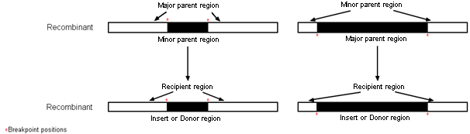

Figure S1. Schematic representation of the sequence regions involved in each recombination event. The two schematics at the top use RDP4 nomenclature (minor and major parents) and the schematics at the bottom use the nomenclature of the present manuscript (inserts/donors and recipients).

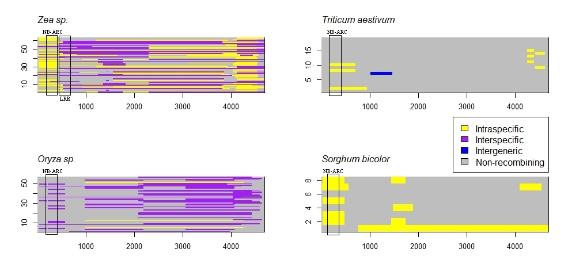Figure S2. Schematic of the recombination events found in RDP4. The fasta alignments for Sorghum bicolor, Triticum aestivum, Oryza sp. and Zea sp. are visualized using the ape package in R. No recombination events were found in Brachypodium distachyon. NB-ARC: nucleotide binding site, LRR: leucine-rich repeat region.
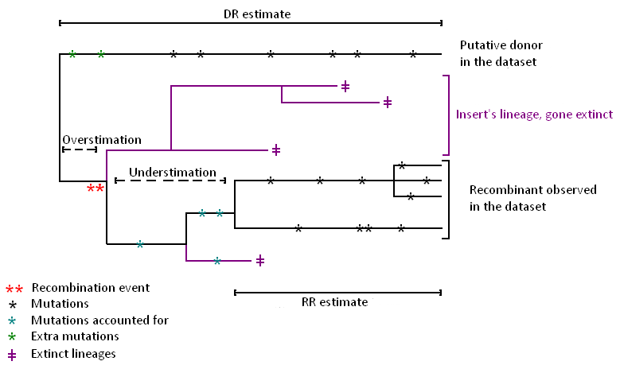
Figure S3. The two dating estimates (Recombination Radiation (RR) and best Donor vs best Recombinant (DR)) used in this study. The DR estimate is upwards biased because the putative donor might be slightly diverged from the ‘real’ donor, and those mutations (green asterisks) are counted towards the divergence time since recombination. The RR estimate is downwards biased if some of the recombinants have since gone extinct, which loses some divergent mutations (blue asterisk).
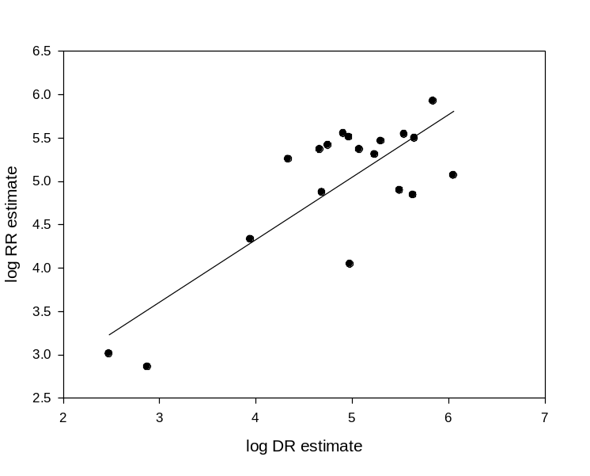
Figure S4. Correlation between the log of the DR estimate and the log of the RR estimate (Regression: R² = 0.64; F_{1,36} = 30.46; p<0.001). The regression line is shown. DR estimate = Best donor vs. Best recombinant, RR estimate = Recombinant radiation.
Figure S5. Maximum clade credibility tree of the Rp1 sequences of Oryza spp. using the total (A) and truncated alignment (B). Trees were inferred using BEAST v1.62 and represent a close-up of the trees in Figure 3. Posterior probabilities are in italic. The same changes in topology were observed when using calibration.
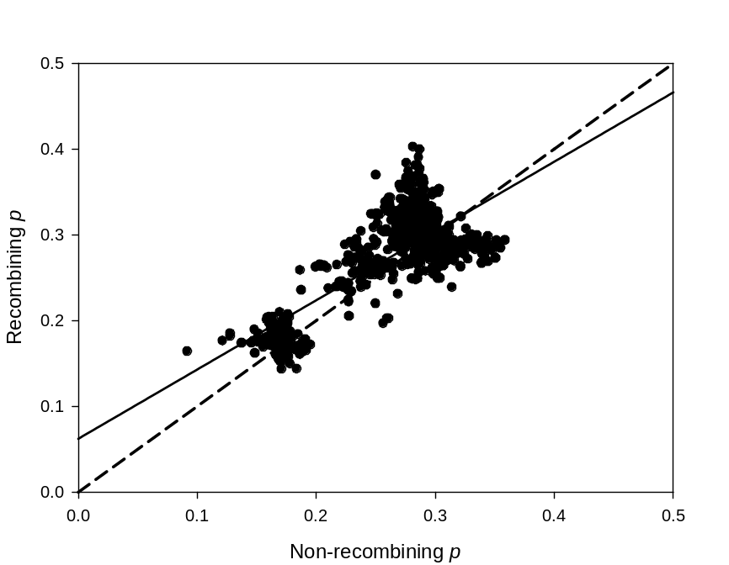
Figure S6. Number of polymorphic sites P in non-recombining (X-axis) and recombining blocks (Y-axis). Each dot represents the genetic diversity estimated for one pairwise comparison per species (or race). Also shown are a Y=X line (dashed) as well as a regression line (solid). Points below the Y=X line represent instances where recombining blocks were more diverged than non-recombining blocks while points above this line represent instances where recombining blocks were less diverged than non-recombining blocks. Recombination tends to increase the divergence in younger (less polymorphic) sequences.

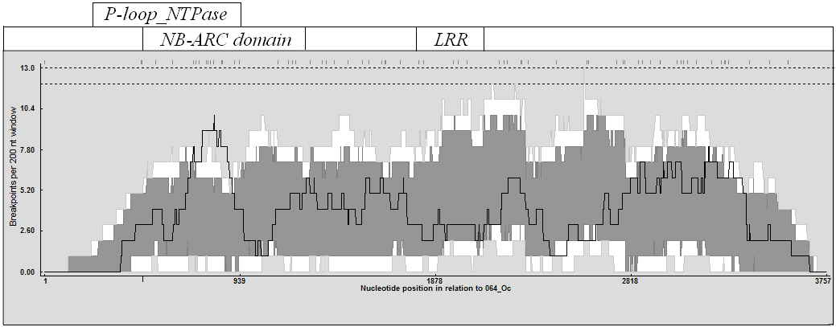

Figure S7. Potential recombination breakpoint hot spots within the Poaceae total alignment. Detectable breakpoint positions are indicated by small vertical lines at the top of the graph. A 200-nucleotide sliding window was moved along the alignment (1bp slide) and the breakpoints detected within the window region were counted and plotted (solid line). The upper and lower broken lines, respectively, indicate 99% and 95% conﬁdence thresholds for globally signiﬁcant breakpoint clusters. The light- and dark-gray areas, respectively, indicate local 99% and 95% breakpoint-clustering thresholds, taking into account local regional differences in sequence diversity that inﬂuence the abilities of different methods to detect recombination breakpoints (for a detailed description of the permutation test, see Heath et al. 2006).

Genus (Subfamily) | Species | gi number | Sample size (per genus) | Number of recombinant sequences (per genus) | Average number of bp affected by recombination
Oryza (Ehrhartoideae) | alta | 304325063* and 304325348 | 56 | 47 | 1710
Oryza (Ehrhartoideae) | coarctata | 304325064* | 56 | 47 | 1710
Oryza (Ehrhartoideae) | sativa Japonica | 304325167, 169, 171, 173, 175, 177, 179, 181, 183, 185, 187, 189, 191, 193, 195, 197, 199 and 304325065* | 56 | 47 | 1710
Oryza (Ehrhartoideae) | punctata | 304325066* | 56 | 47 | 1710
Oryza (Ehrhartoideae) | rufipogon | 304325211, 213, 215, 217 and 304325067* | 56 | 47 | 1710
Oryza (Ehrhartoideae) | brachyantha | 304325068* | 56 | 47 | 1710
Oryza (Ehrhartoideae) | australiensis | 304325121 | 56 | 47 | 1710
Oryza (Ehrhartoideae) | glaberrima | 304325123 | 56 | 47 | 1710
Oryza (Ehrhartoideae) | sativa Indica | 304325125, 127, 129, 131, 133, 135, 137, 139, 141, 143, 145, 147, 149, 151, 153, 155, 157, 159, 161, 163 and 165 | 56 | 47 | 1710
Oryza (Ehrhartoideae) | minuta | 304325201 | 56 | 47 | 1710
Oryza (Ehrhartoideae) | nivara | 304325203, 205, 207 and 209 | 56 | 47 | 1710
Sorghum (Panicoideae) | bicolor | 304325236, 069*, 070*, 071*, 072*, 073*, 074* and 304325075* | 8 | 7 | 970
Zea (Panicoideae) | mays subsp. parviglumis | 304325077, 078, 079, 080, 081, 082, 083, 084, 268, 270, 272, 274, 276, 278, 280, 282, 284, 286, 288, 290, 292, 294, 296, 298, 300, 302, 304, 306, 308, 310, 312, 314, 316, 318, 320, 322, 324, 326, 328, 330, 332, 334, 336, 338, 340, 342 and 304325344 | 63 | 61 | 2653
Zea (Panicoideae) | luxurians | 304325250, 252, 254, 256, 258, 260, 362, 264 and 304325266 | 63 | 61 | 2653
Zea (Panicoideae) | diploperennis | 304325238, 240, 242, 244, 246, 248 and 304325076* | 63 | 61 | 2653
Triticum (Pooideae) | aestivum | 304325085*, 086*, 087*, 088*, 219, 221, 223 (locus 1), 225*, 226* (locus 1), 227*, 228*, 229* (locus 1), 230*, 231* (locus 1), 232*, 233*, 234*, 235* and 304325346 | 19 | 9 | 165
Brachypodium (Pooideae) | distachyon | 304325089, 091, 093, 095, 097, 099, 101, 103, 105, 107, 109, 111, 113, 115, 117, 118, 119 and 304325120 | 18 | 0 | 0
Table S1. Gi numbers of the sequences used for the analyses in this study. Pseudogenes are starred.

Event n° | Begin | End | Recombinant | Donor | Recipient | RDP | Geneconv | Bootscan | MaxChi | Chimaera | SiScan | 3Seq
1 | 2299 | 4355 | 320_Zm | 328_Zm* | 318_Zm | 1.53E-42 | 6.32E-42 | 6.01E-47 | 3.80E-26 | 1.79E-27 | 4.12E-32 | 2.30E-74 | Intraspecific events
2 | 35 | 3652 | 322_Zm | 079_Zm | 330_Zm | 5.58E-28 | 2.67E-20 | 1.10E-28 | 9.91E-20 | 2.64E-18 | 2.74E-46 | 1.06E-71 | Intraspecific events
3 | 3084 | 4571 | 083_Zm | 268_Zm | 080_Zm | 5.43E-22 | 6.45E-21 | 3.00E-20 | 6.31E-27 | 8.09E-24 | 3.76E-36 | 7.28E-63 | Intraspecific events
6 | 875 | 2298 | 310_Zm | 288_Zm* | 312_Zm | 5.89E-05 | 1.59E-03 | 7.56E-06 | 2.58E-05 | 2.35E-07 | 5.26E-14 | 3.53E-52 | Intraspecific events
9 | 5 | 1003 | 075_Sb | 071_Sb | 070_Sb | NS | 1.14E-30 | 1.52E-31 | 1.60E-09 | 1.70E-09 | 3.42E-11 | 7.19E-36 | Intraspecific events
10 | 417 | 1661 | 304_Zm | 288_Zm | 286_Zm | 3.10E-15 | 1.70E-12 | 1.65E-16 | 1.27E-14 | 4.43E-16 | 2.13E-19 | 2.50E-34 | Intraspecific events
11 | 770 | 4692 | 069_Sb | 070_Sb* | 236_Sb | NS | 5.61E-07 | 1.45E-10 | 2.03E-10 | 4.19E-10 | 8.29E-29 | 2.28E-26 | Intraspecific events
13 | 1 | 771 | 286_Zm | 306_Zm | 338_Zm* | 4.82E-17 | 1.15E-14 | 7.69E-17 | 3.24E-08 | 2.02E-10 | 1.58E-12 | 3.64E-24 | Intraspecific events
14 | 2299 | 4080 | 318_Zm | 328_Zm | 292_Zm* | 9.66E-15 | 6.83E-11 | 2.53E-15 | 7.64E-08 | 1.04E-02 | 8.70E-23 | 4.44E-24 | Intraspecific events
18 | 824 | 2298 | 081_Zm | 276_Zm | 264_Zl* | NS | NS | 6.92E-04 | 3.93E-05 | 3.83E-04 | 4.77E-10 | 6.55E-23 | Intraspecific events
19 | 4034 | 4539 | 340_Zm | 316_Zm* | 338_Zm | 2.19E-13 | 4.72E-10 | 2.19E-13 | 4.87E-09 | 6.01E-09 | 3.19E-11 | 7.65E-23 | Intraspecific events
21 | 1479 | 1900 | 073_Sb | 072_Sb | 236_Sb | 2.01E-19 | 3.97E-17 | 8.58E-20 | 6.13E-09 | 1.91E-08 | 1.24E-12 | 5.25E-07 | Intraspecific events
22 | 875 | 1253 | 274_Zm | 318_Zm | 077_Zm | 6.06E-14 | 2.44E-10 | 4.51E-06 | 7.22E-08 | 2.86E-08 | 4.96E-11 | 7.13E-19 | Intraspecific events
24 | 139 | 3903 | 280_Zm | 342_Zm | 272_Zm | 1.07E-04 | NS | 1.07E-04 | 5.25E-06 | 1.44E-05 | 1.36E-19 | 1.15E-17 | Intraspecific events
26 | 596 | 2298 | 294_Zm | 296_Zm | 328_Zm* | 1.39E-02 | NS | 8.64E-05 | 5.07E-05 | 5.59E-04 | 6.92E-11 | 1.18E-15 | Intraspecific events
28 | 2299 | 4030 | 258_Zl | 264_Zl | 324_Zm* | 1.36E-02 | NS | 2.32E-02 | NS | 5.65E-03 | 1.11E-09 | 3.29E-14 | Intraspecific events
30 | 4117 | 4571 | 334_Zm | 304_Zm | 080_Zm | 1.10E-03 | NS | 1.11E-03 | 1.02E-05 | 1.79E-02 | 2.13E-13 | 1.22E-12 | Intraspecific events
34 | 908 | 1289 | 332_Zm | 286_Zm* | 316_Zm | 1.33E-03 | 4.69E-02 | NS | 9.13E-04 | NS | 7.40E-11 | 9.29E-05 | Intraspecific events
35 | 1257 | 1829 | 328_Zm | 268_Zm* | 338_Zm | NS | 6.14E-03 | 2.13E-04 | NS | NS | 8.63E-10 | 4.79E-03 | Intraspecific events
36 | 1 | 410 | 080_Zm | 252_Zl* | 308_Zm | NS | NS | 5.86E-04 | 1.70E-05 | 1.61E-05 | 6.04E-09 | 2.46E-08 | Intraspecific events
38 | 33 | 447 | 326_Zm | 320_Zm | 292_Zm | NS | NS | 4.89E-03 | NS | NS | 1.70E-08 | 4.38E-08 | Intraspecific events
39 | 171 | 945 | 086_Ta | 232_Ta | 234_Ta | 6.95E-03 | NS | 3.54E-04 | 3.80E-06 | 2.80E-08 | 3.71E-06 | NS | Intraspecific events
40 | 976 | 4264 | 209_On | 205_On | 066_Op* | 8.34E-03 | NS | 5.53E-03 | 6.80E-08 | 5.50E-08 | 1.14E-11 | 3.57E-04 | Intraspecific events
44 | 25 | 476 | 072_Sb | 074_Sb | 070_Sb | 1.77E-06 | NS | 1.31E-06 | NS | 2.51E-03 | NS | NS | Intraspecific events
45 | 4418 | 4619 | 231_Ta | 064_Oc* | 229_Ta | 3.94E-06 | NS | 9.81E-05 | NS | NS | 1.13E-03 | NS | Intraspecific events
4 | 663 | 3976 | 123_Og | 133_Osi | 129_Osi* | 1.54E-21 | 2.35E-14 | 7.80E-23 | 3.41E-19 | 1.51E-17 | 6.86E-45 | 2.83E-53 | Interspecific events
5 | 2091 | 3936 | 157_Osi | 185_Osj | 205_On* | 3.13E-18 | 7.11E-36 | 6.80E-38 | 1.35E-15 | 1.35E-15 | 9.63E-18 | 9.75E-53 | Interspecific events
7 | 976 | 2090 | 157_Osi | 217_Or* | 185_Osj | 4.29E-10 | NS | 2.26E-10 | 1.59E-13 | 1.55E-13 | 5.88E-19 | 6.49E-46 | Interspecific events
8 | 532 | 3825 | 308_Zm | 250_Zl | 260_Zl* | 8.91E-16 | 1.34E-18 | 3.24E-22 | 9.36E-18 | 1.96E-12 | 1.24E-39 | 2.32E-38 | Interspecific events
12 | 38 | 663 | 129_Osi | 217_Or* | 209_On | 2.22E-10 | 4.56E-08 | 8.31E-10 | 9.70E-09 | 1.25E-08 | 2.94E-09 | 1.96E-25 | Interspecific events
15 | 448 | 2298 | 274_Zm | 342_Zm* | 238_Zd | 2.33E-05 | 2.16E-04 | 7.78E-08 | 5.81E-08 | 7.68E-04 | 1.79E-11 | 1.59E-28 | Interspecific events
16 | 4066 | 4570 | 217_Or | 157_Osi | 207_On | 1.58E-03 | 2.55E-10 | 5.37E-12 | 2.23E-10 | 1.06E-09 | 4.88E-12 | 7.08E-24 | Interspecific events
17 | 1557 | 3855 | 250_Zl | 260_Zl | 282_Zm | 3.45E-14 | 2.91E-13 | 8.15E-16 | 2.96E-09 | 8.68E-12 | 1.23E-13 | 1.74E-23 | Interspecific events
20 | 2299 | 4692 | 312_Zm | 260_Zl | 298_Zm | 0.015469 | NS | 8.97E-07 | 3.05E-05 | 8.47E-05 | 5.86E-28 | 2.68E-21 | Interspecific events
23 | 663 | 1725 | 123_Og | 201_Om | 207_On | 5.51E-14 | 4.22E-14 | NS | 5.23E-12 | 2.10E-12 | NS | 2.73E-18 | Interspecific events
25 | 4117 | 4692 | 278_Zm | 081_Zm | 250_Zl | 7.98E-06 | 4.28E-05 | 3.53E-06 | 3.17E-08 | 2.44E-07 | 8.63E-17 | 7.16E-13 | Interspecific events
27 | 1 | 975 | 173_Osj | 157_Osi | 185_Osj | NS | 2.53E-05 | 3.54E-09 | 1.45E-05 | 1.05E-05 | NS | 4.49E-21 | Interspecific events
29 | 3297 | 3957 | 185_Osj | 147_Osi | 205_On | 1.82E-13 | 2.61E-10 | 6.65E-13 | 2.99E-04 | 7.62E-05 | 7.77E-05 | 4.61E-07 | Interspecific events
31 | 269 | 871 | 244_Zd | 288_Zm* | 078_Zm | 4.29E-05 | 1.73E-03 | 1.96E-05 | 7.88E-07 | NS | 6.57E-12 | NS | Interspecific events
32 | 3977 | 4584 | 201_Om | 066_Op | 209_On | 1.37E-07 | 1.10E-05 | 6.45E-06 | 1.81E-06 | 2.14E-07 | 2.95E-07 | 2.53E-11 | Interspecific events
33 | 2091 | 2308 | 185_Osj | 209_On* | 205_On | NS | 3.38E-04 | 4.97E-11 | 0.022288 | 3.88E-03 | 1.49E-03 | 8.42E-04 | Interspecific events
37 | 154 | 1265 | 125_Osi | 226_Ta* | 066_Op | 5.48E-03 | NS | 1.84E-03 | 1.14E-04 | 1.19E-08 | 3.83E-07 | 1.02E-02 | Interspecific events
42 | 1 | 874 | 264_Zl | 298_Zm | 252_Zl | 1.41E-05 | 7.76E-04 | 4.03E-06 | NS | NS | 4.20E-06 | 4.96E-07 | Interspecific events
43 | 1390 | 2189 | 201_Om | 129_Osi | 064_Oc* | NS | 3.00E-02 | NS | 2.52E-04 | 9.72E-07 | 1.01E-07 | NS | Interspecific events
46 | 3651 | 3976 | 201_Om | 066_Op | 121_Oau* | 3.46E-04 | NS | 3.14E-05 | NS | NS | 6.83E-04 | NS | Interspecific events
47 | 3927 | 4692 | 294_Zm | 288_Zm | 238_Zd | NS | 9.43E-03 | 2.12E-04 | NS | NS | NS | 3.41E-05 | Interspecific events
48 | 3644 | 3822 | 207_On | 123_Og | 217_Or | 3.34E-03 | 4.53E-03 | 2.28E-02 | NS | NS | NS | 6.50E-05 | Interspecific events
49 | 79 | 657 | 123_Og | 207_On | 185_Osj | 1.85E-04 | NS | 4.54E-04 | NS | NS | 1.20E-09 | NS | Interspecific events
50 | 1417 | 1481 | 246_Zd | 286_Zm* | 264_Zl | 6.66E-03 | 3.79E-02 | 6.25E-03 | NS | NS | 7.34E-04 | NS | Interspecific events
41 | 1012 | 1469 | 223_Ta | 234_Ta* | 107_Bd | NS | NS | 0.0324198 | NS | 3.45E-02 | 8.01E-08 | NS
Table S2. The 50 events detected by at least three methods in RDP4. The events given in this table are also shown in Figure 1. Unknown sequences are starred and the intergeneric event is in bold.

Event n° | Begin | End | Recombinant | Donor | Recipient | RDP | Geneconv | Bootscan | MaxChi | Chimaera | SiScan | 3Seq
51 | 3376 | 4355 | 326_Zm | 330_Zm | 320_Zm | NS | NS | 4.20E-18 | 2.88E-15 | 2.01E-15 | NS | 4.75E-41 | Intraspecific events
52 | 3826 | 4454 | 084_Zm | 080_Zm | 272_Zm | NS | NS | NS | NS | NS | 2.93E-06 | 1.49E-15 | Intraspecific events
53 | 1742 | 2298 | 320_Zm | 077_Zm | 286_Zm* | NS | NS | NS | NS | 7.09E-03 | 1.73E-12 | 3.62E-02 | Intraspecific events
54 | 817 | 1279 | 286_Zm | 336_Zm | 302_Zm* | NS | NS | NS | NS | 2.72E-04 | 1.07E-09 | NS | Intraspecific events
56 | 3050 | 4692 | 237_Sb | 070_Sb | 070_Sb | NS | 1.23E-05 | NS | 1.89E-08 | 8.40E-07 | NS | NS | Intraspecific events
58 | 139 | 4255 | 270_Zm | 272_Zm | 342_Zm | NS | NS | NS | NS | NS | 2.64E-12 | 5.44E-08 | Intraspecific events
61 | 1450 | 1871 | 069_Sb | 278_Zm* | 072_Sb | 0.036034 | NS | NS | 1.2E-07 | 7.67E-05 | NS | NS | Intraspecific events
63 | 421 | 578 | 081_Zm | 280_Zm | 314_Zm | NS | 2.12E-02 | NS | NS | NS | NS | 7.36E-07 | Intraspecific events
68 | 743 | 1371 | 077_Zm | 242_Zd* | 280_Zm | 5.78E-03 | NS | NS | NS | NS | NS | 6.58E-03 | Intraspecific events
70 | 4256 | 4398 | 230_Ta | 292_Zm* | 346_Ta | 7.25E-03 | NS | NS | NS | 1.61E-02 | NS | NS | Intraspecific events
71 | 3718 | 3818 | 071_Sb | 076_Zd* | 072_Sb | 3.38E-02 | 1.17E-02 | NS | NS | NS | NS | NS | Intraspecific events
72 | 172 | 7044 | 227_Ta | 235_Ta | 234_Ta* | NS | NS | 1.70E-02 | NS | NS | 3.90E-05 | NS | Intraspecific events
73 | 622 | 1077 | 236_Sb | 073_Sb | 121_Oau* | NS | NS | NS | 1.49E-03 | NS | 8.80E-24 | NS | Intraspecific events
55 | 1254 | 1764 | 076_Zd | 264_Zl | 238_Zd | NS | NS | NS | 1.87E-02 | NS | 5.02E-06 | 1.75E-09 | Interspecific events
57 | 1 | 1137 | 324_Zm | 246_Zd | 256_Zl | NS | NS | 0.0256742 | NS | NS | 2.44E-08 | NS | Interspecific events
59 | 3065 | 3919 | 213_Or | 147_Osi | 209_On* | NS | NS | NS | 6.27E-05 | NS | 1.49E-09 | 5.11E-07 | Interspecific events
60 | 33 | 447 | 258_Zl | 314_Zm | 292_Zm | NS | NS | NS | 0.011721 | NS | 5.93E-08 | NS | Interspecific events
62 | 1254 | 2077 | 290_Zm | 238_Zd | 274_Zm | NS | NS | NS | NS | NS | 6.32E-06 | 3.92E-07 | Interspecific events
64 | 1359 | 1827 | 240_Zd | 312_Zm* | 077_Zm | NS | NS | NS | NS | 3.24E-02 | 1.21E-06 | 1.13E-02 | Interspecific events
65 | 4195 | 4451 | 083_Zm | 246_Zd* | 080_Zm | NS | NS | NS | 3.85E-02 | 1.33E-02 | 2.02E-02 | 3.04E-04 | Interspecific events
66 | 171 | 594 | 121_Oau | 064_Oc | 066_Op | NS | NS | NS | NS | 1.89E-03 | 3.74E-02 | NS | Interspecific events
67 | 1712 | 4110 | 205_On | 129_Osi | 121_Oau | NS | NS | NS | 1.20E-04 | 2.86E-05 | 1.54E-11 | 4.13E-29 | Interspecific events
69 | 1 | 578 | 264_Zl | 328_Zm | 314_Zm | NS | NS | NS | NS | NS | 3.11E-09 | 6.10E03 | Interspecific events
Table S3. The 23 events detected by two methods in RDP4. Unknown sequences are asterisked.

Genus | Gene diversity | Standard deviation (SE)
Oryza | 0.092 | 0.032
Zea | 0.065 | 0.025
Triticum | 0.168 | 0.043
Sorghum | 0.077 | 0.024
Brachypodium | 0.027 | 0.020
Table S4. Mean gene diversity (±SE) for each genus investigated in this study. Gene diversity was estimated by calculating a heterozygosity value per bp for each genus in Minitab 12.1.

 |  | Recombinants Radiation (RR) |  |  | Donor-Recombinant (DR)
 | Event number | Mean | 5% | 95% | Mean | 5% | 95%
Intraspecific events | 1 | 169,830 | 577 | 427,480 | N/A | N/A | N/A
Intraspecific events | 2 | N/A | N/A | N/A | 826,780 | 127,520 | 2,167,000
Intraspecific events | 3 | 288,630 | 44,290 | 752,180 | 199,510 | 29,033 | 524,210
Intraspecific events | 6 | N/A | N/A | N/A | N/A | N/A | N/A
Intraspecific events | 9 | N/A | N/A | N/A | 14,183 | 0 | 38,571
Intraspecific events | 10 | 74,104 | 357 | 227,290 | 48,786 | 86 | 161,040
Intraspecific events | 11 | N/A | N/A | N/A | N/A | N/A | N/A
Intraspecific events | 13 | 21,331 | 7 | 71,402 | 8,793 | 0 | 32,031
Intraspecific events | 14 | 179,280 | 26,035 | 454,820 | 21,791 | 458 | 62,360
Intraspecific events | 18 | 232,260 | 38,837 | 653,580 | 119,290 | 18,417 | 329,940
Intraspecific events | 19 | 462,440 | 73,477 | 117,490 | N/A | N/A | N/A
Intraspecific events | 21 | 11,021 | 0 | 39,103 | 95,091 | 7,021 | 268,790
Intraspecific events | 22 | N/A | N/A | N/A | 305,070 | 40,027 | 804,970
Intraspecific events | 24 | N/A | N/A | N/A | 182,580 | 28,909 | 485,150
Intraspecific events | 26 | 202,740 | 22,017 | 545,040 | 171,460 | 15,076 | 471,260
Intraspecific events | 28 | 258,930 | 35,541 | 668,380 | 56,185 | 3,944 | 152,470
Intraspecific events | 30 | N/A | N/A | N/A | N/A | N/A | N/A
Intraspecific events | 34 | N/A | N/A | N/A | N/A | N/A | N/A
Intraspecific events | 35 | N/A | N/A | N/A | N/A | N/A | N/A
Intraspecific events | 36 | 138,530 | 8,164 | 389,450 | N/A | N/A | N/A
Intraspecific events | 38 | N/A | N/A | N/A | 35,777 | 5 | 108,970
Intraspecific events | 39 | N/A | N/A | N/A | N/A | N/A | N/A
Intraspecific events | 40 | 78,318 | 10,976 | 199,430 | 311,830 | 47,871 | 783,140
Intraspecific events | 44 | N/A | N/A | N/A | 694,120 | 91,125 | 1,778,600
Intraspecific events | 45 | 1,402,800 | 162,040 | 3,750,100 | N/A | N/A | N/A
Intraspecific events | 51 | N/A | N/A | N/A | N/A | N/A | N/A
Intraspecific events | 52 | 346,990 | 57,244 | 897,340 | 347,110 | 57,124 | 897,340
Intraspecific events | 53 | N/A | N/A | N/A | N/A | N/A | N/A
Intraspecific events | 54 | N/A | N/A | N/A | 195,830 | 18,031 | 529,400
Intraspecific events | 56 | N/A | N/A | N/A | 410,090 | 58,467 | 1,043,300
Intraspecific events | 58 | N/A | N/A | N/A | 172,800 | 22,536 | 447,900
Intraspecific events | 61 | 178,370 | 14,639 | 481,870 | N/A | N/A | N/A
Intraspecific events | 63 | N/A | N/A | N/A | N/A | N/A | N/A
Intraspecific events | 68 | N/A | N/A | N/A | N/A | N/A | N/A
Intraspecific events | 70 | 3,853,100 | 460,560 | 10,474,000 | N/A | N/A | N/A
Intraspecific events | 71 | 229,600 | 5,711 | 662,730 | N/A | N/A | N/A
Intraspecific events | 72 | 836,820 | 138,410 | 2,224,200 | 693,320 | 109,000 | 1,829,100
Intraspecific events | 73 | N/A | N/A | N/A | 254,690 | 36,143 | 695,490
Interspecific recombination events | 4 | 1,067,500 | 197,730 | 2,795,100 | N/A | N/A | N/A
Interspecific recombination events | 5 | 382,660 | 39,222 | 1,074,200 | 84,336 | 0 | 272,790
Interspecific recombination events | 7 | 174,070 | 2,571 | 597,150 | N/A | N/A | N/A
Interspecific recombination events | 8 | 116,620 | 15,630 | 310,950 | 1,127,600 | 175,230 | 2,939,300
Interspecific recombination events | 12 | N/A | N/A | N/A | N/A | N/A | N/A
Interspecific recombination events | 15 | 384,810 | 55,303 | 1,000,400 | N/A | N/A | N/A
Interspecific recombination events | 16 | 353,770 | 28,644 | 931,380 | 81,144 | 1,699 | 229,360
Interspecific recombination events | 17 | 232,040 | 39,884 | 615,240 | 46,186 | 5,068 | 126,080
Interspecific recombination events | 20 | 312,490 | 60,498 | 780,550 | 443,540 | 78,304 | 1,091,700
Interspecific recombination events | 23 | N/A | N/A | N/A | N/A | N/A | N/A
Interspecific recombination events | 25 | 320,290 | 55,218 | 839,010 | 92,673 | 7,731 | 248,160
Interspecific recombination events | 27 | N/A | N/A | N/A | N/A | N/A | N/A
Interspecific recombination events | 29 | N/A | N/A | N/A | N/A | N/A | N/A
Interspecific recombination events | 31 | N/A | N/A | N/A | N/A | N/A | N/A
Interspecific recombination events | 32 | N/A | N/A | N/A | 130,720 | 14,202 | 355,720
Interspecific recombination events | 33 | N/A | N/A | N/A | N/A | N/A | N/A
Interspecific recombination events | 37 | 1,477,500 | 118 | 5,609,400 | N/A | N/A | N/A
Interspecific recombination events | 42 | N/A | N/A | N/A | 163,000 | 40 | 490,000
Interspecific recombination events | 43 | N/A | N/A | N/A | N/A | N/A | N/A
Interspecific recombination events | 46 | N/A | N/A | N/A | N/A | N/A | N/A
Interspecific recombination events | 47 | N/A | N/A | N/A | N/A | N/A | N/A
Interspecific recombination events | 48 | 1,024 | 0 | 3,901 | 300 | 0 | 799
Interspecific recombination events | 49 | N/A | N/A | N/A | 27,320 | 134 | 85,522
Interspecific recombination events | 50 | 556,550 | 30,549 | 1,547,200 | N/A | N/A | N/A
Interspecific recombination events | 55 | N/A | N/A | N/A | 140,070 | 11,593 | 390,840
Interspecific recombination events | 57 | N/A | N/A | N/A | 26,411 | 49 | 65,962
Interspecific recombination events | 59 | N/A | N/A | N/A | N/A | N/A | N/A
Interspecific recombination events | 60 | 722 | 0 | 2,858 | 753 | 0 | 2,747
Interspecific recombination events | 62 | N/A | N/A | N/A | N/A | N/A | N/A
Interspecific recombination events | 64 | 270,640 | 41,497 | 702,920 | N/A | N/A | N/A
Interspecific recombination events | 65 | 304,410 | 25,929 | 806,620 | N/A | N/A | N/A
Interspecific recombination events | 66 | N/A | N/A | N/A | 1,026,400 | 143,460 | 2,760,200
Interspecific recombination events | 67 | 69,155 | 1,053 | 263,420 | 429,520 | 44,460 | 1,138,800
Interspecific recombination events | 69 | N/A | N/A | N/A | 101,050 | 3,160 | 272,620
 | 41 | N/A | N/A | N/A | N/A | N/A | N/A
Table S5. Mean (5%-95% CI) of the estimated age of the RR and the DR calculated by BEAST (in years). The RR estimate could only be dated when there were at least two recombinants and the DR estimate was calculated when the best donor was genuinely detected by RDP4 (not unknown). The intergeneric event is in bold. Highlighted in grey are the events that occurred after the split of the species involved (see also Table S6). RR = recombinant radiation, DR = split of the donor and the recombinant.

Event # | Recombinant | Donor | Recipient | Mean estimate (years) | 5% CI | 95% CI | Reference divergence time (years)
32 | O. minuta (? – BB-CC) | O. punctata (African – BB) | O. nivara (Asian – AA) | 130,720 | 14,202 | 355,720 | 2,000,000-7,500,000^{1,2}
48 | O. nivara (Asian - AA) | O. glaberrima (African - AA) | O. rufipogon  (Asian - AA) | 1,024 | 0 | 3,901 | 1,200,000³
49 | O. glaberrima (African - AA) | O. nivara  (Asian - AA) | O. sativa japonica (Asian - AA) | 27,320 | 134 | 85,522 | 1,200,000³
60 | Z. luxurians  (Central America) | Z. mays parviglumis  (Central America) | Z. mays parviglumis  (Central America) | 722 | 0 | 2,858 | 60,000-140,000⁴
Table S6. Summary table of the four introgression events indicative of interspecific hybridization. In these cases, the date of the interspecific recombination appeared to be more recent than the divergence of species in which they were found. When the two estimates for the age of the insert were available (with the DR and the RR methods), the oldest (most conservative) estimate is given. The place of origin of all species are given as well as the genome types (only for Oryza species) ¹ Kim et al. 2007, ² Lu et al. 2008, ³ Tian et al. 2011, ⁴ Ross-Ibarra et al. 2009.

 |  | Total alignment |  |  | Truncated alignment
 |  | Mean | 5% | 95% | Mean | 5% | 95%
No calibration | Sorghum bicolor | 14.2 | 5.2 | 22.7 | 13.5 | 7.5 | 19.5
No calibration | Zea spp. | 13.5 | 9.1 | 18.9 | 11.4 | 8.4 | 15.4
No calibration | Triticum aestivum2 | 12.5 | 8.1 | 18.9 | 10.7 | 6.8 | 14.3
No calibration | Brachypodium distachyon | 3.8 | 1.5 | 7.7 | 3.5 | 1.5 | 6.5
No calibration | Oryza spp. | 18.4 | 10.8 | 30.0 | 14.6 | 10 | 20.5
No calibration | Sorghum-Zea | 19.2 | 12.4 | 29.5 | 16.7 | 11.8 | 23.2
No calibration | Triticum1-Brachypodium | 21.1 | 8.6 | 32.0 | 17.5 | 9.7 | 25.7
No calibration | Triticum2-Oryza | 24.7 | 16.2 | 36.8 | na | na | na
No calibration | Triticum-Brachypodium | na | na | na | 20.4 | 12.1 | 28.2
No calibration | Oryza-Triticum-Brachypodium | 27.7 | 18.8 | 45.2 | 23.4 | 16.5 | 32.4
No calibration | Root of the tree | 37.4 | 24.3 | 53.2 | 29.9 | 20.3 | 44.2
Calibration | Sorghum bicolor | 8.0 | 4.5 | 11.9 | 8.3 | 5.68 | 10.1
Calibration | Zea spp. | 7.9 | 5.4 | 10.4 | 7.9 | 5.5 | 10.0
Calibration | Triticum aestivum2 | 9.3 | 3.5 | 18.1 | 9.8 | 5.2 | 15.2
Calibration | Brachypodium distachyon | 2.7 | 0.21 | 5.7 | 3.1 | 0.98 | 5.9
Calibration | Oryza spp. | 13.4 | 4.6 | 31.2 | 13.2 | 5.6 | 26.7
Calibration | Sorghum-Zea | 10.3 | 8.0 | 12.0 | 10.0 | 8.2 | 12.0
Calibration | Triticum1-Brachypodium | 13.5 | 0.83 | 26.5 | 18.0 | 6.0 | 15.2
Calibration | Triticum2-Oryza | na | na | na | na | na | na
Calibration | Triticum-Brachypodium | 33.8 | 32.5 | 41.7 | 34.3 | 28.3 | 40.2
Calibration | Oryza-Triticum-Brachypodium | na | na | na | na | na | na
Calibration | Root of the tree | 38.7 | 32.5 | 48.1 | 38.8 | 32.4 | 46.8
Table S7. Mean (5-95%CI) of the estimated age for the split of the genera/species calculated by BEAST. (Top) No priors on species divergences are provided to BEAST. (Bottom) Calibrations points from Table 1 are used (divergence time in million years).

Genus | Model comparison | [2ΔlnL] | df | P value
Brachypodium | M0 vs. M3 | 8.13 | 4 | 0.087
Brachypodium | M1 vs. M2 | 5.65 | 2 | 0.059
Brachypodium | M7 vs. M8 | 5.76 | 2 | 0.056
Triticum | M0 vs. M3 | 425.48 | 4 | <0.001
Triticum | M1 vs. M2 | 110.57 | 2 | <0.001
Triticum | M7 vs. M8 | 124.4 | 2 | <0.001
Oryza | M0 vs. M3 | 690.72 | 4 | <0.001
Oryza | M1 vs. M2 | 125.7 | 2 | <0.001
Oryza | M7 vs. M8 | 147.52 | 2 | <0.001
Zea | M0 vs. M3 | 3878.86 | 4 | <0.001
Zea | M1 vs. M2 | 1525.54 | 2 | <0.001
Zea | M7 vs. M8 | 1695.02 | 2 | <0.001
Table S8. Likelihood ratio tests for with associated p-values of models of selection versus their null comparator. Brachypodium, Triticum, Oryza and Zea are analyzed here unlike Sorghum for which only one sequence was functional.

 | Model | Log-likelihood | Parameter estimates
Triticum | M0 (one ratio) | -11523.31 | ω=0.597
Triticum | M3 (discrete) | -11366.85 | p₀=0.632, ω₀=0.182, p₁=0.346, ω₁=1.429, p₂=0.052, ω₂=8.502
Triticum | M1a (nearly neutral) | -11311.56 | p₀=0.534, ω₀=0.090, p₁=0.466, ω₁=1.000
Triticum | M2a (positive selection) | -11310.57 | p₀=0.516, ω₀=0.121, p₁=0.405, ω₁=1.000, p₂=0.078, ω₂=6.094
Triticum | M7 (beta) | -11374.86 | p=0.115, q=0.098
Triticum | M8 (beta&ω) | -11312.66 | p₀=0.911, p=0.294, q=0.311 ,p₁=0.089, ω=5.610
Oryza | M0 (one ratio) | -15909.18 | ω=0.451
Oryza | M3 (discrete) | -15563.83 | p₀=0.511, ω₀=0.042, p₁=0.439, ω₁=0.751, p₂=0.049, ω₂=4.248
Oryza | M1a (nearly neutral) | -15628.85 | p₀=0.640, ω₀=0.082, p₁=0.360, ω₁=1.000
Oryza | M2a (positive selection) | -15566.00 | p₀=0.613, ω₀=0.086, p₁=0.351, ω₁=1.000, p₂=0.036, ω₂=5.084
Oryza | M7 (beta) | -15637.28 | p=0.16245, q=0.23415
Oryza | M8 (beta&ω) | -15563.52 | p₀=0.95607, p=0.23629, q=0.38240, p₁=0.04393, ω=4.47772
Brachypodium | M0 (one ratio) | -6260.79 | ω=0.778
Brachypodium | M3 (discrete) | -6256.72 | p₀=0.995, ω₀=0.761, p₁=0.005, ω₁=111.245, p₂=0.000, ω₂=179.928
Brachypodium | M1a (nearly neutral) | -6259.55 | p₀=0.268, ω₀=0.000, p₁=0.732, ω₁=1.000
Brachypodium | M2a (positive selection) | -6256.73 | p₀=0.995, ω₀=0.761, p₁=0.000, ω₁=1.000, p₂=0.005, ω₂=111.293
Brachypodium | M7 (beta) | -6259.61 | p=0.012, q=0.005
Brachypodium | M8 (beta&ω) | -6257.49 | p₀=0.993, p=0.015, q=0.005 ,p₁=0.007, ω=28.916
Zea | M0 (one ratio) | -27359.97 | ω=0.792
Zea | M3 (discrete) | -25420.54 | p₀=0.811, ω₀=0.224, p₁=0.151, ω₁=2.623, p₂=0.038, ω₂=9.724
Zea | M1a (nearly neutral) | -26227.65 | p₀=0.755, ω₀=0.095, p₁=0.245, ω₁=1.000
Zea | M2a (positive selection) | -25464.88 | p₀=0.676, ω₀=0.129, p₁=0.237, ω₁=1.000, p₂=0.087, ω₂=6.014
Zea | M7 (beta) | -26333.73 | p=0.19788, q=0.37987
Zea | M8 (beta&ω) | -25486.22 | p₀=0.90592, p=0.32556, q=0.60116, p₁=0.09408, ω=5.86620
Table S9. PAML results for positive selection in each genus.

Method S1: Definitions on recombination events.
Recombination (or introgression) results in a mosaic sequence in which the different segments (hereafter ‘regions’) are derived from different ancestral sequences (MRCAs), i.e. the major and the minor parents. RDP4 defines the “major parent” as the sequence that made the largest contribution (in bp) to the recombinant sequence, and the “minor parent” as the sequence contributing less. It usually provides several parents and recombinants for a particular recombination event and we report the most likely triplet throughout the text. For the purpose of this study, the parental sequences will not be referred to as minor and major parents, but rather, as “donors” and “recipients”. The donor is the parental sequence that is similar to the recombinant in between the breakpoint positions and the recipient is the parental sequence that is similar to the recombinant outside the breakpoint positions (Fig. S1). In cases where only one breakpoint was identified, the recipient was the sequence that made the largest contribution. We also define the “insert” as the region that is located in between the two breakpoint positions. Under the condition that all three sequences (i.e. recombinant, donor and recipient) were of the same species, the recombination event was considered to be intraspecific. Cases in which recombination involved different species were considered to be interspecific, and events between different genera were considered intergeneric. In some recombination events RDP4 indicated that one of the parents (donor or recipient) was “unknown”. “Unknowns” are sequences that the software considered to be the most similar to the hypothetical parent (which is absent from the dataset). This means that the real parent was not sampled but despite this, a significant recombination signal was detected. In this study, we have avoided problems associated with incomplete lineage sorting/ incomplete sampling by discarding “unknown” parents in the dating of the recombination events. We thereby avoided the risk of potentially inflating the nucleotide variation between the sequences involved in recombination, which could have resulted in overestimating the age of recombination events.

