Chapter 4
Processing and ageing in the atmosphere

Alex R. Baker, Olga Laskina, Vicki H. Grassian

Abstract
Transport through the atmosphere exposes mineral dust to a number of processes that alter its physicochemical properties, which in turn affects its direct and indirect impacts on climate. In this chapter we review the physical and chemical processes that alter dust properties, and their impacts on dust’s radiative properties, cloud condensation nucleus activity, morphology, nutrient and trace element solubility and the impacts of heterogeneous chemistry on dust surfaces on atmospheric composition.

A.R. Baker
Centre for Ocean and Atmospheric Sciences, School of Environmental Sciences, University of East Anglia, Norwich NR4 7TJ, UK

O. Laskina,
V.H. Grassian
Department of Chemistry, University of Iowa, Iowa City, IA 52242-1294, USA

4.1 Introduction
Mineral dust aerosol is an abundant component of the Earth’s atmosphere. Once suspended in the atmosphere, dust can be subjected to a number of processes that influence its transport, deposition, and impact on the environment. Effects range from purely physical, e.g. winnowing, to those associated with heterogeneous chemistry on dust particle surfaces. Heterogeneous chemistry during long-range transport may alter hygroscopicity (and hence removal mechanisms), reactivity of dust constituents and the composition of the atmosphere, as illustrated schematically in Figure 4.1. In this chapter we examine these processes using data from field observations and laboratory measurements. Field studies allow us to assess the net effect of the various complex processes involved, while laboratory work provides the means to study fundamental chemical and physical mechanisms under controlled conditions.

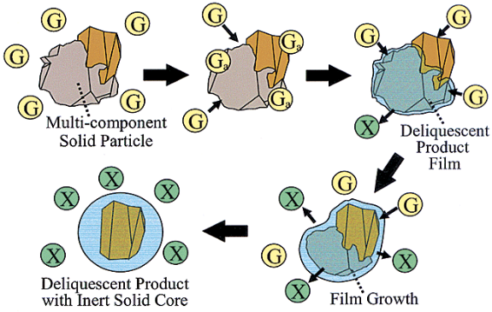

Figure 4.1 Pictorial representation of changes in a composite mineral dust particle as it is processed in the atmosphere. Reprinted with permission from C. R. Usher, A. E. Michel and V. H. Grassian (2003) Reactions on mineral dust. Chemical Reviews, 103 (12), 4883–4939. Copyright (2003) American Chemical Society.

4.2 Physical Processing
As discussed in Chapters 8 and 17, winnowing leads to shifts in the size spectrum of suspended dust during transport away from source areas (Maring et al., 2003, Mahowald et al., 2005). Large particles (> 10 µm) are removed rather rapidly and do not contribute appreciably to long-range transport (Formenti et al., 2011). This shift also potentially affects the mineralogy of transported dust, as large quartz grains are removed close to source (Glaccum and Prospero, 1980).
The modal size of long-range transported dust is generally considered to be 1-3 µm (Arimoto et al., 1997, Schulz et al., 1998, Reid et al., 2003), but there are reports of giant particles (> 75 µm) being transported many thousands of km away from sources (see Chapter 17, Betzer et al., 1988).

4.3 Chemical processing

4.3.1 Impacts on physical properties of dust
Heterogeneous chemistry and photochemistry of mineral dust aerosol is extremely important as these reactions change the properties of the particles and their direct and indirect climate forcing, thus impacting climate (see Chapter 13 for a detailed discussion of the impact of dust on radiative forcing). There are still many uncertainties associated with the role of mineral dust aerosol on climate, in part due to its inherent heterogeneity and in part due to the incomplete understanding of the influence of ageing processes on climate related properties of mineral dust. Processing may alter the chemical composition of particles and, ultimately, may change the optical properties, hygroscopicity, cloud condensation nuclei (CCN) and ice nuclei (IN) activity (see Chapter 12).

For example, sulphate coatings on mineral dust particles are known to have a cooling effect by effectively scattering radiation and to promote CCN activity (Yin et al., 2002), at the same time the presence of sulphuric acid leads to a decrease in the dust particles' ice nucleation ability (Sullivan et al., 2010). Cloud processing of dust particles with sea-salt species and anthropogenic pollutants is an important pathway in the formation of hygroscopic species (Kim and Park, 2012). Calcite particles reacted with nitric or oxalic acids show an increase in the hygroscopicity due to the formation of hygroscopic species (Gierlus et al., 2012). Coating of mineral particles with soluble materials such as sulphate, nitrate and chloride also increases cloud condensation nuclei activity (Crumeyrolle et al., 2008), however the exact effect (enhancement or inhibition) on cloud formation depends on the particular chemical interactions (Sullivan et al., 2009). Coated mineral particles may accelerate the formation of precipitation particles in continental clouds (Yin et al., 2002).

For calcium carbonate (CaCO₃) reaction with HNO₃ in the presence of water leads to the formation of calcium nitrate droplets. This causes a significant change in particle morphology, size, scattering properties and hygroscopic growth relative to calcium carbonate (Gibson et al., 2006), as shown in Figure 4.2.
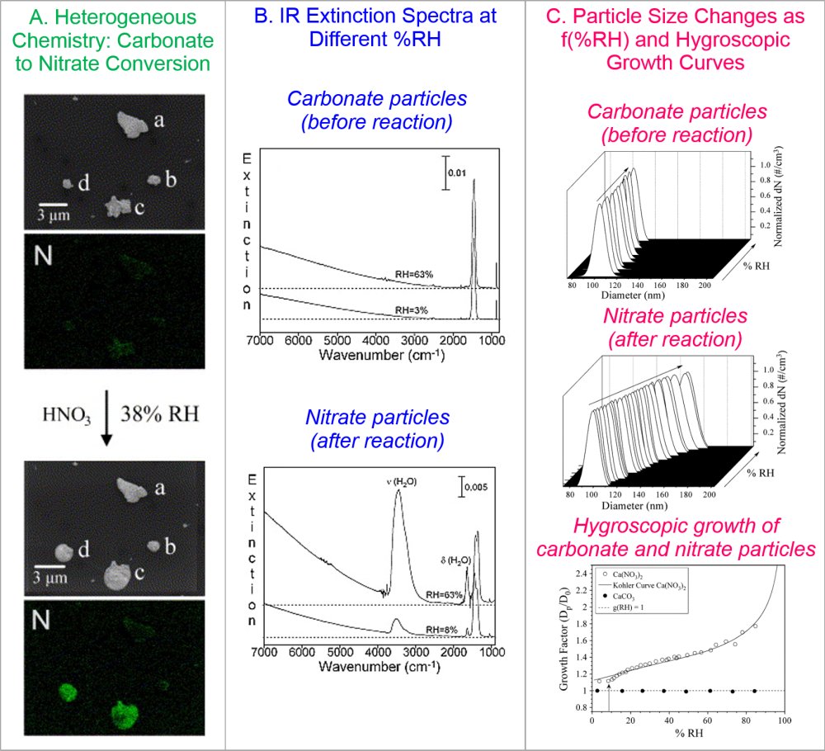

Figure 4.2 A. Heterogeneous chemistry of mineral dust measured with scanning electron microscopy and energy dispersive X-ray analysis. These data show that carbonate particles “c” and “d” have unique reactivity with gas-phase nitric acid to form nitrate particles that take up water as shown by the change in particle size and shape (spherical). B. Infrared extinction spectra at two % RHs for carbonate and nitrate particles showing that nitrate particles scatter light to a greater extent at higher relative humidity due to the size change and increased water content of the particles. C. Increase in particle size for a 0.1 micron-sized dry particle as a function of relative humidity for carbonate compared to nitrate particles. The growth factor (ratio of particle diameter at a given relative humidity to the dry particle diameter) for carbonate particles is one at % RH whereas the growth factor of nitrate particles is greater than one and increases with relative humidity.

4.3.2 Impacts on dust reactivity
Chemical processing has some potentially important impacts on the reactivity of dust in the environment. The most significant of these is the potential to increase the solubility of nutrients, such as iron (Fe) and phosphorus (P) contained in dust, and thus to enhance their bioavailability once deposited onto marine and terrestrial ecosystems (see Chapter 14).
Several potential mechanisms which might lead to changes in the chemical properties of dust during atmospheric transport have been proposed (see Baker and Croot, 2010). The interaction of dust with both mineral and organic acids has been suggested to enhance dissolution of trace metals (Pehkonen et al., 1993, Spokes et al., 1994, Spokes and Jickells, 1996, Desboeufs et al., 2001, Mackie et al., 2005, Shi et al., 2011) and phosphorus (Nenes et al., 2011). Although this enhancement appears to be largely reversible when pH is raised (Spokes et al., 1994, Spokes and Jickells, 1996, Mackie et al., 2005, Shi et al., 2011), it appears that newly precipitated Fe takes the form of amorphous ferrihydrite nanoparticles, which are more soluble than the Fe originally associated with dust particle surfaces (Shi et al., 2009). Acid-processing reactions have formed the basis of several attempts to model changes in Fe solubility in atmospheric dust, with a variety of iron-containing minerals being used as models for dust (Meskhidze et al., 2003, Johnson et al., 2010, Ito, 2013). Photochemical redox changes (e.g. reduction of Fe (III) to the more soluble Fe (II)), often enhanced by organic components, such as oxalate, have also been suggested to enhance the solubility of Fe in the atmosphere (Erel et al., 1993, Pehkonen et al., 1993, Siefert et al., 1994).

Dust reactivity changes as a result of atmospheric transport have also been linked to the physical consequences of winnowing. Baker and Jickells (2006) suggested that decreasing particle size spectrum during transport led to increasing particle surface area to volume ratios and hence to higher fractional solubility of iron and other dust components. Journet et al. (2008) linked changes in mineralogy to changes in overall solubility of Fe in dust, and suggested that >96% of soluble Fe was derived from clay minerals, rather Fe oxides. Cwiertny et al. (2008) also suggested in a study on authentic dust samples that clay minerals played an important role in Fe solubility. Furthermore, it was also noted that Fe present as Fe(II) in clays were particularly soluble.

The extent to which atmospheric processing enhances trace element solubility is not very well defined. Measurements of solubility in dust actually at source are very scarce and measurements on source soil materials (also few in number) are probably not representative of suspended dust at source because abrasion and fractionation during dust uplift significantly alter the dust with respect to the parent soil (Bullard et al., 2004, Mackie et al., 2006). Nevertheless, analysis of atmospheric dust collected over a broad range of dust concentrations appears to show a general hyperbolic increase in Fe solubility as dust concentration (or total Fe concentration, as a proxy for dust concentration) decreases (e.g. Chen and Siefert, 2004, Baker and Jickells, 2006, Sedwick et al., 2007, Theodosi et al., 2010). Sholkovitz et al. (2012) compiled (~1000) available measurements of iron solubility and total Fe concentration from more than 20 studies of (marine) aerosols, and showed that this hyperbolic relationship is observed consistently on a global scale. In Figure 4.3 we replot the Sholkovitz dataset (excluding samples extracted with strong acid solutions, which have been shown to release a significantly higher fraction of Fe from dust than the majority of methods used in the dataset (Witt et al., 2010)). It is apparent from Figure 4.3 that similar behaviour is exhibited under four, rather different, conditions for the extraction of soluble Fe (ultrapure water, ammonium acetate, formate and seawater leaching solutions) and that there is considerable scatter about the general solubility – concentration trend within, and between, these methods.

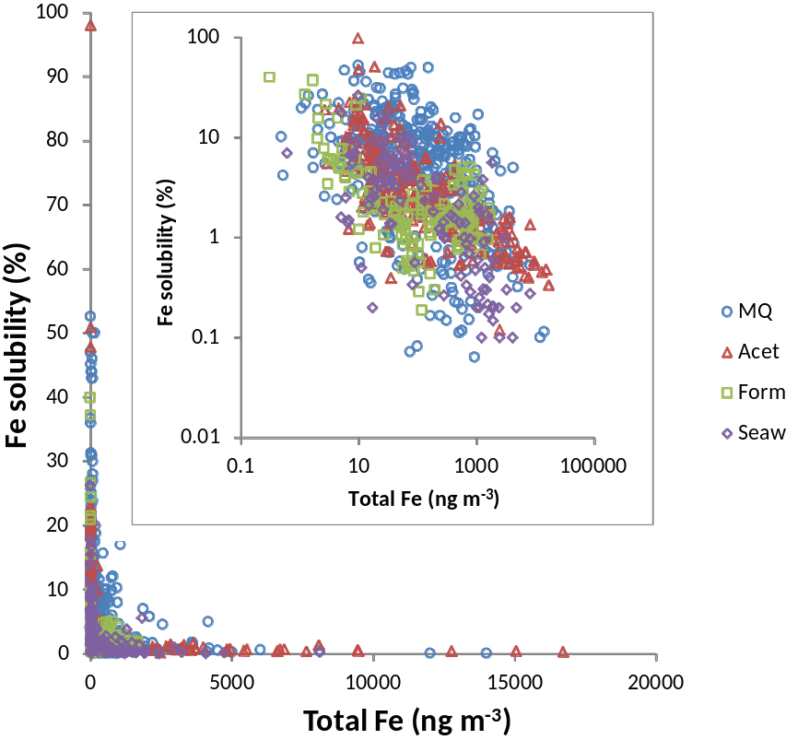

Figure 4.3 Percentage of soluble Fe in ~1000 aerosol samples plotted as a function of total atmospheric Fe concentration. Data is taken from the compilation of Sholkovitz et al. (2012) and symbols indicate the leaching solutions in which the aerosol samples were solubilised. Inset shows the same data replotted on a log – log scale.

Several authors have suggested that non-dust Fe might contribute to elevated Fe solubility values, particularly at low dust concentrations (e.g. Guieu et al., 2005, Sedwick et al., 2007, Sholkovitz et al., 2012). In Figure 4.4 we compare Fe solubility for subsets of the data in Figure 4.3 for total Fe concentration ranges of 30 – 100 ng TFe m⁻³ and 300 – 1000 ng TFe m⁻³. These data appear to indicate that Fe solubility increases as total Fe decreases, even when non-dust sources of Fe are unlikely to be significant. This effect seems to be common to most of the analytical methods used to determine soluble Fe concentrations, except for leaching in formate solutions. The presentation of the data in Figure 4.4 does not allow for variations due to other factors, such as dust source. In Table 4.1 we break the Sholkovitz dataset down further to show variations in median solubility between soluble Fe extraction methods in different oceans over a broader range of total Fe concentrations. This table shows similar trends in solubility between methods to those evident in Figure 4.4 and may point to differences in solubility between different ocean basins (e.g. MQ solubility in the North Pacific may be slightly higher than in the North Atlantic). However, some of the apparent solubility differences in Table 4.1 (e.g. MQ solubility is higher than acetate solubility) are probably artefacts. Indeed a recent direct intercomparison exercise showed that acetate leaching solubilised more Fe than did MQ (Morton et al., 2013). Overall, the inter-method comparison shown in Table 4.1 provides further support to the observation of Aguilar-Islas et al. (2010) that inter-sample variability is a more significant contributor to the wide range of observed aerosol Fe solubility values than is inter-method variability.

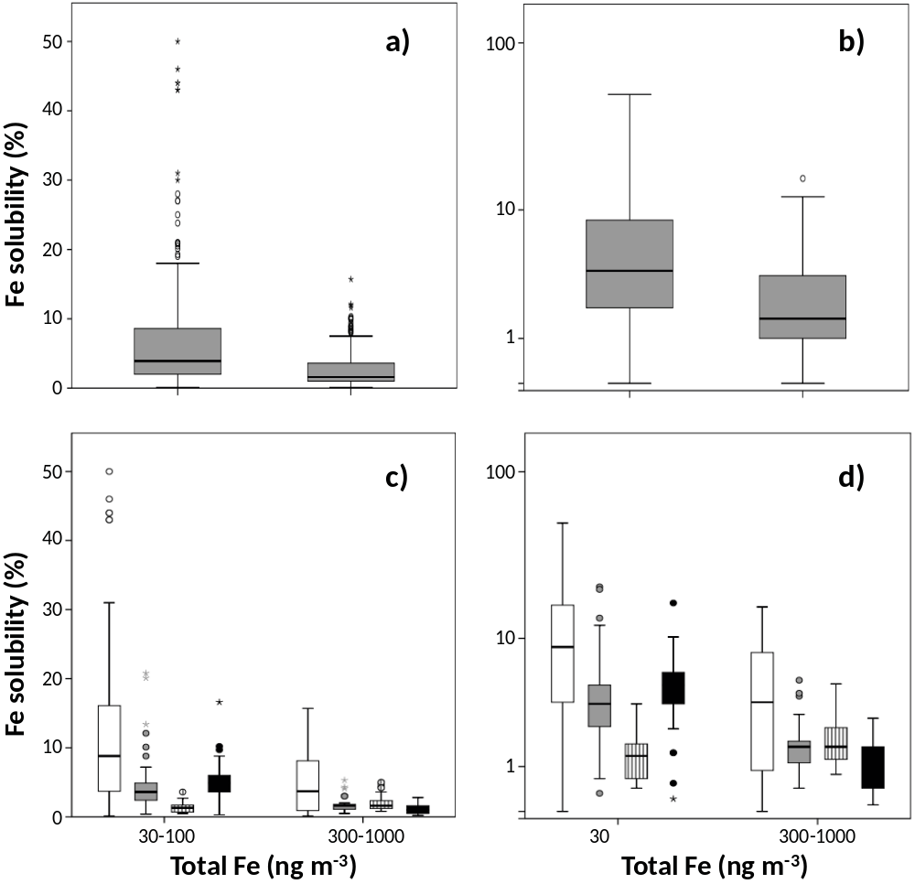

Figure 4.4 Box and whisker plots showing percentage soluble Fe for two subsets of the Sholkovitz et al. (2012) data compilation: total Fe concentrations of 30 – 100 ng TFe m⁻³ and 300 – 1000 ng TFe m⁻³. Characteristics of all the data in those concentration ranges are shown in a) (linear y-axis scale) and b) (log y-axis scale). In panels c) and d) the data is further sub-divided according to the leaching solution used for soluble Fe determination (ultrapure water (white), ammonium acetate (grey), formate (vertical stripes), seawater (black)).

Baker and Croot (2010) pointed out that it is very difficult to identify the mechanisms responsible for the hyperbolic solubility relationship from field observations of Fe solubility alone. Further insight can be gained by examining the behaviour of other dust components and related chemical tracers in field data and through controlled laboratory studies. Sholkovitz and co-workers (Sedwick et al., 2007, Sholkovitz et al., 2009, Sholkovitz et al., 2012) have linked high Fe solubility in samples collected from the western North Atlantic region to anthropogenic Fe emissions, using V (and Ni) as tracers for combustion-derived Fe. While this source is not strictly “dust”, this does suggest that there is some anthropogenic influence on Fe solubility, and this influence is most likely to be significant at low dust concentrations.
Similar hyperbolic solubility – concentration relationships have been identified for other dust components (e.g. Al, P & Si in aerosol (Baker and Jickells, 2006), Al in rainfall (Prospero et al., 1987)). In Figure 4.5 we show percentage solubility – total element concentration relationships for Fe, Al, Mn, P and Si for samples collected over the Atlantic Ocean. Symbols in Figure 4.5 indicate source regions for the samples, based on 5 day air mass back trajectories (see Baker et al., 2006). While these indicate that different source regions appear to have characteristic solubilities (see Baker et al., 2006), for Fe, Al, P and Si, it would appear that solubility varies strongly with total element concentration, as noted above. The solubility of Mn however, does not exhibit the same hyperbolic relationship with total concentration. Mn solubility varies over a much more restricted range than the other elements, and appears to be much less dependent on total Mn concentration (Figures 4.5c & f). This difference may be related to the association of Mn with different mineral phases and to the tendency of Mn to form oxide coatings on other particles (Potter and Rossman, 1979, Guest et al., 2002).

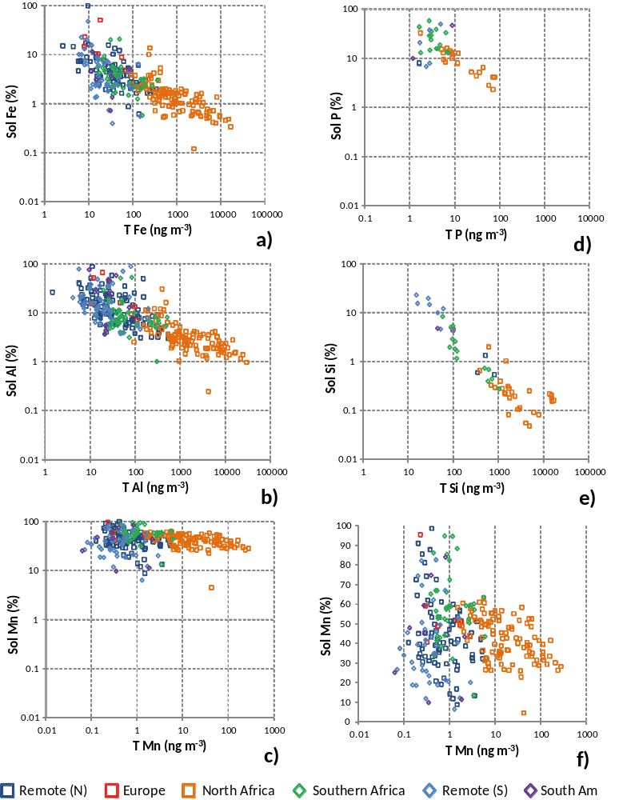

Figure 4.5 Percentage elemental solubility plotted as a function of total atmospheric elemental concentration for a) Fe, b) Al, c) Mn, d) P and e) Si (all on log – log scales) for aerosol samples collected over the North and South Atlantic. Fe data (a) is the ammonium acetate leach data from Figure 4.3 and the Al and Mn data (b & c) were obtained from the same samples, using the same methods. P and Si data are from a subset of the samples in a-c (n = 44 and 54 for P and Si respectively), using a solution buffered at pH 7 for extraction of soluble P and Si. Total Si (e) was estimated from total Al, using the Si/Al ratio of Saharan dust aerosol at Sal, Cape Verde (Chiapello et al., 1997). f) is the same as c) with a linear scale for the y-axis.

The similarity of the hyperbolic solubility relationships for Fe, Al, P and Si imply that the overall impact of atmospheric processing on solubility is similar for these elements, even if the relationship itself does not give clear evidence for which, if any, of the potential processing mechanisms dominate. However, redox changes can probably be discounted as a major control on solubility (Baker and Croot, 2010), since there are no significant differences between redox-acitve Fe (Figure 5a) and the non-redox-active elements Al,P and Si (Figures 5b, d, e).
If acid processing is a significant control on solubility, some significant differences in dust – acid interactions might be expected in different regions of the world. North African dust is uplifted into air influenced by European and North African sulphur and nitrogen oxide emissions before transport over the Atlantic. In contrast, dust from the great Asian deserts is transported significant distances before encountering high concentrations of acid precursors emitted from the industrialised regions of southeast Asia. These two regimes imply rather different mechanisms for the interaction of dust and anthropogenic acids, with direct uptake of gaseous species likely to be more important for Asian dust.
4.3.3 Impacts on atmospheric composition
Heterogeneous chemistry on dust surfaces leads to uptake and release of several atmospherically important trace gas species, as well as the formation or alteration of secondary coatings on mineral particles. Controlled laboratory experiments on model mineral phases and authentic dusts have demonstrated that these processes can be sensitive to relative humidity, photolysis and the nature of the reactive surface.
4.3.3.1 Nitric acid and nitrogen oxides
Nitric acid reacts with mineral dust resulting in formation of surface nitrate and gas-phase species including NO, NO₂, and N₂O (Rubasinghege and Grassian, 2009). Studies performed on clays and authentic dust samples from Africa and Asia show efficient uptake of nitric acid onto these samples (Hanisch and Crowley, 2001).
When oxide surfaces are exposed to NO₂ it reacts with the surface to form nitrite or nitrate at higher NO₂ pressure. In addition, gas-phase NO is produced. Relative humidity and temperature influence the uptake of NO₂ by clays and soil samples (Zhang et al., 2012). Heterogeneous hydrolysis of NO₂ on silicate surfaces produces HONO and NO and it was proposed that this reaction does not depend strongly on the nature of surface (Finlayson-Pitts et al., 2003). This suggests that any mineral dust can provide a surface for this reaction. Trace amounts of TiO₂ in the authentic dust can play an important role in NO₂ uptake. When NO₃⁻ adsorbed on mineral dust surfaces containing TiO₂ is irradiated, NO and NO₂ (NO_{x}) are detected, however SiO₂ does not show NO_{x} formation. Consequently, TiO₂ is responsible for NO_{x} production (Ndour et al., 2009). NO₂ uptake on TiO₂ as well as Saharan sand samples shows a significant increase under irradiation.
NO adsorption on TiO₂ in the presence of molecular oxygen leads to the formation of surface adsorbed nitrate and NO⁺ (Hadjiivanov and Knozinger, 2000). Heterogeneous reaction of NO with adsorbed nitric acid is a significant source of HONO in polluted areas. Besides, this reaction also converts nitric acid to NO_{x} (Saliba et al., 2000). The exposure of surface nitrate-coated aluminum oxide to gaseous hydrogen chloride (HCl) yields several gas-phase products, including NOCl, NO₂, and HNO₃ under dry, or NO and N₂O under humid conditions
Daytime photochemistry of dust-adsorbed nitrogen species can be responsible for formation of HONO, a precursor to the hydroxyl radical. Adsorbed molecular HNO₃ undergoes photolysis to form HONO or HONO and H₂O₂ in the presence of water (Ramazan et al., 2006). As the relative humidity decreases, the adsorbed HONO reacts with adsorbed nitric acid to form NO₂. Photolysis of surface nitrate yields only NO₂, NO and N₂O on Al₂O₃ (Rubasinghege and Grassian, 2009), but HONO on SiO₂ (Ma et al., 2011). The latter can account for the presence of HONO in the dust-laden atmosphere. TiO₂ photocatalysis is another potential source of daytime HONO, a process which shows a strong dependence on the relative humidity (RH) (Gustafsson et al., 2006). Another mechanism of HONO formation involves heterogeneous photochemistry of NO₂ on soil particles and ice films coated with humic substances (Bartels-Rausch et al., 2010).
4.3.3.2 Sulphur species
Sulphur dioxide adsorbs irreversibly on mineral oxides and authentic aerosol samples to form surface sulphite, bisulphite, and sulphate and this process is significantly enhanced in the presence of adsorbed water. Atmospheric sulphur dioxide can be oxidized to sulphate or sulphuric acid on dust surfaces (Usher et al., 2002, Wu et al., 2011). Iron compounds are responsible for the removal of SO₂ from gas mixtures with uptake limited to the outer layer of the particles. Adsorbed SO₂ oxidizes on the surface of most iron oxides to form a bidentate or monodentate surface sulphate species. The reaction of SO₂ on the surface of mixed particles of Fe₂O₃ and NaCl mainly produces sulphate/bisulphate species. Oxidation of sulphur dioxide into sulphate readily occurs on TiO₂ yielding adsorbed sulphite in the dark and adsorbed sulphate under irradiation (Rubasinghege et al., 2010). Reaction of calcium carbonate with sulphur dioxide leads to formation of adsorbed sulphite. This reaction is enhanced in the presence of water as reviewed in Rubasinghege and Grassian (2013).
Carbonyl sulphide (OCS) is one of the most abundant sulphur compounds in the atmosphere. It can be catalytically oxidized on mineral oxides to produce surface SO₄²⁻ species and gaseous CO₂. Reversible and irreversible adsorption of OCS is observed on α-Fe₂O₃ and ZnO, respectively, whereas no uptake is observed on SiO₂ and TiO₂. On kaolinite OCS can only be reversibly adsorbed at Al-OH sites. The hydrolysis of OCS and succeeding oxidation of intermediate products readily takes place on α-Al₂O₃, MgO, and CaO (Liu et al., 2010). On the surface of hematite the adsorbed OCS is oxidized, forming surface hydrogen thiocarbonate, carbonate, and sulphate species and gaseous CO₂ (Chen et al., 2007).
We have discussed above that sulphur dioxide forms sulphate ions on the surface of dust particles. However, there is evidence for an alternate pathway in which a series of reactions under solar light causes formation of gaseous sulphuric acid as an intermediate product leading either to surface-bound sulphate production or nucleation. This photocatalytic mechanism is based on the presence of semiconductor metal oxides in mineral dust with a band gap (the difference in energy between the valence and conduction bands) within the solar spectrum. The production of electron/hole pairs at the semiconductor surface upon excitation enables these minerals to act as photocatalysts, leading to the formation of reactive species such as OH radicals in the gas phase. These OH radicals can initiate the conversion of SO₂ to H₂SO₄ and subsequently new particle formation as shown in Figure 4.6 (Dupart et al., 2012). New particle formation is usually inhibited during a dust event, however there is a decoupling between nucleation and growth (Kulmala et al., 2000), which allows formation of new aerosol particles even during high dust loadings.

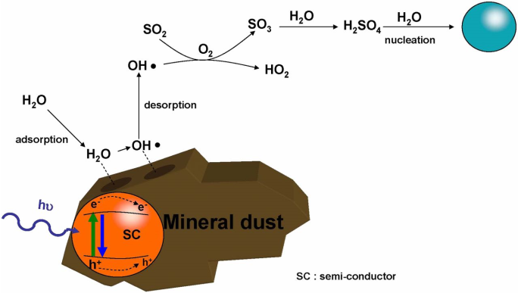

Figure 4.6 The semiconductor (SC) components of dust under UV irradiation are producing OH radicals that can desorb and oxidize SO₂. The produced sulphuric acid may then initiate nucleation events. Reprinted with permission from Dupart, Y., King, S. M., Nekat, B., Nowak, A., Wiedensohler, A., Herrmann, H., David, G., Thomas, B., Miffre, A., Rairoux, P., D’Anna, B. and George, C. (2012) Mineral dust photochemistry induces nucleation events in the presence of SO2, Proceedings of the National Academy of Sciences, 109, 51, 20842–20847. Copyright (2012) National Academy of Sciences, USA.

4.3.3.3 Ozone
Trace amounts of TiO₂ may be responsible for ozone loss. Doping of SiO₂ with TiO₂ increases ozone decomposition (Nicolas et al., 2009) and TiO₂-containing Saharan dust shows irreversible ozone uptake (Hanisch and Crowley, 2003). Ozone decay rate is significantly higher under irradiation compared to dark conditions, indicating that this reaction is also photo-induced.
Heterogeneous photochemistry of O₃ depends on the surface properties of oxides. For example Fe₂O₃ shows high uptake capacity and catalytic decomposition toward O₃, but Al₂O₃ is deactivated by O₃ exposure. The photoenhancement of O₃ decomposition on Fe₂O₃ is explained by its semiconductor properties. Irradiation of Fe₂O₃ with UV photons having energies higher than 2.2 eV creates electron-hole pairs, which initiate photochemical reactions. Since mineral dust aerosol can contain a variety of semiconductor metal oxides, such as TiO₂, ZnO, and Fe₂O₃, heterogeneous photodecomposition of O₃ may be an important path of ozone loss in the troposphere.
4.3.3.4 Other Inorganic and Organic Species
Adsorption of hydrogen peroxide on SiO₂ and CaCO₃ is mainly reversible. Metal oxides exhibit catalytic behaviour toward the decomposition of hydrogen peroxide, while SiO₂ does not (Wang et al., 2011). The uptake of hydrogen peroxide by TiO₂ was found to decrease at higher RH, while irradiation enhances H₂O₂ decomposition with formation of HO₂ intermediate (Yi et al., 2012).
Adsorption of acidic gases on calcium carbonate under dry conditions shows the formation of carbonic acid on the calcite surface (Al-Hosney and Grassian, 2004). The acid is stable over long periods at low temperatures even in the presence of water vapour (Bernard et al., 2012). Thus, in the high troposphere H₂CO₃ may be adsorbed on mineral dust particles.
Organic compounds are often associated with dust particles (Lee et al., 2002, Russell et al., 2002) and adsorption of organics on minerals is an important process. Adsorption of carbonyls on SiO₂ particles is nonreactive and reversible (Carlos-Cuellar et al., 2003), but it is irreversible on other oxides (α-Al₂O₃, TiO₂, α-Fe₂O₃, SiO₂, and CaO) (Xu et al., 2006). Carbonyl compounds can undergo photolysis and react with OH radicals, yielding peroxy radicals and peroxyacetylnitrates (PAN) (Li et al., 2001).
Multiple studies show that tropospheric particles are often associated with organic acids (Lee et al., 2002). Dissociation of formic acid yields mono- and bidentate formate species. The adsorption of acetic acid produces both molecularly adsorbed acetic acid and acetate groups (Takeuchi et al., 2010). The extent of the reaction varies with the mineral phase of the particles. For α-Al₂O₃, the reaction is limited to the surface, while for MgO the bulk of the particle is involved. For CaCO₃, acetic acid uptake is limited to the surface under dry conditions, but penetrates to the bulk under humid conditions (Ma et al., 2012). Illumination of environmental surfaces including Fe₂O₃, TiO₂, Mauritanian sand, and Icelandic volcanic ash with adsorbed oxalic acid produces gas phase CO₂ (Styler and Donaldson, 2012).
4.4 Summary
Atmospheric processing of mineral dust leads to evolution of many dust physicochemical properties during transport. Heterogeneous chemistry, in particular, has profound effects on dust morphology, optical properties and nutrient availability and alters atmospheric composition. These changes influence the direct and indirect effects of dust on climate. Therefore, comprehensive understanding of the effect of mineral dust on climate requires detailed knowledge of dust mineralogy and the changes in chemical composition and properties that take place during global transport and atmospheric processing.

Table 4.1. Median percentage Fe solubility values for aerosol samples contained in the Sholkovitz et al. (2012) data set. Values are given for the whole data and for subsets of the data obtained using Fe dissolution into ultrapure water (MQ), pH 4.7 ammonium acetate buffer (Acetate), pH 4.2 formate buffer (Formate) and seawater (Seawater). The data is also further sub-divided according to the total atmospheric Fe concentration of the samples.
 | Region
Method | N. Atlantic | S. Atlantic | N. Pacific | N. Indian | All Oceans
All TFe concentrations
All methods | 2.6 (419) | 3.2 (91) | 4.2 (270) | 3.6 (157) | 3.1 (960)
MQ | 5.0 (150) |  | 7.0 (122) | 6.6 (112) | 6.0 (384)
Acetate | 2.0 (198) | 3.2 (91) |  |  | 2.5 (296)
Formate | 2.2 (66) |  | 1.4 (58) | 1.4 (26) | 1.7 (150)
Seawater | 3.2 (5) |  | 3.6 (90) | 0.3 (19) | 2.3 (121)
1-<10
ng TFe m⁻³
MQ | 9.6 (34) |  | 20 (5) |  | 10.0 (39)
Acetate | 15 (13) | 10 (9) |  |  | 10.0 (25)
Formate | 4.6 (8) |  | 6.1 (15) |  | 6.1 (23)
Seawater |  |  | 7.0 (7) |  | 6.6 (12)
10-<100
ng TFe m⁻³
MQ | 5.8 (79) |  | 8.1 (46) | 24 (26) | 8.6 (151)
Acetate | 4.1 (64) | 3.6 (69) |  |  | 3.7 (137)
Formate | 2.3 (13) |  | 1.2 (31) |  | 1.5 (44)
Seawater | 3.5 (4) |  | 5.0 (46) |  | 4.6 (52)
100-<1000
ng TFe m⁻³
MQ | 1.0 (32) |  | 7.8 (44) | 5.3 (77) | 5.2 (153)
Acetate | 1.7 (79) | 2.3 (13) |  |  | 1.8 (92)
Formate | 1.7 (41) |  | 1.1 (12) | 1.5 (22) | 1.5 (75)
Seawater | 2.6 (1) |  | 1.4 (17) | 1.0 (11) | 1.2 (29)
1000-<10000 ng TFe m⁻³
MQ | 5.0 (5) |  | 0.9 (27) | 1.7 (9) | 1.2 (41)
Acetate | 0.7 (42) |  |  |  | 0.7 (42)
Formate | 2.4 (4) |  |  | 1.0 (4) | 1.4 (8)
Seawater |  |  | 0.6 (20) | 0.2 (8) | 0.3 (28)

4.5 References
Aguilar-Islas AM, Wu JF, Rember R, Johansen AM, and Shank LM (2010) Dissolution of aerosol-derived iron in seawater: leach solution chemistry, aerosol type, and colloidal iron fraction. Marine Chemistry 120, 25-33.
Al-Hosney HA and Grassian VH (2004) Carbonic acid: An important intermediate in the surface chemistry of calcium carbonate. Journal of the American Chemical Society 126, 8068-9.
Arimoto R, Ray BJ, Lewis NF, Tomza U, and Duce RA (1997) Mass-particle size distributions of atmospheric dust and the dry deposition of dust to the remote ocean. Journal of Geophysical Research 102, 15867-74.
Baker AR and Croot PL (2010) Atmospheric and marine controls on aerosol iron solubility in seawater. Marine Chemistry 120, 4-13.
Baker AR and Jickells TD (2006) Mineral particle size as a control on aerosol iron solubility. Geophysical Research Letters 33, L17608, doi: 10.1029/2006GL026557.
Baker AR, Jickells TD, Witt M, and Linge KL (2006) Trends in the solubility of iron, aluminium, manganese and phosphorus in aerosol collected over the Atlantic Ocean. Marine Chemistry 98, 43-58.
Bartels-Rausch T, Brigante M, Elshorbany YF, Ammann M, D'Anna B, George C et al. (2010) Humic acid in ice photo-enhanced conversion of nitrogen dioxide into nitrous acid. Atmospheric Environment 44, 5443-50.
Bernard J, Seidl M, Mayer E, and Loerting T (2012) Formation and stability of bulk carbonic acid (H₂CO₃) by protonation of tropospheric calcite. Chemphyschem 13, 3087-91.
Betzer PR, Carder KL, Duce RA, Merrill JT, Tindale NW, Uematsu M et al. (1988) Long-range transport of giant mineral aerosol particles. Nature 336, 568-71.
Bullard JE, McTainsh GH, and Pudmenzky C (2004) Aeolian abrasion and modes of fine particle production from natural red dune sands: an experimental study. Sedimentology 51, 1103-25.
Carlos-Cuellar S, Li P, Christensen AP, Krueger BJ, Burrichter C, and Grassian VH (2003) Heterogeneous uptake kinetics of volatile organic compounds on oxide surfaces using a Knudsen cell reactor: Adsorption of acetic acid, formaldehyde, and methanol on α-Fe₂O₃, α-Al₂O₃, and SiO₂. Journal of Physical Chemistry A 107, 4250-61.
Chen HH, Kong LD, Chen JM, Zhang RY, and Wang L (2007) Heterogeneous uptake of carbonyl sulfide on hematite and hematite-NaCl mixtures. Environmental Science & Technology 41, 6484-90.
Chen Y and Siefert RL (2004) Seasonal and spatial distributions and dry deposition fluxes of atmospheric total and labile iron over the tropical and subtropical North Atlantic Ocean. Journal of Geophysical Research-Atmospheres 109, D09305, doi:10.1029/2003JD003958.
Chiapello I, Bergametti G, Chatenet B, Bousquet P, Dulac F, and Santos Soares E (1997) Origins of African dust transported over the northeastern tropical Atlantic. Journal of Geophysical Research 102, 13701-9.
Crumeyrolle S, Gomes L, Tulet P, Matsuki A, Schwarzenboeck A, and Crahan K (2008) Increase of the aerosol hygroscopicity by cloud processing in a mesoscale convective system: a case study from the AMMA campaign. Atmospheric Chemistry and Physics 8, 6907-24.
Cwiertny DM, Baltrusaitis J, Hunter GJ, Laskin A, Scherer MM, and Grassian VH (2008) Characterization and acid-mobilization study of iron-containing mineral dust source materials. Journal of Geophysical Research 113, D05202, doi:10.1029/2007JD009332.
Desboeufs KV, Losno R, and Colin JL (2001) Factors influencing aerosol solubility during cloud processes. Atmospheric Environment 35, 3529-37.
Dupart Y, King SM, Nekat B, Nowak A, Wiedensohler A, Herrmann H et al. (2012) Mineral dust photochemistry induces nucleation events in the presence of SO₂. Proceedings of the National Academy of Sciences of the United States of America 109, 20842-7.
Erel Y, Pehkonen SO, and Hoffmann MR (1993) Redox chemistry of iron in fog and stratus clouds. Journal of Geophysical Research 98, 18423-34.
Finlayson-Pitts BJ, Wingen LM, Sumner AL, Syomin D, and Ramazan KA (2003) The heterogeneous hydrolysis of NO₂ in laboratory systems and in outdoor and indoor atmospheres: An integrated mechanism. Physical Chemistry Chemical Physics 5, 223-42.
Formenti P, Schütz L, Balkanski Y, Desboeufs K, Ebert M, Kandler K et al. (2011) Recent progress in understanding physical and chemical properties of African and Asian mineral dust. Atmospheric Chemistry and Physics 11, 8231-56.
Gibson ER, Hudson PK, and Grassian VH (2006) Physicochemical properties of nitrate aerosols: Implications for the atmosphere. Journal of Physical Chemistry A 110, 11785-99.
Gierlus KM, Laskina O, Abernathy TL, and Grassian VH (2012) Laboratory study of the effect of oxalic acid on the cloud condensation nuclei activity of mineral dust aerosol. Atmospheric Environment 46, 125-30.
Glaccum RA and Prospero JM (1980) Saharan aerosols over the tropical North Atlantic - Mineralogy. Marine Geology 37, 295-321.
Guest CA, Schulze DG, Thompson IA, and Huber DM (2002) Correlating manganese X-ray absorption near-edge structure spectra with extractable soil manganese. Soil Science Society of America Journal 66, 1172-81.
Guieu C, Bonnet S, Wagener T, and Loye-Pilot MD (2005) Biomass burning as a source of dissolved iron to the open ocean? Geophysical Research Letters 32, L19608, doi:10.1029/2005GL022962.
Gustafsson RJ, Orlov A, Griffiths PT, Cox RA, and Lambert RM (2006) Reduction of NO₂ to nitrous acid on illuminated titanium dioxide aerosol surfaces: implications for photocatalysis and atmospheric chemistry. Chemical Communications 3936-8.
Hadjiivanov K and Knozinger H (2000) Species formed after NO adsorption and NO+O₂ co-adsorption on TiO₂: an FTIR spectroscopic study. Physical Chemistry Chemical Physics 2, 2803-6.
Hanisch F and Crowley JN (2001) Heterogeneous reactivity of gaseous nitric acid on Al₂O₃, CaCO₃, and atmospheric dust samples: A Knudsen cell study. Journal of Physical Chemistry A 105, 3096-106.
Hanisch F and Crowley JN (2003) Ozone decomposition on Saharan dust: an experimental investigation. Atmospheric Chemistry and Physics 3, 119-30.
Ito A (2013) Global modeling study of potentially bioavailable iron input from shipboard aerosol sources to the ocean. Global Biogeochemical Cycles 27, 1-10, doi:.1029/2012GB004378.
Johnson MS, Meskhidze N, Solmon F, Gasso S, Chuang PY, Gaiero DM et al. (2010) Modeling dust and soluble iron deposition to the South Atlantic Ocean. Journal of Geophysical Research 115, D15202, doi:10.1029/2009JD013311.
Journet E, Desboeufs KV, Caquineau S, and Colin JL (2008) Mineralogy as a critical factor of dust iron solubility. Geophysical Research Letters 35, L07805, doi:10.1029/2007GL031589.
Kim J-S and Park K (2012) Atmospheric aging of Asian dust particles during long range transport. Aerosol Science and Technology 46, 913-24.
Kulmala M, Pirjola U, and Makela JM (2000) Stable sulphate clusters as a source of new atmospheric particles. Nature 404, 66-9.
Lee SH, Murphy DM, Thomson DS, and Middlebrook AM (2002) Chemical components of single particles measured with Particle Analysis by Laser Mass Spectrometry (PALMS) during the Atlanta SuperSite Project: Focus on organic/sulfate, lead, soot, and mineral particles. Journal of Geophysical Research-Atmospheres 107, 4003, doi:10.1029/2000JD000011.
Li P, Perreau KA, Covington E, Song CH, Carmichael GR, and Grassian VH (2001) Heterogeneous reactions of volatile organic compounds on oxide particles of the most abundant crustal elements: Surface reactions of acetaldehyde, acetone, and propionaldehyde on SiO₂, Al₂O₃, Fe₂O₃, TiO₂, and CaO. Journal of Geophysical Research-Atmospheres 106, 5517-29.
Liu Y, Ma J, and He H (2010) Heterogeneous reactions of carbonyl sulfide on mineral oxides: mechanism and kinetics study. Atmospheric Chemistry and Physics 10, 10335-44.
Ma J, Liu Y, and He H (2011) Heterogeneous reactions between NO₂ and anthracene adsorbed on SiO₂ and MgO. Atmospheric Environment 45, 917-24.
Ma Q, Liu Y, Liu C, and He H (2012) Heterogeneous reaction of acetic acid on MgO, α-Al₂O₃, and CaCO₃ and the effect on the hygroscopic behaviour of these particles. Physical Chemistry Chemical Physics 14, 8403-9.
Mackie DS, Boyd PW, Hunter KA, and McTainsh GH (2005) Simulating the cloud processing of iron in Australian dust: pH and dust concentration. Geophysical Research Letters 32, L06809, doi:10.1029/2004GL022122.
Mackie DS, Peat JM, McTainsh GH, Boyd PW, and Hunter KA (2006) Soil abrasion and eolian dust production: Implications for iron partitioning and solubility. Geochemistry Geophysics Geosystems 7, Q12Q03, doi:10.1029/2006GC001404.
Mahowald NM, Baker AR, Bergametti G, Brooks N, Duce RA, Jickells TD et al. (2005) The atmospheric global dust cycle and iron inputs to the ocean. Global Biogeochemical Cycles 19, GB4025, doi:10.1029/2004GB002402.
Maring H, Savoie DL, Izaguirre MA, Custals L, and Reid JS (2003) Mineral dust aerosol size distribution change during atmospheric transport. Journal of Geophysical Research 108, 8592, doi:10.1029/2002JD002536.
Meskhidze N, Chameides WL, Nenes A, and Chen G (2003) Iron mobilization in mineral dust: Can anthropogenic SO₂ emissions affect ocean productivity? Geophysical Research Letters 30, 2085, doi:10.1029/2003GL018035.
Morton P, Landing WM, Hsu SC, Milne A, Aguilar-Islas AM, Baker AR et al. (2013) Methods for sampling and analysis of marine aerosols: results from the 2008 GEOTRACES aerosol intercalibration experiment. Limnology and Oceanography-Methods 11, 62-78.
Ndour M, Conchon P, D'Anna B, Ka O, and George C (2009) Photochemistry of mineral dust surface as a potential atmospheric renoxification process. Geophysical Research Letters 36, L05816, doi:10.1029/2008GL036662.
Nenes A, Krom MD, Mihalopoulos N, Van Cappellen P, Shi Z, Bougiatioti A et al. (2011) Atmospheric acidification of mineral aerosols: a source of bioavailable phosphorus for the oceans. Atmospheric Chemistry and Physics 11, 6265-72.
Nicolas M, Ndour M, Ka O, D'Anna B, and George C (2009) Photochemistry of atmospheric dust: Ozone decomposition on illuminated titanium dioxide. Environmental Science & Technology 43, 7437-42.
Pehkonen SO, Siefert R, Erel Y, Webb S, and Hoffmann MR (1993) Photoreduction of iron oxyhydroxides in the presence of important atmospheric organic-compounds. Environmental Science & Technology 27, 2056-62.
Potter RM and Rossman GR (1979) The manganese- and iron-oxide mineralogy of desert varnish. Chemical Geology 25, 79-94.
Prospero JM, Nees RT, and Uematsu M (1987) Deposition rate of particulate and dissolved aluminum derived from Saharan dust in precipitation at Miami, Florida. Journal of Geophysical Research 92, 14,723–14,31.
Ramazan KA, Wingen LM, Miller Y, Chaban GM, Gerber RB, Xantheas SS et al. (2006) New experimental and theoretical approach to the heterogeneous hydrolysis of NO₂: Key role of molecular nitric acid and its complexes. Journal of Physical Chemistry A 110, 6886-97.
Reid JS, Jonsson HH, Maring HB, Smirnov A, Savoie DL, Cliff SS et al. (2003) Comparison of size and morphological measurements of coarse mode dust particles from Africa. Journal of Geophysical Research 108, 8593, doi:10.1029/2002JD002485.
Rubasinghege G and Grassian VH (2009) Photochemistry of adsorbed nitrate on aluminum oxide particle surfaces. Journal of Physical Chemistry A 113, 7818-25.
Rubasinghege G and Grassian VH (2013) Role(s) of adsorbed water in the surface chemistry of environmental interfaces. Chemical Communications
Rubasinghege G, Lentz RW, Scherer MM, and Grassian VH (2010) Simulated atmospheric processing of iron oxyhydroxide minerals at low pH: Roles of particle size and acid anion in iron dissolution. Proceedings of the National Academy of Sciences of the United States of America 107, 6628-33.
Russell LM, Maria SF, and Myneni SCB (2002) Mapping organic coatings on atmospheric particles. Geophysical Research Letters 29, 1779, doi:10.029/2002GL014874.
Saliba NA, Mochida M, and Finlayson-Pitts BJ (2000) Laboratory studies of sources of HONO in polluted urban atmospheres. Geophysical Research Letters 27, 3229-32.
Schulz M, Balkanski YJ, Guelle W, and Dulac F (1998) Role of aerosol size distribution and source location in a three-dimensional simulation of a Saharan dust episode tested against satellite-derived optical thickness. Journal of Geophysical Research-Atmospheres 103, 10579-92.
Sedwick PN, Sholkovitz ER, and Church TM (2007) Impact of anthropogenic combustion emissions on the fractional solubility of aerosol iron: Evidence from the Sargasso Sea. Geochemistry Geophysics Geosystems 8, Q10Q06, doi:10.1029/2007GC001586.
Shi Z, Bonneville S, Krom MD, Carslaw KS, Jickells TD, Baker AR et al. (2011) Iron dissolution kinetics of mineral dust at low pH during simulated atmospheric processing. Atmospheric Chemistry and Physics 11, 995-1007.
Shi Z, Krom MD, Bonneville S, Baker AR, Jickells TD, and Benning LG (2009) Formation of iron nanoparticles and increase in iron reactivity in mineral dust during simulated cloud processing. Environmental Science & Technology 43, 6592-6.
Sholkovitz ER, Sedwick PN, and Church TM (2009) Influence of anthropogenic combustion emissions on the deposition of soluble aerosol iron to the ocean: Empirical estimates for island sites in the North Atlantic. Geochimica et Cosmochimica Acta 73, 3981-4003.
Sholkovitz ER, Sedwick PN, Church TM, Baker AR, and Powell CF (2012) Fractional solubility of aerosol iron: Synthesis of a global-scale data set. Geochimica et Cosmochimica Acta 89, 173-89.
Siefert RL, Pehkonen SO, Erel Y, and Hoffmann MR (1994) Iron photochemistry of aqueous suspensions of ambient aerosol with added organic acids. Geochimica et Cosmochimica Acta 58, 3271-9.
Spokes LJ and Jickells TD (1996) Factors controlling the solubility of aerosol trace metals in the atmosphere and on mixing into seawater. Aquatic Geochemistry 1, 355-74.
Spokes LJ, Jickells TD, and Lim B (1994) Solubilisation of aerosol trace metals by cloud processing: A laboratory study. Geochimica et Cosmochimica Acta 58, 3281-7.
Styler SA and Donaldson DJ (2012) Heterogeneous photochemistry of oxalic acid on Mauritanian sand and Icelandic volcanic ash. Environmental Science & Technology 46, 8756-63.
Sullivan RC, Moore MJK, Petters MD, Kreidenweis SM, Roberts GC, and Prather KA (2009) Effect of chemical mixing state on the hygroscopicity and cloud nucleation properties of calcium mineral dust particles. Atmospheric Chemistry and Physics 9, 3303-16.
Sullivan RC, Petters MD, DeMott PJ, Kreidenweis SM, Wex H, Niedermeier D et al. (2010) Irreversible loss of ice nucleation active sites in mineral dust particles caused by sulphuric acid condensation. Atmospheric Chemistry and Physics 10, 11471-87.
Takeuchi M, Deguchi J, Sakai S, and Anpo M (2010) Effect of H₂O vapor addition on the photocatalytic oxidation of ethanol, acetaldehyde and acetic acid in the gas phase on TiO₂ semiconductor powders. Applied Catalysis B-Environmental 96, 218-23.
Theodosi C, Markaki Z, and Mihalopoulos N (2010) Iron speciation, solubility and temporal variability in wet and dry deposition in the Eastern Mediterranean. Marine Chemistry 120, 100-7.
Usher CR, Al-Hosney H, Carlos-Cuellar S, and Grassian VH (2002) A laboratory study of the heterogeneous uptake and oxidation of sulfur dioxide on mineral dust particles. Journal of Geophysical Research-Atmospheres 107, 4713, doi:10.1029/2002JD002051.
Wang W-G, Ge M-F, and Sun Q (2011) Heterogeneous uptake of hydrogen peroxide on mineral oxides. Chinese Journal of Chemical Physics 24, 515-20.
Witt MLI, Mather TA, Baker AR, de Hoog C-J, and Pyle DM (2010) Atmospheric trace metals over the south-west Indian Ocean: Total gaseous mercury, aerosol trace metal concentrations and lead isotope ratios. Marine Chemistry 121, 2-16.
Wu LY, Tong SR, Wang WG, and Ge MF (2011) Effects of temperature on the heterogeneous oxidation of sulfur dioxide by ozone on calcium carbonate. Atmospheric Chemistry and Physics 11, 6593-605.
Xu B-Y, Zhu T, Tang X-Y, Ding J, and Li H-J (2006) Heterogeneous reaction of formaldehyde on surface of α-Al₂O₃ particles. Chemical Journal of Chinese Universities-Chinese 27, 1912-7.
Yi J, Bahrini C, Schoemaecker C, Fittschen C, and Choi W (2012) Photocatalytic decomposition of H₂O₂ on different TiO₂ surfaces along with the concurrent generation of HO₂ radicals monitored using cavity ring down spectroscopy. Journal of Physical Chemistry C 116, 10090-7.
Yin Y, Wurzler S, Levin Z, and Reisin TG (2002) Interactions of mineral dust particles and clouds: Effects on precipitation and cloud optical properties. Journal of Geophysical Research-Atmospheres 107, 4724, doi:10.1029/2001JD001544.
Zhang Z, Shang J, Zhu T, Li H-J, Zhao D, Liu Y et al. (2012) Heterogeneous reaction of NO₂ on the surface of montmorillonite particles. Journal of Environmental Sciences-China 24, 1753-8.

