OP0595, a new diazabicyclooctane: Mode of action as a serine β-lactamase inhibitor, antibiotic and β-lactam ‘enhancer’

Akihiro Morinaka¹*, Yuko Tsutsumi¹, Mototsugu Yamada¹, Kenji Suzuki¹, Takashi Watanabe¹, Takao Abe¹, Takeshi Furuuchi¹, Seiichi Inamura¹, Yoshiaki Sakamaki¹, Nakako Mitsuhashi¹, Takashi Ida¹ and David M. Livermore²
¹Meiji Seika Pharma Co., Ltd., Yokohama, Japan, ²Norwich Medical School, University of East Anglia, Norwich NR4 7TJ, UK

*Corresponding author:
Akihiro Morinaka
Meiji Seika Pharma Co., Ltd.,
2-4-16, Kyobashi, Chuo-ku, Tokyo 104-8002, Japan

Tel: +81-3-3273-3348
Fax +81-3-3273-5620
akihiro.morinaka@meiji.com

Running title: OP0595 against β-lactamases
Key words: Enterobacteriaceae, antibiotic resistance, penicillin-binding proteins
Objectives: The production of a growing diversity of β-lactamases by Gram-negative bacteria challenges antimicrobial chemotherapy. OP0595, discovered separately by each of Meiji Seika Pharma and Fedora Pharmaceuticals Inc., is a new diazabicyclooctane serine β-lactamase inhibitor, which acts also as an antibiotic and as β-lactamase-independent β-lactam ‘enhancer’.
Methods: Inhibitory activity against serine β-lactamases and affinity for penicillin-binding proteins (PBPs) were determined using nitrocefin and Bocillin FL, respectively. MICs alone and in combination with β-lactam agents were measured according to CLSI recommendations. Morphological changes in Escherichia coli were examined by phase-contrast microscopy.
Results: IC₅₀s of OP0595 for Class A and C β-lactamases were <1000 nM, with covalent binding demonstrated to the active site serine of CTX-M-44 and AmpC enzymes. OP0595 also had direct antibiotic activity against many Enterobacteriaceae, associated with inhibition of PBP2 and conversion of the bacteria to spherical forms. Synergy between OP0595 and β-lactam agents was seen against strains producing Class A and C β-lactamase vulnerable to inhibition. Last, OP0595 lowered the MICs of PBP3-targeted partner β-lactam agents for a non-β-lactamase-producing E. coli mutant that was resistant to OP0595 itself, indicating β-lactamase independent ‘enhancer’ -based synergy.
Conclusions: OP0595 acts in three ways: i) as an inhibitor of class A and C β-lactamases, covalently binding at their active sites; ii) as an antibacterial, by inhibiting PBP2 of several Enterobacteriaceae; and iii) as an ’enhancer’ of β-lactam agents that bind to other PBPs besides PBP2 for several Enterobacteriaceae. OP0595 has considerable potential to overcome resistance when it is combined with various β-lactam agents.

Introduction
The global increase in antibiotic-resistant Gram-negative bacteria in recent years poses a serious medical problem. In many cases, the mechanisms of resistance involve the production of β-lactamase. As of 2012, roughly 1300 β-lactamases had been identified, including many that cannot be inhibited by established β-lactamase inhibitors such as tazobactam and clavulanic acid, and several that hydrolyse carbapenems, which previously were regarded as ‘β-lactamase stable’.¹
β-Lactamases can be classified according to several schemes. The most fundamental is the Ambler classification, which is based on amino acid sequence. This splits the serine β-lactamases into Class A, which includes the common TEM, SHV, CTX-M and KPC types, Class C (AmpC, CMY, etc.) and D (OXA). Class B comprises the metallo-enzymes (e.g. IMP, NDM, etc.), which require divalent cations, generally zinc, for substrate hydrolysis.²
The spread of extended-spectrum TEM, SHV and CTX-M β-lactamases has driven increased clinical dependence on carbapenems, but carbapenemase-producing Enterobacteriaceae are now spreading rapidly worldwide.³ The prevalent carbapenemase types vary geographically, with KPC types dominant in the Americas, China, Israel and parts of southern Europe, but with OXA-48 prevalent in the Middle East (except Israel), and NDM in south Asia.⁴ Bacteria with these enzymes can cause severe infections, and the fatality rate in cases of bloodstream infections involving carbapenemases-producing K. pneumoniae is high.⁵
As a result, new and effective β-lactamase inhibitors are urgently needed, and two diazabicyclooctanes, namely avibactam and relebactam (MK-7655), are under clinical development for this role.⁶ Diazabicyclooctanes represent a new class of β-lactamase inhibitor and show strong inhibitory activity against Class A β-lactamases, including KPC types, as well as AmpC enzymes. The initial partner β-lactam agents for avibactam and relebactam are ceftazidime and imipenem, respectively, and these inhibitors restore the antibiotic activity of substrate antibiotics against strains producing serine β-lactamases.⁷⁻¹⁰
Recently, each of Meiji Seika Pharma Co., Ltd. and Fedora Pharmaceuticals Inc. discovered separately a new diazabicyclooctane β-lactamase inhibitor, named OP0595, which is now under clinical development.¹¹ OP0595 acts in three ways: i) as a β-lactamase inhibitor, ii) as an antibiotic agent against Enterobacteriaceae, and iii) as an ’enhancer’ of the activity of various β-lactam agents. The objective of this work was to evaluate these three mechanisms of action by examining interactions with penicillin-binding proteins (PBPs), β-lactamases and whole bacteria, both alone and in combination with partner β-lactams.

Materials and Methods
Compounds
OP0595 (Figure 1) and avibactam were synthesized by Meiji Seika Pharma Co., Ltd.;¹² OP0595 was evaluated as the anhydride. Other compounds were from suppliers as follows: tazobactam and sulbactam from LKT Laboratories (St. Paul, Mn, USA); mecillinam from Toronto Research Chemicals (Toronto, Ontario, Canada); clavulanic acid, piperacillin, ceftazidime and aztreonam from Sigma-Aldrich (St. Louis, Mo, USA); cefepime and meropenem from the United States Pharmacopeial Convention (Rockville, Mo, USA).

Bacterial strains
Most of the strains were obtained from the American Type Culture Collection (ATCC). Exceptions were that Escherichia coli K-12 W3110 (NBRC 12713) was obtained from the National Bio Resource Project (NBRP, Tokyo, Japan), and the ‘MSC’ strains are clinical isolates from Japan. OP0595-resistant mutants were selected from E. coli K-12 W3110 on Mueller–Hinton agar (MHA) containing OP0595 at 16 mg/L.

Preparation of β-lactamase enzymes
The β-lactamase coding regions – excluding determinants of the signal peptides – of bla_{OXA-23} (GenBank accession number EF016357) from Acinetobacter baumannii; chromosomal ampC (AB016611) from Enterobacter cloacae; bla_{TEM-1} (AY458016), bla_{TEM-10} (U09188), bla_{CTX-M-44} (D37830), bla_{OXA-1} (J02967), bla_{CTX-M-14} (AF252622), bla_{CTX-M-15} (AY044436) and bla_{CMY-2} (AM779748) from E. coli; bla_{KPC-2} (DQ989639) from Klebsiella pneumoniae; bla_{OXA-2} (AB188812) and chromosomal ampC (AE004091) from Pseudomonas aeruginosa were amplified by PCR using plasmid or genomic DNA as a template. These PCR products were then incorporated into a pET-28(+) vector (Merck KGaA, Darmstadt, Germany) and their sequences were verified. The resulting plasmids were introduced into E. coli BL21 (DE3) (Merck). Protein expression was induced with 1 mM IPTG at 20°C overnight. Bacterial cells were collected and disrupted by sonication; enzymes then were purified from these extracts by column chromatography (Supplementary Methods). The expression and purification procedures for IMP-1 β-lactamases have been described previously.¹³

β-Lactamase inhibitory activity
Inhibitory activity was determined spectrophotometrically, using nitrocefin as the substrate. Duplicate dilutions of the inhibitor and the β-lactamase were dispensed into 96-well microtitre plates, After incubation at 30°C and pH 7.0 for 10 min, nitrocefin was added to a final concentration of 0.1 mM, The change in absorbance of each sample at 492 nm was measured after further incubation at 30°C for 20 min using a Multiskan Ascent instrument (Thermo Fisher Scientific, Yokohama, Japan). IC₅₀ values were calculated by logistic regression using SAS System Version 9.1 (SAS Institute Japan Ltd., Tokyo, Japan).

X-ray crystallography
Crystals of P. aeruginosa AmpC β-lactamase and CTX-M-44 enzyme (Toho-1; CTX-M group 2) from E. coli, each complexed with OP0595, were prepared by the vapour-diffusion method in the presence of OP0595.¹⁴ X-ray diffraction data were collected from a synchrotron ring on Beamlines Systems (either BL41XU at SPring-8 [Hyogo, Japan] or NW-12A at Photon Factory [Tsukuba, Japan]). The structures of both complexes were determined by the molecular replacement method, using the program Molrep.¹⁵ Model building and crystallographic refinement were performed using the programs Coot¹⁶ and Refmac5,¹⁷ respectively. The atomic coordinates and structure factors have been deposited in the Protein Data Bank under the accession codes 4X68 (P. aeruginosa AmpC) and 4X69 (CTX-M-44).

Susceptibility testing
The minimum inhibitory concentration (MIC) of each compound was determined by agar dilution and broth microdilution, both performed according to CLSI guidelines.^{18,19} The test inoculum was approximately 1 × 10⁴ cfu/spot or approximately 5 × 10⁴ cfu/well. The MIC was defined as the lowest concentration to prevent visible growth after incubation at 35°C for 18-20h.

PBP binding assay
A PBP-containing membrane suspension from E. coli K-12 W3110 was prepared according to the Iida method,²⁰ and was incubated with the test drug solution at 35°C and pH 7.0 for 20 min. Bocillin FL (Thermo Fisher Scientific) was then added to a final concentration of 0.025 mM, with incubation continued for a further 10 min at 35°C. Electrophoresis Sample Buffer Solution with a Reducing Reagent (Nacalai Tesque, Inc., Kyoto, Japan) was added; afterwards the mixture was boiled at 100°C for 5 min and then cooled on ice for 1 min. The resulting solution was applied to a 5 to 12.5% gradient SDS-polyacrylamide gel (DRC Co., Ltd., Tokyo, Japan), with proteins separated at 300 V for 12 min. The gel was rinsed three times for 5 min each with deionized water and the Bocillin FL-labelled PBPs were visualized by using an Image Quant LAS 4000 analyser to measure fluorescence intensities, with excitation at 460 nm and emission at 515 nm. IC₅₀ values were calculated based on duplicate experiments by logistic regression using SAS Version 9.1.

Morphological changes
As previously described by Dalhoff et al.,²¹ thin layers of MHA, containing various concentrations of drugs was spread on glass slides. Well-isolated E. coli K-12 W3110 colonies from a MHA plate were then suspended in sterile saline to a turbidity equivalent to a 0.5 McFarland standard. This inoculum was spread on the surface of the drug-agar slides and a glass coverslip was placed over each preparation before sealing with paraffin wax. The preparations were incubated at 37°C and examined at intervals under a phase-contrast microscope (Keyence Corporation, Osaka, Japan).

Results
β-Lactamase inhibitory activity
IC₅₀ values of OP0595 were determined for representative Class A, C, and D β-lactamases using nitrocefin as a substrate (Table 1) and were similar to those of avibactam, or slightly higher. IC₅₀ values were below 1000 nM for all Class A and C serine-β-lactamases tested; Class D β-lactamases, and particularly OXA-23, appeared more resistant to inhibition by both diazabicyclooctanes, but should be treated with some caution because at least some of these enzymes interconvert (e.g. by lysine carboxylation) between more and less active forms, which may differ in their vulnerability to inhibition. OP0595 and avibactam did not inhibit the IMP-1 metallo-β-lactamase (Class B) significantly, as indicated by IC₅₀ values >0.3 mM.

X-ray crystallography
The crystal structures of OP0595 complexed with AmpC and CTX-M-44 enzymes were determined at 1.68 and 1.42Å resolution, respectively. Both structures showed that OP0595 became covalently bound to the active-site serine of the β-lactamase after opening of the carbonyl to nitrogen bond in the five-membered ring (Figure 2). Avibactam binds similarly.^{22,23}
In the AmpC complex, the carboxamide group of the OP0595 side-chain formed hydrogen bonds with the side chains of Gln-146 and Asn-179 and to the carbonyl oxygen of Ser-345. In the case of CTX-M-44, the same carboxamide group formed hydrogen bonds with the side chains of Asn-104 and Asn-132 and with a water molecule. These hydrogen-bond networks are similar to those observed in the crystal structure of avibactam complexed with AmpC and CTX-M-15 enzymes.^{22,23} For the CTX-M-44-OP0595 complex, electron density corresponding to the terminal amine of the inhibitor was hardly visible (data not shown), indicating that this has a flexible conformation and was not participating in hydrogen bonding.

Antibiotic activity and underlying mechanism
OP0595 showed antibiotic activity against many Enterobacteriaceae strains at 1 to 8 mg/L whereas non-fermenters, some Proteeae and Serratia, and Gram-positive strains were more resistant (Table 2). MICs of avibactam were c. 8-fold higher than those of OP0595.
MICs were also determined using OP0595 in combination with piperacillin, cefepime, or meropenem against reference Gram-positive and -negative strains, including Enterobacteriaceae with KPC, extended-spectrum, and AmpC enzymes (Table 2). In many cases the results of these combination studies were dominated by the antibacterial activity of OP0595. Nevertheless, and illustrating β-lactamase inhibitory activity, synergy was also seen with substrate β-lactam agents for strains that were resistant to OP0595, for example K. pneumoniae ATCC 700603, with an SHV-18 ESBL, and for P. aeruginosa MSC17715 and 17716 strains with high-level AmpC activity, and for Burkholderia cepacia ATCC 25416. No synergy was seen between OP0595 and β-lactam agents, nor between avibactam and ceftazidime, for A. baumannii ATCC BAA-2093, Stenotrophomonas maltophilia ATCC 13637 and various Gram-positive strains and, in contrast to the OP0595 combinations, ceftazidime/avibactam was not synergistically active against B. cepacia ATCC 25416.
To elucidate the basis of its antibiotic activity, the affinity of OP0595 for the PBPs of E. coli K-12 W3110 was determined in comparison to avibactam, mecillinam, aztreonam, piperacillin, cefepime and meropenem (Table 3). OP0595 bound to only PBP2. Its binding affinity was stronger than that of avibactam but weaker than that of mecillinam.
Next, the morphological changes induced by OP0595, mecillinam and cefepime in E. coli K-12 strain W3110 were evaluated (Figure 3). OP0595 and mecillinam both induced spherical cell formation at 1×MIC. These observations support the view that the antibiotic activity resulted from inhibition of PBP2, as with mecillinam. By contrast, cefepime induced filament formation 1×MIC and showed highest binding affinity for PBP3, a known correlate on filament formation in Enterobacteriaceae.²⁴

Enhancer activity of OP0595
Some Enterobacteriaceae strains are resistant to the antibiotic activity of PBP2 inhibitors such as mecillinam.^{25,26} However, even in these cases, mecillinam retains an ‘enhancer’ effect on the antibiotic activity of other β-lactam agents.^{27,28} We therefore examined whether OP0595 similarly could enhance the antibiotic activity of other β-lactam agents against an OP0595-resistant mutant of the β-lactamase-negative strain E. coli K-12 W3110 (Table 4). This mutant acquired cross-resistance to mecillinam but not to other β-lactam agents. OP0595, at 4 mg/L, lowered the MIC of piperacillin, cefepime and aztreonam by 4- to 32-fold, as did mecillinam; by contrast, meropenem/OP0595 and mecillinam/OP0595 were no more active than meropenem and mecillinam alone. The enhancer effect for piperacillin, cefepime and aztreonam increased as the concentration of OP0595 was raised (Figure 4).

Discussion
The worldwide spread of potent β-lactamases, including ESBLs and carbapenemases, creates a need and opportunity for new β-lactamase inhibitors. In this study, we demonstrate that OP0595, a new diazabicyclooctane molecule, acts in three ways: i) as a β-lactamase inhibitor; ii) as a PBP2-targeted antibiotic agent against Enterobacteriaceae; and iii) as an ’enhancer’ of the activity of several β-lactam agents that primarily target PBP3.
OP0595 inhibited Class A and C β-lactamases almost as strongly as avibactam. Crystallographic analysis for CTX-M-44 and AmpC (Figure 2) showed that OP0595 bound covalently to the active-site serine of these β-lactamases, and that the carboxamide group of OP0595 formed hydrogen bonds in the active-site pocket, similarly to avibactam.^{22,23} Crystallographic analysis further suggested that the terminal alkyl amine moiety on OP0595’s side chain does not much contribute to the inhibitor’s interaction with the active-site pocket of these enzymes. In particular, this alkyl amine does not form a hydrogen bond and may, rather, have a weak hydrophobic interaction with the bottom of the pocket. This is consistent with the observation that, in comparison to avibactam, the inhibitory activity of OP0595 against β-lactamases was not improved by extension of this side chain. However, more studies, including acylation and deacylation kinetics, are needed to definitively compare OP0595 and avibactam.²⁹ It should also be noted that the present work was done with CTX-M-44, a group 2 CTX-M enzyme, whereas published work with avibactam was with CTX-M-15, which belongs to CTX-M group 1.
OP0595 itself inhibited the growth of many Enterobacteriaceae strains at concentrations of 1 to 8 mg/L. This masked its interactions with other β-lactam agents in combination susceptibility tests (Table 2) except for strains, such as K. pneumoniae ATCC 700603 and the AmpC-derepressed strains of P. aeruginosa in Table 2 that were resistant to OP0595. In these latter cases synergy was seen when OP0595 was combined with substrate β-lactam agents, illustrating its activity as an inhibitor of Class A and C enzymes.
The mechanism underlying the antibiotic activity of OP0595 involved the inhibition of PBP2, as shown by a PBP binding assay. This is the same target as for mecillinam and (much more weakly), avibactam. Moreover, like mecillinam, OP0595 induced spherical cell formation in E. coli, as is typically seen following inhibition of PBP2.^{30,31}
In the 1980s and 1990s mecillinam was repeatedly reported to be an ‘enhancer’ of the activity of other β-lactam agents, though the mechanism underlying this behaviour remains unelucidated.^{27,28,30,31} OP0595 likewise showed enhancer activity towards piperacillin, cefepime and aztreonam, which it synergised against a β-lactamase-negative, OP0595-resistant (MIC >32 mg/L) E. coli mutant (Table 4, Figure 4). By contrast, OP0595 did not synergise with meropenem or mecillinam against this organism. A likely explanation of this difference is that meropenem and mecillinam also show their highest affinity to PBP2 whereas piperacillin, cefepime and aztreonam are primarily directed against PBP3. Avibactam, at 4 mg/L, did not show enhancer activity for ceftazidime, even though its highest affinity was towards PBP2; it is possible that an enhancer effect might be seen at higher, clinically unattainable, concentrations. The mechanism of OP0595 resistance in the mutant is uncertain but the observations suggest that the enhancer and antibacterial effects are substantially independent. In support of this conclusion, sequencing revealed that the PBP2 gene, pbp2, was unaltered in the mutant (data not shown). This accords with recent observations that mutational resistance to mecillinam most often depends on mutations that affect the respiratory chain, the ribosome, cysteine biosynthesis, tRNA synthesis, and pyrophosphate metabolism.³² These affect cellular levels of guanosine tetraphosphate (ppGpp), activating the stringent response and –although the exact mediation remains unclear – somehow allow stabilisation and growth of the round forms induced by attack on PBP2.³³ Given their identical PBP target it is likely that the behaviour of OP0595 and mecillinam are similar in this context and this view is supported by the observation that, as with OP0595 (Table 4, Figure 4) mecillinam too retains its enhancer effect even against mecillinam resistant strains.^{27,28}
In conclusion, OP0595 has been shown to have the following three modes of action: i) as an inhibitor of class A and C β-lactamase, via covalent binding to these enzymes; ii) as an antibiotic agent, by inhibiting PBP2 of Enterobacteriaceae; and iii), similarly to mecillinam, as an ‘enhancer’ of the activity of β-lactam agents that bind primarily to PBPs other than PBP2. Combinations of OP0595 with β-lactam agents provide a potential to overcome resistance. Any of the agents in Table 2 and 4 might be a potential partner drug and, notably, the MICs of cefepime/OP0595 equalled or were lower than those of ceftazidime/avibactam.

Acknowledgements
We thank Dr. Toshiaki Mase, Dr. Eiki Shitara and Dr. Takuji Yoshida of Meiji Seika Pharma Co., Ltd. for productive discussion. We thank Dr. Kazuya Hasegawa and Dr. Hideo Okumura of Japan Synchrotron Radiation Research Institute for assistance with X-ray data collection on the BL41XU beamline at SPring-8, and Dr. Yusuke Yamada of Photon Factory and the staff of beamline AR-NW12A for assistance with data collection at Photon Factory. We also thank Ms. Yumiko Suzuki and Ms. Tomomi Koide for their technical assistance with the experiments.

Funding
This work was internally funded.

Transparency declarations
All authors except DML are employees of Meiji Seika.
DML: Advisory Boards or ad hoc consultancy – Accelerate, Achaogen, Adenium, Alere, Allecra, Altermune, Astellas, AstraZeneca, Auspherix, Basilea, Bayer, BioVersys, Cubist, Curetis, Cycle, Discuva, Forest, GSK, Meiji, Pfizer, Roche, Shionogi, Tetraphase, VenatoRx, Wockhardt; Paid lectures – AOP Orphan, Astellas, AstraZeneca, Bruker, Curetis, Merck, Pfizer, Leo; Relevant shareholdings in – Dechra, GSK, Merck, Perkin Elmer, Pfizer amounting to <10% of portfolio value. Contract work for Achaogen, Adenium, AstraZeneca, Basilea, Cubist, GSK, Melinta, Meiji, Tetraphase, VenatoRx, Wockhardt.

Reference List
- Bush K. Proliferation and significance of clinically relevant β-lactamases. Ann N Y Acad Sci 2013; 1277: 84-90.
- Bush K, Jacoby GA. Updated functional classification of β−lactamases. Antimicrob Agents Chemother 2010; 54: 969-76.
- Gupta N, Limbago BM, Patel JB et al. Carbapenem-resistant Enterobacteriaceae: epidemiology and prevention. Clin Infect Dis 2011; 53: 60-7.
- Munoz-Price LS, Poirel L, Bonomo RA et al. Clinical epidemiology of the global expansion of Klebsiella pneumoniae carbapenemases. Lancet Infect Dis 2013; 13: 785-96.
- Tumbarello M, Viale P, Viscoli C et al. Predictors of mortality in bloodstream infections caused by Klebsiella pneumoniae carbapenemase-producing K. pneumoniae: importance of combination therapy. Clin Infect Dis 2012; 55: 943-50.
- Watkins RR, Papp-Wallace KM, Drawz SM et al. Novel β-lactamase inhibitors: a therapeutic hope against the scourge of multidrug resistance. Front Microbiol 2013; 4: 1-8.
- Zhanel GG, Lawson CD, Adam H et al. Ceftazidime-avibactam: a novel cephalosporin/β-lactamase inhibitor combination. Drugs 2013; 73: 159-77.
- Livermore DM, Mushtaq S, Warner M et al. Activities of NXL104 combinations with ceftazidime and aztreonam against carbapenemase-producing Enterobacteriaceae. Antimicrob Agents Chemother 2011; 55: 390-4.
- Hirsch EB, Ledesma KR, Chang KT et al. In vitro activity of MK-7655, a novel β-lactamase inhibitor, in combination with imipenem against carbapenem-resistant Gram-negative bacteria. Antimicrob Agents Chemother 2012; 56: 3753-7.
- Livermore DM, Warner M, Mushtaq S. Activity of MK-7655 combined with imipenem against Enterobacteriaceae and Pseudomonas aeruginosa. J Antimicrob Chemother 2013; 68: 2286-90.
- Kano A, Koresawa T, Matsumoto K et al. First in human study to assess safety, tolerability and pharmacokinetics of beta-lactamase inhibitor OP0595. Twenty-fifth European Congress of Clinical Microbiology and Infectious Diseases, Copenhagen, Denmark, 2015. Poster P0236. available via: https://www.escmid.org/escmid_library/online_lecture_library/. European Society of Clinical Microbiology and Infectious Diseases, Basel, Switzerland.
- Abe T, Furuuchi T, Sakamaki Y et al. Novel β-Lactamase Inhibitor and Process for Preparing the Same. Meiji Seika Pharma Co., Ltd., WO2013180197.
- Livermore DM, Mushtaq S, Morinaka A et al. Activity of carbapenems with ME1071 (disodium 2,3-diethylmaleate) against Enterobacteriaceae and Acinetobacter spp. with carbapenemases, including NDM enzymes. J Antimicrob Chemother 2013; 68: 153-8.
- McRee DE. Practical Protein Crystallography. San Diego: Academic Press, 1993.
- Vagin A, Teplyakov A. MOLREP: an automated program for molecular replacement. J Appl Cryst 1997; 30: 1022-5.
- Emsley P, Lohkamp B, Scott W et al. Features and development of Coot. Acta Cryst 2010; D66: 486-501.
- Murshudov G, Vagin A, Dodson E. Refinement of macromolecular structures by the maximum-likelihood method. Acta Cryst 1997; D53: 240-55.
- Clinical and Laboratory Standards Institute. Performance Standards for Antimicrobial Susceptibility Testing: Twenty-Fifth Informational Supplement M100-S25. CLSI, Wayne, PA, USA, 2015.
- Clinical and Laboratory Standards Institute. Methods for Dilution Antimicrobial Susceptibility Tests for Bacteria That Grow Aerobically-Tenth Edition: Approved Standard M7-A10. CLSI, Wayne, PA, USA, 2015.
- Iida K, Hirata S, Nakamuta S et al. Inhibition of cell division of Escherichia coli by a new synthetic penicillin, piperacillin. Antimicrob Agents Chemother 1978; 14: 257-66.
- Dalhoff A, Nasu T, Okamoto K. Target affinities of faropenem to and its impact on the morphology of gram-positive and gram-negative bacteria. Chemotherapy (Basel) 2003; 49: 172-83.
- Lahiri SD, Mangani S, Durand-Reville T et al. Structural insight into potent broad-spectrum inhibition with reversible recyclization mechanism: avibactam in complex with CTX-M-15 and Pseudomonas aeruginosa AmpC β-lactamases. Antimicrob Agents Chemother 2013; 57: 2496-505.
- Lahiri SD, Johnstone MR, Ross PL et al. Avibactam and class C β-lactamases: mechanism of inhibition, conservation of the binding pocket, and implications for resistance. Antimicrob Agents Chemother 2014; 58: 5704-13.
- Curtis NA, Eisenstadt RL, Turner KA et al. Inhibition of penicillin-binding protein 3 of Escherichia coli K-12. Effects upon growth, viability and outer membrane barrier function. J Antimicrob Chemother 1985; 16: 287-96.
- Young KD. Why spherical Escherichia coli dies: the inside story. J Bacteriol 2008; 190: 1497-8.
- Laubacher ME, Ades SE. The Rcs phosphorelay is a cell envelope stress response activated by peptidoglycan stress and contributes to intrinsic antibiotic resistance. J Bacteriol 2008; 190: 2065-74.
- Verbist L. In-vitro activity of the combinations of ampicillin with mecillinam or with β−lactamase inhibitors against strains resistant to ampicillin. J Antimicrob Chemother 1985; 16: 719-25.
- Isenberg HD, Sampson-Scherer J, Cleeland R et al. Correlation of the results of antibiotic synergy and susceptibility testing in vitro with results in experimental mouse infections. Crit Rev Microbiol 1982; 10: 1-76.
- Ehmann DE, Jahic H, Ross PL et al. Kinetics of avibactam inhibition against Class A, C, and D β-lactamases. J Biol Chem 2013; 288: 27960-71.
- Eng RH, Liu R, Smith SM, Johnson ES et al. Amdinocillin: interaction with other β−lactam antibiotics for gram-negative bacteria. Chemotherapy 1988; 34: 18-26.
- Gutmann L, Vincent S, Billot-Klein D et al. Involvement of penicillin-binding protein 2 with other penicillin-binding proteins in lysis of Escherichia coli by some β−lactam antibiotics alone and in synergistic lytic effect of amdinocillin (mecillinam). Antimicrob Agents Chemother 1986; 30: 906-12.
- Thulin E, Sundqvist M, Andersson DI. Amdinocillin (mecillinam) resistance mutations in clinical isolates and laboratory-selected mutants of Escherichia coli. Antimicrob Agents Chemother 2015; 59: 1718-27.
- Joseleau-Petit D, Thévenet D, D'Ari R. ppGpp concentration, growth without PBP2 activity, and growth-rate control in Escherichia coli. Mol Microbiol 1994; 13: 911-7.

Table 1. Inhibitory activity of OP0595 against various β-lactamases
Enzyme |  | IC₅₀ (nM)
Enzyme | Molecular  class | OP0595 | Avibactam | Tazobactam | Clavulanic acid | Sulbactam
TEM-1 | A | 26.1 | 6.97 | 9.60 | 49.5 | 615
TEM-10 | A | 95.7 | 12.9 | 33.7 | 4.85 | 136
CTX-M-14 | A | 9.49 | 2.99 | 2.92 | 39.8 | 464
CTX-M-15 | A | 13.1 | 1.00 | 1.67 | 6.16 | 167
CTX-M-44 | A | 22.0 | 4.40 | 2.93 | 23.9 | 181
KPC-2 | A | 869 | 186 | NDª | ND | ND
AmpC of  Enterobacter cloacae | C | 845 | 923 | 5430 | >300000 | 32200
AmpC of  Pseudomonas aeruginosa | C | 271 | 401 | 947 | >300000 | 5704
CMY-2 | C | 15.0 | 43.6 | 723 | 76100 | 6550
OXA-1 | D | 3050 | 130 | 1400 | 988 | 5470
OXA-2 | D | 1070 | 485 | 2.43 | 230 | 66.6
OXA-23 | D | 46400 | 2320 | 957 | 6460 | 20800
IMP-1 | B | >300000 | >300000 | ND | ND | ND
ª ND means not determined: carbapenemases are universally agreed to be resistant to clavam and penicillanic acid inhibitors.
Table 2. Antimicrobial spectrum of OP0595 alone and in combination with β-lactam agents against Gram-positive and -negative bacteria determined by CLSI agar dilution
 | MIC (mg/L) ª
Organism, β-lactamase | OP0595 | Avibactam | Piperacillin | Piperacillin/  OP0595 | Piperacillin/  tazobactam | Cefepime | Cefepime/  OP0595 | Meropenem | Meropenem/  OP0595 | Ceftazidime | Ceftazidime/  avibactam
Citrobacter freundii ATCC 8090 | 4 | 32 | 1 | ≤0.008 | 0.5 | ≤0.008 | ≤0.008 | 0.03 | ≤0.008 | 0.12 | 0.03
Enterobacter cloacae ATCC 13047 | 2 | 16 | 4 | ≤0.008 | 8 | 0.06 | ≤0.008 | 0.03 | ≤0.008 | 2 | 0.25
Escherichia coli NBRC 12713 (W3110) | 2 | 16 | 1 | ≤0.008 | 1 | 0.03 | ≤0.008 | 0.03 | ≤0.008 | 0.12 | 0.12
Escherichia coli ATCC 25922 | 2 | 8 | 4 | ≤0.008 | 2 | 0.06 | ≤0.008 | 0.015 | ≤0.008 | 0.25 | 0.06
Escherichia coli ATCC 35218, TEM-1 | 1 | 16 | 128 | ≤0.008 | 0.5 | 0.03 | ≤0.008 | 0.015 | ≤0.008 | 0.06 | 0.03
Escherichia coli MSC20653, CTX-M-15 + OXA-1 | 2 | 16 | >128 | ≤0.008 | 8 | 64 | ≤0.008 | 0.03 | ≤0.008 | 64 | 0.12
Escherichia coli MSC20662, CTX-M-15 | 4 | 16 | >128 | ≤0.008 | 8 | 64 | ≤0.008 | 0.06 | ≤0.008 | 32 | 0.12
Klebsiella oxytoca ATCC 13182 | 4 | 32 | 4 | ≤0.008 | 1 | 0.03 | ≤0.008 | 0.03 | ≤0.008 | 0.06 | 0.06
Klebsiella pneumoniae ATCC 10031 | 2 | 16 | 1 | ≤0.008 | 0.03 | 0.015 | ≤0.008 | 0.03 | ≤0.008 | 0.06 | 0.06
Klebsiella pneumoniae ATCC 700603, SHV-18 | >32 | >32 | 64 | 0.5 | 8 | 1 | 0.03 | 0.03 | 0.015 | 16 | 0.25
Klebsiella pneumoniae ATCC BAA-1705, KPC-2 | 2 | 8 | >128 | ≤0.008 | >128 | 8 | ≤0.008 | 2 | ≤0.008 | 32 | 0.5
Klebsiella pneumoniae ATCC BAA-1904, KPC-3 | 2 | 32 | 128 | ≤0.008 | >128 | 2 | ≤0.008 | 2 | ≤0.008 | 32 | 0.5
Morganella morganii ATCC 25830 | 8 | >32 | ≤0.008 | ≤0.008 | ≤0.008 | ≤0.008 | ≤0.008 | 0.03 | 0.015 | ≤0.008 | ≤0.008
Proteus mirabilis ATCC 29906 | >32 | 32 | 0.5 | ≤0.008 | 0.25 | 0.06 | ≤0.008 | 0.03 | ≤0.008 | 0.06 | 0.03
Proteus vulgaris ATCC 29905 | 2 | 32 | 0.015 | ≤0.008 | ≤0.008 | 0.03 | ≤0.008 | 0.03 | ≤0.008 | 0.03 | 0.03
Salmonella enterica ATCC 13311 | >32 | >32 | 1 | 0.25 | 1 | 0.015 | ≤0.008 | 0.03 | ≤0.008 | 0.12 | 0.12
Serratia marcescens ATCC 13880 | >32 | >32 | 1 | 0.12 | 1 | 0.06 | 0.015 | 0.03 | 0.015 | 0.12 | 0.12
Shigella flexneri ATCC 29903 | 4 | 16 | 0.5 | ≤0.008 | 0.5 | 0.015 | ≤0.008 | 0.015 | ≤0.008 | 0.06 | 0.06
Acinetobactor baumannii ATCC BAA-2093 | >32 | >32 | 8 | 4 | ≤0.008^{c} | 4 | 4 | 0.25 | 0.25 | 2 | 4
Burkholderia cepacia ATCC 25416 | 16 | >32 | 16 | 2 | 16 | 32 | 2 | 4 | 0.5 | 4 | 4
Pseudomonas aeruginosa ATCC 27853 | >32 | >32 | 4 | 2 | 2 | 1 | 1 | 0.25 | 0.25 | 1 | 1
Pseudomonas aeruginosa MSC17715, AmpC ^{b} | >32 | >32 | 64 | 4 | 64 | 8 | 2 | 4 | 2 | 16 | 2
Pseudomonas aeruginosa MSC17716, AmpC ^{b} | >32 | >32 | 64 | 4 | 16 | 4 | 1 | 8 | 2 | 8 | 1
Stenotrophomonas maltophilia ATCC 13637 | >32 | >32 | 16 | 8 | 8 | 8 | 4 | 128 | 128 | 16 | 16
Bacillus subtilis ATCC 6633 | >32 | >32 | 0.12 | 0.12 | 0.12 | 0.5 | 0.5 | 0.03 | 0.06 | 4 | 2
Enterococcus faecalis ATCC 29212 | >32 | >32 | 2 | 2 | 2 | 128 | 64 | 4 | 4 | >128 | >128
Enterococcus faecium ATCC 19434 | >32 | >32 | 8 | 8 | 8 | >128 | >128 | 8 | 8 | >128 | >128
Staphylococcus aureus ATCC 29213 | >32 | >32 | 1 | 1 | 0.5 | 2 | 2 | 0.06 | 0.12 | 8 | 8
ª The combined concentration of β-lactamase inhibitors was fixed at 4 mg/L.
^{b} AmpC derepressed strain.
^{c} Inhibition by tazobactam alone.
Table 3. PBP binding activity of OP0595 against Escherichia coli K-12 strain W3110
E. coli PBP | IC₅₀ (mg/L)
E. coli PBP | OP0595 | Avibactam | Mecillinam | Aztreonam | Piperacillin | Cefepime | Meropenem
1a/1b | >8 | >8 | >8 | >8 | 1.1 | 2.3 | 0.73
2 | 0.12 | 0.49 | <0.008 | >8 | 0.44 | 0.24 | <0.008
3 | >8 | >8 | >8 | 0.011 | <0.008 | 0.012 | 0.082
4 | >8 | >8 | >8 | >8 | 6.9 | 6.6 | 0.011
5/6 | >8 | >8 | >8 | >8 | 6.3 | >8 | 0.28

Table 4. Antibiotic activity of OP0595 alone and in combination against β-lactamase-negative and OP0595-resistant E. coli determined by CLSI broth microdilution
E. coli | MIC (mg/L) ª
E. coli | OP0595 |  | AVI |  | Piperacillin |  |  |  | Cefepime |  |  |  | Aztreonam |  |  |  | Meropenem |  |  |  | Mecillinam |  |  | Ceftazidime
E. coli | Alone |  | Alone |  | Alone | +OP | +MEC |  | Alone | +OP | +MEC |  | Alone | +OP | +MEC |  | Alone | +OP | +MEC |  | Alone | +OP |  | Alone | +AVI
Parent | 2 |  | 16 |  | 1 | ≤0.008 | ≤0.008 |  | 0.03 | ≤0.008 | ≤0.008 |  | 0.06 | ≤0.008 | ≤0.008 |  | 0.03 | ≤0.008 | ≤0.008 |  | 0.5 | ≤0.008 |  | 0.12 | 0.12
OP0595- resistant | >16 |  | >16 |  | 2 | 0.5 | 0.12 |  | 0.03 | ≤0.008 | ≤0.008 |  | 0.12 | ≤0.008 | ≤0.008 |  | 0.03 | 0.03 | 0.03 |  | >8 | >8 |  | 0.12 | 0.12
ª The combined concentration of β-lactamase inhibitors was fixed at 4 mg/L.
Abbreviations: OP, OP0595; MEC, mecillinam; AVI, avibactam.

Figure 1. Chemical structure of OP0595. (2S, 5R)-N-(2-Aminoethoxy)-7-oxo-6-(sulfooxy)-1,6-diazabicyclo[3.2.1]octane-2-carboxamide, monohydrate.
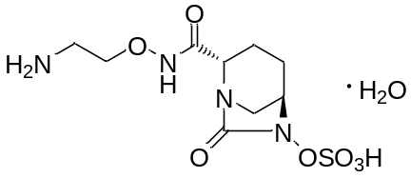

Figure 2. X-ray crystallographic analyses of co-crystal of OP0595 with (a) AmpC or (b) CTX-M-44 β-lactamases. OP0595 and neighbouring amino acids within 5 Å are shown as stick models, with their carbon atoms coloured green and yellow, respectively. Water molecules and active-site pockets are displayed by ball and surface models, respectively. Hydrogen bonds are represented by thin green lines. The terminal amine of OP0595 has a flexible conformation in the CTX-M-44 complex.
(a)
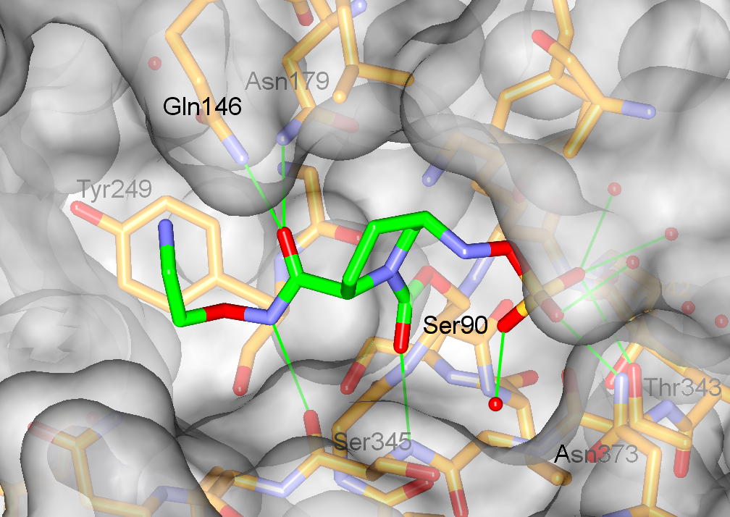
(b)
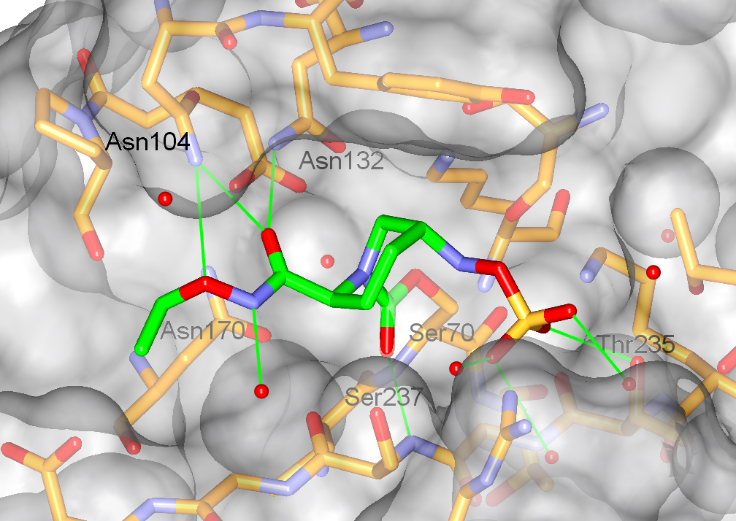

Figure 3. Phase-contrast micrographs of E. coli K-12 strain W3110 after exposure to OP0595 or β-lactam agents at 1×MIC taken at 4.5 hours after the addition of each compound. The concentrations of compounds were as follows: (a) antibiotic-free control; (b) 0.03 mg/L of cefepime; (c) 2 mg/L of OP0595; (d) 0.5 mg/L of mecillinam.
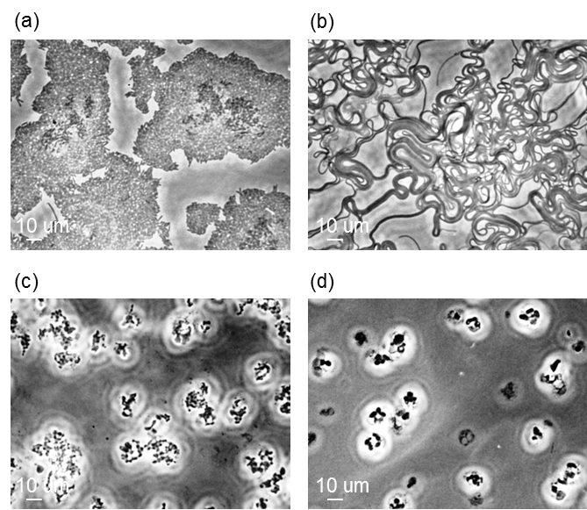

Figure 4. Activity of OP0595 as an enhancer of the antibiotic activity of various β-lactam agents against a β-lactamase-negative and OP0595-resistant mutant of E. coli K-12 W3110. Symbols: ●, mecillinam/OP0595; ▲, piperacillin/OP0595; ■, aztreonam/OP0595; ○, meropenem/OP0595; △, cefepime/OP0595; □, ceftazidime/avibactam.
