The impact of climate change on agriculture:
nonlinear effects and aggregation bias in Ricardian models of farmland values

Carlo Fezzi^{,2} , Ian Bateman

Abstract

Ricardian (hedonic) analyses of the impact of climate change on farmland values typically assume additively separable effects of temperature and precipitation with model estimation being implemented on data aggregated across counties or large regions. We use a large panel of farm-level data to investigate the potential bias induced by such approaches. Consistent with the literature on plant physiology, we observe significant non-linear interaction effects, with more abundant precipitation acting as a mitigating factor for increased heat stress. This interaction disappears when the same data is aggregated in the conventional manner, leading to predictions of climate change impacts which are significantly distorted.

Key words: Climate Change, Agriculture, Ricardian Analysis, Aggregation Bias, Semi-parametric models.

JEL codes: Q54, C23, C14

1. Introduction

There is growing policy concern regarding the potential impact of climate change on agriculture as variation in temperature and precipitation significantly affect crop and livestock production (e.g. Intergovernmental Panel on Climate Change, IPCC, 2014). Different approaches have been used to try to quantify this effect (see Mendelsohn and Dinar, 2009, chap. 3, for a review). Early works focused on biophysical crop models simulating the impact of changes in weather on plants' growth and input requirements (e.g. Adams et al., 1990; Kaufmann and Snell, 1997). These techniques include only limited behavioral responses in farmers’ adaptation to climate change and, therefore, may risk over-estimating negative impacts. More recent studies derive the effect of climate on crop yield (Schlenker and Roberts, 2009; Welch et al., 2010; Lobell et al., 2011) or farm profits (e.g. Deschênes and Greenstone, 2007, 2012) by fitting statistical or econometric models to time series, cross-sectional, or panel data. There are strengths and weaknesses in each of these approaches: for example, while panel models can include location-specific fixed effects to absorb possible time-invariant omitted variables, identification rests on random year-to-year weather shocks, which are different from permanent shifts in climate (Fisher et al., 2012).

Among the economic analyses, the Ricardian (or hedonic) method, introduced by Mendelsohn et al. (1994), has gained considerable prominence. In recent years, this approach has been applied to various countries across the globe, including the United States (US, e.g. Schlenker et al, 2005; 2006), Brazil (Timmins, 2006), Germany (Lang, 2007), Latin America (Seo and Mendelsohn, 2008) and Africa (Seo et al., 2009). The Ricardian method is based on the notion that, in a competitive market, the value of farmland reflects the discounted sum of the expected future profits which can be derived from it (Ricardo, 1817). Estimation is typically implemented using data aggregated over counties or large regions. By regressing land prices on climatic measures and a set of exogenous control variables, this technique estimates the impact of climate on farmers’ expected incomes by relying on the cross-sectional variation observed in the current climate. This model is most commonly estimated using cross-sectional data as climate has not changed enough over time to allow the identification of its effect in any given location.

The major advantage of the Ricardian approach is that it automatically captures adaptation, since farmers adjust inputs and outputs to match local conditions. Three major drawbacks are (a) the implicit assumption of fixed prices, (b) possible omitted variables (an issue that typically affects all cross-sectional analyses) and (c) potential aggregation bias. Of these issues, fixed prices, set at the global level, are a common assumption in most studies that use a partial-equilibrium setting. Similarly, omitted variables, while not amenable to direct testing, tend to be of a lesser concern given the robustness of the observed relationship across years and settings (e.g. Schlenker et al., 2006). In contrast, data aggregation may conceal non-linear effects and farm-level heterogeneity resulting in biased parameters and subsequent predictions (e.g. Theil, 1954). Maybe surprisingly, almost all prior studies have employed county- or regional-level data (e.g. Mendelsohn et al., 1994; Schlenker et al., 2005; 2006; Mendelsohn and Reinsborough, 2007; Lang 2008; Seo and Mendelsohn, 2008; Seo et al., 2009) but none have yet tested the effect of the aggregation process on the parameter estimates and on the resulting projections of climate change impacts.

In light of these issues, this study makes three main contributions to the literature. First, we test for aggregation bias by comparing the estimates resulting from a unique panel of farm-level data with those obtained after aggregating the same data to the conventional county-level in order to replicate previous findings. This test reveals a strong aggregation bias in both the coefficient estimates and in the resulting projections of climate change impacts. Second, in line with the literature on plant physiology (e.g. Monteith, 1977; Morison, 1996), our farm-level analysis estimates a significant interaction effect between precipitation and temperature in determining land values. This effect, typically ignored in previous Ricardian studies, disappears when the same data is aggregated at the county level. Third, we test for functional form miss-specification by estimating the first semi-parametric Ricardian model on farm-level data. In our application this flexible functional form model does not yield results which are significantly different from those obtained using the simpler, parametric model.

Aggregation bias is a long-standing issue in econometrics, recognized since the seminal works by Theil (1954), Grunfeld and Griliches (1960), and Feige and Watts (1972). While in linear models this issue can be resolved by using appropriate weighs, in non-linear specifications the aggregation process typically produces biased coefficients and predictions (Lewbel 1991; Garderen, Lee and Pesaran, 2000; Imbs et al., 2005). As Ricardian analyses typically use aggregated information and report strong non-linear climatic effects, it of interest to test whether these results are robust to aggregation bias. We compare farm-level and county-level approaches to assess the suitability of aggregate data by (a) evaluating the parameter estimates of the climatic variables and by (b) measuring the predicted impact of climate change on agriculture. Such a comparison exposes strong aggregation bias with severe implications for predictions: on average, climate change impacts estimated on aggregated data differ by a factor of three compared with those derived from farm-level information. Our results also indicate that this bias is most probably caused by the fact that aggregated data do not adequately represent the fine variation in local climate experienced by each farm within a county.

Since farmland values are the discounted sums of future profits, any factor that impacts crop productivity and yield should also affect farmland values. Crop research has shown that plant yield response to weather and climate is highly non-linear and includes significant interaction effects between temperature and precipitation (e.g. Hillel and Rosenzweig, 2010; Welch et al., 2010). Surprisingly, most Ricardian studies (e.g. Mendelsohn et al., 1994; Schlenker et al., 2005; 2006) do not document such an interaction but rather assume the impact of temperature and precipitation to be additively separable. Additive effects are at odds with plant physiology, since increased heat generates higher demand for water in crop development (e.g. Monteith, 1977; Morison, 1996). Our farm-level analysis reconciles the Ricardian approach with the literature on plants and crops growth by confirming a significant interaction effect: precipitation is more valuable when temperatures are high. Similarly, temperature has a positive effect on land value only if there is enough precipitation to prevent possible droughts. We only observe the interaction effect in our farm-level data set, again highlighting the importance of using micro-level data. This result is robust in a variety of settings, including different datasets, climate definitions and estimation methods.

A related issue is that Ricardian analyses typically assume climatic effects to have simple quadratic forms (e.g. Mendelsohn et al., 1994; Schlenker et al., 2005; 2006). However, previous research has shown that in hedonic models restrictive parametric specification can rarely be justified a priori (e.g. Cropper et al., 1987; Ekeland et al., 2002, 2004) and that semi- and non-parametric alternatives can provide several advantages (Anglin and Gencay, 1996; Parmeter et al., 2007; Bontemps et al., 2008). In addition, findings reported by Deschênes and Greenstone (2012) seem to indicate that the predicted impacts of climate change on farm profits are heavily dependent on the functional form assumed for the climatic and control variables. Therefore, we test for functional form miss-specification arising from omitted non-linear effects by estimating a semi-parametric farm-level Ricardian model. Compared with the parametric regression, this approach provides a superior fit and reveals an even stronger interaction between rainfall and temperature. However, climate change impact predictions are not significantly different from those obtained using the simpler specification.

Our empirical application covers farms located in Great Britain (GB). While GB is smaller than the spatial extent of other Ricardian analyses, its geographic position (surrounded to the south by the Gulf Stream and to the north by sub-Arctic waters) generates a diversity of micro-climates yielding a wide range of variation in temperature and precipitation. Obviously, heterogeneity in climate is necessary to obtain precise estimates. Focusing on a narrow spatial scale that has significant variation in climate is even preferable as other, potentially confounding, variables are more homogenous. In the extreme, having identical farms that only differ in climate would be the best-case scenario for identifying the effect of climate on land values. Limited spatial scale can therefore be considered as an advantage rather than a constraint on the analysis. However, the major benefit arising from focusing on GB is the availability of accurate local climate measurements derived by one of the most dense weather station networks in the world, comprising 540 temperature and 4400 rainfall stations (Perry and Hollis, 2005). Comparison with the PRISM data (Di Luzio et al., 2008) used in the most recent Ricardian analyses (Deschênes and Greenstone 2012, Fisher et al. 2012) reveals that the number of temperature stations per square mile is roughly twice that of the US while the number of precipitation-stations is more than 20 times higher. Given that precipitation and (to a lesser extent) temperature are notoriously highly variable over space (e.g. Baigorria et al., 2006; Mendelsohn et al. 2007), this substantial increase in accuracy is crucial for obtaining precise estimates of the farm-level climatic conditions and to effectively test for aggregation bias. Conversely, a sparse network of weather stations would introduce measurement error in local climatic values, thereby undermining the superiority of farm-level estimates over their county-level counterparts.

2. The data

This analysis integrates multiple sources of information expressed at different spatial scales to generate a database covering the whole of GB. These data are detailed throughout the remainder of this section.

Land value data. Data on land value are derived from the Farm Business Survey and the Scottish Farm Accounts Survey panels which, sampled annually, include information on the physical characteristics and economic performance of farm businesses throughout Great Britain. Farms are retained in the sample for several years, with only 10% of them being replaced in each survey. The two Farm Surveys (FS) include a specific figure for land value, which excludes buildings and other improvements used for agriculture (it includes, however, the value of buildings and dwellings older than 30 years) and reflects the expected sale value assessed by professional farmland sales agents based on agricultural land sales taking place in the area where the farm is located. Since these estimates are not revised each year, we discard from the analysis all records for which the farmland value does not change from the previous year, as this indicates that the value has not been updated over that period. Therefore, while most Ricardian models are based purely on cross-sectional information, our data is an unbalanced panel, which includes both spatial and time variation in farmland price. The FS also contains the location of the farm on a 10x10 km grid square basis, which we use to link farm value to environmental and climatic characteristics. In this analysis we consider 10 years of FS data, from 1999 to 2008, consisting of approximately 2500 farm records each year. Farms included in the panel comprise a variety of land uses including arable crops, livestock pasture and forestry. Eliminating farms smaller than 30ha as well as those for which the land value or the location are missing leaves about 9500 observations for analysis.

Climatic variables. Temperature and precipitation are represented by the 5x5 km grid cell data available from the UK Meteorological Office archive (Met Office, http://www.metoffice.gov.uk/). As previously mentioned, this data is derived from one of the most dense networks of weather stations in the world which include, on average, one temperature station every 20x20 km (540 stations) and one rainfall station every 7x7 km (4400 stations). The process used to derive the 5x5 km grid climate data published by UK Met Office is based on multiple regressions with inverse distance-weighted interpolation and takes into account geographic and topographic factors, validated by randomly excluding 10% of the stations and predicting for their values (Perry and Hollis, 2005). This approach yields an out-of-sample Root Mean Square Error (RMSE) of 0.36ºC for the monthly mean temperature (3.5% of the mean value) and of 16mm (3.6%) for the total monthly precipitation. This strong predictive performance reassures us of the ability of the 5x5 km climatic data to accurately represent the local conditions faced by the individual farmers within our sample. This feature is essential to effectively test for aggregation bias. Data collected on a sparser network of weather stations, in fact, would introduce measurement error in local temperature and precipitation values, undermining the superiority of farm-level estimates over their county-level counterparts.

As per Deschênes and Greenstone (2012) and Fisher et al. (2012), for each observation we calculate climatic variables as averages over the 30 years period 1971-2000. Temperature has been included in Ricardian models as monthly or seasonal averages (Mendelsohn et al., 1994; Seo et al., 2009 consider average temperature in the month of January, April, July and October) or as the number of degree days in the growing season between 5.5ºC and 32ºC (Schlenker et al., 2006; Deschênes and Greenstone 2009; 2012; Fisher et al. 2012). The concept of degree days is derived from the agronomic literature and reflects the fact that plant growth is linear in temperature only within a certain range, with temperatures below this interval being irrelevant for crop development, while temperatures above that threshold being potentially harmful. Schlenker et al. (2006) show how this strategy is superior to including monthly averages, mainly because temperatures in different months can be highly correlated with each other (for example, in our climatic data the correlation of the average temperature in October with the one in January, April and July are, respectively, 0.93, 0.97 and 0.91). As in previous contributions, we consider only the degree days during the main growing season, defined for GB as the months from April to September. To derive degree days, we use the common assumption that, during the day, temperature (temp) follows a sinusoidal function (Schlenker and Roberts, 2006):

,

where χ is defined between -1/2π and 3/2π and temp_{min} (temp_{max}) is the minimum (maximum) temperature within the day. Since data on the minimum and maximum temperature in each day of the year are not available, we use average monthly minimum and maximum temperature to compute the number of degree days. For consistency with previous analyses and also following the standard in GB (e.g. UK Met Office, http://www.metoffice.gov.uk/) we employ 5.5ºC as our lower threshold. Considering the upper threshold after which temperatures become harmful, recent studies on crop yield (e.g. Schlenker and Roberts, 2009) suggest that 32ºC may be too high and that a value of 29/30ºC may better represent crop development. In any case, the relatively cold climate characterizing GB's growing season makes this latter threshold not relevant for our study. In fact, our highest recorded monthly average temperature is 27.31ºC in July 1983, which is well below even the most conservative threshold of 29ºC. Note that this is not the highest 1971-2000 climatic average, but the highest monthly average within this time span (the highest monthly 30 years average in our data is barely 23.00ºC, occurring in the month of July).

Considering rainfall, as in previous studies we include the total precipitation in the growing season. Finally, as the 5x5 km grid of climatic data and the 10x10 km grid of farm location data share the same origin, we convert degree days and precipitation from 5x5km to 10x10km grid squares to match the resolution of the farm location data by using arithmetic averages. Figure 1 illustrates the climatic variability in our data plotting the map of degree days and precipitation and including also county boundaries.

[Figure 1 about here]

Environmental and other control variables. Besides climate, several other factors can significantly influence farmland values. Considering soil characteristics, we include soil texture as the share of fine (clay share between 35% and 60%), medium fine (clay < 35% and sand < 15%), medium (clay between 18% and 35% and sand >15% or clay between 18% and 35% and sand < 65%), coarse (clay < 18% and sand > 65%) and peaty soils, and the depth to rock. These variables are derived from the 1km grid square data given in the European Soil Database (ESDB) maintained by the European soil data centre (http://eusoils.jrc.ec.europa.eu/). We also include average slope (derived from the Ordnance Survey, Digital Terrain Model, available at: http://www.ordnancesurvey.co.uk/oswebsite/), representing the suitability of land for machinery operations, and population density (computed from 1990 and 2000 census data, http://casweb.mimas.ac.uk/) to capture the opportunity value of converting land to residential use, distance to markets and the availability of amenities or off-farm work for the members of the farmer’s family. Finally, to capture the impact of location-specific policies we include the share of each 10km grid square classified as National Park, Nitrate Vulnerable Zone (NVZ) or Environmentally Sensitive Areas (ESA) in each year. NVZs, established in 1996 and extended in 2003 and 2008 to cover more than 70% of English farmland, are designed to reduce surface and groundwater nitrate contamination by imposing certain restrictions on the agricultural activities of farms within their boundaries (e.g. limiting the amount of fertilizer to be used on fields, regulating the storage of organic manure, etc.). ESAs, introduced in 1987 and extended in subsequent years, are intended to safeguard and enhance areas of high landscape, wildlife or historic value. Unlike NVZs, participation in ESA schemes is voluntary and farmers receive monetary compensation for engaging in environmentally friendly farming practices, such as converting arable land to permanent grassland, establishing hedgerows, etc.

[TABLE 1 about here]
Farm-level data descriptive statistics

Descriptive statistics for these variables are reported in Table 1. The distribution of farmland values appears to be highly skewed with a long right tail, which could support a log-normal distribution as, for example, implemented by Schlenker et al. (2006). Considering rainfall levels, although GB covers a relatively modest area compared to those analyzed in other Ricardian studies (e.g. US, Brazil), its location between the warm waters of the Gulf Stream to the West and the cold climates of Scandinavia to the East means that it exhibits a wide range of precipitations across the growing season (from 244 to 1434 mm). This range actually exceeds that reported for the rainfed US counties (from 332 to 982mm) analyzed by Schlenker et al. (2006). Indeed, accounting for irrigation (Schlenker et al., 2005) is not necessary in GB, since most farmland is rainfed (less than 1% of the farms in our sample use any irrigation at all). Furthermore, temperatures rarely reach particularly high values, with total degree days in the growing season ranging between 654 dayºC and 1639 dayºC.

Aggregation. In order to obtain units of aggregation comparable with those examined in previous Ricardian studies, we aggregate our farm-level values to the official ‘third level’ Nomenclature of Territorial Units for Statistics (NUTS) areas as defined by the European Union (which roughly correspond to GB counties). Their size varies considerably, ranging from about 40 km² to more than 10000 km², with an average of 1814 km² (for comparison, the average area of US counties is about 3000 km²). We assign each farm to a county based on its spatial location and compute the aggregated land values as farmland-area weighted averages. Similarly, we aggregate climatic and control variables using as weights the amount of agricultural land within each 10 km grid square included in a county. This leads to over 30 farm records for each county (with an average of 11 farms in each year per county) and a total of 848 aggregated observations.

[TABLE 2 about here]
Descriptive statistics of the climatic variables aggregation

The statistics reported in Table 2 measure the impact of the aggregation process on the accuracy of the climatic variables. The upper part of the table reports the subdivision of the total variability (sum of squares) in within-counties and between-counties variation. The higher the within-county variation so the greater is the share of climate variability lost through the aggregation process. The within-county variation for degree days and temperature is respectively 20% and 37% of the total variation, indicating that both variables vary considerably at this level. In line with the previous literature, precipitation appears to be the most spatially variable climatic factor (e.g. Mendelsohn et al., 2007; Auffhammer et al., 2013). The between-county statistics, reported in the middle of Table 2, denote the variation in climate retained in the aggregated data, represented as county-level averages. Considering degree days, the values range between 756 dayºC and 1611 dayºC (with a mean of 1290 dayºC), which is very similar to that observed for farm-level data. However, precipitation during the growing season presents a minimum value of 275 mm and a maximum of 811 mm, which is considerably lower than the highest value observed on the farm-level data (1434 mm). Again, this can be explained by the high spatial variability of rainfall, which causes some of the extreme values observed in farm-level data to be lost in county-level statistics. The lower section of Table 2 reports within-county statistics, indicating the heterogeneity in climate which is concealed by the aggregation, represented as county-level ranges of variation. Within the average county, degree days and precipitation vary by about 230dayºC and 150mm respectively. This loss of climatic information is substantial and corresponds, in turn, to about 22% and 15% of the range of values observed across the entirety of GB. In addition, there is also considerable variation around this mean, with some counties presenting a relatively homogenous climate while others exhibit strong heterogeneity.

3. Methodology

3.1 The Ricardian model

The Ricardian approach assumes that each farmer allocates land among different activities in order to maximize net revenues. Consequently, in a competitive market, farmland price equals the expected present value of the future stream of income derived from land. We assume that farms are atomistic and that input demand is small enough to not influence input prices. By the same token, idiosyncratic weather shocks do not influence the exogenous output prices since the quantity produced in GB is not large enough to affect the global market. The Ricardian approach does not model farmers’ land allocations, input and output choices explicitly, but rather estimates the overall value of each land characteristic by specifying the hedonic, reduced form model:

(1) 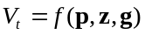,

where V_{t} = the farmland value per hectare in year t, p = input and output prices expectations, z = climatic variables, g = all other exogenous factors including soil types, terrain etc. and f(.) is a functional form unknown a priori. As in most hedonic models, economic theory provides little guidance regarding the shape of this relation.

3.2 Testing for aggregation bias and omitted non-linearities

Virtually all Ricardian analyses have translated equation (1) into an empirically tractable model by assuming a linear or semi-log specification with a quadratic formulation for the climatic variables (here degree days, dd, and precipitation, prec) and a linear function for all other determinants. Findings reported by Schlenker et al. (2006) suggest that a log-transformation of the dependent variable outperforms a linear specification, since the distribution of land values is non-negative and typically highly skewed. Estimation is normally implemented on data aggregated over counties or larger regions. As a starting point, we open our analysis by replicating such conventional model, which has been implemented in the majority of Ricardian studies so far. This hedonic equation (Model A) is specified as:

(2) ,

where c indicates the county, t indicates the time at which expectations are taken, β₀, ... , β₄ and γ are the county-level parameters to be estimated and u_{c,t} is a residual component which we define as being the sum of a county-specific random effect and a residual, both normally distributed and uncorrelated (u_{c,t} = α_{c} + ε_{c,t}). In our framework the vector g_{c,t} includes population density (dpop and dpop², see Schlenker at al. 2006), depth to rock (dtr), slope, soil texture shares, National Park (s_{park}), ESA (s_{esa}) and NVZ (s_{nvz}) shares. As in most Ricardian models, price and other potential omitted variables are accounted for by including regional fixed effects (for England, Wales and Scotland) and yearly fixed effects, represented by the term d_{c,t}.

This quadratic approximation with additively separable climatic effect (on the logarithmic scale) has been implemented in most applications (see Mendelsohn and Dinar, 2009, for a review) because it allows the identification of “optimal” crop growing conditions while maintaining simplicity in estimation. In this specification, climatic effects are multiplicative. For example, the marginal effect of precipitation is:

(3) 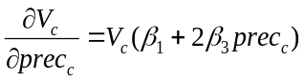.

This effect, therefore, depends on all the variables which determine the land value V_{c}. However, this formulation does not encompass all interactions among climatic variables. In fact, the sign of the marginal effect (3) depends solely on the term β₁ + 2β₃ prec_{c}, which contains only the parameters of precipitation itself, and none of those relating to other variables. This means that the optimal amount of rainfall will not depend on the level of temperature, and vice versa. This constraint might not necessarily be valid. For instance, agronomic experiments have shown that warmer conditions typically lead to an increase in crop requirements for water (e.g. Morison, 1996).

The simplest approach to relaxing the assumption of additively separable climatic effects is to include an interaction term to equation (2), allowing the effect of precipitation and temperature to be mutually dependent. Therefore, we estimate our second specification (Model B) as:

(4) ,

There are good theoretical reasons to believe that even simple non-linear relations, such as those represented by equations (2) and (4), are not robust to the aggregation process. In fact, even under very stringent conditions, recovering the farm-level parameters using a county-level regression would require the inclusion of squares and cross-products of the explanatory variables and very complex functional forms (Van Garderen, Lee and Pesaran, 2000, provide a few examples). Given that most Ricardian analysis have been implemented on aggregated data, it is important to investigate the size of any bias inherent in such approaches and its implication for the prediction of climate change impacts.

The simplest approach to test for aggregation bias is to re-estimate model (4) using the same data, but disaggregated at the farm-level, examining whether parameters and climate change impacts predictions are significantly different from those obtained with county-level data. The resulting specification (Model C) can be written as:

(5) ,

where i indicates the farm, j the 10km grid square, α₀, ... , α₅ and ξ are the farm-level parameters to be estimated and all other terms are defined previously. We specify the residual component to include both a farm-level and a 10x10km cell-specific random effect (u_{i,j,t} = w_{j} + α_{i,j} + ε_{i,j,t}), to take into account that farms located within the same area may share common un-modelled factors which may significantly affect their land value. This is also a simple approach to account for spatial auto-correlation by allowing the residuals of the farms located within the same cell to be correlated with each other.

A drawback of this latter approach (and of any other strict parameterization) is that it constrains the effects to assume very specific functional forms. In such a model, climatic impacts are forced to be quadratic and their interaction is assumed to be linear. While these might be reasonable approximations, there is no theoretical justification underpinning such a rigid structure, which is mainly adopted for ease of estimation. Therefore, it is worth investigating possible functional form mis-specification by using a more flexible model. Here we represent the relationships of interest via smooth functions, deriving an Additive Mixed Model (AMM) which is our most general and last specification (Model D):

(6) .

In this model the joint effects of temperature and precipitation are encompassed by a multidimensional smooth function f(.), which allows the estimation of flexible non-linear relationships and interaction effects. The control variables are also included via smooth functions, s₁(.),..., s_{h}(.), to capture possible non-linear relations. However, to maintain simplicity in the interpretation and avoid the well-known curse of dimensionality, their effects are assumed to be additively separable. The marginal effects of rainfall can be derived as:

(7) 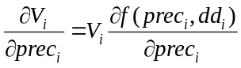.

Note that the sign of this marginal effect is a function of both precipitation and temperature. As a result, the model encompasses, in a flexible form, the interaction effects amongst all climatic factors. This is a very general specification and encompasses Model C as a special case. Comparing the estimates from the two models allows us to test for omitted non-linear relations.

4. Empirical application

4.1 Estimation results

We estimate models A (eq. 2), B (4), C (5) and D (6) via Restricted Maximum Likelihood (REML). Here A, B and C are standard linear regression models with random effects. Model D is implemented by representing the smooth functions as natural cubic splines, which fit third degree polynomial functions between a set of knots located between the range of values of each explanatory variable. The number and the location of the knots effectively determine the flexibility of each smooth function. We estimate the optimal number of knots (i.e. the optimal amount of smoothing) directly from the data by following the approach illustrated by Ruppert, Wand and Carroll (2003) and Wood (2006), who suggest representing the smoothing splines as random effects (details are in the online appendix). This approach automatically reduces the smooth functions of the variables for which the optimal fit does not include any non-linearity to standard linear forms. In the extreme, a model in which none of the non-linear relationships are supported by the data will be reduced directly to a standard linear regression during estimation. The optimal level of non-linearity of each smooth function is indicated by the ‘Effective Degrees of Freedom’ (EDF). The higher the EDF, the more non-linear is the estimated function. An EDF equal to 1 suggests that the best smooth function representation is linear.

The parameter estimates and diagnostics of the four models are presented in Table 3. The first column reports the coefficients of Model A: the standard Ricardian regression based on county-averaged data. The estimated effect of degree days is always positive (with the quadratic effect being non-significant) and the effect of precipitation is negative with a quadratic shape. This is not entirely surprising, given the relatively wet and cold conditions which characterize GB. The coefficients of the control variables have intuitive signs. Better physical environments (lower slope and deeper soils) translate into higher land values. Finally, while not reported in the table to preserve space, the yearly fixed effects are also significant, highlighting the presence of important differences among the (deflated) land values in different years, reflecting evolutions in market conditions, policy and technology. Also the regional fixed effects are significant.

Model B, presented in the second column, also employs aggregated county-level data to test whether the interaction effect between degree days and precipitation is significant. The approximate t-test is -1.73, with approximate p-value of 0.086, which does not reject the null hypothesis of no interaction at the standard 5% level. In addition, the negative sign of the corresponding coefficient is counter-intuitive. Previous crop studies (e.g. Monteith, 1977; Morison, 1996) demonstrated that the amount of water required for plant development increases with temperature, implying a positive rather than a negative interaction. Altogether, we conclude that county-level estimates suggest predominantly additive climatic effects, with a strong quadratic component for precipitation and without a significant interaction between precipitation and temperature. Overall, taking into account the wet and cold British climate, these conclusions are in line with those reported by previous Ricardian analyses (see Mendelsohn and Dinar, 2009, chap. 7, for a review).

[ TABLE 3 about here ]
Parameter estimates and diagnostics

These results obtained on aggregated data are, however, overturned when individual farm records are analyzed. As the estimates of Model C (third column) show, rainfall and degree days present strong non-linear effects, with one quadratic term and the interaction term being highly statistically significant. The interaction is positive: consistent with the agronomic literature, the optimal amount of rainfall increases with temperature. Interestingly, the quadratic effect of precipitation is no longer significant, indicating that in Model B some of the variation attributed to the interaction may have been captured by the quadratic coefficient. The estimates of the semi-parametric Model D, reported in the last column of Table 3, are in line with those provided by the parametric Model C. The EDF of the bivariate smooth function of temperature and precipitation is equal to 8.61, indicating strong non-linear effects and interactions. For comparison, the bivariate smooth function corresponding to the climatic effects estimated in Model C (i.e. two quadratic effects with a linear interaction term) would have an EDF equal to 5.

Figure 2 provides a graphical representation of the estimates produced by the semi-parametric model. The left-hand panel represents with iso-value lines the joint effects of the climatic variables on land price. We only draw such contours for values of degree days and temperature observed within the estimation sample, as represented in the scatter plot in the right-hand panel. For example, in GB there are no areas with both relatively high temperature and high precipitations and, therefore, the top-right corner of the left-hand plot is blank. Furthermore, the distribution of the climatic variables appears to be highly skewed, with most farms located in areas characterized by relatively high temperature (dd > 1300) and low precipitation (prec < 500). Therefore, the upper-left parts of the contour graphs are the most relevant for climate change predictions in GB (the next section shows how our sample of farms is representative of the overall conditions in the country). The contour-plot shows a clear interaction effect. In the colder areas (dd < 1200), abundant precipitation reduces agricultural land values while, in warmer areas (dd > 1400) the crop requirement for water increases and the effect of rainfall becomes positive. Therefore, beyond a certain level, higher temperatures increase land values only if there is enough precipitation to prevent heat-related stress. This means that there is not a generalized, ideal level of temperature which defines the best crop growing conditions (as implied in previous Ricardian studies) but, rather, that optimal temperature levels vary with the availability of precipitation. Similarly, the optimal level of precipitation depends on the level of temperature.

[Figure 2 about here]

This interaction effect is analyzed in greater detail through the next two figures. Figure 3 represents the estimated impact of precipitation on land value for two levels of temperature. When temperature is low (dd = 1100, left-hand panel), we observe a strong negative effect of high precipitation which can be attributed to soil waterlogging, delayed ploughing and sowing, or to the negative effect that excess soil moisture can have on plant growth (e.g. IPCC, 2014). However, as temperature increases, the relationship with rainfall becomes more moderate and in the warmest areas (dd = 1500, right-hand panel) higher precipitation has a positive effect on land values across the entire range of observed data. Moving to consider the effect of temperature, Figure 4 represents the impact of degree days for two different levels of precipitation. In areas where rainfall is relatively low (300mm, left hand panel) the positive effect of warmer temperatures on plant growth are offset by the increase in drought risk such that the resulting net effect on land value is not significant. However, in areas of higher precipitation (500mm, right hand panel), increased water availability protects plants from heat stress allowing temperature to have a strong and positive effect on land value.

[Figure 3 about here]

[Figure 4 about here]

Overall, the interaction effect between temperature and rainfall, which is positive and significant in the farm-level analyses, completely disappears (or even becomes negative) in county-level estimates. The main reason for the attenuation of this effect is that the aggregated county-level data ignore the heterogeneity in climate faced by individual farms within a county. Since both temperature and rainfall patterns are expected to vary as a result of climate change, this aggregation bias may have significant implications for climate change predictions. Such a hypothesis is tested in the next section which compares the projected climate change impacts derived from each of our four Ricardian regression models. However, we first report a series of checks to test whether our farm-level results are stable and robust to possible omitted-variable bias and to examine whether our aggregation bias evidence is consistent across specifications, data and climate definitions.

4.2 Robustness tests

We open this sub-section by undertaking some robustness analyses on our farm-level estimates, testing for omitted variable bias and parameter stability. We then move to consider alternative Ricardian models to show that our aggregation bias findings are robust to range of specifications and data definitions.

Concerns about potential omitted cross-sectional variables in Ricardian analyses have been raised by Deschênes and Greenstone (2007, 2012), among others. A panel fixed-effect estimator is not applicable here, since it would eliminate not only the potential bias but also all the cross-sectional variation upon which the parameters of the Ricardian model hinge. Ricardian analyses represent climate (as opposed to weather), through long-term averages of temperature and rainfall which, even in long panels, present a time-variability which is almost negligible compared to the cross-sectional (spatial) variability. This means that fixed-effect estimators, intended to eliminate potential time-invariant omitted variables, cannot be implemented in this context because they would also remove the crucial spatial variation in climate. A second, related issue, concerns the distortions in the land market which various agricultural policies tend to create (e.g. Barnard et al., 1997). For instance, crop and environmental payments could be capitalized into the land price and, if correlated with climatic variables, introduce a bias in their coefficient estimates.

We address both issues by testing whether the parameters of degree days and precipitation are stable over time. If cross-sectional and time-varying omitted variable bias were a problem, then these coefficients should exhibit significant temporal variation, reflecting changes in agricultural prices and policies over time. Our sample provides a particularly rigorous basis for such a test as the ten years covered by our data saw agricultural policies in GB change markedly, as a result of various reforms to the EU Common Agricultural Policy. These policy developments culminated with the introduction of decoupled single farm payments in 2005, replacing the system of area-based crop-specific subsidies in place since 1992. Input and output prices also changed dramatically during this period, with, for instance, cereal prices more than doubling during the period from 2007 to 2008.

These transformations have different effects across locations. For instance, an increase in the price of cereals may boost the arable area and revenues in lowland farms, while impinging negatively on upland sheep and beef farms through high feedstuff prices. Similarly, many policies are area-specific. NVZs, for example, have been significantly expanded in recent years. Therefore, evaluating parameter stability over time is not simply a check against time-varying omitted variables but rather a stricter test for spatial effects varying over time. If these effects are correlated with climate, one would expect the smooth functions of temperature and precipitation to present significant variation over time in such unstable market conditions. To investigate this hypothesis, we choose the first year in our sample (1999) as a baseline and test for parameter stability comparing one year at a time via pairwise F-tests (Pinheiro and Bates, 2000). Since the distribution of this test is only approximated, we compute it via 500 bootstrap repetitions. We test our final and more flexible specification, Model D, and in order to use the standard inference for random-effect models, we define the spline bases of the model a priori and implement un-penalized estimation via REML. To attain a level of flexibility comparable to the optimal one selected by the penalized likelihood, we choose natural cubic splines with 4 knots for population density and 16 knots for the joint function of precipitation and rainfall, while all other variables are modelled as linear terms. Table 4 reports the results: none of the pairwise instability tests is significant at the 5% level. This is consistent with the null hypothesis of parameter invariance which, therefore, we find no evidence to reject. Overall, these results reassure us about the robustness of our climate impact estimates to omitted variable bias such as changes in prices and agro-environmental policies.

[ TABLE 4 about here ]
Pairwise stability tests

We now test whether the evidence of aggregation bias is consistent across different data, models and aggregation methods. For each alternative specification, Table 5 reports the interaction coefficients between precipitation and temperature estimated on county-level (Model B) and farm-level data (Model C). Since the two models have the same structure and variables, any difference in the parameter estimates can be attributed to the aggregation process. For comparison, the first row reports the coefficients of the original specification. In the second row we test the effect of using a different aggregation method. Rather than taking area-weighted averages of the land value of all farms located in each county, we use simple, un-weighted averages. As can be seen, the aggregation bias becomes even larger, with the interaction effect remaining negative but now growing stronger and significant. This is not unexpected, given that not taking into account the relative size of the properties can produce aggregated data which are less representative of the original population.

[ TABLE 5 about here ]
Parameter estimates according to alternative specifications

The third row of Table 5 reports the results obtained using a different climate specification. Rather than calculating climate as the average weather between the years 1971-2000, we follow Schlenker et al. (2006) and define climate as the average weather in the 30 years preceding each observations (e.g. for 2005 data the climate is defined as the average between the years 1975-2004). This means that we introduce some temporal variation which allows climate to change somewhat from year to year in each cell or county. The resulting coefficients are very similar to those in the baseline approach, suggesting that our conclusions are robust to different definitions of climate.

In the fourth row we re-estimate the models including all observations in which the farmland value is not updated in that year. Such an approach might be justifiable if replicated entries reflect periods over which owners do not perceive significant changes in their property value (as opposed to a failure to update value changes). While the magnitude of some of the climate coefficients appears to slightly increase, the results are consistent with the baseline specification in that we observe a strong, positive and significant interaction effect on farm-level observations and no interaction on county-level data.

Rows five and six of Table 5 report results obtained by broadening the farm sample to include very small farms. Recalling section 2, the rationale behind limiting our analysis to properties larger than 30ha is that our definition of farmland value includes the value of buildings and houses older than 30 years. While this is not a problem for large farms, very small properties with old household buildings can present a significantly inflated farmland values per hectare. However, as shown in the fifth row, including all farms larger than 5ha (3801 farms) does not significantly impact the estimated climatic coefficients. The sixth row shows that even encompassing all properties in the FS sample (4044 farms), including those smaller than 1ha, does not change the sign and the magnitude of the coefficients, although the interaction effect becomes non-significant because the additional noise introduced the data.

In row seven of Table 5 we allow for a stronger spatial autocorrelation in the farm-level model, including an additional random effect term grouping together clusters of nine 10x10 cells (total area: 900km²). While the magnitude of some of the interaction coefficient slightly decreases, the parameter is still positive and significant at the 5% level.

In row eight we allow for a more general form of spatial correlation, departing from the normality assumption typical of random effect models. We estimate the model with ordinary least squares but calculate the standard errors using a cluster-robust covariance matrix at the cell level as in Fisher et al. (2012) and Deschênes and Greenstone (2012). Again, results are consistent with the base specification. Finally, in row nine we combine departure from normality with an even larger spatial autocorrelation, using a cluster-robust covariance matrix at the county level. While allowing a very general structure of the residuals generates large standard errors because of the relatively high collinearity between rainfall and temperature, results remain essentially unchanged.

Even though the stability tests reported in Table 4 showed no bias arising from omitted spatial effects varying over time, it still possible that some omitted and time-constant variables may be affecting our estimates. As explained above, fixed effects cannot be used to address this concern as they would remove most of the climatic variation on which depends the estimation of the temperature and precipitation coefficients. However, we can examine whether the climate parameters vary if some of the control variables we have in the model are removed. If results are stable, we may expect that they will also be robust to unobserved variables. In row ten of Table 5 we report our estimates after removing population density, and in row eleven after additionally excluding the depth to rock and slope variables. Results show that, even without these important control variables, the climatic coefficients remain very stable in both farm-level and county-level specifications.

Since the effect of precipitation is positive for a limited part of our sample (circa dd > 1400), one may wonder if this is due to some omitted variable which is correlated with the locations characterized by high precipitation and high temperature. To address this issue, we removed from the sample all farms for which dd ≥ 1400 and prec ≥ 350 (290 farms in total, almost 10% of our sample). Most of these farms are located in the South West of England and in the South of Wales. Climatic parameters, reported in row twelve of Table 5 again remain consistent, with a positive and significant interaction on farm-level data and a negative and borderline significant effect on county-level models.

One may wonder if the aggregation bias is mainly driven by the presence of some large and climatically heterogeneous counties. To test this issue, in row thirteen we re-estimate our models after eliminating all farms located within the largest counties in England (North Yorkshire), Wales (South West Wales) and Scotland (Caithness, Sutherland, Ross and Cromarty). These counties include 377 farms, corresponding to about 12% of our data. The results on both farm-level and county-level data are not significantly different from those obtained using the full sample.

All the robustness tests confirm the presence of aggregation bias. While farm-level results, in line with the literature on plant physiology, estimate a significant interaction effect between temperature and precipitation in determining land profitability, county-level analyses provide a different picture with essentially precipitation and temperature being additively separable. Is this bias caused by grouping together properties with different land values, or by the cruder representation of climate? In order to answer this question, in row fourteen, which completes Table 5, we report the estimates of a farm-level model which represents climate using the values of rainfall and precipitations calculated for the aggregated data, i.e. county-level weighted averages. The resulting coefficients are indeed biased and similar to those estimated on aggregated data with, in particular, the interaction effect being non-significant and the quadratic precipitation term being strongly significant (latter term not reported in the Table to preserve space but available upon request). This shows that not taking into account the important within-county variation in climate (previously illustrated in Table 2) may well be the main cause of the bias we detect on the models estimated on aggregated data.

5. Climate change impact predictions

We combine the estimates presented in the previous section with the recently released UK Climatic Projections 2009 (UKCIP09, source: ukclimateprojections.defra.gov.uk) to project the impact of climate change on agriculture in GB and to test whether aggregation bias has any implication for predictions. Specifically, we use the UKCIP09 projected changes in monthly average minimum temperature, maximum temperature and precipitation in the medium level emission scenario (corresponding to the SRES A1B in the IPCC Special Report on Emissions Scenarios; Nakicenovic et al., 2000) for the climate in the years 2020-2049. This data is available on 25x25 km grid squares covering the entire UK. As suggested by Auffhammer et al. (2013), we derive the values of degree days and precipitation in the climate change scenarios by applying projected changes to an historical baseline. Here we use the 10x10 km Met Office historical averages for the years 1961-1990, which are the baseline climatic conditions identified by the UKCIP09.

To derive the impact of climate change, we predict log-agricultural land price under both the baseline (1961-1990) and the climate change scenario (2020-2049). The only difference between the two scenarios is climate: all other determinants (soil, population density, etc.) are kept constant at their 2008 values, the last year of our farm data. Consequently, we do not consider other factors that are likely to change in the future, such as technology, prices, land use and population. Therefore, our results are intended to estimate how climate will affect agriculture ceteris paribus, and should not be interpreted as predictions of the future. Table 6 reports descriptive statistics for the climatic and environmental determinants in the baseline and climate change scenarios. The ranges of the exogenous variables are similar to those of the data used for estimation (see Table 1), indicating that our FS sample is representative of the overall environmental conditions in Great Britain.

[ TABLE 6 about here ]
Descriptive statistics of the climatic and environmental variables

Compared to the baseline, the UKCIP 2020-2049 medium emission climate change scenario is characterized by both higher temperatures and lower precipitation during the growing season. The highest value of degree days is 1948, still considerably below 2400: the threshold identified by Schlenker et al. (2006) as the level at which temperature begins to have a negative effect on land values. Therefore, we can extrapolate our model estimates with sufficient confidence. However, to test the robustness to these out-of-sample projections, we also compute climate change impacts using a “constrained” scenario, in which all combinations of rainfall and temperature are restricted to be within the range used for estimation. For example, in this “constrained” scenario we set to 1700 the maximum value for degree days and to 240 mm the minimum quantity of precipitation. While we calculate predictions from the parametric specifications (Models A, B and C) using both the “unconstrained” and “constrained” climate change scenarios, we only use the latter for the semi-parametric regression (Model D) since the bi-dimensional smooth function of degree days and precipitation is potentially erratic when applied outside the range of values used for estimation, generating unreliable results when used out-of-sample.

The predicted impacts of climate change on farmland values derived from our four models are reported in Table 7. To provide a meaningful summary of grid squares or counties with different agricultural areas and land values, the percentage changes are weighted by the baseline total value of agricultural land in each cell or county. The county-level regressions (Model A and B) predict strong and positive impacts of expected climate change on the rural sector, with an overall increase of about 20% in GB farm values compared to baseline levels. By applying a 5% discount rate (as per Mendelsohn et al., 1994), this translates into an increase in total GB farm net revenues of £1 billion per annum. Furthermore, according to Model B (county-level with interaction effect), the 1st decile of the predicted changes corresponds to an increase of around 12% and the last decile to an increase of 32%, indicating that almost all counties will be significantly better-off as a result of projected climate change. Model A (county level with no interaction) presents a slightly more heterogeneous picture, with the first decile predicted to experience almost no change in value and gains rising to about 45% for the last decile.

[ TABLE 7 about here ]
Climate change impact on agriculture in the 2020-2049 UKCIP medium emission scenario

In contrast to the aggregated, county level analyses, the estimates provided by the farm-level models (Model C and D) are considerably less optimistic. Model C predicts a mean increase in farm value ranging between 6% and 8% (which is lower than the first decile predicted by Model B) with large areas experiencing losses and the first decile now indicating a loss of between 12% and 20%, depending on the climate change scenario. These results are not significantly different to those obtained using our most flexible regression, Model D, which suggests that climate change will induce a diverse set of impacts on agricultural land values ranging from a lower decile loss of 5% to an upper decile increase of almost 40% with a mean value around +7%, comparable to an annual rise in net revenues of about £400 million.

[Figure 5 about here]

Figure 5 presents maps of the spatial distribution of farmland value changes derived from models B and C. These models use the same specification with both including quadratic functions of degree days and precipitation and an interaction effect, but they differ in that model B is estimated on county data, while model C employs farm data. Consistent with the statistics reported in Table 7, Model B predicts a somewhat uniform increase in land values throughout GB, driven by the warmer and drier climate. In contrast, Model C projects spatially heterogeneous impacts with the wetter areas of Scotland, Wales and the North of England being significantly better-off and the dry lowland of the South-East of England being the main loser. The main rationales for this loss are the higher temperature and reduced precipitation, which can lead to water deficiency and less favorable farming conditions, ultimately lowering land values. Not surprisingly, the motivation for this difference in predictions between farm-level and county-level models can be found in the interaction effect between temperature and rainfall. Recalling Figure 2 and 3, precipitation in farm-level models can either have a negative or positive effect on land values depending on the level of temperature. While the warmer growing season projected in this climate change scenario can boost yields, it can also increase crop water demand and reduce drought-tolerance. County-level models do not capture the interaction effect between temperature and precipitation and, therefore, erroneously project lower rainfall and higher temperatures to always have positive impacts on land values.

Finally, in Figure 6 we present box-plots of the distribution of the change in total GB farm net revenues according to different models, computed via 5000 Monte Carlo repetitions. Results compare county-level against farm-level estimates using a variety of specifications among the ones reported in Table 5, with each permutation investigated using both the unconstrained and constrained climate predictions. Specifically, we plot the results using the baseline model (row 1 in Table 5), a different aggregation method (row 2), using a different climate definition (row 3), including the observations for which the farmland value was not updated (row 4), including a larger spatial-autocorrelation (row 7) and using an even larger (county-level) and more general autocorrelation specification (row 9).

[Figure 6 about here]

The boxplots clearly illustrate the bias introduced by aggregation. None of the mean impacts predicted by the county-level models fall within the confidence intervals of any of the impacts predicted by the farm-level models. County level models indicate a strong and unequivocally positive impact of climate change. Despite the confidence intervals being quite large, all predictions are significantly different from zero. In contrast, the farm-level estimates reveal that the overall net effect is most likely to be much smaller and, according to some specifications, this impact may not even be significantly different from zero. In comparison, restricting the climate change conditions to remain within the boundaries of the estimation sample (“constrained” climate scenario) as opposed to using the original UKCIP temperature and precipitation values (“unconstrained” climate scenario) has a small effect on results. Overall, these findings show that the aggregation has not only affected the parameter estimates, as shown in the previous section, but has also led to climate change impact projections which are significantly distorted.

6. Concluding remarks

Both Fisher et al. (2012) and Deschênes and Greenstone (2012) conclude their analyses by pointing out that, despite the growing literature, a consensus on the potential economic impact of climate change on agriculture still remains far from being achieved. This paper contributes to the debate by highlighting two significant issues which have been previously overlooked: aggregation bias and interactions between temperature and precipitation. We present a Ricardian analysis of farmland values using a unique, 10 year panel of more than 3000 farms located in GB, a country characterized by one of the most dense weather station networks in the world. This allows us to accurately represent the local climatic conditions affecting each farm in our sample. We compare this analysis with conventional models estimated on data averaged across counties, demonstrating that a significant bias afflicts climatic coefficients based on aggregated data. While our county-level regressions appear to confirm the assumption of additive climatic effects implemented in previous Ricardian studies, our farm-level analyses reveal important interactions between precipitation and temperature in determining land values. Consistent with the literature on plant physiology, which shows that the crop requirement for water increases with temperature, we find that higher precipitation is more valuable when temperatures are high. Accordingly, higher temperatures increase land values only if there is enough precipitation to prevent the risk of drought. This interaction effect becomes statistically insignificant when we analyze the same data aggregated over counties. These findings are consistent across different data, models and aggregation methods. Ignoring this interaction has significant implication for climate change impact projections which are severely distorted by aggregation bias.

We also test for functional form miss-specification by estimating a semi-parametric model based on penalized splines. The results do not appear to be significantly different from those obtained using the simpler, quadratic regression with interaction. Although farmland values have changed considerably in the 10 years included in the analysis, our estimates remain remarkably robust. As observed by Schlenker et al. (2006) and Fisher et al. (2012), we find that the fundamental dependence of agricultural incomes on climatic conditions is independent of government policies and crop prices.

One possible explanation for the aggregation bias is measurement error (e.g. Auffhammer et al., 2013). As shown in this paper, aggregated data fail to account for the fine-scale variations in the local climate affecting single farms and erroneously assumes counties to be climatically homogenous units. On this point, using county-level climate averages with farm-level land value data still produces biased coefficients. Unfortunately, in most countries weather station networks are not dense enough to provide the accurate local climate measures (in particular regarding precipitation) required for extensive farm-level analyses. Our findings are consistent with previous research (e.g. Sinclair, 2011) in showing that local patterns of precipitation play a fundamental role in understanding the impact of climate change on agriculture. They also highlight the importance of collecting weather data accurate enough to truthfully represent local climatic conditions. While aggregation bias could be less significant in countries where climate presents less local variation (or where the agricultural sector is more homogeneous), the fact that previous county-level analyses ignored the interaction effect between precipitation and temperature may cast some doubt on the validity of their conclusions. This is an empirical question which could be worth investigating in the future by, for example, analyzing farm-level statistics for enterprises located close to weather stations, in order to generate more precise information on the corresponding climate.

Obviously, the usual caveats of Ricardian analyses apply also here. Prices, population and other drivers are assumed to remain constant between the scenarios. The impact of changes in the length of the growing season or variation in intra-seasonal precipitation patterns are not taken into account. Finally, possible beneficial effects of increased CO₂ fertilization on crop growth are also not included, though some recent research suggests that those may be much smaller than previously believed (Long et al., 2006).

7. References

Adams Richard M., Rosenzweig Cynthia, Peart Robert M., Ritchie Joe T., McCarl Bruce A., Glyer David J., Curry Bruce R., Jones James W., Boote Kenneth J., Hartwell Allen Jr L. 1990. Global climate change and US agriculture. Nature 344: 219-224.

Anglin Paul M,, Gencay Ramazan. 1996. Semiparametric estimation of a hedonic price function. Journal of Applied Econometrics 11: 633-648.

Auffhammer Maximilian, Hsiang Solomon M., Schlenker Wolfram, Sobel Adam. 2013. Using weather data and climate model output in economic analyses of climate change. Review of Environmental Economics and Policy 7: 181-198.

Baigorria Guillermo A., Jones James W., O’Brien James J. 2006. Understanding rainfall spatial variability in southeast USA at different timescales. International Journal of Climatology. 27: 749-760.

Barnard Charles H., Whittaker Gerald, Westenbarger David, Ahearn Mary. 1997. Evidence of capitalization of direct government payments into U.S. cropland values. American Journal of Agricultural Economics 79: 1642-1650.

Bontemps Christophe, Simioni Michel, Surry Yves. 2008. Semiparametric hedonic price models: assessing the effects of agricultural nonpoint source pollution. Journal of Applied Econometrics 23: 825-842.

Carpenter James R., Goldstein Harvey, Rasbash Jon. 2003. A novel bootstrap procedure for assessing the relationship between class size and achievement, Journal of the Royal Statistical Society Series C 52: 431-443.

Cropper Maureen L, Deck Leland B, McConnell Kenneth E. 1988. On the choice of functional form for hedonic price functions. The Review of Economics and Statistics 70: 668-675.
Davidson Russell, MacKinnon James G. 1981. Several tests for model specification in the presence of alternative hypotheses. Econometrica 49: 781-793.

Davidson Russell, MacKinnon James G. 2002. Bootstrap J tests for nonnested linear regression models. Journal of Econometrics 109: 167-193.

Deschênes Olivier, Greenstone Michael. 2007. The economic impacts of climate change: evidence from agricultural output and random fluctuations in weather. American Economic Review 97: 354-385.

Deschênes Oliver, Greenstone Michael. 2012. The economic impacts of climate change: evidence from agricultural output and random fluctuations in weather: reply. American Economic Review 102: 3761-73.

Di Luzio Mauro, Johnson Gregory L., Daly Christopher, Eisheid Jon K., Arnold Jeffrey G. 2008. Constructing retrospective gridded daily precipitation and temperature datasets for the conterminous United States. Journal of Applied Meteorology and Climatology 47: 475-497.

Ekeland Ivar, Heckman James, Nesheim Lars. 2002. Identifying hedonic models. American Economic Review 92: 304-309.

Ekeland Ivar, Heckman James, Nesheim Lars. 2004. Identification and estimation of hedonic models, Journal of Political Economy 112: S60-S109.

Feige Edgar L., Watts Harold. 1972. An investigation of the consequences of partial aggregation of micro-economic data. Econometrica 40: 343-360.

Fisher Anthony, Hanemann Michael, Roberts Michael J., Schlenker Wolfram. 2012. The economic impacts of climate change: evidence from agricultural output and random fluctuations in weather: comment. American Economic Review 102: 3749-3760.

Grunfeld Yehuda, Griliches Zvi. 1960. Is aggregation necessarily bad? Review of Economics and Statistics 42: 1-13.

Hillel Daniel, Rosenzweig Cynthia. 2010. Handbook of climate change and agroecosystems: impacts, adaptation and mitigation. London: Imperial College Press.

Hitchin Roger. 1983. Estimating monthly degree-days. Building Service Engineering Research and Technology 4: 159-162.

Imbs Jean, Mumtaz Haroon, Ravn Morten O., Rey Helene. 2005. PPP strikes back: aggregation and the real exchange rate. Quarterly Journal of Economics 120: 1-43.

Intergovernmental Panel on Climate Change. 2014. Climate change 2014: Impacts, Adaptation and Vulnerability. Geneva: Intergovernmental Panel on Climate Change,.

Kaufmann Robert K., Snell Seth E. 1997. A biophysical model of corn yield: integrating climatic and social determinants. American Journal of Agricultural Economics 79: 178-190

Kostov Philip. 2009. Spatial dependence in agricultural land prices: does it exist? Agricultural Economics, 40: 347-353.

Laird Nan M., Ware James H. 1982. Random-effects models for longitudinal data. Biometrics 38: 963-974.

Lang Gunter. 2007. Where are Germany’s gains from Kyoto? Estimating the effects of global warming on agriculture. Climatic Change 84: 423–439.

Lewbel Arthur. 1991. Aggregation with log-linear models. Review of Economic Studies 59: 635-642.

Lobell David B, Schlenker Wolfram, Costa-Roberts Justin. 2011. Climate trends and global crop production since 1980. Science 333: 616-620.

Long Stephen P., Ainsworth Elizabeth A., Leakey Andrew D.B., Nosberger Josef, Ort Donald R. (2006) Food for thought: lower-than-expected crop yield stimulation with rising CO2 concentrations. Science 312: 1918–1921.

Maddison David. 2009. A spatio-temporal model of farmland values. Journal of Agricultural Economics 60: 171-189.

Mendelsohn Robert, Dinar Ariel. 2009. Climate change and agriculture: an economic analysis of global impacts, adaptation and distributional effects. Northampton: Edward Elgar.

Mendelsohn Robert, Nordhaus William D., Shaw Daigee. 1994. The impact of global warming on agriculture: a Ricardian analysis. American Economic Review 84: 753-771.

Mendelsohn Robert, Kurukulasuriya Pradeep, Basist Alan, Kogan Felix, Williams Claude. 2007. Climate analysis with satellite versus weather station data. Climatic Change 81: 71-83.

Mendelsohn Robert, Reinsborough Michelle. 2007. A Ricardian analysis of US and Canadian farmland. Climatic Change 81: 9-17.

McKinsey James W. Jr., Evenson Robert E. 1998. Technology-climate interactions: was the green revolution climate friendly? In: Measuring the Impact of Climate Change on Indian Agriculture, chapter 6: 185-204, World Bank Technical Paper n. 402.

Morison James I.L. 1996. Climate change and crop growth. Environmental Management and Health 7: 24-27.

Monteith James I.L. 1977. Climate and the efficiency of crop production in Britain. Philosophical Transactions of the Royal Society B: Biological Sciences 281: 277-294.

Parmeter Christopher F., Henderson Daniel J., Kumbhakar Subal C. 2007. Nonparametric estimation of a hedonic price function. Journal of Applied Econometrics 22: 695-699.

Perry, Matthew, Hollis David. 2005. The generation of monthly gridded datasets for a range of climatic variables over the UK. The International Journal of Climatology 25: 1041-1054.

Pinheiro Jose C., Bates Douglas M. 2000. Mixed effects models in S and S-plus. New York: Springer.

Ricardo David. 1817. On the principles of political economy and taxation. London: John Murray.

Ruppert David, Wand Matt P., Carroll Raymond J. 2003. Semiparametric regression. New York: Cambridge University Press.

Schlenker Wolfram, Hanemann Michael, Fisher Anthony C. 2005. Will U.S. agriculture really benefit from global warming? Accounting for irrigation in the hedonic approach. American Economic Review 95: 395-406.

Schlenker Wolfram, Hanemann Michael, Fisher Anthony C. 2006. The impact of global warming on U.S. agriculture: an econometric analysis of optimal growing conditions. Review of Economics and Statistics 88: 113-125.

Schlenker Wolfram, Hanemann Michael, Fisher Anthony C. 2007. Water availability, degree days and the potential impact of climate change on irrigated agriculture in California. Climatic Change 81: 19-38.

Schlenker Wolfram, Roberts Michael J. 2006. Nonlinear effects of weather on corn yields. Review of Agricultural Economics 28: 391-398.

Schlenker Wolfram, Roberts Michael J. 2009. Nonlinear Temperature Effects indicate Severe Damages to U.S. Crop Yields under Climate Change. Proceedings of the National Academy of Sciences 106: pp. 15594-15598.

Seo Niggol S., Mendelsohn Robert. 2008. A Ricardian analysis of the impact of climate change on Latin American farms. Chilean Journal of Agricultural Research 68: 69-79.

Seo Niggol S., Mendelsohn Robert, Dinar Ariel, Hassan Rashid, Kurukulasuriya Pradeep. 2009. A Ricardian analysis of the distribution of climate change impacts on agriculture across agro-ecological zones in Africa. Environmental and Resource Economics 43: 313-332.

Sinclair Thomas R. 2011. Precipitation: the thousand-pound gorilla in crop response to climate change. in Handbook of Climate Change and Agroecosystems - Vol. I, ed. D. Hillel and C. Rosenzweig. London: Imperial College Press.

Theil Henri. 1954. Linear Aggregation of Economic Relations. Amsterdam: North-Holland.

Thom H.C.S. 1966. Normal degree days above any base by the universal truncation coefficient. Monthly Weather Review 94: 461-465.

Timmins Christopher. 2006. Endogenous land use and the Ricardian valuation of climate change, Environmental and Resource Economics 33: 119-142.

UK Climate Impacts Programme (UKCIP). 2009. UK climate projection: briefing report. Exeter: Met Office Hadley Centre.

Van Garderen Kees Jan, Lee Kevin, Pesaran M. Hasheim. 2000. Cross-sectional aggregation of non-linear models. Journal of Econometrics 95: 285-331.

Wang Jinxia, Mendelsohn Robert, Dinar Ariel, Huang Jikun, Rozelle Scott, Zhang Lijuan. 2009. The impact of climate change on China's agriculture. Agricultural Economics 40: 323-337.

Welch Jarrod R., Vincent Jeffrey R., Auffhammer Maximillian, Moya Piedad F., Dobermann Achim, Dawe David. 2010. Rice yields in tropical/subtropical Asia exhibit large but opposing sensitivities to minimum and maxim temperatures. Proceedings of the National Academy of Science 107: 14562-14567.

Welham Sue J., Cullis Brian R., Kenward Michael G., Thompson Robin. 2007. A comparison of mixed model splines for curve fitting. Australian and New Zealand Journal of Statistics 49: 1-23.

Wood Simon N. 2006. Generalized additive models: an introduction with R, New York: Chapman and Hall.

Tables and Figures

TABLE 1
Farm level data descriptive statistics
 | Symbol | Units |  | 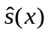 | Min | max
land value | V | 1000£/ha | 7.16 | 5.21 | 0.02 | 192.01
degree days | dd | day ºC | 1313.72 | 185.21 | 654.70 | 1639.06
precipitation | prec | Mm | 384.62 | 101.60 | 245.20 | 1433.59
soil class
-fine | s_{f} | % | 14.96 | 28.03 | 0.00 | 100.00
-medium fine | s_{mf} | % | 8.58 | 21.49 | 0.00 | 100.00
-medium | s_{m} | % | 58.59 | 38.81 | 0.00 | 100.00
-coarse | s_{c} | % | 12.13 | 21.42 | 0.00 | 100.00
-peat | s_{p} | % | 5.74 | 16.72 | 0.00 | 100.00
depth to rock | dtr | Dm | 7.42 | 3.26 | 0.00 | 14.00
slope | slo | º | 3.23 | 2.21 | 0.00 | 17.06
pop. density | dpop | pop/km² | 203.20 | 258.30 | 6.80 | 2896.0
park share | s_{park} | % | 7.13 | 22.45 | 0.00 | 100.00
ESA share | s_{esa} | % | 11.79 | 26.18 | 0.00 | 100.00
NVZ share | s_{nvz} | % | 35.01 | 43.12 | 0.00 | 100.00
Notes: indicates the sample mean, the sample standard deviation. Statistics refers to the observations in our FS sample, not to Great Britain as a whole. Land value and income are deflated using the GDP deflator with 2008 as the baseline year (source: HM Treasury, http://www.hmtreasury.gov.uk/Economic_Data_and_Tools/ GDP_Deflators/data_gdp_index.cfm, accessed on the 16th June 2010). The total number of observations is 9506 (3283 farms located in 1361 different 10 km grid cells).

TABLE 2
Descriptive statistics of the climatic variables aggregation
Sum of squares | Within | Between | Total
Degree days (x 10,000 dayºC) | 971  (19.6%) | 3994  (80.4%) | 4965
Precipitation (x 10,000 mm) | 636  (37.4%) | 1065  (63.6%) | 1701
 |  | Min | max
Between-county statistics
Mean precipitation (mm) | 400.80 | 275.70 | 811.00
Mean degree days (dayºC ) | 1290.00 | 756.90 | 1605.00
Within-county statistics
Range of Precipitation (mm) | 157.50 | 2.09 | 1075.00
Range of degree days (dayºC) | 230.40 | 1.00 | 801.70
Notes: Statistics refer to climatic conditions calculated as the weather average from year 1970 to year 2000 (indicates the sample mean). The Sum of squares relates to both within- and between-county variation. Between-county statistics denote the climatic conditions observed on aggregated county-level data expressed as the average climate for each county. Within-county statistics indicate the loss of climatic variability due to the aggregation process, represented as the range of variation of climate within counties.

TABLE 3
Parameter estimates and diagnostics
 |  | Model A  county-level,  no climatic interaction | Model B  county-level,  climatic interaction | Model C  farm-level,  climatic interaction | Model D  farm-level,  semi-parametric
Climate variables
precipitation (prec) |  | 0.580  (0.801) | 0.639  (0.790) | -0.583 *  (0.233) | --
prec² |  | -7.756 ***  (2.130) | -10.299 ***  (2.561) | 0.253  (0.559) | --
degree days (dd) |  | 1.217 ***  (0.313) | 1.112 ***  (0.315) | 0.692 ***  (0.122) | --
dd² |  | -1.138  (1.125) | -1.125  (1.112) | -1.676 ***  (0.434) | --
dd * prec |  | -- | -4.567  (2.633) | 2.741 **  (1.022) | 8.606 ***
Control variables
slope |  | -0.045  (0.031) | -0.057  (0.031) | -0.026 **  (0.008) | 1.000 ***
depth to rock |  | -0.001  (0.002) | -0.001  (0.002) | -0.000  (0.000) | 1.895
pop. density (dpop) |  | 0.091  (0.217) | 0.139  (0.216) | 0.398 ***  (0.100) | 3.751 ***
dpop² |  | -0.058  (0.115) | -0.081  (0.114) | -0.201 ***  (0.059) | --
share park |  | 0.747 **  (0.256) | 0.710 **  (0.254) | 0.175 **  (0.059) | 0.191**  (0.060)
share NVZ |  | 0.012  (0.049) | 0.011  (0.049) | -0.033 *  (0.013) | -0.031 *  (0.013)
share ESA |  | -0.410 *  (0.174) | -0.403 *  (0.171) | 0.027  (0.045) | 0.011  (0.045)
Fixed effects |  | Yes *** | Yes *** | Yes *** | Yes ***
Soils shares |  | Yes | Yes | Yes *** | Yes ***
Random effects
County |  | 0.234 | 0.230 | -- | --
Cell |  | -- | -- | 0.279 | 0.271
Farm |  | -- | -- | 0.403 | 0.402
Residuals |  | 0.274 | 0.273 | 0.184 | 0.184
Model fit
LogLik |  | -233.09 | -229.71 | -2045.58 | -1966.49
AIC |  | 523.18 | 519.43 | 4153.16 | 3998.97
BIC |  | 660.79 | 660.70 | 4375.02 | 4235.24
Notes: Models A and B are estimated on county averages with 848 observations for a total of 102 counties. Models C and D are estimated on farm data with 9506 observations for a total of 3283 farms in 1361 cells of 10km square. All models estimated with Restricted Maximum Likelihood. Yearly fixed effect and Scotland and Wales dummy variables statistically significant but not reported in the table to preserve space. In Models A, B and C the table reports the coefficient estimate (with standard error in parenthesis) and the significance calculated with an approximate t-value conditional on the random effects (details in Pinheiro and Bates, 2000). The asterisks are defined as: * = significant at the 0.05 level, ** = significant at the 0.01 level, *** = significant at the 0.001 level. In model D the table reports the “effective degree of freedom” and the significance calculated with an approximate F-test (details in Wood, 2006). In models A, B and C precipitation and degree days are centered to the population means to reduce multicollinearity, and precipitation, degree days and population density are divided by 1000 to increase readability of the coefficients. LogLik = (restricted) log-likelihood, AIC = Akaike Information Criterion, BIC = Bayesian Information Criterion.

TABLE 4
Pairwise stability tests
years | F-test | p-value
1999 and 2000 | 0.58 | 0.802
1999 and 2001 | 1.76 | 0.084
1999 and 2002 | 1.19 | 0.296
1999 and 2003 | 1.75 | 0.088
1999 and 2004 | 1.12 | 0.258
1999 and 2005 | 1.64 | 0.084
1999 and 2006 | 1.57 | 0.092
1999 and 2007 | 1.24 | 0.258
1999 and 2008 | 1.14 | 0.314

Notes: test on Model D (see Table 3) estimated only on those farms which are present in both years, with 4 knots for population density and 16 knots for the joint effect of rainfall and temperature. The approximated F-statistics test the stability of the climate parameters from one year to the other and are conditional on the random-effect estimates, as suggested in Pinheiro and Bates (2000). Approximated p-values calculated with 500 bootstrap repetitions maintaining the hierarchical structure of the data following the approach introduced by Carpenter, Goldstein and Rasbash (2003).

TABLE 5
Interaction effect between precipitation and temperature according to alternative specifications

Specification | County-level  (MODEL B) |  | Farm-level  (MODEL C)
Base specification (1)  (only farms bigger than 30ha, climate 1971-2000, area-weighted aggregation) | -4.57  (2.63) |  | 2.74 **  (1.02)
Different aggregation method (2)  (aggregating data by using un-weighted arithmetic averages) | -8.10 **  (2.75) |  | --
Different climate specification (3)  (climate calculated as the average weather in the 30 previous years) | -0.23  (2.46) |  | 3.91***  (0.87)
Including not updated values (4)  (including observations in which the land value is not updated in that year) | -0.92  (2.85) |  | 3.16**  (0.99)
Including also small farms (5)  (including all farms bigger than 5ha) | -4.55  (2.77) |  | 2.59*  (1.08)
Including all farms (6)  (including all farms, even farms smaller than 1ha) | -1.69  (3.47) |  | 0.73  (1.39)
Larger spatial autocorrelation (7)  (including an additional random effect term grouping nine 10km cells) | -- |  | 2.56*  (1.27)
Non-Gaussian errors and more general correlation (8)  (model estimated using cluster-robust covariance matrix at the cell level) | -- |  | 2.94*  (1.47)
Generalized residuals and larger spatial correlation (9)  (model estimated using cluster-robust covariance matrix at the county level) | -- |  | 2.94  (2.31)
Excluding covariates 1 (10)  (Eliminating from the model the strongest control-variable: population density) | -4.36  (2.60) |  | 2.69**  (1.03)
Excluding covariates 2 (11)  (Eliminating from the model population density, depth to rock and slope) | -3.36  (2.54) |  | 2.92**  (1.02)
Excluding areas with the most favorable climate (12)  (Eliminating all farms for which dd > 1400 and prec > 350) | -4.90  (2.87) |  | 3.65**  (1.16)
Excluding large counties (13)  (Eliminating the largest county in each one of the three GB countries) | -5.22  (2.64) |  | 4.08**  (1.11)
Using county-level climate (14)  (using county-level climate data on farm land value data) | -- |  | 0.34  (1.18)
Notes: Coefficients estimated via Restricted Maximum Likelihood (REML) and defined as in Table 3. Standard errors conditional to the random-effects in parenthesis. Asterisks indicate significance, * = significant at the 0.05 level, ** = significant at the 0.01 level, *** = significant at the 0.001 level.

TABLE 6
Descriptive statistics of the climatic and environmental variables

 | units |  |  | min | max
Baseline
(1960-1990)
degree days | day ºC | 1164.0 | 251.8 | 367.4 | 1645.0
precipitation | mm | 450.7 | 169.0 | 250.8 | 1504.0
Climate change projections (UKCIP 2020-2049)
degree days | day ºC | 1424.0 | 276.1 | 571.6 | 1948.0
precipitation | mm | 395.8 | 188.3 | 158.6 | 1444.0
Control variables
depth to rock | dm | 6.4 | 3.5 | 0.0 | 14.0
Slope | º | 4.4 | 3.6 | 0.0 | 24.7
pop. density | pop/Km² | 226.4 | 434.6 | 8.0 | 4924.0
Notes: indicates the sample mean, the sample standard deviation. Data refer to 10 km grid square cells for Great Britain, only including only cells in which there is some agricultural land. Control variables are assumed to remain constant between the two scenarios.

TABLE 7:
Climate change impact on agriculture in the 2020-2049 UKCIP medium emission scenario

Model | sample | mean (%) | Q 10  (%) | Q 90  (%) | Total (M£) | std.err (M£)
Model A  (county, no climatic interactions) | Unconstrained | 17.83 | -0.02 | 45.74 | 918 | 600
Model A  (county, no climatic interactions) | Constrained | 18.69 | 0.00 | 44.54 | 963 | 527
Model B  (county, climatic interactions) | Unconstrained | 21.12 | 12.81 | 32.71 | 1088 | 588
Model B  (county, climatic interactions) | Constrained | 20.81 | 11.06 | 32.71 | 1072 | 518
Model C  (farm, climatic interactions) | Unconstrained | 5.92 | -19.86 | 41.05 | 304 | 239
Model C  (farm, climatic interactions) | Constrained | 7.66 | -12.58 | 40.33 | 394 | 218
Model D  (farm, semi-parametric) | Constrained | 7.76 | -4.78 | 37.01 | 400 | 412
Notes: Weighted statistics (weights = agricultural land area * land value in the baseline). “Q10” indicates the 10% quantile, “Q90” the 90% quantile, “Total” refers to the sum of annual GB farm net revenues assuming a discount rate of 5%, and “std.err” is the standard deviation of the total, calculated via 5000 Monte Carlo repetitions.

Figure 1: Degree days and rainfall during the growing season in Great Britain.

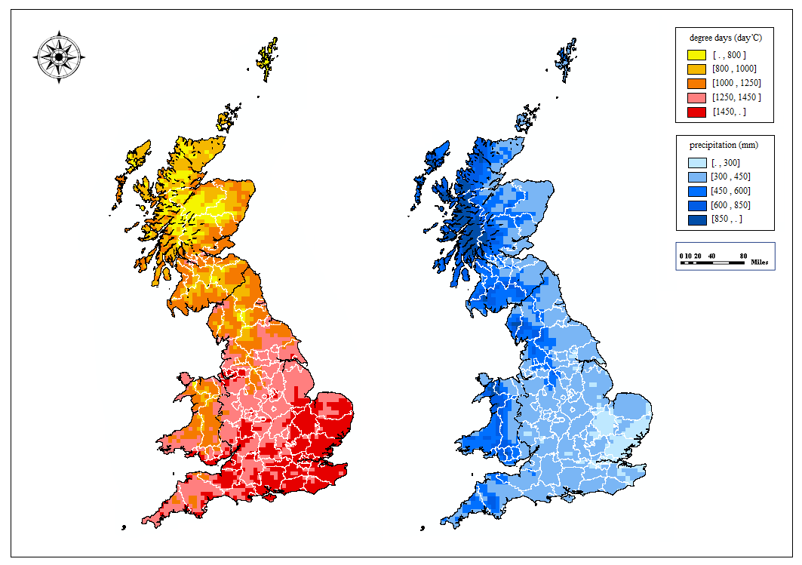Notes: 10 x 10 km grid squares Met Office climate 1971 - 2000 data corresponding to the growing season (April - September). White lines indicate county (NUTS3) limits.

Figure 2: The effect of temperature and precipitation on the logarithm of land price: contour plots with iso-value lines (left) and observed climate data (right).

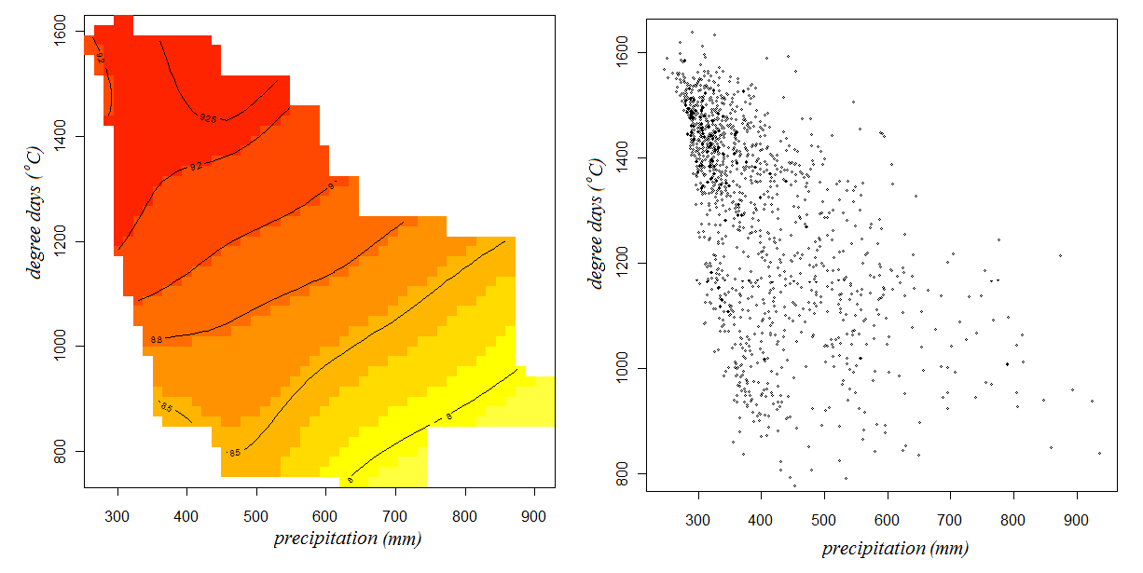
Notes: Left panel shows the estimated effect of precipitation and degree days on the logarithm of land value according to the semi-parametric Model D. Right panel shows the scatter plot of the values of precipitation and degree days within the farm-level sample.

Figure 3: The effect of precipitation on the logarithm of farmland value for different levels of temperature

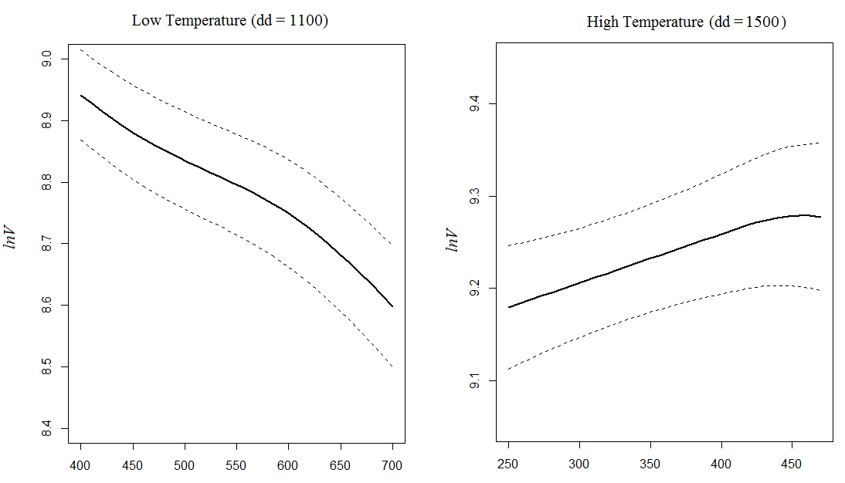

Note: Left panel shows the estimated effect of precipitation when temperature is low (1100 ºC degree days in the growing season). Right panel shows the estimated effect of precipitation when temperature is high (1500 ºC degree days in the growing season). Solid line = mean estimate according to the semi-parametric Model D, dotted line = ± 1 standard error.

Figure 4: The effect of temperature on the logarithm of farmland value for different levels of precipitation
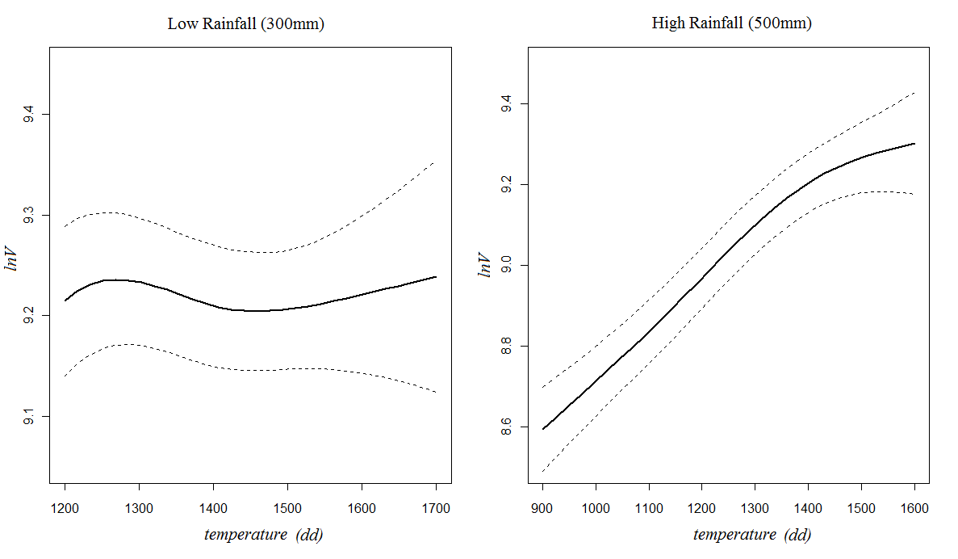
Note: Left panel shows the estimated effect of temperature when precipitation is low (300 mm in the growing season). Right panel shows the estimated effect of precipitation when temperature is high (500 mm in the growing season). Solid line = mean estimate according to the semi-parametric Model D, dotted line = ± 1 standard error.

Figure 5: Maps of estimated impact of climate change on GB agriculture in the 2020-2049 UKCIP medium emission scenario
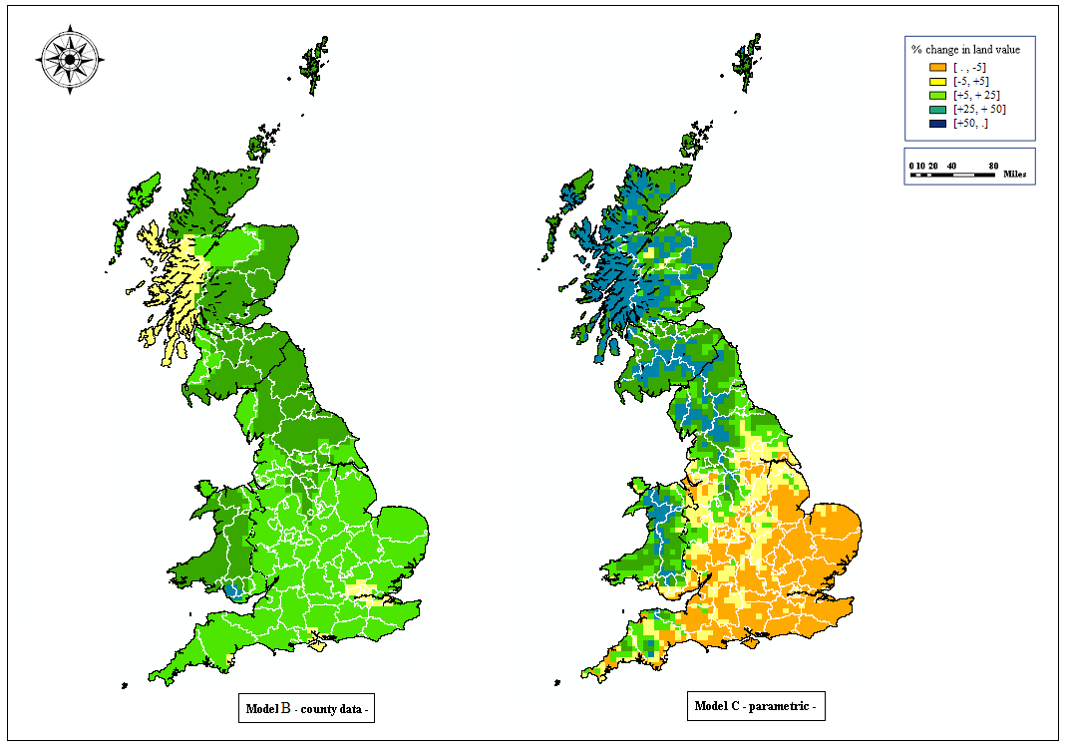
Notes: Models correspond to Model B and Model C in Table 3. Both models include interaction effects, Model B is estimated on county level data, and Model C on farm level data. White lines indicate county (NUTS3) limits. "Constrained" climate change scenarios.

Figure 6: Estimated total impact of climate change on GB agriculture in the 2020-2049 UKCIP medium emission scenario in different model specifications

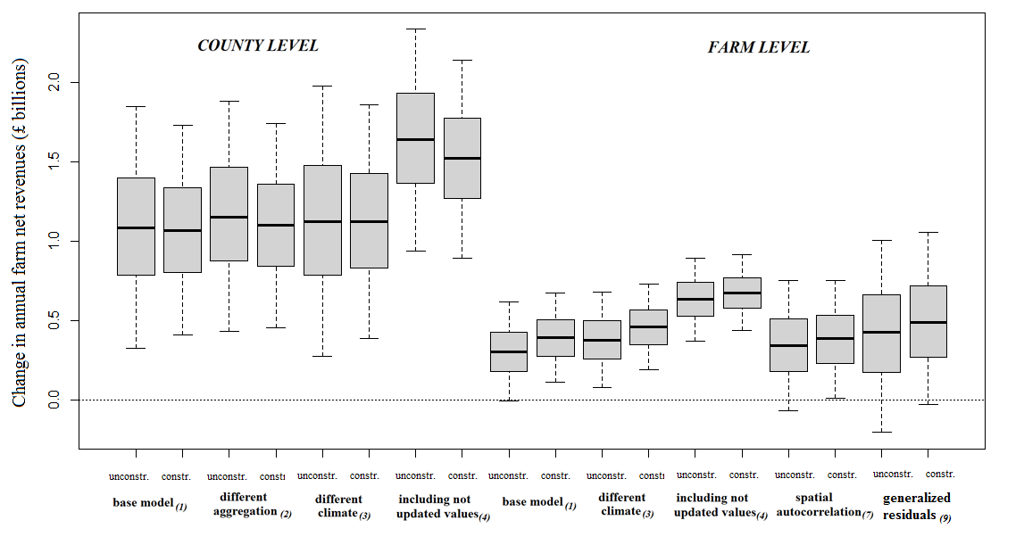
Notes: The boxplots represent confidence intervals for the change in total GB annual farm net revenues, calculated with 5000 Monte Carlo repetitions. The gray box indicates the 1st and 3rd quartile, the whiskers the 90% confidence interval. The models include interaction effects, are estimated on county level data (Model B) and farm level data (Model C) and are based on five different specifications reported in Table 5 (rows 1, 2, 3, 4 and 7, in parenthesis). “unconst.” indicates the unconstrained climate change scenario, “constr.” indicates the constrained climate change scenario.

Department of Economics, University of California, San Diego (UCSD), 9500 Gilman Drive, La Jolla, CA 92093-0508, Corresponding author email: c.fezzi@uea.ac.uk, phone: (+1)858-822-5031.
CSERGE (School of Environmental Sciences), University of East Anglia, NR4 7TJ, Norwich (UK).
Acknowledgements: This paper has benefited from funding by the European Union Marie Curie International Outgoing Fellowship “Land Use Change, Environment and Society (LUCES)” (Ref: FP7-PEOPLE-2011-IOF-302290) and the ESRC Social, Economic and Environmental Research (SEER) grant (Ref: RES-060-25-0063). Many thanks to Richard Carson, Silvia Ferrini, David Hennessy, Joe Herriges, Cathy Kling, Luisa Menapace, Marije Schaafsma and Wolfram Schlenker for their helpful comments. We are very grateful to two anonymous Referees and the Editor Max Auffhammer for a series constructive suggestions which allowed us to considerably improve the paper. Remaining errors are, of course, our responsibility.
To our knowledge, the only Ricardian model estimated on farm-level data so far is the one presented by Schlenker et al. (2007). Other papers used farm-level information on yield (e.g. Welch et al., 2010) or farm revenues (e.g. Mendelsohn and Dinar, 2009; Wang et al., 2009), but the standard Ricardian approach requires farmland value data (analyses of farm net-revenues are sometimes referred to as semi-Ricardian approaches, McKinsey and Evenson, 1998).
Mendelsohn and Reinsborough (2007) and Seo et al. (2009) do include interaction effects but represent climate using temperature and precipitation during the months of January, April, July and October, rather than degree days and precipitation in the growing season as recommended by Schlenker et al. (2006) and extensively applied thereafter (e.g. Lang, 2007; Schlenker et al., 2007; Deschênes and Greenstone 2007; 2012, Fisher et al. 2012). An issue with using monthly averages is that the high cross-sectional correlation which characterizes these variables significantly limits the interpretability of the resulting interaction terms (in our sample, for instance, the correlations between the average temperature in October with the one in January, April and July are, respectively, 0.93, 0.97 and 0.91).
Therefore, it is a function of both the discounted value of agricultural production and the potential for other uses such as urban development. In our model we control for this latter factor by including a semi-parametric function of population density as explanatory variable.
As an example, consider a farm which is surveyed in the years 2000-2005. The farmland value is estimated to be £1000 per hectare in year 2000, £1500 in 2001, 2002 and 2003 and £1800 in 2004 and 2005. In this case we include in the analysis only the records relative to years 2000, 2001 and 2004. However, as a robustness test we also estimate the model including the years in which the farmland value remains constant showing that the results remain essentially unchanged.
In farms with only a small amount of owned land, farmland price per hectare can be significantly inflated when the property contains buildings or houses older than 30 years, since their value is included in the farmland price. This effect will be obviously diluted in large farms. Therefore, to reduce this source of noise in the data we eliminate all farms in which the owned land is smaller than 30 hectares. In the robustness tests section, however, we also report the estimates obtained by including all farms and show that our findings remain consistent.
This is, not surprisingly, just an approximation. Recent literature (e.g. Schlenker and Roberts, 2006) shows how the effect of temperature on yield can present non-linearities even within the two thresholds. However, since the objective of a Ricardian analysis is not to analyze crop growth but to understand the effect of climate on land value, the linearity assumption to compute degree days still constitutes a reasonable approximation.
We do not use approach developed by Thom (1966), commonly implemented on US data, because his formula is based on the average monthly temperature and its standard deviation. On the other hand, we have information on the average monthly minimum temperature and the average monthly maximum temperature. This latter information provide a better representation of the GB climate (Hitchin, 1983).
An alternative approach is using cluster robust standard errors, as implemented, among others, by Fisher at al. (2012) and Deschênes and Greenstone (2012). While this approach can be easily implemented for Model C, to the best of our knowledge there is no established approach for deriving robust errors for additive models estimated via penalized likelihood (Model D). Therefore, for ease of comparison we present the simplest specification with farm- and cell-specific random effects for both models. In the robustness test section however, we present further specifications for Model C. In addition to using cluster robust standard errors at the cell level, we also allow a stronger spatial autocorrelation by adding a further random effect term, grouping together clusters of 9 cells. Results remain essentially unchanged.
While significant, yearly variation does not account for a large part of the variability in land values which, as one may expect, is mainly related to cross-sectional heterogeneity. For instance, in Model A (county level) the share of the variation captured by the yearly fixed effects is only 2.5% of the total variation captured by the model, while in Model C (farm level) this rises but only to about 6.5%.
We also tried to estimate a farm-level model with no interaction effect. In such a model the quadratic parameter of precipitation is still not significant. This indicates that the cause of this difference in statistical significance cannot be attributed to possible collinearity between the quadratic term and the interaction term but it is actually caused by the aggregation process. Results are not reported in Table 2 to preserve space but are available from the Authors upon request.
We cannot compare Model C and D via a likelihood ratio test since the two models are not nested. However, the log-likelihood, the Akaike Information Criterion (AIC) and the Bayesian Information Criterion (BIC), reported at the end of Table 3, suggest that the semi-parametric specification provides a better fit. Ignoring this non-linearity also comes at the cost of increasing the un-modelled spatial autocorrelation, which is reflected in the higher value of the cell-specific random component of Model C compared to that of Model D. This is consistent with Kostov’s (2009) findings, which shows that flexible functional forms can significantly reduce residual spatial auto-correlation in farmland price modelling. While Model D is more flexible, Model C provides more robust predictions when applied outside the range of the data used for estimation. Therefore, we view the two models are complementary rather than competitive and we retain both for climate change impact projections.
This F-test is conditional on the estimates of the random effects and it is only approximated. Nevertheless, it is the most appropriate in our context since, as shown by Pinheiro and Bates (2000), likelihood ratio tests should not be used for the significance of fixed parameters in random effect models. To obtain the empirical distribution of this test we use a bootstrap procedure specifically designed to take into account the hierarchical structure of random effect models, i.e. we re-sample residuals hierarchically at the cell, farm and observation levels (see Carpenter, Goldstein and Rasbash, 2003).
We compute the total agricultural area within each square or county using 1 km grid data from the Land Cover Map 2000 (LCM2000, http://www.ceh.ac.uk/LandCoverMap2000.html), produced by the Centre for Ecology and Hydrology. LCM2000 is a parcel-based classification of satellite image data showing land cover for the entire United Kingdom. We include in agriculture the land classified as: (a) arable and horticultural, (b) improved grassland, (c) semi-natural, rough grass and bracken and (d) mountain, heath and bog. This definition somewhat overestimates the amount of agriculture in GB, resulting in a total of about 19 million hectares rather than the 17 million presented in the official statistics (e.g. http://www.defra.gov.uk/statistics/). Therefore, we rescaled the agricultural area in each cell or county by multiplying it by a factor of 0.9 to match with the official GB total.

