Differences in the effects of crowding on size perception and grip scaling in densely cluttered 3D scenes
Juan Chen^{1,*}, Irene Sperandio^{1,2}, Melvyn Alan Goodale^{1,*}
¹The Brain and Mind Institute, the University of Western Ontario, London, Ontario N6A 5B7, Canada,
²The School of Psychology, University of East Anglia, Norwich, NR4 7TJ, United Kingdom

* To whom correspondence should be addressed to Juan Chen or Melvyn A. Goodale, the Brain and Mind Institute, the University of Western Ontario, London, Ontario N6A 5B7, Canada. Email: jchen737@uwo.ca or mgoodale@uwo.ca
Running title: Effects of crowding on perception and action

Abstract
Objects rarely appear in isolation in natural scenes. Although many studies have investigated how nearby objects influence perception in cluttered scenes (i.e. crowding), none has studied how nearby objects influence visually guided action. In Experiment 1, we found that participants could scale their grasp to the size of a crowded target, even when they could not perceive its size, demonstrating for the first time that neurologically-intact participants can use unconscious visual information to scale their grasp to real objects in real scenes. In Experiments 2 and 3, we showed that changing the eccentricity of the display and the orientation of the flankers had no effect on grasping but strongly affected perception. The differential effects of eccentricity and flanker orientation on perception and grasping show that the known differences in retinotopy between the ventral and dorsal streams are reflected in the way in which people deal with targets in cluttered scenes.
Keywords crowding, size perception, grasping, unconsciousness, visual periphery, cluttered scenes, radial-tangential anisotropy

Introduction
In the laboratory, the presence of flanking objects has been shown to interfere with the ability to identify the features of a target presented in the periphery of the visual field. This phenomenon is called “crowding” (Levi, 2008; Whitney & Levi, 2011). But crowding is not limited to the laboratory. In the real world, objects rarely appear in isolation, and crowding in cluttered scenes is an integral part of everyday life.
In crowded arrays, the features of the target and the flankers become mixed or averaged (Parkes, Lund, Angelucci, Solomon, & Morgan, 2001). The strength of crowding depends on many factors, including, the distance between flankers and target, the number of flankers, and their eccentricity (Chen et al., 2014; Levi, 2008; Whitney & Levi, 2011). Crowding can render a specific feature of the target “invisible”, i.e. the feature cannot be identified (He, Cavanagh, & Intriligator, 1996), even though people know the target is there (Liu, Jiang, Sun, & He, 2009).
Crowding has been considered a bottleneck for object recognition (Levi, 2008; Whitney & Levi, 2011). But vision is not only important for object recognition; it also plays a critical role in the control of object-directed actions such as reaching and grasping. Therefore, it is important to investigate how crowding influences actions directed towards a target. Does the effect of crowding on visually-guided action simply reflect its effect on visual perception? There are reasons to believe that this might not be the case.
According to the influential two-visual systems account (Goodale & Milner, 1992), our visual perception of the world is mediated by the ventral stream projecting from early visual areas to the inferotemporal cortex, whereas the control of skilled actions is mediated by the dorsal stream projecting from early visual areas to the posterior parietal cortex. There are several critical differences in the functional organization of the ventral and dorsal streams. A recent neuroimaging study, for example, demonstrated that when a stimulus is made invisible by flash suppression, object-related activation is still present in the dorsal but not the ventral stream (Fang & He, 2005). Thus, one might expect that, if a particular object feature were to be made perceptually invisible, the ‘unseen’ feature could still modulate actions directed towards that object. In addition, some areas in the dorsal and ventral streams have clear differences in their retinotopic organization. For example, the fovea is over-represented in areas of the ventral stream implicated in object recognition (Malach, Levy, & Hasson, 2002), whereas the entire visual field is more evenly represented in some action-related areas of the dorsal stream (Colby, Gattass, Olson, & Gross, 1988). Thus, if it is the case that perceptual report depends more on the ventral stream and the visual control of action on the dorsal stream, then one might expect that the spatial layout of the display would affect perception and action differently.
We tested these predictions in a series of experiments in which participants were presented with a three dimensional target in isolation (uncrowded) in the far periphery or surrounded by three-dimensional flanking objects (crowded). In Experiment 1, we examined whether or not participants could use “invisible” size information induced by crowding to guide their grasping. In Experiments 2 and 3, we examined how the eccentricity of the display and the orientation of the flankers influence the effects of crowding on grasping vs. perceptual estimation of target size.

Method

Participants
Ten participants (five males) took part in Experiment 1. Additional groups of twelve participants took part in Experiment 2 (six males) and Experiment 3a (three males) and Experiment 3b (six males). Previous studies in our laboratory and others have shown that 10-14 participants provide sufficient power for studies comparing visual perception with action measures (Aglioti, DeSouza, & Goodale, 1995; Binsted, Brownell, Vorontsova, Heath, & Saucier, 2007; Toet & Levi, 1992). Some of the participants took part in more than one experiment. All were right-handed and had normal or corrected-to-normal vision. Their ages ranged between 18 and 35 years. In all experiments, participants gave informed consent. The experiments were approved by the University of Western Ontario Ethic Review Board.

Apparatus and stimuli
We carried out three experiments. In all experiments, the stimuli were white plastic disks with diameters ranging from 2.25 cm to 4.75 cm, in 0.25 cm increments (11 disks in total). The thickness of the disks was 1 cm. The target disk was presented either in isolation (uncrowded) or surrounded by flankers (crowded) (Fig. 1a). The flankers were randomly chosen from the remaining disks. All flankers were fixed on the table with Velcro. Only the target was movable. To make sure that participants would not worry about bumping into the flankers, the target was raised 0.5 cm higher with a black foam pad. The layout of the stimuli varied in different experiments.
Participants were seated in front of a black table with their heads stabilized by a chin rest. They wore liquid crystal goggles (PLATO goggles; Translucent Technologies, Toronto, ON, Canada) throughout the experiments to control the visibility of the display and their moving hand. A start button was located 15 cm from the edge of the tabletop facing the participants. The 3D positions of the fingers of the right hand were tracked with an OPTOTRAK system (Northern Digital, Waterloo, ON, Canada) in which the infrared light emitting diodes (IREDs) were attached to the right corner of the thumb nail and the left corner of the index finger. The sample rate was 200 Hz.

Procedure and design
In general, the procedures were identical in all experiments except that both open- and closed-loop trials (see below) were included in Experiment 1, whereas only open-loop trials were included in the other experiments. At the beginning of each trial, the goggles were closed. Participants held down the start button with the thumb and index finger pinched together. After the disks had been placed on the table, the goggles were opened. On grasping trials, participants were required to reach out and pick up the target disk with their thumb and index finger as quickly and as accurately as possible (grasping task). The OPTOTRAK was triggered as soon as the goggles were opened to record the entire grasping movement. On perceptual trials, participants were required to indicate the size of the target disk manually by opening their thumb and index finger a matching amount (manual estimation task). When participants signalled that they were satisfied with their estimate, the experimenter triggered the OPTOTRAK to record the data. After they had made their estimate, participants then picked up the disk to ensure that on perceptual trials they had the same haptic feedback about the size of the target as they did on grasping trials (Haffenden & Goodale, 1998). On some trials, the goggles were closed as soon as the start button was released (open-loop) so that participants could not see their moving hand or the disks during the execution of the movement. On other trials, the goggles were closed 3 s after participants released the button (closed-loop), permitting a full view of the moving hand and the target (Fig. 1b).
If participants can see their movements during the execution of the movement (closed loop), they can adjust the initial programming of their grip aperture on the basis of online visual feedback. In contrast, if participants are tested in open loop (without online feedback), only the initial programming on the basis of visual information available before the movement began would influence their grip aperture. We included both open- and closed-loop conditions in Experiment 1 to investigate whether or not the availability of online visual feedback made any difference to the results.
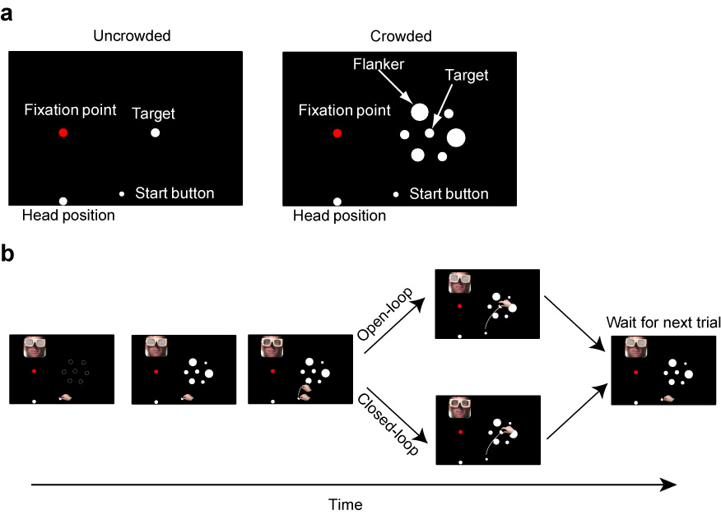

Fig. 1 Display and procedure of Experiment 1. (a) In the uncrowded condition, a white target disk was presented in isolation. In the crowded condition, the disk was surrounded by other disks (flankers). (b) The procedure of a trial (see methods for details). The dashed circles indicate the possible positions of the flankers.

In Experiment 1, the fixation point was positioned directly in front of the participant. The distance from their eyes to the fixation point was 45 cm in Experiment 1. The target was either 3 cm or 3.75 cm in diameter, and was presented along the horizontal meridian at an eccentricity of 30° to the right. There were six flankers located on the six corners of an imaginary hexagon with the target in the center (Fig. 1a). The center-to-center distance between flankers and target was 6.5 cm. There were 16 combinations of conditions and target sizes (2 crowding conditions (crowded or uncrowded) × 2 tasks (grasping or manual estimation) × 2 viewing conditions (closed or open-loop) × 2 target sizes (3 cm or 3.75 cm)) with 10 repetitions for each combination of condition and target size (160 trials in total). Grasping trials and manual estimation trials were blocked separately, two blocks of 40 experimental trials for each task. Eight additional trials with two other target sizes (2.5 cm and 4.25 cm) were randomly interleaved with the 40 experimental trials in each block. These additional trials with other target sizes were not analyzed but prevented participants from memorizing the two target sizes that were analyzed. In short, Experiment 1 consisted of 192 trials in total.
In Experiment 2, the stimulus display was in the same position (along horizontal meridian) in all three eccentricity conditions. The position of the fixation point was varied to manipulate the eccentricity of the display (Fig. 3a). The distance from their eyes to the fixation point was 49 cm in the 20° eccentricity condition, 50 cm in the 10° and 30° eccentricity conditions. The target varied in size: 2.5 cm, 2.75 cm, 3 cm, 3.25 cm, or 3.5 cm in diameter. There were five flankers around the target. The center-to-center distance between flankers and target was also 6.5 cm. There were 60 combinations of conditions and target sizes (2 crowding conditions × 2 tasks × 3 eccentricities × 5 target sizes) with five repetitions for each combination for a total of 300 trials. Trials for different eccentricities were blocked separately to avoid eye movements between trials.
In Experiment 3a and 3b, the flankers were oriented either radially or tangentially with respect to the fixation point. In the radial orientation arrangement, all the flankers were positioned on both sides of the target along a line extending from the fixation point through the target; in the tangential orientation arrangement, the flankers were positioned on both sides of the target along a line that was perpendicular to the radial orientation. The target diameters were also 2.5 cm, 2.75 cm, 3 cm, 3.25 cm, or 3.5 cm. Only four flankers were used. The distance between adjacent pair of disks (i.e. distance between adjacent flanker and target or adjacent flankers) was 5.5 cm. In Experiment 3a, the target was placed at an eccentricity of 20° in the upper visual field (Fig. 4a). In Experiment 3b, the display remained in the same position but the fixation point was moved above the display which made the display at an eccentricity of 17° in the lower visual field (Fig. 4b). The distance from their eyes to the fixation point was 39 cm in Experiment 3a, and 46 cm in Experiment 3b. In Experiments 3a and 3b, there were 30 combinations of conditions and target sizes (3 stimulus conditions (uncrowded, crowded_tangential, crowded_radial) × 2 tasks × 5 target sizes) with six repetitions for each combination for a total of 180 trials.
In all experiments, perceptual trials and action trials were blocked into separate sessions and were performed in different random orders both within and across participants. The crowded and uncrowded trials were randomly presented within each block of perception and action trials. All participants were given 10-30 minutes of training before doing the real experiment so that they could control their eye movements and get used to the tasks.
To make sure that participants were fixating properly, we opened the goggles before each block of trials, and gave the participants time enough to adjust their head orientation so that when the goggles were opened in the experiment itself they would be looking directly ahead at the fixation point. Then we asked them to maintain fixation and keep their head still throughout the block even when the goggles were closed. This was practiced before they started the main experiments. We confirmed that they could remain fixated properly by asking them periodically if they had to re-fixate after the goggles were open. They reported no difficulty. Eye movements were also visually monitored by means of a video-camera in the practice phase, but not in the main experiments because the experimenter was preparing to place objects on the table. As participants saw the fixation point before the goggles were closed and could remember the relative position of the fixation point to their head position, they could maintain their gaze on the fixation point reasonably well (as revealed by the video camera in the practice phase), as long as they kept their head still. We confirmed that this was the case by recording the eye movements of an additional group of naïve participants while they performed the same tasks that were tested in Experiment 1 (see Figure S1, Table S1, Table S2, Video S1, and Video S2 in the Supplemental Material available online).
Data collection and analysis
On perceptual trials, the distance between the IREDs on the index finger and thumb was recorded as soon as participants indicated that they were satisfied with their estimate. On grasping trials, the distance between two IREDs was recorded throughout the entire movement. The peak grip aperture (PGA) during the approach phase to the object was extracted. PGA occurs well before the fingers make contact with the target object, is typically scaled to size of the goal object, and is programmed before the movement begins (Jeannerod, 1986).
In Experiment 1, the manual estimates and the PGAs were averaged for each condition and for each individual. A four-way repeated-measures ANOVA was used to analyze the main effects of crowding, task, viewing condition, and actual size as well as their interactions. Post-hoc paired t-tests (two-tailed) were also used to examine whether or not the manual estimates or PGAs of the 3 cm and 3.75 cm target were significantly different. In Experiments 2 and 3a and 3b, the Pearson’s product-moment correlations between target sizes and estimates in the manual estimation task and target sizes and PGAs in the grasping task were calculated for each participant. We then transformed all the correlation values to Fisher Z-scores to perform statistical analyses. To quantify the influence of crowding at various eccentricities (10°, 20°, or 30°) in Experiment 2 or along different directions (radial or tangential) in Experiment 3 on estimation and grasping, the Fisher Z-scores were normalized against the corresponding uncrowded condition (i.e. normalized Fisher Z = (Fisher Z in crowded condition) / (Fisher Z in uncrowded condition)). We also conducted a regression analysis on the same data (see Supplementary Materials for details). Because the slope of regression line and correlation coefficient gave the same results, only correlation coefficients are reported here.

Results
Effects of crowding on perception and action. Experiment 1 was designed to explore the effects of crowding on perception and action. Specifically, we tested whether participants could scale their grip aperture to the size of the target even when they could not identify the size of the target. A four-way repeated-measures ANOVA was carried out on the manual estimates and PGAs with task (estimation vs. grasping), crowding (uncrowded vs. crowded), viewing conditions (closed- vs. open-loop) and target size (3 vs. 3.75 cm) as main factors. The significant interaction between task and crowding (F (1, 9) = 6.818, P = 0.028) suggests that crowding had different effects on grasping and manual estimation tasks. Not surprisingly, when the target was presented in isolation, participants were able to indicate the difference in size between the two targets – and this was true for both closed- and open-loop trials (closed-loop, t (9) = 7.23, P < 0.001; open-loop, t (9) = 9.19, P < 0.001). Similarly, for targets presented in isolation, participants showed excellent grip scaling during grasping (closed-loop, t (9) = 4.29, P = 0.002; open-loop, t (9) = 4.79, P = 0.001) (Fig. 2).
Things were quite different, however, when the target disks were surrounded by flankers. In this condition, participants could no longer discriminate between the two disk sizes using a manual estimate (closed-loop, t (9) = 1.02, P = 0.334; open-loop, t (9) = 1.78, P = 0.108), presumably because the size of the target was perceptually “invisible”. One should note that “invisible” refers to the fact that participants could not identify the size of the target although they were aware of the presence of the target and its position. In contrast, when they were asked to grasp the same targets, their PGA was still scaled to target size (closed-loop, t (9) = 4.21, P = 0.002; open-loop, t (9) = 3.392, P = 0.008) (Fig. 2). This suggests that information about target size can still be processed to guide grasping even when that information is perceptually “invisible”. In other words, grasping appeared to escape to some degree the effects of perceptual crowding. It should be noted that the different effects of crowding on grasping and manual estimation cannot have been due to differences in haptic feedback between the two tasks. In fact, in our manual estimation task, participants were instructed to pick up the target after they made their estimates. Therefore, the opportunity to use haptic feedback was available in both tasks.
Although participants could still scale their grip aperture even when the size of the target was perceptually inaccessible, this does not mean crowding had no effect whatsoever on grasping. Results clearly show that when the target was crowded, the PGAs were smaller than when the target was presented in isolation, as demonstrated by the downward shift in overall grip aperture for crowded targets compared with uncrowded targets in both the closed- and open-loop conditions (see Figure 2b). We suspect that the reason for this downward shift is that the flankers, which were real three-dimensional objects, were treated by the visuomotor system as obstacles. To further explore the extent to which grip scaling was affected by crowding, for each participant we first computed the slopes (denoted as b) of the functions describing the relationship between target size and PGA. We then compared the slopes for the uncrowded and crowded displays for both open- and closed-loop conditions. In closed loop, the mean slopes for the uncrowded and crowded conditions were 1.007 and 0.319, respectively. In open loop, the mean slopes for the uncrowded and crowded conditions were 1.095 and 0.657. Thus, on average, there was about a 50% reduction in slope in the crowded as compared to the uncrowded condition (closed-loop, 68.34%; open loop: 40.00%). In both cases, the reductions in slope were significant (closed-loop: t(9)=3.59, p=0.006; open-loop: t(9)=2.77, p=0.022). The reduction in slope for grasping in the crowded condition could be due in part to the possibility discussed earlier that the flankers were treated as obstacles. The presence of obstacles might be expected to affect grasps directed at the larger object more than grasps to the smaller one. This remains only a speculation, however. In any case, it is important to emphasize that grip scaling was still present in the crowded condition; i.e., the slope was significantly bigger than zero.
It should be noted that the main effect of viewing conditions was not significant (F (1, 9) = 2.144, P = 0.177), which suggests that visual feedback (or online adjustment) is not a critical factor. In other words, the inclusion of visual feedback did not improve the performance of the participants. Participants showed grip scaling with the crowded display even when they programmed their response entirely on the basis of visual information that was available before the movement began. Because open loop has the advantage of reducing the possibility of participants making saccades toward the display to gather more information during the execution of the movement, we decided to use only open-loop trials in Experiment 2 and 3.
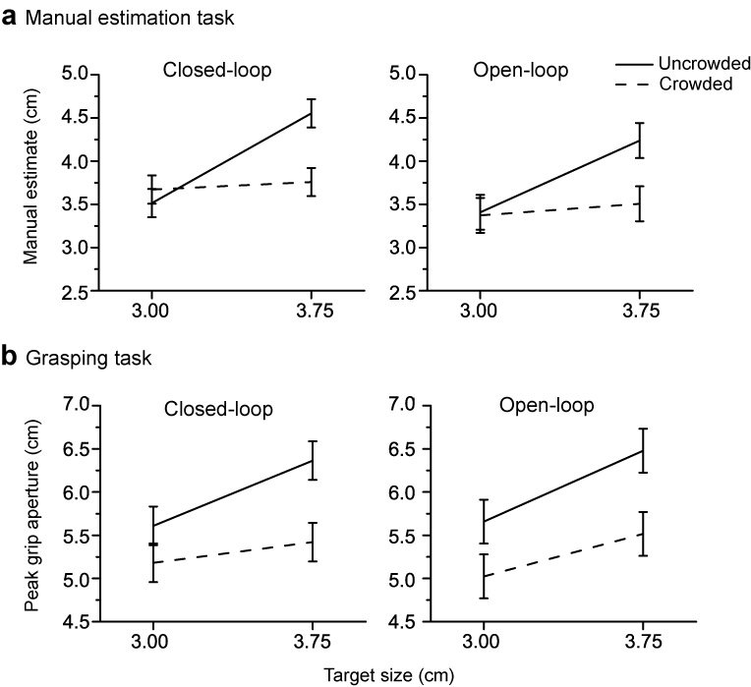

Fig. 2 Results of Experiment 1. (a) Manual estimates in uncrowded and crowded conditions as a function of target size. (b) Peak grip apertures (PGAs) in uncrowded and crowded conditions as a function of target size. Left column, closed-loop. Right column, open-loop. All the figures in this paper represent error bars as within-subject 95% confidence intervals (Masson & Loftus, 2003).
Effects of eccentricity on perception and action under crowded conditions. Previous results have shown that the crowding effect on perception increases with the eccentricity of the display (Levi, 2008; Whitney & Levi, 2011). In Experiment 2, we examined whether or not eccentricity also influences the effect of crowding on action. Eccentricity was changed by displacing the fixation point closer to or further away from the stimulus display (Fig. 3a), while keeping the positions of the participant, start button, and stimulus display constant. We decided to move the fixation point, instead of the stimulus display to make sure that the relative positions of the body, hand, and target were identical despite the changes in retinal eccentricity of the display. This ensured that the biomechanical requirements for grasping in the different eccentricity conditions were identical. In all eccentricities, we measured participants’ manual estimates and PGAs when the target was presented either in isolation or crowded by flankers. To get a better measurement of participants’ estimation or grasping abilities, we used five target sizes and calculated the correlation between the actual sizes and the manual estimates on perceptual trials and between the actual sizes and the PGAs on grasping trials. The higher the correlation, the better the estimation or grasping ability. The raw correlation values were then converted to Fisher Z-scores so that they could be linearly compared to each other and analyzed with the Z statistic (Fisher, 1915, 1921).
Fig. 3b, left shows the Fisher Z-scores in all conditions. As can be seen, the correlations for both grasping and estimation with target size in the uncrowded condition were high and did not decrease dramatically with eccentricity. In the crowded condition, however, the correlation for the estimation task decreased sharply to almost zero. In contrast, the correlation for grasping decreased just slightly. Because our goal was to explore the influence of crowding at different eccentricities, we normalized the Fisher Z-scores in the crowded condition against the scores in the uncrowded condition for each eccentricity to rule out a general influence of eccentricity on the participants’ ability to estimate the target size or scale the grasp even under uncrowded conditions. In other words, we wanted to isolate the effect of eccentricity on crowding in each case. All statistical analyses were performed on the normalized results (Fig. 3b, right). A two-way repeated-measures ANOVA with task (estimation vs. grasping) and eccentricity (10°, 20°, or 30°) as main factors revealed that the interaction between eccentricity and task was significant (F(2,22) = 4.57, p = 0.022). This suggests that the effects of crowding on grasping and manual estimation were differentially affected by changes in eccentricity. One-way repeated-measures ANOVAs on the normalized Fisher Z-scores with eccentricity as main factor revealed that although eccentricity had a highly significant effect on the manual estimates (F (2, 22) = 13.01, P = 0.000), it had no effect on grasping (F (2, 22) = 0.340, P = 0.716). This finding provides support for the idea that any influence that crowding might have on grip scaling is not affected by eccentricity.
As can be seen from the normalized Fisher Z score in Figures 3, the strength of the correlations between grip aperture and target size for crowded displays were 50% to 66% of those observed in the uncrowded displays.
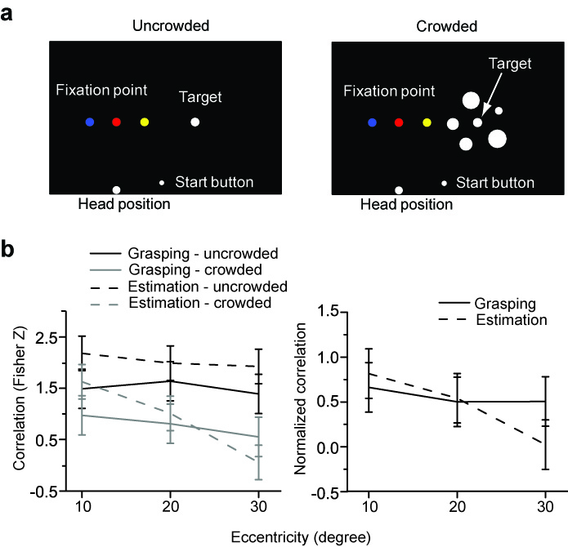
Fig. 3 Displays and results of Experiment 2. (a) To vary the eccentricity of the display, the fixation point was moved to different positions (yellow, 10˚; red, 20˚; blue, 30˚). (b) Results of Experiment 2. Left panel, Fisher Z-scores of the correlation values. Right panel, normalized Fisher Z-scores for crowded conditions against uncrowded conditions.

Effects of flanker orientation on perception and action under crowded conditions. Another well-established property of perceptual crowding is its radial-tangential anisotropy, which refers to the stronger crowding effect induced by flankers that extend along a radial vector from fixation than along a tangential vector (Toet & Levi, 1992). In Experiment 3, we tested whether or not this radial-tangential anisotropy is also evident for the crowding effect on action. The target was presented either in isolation or with flankers that were placed along a radial direction from fixation or tangential to fixation. Similar to Experiment 2, five target sizes were used. The correlations between the actual sizes of the target and the manual estimates, and between the actual sizes and the PGAs were calculated. These correlations were again converted to Fisher Z-scores. For the two different crowded conditions (i.e. radial vs. tangential), the correlations were also normalized with respect to the uncrowded condition to obtain the pure effect of radial and tangential flankers on crowding. All statistical analyses were performed on these normalized scores.
To reduce the possibility that the fingers of the grasping hand might be more likely to collide with the flankers in one orientation of the display than the other, participants were instructed to pick up the object across its ‘vertical’ axis, which was oriented at 45° with respect to the tangential and radial orientations of the flanker display (Fig. 4). To make this easier for the participants, the start button in Experiment 3 was always located immediately below the target. Nevertheless, it was still possible that when the flankers were arranged in one orientation they would be more likely to interfere with the grasp than when they were arranged in the other orientation. To rule out this possibility, two separate sub-experiments were carried out. In Experiment 3a, the fixation point was positioned below the display so that the target and flankers were located in the upper visual field (Fig. 4a). In Experiment 3b, the fixation point was moved above the display so that the target and flankers were now in the lower visual field (Fig. 4b). Thus, the radial orientation of the target and flankers in Experiment 3a became the tangential orientation in Experiment 3b, and vice versa. These manipulations ensured that the potential effects of radial and tangential arrangements of the flankers on grasping would not be contaminated by biomechanical factors.
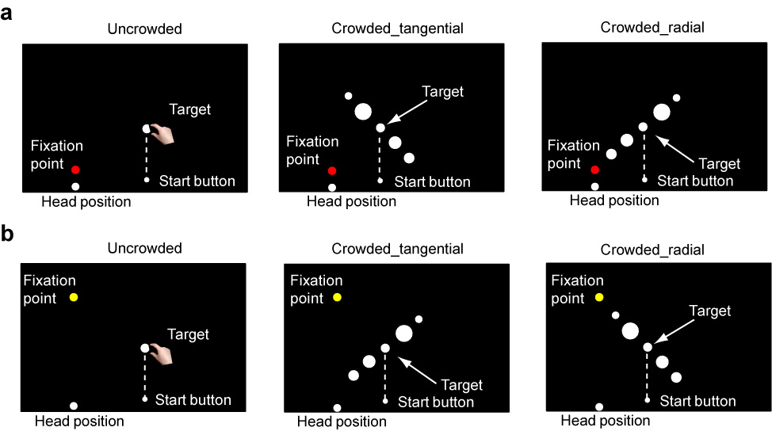
Fig. 4 Displays of Experiments 3a (a) and 3b (b). (a) The flankers and target were tangentially or radially positioned relative to the fixation point (red dot). (b) The fixation dot was moved upper (yellow dot) so that the tangential display of Experiment 3a became the radial display in Experiment 3b, and vice versa. The dashed lines, which were not actually present in the display, make it clear that the target was positioned right above the start button.
In Experiment 3a, a two-way repeated-measures ANOVA on the normalized Fisher Z-scores with task (estimation vs. grasping) and flanker orientation (radial vs. tangential) as main factors revealed a significant interaction between task and flanker direction (F (1, 11) = 6.10, P = 0.031) but no main effects. In line with earlier studies (Levi, 2008; Toet & Levi, 1992; Whitney & Levi, 2011), we found that manual estimates were more accurate with the tangential than the radial display (t (11) = 3.158, P = 0.009) (Fig. 5). As we predicted, however, not only did participants show significant grip scaling to target size with both the tangential and radial displays, there was also no significant difference in their scaling in the two conditions (t (11) = 1.118, P = 0.287). In Experiment 3b, manual estimates were more accurate with the tangential than with the radial displays (t (11) = 3.169, P = 0.009). And again, grip scaling was equivalent across the two displays (t (11) = 0.158, P = 0.877), and the interaction between task and flanker orientation was significant (F (1, 11) = 4.91, P = 0.049).
In Experiment 3a, the mean Fisher Z scores of the correlations between grip aperture and target size in the tangential and radial crowded conditions were 69.7% and 85.0% respectively of the corresponding scores in the uncrowded versions (see the normalized correlation in Figure 5a, right panel). In Experiment 3b, they were 43.1% and 45.6% of those in the uncrowded versions (Figure 5b, right panel).
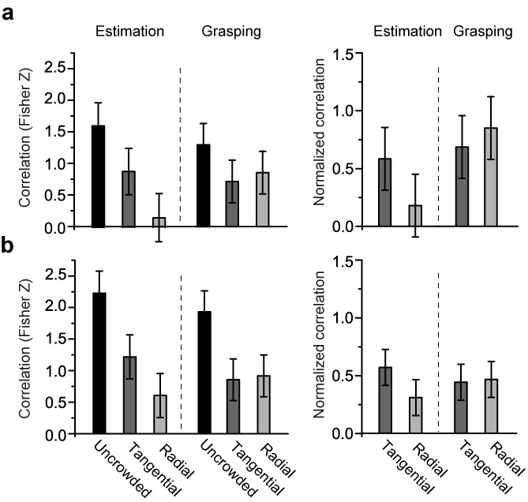
Fig. 5 Results of Experiments 3a and 3b. (a) Results of Experiment 3a in which the stimulus display was presented in the upper visual field. (b) Results of Experiment 3b in which the stimulus display was presented in the lower visual field. Left column, Fisher Z-scores of the correlations values in the uncrowded, crowded_radial and crowded_tangential conditions. Right column, normalized Fisher Z-scores for crowded against uncrowded conditions.

Discussion
In this study, we examined how crowding affects visually-guided grasping in 3D scenes. In Experiment 1, we showed that participants scaled their grasp to the size of the target in conditions in which the target’s size was not accessible to conscious report, suggesting that the visual control of target-directed actions such as grasping can escape to some degree the effects of crowding. In Experiment 2, we showed that changes in retinal eccentricity that had a significant effect on the visibility of target size had little effect on grip scaling. Finally, in Experiment 3, we showed that the well-known radial-tangential anisotropy that is evident in perceptual crowding (Toet & Levi, 1992) is not present for grip scaling.
Although we found that participants were able to grasp the target using “invisible” size information in Experiment 1, this does not mean that crowding had absolutely no effect on grasping. In fact, participants' grip aperture was smaller overall and the correlations with size were somewhat weaker when the target was crowded than when it was presented in isolation. The smaller grip aperture probably reflects a strategy to avoid collision with the flankers (Chapman, Gallivan, Culham, & Goodale, 2011; Voudouris, Smeets, & Brenner, 2012). Nevertheless, the results of Experiment 1 clearly indicate that “invisible” information can still be employed to guide action. Because, in Experiments 2 and 3, we were exploring how the eccentricity and the orientation of display affect grasping, we did not manipulate visibility of target size. We found that as the number of flankers, the eccentricity of the display (Experiment 2), and the orientation of flankers (Experiment 3) changed, so did the strength of crowding effect on perceptual estimates of target size. The strength of crowding effect on grasping, however, remained constant.
Our study is, to the best of our knowledge, the first systematic study of real actions on 3D objects in densely cluttered scenes. Although many studies have studied how crowding influences perception, none of them have studied how crowding influences real action. In an earlier study, Bulakowski and colleagues (2009) also examined the effects of crowding on perception and action. In their visuomotor task, participants pretended to grasp oriented bars presented on a computer monitor. In other words, their ‘action’ task involved a pantomimed grasp (pretending to grasp bars on the monitor), rather than a real grasp (picking up 3D objects on a tabletop). There is evidence that the two kinds of grasping engage different processes. For example, real grasping has been shown to be far less sensitive to pictorial illusions and the irrelevant dimension of the target object than pantomimed grasping (Ganel & Goodale, 2003; Ganel, Tanzer, & Goodale, 2008). It has been suggested, therefore, that the visual control of pantomimed grasping engages perceptual processing in the ventral stream whereas real grasping is mediated by encapsulated visuomotor mechanisms in the dorsal stream (Goodale, 2011; Milner & Goodale, 2006). This may explain why a striking dissociation in the effects of crowding on perception and action was found in our study whereas no dissociation was found in theirs. To test this possibility, we conducted a screen version of Experiment 1 (i.e. 2D targets and flankers images were presented on a screen) and asked participants to pretend to grasp the target. Consistent with our prediction and the results of Bulakowski and colleagues (2009), there was no dissociation between the effects of crowding on perception and action when a pantomimed grasp was employed (see Figure S2 in the Supplemental Material available online).
In Experiment 1, the participants had no conscious perception of the target’s size – or even where the target stopped and the flanker began. Remarkably, however, even though they could not perceive the size of the target (or its edges), they scaled their grasp reliably when they picked it up. Even when we showed them their own data, several participants could not believe that they were doing so well. It should be noted that this is not simply another demonstration that actions escape visual illusions of size (Aglioti, et al., 1995). In size-contrast illusions, people scale their grasp accurately to targets that they believe are larger or smaller than they really are. In other words, the perceptual error is one of the computation of size; the target, the flankers, and their edges are all clearly visible. Crowding, in which a target and flankers are viewed in the far periphery, is very different. Observers cannot distinguish edges of the target from those of the flankers because they are all jumbled together (e.g. (Levi & Carney, 2009; Martelli, Majaj, & Pelli, 2005; Pelli, Palomares, & Majaj, 2004). Therefore, our crowding study goes well beyond the previous size-contrast illusion studies, and shows that unconscious information can influence our actions.
Previous studies have shown that perceptually invisible information can influence actions such as pointing and reaching. For example, Binsted and colleagues (2007) found that healthy participants modulated movement time in a pointing task as a function of target size – even when the 2D target was made invisible by object-substitution masking. Similarly, Roseboom and Arnold (2011) found that, after training and feedback, participants could learn to adjust their reaching hand to the orientation of a 2D stimulus that was made invisible using binocular suppression. Our study, however, is the first to demonstrate that neurologically-intact participants can use unconscious visual information to scale their grasp to real 3D objects in real scenes – and that this happens without any explicit training.
How can unconscious visual information be used to guide actions? Neuroimaging has demonstrated that perceptually invisible stimuli will sometimes activate the dorsal stream independently of the ventral stream (Baseler, Morland, & Wandell, 1999; Fang & He, 2005). Exactly why this occurs is not well understood. There are certainly differences in the way in which retinal input reaches the two streams. Area V1 is the major conduit of visual input into the ventral stream (Girard & Bullier, 1989; Girard, Salin, & Bullier, 1991b; Rocha-Miranda, Bender, Gross, & Mishkin, 1975) – which may explain why patients with V1 lesions no longer perceive objects in their affected visual field. In contrast, even though V1 sends major projections to the dorsal stream, visual signals can also reach the dorsal stream via other pathways that bypass V1. Evidence from neurophysiological and anatomical studies in the monkey as well as neuroimaging studies in patients with V1 lesions has shown that some of the signals that bypass V1 involve direct subcortical projections to MT (middle temporal area) (Sincich, Park, Wohlgemuth, & Horton, 2004), V3A (Girard, Salin, & Bullier, 1991a), and parieto-occipital structures, such as V6 and V6A (Colby, et al., 1988). These extra-geniculostriate projections are likely the neural substrates for actions guided by unconscious visual information.
In Experiments 2 and 3, we showed that although changing display eccentricity and flanker orientation strongly affected perceptual estimation, this was not the case for grasping. One possible reason for the strong effect of eccentricity and flanker orientation on perceptual crowding is the over-representation of central vision in V1 (cortical magnification), leading to less visual resolution in the far periphery which in turn is more evident along radial than tangential vectors (Levi, 2008; Levi, Klein, & Aitsebaomo, 1985). Moreover, the cortical magnification of central vision in V1 is preserved, and even amplified, in downstream areas of the ventral stream, particularly those involved in object recognition (Malach, et al., 2002). This is not the case in dorsal-stream areas such as V6 and V6A, for example, that are thought to play a critical role in the visual control of reaching and grasping (Fattori, Breveglieri, Amoroso, & Galletti, 2004; Galletti, Kutz, Gamberini, Breveglieri, & Fattori, 2003). Area V6 has a relatively isotropic representation of the entire visual field in humans (Pitzalis, 2006) and monkeys (Colby, et al., 1988), and V6A has an over-representation of the far periphery (Galletti, Fattori, Kutz, & Gamberini, 1999). In other words, these dorsal-stream areas have no cortical magnification of central vision. In short, the differential effects of eccentricity and flanker orientation on perception vs. grasping follow directly from known differences in the retinotopic organization of the ventral and dorsal streams.
In sum, we demonstrated that crowding has quite different effects on grasping than it does on perceptual report. The striking difference between the effects of crowding on grasping and estimation suggests that visually-guided action does not depend solely on conscious visual perception.

Author Contributions
J.C., I.S. and M.A.G. designed the study. J.C. collected the data. J.C. and I.S. analyzed the data. J.C., I.S. and M.A.G. wrote the paper.

Acknowledgments
The authors thank Dr. Haitao Yang for his technical assistance. This work was funded by an NSERC grant (#6313) awarded to M.A.G.

References
Aglioti, S., DeSouza, J. F. X., & Goodale, M. A. (1995). Size-contrast illusions deceive the eye but not the hand. Current Biology, 5(6), 679-685. doi: http://dx.doi.org/10.1016/S0960-9822(95)00133-3
Baseler, H. A., Morland, A. B., & Wandell, B. A. (1999). Topographic Organization of Human Visual Areas in the Absence of Input from Primary Cortex. The Journal of Neuroscience, 19(7), 2619-2627.
Binsted, G., Brownell, K., Vorontsova, Z., Heath, M., & Saucier, D. (2007). Visuomotor system uses target features unavailable to conscious awareness. Proceedings of the National Academy of Sciences, 104(31), 12669-12672. doi: 10.1073/pnas.0702307104
Bulakowski, P. F., Post, R. B., & Whitney, D. (2009). Visuomotor crowding: the resolution of grasping in cluttered scenes. [Original Research]. Frontiers in Behavioral Neuroscience, 3. doi: 10.3389/neuro.08.049.2009
Chapman, C. S., Gallivan, J. P., Culham, J. C., & Goodale, M. A. (2011). Mental blocks: fMRI reveals top-down modulation of early visual cortex when obstacles interfere with grasp planning. Neuropsychologia, 49(7), 1703-1717. doi: 10.1016/j.neuropsychologia.2011.02.048
Chen, J., He, Y., Zhu, Z., Zhou, T., Peng, Y., Zhang, X., & Fang, F. (2014). Attention-Dependent Early Cortical Suppression Contributes to Crowding. The Journal of Neuroscience, 34(32), 10465-10474. doi: 10.1523/jneurosci.1140-14.2014
Colby, C. L., Gattass, R., Olson, C. R., & Gross, C. G. (1988). Topographical organization of cortical afferents to extrastriate visual area PO in the macaque: A dual tracer study. The Journal of Comparative Neurology, 269(3), 392-413. doi: 10.1002/cne.902690307
Fang, F., & He, S. (2005). Cortical responses to invisible objects in the human dorsal and ventral pathways. Nature Neuroscience, 8(10), 1380-1385. doi: 10.1038/nn1537
Fattori, P., Breveglieri, R., Amoroso, K., & Galletti, C. (2004). Evidence for both reaching and grasping activity in the medial parieto-occipital cortex of the macaque. European Journal of Neuroscience, 20(9), 2457-2466. doi: 10.1111/j.1460-9568.2004.03697.x
Fisher, R. A. (1915). Frequency Distribution of the Values of the Correlation Coefficient in Samples from an Indefinitely Large Population. Biometrika, 10(4), 507-521. doi: 10.2307/2331838
Fisher, R. A. (1921). On the probable error of a coefficient of correlation deduced from a small sample. Metron, 1, 3-32. doi: citeulike-article-id:2344770
Galletti, C., Fattori, P., Kutz, D. F., & Gamberini, M. (1999). Brain location and visual topography of cortical area V6A in the macaque monkey. European Journal of Neuroscience, 11(2), 575-582. doi: 10.1046/j.1460-9568.1999.00467.x
Galletti, C., Kutz, D., Gamberini, M., Breveglieri, R., & Fattori, P. (2003). Role of the medial parieto-occipital cortex in the control of reaching and grasping movements. Experimental Brain Research, 153(2), 158-170. doi: 10.1007/s00221-003-1589-z
Ganel, T., & Goodale, M. A. (2003). Visual control of action but not perception requires analytical processing of object shape. [10.1038/nature02156]. Nature, 426(6967), 664-667. doi: http://www.nature.com/nature/journal/v426/n6967/suppinfo/nature02156_S1.html
Ganel, T., Tanzer, M., & Goodale, M. A. (2008). A Double Dissociation Between Action and Perception in the Context of Visual Illusions: Opposite Effects of Real and Illusory Size. Psychological Science, 19(3), 221-225. doi: 10.1111/j.1467-9280.2008.02071.x
Girard, P., & Bullier, J. (1989). Visual activity in area V2 during reversible inactivation of area 17 in the macaque monkey. Journal of Neurophysiology, 62(6), 1287-1302.
Girard, P., Salin, P., & Bullier, J. (1991a). Visual activity in areas V3a and V3 during reversible inactivation of area V1 in the macaque monkey. Journal of Neurophysiology, 66(5), 1493-1503.
Girard, P., Salin, P., & Bullier, J. (1991b). Visual activity in macaque area V4 depends on area 17 input. Neuroreport, 2(2), 81.
Goodale, M. A. (2011). Transforming vision into action. Vision Research, 51(13), 1567-1587. doi: http://dx.doi.org/10.1016/j.visres.2010.07.027
Goodale, M. A., & Milner, A. D. (1992). Separate visual pathways for perception and action. Trends in Neurosciences, 15(1), 20-25. doi: http://dx.doi.org/10.1016/0166-2236(92)90344-8
Haffenden, A. M., & Goodale, M. A. (1998). The Effect of Pictorial Illusion on Prehension and Perception. Journal of Cognitive Neuroscience, 10(1), 122-136. doi: 10.1162/089892998563824
He, S., Cavanagh, P., & Intriligator, J. (1996). Attentional resolution and the locus of visual awareness. Nature, 383(6598), 334-337.
Jeannerod, M. (1986). Mechanisms of visuomotor coordination: A study in normal and brain-damaged subjects. Neuropsychologia, 24(1), 41-78. doi: http://dx.doi.org/10.1016/0028-3932(86)90042-4
Levi, D. M. (2008). Crowding—An essential bottleneck for object recognition: A mini-review. Vision Research, 48(5), 635-654.
Levi, D. M., & Carney, T. (2009). Crowding in peripheral vision: Why bigger is better. Current Biology, 19(23), 1988-1993.
Levi, D. M., Klein, S. A., & Aitsebaomo, A. P. (1985). Vernier acuity, crowding and cortical magnification. Vision Research, 25(7), 963-977.
Liu, T., Jiang, Y., Sun, X., & He, S. (2009). Reduction of the Crowding Effect in Spatially Adjacent but Cortically Remote Visual Stimuli. Current Biology, 19(2), 127-132.
Malach, R., Levy, I., & Hasson, U. (2002). The topography of high-order human object areas. Trends in Cognitive Sciences, 6(4), 176-184. doi: http://dx.doi.org/10.1016/S1364-6613(02)01870-3
Martelli, M., Majaj, N. J., & Pelli, D. G. (2005). Are faces processed like words? A diagnostic test for recognition by parts. Journal of Vision, 5(1). doi: 10.1167/5.1.6
Masson, M. E., & Loftus, G. R. (2003). Using confidence intervals for graphically based data interpretation. Canadian Journal of Experimental Psychology/Revue canadienne de psychologie expérimentale, 57(3), 203.
Milner, A. D., & Goodale, M. A. (2006). The visual brain in action. New York: Oxford University Press.
Parkes, L., Lund, J., Angelucci, A., Solomon, J. A., & Morgan, M. (2001). Compulsory averaging of crowded orientation signals in human vision. Nature Neuroscience, 4(7), 739-744.
Pelli, D. G., Palomares, M., & Majaj, N. J. (2004). Crowding is unlike ordinary masking: Distinguishing feature integration from detection. Journal of Vision, 4(12). doi: 10.1167/4.12.12
Pitzalis, S. (2006). Wide-Field Retinotopy Defines Human Cortical Visual Area V6. Journal of Neuroscience, 26(30), 7962-7973. doi: 10.1523/jneurosci.0178-06.2006
Rocha-Miranda, C. E., Bender, D. B., Gross, C. G., & Mishkin, M. (1975). Visual activation of neurons in inferotemporal cortex depends on striate cortex and forebrain commissures. Journal of Neurophysiology, 38(3), 475-491.
Roseboom, W., & Arnold, D. H. (2011). Learning to reach for ‘invisible’ visual input. Current Biology, 21(13), R493-R494. doi: 10.1016/j.cub.2011.05.036
Sincich, L. C., Park, K. F., Wohlgemuth, M. J., & Horton, J. C. (2004). Bypassing V1: a direct geniculate input to area MT. Nature Neuroscience, 7(10), 1123-1128.
Toet, A., & Levi, D. M. (1992). The two-dimensional shape of spatial interaction zones in the parafovea. Vision Research, 32(7), 1349-1357.
Voudouris, D., Smeets, J., & Brenner, E. (2012). Do obstacles affect the selection of grasping points? Human movement science, 31(5), 1090-1102.
Whitney, D., & Levi, D. M. (2011). Visual crowding: a fundamental limit on conscious perception and object recognition. Trends in Cognitive Sciences, 15(4), 160-168.

