Title: Coastal ecosystems: a critical element of risk reduction
Authors: Mark Spalding^{1*}, Anna McIvor², Michael Beck³, Evamaria Koch⁴, Iris Möller², Denise Reed⁵, Pamela Rubinoff⁶, Thomas Spencer², Trevor Tolhurst⁷, Ty Wamsley⁸, Bregjie van Wesenbeeck⁹, Eric Wolanski¹⁰, Colin Woodroffe,
Affiliations:
¹ Global Marine Team, The Nature Conservancy and Conservation Science Group, University of Cambridge, Department of Zoology, Downing Street, Cambridge, CB2 3EJ, UK.
² Cambridge Coastal Research Unit, University of Cambridge, Department of Geography, Cambridge, CB2 3EN, UK.
³ Global Marine Team, The Nature Conservancy, Institute of Marine Sciences, University of California, Santa Cruz, CA, 95062, USA.
⁴ Horn Point Laboratory, University of Maryland Center for Environmental Science, P.O. Box 775, Cambridge, MD 21613, USA.
⁵ Department of Earth and Environmental Sciences, University of New Orleans, New Orleans, LA 70148, USA.
⁶ Rhode Island Sea Grant, University of Rhode Island, South Ferry Road, Narragansett, RI 02882, USA.
⁷ School of Environmental Sciences, University of East Anglia, Norwich Research Park, Norwich, NR4 7TJ, UK.
⁸ Coastal and Hydraulics Laboratory, U.S. Army Engineer Research and Development Center, 3909 Halls Ferry Rd., Vicksburg, MS 39180, USA.
⁹ Deltares, P.O. Box 177, 2600 HD Delft, The Netherlands.
¹⁰ School of Marine and Tropical Biology, James Cook University, Townsville, QLD 4811, Australia.
¹¹ School of Earth and Environmental Sciences, University of Wollongong, NSW 2522, Australia
*Correspondence to: mspalding@tnc.org.
Abstract:
The role of ecosystems in coastal risk reduction has not been sufficiently accounted for in coastal planning and engineering. Evidence is now available that shows how, and under what conditions, ecosystems can play a valuable function in wave and storm surge attenuation, erosion reduction and in the longer term maintenance of the coastal profile. Both through their capacity for self repair and recovery, and through the co-benefits they provide, ecosystems can offer considerable advantages over traditional engineering approaches in some settings. They can also be combined with traditional engineering designs. We make a number of recommendations to encourage the utilization of existing knowledge and to improve the uptake of ecosystems in policy, planning and funding for coastal hazard risk reduction.
One Sentence Summary:
Ecosystems can play important roles in reducing risk from coastal hazards and need to be incorporated into policy, planning and engineering approaches.

The risks and costs of coastal hazards to people and infrastructure are increasing. The landfall of “Superstorm" Sandy in New York on 30 October 2012, just a few months after Hurricane Isaac hit the Louisiana coast (on the 7th anniversary of Katrina’s landfall) has re-ignited public discourse on the role of climate change in altering storm distribution and intensity. While academic debate in this arena continues (1-3), action may still be a prudent response (4). This was well captured in the words of the New York mayor Michael Bloomberg following the devastation of Sandy: “while the increase in extreme weather we have experienced in New York City and around the world may or may not be the result of it [climate change], the risk that it may be — given the devastation it is wreaking — should be enough to compel all elected leaders to take immediate action”(5). Further impetus for action is that an increasing number of people and economic investments are vulnerable to such disasters as coastal populations expand (6). This has led to a growing reliance on risk reduction through engineered solutions (7-9), but such solutions can themselves trigger further problems: interfering with coastal water movements, reducing sediment input or altering natural systems that play a role in flood risk mitigation.

Risk reduction strategies need to be robust, reliable, safe, cost-efficient, and adaptive to deal with uncertain future scenarios. There is now substantial evidence describing how ecosystems can reduce flood risk in the face of extreme storm events, and can mitigate impacts such as erosion and inundation linked to longer-term sea level rise. Such benefits can stand alone, but can also be incorporated into hybrid engineering solutions where ecosystems are utilized alongside engineering responses in coastal defense. Although there are historical examples of hybrid approaches, for example using saltmarshes to protect dykes in Northern Europe (10), and although soft engineering approaches such as beach nourishment have increased in many areas, the concept of combining living ecosystems into coastal engineering remains rare, or relatively small-scale (11). Ecologists, planners and engineers need to work together to bring these ecosystem services into wider coastal defense planning and implementation to optimize risk reduction in the coastal zone. Here, we provide a brief review of key ecosystem services and make recommendations for immediate implementation.

Flood risk mitigation services of ecosystems
Many coastal ecosystems are known to attenuate waves. Waves can be rapidly reduced in height as they pass over or through morphologically complex ecosystems (12-16). This attenuation is non-linear, with greatest reduction in the first meters of transit (17, 18). Models are beginning to capture the complexity of these processes (19, 20). Such attenuation also reduces wave set-up and run-up which can be a major component of erosion and inundation dynamics. While such processes may become less effective in some submerged ecosystems during high water and storm surge events (21), mangroves, supra-tidal vegetation and coastal forests continue to play this role. In many coastal settings multiple communities such as mangroves, seagrasses and reefs are found in sequence across the coastal profile and are likely to play an additive, even synergistic role in coastal defense.

Over wide expanses (kilometers rather than meters) mangroves and other coastal wetlands can reduce surge water levels and inundation extent (22-24). Much was written about the role that mangroves may have played in coastal defense following the 2004 Asian Tsunami, but overall the conclusions were mixed (25). Extreme events can overwhelm both natural and human defenses, but partial attenuation or reduction of impacts can still save lives and there is evidence that in some places wide mangrove forests, seagrass beds or coral reefs may be able to perform such a role In the case of surges associated with storms or small to moderate tsunamis (24, 26-31).

Ecosystems can also contribute to the maintenance or accretion of substrates. They generate considerable volumes of organic and mineral sediments (e.g., coral sands, seagrass and marsh detritus) (32-35). By reducing wave energy, they lower water velocities and shear stress near the sea bed, reducing erosion and enhancing particulate deposition (16, 36-40). Erosion may be further reduced through mechanical protection provided by biofilms, roots and rhizomes, or through alteration of the mechanical and chemical properties of the substrate (e.g., bulk density, soil cohesion) (41-43).

Self-repair and adaptive capacity of ecosystems
Perhaps the most striking difference between ecosystems and engineered structures in the coastal zone is that ecosystems have the capacity to recover and regenerate in response to physical changes (32). Sedimentary records show that in some settings mangroves, coral reefs and saltmarshes have been able to maintain surface elevation with respect to sea-level rise, even at rates greater than currently being experienced (44-46), while they can of course also migrate laterally both landwards and seawards. Although such migration presents challenges in many managed landscapes, where allowed it ensures continued provision of hazard risk reduction in future sea level scenarios (47) (Figure 1). By contrast, alterations to sediment input or inundation of coastal wetlands, through the installation of hard engineering or changes in riverine inputs, frequently leads to subsidence (48, 49), while the prevention of landwards migration by engineered sea defenses can accelerate wetland loss through coastal squeeze as sea levels rise (50).

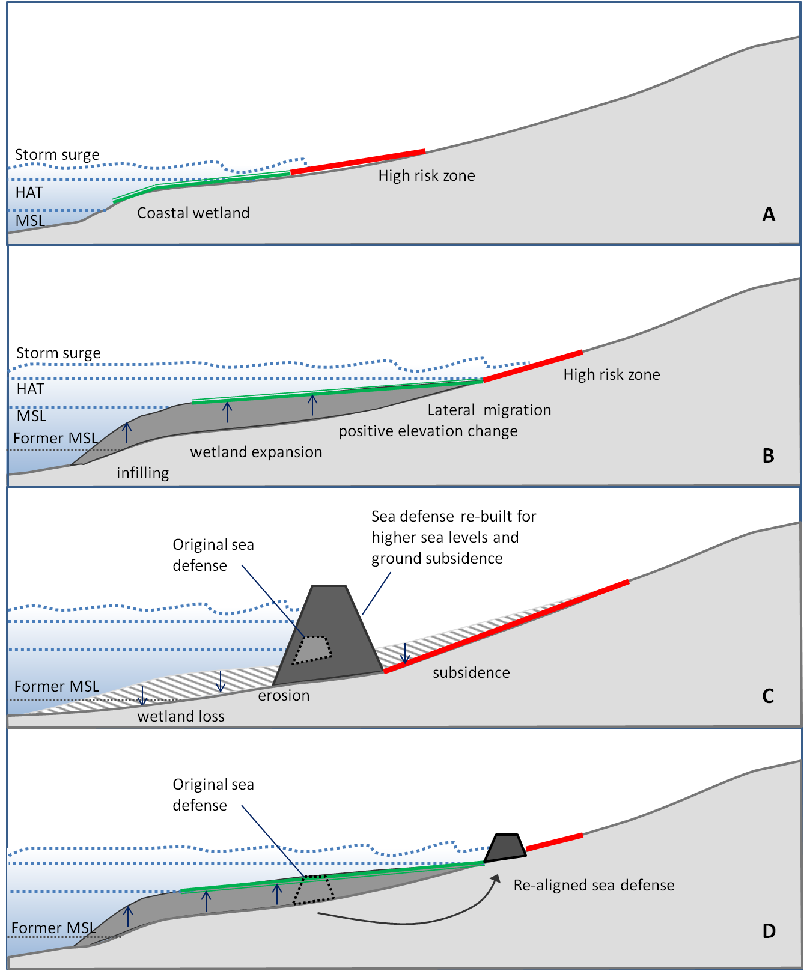

Figure 1: Graphic representation of how elevation of coastal marshes might be expected to vary in response to increases in relative sea level. A – contemporary natural shoreline. B – natural shoreline following sea level rise in locations where growth and sediment supply allow some degree of positive elevation change, as well as lateral (landwards) migration. C – hard engineering solutions “holding the line” of contemporary coastlines through increasingly large interventions. D – Hybrid interventions (see Figure 2), where space is allowed for the maintenance of natural coastal defenses.

Costs and co-benefits
In the face of global change and growing vulnerability, the design, building and maintenance costs of coastal engineered structures is increasing. Existing coastal ecosystems may already be providing some degree of protection with no installation costs, although ecosystem restoration or ongoing management will likely incur future expense. Additionally, compared to mono-functional engineered flood defense infrastructure, coastal ecosystems provide multiple ecosystem services: thus shoreline defense may be only a small fraction of their total value (51). Effective valuation of this array of benefits is critical in coastal planning – the losses associated with hard engineering may be considerable if such protection entails the loss of these co-benefits (52).

Cautions
Of course ecosystems will play a variable role in coastal defense from one area to another, influenced by geomorphic setting (including bathymetry, coastal typology, geology and sediment supply), oceanography (including currents, tides), the dimensions and structure of the habitat, and the local risk environment. Such variability is already incorporated into designs for engineered structures and must be similarly accounted for in the utilization of ecosystems in coastal protection. The state of science for engineered structures is such that their response to particular hazards can be reasonably well modeled, and designs can be altered to achieve maximum risk reductions, often with relatively small spatial footprints, which may be of particular importance adjacent to highly developed shores. By contrast some ecosystems may require a much larger spatial footprint, but they also offer many co-benefits that can be lost with hard engineering approaches. Studies highlighting limitations are as important as those identifying opportunities in the development of ecosystem-based risk reduction (41, 52). In many areas, ecosystems may not provide acceptable levels of risk reduction. Elsewhere optimal solutions will include a hybrid of engineered and ecosystem components, with ecosystems reducing overall risk and increasing the longevity of engineered structures.

Both natural and engineered structures have limits or thresholds to their functional performance. For example, wave attenuation by coral reefs or by submerged breakwaters will be diminished with increasing water depth over the structure (12), and during very high storm surges their role in wave attenuation may be much reduced. While we note that ecosystems often have a regenerative capacity, the most extreme coastal hazards can lead to widespread loss of mangroves, corals and other key biotic components, and can even result in changes in surface elevation. Conditions of substrate, light and elevation may remain suitable for these ecosystems, but time-frames for recovery may be years to decades (53). In places such recovery rates are being enhanced by anthropogenic interventions such as replanting (54, 55). Engineered structures have a design life, typically 20-50 years, and are built for projected environmental, climatic and anthropogenic conditions over that period. Under stable conditions we know that many coastal ecosystems can remain in place for centuries, although such longevity is often accompanied by lateral migration. Such persistence can also be challenged by climate change and more proximal human impacts. Thus coral bleaching and ocean acidification may threaten the longer-term future of coral reefs (56). Even so, reefs are likely to maintain their critical coastal protection function at least for the 20-50 year time scales of most coastal planners.

Recommendations
We note recent and ongoing engineering work which is highlighting the role of ecosystems either alone or in hybrid engineering efforts, such as the Building with Nature work in The Netherlands (57, 58) and living shorelines work in the USA (11, 59). Such initiatives, largely driven by the private sector, complement the already well established efforts under way by many agencies and communities to utilize natural processes through ecosystem conservation, restoration and managed realignment (11, 60-62). Likewise we note the growing interest from other agencies in pursuing this work, including the U.S. Army Corps of Engineers Engineering with Nature approach and the Systems Approach to Geomorphic Engineering (SAGE) initiative of the U.S. Army Corps of Engineers, the Federal Emergency Management Agency (FEMA) and the National Oceanic and Atmospheric Administration, through their consortium, to carry these ideas forward. To embed this idea in policies and planning and work towards co-design of natural and engineered flood risk reduction infrastructure we recommend:

- The risk reduction benefits of ecosystems need to be quantified and incorporated into local planning and development. Conservation and restoration initiatives need to be designed to deliver, or enhance, coastal protection benefits at the point of need. For example oyster reef restoration projects are being designed for specific environmental and risk settings, in the Gulf of Mexico following engineering guidelines for the design of low-crested, submerged breakwaters (62);

- Models and planning approaches also need to account for the cumulative benefits of multiple ecosystems – risk reduction capacity may be greatly enhanced across a sequence of habitats such as seagrasses, shellfish reefs and marshes, and such ecosystem combinations are common;

- Ecosystems should be managed where necessary to maintain or enhance risk reduction properties, including ecological restoration of key structural components of the ecosystem (mangrove, seagrass and saltmarsh plants, corals), but also physical interventions such as the restoration of water and sediment flows and the removal of pollutants;

- Investment decisions including loans by the World Bank and other Development Banks for climate adaptation and disaster risk reduction, and investment by agencies such as FEMA, should be informed not only by direct costs and benefits, but also by the suite of associated ecosystem service benefits that may be lost with hard engineering solutions;

- Where ecosystems offer acceptable levels of risk reduction then funds such as FEMA’s hazard mitigation grants, or international support such as Climate Adaptation Funds, should target and incentivize habitat conservation and restoration measures, and/or the utilization of hybrid solutions rather than focusing solely on hard defense solutions;

- Risk insurance models should examine risk reduction benefits associated with intact ecosystems; and where appropriate property owners should receive incentives for ecosystem conservation/restoration;

- While the design life of engineered structures is often well quantified, a similar quantification is only just starting to develop for ecosystems. Future research should be directed towards establishing a better knowledge of the resilience of natural features at the coast to allow these features to be incorporated into integrated coastal protection frameworks.

Risk reduction in coastal areas is achieved through a variety of measures, including structural approaches (i.e. levees or walls), legal frameworks (i.e. building codes, land use zoning) and social and behavioral modifications (i.e. evacuation, retreat (Figure 2). Ecosystems form a critical but rarely acknowledged part of risk reduction in many areas, with potential cost-savings and co-benefits. New efforts and funding for coastal adaptation are rapidly being developed and allocated (63, 64); if appropriate natural solutions are overlooked, the economic and social costs for future generations will be significant.

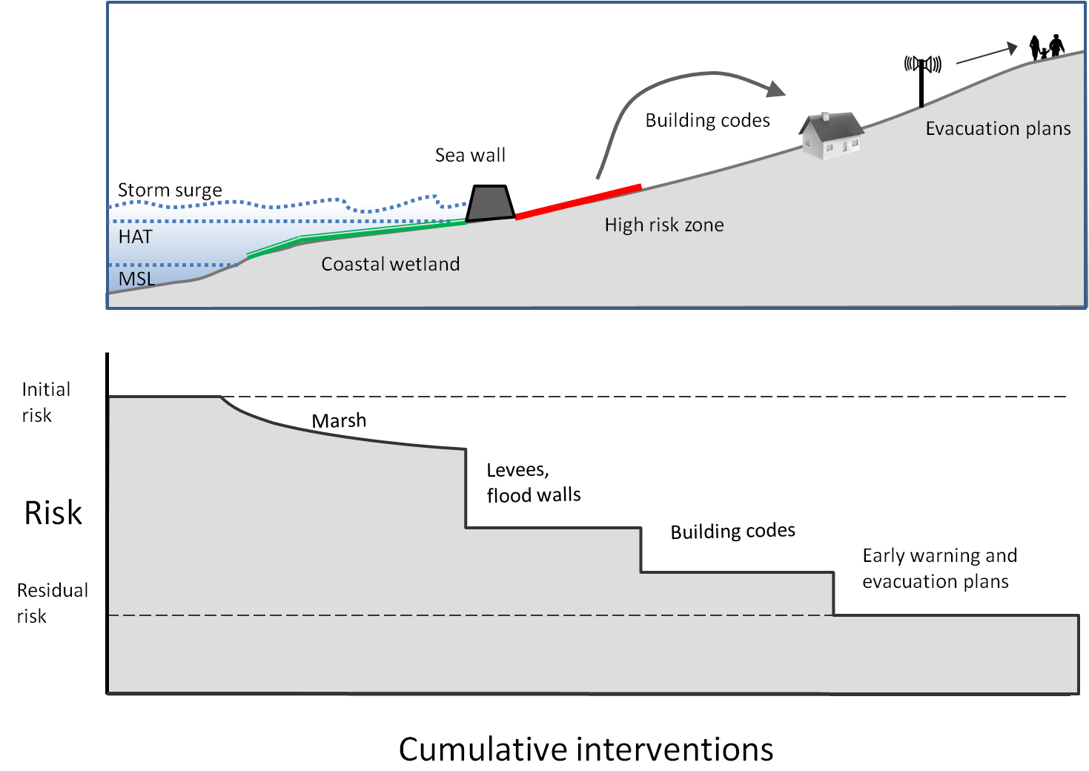

Figure 2: Ecosystems can form an important part of risk reduction, which is typically achieved through a combination of environmental, engineered, social, cultural and legal approaches as illustrated in the upper figure. Cumulative interventions (lower figure) cannot remove risk, but rather reduce it to an acceptable level of residual risk.

References and Notes
1. G. Villarini, G. A. Vecchi, T. R. Knutson, M. Zhao, J. A. Smith, North Atlantic Tropical Storm Frequency Response to Anthropogenic Forcing: Projections and Sources of Uncertainty. J. Clim. 24, 3224 (2011).
2. M. A. Bender et al., Modeled Impact of Anthropogenic Warming on the Frequency of Intense Atlantic Hurricanes. Science 327, 454 (2010).
3. H. Murakami, B. Wang, A. Kitoh, Future Change of Western North Pacific Typhoons: Projections by a 20-km-Mesh Global Atmospheric Model*. J. Clim. 24, 1154 (2011).
4. R. Pielke, Jr., D. Sarewitz, Bringing Society Back into the Climate Debate. Popul. Environ. 26, 255 (2005).
5. M. R. Bloomberg, “A Vote for a President to Lead on Climate Change,” Bloomberg View, 2012.
6. R. Mendelsohn, K. Emanuel, S. Chonabayashi, L. Bakkensen, The impact of climate change on global tropical cyclone damage. Nature Climate Change 2, 205 (2012).
7. U.S. Army Corps of Engineers, Coastal Engineering Manual. Engineer Manual 1110-2-1100. (U.S. Army Corps of Engineers, Washington DC, 2002).
8. D. Reeve, A. J. Chadwick, C. Fleming, Coastal Engineering: Processes, Theory and Design Practice (Spon Press, Taylor and Francis Group, London and New York., 2004).
9. J. W. Kamphuis, Introduction to Coastal Engineering and Management (2nd Edition). Advanced Series on Coastal Engineering (World Scientific, ed. 2, 2010), pp. 600.
10. H. D. Niemeyer, H. Eiben, H. Rohde, in History and Heritage of Coastal Engineering, N. C. Kraus, Ed. (American Society of Civil Engineers, 1996), pp. 169-213.
11. C. Currin, W. Chappell, A. Deaton, in Puget Sound Shorelines and the Impacts of Armoring—Proceedings of a State of the Science Workshop, May 2009 H. Shipman, M. Dethier, G. Gelfenbaum, K. Fresh, R. Dinicola, Eds. (U.S. Geological Survey Scientific Investigations Report 2010-5254, 2010), pp. 91-102.
12. P. S. Kench, R. W. Brander, Wave Processes on Coral Reef Flats: Implications for Reef Geomorphology Using Australian Case Studies. J. Coast. Res., 209 (2006).
13. E. W. Koch, L. P. Sanford, S.-N. Chen, D. J. Shafer, J. M. Smith, “Waves in Seagrass Systems: Review and Technical Recommendations” (Washington, D.C., 2006).
14. I. Möller, Quantifying saltmarsh vegetation and its effect on wave height dissipation: Results from a UK East coast saltmarsh. Estuarine Coast. Shelf Sci. 69, 337 (2006).
15. Y. Mazda, M. Magi, Y. Ikeda, T. Kurokawa, T. Asano, Wave reduction in a mangrove forest dominated by Sonneratia sp. Wetlands Ecol. Manage. 14, 365 (Aug, 2006).
16. K. Gedan, M. Kirwan, E. Wolanski, E. Barbier, B. Silliman, The present and future role of coastal wetland vegetation in protecting shorelines: answering recent challenges to the paradigm. Clim. Change 106, 7 (2011).
17. I. Möller, T. Spencer, Wave dissipation over macro-tidal saltmarshes: Effects of marsh edge typology and vegetation change. J. Coast. Res. 36, 506 (2002).
18. E. W. Koch et al., Non-linearity in ecosystem services: temporal and spatial variability in coastal protection. Frontiers Ecol. Env. 7, 29 (2009).
19. T. Suzuki, M. Zijlema, B. Burger, M. C. Meijer, S. Narayan, Wave dissipation by vegetation with layer schematization in SWAN. Coast. Eng. 59, 64 (Jan, 2012).
20. Y. Yao, Z. Huang, S. G. Monismith, E. Y. M. Lo, 1DH Boussinesq modeling of wave transformation over fringing reefs. Ocean Eng. 47, 30 (2012).
21. M. S. Fonseca, J. A. Cahalan, A preliminary evaluation of wave attenuation by four species of seagrass. Estuarine Coast. Shelf Sci. 35, 565 (1992).
22. K. W. Krauss et al., Water level observations in mangrove swamps during two hurricanes in Florida. Wetlands 29, 142 (2009).
23. T. V. Wamsley, M. A. Cialone, J. M. Smith, J. H. Atkinson, J. D. Rosati, The potential of wetlands in reducing storm surge. Ocean Eng. 37, 59 (2009).
24. K. Zhang et al., The role of mangroves in attenuating storm surges. Estuarine Coast. Shelf Sci. 102–103, 11 (2012).
25. R. Cochard et al., The 2004 tsunami in Aceh and Southern Thailand: A review on coastal ecosystems, wave hazards and vulnerability. Pers. Plant Ecol. Evol. Systematics 10, 3 (2008).
26. H. J. S. Fernando, S. P. Samarawickrama, S. Balasubramanian, S. S. L. Hettiarachchi, S. Voropayev, Effects of porous barriers such as coral reefs on coastal wave propagation. J. Hydro-env. Res. 1, 187 (2008).
27. G. Gelfenbaum, A. Apotsos, A. W. Stevens, B. Jaffe, Effects of fringing reefs on tsunami inundation: American Samoa. Earth-Sci. Rev. 107, 12 (2011).
28. J. C. Laso Bayas et al., Influence of coastal vegetation on the 2004 tsunami wave impact in west Aceh. Proc. Natl. Acad. Sci. U.S.A.108, 18612 (November 7, 2011, 2011).
29. N. Tanaka, Vegetation bioshields for tsunami mitigation: review of effectiveness, limitations, construction, and sustainable management. Landscape Ecol. Eng. 5, 71 (Feb, 2009).
30. S. Das, J. R. Vincent, Mangroves protected villages and reduced death toll during Indian super cyclone. Proc. Natl. Acad. Sci. U.S.A. 106, 7357 (May 5, 2009, 2009).
31. B. Chatenoux, P. Peduzzi, Impacts from the 2004 Indian Ocean Tsunami: analysing the potential protecting role of environmental features. Nat. Hazards 40, 289 (2007).
32. K. L. McKee, Biophysical controls on accretion and elevation change in Caribbean mangrove ecosystems. Estuarine Coast. Shelf Sci. 91, 475 (Mar 1, 2011).
33. C. E. Lovelock, V. Bennion, A. Grinham, D. R. Cahoon, The Role of Surface and Subsurface Processes in Keeping Pace with Sea Level Rise in Intertidal Wetlands of Moreton Bay, Queensland, Australia. Ecosystems 14, 745 (2011).
34. C. T. Perry, S. G. Smithers, P. Gulliver, N. K. Browne, Evidence of very rapid reef accretion and reef growth under high turbidity and terrigenous sedimentation. Geology 40, 719 (2012).
35. E. Gacia et al., Sediment deposition and production in SE-Asia seagrass meadows. Estuarine Coast. Shelf Sci. 56, 909 (2003).
36. D. R. Plew, Depth-Averaged Drag Coefficient for Modeling Flow through Suspended Canopies. J. Hydraulic Eng. 137, 234 (2011).
37. A. Lefebvre, C. E. L. Thompson, C. L. Amos, Influence of Zostera marina canopies on unidirectional flow, hydraulic roughness and sediment movement. Continental Shelf Res. 30, 1783 (2010).
38. A. Wang, S. Gao, J. Chen, D. Li, Sediment dynamic responses of coastal salt marsh to typhoon "KAEMI" in Quanzhou Bay, Fujian Province, China. Chinese Sci. Bulletin 54, 120 (2009).
39. E. Koch, J. Ackerman, J. Verduin, M. Keulen, in Seagrasses: Biology, Ecology and Conservation, A. W. D. Larkum, R. J. Orth, C. M. Duarte, Eds. (Springer Netherlands, 2006), pp. 193-225.
40. W. F. de Boer, Seagrass–sediment interactions, positive feedbacks and critical thresholds for occurrence: a review. Hydrobiologia 591, 5 (2007).
41. R. A. Feagin et al., Does vegetation prevent wave erosion of salt marsh edges? Proc. Natl. Acad. Sci. U.S.A. 106, 10109 (2009).
42. S. L. Yang et al., Spatial and temporal variations in sediment grain size in tidal wetlands, Yangtze Delta: On the role of physical and biotic controls. Estuarine Coast. Shelf Sci. 77, 657 (2008).
43. U. Neumeier, C. L. Amos, Turbulence reduction by the canopy of coastal Spartina salt-marshes. J. Coast Res., 433 (2006).
44. K. L. McKee, D. Cahoon, I. C. Feller, Caribbean mangroves adjust to rising sea-level through biotic controls on soil elevation change. Global Ecol. Biogeog. 16, 545 (2007).
45. L. F. Montaggioni, History of Indo-Pacific coral reef systems since the last glaciation: Development patterns and controlling factors. Earth-Sci. Rev. 71, 1 (2005).
46. J. R. L. Allen, Morphodynamics of Holocene salt marshes: a review sketch from the Atlantic and Southern North Sea coasts of Europe. Quaternary Sci. Rev. 19, 1155 (2000).
47. S. Rupp-Armstrong, R. J. Nicholls, Coastal and Estuarine Retreat: A Comparison of the Application of Managed Realignment in England and Germany. J. Coast. Res. 23, 1418 (2007).
48. J. P. M. Syvitski et al., Sinking deltas due to human activities. Nature Geosci. 2, 681 (2009).
49. C. M. Crain, K. B. Gedan, M. Dione, in Human Impacts on Salt Marshes: a Global Perspective, B. R. Silliman, E. D. Grosholz, M. D. Bertness, Eds. (University of California Press, Berkeley, CA, 2009), pp. 149-169.
50. L. A. Boorman, A. Garbutt, in Treatise on Estuarine and Coastal Science, L. Chicharo, M. Zalewski, Eds. (Elsevier, Amsterdam, 2012), vol. 10, pp. 189-216.
51. E. B. Barbier et al., The value of estuarine and coastal ecosystem services. Ecol. Monogr. 81, 169 (2011).
52. R. A. Feagin et al., Shelter from the storm? Use and misuse of coastal vegetation bioshields for managing natural disasters. Cons. Lett. 3, 1 (2009).
53. D. M. Alongi, Mangrove forests: Resilience, protection from tsunamis, and responses to global climate change. Estuarine Coast. Shelf Sci. 76, 1 (2008).
54. Á. Borja, D. Dauer, M. Elliott, C. Simenstad, Medium- and Long-term Recovery of Estuarine and Coastal Ecosystems: Patterns, Rates and Restoration Effectiveness. Estuaries and Coasts 33, 1249 (2010/11/01, 2010).
55. R. R. Lewis III, G. Perillo, in Coastal Wetlands: An Integrated Ecosystem Approach. (Elsevier, Oxford, UK, 2009), pp. 787-800.
56. J. E. N. Veron et al., The coral reef crisis: The critical importance of <350ppm CO2. Mar. Pollut. Bull. 58, 1428 (2009).
57. B. W. Borsje et al., How ecological engineering can serve in coastal protection. Ecol. Eng. 37, 113 (2011).
58. R. E. van den Hoek, M. Brugnach, A. Y. Hoekstra, Shifting to ecological engineering in flood management: Introducing new uncertainties in the development of a Building with Nature pilot project. Env. Sci. Pol. 22, 85 (2012).
59. L. Wallendorf, R. Walker, B. Bendell, in Coastal Engineering Practice. Proceedings of the 2011 Conference on Coastal Engineering Practice, held in San Diego, California, August 21-24, 2011, O. T. Magoon, R. M. Noble, D. D. Treadwell, Y. C. Kim, Eds. (American Society of Civil Engineers, San Diego, 2011), pp. 1064-1077.
60. IFRC, Breaking the waves. Impact analysis of coastal afforestation for disaster risk reduction in Viet Nam., (International Federation of Red Cross and Red Crescent Societies, Geneva, 2011), pp. 51.
61. T. Luisetti et al., Coastal and marine ecosystem services valuation for policy and management: Managed realignment case studies in England. Ocean Coast. Manage. 54, 212 (2011).
62. S. B. Scyphers, S. P. Powers, K. L. Heck, D. Byron, Oyster reefs as natural breakwaters mitigate shoreline loss and facilitate fisheries. PLoS ONE 6, (2011).
63. R. J. T. Klein, A. Möhner, The Political Dimension of Vulnerability: Implications for the Green Climate Fund. IDS Bulletin 42, 15 (2011).
64. J. Ford, L. Berrang-Ford, J. Paterson, A systematic review of observed climate change adaptation in developed nations. Clim. Change 106, 327 (2011).

We acknowledge funding from this work provided to The Nature Conservancy by the Forrest and Frances Lattner Foundation and the The Morgridge Ecosystem Services Fund, and support from Wetlands International through their project Mangrove Capital. We are also grateful to the many participants who attended workshops held in Washington DC, Bogor, Indonesia and Cambridge, UK which helped in the development of our ideas, including Dolf de Groot, Joanna Ellison, Filippo Ferrario, Catherine Lovelock, Karen McKee, David McKinnie, I. Nyoman Suryadiputra, Norio Tanaka, Femke Tonneijck, Mai Sỹ Tuấn, Jan van Dalfsen, Pieter van Eijk, Jo Wilson and Han Winterwerp.

