Glucocorticoid Prescribing Trends in Congenital Adrenal Hyperplasia, 2017 to 2023
Glucocorticoid Use in CAH, 2017–2023
Roxas A^{1*}, Gihawi A^{1, 58*}, Makarchuk M¹, Bryce J², Chen M², Ahmed S.F^{2,3}, Ali S.R^{2,3}, Drake A¹, Casipe M⁴, Groves L¹, Idkowiak J⁵, Krone R⁵, Flueck C⁶, Nordenström A⁷, Reisch N⁸, Claahsen – van der Grinten H.L.⁹, Adriaansen B.P.H⁹, Birkebaek N.H¹⁰, Hannema S¹¹, O Reilly M.W¹²,Cussen L¹², Zaric S.P¹³, Neumann U¹⁴, Baronio F¹⁵, Vieites A¹⁶, Alonso G.F¹⁷, Elsedfy H¹⁸, Mazen I¹⁹, Thankamony A²⁰, Witczak J²¹, Rees D.A²¹, Atapattu N²², Seneviratne S.N²³, Cools M²⁴, Hayat El Kaddouri²⁴, Alegria Ferri Perez²⁴, Guven A²⁵, Poyrazoglu S²⁶, Fu A²⁷, Janus D²⁸, Globa E²⁹, Shenoy S³⁰, de Bruin C³¹, Korbonits M³², Adam S³³, Wasniewska M³⁴, Russo G³⁵, Phan-Hug F^{36,37}, Bonfig W³⁸, Salerno M³⁹, Tomlinson J.W⁴⁰, Leka-Emiri S⁴¹, de Vries L⁴², Yarhere I⁴³, Guaranga-Filho G⁴⁴, van Eck J⁴⁵, Bachega T.A.S.S⁴⁶, Krone N⁴⁷, De Bono M⁴⁸, Davies JH⁴⁹, Segev-Becker A⁵⁰, Iotova V⁵¹, Lenherr-Taube N⁵², German A⁵³, Giordano R⁵⁴, De Sanctis L⁵⁵, Probst U⁵⁶, Markosyan R⁵⁷, Brewer D⁵⁸, Costa E.C⁵⁹, Webb EA^{1, 60}
* These authors contributed equally to this work
¹ Norwich Medical School, University of East Anglia, Norwich, UK, ² Office for Rare Conditions, Royal Hospital for Children & Queen Elizabeth University Hospital, Glasgow, United Kingdom, ³ Developmental Endocrinology Research Group, School of Medicine, Dentistry & Nursing, University of Glasgow, Glasgow, United Kingdom, ⁴ Royal Devon University Healthcare NHS Foundation Trust, ⁵ Department of Paediatric Endocrinology, Birmingham Women's & Children's Hospital, Birmingham B4 6NH, UK, ⁶ Pediatric Endocrinology, Diabetology and Metabolism, Department of Pediatrics and Department of Biomedical Research, Bern University Hospital Inselspital, University of Bern, 3010 Bern, Switzerland, ⁷ Department of Women's and Children's Health, Karolinska Institute, Stockholm, Sweden/Paediatric Endocrinology Unit, Karolinska University Hospital, Stockholm, Sweden, ⁸ Medizinische Klinik IV, Ludwig-Maximillian University Hospital Munich, Munich, Germany,⁹ Department of Paediatrics, Division of Paediatric Endocrinology, Radboud university medical centre, Amalia Children’s hospital, Nijmegen, the Netherlands, ¹⁰ Department of Paediatrics, Aarhus University Hospital, Aarhus N., Denmark, ¹¹ Department of Pediatric Endocrinology, Amsterdam UMC location Vrije Universiteit Amsterdam, Amsterdam, The Netherlands, ¹² Beaumont Hospital and RCSI University of Medicine and Health Sciences, Dublin, Ireland, ¹³ Department of Endocrinology, Institute for Mother and Child Healthcare of Serbia, ¹⁴ Institute for Experimental Paediatric Endocrinology, Charité Universitätsmedizin Berlin, Berlin, Germany, ¹⁵ Department Hospital of Woman and Child, Pediatric Unit, Center for Rare Endocrine Conditions (Endo-ERN), IRCCS - S.Orsola-Malpighi University Hospital, 40138 Bologna, Italy, ¹⁶ Centro de Investigaciones Endocrinológicas, División de Endocrinología, Hospital de Niños Ricardo Gutiérrez, Buenos Aires, Argentina, ¹⁷ Sección Endocrinología Pediátrica, Hospital Italiano de Buenos Aires, ¹⁸ Department of Pediatrics, Ain Shams University, Cairo, Egypt, ¹⁹ Clinical Genetics Department, Human Genetics and Genome Research Institute, National Research Centre, Cairo, Egypt, ²⁰ Department of Paediatrics, University of Cambridge, Cambridge, UK, ²¹ Neuroscience and Mental Health Innovation Institute, School of Medicine, Cardiff University, UK, ²² Endocrinology, Lady Ridgeway Hospital for Children, Colombo, Sri Lanka, ²³ Department of Paediatrics, Faculty of Medicine, University of Colombo, Colombo, Sri Lanka, ²⁴ Department of Internal Medicine and Paediatrics, Ghent University, and Department of Paediatric Endocrinology, Ghent University Hospital, Ghent, Belgium, ²⁵ Emeritus Professor of Health Science University, İstanbul, Turkey ²⁶ Istanbul Faculty of Medicine, Pediatric Endocrinology Unit, Istanbul University, Istanbul, Turkey, ²⁷ Department of Paediatrics, Princess Margaret Hospital, Kowloon, Hong Kong, ²⁸ Department of Paediatric and Adolescent Endocrinology, University Children's Hospital, Jagiellonian University, Krakow, Poland. dominika.janus@uj.edu.pl, ²⁹ Ukrainian Research Centre of Endocrine Surgery, Endocrine Organs and Tissue Transplantation, MoH of Ukraine, ³⁰ Department of General Paediatrics and Endocrinology, Leicester Children's Hospital, University Hospitals of Leicester NHS Trust, Leicester, UK, ³¹ Division of Endocrinology, Department of Pediatrics, Willem-Alexander Children's Hospital, Leiden University Medical Center, Leiden, the Netherlands, ³² Centre for Endocrinology, William Harvey Research Institute, Barts and the London School of Medicine and Dentistry, Queen Mary University of London, UK, ³³ Department of Endocrinology, The Christie Hospital NHS Foundation Trust, Manchester, UK./Manchester Academic Health Science Centre, Manchester, UK/Faculty of Biology, Medicine and Health, The University of Manchester, Manchester, UK, ³⁴ Unit of Pediatrics, Department of Human Pathology of Adulthood and Childhood, University of Messina, Messina, Italy, ³⁵ IRCCS Ospedale San Raffaele, Milan Italy, ³⁶ Pediatric Endocrinologist, Hôpital de Morges, Morges, Switzerland, ³⁷ Service of Endocrinology, Diabetology, and Metabolism, Lausanne University Hospital, Lausanne, Switzerland, ³⁸ Department of Pediatrics, Technical University of Munich, TUM School of Medicine, 80804 Munich, Germany, ³⁹ Department of Translational Medical Sciences, Paediatric Endocrinology Unit, University of Naples 'Federico II', Naples, Italy, ⁴⁰ Oxford Center for Diabetes, Endocrinology and Metabolism, University of Oxford, Oxford, UK jeremy.tomlinson@ocdem.ox.ac.uk, ⁴¹ Department of Endocrinology-Growth and Development, 'P & A Kyriakou' Children's Hospital, Athens, Greece, ⁴² The Jesse Z and Sara Lea Shafer Institute for Endocrinology and Diabetes, National Center for Childhood Diabetes, Schneider Children's Medical Center of Israel, Petah Tikva, Israel; Sackler Faculty of Medicine, Tel Aviv University, Tel Aviv, Israel. Electronic address: liatdevries@gmail.com, ⁴³ Endocrinology Unit, Paediatrics Department, University of Port Harcourt Teaching Hospital, Port Harcourt, Nigeria, ⁴⁴ Universidade Feberal do Rio Grande dol Sul (UFRDS), Porto Alegre, Brazil, ⁴⁵ Department of Pediatrics, div pediatric endocrinology, Erasmus MC Center of expertise for DSD, Erasmus Medical Center-Sophia Children's Hospital, Rotterdam, Netherlands, ⁴⁶ Unidade de Endocrinologia do Desenvolvimento, Laboratório de Hormônios e Genética Molecular/LIM42, Disciplina de Endocrinologia, Hospital Das Clinicas, Faculdade De Medicina, Universidade de Sao Paulo, São Paulo, Brazil, ⁴⁷ Department of Oncology and Metabolism, University of Sheffield, Sheffield, UK, ⁴⁸ Department of Endocrinology, Sheffield Teaching Hospitals NHS Foundation Trust, Sheffield, UK, ⁴⁹ Faculty of Medicine, University of Southampton, Southampton, SO16 5YA, UK/Wessex Clinical Genetics Service, University Hospital Southampton National Health Service Foundation Trust, Southampton, SO16 5YA, UK, ⁵⁰ Pediatric Endocrinology and Diabetes Unit, Dana-Dwek Children's Hospital, Tel Aviv Sourasky Medical Center, Tel Aviv, Israel/Sackler Faculty of Medicine, Tel Aviv University, Tel Aviv, Israel, ⁵¹ Medical University Varna, Varna, Bulgaria, ⁵² Division of Pediatric Endocrinology and Diabetology, University Children's Hospital, University of Zurich, CH-8032, Zurich, Switzerland/Children's Research Center, University Children's Hospital, University of Zurich, CH-8032, Zurich, SwitzerlandElectronic address: nina.lenherr@kispi.uzh.ch, ⁵³ The Ruth and Bruce Rappaport Faculty of Medicine, Technion-Israel Institute of Technology, 31096 Haifa, Israel/Pediatric Endocrinology, Haemek Medical Center, 18317 Afula, Israel, ⁵⁴ Department of Biological and Clinical Sciences, University of Turin, Turin, Italy, ⁵⁵ Pediatric Endocrinology Unit, Regina Margherita Children's Hospital, University of Turin, 10126 Turin, Italy, ⁵⁶ Pediatric Department, Kantonsspital Winterthur, Winterthur, Switzerland, ⁵⁷ Endocrinology, Yerevan State Medical University Endocrinology Clinic, Yerevan, Armenia, 1, ⁵⁸ Metabolic Health Research Centre, Norwich Medical School, University of East Anglia, Norwich, UK,⁵⁹ Hospital de Clinical de Porto Alegre, Porto Alegre, Brazil, ⁶⁰ Norfolk and Norwich University Hospital NHS Foundation Trust Colney Lane, Norwich NR4 7UY

Keywords: Congenital Adrenal Hyperplasia, Glucocorticoid, Prescribing, Hydrocortisone
Corresponding author’s postal and email address:
Dr. Emma Webb, Jenny Lind Children's Hospital, Norfolk and Norwich University Hospital, NHS Foundation Trust, Colney Lane, Norwich NR4 7UY emma.webb@nnuh.nhs.uk
EW made a substantial contribution to the organisation and conduct of the study and critiqued the output for important intellectual content

Acknowledgements
The I‐CAH/I‐DSD registries were developed using support research grants from the Medical Research Council (G1100236), the Seventh European Union Framework Programme (201444), the European Society for Paediatric Endocrinology Research Unit, and an unrestricted education grant from Diurnal Ltd. X. T. is supported by an unrestricted educational grant from Neurocrine Biosciences. Abraham Gihawi is supported by Prostate Cancer UK (research grant reference: TLD-CAF22-011).
Conflict of Interest Statement
The authors declare no conflict of interest while conducting the study.

Author Declaration
H. L. Claahsen–van der Grinten has served as a medical adviser for Crincerfont and has received a lecture fee from Sandoz (2025).
J. W. Tomlinson has received a lecture fee from Neurocrine (2025).
A. Rees has received honoraria for lectures from Neurocrine Biosciences and FrostPharma, and for participation in an advisory board for Neurocrine Biosciences.

Funding Statement
Research grants from the Medical Research Council (G1100236), the Seventh European Union Framework Programme (201444), the European Society for Paediatric Endocrinology Research Unit and an unrestricted education grant from Diurnal Ltd. X. T. is supported by an unrestricted educational grant from Neurocrine Biosciences.

Ethics
The I-DSD Registry is approved by the National Research Ethics Service in the United Kingdom as a research database of information that is collected as part of routine clinical care (19/WS/0131). The data within this registry are deposited by clinicians following informed consent from patients or guardians. The study was carried out according to the Declaration of Helsinki.

Data availability statement
The datasets generated and analysed during the current study are not available publicly but available to access through a data sharing agreement available at https://idsdorg.files.wordpress.com/2021/11/i-dsd-i-cah-i-ts-data-sharing-agreement-v4.0-241121.docx.

Glucocorticoid Prescribing Trends in Congenital Adrenal Hyperplasia, 2017 to 2023
Glucocorticoid Use in CAH, 2017–2023
2,848 words (excluding references and figure legends)

ABSTRACT
Objective: This study investigates the utilization of modern glucocorticoid medications (Acecort®, Alkindi®, Efmody®, Plenadren®) for congenital adrenal hyperplasia due to 21-hydroxylase deficiency, examining prescribing patterns, barriers to adoption, and geographical and temporal trends. Methods: A two-part study was conducted: a retrospective analysis of treatment regimens from the International Congenital Adrenal Hyperplasia Registry across 46 centres in 20 countries (2017-2023), and a qualitative survey of 39 centres regarding barriers to prescribing modern medications. Patients included both paediatric and adult populations. Data analysed included regional prescription trends, timing of modern glucocorticoid adoption, and identified barriers. Results: From 2017-2023, 44 of 790 (5%) patients transitioned from traditional to modern glucocorticoid therapy, with the highest adoption in high-income Western European countries. Alkindi® was exclusively prescribed to patients under 8 years, while 97% of Efmody® users were 7 years or older. By 2023, modern glucocorticoid availability varied among centres: Alkindi® (54%), Efmody® (46%), Plenadren® (33%), and Acecort® (15%).. Conclusion: Adoption of modern glucocorticoid medications for congenital adrenal hyperplasia remains limited, with only approximately 5% of patients transitioning from traditional therapies. Significant barriers include legislative approval, supply chain challenges, and elevated costs.

PLAIN LANGUAGE SUMMARY
This international study looked at how new medications for congenital adrenal hyperplasia are used globally. We found that despite increasing availability of new medications during the study time period, only a small number of patients (5%) switched to these newer treatments. This limited use is mainly due to high costs, problems with getting legal approval, and supply issues, highlighting unequal access to care worldwide.
INTRODUCTION
Congenital adrenal hyperplasia (CAH) most commonly results from pathogenic variants in the CYP21A2 gene, leading to 21-hydroxylase deficiency (21-OHD) ¹. This enzyme deficiency impairs cortisol and aldosterone synthesis and results in excess androgen production ². The clinical spectrum of CAH is diverse, ranging from mild to severe forms depending on the extent of the enzymatic defect and associated hormonal disturbances ¹.

Lifelong glucocorticoid (GC) replacement is essential for individuals with classic 21-OHD. Standard treatment includes the use of GCs including, hydrocortisone, prednisolone or dexamethasone, which serve to replace cortisol and suppress excess adrenal androgen production via negative feedback on the hypothalamic–pituitary–adrenal (HPA) axis³. Dosing regimens are individualised based on the patient's age, physical characteristics, disease severity, and therapeutic response. The treatment goal is to restore physiological cortisol concentrations while suppressing androgens to within normal ranges. However, achieving this balance remains clinically challenging ⁴.

Management is further complicated by factors such as intercurrent illness, physical stress, growth spurts, and puberty, particularly in paediatric populations ¹. Dexamethasone was introduced in CAH management in 1971, while HC and prednisolone have been in use since the 1950s ⁵⁻⁷. HC remains the cornerstone of replacement therapy for growing children, frequently administered as a thrice-daily immediate-release formulation. However, there are currently no standardised treatment guidelines for adults ⁴. The lack of robust comparative studies evaluating different GC regimens has led to variability in prescribing practices across different providers and regions ^{8,9}.

Conventional GC therapies do not accurately replicate the body's natural circadian rhythm of cortisol secretion due to its short half-life and non-physiological dosing. This results in periods of overtreatment, causing adrenal hormone oversuppression, or undertreatment, leading to hyperandrogenism, in both children and adults ^{4,10}. Two large cohort studies found that only one-third of the study population had normal serum androstenedione levels ^{10,11}, with high rates of associated health complications, including hypertension, obesity, subfertility, and hirsutism present ¹². Additional studies confirm that prolonged exposure to supraphysiologic GC doses correlates with adverse metabolic outcomes. In a Swedish cohort, Falhammer et al. reported higher rates of hypertension, obesity, dyslipidemia, and diabetes in 588 CAH patients compared to controls ^{13,14}. Similarly, the UK Congenital Adrenal Hyperplasia Adult Study Executive (CaHASE) study found that CAH patients had significantly higher BMI and reduced adult height ¹¹.

Beyond physical health, current treatment limitations negatively affect psychological well-being. Individuals with CAH often report a lower quality of life (QoL) and poorer body image compared to non-CAH peers ^{15,16}. These findings underscore the need for improved therapeutic strategies and modern medication options.

Recent advancements in CAH management include the development of innovative steroid replacement medications. For this study, “modern GC medications” refers to agents other than standard HC, dexamethasone, and prednisolone. Specifically, we define this group to include Alkindi®, Acecort®, Efmody® (also known as Chronocort), and Plenadren® ¹².

Alkindi® granules (0.5, 1, 2, and 5 mg) and Acecort® tablets (1, 2, 3, 5 and 10 mg) provide smaller dosing increments which allow more precise dosing in infants and young children, reducing the risks of adrenal crises and growth disturbances associated with inconsistent dosing ¹⁷⁻¹⁹. Two modified-release HC preparations—Efmody® and Plenadren®—have been developed to mimic natural diurnal cortisol rhythms more effectively ¹². However, it is important to note that Plenadren is currently approved only for Addison’s disease and secondary adrenal insufficiency, not CAH ². However, it is noted that the availability of these modern GC medications for patients varies across countries and between centres ^{8, 24}.

This international study, encompassing data from 46 CAH centres worldwide, aims to:
- Explore the range of GC preparations currently being prescribed for both paediatric and adult patients.
- Identify potential barriers to prescribing modern GC medications.
- Examine geographical and temporal trends in GC prescribing practices from 2017 to 2023.

Patients and Methods
This study comprised two complementary components: a retrospective analysis of prescribing trends and a qualitative survey of clinical practice.
Retrospective Registry Analysis
The retrospective component utilised data from the International Congenital Adrenal Hyperplasia (I-CAH) Registry, a global, ethically approved clinical database that captures pseudonymised information on patients with CAH. Ethical approval was granted by the UK National Research Ethics Service (Reference: 19/WS/0131), and data entry is conducted by healthcare professionals following informed consent from patients or guardians. The study adhered to the principles outlined in the Declaration of Helsinki.
Paediatric and adult patients included in this analysis were diagnosed with CAH due to 21-OHD. Extracted data included fields from both the registry’s basic module (register ID, year of birth, country, centre, disorder type, definitive diagnosis, sex assigned at birth, and age at diagnosis) and longitudinal module (date of visit, age, height, weight, body surface area, type and dosage of GC, administration timing, and reported treatment adherence).

Qualitative Survey
A structured qualitative survey was distributed to all 46 CAH centres, located in 20 countries contributing to the registry to explore the availability of modern GC medications and perceived barriers to their use. Centres were categorised by country income level using the World Bank’s World Development Indicators ²¹. Survey items addressed regulatory, economic, logistical, and clinical factors affecting the adoption of modern GCs.

Data Analysis
Quantitative data from the registry were analysed using the R programming language. Descriptive statistics were used to summarise patient demographics and GC prescribing patterns. The number and percentage of patients prescribed modern versus traditional GCs were analysed by year, age group, and country. The availability of Alkindi®, Acecort®, Efmody®, and Plenadren® at each centre was recorded for each year between 2017 and 2023.
Qualitative survey responses were categorised thematically (e.g., cost, approval, supply chain, awareness), and summarised using frequency counts. Data for Gross Domestic Product (GDP) per capita was downloaded from Our World in Data (https://ourworldindata.org/grapher/gdp-per-capita-worldbank?tab=table&overlay=download-data). A box plot was produced for GDP per capita by countries that did or did not use modern glucocorticoid medications using the ggplot R package. Wilcoxon signed-rank tests were calculated using the stat_compare_means function (ggpubr R package) and sample numbers were added to each group using the stat_n_text function (EnvStats R package).
Results
Study Summary
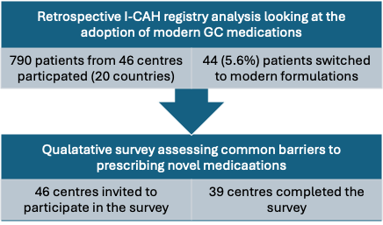
Patient Demographics
Data were available for 790 patients diagnosed with 21-OHD from 46 participating centres globally. Key demographic characteristics at the time of the first recorded visit are summarised in Table 1.

Table 1. Patient demographics at first visit in individuals with congenital adrenal hyperplasia.
Characteristic | N | N = 790¹
Age at First Presentation (years) | 752 | 0.08 (0.08, 0.08)
Height (cm) | 720 | 125 (78, 151)
Weight (kg) | 748 | 26 (10, 52)
BMI (kg/m²) | 715 | 17.6 (15.4, 21.5)
BSA (m²) | 715 | 0.93 (0.47, 1.44)
Follow-up Length (days) | 790 | 992 (420, 1,816)
Fludrocortisone Use | 779 | 598 (77%)
Baseline Medication | 790
Alkindi |  | 3 (0.4%)
Dexamethasone |  | 50 (6.3%)
Hydrocortisone |  | 677 (86%)
Prednisolone |  | 57 (7.2%)
Prednisone |  | 3 (0.4%)
¹ Values are median (Q1, Q3) or n (%)
BMI: Body Mass Index; BSA: Body Surface Area

Adoption of Modern GC Therapies (2017–2023)
Among 790 patients with complete treatment records, 44 patients (5.6%) switched from traditional GC therapies (hydrocortisone, prednisolone, dexamethasone) to modern formulations (Alkindi®, Acecort®, Efmody®, Plenadren®) during the study period. In 2018, only 2 of the participating centres reported having access to Alkindi®. No centres had Efmody® or Acecort®, while 10 centres offered Plenadren®. By 2023, the availability of modern GC formulations had significantly increased. Alkindi® was available at 21 centres, Efmody® at 18 centres, Plenadren® at 13 centres, and Acecort® at 6 centres.
Age-Related Prescribing Patterns
Prescribing patterns varied significantly based on patient age (Figure 1). Alkindi® was exclusively prescribed to patients under the age of 8, with all 12 patients receiving the medication being under 8 years old (mean age 4.37 years; range 0.93-7.92 years). Efmody® was prescribed to 30 out of the 31 patients aged 7 years or older (mean age 13; range 0-24 years). Only one patient aged 14 years was prescribed Acecort®, and no patients were prescribed Plenadren® during the study period.

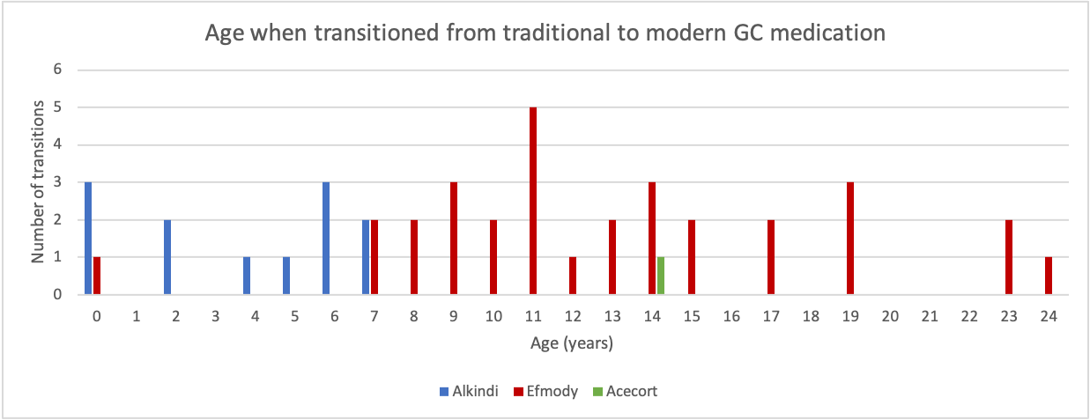
Figure 1. Histogram showing the number of patients who transitioned from traditional to modern GC medication, according to age. Colours represent the type of modern GC: blue (Alkindi), red (Efmody), green (Acecort).
Cross-Centre and Regional Variation
Considerable variation in the availability and adoption of modern GCs was observed between centres, both within and between countries (Figure 3). One anonymised high-income country (“Country A”) exhibited the highest increase in modern GC availability, rising from 10% in 2022 to 45% in 2023. Another high-income country (“Country B”) began adopting modern medications in mid-2023 but maintained a relatively low uptake of about 15% for the remainder of the study period. Countries C, D, and E, all high-income countries, exhibited more consistent but modest uptake of modern GCs. Country D, which introduced modern GCs earlier than Country C, had a plateaued adoption rate of about 13% throughout the study period. Similarly, Country E followed a similar trend. In contrast, Country C experienced a gradual increase in modern medication use from 2019, ultimately reaching 5% by the end of the study period (see Figure 4 for the frequency of uptake of modern GC medications per country by 2023).
Barriers to prescription
A total of 39 centres (out of the original 46) completed the survey. 27 were located in high-income countries, 9 in upper-middle-income countries, 2 in lower-middle-income countries, and 1 in a low-income country.
Several barriers were identified to the prescribing of modern GC medications (Figure 5). The most frequently reported barrier was cost. Centres cited high costs as a barrier to the adoption of various modern GCs. Specifically, five centres reported cost-related barriers to adopting Efmody® (three from high-income countries, one from an upper-middle-income country, and one from a lower-middle-income country). Three centres reported similar concerns regarding Plenadren® (two from high-income countries and one from an upper-middle-income country), while four centres cited cost as a barrier to adopting Alkindi® (two from high-income countries, one from a lower-middle-income country, and one from a low-income country). Three centres noted cost as a barrier to adopting Acecort® (two from high-income countries and one from a lower-middle-income country). There was a trend to GDP being higher in countries where novel GC’s were prescribed (p=0.076, Figure 2).
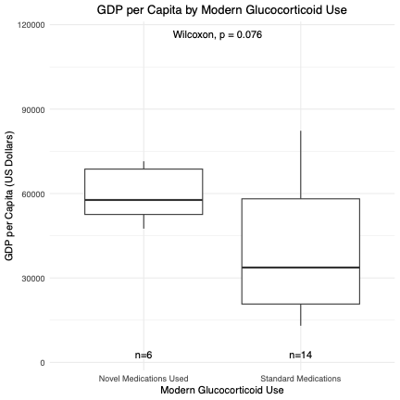
Figure 2. Boxplot showing the difference in GDP per capita between countries where modern GC medication was used (n=6) compared to those where novel GC were not used (n=14)
Other barriers included a lack of confidence in prescribing specific modern GCs. One centre each cited a lack of confidence in prescribing Plenadren® and Acecort®. Additionally, some centres reported limited awareness of the availability of certain modern GCs, with one centre indicating this concern for Plenadren®, one for Alkindi®, and two for Acecort®. Logistical constraints, such as issues with supply chains, were reported as barriers by several centres: six centres cited logistical constraints for Efmody®, eight for Plenadren®, six for Alkindi®, and nine for Acecort®. Novel medications were prescribed in 8 centres based in 6 countries. Overall, there were 24 centres based in these 6 countries reporting data into the registry. There were differences in prescribing practices within countries with some centres reporting the medication as not available/not licensed in their country where other centres in the same country were able to prescribe it.
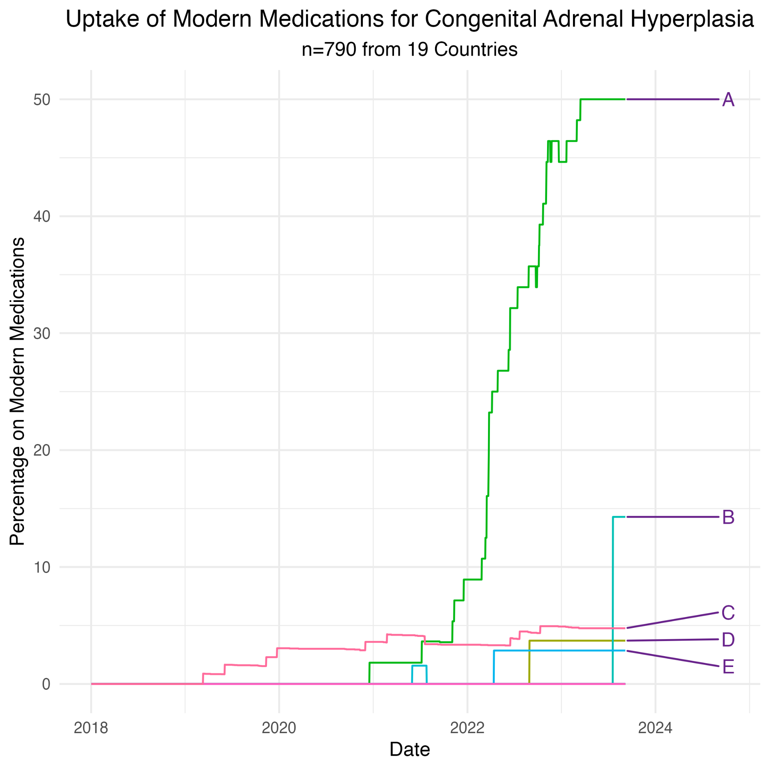
Figure 3. Percentage of patients on modern medications for CAH (Congenital Adrenal Hyperplasia) from 2017-2023 in different geographical areas with different countries being denoted by a different letter.
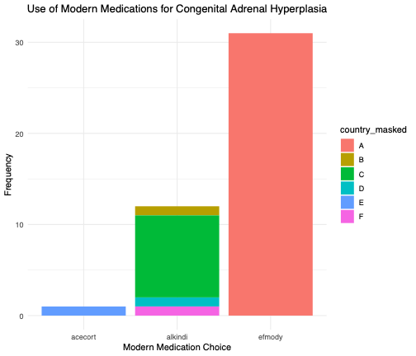
Figure 4. Bar chart showing the frequency of uptake of modern GC medications per country by 2023. Frequency represents the total number of patients on each medication by 2023, with different countries denoted by letters.

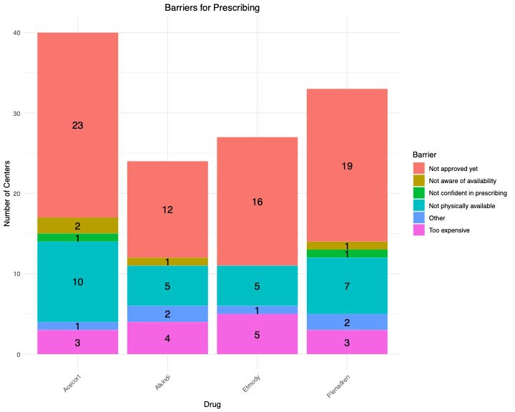
Figure 5. Bar chart showing reported barriers for prescribing according to the type of modern GC. Barriers to prescribing new medications included; medication not approved yet (legislation not in place), poor marketing of the GC preparation (not aware of its availability), not confident in prescribing, not physically available (supply chain not established), Other (no suitable patient, local prescribing approval not in place, centre only manages adults-Alkindi not licensed for adults, patient accessed new medication through cares foundation).

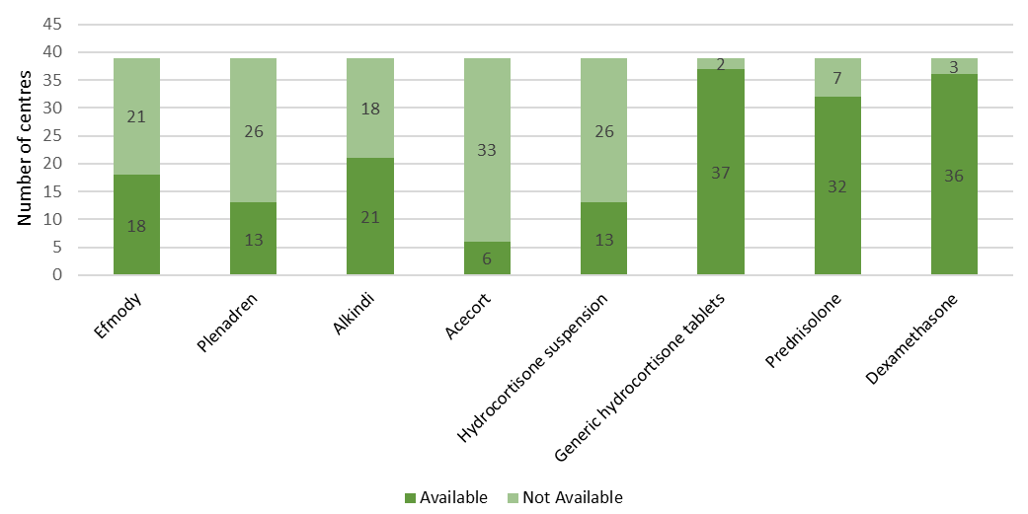
Figure 6. Bar chart showing the availability of drugs (traditional and modern) across the 39 participating centres at the end of 2023.
DISCUSSION
This international multicentre registry study of 790 individuals with 21-OHD provides new insights into GC prescribing trends and barriers to the adoption of modern therapies. Despite increasing global availability, the adoption of modern GCs—defined in this study as Alkindi®, Acecort®, Efmody®, and Plenadren®—remained limited over the study period from 2017 to 2023. Only 5.6% of patients transitioned from traditional GC therapies to modern alternatives, indicating slow integration into routine care.
A marked increase in the availability and prescription of Alkindi® and Efmody® was observed starting in 2021, coinciding with their regulatory approval timelines. Alkindi®, Diurnal’s first licensed paediatric hydrocortisone formulation, was approved via the EU Paediatric Use Marketing Authorisation (PUMA) route in 2018. Initially, it experienced limited uptake but gradually gained popularity over time, likely due to the growing recognition of the clinical need for accurate dosing in infants and young children, a gap Alkindi® addressed with its availability in 0.5 to 5 mg doses ²².
Efmody®, Diurnal’s second GC product, received marketing authorisation from the European Commission in May 2021. The commercial launch of Efmody® in Europe took place in September 2021, following its approval by the UK Medicines and Healthcare Products Regulatory Agency (MHRA) in July 2021. These regulatory milestones likely contributed to the spike in availability across participating centres from 2021 onwards.
Prescribing patterns differed by age, with Alkindi® used exclusively in patients under 7 years of age and Efmody® primarily prescribed in older children and adults. These findings reflect pharmacological licensing (for example, Efmody® is only licensed for ages 12 and over)²³ and pharmacological tailoring of treatment to patient needs, aligning with the intended use of these formulations.
Inter-country differences in uptake were notable. While some high-income countries reported a substantial increase in modern GC availability, others showed minimal uptake, despite similar economic and healthcare contexts ^{8, 24}. This inconsistency mirrors findings from previous multinational studies on CAH management and highlights the ongoing variability in care delivery and medication availability for rare endocrine conditions ^{3, 19, 25}.
The adoption of modern GC faces several notable hurdles. A prominent challenge, cited by up to 55% of centres in the case of Acecort®, is the lack of regulatory approval. This suggests that despite recognised clinical needs and interest among healthcare professionals, delays in legislative processes remain a primary obstacle to their widespread use. Indeed, insights from Diurnal, the manufacturer of Acecort®, corroborate the complexities surrounding regulatory pathways and market availability for these newer treatments ²⁶. Furthermore, Lundgren's broader analysis of barriers to implementing modern therapies for rare endocrine disorders echoes the significant impact of regulatory challenges in this field ²⁷. Cost represents another substantial impediment, frequently reported across diverse economic settings. Notably, expense was a concern not only in low-resource countries but also in high- and upper-middle-income nations. This indicates that price sensitivity is not simply a reflection of a country's economic classification. Instead, it likely reflects variations in national health policies, medication pricing agreements, and reimbursement frameworks, a point further elaborated by Zhao et al.'s work on the economic considerations influencing access to therapies for rare diseases ²⁸. These barriers subsequently result in unequal possibilities for patients.
Other reported barriers included logistical challenges in medication supply chains, limited clinician awareness, and a lack of prescribing confidence. These are common when introducing new formulations and reflect the importance of ongoing education.
The total number of centres responding to the qualitative survey was 39, of which 27 were in high-income countries, 11 in middle-income countries, and one in a low-income country. Socioeconomic status likely influenced access and uptake to some degree, but the inconsistent relationship between income level and barriers such as cost suggests a complex interaction of healthcare funding models, policy frameworks, and market strategy. Pharmaceutical companies may have prioritised markets with favourable reimbursement pathways and greater commercial return, which could help explain early uptake in some high-income centres.
This study has several strengths, including its international scale, integration of quantitative registry data with qualitative centre-level perspectives, and the focus on temporal trends. Nonetheless, limitations must be acknowledged. A key issue was incomplete data from some sites, which may have led to underreporting of modern GC use. Furthermore, the survey did not capture every country or CAH centre globally, and the participating centres may not be fully representative of all clinical settings, introducing potential selection bias. Data on registry participants gender was not available, so we were unable to report height and weight SDS values. In addition, while this study focused on access and prescribing trends, it did not assess the patient profile of those patients for whom a medication switch was considered, treatment outcomes such as mean hydrocortisone-equivalent dose before and after transition to the new formulation limiting conclusions about clinical effectiveness and patient benefit.
Looking forward, ongoing research is needed to address the remaining clinical uncertainties regarding modified-release GC and their long-term impact on metabolic control, growth, fertility, and quality of life. Education and training sessions for prescribers may help increase awareness and confidence in newer medications. Furthermore, as more of these therapies receive approval, repeat analyses of prescribing trends will be important to assess whether existing barriers are reduced over time.
CONCLUSION
This international study highlights the evolving landscape of GC prescribing for CAH, with a gradual but uneven uptake of modern GC formulations such as Alkindi® and Efmody® between 2017 and 2023. Despite the increasing availability of these medications—particularly following European regulatory approvals—adoption remains limited, affecting only 5% of patients in this cohort. Marked inter-country variation was observed, even among high-income settings, suggesting that factors beyond economic classification—such as regulatory approval status, health policy frameworks, and clinician familiarity—play a significant role in access and prescribing behaviour. Barriers, including cost, limited awareness, and supply chain constraints, were frequently reported, underscoring ongoing inequities in CAH care delivery.
The findings reinforce the urgent need for harmonised clinical guidance, increased education on modern GC options, and policy efforts to address structural barriers to medication access. Future research should focus on long-term outcomes associated with newer formulations and on strategies to support equitable implementation across diverse healthcare settings.
References
1. Speiser PW, Azziz R, Baskin LS, et al. Congenital Adrenal Hyperplasia Due to Steroid 21-Hydroxylase Deficiency: An Endocrine Society Clinical Practice Guideline. J Clin Endocrinol Metab. 2010;95(9):4133-4160. doi:10.1210/jc.2009-2631
2. Witchel SF. Congenital Adrenal Hyperplasia. J Pediatr Adolesc Gynecol. 2017;30(5):520-534. doi:10.1016/j.jpag.2017.04.001
3. Claahsen - van der Grinten HL, Speiser PW, Ahmed SF, et al. Congenital Adrenal Hyperplasia—Current Insights in Pathophysiology, Diagnostics, and Management. Endocr Rev. 2022;43(1):91-159. doi:10.1210/endrev/bnab016
4. Mallappa A, Sinaii N, Kumar P, et al. A Phase 2 Study of Chronocort, a Modified-Release Formulation of Hydrocortisone, in the Treatment of Adults With Classic Congenital Adrenal Hyperplasia. J Clin Endocrinol Metab. 2015;100(3):1137-1145. doi:10.1210/jc.2014-3809
5. Rivkees SA. Dexamethasone Therapy of Congenital Adrenal Hyperplasia and the Myth of the “Growth Toxic” Glucocorticoid. Int J Pediatr Endocrinol. 2010;2010:1-7. doi:10.1155/2010/569680
6. Speiser PW. Invited Commentary: A Phase 2, Multicenter Study of Nevanimibe for the Treatment of Congenital Adrenal Hyperplasia. J Clin Endocrinol Metab. 2020;105(10):e3818-e3819. doi:10.1210/clinem/dgaa509
7. Wilkins L, Lewis RA, Klein R, et al. TREATMENT OF CONGENITAL ADRENAL HYPER-PLASIA WITH CORTISONE*. J Clin Endocrinol Metab. 1951;11(1):1-25. doi:10.1210/jcem-11-1-1
8. Bacila I, Freeman N, Daniel E, et al. International practice of corticosteroid replacement therapy in congenital adrenal hyperplasia: data from the I-CAH registry. Eur J Endocrinol. 2021;184(4):553-563. doi:10.1530/EJE-20-1249
9. Ng SM, Stepien KM, Krishan A. Glucocorticoid replacement regimens for treating congenital adrenal hyperplasia. Cochrane Database of Systematic Reviews. 2020;2020(3). doi:10.1002/14651858.CD012517.pub2
10. Finkielstain GP, Kim MS, Sinaii N, et al. Clinical Characteristics of a Cohort of 244 Patients with Congenital Adrenal Hyperplasia. J Clin Endocrinol Metab. 2012;97(12):4429-4438. doi:10.1210/jc.2012-2102
11. Arlt W, Willis DS, Wild SH, et al. Health Status of Adults with Congenital Adrenal Hyperplasia: A Cohort Study of 203 Patients. J Clin Endocrinol Metab. 2010;95(11):5110-5121. doi:10.1210/jc.2010-0917
12. Schröder MAM, Claahsen - van der Grinten HL. Modern treatments for congenital adrenal hyperplasia. Rev Endocr Metab Disord. 2022;23(3):631-645. doi:10.1007/s11154-022-09717-w
13. Falhammar H, Frisén L, Hirschberg AL, et al. Increased Cardiovascular and Metabolic Morbidity in Patients With 21-Hydroxylase Deficiency: A Swedish Population-Based National Cohort Study. J Clin Endocrinol Metab. 2015;100(9):3520-3528. doi:10.1210/JC.2015-2093
14. Whittle E, Falhammar H. Glucocorticoid Regimens in the Treatment of Congenital Adrenal Hyperplasia: A Systematic Review and Meta-Analysis. J Endocr Soc. 2019;3(6):1227-1245. doi:10.1210/js.2019-00136
15. Tschaidse L, Quinkler M, Claahsen-van der Grinten H, et al. Body Image and Quality of Life in Women with Congenital Adrenal Hyperplasia. J Clin Med. 2022;11(15):4506. doi:10.3390/jcm11154506
16. Şentürk Pilan B, Özbaran B, Çelik D, et al. Quality of Life and Psychological Well-being in Children and Adolescents with Disorders of Sex Development. J Clin Res Pediatr Endocrinol. 2021;13(1):23-33. doi:10.4274/jcrpe.galenos.2020.2020.0141
17. ACE Pharmaceuticals. ACEcort. ACE-pharm.nl. Accessed May 7, 2025. https://www.ace-pharm.nl/en/products/acecort/
18. Whitaker MJ, Spielmann S, Digweed D, et al. Development and Testing in Healthy Adults of Oral Hydrocortisone Granules With Taste Masking for the Treatment of Neonates and Infants With Adrenal Insufficiency. J Clin Endocrinol Metab. 2015;100(4):1681-1688. doi:10.1210/jc.2014-4060
19. Neumann U, Braune K, Whitaker MJ, et al. A Prospective Study of Children Aged 0–8 Years with CAH and Adrenal Insufficiency Treated with Hydrocortisone Granules. J Clin Endocrinol Metab. 2021;106(3):e1433-e1440. doi:10.1210/clinem/dgaa626
20. Nordenström A, Falhammar H, Lajic S. Current and Novel Treatment Strategies in Children with Congenital Adrenal Hyperplasia [published correction appears in Horm Res Paediatr. 2022 Mar 28:1. doi: 10.1159/000524035.]. Horm Res Paediatr. 2023;96(6):560-572. doi:10.1159/000522260
21. World Bank. World Bank income groups. Our World in Data. https://ourworldindata.org/grapher/world-bank-income-groups. Accessed March 4, 2025.
22. Watson C, Webb E, Kerr S, et al. How close is the dose? Manipulation of 10 mg hydrocortisone tablets to provide appropriate doses to children. Int J Pharm. 2018;545(1-2):57-63. doi:10.1016/j.ijpharm.2018.04.054
23. European Medicines Agency. Efmody. European Public Assessment Report. https://www.ema.europa.eu/en/medicines/human/EPAR/efmody. Published March 26, 2021. Updated June 5, 2025. Accessed June 20, 2025.
24. Bacila I, Blankenstein O, Neumann U, et al. Exploring trends in the glucocorticoid and mineralocorticoid treatment of congenital adrenal hyperplasia by analysing data from the I-CAH registry. Endocrine Abstracts. Published online November 11, 2019. doi:10.1530/endoabs.66.OC1.1
25. Han TS, Conway GS, Willis DS, et al. Relationship Between Final Height and Health Outcomes in Adults With Congenital Adrenal Hyperplasia: United Kingdom Congenital Adrenal Hyperplasia Adult Study Executive (CaHASE). J Clin Endocrinol Metab. 2014;99(8):E1547-E1555. doi:10.1210/jc.2014-1486
26. Diurnal. Regulatory updates and market availability of Acecort® and other modern glucocorticoids. Diurnal. Published 2021. Accessed May 13, 2025 at: www.diurnal.com.
27. Lundgren A. Barriers to the implementation of modern therapies in rare endocrine disorders. J Endocrinol Metab. 2020;25(2):97-104. doi:10.1530/JEM-20-0037
28. Zhao J, et al. Economic evaluations of rare disease therapies: Impact on drug access and reimbursement. Pharm Policy Law. 2020;22(1):39-50. doi:10.3233/PPL-190313

