This paper is accepted for publication, after peer review, in Memory & Cognition and is subject to Springer Nature’s AM terms of use, but is not the Version of Record and does not reflect post-acceptance improvements, or any corrections. The Version of Record will be available, upon publication, at http//dx.doi.org/10.3758/s13421-025-01770-5

Running head: DYNAMIC FACE RECOGNITION

Dissociating Effects of Gaze Direction and Facial Motion on Memory of Dynamic Faces

Xinran Feng^{1,2}, Mintao Zhao^{3*}, and Guomei Zhou^{1*}

¹ Department of Psychology, Sun Yat-sen University, Guangzhou, China
² Department of Psychology, Tsinghua University, Beijing, China
³ School of Psychology, University of East Anglia, Norwich, UK

*Correspondence should be addressed to:
Guomei Zhou
Department of Psychology
Sun Yat-sen University
Guangzhou, China
Email: zhougm@mail.sysu.edu.cn

Mintao Zhao
School of Psychology
University of East Anglia
Norwich, UK
Email: mintao.zhao@uea.ac.uk

Abstract

Research on dynamic face processing often emphasizes facial movements while overlooking how social information conveyed by moving faces influences face perception and memory. Our study investigated how eye gaze, a critical social cues, affects the memory of dynamic faces and whether the effect generalizes across facial motion (e.g., rigid and elastic motion) and own- and other-race faces. We employed a recognition memory task across three experiments to address these questions. Experiment 1 compared memory following learning static or moving faces and showed better memory for static and elastically moving faces (i.e., with a direct gaze) than for rigidly moving faces (i.e., with varying gaze directions), more so for own- than other-race faces. Experiment 2 manipulated gaze direction in both elastic and rigid facial motion (i.e., direct vs. averted) and showed a direct-gaze advantage. Learning direct-gaze faces, with either rigid or elastic facial motion, produced consistently better memory performance than that after learning averted-gaze faces, which was more pronounced for own-race faces. Experiment 3 manipulated the congruency of gaze direction between learning and test phases for both rigid and elastic facial motion. The advantage of learning direct-gaze faces persisted, irrespective of gaze congruency between study and test faces. These results not only demonstrate the crucial role of social signals, like eye gaze, in face memory but also dissociate the influences of facial motion and its accompanying gaze directions on the memory of dynamic faces, which may help reconcile discrepant findings regarding the effect of facial motion on face perception and recognition.

Keywords: face recognition; facial motion; eye gaze; face race; social attention

Introduction

Recently, there has been an increase in research devoted to the understanding of how people perceive, recognize, and interact with dynamic faces (for reviews, see Xiao et al., 2014; Krumhuber et al., 2023), using simulated facial motion, virtual humans, and real-life scenarios to characterize how people process identity and emotion of dynamic faces (Bindemann et al., 2022; Dobs et al., 2016; Geraets et al., 2021; Krumhuber et al., 2023; Ritchie et al., 2020). Compared to static faces, dynamic faces provide not only additional perceptual information, such as viewpoints or structural changes (O'Toole et al., 2002) but also extra social information, such as nodding in agreement or shaking in disagreement (Krumhuber et al., 2023). Many studies have tested how the additional perceptual information changes the visual analysis of dynamic faces, such as whether dynamic faces are processed as holistically as static faces (e.g., Favelle et al., 2015; Xiao et al., 2012, 2013; Zhao & Bülthoff, 2017; Zhou et al., 2021). In contrast, little research has systematically investigated how the social information embedded in facial motion affects the visual processing of dynamic faces (see Butcher & Lander, 2017; Roark et al., 2003 for a review). In the present study, we aimed to address this question by investigating whether eye gaze, one of the significant social cues exhibited by dynamic faces, affects memory of dynamic faces, and if so, whether it generalizes across facial motion (e.g., rigid vs elastic motion) and across own and other-race faces.

Effect of motion on face recognition
Different hypotheses have been proposed to explain how facial motion may affect face recognition (see O'Toole et al., 2002; Roark et al., 2003, for reviews). The "supplemental information hypothesis" proposes that faces in motion provide additional characteristic information about a face's identity, such as someone's particular way of smiling (O'Toole et al., 2002). Recognition of familiar faces particularly benefits from such idiosyncratic facial motion (Butcher & Lander, 2017; Knight & Johnston, 1997; Pilz et al., 2011), suggesting that extensive experience with a familiar person makes their characteristic facial movements intrinsic to their face representation (O'Toole et al., 2002; Roark et al., 2003). Alternatively, the "representation enhancement hypothesis" posits that facial motion helps establish a more robust 3D face representation (O'Toole et al., 2002) and helps combine multimodal information (e.g., voice and face) into person representation (Yovel & O'Toole, 2015). This enhanced representation can improve face recognition performance. Consistent with this hypothesis, Butcher et al. (2011) showed that facial motion displayed during the encoding stage leads to better recognition performance than when facial motion is absent or only shown at the test.
Unlike the two aforementioned hypotheses that primarily highlight the additional perceptual information provided by facial motion (e.g., dynamic facial movements, 3D facial structure), the "social signals hypothesis" emphasizes the role of social information embedded in facial motion, which may either facilitate face memory by attracting and maintaining visual attention to dynamic faces or impair face memory by diverting attention away from identity analysis (Lander & Butcher, 2015; Roark et al., 2003). In line with this view, it has been shown that elastic facial motion attracts attention to internal facial features (Bucher et al., 2024) and that visual search performance is faster and more accurate for faces learned in motion than those learned in static format (Butcher, Lander, & Jagger, 2017).
While these hypotheses offer plausible accounts for differences between the processing of moving versus static faces, they do not specify whether different types of facial motion affect face recognition differently, and, if so, how. Previous studies have focused on two types of facial motion: rigid motion and elastic motion (O'Toole, et al., 2002). Rigid facial motion (e.g., nodding or shaking the head) produces multiple facial views without physically changing the shape and spatial relations of facial components. In contrast, elastic facial motion (e.g., speaking or laughing) often changes both. According to the above hypotheses, rigid motion may help enhance the 3D representation of faces (e.g., via the structure-from-motion processes, O'Toole et al., 2002; Roark et al., 2003), whereas elastic motion may provide supplementary information to face identity (e.g., one’s distinctive smile, Knappmeyer et al., 2003). While previous research showed that both rigid and elastic motion could improve face recognition (e.g., Butcher et al., 2011; Lander & Bruce, 2003; Pike et al., 1997; but see Christie & Bruce, 1998; Zhao et al., 2014), little research has directly compared the effect of rigid and elastic motion on face memory.
Moreover, although the three hypotheses highlight the roles of extra perceptual and social information respectively, how these two aspects of information interact to influence the memory of moving faces remains unclear. For instance, rigid facial motion like a shaking head may contribute to a robust 3D face representation while simultaneously signaling disagreement, a negative social cue that may divert attention from the face. That is, social and perceptual cues may jointly influence the visual processing of a dynamic face. Surprisingly, little research has attempted to disentangle the intertwined effects of social and perceptual information on the memory of dynamic faces. Therefore, how rigid and elastic facial motion affects face memory differently and what underlies such differences remains to be elucidated. Here, we address this question by investigating the effect of eye gaze—one of the significant social cues conveyed by facial motion—on the memory of dynamic faces.

Effect of gaze on face recognition
Although previous studies using static faces have shown that eye gaze provides a crucial social and communicational cue for interacting with other people (e.g., Adams et al., 2010; Langton et al., 2000), how eye gaze affects the memory of dynamic faces remains unexplored. Previous studies with static faces suggested that direct gaze may lead to better encoding of faces as it signals social engagement, self-reference and intent of communication. Compared to faces with an averted gaze, static faces with a direct gaze capture more attention (e.g., Frischen, Bayliss, & Tipper, 2007; Senju & Hasegawa, 2005) and are better remembered (Hood et al., 2003; Mason, Hood, & Macrae, 2004; Smith, Hood, & Hector, 2006). In contrast, the averted gaze shown in static faces may impair face encoding, as it often disrupts eye contact with the observer and orients the observer's attention away from the face (e.g., Bayliss et al., 2013; Frischen et al., 2007).
For dynamic faces, elastic facial motion maintains direct eye contact with the observer (i.e., with direct gaze), whereas rigid facial motion disrupts such continuous direct eye contact (i.e., with averted gaze). Given the social significance of eye contact (e.g., Adams et al., 2010), the lack of eye contact in rigidly moving faces may lead participants to pay less attention to them and involve less elaborate face processing. Consistent with this hypothesis, face memory of static faces was better for direct gaze than for averted gaze (e.g., Frischen et al., 2007; Senju & Hasegawa, 2005), and the effect is stronger when the head orientation is non-frontal compared to frontal views (Vuilleumier et al., 2005). If the effect of gaze on face recognition applies similarly to static and dynamic faces, different eye gaze directions may produce better face memory for elastically than rigidly moving faces. In contrast, if memory of dynamic faces is resistant to the influence of gaze direction, differences in gaze direction should not affect recognition of faces showing either rigid or elastic motion.

Effects of motion and gaze on own and other-race face recognition
While the effect of race on face memory has been well documented (i.e., own-race advantage, see Hayward, Crookes, & Rhodes, 2013; Hugenberg et al., 2010; Meissner & Brigham, 2001; Tanaka et al., 2013, for reviews), how facial motion affects memory of own- and other-race faces remains to be elucidated. For instance, Butcher et al. (2011) showed that elastic facial motion enhanced memory of both own- and other-race faces when compared to learning static faces, although own-race faces were consistently remembered better than other-race faces. However, enhanced face memory for own- than other-race faces was not found with learning rigidly moving faces (Zhao et al., 2014). The rigid motion seemed to impair the recognition of own-race faces but not affect the recognition of other-race faces, abolishing the own-race advantage in face memory. These studies suggest that different types of facial motion may affect memory of own- and other-race faces differently.
Gaze direction and eye contact may also affect memory of own- and other-race faces differently. Previous studies have shown that an own-race advantage in face recognition is found only with the faces making direct eye contact, but not with averted-gaze faces lack of eye contact (e.g., Adams et al., 2010; Sessa & Dalmaso, 2016). Specifically, these studies found that direct gaze enhanced face recognition performance for own-race faces compared to averted-gaze faces. In contrast, for other-race faces, gaze direction did not affect face recognition. It remains unknown exactly why gaze affects own- and other-race static faces differently. One possibility might be that people look more at the eye region in own- than in other-race faces (Goldinger et al., 2009; Kawakami et al., 2014; Wu, Laeng, & Magnussen, 2011). If own-race faces are processed with more involvement of eye gaze than other-race faces, the effect of eye gaze on memory of rigidly and elastically moving faces should be more prominent in own- than other-race faces. If, however, facial motion reduces the differences in eye/gaze processing for own- and other-race faces observed in static faces, the effect of gaze on dynamic face memory may generalize across own- and other-race faces.
Previous research on recognition of dynamic faces employed various lengths of face encoding times, some were short (e.g., 2 s elastic motion in Butcher et al., 2011; 3 s elastic/rigid motion in Christie & Bruce, 1998) and others were long (e.g., 7 s elastic/rigid motion in Lander & Bruce, 2003; 8 s rigid motion in Zhao et al., 2014; 10 s rigid motion in Pike et al., 1997). Although longer encoding time often leads to better memory (e.g., Frost & Weaver, 1997; Goldinger et al., 2009; Memon et al., 2003), how encoding duration modulates the effect of facial motion and gaze on dynamic face memory remains unclear. For instance, mixed effects of facial motion on the memory of own- and other-race faces have been observed in previous studies (e.g., Butcher et al., 2011; Zhao et al., 2014), which could be due to either the types of facial motion (elastic vs. rigid) or the encoding durations (2 s vs. 8 s). Similarly, different effects of gaze on cross-race face memory are also observed with different lengths of face encoding (e.g., 3.2 s in Adams et al., 2010; 0.2 s in Sessa & Dalmaso, 2016). Thus, testing memory of own- and other-race dynamic faces following both short and long encoding time will help establish how gaze and motion may affect own- and other-race face memory differently.

The present study
Here we conducted three experiments to systematically investigate how facial motion, gaze, and race of faces interact to influence memory of dynamic faces. We aimed to address three questions that are essential to the understanding of memory of dynamic faces. First, do rigid and elastic facial motion affect face memory differently? Second, how does gaze direction influence memories of rigidly and elastically moving faces? Lastly, are effects of facial motion and gaze direction on face memory generalized across own- and other-race faces? To answer these questions, in Experiment 1, we first tested how memory of rigidly and elastically moving faces differ from each other and differ from memory of static faces. As previous studies showed mixed effects of facial motion on own- and other-race faces with possible confounding of encoding time (e.g., 2 s elastic motion in Butcher et al. 2011; 8 s rigid motion in Zhao et al., 2014), we tested the effects of facial motion and encoding time on both own- and other-race faces. The results of Experiment 1 thus helped establish the baseline measures of the effect of facial motion on face memory.
In Experiment 2, we directly manipulated and tested the effect of eye gaze during learning to investigate whether gaze direction underlies different influences of rigid and elastic motion on face memory. Given that eye gaze has been shown to affect own- and other-race face processing differently (e.g., Adams et al., 2010; Goldinger et al., 2009; Kawakami et al., 2014; Sessa & Dalmaso, 2016), we tested participants with own- and other-race faces separately (Experiment 2A, 2B). Lastly, Experiment 3 manipulated gaze directions both during learning and at test to further examine whether the effect of eye gaze was driven by gaze direction at encoding or by the congruency of gaze directions across learning and test. These experiments, to our knowledge, provided the first direct test of how gaze direction—one of the most significant social signals—modulates memory of dynamic faces.

Experiment 1

Experiment 1 aimed to establish the effect of rigid and elastic facial motion on face memory and whether the effect generalizes across own- and other-race faces and across short and long encoding times. Participants first learned two sets of Chinese and European faces, either with short or long display time, that showed either rigid motion (i.e., rotating head in the depth plane), elastic motion (i.e., blinking eyes, opening and closing mouth), or as static images. Then their memory of these faces was probed with an old/new recognition task.
To present dynamic faces, previous studies have used both simulated (e.g., apparent motion created by the rapid presentation of image series, e.g., Xiao et al, 2012; Zhao & Bülthoff, 2017) and real facial motion (e.g., video recording of people smiling or talking, e.g., Bucher et al., 2011; Lander & Bruce, 2003). In the present study, we used highly controlled, simulated facial motion to control the potential influence of motion-irrelevant information on face memory. Specifically, each of our dynamic face stimuli was created based on one static facial image, which was used to reconstruct a 3D face model based on machine learning algorithms implemented in the FaceGen Modeller Software (Singular Inversions, Canada). This ensured that dynamic faces and static faces shared the same invariant face features. We also standardized both rigid and non-rigid facial motion across our face stimuli. To do so, we created the same elastic/rigid facial movements for the same frame across all dynamic faces (see Methods below for details). This approach matched facial motion between own- and other-race face stimuli and across individual faces within each race. In comparison to real elastic facial motion, our manipulation eliminated potential idiosyncratic dynamic facial signatures (e.g., a person’s characteristic way of smiling). If the facilitation effect of elastic facial motion on face memory is exclusively driven by such dynamic facial signatures, removing these signatures should weaken or eliminate the motion advantage.
Since we applied the same elastic and rigid facial motion to all faces (i.e., via the same parameters; see Method section), the identical elastic facial motion across faces should not add idiosyncratic features to enhance face memory, while the same rigid motion will still enhance 3D face representations. If this is the case, rigid motion will produce a better face memory than elastic motion, for both own- and other-race faces. In contrast, if gaze direction plays a crucial role in encoding moving faces, as proposed by the social signal hypothesis (e.g., Lander & Butcher, 2015; Roark et al., 2003), direct gaze shown with elastic facial motion should lead to a better face memory than averted gaze exhibited in rigid facial motion. The effect of gaze may be weaker for other- than for own-race faces, as people are less sensitive to the gaze/eyes of other- than own-race faces (e.g., Adams et al., 2010; Collova et al., 2017; Sessa & Dalmaso, 2016). Regarding encoding duration, the effect of facial motion (or gaze) may be equivalent or stronger for the long than the short condition, as the former is likely to provide sufficient time for establishing an enhanced 3D face representation and for the social signals from gaze to take effect on face encoding.

Method
Participants
In total, 167 Chinese undergraduates (49 males, 118 females; aged from 17 to 26, mean age = 19.5) took part in the experiment and were randomly assigned to six groups (27 participants in one group and 28 participants each in the other five groups). A power analysis using G*Power 3.1 (Faul et al, 2009) indicated that a total sample of 60 participants would be needed to detect a moderate effect size of $η_{p}^{2}$ = .06 (Cohen’s f = 0.25) of within-between interaction of a 3 (Motion) $×$ 2 (Encoding time) $×$ 2 (Gaze) design, with 80% power and alpha at .05. All participants gave informed consent before the experiment and were paid for their participation.

Materials
To manipulate both facial motion and eye gaze of faces, we created 3D models of real faces based on 40 photographs using the FaceGen Modeller software. These photographs consisted of 20 Chinese faces (half male and half female, aged between 20 and 30 years old) from our in-house face database and 20 Caucasian faces (half male and half female, aged between 20 and 30 years old) from the Karolinska Directed Emotional Faces (Lundqvist et al., 1998), with each displaying a front-view face of a real person with a neutral expression. After manually placing landmark points in each face image (e.g., corners of eyes, tip of nose and so on), the software package was able to produce 3D models of the faces based on machine learning algorithms trained to reconstruct 3D face models from front-view face images. Once 3D face models were created, the software allowed us to specifically manipulate various aspects of faces, such as gaze direction and face orientation.
For each face, we created three sets of images (see Figure 1), which were then used to create stimuli displaying the same person in three conditions. In the static condition (Figure 1a), we set the horizontal axis for each model to 0° and then took a front-view screenshot. In the rigid motion condition (Figure 1b), as done by Xiao et al. (2012), we rotated each model in the depth plane from -90° to 90° to create eight screenshots separated by 26° in steps. In the elastic motion condition (Figure 1c), we created 13 screenshots for each model. Among the 13 screenshots, the last screenshot was identical to the one used in the static condition; the other twelve screenshots were faces with the manipulation of eyelids and mouths. For the eyes, we simulated eye blinking by setting the attributes in FaceGen “Modifier: Blink Left” and “Modifier: Blink Right” simultaneously to 0 for open eyes, 0.5 for half-open eyes, and 1.0 for fully closed eyes. For the mouth, we adjusted the values in attributes “Phoneme: aah/ee/i/oh/big aah” collectively to mimic mouth movement during speech. For all screenshots, we set the “Pitch rotation” to -11° in all three conditions to keep the 3D face model looking straight ahead. All images were converted into grayscale and measured 240$×$240 pixels. For both rigid and elastic motion conditions, apparent facial motion was created by rapidly presenting the sequence of corresponding screenshots as frames.

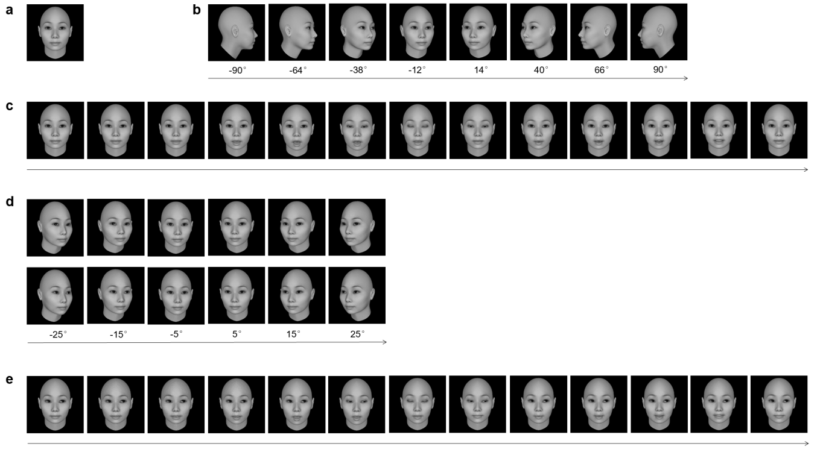
Figure 1. Examples of a 3D model face used in Experiments 1, 2, and 3. (a). A front-view face with a neutral expression was used in the static condition in Experiment 1. (b). Eight frames were used to display rigid motion in Experiment 1, which were presented in the sequence of 1-2-3-4-5-6-7-8-7-6-5-4-3-2-1, with each frame lasting for 100 ms. (c). Thirteen frames were used to display elastic facial motion in Experiment 1, each displayed for 100 ms. (d). The rigid motion condition in Experiments 2 and 3 used six frames presented in the sequence of 1-2-3-4-5-6-5-4-3-2-1. Each frame lasted for 118 ms so the presentation time was equivalent between rigid and elastic motion conditions. The upper sequence shows faces with a direct gaze, while the lower sequence shows faces with an averted gaze. (e). An illustration of elastic motion in Experiment 2 and 3, showing faces with eye gaze averted to the right. The averted eye gaze to the left or the right was counterbalanced across participants. For high-resolution images of the stimuli, please refer to Supplementary Figure S1.

Design and Procedure
We used a 3 (Motion: static, elastic, rigid) $×$ 2 (Encoding time: short, long) $×$ 2 (Race: own-race, other-race) mixed design, with Motion and Encoding time as between-subjects variables and Race as a within-subjects variable. This design allowed us to ensure that no face identities appeared more than once throughout the experiment. All stimuli were presented on a 23-inch computer screen (1920$×$1080 pixels). The experiment was conducted using E-Prime 2.0 software (Psychology Software Tools, Pittsburgh, USA).
Participants were randomly divided into six groups, one for each of the six conditions resulting from a factorial combination of facial motion and encoding time (i.e., static-short, static-long, elastic-short, elastic-long, rigid-short, and rigid-long). Each participant completed two blocks of tasks, one with own-race faces (i.e., Chinese faces) and the other with other-race faces (i.e., Caucasian faces). They had a 1-minute break between the two blocks. The order of the two blocks was counterbalanced across participants.
Each block contained a learning and a recognition phase. In the learning phase, participants were instructed to remember 10 faces (half male and half female) that were presented sequentially. The 10 target faces were randomly selected from the 20 faces (half male and half female) for each participant. Then, participants learned the same 10 target faces again in the same order. Rigid facial motion was presented by displaying a sequence of 15 frames (Figure 1b), whereas elastic facial motion was presented using 13 frames (Figure 1c). Each frame was displayed for 100 ms, and the whole image sequence was displayed once in the short encoding-time condition and repeated three times in the long encoding-time condition. As participants learned the faces twice, the total encoding times for rigid motion were 3 s (short) and 9 s (long), and for elastic motion were 2.6 s (short) and 7.8 s (long). These discrepancies in time arose from the different numbers of frames required to depict elastic and rigid facial movements, while maintaining the same speed of 100 ms per frame. In the static condition, each face was presented as a single static image (Figure 1a), with total display times set to 3 s in the short encoding-time condition and 7.8 s in the long encoding-time condition to align with the dynamic conditions. Note that our short and long encoding times match those used in previous studies, which employed durations of 2 seconds (Butcher et al., 2011) and 3 seconds (Christie & Bruce, 1998) for short elastic motion and 3 seconds for short rigid motion (Christie & Bruce, 1998); for long elastic motion, 7 seconds were used (Lander & Bruce, 2003), and for long rigid motion, 7 seconds (Lander & Bruce, 2003), 8 seconds (Zhao et al., 2014), and 10 seconds (Pike et al., 1997) were reported. While the time differences between our elastic and rigid motion conditions (0.4 and 1.2 seconds for short and long encoding condition, respectively) were less likely to impact the results, to control for this potential confounding factor, we matched the encoding times for elastic and rigid motion in Experiments 2 and 3 (Figures 1d and 1e).
In the recognition phase, static front-view faces were shown in all conditions. Twenty test faces (10 old and 10 new) were displayed in a randomized order, with each face displayed until a response was made. Participants’ task was to indicate whether the displayed face had been learned in the learning stage or not, by pressing corresponding keys on a keyboard. Participants were instructed to respond as accurately as possible.

Results
For this and subsequent experiments, individual participants' performance was measured using response sensitivity (i.e., d’, Figure 2), calculated based on their individual Hit and false alarms rates (FA) in each condition [d’=Z(hit)-Z(FA), see Supplemental Table S1 for detailed results]. The response sensitivity data were submitted to a 3 (Motion: static, elastic, rigid) $×$ 2 (Encoding time: short, long)$×$2 (Race: own-race, other-race) mixed-design ANOVA, with Bonferroni correction for all post hoc multiple comparisons (see Figure 2). For the important results that did not reach conventional significance (p>.05), we conducted Bayesian ANOVAs using JASP software (Love et.al, 2019) to further examine the effects. Bayes factors (BF₁₀, BF_{incl}) indicate the relative evidence for the alternative hypothesis (H₁) versus the null hypothesis (H₀). Following van Doorn et al. (2021), we interpreted Bayes factors as follows: values between 1 and 3 provide weak support for H₁; between 3 and 10, moderate support; and above 10, strong support. Conversely, values between 1/3 and 1 offer weak support for H₀; between 1/10 and 1/3, moderate support; and below 1/10, strong support (van Doorn et al., 2021).
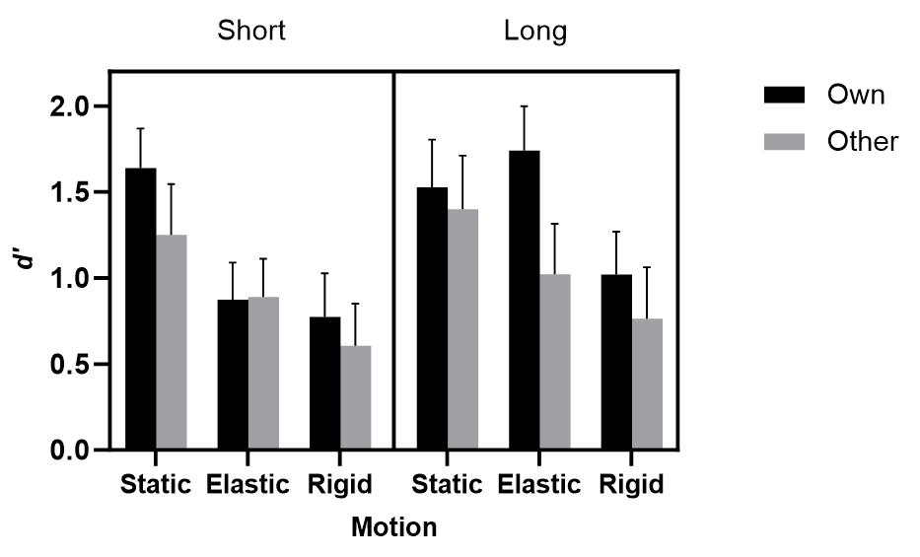
Figure 2. Mean response sensitivity (d’) as a function of facial motion, race, and encoding time in Experiment 1. Error bars represent the 95% confidence interval (CI).

The ANOVA revealed a significant main effect of Motion, F(2,161)=26.31, p<.001, $η_{p}^{2}$=.25. Post hoc comparisons showed that performance for the static condition (M± SE, 1.46±0.07) was better than that for the elastic-motion condition (1.13±0.07, p=.002), which was then better than that for the rigid-motion condition (0.79±0.07, p=.001), showing an ordered pattern of responses. There was also a significant main effect of Race, F(1,161)=13.93, p<.001, $η_{p}^{2}$ =.08, with better performance for own-race faces (1.26±0.05) than for other-race faces (0.99±0.06). Encoding time also showed a significant main effect, F(1,161)=10.27, p=.002, $η_{p}^{2}$=.06, with better performance for the long encoding-time condition (1.25±0.05) than for the short encoding-time condition (1.01±0.05).
The interaction between Motion and Encoding time was significant, F(2,161)=1.63, p=.033, $η_{p}^{2}$=.04. An analysis of the simple effects showed that, for short encoding times, participants’ performance in the elastic-motion condition (0.88±0.09) was similar to that for rigid motion (0.69±0.09, p=.140), and worse than that in the static condition (1.45±0.09, p<.001). For long encoding times, however, performance in the elastic-motion condition (1.38±0.09) was significantly better than that for rigid motion (0.89±0.09, p<.001), and similar to that in the static condition (1.46±0.09, p=.527).
Importantly, the three-way interaction was also significant, F(2,161)=3.91, p=.022, $η_{p}^{2}$=.05. Separate ANOVAs (Race$×$ Motion) were conducted for each encoding time condition. For the short encoding-time condition, the significant main effect of Motion [F(2,81)=22.43, p<.001, $η_{p}^{2}$=.36] revealed that recognition performance was better for static faces than for both elastic-motion faces (p<.001) and rigid-motion faces (p<.001), with no significant difference between the two motion conditions (p=.105). The main effect of Race [F(1,81)=3.34, p=.071, $η_{p}^{2}$=.04] did not reach conventional significance. But the Bayesian ANOVA showed very strong evidence for the effect of Race (BF_{incl} = 117.03). Its interaction with Motion [F(2,81)=1.40, p=.254, $η_{p}^{2}$=.03] did not reach significance. For the long encoding-time condition, there were significant main effects of Race [F(1,80)=11.45, p=.001, $η_{p}^{2}$=.13] and Motion [F(2,80)=9.63, p<.001, $η_{p}^{2}$=.19]. Post hoc comparisons showed similar performance between the static and elastic-motion conditions (p=.562), but a better performance in the elastic than rigid-motion condition (p<.001). The Race$×$Motion interaction did not reach significance, F(2,80)=2.68, p=.075, $η_{p}^{2}$=.06. However, the Bayesian ANOVA showed weak support for the interaction effect (BF_{incl}=1.197). Further analysis showed better recognition for elastic-motion faces than rigid-motion faces only for own-race faces (Mean difference =0.72, SE=0.18, p<.001), but not for other-race faces (Mean difference =0.26, SE=0.21, p=.217).

Discussion
Experiment 1 shows that facial motion impairs face recognition. This result is consistent with previous findings that rigid facial motion can adversely affect face memory (Christie & Bruce, 1998; Zhao et al., 2014), but it differs from previous studies showing a motion advantage in face recognition (e.g., Butcher et al.,2011; Lander & Bruce, 2003). One potential explanation for the lack of a motion advantage is that our test faces were the same as those learned in the static condition, which would benefit the static condition due to the encoding-test congruency (i.e., matching identical images). Stimulus-based differences may also contribute to the discrepant results across studies. For instance, the 3D grey-scale faces used here differ from the colorful video clips used by Butcher et al. (2011) and are similar to those used in Zhao et al (2014). Moreover, both the present study and Zhao et al. (2014) used simulated facial motion, whereas Butcher et al. (2011) used natural facial motion (i.e., speaking). Diminished recognition has been found for computer-generated static faces in comparison to photographs of real faces (Crookes et al., 2015).
More importantly, elastic motion produces overall better performance than rigid motion, particularly when the encoding time is long (see also Lander & Bruce, 2003), even though the encoding time was slightly longer for the rigid than elastic motion (i.e., 9 s vs 7.8 s). This finding contradicts the prediction that rigid motion might facilitate face memory more so than elastic motion, as our elastically moving faces lack idiosyncratic facial features. Moreover, we found that long encoding time substantially improved recognition performance in the elastic motion condition, but less so in the rigid motion condition. These results indicate that the influences of rigid and elastic motion on face memory are supported by different mechanisms and cannot be exclusively attributed to the supplementary idiosyncratic information or enhanced 3D face representation (Butcher & Lander, 2017; Roark et al., 2003).
Better recognition performance in the elastic than rigid motion condition concurs with the prediction based on the social signal hypothesis, that is, learning faces with a direct gaze leads to better face memory than that with an averted gaze (Hood et al., 2003; Mason et al., 2004; Smith et al., 2006). Moreover, our results suggest that the effect of gaze on memory of dynamic faces needs a relatively long encoding time to emerge. Although previous studies showed a more prominent effect of gaze on memory of own- than other-race faces (e.g., Adams et al., 2010; Sessa & Dalmaso, 2016), we did not observe strong evidence that race modulates the effect of facial motion (and its embedded gaze) on face memory.
Alternative accounts are also possible. For instance, different head directions between elastic and rigid facial motion may lead to different face representations. Given that our test faces were always presented as frontal-view faces, face representation formed with elastically moving faces (which remain in front view) will be more congruent with the test face than those formed with rigidly moving faces (which are accompanied by constantly varying facing directions). Moreover, the elastic motion contained one frame showing the same view as the test face, whereas rigid motion did not. These factors may lead to better memory for elastically than rigidly moving faces. To directly investigate whether gaze direction affects the memory of dynamic faces, we manipulated gaze direction in both elastically and rigidly moving faces in Experiment 2.

Experiment 2

Experiment 2 investigated whether gaze direction affects the memory of dynamic faces, specifically, whether learning direct-gaze faces enhances face memory in comparison with learning averted-gaze faces. To this aim, we manipulated gaze direction in both elastically and rigidly moving faces so that both types of dynamic faces could be learned while displaying either direct or averted gaze. In addition, in Experiment 1, the encoding time was slightly different between the rigid motion (3 s and 9 s for short and long-encoding time, respectively) and elastic motion condition (2.6 s and 7.8 s). We minimized this difference in Experiment 2.
Given that previous studies have shown that gaze affects recognition of own- and other-race faces differently (e.g., Adams et al., 2010; Collova et al., 2017; Sessa & Dalmaso, 2016), we tested the effect of gaze direction on the memory of own- and other-race faces separately (Experiment 2A: own-race faces; Experiment 2B: other-race faces). This design allowed us to isolate the specific effects of gaze direction and facial motion for each face race group, without explicitly highlighting race-related biases in face recognition (e.g., own-race advantage observed in Experiment 1). The design and procedure of Experiments 2A and 2B were identical, with the only difference being the race of the faces used. Both experiments manipulated facial motion (elastic vs. rigid), gaze direction (direct vs. averted), and encoding time (short vs. long).
Experiment 2 allowed us to test the following predictions. First, when comparing the two facial motion conditions, if the difference observed in Experiment 1 was driven by gaze direction, we would expect a better performance following learning direct-gaze faces than after learning averted-gaze faces, for both types of facial motion. Moreover, the difference in performance between rigid and elastic facial motion conditions would be reduced, if not eliminated, when gaze direction is matched. Second, when comparing short and long encoding conditions, if direct eye contact enhances face encoding with longer encoding time, as suggested in Experiment 1, we would expect better performance for long than short encoding time conditions when learning direct-gaze faces, but less so when learning averted-gaze faces, for both facial motion conditions. Third, if the effect of gaze direction on face memory does not generalize across own- and other-race faces, as outlined above, it should apply to own-race faces (Experiment 2A) but less so to other-race faces (Experiment 2B). If the effect of gaze direction on face memory does generalize across own- and other-race faces, as shown in Experiment 1, we should observe no interaction involving race in Experiment 2. Finally, if gaze direction plays a negligible role in the memory of dynamic faces, we would expect to observe a similar motion effect to that of Experiment 1, regardless of the gaze direction we manipulated.

Method
Participants
We recruited 96 Chinese participants from the same population (27 males, 69 females; aged from 18 to 24, mean age = 19.5) and randomly assigned them to four groups (24 participants in each group) in Experiment 2A. A power analysis using G*Power indicated that a total sample of 48 participants would be needed to detect a moderate effect size (Cohen’s f = 0.25), with 80% power and alpha at .05, using a mixed ANOVA for assessing the within-between interaction of a 2 (Motion: elastic, rigid) $×$ 2 (Encoding time: short, long) $×$ 2 (Gaze of study faces: direct, averted) design.
We recruited another 96 Chinese participants (22 males, and 74 females; aged from 17 to 26, mean age = 20.6) and randomly assigned them to four groups (24 participants in each group) in Experiment 2B.

Materials
Stimuli were created based on the same 20 Chinese and 20 Caucasian 3D face models used in Experiment 1. To generate rigid-motion faces with direct eye gaze, the range of rotation was reduced to between -25° and 25° with steps of 10° (see Figure 1d), so the faces/heads could be rotated to the left or right while still maintaining a natural direct eye gaze. Gaze direction was manipulated by adjusting the attributes of the 3D face model (i.e., “Modifier: LookRight” and “Modifier: LookLeft” in FaceGen software). For instance, if the face was turned to the left (the direction to the observer) for 25°, then the “LookLeft” (the direction to the model) modifier was set to 1.0 (i.e., the maximum of pupil rotation towards the left) accordingly, ensuring a natural direct eye gaze. For the averted-gaze rigid-motion faces, these two attributes were not adjusted (i.e., gaze direction was always aligned with the head direction). The way we generated direct-gaze elastic-motion faces was identical to that in Experiment 1. For the averted-gaze elastic-motion faces, we adjusted the same attributes ("Modifier: LookRight" and "Modifier: LookLeft") so that all faces had an averted gaze (half to the left and half to the right, Figure 1e). Stimuli used in the recognition phase were the same as in Experiment 1 (i.e., static front-view faces).
Importantly, we matched the display time between rigid and elastic motion. We used 11 frames to create rigid facial motion, with each displayed for 118 ms (Figure 1d). As participants repeated the learning procedure once, the total encoding time was 2596 ms (=11×118×2) in the short encoding time condition and 7788 ms in the long encoding time condition (i.e., repeated three times). These durations were equivalent to those used in the elastic motion condition (2600 ms and 7800 ms, respectively, as in Experiment 1).

Design and Procedure
We used a 2 (Motion: elastic, rigid) $×$ 2 (Encoding time: short, long) $×$ 2 (Gaze of study faces: direct, averted) mixed design for each experiment, with Motion and Encoding time as between-subject variables and Gaze as a within-subject variable. Participants were randomly assigned to the four experimental conditions (i.e., elastic-short, elastic-long, rigid-short, and rigid-long). Each participant had two blocks of tasks, one with direct-gaze faces and one with averted-gaze faces. The order of the two blocks was counterbalanced across participants. Each block consisted of a learning phase and a recognition phase. During the learning phase, faces were presented in motion, elastic or rigid, with either a direct or an averted gaze. In the recognition phase, all faces across the four conditions were presented as static, front-view images with a direct gaze. For the averted-gaze condition, half of the participants learned faces looking to the left and half learned faces looking to the right. The procedure was the same as that in Experiment 1.

Experiment 2A
Results
Response sensitivity data (d’) for each condition are shown in Figure 3. Full details of the hit rates and false alarms are shown in Supplemental Table S2. These data were submitted to a 2 (Motion: elastic, rigid) $×$ 2 (Encoding time: short, long)$×$2 (Gaze: direct, averted) mixed ANOVA.
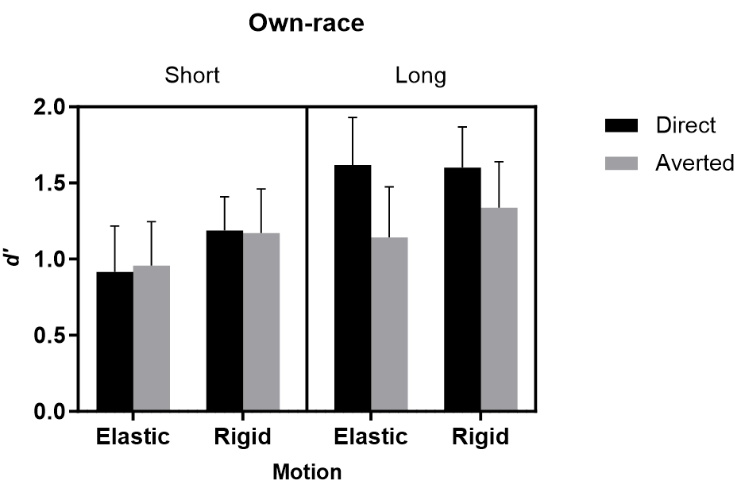
Figure 3. Response sensitivity (d’) as a function of gaze direction, facial motion, and encoding time for own-race faces observed in Experiment 2A. Error bars represent the 95% confidence interval (CI).

We found a significant main effect of Gaze direction, F(1,92)=3.99, p=.048, $η_{p}^{2}$=.04, with better performance for direct-gaze faces (1.33±0.07) than for averted-gaze faces (1.15±0.07), and Encoding time, F(1,92)=11.38, p=.001, $η_{p}^{2}$=.11, with better performance for long encoding time (1.43±0.08) than short encoding time (1.06±0.08). Elastic and rigid facial motion did not produce significantly different recognition performance, as the main effect of Motion was not significant, F(1,92)=2.34, p=.130, $η_{p}^{2}$=.03. To further examine the null effect of Motion, we performed a Bayesian ANOVA. The result also showed support for H₀, although weak (BF_{incl} = 0.529).
The interaction between Gaze and Encoding time was significant, F(1,92)=4.55, p=.036, $η_{p}^{2}$=.05. An analysis of simple effects showed that, with short encoding times, there was no difference between direct-gaze and averted-gaze conditions, F(1,92)=0.01, p=.925, $η_{p}^{2}$<.001. With a longer encoding time, however, performance was better for direct-gaze faces than averted-gaze faces, F(1,92)=8.53, p=.004, $η_{p}^{2}$=.09. None of the other interactions reached statistical significance [Gaze × Motion: F(1,92)=0.18, p=.671, $η_{p}^{2}$=.002; Motion × Encoding time: F(1,92)=0.50, p=.479, $η_{p}^{2}$=.005; three-way interaction: F(1,92)=0.58, p=.447, $η_{p}^{2}$=.01], suggesting that facial motion does not significantly modulate the effect of gaze direction on face recognition.

Discussion
Learning dynamic faces displaying a direct gaze produces better face memory than that with an averted gaze, consistent with previous findings using static faces (e.g., Adams et al., 2010; Hood et al., 2003; Mason et al., 2004; Sessa & Dalmaso, 2016; Smith et al., 2006). Importantly, this beneficial effect of direct gaze on face memory occurs for both types of facial motion. These results indicate that differences in recognition performance between elastic and rigid motion (as found in Experiment 1) are driven by differences in gaze direction rather than facial motion per se. When eye gaze is controlled, rigid and elastic facial motion produce equivalent recognition performance. When rigidly moving faces display a direct gaze, they elicit similar performance as elastically moving faces. Similarly, when elastically moving faces are presented with averted gaze, they no longer show better performance than rigidly moving faces. Therefore, these results dissociated the intertwined effects of facial motion and eye gaze on face memory, providing further direct evidence for the social signals hypothesis.
The effect of gaze on the memory of dynamic faces is modulated by encoding time. Direct gaze leads to better recognition performance than averted gaze in the long, but not short, encoding-time condition. The direct gaze advantage in the longer encoding condition may be driven by the opportunity for more complete and detailed processing of the face and gaze, rather than solely the reflexive attentional capture seen in shorter exposures. When participants are given more time to encode dynamic faces, their memory for direct-gaze faces (e.g., elastic-motion faces used in Experiment 1), regardless of which type of motion was displayed, is enhanced; but their memory for averted-gaze faces (e.g., rigid-motion faces used in Experiment 1) remains the same across both encoding-time conditions. These results suggest that longer eye contact helps establish a more elaborate face memory, aligning with research indicating that direct-gaze faces attract more attention (Frischen et al., 2007; Senju & Hasegawa, 2005) and increases viewing time (Senju & Hasegawa, 2005).

Experiment 2B
Experiment 2B examined whether the beneficial effect of direct gaze direction on the memory of dynamic faces generalizes to other-race faces. Previous studies have shown that gaze direction does not affect performance for other-race faces (e.g., Adams et al., 2010; Collova et al., 2017; Sessa & Dalmaso, 2016). Moreover, when learning faces for a memory task, people tend to look at the eye region more frequently and/or longer for own- than for other-race faces (Goldinger et al., 2009; Kawakami et al., 2014; Wu et al., 2011). Therefore, the influence of eye gaze on facial memory may not generalize to other-race faces. However, since Experiment 1 did not find a significant interaction between motion and race, it is also possible that the potential effect of eye gaze on the memory of own- and other-race faces does not differ qualitatively.

Results
Response sensitivity data for each condition are shown in Figure 4. Full details of the hit rates and false alarms are shown in Supplemental Table S2. The same 2 (Motion: elastic, rigid) $×$ 2 (Encoding time: short, long)$×$2 (Gaze: direct, averted) mixed ANOVA showed no significant main effects of Encoding time [F(1,92)=3.38, p=.069, $η_{p}^{2}$=.035, BF_{incl}=0.956], Gaze [F(1,92)=1.00, p=.320, $η_{p}^{2}$=.01], and Motion [F(1,92)=0.51, p=.475, $η_{p}^{2}$=.006]. Their interactions [Gaze × Motion: F(1,92)=2.19, p=.142, $η_{p}^{2}$=.02; Gaze × Encoding time: F(1,92)=0.27, p=.607, $η_{p}^{2}$=.003; Motion × Encoding time: F(1,92)=0.004, p=.948, $η_{p}^{2}$<.001; three-way interaction: F(1,92)=0.17, p=.685, $η_{p}^{2}$=.002, see Figure 4] were not significant (for all nonsignificant main effects and interactions, Bayesian analysis confirmed these null effects with weak or moderate evidence, all BF_{incl}< 1).
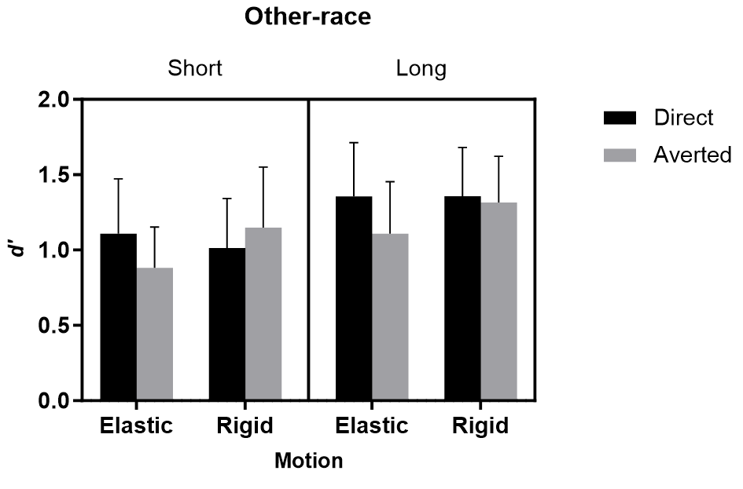
Figure 4. Response sensitivity (d’) as a function of gaze direction, facial motion, and encoding time for other-race faces observed in Experiment 2B. Error bars represent the 95% confidence interval (CI).

To further examine whether race significantly modulates the effect of gaze on face memory, we combined data in Experiments 2A and 2B and performed a 2 (Race: own, other) ×2 (Motion: elastic, rigid) × 2 (Encoding time: short, long) × 2 (Gaze: direct, averted) mixed ANOVA (see supplementary Table S4 for full details of the results). This analysis revealed significant main effects of gaze, F(1,184)=4.39, p=.038, $η_{p}^{2}$=.02, and encoding time, F(1,184)=12.66, p<.001, $η_{p}^{2}$=.06. None of the other main effects or interactions reached significance, all Fs ≤ 3.36, ps ≥.068, $η_{p}^{2}$≤.02, all BF_{incl} <1. Therefore, while the patterns of results for own- and other-races appeared to be different, as observed in Experiments 2A and 2B, the race of faces did not significantly modulate the effect of gaze on face memory.

Discussion
Unlike Experiment 2A, direct gaze did not significantly enhance the memory of other-race faces, which is consistent with previous findings (Adams et al., 2010; Collova et al., 2017; Sessa & Dalmaso, 2016). These results are in line with the view that gaze is processed differently in own- and other-race faces (e.g., Collova et al., 2017). Nonetheless, caution should be taken when interpreting these results. First, our analysis of the combined data from Experiments 2A and 2B showed no significant interactions that involved race. This result suggests that the effect of gaze may be numerically weaker for other- than for own-race faces, rather than qualitatively different. Second, as we only tested Chinese participants with Chinese and Caucasian faces, we cannot rule out the possibility that the observed results might be due to the stimuli rather than the race of faces. Further research testing observers of both races may help reveal exactly how race modulates the influence of motion and gaze on face memory.
Overall, Experiment 2 demonstrates that gaze direction at encoding affects face memory and contributes to the differences in memory for elastically and rigidly moving faces. However, it may be argued that the better performance following learning direct-gaze faces may be due to the study-test congruency (e.g., Buratto, Matthews, & Lamberts, 2009; Zhou et al., 2021). Since our test faces were always shown in frontal view with a direct gaze (in Experiments 1 and 2), learning direct-gaze faces may produce better performance than learning averted-gaze faces. This might also explain why elastic motion produces better recognition performance than rigid motion in Experiment 1, as the former shows a direct gaze and a frontal view that are congruent with the test faces, whereas the latter does not. In Experiment 3, we addressed this question by manipulating the congruency between gaze directions during encoding and at the test.

Experiment 3

Experiment 3 tested whether the effect of gaze direction on face memory is driven by the encoding of direct-/averted-gaze faces (i.e., eye contact at encoding) or by the consistency between gaze directions during encoding and at the test (i.e., study-test congruency). Instead of presenting all test faces with a direct gaze (as in Experiments 1 and 2), we presented test faces in either a direct or an averted gaze for both rigid and elastic facial motion conditions. To minimize the influence of head orientation incongruency, test faces were shown in frontal view after learning elastically moving faces and were shown in rotated views (i.e., left or right 15°) after learning rigidly moving faces. Given that the effect of gaze direction on face memory was more prominent in the long encoding-time condition and was primarily observed for own-race faces (Experiment 2A), Experiment 3 focused on testing the effect of gaze direction and study-test congruency when participants learned own-race faces with a long encoding time (i.e., 7.8 s).
If the effect of gaze direction on the memory of dynamic faces is due to different face representations formed at encoding, learning direct-gaze faces should produce better memory performance than learning averted-gaze faces, regardless of whether the test faces show congruent or incongruent gaze direction. Alternatively, if the effect of gaze direction is supported by the study-test congruency effect, we would expect to observe better recognition performance when gaze directions during encoding and at test are congruent than when they are not, regardless of whether participants learned direct- or averted-gaze faces.

Method
Participants
Based on the same power analysis as in Experiment 2, we tested 96 Chinese participants (27 males, aged from 18 to 24 years old, mean age = 20.4) in this experiment. None of them took part in previous experiments. One participant was excluded due to technical issues during data collection, resulting in 23 participants in one group and 24 participants in each of the other three groups.

Materials, Design, and Procedure
The stimuli were similar to those in Experiment 2A. For faces shown at the test stage, in addition to the front-view direct-gaze faces used before (Figure 1a), we also created front-view averted-gaze faces (either to the left or right; Figure 5, upper row), which were used as test faces for the elastic motion condition. For the rigid motion condition, we used rotated-view faces (15° to the left or right) with either direct or averted gaze direction (Figure 5, lower row).
We used a 2 (Motion: elastic vs. rigid) × 2 (Study-test gaze congruency: congruent vs. incongruent) × 2 (Gaze of study face: direct vs. averted) mixed design, with Motion and Gaze congruency as between-subjects variables, and Gaze of study face as a within-subjects variable. Participants were randomly assigned into four groups (elastic-congruent, elastic-incongruent, rigid-congruent, rigid-incongruent).
The procedure was the same as in Experiment 2A, except that participants only learned own-race faces with a long encoding time. Each participant had two blocks of tasks, one for learning direct-gaze faces and one for learning averted-gaze faces. The order of the two blocks was counterbalanced across participants. For the averted-gaze condition, half of the participants learned faces looking to the left, while the other half learned faces looking to the right.
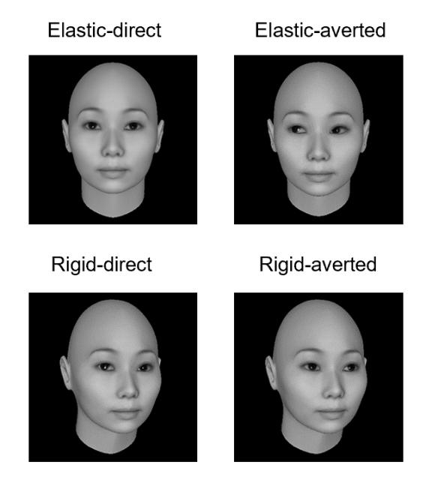
Figure 5. Examples of the test faces used in Experiment 3. Test faces could show either congruent or incongruent gaze direction with the learned faces.

Results and Discussion
Response sensitivity data are summarized in Figure 6 (details of hit rates and false alarms are shown in Supplemental Table S3).
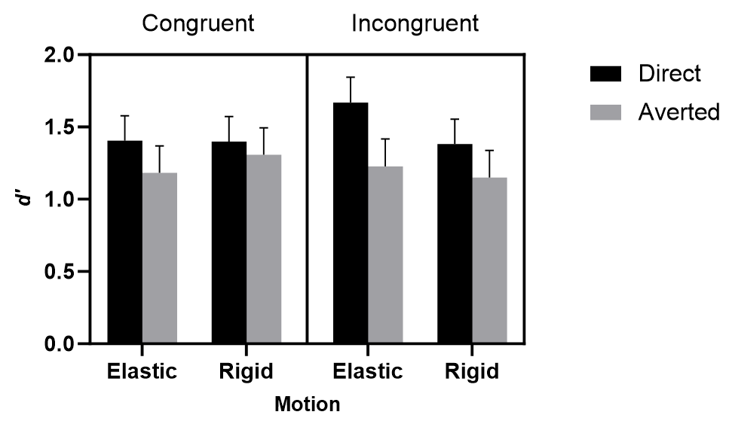
Figure 6. Response sensitivity (d') as a function of facial motion, study-test gaze congruency, and gaze direction during encoding for own-race faces in Experiment 3. Error bars represent the 95% confidence interval (CI).

A 2 (Motion: elastic, rigid) $×$ 2 (Study-test gaze congruency: congruent vs. incongruent)$×$2 (Gaze of study face: direct vs. averted) mixed ANOVA only revealed a significant main effect of Gaze at encoding (F(1,91)=4.43, p=.038, $η_{p}^{2}$=.05), with better performance after learning direct-gaze faces (1.46±0.09) than that after learning averted-gaze faces (1.22±0.09). No other main effects [Congruency: F(1,91)=0.06, p=.808, $η_{p}^{2}$=.001; Motion: F(1,91)=0.20, p=.655, ${η_{p}}^{2}$=.002] or interactions [Gaze × Motion: F(1,91)=0.53, p=.467, $η_{p}^{2}$=.006; Gaze × Congruency: F(1,91)=0.59, p=.446, $η_{p}^{2}$=.006; Motion × Congruency: F(1,91)=0.78, p=.379, $η_{p}^{2}$<.001; three-way interaction: F(1,91)=0.03, p=.868, $η_{p}^{2}$<.001] reached statistical significance. For all nonsignificant main effects and interactions, Bayesian analysis showed moderate evidence supporting these null effects (all BF_{incl} < 1).

These results demonstrate that learning dynamic faces with a direct gaze produces better face memory than learning faces with an averted gaze, consistent with the results of Experiment 2A. Such a direct-gaze advantage applies similarly to the learning of elastically and rigidly moving faces. Importantly, when gaze direction during learning and at test was both controlled and matched, the memory of dynamic faces also did not differ between rigid and elastic facial motion. These results further confirm that the difference between the memory of faces showing rigid and elastic motion, as seen in Experiment 1, is driven by gaze direction at learning.
Moreover, our results demonstrate that the direct gaze advantage cannot be attributed to the congruent gaze directions across the learning and test phases. Our manipulation of gaze congruency neither modulated the main effect of facial motion nor the effect of gaze direction in learning. Participants showed overall equivalent performance between congruent and incongruent conditions. These results support the view that facial motion is more influential on face memory when presented at learning than at recognition (e.g., Butcher et al., 2011).

General Discussion
This study addressed a significant theoretical gap in our understanding of dynamic face recognition: how social signals, particularly eye gaze — one of the significant social cues conveyed in dynamic faces — affect their memory? We specifically explored three core questions: 1) Do rigid and elastic facial motions affect face memory differently? 2) How does gaze direction influence memories of rigidly and elastically moving faces? 3) Do the effects of facial motion and gaze direction on face memory generalize across own- and other-race faces?
Our results demonstrate that the role of facial motion in face processing is not solely driven by socially significant facial movements like smiling or speaking. Instead, it’s profoundly influenced by gaze direction accompanying these movements. We found consistent and strong evidence that a direct gaze during encoding significantly enhances the memory of dynamic faces. First, faces showing elastic motion with a direct gaze were memorized better than faces showing rigid motion that primarily avoided direct gaze (Experiment 1). Second, when gaze direction was directly manipulated in rigid and elastic facial motion, learning direct-gaze faces produced better memory than learning averted-gaze faces, regardless of whether facial motion was rigid or elastic (Experiment 2). Furthermore, the advantage of direct gaze persisted regardless of whether the gaze direction between the study and test faces was congruent or incongruent (Experiment 3). These results not only provide direct evidence for the social signal hypothesis regarding facial motion but also dissociate, for the first time to our knowledge, between the roles of gaze direction and facial motion in the memory of dynamic faces.

Dissociating gaze from facial motion
Previous studies have rarely dissociated the effect of eye gaze from its accompanying facial movements (e.g., elastic vs rigid) and often attributed performance differences exclusively to facial movements. Here, our results demonstrate that differences between memories of rigidly and elastically moving faces are mediated by gaze direction. When gaze direction at learning was matched, differences between memory of rigidly and elastically moving faces disappeared. When all faces displayed a direct gaze at learning, memory of moving faces (in Experiments 2 and 3) became equivalent to that observed with static faces (in Experiment 1).
Regardless of facial movements, our attention is more drawn to a face showing direct eye contact than to those looking away (e.g., Frischen et al., 2007; Senju & Hasegawa, 2005). Similarly, viewing faces showing a deviated gaze often automatically diverts our attention to the location/direction of the gaze, reducing the available resources for processing the face itself (i.e., gaze following, Bayliss et al., 2013; Bonato et al., 2009). Therefore, eye gaze and facial motion may both affect face memory, but through different mechanisms. Dissociating the role of gaze from facial motion will help reconcile the discrepant findings on the effect of rigid and elastic motion on face memory (Bruce et al., 1999; Lander & Bruce, 2003), on the other-race effect (e.g., Butcher et al., 2011; Zhao et al., 2014), and on the holistic face processing (e.g., Favelle et al., 2015; Xiao et al., 2012, 2013; Zhao & Bülthoff, 2017).

Generalizability of the gaze effect
The present study demonstrates that the effect of eye gaze on face memory generalizes from static to moving faces. When the gaze of static faces was manipulated (e.g., direct, deviated, or eye-closed), faces that make direct eye contact often produce better face memory than those avoiding eye contact (e.g., Adams et al., 2010; Hood et al., 2003). Similarly, perception of static facial emotion is enhanced when eye gaze matches the intention of facial expressions (e.g., approaching when showing a happy expression or avoidance when displaying a fear expression; Adams & Kleck, 2005; Milders et al., 2011). Here, we show that sustained eye contact with a face enhances face memory whether the face is moving rigidly or elastically. This finding suggests that facial movement does not overshadow the influence of eye gaze on face processing, which may apply to both static and dynamic faces via a shared mechanism (e.g., social attention, Langton et al., 2000).
Furthermore, both Experiments 1 and 2 did not find a statistically significant modulation effect of race, which seems to suggest that the effect of eye gaze could generalize across own- and other-race faces. However, our results showed gaze effect for own-race faces but not for other-race faces, suggesting that the effect of gaze may be numerically weaker for other-race than for own-race faces, rather than qualitatively different. This observation aligns with previous findings that people are more sensitive to direct gaze in own- than other-race faces (Collova et al., 2017) and that learning direct-gaze faces enhances the memory of own- but not other-race faces (Adams et al., 2010, see also Sessa & Dalmaso, 2016).
The observed gaze effect might be due to that direct-gaze faces attract more attention than averted-gaze faces (e.g., Frischen et al., 2007; Senju & Hasegawa, 2005), more so for own- and other-race faces (e.g., Zhou et al., 2014, 2015). Alternatively, a plausible interpretation is that eye contact facilitates face recognition via an implied communicative motivation, which may be stronger for own- than other-race faces (e.g., Gong et al., 2024). Therefore, both gaze and race of faces—two important social cues in a face—can jointly determine how well faces are remembered. Note that we only tested Chinese participants here; future studies involving participants and faces of both races will help reveal how the race of faces may modulate the effects of gaze on face memory.

Theory of dynamic face recognition
Our results showed no motion advantage in face memory, which differs from previous studies (see O’Toole et al., 2002; Xiao et al, 2014; for reviews). One possibility is that simultaneous processing of facial motion may impair visual attention to face identity (Roark et al., 2003), particularly when processing time is limited (i.e., in short time encoding condition), when eye gaze diverts attention away from the faces (i.e., averted gaze condition), or when processing unfamiliar face identities (which itself proves to be a difficult task that may already take up a significant amount of attention, see Hancock, Bruce, & Burton, 2000; Johnston & Edmonds, 2009; for reviews).
The absence of motion advantage might also be attributed to the lack of naturalistic facial motion. Previous studies using realistic moving faces (e.g., video recordings) often found a motion advantage (e.g., Butcher et al., 2011; Lander, Christie, & Bruce, 1999; Lander et al., 2003; Pike et al., 1997). In contrast, research using simulated facial motion by animating computer-generated faces (e.g., Zhao et al., 2014, the present study) or real faces (Christie & Bruce., 1998) observed no such effect. The simulated facial motion used in our study may not capture the nuanced dynamics of real-world facial movements and their perception (e.g., Gaither et al., 2019; Lander, Chuang, & Wickham, 2006), thereby eliminating the motion advantage. Thus, caution should be taken when generalizing our results to naturalistic facial motion. Note, however, that naturalistic moving faces do not necessarily enhance face memory (e.g., Mileva & Burton, 2019, see also Maguinness & Newell, 2014).
Although our results are in line with the social signals hypothesis, they do not necessarily refute the supplementary information hypothesis or the representation enhancement hypothesis, which may operate under different circumstances (O’Toole et al., 2002; Roark et al., 2003). For example, since all our elastically moving faces share the same facial movements, elastic facial motion may not provide extra “dynamic facial features” to individual faces, thereby minimizing the potential contribution of such supplementary information to face memory. Research that applies idiosyncratic elastic facial motion to different faces will provide a sensitive test for the supplementary information hypothesis. For instance, Bucher and Lander (2017) showed that naturalistic facial motion benefits face memory more when facial motion is more excessive and distinctive.
Similarly, as we only manipulated gaze and head direction between study and test faces, our face memory test may not be sufficiently sensitive to the 3D facial structures, which are presumably enhanced when faces are learned with rigid motion. Employing face recognition task that relies on 3D facial structures will offer a better test for the representation enhancement hypothesis and help reconcile discrepant findings on the role of rigid motion in face recognition (e.g., Christie & Bruce, 1998; Pike et al., 1997) and face perception (e.g., Favelle et al., 2015; Xiao et al., 2012, 2013; Zhao & Bülthoff, 2017).

Conclusion
In summary, our study systematically investigated the effect of facial motion and eye gaze on face memory and whether these effects generalize across own- and other-race faces. By systematically manipulating gaze direction in rigidly and elastically moving faces, we dissociated the roles of facial motion from its accompanying eye gaze—an essential social cue often confounded with facial motion—in face memory. Our results reveal a robust direct-gaze advantage in the memory of dynamic faces. Faces learned with a direct gaze are remembered better than those with an averted gaze, irrespective of whether faces are moving rigidly or elastically. Moreover, this direct-gaze advantage is more pronounced for own-race than other-race faces and is stronger with longer face encoding time. These results not only provide a novel account for the influences of rigid and elastic motion on face memory but also highlight the determining role of social signals (i.e., gaze) in memory of both static and dynamic faces.
Acknowledgements
We thank Emily Mason for her help with proofreading.

Declarations

Funding
The study and the preparation of this research report were supported by research grants from the National Natural Science Foundation of China to Guomei Zhou (31771208, 32071048) and a research grant from the Royal Society, the United Kingdom (RGS\R2\202066) to Mintao Zhao.

Conflicts of interest/Competing interests
The authors declare no conflicts of interest.

Ethics approval
Approval was obtained from the Institutional Review Board of Department of Psychology at Sun Yat-sen University. The procedures used in this study adhere to the tenets of the Declaration of Helsinki.

Consent to participate
Participants were provided appropriate disclosures and provided informed consent upon enrollment into the study.

Consent for publication
Participants were fully informed that data describing their performance would be published subsequent to the study’s conclusion, and that no potentially identifying information would be disclosed in doing so.

Availability of data and materials
The data and materials of the present study can be accessed via https://osf.io/yw6x2

Code availability
The code used in this study is available upon request from the corresponding author, subject to the approval of any necessary permissions and agreements.

Authors' contributions
X.F., G.Z., and M.Z. designed experiments, X.F. performed experiments, analyzed data, and wrote the original draft; M.Z. and G.Z. made critical revisions. All authors discussed the results and implications and commented on the manuscript at all stages.
References
Adams Jr, R. B., & Kleck, R. E. (2005). Effects of direct and averted gaze on the perception of facially communicated emotion. Emotion, 5(1), 3-11.
Adams Jr, R. B., Pauker, K., & Weisbuch, M. (2010). Looking the other way: The role of gaze direction in the cross-race memory effect. Journal of Experimental Social Psychology, 46(2), 478-481.
Bayliss, A. P., Murphy, E., Naughtin, C. K., Kritikos, A., Schilbach, L., & Becker, S. I. (2013). “Gaze leading”: Initiating simulated joint attention influences eye movements and choice behavior. Journal of Experimental Psychology: General, 142(1), 76–92. https://doi.org/10.1037/a0029286
Bindemann, M., Fysh, M. C., Trifonova, I. V., Allen, J., McCall, C., & Burton, A. M. (2022). Face identification in the laboratory and in virtual worlds. Journal of Applied Research in Memory and Cognition, 11(1), 120.
Bonato, M., Priftis, K., Marenzi, R., & Zorzi, M. (2009). Normal and impaired reflexive orienting of attention after central nonpredictive cues. Journal of Cognitive Neuroscience, 21(4), 745–759.
Bruce, V., Henderson, Z., Greenwood, K., Hancock, P.J.B., Burton, A., & Miller, P. (1999). Verification of face identities from images captured on video. Journal of Experimental Psychology: Applied, 5, 339–360.
Buratto, L. G., Matthews, W. J., & Lamberts, K. (2009). When are moving images remembered better? Study–test congruence and the dynamic superiority effect. Quarterly Journal of Experimental Psychology, 62(10), 1896-1903.
Butcher, N., & Lander, K. (2017). Exploring the motion advantage: evaluating the contribution of familiarity and differences in facial motion. Quarterly Journal of Experimental Psychology, 70(5), 919-929.
Butcher, N., Lander, K., Fang, H., & Costen, N. (2011). The effect of motion at encoding and retrieval for same- and other-race face recognition. British Journal of Psychology, 102(4), 931-942.
Butcher, N., Lander, K., & Jagger, R. (2017). A search advantage for dynamic same-race and other-race faces. Visual Cognition, 25(4-6), 442-455.
Christie, F., & Bruce, V. (1998). The role of dynamic information in the recognition of unfamiliar faces. Memory & Cognition, 26(4), 780-790.
Collova, J. R., Kloth, N., Crookes, K., Burton, N., Chan, C. Y., Hsiao, J. H., & Rhodes, G. (2017). A new other-race effect for gaze perception. Journal of Experimental Psychology: Human Perception and Performance, 43(11), 1857-1863.
Crookes, K., Ewing, L., Gildenhuys, J. D., Kloth, N., Hayward, W. G., Oxner, M., Pond, S., & Rhodes, G. (2015). How well do computer-generated faces tap face expertise? PloS One, 10(11), e0141353.
Dobs, K., Bülthoff, I. & Schultz, J. (2016). Identity information content depends on the type of facial movement. Scientific Reports, 6, 34301. https://doi.org/10.1038/srep34301
Favelle, S., Tobin, A., Piepers, D., Burke, D., & Robbins, R. A. (2015). Dynamic composite faces are processed holistically. Vision Research, 112, 26-32.
Faul, F., Erdfelder, E., Buchner, A., & Lang, A. G. (2009). Statistical power analyses using G* Power 3.1: Tests for correlation and regression analyses. Behavior Research Methods, 41(4), 1149-1160.
Frischen, A., Bayliss, A. P., & Tipper, S. P. (2007). Gaze cueing of attention: Visual attention, social cognition, and individual differences. Psychological Bulletin, 133(4), 694-724.
Frost, P., & Weaver, C. A. (1997). Overcoming misinformation effects in eyewitness memory: Effects of encoding time and event cues. Memory, 5(6), 725-740.
Gaither, S. E., Chen, J. M., Pauker, K., & Sommers, S. R. (2019). At face value: Psychological outcomes differ for real vs. computer-generated multiracial faces. The Journal of Social Psychology, 159(5), 592–610.
Geraets, C. N. W., Tuente, S. K., Lestestuiver, B. P., Van Beilen, M., Nijman, S. A., Marsman, J. B. C., & Veling, W. (2021). Virtual reality facial emotion recognition in social environments: An eye-tracking study. Internet Interventions, 25, 100432.
Goldinger, S. D., He, Y., & Papesh, M. H. (2009). Deficits in cross-race face learning: Insights from eye movements and pupillometry. Journal of Experimental Psychology: Learning, Memory, and Cognition, 35(5), 1105-1122.
Gong, Y., Zhao, X., Ma, Q., & Zhou, G. (2024). Social identity threat attenuates own-race bias in face recognition under the “Asian-Caucasian” context. Journal of Experimental Social Psychology, 113, 104624. https://doi.org/10.1016/j.jesp.2024.104624
Hancock, P. J. B., Bruce, V., & Burton, A. M. (2000). Recognition of unfamiliar faces. Trends in Cognitive Sciences, 4(9), 330–337. https://doi.org/10.1016/S1364-6613(00)01519-9
Hayward, W. G., Crookes, K., & Rhodes, G. (2013). The other-race effect: Holistic coding differences and beyond. Visual Cognition, 21, 1224-1247.
Hood, B. M., Macrae, C. N., Cole‐Davies, V., & Dias, M. (2003). Eye remember you: The effects of gaze direction on face recognition in children and adults. Developmental Science, 6(1), 67-71.
Hugenberg, K., Young, S. G., Bernstein, M. J., & Sacco, D. F. (2010). The categorization-individuation model: An integrative account of the other-race recognition deficit. Psychological Review, 117(4), 1168-1187.
Johnston, R. A., & Edmonds, A. J. (2009). Familiar and unfamiliar face recognition: A review. Memory, 17(5), 577-596.
Kawakami, K., Williams, A., Sidhu, D., Choma, B. L., Rodriguez-Bailón, R., Cañadas, E., Chung, D., & Hugenberg, K. (2014). An eye for the I: Preferential attention to the eyes of ingroup members. Journal of Personality and Social Psychology, 107(1), 1-20.
Knappmeyer, B., Thornton, I. M., & Bülthoff, H. H. (2003). The use of facial motion and facial form during the processing of identity. Vision Research, 43(18), 1921-1936.
Knight, B., & Johnston, A. (1997). The role of movement in face recognition. Visual Cognition, 4(3), 265-273.
Krumhuber, E. G., Skora, L. I., Hill, H. C., & Lander, K. (2023). The role of facial movements in emotion recognition. Nature Reviews Psychology, 2(5), 283-296.
Lander, K., & Bruce, V. (2003). The role of motion in learning new faces. Visual Cognition, 10(8), 897-912.
Lander, K., Christie, F., & Bruce, V. (1999). The role of movement in the recognition of famous faces. Memory & Cognition, 27(6), 974-985.
Lander, K., Chuang, L., & Wickham, L. (2006). Recognizing face identity from natural and morphed smiles. The Quarterly Journal of Experimental Psychology, 59(5), 801–808.
Langton, S. R., Watt, R. J., & Bruce, I. I. (2000). Do the eyes have it? Cues to the direction of social attention. Trends in Cognitive Sciences, 4(2), 50-59.
Love, J., Selker, R., Marsman, M., Jamil, T., Dropmann, D., Verhagen, J., ... & Wagenmakers, E. J. (2019). JASP: Graphical statistical software for common statistical designs. Journal of Statistical Software, 88, 1-17.
Lundqvist, D., Flykt, A., & Öhman, A. (1998). Karolinska directed emotional faces. PsycTESTS Dataset, 91, 630.
Maguinness, C. & Newell, F. N. (2014). Motion facilitates face perception across changes in viewpoint and expression in older adults. Journal of Experimental Psychology: Human Perception and Performance, 40(6), 2266-2280.
Mason, M., Hood, B., & Macrae, C. N. (2004). Look into my eyes: Gaze direction and person memory. Memory, 12(5), 637-643.
Meissner, C. A., & Brigham, J. C. (2001). Thirty years of investigating the own-race bias in memory for faces: A meta-analytic review. Psychology, Public Policy, and Law, 7(1), 3.
Memon, A., Hope, L., & Bull, R. (2003). Exposure duration: Effects on eyewitness accuracy and confidence. British Journal of Psychology, 94(3), 339-354.
Milders, M., Hietanen, J. K., Leppänen, J. M., & Braun, M. (2011). Detection of emotional faces is modulated by the direction of eye gaze. Emotion, 11(6), 1456.
Mileva, M., & Burton, A. M. (2019). Face search in CCTV surveillance. Cognitive Research: Principles and Implications, 4(1), 1-21.
O’Toole, A. J., Roark, D. A., & Abdi, H. (2002). Recognizing moving faces: A psychological and neural synthesis. Trends in Cognitive Sciences, 6(6), 261-266.
Pike, G. E., Kemp, R. I., Towell, N. A., & Phillips, K. C. (1997). Recognizing moving faces: The relative contribution of motion and perspective view information. Visual Cognition, 4(4), 409-438.
Pilz, K.S., Vuong, Q. C., Bülthoff, H. H., & Thornton, I. M. (2011). Walk this way: approaching bodies can influence the processing of faces. Cognition, 118(1), 17–31.
Ritchie, K. L., Mireku, M. O., & Kramer, R. S. (2020). Face averages and multiple images in a live matching task. British Journal of Psychology, 111(1), 92-102.
Roark, D. A., Barrett, S. E., Spence, M. J., Abdi, H., & O’Toole, A. J. (2003). Psychological and neural perspectives on the role of motion in face recognition. Behavioral and Cognitive Neuroscience Reviews, 2(1), 15-46.
Senju, A., & Hasegawa, T. (2005). Direct gaze captures visuospatial attention. Visual Cognition, 12(1), 127-144.
Sessa, P., & Dalmaso, M. (2016). Race perception and gaze direction differently impair visual working memory for faces: An event-related potential study. Social Neuroscience, 11(1), 97-107.
Smith, A. D., Hood, B. M., & Hector, K. (2006). Eye remember you two: Gaze direction modulates face recognition in a developmental study. Developmental Science, 9(5), 465-472.
Tanaka, J. W., Heptonstall, B., & Hagen, S. (2013). Perceptual expertise and the plasticity of other-race face recognition. Visual Cognition, 21, 1183-1201.
van Doorn, J., van den Bergh, D., Böhm, U., Dablander, F., Derks, K., Draws, T., ...., & Wagenmakers, E.-J. (2021). The JASP guidelines for conducting and reporting a Bayesian analysis. Psychonomic Bulletin & Review, 28(3), 813–826.
Vuilleumier, P., George, N., Lister, V., Armony, J., & Driver, J. (2005). Effects of perceived mutual gaze and gender on face processing and recognition memory. Visual Cognition, 12(1), 85-101.
Wu, E. X. W., Laeng, B., & Magnussen, S. (2011). Through the eyes of the own-race bias: Eye-tracking and pupillometry during face recognition. Social Neuroscience, 7(2), 202–216. https://doi.org/10.1080/17470919.2011.596946
Xiao, N. G., Perrotta, S., Quinn, P. C., Wang, Z., Sun, Y. H. P., & Lee, K. (2014). On the facilitative effects of face motion on face recognition and its development. Frontiers in Psychology, 5, 633.
Xiao, N. G., Quinn, P. C., Ge, L., & Lee, K. (2012). Rigid facial motion influences featural, but not holistic, face processing. Vision Research, 57, 26-34.
Xiao, N. G., Quinn, P. C., Ge, L., & Lee, K. (2013). Elastic facial movement influences part-based but not holistic processing. Journal of Experimental Psychology: Human Perception and Performance, 39(5), 1457-1467.
Yovel, G. & O’Toole, A. J. (2015). Recognizing people in motion. Trends in Cognitive Sciences, 20(5), 383-395.
Zhao, M., & Bülthoff, I. (2017). Holistic processing of static and moving faces. Journal of Experimental Psychology: Learning, Memory, and Cognition, 43(7), 1020-1035.
Zhao, M., Hayward, W. G., & Bülthoff, I. (2014). Face format at encoding affects the other-race effect in face memory. Journal of Vision, 14(9), 6. https://doi.org/10.1167/14.9.6.
Zhou, G., Cheng, Z., Yue, Z., Tredoux, C., He, J., & Wang, L. (2015). Own-race faces capture attention faster than other-race faces: Evidence from response time and the N2pc. PloS ONE, 10(6), e0127709.
Zhou, Y., Liu, X., Feng, X., & Zhou, G. (2021). The constancy of the holistic processing of unfamiliar faces: Evidence from the study-test consistency effect and the within-person motion and viewpoint invariance. Attention, Perception, & Psychophysics, 83, 2174-2188.
Zhou, G., Pu, X., Young, S. G., & Tse, C. S. (2014). Effects of divided attention and social categorization on the Own-Race Bias in face recognition. Visual Cognition, 22(9-10), 1296-1310.

