The role of vitamin D metabolism in regulating bone turnover in adolescents with perinatally-acquired HIV in Southern Africa: a cross-sectional study in Zimbabwe and Zambia
Authors
Tafadzwa Madanhire^{1,2} (MSc), Kate A. Ward^{3,4} (PhD), Amy Macdougall² (PhD), Nuredin Mohammed^{4,5} (PhD), Suzanne Filteau⁶ (PhD), Lackson Kasonka⁷ (PhD), Hilda. B. Mabuda⁷ (MSc), Molly Chisenga⁷ (MSc), Jonathan Tang^{8,9} (PhD), William. D. Fraser ^{8,9} (PhD), Tsitsi. Bandason¹ (MSc), Nyasha. V. Dzavakwa^{1,5} (MSc), Victoria Simms ^{1,5} (PhD), Rashida. A. Ferrand ^{1,10} (PhD), Celia. L. Gregson ^{1,11} (PhD)
Affiliations

- The Health Research Unit Zimbabwe, Biomedical Research and Training Institute, Harare, Zimbabwe
- Department of Infectious Disease Epidemiology, Faculty of Epidemiology and Population Health, London School of Hygiene and Tropical Medicine, London, UK
- MRC Lifecourse Epidemiology Centre, Human Development and Health, University of Southampton, Southampton, UK
- Medical Research Council Unit The Gambia at the London School of Hygiene & Tropical Medicine, Banjul, The Gambia
- MRC International Statistics and Epidemiology Group, Faculty of Epidemiology and Population Health, London School of Hygiene & Tropical Medicine, London, UK.
- Department of Population Health, Faculty of Epidemiology and Population Health, London School of Hygiene and Tropical Medicine, London, UK
- University Teaching Hospital, Lusaka, Zambia
- Bioanalytical Facility, Norwich Medical School, University of East Anglia, Norwich Research Park, Norwich, UK
- Clinical Biochemistry, Diabetes and Endocrinology, Norfolk and Norwich University Hospital, Norwich, UK
- Clinical Research Department, Faculty of Infectious and Tropical Diseases, London School of Hygiene and Tropical Medicine, London, UK
- Global Musculoskeletal Research Group, Musculoskeletal Research Unit, Bristol Medical School, University of Bristol
Corresponding author: Tafadzwa Madanhire, Biomedical Research and Training Institute, 8 Ross Avenue, Belgravia, Harare, Zimbabwe. Email: tafadzwa.madanhire@lshtm.ac.uk

Grants: NIH-D43; EDCTP-RIA2018CO-2512
Abstract count: 300/300. Manuscript word count: 3730

Keywords: HIV, vitamin D, parathyroid hormone, Africa

Supplementary materials are included with this submission.
Disclosures: The authors declare that no competing interests exist
Abstract
Vitamin D dysregulation can occur in people living with HIV, disrupting calcium homeostasis and bone turnover. We aimed to investigate the potential mechanisms by which vitamin D regulates bone turnover in adolescents living with perinatally-acquired HIV (ALWH) in southern Africa. A pre-planned secondary analysis was performed of baseline data from the VITALITY trial [PACTR20200989766029] which enrolled ALWH (11-19 years) taking antiretroviral therapy for ≥6 months, and recorded socio-demographic, clinical and dietary data. After over-night fasting, vitamin D metabolites [25(OH)D, 1,25(OH)₂D, 24,25(OH)₂D], intact parathyroid hormone (PTH) and bone turnover markers (BTMs) [CTX and P1NP] were measured. Tandem Mass Spectrometry measured vitamin D metabolites, whilst intact PTH and BTMs were analysed by electrochemiluminescence immunoassay. Stratified by 25(OH)D [<75 vs ≥75nmol/L], associations between standardized concentrations (β=standard deviations) of vitamin D metabolites, intact PTH and BTMs were assessed using structural equations modelling (SEM) adjusted for age, sex and country (Zimbabwe/Zambia). Among the 842 ALWH enrolled, the median dietary calcium intake was 100 mg [IQR:55-145]. The SEM showed PTH was positively associated [β 0.21, 95%CI: 0.1,0.32] with 1,25(OH)₂D, only when 25(OH)D was <75nmol/L vs ≥75nmol/L [β 0.23, 95%CI: -0.13,0.59], with evidence of an interaction [β -0.11, 95%CI: -0.20,-0.02]. A positive relationship between 25(OH)D and 24,25(OH)₂D was seen irrespective of 25(OH)D concentration. 24,25(OH)₂D was inversely related to BTMs, particularly when 25(OH)D was <75nmol/L [CTX: β -0.15, 95%CI: -0.24,-0.06, and P1NP: β -0.14, 95%CI: -0.22,-0.06]. There was interaction between dietary calcium and 25(OH)D on PTH [β -0.15, 95% CI: -0.22,-0.07] suggesting an interaction between low 25(OH)D and low dietary calcium which increases PTH. In conclusion, associations between 25(OH)D, PTH, 1,25(OH)₂D and BTMs in ALWH appear dependent upon 25(OH)D concentrations <75nmol/L and calcium intake. A novel, potentially causal pathway between 25(OH)D, 24,25(OH)₂D and BTMs was seen. Findings enhance understanding of vitamin D metabolism in people living with HIV.

Lay summary
Vitamin D plays an important role in regulating calcium and supporting bone health particularly during puberty when the body needs extra nutrients to support rapid growth. However, many people living with HIV often have low vitamin D, which may be because HIV disrupts how the body processes vitamin D, or because of certain HIV treatments like tenofovir-disoproxil-fumarate, or, in Africa people have low calcium diets. We researched adolescents, age 11 to 19 years, living with HIV in Zimbabwe and Zambia, with low calcium diets. We investigated how important hormones control vitamin D and how this relates to bone activity, and growth. The findings suggest adolescents living with HIV need higher levels of vitamin D than has traditionally been thought. Our research also discovered a new link between a vitamin D breakdown product [called 24,25(OH)₂D], and suggests this might play its own role influencing bone activity and development. These findings provide new understanding of vitamin D and its actions in people living with HIV in Africa. In addition the study findings might inform vitamin D supplementation programs in adolescents living with HIV to target achieving higher vitamin D levels to see improvements in bone health

Introduction

Globally, more than 60% of children and adolescents (age ≤19 years) living with human immunodeficiency virus (HIV) infection are resident in East and Southern Africa (1). In these low-resource settings, HIV infection is known to be associated with stunting, wasting and low bone mineral density, affecting up to 50% of adolescents (2). This poor growth and bone health is in part attributed to HIV-related vitamin D insufficiency, chronic inflammation, effects of antiretroviral therapy (ART), and nutritional deficiencies (2,3).

Vitamin D plays a pivotal role in maintaining skeletal health through regulation of calcium homeostasis and bone metabolism (4) and hence growth in childhood and adolescence (5). Most vitamin D is formed after exposure to sunlight; 7-dehydrocholesterol in the skin absorbs UV-B radiation to produce vitamin D₃ (6). Vitamin D undergoes hepatic hydroxylation (by 25-hydroxylase: CYP2R1) to form 25-hydroxyvitamin D [25(OH)D] in the liver, the commonly indicator of vitamin D status (7). For its well-recognized role in maintaining calcium and phosphate homeostasis (8), 25(OH)D subsequently undergoes renal hydroxylation (by 1α-hydroxylase: CYP27B1) to form the biologically active metabolite, 1,25-dihydroxyvitamin D [1,25(OH)₂D]. Parathyroid hormone (PTH) promotes this renal conversion of 25(OH)D to 1,25(OH)₂D. In this pathway, calcium absorption, promoted by vitamin D, feeds back to suppress PTH production by the parathyroid glands (9). In the kidneys, the enzyme 25OHD-24 hydroxylase (CYP24A1) catabolises 25(OH)D into 24,25(OH)₂D, often considered an inactive excretory product of the vitamin D pathway, although some evidence suggests it inhibits PTH-stimulated osteoclast formation and bone resorption (10).

Vitamin D metabolism in people living with HIV is incompletely understood, given the convergence of several factors. Firstly, HIV-driven dysregulated systemic immune activation can lead to increased production of proinflammatory cytokines (e.g., TNF-α and IFN-γ) that inhibit enzymatic conversion of 25(OH)D to 1,25(OH)2D (11). Secondly, given that ART coverage in children remains suboptimal (57% in 2022 compared to 83% in adults), many children with HIV do not start ART until later childhood (12); it is unclear how inadequate HIV treatment affects vitamin D metabolism and skeletal development. Thirdly, tenofovir disoproxil fumarate (TDF), part of the first-line regimen to treat HIV, is associated with 2-6% bone mineral density (BMD) loss within the first 1-2 years of therapy among adults, thought to be due to renal phosphate wasting, potentially disturbing calcium and phosphate homeostasis (13). Furthermore, efavirenz, and lopinavir/ritonavir are known to induce 24-hydroxylase, predisposing individuals to vitamin D deficiency (5). Fourthly, it is important to note that most of the global HIV population resides in Africa, where low dietary calcium intakes are the norm (mean dietary intakes often are less than 400mg/day, less than half the dietary recommended amount elsewhere in the world) (14). Furthermore, poor health status associated with HIV may result in reduced outdoor activity and limited sun exposure, further exacerbating vitamin D deficiency.

This study aimed to understand the potential mechanism by which vitamin D metabolism regulates bone turnover in adolescents with perinatally-acquired HIV (ALWH) in Southern Africa.

Methods

Study design, setting and population
A pre-planned cross-sectional study was nested within a phase III individually randomised, double-blinded, placebo-controlled trial of vitamin D₃/calcium carbonate or placebo [Vitamin D for adolescents with HIV to reduce musculoskeletal morbidity and immunopathology (VITALITY): Pan African Clinical Trials Registry PACTR20200989766029] (15,16). The trial enrolled ALWH (age 11-19 years) recruited from public sector HIV clinics in Harare, Zimbabwe and Lusaka, Zambia between February and November 2021; both settings have similar latitude suggesting comparable sunlight exposure (15). The inclusion criteria were perinatally-acquired HIV, taking antiretroviral therapy (ART) for at least six months, and willing to give blood samples. Exclusion criteria included: being acutely unwell, taking tuberculosis treatment, being pregnant or breastfeeding and a history of thyrotoxicosis, chronic renal disease, hypercalcemia, phosphate metabolism disorder or osteomalacia. Baseline data were used for this analysis.
Data collection
An interviewer-administered questionnaire, pre-programmed using Open Data Kit onto electronic tablets, was used to collect socio-demographic [age, sex and socio-economic (SES) status], clinical [HIV viral load and ART regimen], and dietary calcium and vitamin D intakes. SES quintiles were derived from a principal component analysis of the participant’s household assets (17). In addition, dietary calcium and vitamin D intakes were assessed using a dietary diversity questionnaire based on that of the Food and Agriculture Organization of the United Nations (FAO) questionnaire adapted to Zimbabwe and Zambia, and focussing on foods rich in calcium or vitamin D (legumes, dairy, eggs, meat/poultry, fish) (18). Using the FAO food composition tables, dietary vitamin D and calcium intakes were intake was estimated based on the frequency of consumption and portion size (19,20) (Supplemental Table 1). Participants underwent height and weight assessments in triplicate with the median used, and Tanner pubertal staging was based on testes and breast sizes and pubic hair development (21). Anthropometric measurement Z-scores were calculated using UK reference data in the STATA zanthro module (in order to align with the bone reference data which was sampled from a UK population) (22); stunting and underweight were classified as height and weight for age Z-score <-2 respectively (23).
Blood tests and analysis
Blood samples were collected in EDTA tubes from which HIV viral load, vitamin D metabolites and BTMs were tested. Samples were collected, transferred in a cool box to the laboratory, where they were processed and frozen to -80ºC within 4-6 hours of sample collection. HIV viral load was measured using Qiagen rotor gene Q, Hologic Panther, or GeneXpert machines in Zambia and the Roche COBAS Ampliprep/COBAS Taqman48 in Zimbabwe. The cut-off value of 60 copies/ml, used to classify HIV viral load suppression, was determined based on the limit of detection of the Qiagen rotor gene Q.
The 25(OH)D, 1,25(OH)₂D, 24,25(OH)₂D, intact PTH and bone turnover marker (CTX and P1NP) concentrations were analysed at the Bioanalytical Facility, University of East Anglia (Norwich, UK). Liquid chromatography Tandem Mass Spectrometry (LC-MS/MS) methods were used for 25(OH)D, 1,25(OH)₂D and 24,25(OH)₂D as previously described (10,24). The 25(OH)D3 and 25(OH)D2 assays were calibrated using the National Institute of Science and Technology (NIST) standard reference material SRM972a. Inter-assay coefficients of variation (CV) were <8.4% across the assay working range of 0.1 to 200.0 nmol/L. 1,25(OH)₂D3, 1,25(OH)₂D2, 24,25(OH)₂D3 and 24,25(OH)₂D2 were analysed by LC-MS/MS following immunoaffinity sample pre-treatment and derivatisation. The assays were calibrated using certified pure internal standards (Cerilliant, LGC). Inter-assay CVs were <9.8% across the assay working range of 20.0 to 800.0 pmol/L. All vitamin D metabolite assays met the requirements specified by vitamin D external quality assessment (DEQAS) scheme (http://www.deqas.org/; accessed on 30th Oct 2023). The 25(OH)D3 and 25(OH)D2 assays showed <6% accuracy bias against the Centre for Disease Control and Prevention (CDC) reference measurement (RMP) target values on the DEQAS scheme. Intact PTH was analysed by electrochemiluminescence immunoassay (ECLIA) on the COBAS (Roche Diagnostics, Mannheim, Germany) platform. The inter-assay CV was ≤ 3.8% across the analytical range of 0.1-530.0 pmoL.
Bone formation and resorption were measured by P1NP and CTX respectively. P1NP reference values were 20-76 µg/L and 30-78 µg/L for males and females respectively. CTX reference values by sex and age were (i) males: 11-13 years, 0.23-1.24 μg/L; 14-17 years 0.24-1.73 μg/L; 17-19 years 0.10-0.79 μg/L, (ii) females: 11-13 years, 0.33-1.7 μg/L; 14-19 years, 0.1-0.5 μg/L.
A further 4mls of blood was collected for serum quantification of creatinine, calcium and phosphate. Creatinine clearance was calculated using the Cockcroft-Gault formula (25), adjusting for body surface area (26), as recommended this in context (27).
Dual-energy X-ray absorptiometry (DXA)
DXA scans were performed by trained radiographers using a Hologic QDR Wi densitometer (Hologic Inc., Bedford, MA, USA) with Apex software version 4.5 for scan analysis in Zambia and a Lunar iDXA (General Electric Healthcare, Waltham, MA) software version 17 densitometer in Zimbabwe. Daily quality control calibrations were conducted using manufacturer phantoms. DXA scans, taken of the total body and lumbar spine (L1-L4), were repeated in a subgroup (n=60 in each country) to determine reproducibility of BMD measurements. In Zambia the precision error was a root mean square-standard deviation (RMS-SD) of 0.023 g/cm² (lumbar spine [LS]) and 0.012 g/cm² (total body less head [TBLH]) with an RMS-coefficient of variation (CV) of 1.51% (LS) and 1.06% (TBLH), in Zimbabwe RMS-SD 0.021 g/cm² at LS, 0.013 g/cm² at TBLH, with RMS-CV 1.40% at LS and 0.89% at TBLH. A further cross-calibration with the European Spine phantom was scanned on both DXA machines every 6 months throughout data collection and confirmed no drift in measurement over the 2 study years (28,29). DXA also provides measures for fat and lean tissue mass, with lean mass by DXA a measure of muscle mass. An important limitation of DXA use in children is that two-dimensional (areal) bone density values are highly dependent upon body, and hence bone size so that DXA underestimates bone density in small children (22). Therefore size-adjustment was used, specifically (i) TBLH Bone Mineral Density (BMD) adjusted for height (TBLH-BMD^{HT}) and (ii) lumbar spine bone mineral apparent density (LS-BMAD) calculated using the Carter method (30). Then, sex and age-matched Z-scores were generated using UK population reference data (17), in the absence of local reference data and to ensure compatibility between DXA software and manufacturer (30).

Ethical considerations
In line with the Declaration of Helsinki, written informed consent was obtained from guardians with written assent from participants aged <18 years. Participants aged 18 years or older and emancipated minors (those aged below 18 years who are married or have children) provided independent consent (31). The study was approved by the Biomedical Research and Training Institute Institutional Review Board (reference AP158/2020), the Harare Central Hospital Ethics committee (reference HCHEC 030320/12), the Medical Research Council of Zimbabwe (reference A/2626), the University of Zambia Biomedical Research Ethics Committee (reference 1116-2020) and the London School of Hygiene and Tropical Medicine Ethics Committee (reference 22030).
Statistical analysis
Data were cleaned, checked and analysed using Stata 17 (Stata Corp, College Station, TX) (32). All quantitative variables were summarised using the mean ± standard deviation (SD) if normally distributed, or otherwise as median with an interquartile range (IQR). Categorical variables were summarised as frequencies with percentages. Monthly variation in 25(OH)D concentrations over the data collection period by country was investigated using box (median and IQR) plots.
Assessment of effects between observed standardized vitamin D metabolites (25(OH)D, 1,25(OH)₂D, 24,25(OH)₂D), PTH, P1NP and CTX was performed using structural equations (path) modelling (SEM) with robust standard errors (33). Through model specification, this allowed testing of the hypothesized multiple biological pathways, including feedback loops, in the context of HIV.
The SEMs were stratified by 25(OH)D concentration [<75nmol/L vs $≥$75nmol/L] to account for unique relationships between observed standardized vitamin D metabolites, PTH, P1NP and CTX in circumstances when PTH is either suppressed [25(OH)D $≥7$5nmol/L] or not [25(OH)D <75nmol/L] in this population (Madanhire et al. manuscript conditionally accepted 2024: British Journal of Nutrition). The SEM analyses further evaluated the interaction of dietary calcium and 25(OH)D on PTH and the vitamin D feedback loop (9). All SEM path models were adjusted a priori for sex, age and country. Positive coefficients represent positive relationships between variables whilst negative values indicate inverse associations. The SEM fit was evaluated using the standardized root mean square residual (SRMR) (34), thus allowing assessment of the average magnitude of the discrepancies between observed and expected correlations as an absolute measure of model fit, with values <0.1 considered acceptably good fit (33).
In sensitivity analyses, all SEMs were further adjusted for creatinine clearance levels. Secondly, standalone multivariable linear regression models with robust standard errors were considered: (i) the interaction between PTH and 25(OH)D on 1,25(OH)₂D; the associations between both 1,25(OH)₂D and PTH and (ii) CTX, and (iii) P1NP; (iv) the association between 25(OH)D and 1,25(OH)₂D; the associations between 24,25(OH)₂D and (vi) CTX and (v) P1NP. Thirdly, SEMs adjusted for sex, age and country were re-run stratified by 25(OH)D concentration <50nmol/L vs $≥$50nmol/L.
Results
Participant characteristics
In total, 842 adolescents aged 11-19 years were enrolled; 448 were female (53.2%) and median age was 15.5 (IQR: 13.2-17.9) years. Most (n=660; 78.3%) reported dairy consumption not more than twice a week, such that 639 (75.9%) reported consuming less than 150mg calcium a day, particularly those living in Zambia (Table 1). Most were in the later stages of puberty, with 207 (24.6%) in Tanner stage IV and 261 (31.1%) in stage V. Overall, 30% were stunted (height for age Z-score <-2) and the same proportion underweight (weight for age Z-score < -2). A fifth (n=164; 19.5%) of those enrolled had an unsuppressed viral load ≥60 copies/ml and 81.7% (n=688) were taking tenofovir disoproxil fumarate (TDF). The median serum creatinine clearance was 108.3 [IQR: 91.9, 139.7] mL/min; 10% of participants had creatinine clearance of either <75mL/min or <85mL/min in female and male participants respectively. The median phosphate concentration was 1.12 [IQR: 0.99-1.28] mmol/L; no participant had an abnormal phosphate, and the median calcium concentration was 9.4 [IQR: 9.0, 9.7] and again no participant had an abnormal phosphate.
Vitamin D metabolites, PTH and bone turnover markers
Mean 25(OH)D was 66.1 (SD:16.5) nmol/L and was lower in Zambian compared to Zimbabwean children (Table 1). Overall, 75.6% had 25(OH)D <75nmol/L and again, this was more common in Zambian (87.4%) than in Zimbabwean (64.0%) children. No evidence of seasonal variation in 25(OH)D concentrations by country was seen (Supplemental Figure 1); dietary vitamin D intake was lower in Zambian children (Table 1). In all participants, the mean concentrations of 1,25(OH)₂D and 24,25(OH)₂D were 211 (SD: 70) pmol/L and 4.1 (SD: 1.6) nmol/L respectively, these were again lower in Zambian children. However, the median PTH was similar between the two countries. No participant had a low CTX or P1NP concentration, whilst 18.2% and 2% had normal concentrations for age respectively. The mean height Z-score was 1.65 (SD: 0.23); this was higher in Zimbabweans than Zambians. In addition, the mean LS BMAD Z-score was 0.82 (SD:0.19) and again this was higher in Zimbabweans than Zambians.
Associations between 25(OH)D, 1,25(OH)₂D, 24,25(OH)₂D, PTH and bone formation (PINP)
The SEM showed that PTH was positively associated with 1,25(OH)₂D when 25(OH)D was <75nmol/L but not when 25(OH)D was $≥$75nmol/L, with clear evidence of an interaction between PTH and 25(OH)D on 1,25(OH)₂D (Figure 1 and Supplemental Table 2). Specifically, when 25(OH)D was <75nmol/L, increasing PTH concentrations resulted in a negative association between 25(OH)D and 1,25(OH)₂D (β: -0.11, [95% CI: -0.20, -0.02]). Among participants with 25(OH)D$≥$75nmol/L, no clear association between PTH and P1NP was identified. Furthermore, the SEM showed a positive relationship between 1,25(OH)₂D and the bone formation marker P1NP, with a stronger association in participants with 25(OH)D <75nmol/L than in those with 25(OH)D$≥$75nmol/L. A strong positive association was seen between 25(OH)D and 24,25(OH)₂D irrespective of 25(OH)D concentration. In addition, a direct path was evident in all participants, showing a negative association between 24,25(OH)₂D and P1NP, with the path coefficient stronger for those with 25(OH)D < 75nmol/L.
Associations between 25(OH)D, 1,25(OH)₂D, 24,25(OH)₂D, PTH and bone resorption (CTX)
As seen earlier with P1NP, an interaction effect was evident between PTH and 25(OH)D on 1,25(OH)₂D (Figure 2 and Supplemental Table 2). PTH was positively associated with CTX (β: 0.15 [95% CI:0.08, 0.22]) when serum 25(OH)D was <75nmol/L, with a negative association between 24,25(OH)₂D and CTX observed in all participants (Supplemental Table 3).
Anabolic feedback loop between 25(OH)D, 1,25(OH)₂D and PTH
The anabolic feedback loop (Figure 3 and Supplemental Table 4 ) in the SEM identified evidence of an interaction between PTH and 1,25(OH)₂D on 25(OH)D (β: -0.08, [95% CI:-0.11, -0.05]), when 25(OH)D was <75nmol/L, suggesting the association between PTH and 1,25(OH)₂D weakens at higher 25(OH)D concentrations.
Interaction between dietary calcium and 25(OH)D on PTH
The SEM for dietary calcium, 25(OH)D and PTH (Figure 4 and Supplemental Table 5) showed evidence of an interaction between dietary calcium and 25(OH)D on PTH (this is further visualised in Supplemental Figure 3), suggesting the association between 25(OH)D and PTH weakens (β: -0.15 SD [95% CI: -0.22, -0.07] when dietary calcium intake is above 150mg/day.

In the sensitivity analyses, SEMs adjusted for creatinine clearance showed consistent findings with the main analyses Supplemental Table 6). Secondly, linear regression models generated results consistent with the SEMs, though with relatively lower coefficients of determination (Supplemental Figure 3). SEMs stratified by 25(OH)D concentration [25(OH)D<50nmol/L (n=117) vs ≥50nmol/L (n=725)] showed different findings; the expected association between PTH and 1,25(OH)₂D among those with lower vitamin D [25(OH)D < 50nmol/L) is lost and now only evident among participants with 25(OH)D ≥ 50nmol/L. In addition, the positive relationships between PTH and both P1NP and CTX observed in adolescents with 25(OH)D < 75nmol/L is now only seen in those 25(OH)D≥50 nmol/L (Supplemental Table 7).
In the SEMs, relationships between vitamin D metabolites, dietary calcium, PTH and P1NP/CTX (stratified by 25(OH)D concentration, <75nmol/L vs $≥$75nmol/L), showed low SRMR of 0.071 (Figure 1), 0.07 (Figure 2), 0.01 (Figure 3) and 0.066 (Figure 4) indicating good model fit.

Discussion
In this study we have confirmed vitamin D metabolic pathways including the role of PTH in regulating 25(OH)D hydroxylation to 1,25(OH)₂D, with stronger associations observed when 25(OH)D is <75nmol/L. As expected, we verified a positive association between plasma concentrations of 1,25(OH)₂D and PTH. We further showed a clear relationship between higher PTH and increased bone turnover (CTX and P1NP). All PTH regulated pathways were confirmed when 25(OH)D <75nmol/L. In addition to a positive association between 25(OH)D and 24,25(OH)₂D, we identified a novel inverse relationship between 24,25(OH)₂D and bone turnover, irrespective of 25(OH)D concentration. Despite very low dietary calcium intakes in this population, we confirmed an association between greater dietary calcium intake and lower PTH resulting in attenuation of the relationship between 25(OH)D and PTH.

Our study has confirmed established metabolic pathways including the role of PTH in regulating renal 25(OH)D hydroxylation to 1,25(OH)₂D, with stronger associations more evident when 25(OH)D is <75nmol/L. The observed positive association between PTH and bone turnover when 25(OH)D is <75nmol/L, is consistent with our previous work which showed attenuation of the relationship between 25(OH)D and PTH only when 25(OH)D is ≥75nmol/L (Madanhire et al, manuscript in review). In addition, the paradoxical findings observed when stratifying by 50nmol/L vs 75nmol/L further validates the 75nmol/L threshold when considering the downstream PTH effects on bone turnover. Similarly, previous histomorphometric studies, although not in African populations, have shown absence of mineralization defects indicative of osteomalacia, only in individuals with circulating 25(OH)D >75 nmol/L, suggesting this may be a minimum threshold required to maintain skeletal health (35). Furthermore, a recent systematic review of vitamin D prevalence, consisting of 130 studies from 23 African countries, including some participants living with HIV, spanning the lifecourse (birth to 90 years), included 46 studies that defined 25(OH)D sufficiency using a threshold of ≥75 nmol/L (36). The systematic review showed that low vitamin D, defined as 25(OH)D <75 nmol/L, affects three in five people in Africa and is associated with histomorphometrically assessed osteomalacia, decreased innate immunity and reduced overall well-being (36,37). Taken together, these findings are consistent in suggesting a 25(OH)D concentration ≥75nmol/L is necessary to achieve optimal bone health in children and adolescents growing up with HIV in Africa. In support of the evidence on the negative effect of 25(OH)D <75 nmol/L concentration, findings from the National Health and Nutrition Examination Survey (2001–2004) on American children and adolescents age 6-18 years, with 25(OH)D <75nmol/L showed lower BMD compared to those with 25(OH)D ≥75nmol/ (38). Similarly, an observational study, in a younger Canadian population (1.8-6.0 years), showed 25(OH)D concentrations >75 nmol/L were positively associated with forearm and total body BMC and areal BMD (39).

Our study findings supported 25(OH)D catabolism to 24,25(OH)₂D irrespective of 25(OH)D concentration. In addition, we detected evidence of a negative association between 24,25(OH)₂D and bone turnover. Although 24,25(OH)₂D has traditionally been considered relatively inactive, its negative association on bone turnover may reflect increased vitamin D receptor (VDR) activity, driven by CYP24A1-mediated vitamin D catabolism, rather than a direct hormonal effect (40). Some studies of the vitamin D metabolic ratio [24,25(OH)₂D/ 25(OH)D x 100%] have been associated with fracture risk in older adults (41). In our study, we observed a vitamin D metabolic ratio of 6.1% which has been considered ‘normal’ in European individuals aged >18 years with acute or chronic conditions (42). European studies (DESIRE and LURIC) have shown associations of high 24,25(OH)₂D with both high PTH and high bone turnover (42). Our findings lend credibility and validity to a role of 24,25(OH) ₂D in regulating bone turnover, but the mechanism underlying this association, seen in those living with HIV, remains to be determined.

Low calcium consumed through the diet leads to PTH stimulation of intestinal absorption of calcium through production of 1,25(OH)₂D to maintain calcium homeostasis (43); in identifying this effect, our SEMs were validated. Notably, average daily calcium intakes in this part of Africa were markedly lower (range: 150-400mg/day) than those recommended internationally by the European Food Safety Authority (EFSA) (1150-1300mg/day) (44), and have been associated with low vitamin D concentrations (45). Such low intakes are seen across other parts of Africa, such as in The Gambia where dietary calcium intakes (<150 mg/day) are well below international recommendations (46,47). Some have suggested that populations in Africa might be habituated to lower calcium intakes (48). This habituation is hypothesized to involve increased intestinal calcium absorption and/or reduced renal calcium excretion and/or enhanced stimulation of renal 1-α hydroxylase (49). However, the suppression of PTH with increased dietary calcium seen in our study suggests that, even in populations with historically low calcium intakes, the relationship between PTH and dietary calcium is similar to that in populations with higher intakes.
Overall, our findings are potentially generalisable to the Black African adolescent population living with HIV in East and Southern Africa, where delayed ART initiation, poor nutrition and chronically low dietary calcium intakes are seen. Currently, we do not have evidence to suggest generalisability beyond this population.
Strength and limitations
The study strengths include a large sample size to enhance understanding of relationships between multiple vitamin D metabolites and improve precision of SEM estimates among African ALWH. Limitations include use of cross-sectional data as relationships observed at a single time point may not reflect long-term variations in pathways studied with SEMs. The dietary calcium data had several limitations: intake assessment is only semi-quantitative using a diet diversity questionnaire, food portions are often poorly estimated, and there is potential for recall bias (50). Furthermore, while we calculated dietary calcium, calcium-rich foods also tend to be high in protein which could have influenced the findings. The study lacked an HIV-negative comparison population in order to determine the generalizability of our findings to the wider Zimbabwean and Zambian populations. Analyses were not adjusted for pubertal staging, ART regimen and viral load, as the complexity of the SEM needed to be balanced against the potential for residual confounding. In addition, the study used UK reference data to assess bone status due to lack of local data potentially leading to misclassification. Whilst no participant had clinical signs or rickets, the study was unable to exclude a degree of osteomalacia contributing to low BMD.

Conclusion
Overall, our findings suggest that 25(OH)D concentrations above 75 nmol/L are needed for optimal bone health in children and adolescents growing up with HIV in Southern Africa. We have identified a novel effect the catabolic metabolite 24,25(OH)₂D on bone turnover, suggesting excessive 24,25(OH)₂D may be detrimental for bone health, for which the underlying mechanism requires further study. It remains to be determined whether calcium and vitamin D supplementation proves beneficial to bone turnover and ultimately bone density in children and adolescents growing up with HIV in this region.

Acknowledgments
This project is part of the EDCTP2 programme supported by the European Union (Grant number RIA2018CO-2512) The research reported in this publication was supported by the Fogarty International Center of the National Institutes of Health under Award Number D43TW011326 to TM. The content is solely the responsibility of the authors and does not necessarily represent the official views of the National Institutes of Health. CLG is funded by the National Institute for Health and Care Research (NIHR302394). The views expressed are those of the authors and not necessarily those of the NIHR or the Department of Health and Social Care.

Declaration of interests
Authors have no conflicts of interest to declare.

Authorship
The study was conceived by TM, CLG. Design: TM, NVD, VS, LK, RAF, CLG. Data acquisition: TM, TB, VS, NVD, HBM, MC, JCYT. Analysis: TM, AM, NM, KAW, CLG. Interpretation: TM, AM, KAW, NM, RAF, CLG. Manuscript drafting: TM, KAW, CLG. Manuscript revision: TM, JCYT, WDF, NVD, RAF, SF, CLG. All authors take responsibility for their contributions outlined above and have read and approved the final manuscript.

Data availability
The datasets used and/or analysed during the current study are available at the London School of Hygiene and Tropical Medicine (LSHTM) DataCompass repository (DOI: 10.17037/DATA.00003868) upon reasonable request to the corresponding author.

References

1. UNAIDS epidemiological estimates, 2022 (https://aidsinfo.unaids.org/).
2. Rukuni R, Rehman AM, Mukwasi-Kahari C, Madanhire T, Kowo-Nyakoko F, McHugh G, et al. Effect of HIV infection on growth and bone density in peripubertal children in the era of antiretroviral therapy: a cross-sectional study in Zimbabwe. The Lancet Child & Adolescent Health. 2021 Aug 1;5(8):569–81.
3. Rukuni R, Gregson C, Kahari C, Kowo F, McHugh G, Munyati S, et al. The IMpact of Vertical HIV infection on child and Adolescent SKeletal development in Harare, Zimbabwe (IMVASK Study): a protocol for a prospective cohort study. BMJ Open. 2020 Feb;10(2):e031792.
4. Carmeliet G, Dermauw V, Bouillon R. Vitamin D signaling in calcium and bone homeostasis: A delicate balance. Best Practice & Research Clinical Endocrinology & Metabolism. 2015 Aug 1;29(4):621–31.
5. Piloya TW, Bakeera–Kitaka S, Kisitu GP, Idro R, Cusick SE. Vitamin D status and associated factors among HIV-infected children and adolescents on antiretroviral therapy in Kampala, Uganda. PLoS One. 2021 Jun 24;16(6):e0253689.
6. Mostafa WZ, Hegazy RA. Vitamin D and the skin: Focus on a complex relationship: A review. Journal of Advanced Research. 2015 Nov 1;6(6):793–804.
7. Bikle DD. Vitamin D Metabolism, Mechanism of Action, and Clinical Applications. Chem Biol. 2014 Mar 20;21(3):319–29.
8. Christakos S, Dhawan P, Verstuyf A, Verlinden L, Carmeliet G. Vitamin D: Metabolism, Molecular Mechanism of Action, and Pleiotropic Effects. Physiological Reviews. 2016 Jan;96(1):365–408.
9. Sirajudeen S, Shah I, Al Menhali A. A Narrative Role of Vitamin D and Its Receptor: With Current Evidence on the Gastric Tissues. International Journal of Molecular Sciences. 2019 Jan;20(15):3832.
10. Tang JCY, Nicholls H, Piec I, Washbourne CJ, Dutton JJ, Jackson S, et al. Reference intervals for serum 24,25-dihydroxyvitamin D and the ratio with 25-hydroxyvitamin D established using a newly developed LC–MS/MS method. The Journal of Nutritional Biochemistry. 2017 Aug 1;46:21–9.
11. Currò M, Visalli G, Pellicanò GF, Ferlazzo N, Costanzo MG, D’Andrea F, et al. Vitamin D Status Modulates Inflammatory Response in HIV+ Subjects: Evidence for Involvement of Autophagy and TG2 Expression in PBMC. Int J Mol Sci. 2020 Oct 13;21(20):7558.
12. Joint United Nations Programme on HIV/AIDS. The path that ends AIDS: UNAIDS Global AIDS Update 2023. Joint United Nations Programme on HIV/AIDS; 2023. Licence: CC BY-NC-SA 3.0 IGO; 2023.
13. Fux CA, Rauch A, Simcock M, Bucher HC, Hirschel B, Opravil M, et al. Tenofovir use is associated with an increase in serum alkaline phosphatase in the Swiss HIV Cohort Study. Antivir Ther. 2008;13(8):1077–82.
14. Shlisky J, Mandlik R, Askari S, Abrams S, Belizan JM, Bourassa MW, et al. Calcium deficiency worldwide: prevalence of inadequate intakes and associated health outcomes. Annals of the New York Academy of Sciences. 2022;1512(1):10–28.
15. Elevation from Harare to Lusaka [Internet]. [cited 2023 Aug 31]. Available from: https://www.distancesto.com/route-elevation/zw/harare-to-lusaka/history/22462.html
16. Dzavakwa NV, Chisenga M, McHugh G, Filteau S, Gregson CL, Kasonka L, et al. Update: Vitamin D3 and calcium carbonate supplementation for adolescents with HIV to reduce musculoskeletal morbidity and immunopathology (VITALITY trial): study protocol for a randomised placebo-controlled trial. Trials. 2024 Jul 22;25(1):499.
17. Chasekwa B, Maluccio JA, Ntozini R, Moulton LH, Wu F, Smith LE, et al. Measuring wealth in rural communities: Lessons from the Sanitation, Hygiene, Infant Nutrition Efficacy (SHINE) trial. PLOS ONE. 2018 Jun 28;13(6):e0199393.
18. Kennedy G, Ballard T, Dop MC. Guidelines for measuring household and individual dietary diversity. Rome: Food and Agriculture Organization of the United Nations; 2011.
19. A Guide to Calcium-Rich Foods - Bone Health & Osteoporosis Foundation [Internet]. 2016 [cited 2024 Aug 13]. Available from: https://www.bonehealthandosteoporosis.org/patients/treatment/calciumvitamin-d/a-guide-to-calcium-rich-foods/
20. CALCIUM - Calcium Calculator | International Osteoporosis Foundation [Internet]. [cited 2024 Aug 13]. Available from: https://www.osteoporosis.foundation/educational-hub/topic/calcium-calculator
21. Duke PM, Litt IF, Gross RT. Adolescents’ Self-Assessment of Sexual Maturation. Pediatrics. 1980 Dec 1;66(6):918–20.
22. Crabtree NJ, Shaw NJ, Bishop NJ, Adams JE, Mughal MZ, Arundel P, et al. Amalgamated Reference Data for Size-Adjusted Bone Densitometry Measurements in 3598 Children and Young Adults—the ALPHABET Study. Journal of Bone and Mineral Research. 2017;32(1):172–80.
23. Cole TJ, Freeman JV, Preece MA. British 1990 growth reference centiles for weight, height, body mass index and head circumference fitted by maximum penalized likelihood. Stat Med. 1998 Feb 28;17(4):407–29.
24. Tang, J.C.Y. (2019) Chapter 10 - Immunoaffinity extraction and DAPTAD derivatisation for LC-MS/MS quantification of serum 1,25-dihydroxyvitamin D. Methods for the Measurement of Vitamin D Metabolites and Studies on Their Relationships in Health and Disease. Doctoral thesis, University of East Anglia. Pg 145-162.
25. Cockcroft DW, Gault H. Prediction of Creatinine Clearance from Serum Creatinine. Nephron. 1976;16(1):31–41.
26. Haycock GB, Schwartz GJ, Wisotsky DH. Geometric method for measuring body surface area: A height-weight formula validated in infants, children, and adults. The Journal of Pediatrics. 1978 Jul;93(1):62–6.
27. Fabian J, Kalyesubula R, Mkandawire J, Hansen CH, Nitsch D, Musenge E, et al. Measurement of kidney function in Malawi, South Africa, and Uganda: a multicentre cohort study. The Lancet Global Health. 2022 Aug 1;10(8):e1159–69.
28. Genant HK, Grampp S, Glüer CC, Faulkner KG, Jergas M, Engelke K, et al. Universal standardization for dual X-ray absorptiometry: Patient and phantom cross-calibration results. Journal of Bone and Mineral Research. 1994 Oct 1;9(10):1503–14.
29. Pearson J, Dequeker J, Henley M, Bright J, Reeve J, Kalender W, et al. European semi-anthropomorphic spine phantom for the calibration of bone densitometers: Assessment of precision, stability and accuracy the European quantitation of osteoporosis study group. Osteoporosis Int. 1995 May;5(3):174–84.
30. Crabtree NJ, Arabi A, Bachrach LK, Fewtrell M, El-Hajj Fuleihan G, Kecskemethy HH, et al. Dual-Energy X-Ray Absorptiometry Interpretation and Reporting in Children and Adolescents: The Revised 2013 ISCD Pediatric Official Positions. Journal of Clinical Densitometry. 2014 Apr 1;17(2):225–42.
31. Carlson RV, Boyd KM, Webb DJ. The revision of the Declaration of Helsinki: past, present and future. British Journal of Clinical Pharmacology. 2004;57(6):695–713.
32. StataCorp. 2023. Stata Statistical Software: Release 18. College Station, TX: StataCorp LLC.
33. Kline RB. Principles and practice of structural equation modeling, 4th ed. New York, NY, US: Guilford Press; 2016. xvii, 534 p. (Principles and practice of structural equation modeling, 4th ed).
34. Schermelleh-Engel K, Moosbrugger H, Müller H. Evaluating the Fit of Structural Equation Models: Tests of Significance and Descriptive Goodness-of-Fit Measures. Methods of Psychological Research Online. 2003 May 25;8:23–74.
35. Priemel M, von Domarus C, Klatte TO, Kessler S, Schlie J, Meier S, et al. Bone mineralization defects and vitamin D deficiency: Histomorphometric analysis of iliac crest bone biopsies and circulating 25‐hydroxyvitamin D in 675 patients. Journal of Bone and Mineral Research. 2010 Feb 1;25(2):305–12.
36. Mogire RM, Mutua A, Kimita W, Kamau A, Bejon P, Pettifor JM, et al. Prevalence of vitamin D deficiency in Africa: a systematic review and meta-analysis. The Lancet Global Health. 2020 Jan 1;8(1):e134–42.
37. Schnitzler CM, Pettifor JM. Calcium Deficiency Rickets in African Adolescents: Cortical Bone Histomorphometry. JBMR Plus. 2019 Feb 11;3(6):e10169.
38. Kumar J, Muntner P, Kaskel FJ, Hailpern SM, Melamed ML. Prevalence and Associations of 25-Hydroxyvitamin D Deficiency in US Children: NHANES 2001–2004. Pediatrics. 2009 Sep 1;124(3):e362–70.
39. Nguyen HS, Van Tran K, Chen SY, Tam KW. A Systematic Review and Meta-Analysis of Randomized Controlled Trials of the Effects of Vitamin D Supplementation on Children and Young Adults with HIV Infection. The Journal of Nutrition. 2023 Jan 1;153(1):138–47.
40. Seiler J, Ebert R, Rudert M, Herrmann M, Leich E, Weißenberger M, et al. Bone Metastases of Diverse Primary Origin Frequently Express the VDR (Vitamin D Receptor) and CYP24A1. J Clin Med. 2022 Nov 3;11(21):6537.
41. Ginsberg C, Hoofnagle AN, Katz R, Hughes‐Austin J, Miller LM, Becker JO, et al. The Vitamin D Metabolite Ratio Is Associated With Changes in Bone Density and Fracture Risk in Older Adults. Journal of Bone and Mineral Research. 2021 Dec 1;36(12):2343–50.
42. Kaufmann M, Gallagher JC, Peacock M, Schlingmann KP, Konrad M, DeLuca HF, et al. Clinical Utility of Simultaneous Quantitation of 25-Hydroxyvitamin D and 24,25-Dihydroxyvitamin D by LC-MS/MS Involving Derivatization With DMEQ-TAD. The Journal of Clinical Endocrinology & Metabolism. 2014 Jul 1;99(7):2567–74.
43. Patel P, Mughal MZ, Patel P, Yagnik B, Kajale N, Mandlik R, et al. Dietary calcium intake influences the relationship between serum 25-hydroxyvitamin D3 (25OHD) concentration and parathyroid hormone (PTH) concentration. Arch Dis Child. 2016 Apr;101(4):316–9.
44. EFSA Panel on Dietetic Products, Nutrition, and Allergies (NDA). Scientific Opinion on principles for deriving and applying Dietary Reference Values. EFSA Journal. 2010;8(3):1458.
45. Sempos CT, Durazo-Arvizu RA, Fischer PR, Munns CF, Pettifor JM, Thacher TD. Serum 25-hydroxyvitamin D requirements to prevent nutritional rickets in Nigerian children on a low-calcium diet—a multivariable reanalysis. The American Journal of Clinical Nutrition. 2021 Jul 1;114(1):231–7.
46. Dibba B, Prentice A, Ceesay M, Stirling DM, Cole TJ, Poskitt EM. Effect of calcium supplementation on bone mineral accretion in Gambian children accustomed to a low-calcium diet123. The American Journal of Clinical Nutrition. 2000 Feb 1;71(2):544–9.
47. Balk EM, Adam GP, Langberg VN, Earley A, Clark P, Ebeling PR, et al. Global dietary calcium intake among adults: a systematic review. Osteoporos Int. 2017 Dec;28(12):3315–24.
48. Pettifor JM. Calcium and Vitamin D Metabolism in Children in Developing Countries. Annals of Nutrition and Metabolism. 2014 Oct 22;64(Suppl. 2):15–22.
49. Sellers EAC, Sharma A, Rodd C. Adaptation of Inuit children to a low-calcium diet. CMAJ. 2003 Apr 29;168(9):1141–3.
50. Naska A, Lagiou A, Lagiou P. Dietary assessment methods in epidemiological research: current state of the art and future prospects. F1000Res. 2017 Jun 16;6:926.

Table 1: Baseline socio-demographic, growth and clinical characteristics by country

Legend: A description of socio-demographic, growth, clinical and vitamin D characteristics stratified by country.

Figure 1: Relative associations presented in standardized coefficients between vitamin D metabolites, PTH and P1NP stratified by 25(OH)D concentration [<75nmol vs $≥$75nmol/L]

Legend: SEMs showing direct effects [standardised $β (95\% CI$)] for vitamin D metabolites [25(OH)D, 1,25(OH)₂D and 24,25(OH)₂D], PTH and P1NP from the biologically specified model. The direct SEM effects are stratified by 25(OH)D<75nmol/L (dashed line) and 25(OH)D$≥$75nmol/L (solid line) concentration. The black and grey lines are showing direct and interaction associations respectively from maximum likelihood estimation.

Figure 2: Relative associations presented in standardized coefficients between vitamin D metabolites, PTH and CTX stratified by 25(OH)D concentration [<75nmol vs $≥$75nmol/L]

Legend: SEMs showing direct effects [standardised $β (95\% CI$)] for vitamin D metabolites [25(OH)D, 1,25(OH)₂D and 24,25(OH)₂D], PTH and CTX the biologically specified model. The direct SEM effects are stratified by 25(OH)D<75nmol/L (dashed line) and 25(OH)D$≥$75nmol/L (solid line) concentration. The black and grey lines are showing direct and interaction associations respectively from maximum likelihood estimation.

Figure 3: SEM for vitamin D feedback loops and the anabolic reaction by 25(OH)D concentration [<75nmol vs $≥$75nmol/L]

Legend: An SEM for the direct effects [standardised $β (95\% CI$)] between 25(OH)D, PTH and 1,25(OH)₂D stratified by 25(OH)D<75nmol/L (dashed line) and 25(OH)D$≥$75nmol/L (solid line) concentration. The SEM shows the bidirectional 1,25(OH)₂D feedback loop on 25(OH)D is presented as the grey interaction effect [standardised $β (95\% CI$)] of 1,25(OH)₂D and PTH on 25(OH)D estimated from maximum likelihood.

Figure 4: SEM model with the interaction effect of 25(OH)D and dietary calcium on PTH

Legend: An SEM model showing interaction effect [standardised $β (95\% CI$) in grey] of dietary calcium and 25(OH)D on PTH.

Supplemental Table 1: Dietary calcium and vitamin D conversion

Legend: Table for median dietary calcium (mg/week) and vitamin D intake (µg /week) for different food items consumed at different frequencies/week

Supplemental Table 2: Relative associations presented in standardized coefficients between vitamin D metabolites, PTH and bone turnover markers stratified by 25(OH)D concentration [<75nmol vs $≥$75nmol/L]

Legend: SEMs showing direct effects [standardised $β (95\% CI$)] for vitamin D metabolites [25(OH)D, 1,25(OH)₂D and 24,25(OH)₂D], PTH and bone turnover markers (CTX and P1NP). The direct SEM effects are stratified by 25(OH)D<75nmol/L and 25(OH)D$≥$75nmol/L concentration

Supplemental Table 3: Total, direct, and indirect effects between vitamin D pathway metabolites and bone turnover markers (P1NP and CTX) stratified by 25(OH)D groups.

Legend: Table of standardized $β (95\% CI$) coefficients showing direct, indirect and total effects between vitamin D metabolites, PTH and bone turnover markers stratified by 25(OH)D<75nmol/L and 25(OH)D$≥$75nmol/L

Supplemental Table 4: SEM for vitamin D feedback loops and the anabolic reaction by 25(OH)D concentration [<75nmol vs $≥$75nmol/L]

Legend: An SEM for the direct effects [standardised $β (95\% CI$)] between 25(OH)D and 1,25(OH)₂D stratified by 25(OH)D<75nmol/L and 25(OH)D$≥$75nmol/L concentration. A 1,25(OH)₂D feedback loop on 25(OH)D is shown as the interaction [standardised $β (95\% CI$)] between 1,25(OH)₂D and PTH.

Supplemental Table 5: SEM model with the interaction effect of 25(OH)D and dietary calcium on PTH

Legend: An SEM model showing interaction effect [standardised $β (95\% CI$)] of dietary calcium and 25(OH)D on PTH.

Supplemental Table 6: Relative associations presented in standardized coefficients between vitamin D metabolites, PTH and P1NP, adjusted for creatinine clearance and stratified by 25(OH)D concentration [<75nmol vs $≥$75nmol/L].

Legend: An SEM showing direct effects [standardised $β (95\% CI$)] for vitamin D metabolites [25(OH)D, 1,25(OH)₂D and 24,25(OH)₂D], PTH and P1NP. The model is adjusted for age, sex, country and creatinine clearance level stratified by 25(OH)D<75nmol/L and 25(OH)D$≥$75nmol/L concentration

Supplemental Table 7: Relative associations presented in standardized coefficients between vitamin D metabolites, PTH and P1NP stratified by 25(OH)D concentration [<50nmol vs $≥$50nmol/L].

Legend: An SEM showing direct effects [standardised $β (95\% CI$)] for vitamin D metabolites [25(OH)D, 1,25(OH)₂D and 24,25(OH)₂D], PTH and P1NP. The model is adjusted for age, sex and country stratified by 25(OH)D<50nmol/L and 25(OH)D$≥$50nmol/L concentration

Supplemental Figure 1: Supplemental figure 1: Monthly variations in serum 25(OH)D concentrations by country.

Legend: Box and whisker plots showing monthly median (horizontal line) and interquartile range (IQR) for 25(OH)D levels over the data collection period stratified by country.

Supplemental Figure 2: A scatter plot showing the relationship between 25(OH)D and PTH stratified by daily calcium intake (<150mg vs ≥150mg)

Legend: A scatter plot showing evidence of interaction for the relationship between 25(OH)D and PTH by daily dietary calcium intake [<150mg (blue) vs $≥1$50mg (black)]

Supplemental Figure 3: The linear associations between vitamin D metabolites and bone turnover markers adjusted for age, sex, height, country and total body percentage fat mass.

Legend: Linear associations [standardised $β (95\% CI$)] between vitamin D metabolites, PTH and P1NP on pathways stratified by 25(OH)D levels with dashed and solid lines are showing relationships for 25(OH)D<75nmol/L and 25(OH)D$≥$75nmol/L respectively.

Table 1: Baseline socio-demographic, growth and clinical characteristics by country

 | Total  (n=842) | Zambia  (n=420) | Zimbabwe  (n=422)
Socio-demographic characteristics
Sex: Female, n (%) | 448 (53.2) | 230 (54.8) | 218 (51.7)
Age, median (IQR) | 15.5 (13.2-17.9) | 15.0 (13.0-17.4) | 16.2 (13.6-18.1)
Socio-Economic Status quintiles, n (%)  Q₁  Q₂  Q₃  Q₄  Q₅ | 170 (20.2)  167 (19.8)  175 (20.8)  162 (19.2)  168 (19.9) | 80 (19.0)  86 (20.5)  101 (24.0)  77 (18.3)  76 (18.1) | 90 (21.3)  81 (19.2)  74 (17.5)  85 (20.1)  92 (21.8)
Dairy consumption, n (%)  Never  <1/week  1-2 times/week  3-5 times/week  Almost every day | 100 (11.9)  276 (32.8)  284 (33.7)  92 (10.9)  90 (10.7) | 64 (15.2)  173 (41.2)  90 (21.4)  49 (11.7)  44 (10.5) | 36 (8.5)  103 (24.4)  194 (46.0)  43 (10.2)  46 (10.9)
Dietary vitamin D intake (µg/week), n (%)  <4  4-<6  6-<8  8+ | 173 (20.5)  496 (58.9)  161 (19.1)  12 (1.4) | 122 (29.0)  235 (55.9)  59 (14.0)  4 (0.9) | 51 (12.1)  261 (61.8)  102 (24.2)  8 (1.9)
Dietary calcium intake (mg/week), n (%)  <150  150-299  300+ | 639 (75.9)  129 (15.3)  74 (8.8) | 321 (76.4)  66 (15.7)  33 (7.9) | 318 (75.4)  63 (14.9)  41 (9.7)
Growth characteristics
Tanner stage, n (%)  I  II  III  IV  V | 77 (9.2)  129 (15.4)  166 (19.8)  207 (24.6)  261 (31.1) | 31 (7.4)  72 (17.1)  90 (21.4)  102 (24.3)  125 (29.8) | 46 (11.0)  57 (13.6)  76 (18.1)  105 (25.0)  136 (32.4)
Height for age z-score <-2, n (%) | 251/840 (29.9) | 126/420 (30.0) | 126/420 (30.0)
Weight for age z-score <-2, n (%) | 253 (30.0) | 135 (32.1) | 118 (28.0)
HIV clinical characteristics
Viral load (≥60 copies/ml), n (%) | 164/841 (19.5) | 64/419 (15.3) | 100/422 (23.7)
TDF containing ART regimen, n (%) | 688 (81.7) | 360 (85.7) | 328 (77.7)
Vitamin D metabolites
25(OH)D (nmol/L), mean (SD) | 66.1 (16.5) | 61.3 (14.2) | 70.8 (17.3)
25(OH)D (<75 nmol/L), n (%) | 637 (75.6) | 367 (87.4)) | 270 (64.0)
1,25(OH)₂D (pmol/L), mean (SD) | 210.6 (70.4) | 208.1 (65.5) | 213.1 (75.0)
24,25(OH)₂D (nmol/L), mean (SD) | 4.1 (1.6) | 3.7 (1.3) | 4.5 (1.8)
Vitamin D metabolite ratio, (percentage)  [24,25(OH)₂D/25(OH)D] | 6.1 (1.6) | 6.0 (1.6) | 6.2 (1.6)
PTH (pmol/L), median (IQR) | 4.3 (3.3-5.6) | 4.2 (3.3-5.4) | 4.4 (3.3-5.8)
PTH (>6.9 pmol/L), n (%) | 109 (13.0) | 44 (10.5) | 65 (15.4)
Calcium (mg/dL), median (IQR) | 9.4 (9.0-9.7) | 9.4 (9.0-9.8) | 9.4 (9.0-9.8)
Bone turnover markers
CTX (µgL), median (IQR) | 1.5 (1.0-2.1) | 1.5 (1.0-2.0)) | 1.6 (1.0-2.2)
P1NP (µgL), median (IQR) | 467.5 (210.3-850.6) | 507 (223.4-845.1) | 438.1 (198-867.3)
Bone mineral density (n=836)
TBLH BMD adjusted for height, mean (SD) | 1.65 (0.23) | 1.58 (0.20) | 1.71 (0.24)
LS BMAD, mean (SD) | 0.82 (0.19) | 0.74 (0.16) | 0.90 (0.1)
Renal function characteristics
Creatinine clearance (mL/min), median (IQR) | 108.3 (91.9-139.7) | 94.6 (85.4, 105.1) | 139.2 (112.4-181.0)
Phosphate (mmol/L), median (IQR) | 1.12 (0.99-1.28) | 1.14 (1.00, 1.27) | 1.11 (0.98, 1.3)
No participants had low/high calcium concentration or high phosphate level: 10% of the participants had creatinine clearance of either 75mL/min or 8575mL/min in female and male participants

Figure 1: Relative associations presented in standardized coefficients between vitamin D metabolites, PTH and P1NP stratified by 25(OH)D levels [<75nmol vs $≥$75nmol/L]
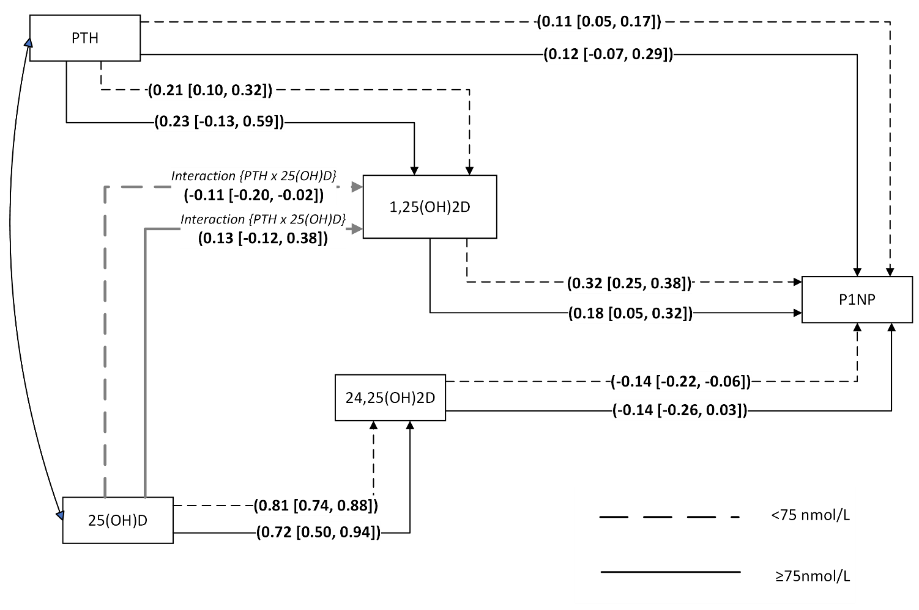

PTH: Parathyroid hormone; 25(OH)D: 25 hydroxy-vitamin D; 1,25(OH)₂D: 1,25 dihydroxy-vitamin D; 24,25(OH)₂D: 24,25 dihydroxy-vitamin D; P1NP: Procollagen Type 1 N-Terminal Propeptide

Figure 2: Relative associations presented in standardized coefficients between vitamin D metabolites, PTH and CTX stratified by 25(OH)D levels [<75nmol vs $≥$75nmol/L]

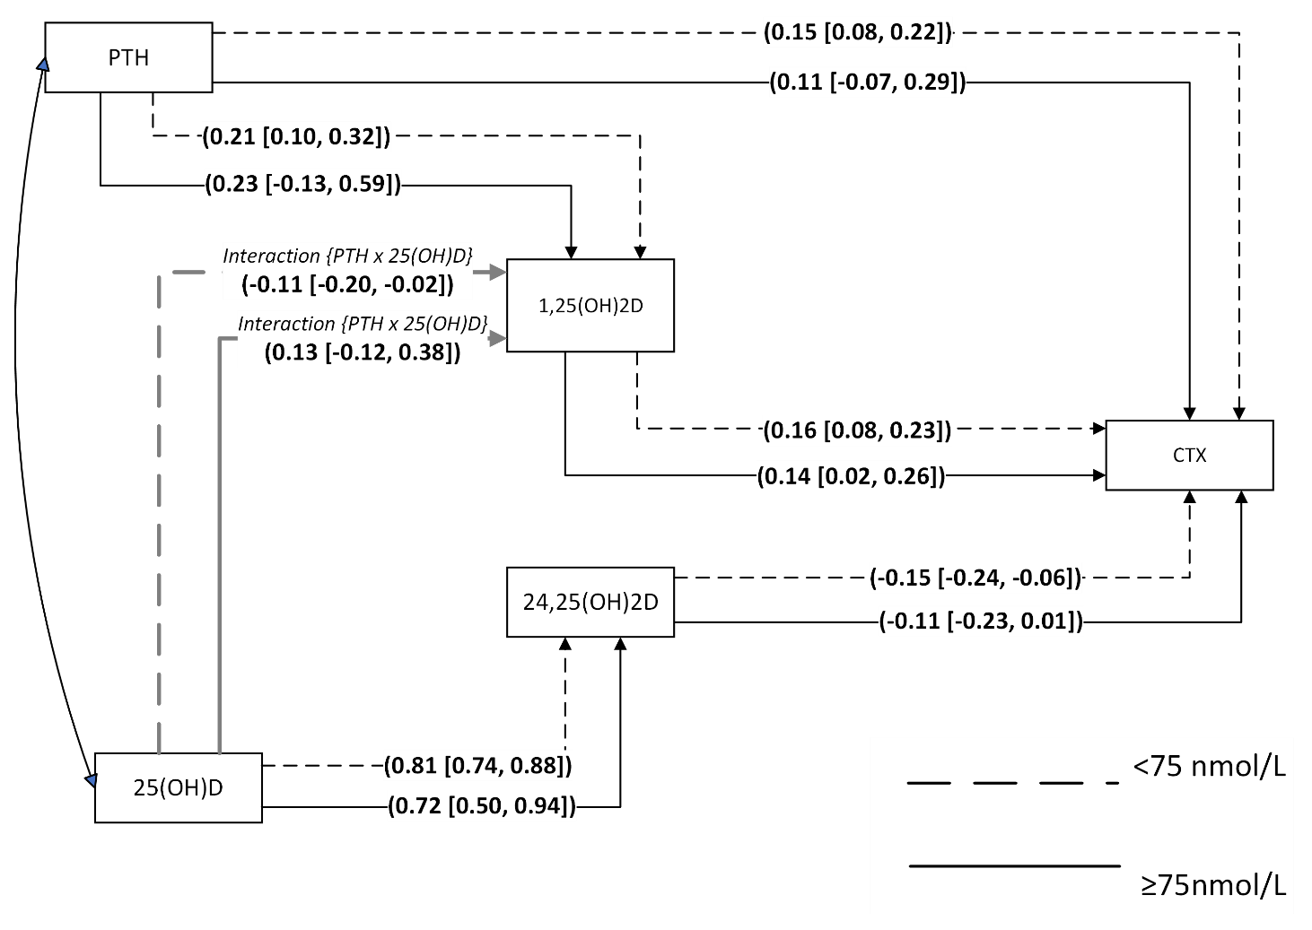

PTH: Parathyroid hormone; 25(OH)D: 25 hydroxy-vitamin D; 1,25(OH)₂D: 1,25 dihydroxy-vitamin D; 24,25(OH)₂D: 24,25 dihydroxy-vitamin D; CTX: C-Terminal Telopeptide of Type I Collagen

Figure 3: SEM illustrating the vitamin D feedback loop and anabolic response according to the concentration of 25(OH)D

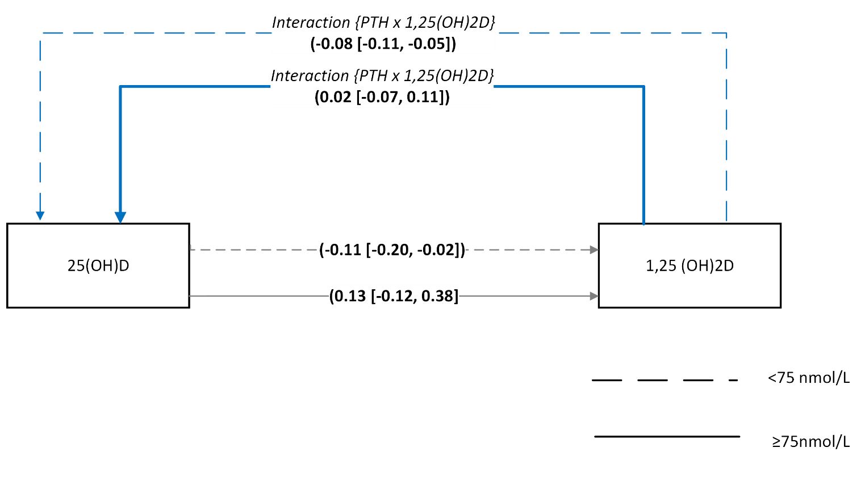

PTH: Parathyroid hormone; 25(OH)D: 25 hydroxy-vitamin D; 1,25(OH)₂D: 1,25 dihydroxy-vitamin D

Figure 4: SEM model with the interaction effect of 25(OH)D and dietary calcium on PTH

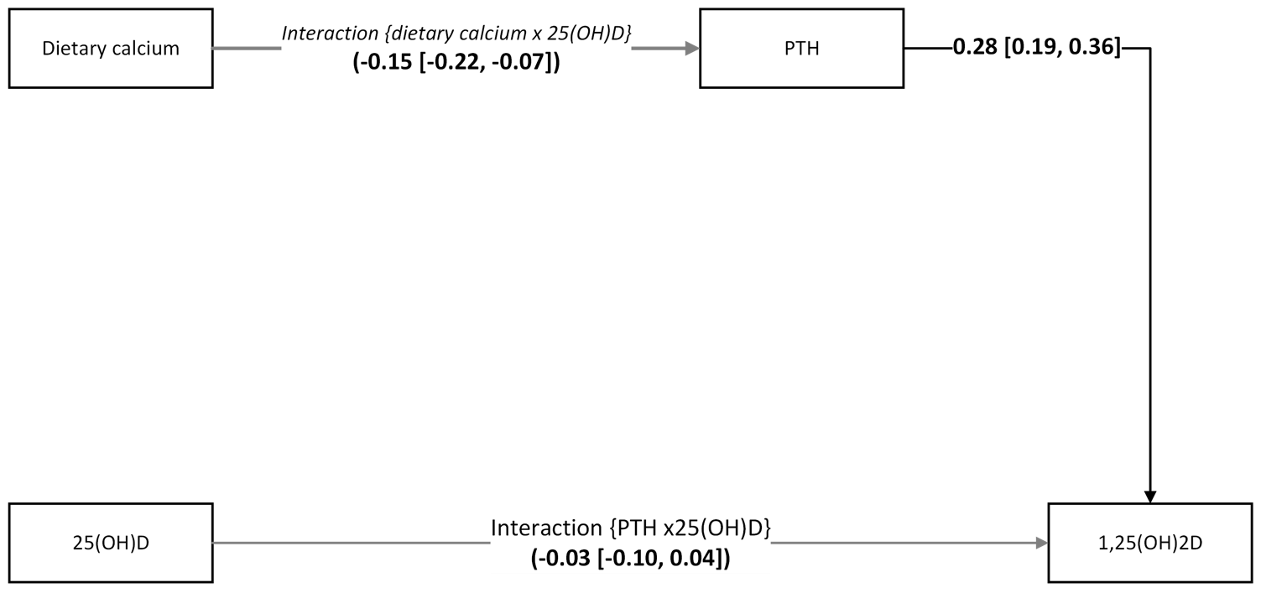

PTH: Parathyroid hormone; 25(OH)D: 25 hydroxy-vitamin D; 1,25(OH)₂D: 1,25 dihydroxy-vitamin D

Supplemental Table 1: Conversion of self-reported dietary consumption into weekly median calcium and vitamin D intakes
 | Calcium Intake-median (mg/week) | Vit D intake-median (µg /week)
Dairy
Never | 0
Less than 4 times in past month | 129.5
1-2 times a week | 499.5
3-5 times a week | 1249.5
Almost every day | 1875
Legumes
Never | 0
Less than 4 times in past month | 24.5
1-2 times a week | 79.5
3-5 times a week | 199.5
Almost every day | 300
Fish
Never | 0 | 0
Less than 4 times in past month | 29.5 | 1.22
1-2 times a week | 99.5 | 3.95
3-5 times a week | 249.5 | 8.95
Almost every day | 375 | 13.00
Eggs
Never | 0 | 0
Less than 4 times in past month | 23.5 | 1.95
1-2 times a week | 74 | 5.95
3-5 times a week | 184.5 | 14.5
Almost every day | 281.5 | 22.5
Meat
Never |  | 0
Less than 4 times in past month |  | 0.295
1-2 times a week |  | 0.995
3-5 times a week |  | 2.50
Almost every day |  | 3.75
Fortified margarine and oils
Never |  | 0
Less than 4 times in past month |  | 1.95
1-2 times a week |  | 5.95
3-5 times a week |  | 14.95
Almost every day |  | 22.50
Vitamin supplements
Never | 0 | 0
Less than 4 times in past month | 250 | 5
1-2 times a week | 999.5 | 19.5
3-5 times a week | 2499.5 | 49.5
Almost every day | 3750 | 75

Supplemental Table 2: Relative associations presented in standardized coefficients between vitamin D metabolites, PTH and bone turnover markers stratified by 25(OH)D levels [<75nmol vs $≥$75nmol/L]

Pathways |  |  | 25(OH)D concentration at baseline (n=842)
 |  |  | <75nmol/L (n=637) β [95% CI] | ≥ 75nmol/L (n=205)  β [95% CI]
Interaction of 25(OH)D and PTH |  | 1,25(OH)₂D | -0.11 [-0.20, -0.02]^{b} | 0.13 [-0.12, 0.38]
PTH |  | 1,25(OH)₂D | 0.21 [0.10, 0.32]ª | 0.23 [-0.13, 0.59]
25(OH)D |  | 24,25(OH)₂D | 0.81 [0.74, 0.88]ª | 0.72 [0.50, 0.94]ª
P1NP
PTH |  | P1NP | 0.18 [0.12, 0.25]ª | 0.16 [-0.02, 0.34]
1,25(OH)₂D |  | P1NP | 0.32 [0.25, 0.38]ª | 0.18 [0.05, 0.32]ª
24,25(OH)₂D |  | P1NP | -0.14 [-0.22, -0.06]ª | -0.14 [-0.26, -0.03]^{b}
CTX
PTH |  | CTX | 0.18 [0.11, 0.26]ª | 0.14 [-0.03, 0.32]
1,25(OH)₂D |  | CTX | 0.16 [0.08, 0.23]ª | 0.14 [0.02, 0.26]^{b}
24,25(OH)₂D |  | CTX | -0.15 [-0.24, -0.06]ª | -0.11 [-0.23, 0.01]^{c}
The pathways are adjusted for sex, age and country showing standardised Beta coefficients and 95% CI

PTH: Parathyroid hormone
25(OH)D: 25 hydroxy vitamin D
1,25(OH)₂D: 1,25 dihydroxy vitamin D
24,25(OH)₂D: 24,25 dihydroxy vitamin D
P1NP: Procollagen Type 1 N-Terminal Propeptide
CTX: C-Terminal Telopeptide of Type I Collagen

ª: p<0.001, ^{b}: p<0.05, ^{c}: 0.01<p<0.05

Supplemental Table 3: Total, direct, and indirect effects between vitamin D₃ pathway metabolites and bone turnover markers (P1NP and CTX) stratified by 25(OH)D groups.

Pathways | Standardized total effect |  | Standardized direct effect |  | Standardized indirect effect
Pathways | <75nmol  (n=637) | $≥$75 nmol  (n=205) | <75nmol  (n=637) | $≥$75 nmol  (n=205) | <75nmol  (n=637) | $≥$75 nmol  (n=205)
25(OH)D.PTH → 1,25(OH)₂D | -0.11 [-0.20, -0.02] | 0.13 [-0.12, 0.38] | -0.11 [-0.20, -0.02] | 0.13 [-0.12, 0.38]
PTH → 1,25(OH)₂D | 0.21 [0.10, 0.32] | 0.23 [-0.13, 0.59] | 0.21 [0.10, 0.32] | 0.23 [-0.13, 0.59] | - | -
25(OH)D → 24,25(OH)₂D | 0.81 [0.74, 0.88] | 0.72 [0.50, 0.94] | 0.81 [0.74, 0.88] | 0.72 [0.50, 0.94]
P1NP
PTH → P1NP | 0.18 [0.12, 0.25] | 0.16 [-0.02, 0.34] | 0.11 [0.05, 0.17] | 0.12 [-0.05, 0.29] | 0.07 [0.03, 0.10] | 0.04 [-0.03, 0.11]
1,25(OH)₂D → P1NP | 0.32 [0.25, 0.38] | 0.18 [0.05, 0.32] | 0.32 [0.25, 0.38] | 0.18 [0.05, 0.32] | - | -
24,25(OH)₂D → P1NP | -0.14 [-0.22, -0.06] | -0.14 [-0.26, -0.03] | -0.14 [-0.22, -0.06] | -0.14 [-0.26, -0.03]
CTX
PTH → CTX | 0.18 [0.11, 0.26] | 0.14 [-0.03, 0.32] | 0.15 [0.08, 0.22] | 0.11 [-0.07, 0.29] | 0.03 [0.01, 0.06] | 0.03 [-0.02, 0.09]
1,25(OH)₂D → CTX | 0.16 [0.08, 0.23] | 0.14 [0.02, 0.26] | 0.16 [0.08, 0.23] | 0.14 [0.02, 0.26] | - | -
24,25(OH)₂D → CTX | -0.15 [-0.24, -0.06] | -0.11 [-0.23, 0.01] | -0.15 [-0.24, -0.06] | -0.11 [-0.23, 0.01] | - | -

Supplemental Table 4: SEM for vitamin D feedback loops and the anabolic reaction by 25(OH)D concentration [<75nmol vs $≥$75nmol/L]

Pathways |  |  | 25(OH)D concentration at baseline (n=842)
 |  |  | <75nmol/L (n=637) β [95% CI] | ≥ 75nmol/L (n=205)  β [95% CI]
Interaction of PTH and 1,25(OH)₂D |  | 25(OH)D | -0.08 [-0.11, -0.05]ª | 0.02 [-0.07, 0.11]
Interaction of 25(OH)D and PTH |  | 1,25(OH)₂D | -0.11 [-0.20, -0.02]^{b} | 0.13 [-0.12, 0.38]
The pathways are adjusted for sex, age and country showing standardised Beta coefficients and 95% CI

PTH: Parathyroid hormone
25(OH)D: 25 hydroxyvitamin D;
1,25(OH)₂D: 1,25 dihydroxy-vitamin D

ª: p<0.001, ^{b}: p<0.05, ^{c}: 0.01<p<0.05

Supplemental Table 5: SEM model with the interaction effect of 25(OH)D and dietary calcium on PTH

Pathways |  |  | (β [95% CI]  (n=842)
Interaction of dietary calcium and 25(OH)D |  | 25(OH)D | -0.15 [-0.22, -0.07]ª
Interaction of 25(OH)D and PTH |  | 1,25(OH)₂D | -0.03 [-0.10, -0.04]
PTH |  | 1,25(OH)₂D | 0.28 [0.19, 0.36]ª
The pathways are adjusted for sex, age and country showing standardised Beta coefficients and 95% CI

PTH: Parathyroid hormone
25(OH)D: 25 hydroxy-vitamin D
1,25(OH)₂D: 1,25 dihydroxy-vitamin D

ª: p<0.001, ^{b}: p<0.05, ^{c}: 0.01<p<0.05

Supplemental Table 6: Relative associations presented in standardized coefficients between vitamin D metabolites, PTH and P1NP, adjusted for creatinine clearance and stratified by 25(OH)D concentration [<75nmol vs $≥$75nmol/L].

Pathways |  |  | 25(OH)D concentration at baseline (n=842)
 |  |  | <75nmol/L (n=637) β [95% CI] | ≥ 75nmol/L (n=205)  β [95% CI]
Interaction of 25(OH)D and PTH |  | 1,25(OH)₂D | -0.13 [-0.21, -0.04]ª | 0.10 [-0.13, 0.33]
PTH |  | 1,25(OH)₂D | 0.19 [0.10, 0.29]ª | 0.20 [-0.15, 0.56]
25(OH)D |  | 24,25(OH)₂D | 0.82 [0.76, 0.89]ª | 0.75 [0.56, 0.94]ª
P1NP
PTH |  | P1NP | 0.14 [0.08, 0.19]ª | 0.05 [-0.10, 0.21]
1,25(OH)₂D |  | P1NP | 0.32 [0.26, 0.38]ª | 0.18 [0.07, 0.30]ª
24,25(OH)₂D |  | P1NP | -0.13 [-0.21, -0.05]ª | -0.18 [-0.29, -0.08]ª
CTX
PTH |  | CTX | 0.15 [0.09, 0.22]ª | 0.07 [-0.09, 0.23]
1,25(OH)₂D |  | CTX | 0.18 [0.11, 0.25]ª | 0.16 [0.04, 0.27]ª
24,25(OH)₂D |  | CTX | -0.14 [-0.23, -0.06]ª | -0.11 [-0.22, -0.01]^{b}
The pathways are adjusted for creatinine clearance, sex, age and country showing standardised Beta coefficients and 95% CI

PTH: Parathyroid hormone
25(OH)D: 25 hydroxy vitamin D
1,25(OH)₂D: 1,25 dihydroxy vitamin D
24,25(OH)₂D: 24,25 dihydroxy vitamin D
P1NP: Procollagen Type 1 N-Terminal Propeptide
CTX: C-Terminal Telopeptide of Type I Collagen

ª: p<0.001, ^{b}: p<0.05, ^{c}: 0.01<p<0.05

Supplemental Table 7: Relative associations presented in standardized coefficients between vitamin D metabolites, PTH and P1NP stratified by 25(OH)D concentration [<50nmol vs $≥$50nmol/L].

Pathways |  |  | 25(OH)D concentration at baseline (n=842)
 |  |  | <50nmol/L (n=117) β [95% CI] | ≥ 50nmol/L (n=725)  β [95% CI]
Interaction of 25(OH)D and PTH |  | 1,25(OH)₂D | -0.03 [-0.22, 0.15] | 0.03 [-0.09, 0.15]
PTH |  | 1,25(OH)₂D | 0.34 [-0.05, 0.74]^{c} | 0.25 [0.16, 0.33]ª
25(OH)D |  | 24,25(OH)₂D | 0.66 [0.44, 0.88]ª | 0.74 [0.66, 0.82]ª
P1NP
PTH |  | P1NP | 0.06 [-0.06, 0.17] | 0.13 [0.06, 0.20]ª
1,25(OH)₂D |  | P1NP | 0.45 [0.32, 0.59]ª | 0.25 [0.18, 0.32]ª
24,25(OH)₂D |  | P1NP | -0.19 [-0.46, 0.09] | -0.13 [-0.19, -0.07]ª
CTX
PTH |  | CTX | 0.16 [0.04, 0.28] | 0.16 [0.09, 0.24]ª
1,25(OH)₂D |  | CTX | 0.15 [0.003, 0.31]^{b} | 0.16 [0.10, 24]ª
24,25(OH)₂D |  | CTX | -0.16 [-0.44, 0.12] | -0.12 [-0.18, -0.05]ª
The pathways are adjusted for sex, age and country showing standardised Beta coefficients and 95% CI

PTH: Parathyroid hormone
25(OH)D: 25 hydroxy vitamin D
1,25(OH)₂D: 1,25 dihydroxy vitamin D
24,25(OH)₂D: 24,25 dihydroxy vitamin D
P1NP: Procollagen Type 1 N-Terminal Propeptide
CTX: C-Terminal Telopeptide of Type I Collagen

ª: p<0.001, ^{b}: p<0.05, ^{c}: 0.01<p<0.05

Supplemental Figure 1: Monthly variations in serum 25(OH)D concentrations by country.
Supplemental Figure 2: A scatter plot showing the relationship between 25(OH)D and PTH stratified by daily calcium intake (<150mg vs ≥150mg)

Supplemental Figure 3: The linear associations between vitamin D metabolites and bone turnover markers adjusted for age, sex, height, country and total body percentage fat mass.
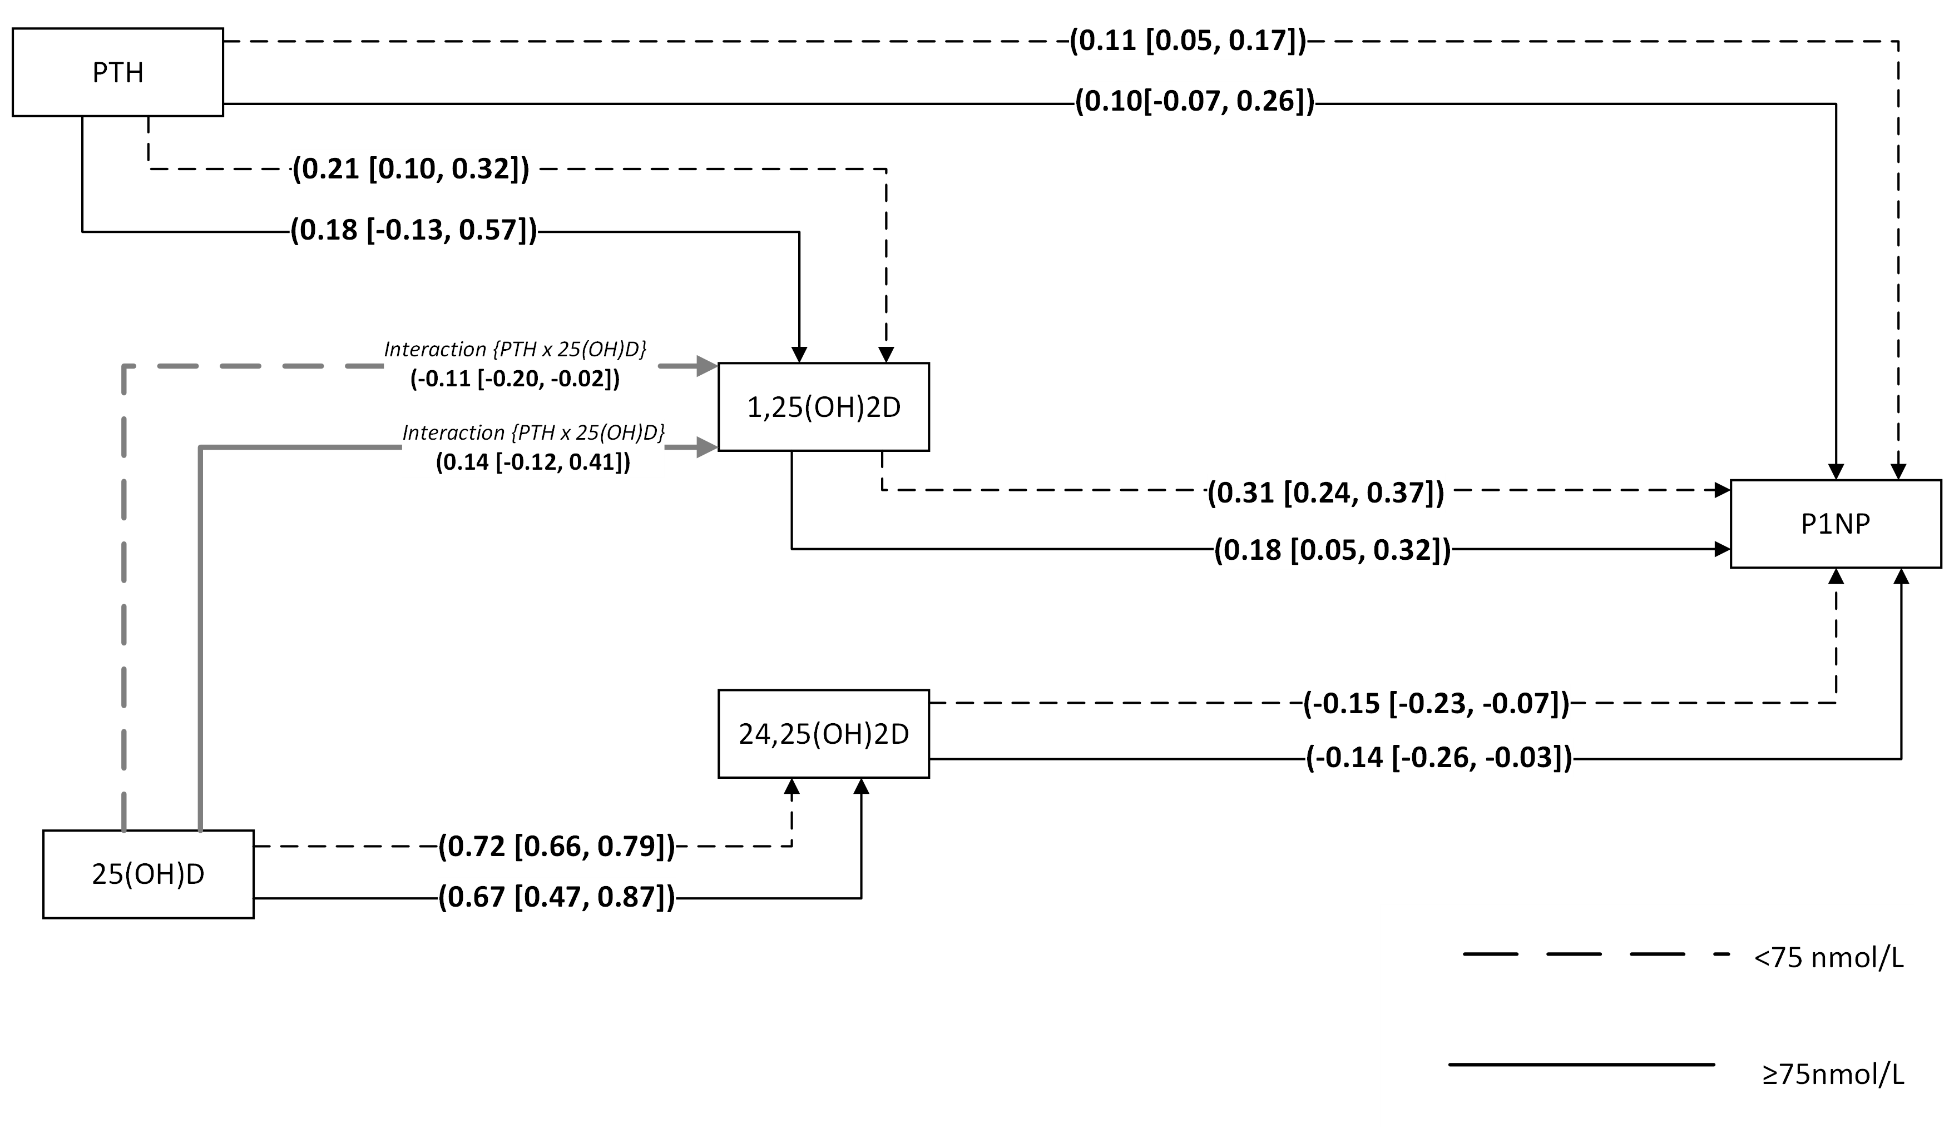
25(OH)D concentration

