Zeolitic imidazolate framework-derived Co-Fe@NC for rechargeable hybrid sodium–air battery with a low voltage gap and long cycle life
Haixing Gaoª, Siqi Zhuª, Yao Kangª, Duc Anh Dinh^{b}, Kwan San Hui^{c,*}, Feng Bin^{d}, Xi Fan^{e}, Fuming Chen^{f}, Azhar Mahmood^{g}, Jianxin Geng^{h}, Weng-Chon (Max) Cheong^{i,*}, Kwun Nam Hui^{a,*}

ªJoint Key Laboratory of the Ministry of Education, Institute of Applied Physics and Materials Engineering, University of Macau, Avenida da Universidade, Taipa, Macau SAR, 999078, China
^{b}NTT hi-tech Insitute, Nguyen Tat Thanh University, Ho Chi Minh city 700000, Vietnam
^{c}School of Engineering, University of East Anglia, Norwich, NR4 7TJ, United Kingdom
^{d}State Key Laboratory of High-Temperature Gas Dynamics, Institute of Mechanics, Chinese Academy of Science, Beijing 100190, PR China
^{e}Ningbo Institute of Materials Technology, Engineering, Chinese Academy of Sciences, Ningbo, 315201, China
^{f}State Key Laboratory of Optic Information Physics and Technologies, School of Physics and Telecommunication Engineering, South China Normal University, Guangzhou, China 510006, China
^{g}Center for Advanced Analytical Science, School of Chemistry and Chemical Engineering, Guangzhou University, Guangzhou 510006, P. R. China

^{h}Beijing University of Chemical Technology, College of Energy, 15 North Third Ring East Road, Chaoyang District, Beijing, CN 100029
^{i}Department of Physics and Chemistry, Faculty of Science and Technology, University of Macau, Macao SAR, 999078, P. R. China

* Corresponding author
Kwun Sam Hui, E-mail: k.hui@uea.ac.uk
Weng-Chon (Max), E-mail: maxcheong@um.edu.mo
Kwun Nam Hui, E-mail: bizhui@um.edu.mo

ABSTRACT
Developing low-cost, efficient electrocatalysts for the air electrode of high-performance rechargeable hybrid sodium–air batteries (HSABs) remains challenging. Herein, efficient bimetallic nanoparticles encapsulated in nitrogen-doped carbon (Co-Fe@NC) were developed for oxygen reduction and evolution reactions in the HSAB. The bimetallic Co-Fe@NC catalyst outperformed its monometallic counterparts in ORR/OER activity. The assembled HSAB, utilizing the Co-Fe@NC in the air electrode, exhibited a smaller voltage gap of 0.27 V and a higher power density of 5.39 mW/cm² compared with the air electrode utilizing Pt/C+RuO₂ (0.55 V, 4.79 mW/cm²). Furthermore, the round-trip efficiency of the assembled HSAB is up to 75.37% after 700 hours cycling at 0.1 mA/cm², outperforming the benchmark HSAB with Pt/C+RuO₂ (65.76% after 400 hours). This work presents a promising strategy to prepare low-cost, efficient electrocatalysts to substitute the precious catalyst Pt/C+RuO₂ in HSABs or other metal-air batteries for practical applications.

KEYWORDS: Zeolitic-Imidazolate-Frameworks (ZIF); MOF-derived materials; bimetallic materials; bifunctional electrocatalyst; hybrid sodium–air battery

1. INTRODUCTION
To achieve large-scale energy storage to make full use of unstable sustainable energy sources such as wind power and photovoltaic power, various battery technologies are constantly being explored.¹ Lithium-ion batteries are currently the most successful commercialized battery. However, the vast advantages of conventional lithium-ion batteries do not cover their natural limitations, including the inadequate reserves of lithium on the Earth and limited specific energy density (about 300 Wh/kg).² The rechargeable metal-air battery is a very good alternative that can be used to replace lithium-ion batteries due to their low cost and extremely high energy density.³⁻⁵ In comparison with rechargeable lithium-air batteries, sodium-air batteries have aroused high research attention owing to the lower charging voltage and the plentiful sodium. However, during the discharge process, insoluble discharge products (e.g., NaO₂, Na₂O₂, or Na₂O₂-2H₂O) are formed on the air electrode, leading to irreversible electrochemical reactions and further deteriorating the intrinsic sluggish kinetics on the air cathode because of the stacking insoluble discharge products, which tends to block the gas diffusion channels, resulting in the appearance of high overpotentials.
Rechargeable hybrid sodium–air batteries (HSABs) have bright application prospects due to their high theoretical energy density (2600 Wh/kg) and dismiss the insoluble discharge products by using an aqueous sodium hydroxide solution on the cathode side.^{1, 6, 7} The performance of HSABs largely depends on the oxygen reduction reaction (ORR) and the oxygen evolution reaction (OER) that occurred in the electrocatalysts on the air cathode. To enhance the efficiency of air electrodes, precious metals-based electrocatalysts are considered to be the best electrocatalysts due to their high performance.⁸ Pt/C and RuO₂ are the state-of-the-art electrocatalysts for ORR and OER, respectively. However, their scarcity and limited stability in alkaline HSABs hinder their further application. Therefore, exploring high-performance bifunctional electrocatalysts with low cost for HSABs is of urgent need.
Recently, metal-nitrogen-doped carbon (M-N-C) catalysts have emerged as a promising family of electrocatalysts for ORR, reducing the cost of electrode materials.⁹⁻¹⁴ Among the various reported M-N-C catalysts, iron-nitrogen-doped carbon (Fe-N-C) materials have drawn significant attention due to their relatively high ORR performance.^{15, 16} The typical synthesis method of Fe-N-C is based on the pyrolysis of modified zeolitic imidazolate frameworks (ZIFs).¹⁷⁻²¹ During the calcination process, metallic species such as Fe and Fe₃C were often formed together with the existence of Fe-N_{x} moieties that are deemed to be active sites for ORR.²²⁻²⁵ Metal-N active sites formed between metal nanoparticles and the surrounding N atoms within carbon shells can also play a crucial role in alkaline ORR.²⁶⁻³⁰ For example, Shi et al. synthesized graphene-encapsulated Co nanocrystals and spatially isolated single Co atoms for highly efficient ORR.³¹ Wang et al. developed an N-doped porous carbon nanocage with the coexistence of atomically dispersed Co-N₄ sites and small Co nanoparticles, which showed excellent ORR activity and outstanding stability in alkaline media.³² Qiao et al. developed an effective approach to preparing a Pt or Pt₃Co nanoparticle dispersion on FeN₄ site-rich carbon, the optimal Pt₃Co/FeN₄ catalyst achieved significantly enhanced performance and durability.³³ Therefore, besides the metal-N_{x} active site, the cooperation of nanoparticles could enhance the catalytic performance and satisfy the demand for highly efficient bifunctional electrocatalysts.³⁴⁻³⁷
Herein, we developed a bifunctional electrocatalyst with Co₃Fe₇/Fe₃C/FeN_{0.0324} nanoparticles encapsulated in cobalt, iron-nitrogen-doped carbon (donated as Co-Fe@NC) derived from ZIFs. After pyrolysis of ZIFs precursor at the elevated temperature, the Fe/Co-N_{x}C_{y} species co-existing with Co₃Fe₇/Fe₃C/FeN_{0.0324} were formed and anchored on the nitrogen-doped carbon. The as-prepared Co-Fe@NC exhibited an overall potential gap (ΔE=E_{j=10} - E_{1/2}) of 0.88 V comparable to Pt/C+RuO₂ (0.86 V) in 0.1 M KOH. The HSAB assembled with Co-Fe@NC air electrode exhibits a low voltage gap of 0.27 V at 0.1 mA/cm², a high power density of 5.39 mW/cm² (corresponding to 2695 mW/g), and remarkable cycling stability (reaching 700 h). This study highlights cost-effective bifunctional electrocatalysts for renewable energy storage applications.

2. EXPERIMENTAL SECTION

2.1 Catalyst preparation
Synthesis of precursor: The CoFe-containing ZIF-8 precursor (CoFeZn-ZIFs) was synthesized as follows: 45.0 mmol 2-methylimidazole was dissolved in 80 mL methanol under vigorous stirring, 5.6 mmol Zn(CH₃COO)₂·2H₂O, 0.14 mmol Co(acac)₃, and 0.14 mmol Fe(acac)₃ were dissolved in another 80 mL methanol. Then the above two solutions were mixed under constant stirring. After the mixed solution under vigorous stirring for 24 h at room temperature, the precipitation formed. The precipitation was centrifugated and washed three times with methanol to remove the reaction residue. The precipitation (CoFeZn-ZIFs) was dried in a vacuum oven at 60 ℃. CoZn-ZIF and FeZn-ZIFs were synthesized by the same method except by adding the iron and cobalt metal salts, respectively. During the synthesis, the molar ratio between Zn and the metal ions is kept the same. ZIF-8 was also prepared for reference (absence of both Co(acac)₃ and Fe(acac)₃).
Synthesis of electrocatalyst: The Co-Fe@NC, Fe@NC, Co-NC, and NC were prepared by the annealing of FeCoZn-ZIFs, CoZn-ZIFs, FeZn-ZIFs, and ZIF-8 under the protection of N₂, respectively. The temperature of calcination is 920 ℃ (5 ℃/min) for 3 h. Then naturally cooled to room temperature, the products were collected and without any further treatment.
2.2. Physical characterization
The morphology of the electrocatalysts was portrayed by scanning electron microscopy (SEM, Zeiss Sigma) and transmission electron microscopy (TEM, Talos F200X, FEI, accelerating voltage of 200 kV). The crystallographic structure was determined using an Ultima IV XRD equipped with Cu Kα radiation (λ = 1.5418 Å), and the data were collected in the Bragg–Brentano mode with a scan rate of 10°/min. X-ray photoelectron spectroscopy (XPS) was offered out on a Thermo Scientific ESCALAB Xi⁺ XPS Microprobe. The Raman spectroscopy was performed on Horiba LABHRev-UV operated at 633 nm wavelength.
2.3. Electrochemical measurements
The electrochemical tests were performed under a three-electrode system using an electrochemical workstation (VMP-300 Bio-logic system). A Pt wire and Hg/HgO electrode served as the counter electrode and the reference electrode, respectively. All measured potentials were calibrated to the reversible hydrogen electrode (RHE) according to the equation:
$E_{RHE}=E_{Hg/HgO}+0.0591×pH+0.098 V$.
A rotating disk electrode (RDE, 5 mm diameter) was the working electrode. 5.0 mg electrocatalyst was mixed with 950 μL ethanol + 50 μL 5 wt% Nafion solution and subsequently under ultrasonic for approximately 2 h. 20 µL of the resulting ink was loaded on the working electrode, achieving a catalyst loading of 0.5 mg/cm², followed by evaporation of the solvent in the air. The commercial 20% Pt/C catalyst and RuO₂ with the same loading were used as the ORR and OER benchmark, respectively.
The ORR test was performed in 0.1 M KOH with saturated oxygen. The linear sweep voltammetry (LSV) curve was recorded at a scan rate of 2 mV/s at 1600 rpm. According to the Tafel equation, use the LSV profile data to calculate the Tafel slope:
$$η=b log⁡(j/j_{0})$$
where η is the overpotential calculated by η = |1.23 V – E_{RHE}|, j is the recorded disk current density, j₀ is the exchange current density, and b is the Tafel slope.
The kinetic current density (J_{k}) was calculated by the Koutecky-Levich equation:
$$1/J=1/J_{L}+1/J_{k}$$
where J, J_{k}, and J_{L} are the measured, kinetic, and limiting current density, respectively.
Electrochemical surface area (ECSA) was evaluated by the double-layer capacitance (C_{dl}) of the electrocatalysts. C_{dl} was measured by CV at different scan rates in the nonFaradaic potential range. The value of C_{dl} was half of the slope derived from the difference between anode and cathode current density (Δj = j_{a}−j_{c}) against the scan rate. The C_{dl} is converted into the ECSA using the specific capacitance value for a flat standard electrode with 1 cm² of real surface area (C_{s}), the C_{s} is generally in the range of 20 to 60 μF cm⁻². Here we use the average value of 40 μF cm⁻² per cm_{ECSA}² to calculate the ECSA.³⁸
$$ECSA=C_{dl}/C_{s}$$
The normalized specific J_{k} ($J_{k ECSA}$) can be obtained by:
$$J_{k ECSA }=J_{k}/ECSA$$
For RRDE measurement, the electron transfer number (n) and peroxide intermediate production percentage (H₂O₂%) was calculated according to the following formula:
$$n=4×I_{d}{/(I}_{d}+I_{r}/N)$$
$$H_{2}O_{2}\%=200×{(I}_{r}/N)/(I_{d}+I_{r}/N)$$
where I_{d} is the disk current, I_{r} is the ring current, and N is the current collection efficiency at the ring, which was 0.37 comes from the manufacturer.
To evaluate the stability, LSV curves before and after 4000, 8000, and 12000 CV cycles across the potential window of 0.2 to 1.0 V vs. RHE in O₂-saturated 0.1 M KOH solution were performed, the stability was also assessed by current-time chronoamperometric measurements at 0.8 V vs. RHE. The OER test was also performed in 0.1 M KOH. LSV curves were also recorded at a scanning rate of 2 mV/s with 1600 rpm rotation speed.
2.4. Hybrid sodium-air battery assembles
To assemble a hybrid sodium–air battery, sodium metal attached to a nickel foam (current collector) was used as an anode enclosed in a stainless-steel cabinet. The organic electrolyte is a 0.6 mL solution of 1 M NaClO₄ in EC/DMC/EMC (1: 1: 1) with 5 vol% FEC also encapsulated in stainless steel cavity. NASICON was employed as a separator. It was chosen to separate the organic and aqueous electrolytes and only allow the migration of Na⁺ during the discharge/charge process. The anode assembly of the hybrid sodium–air battery was in a glove box. The catholyte is 10 mL 1 M NaOH solution. The electrocatalyst Co-Fe@NC was loading on the waterproof carbon cloth serving as a cathode. The loading mass is about 2 mg/cm². The commercial Pt/C+RuO₂ was also loading on the carbon cloth for comparison. Then, the power density of homemade hybrid sodium-air battery was measured by Bio-logic electrochemical workstation and the cycling performance was measured on LAND battery testing station (CT2001 A, Wuhan LAND electronics) at room temperature. The cycling performance is evaluated by constant current discharge–charge mode. The discharge–charge cycle is 4 h at a current density of 0.1 mA/cm² (2 h for discharge and 2 h for charge processes).

3. RESULTS AND DISCUSSION

3.1. Material synthesis and characterization
The Co-Fe@NC was synthesized by the pyrolysis of FeCoZn-ZIFs precursor, as illustrated in Fig. 1a. First, the FeCoZn-ZIFs were prepared by a host-guest process, where ZIF is as the host, while Fe(acac)₃ and Co(acac)₃ are the guests.³⁹ During the growth of ZIFs, Fe(acac)₃ and Co(acac)₃ precursors are encapsulated in the cavities. Then, the Co-Fe@NC was obtained by pyrolysis in an inert N₂ atmosphere. To remove Zn and obtain the highly graphitized carbon, the pyrolysis was performed at 920 °C for 3 h.
X-ray diffraction (XRD) was performed to explore the crystalline phase of the electrocatalysts. The XRD patterns (Fig. 1b) of NC and Co-NC only show two broad carbon peaks (approximately centered at 26° and 43°), indicating that no other phase is formed during the pyrolysis process due to the evaporation of Zn and high dispersion of Co. All diffraction peaks for Fe@NC could be indexed to Fe₃C (PDF # 35-0772), Fe (PDF # 87-0721), and FeN_{0.0324} (PDF # 75-2127). For the Co-Fe@NC sample, an additional peak of Co₃Fe₇ (PDF # 48-1817) was observed. It is suspected that Fe/Co precursors in the FeCoZn-ZIFs were reduced to metallic Co₃Fe₇ by its organic skeleton and metallic iron combined with the surrounding carbon and nitrogen formed Fe₃C and FeN_{0.0324} under high temperature.⁴⁰ Raman spectra (Fig. 1c) of the electrocatalyst presents two peaks centered at ∼1330 cm⁻¹ (D band) and ∼1583 cm⁻¹ (G band). The ratio of I_{D}/I_{G} in Co-Fe@NC is 1.18 in the Raman spectra, which is higher than Fe@NC (1.16), Co-NC (1.09), and NC (0.98). The D band is usually assigned to the disorder and imperfection of the carbon.⁴¹ The increased I_{D}/I_{G} ratio indicates more structural defects, which is beneficial to improve electrocatalytic performance.^{42, 43} The N₂ adsorption/desorption isotherms were measured to investigate the specific surface area and pore size distribution of Co-Fe@NC (Fig. S1 and Table S1). The Brunauer-Emmett-Teller (BET) surface area of Co-Fe@NC was identified as 451.2 m²/g and the average pore size is 3.33 nm. The large surface area and pore size will facilitate the contact between the catalyst surface and the reactants in the electrolyte, also provide more exposed active sites to participate in the electrocatalytic reaction, which ultimately contributes to the performance.⁴⁴ This suggests that the carbon framework obtained by annealing of ZIF precursors is a promising substrate for electrocatalysts.
The FeCoZn-ZIFs precursor is polyhedral with a smooth surface, as indicated by scanning electron microscopy (SEM) (Fig. S2a). After pyrolysis, the resultant Co-Fe@NC retained the polyhedral morphology, and the formed nanoparticles are observed in the carbon polyhedron after pyrolysis (Fig. S2b). Compared with Fe@NC (Fig. S3) and Co-NC (Fig. S4), the obtained Co-Fe@NC preserves the polyhedral morphology in the framework and exhibits porous structure with a rough surface which provides accessibility of active sites for reactant, fast electrolyte penetration/diffusion, and high utilization of catalysts. Also, the high-orderly carbon framework can efficiently suppress the aggregation of metal nanoparticles. In particular, the Co-NC sample showed the presence of no carbon nanotubes that was attributed to the absence of nanoparticle formation (Fig. S5).⁴⁵ The generation of carbon nanotubes is dependent on obtaining small nanocatalysts with high reactivity during the thermal decomposition process.⁴⁶ As shown in the TEM image (Fig. 1d), Co-Fe@NC is composed of polyhedral carbon particles and carbon nanotubes, while some metal particles are encapsulated in carbon polyhedral. We can observe particles surrounded by carbon shells from the high-resolution transmission electron microscopy (HRTEM) image (Fig. 1e). The lattice fringe distance of the wrapped particle was measured as 0.21 nm, 0.18 nm (Fig. S6a), and 0.20 nm (Fig. S6b), which is corresponding to the Fe₃C (211), FeN_{0.0324} (200), and Co₃Fe₇(110) facets, respectively. The lattice fringe distance of the shell is 0.34 nm, corresponding to the graphite C (002), which is beneficial to the protection of the nanoparticles from electrolyte erosion and leads to long-term stability.⁴⁷
The high-angle annular dark-field scanning transmission electron microscopy (HAADF-STEM) images of Co-Fe@NC (Fig. 1f) verify that the nanoparticle was supported on the nitrogen-doped carbon polyhedron. The corresponding elemental mapping images validate that nanoparticles mainly consist of Fe and its compounds. In addition, Co, N, and C are homogeneously distributed in the polyhedron particles. The results indicate that the iron element aggregates and reacts with the surrounding carbon, nitrogen, and cobalt in the process of high-temperature calcination, resulting in the formation of the Fe₃C, FeN_{0.0324}, and Co₃Fe₇.

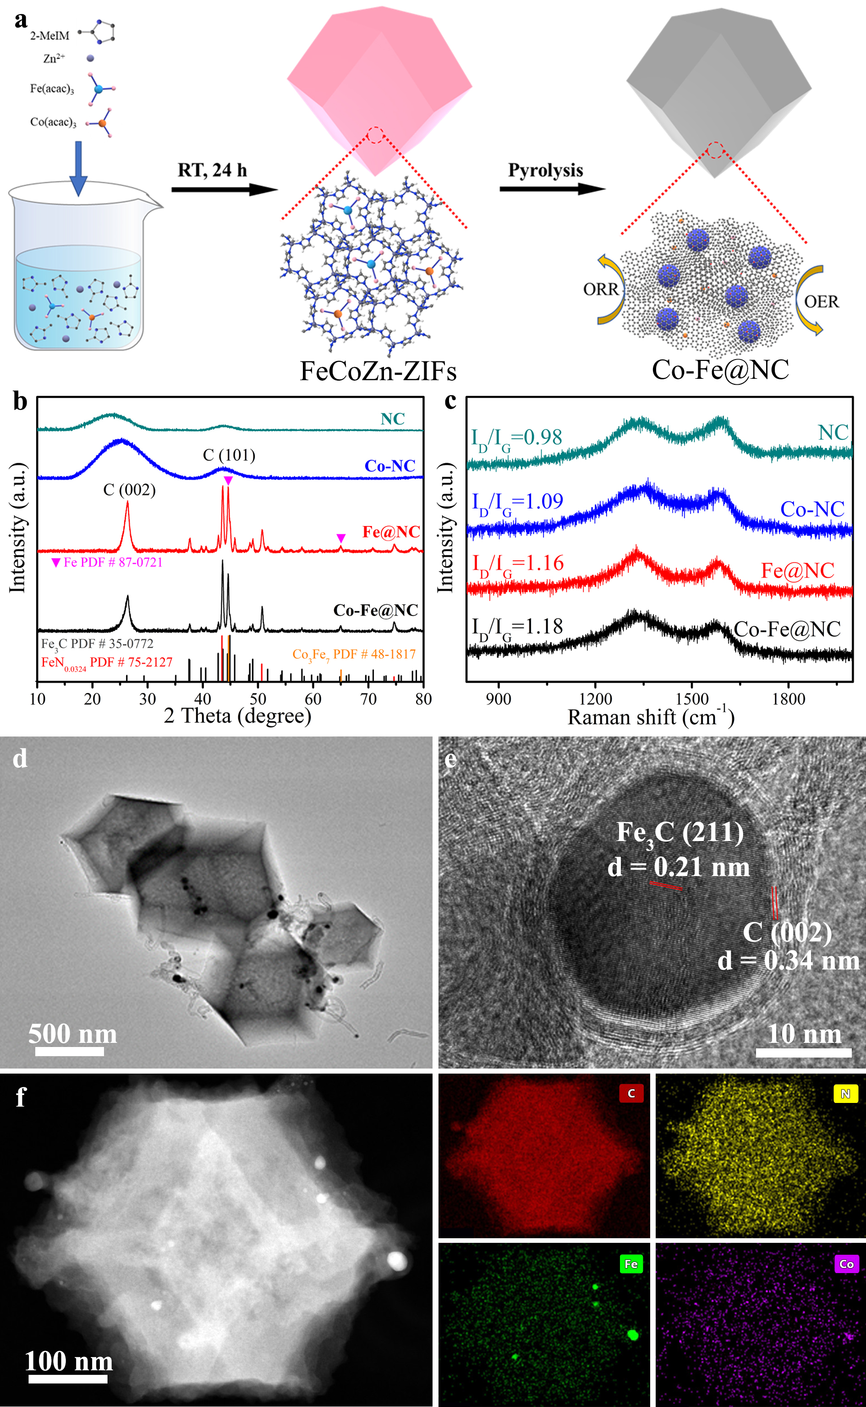
Fig. 1 (a) Schematic diagram of the synthesis route of Co-Fe@NC. (b) XRD patterns and (c) Raman spectra of the Co-Fe@NC, Fe@NC, Co-NC, and NC samples. (d) TEM image and (e) HRTEM image of Co-Fe@NC. (f) The HAADF-STEM image and corresponding elemental mappings of a typical Co-Fe@NC, revealing the elemental distributions of C (red), N (yellow), Fe (green), and Co (violet).
X-ray photoelectron spectroscopy (XPS) was adopted to investigate the content and state of the elements on the surface of the catalysts. Fig. 2a shows the XPS survey of all the samples. The Co-Fe@NC is mainly composed of Co, Fe, N, and C elements. The O element was also detected due to the adsorbed oxygen on the surface of Co-Fe@NC. The quantitative investigation explicates that the atomic percentage of C, N, O, Co, and Fe in Co-Fe@NC are 94.15%, 3.21%, 2.11%, 0.15%, and 0.38%, respectively. The metal content of Co-Fe@NC was also characterized by the inductively coupled plasma emission spectroscopy (ICP-AES) (Table S2).
As shown in Fig. 2b, the high-resolution N 1s spectra of the Co-Fe@NC was principally matched as pyridinic-N (398.4 eV), metal (Co, Fe)-N_{x} (399.1 eV), pyrrolic-N (399.9 eV), graphitic-N (401.2 eV), and oxidized-N (402.6 eV).⁴⁸⁻⁵¹ It is worth noting that pyridine-N located at the edge of the graphite structure can be easily combined with Co or Fe to form a metal-N_{x} interface as a catalytic active center.²⁵⁻²⁷ Due to the good dispersion of cobalt, uniform and abundant metal-N_{x} were formed in the Co-NC. Results showed that Fe is more likely to react with carbon and nitrogen to form Fe₃C and FeN_{0.0324}. The metal-pyridine-N species, which can be assigned to iron or cobalt atoms coordinated with nitrogen atoms, is widely reported as the highly active site of ORR.^{27, 52-54}
In Fig. 2c, the Fe 2p_{3/2} of Co-Fe@NC can be deconvoluted into Fe⁰ (708.1 eV), Fe²⁺ (710.7 eV), Fe³⁺ (713.2 eV), and shakeup satellite (716.8 eV). And peaks in Fe 2p_{1/2} corresponded to the Fe⁰ (720.8 eV), Fe²⁺ (723.4 eV), Fe³⁺ (725.9 eV), and shakeup satellite peak (729.5 eV).⁵⁵⁻⁵⁸ In Fig. 2d, it should be noted that no Co⁰ was observed in Co-Fe@NC and Co-NC, revealing that the majority of Co is in atomically-dispersed CoN_{x}.⁵⁹ The peak at 782.0 eV is corresponding to the Co–N species.⁶⁰ Compared with Co-NC, the binding energy of Co shifts to a higher value in Co-Fe@NC, indicating that the reduced charge density around cobalt.
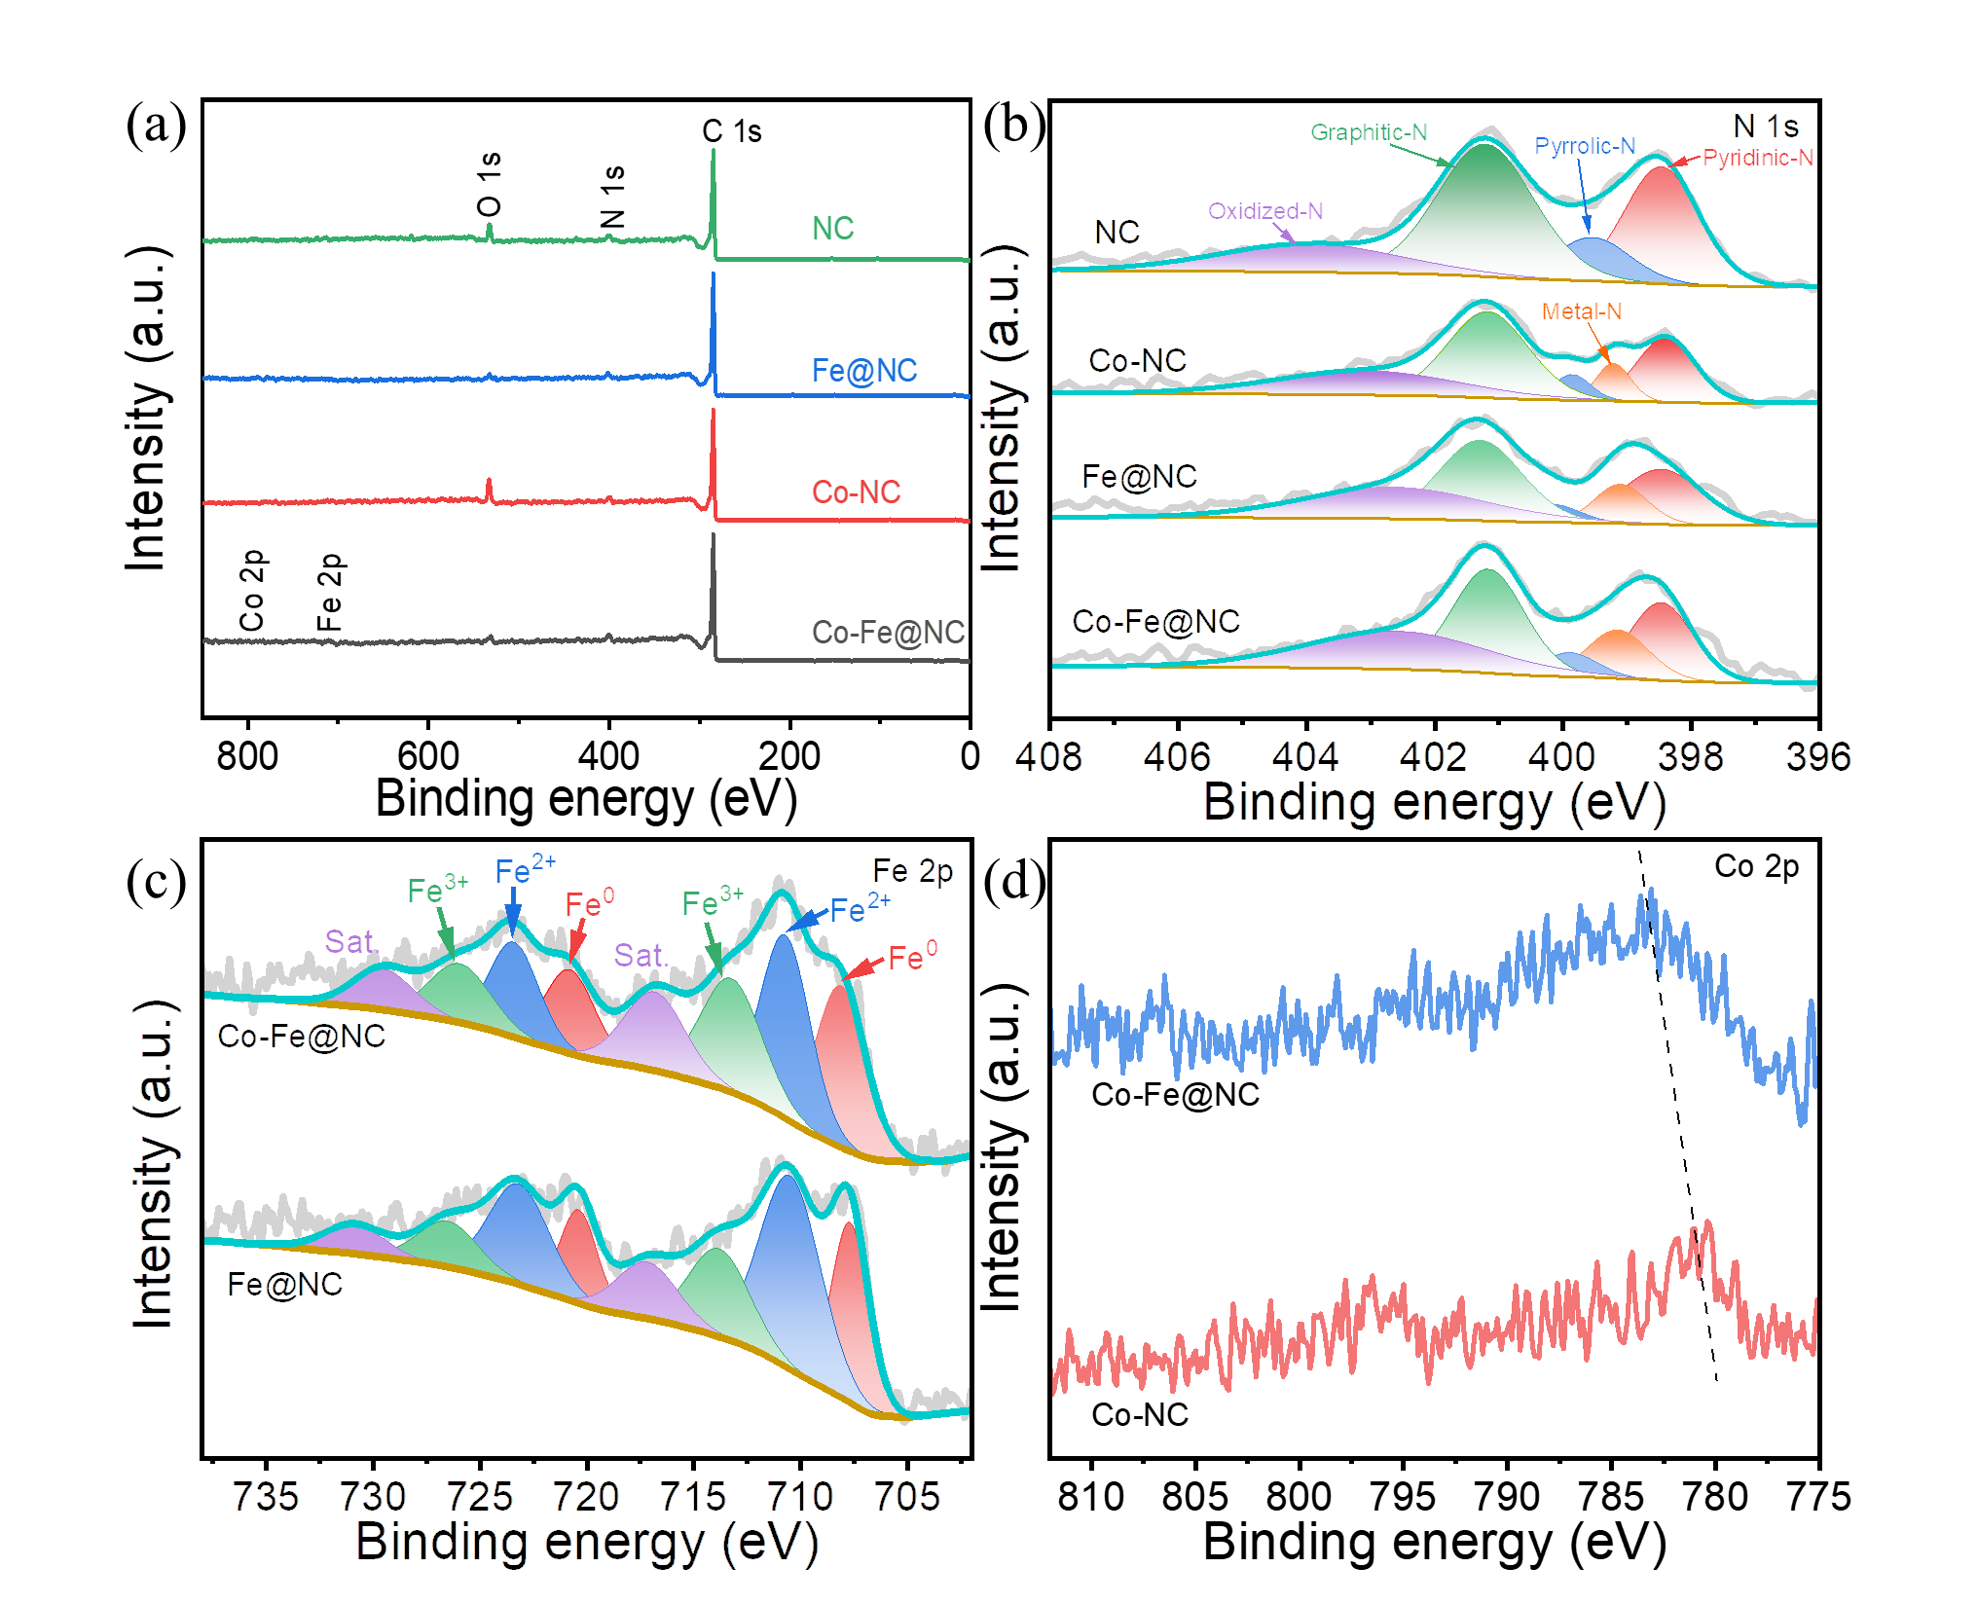
Fig. 2 (a) XPS survey spectra of the samples. (b) High-resolution N 1s spectra of the samples. (c) High-resolution Fe 2p spectra of Co-Fe@NC and Fe@NC. (d) High-resolution Co 2p spectra of Fe@NC and Co-NC.
3.2. Electrochemical performance
The ORR performance of the as-synthesized electrocatalysts was measured by linear sweep voltammetry (LSV) curves in O₂-saturated 0.1 M KOH under the rotating speed of 1600 rpm. As shown in Fig. 3a, Co-Fe@NC exhibits a 1.02 V vs. RHE of onset potential (E_{onset}, defined at -0.20 mA/cm²), 0.86 V vs. RHE of half-wave potential (E_{1/2}), and 5.55 mA/cm² of limited current density (J_{L}, defined at 0.20 V vs. RHE). These performances are superior to those of the Fe@NC (E_{1/2}=0.80 V, J_{L}=5.65 mA/cm²), Co-NC (E_{1/2}=0.81 V, J_{L}=4.55 mA/cm²), NC (E_{1/2}=0.74 V, J_{L}=4.62 mA/cm²), and commercial 20% Pt/C (E_{1/2}=0.83 V, J_{L}=5.32 mA/cm²). The kinetic current density (J_{k}) is proportional to the intrinsic activity of the catalyst.⁶¹ J_{k} was calculated using the Koutecky–Levich equation.⁶² The relationship between J_{k} and the potential of different catalysts is shown in Fig. S7. Co-Fe@NC exhibits the best electrocatalytic activity in 0.8−1.0 V, even exceeding Pt/C. The Tafel slopes based on kinetic current are presented in Fig. 3b, Co-Fe@NC exhibits a lower Tafel slope (85.4 mV/dec) than Pt/C (107.8 mV/dec), signifying a faster ORR kinetics process. Co-Fe@NC also shows the lowest charge transfer resistance (R_{ct}), verifying the faster charge transfer kinetics (Fig. S8 and Table S3). To eliminate the influence of the active area and obtain the true intrinsic activity, the J_{k} of the electrocatalysts is further normalized by electrochemical surface area (ECSA), as shown in Fig. 3c. The ECSA was measured by CV at different scan rates in the non-Faradaic potential range, as shown in Fig. S9. The results showed that Co-Fe@NC exhibits the largest J_{k} in 0.8−1.0 V after normalization. In Fig. 3d and Table S4, the largest value of E_{1/2} (0.86 V) and J_{k ECSA} (0.0567 mA/cm² at 0.8 V) both demonstrated the superiority of Co-Fe@NC. These results indicated that the additional Co doping in Fe@NC promotes electrocatalytic performance compared with Fe@NC.
To better understand the intermediate procedure of the oxygen reduction process, the rotating ring disk electrode (RRDE) test was performed, as shown in Fig. S10. The hydrogen peroxide yield (H₂O₂%) and the number of electron transfers are calculated by the RRDE result. As shown in Fig. 3e, the charge transfer number (n) is 3.77–3.99, and the H₂O₂% is 0.34–11.59% in the range of 0.20–0.90 V, indicating that the reduction of O₂ is carrying out a four-electron process on Co-Fe@NC. To identify the possible active sites for ORR, poisoning tests were performed with the addition of 10 mM KSCN in 0.1 M KOH (Fig. S11). Co-Fe-@NC showed strong resistance to the SCN⁻ ion poisoning effect in alkaline electrolytes. The decrease in ORR performance was very limited. Thus, atomically dispersed iron and cobalt in the catalysts are not the main active sites in Co-Fe-@NC. To further study catalytic processes, we performed acid washing (Co-Fe@NC immersed in 0.5 M H₂SO₄ for 12 h under 80℃) to remove metal nanoparticles. As shown in Fig. S12, the ORR performance dramatically decreased after acid washing, indicating that the metal nanoparticles are indispensable for catalytic activity.⁵⁵ Notably, the catalytic activity of NC derived from ZIF-8 shows sluggish ORR among the studied samples, indicating that the influence of residual Zn is negligible.⁶³
Apart from ORR activity, the electrochemical stability of the catalyst is another important criterion for evaluating practical applications. To characterize the stability of the Co-Fe@NC, the LSV curve before and after 12000 CV cycles was measured in O₂-saturated 0.1 M KOH at a rotating speed of 1600 rpm (Fig. 3f). The Co-Fe@NC electrocatalyst retained superior catalytic property with a slight 5 mV decrease on E_{1/2} of the LSV curves. Furthermore, the i–t curve at 0.80 V vs. RHE of Co-Fe@NC and 20% Pt/C was also compared (Fig. S13). Results showed that Co-Fe@NC maintains 94% of initial current after 12 hours test, but the Pt/C only remains 80% of starting current after 2 hours, indicating the remarkable ORR durability of Co-Fe@NC.
The OER activities of the electrocatalysts were also evaluated by LSV curves using an RDE in 0.1 M KOH. In Fig. 3g and h, Co-Fe@NC displays the lowest overpotential (509 mV at 10 mA/cm²) and Tafel slope (198.5 mV/dec) compared with Fe@NC, Co-NC, and NC, which is comparable to commercial RuO₂ (463 mV at 10 mA/cm², 137.1 mV/dec). By calculating the difference between the potential of the OER at 10 mA/cm² and the half-wave potential in the ORR process (ΔE, potential gap), the bifunctional characteristics of the electrocatalyst can be revealed. As shown in Fig. 3i, Co-Fe@NC exhibits a ΔE (0.88 V) that is comparable with Pt/C+RuO₂ (0.86 V).
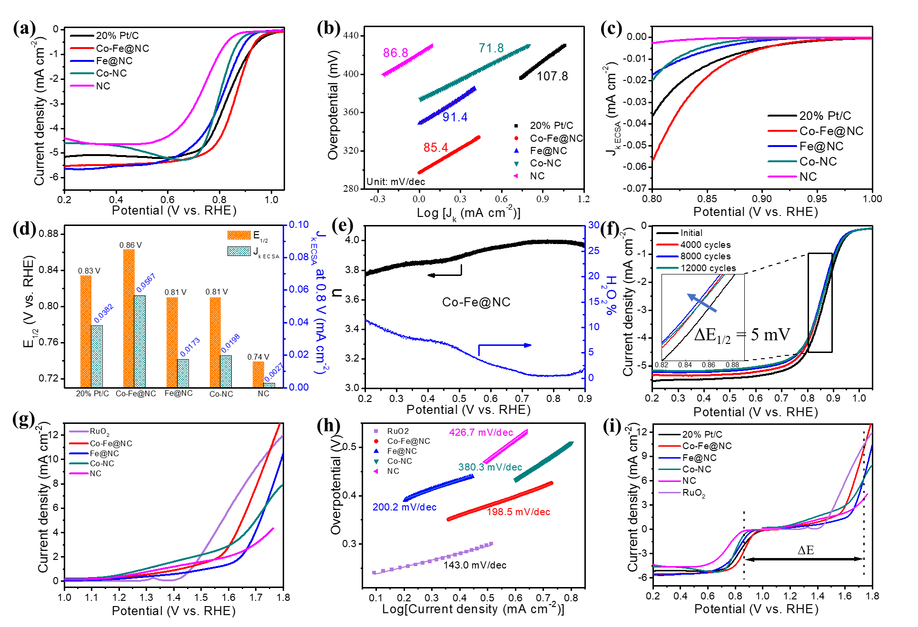
Fig. 3 (a) LSV curves tested at 1600 rpm with a scanning sweep of 2.0 mV/s of the different electrocatalysts. (b) Corresponding Tafel plots of ORR based on kinetic current. (c) Normalized by ECSA of specific J_{k} (J_{k ECSA}). (d) Comparison of E_{1/2} and J_{k} at 0.80 V vs. RHE for different electrocatalysts. (e) The charge transfer number (n) and corresponding peroxide yield (H₂O₂%) of Co-Fe@NC at 0.20– 0.90 V vs. RHE based on the RRDE test. (f) LSV curves of Co-Fe@NC before and after 4000, 8000, and 12000 cycles. (g) LSV curves tested at 1600 rpm with a scanning sweep of 2 mV/s of different electrocatalyst in 0.1 M KOH; (h) Corresponding Tafel plots of OER from (g). (i) The overall LSV curve of all catalysts.
3.3. The HSAB system analysis
To prove the potential of Co-Fe@NC electrocatalyst for the practical application in HSAB. Fig. 4a illustrates the schematic configuration of HSAB. During the discharge process, the metallic Na on the anode loses electrons and converts to Na⁺ ions, then Na⁺ ions spread to the cathode. On the cathode, oxygen receives electrons and is reduced to OH⁻. On the contrary, during the charging process, OER reactions occur at the cathode, and Na⁺ migrates to the anode and is eventually reduced to form metallic Na.
The battery reactions are shown as follows^{64, 65}:
Anode: ${Na}^{+}+e^{-}\underset{⇔}{ }Na E^{0}=-2.71 V$
Cathode:${O_{2}}^{ }+{2H}_{2}O+4e^{-}\underset{⇔}{ }4{OH}^{-} E^{0}=+0.40 V$
Overall:${4Na}^{ }+{O_{2}}^{ }+{2H}_{2}O\underset{⇔}{ }4NaOH { E}^{0}=3.11 V$
Subsequently, as shown in Fig. 4b, the initial charge-discharge curves of different electrocatalysts were studied, where ΔV denotes the voltage gap between charge and discharge plateau. The HSAB assembled with the Co-Fe@NC possessed a discharge/charge plateau of 2.82/3.09 V under 0.1 mA/cm², exhibited a lower ΔV of 0.27 V, and higher round trip efficiency of 91.2% compared with Pt/C+ RuO₂ (0.55 V, 83.5%) (Fig. 4c). As shown in Fig. S14, the HSAB rate performance was characterized by charging and discharging at different current densities from 0.1 mA cm⁻² to 0.4 mA cm⁻². The results show that as the current density increases, the discharge voltage plateau of Co-Fe@NC decreases while the charge voltage plateau increases, i.e., the voltage gap increases from 0.27 V to 0.74 V, and the round-trip efficiency decreases from 91.2% to 78.1%.
LSV was performed to further evaluate the electrochemical activity of the air electrode. (Fig. 4d). The Co-Fe@NC-based HSAB shows a higher discharge voltage compared with the Pt/C+RuO₂ based HSAB. Notably, the peak power density of the Co-Fe@NC reached 5.39 mW/cm² (2695.0 mW/g), which is larger than that of Pt/C+RuO₂ (4.79 mW/cm², 2395.0 mW/g).
As shown in Fig. 4e, the durability of the assembled HSAB was tested by the constant current charge-discharge method at the current density is 0.1 mA/cm² with each discharge-charge cycle of 4 h. Compared with Pt/C+RuO₂, Co-Fe@NC exhibits a lower initial charge-discharge voltage difference, which means better round-trip efficiency, and this advantage is increasing accompanied by the number of cycles. After 700 h (175 cycles), the voltage gap of Co-Fe@NC increases to 0.85 V, and round-trip efficiency keeps at 75.37% (Fig. 4f). Contrary to this, the voltage gap of Pt/C+RuO₂ is increased to 1.33 V, and round-trip efficiency decreases to 65.76% only after 400 h (100 cycles). Notably, the performance of our Co-Fe@NC-based HSAB outperforms the previously reported literature (Table S5). After the long-term stability cycle test, the Co-Fe@NC air electrode retains the framework as revealed by the SEM and mapping images of Co-Fe@NC (Fig. S15, S16), signifying the superior structural durability during long cycle operation.
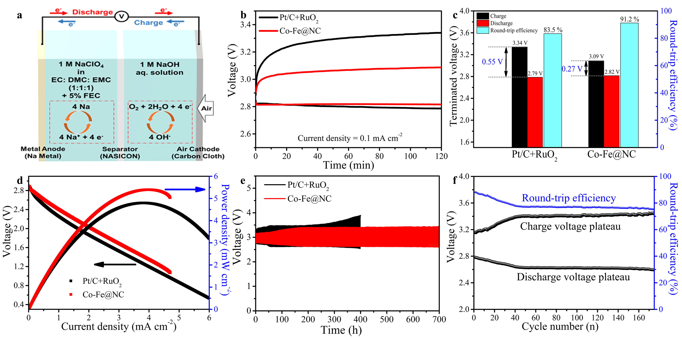
Fig. 4 (a) A schematic of hybrid sodium–air battery. (b) First charge-discharge curves of hybrid sodium–air battery using Co-Fe@NC and 20% Pt/C+RuO₂ as air electrode catalyst at a current density of 0.1 mA/cm². (c) Comparison of the voltage gap and round-trip efficiency of the Co-Fe@NC and 20% Pt/C+RuO₂. (d) Discharge polarization and the power density curves of the hybrid sodium–air battery employing Co-Fe@NC and 20% Pt/C+RuO₂. (e) Galvanostatic cycling curves at 0.1 mA/cm² of the fabricated hybrid sodium–air battery employing Co-Fe@NC and 20% Pt/C+RuO₂. (f) Cycling stability of Co-Fe@NC up to 175 cycles with charge/discharge voltage plateau and round-trip efficiency.

4. CONCLUSIONS
In conclusion, a host-guest strategy was presented to prepare the ZIF-derived atomically dispersed metal-N_{x} combined with Co₃Fe₇/Fe₃C/FeN_{0.0324} anchored in nitrogen-doped carbon, bifunctional catalyst (Co-Fe@NC) for the HSAB. The HSAB assembled with the Co-Fe@NC as air electrode, showed high ORR/OER activities with a low voltage gap (0.27 V) and a long cycling life (up to 700 h; about 175 cycles), compared with the benchmarked electrocatalyst Pt/C+RuO₂. The high-performance HSAB originates from the intensive charge polarization due to the disordered carbon, and the abundant catalytic active centers derived from the interaction between metal nanoparticles and metal-nitrogen-doped carbon shells. This study lays the foundation for preparing low-cost, efficient electrocatalysts for practical applications of HSABs in sustainable energy storage sectors.

ASSOCIATED CONTENT
Supporting Information
The Supporting Information is available free of charge at https://pubs.acs.org/doi/10.1021/......
SEM images of precursor of catalyst; HRTEM images of catalyst; Potential dependence of calculated kinetic current density; ECSA tests; RRDE test; LSV curves of Co-Fe@NC before and after acid wash; Stability teset (i–t curve at 0.80 V); SEM images and mapping of Co-Fe@NC after long-term cycling test of HSAB; and comparison of electrocatalytic and battery performance.
Funding
This work was funded by the Science and Technology Development Fund, Macau SAR (File no. 0191/2017/A3, 0041/2019/A1, 0046/2019/AFJ, 0021/2019/AIR), University of Macau (File no. MYRG2017-00216-FST and MYRG2018-00192-IAPME), the UEA funding, the State Key Laboratory of Organic-Inorganic Composites (oic-202101002), Science and Technology Program of Guangzhou (2019050001), and National Key Research and Development Program of China (2019YFE0198000). F. Chen acknowledges the Pearl River Talent Program (2019QN01L951). The authors gratefully acknowledge the financial support from the National Natural Science Foundation of China (No.52176141).

Notes
The authors declare no competing financial interest.
Reference
(1) Liu, Q. F.; Pan, Z. F.; Wang, E. D.; An, L.; Sun, G. Q., Aqueous metal-air batteries: Fundamentals and applications. Energy Storage Mater. 2020, 27, 478-505.
(2) Kwak, W. J.; Rosy; Sharon, D.; Xia, C.; Kim, H.; Johnson, L. R.; Bruce, P. G.; Nazar, L. F.; Sun, Y. K.; Frimer, A. A.; Noked, M.; Freunberger, S. A.; Aurbach, D., Lithium-Oxygen Batteries and Related Systems: Potential, Status, and Future. Chem. Rev. 2020, 120 (14), 6626-6683.
(3) Peng, L. S.; Shang, L.; Zhang, T. R.; Waterhouse, G. I. N., Recent Advances in the Development of Single-Atom Catalysts for Oxygen Electrocatalysis and Zinc-Air Batteries. Adv. Energy Mater. 2020, 10 (48), 2003018.
(4) Chen, Z.; Wang, Q.; Zhang, X.; Lei, Y.; Hu, W.; Luo, Y.; Wang, Y., N-doped defective carbon with trace Co for efficient rechargeable liquid electrolyte-/all-solid-state Zn-air batteries. Sci. Bull. 2018, 63 (9), 548-555.
(5) Lei, Y.; Wang, Q.; Peng, S.; Ramakrishna, S.; Zhang, D.; Zhou, K., Electrospun Inorganic Nanofibers for Oxygen Electrocatalysis: Design, Fabrication, and Progress. Adv. Energy Mater. 2020, 10 (45), 1902115.
(6) Wen, X. D.; Zhang, Q. Q.; Guan, J. Q., Applications of metal-organic framework-derived materials in fuel cells and metal-air batteries. Coordin. Chem. Rev. 2020, 409, 213214.
(7) Shah, S. S. A.; Najam, T.; Aslam, M. K.; Ashfaq, M.; Rahman, M. M.; Wang, K.; Tsiakaras, P.; Song, S. Q.; Wang, Y., Recent advances on oxygen reduction electrocatalysis: Correlating the characteristic properties of metal organic frameworks and the derived nanomaterials. Appl. Catal. B-Environ. 2020, 268, 118570.
(8) Zang, W. J.; Sumboja, A.; Ma, Y. Y.; Zhang, H.; Wu, Y.; Wu, S. S.; Wu, H. J.; Liu, Z. L.; Guan, C.; Wang, J.; Pennycook, S. J., Single Co Atoms Anchored in Porous N-Doped Carbon for Efficient Zinc-Air Battery Cathodes. ACS Catal. 2018, 8 (10), 8961-8969.
(9) Zhao, D.; Zhuang, Z.; Cao, X.; Zhang, C.; Peng, Q.; Chen, C.; Li, Y., Atomic site electrocatalysts for water splitting, oxygen reduction and selective oxidation. Chem. Soc. Rev. 2020, 49 (7), 2215-2264.
(10) Martinez, U.; Komini Babu, S.; Holby, E. F.; Chung, H. T.; Yin, X.; Zelenay, P., Progress in the Development of Fe-Based PGM-Free Electrocatalysts for the Oxygen Reduction Reaction. Adv. Mater. 2019, 31 (31), e1806545.
(11) Shen, H. J.; Thomas, T.; Rasaki, S. A.; Saad, A.; Hu, C.; Wang, J. C.; Yang, M. H., Oxygen Reduction Reactions of Fe-N-C Catalysts: Current Status and the Way Forward. Electrochem. Energy R. 2019, 2 (2), 252-276.
(12) Asset, T.; Atanassov, P., Iron-Nitrogen-Carbon Catalysts for Proton Exchange Membrane Fuel Cells. Joule 2020, 4 (1), 33-44.
(13) Deng, J.; Li, X.; Imhanria, S.; Chen, K. Y.; Deng, X. M.; Wang, W., Molybdenum carbide-nitrogen doped carbon composites as effective non-precious electrocatalyst for direct hydrazine fuel cell. Electrochim. Acta 2021, 384, 138417.
(14) Han, J.; Deng, X. M.; Chen, K. Y.; Imhanria, S.; Sun, Y.; Wang, W., Electrochemical conversion of CO₂ into tunable syngas on a B, P, N tri-doped carbon. Renew. Energ. 2021, 177, 636-642.
(15) Li, Y. Y.; Zhang, P. Y.; Wan, L. Y.; Zheng, Y. P.; Qu, X. M.; Zhang, H. K.; Wang, Y. S.; Zaghib, K.; Yuan, J. Y.; Sun, S. H.; Wang, Y. C.; Zhou, Z. Y.; Sun, S. G., A General Carboxylate-Assisted Approach to Boost the ORR Performance of ZIF-Derived Fe/N/C Catalysts for Proton Exchange Membrane Fuel Cells. Adv. Funct. Mater. 2021, 31 (15), 2009645.
(16) Zhao, J.; Deng, J.; Han, J.; Imhanria, S.; Chen, K. Y.; Wang, W., Effective tunable syngas generation via CO₂ reduction reaction by non-precious Fe-N-C electrocatalyst. Chem. Eng. J. 2020, 389, 124323.
(17) Qiao, M.; Wang, Y.; Wang, Q.; Hu, G.; Mamat, X.; Zhang, S.; Wang, S., Hierarchically Ordered Porous Carbon with Atomically Dispersed FeN₄ for Ultraefficient Oxygen Reduction Reaction in Proton-Exchange Membrane Fuel Cells. Angew. Chem. Int. Ed. 2020, 59 (7), 2688-2694.
(18) Mohd Adli, N.; Shan, W.; Hwang, S.; Samarakoon, W.; Karakalos, S.; Li, Y.; Cullen, D. A.; Su, D.; Feng, Z.; Wang, G.; Wu, G., Engineering Atomically Dispersed FeN₄ Active Sites for CO2 Electroreduction. Angew. Chem. Int. Ed. 2021, 60 (2), 1022-1032.
(19) Luo, E. G.; Wang, C.; Li, Y.; Wang, X.; Gong, L. Y.; Zhao, T.; Jin, Z.; Ge, J. J.; Liu, C. P.; Xing, W., Accelerated oxygen reduction on Fe/N/C catalysts derived from precisely-designed ZIF precursors. Nano Res. 2020, 13 (9), 2420-2426.
(20) Chen, X.; Ma, D. D.; Chen, B.; Zhang, K. X.; Zou, R. Q.; Wu, X. T.; Zhu, Q. L., Metal-organic framework-derived mesoporous carbon nanoframes embedded with atomically dispersed Fe-N-x active sites for efficient bifunctional oxygen and carbon dioxide electroreduction. Appl. Catal. B-Environ. 2020, 267, 118720.
(21) Ao, X.; Zhang, W.; Zhao, B. T.; Ding, Y.; Nam, G.; Soule, L.; Abdelhafiz, A.; Wang, C. D.; Liu, M. L., Atomically dispersed Fe-N-C decorated with Pt-alloy core-shell nanoparticles for improved activity and durability towards oxygen reduction. Energ. Environ. Sci. 2020, 13 (9), 3032-3040.
(22) Wu, J. B.; Xiong, L. K.; Zhao, B. T.; Liu, M. L.; Huang, L., Densely Populated Single Atom Catalysts. Small Methods 2020, 4 (2), 1900540.
(23) Chen, G.; Liu, P.; Liao, Z.; Sun, F.; He, Y.; Zhong, H.; Zhang, T.; Zschech, E.; Chen, M.; Wu, G.; Zhang, J.; Feng, X., Zinc-Mediated Template Synthesis of Fe-N-C Electrocatalysts with Densely Accessible Fe-Nx Active Sites for Efficient Oxygen Reduction. Adv. Mater. 2020, 32 (8), e1907399.
(24) Zhou, Y.; Tao, X.; Chen, G.; Lu, R.; Wang, D.; Chen, M. X.; Jin, E.; Yang, J.; Liang, H. W.; Zhao, Y.; Feng, X.; Narita, A.; Mullen, K., Multilayer stabilization for fabricating high-loading single-atom catalysts. Nat. Commun. 2020, 11 (1), 5892.
(25) Lin, X. X.; Peng, P.; Guo, J. N.; Xie, L. H.; Liu, Y. J.; Xiang, Z. H., A new steric tetra-imidazole for facile synthesis of high loading atomically dispersed FeN₄ electrocatalysts. Nano Energy 2021, 80, 105533.
(26) Wang, T. T.; Kou, Z. K.; Mu, S. C.; Liu, J. P.; He, D. P.; Amiinu, I. S.; Meng, W.; Zhou, K.; Luo, Z. X.; Chaemchuen, S.; Verpoort, F., 2D Dual-Metal Zeolitic-Imidazolate-Framework-(ZIF)-Derived Bifunctional Air Electrodes with Ultrahigh Electrochemical Properties for Rechargeable Zinc-Air Batteries. Adv. Funct. Mater. 2018, 28 (5), 1705048.
(27) Xu, Q. C.; Jiang, H.; Li, Y. H.; Liang, D.; Hu, Y. J.; Li, C. Z., In-situ enriching active sites on co-doped Fe-Co₄N@N-C nanosheet array as air cathode for flexible rechargeable Zn-air batteries. Appl. Catal. B-Environ. 2019, 256, 117893.
(28) Lou, Y. W.; Liu, J. J.; Liu, M.; Wang, F., Hexagonal Fe₂N Coupled with N-Doped Carbon: Crystal-Plane-Dependent Electrocatalytic Activity for Oxygen Reduction. ACS Catal. 2020, 10 (4), 2443-2451.
(29) Cui, X.; Gao, L.; Lei, S.; Liang, S.; Zhang, J.; Sewell, C. D.; Xue, W.; Liu, Q.; Lin, Z.; Yang, Y., Simultaneously Crafting Single‐Atomic Fe Sites and Graphitic Layer‐Wrapped Fe₃C Nanoparticles Encapsulated within Mesoporous Carbon Tubes for Oxygen Reduction. Adv. Funct. Mater. 2020, 31 (10), 2009197.
(30) Lv, B.; Zeng, S.; Yang, W.; Qiao, J.; Zhang, C.; Zhu, C. F.; Chen, M. H.; Di, J. T.; Li, Q. W., In-situ embedding zeolitic imidazolate framework derived Co-N-C bifunctional catalysts in carbon nanotube networks for flexible Zn-air batteries. J. Energy Chem. 2019, 38, 170-176.
(31) Shi, C. W.; Liu, Y. H.; Qi, R. Y.; Li, J. T.; Zhu, J. X.; Yu, R. H.; Li, S. D.; Hong, X. F.; Wu, J. S.; Xi, S. B.; Zhou, L.; Mai, L. Q., Hierarchical N-doped carbon spheres anchored with cobalt nanocrystals and single atoms for oxygen reduction reaction. Nano Energy 2021, 87, 106153.
(32) Wang, Z.; Zhu, C.; Tan, H.; Liu, J.; Xu, L. L.; Zhang, Y. Q.; Liu, Y. P.; Zou, X. X.; Liu, Z.; Lu, X. H., Understanding the Synergistic Effects of Cobalt Single Atoms and Small Nanoparticles: Enhancing Oxygen Reduction Reaction Catalytic Activity and Stability for Zinc-Air Batteries. Adv. Funct. Mater. 2021, 31 (45), 2104735.
(33) Qiao, Z.; Wang, C. Y.; Li, C. Z.; Zeng, Y. C.; Hwang, S.; Li, B. Y.; Karakalos, S.; Park, J.; Kropf, A. J.; Wegener, E. C.; Gong, Q.; Xu, H.; Wang, G. F.; Myers, D. J.; Xie, J.; Spendelow, J. S.; Wu, G., Atomically dispersed single iron sites for promoting Pt and Pt₃Co fuel cell catalysts: performance and durability improvements. Energ. Environ. Sci. 2021, 14 (9), 4948-4960.
(34) Morales, D. M.; Kazakova, M. A.; Dieckhofer, S.; Selyutin, A. G.; Golubtsov, G. V.; Schuhmann, W.; Masa, J., Trimetallic Mn-Fe-Ni Oxide Nanoparticles Supported on Multi-Walled Carbon Nanotubes as High-Performance Bifunctional ORR/OER Electrocatalyst in Alkaline Media. Advanced Functional Materials 2020, 30 (6), 1905992.
(35) Ding, D. N.; Shen, K.; Chen, X. D.; Chen, H. R.; Chen, J. Y.; Fan, T.; Wu, R. F.; Li, Y. W., Multi-Level Architecture Optimization of MOF-Templated Co-Based Nanoparticles Embedded in Hollow N-Doped Carbon Polyhedra for Efficient OER and ORR. ACS Catal. 2018, 8 (9), 7879-7888.
(36) Liu, Y.; Feng, Q.; Liu, W.; Li, Q.; Wang, Y.; Liu, B.; Zheng, L.; Wang, W.; Huang, L.; Chen, L.; Xiong, X.; Lei, Y., Boosting interfacial charge transfer for alkaline hydrogen evolution via rational interior Se modification. Nano Energy 2021, 81, 105641.
(37) Liu, Y.; Song, C.; Wang, Y.; Cao, W.; Lei, Y.; Feng, Q.; Chen, Z.; Liang, S.; Xu, L.; Jiang, L., Rational designed Co@N-doped carbon catalyst for high-efficient H₂S selective oxidation by regulating electronic structures. Chem. Eng. J. 2020, 401, 126038.
(38) Chen, Z. L.; Qing, H. L.; Wang, R. R.; Wu, R. B., Charge pumping enabling Co-NC to outperform benchmark Pt catalyst for pH-universal hydrogen evolution reaction. Energ. Environ. Sci. 2021, 14 (5), 3160-3173.
(39) Li, Z.; Chen, Y.; Ji, S.; Tang, Y.; Chen, W.; Li, A.; Zhao, J.; Xiong, Y.; Wu, Y.; Gong, Y.; Yao, T.; Liu, W.; Zheng, L.; Dong, J.; Wang, Y.; Zhuang, Z.; Xing, W.; He, C. T.; Peng, C.; Cheong, W. C.; Li, Q.; Zhang, M.; Chen, Z.; Fu, N.; Gao, X.; Zhu, W.; Wan, J.; Zhang, J.; Gu, L.; Wei, S.; Hu, P.; Luo, J.; Li, J.; Chen, C.; Peng, Q.; Duan, X.; Huang, Y.; Chen, X. M.; Wang, D.; Li, Y., Iridium single-atom catalyst on nitrogen-doped carbon for formic acid oxidation synthesized using a general host-guest strategy. Nat. Chem. 2020, 12 (8), 764-772.
(40) Lu, M. T.; Li, Y. W.; Wu, Y. H.; Xu, H.; Gao, J. K.; Xu, S. Q., Trimetallic Nanoparticles Encapsulated into Bamboo-Like N-Doped Carbon Nanotubes as a Robust Catalyst for Efficient Oxygen Evolution Electrocatalysis. Chemnanomat 2020, 6 (10), 1496-1501.
(41) Chang, Y.; Chen, J. X.; Jia, J. C.; Hu, X.; Yang, H. J.; Jia, M. L.; Wen, Z. H., The fluorine-doped and defects engineered carbon nanosheets as advanced electrocatalysts for oxygen electroreduction. Appl. Catal. B-Environ. 2021, 284, 119721.
(42) Ahsan, M. A.; He, T.; Eid, K.; Abdullah, A. M.; Curry, M. L.; Du, A.; Puente Santiago, A. R.; Echegoyen, L.; Noveron, J. C., Tuning the Intermolecular Electron Transfer of Low-Dimensional and Metal-Free BCN/C60 Electrocatalysts via Interfacial Defects for Efficient Hydrogen and Oxygen Electrochemistry. J. Am. Chem. Soc. 2021, 143 (2), 1203-1215.
(43) Ahsan, M. A.; Puente Santiago, A. R.; Hong, Y.; Zhang, N.; Cano, M.; Rodriguez-Castellon, E.; Echegoyen, L.; Sreenivasan, S. T.; Noveron, J. C., Tuning of Trifunctional NiCu Bimetallic Nanoparticles Confined in a Porous Carbon Network with Surface Composition and Local Structural Distortions for the Electrocatalytic Oxygen Reduction, Oxygen and Hydrogen Evolution Reactions. J. Am. Chem. Soc. 2020, 142 (34), 14688-14701.
(44) Lin, Z.; Huang, H.; Cheng, L.; Hu, W.; Xu, P.; Yang, Y.; Li, J.; Gao, F.; Yang, K.; Liu, S.; Jiang, P.; Yan, W.; Chen, S.; Wang, C.; Tong, H.; Huang, M.; Zheng, W.; Wang, H.; Chen, Q., Tuning the p-Orbital Electron Structure of s-Block Metal Ca Enables a High-Performance Electrocatalyst for Oxygen Reduction. Adv. Mater. 2021, n/a (n/a), 2107103.
(45) Wang, Q.; Ye, K.; Xu, L.; Hu, W.; Lei, Y.; Zhang, Y.; Chen, Y.; Zhou, K.; Jiang, J.; Basset, J. M.; Wang, D.; Li, Y., Carbon nanotube-encapsulated cobalt for oxygen reduction: integration of space confinement and N-doping. Chem. Commun. 2019, 55 (98), 14801-14804.
(46) Meng, J.; Niu, C.; Xu, L.; Li, J.; Liu, X.; Wang, X.; Wu, Y.; Xu, X.; Chen, W.; Li, Q.; Zhu, Z.; Zhao, D.; Mai, L., General Oriented Formation of Carbon Nanotubes from Metal-Organic Frameworks. J. Am. Chem. Soc. 2017, 139 (24), 8212-8221.
(47) Cao, F.; Yang, X.; Shen, C.; Li, X.; Wang, J. M.; Qin, G. W.; Li, S.; Pang, X. Y.; Li, G. Q., Electrospinning synthesis of transition metal alloy nanoparticles encapsulated in nitrogen-doped carbon layers as an advanced bifunctional oxygen electrode. J. Mater. Chem. A 2020, 8 (15), 7245-7252.
(48) Kuang, P.; Wang, Y.; Zhu, B.; Xia, F.; Tung, C. W.; Wu, J.; Chen, H. M.; Yu, J., Pt Single Atoms Supported on N-Doped Mesoporous Hollow Carbon Spheres with Enhanced Electrocatalytic H2 -Evolution Activity. Adv. Mater. 2021, 33 (18), e2008599.
(49) Luo, X.; Wei, X.; Wang, H.; Gu, W.; Kaneko, T.; Yoshida, Y.; Zhao, X.; Zhu, C., Secondary-Atom-Doping Enables Robust Fe-N-C Single-Atom Catalysts with Enhanced Oxygen Reduction Reaction. Nano-Micro. Lett. 2020, 12 (1), 163.
(50) Jiao, L.; Wan, G.; Zhang, R.; Zhou, H.; Yu, S. H.; Jiang, H. L., From Metal-Organic Frameworks to Single-Atom Fe Implanted N-doped Porous Carbons: Efficient Oxygen Reduction in Both Alkaline and Acidic Media. Angew. Chem. Int. Ed. 2018, 57 (28), 8525-8529.
(51) Zhao, J.; Rong, F.; Yao, Y.; Fan, W. J.; Li, M. R.; Yang, Q. H., Co NP/NC hollow nanoparticles derived from yolk-shell structured ZIFs@polydopamine as bifunctional electrocatalysts for water oxidation and oxygen reduction reactions. J. Energy Chem. 2018, 27 (4), 1261-1267.
(52) Li, S. S.; Chen, W. H.; Pan, H. Z.; Cao, Y. W.; Jiang, Z. Q.; Tian, X. N.; Hao, X. G.; Maiyalagan, T.; Jiang, Z. J., FeCo Alloy Nanoparticles Coated by an Ultrathin N-Doped Carbon Layer and Encapsulated in Carbon Nanotubes as a Highly Efficient Bifunctional Air Electrode for Rechargeable Zn-Air Batteries. ACS Sustain. Chem. Eng. 2019, 7 (9), 8530-8541.
(53) Yang, L. J.; Feng, S. Z.; Xu, G. C.; Wei, B.; Zhang, L., Electrospun MOF-Based FeCo Nanoparticles Embedded in Nitrogen-Doped Mesoporous Carbon Nanofibers as an Efficient Bifunctional Catalyst for Oxygen Reduction and Oxygen Evolution Reactions in Zinc-Air Batteries. ACS Sustain. Chem. Eng. 2019, 7 (5), 5462-5475.
(54) Li, J.; Zhang, H.; Samarakoon, W.; Shan, W.; Cullen, D. A.; Karakalos, S.; Chen, M.; Gu, D.; More, K. L.; Wang, G.; Feng, Z.; Wang, Z.; Wu, G., Thermally Driven Structure and Performance Evolution of Atomically Dispersed FeN₄ Sites for Oxygen Reduction. Angew. Chem. Int. Ed. 2019, 58 (52), 18971-18980.
(55) Yin, S. H.; Yang, J.; Han, Y.; Li, G.; Wan, L. Y.; Chen, Y. H.; Chen, C.; Qu, X. M.; Jiang, Y. X.; Sun, S. G., Construction of Highly Active Metal-Containing Nanoparticles and FeCo-N₄ Composite Sites for the Acidic Oxygen Reduction Reaction. Angew. Chem. Int. Ed. 2020, 59 (49), 21976-21979.
(56) Ma, L.; Chen, S.; Pei, Z.; Huang, Y.; Liang, G.; Mo, F.; Yang, Q.; Su, J.; Gao, Y.; Zapien, J. A.; Zhi, C., Single-Site Active Iron-Based Bifunctional Oxygen Catalyst for a Compressible and Rechargeable Zinc-Air Battery. ACS Nano 2018, 12 (2), 1949-1958.
(57) Li, G.; Deng, W.; He, L.; Wu, J.; Liu, J.; Wu, T.; Wang, Y.; Wang, X., Zn, Co, and Fe Tridoped N-C Core-Shell Nanocages as the High-Efficiency Oxygen Reduction Reaction Electrocatalyst in Zinc-Air Batteries. ACS Appl. Mater. Interfaces 2021, 13 (24), 28324-28333.
(58) Song, L.; Wang, T.; Li, L.; Wu, C.; He, J., Zn₃[Fe(CN)₆]₂ derived Fe/Fe₅C₂@N-doped carbon as a highly effective oxygen reduction reaction catalyst for zinc-air battery. Appl. Catal. B- Environ. 2019, 244, 197-205.
(59) Xie, X. H.; He, C.; Li, B. Y.; He, Y. H.; Cullen, D. A.; Wegener, E. C.; Kropf, A. J.; Martinez, U.; Cheng, Y. W.; Engelhard, M. H.; Bowden, M. E.; Song, M.; Lemmon, T.; Li, X. S.; Nie, Z. M.; Liu, J.; Myers, D. J.; Zelenay, P.; Wang, G. F.; Wu, G.; Ramani, V.; Shao, Y. Y., Performance enhancement and degradation mechanism identification of a single-atom Co-N-C catalyst for proton exchange membrane fuel cells. Nat. Catal. 2020, 3 (12), 1044-1054.
(60) Tong, Y. P.; Liang, Y.; Hu, Y. X.; Shamsaei, E.; Wei, J.; Hao, Y. X.; Mei, W. W.; Chen, X.; Shi, Y. R.; Wang, H. T., Synthesis of ZIF/CNT nanonecklaces and their derived cobalt nanoparticles/N-doped carbon catalysts for oxygen reduction reaction. J. Alloy. Compd. 2020, 816, 152684.
(61) Wang, X.; Jia, Y.; Mao, X.; Liu, D.; He, W.; Li, J.; Liu, J.; Yan, X.; Chen, J.; Song, L.; Du, A.; Yao, X., Edge-Rich Fe-N₄ Active Sites in Defective Carbon for Oxygen Reduction Catalysis. Adv. Mater. 2020, 32 (16), e2000966.
(62) Li, F.; Bu, Y.; Han, G. F.; Noh, H. J.; Kim, S. J.; Ahmad, I.; Lu, Y.; Zhang, P.; Jeong, H. Y.; Fu, Z.; Zhong, Q.; Baek, J. B., Identifying the structure of Zn-N₂ active sites and structural activation. Nat. Commun. 2019, 10 (1), 2623.
(63) Xiao, M.; Chen, Y.; Zhu, J.; Zhang, H.; Zhao, X.; Gao, L.; Wang, X.; Zhao, J.; Ge, J.; Jiang, Z.; Chen, S.; Liu, C.; Xing, W., Climbing the Apex of the ORR Volcano Plot via Binuclear Site Construction: Electronic and Geometric Engineering. J. Am. Chem. Soc. 2019, 141 (44), 17763-17770.
(64) Senthilkumar, B.; Irshad, A.; Barpanda, P., Cobalt and Nickel Phosphates as Multifunctional Air-Cathodes for Rechargeable Hybrid Sodium-Air Battery Applications. ACS Appl. Mater. Interfaces 2019, 11 (37), 33811-33818.
(65) Zhu, J.; Qu, T.; Su, F.; Wu, Y.; Kang, Y.; Chen, K.; Yao, Y.; Ma, W.; Yang, B.; Dai, Y.; Liang, F.; Xue, D., Highly dispersed Co nanoparticles decorated on a N-doped defective carbon nano-framework for a hybrid Na-air battery. Dalton T. 2020, 49 (6), 1811-1821.

