People’s experiences of ‘personally important moments’ following an Acquired Brain Injury (ABI), the meanings they attach to them and the influence they have on their post-ABI journey: A qualitative study.

Katie Venables

Thesis submitted in partial fulfilment of the degree of Doctor of Clinical Psychology
University of East Anglia

Faculty of Medicine and Health Sciences

Submission Date: 19th April 2017

Thesis portfolio word count: 34,577

© This copy of the thesis has been supplied on condition that anyone who consults it is understood to recognise that its copyright rests with the author and that use of any information derived there from must be in accordance with current UK Copyright Law. In addition, any quotation or extract must include full attribution.
Overall Abstract for Thesis Portfolio
This research portfolio aimed to increase understanding of the needs of people with Acquired Brain Injury (ABI) and their caregivers and provide insight in to how they may be better supported. The aim was to systematically review current literature on providing caregivers with person-to-person information and education during post-stroke rehabilitation and the effect this has on their depressive symptoms. The second aim was to discover moments that people experience post-ABI that they consider to be ‘personally important’, to explore the subjective meaning attached to these moments and the influence on their post-injury journey. A systematic review was conducted using electronic databases and manual reference search. Alongside this review ten individuals with ABI were interviewed. Interviews were analysed using grounded theory and a theoretical model was developed. The systematic review yielded 12 studies appropriate for inclusion. Nine studies were rated as having good methodological quality, two were moderate and two were weak. Seven studies found that providing caregivers with education and information in post-stroke rehabilitation reduced their depressive symptoms. Five studies had no significant findings. From the qualitative research, three broad types of important moments were identified: Moments that contribute to a coherent sense of self, Moments of social interaction and Moments of disempowerment. The types of moments and the process of subjective meaning-making were associated with two types of influence on the lives of individuals: Ability to work with own reality and “What will be will be”. In conclusion, providing caregivers with person-to-person information and education during post-stroke rehabilitation may reduce their depressive symptoms. Findings are presented tentatively and further research is required. Conclusions from the qualitative research suggest people experience important moments, following ABI, that increase awareness of the post-injury self. Subjective appraisal of important moments impacts on a person’s sense of continued self and influences broader adjustment narratives.
Table of Contents
Acknowledgements 5
Introduction to Thesis Portfolio 6
Reference List 8

Chapter 1. Systematic Review 10
Abstract 12
Introduction 13
Method 16
Results 20
Discussion 32
Reference List 39

Chapter 2. Bridging Chapter 44
Reference List 46

Chapter 3. Qualitative Research Paper 47
Abstract 49
Introduction 50
Method 56
Results 64
Discussion 91
Reference List 101

Chapter 4. Extended Methodology 108
Reference List 113

Chapter 5. Overall Discussion and Critical Appraisal 114
Reference List 123

Appendices
Appendix A – Mayo-Portland Adaptability Inventory-4 126
Appendix B – Hospital Anxiety and Depression Scale 130
Appendix C – Robson Self-Concept Questionnaire 132
Appendix D – Research and Ethics Approval 135
Appendix E – Health and Research Authority Approval 138
Appendix F – Participant Information Sheet 139
Appendix G –Consent to Contact Sheet 142
Appendix H – Consent to Participate Form 143
Appendix I – Demographic Information Sheet 145
Appendix J – Semi-Structured Interview Schedule 146
Appendix K – Example of Coded Transcript 147
Appendix L – Example of Memoing 149
Appendix M – Examples of Clustering 150
Appendix N – Example of Excel Data Spreadsheet 154
Appendix O – Author Guidance (Disability and Rehabilitation) 155

Acknowledgements
First, I would like to thank my ‘super’ Supervisor Fergus Gracey for always being so supportive, available and enthusiastic. I would also like to my second Supervisor and Advisor, Paul Fisher, who has also been extremely supportive and helpful throughout this process.
I would especially like to acknowledge the individuals that participated in this research, a heartfelt thank you to each of you for sharing such emotive and personal experiences with me. Thank you also to the kind staff at the services that helped with recruitment, I’m extremely grateful for your input.
To my lovely Mom and Dad, you have supported me through this entire journey and I simply would not have made it this far with your love and generosity. Thanks for all the endless hours you’ve listened to me moaning and whinging!
Lastly, thanks to Alex Strazzanti for your ongoing technical support!

Introduction to the Thesis Portfolio
This thesis portfolio consists of two main papers: a systematic review and a qualitative research paper. There is a bridging chapter and a final discussion chapter, bringing together the findings from both studies and discussing them in the context of the current available literature.
The research within this portfolio focusses on Acquired Brain Injury (ABI). ABI is defined as damage to the brain, which occurs after birth and is not related to a congenital or a degenerative disease (Headway, 2017). These consequences may be temporary or permanent and cause partial or functional disability or difficulties in psychosocial adjustment (Murray & Lopez, 1996). Following ABI individuals experience a wide range of different difficulties, depending on the nature and location of their injury and may present to rehabilitation with various combinations of physical, communicative, cognitive, behavioural, psychosocial and environmental problems. Consequently, tailored interventions are required to suit the unique needs of individuals (Turner-Stokes, Bill & Dredge, 2011). Research has evidenced that multi-disciplinary holistic rehabilitation programmes are effective in improving outcomes following ABI (Turner-Stokes, Bill & Dredge, 2011) however it is argued that further research is needed in order to investigate the patient characteristics and therapeutic factors that contribute to optimal outcomes (Cicerone et al., 2008).
The event of an ABI is typically stressful and traumatic both for individuals and their families (Gracey & Ownsworth, 2012). Due to the long term nature of ABI and its ongoing consequences, individuals and families are often faced with chronic distress and change in quality of life and family functioning (Norup, Siert & Lykke Mortensen, 2010; Thompson, & Ryan, 2009). The psychological well-being and coping skills of the caregiver directly impact on the emotional well-being and quality of life of the injured person (Oddy & Herbert, 2003; Sander et al.,2002; Gan, Campbell, Gemeinhardt, & McFadden, 2006) and depression and anxiety in the primary caregiver has been associated with greater and longer lasting cognitive, behavioural and emotional changes in the person they care for (Klonoff, 2014). Greater understanding is required as to the post-ABI experiences of individuals that contribute to such changes and research providing insight in to, and evidence for, the interventions that may help reduce negative outcomes for carers is therefore crucial.
Aspects of the health of caregivers are addressed in several reviews (Ellis, Mant, Langhorne, Dennis, & Winner, 2010; Smith et al., 2008) however the caregivers were not the primary focus. A review of interventions for stroke caregivers was conducted by Legg et al. (2011) and found that there was insufficient data to support or refute the use of information and education for caregivers to reduce depression and suggested further research was required.
This research portfolio aims to provide both qualitative and quantitative information that contributes to a greater understanding of the experience and needs of people with ABI and their caregivers and offer insight on how to better support them in clinical practice.

Reference List
Cicerone, K. D., Mott, T., Azulay, J., Sharlow-Galella, M. A., Ellmo, W. J., Paradise, S., Friel, J. C. (2008). A randomized controlled trial of holistic neuropsychological rehabilitation after traumatic brain injury. Archives of Physical Medicine Rehabilitation; 89: 2239-49.
Ellis, G., Mant, J., Langhorne, P., Dennis, M., Winner, S. (2010). Stroke liaison workers for stroke patients and carers: an individual patient data meta-analysis (Review). The Cochrane Database of Systematic Reviews. 12:5.
Gan, C., Campbell, K. A., Gemeinhardt, M., & McFadden, G. T. (2006). Predictors of family system functioning after brain injury. Brain Injury,20(6), 587-600.
Gracey, F., & Ownsworth, T. (2012). The experience of self in the world: the personal and social contexts of identity change after brain injury. In J Jetten, C Haslam, & SA Haslam. The social cure: Identity, health and well-being. (pp.273-295). US: Psychology Press.
Headway. (2017). Types of brain injury. Retrieved from https://www.headway.org.uk/about-brain-injury/individuals/types-of-brain-injury/
Klonoff, P. S. (2014). Psychotherapy for Families after Brain Injury. Psychotherapy after Brain Injury: Principles and Techniques. New York: Springer.
Legg, L. A., Quinn, T. J., Mahmood, F., Weir, C. J., Tierney, J., Stott, D. J., Smith, L. N., & Langhorne, P. (2011). Non-pharmacological interventions for caregivers of stroke survivors (Review). The Cochrane Database of Systematic Reviews, 5;(10). doi: 10.1002/14651858.CD008179.
Murray, C., & Lopez, A. D. (1996). The Burden of Disease. Boston: The Harvard School of Public Health (on behalf of The World Health Organisation).
Norup, A., Siert, L., & Lykke Mortensen, E. (2010). Emotional distress and quality of life in relatives of patients with severe brain injury: the first month after injury. Brain Injury, 24(2), 81-8.
Oddy, M., & Herbert, C. (2003). Intervention with families following brain injury: Evidence-based practice. Neuropsychological rehabilitation, 13 (1-2), 259-73.
Sander, A. M., Caroselli, J. S., High, W. M., Becker, C., Neese, L., & Scheibel, R. (2002). Relationship of family functioning to progress in a post-acute rehabilitation programme following traumatic brain injury. Brain Injury, 16(8), 649-57.
Smith, J., Forster, A., House, A., Knapp, P., Wright, J., Young, J. (2008). Information provision for stroke patients and their caregivers. Cochrane Database of Systematic Reviews, 16;(2). doi: 10.1002/14651858.CD001919.
Thompson, H. S., & Ryan, A. (2009). The impact of stroke consequences on spousal relationships from the perspective of the person with stroke. Journal of Clinical nursing, 18(12), 1830-1811.
Turner-Stokes, L., Bill, A., & Dredge, R. (2011). A Cost Analysis of Specialist Inpatient Neurorehabilitation Services in the UK. Clinical Rehabilitation, 26 (3), 256-263.

Chapter 1.
Systematic Review Prepared for Submission to: Disability and Rehabilitation

Does providing person-to-person education/ information to caregivers, during post-stroke rehabilitation, reduce their depressive symptoms? A systematic review of evidence.

Katie Venablesª, Fergus Gracey^{b*}, and Paul Fisher^{c}
^{abc}Department of Clinical Psychology, University of East Anglia, Norwich, United Kingdom

*Correspondence concerning this article should be addressed to Fergus Gracey, Department of Clinical Psychology, School of Medicine, University of East Anglia, Norwich, United Kingdom.
Email: f.gracey@uea.ac.uk, 01603 456161 (ext.2898)
Abstract
Stroke is a leading cause of disability in the UK and can leave individuals with severe cognitive, emotional, behavioural and social difficulties, subsequently leaving many people dependant on caregivers. The demands of caregiving are difficult and time consuming, and can negatively affect the caregiver’s well-being. Despite this it is not standard clinical practice to provide ongoing support for their care-giving role or involve them in the rehabilitation process. The main objective was to review the evidence of the impact that providing person-to-person information and education during post-stroke rehabilitation, has on caregivers depressive symptoms. A systematic review of the literature was conducted using electronic databases: SCOPUS, MEDline, PsychINFO and CINAHL complete and a manual search of relevant reference lists. After applying the inclusion criteria 12 studies were deemed appropriate to include and the data from each study was collated. Nine of the studies were rated as having good methodological quality, two were moderate and two were rated as weak. Seven of the studies had significant findings, five did not. Trends in the data suggested that individualised problem solving interventions of nine weeks or longer and delivered by telephone may be effective at reducing caregiver depressive symptoms. Providing caregivers with person-to-person information and education during post-stroke rehabilitation may reduce their depressive symptoms. Findings are presented tentatively and further research is required.
Keywords: acquired brain injury, caregiver, depression, education, information, rehabilitation

Introduction
Stroke is a leading cause of disability in the UK [1] and the second largest cause of death worldwide [2]. There are more than 152,000 strokes in the UK each year [1] and stroke survivors currently make up 1.7% of the UK population [1]. Within the medical literature, stroke is defined as a cerebral vascular accident resulting in an interruption of blood flow to an area of the brain from either a blood clot or the rupture of a blood vessel. The interruption of perfusion leads to ischemia, brain cellular damage, often leading to permanent damage [3]. Stroke causes the greatest range of disabilities in comparison to any other condition [4] and the impact can be devastating, leaving a person with residual impairment of physical, and social functions [5]. The psychological impact on stroke survivors is also well documented. Around a third of stroke survivors experience depression after their stroke [6] and over half of stroke survivors experience symptoms of anxiety [7].
Due to the long-term consequences of stroke, more than one third of people are left dependent on an informal caregiver [8]. Informal caregivers are people who provide help and support without payment to a family member or friend who may not be able to manage because of frailty, illness or disability [9]. Informal caregivers provide a substantial amount of essential support as stroke survivors return to community living [10]. The demands of caregiving are difficult and time consuming and can negatively affect the caregiver’s well-being [11]. The negative effect of the caring role has been well documented in the literature [12]. Research has shown that stress related to providing care can result in a negative psychological impact, anxiety and physical health decline for the caregiver [13-17]. Denno et al. [17] surveyed 153 caregivers and found that increased caregiver burden was strongly correlated with caregiver anxiety and depression. Alvona et al. [18] identified a high prevalence of depressive (40.2%) and anxiety (21.4%) symptoms among caregivers of stroke survivors. In a study of 28 family caregivers, [19] Creasy et al. found that some caregivers felt disconnected and ignored by health care providers and were subsequently unsuccessful in obtaining answers to their information needs. Research has shown that some caregivers are hesitant to ask important questions of the health care professionals and may possess a misunderstanding as to the requirements of their role [20].
A study by Ostwald et al. [21] of 159 caregivers, found that the level of preparation for discharge provided by medical professionals can either lessen or increase the amount of stress experienced by the caregiver. Research has indicated that the development of depression among caregivers, following stroke, stems from a lack of preparedness for the abrupt change in role, combined with a lack of support leaving them feeling frustrated [3]. The demands of providing daily care for the stroke survivor cause the caregiver to sacrifice opportunities for social participation in the community, leading to isolation [3]. Caregivers psychosocial functioning is directly associated with the quality of care that they provide to the person with the brain injury [22]. Furthermore, it is recognised that the quality of life and psychological well-being of the injured person often depends on the psychological health and coping skills of their family caregivers [23, 24, 25]. Heightened depression and anxiety in the primary caregiver has been associated with greater and longer lasting cognitive, behavioural and emotional changes in the person they care for [26].
Perakis, [27] suggest that to treat depression and anxiety in the caregiver, they need to learn coping skills. Research suggests that these coping skills should include self-soothing techniques, psychoeducation, goal setting and cognitive behavioural techniques [28, 29, 27].
Despite the wealth of evidence regarding the impact of ABI on the caregiver and the potential impact this then has on the cared for, it is not standard clinical practice to prepare or provide ongoing support for their care-giving role [10].
In addition to the clinical effects of poor emotional well-being on the stroke survivor and caregiver, there are also cost implications. It is estimated that the average NHS and social care cost for each person that has a stroke is approximately £22,000 a year [30]. Previous research has estimated that stroke costs the UK around £9 billion a year as a society. This includes £2.4 billion a year in informal care costs, £1.3 billion in lost income due to care, disability and death, and over £800 million in benefit payments [31].
Given the significant impact caring has on caregiver well-being, the subsequent impact on the well-being of those they care for, and the cost implications of these the need for evidence based cost effective interventions for caregivers is critical.
A systematic review of interventions for caregivers of stroke survivors by Legg et al. [32] examined the findings of 8 RCT’s. Primary outcomes included caregiver strain and caregiver well-being. The interventions included; Support and information, Teaching procedural knowledge and Psycho-education. They concluded that there was insufficient evidence to support or refute the use of information and support interventions or psycho-educational interventions for caregivers of stroke survivors to reduce or prevent caregiver stress and strain, depression or anxiety.
A more recent review of the literature addressing stroke caregiver burden by Camak [3] suggested that there are still gaps in the research regarding evidence-based programmes addressing the unique educational needs of caregivers, further research is therefore required.
Objectives
The objective of this review was to provide a reliable summary of the existing literature examining the impact of involving stroke caregivers in post-stroke rehabilitation by providing them with person-to-person information and education, and whether this led to a reduction in their depressive symptoms.
The specific question was as follows:
Does providing person-to-person education/ information to caregivers during post-stroke rehabilitation, reduce their depressive symptoms? A systematic review of the evidence.
Method
Eligibility for inclusion
Types of studies
This review included all Randomised Controlled Trials (RCT’s) that examined the effect of education and information provision, on carer depression in post-stroke rehabilitation.
Types of participants
We included trials that recruited informal caregivers of stroke patients. For the purpose of this review, the term ‘caregiver’ refers to any none paid persons providing care to stroke survivors. We included only studies with adult caregivers, over the age of 18. We also only included studies involving caregivers of adult stroke patients.
Types of interventions
The review included studies of interventions involving person-to-person provision of both education and information (face-to-face, telephone, video calls, online chat). Studies were excluded if they only involved information provision.

Types of outcome measures
This review included RCT’s investigating carer depression, therefore depression outcome measures were required for inclusion. Studies using measures of general mental health, or those unable to provide a separate depression score, resulted in exclusion from this review.
Search restrictions
This review only included studies that were published in English. The search was also restricted by age, and included studies on the adult population (18>). The search only included peer reviewed journals.
Informational Sources
Electronic searches
The following databases were searched for published literature: SCOPUS, MEDline, PsychINFO and CINAHL complete.
The following search terms were used:
- ‘Stroke’ ‘OR’ ‘CVA’ ‘OR’ ‘Cerebrovascular accident’ ‘OR’ ‘Cerebral vascular accident’ ‘OR’ ‘Hemorrhag*’ ‘OR’ ‘Heamorrhag*’
- ‘AND’
- ‘Family’ ‘OR’ ‘Carer’ ‘OR’ ‘Care giver*’ ‘OR’ ‘Caregiver*’ ‘OR’ ‘Spouse*’ ‘OR’ ‘Partner*’ ‘OR’ ‘Families’ ‘OR’ ‘Family intervention’ ‘OR ‘Family therapy’ ‘OR’ ‘Family involvement’ ‘OR’ ‘Relatives’
- ‘AND’
- ‘Depression’ ‘OR’ ‘Low mood’ ‘OR’ ‘Depressive symptoms’ ‘OR’ ‘Carer depression’
- ‘AND’
- ‘RCT’ ‘OR’ ‘Randomised control* trial’ ‘OR’ ‘Randomized control* trial’
The final literature search was conducted on the 10th September 2016 therefore only research published up to this point was included in the review. In an effort to identify further published trials, a manual reference search of relevant papers was also conducted.
Search results
The electronic search identified 363 records. A further 12 articles were identified through manual searches of the reference lists of the 31 articles assessed against inclusion and exclusion criteria. A total of 12 studies were included in the review. Details of the process of article selection are provided in Figure I.

Figure 1
Flow diagram demonstrating process of article selection
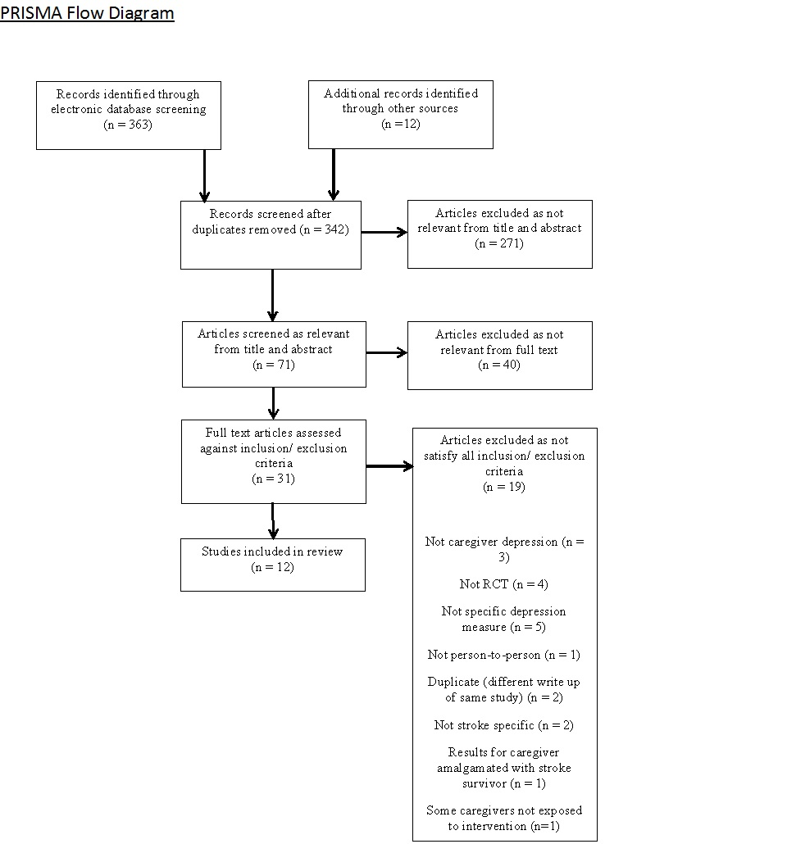

Data synthesis and quality assessment
Each of the 12 studies were reviewed against the aims of the systematic review and relevant data was extracted from each study (see Table 1). This included sample size, intervention, intervention details, outcome measure, summary of results and methodological quality.
Methodological quality of all included studies was scored using the PEDro (Physiotherapy Evidence Database) scale. The PEDro scale is a valid measure of the methodological quality of clinical trials. [33]. PEDro was originally designed for assessing the quality of RCT’s for physiotherapy, but has since been used to assess quality of psychological studies [34]. It consists of 11 items relating to: random allocation of participants, concealed allocation, blinding and reporting of statistical and measures of variability. For the purpose of this review, two items of the PEDro scale were not applicable and were therefore removed. Item number 5 was removed. This item refers to blinding of subjects, as participants could not be blind given the nature of the intervention they were receiving (aware of treatment group) and so this was not possible. Item 6 was removed. This item refers to blinding of therapist, as therapists were those delivering the intervention this was not possible. With two items removed, studies were given a quality rating out of the nine items valid for this study. The score obtained was used to give a general indication of quality. A score of 7-9 was considered good quality, a score of 5-6 was considered moderate and a score of 5 or below was considered weak.
Results
Included studies
Twelve studies were included in the review [35-46]. A summary of study details is provided in Table 1.

Table 1
Correlations Among and Descriptive Statistics For Key Study Variables
Study Authors [reference number] | N  Total (T)  Intervention (I)  Control (C)  Sham (S) |  | Intervention (I)  Control (C)  Sham (S) |  | Intervention  details |  | Outcome  measure |  | Summary of results relating to carer depression |  | Pedro rating /9
Perrin, Johnston, Vogel, Heesacker, Vega-Trujillo, Anderson & Rittman, 2010  [35] | T= 61  Numbers allocated to I and C not stated |  | I = Transition Assistance Program (TAP) C = TAU |  | Skill development, education, and supportive problem solving.  Four videophone calls and one face-to-face meeting. |  | Short version (10-item) of the CESD-10 |  | Non-significant  ‘Full model’ no significant treatment effects. |  | 4 - weak
Grant, 1999 [36] | T= 30  Numbers allocated to I and C not stated |  | I = Social Problem Solving Partnerships (SPSP) , either telephone group or home visit group)  C = TAU |  | Training in use of social problem solving skills in managing caregiver problems, provided by registered nurse.  7 contacts, either telephone call s or home visits, over 12 week period |  | CES-D |  | Some significant effects  Telephone group had significant reduction in depression at 2 weeks (B= -1.63;p<.01) and 5 weeks (B = -.91;p = .05) after discharge. |  | 3 - weak
Grant, Elliott, Weaver, Bartolcci, Giger, 2002 [37] | T = 63  Numbers allocated to I and C not stated |  | I = Social Problem-solving Telephone Partnerships (SPTP) plus usual discharge planning  S = Sham telephone intervention plus TAU  C = TAU |  | Content of I = Training in use of social problem solving skills in managing caregiver problems, provided by registered nurse. 3 hour home visit post discharge.  Followed by weekly then biweekly telephone contacts |  | CES-D |  | Some significant effects  Carers in intervention group had significantly less depression ( = -2.918: p=<0.001) than in sham intervention group and the control |  | 6 - moderate
Pfeiffer, Berry, Schayck, Hautzinger, Wengert, Hoffrichter, Becker, & Elliott, 2014 [38] | T = 122  I = 60  C = 62 |  | I = Problem solving intervention (PSI) and monthly information letters in addition to usual care  C = monthly information letters in addition to TAU |  | Content of I = 2 home visits and 18 telephone calls delivered over a 3-month intensive intervention and a 9-month maintenance period. |  | CES - D |  | Some significant effects  PSI group showed significantly lower levels of depressive symptoms after 3 months (p<.01, d= - .48) and after 12 months (p<.05, d = -.37) |  | 8 - good
Bakas, Farran, Austin, Given, Johnson & Williams, 2009  [39] | T = 40  I = 21  C = 19 |  | I = Telephone Assessment and Skill-Building Kit (TASK)  C = Attention control group. Brochure and calls with only active listening and paraphrasing |  | Content of I = 8-week program, TASK notebook and individualised interventions to aid skill building. Telephone calls only |  | PHQ-9 |  | Non-significant  Moderate decreases for depressive symptoms at 4 weeks, F(1, 36) = 3.35, p = .08, η2 = .09; however, the effect sizes became small at 8 and 12 weeks. |  | 7 - good
Bakas, Austin, Habermann, Jessup, McLennon, Mitchell, Morrison, Yang, Stump & Weaver, 2015 [40] | T = 254  I = 123  C =131 |  | I = Telephone Assessment and Skill-Building Kit (TASK II).  C = Information, Support and Referral (ISR) comparison group. Received calls but only active listening. |  | Content of I = Nurse-led skill building intervention. 8 weekly calls and a 12 week booster call |  | PHQ-9 |  | Some significant effects  At primary end point (8 weeks) TASK II group (with baseline PHQ-9 >5) reported a greater reduction in depressive symptoms from baseline to 8 weeks than those in the ISR group (mean difference [SE]=−2.6 [1.1]; P=0.013. This represented a statistically significant interaction between time and treatment  Among caregivers with baseline PHQ-9 ≥5, those randomized to the TASK II intervention had a greater reduction in depressive symptoms from baseline to 8, 24, and 52 weeks |  | 8 - good
Kalra, Evans, Perez, Melbourn, Patel, Knapp, Donaldson, 2004 [41] | T = 300  I = 151  C = 149 |  | I = Caregiver training  C = TAU |  | Content of I = information on stroke, benefits and local services and ‘hands on’ training (moving and lifting, ADL’s and communication). Three to five sessions lasting 30-45 minutes, and a “follow through” session at home |  | HADS |  | Some significant effects  Caregiver depression improved significantly at 3 (no statistical data given) and 12 months (p=0.001) |  | 6 - moderate
Ostwald, Godwin, Cron, Kelley, Hersch & Davis, 2014 [42] | T= 134  I = 69  C = 65 |  | I = Home visits for 6 months post discharge plus mailed info  C = Mailed info only |  | Content of I = Home based intervention –Provided by practice nurse, OT and physio. Information provided on: education, support, skill training, counselling, and links to local services/ resources. Average of 36.7 hours of psychoeducation over 6 months |  | GDS |  | Non-significant  Depression not significantly different between the caregiver groups through 6 or 12 months |  | 7 - good
Forster, Dickerson, Young, Patel, Kalra, Nixon, Smithard, Knapp, Holloway, Anwar & Farrin, 2013 [43] | T = 609  I = 295  C = 478  Doesn’t tally |  | I = London Stroke Carer Training Course (LSCTC)  C = Usual care |  | Content of I = caregiver training sessions and competency assessment (details page 6) |  | HADS |  | Non-significant  No significant differences found in outcomes at 6 or 12 months, between intervention and control |  | 8 - good
King, Faan, Hartke, Houle, Lee, Herring, Alexander-Peterson & Raad, 2012 [44] | T = 121  I = 55  C = 66 |  | I= Caregiver Problem Solving Intervention (CPSI)  C = WLC (Wait List Control).  Content of C = Supportive listening from counsellor with no problems solving |  | Content of I = Training in skills for problem-solving and coping with stress and emotional responses. Where possible first 2 sessions face-to-face, then tel calls |  | CES-D |  | Some significant effects  ANOVA - T2 (3 to 4 months) differences in change scores favouring the CPSI for depression (Group x Time: F2, 238 = 3.43, p = .035) |  | 9 - good
Johnston, Bonetti, Joice, Pollard, Morrison, Francis, MacWalter, 2007 [45] | T = 172  I = 82  C = 90 |  | I = Work book based intervention with home visits  C = Normal care |  | Content of I = Information on stroke and recovery, guidance on coping skills – drawing on CBT. Questions answered, encouragement given, goal setting and tasks. 5 week period. Home visits and telephone contacts |  | HADS |  | Non-significant  There were no signiﬁcant effects of group by time interactions on the total HADS for carers (F<1). |  | 7 - good
Smith, Egbert, Dellman-Jenkins & Nanna, 2012 [46] | T = 32  I = 15  C = 17 |  | I = Web based intervention including key intervention components  C = Resource room only (no key intervention components) |  | Content of I = Web based intervention (Guide, educational videos, online chat, email/ message board, problem solving, and resource room) |  | CES-D |  | Some significant effects  Statistically significant differences were found between conditions. At T2 and T3 intervention condition reported lower CES-D scores than did controls for both intent-to treat, F(1,29) 6.13 p <.01; observed power .67, and per protocol, F(1, 26) 5.80, p<.05; observed power .64, analyses. The standardized effect sizes associated with mean differences were large at T2 for CG (.79 intent to treat; .81 per protocol), but only medium at T3 (.52 intent to treat; .41 per protocol) |  | 9 - good
Best interpretation of PEDro score in the context of limitations due to missing data / failure to report

Participants
A number of included studies failed to report the sample size and so it was not possible to calculate precise numbers of participants included in this review. Stroke caregiver participants were recruited predominantly from hospital services, in addition to veteran’s association and community charity sector groups. Five of the thirteen studies specifically looked at family caregivers, two of these being spousal caregivers. The others did not specify the relationship.
Interventions
Interventions were varied but with many similar core characteristics. All of the twelve studies involved the provision of some educational element. All studies included the transference of information from professional to caregiver, most with the addition of accessible written information. Eleven of the 12 studies used individualised interventions, with at least some element of them being tailored to carer needs. One study used a manualised protocol.
Interventions were delivered by a range of health care professions including; Nursing, Occupational Therapy, Physiotherapy, and Clinical Psychology, with Nursing being the most common. In four trials nurses delivered the entire intervention but were involved in delivery across nine of the 12 studies included in this review. Method of delivery of intervention was also varied. Nine of the 12 studies used face-to-face delivery, most in combination with telephone calls. One study used face to face with the addition of video calls. Nine studies used telephone calls, in two of which this was the only method of contact. One study used online chat, which involved the use of headsets. Duration of intervention ranged primarily between five and 12 weeks. One intervention was delivered over a six month period and one over a 12 month period. In one study, duration was unspecified and was described as dependant on individual need.
Not all studies provided clear information regarding the number and duration of contacts. Approximate number of contacts ranged between three and 17. Subsequently, hours of contact time also varied from three to 18.
In five of the 12 studies, the control condition was standard care. Three studies used a control of ‘information only’ without person-to-person contact, two studies used control groups in which ‘active listening’ was provided without an educational element and one study provided ‘active listening’ without education or information. One study included a ‘sham’ condition in addition to the ‘standard care’ control. This ‘sham’ consisted of ‘usual care’ plus telephone intervention.
Primary Outcome Measure
Six trials used the Center for Epidemiologic Studies Depression Scale (CESD) [47] or the shortened version (CESD-10). Three trials used the Hospital Anxiety and Depression measure (HADS) [48]. Two used the Patient Health Questionnaire (PHQ-9) [49] and one used the Geriatric Depression Scale (GDS) [50].
Description of quality rating for studies included - PEDro
Eight out of the 12 trials included scored between 7 and 9 on the PEDro scale. Two scored between 5 and 6 and two scored <4. However it was difficult to determine whether these scores reflect study quality or reporting quality, a point returned to later in the discussion.

Study Findings
Seven of the 12 studies included found some significant effects of education and information provision on caregiver depression.
Skill building
Two studies scoring 7 and 8 on the PEDro scale evaluated the effect of a telephone only support package Telephone Assessment and Skill-building Kit (TASK); [39] and TASK II [40]. TASK I was of 8 weeks duration and included tip sheets and support tailored to caregivers needs. No significant difference in caregiver depression for TASK compared with control was found at the end of intervention, no follow up assessment was conducted. The TASK II intervention was of 12 weeks duration, also included tip sheets and individualised support for caregivers. Compared with control, TASK II group showed a significant reduction in depressive symptoms (PHQ-9) at the end of intervention. To avoid possible floor effects, those with PHQ-9 greater than 5 were analysed separately, this subgroup showed significant changes at treatment end and 24 and 52 week follow-up.
Skill building and problem solving
One study with a score of 4 on the PEDro [35] assessed the impact of the (brief intervention 6 week, pilot) Transition Assistance Program (TAP) on stroke caregiver depression (CESD-10). The program is composed of skill development, education and supportive problem solving. In primary analysis, treatment was non-significant.
Two studies investigated the impact of a 12 week Social Problem-Solving Partnerships (SPSP) intervention on family caregiver depression (CESD-10). SPSP involves training and support in social problem solving skills. Grant [36] reported an RCT scoring 3 on the PEDro, comparing the effectiveness of home and telephone delivery of the SPSP. Both intervention groups (home and telephone) had a significant reduction in depression at two and five weeks after discharge. Grant [37] reported an RCT scoring 6 on the PEDro, assessing the impact of the SPSP intervention. Carers in intervention group had significantly less depression, at end of intervention, than in sham intervention group and the control.
Pfeiffer [38] reported an RCT scoring 8 on the PEDro, examining the effectiveness of a 12 month Problem-Solving (face-to-face and problem solving) Intervention (PSI) on stroke caregiver depression (CESD-10). PSI consisted of identifying and addressing individual caregiver problems. In comparison to control, the PSI group showed significantly lower levels of depressive symptoms after 3 months and after 12 months.
A study by King [44] scoring 9 on the PEDro, assessed the efficacy of the 10 week Caregiver Problem Solving Intervention (CPSI). At time point 2 (3-4 months) there were significant differences in change scores favouring the CPSI for depression over control.
CBT based Coping Skills
Johnston [45] reported an RCT scoring 7 on the PEDro, evaluating the effectiveness of a work-book based intervention on caregiver depression (HADS). The five week intervention consisted of information, coping skills, goal setting, relaxation techniques and participants were provided with person-to-person monitoring and encouragement via telephone. No significant difference in caregiver depression for intervention, compared with control was found at end point.
Practical/ Physical Caregiving
Two studies evaluated the effectiveness of practical based interventions for caregivers delivered pre-discharge [41,43], both had face-to-face delivery. Kalra [41] reported an RCT scoring 6 on the PEDro, evaluating the effectiveness of a brief (three to five sessions) intervention, training caregivers in basic nursing and facilitation of personal care techniques on caregiver depression (HADS). Caregiver depression improved significantly, compared to control at 3 and 12 months. The second study [43] reported an RCT scoring 8 on the PEDro, evaluating whether or not a structured, competency based training programme (duration/ contacts not stated) for caregivers of stroke inpatients improved depression outcomes for caregivers (HADS). No significant differences were found in outcomes, at 6 or 12 months, between intervention and control.
Psychoeducational
Ostwald [42] reported an RCT scoring 7 on the PEDro, comparing depression outcomes (GDS) of a six month home based psychoeducational program to mailed information only to spousal caregivers of stroke patients. They found that depression scores were not significantly different between the two caregiver groups at 6 or 12 months.
Knowledge, Resources and Support
A study scoring 9 on the PEDro, [46] tested the efficacy of a nine week web based intervention (including person-to-person interactive chat and messaging) for alleviating carer depression (CESD-10). The intervention was designed to provide stroke caregivers with knowledge, resources and skills. Carers were invited to discuss their particular problems regarding a named topic for interactive discussion. Carers were provided with emotional support by a Professional Guide and they were encouraged to interact with other caregivers to enhance mutual well-being. Statistically significant differences were found between intervention and control at time point 2 (T2 - end) and time point 3 (T3 - 1 month follow up). The standardized effect sizes associated with mean differences were large at T2 for but only medium at T3.
Discussion
Summary of the systematic review main findings
The main purpose of this review was to give a systematic overview of existing literature, examining the impact of providing stroke caregivers with person-to-person information and education in post-stroke rehabilitation and determine whether this provision led to a reduction in their depressive symptoms.
Significant findings were reported in seven of the 12 studies [40,36,37,38,44,41,46] with results revealing improvement in caregiver depression outcomes.
Six of the significant studies had moderate to good quality rating [37,38,40,41,44,46], the one significant study with weak quality rating [36] was a pilot for one of the significant studies with moderate quality [37]. This provides some evidence of the potential of caregiver interventions to improve their depression outcomes. However, the studies selected for this review included a wide range of interventions and several outcome measures. This combined with the variance in methodologies and quality of evidence makes any possible conclusions tentative.
The interventions across studies were heterogeneous with substantial differences in mode of delivery, length of sessions, overall duration and frequency of delivery. They were also delivered by a range of professionals, some by one individual and some by two. Within the studies yielding significant results, a general trend in type of intervention was observed. The content of the interventions was primarily focussed on active and personalised problem solving [36-38,41,44,46]. In contrast within the non-significant studies, there was a trend for interventions to centre on skill [35,39,42,43,45]. Trends in method of delivery were also noted, six of the seven studies with significant findings had primarily telephone delivery [36-38,40,44], whereas the trend within the non-significant studies was primarily face-to-face [35,42,43,45]. Differences in duration of intervention were also noted. Six of the seven significant studies were of nine weeks plus in duration. [36,37,38,40,44,46]. In comparison four of the five non- significant studies were of eight weeks or less in duration [35,43,39,45]. This trend was also reflected in hours of contact time. Six of the seven significant studies had eight hours plus contact time [40,36,37,38,44,46], whereas four of the five non-significant studies had less than eight hours contact time [35,39,43,45].
Whilst the above trends are acknowledged, it is noted that many of the significant studies include all four trends (problem solving content, telephone delivery, longer duration and more contact time). These confounding variables make determining the important variable for reducing caregiver depression impossible.
Strengths, Limitations and methodological issues of included studies
As evidenced by the small sample of studies available, there is a limited amount of existing research in this field. A particular challenge in this area of research was that many studies included both patient and carer as participants, making the results often difficult to separate/ interpret. Several papers considered for this review were excluded as the analyses and results were presented jointly, therefore further reducing the available sample size.
Issues in quality of reporting impacted the findings of this review. Unfortunately the intervention components described in some of the included studies were not outlined in enough detail to draw any firm conclusions on the impact on intervention content. Three of the included studies failed to report the number of participants in the control and experimental groups. No studies offered any descriptions of co-interventions, such as anti-depressant medication. This could be a potentially confounding variable.
Ten of the 12 studies had moderate to good quality ratings [37-46], the two with lower scores were small scale pilots [35,36]. A systematic and established criteria, the PEDro scale [33], was employed in terms of rating quality of evidence. However this was not without limitations due to further issues with inconsistent reporting. Many of the studies failed to report explicitly on specific criteria making the assessment of bias difficult. For example details of criterion 8 (measures of at least one key outcome were obtained from more than 85% of the subjects initially allocated to groups) and 9 (all subjects for whom outcome measures were available received the treatment or control condition as allocated or, where this was not the case, data for at least one key outcome was analysed by ‘intention to treat’) were frequently not stated. Where this was the case a consistent approach was taken and the criterion was scored 0. These limitations made it difficult to establish whether issues were due to methodological quality or quality of reporting. The lack of adequate reporting, and the difficulties it presents, are well recognised and led to the original development of the CONSORT (Consolidated Standards of Reporting Trials) statement in 1996 and its most recent revision in 2010 [51]. The CONSORT statement provides guidance on reporting for RCTs and facilitates clarity, completeness and transparency of reporting by encouraging explicit descriptions, without ambiguity or omission, in order to best serve the reader [51]. Despite the availability of this, inconsistent reporting still presented significant challenges for this current research.
Overall, a number of issues compromise ability to make clear judgements on risk of bias; not reporting sample size, patient versus carer (recipient of intervention), gaps in reporting, co-interventions. Flaws in the design, conduct, analysis, and reporting of randomised trials can cause the effect of an intervention to be underestimated or overestimated.
Strengths, limitations and methodological issues of this review
This review has addressed a gap in the research evidence base by focussing on the impact that providing stroke caregivers with person-to-person information and education in post-stroke rehabilitation has specifically on carer depression. Other studies have focussed more on burden, stress and coping [3]. However this review has a number of limitations. This research was conducted as part of a Doctoral research programme, which resulted in constraints of time and resources. The review excluded non-English studies, and unpublished studies were also excluded, thus leaving a potential for bias and meaning findings may not be generalisable. Excluding unpublished studies can result in publication bias or the "file drawer problem" [52]. This refers to the bias introduced into scientific literature by a tendency to publish positive results and to not publish negative or non-confirmatory results.
Whilst searches were only conducted by one researcher, a sub-section of selected studies were independently checked against inclusion/exclusion criteria by a second researcher to ensure consistency. Studies in which eligibility was unclear were discussed between the first and second researcher until a consensus was reached.
In regards to the issue of assessing methodological quality/ the presence of bias in studies, the PEDro was chosen as research has demonstrated its reliability and validity in assessing the methodological quality of clinical trials [53,33] and providing a comprehensive measure of methodological quality of stroke literature [54]. When considering queries relating to incomplete reporting in relation to PEDro criteria, it is acknowledged that the authors could have been contacted for clarification. Unfortunately time constraints meant this was not possible. It is therefore acknowledged that this may have implications regarding the accuracy of summary scores and subsequent quality appraisals.
The use of summary scores from quality scales, where a study receives one point for each item met, has been criticised on several grounds [55]. Items that are important in some situations, may not relevant in others but are given the same weight in the quality scale [55]. Therefore the Cochrane Bias Methods Group and Statistical Methods Group recommend that summary scores obtained from quality scales should not be used [56]. The Cochrane Collaboration developed ‘The Cochrane Collaboration’s tool for assessing risk of bias’ [57], with the aim of making the process clearer and more accurate [57]. The tool is neither a scale nor a checklist, but a domain-based evaluation. It comprises a judgement and a support for the judgement for each entry in a ‘Risk of bias’ table, where each entry addresses a specific feature of the study. The judgement for each entry involves assessing the risk of bias as ‘low risk’, as ‘high risk, or as ‘unclear risk’, with the last category indicating either lack of information or uncertainty over the potential for bias. It is noted that, given the issues in assessing quality, the Cochrane may have provided a better assessment.
It is possible that the search terms used may have not captured all the data. Although a systematic methodology was employed, it is still possible that some studies were missed. As caregivers were not always the primary participant, they may not have been identified through the search strategy used. This study searched four databases, it is acknowledged that we could have searched wider.
Implications for practice and research
In future, studies need to give clearer description of the intervention offered. The CONSORT statement developed for complex interventions offers some guidance but requires only one item saying ‘sufficient details to allow replication, including how and when they were actually administered.’ thus leaving interpretation of ‘sufficient details’ up to the author [58]. This has recently been extended on by Hoffman et al. [59] who present the Template for Intervention Description and Replication (TIDieR) checklist and guide. The aim of this is to improve the reporting of interventions and make it easier for authors to structure accounts of their interventions, reviewers and editors to assess the descriptions, and readers to use the information.
Trends in the significant studies suggest that interventions of longer duration and more contact time may be more effective in reducing caregiver depression. This has cost implications for services, particularly in the current economic climate. However, trends also indicated that telephone delivery is effective which potentially may be easier to implement and more economically viable than face-to-face interventions.
Studies with significant outcomes for carers, indicate that a range of interventions may reduce caregiver depression, further research is necessary in order to reduce the potential risk of confounding bias and establish those interventions most effective in reducing carer depression.

Disclosure of interest
The author reports no conflict of interest. This research was supported by the University of East Anglia as fulfilment of the Doctoral Programme in Clinical Psychology.
Reference List
*denotes studies included in the systematic review
- Stoke Association. State of the Nation Stroke statistics. 2017. Available at https://www.stroke.org.uk/sites/default/files/state_of_the_nation_2017_final_1.pdf

- World Health Organization. The top 10 causes of death. 2017. Available at https:// http://www.who.int/mediacentre/factsheets/fs310/en/
- Camak D. Addressing the burden of stroke caregivers: A literature review. Journal of Clinical Nursing. 2015;(24)17-18.

- Adamson J, Beswick A, Ebrahim S. Is stroke the most common cause of disability? Journal of Stroke and Cerebrovascular Diseases. 2004;13:171-177.

- Caro CC, Mendes PV, Costa JD, Nock LJ, et al. Independence and cognition post-stroke and its relationship to burden and quality of life of family caregivers. Journal Topics in Stroke Rehabilitation. 2017;24:3:194-199.
- Ayerbe L, Ayis SA, Crichton S, et al. Explanatory factors for the association between depression and long term physical disability after stroke. Age Ageing. 2015;44:1054-1058.
- Ayerbe, L, Ayis, SA, Crichton S, et al. Natural history, predictors and associated outcomes of anxiety up to 10 years after stroke: the South London Stroke Register. Age Ageing. 2014;43:542-547.
- Smith LN, Lawrence M, Kerr SM, et al. Informal carers' experience of caring for stroke survivors Journal of Advanced Nursing. 2004;46:3:235-44.

- Department of Health, Social Services and Public Safety. Improving Stroke Services in Northern Ireland, Consultation Document. 2007.

- Cameron JI, Nagile G, Silver FL, et al. Stroke family caregivers’ support needs change across the care continuum: a qualitative study using the timing it right framework. Disability and Rehabilitation. 2013;35:4:315-24.

- Clark PC, Aycock DM, Reiss A, et al. Potential Benefits for Caregivers of Stroke Survivors Receiving BTX-A and Exercise for Upper Extremity Spasticity. Rehabilitation Nursing. 2013:0:1-9.

- Greenwood N, Mackenzie A. Informal caring for stroke survivors: Meta-ethnographic review of qualitative literature. Maturitas. 2010;66:268-276.

- Das S, Hazra A, Ray BK, et al. Burden among stroke caregivers: results of a community based study from Kolkata, India. Stroke. 2010; 41:2965–2968.

- King RB, Rourke Ainsworth C, Ronen M, et al. Stroke caregivers: Pressing problems reported during the first months of caregiving. Journal of Neuroscience Nursing. 2010;42:302–311.

- Peyovi H, Mohammad-Saeid D, Farahani-Nia M, et al. The relationship between perceived life changes and depression in caregivers of stroke patients. Journal of Neuro-science Nursing. 2012;44, 329–338.

- Chen P, Botticello A. Spouses of stroke survivors may be at risk for poor cognitive functioning: a cross-sectional population-based study. Topics in Stroke Rehabilitation. 2013;24:1:24-33.

- Denno MS, Gillard PJ, Graham GD, et al. Anxiety and depression associated with caregiver burden in caregivers of stroke survivors with spasticity. Archives of Physical Medicine and Rehabilitation. 2013;94:1731-6.

- Alvona Z, Loha JS, Tan MW, et al. The global prevalence of anxiety and depressive symptoms among caregivers of stroke survivors. The Journal of Post-acute and Long Term Care Medicine. 2017;18:2:111–116.

- Creasy KR, Lutz BJ, Young ME, et al. Clinical implications of family-centered care in stroke rehabilitation. Rehabilitation Nursing. 2015;40:6:349-59.

- Guberman N. Caregivers: Their role in rehabilitation. In JH Stone, M Blouin . International Encyclopedia of Rehabilitation. New York (NY): Center for International Rehabilitation Research Information and Exchange (CIRRIE);2009.

- Ostwald SK, Godwin KM, Cheong H, et al. Predictors of resuming therapy within four weeks after discharge from inpatient rehabilitation. Stroke Rehabilitation. 2009;16:80–91.

- Vangel SJ, Rapport LJ, Hanks RA. Effects of family and caregiver psychosocial functioning on outcomes in persons with traumatic brain Injury. Journal of Head Trauma Rehabilitation. 2011;26:1:20–29.

- Oddy M, Herbert C. Intervention with families following brain injury: Evidence-based practice. Neuropsychol Rehabil. 2003;13:1-2:259-73.

- Sander AM, Caroselli JS, High WM et al. Relationship of family functioning to progress in a post-acute rehabilitation programme following traumatic brain injury. Brain Injury. 2002;16:8:649-57.

- Gan C, Campbell KA, Gemeinhardt M, et al. Predictors of family system functioning after brain injury Brain Injury. 2006;20:6:587-600.

- Klonoff PS. Psychotherapy for Families after Brain Injury. Psychotherapy after Brain Injury: Principles and Techniques. New York (NY): Springer; 2014.

- Perakis CR. Soul sickness: a frequently missed diagnosis. Journal of American Osteopath Association. 2010;110:6:347-9.

- Clarke DM, Kissane DW. Demoralization: Its phenomenology and importance. Australian and New Zealand Journal of Psychiatry. 2002;36:733-742.

- Klonoff PS, Koberstein EJ. A family experiential model of recovery after brain injury. Bullet of the Menninger Clinic. 2010;72:2:109-129.

- Royal College of Physicians Sentinel Stroke National Audit Programme (SSNAP). Stroke health economics: Cost and Cost-effectiveness analysis. 2016. (1).

- Saka O, McGuire A, Wolfe C. Cost of stroke in the United Kingdom. Age and Ageing. 2009;38: 27-32.

- Legg L, Drummond A, Leonardi-Bee J, et al. Occupational therapy for patients with problems in personal activities of daily living after stroke: systematic review of randomised trials. British Medical Journal. 2007;335:922.

- deMorton NA. The PEDro scale is a valid measure of the methodological quality of clinical trials: a demographic study. Australian Journal of Physiotherapy. 2009;55: 2:129-133.

- Barlow DH. The Oxford handbook of Clinical Psychology. Ney York (NY):Oxford University Press; 2014.

- *Perrin PB, Johnston A, Vogel B, et al. A culturally sensitive transition assistance program for stroke caregivers: Examining caregiver mental health and stroke rehabilitation. Journal of Rehabilitation Research & Development. 2010;47:7:605-616.

- *Grant, JS. Social problem-solving partnerships with family caregivers. Rehabilitation Nursing. 1999;24:6:254-260.

- *Grant JS, Elliott TR, Weaver M, et al. Telephone intervention with family caregivers of stroke survivors after rehabilitation. Stoke. 2002;33:2060-2065.

- *Pfeiffer K, Berry JW, Schayck R, et al. Telephone-based problem-solving intervention for family caregivers of stroke survivors: A randomized controlled trial. Journal of Consulting and Clinical psychology. 2014;82:4:628-643.

- *Bakas T, Farran CJ, Austin JK, et al. Stoke caregiver outcomes from the Telephone Assessment and Skill-Building (TASK). Topics in Stroke Rehabilitation. 2009;16:2:105-121.

- *Bakas T, Austin JK, Habermann B, et al. Telephone Assessment and Skill-Building Kit (TASK II) for stroke caregivers. Stroke; a Journal of Cerebral Circulation. Available from PMID 26549488 DOI: 10.1161/STROKEAHA.115.011099

- *Kalra L, Evans A, Perez EI, et al. Training care givers of stroke patients: randomised controlled trial. British medical Journal. 2004;328:1099-1101.

- *Ostwald SK, Godwin KM, Cron SG, et al. Home-based psychoeducational and mailed information programs for stroke-caregiving dyads post-discharge: a randomized trial. Disability and Rehabilitation. 2014;36:1:55-62.

- *Forster A, Dickerson J, Young J, et al. A cluster randomised controlled trial and economic evaluation of a structured training programme for caregivers of inpatients after stroke: the TRACS trial. Health Technology Assessment. 2013;17:46:1-98.

- *King RB, Faan RN, Hartke RJ, et al. A problem-solving early intervention for stroke caregivers: One year follow up. Rehabilitation Nursing. 2012; 37:5:231-243.

- *Johnston M, Bonetti D, Joice S, et al. Recovery from disability after stroke as a target for a behavioural intervention: Results of a randomized controlled trial. Disability and Rehabilitation2007;29:14:1117-1127.

- *Smith GC, Egbert N, Dellman-Jenkins M, et al. Reducing depression in stroke survivors and their informal caregivers: A randomized clinical trial of a web-based intervention. Rehabilitation Psychology. 2012;57:3:196-206.

- Andresen EM, Malmgren JA, Carter WB, et al. Screening for depression in well older adults: Evaluation of a short form of the CES-D (Center for Epidemiologic Studies Depression Scale). American Journal of Preventive Medicine. 1994;10:2:77–84.

- Zigmond AS, Snaith RP. "The hospital anxiety and depression scale". Acta Psychiatrica Scandinavica. 1983; 67:6:361–370.

- Spitzer RL, Kroenke K, Williams JB, et al. Validation and utility of a self-report version of PRIME-MD: the PHQ primary care study. Journal of the American Medical Association. 1999;282:18:1737–44.

- D’Ath P, Katona P, Mullan E, et al. Screening, detection and management of depression in elderly primary care attenders: the acceptability and performance of the 15-item geriatric depression scale (GDS15) and the development of short versions. Family Practice. 1994;11:260–6.

- Schulz KF, Altman DG, Moher D. CONSORT 2010 Statement: updated guidelines for reporting parallel group randomised trials. BMC Medicine. 2010; 8:18.

- Rosenthal R. (1979). The ‘file drawer problem’ and tolerance for null results. Psych Bull. 1979;86:638–641.

- Maher CG, Sherrington C, Herbert RD, et al. Reliability of the PEDro scale for rating quality of randomized controlled trials. Phys Ther. 2003;83:713-721.

- Bhogal SK, Teasell RW, Foley NC, et al. The PEDro scale provides a more comprehensive measure of methodological quality than the Jadad Scale in stroke rehabilitation literature. J Clin Epidemiol. 2005;58:7:668-673.

- Armijo-Olivo S, da Costa BR, Cummings GG, et al. PEDro or Cochrane to assess the quality of clinical trials? A meta-epidemiological study. PLOSone. 2015; DOI: 10.1371/journal.pone.0132634

- Higgins J, Altman DG, Gøtzsche PC, et al. The Cochrane Collaboration’s tool for assessing risk of bias in randomised trials. British Medical Journal. 2011;343.

- Higgins J, Green S. Cochrane Handbook for Systematic Reviews of Interventions. West Sussex, England (UK): Wiley & Sons; 2011.

- van Heugten C, Grego GW, Wade DT. Evidence-based cognitive rehabilitation after acquired brain injury: A systematic review of content of treatment. Neuropsychological Rehabilitation. 2012;22:5:653–673.

- Hoffmann T, Glasziou P, Boutron I, et al. Better reporting of interventions: template for intervention description and replication (TIDieR) checklist and guide.BMJ 2014;348.

Chapter 2. Bridging Chapter
The overarching aim of this research portfolio is to provide a greater insight in to the needs of people with ABI and their caregivers, in order to provide a better understanding of how their needs can be supported.
The systematic review addressed the stated aim of reviewing current literature on providing person-to-person information and education to caregivers during post-stroke rehabilitation and the effect this has on their depressive symptoms. Findings from the review suggest that providing post-stroke caregivers with information and educational based interventions may help to reduce their depressive symptoms.
The systematic review examined the current quantitative evidence regarding carer depression in post-stroke rehabilitation. It was focussed specifically on the impact that providing carers with person-to-person information and education during post-stroke rehabilitation had on their depressive symptoms as measured by objective depression measures.
The research presented in this portfolio is approached from a critical realist perspective. Critical realism is a useful philosophical framework for social science (Fletcher, 2017), it is an epistemological standpoint that moves beyond the realism-constructionism divide providing an intersection between a constructivist epistemology and a realist ontology (Ussher, 2011). It recognises the value of, and incorporates, findings from different perspectives in to one framework without having to reconcile competing epistemological assumptions or the truth claims in positivist research (Ussher, 2011).
The second aim of this portfolio was to discover what specific moments people have following ABI that they consider to be ‘personally important’, and how these influence their post-injury lives. The following qualitative research aims to explore the individual experience of living with an ABI and provide insight in to the subjective meaning attached to important moments.

Reference List
Fletcher, A. J. (2017). Applying critical realism in qualitative research: methodology meets method. International Journal of Social Research Methodology, 20(2),181-194.
Ussher, J.M. (2011). The madness of women: Myth and experience. London: Routledge.

Chapter 3.
Qualitative Research Paper Prepared for Submission to: Disability and Rehabilitation

People’s experiences of ‘personally important moments’ following an Acquired Brain Injury (ABI), the meanings they attach to them and the influence they have on their post ABI journey: A qualitative study.

Katie Venablesª, Fergus Gracey^{b*}, and Paul Fisher^{c}
^{abc}Department of Clinical Psychology, University of East Anglia, Norwich, United Kingdom

*Correspondence concerning this article should be addressed to Fergus Gracey, Department of Clinical Psychology, University of East Anglia, Norwich, United Kingdom.
Email: f.gracey@uea.ac.uk, 01603 456161 (ext.2898)
Abstract
Aims: The aim of this study was to discover what specific experiences people have following an ABI that they consider to be ‘personally important moments’ and in what context these moments occur. The focus of this aim was the subjective meaning individuals attach to these moments, the impact on awareness of post-ABI self and the influence they have on their post-injury journey.
Methods: Ten individuals with an ABI were interviewed individually. Interviews were analysed using grounded theory methods and a theoretical model was developed.
Results: Three broad types of important moments were identified: Moments that contribute to a coherent sense of self, Moments of social interaction and Moments of disempowerment. The types of moments and the process of subjective meaning-making resulted in an increased awareness of the post-injury self and were associated with two types of influence on individuals broader adjustment: Ability to work with own reality and “What will be will be”.
Conclusions: Personally important moments that occur post-ABI contribute to an increased awareness of the post-injury self. These moments can have a significant impact on an individual’s well-being and can subsequently influence their ability to adapt to and work with their post-ABI circumstances.
Keywords: acquired brain injury, ABI, moments, adjustment, self-identity, rehabilitation

Introduction
In the United Kingdom there are more than one million survivors of Acquired Brain Injury (ABI), living with the lasting effects [1]. ABI is defined as brain damage caused after birth and can result in temporary or permanent cognitive, physical, emotional, and/or behavioural changes. Subsequently a complex set of biological, psychological and social domains interact, influencing the individual experience of life post-ABI. This poses a significant challenge when developing rehabilitation programmes and in order to ensure the provision of appropriate interventions, an understanding of the interplay between these domains is crucial [2].
ABI can affect all facets of an individual’s functioning and as a result can challenge the very nature of the person [3]. Developments in medicine and rehabilitation now permit a good level of physical and functional recovery. However, the long-term psychological effects are frequently the primary difficulty people face in reintegrating in to their various life contexts and for this reason ABI has been referred to as a ‘silent epidemic’ [4]. The critical relevance of multi-disciplinary neuropsychological rehabilitation in post-ABI recovery has been widely recognised by the professionals involved [5]. Current holistic neuropsychological rehabilitation primarily includes: cognitive rehabilitation, psychotherapeutic interventions, psychoeducation and a supportive, and structured therapeutic milieu [6]. Research has evidenced that these holistic programmes result in greater improvements than other interventions [7], a randomised controlled study by Cicerone et al. [8] found that, in comparison to individual and discipline specific, multi-disciplinary cognitive rehabilitation was significantly associated with better outcomes in several domains of post-ABI adjustment (employment, life satisfaction, self-efficacy and community functioning). It is argued that there is a need for future research to move beyond the question of whether rehabilitation is effective but to investigate the patient characteristics and therapeutic factors that contribute to optimal clinical outcome [8]. However, the complexity of the factors, processes and individual differences that play a part in rehabilitation programmes, makes identifying their critical elements particularly difficult [9]. It is suggested that there is a need for more research in order to identify the content and processes involved in rehabilitation interventions [10].
In recent years the biopsychosocial framework [11], which is applied to many other chronic health conditions, has been applied to ABI rehabilitation. The approach highlights the importance of biological, psychological, and social factors and their complex interactions in post-ABI adjustment. Whilst this offers a useful structure for understanding factors involved in individual adjustment outcomes, it does not provide an understanding of the interactions and reciprocal effects between factors [2].
One theory present in the literature that does attempt to provide insight in to the process of adjustment is self-discrepancy theory [12]. In this theory, self-discrepancy, is defined as the degree of difference between a person’s self-concept or “actual self ” and other self-representations that relate to some desired or aspired-to state (ideal self and ought self). Following ABI individuals are likely to experience many instances of discrepancy, a common theme in the literature being the perceived change between pre-injury and post-injury self [13]. Such discrepancies can make forming a coherent sense of self following injury, extremely challenging for individuals [14]. Research shows that self discrepancy is associated with poor adjustment [15]. Cantor et al. [16] tested predictions from self-discrepancy theory and found strong correlations between affective distress and self-discrepancy following ABI. Research by Ellis-Hill & Horn [17] found that individuals viewed their present (post-stroke) self in more negative terms than their pre-stroke self. They found that as a consequence of negative change in identity, individuals following stroke, may settle for a restricted future because of their expectations of life with a disability. In order for rehabilitation interventions to be effective, clinicians require a greater understanding of the meaning of the injury within the life of each individual [13,17].
Gracey, Evans and Malley [18] present the ‘Y’-shaped process model of rehabilitation for ABI. This proposes that the adaptation and reintegration following ABI involves coming to awareness of, understanding and reducing social and psychological discrepancies. The authors suggest that for some individuals the level of threat created by the discrepant-self, and the stress and fear experienced due to the post-injury situation leads to them adopting coping strategies. In the short term these strategies reduce threat, but they result in failure to resolve the discrepancies. This failure subsequently leads to poorer outcomes. Following distressing events, threat appraisals have been shown to be consistently related to higher levels of distress and poorer adjustment and coping [19,20,21].
There is diversity within the literature in the conceptualisation of coping [22] however, the ‘The Transactional Theory of Stress and Coping’ [23] offers a theoretical foundation and has been applied to ABI [24]. The model assumes that an event is defined as stressful due to the individual’s subjective appraisal of it, as opposed to its objective characteristic. In the primary appraisal process the individual evaluates the potential level of threat, harm, loss or challenge to themselves. In secondary appraisal, they evaluate what can be done to overcome the above. In this theory, these processes result in ‘coping’, which are the cognitive and behavioural efforts used to deal with the event and one’s reaction to it. A recent review by Park et al [25] suggests that initial appraisals of an event’s meaning involve other determinants such as; the extent to which the event is controllable, attributions as to why the event occurred and the implications it has on the individual’s future. A greater understanding of these determinants in relation to ABI could have major implications for ABI rehabilitation programmes and their impact on how individuals adjust post-injury.
The process of stress appraisal and coping is influenced by a continuous interplay between individual, personal and environmental factors [22]. Whilst the Lazaruz and Folkman [23] model incorporates the possibility that many different stressors can be present at one time, it does not provide a description of how interactions between these stressors take place when individuals attempt to cope with them simultaneously [22]. Following ABI individuals are frequently faced with multiple simultaneous stressors. A deeper understanding of how these stressors interact with individual and contextual factors could be beneficial for future rehabilitation programme development.
Many studies have identified that appraisement and meaning-making attempts following significantly stressful events are a near universal experience [26] and it is widely accepted that it is essential for adjusting to them [27] and restoring a sense of comprehensibility [25]. Findings from Nochi [28] and literature on well-being [29] also state the importance of interpretation of life events and experiences as the key to positive adaptation [18]. One of the central aims of ABI rehabilitation is to support individuals in positive adaptation to their post-injury circumstances, an understanding of how individuals interpret their ABI and their experiences of events that follow is crucial.
There is an existing wealth of literature on stress, appraisal and coping, however it is broadly concerned with ‘stressors’ in the general sense and does not focus on specific events , their meanings and their impact on individual’s wider narratives of adjustment.
One of the few studies that does explore the impact of significant events occurring post-ABI is Ownsworth et al. [30] who found that negative life events shortly after injury predicted later emotional distress and that positive life events were related to better emotional adjustment. Gracey and Ownsworth [2] present an account of adjustment that links the occurrence of specific life events or triggers to development of self-discrepancy. Gracey et al. [31] highlight the role that ‘threat’ reactions to very specific triggers might play a role in the longer-term adjustment process. A small number of studies concerning specific types of events or moments have been conducted.
Tregar, [32] reviewed literature on the event of return to work post-ABI (stroke) and found that it positively influenced self-image, well-being and life satisfaction. Several studies have examined the important event of returning to driving/ loss of licence following ABI and subsequent impact on community integration [33,34] and experience of loss [35].
Nalder et al. [36] investigated people’s experiences of ‘sentinel events’ (which they defined as ‘important events, either positive or negative, which arise in the life of an individual’) following ABI in the transition from hospital to home. Identified key themes were; importance of meaningful activity, return to driving, changes to relationships and level of independence. Qualitative data gathered highlighted the impact that sentinel events, interpreted as personally meaningful, can have on this difficult transition period. This research focussed on broader categories of life events and does not offer insight in to specific individually important moments. Further research is needed to investigate such moments, the meaning they hold for people and their impact on the wider post-ABI life course [36].
Levack et al. [37] employed grounded theory to investigate the experiences of change and reconstruction of self-identity after traumatic brain injury. The central emerging concept was that of desiring to be or having lost a sense of being an integrated and valued person. The three main subthemes were: (1) having a coherent, satisfying and continued sense of oneself, (2) respect, validation and acceptance by others and (3) having a valued place in the world.
The previously mentioned ‘Y’-shaped model of rehabilitation for ABI presented by Gracey, Evans and Malley [18] proposes that resolving and moving on from the threat of discrepancy, as well as consolidation of new positive meanings is accomplished in post-ABI rehabilitation via the process of linking specific events with broader/ wider meaning, thus facilitating the individual to build alternatives to threat and discrepancy. Whilst this model offers insight in to factors thought to be significant to rehabilitation outcome, it does not explore the subjective interpretation of moments in rehabilitation or how significant factors may be connected.
Whilst studies, such as Levack [37] have applied a qualitative, grounded theory approach to provide insight in to broad themes associated with post-ABI experiences, there are no such qualitative studies that employ these methods in the attempt to understand people’s experience of specific, important and meaningful moments following ABI, their appraisal of them and the impact that these may have on their post-injury lives.
In summary, there are many existing quantitative studies on ABI outcome but these tend to measure over-arching themes such as self-discrepancy, self-esteem, depression or coping. Existing qualitative literature also tends to focus on broad topics such as adjustment and positive growth. There is a gap in current literature in studies examining specific moments and events, the meanings ascribed to them and their impact on wider adjustment processes. This research hopes to address the current gap.
Research Questions
What specific experiences do people have following an ABI that they consider to be ‘personally important moments’? In what context do these experiences occur? What meanings do these moments hold for people? How do they feel these experiences have impacted on the narrative of their post-ABI journey and do they believe they have influenced its direction?
Method
Design
This study was approached from a critical realist stance. Critical realism is an epistemological standpoint that moves beyond the realism-constructionism divide and provides an intersection between a constructivist epistemology and a realist ontology [38]. Within the context of this research it combines the materiality of embodied and psychological distress, the biological, organic nature of ABI and the reality of subsequent changes to people’s lives.
This study employed Grounded Theory (GT) to explore individual’s experiences of ‘personally important moments’ following ABI and the relationship between these moments and the individual’s broader adjustment. GT was selected for this study because it has the capacity to interpret complex phenomena [39]. It facilitates the move from a description of what is happening to an understanding of the process by which it is happening [40], enabling the development of conceptual theories from information ‘grounded’ in the data. Furthermore, whilst recognising the importance of subjectivity and meaning making, this study also recognises commonality of experience and is interested in the links and processes involved. GT is particularly suited to areas in which there has been little research and can provide insight in to areas that are relatively unknown [41] and was therefore appropriate for this exploratory study.
It is important within GT research to provide context by situating data within settings and providing descriptions of participants, in order to characterise the sample for the reader [42]. In providing a detailed description of the sample, it allows the reader to decide whether these research findings are relevant and transferable to his or her clinical practice.
More importantly, within qualitative research, it is essential to provide understanding of individual experience. The participants in this research cannot be understood as a unified cohort and by providing the reader with detail on participant’s characteristics it is hoped to provide richness in understanding.
The study utilised in-depth, semi-structured interviews (SSI’s), these offered a structured baseline whilst providing flexibility and allowing for the development of a relationship between researcher and participant.

Participants
Ten participants were recruited via two recruitment sites. One was an NHS community-based ABI rehabilitation service and one was a voluntary sector service providing ABI rehabilitation day services. Potential participants were screened according to various inclusion and exclusion criteria. The inclusion criteria were as follows: participants were aged 18 or above, have capacity to consent, have a non-progressive ABI at least one year ago (not during childhood and are currently medically stable), have sufficient communication abilities (with use of aids if required) to allow participation in semi-structured interviews and be able to provide informed consent, and be fluent in the English language. Participants were excluded if: they had a pre-injury history of severe and enduring mental health difficulties or substance misuse disorder, their symptom rating (as measured by the by mood rating scale Hospital Anxiety and Depression Scale) was in the ‘severe’ category, or had a current substance misuse disorder.
All participants reported experiencing cognitive, physical and emotional difficulties as a result of their ABI. At time of interview, all participants reported still experiencing some residual difficulties. See Table 1 for further participant details.
Demographic information and rating scales
In order to characterise the types of people that were included in the study participants were asked about demographic information related to their ABI and also asked to complete three rating scales. This type of clinical information is routinely gathered in ABI services and was important so the GT developed could be contextualised.
The first rating was the Mayo-Portland Adaptability Inventory [43], this scale represents the range of physical, cognitive, emotional, behavioural, and social problems that people encounter after ABI (Appendix A). Nine of the 10 participants were between the ‘Mild’ and ‘Mild to Moderate’ range for overall adaptability. One participant was in the ‘Moderate to Severe’ range. The second rating scale was the Hospital Anxiety and Depression Scale (HADS) [44], a copy can be found in Appendix B. This is used to measure severity of anxiety and depression in both hospital and community settings. Most of the participants were in the ‘Normal’ range for anxiety and depression. Two participants were ‘Borderline’ for anxiety, two were ‘Borderline’ for depression and one participant was ‘Abnormal’ for both anxiety and depression. The third was The Robson Self-concept Questionnaire [45]. This is a self-report questionnaire that measures self-esteem, a copy can be found in Appendix C. Eight of the 10 participants were in the ‘Normal’ range, two were below this but not in the range of ‘Clinical significance’.

Table 1
Participant information
Pseudonym (age) | Nature |  | Time Since Injury (TSI) (years) |  | HADS (Anxiety) |  | HADS (Depression) |  | Robson (Self-concept) |  | Mayo (Total)
Steven (28) | Tumour/ Stroke |  | 3 |  | 6 Normal |  | 3 Normal |  | 158 |  | 53 Mod/severe
Peter (47) | TBI as result of accidental fall |  | 20 |  | 6 Normal |  | 2 Normal |  | 110 |  | 48 mild/mod
Stuart (24) | TBI as result of road traffic accident |  | 4 |  | 2 Normal |  | 8 Borderline |  | 123 |  | Mild/moderate
Mandy (35) | TBI as result of accidental fall |  | 1 |  | 8 Borderline |  | 6 Normal |  | 147 |  | Mild
Sarah (52) | TBI as result of road traffic accident |  | 7 |  | 16 Abnormal |  | 13 Abnormal |  | 125 |  | Mild/ moderate
Judy (65) | Tumour/ Stroke |  | 11 |  | 6 Normal |  | 4 Normal |  | 151 |  | Mild/moderate
Steph (42) | TBI as result of accidental fall |  | 7 |  | 9 Normal |  | 6 Normal |  | 137 |  | Mild/ moderate
Gordon (71) | TBI as result of road traffic accident |  | 8 |  | 3 Normal |  | 1 Normal |  | Missing |  | Mild/ moderate
Darren (49) | TBI as result of road traffic collision |  | 4 |  | 4 Normal |  | 1 Normal |  | 157 |  | Mild/ moderate
Eve (64) | TBI as result of accidental fall |  | 5 |  | 10 Borderline |  | 10 Borderline |  | 133 |  | Mild/ moderate

Procedure
Ethical approval was granted by an NHS Research Ethics Committee (Appendix D), the Health Research Authority (Appendix E) and relevant research and development departments.
Potential participants were identified by clinicians within the recruiting services, who acted as gatekeepers, distributed participant information sheets (Appendix F) and gained written consent for the participants to be contacted by the first author (Appendix G). All participants gave written consent to participate (Appendix H).
Prior to interviews participants were asked to complete the rating scales and demographic information was collected (Appendix I).
The first author collected data for each participant via semi-structured interviews that took place at the recruiting sites or participant’s homes and lasted between 45 and 90 minutes. An SSI format was used with general questions forming a point of departure (Appendix J), but interviews were guided by the participants and emerging themes. Interviews were recorded using a digital Dictaphone and then transcribed, some completed by the primary author and some by professional transcription services.
Data Analyses
A GT methodology was used to analyse the extensive in-depth interview transcripts [46,47], this involved multiple stages of iterative analysis. Immersion in the data was essential for the process of analysis.
The first four interviews were analysed using line by line open coding to describe the data and identify emerging patterns (Appendix K). This was an iterative process, as these emerging patterns influenced amendments to the interview schedule for later interviews and were also used to develop tentative themes. Subsequent interviews were conducted and coded with these in mind, whilst remaining open to new findings across all ten transcripts.
Several in vivo codes [48] emerged from the data. These terms used by participants were subjected to the comparative method and some were subsequently integrated in to the theory.
More focussed coding was then generated by identifying codes that appeared more frequently in the initial coding. The constant comparative method [49] was applied in order to find similarities and differences. Brief memos were used to aid the development of categories (Appendix L) and definitions/headings were created. At this point all transcripts and recordings were re-visited and definitions/ headings were amended. Initial clustering and sequencing of ideas took place to facilitate thought on how findings might be related (Appendix M).
Data collection, coding, memoing and subsequent interviewing occurred simultaneously to shape developing ideas. Relationships between identified codes and categories were explored with increasing levels of abstraction, using progressive levels of coding for data reduction. Data and coding was entered in to an Excel spreadsheet (Appendix N), which was used to look for commonality in new and adapted emerging categories. It was also used to look for deviant examples that did not fit with emerging categories.
Throughout each phase of coding we moved closer to the development of a theory, analysis progressed from description and clustering of extracts relating to the phenomenon of moments, to identification of codes that enabled description of processes.
Throughout the process of analysis themes, categories and processes were discussed extensively in research supervision with the research supervisors (FG and PF), who both have considerable experience of qualitative research and grounded theory methodology. Ideas were shared and generated in collaboration.
The concept of saturation is a complex one, with little agreement amongst researchers [48]. Instead of saturation, Dey [50] refers to ‘theoretical sufficiency’ meaning that categories have been developed to a sufficient extent, so that it is possible to explore their relationships and draw some conclusions. In this current research, data collection was ceased when it was agreed we had gained a sample comprehensive enough in breadth and depth to have provided sufficient data to generate and support interpretation and draw conclusions regarding the main research aims.
The analysis culminated in the formation of a grounded theory model representing the participants’ experiences.
Results

A grounded theory of experiences of personally important moments after brain injury, the impact they have on awareness of self and the influence they have on post-injury journey’s emerged from our data.
The post-injury moments participants experienced, and recalled as important, all contributed to an increased awareness of the post-injury self. Whilst this process was common amongst all participants, the interpretation of these moments and the influence they had on individuals lives differed. When faced with the reality of post-injury change some participants were able to draw on elements of moments they experienced as contributing to a continued sense of self. This interpretation of a continued self subsequently allowed them to acknowledge, tolerate and work with their current circumstances in order to move forward and progress. Other participants described moments in which they felt the self was challenged and discrepancy highlighted. In light of this challenged self some participants described a pivotal “sink or swim” decision and an ability to draw on resources in order to reconnect with their sense of self and move forward. For others the awareness of challenged self propelled them, despite some failed efforts to resist, in to a more passive or avoidant state.
A more detailed description of the model presented (Figure 1) will now be provided. Whilst the explanation of components and elements of this model have been presented in sequential form, the GT constructed from the data is not a linear process. Lines within the model represent two-way travel. For many participants their journeys and processes were fluid and organic, sometimes circular. They were iterative and changed over time. People moved between moments and altering levels of awareness of post-injury self.
1.3b Disempowered by others
“no choice”

Figure 1
Grounded Theory Model

Ability to work with my own reality
3 - INFLUENCE
Fail
Effort
Resources
“Sink or swim”
“What will be, will be”
Discontinuity
Continuity
Increased awareness of post-injury self
1.1 Moments that contribute to a coherent sense of self
1.2. Moments of social interaction
1.3. Moments of disempowerment
1.1a Affirmation of pre-ABI qualities and characteristics
1.1b Affirmation life has meaning
1.2a Positive moments of social interaction
1.2b Negative moments of social interaction
1.3a Disempowered by limitations

2 - AWARENESS
1 - MOMENTS

The model is presented in three main components: 1. the Moments that participants described, 2. the Increased awareness of post-injury self participants experienced as a result of the Moments and 3. the Influence that these moments and subsequent increased awareness have on their broader post-injury narrative.
Component 1. – Moments
All participants described personally important moments following ABI. Three core categories of moments emerged; 1.1 Moments that contribute to a coherent sense of self, 1.2 Moments of social interaction and 1.3 Moments of disempowerment.
Based on participant’s descriptions of different types of moments, each of these categories was subdivided into two, creating six sub-categories: 1.1a Moments that provide Affirmation of pre-ABI qualities and characteristics, 1.1b Moments that offer Affirmation life has meaning, 1.2a Positive moments of social interaction, 1.2b Negative moments of social interaction, 1.3a Disempowered by limitations and 1.3b Disempowered by others: “no choice”. These categories and six sub-categories will now be described in greater detail, using participant extracts to illustrate.
1.1 Moments that contribute to a coherent sense of self
All participants described important moments following ABI that contributed to them maintaining or regaining a coherent sense of self. Within participants’ descriptions, these moments appeared to serve two types of function: firstly to provide confirmation of the existence of pre-ABI qualities and characteristics and secondly to confirm that their life has meaning. In all examples, these moments were in the context of purposeful activity and linked to an increased awareness of the post-injury self.
1.1a Affirmation of Pre-ABI qualities and characteristics. Moments which offered individuals an opportunity to demonstrate pre-injury knowledge and skills were recounted as important by several participants. Participants connected these moments with an enduring sense of self, a sense of achievement/ progress and also described a subsequent positive impact on well-being and/ or recovery.
I go to one (rehabilitation group) that’s project work, and that’s good because it requires me to… use my cognitive abilities to problem solving and reasoning and so we’ve just done a questionnaire…and that was really good because you had to construct the questionnaire, get them out and handed in but then also analyse the data afterwards and…I can remember my degree all about qualitative and quantitative data and so on and it was nice to know that I can still kind of operate on that level. It felt good to achieve that and that’s the great thing about it from a wellbeing point of view. [Steven]
One of the things we did in (name of holiday resort) was we were linked to the hotel that made beautiful jam and they did beautiful breakfast. So (name) suggested, "Oh, write a book about it." So we did, and (title of book)--. It took a bit of doing. (wife’s name)’s writing skills, my editing layout skills. It was printed in (name of holiday resort). We got 6000 printed and they've been selling ever since. This is now about 10 years. Now when we go (name of holiday resort) they say, “Oh, here's a few hundred Euros for your share of the books we've sold." It just brings a bit of joy to people. [Gordon]
Moments that represented achievement and/ or recognition of progress were presented by most participants and appeared to provide reinforcement that they were regaining parts of the self that they felt had been lost. These moments provided connection to aspects of their pre-ABI personal qualities.
So like he taped a verbal message and I just remember…A few months ago and (husband) stumbled across it and he’s like remember this and umm I heard it again and I was just spoke like you know (speaks slowly) like I was drunk and like a child like I really had trouble speaking and I’m like oh my gosh I’ve you know you have really come on so… I do find those things really positive. [Mandy]
The journey for me has been like a hurdle race. I was a very, very good sportswoman (pre-ABI), very. Every time I achieve something, I run for another hurdle. I haven't quite yet got to the end, but I'm getting there. Every time I do something that I didn't think I would do, I run for another one. It's a hurdle race. [Eve]
Other moments that participants described as affirming pre-ABI characteristics were those that offered direct connections to their former roles and careers. Several of the participants had been unable to return to former employment due to the consequences of their ABI. Most participants described the importance of post-injury activities that provided pre-injury connections to previous occupations. Gordon appeared to seek out activities that provided him with these connections. In the moment described below he makes a direct link between a post-ABI experience and the impact on the self.
Being a computer nerd she invited me along to a drinks reception because I was talking about the (computer related invention). Researcher: What was important to you about that that? Gordon: Well, it's being reckoned on as somebody significant…somebody with a story to tell that's worth listening to. I've certainly had that in my past where the (previous employer) respected what I said until my time ran out at (previous employer). [Gordon]
For some the loss of occupational role following injury was extremely distressing and had a dramatic impact on the sense of self. Darren describes the moment he realised he could not return to work.
It was devastating. I don't think I realised at the time how much I loved what I did…"Well, that's kind of the end of my life as I know it." [Darren]
In the light of such devastation, moments that served to fulfil aspects of his former role, had a significant impact on well-being and progression. For Darren the initial request of assistance from him in the form of volunteering held particular importance.
She said, "Have you ever thought about giving your time to an organisation?" … [laughs] I said, “I spent the last 30 years giving people time in the form of (previous occupation)…So being asked was massive…so I went for an hour, and really enjoyed it, and then went a bit longer really enjoyed it. [Darren]
1.1b Affirmation life has meaning. Most participants gave examples of important moments they felt demonstrated their life had meaning. These generally occurred in the context of purposeful activity and for most participants involved making a contribution, to others and the world. Recognition from others, that the participants had something to offer, featured heavily in the moments participants chose to recount. These moments provided a sense of internal value and externally being valued by others and led to feelings of worth and purpose. For example Peter talks about life having meaning in the context of purposeful activity.
I do a gardening course…and we’ve achieved things in the (name of organisation) garden … and we have this open ground that was absolutely lifeless if you like and we had to make it so the life comes in to it so wiggly worms and things come in to it… I think so it means that my life is not meaningless… it means that there is something that I can do that will be of interest ...to maybe somebody someday or and it just won’t be worthless. [Peter]
Most participants described points following ABI in which they thought their lives were meaningless, accompanied by feelings of worthlessness. Suicidal thoughts or thoughts of being “better off dead” featured in several of the participants narratives.
I don't like talking about it but I did have quite a lot of suicidal thoughts. I remember driving in the car thinking I just want to swerve and not be here anymore. [Steph]
My honest belief is it would have been easier for everybody if- if I'd had died that day… It was that realisation that my world as I know it has just completely changed…When I started to recognise the changes in my personality and the impact on (the family), and then realised -- I didn't feel wanted at all by anybody. I felt outcast, discarded. Felt I didn't have any worth. [Darren]
In the context of this, moments described by participants that provided their lives with a sense of meaning, were experienced as particularly poignant. Moments in which people were viewed by others as having value provided a platform to build on internal self-worth, which in turn allowed people to make changes and move forward in their post-injury lives. In the extract below Darren describes a sudden “lightbulb” moment of recognition of his continued worth.
And so over the course of the winter period they approached me (about setting up a business together) and all of a sudden, it was a real light bulb moment …I thought, I’ve still got value, I’ve still got worth. I’ve still got something to give and I think from that moment on, because somebody had recognised something in me. Which made me think, you know what you’re not all the things that you think you are or have become you're actually still you - you still have something to give. [Darren]
1.2 Moments of social interaction
All participants referred to important moments involving relationships and interactions with others. These moments were generally described as either positive or negative experiences.
1.2a Positive interactions. All participants recounted moments of positive post-injury interactions with others, they included relationships with professionals, family, friends and peers. Participants described many benefits from such interactions, all participants described moments that led to a feeling of being heard, supported and understood. These created an increased awareness of the post-ABI self and in turn had a beneficial impact on their journeys.
I used to go and see (Psychologist) once a week and talk to her and just getting it off your chest and maybe someone to understand. It was just a release for someone to listen to you and understand. [Steph]
For most participants, the moments involving other individuals with ABI were those that held the most importance. These moments commonly occurred within a rehabilitation setting, usually within a group. The moments allowed a sense of identification with others, often in the context of previously feeling alone or “the only one”.
Going to (rehabilitation service) meeting people who would have the same -- Not all necessarily the same problems but going through the same thing, that understand, was just a major thing. Absolutely, a major thing, doing that once a week meeting people, going through the process to help you and speaking to (Psychologist) every week just helped me no end. [Steph]
Yes I really, I did enjoy when we had a communication group just sort of meeting other people cos look it was nice too. We’d often just chat about things that weren’t related to a brain injury at all but then there were times where umm you would touch on things and it was just nice to umm interact with people that had been in the same situation as you or are in the same situation and things. [Mandy]
But the only people that really understand are the people that are sitting with you, that when you're talking to over a coffee, it's almost -- It's a bit like -- I was gonna say an exclusive club. [Darren]
In earlier descriptions given by Darren, he explained that his previous employment had been like belonging to an ‘exclusive club’. This sense of belonging was lost when he had to leave that employment due to his ABI, making his new found sense of belonging particularly meaningful.
I guess-- The exclusivity um. I guess-- So I compare it to because you've all had an injury to your brain. Clearly you wouldn’t have chosen to do that but you're in an exclusive club. Because in order to get there you've had to have an injury to your brain. And that's not dissimilar to say for instance people that do extreme sports and they've got that camaraderie. It doesn’t have to be that extreme but you know take surfers or people that drive VW camper vans they've got this-- There's an instant talking point which can break down a lot of barriers. So that's-- I guess that's how I compared the exclusivity. [Darren]
1.2b Negative social interactions. All participants described moments of interactions with others that they described as negative. Common themes were stigma, being underestimated, patronised, being ignored and being rejected. Participants experienced these moments as invalidating. One participant referred to these experiences as feeling she was viewed as “damaged goods” by others.
(Name of family member) told me how to cook once in the kitchen and um which I knew how to cook but I didn’t tell him that and I watched him ‘now this is how you cut up the chicken even portions and it cooks all well evenly and it will be done within’…… and so I was watching ‘yes ok’ I didn’t dare tell him I knew how to do it still but there you go…I would like (family member) to …. stop seeing me as a damaged good product. [Susan]
She went on to confirm that she experienced repeated moments that she interpreted this way and how they had led her to believe that she was “damaged goods”. Majority of participants referred to these moments of negative social interaction as contributing to a negative view of post-injury self and self-doubt in their abilities. Whilst the term “damaged goods” was not used by other participants, it was a common theme amongst them.
Steph described two moments when she experienced stigma within her working environment. The first moment was after returning to work following her brain injury.
I remember I had an occupational therapist come in and she was saying that you need to do this. You need to do that to help you. This other lady (colleague of Steph) was just like, "Oh, that's ridiculous". You know real negative and she didn't understand at all. [Steph]
Negative attitudes from colleagues and lack of support within this job, resulted in Steph leaving her employment. As a consequence of this experience she went on to explain that she had concealed her brain injury from her next employer.
When I went for the job at (name of Organisation) I never told him about my head injury, because I was embarrassed. I didn't want it to affect me getting the job. [Steph]
As the new employer requesting an increase in hours from her, she explained how she had to ‘confess’ about her injury and the subsequent response that she received.
The chair, who took me on. Actually told me that, “If I’d have known that (you have ABI) I wouldn't have taken you on.” That's what she said. [Steph]
1.3 Moments of disempowerment
All participants talked about post-ABI moments in which they felt disempowered. Participants discussed various ways in which this occurred and drawing upon the data from transcripts, two types of disempowerment emerged; disempowered by limitations and disempowered by others “no choice”.
1.3a Disempowered by limitations. For most, these moments served to highlight the significant changes due to their ABI, increased their awareness of their difficulties and emphasised the subsequent changes to their lives. Participants described moments of disempowerment due to cognitive difficulties but moments that seemed to be accompanied by the biggest emotional response were moments they were disempowered by physical difficulties. Common themes were feeling embarrassed, restricted and excluded.
That catheter kept leaking and I would lie on a wet bed. Researcher: what was that like? Eve: Awful, and I felt so embarrassed … I really wanted to go to the loo on me own, but I couldn't. [Eve]
The biggest thing I missed was playing golf because I used to play before my accident, every Saturday. I went for lessons again after and was hitting the ball and it just didn’t feel right just did not feel at all nothing like what it should do… and apart from the driving that was probably one of the hardest things to accept that I couldn’t play golf anymore. It meant … not meeting all my mates on a Saturday morning again because they would still play and I’d be left just sitting here or whatever …I guess I felt like I was missing out because I knew they were still going …but what had to be had to be so. [Peter]
I needed a wee. I thought, I’ll just nip in the changing room. We were at the (name). The changing rooms were locked. I thought, What am I going to do? I’m either going to pee on myself? I went behind someone's car, squatted, peed, and I couldn't get up. Here I am, in the middle of a car park,…How the hell am I going to get up?…Researcher: How did you feel? Eve: Awful. Awful. Panic. I crawled across the car park…I tried to pull myself up on the back of (name of friend’s) boot but I hadn't got the strength. I crawled to (name of friend’s) van and hang on his wing mirror, … I did, in panic get up. Adrenaline kicked in I suppose, because I was completely panicked. I'd got me trousers around me ankles! …. It's so embarrassing, especially when it's toilet. I don't know what the word is, humiliation ... It's just degrading. I laugh about it now because at the time it probably was funny to someone else, but to me it wasn't. [Eve]
Whilst Eve describes this ‘degrading’ moment, as she comments at the end of this excerpt, she does so with humour and laughter and refers to how her emotional connection to this experience has changed with the passing of time.
Peter describes another moment in which he felt disempowered by disability. In this moment, the objective, physical consequences of his brain injury were evident and directly impacted on his ability to perform safely in a potentially dangerous environment. Subsequently, this was the moment he realised his future dream of becoming a chef, was no longer realistic.
I can remember one time when I was at (name) tech college (training to be a chef) I had obviously an overall on and a pinafore if you like and cos at college they’ve got like a burner which is really hot and I just was doing what they said what the teacher was telling me to do and my pinafore fell on the stove if you like ...and that caught fire...so the teacher come over and put the fire out and I thought maybe I’m not supposed to do this …I used to stand out of the way when they were plating up or whatever even just stand out of the way and they the teacher helped me through the course and he said you can do this course but you can never be on the course to be an actual chef. [Peter]
1.3b Disempowered by others ‘no choice’. The other form of disempowerment that was evident, were moments where participants felt disempowered by others and most were connected to an absoluteness of “no choice”. For example, these moments were often regarding decisions made by those in authority e.g. Medical professionals, Driver and Vehicle Licensing Agency (regarding losing their driving licence), and employers (having to leave work). The descriptions participants offered of these moments increased their awareness of post-injury self and the real consequences of their ABI. These moments were related to their feelings of powerlessness and distress.
The following extract from Sarah illustrates her disempowerment in the decision (made by medical professionals) regarding her attendance at her husband’s funeral.
They (the family) had to ask permission could I go and they (the medical team) said yes as long as we, someone one of our staff, go with her. And when we got to the funeral and the staff was there it didn’t feel like a family funeral…. it felt like an intruder in my world which I wished to release myself from for a short time and couldn’t do. [Sarah]
Several participants relayed moments of disempowerment related to inability to drive and the life changing implications of this. Steven describes an important moment which led to surrendering his licence, subsequently meaning terminating his employment.
I crashed my car on the way home. …because I can’t see left and I turned round like that to look behind my right shoulder and hadn’t realised I’d drifted left. [Steven]
His interpretation of this was that he was no longer capable of driving safely due to his ABI. He talks about the inevitable outcome of his licence been forcibly taken and appears to attempt to maintain some control by deciding to surrender it.
And then after that I just decided I shouldn’t drive anymore surrendered my licence…rather than it being stripped from me I handed it in. [Steven]
This highlighted the limitations posed by his ABI and the changes it meant for his life. He describes how this event restricted his life and how it further disempowered him.
It’s very restrictive you’ve gone from like driving from 17 and it’s just a freedom being able to drive, driving around everywhere like it sounds silly but when you don’t have a licence it’s like you know you have to go and get this from the shops. Up until now I’ve had to then ask someone to do it and people say you know I’ll always do it for you if you ask but it’s different because then you have to ask. [Steven]
Similarly, Judy described a distressing moment when she realised that she was unable to return to her former employment, primarily due to the loss of her licence.
Researcher: was there a point when you realised that wasn’t going to happen (return to work)? Judy: Yes it was about two years after yes its quite sad really…well I think it was obvious because umm because of the brain tumour I haven’t got a driving licence so I can’t drive anywhere…( husband) has to drive me wherever we’re going …but umm so that impacted obviously ...that law (name of hospital) did that they said it was the first thing they would have to do (surrender license)…I really wanted to drive you know desperately wanted to drive but you know when I thought about it afterwards I thought well you know I’m just not going to be able to... I was really upset about it. Researcher: how do you think you’ve learnt to cope with that? Judy: well I just have to I don’t have a choice really. Researcher: and is that hard that choice being taken? Judy: yes really hard. [Judy]
Judy describes a moment she felt disempowered by others in a position of authority and felt patronised, invalidated and disbelieved. This moment increased her awareness of post-injury self, and in contrast validated her negative belief that she is viewed by others as “damaged goods”/ “brain dead”.
And my doctor……says to me are you really sure that’s the pain because it could be the brain injury. I said it’s not the brain injury it’s real pain. No no no she says no it could be sensitisation problem you’ve got. Really? Right, my wrist hurts is that because of sensitisation. It’s in your brain damage. No it’s not because I went to the hospital, I had the MRI scan they told me I had a problem with my wrist which is wear and tear on one side and I’ve got a pulled nerve in there somewhere which gives me my pain ....and they said it’s nothing to do with that (ABI) you really have got a problem they said at this clinic. I said thank you very much… so I’m fighting with a doctor who still thinks I’m brain dead. Researcher: that's a strong term. Judy: well that’s what she does. [Judy]
Eve had been volunteering at a local hospital for several months before it was decided she required an occupational health assessment to determine her fitness to work. Below she describes the moment in which she realises she has been sacked.
I went in the next week, and I got to the car park and the barrier wouldn't go up … I pressed the phone and said I've come in to do my volunteering, but the barrier will not go up. He said, "What's your car registration?" and that's before I could remember it because you made me the little label. I said I don't know, hang on I'll get out and have a look. I …gave him the car registration and he said, "I haven't got you down as having a space." I said, "Hold on a minute, I sat there and the machine went again, he said your space has been blocked. I said why? He said, "I don't know." I thought, "They've got rid of you (name of participant)." I drove out, went around the roundabout, cried my eyes out and never went back. That is what happened. I just thought, "They don't want you." [Eve]
Component 2. – Continuity or Discontinuity in response to Increased awareness of post-injury self
As evident above, the six subtypes of moments described all contributed to participants increased awareness of post-injury self in various ways; by reinforcing the existence of pre-injury qualities and characteristics, by validating self meaning and worth, by identifying with similar others, by being viewed as changed in the eyes of others, by highlighting the emotional and physical change in self and by emphasising limitations. All of which contribute to a continued or a discontinued sense of self.
Continuity or Discontinuity
The moments expressed by participants contributed to an enhanced awareness of the post-injury self. This awareness impacted on participants’ sense of self in two broad ways, either by fostering a sense of continuity or emphasising a sense of discontinuity.
Some participants commented on very specific instances that contributed to a significant increase in their awareness.
Continuity. Increased awareness leading to continuity resulted in a continued and consistent self-identity. Within continuity, participants were able to maintain an enduring sense of self whilst acknowledging that some elements of self were changed or lost. A continuity of life and lifestyle was evident as was a continuity of relationships. This continuity resulted in participant’s ability to work with their own reality (see later named section ‘Ability’). In the following extracts Mandy acknowledges her post-injury changes but reflects on moments that demonstrate elements of her positive pre-injury personality and how these support her in moving forward.
I often compare pre-injury to post-injury… you know I would have probably done this differently or like for instance even with getting dinner and things like that I just find tasks take me a lot longer than they used to…I sort of think well that doesn’t have to, and I don’t want it to, define me…I’m really trying hard you know to just move on and just do things like you would normally so and that’s part of me…On a positive note, one of my main things is always think how it could have been worse so when I’m having a down day where I would feel flat and in a low mood and things like that, I just think well I concentrate on positive things and positive things I’ve done……Researcher: How do you achieve that, having that positive reflection? Mandy: I do feel that it’s part of my personality and I guess I’m fortunate in that it’s just how I was before and it’s part of me and who I am. [Mandy]
Discontinuity. Increased awareness leading to discontinuity resulted in an altered, discrepant self-identity. Within discontinuity, participants focussed on elements of the self that were lost or different rather than the continued elements. Discontinuity also refers to a discontinuity in life, with life often being compared to pre and post-ABI. It also refers to a discontinuity of relationships, as experiencing the self as changed subsequently changes relationships with the other.
Steph describes the moment she received a discriminatory response from her employer (described previously in Negative social interactions section), who told her that she would not have employed her if she had known about her ABI. This had a huge emotional impact on her but also led to increased awareness of the consequences her ABI had on her ability to do her job, contributing to a discontinued sense of self.
Once again, I was devastated. I was actually devastated. It made me think I can't do this. I want to cry right now. I can't believe this. I just think why would somebody be so cruel? I never gave her any reason to think that I couldn't do the job. …I just struggled a bit and it just took me longer. [Steph]
Darren also recalled a moment of increased awareness of post-injury self, this led to a realisation of his own cognitive difficulties via the process of identifying with others and contributed to a discontinued sense of self.
You go and you sit in the sort of the waiting area and then …And you're surrounded with, I don't know, up to 12 people, probably. You kind of look around and say "I don't know why I'm here."… I remember sitting there thinking, "Why am I here, there's nothing wrong with me?" And then the more people got talking, the more I started to think, "Do you know what, I recognise that. I recognise that." And it started to open my eyes. [Darren]
Discontinuity of self resulted in differing influences for different individuals. When faced with discontinuity some participants experienced pivotal points in their trajectory, were able to draw on available resources and were consequently able to work with the reality of their post-ABI circumstances (see below). For others discontinuity, despite some efforts to resist, resulted in the more passive state of “What will be will be” (see below).
“Sink or swim”, Resources
“Sink or swim”. For some, discontinuity of self led to “Sink or swim” which refers to a pivotal, focal point within participant’s internal processing in which they are faced with a decision which determines the subsequent onwards trajectory. A common theme within the descriptions of these focal points was participant’s feeling at their lowest point “Things can’t get any worse”.
Resources. Following the “Sink or swim” decision, participants described drawing on Resources in order to enable them to move forward from that point. In the examples below Sarah, Eve and Steph, draw on professional support from external resources and internal resources such as determination and resilience in order to move in a forward trajectory. Drawing on these resources resulted in participants ability to work with their own reality (see section below).
Steph had previously been reluctant to accept medication from the GP for low mood but in the extract below describes a “Sink or swim” decision that led to a change in her thinking and behaviour.
Researcher: How did you go through that shift (from refusing medication to accepting it)? Steph: Because I was so low I think. I just thought things can't get any worse……If I hadn't taken them (anti-depressant medication) God knows what would have happened. [Steph]
Eve describes a “sink or swim” decision, resulting from a situation in which she was stuck on the floor. Due to physical restrictions, she was unable to stand. She panicked, felt helpless and vulnerable but was able to find the strength to get up.
I was completely on my own, and I knew the only way I was going to get up was to do something myself. [Eve]
She went on to describe the determination triggered by this pivotal point and the desire for it never to be repeated. This determination resulted in her tirelessly practicing standing, initially using handles but progressively improving her muscle strength. She then went on to tell me about a more recent moment of importance for her.
And I can get up now. In fact Saturday I went to the loo at (name of place) first time I can ever remember getting up without holding on (to rails/handles). [Eve]
Sarah described another “Sink or swim” decision in regards to leaving work, following a moment of feeling discriminated against – She describes a thought process where she explores possible outcomes, on one hand she leaves her job but faces the (perceived) possibility that she won’t work again or she sticks it out. She chooses to stick it out, by drawing on her personal characteristic of determination.
"No. I'm not going to leave. I'm going to stick this out because if I leave there, am I ever going to get another job". That's what I thought and my thought process I suppose it is just, "I'm going to do it"……..Once again, the way the person I am is like, "I'll prove to you that I can do this”. [Sarah]
Resist, Fail . When faced with Discontinuity, some individuals made attempts to resist against this. Participants described repeated attempts to maintain occupation or hobbies without allowing for their post-ABI changes, in the hope that they may regain the elements of lost self. Below Judy described moments in which she repeatedly checked the newspaper for jobs, despite knowing that she is unable to return to this career as a consequence of her post-injury limitations:
I mean I always wanted, I even look in the Telegraph at the jobs...because you know I’d like to have a job but ...I don’t think I’m likely to get one but I still look…well I look at I still look for (names previous profession) which isn’t in there very often but then there is the odd place that advertise in there umm and umm I used to love doing (names specific element of previous profession) especially Researcher: so you were really passionate about your job Judy: yes oh yes. [Judy]
For several participants this repeated resistance followed by failure resulted in a negative impact on mood, succumbing to their post-injury circumstances and the more passive state of “What will be will be” (see below).
Component 3. - Influence
The component Influence refers to the influence and impact the Moments and Increased awareness of post-injury self have had on participant’s broader adjustment narratives. Two main broad adjustment narratives were drawn from the data; “What will be, will be” and Ability to work with my own reality. Whilst two types of influence are presented in the model, neither are absolute not all encompassing.
“What will be, will be”
“What will be, will be” refers to a more passive state, where participants were unable to see a choice and subsequently surrender to fate.
Following the example from Judy above in which she described repeated resistance to her current situation, she went on to describe the negative impact of this which ended with a phrase suggesting a resigned position.
Researcher: how does it feel looking at those adverts when you say you’re looking at them but you know that you probably won’t ever be able to do that? P: it makes me really sad when I think about it you know …yes its quite sad really but there we are that’s how life goes. [Judy]
Peter describes his repeated attempts to resist acknowledgement of his post-injury changes, in an attempt to become a professional chef.
I took courses at the tech to be a chef but that was I was never going to be as good as I wanted to be if you like. Researcher: and how was that knowing that that was what you wanted but you weren’t going to succeed at it? Peter: I just tried and tried and tried. [Peter]
He went on to describe the incident mentioned in a previous extract in which he set fire to his pinafore and had to be supported by his tutor to extinguish the flames. This led to his resignation with his current circumstances.
So the teacher come over and put the fire out and I thought maybe I’m not supposed to do this……. I just thought this ain’t for me I’m not going to be able to do it I’ll just do it for myself at home and what will be will be. [Peter]
Some participants experiencing repeated instances of this resist and fail process consequently developed patterns of withdrawal and avoidance, due to the negative impact on their well-being. Stuart describes a moment below in which his difficulties with speech were apparent.
My speech isn’t that great it kind of sucks when I’m trying, because when I get excited as well I can’t say what I want to say …so I kind of I went to say it and nothing came out and I said I think I said (one word) and then ‘song’ and then (next word) and I think they were the three words that came out that but I said a bunch of stuff in-between but they were the three ones that actually came out properly… I kind of get to a point where I think oh man this is not going how I want it to go I really quieten down and I end up just talking to myself I think the people stop like listening because it takes so long for me to say things. [Stuart]
He goes on to explain the subsequent impact of this process on his engagement in conversations, due to his perceived negative response from others and negative subjective emotions.
Researcher: what do you think that process of that happening over the last four years, what do you think are the consequences of that? Stuart: I just I’ve learnt to like dull myself down…not say things…cos if I repeated it and it went wrong again I’d feel like a fanny pretty much…and I also I don’t really want people to have to listen to me twice because that I think that will make them annoyed. [Stuart]
Ability to work with my own reality
Ability to work with my own reality refers to an active state, whereby participants described the ability to; give up resistance and denial, acknowledge and tolerate their circumstances. They are able to be realistic regarding their limitations thus allowing them to make changes in order to move forward and progress. In this state, participants were adaptive, reactive, reflective and flexible and able to find new meaning within their post-ABI reality.
An extract from Darren, taken following a description of a moment that provided a sense of value and worth leading to a Continued sense of self, demonstrates this.
From then on, I started to build up my feeling of worth and with that feeling of worth and value came confidence and as that grew, um I started to become the person I am now. I started to think, "Yeah, you know you don't do that anymore, but actually you can still do this and actually you can still do this." [Darren]
Sally described repeated instances where her pre- injury characteristic of determination aided her progress. By feeling this continued sense of self she is able to accept of her current circumstances, and reflects on her progress.
I keep thinking I’m so lucky because that’s… the only thing I’ve been left with (fatigue), everything else I’ve managed to overcome. [Sally]
She goes on to describe moments that demonstrated achievement contributed to her acceptance and the impact these had on her sense of self.
I’m proud of myself. I don’t say that very often, but when I think where I was and I tend to forget that…where I couldn’t do anything and where I am now, I’m really pleased I stuck to it because I could have easily taken the easy option. I think that (determination) that is a big thing. [Sally]
Participants demonstrating an Ability to work with their own reality were able to acknowledge positive changes/ growth and see new opportunities in their circumstances with an optimistic outlook about the future, including further progress and development.
I’m going to get through this and I’m hopefully going to become a better person. I have learnt things over the last four years that I never would have learned. I’ve become a far, in my mind, better father than I ever would have been. [Darren]
Sally reflected on how experiencing negative emotions had led to her becoming a more compassionate and supportive person.
Back then, before all this, I’d have felt weak…Now I totally understand and if anybody, a lot of my friends now open up to me and I’m quite forward at trying to say don’t be embarrassed about it…I wouldn’t actually say’ sort yourself’ anymore (like before ABI), I’d say ‘go and get some help’. [Sally]
A common theme amongst those able to work with their own reality was making comparisons to others deemed less fortunate, reflecting on their own recovery in a positive light.
Once again, I feel lucky because there’s lots of people that are worse off than me. [Sally]
I think I’ve had a really, really good recovery, like I’ve been very fortunate. [Mandy]
I thought actually there are far, there are people here with injuries that are far worse than what’s happened to me…I could be a lot worse off. So all of a sudden, rather than being ‘woe is me’… it started to become ‘well actually you could have been like this poor chap’. [David]
Discussion
The purpose of this research was to explore the phenomenon of ‘personally important moments’ following ABI. It aimed to explore the meaning that these moments held for the individual and the influence they may have had on their post-ABI life course. The intended objective was to generate a model, theoretically grounded in the data, which would contribute to clinically applicable models of adjustment.
All participants recalled moments within their post-ABI life that they considered to be personally important. Moments were broadly related to either; a coherent sense of self, social interaction or disempowerment. The subjective meaning attached to the experience of these moments had an impact on participants’ beliefs about themselves, others and their place in the world. These interpretations had a subsequent influence on their lives and impacted on the extent that they were able to work/cope with the reality with which they were faced. Findings illustrated two broad influences; Ability to work with own reality and “What will be will be”.
The moments recalled, and people’s experiences of such moments, were highly individualised but there were common themes in the meanings attached to them and their influence on their post-ABI life course, thus resulting in the development of the model presented.
The term ‘moment’ traditionally refers to a brief and specific period of time. Whilst participants did describe specific moments and events in time that actually happened, they were not objective or isolated occurrences. They were connected and constructed in relation to wider circumstances and intrinsically linked to the participants’ broader adjustment narrative. They therefore need to be understood in the broader context of individual experience, this broader context is part of the wider phenomenon.
Moments were related to both previous experience and current circumstances and participants moved backwards and forwards in time in their descriptions of the moments and their meaning and influence. Meaning-making following traumatic events is typically described as occurring over time [51]. Some participants commented that their appraised meaning, interpretation and influence of the moment had changed over time, a process supported by Westphal and Bonnano [52] who suggest that attributions regarding meanings of events are likely to undergo considerable alteration over time and should therefore be considered ‘reattributions’. The meaning-making model presented by Park [25] notes the importance of initial as well as subsequent appraisal in adjusting to distressing life events but comments on how most of the existing literature regarding appraised meaning and distress speaks to the issue of reappraised meaning (meaning likely to be subjected to considerable revision over time) as opposed to initial appraised meaning.
Self-identity broadly refers to a person’s self-understanding of his or her own potential, qualities and inner sameness over time [53]. This study supports existing literature that change in self-identity is an important and potentially distressing aspect of life after ABI and that individuals can experience a sense of lost identity [54] which can lead to poor adjustment outcomes [16]. This research offers insight in to the types of post-ABI moments that serve to reinforce or threaten a coherent sense of self. In line with previous research [55,37] this study found the moments providing participants with this sense of identity continuity across time, positively influenced their ability to work with their own reality. Moments specifically related to affiliative identities or roles such as previous occupation/ professional roles were deemed as meaningful, and served to provide a sense of continued self-identity post-ABI subsequently leading to subjective experience of having worth and value. This is consistent with findings from Walsh et al. [56], who found that in the context of ABI, affiliative identity was a significant driver of well-being. It supports findings from Ponsford [57] who suggested that stress and identity loss are likely to be a consequence in an inability to meet the expectations of the pre-ABI professional role. It also supports findings from Ownsorth et al. [58] who found that returning to productive activity early post-discharge was a predictor of better emotional outcome.
It was evident in our study that whilst participants described elements of themselves that were lost/ changed, others were enduring and that the subjective experience of “I’ve changed” was able to co-exist with “I’m still me”. They were not mutually exclusive. This supports ideas proposed by Ellis-Hill [59], that identity consists of multiple strands, not simply a pre and post-ABI identity. This suggests that moving away from the dichotomy of the old and new self, towards the idea of a self composed of multiple parts that may be lost, maintained or developed, could be more valuable for understanding the complexity of ABI [60].
Findings from the current study also identified the importance of moments that were interpreted as achievement and/ or progress towards goals and the positive influence these had on people’s mood, consequently providing an increase in confidence in abilities. These findings support previous literature that goal achievement is a powerful predictor of subjective well-being [61].
Findings support previous research regarding the importance of purposeful and meaningful activity [36,37] following ABI and its centrality in maintaining a coherent and continued sense of self [62]. Within the moments participants described, purposeful activity was often experienced as fostering a sense of internal value and worth and of being externally valued by others and thus enhancing the belief “I’m still valuable, I’ll still me”. This supports recent findings from Walsh et al. [56] who suggest that identity is intimately intertwined with activity and doing. The interpretation of “I’m still valuable, I’m still me” was described as contributing to participants ability to successfully adapt to their new circumstances, progress and make changes.
There is a growing recognition of the importance of social factors on well-being following ABI [56]. In line with previous research [63] this study found moments interpreted as maintaining a coherent self and moments of social interaction were closely linked. This study also suggests that not only are identity and social interaction linked, but they are associated with the degree to which individuals can adapt and work with their post-ABI circumstances. This supports findings from Gracey et al. [64] who concluded that following ABI, individuals make sense of themselves primarily in terms of their experience of themselves in social and activity contexts, for example whether or not they are ‘feeling part of things’. They suggested that individual emotional adjustment must be considered in the wider context of relation to others. The findings of this current study are further supported by Gracey and Ownsworth [2] who that found that following ABI the social and the personal are intimately connected and closely linked with emotional adjustment and quality of life.
Findings from this study highlight the importance of positive social interaction in the post-ABI journey. Moments experienced as positive interaction and subjectively experienced as being supported and understood, led to positive self-evaluation and individuals being more able to work within their own reality and also hold more optimistic views about their future. This supports findings from Levack [37] who found that feeling respected, validated and accepted by others was important for adjustment following ABI.
This study also demonstrates the value placed upon social interaction with other individuals who have an ABI. Consistent with other findings [65,55] these interactions with similar others were reported as assisting to reduce stress and enhance a sense of shared social identity. Such moments of positive interaction with similar others were experienced by participants as “I’m understood” and “I’m not alone” and fostered a sense of belonging. This internalised meaning of being supported allowed them to be flexible and adaptive in their approach to post-injury life challenges and gave them confidence to take risks. This is supported by Walsh et al. [56] who found that belonging (affiliation to group) was a significant driver for well-being following ABI.
As well as highlighting the importance of establishing post-injury social contacts with other people with an ABI, this study also notes the importance of maintaining pre-ABI social connections and interests. This supports existing literature by Haslam et al. [55] who found that maintaining pre-injury social group membership after stroke was associated with life satisfaction. This research found that there was a shared function in moments experienced as both positive and negative by participants. This was that they both fostered an increased level of awareness of post-injury changes. For some this awareness served the positive function of identifying with others, in turn experiences of feeling less alone. However, more present in the data was that this increased awareness was accompanied by negative emotion, supporting the ‘Y’ shaped model [18]. Existing literature on adjustment and coping following brain injury highlights the profound nature of such realisations and suggests that it can lead to poor coping and outcomes [18], however Brands et al. [22] suggest that little is known about the relationship between awareness of deficits and coping or adaptation and a need for more research.
Nochi’s [54] qualitative study found that not only was loss of self experienced through pre to post-injury self-comparison, but also socially, “in the eyes of others”. Findings from this current study concurs with Nochi [54] and more current research that emphasises that misconceptions and stigma regarding ABI are still rife [66,67], participants described moments in which they were misunderstood, stigmatised and discriminated against. These moments resulted in negative subjective/ internal experience and were associated with the more withdrawn state of “What will be will be”. This offers some support to findings from Haslam et al. [55] who conducted a survey study of social and personal identity following brain injury. They found perceived stigma and broken relationships each mediated the relationship between life satisfaction and both identity change and fear of discrimination. They concluded that those who acquire a stigmatised identity struggle to maintain social identities and relationships, thereby having reduced life satisfaction.
Findings from this study offer insight in to the intricate and complex balance between the objective nature and real (external) consequences of brain injury and the (internal) subjective experience of living with these. All participants described moments in which they felt disempowered, these moments often occurred in the context of situations that their brain injury left them physically restricted or limited. Findings were consistent with that of Nalder et al.’s [36] study in which key themes were related to changes in post-ABI level of independence/dependence and decisions regarding returning to driving. It builds up on a wealth of existing literature addressing the topic of returning to driving [34,68] and work [32,69] by offering qualitative information about the meaning these experiences of disempowerment hold for individuals and the influence they have on their ability to work with their current circumstance. When confronted with functional impairments and activity limitations this research found that those who were able to adopt a flexible approach and adapt their goals/ find alternative solutions by utilising their resources, were better equipped to work with their given circumstances and have better outcomes. This is supported in existing literature, [70,53,22] that suggests that being able to alter goals, and be realistic whilst still working towards restoration leads to better outcomes.
Our findings suggest that when faced with moments of negative social interaction or those of disempowerment, participants frequently appraised them with negative representations of the self “I’m damaged goods”, “they see me as damaged goods”. In line with existing literature [31,53] when faced with the threat of these distressing post-injury moments, participants displayed a range of coping strategies. Findings support that of Anson and Ponsford [71] with avoidant coping being evident within participants descriptions.
The model presented supports previous literature on avoidant, escapist and passive coping in ABI being associated with poorer outcomes [22,71,72,73], a common narrative amongst some participants was to interpret unsuccessful attempts at tasks as “failure”, repeated failures leading to withdrawing and more passive responses – “What will be will be”. Riley et al. [74] investigated relationship between subjective threat appraisals, activity avoidance and anxiety following ABI. They proposed that experience of failure or difficult situations give rise to threat and create anxiety. To reduce anxiety individuals cope by avoiding, and withdrawing. Riley et al. [74] found that post-ABI people also made threat appraisals based on perceived negative interactions with others, also leading to avoidance.
Brands et al. [22] suggest that whilst achieving goals creates positive satisfaction, negative emotions arise when actual performance is far from what the individual is striving for, supporting findings from the current study. They propose that in the face of adversity and/ or failure, individuals need to find the balance between tenacious goal pursuit and flexible goal adjustment and disengage from unobtainable goals in order to achieve successful adaptation following ABI. Findings from the current study concur, individuals that were able to accept their limitations, be realistic and flexible were more able to successfully work with the reality with which they were faced.
A qualitative study by Nochi [75] explored narratives of people who believed that they had adjusted well following brain injury. Adjustment involved participants being able to construct positive and adaptive stories about themselves post-injury, key themes were; living in the here and now, comparing self to others in a more fortunate light (could be worse), and talk about the hope of future recovery. All of these themes were present in the current study.
Clinical Implications
This study offers valuable insight in to the type of moments that individuals deem to be important in the course of their post-ABI life, the meanings they attach to them and how these influence their ability to accept and work within their current reality. This has direct implications for post-ABI rehabilitation as it provides information about the type of moments people need to have in order to foster and support the development of new meaning. It also provides information in to the type of moments experienced that hamper people’s ability to adjust, leaving them in a passive or avoidant state.
It confirms the importance of providing individuals with opportunities to connect with existing aspects of their identity and supporting people with engaging in meaningful activity. It also confirms the importance of peer support within rehabilitation in order for individuals to feel supported, heard and understood.
This study also suggests that there is a lack of understanding still present in the general population, regarding brain injury and the need to raise awareness.
Finally this research demonstrates the negative consequences of experiences of disempowerment and the influence this can have on people’s ability to work within their own reality, subsequently highlighting the importance of providing sources of empowerment where possible.
Evaluation/ strengths and weaknesses
This research was limited by constraints of time and resources and sampling decisions were restricted as a consequence. The sample size is small, and whilst still adequate enough for theoretical sufficiency [50], more participants would have been interviewed if time allowed. Despite this, efforts were made for purposive sampling to ensure a breadth of participants. However, with more time, theoretical sampling would have been used in order to further pursue emerging themes.
In regards to the quality of this research, it was planned and conducted under the awareness of the Eight “Big-Tent” criteria for excellent qualitative research [76]. All eight key markers are met including: (a) worthy topic, (b) rich rigor, (c) sincerity, (d) credibility, (e) resonance, (f) significant contribution, (g) ethics, and (h) meaningful coherence.

Disclosure of interest
The author reports no conflict of interest. This research was supported by the University of East Anglia as fulfilment of the Doctoral Programme in Clinical Psychology.
Reference List
- UKABIF.org. UK: United Kingdon Acquired Brain Injury Forum (UKABIF); [2017]. http://ukabif.org.uk/ukabif
- Gracey, F., & Ownsworth, T. (2012). The experience of self in the world: the personal and social contexts of identity change after brain injury. In J Jetten, C Haslam, SA Haslam. The social cure: Identity, health and well-being. United States (US): Psychology Press;2012:273-295.

- Greenwood, RJ, Barnes, MP, McMillan, TM, et al. Handbook of neurological rehabilitation. New York (NY): Psychology Press;2003.

- Guerreiro S, Rocha Dores A, Castro-Caldas A, et al. Neuropsychology rehabilitation: An overview. In Kldiashvili E, Archil Burduli A, Gocha Ghortlishvili G, et al. Encyclopedia of E-Health and Telemedicine. 2016;273-28.

- Cicerone KD, Langenbahn DM, Braden C, et al. Evidence-based cognitive rehabilitation: updated review of the literature from 2003 through 2008. Archives of Physical Medicine and Rehabilitation. 2011;924:519-30.

- Ben-Yishay L, Diller L. (2011). Handbook of Holistic Neuropsychological Rehabilitation: Outpatient Rehabilitation of Traumatic Brain Injury. New York (NY): Oxford University Press;2011.

- Wilson, B. (2002). Towards a comprehensive model of cognitive rehabilitation.
Neuropsychological Rehabilitation 12(2): 97-110.

- Cicerone KD, Mott T, Azulay J, et al. A randomized controlled trial of holistic neuropsychological rehabilitation after traumatic brain injury. Archives of Physical Medicine Rehabilitation. 2008;89:12:2239-49.

- Craig A, Tran Y, Lovas Y, et al. Spinal cord injury and its association with negative psychological states. nternational Journal of Psychosocial Rehabilitation. 2008;12:115–21.

- Whyte J, Hart T. Its More Than a Black Box; Its a Russian doll: Defining rehabilitation treatments. Journal of Physical Medicine & Rehabilitation. 2003;82:8:639-652.

- Engel GL. 1977. The need for a new medical model: a challenge for biomedicine. Science. 1977;196:4286:129-36.

- Higgins ET. Self-Discrepancy: A theory relating self and affect. Psychological Review
1987;94:319-340.

- Tyerman A, Humphrey M. Changes in self-concept following severe head injury. International Journal of Rehabilitation Research. 1984;7:1:11-23.

- Ownsworth T, Haslam C. Impact of rehabilitation on self-concept following traumatic brain injury: An exploratory systematic review of intervention methodology and efficacy. Neuropsychological Rehabilitation. 2016;26:1-35.

- Walsh SR, Muldoon OT, Gallagher S, et al. Affiliative and “self-as-doer” identities: Relationships between social identity, social support, and emotional status amongst survivors of acquired brain injury (ABI). Neuropsychological Rehabilitation. 2015;25:4:555-573.

- Cantor JB, Ashman TA, Schwartz ME, et al. The role of self-discrepancy theory in understanding post-traumatic brain injury affective disorders: A pilot study. Journal of Head Trauma Rehabilitation. 2005;20:6:527–543.

- Ellis-Hill CS, Horn S. Change in identity and self-concept: A new theoretical approach to recovery following a stroke. Clinical Rehabilitation. 2000;14:3:279-287.

- Gracey F, Evans JJ, Malley D. Capturing process and outcome in complex rehabilitation interventions: A “Y-shaped” model. Neuropsychological Rehabilitation. 2009;19:867-890.

- Chandler M, Kennedy P, Sandhu N. The association between threat appraisals and psychological adjustment in partners of people with spinal cord injuries. Rehabilitation Psychology. 2007;52:470–477.

- Davis C, MacDonald S. Threat appraisals, distress and the development of positive life changes after September 11th in a Canadian sample. Cognitive Behaviour Therapy. 2004;33:68–78.

- Schneider TR. Evaluations of stressful transactions: What’s in an appraisal? Stress and Health: Journal of the International Society for the Investigation of Stress. 2008;24: 151–158.

- Brands IMH, Bouwens SFM, Gregório GW, et al. Effectiveness of a process-oriented patient-tailored outpatient neuropsychological rehabilitation programme for patients in the chronic phase after ABI. Neuropsychological Rehabilitation: An International Journal. 2012;1–14.

- Lazarus RS, Folkman S. Stress, appraisal, and coping. New York (NY): Springer;1984.

- Kendall E, Terry D. Predicting emotional well-being following traumatic brain injury: a test of mediated and moderated models. Social Science & Medicine. 2009;69:6:947-54.

- Park CL. Making sense of the meaning literature: an integrative review of meaning making and its effects on adjustment to stressful life events. Psychological Bulletin. 2010;136:257.

- Davis CG, Wortman CB, Lehman DR, et al. Searching for meaning in loss: Are clinical assumptions correct? Death Studies. 2000;24:6:497-540.

- Gillies J, Neimeyer RA. Loss, Grief, and the Search for Significance: Toward a Model of Meaning Reconstruction in Bereavement. Journal of Constructivist Psychology. 2006;19:31–65.

- Nochi M. Reconstructing self-narratives in coping with traumatic brain injury. Social Science & Medicine. 2000;51:1795-1804.

- Ryff C, Keyes C. The structure of psychological well-being revisited. Journal of Personality and Social Psychology. 1995;69:719–727.

- Ownsworth T, Hawkes A, Steginga S, et al. A biopsychosocial perspective on adjustment and quality of life following brain tumor: a systematic evaluation of
the literature. Disability and Rehabilitation 2009;31:13:1038–55.
- Gracey F, Longworth CE, Psaila K. A provisional transdiagnostic cognitive behavioural model of post brain injury emotional adjustment. Neuro-Disability & Psychotherapy. 2015;3:2:154-185.

- Treger I, Shames J, Giaquin to S, Ring H. Return to work in stroke patients. Disability and Rehabilitation. 2007;29: 1397–1403.

- McCabe P, Lippert C, Weiser M, et al. Community Reintegration Following Acquired Brain Injury. Brain Injury. 2007;21:2:231-257.

- Rapport LJ, Bryer RC, Hanks RA. Driving and community integration after traumatic brain injury. Archives of Physical Medicine and Rehabilitation. 2008;89:922–930.

- Liddle J, Fleming J, McKenna K, et al. Adjustment to loss of the driving role following traumatic brain injury: qualitative exploration with key stakeholders. Journal of Occupational Therapy. 2012;59:1:79-88.

- Nalder E, Fleming J, Cornwall P, Foster M, et al. Recording sentinel events in the life course of individuals with acquired brain injury: A preliminary study. Brain Injury. 2012;26:11:1381-1396.

- Levack WM, Boland P, Taylor WJ, et al. Establishing a person-centred frmaework of self-identity after traumatic brain injury: A grounded theory study to inform measure development. British medical Journal Open. 2014;4.

- Ussher JM. The madness of women: Myth and experience. London: Routledge;2014.

- Charmaz K. "Grounded theory". In: Hesse-Biber, S. N. & Leavy, P. (eds.), Approaches to qualitative research. New York (NY): Oxford University Press;2004:496-521.

- Corbin J, Strauss A. Basics of Qualitative Research: Techniques and Procedures for Developing Grounded Theory. Thousand Oaks. (CA): Sage;2008.

- Jones M, Alony I.Guiding the use of grounded theory in doctoral studies–an example from the Australian film industry. International Journal of Doctoral Studies. 2011;6:95-114.

- Smith JA. Qualitative psychology: A practical guide to research methods. London (UK):Sage;2004.

- Lezak MD, Malec, JF. (2003). Mayo-Portland Adaptability Inventory. Available from http:// www.tbims.org/combi/mpai.

- Zigmond AS, Snaith RP. The Hospital Anxiety And Depression Scale. Acta Psychiatrica Scandinavica. 1983;67:361-70.

- Robson P. Development of a new self-report questionnaire to measure self-esteem. Psychological Medicine. 1989;19:513-518.

- Charmaz K. Constructing Grounded Theory: A Practical Guide Through Qualitative Analysis. London: Sage;2006.

- Strauss A, Corbin J. Basics of Qualitative Research Techniques and Procedures for Developing Grounded Theory. London (UK): Sage;1998.

- Charmaz K. Constructing grounded theory. Introducing qualitative methods. London (UK): SAGE;2014.

- Glaser BG, Strauss AL. Discovery of grounded theory: Strategies for qualitative research. Chicago (US): Aldine;1967.

- Dey I. Grounding categories. In A Bryant, K Charmaz (Eds). The SAGE handbook of grounded theory. London (UK): Sage;2010:167-190.

- Updegraff JA, Taylor SE. From vulnerability to growth: positive and negative effects of stressful life events. In JH Harvey, ED Miller. Loss and Trauma: General and Close Relationship Perspectives. Philadelphia (US): Brunner-Routledge;2000:3–28.

- Westphal M, Bonnano GA. Posttraumatic Growth and Resilience to Trauma: Different Sides of the Same Coin or Different Coins? Applied Psychology. 2007;56:3:417-427.

- Ownsworth T. Self-identity after brain injury. London and. New York (NY): Psychology Press;2014.

- Nochi M. “Loss of self” in the narratives of people with traumatic brain injuries: A qualitative analysis. Social Science & Medicine. 1998;46:7:869–878.

- Haslam C, Holme A, Haslam SA, et al. Maintaining group memberships: Social identity continuity predicts well-being after stroke. Neuropsychological Rehabilitation. 2008;18:671-691.

- Walsh I, Holton JA, Bailyn L, et al. What grounded theory as: A critically reflective conversation among scholars. Organizational Research Methods. 2015:18:4:581-599.

- Ponsford Jl, Downing MG, Stolwyk R. Factors associated with sexuality following traumatic brain injury. Journal of Head Trauma Rehabilitation. 2013;28:3:195-201.

- Ownsworth T, Fleming J, Haines T, et al. Development of Depressive Symptoms During Early Community Reintegration After Traumatic Brain Injury. Journal of the International Neuropsychological Society. 2011;17:1:112-119.

- Ellis-Hill C, Payne s, Ward C. Using stroke to explore the life thread model: an alternative approach to understanding rehabilitation following an acquired disability. Disability Rehabilitation. 2008;30:2:150-9.

- Morton C. Understandings and experiences of living with an acquired brain injury (ABI): an ethnographic and interpretative phenomenological analysis. [dissertation]. Cambridge (UK): The University of Cambridge; 2012.
- Conrad N, Doering BK, Rief W, et al. Looking beyond the importance of life goals. The personal goal model of subjective well-being in neuropsychological rehabilitation. Clinical rehabilitation. 2010;24:5:431-43.

- Ownsworth T, Haslam C. Impact of rehabilitation on self-concept following traumatic brain injury: An exploratory systematic review of intervention methodology and efficacy. Neuropsychological Rehabilitation. 2016;26:1-35.

- Haslam SA, Jetten J, Potmes T. Social Identity, health and well-being: An emerging agenda for applied psychology. Applied Psychology: An International Review. 2009;58:1: 1–23.

- Gracey F, Palmer S, Rous B, et al. “Feeling part of things”: Personal construction of self after brain injury. Neuropsychological Rehabilitation. 2008;18:5-6:627–650.

- Gallagher S., Meaney S, Muldoon OT. The influence of social identity processes on stress appraisals and cardiovascular reactions in response to acute psychological stress. British Journal of Health Psychology. 2014;19:566-579.

- Brennan, J. ‘It’s just everyone understands’: How adults with an acquired brain injury navigate stigma to create meaningful relationships in their communities. [master’s thesis]. Limerick, Ireland: University of Limerick; 2014.

- McMahona T, West SL, Shaw L, Kay et al. Workplace discrimination and traumatic brain injury: The national EEOC ADA research project. Work. 2005;25 67–75.

- Tan KM, O’Driscoll A, O’Neill D. Factors affecting return to driving post-stroke. Irish Journal of Medical Science. 2011;180:41–45.

- Kreutzer JS, Marwitz JH, Walker W, et al. Moderating factors in return to work and job stability after traumatic brain injury. The Journal of Head Trauma Rehabilitation. 2003;18:128–138.

- Klonoff P. Psychotherapy after Brain Injury: Principles and Techniques. New York: Guilford Press;2010.

- Anson k, Ponsford J. Evaluation of a coping skills group following traumatic brain injury Brain Injury. 2006;20:2:167-78.

- Moore AD, Stambrook M. Cognitive moderators of outcome following traumatic brain injury: a conceptual model and implications for rehabilitation. Brain Injury. 1995;9:2:109-30.

- Folkman S, Moskowitz JT. Stress, Positive Emotion, and Coping. Current Directions in Psychological Science. 2000;9:4.

- Riley GA et al. Traumatic Brain Injury: Why and How Often Are Activities Avoided? Brain Injury. 2004;18:9:871-888.

- Nochi M. Reconstructing self-narratives in coping with traumatic brain injury. Social Science & Medicine. 2000;51:1795-1804.

- J. Tracy SJ. Qualitative Quality: Eight ''Big-Tent'' Criteria for Excellent Qualitative Research. Qualitative Inquiry. (2010); 16: 837.

Chapter 4. Extended Methodology
Paradigm, Ontology and Epistemology
In order to ensure an appropriate and robust research design, researchers must select a paradigm congruent with their own beliefs about the nature of reality (Mills, Bonner & Francis, 2006). This paradigm is the ‘net’ that holds together the researchers ontological, epistemological and methodological beliefs (Denzin & Lincoln, 2005).
This research was approached from a critical realist stance. Critical as I believe that any attempts at explaining and describing the world cannot be justified in any absolute sense (Scott, 2005). Realist, because it is my belief that there are objects in the world, including social objects, that exist whether the observer can know them or not (Scott, 2005).
The epistemology and ontology adopted in this research accepts that knowledge is not static, and is interpreted by both participant and observer (Jones & Alony, 2011). It is therefore important for the researcher to be explicit in sharing their own position and context.
Context and Researcher Position
I am a 33 year old white British female, born in the West Midlands region of the United Kingdom. Following graduation from my Psychology degree I worked as an Assistant Psychologist for five years in the area of ABI. During this time I witnessed many people share personal accounts of life post-ABI. Whilst every individual experience is unique it appeared to me that there were frequently commonalities in experiences. People often described ‘personally important moments’, moments that held particular significance for them, resonated with them, and had impacted on the direction and course of their post-injury lives. The nature of these moments varied hugely, some were positive events that appeared to provide glimpses of hope, some were ‘words of wisdom’ that individuals seemed to have taken on board, some were distressing experiences that may have prompted feelings of determination or alternatively of hopelessness. These were emotionally touching to witness. Informal discussions with colleagues suggested that this was a phenomena recognised by others working in ABI rehabilitation. My curiosity and desire to have a greater understanding of these moments as a phenomena provided the guiding rationale for this study.
During the course of this research my understanding of ‘personally important moments’ has grown and changed. I set out on this research with an open mind but unavoidably with some pre-conceptions about how people may experience these moments and what type of moments may emerge. My previous experience of people describing important moments had involved specific ‘lightbulb’ moments, which had immediately resonated with, and impacted on, them. Whilst some such moments were described by participants in this research, they were in the minority. Actually the moments that were mostly described were far more complex, with layers of meaning, interpretation and re-interpretation. A wealth of factors such as: experiences cumulatively leading up to that moment, experiences following the moment, emotional state (at time of moment), current emotional state, beliefs about progress, time passed by, level of support all contributed to how the individual currently remembers, interprets and describes important moments. It may be, at surface level such moments can appear as ‘lightbulb’ moments without exploring subjective experience and meaning-making processes at a deeper level.
I believe an understanding of subjective individual experience following ABI is crucial, my experience of being part of this research has only served to enhance my belief in this. However, it has also enhanced my belief that there is also a commonality of experience amongst people who live with ABI. A greater understanding of both is essential for the rehabilitation process in order to ensure individuals are able to acknowledge and work with their current reality and maintain a continued sense of self.
Interviews
Despite working in the field of ABI for several years, this was the first time I have interviewed individuals for the purpose of research. Most participants chose for the interview to take place in their home, some in the presence of family members. I believe this added to the richness in understanding individual circumstances and created a more informal atmosphere for participants to share such intimate information about their lives. For most people, ABI is an extremely distressing event and recalling memories from this period of time can cause an emotional response. Several participants became emotionally upset during our time together. My clinical training and experience meant I was able to approach topics with care and sensitivity and ensure participant well-being. My personal experience of these situations was that there was an intricate balance required, between being validating and supportive but also pursuing specific phenomena with the purpose of the research in mind.
Whilst all participants described distressing moments related to their ABI, most interviews also contained humorous reflection. Participants recalled some of their experiences with wit and jest, a lightness that I feel may not be reflected in the transcripts. Several participants discussed positive consequences of their ABI which I experienced as a demonstration of resilience and ongoing human spirit and despite the distressing content the overall experience for me was an enjoyable and inspirational one. I was frequently emotionally touched by people’s experiences and genuinely felt, and still feel, privileged that people were so willing to share such personal information and emotions with me. Following the end of each interview I ensured a brief and informal ‘check in’ time with participants to ask about their experience of the interview and ensure their emotional well-being before leaving.
Analysis, Theory Development and Write up
Delays in the early stages of this research combined with the requirements of the Clinical Doctorate resulted in the timeframe for: interviews, analysis and write up were considerably shorter than planned. Following the interviews I felt a real sense of responsibility to the participants, to capture and utilise their stories in a way that could be helpful to others. This led to competing pressures between wanting to ‘do justice’ to the research and fulfilling the course requirements. Striking a balance was difficult at times and I felt my curiosity was compromised.
Many of the participants I interviewed had difficulties with speech and communication, on varying levels. This made the interview process challenging at times as conversations were often tangential. It also contributed to difficulties in the transcribing, analysis and write up in terms of extracting meaning and selecting quotes. I particularly found that cutting quotes down, whilst maintaining their meaning and connection to the complex processes and theory was extremely difficult. The complexity of the phenomena explored within this research was the reason it was so fascinating to complete but attempting to capture such complexity and simplify it to the point of a theory that can easily be understood was an immense challenge. The write up of the results section was particularly problematic and was subsequently drafted and re-drafted many times.
It was interesting to experience the vast contrast between the intricate, abstract, expansive and subjective nature of the phenomena explored and the extremely prescriptive and restrained process and criteria necessary in order to share it with others.

Reference List
Denzin, N. K., & Lincoln, Y. S. (2005). The Sage handbook of qualitative research. Los Angeles, CA: Sage.
Jones, M., & Alony, I. (2011). Guiding the use of grounded theory in doctoral studies–an example from the Australian film industry. International Journal of Doctoral Studies, 6, 95-114.
Mills, J., Bonner, A., & Francis, K. (2006). The development of constructivist grounded theory. International Journal of Qualitative Methods, 5(1), 1-10.
Scott, D. (2005). Critical Realism and Empirical Research Methods in Education. Journal of Philosophy of Education, 39 (4), 633-646.

Chapter 5. Overall Discussion and Critical Appraisal
Overview of the Chapter
This chapter will summarise and critically evaluate the findings from both the systematic review and the empirical paper, and consider how the findings relate to one another and to research and clinical practice.
Main Findings in Relation to Clinical Practice
The current thesis portfolio set out to explore and understand the difficulties both individuals and caregivers face following an ABI and provide insight in to how they cope with the circumstances with which they are presented and what facilitates post-ABI adjustment, allowing them to move forward. Whilst the systematic review and the grounded theory research are of differing perspectives/ epistemologies, they are both exploring related phenomenon.
It became clear from the systematic review that limited research exists that specifically focuses on the provision of person-to- person information and educational interventions for caregivers in post-stroke rehabilitation, and its impact on their depressive symptoms. Whilst the heterogeneity amongst studies meant that findings were presented tentatively, the data suggested that providing caregivers with person-to-person educational and informational interventions during post-stroke rehabilitation may be beneficial in reducing their depressive symptoms.
Trends within the data were apparent. Amongst the studies with significant findings, interventions tailored to the specific carer needs and aimed at increasing problem solving skills led to a reduction in caregiver depressive symptoms. Whilst this trend was presented tentatively due to possible confounding variables, it does offer some support for findings from wider literature on problem solving interventions/ therapy and reduction in depressive symptoms (Bell & D’Zurilla, 2009). It also supports findings from research on the positive impact of problem solving interventions on depressive symptoms in caregivers of other populations (Garand, Rinaldo, Alberth, Delany, Beasock, & Lopez, 2013).
The NICE (National Institute for Health and Care Excellence) accredited National Clinical Guideline for Stroke (Royal College of Physicians, 2016) recommends, in line with The 2014 Care Act, (The Department of Health, 2014) that carers should be offered an assessment of their own needs, in order to identify the practical or emotional support necessary and discuss how these could be met/ signposted to organisations that may help. It also recommends that, the primary stroke caregiver(s) should be offered an educational programme which: explains the nature, consequences and prognosis of stroke, teaches them how to provide care and support, gives them opportunities to practise giving care and provides advice on secondary prevention, including lifestyle changes. Despite this, a recent review suggests that carers still report areas of unmet needs and feeling unprepared to care for loved ones following stroke (Lutz et al., 2016) supporting previous findings from Cameron et al (2012) who found that it was not standard practice to offer ongoing support for stroke caregivers.
Findings from the current review, also presented tentatively due to potential confounding variables, suggest that interventions that consisted of longer duration and contact hours, appeared to reduce depressive symptoms. This combined with the finding that stroke-related problem solving may help reduce depressive symptoms, implies that caregivers may require a greater input from stroke specific rehabilitation services as opposed to a carers assessment and signposting to external generic services in order to improve their emotional well-being. Other studies have evidenced that the well-being of the carer has a considerable impact on the cared for (Vangel, Rapport, Hanks., 2011) therefore it is crucial that the needs of caregivers are also addressed within post-stroke rehabilitation services.
The aim of the qualitative research in this portfolio was to discover what specific experiences people have following an ABI that they consider to be ‘personally important moments’ and in what context these moments occur. It was interested in the subjective meaning individuals attach to these moments, the impact on the post-ABI self and the influence they have on their post-injury journey. The research identified that post-ABI, specific types of moments are held as important and can lead to increased awareness of the post-ABI self. The subjective appraisal of moments combined with the extent individuals have a continued sense of self influences their ability to cope with their post-ABI circumstances.
Findings from this research highlight that for some individuals, a single important moment appears to have major significance (if not immediately then in time) for their sense of self and for their broader adjustment. This has implications for rehabilitation. Often rehabilitation is viewed as a progressive and incremental approach. Some of the moments, and associated meanings, presented in this research suggest there may be a space in post-ABI rehabilitation for ‘one off’ transformative events. It also suggests that offering a space for reflection on events and (re)interpretation of them could be of great importance.
The types of moments identified as important have significant clinical implications for ABI rehabilitation as they were associated with whether individuals maintained a continued sense of self following their injury. A greater understanding of the type of important moments people experience and the subsequent appraisal of them may inform and shape future rehabilitation interventions. The type of moments this research found to be important were those that provided people with a feeling of enduring sense of self. These often occurred through activities and tasks that allowed the demonstration of pre-ABI skills and knowledge. Activities that provided an opportunity for individuals to feel they had purpose, fostered a sense of meaning in life which had a significant impact on their ability to cope with their situation. All of the above demonstrate the kinds of activities and goals within rehabilitation that may help contribute to a continued self. Moments that provided shared experience with similar others were associated with a continued sense of self and enhanced feelings of belonging and feeling supported and understood. This suggests the value of peer experience groups within rehabilitation. Existing research in to the benefits of peer support following ABI is limited (Wobma, et al., 2016) but a recent review found that peer support did significantly improve mood, coping and quality of life (Morris, Fletcher-Smith, & Radford, 2016).
This research identified the commonality in the experience of disempowerment following ABI and whilst it is unlikely that ABI rehabilitation programmes can do much to prevent these moments from occurring, this research offers insight in to how people overcome these experiences. Moments are appraised depending on a huge variety of factors (previous experiences, emotional state, point in rehabilitation, level of awareness) and are reappraised over time. Moments experienced as negative can be reframed in to positives. Understanding the processes and factors involved in appraisal and reappraisal of significant moments in greater depth has implications for ABI rehabilitation interventions. This research found that the meaning attached to moments can heavily influence their ability to manage their given circumstance, therefore if the meaning of moments can be reappraised in a positive light this may influence their ability to cope. The use of humour when reflecting on moments initially experienced as disempowering or degrading was evident in several of the participant’s descriptions. The phenomenon of humour as coping has been explored in the literature, primarily in relation to individuals working within emergency services. Research suggests that ‘black’ or ‘gallows’ humour has therapeutic value when dealing with traumatic events and acts as a coping mechanism contributing to reduced stress, increased resilience and well-being (Christopher, 2008: Scott, 2007). Whilst evident as a phenomenon in this research, this was not explicitly explored. Further research in to humour and coping within an ABI population is recommended.
This research explored the processes individuals experience when faced with a discontinued sense of self. Some individuals described pivotal points and an ability to draw on resources in order to move forward on a more positive trajectory. An understanding of these pivotal points and how to encourage and assist individuals to draw on their personal resources within their rehabilitation journey, could have huge implications for their future and broader adjustment narratives.
Critical Evaluation
The systematic review presented in this portfolio contributes to and expands on limited existing literature on the provision of post-stroke interventions and their impact on caregivers. It is the only review examining the specific person-to-person delivery of informational and educational interventions to caregivers in post-stroke rehabilitation and their effect on caregiver depression. It therefore offers a novel contribution to the field.
Due to the small amount of available literature, studies of varying methodological quality were included, however most were of moderate to good methodological quality, based on the PEDro scale. Difficulties were encountered when rating quality, primarily due to unclear reporting within the studies and it is possible that this affected our ability to rate accurately. Reporting of intervention content was also variable, consequently it was difficult to categorise intervention type. If this research was conducted again, and with less restraint on time, authors would have been contacted in order to clarify any outstanding queries.
The small amount of existing literature also had implications for the review in terms of the heterogeneity amongst the included studies. The variety between intervention type, outcome measures used, and duration and frequency of intervention meant comparisons were complex. There is as yet an insufficient number of studies of adequate quality, to provide clear guidance about the provision of information and educational interventions to reduce caregiver depression.
The grounded theory research presented in this portfolio offers a rich and detailed account of people’s experiences of important moments in their post-ABI lives. It contributes to the field by offering a new theory that is consistent with existing literature but builds upon it by offering a novel insight in to the nature of specific moments and how the subjective appraisal of them impacts upon a continued sense of self and the broader adjustment narrative.
The existing literature presented a challenge due to the differing terminology and language used to describe similar phenomena. For example, subjective meaning-making, appraisal, interpretation adjustment, acceptance, coping. This made the literature difficult to synthesise and understand which studies were similar and relevant.
Participants for this research were recruited via a ‘gatekeeper’ within the recruiting services. Whilst this is an essential process for safeguarding vulnerable populations (British Psychological Society, 2010) it adds another layer of screening that can result in the process becoming less transparent. Gatekeepers within organisations often protect their service users, particularly those deemed as vulnerable (Feldman, Bell, & Berger, 2003). This protection can prevent potential participants from participating, thus raising questions about philosophical nature of gatekeeping (Miller & Bell, 2002). It is acknowledged that the gatekeepers within this research played a significant role in determining the individuals that participated and that it is not possible to be transparent regarding their decision process of who they suggested.
The qualitative research in this portfolio used the HADS as a rating scale to identify severity of anxiety and depression amongst participants. The overlap between physical symptoms of anxiety and depression and those related to brain injury is significant, raising questions regarding the use of these screening measures within this population (Whelan-Goodinson, Ponsford & Schonberger, 2009: Boxley, Flaherty, Spencer, Drag, Pangilinan & Bieliauskas, 2016). However, research has shown the HADS to be a reliable measure of emotional distress in a traumatic brain injury population (Whelan-Goodinson, Ponsford & Schonberger, 2009) and to be a clinically useful measure of anxiety and depression with good reliability (Boxley, Flaherty, Spencer, Drag, Pangilinan & Bieliauskas, 2016). However, it is acknowledged that clinicians should be mindful of the sequalae of brain injury that may confound scores, particularly for the purpose of diagnosis (Whelan-Goodinson, Ponsford & Schonberger, 2009: Boxley, Flaherty, Spencer, Drag, Pangilinan & Bieliauskas, 2016).
The complex nature of the presented phenomena and the processes involved also presented challenges in terms of the development of the theory and model and the write up of findings. The task of capturing and presenting such abstract yet detailed concepts in a comprehensible and cohesive format was enormous. The requirement to organise, label and categorise such nuanced and intricate information in a clear and distinguishable way posed a significant challenge. It highlighted the disparity between professional and participant language and every attempt was made to utilise language used by participants where possible.
The ontology and epistemology adopted in this research accepts that knowledge is not static, and is interpreted by both observer and participant (Jones & Alony, 2011). Previous experiences inevitably shape researchers preconceptions and fieldwork experiences. Every endeavour was made to maintain a reflective position throughout this research, this was supported by the use of a reflective log and extensive regular supervision.
Conclusion
In conclusion, this research suggests that providing caregivers with person-to-person educational and informational interventions during post-stroke rehabilitation may reduce their depressive symptoms. It also identified that post-ABI, individuals experience specific types of important moments that lead to increased awareness of the post-ABI self and can contribute to continued or discontinued sense of self. The subjective appraisal of these moments combined with the extent individuals have a continued sense of self influences their ability to cope with their post-ABI circumstances. Whilst the research presented in this portfolio provides valuable contribution to field of ABI rehabilitation, more research is required.

Reference List
Bell, A., & D’Zurrilla, T. (2009). Problem-solving therapy for depression: a meta-analysis. Clinical Psychology Review, 29(4), 348-353.
Cameron, J. I., Nagile, G., & Silver, F. L. (2013). Stroke family caregivers’ support needs change across the care continuum: a qualitative study using the timing it right framework. Disability and Rehabilitation. 35(4), 315-24.
Christopher, S. (2008). An introduction to black humour as a coping mechanism for student paramedics. Journal of Paramedic Practice, 7(12), 610 – 617.
Feldman, M. S., Bell, J., & Berger, M. T. (2003). Gaining access: A practical and theoretical guide for qualitative researchers. Walnut Creek, CA: AltaMira.
Garand, L., Rinaldo, D., Alberth, M., Delany, J., Beasock, S., Lopez, O. (2014). Effects of problem solving therapy on mental health outcomes in family caregivers of persons with a new diagnosis of mild cognitive impairment or early dementia: A randomized controlled trial. The American Journal of Geriatric Psychiatry, 22(8), 771–781.
Jones, M., & Alony, I. (2011). Guiding the use of grounded theory in doctoral studies–an example from the Australian film industry. International Journal of Doctoral Studies, 6, 95-114.
Lutz, B., Young, M., Creasy, K., Martz, C., Eisenbrandt, L, Brunny, J., & Cook, C. (2016). Improving stroke caregiver readiness for transition from inpatient rehabilitation to home. Gerontologist. Advance online publication. https://www.ncbi.nlm.nih.gov/pubmed/27816914
Miller, T., & Bell, L. (2002). Consenting to what? Issues of access, gate-keeping and informed consent. In: Mauthner M., Birch, B., Jessop, J & Miller, M. Ethics in Qualitative Research. Sage: London 53-69.
Morris, R., Fletcher-Smith, J., & Radford, K. A. (2016). A systematic review of peer mentoring interventions for people with traumatic brain injury. Clinical Rehabilitation. doi: 10.1177/0269215516676303
Royal College of Physicians. (2016). National Clinical Guideline for Stroke. Retrieved from https://www.strokeaudit.org/SupportFiles/Documents/Guidelines/2016-National-Clinical-Guideline-for-Stroke-5t-(1).aspx
Scott, T. (2007). Expression of humour by emergency personnel involved in sudden deathwork. Mortality. Promoting the interdisciplinary study of death and dying, 12(4). doi: 10.1080/13576270701609766
The British Psychological Society. (2010). Code of Human Research Ethics. Retrieved from: http://www.bps.org.uk/sites/default/files/documents/code_of_human_research_ethics.pdf
The Department of Health. (2014). The Care Act. Retrieved from http://www.legislation.gov.uk/ukpga/2014/23/enacted
Vangel, S. J., Rapport, L. J., Hanks, R. A. (2011). Effects of family and caregiver psychosocial functioning on outcomes in persons with traumatic brain Injury. Journal of Head Trauma Rehabilitation, 26(1)20–29.
Womba, R., Nijland, R., Ket, J., & Kwakkal, G. (2016). Evidence for Peer Support in Rehabilitation for Individuals with Acquired Brain Injury: A Systematic Review. Journal of Rehabilitation Medicine, 48(10), 837-840.

Appendix A
Mayo-Portland Adaptability Inventory -4
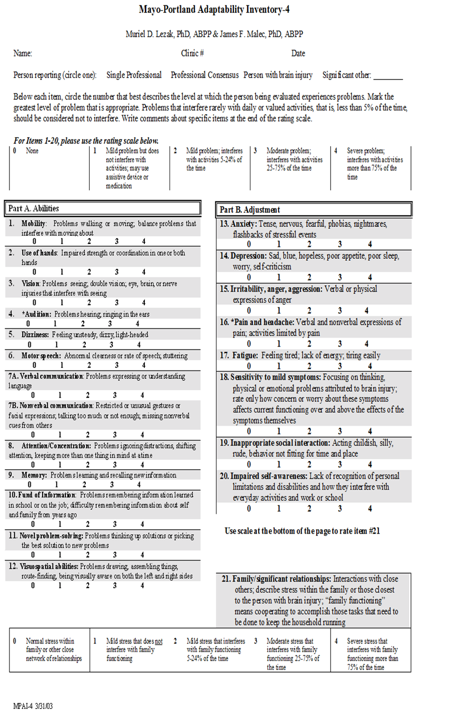

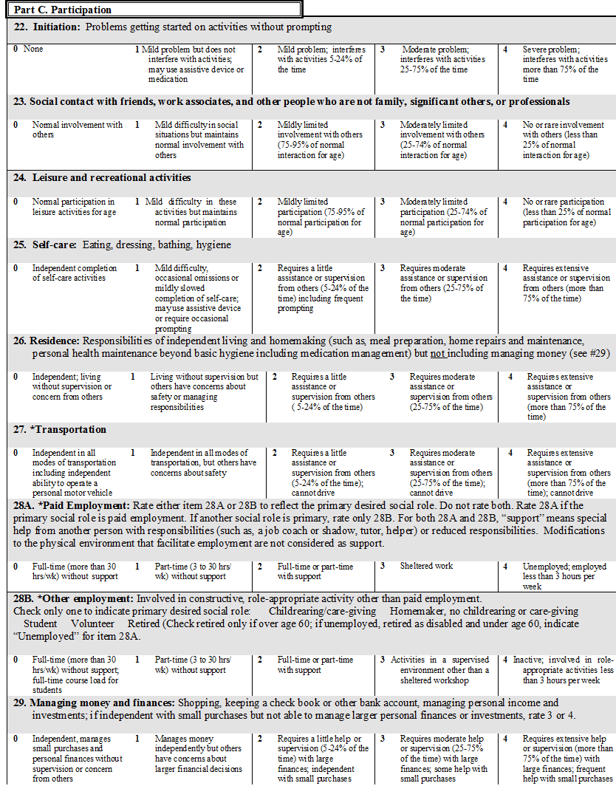
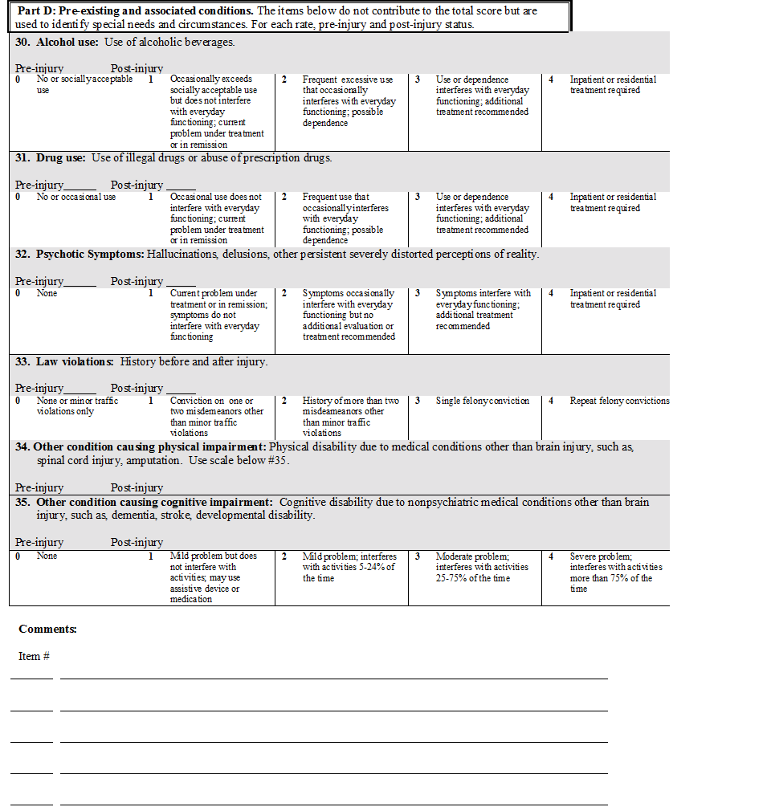
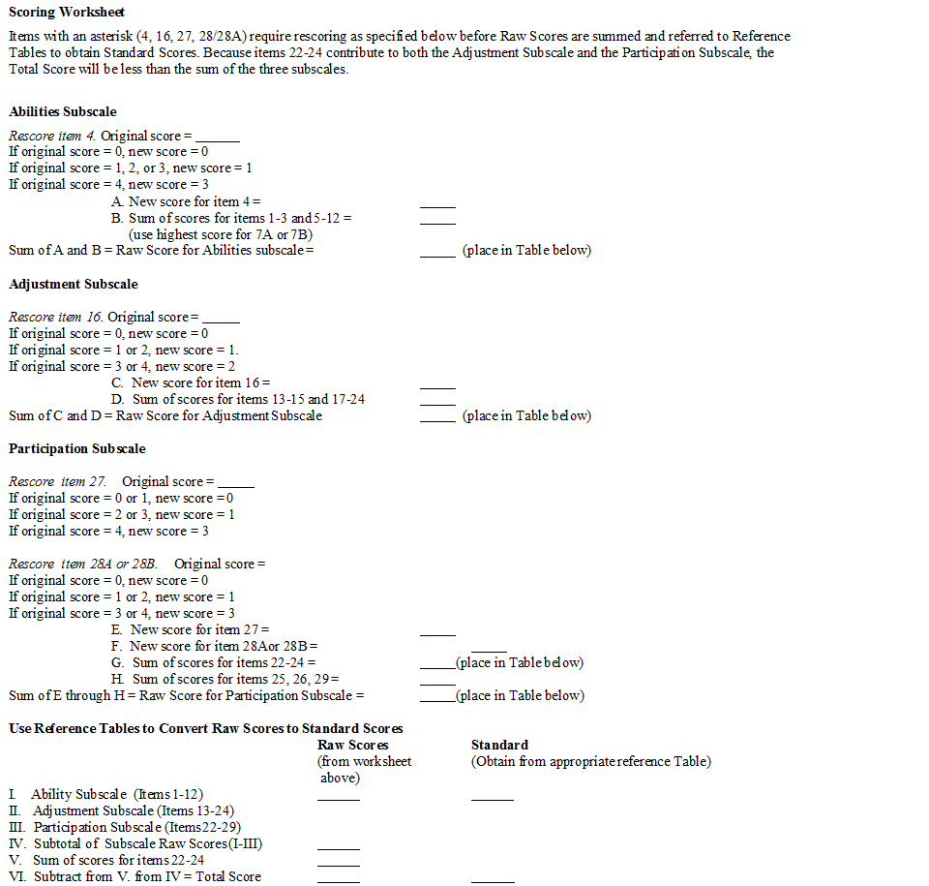
Appendix B
Hospital Anxiety and Depression Scale (HADS)
Hospital Anxiety and Depression Scale (HADS)
Instructions: Doctors are aware that emotions play an important part in most illnesses. If your doctor knows about these feelings he or she will be able to help you more. This questionnaire is designed to help your doctor know how you feel. Read each item and circle the reply which comes closest to how you have been feeling in the past week. Don’t take too long over your replies: your immediate reaction to each item will probably be more accurate than a long thought out response.

I feel tense or ‘wound up’: | A |  | I feel as if I am slowed down: | D
Most of the time | 3 |  | Nearly all of the time | 3
A lot of the time | 2 |  | Very often | 2
Time to time, occasionally | 1 |  | Sometimes | 1
Not at all | 0 |  | Not at all | 0
I still enjoy the things I used to enjoy: | D |  | I get a sort of frightened feeling like ‘butterflies in the stomach’: | A
Definitely as much | 0 |  | Not at all | 0
Not quite so much | 1 |  | Occasionally | 1
Only a little | 2 |  | Quite often | 2
Not at all | 3 |  | Very often | 3
I get a sort of frightened feeling like something awful is about to happen: | A |  | I have lost interest in my appearance: | D
Very definitely and quite badly | 3 |  | Definitely | 3
Yes, but not too badly | 2 |  | I don’t take as much care as I should | 2
A little, but it doesn’t worry me | 1 |  | I may not take quite as much care | 1
Not at all | 0 |  | I take just as much care as ever | 0
I can laugh and see the funny side of things: | D |  | I feel restless as if I have to be on the move: | A
As much as I always could | 0 |  | Very much indeed | 3
Not quite so much now | 1 |  | Quite a lot | 2
Definitely not so much now | 2 |  | Not very much | 1
Not at all | 3 |  | Not at all | 0
Worrying thoughts go through my mind: | A |  | I look forward with enjoyment to things: | D
A great deal of the time | 3 |  | A much as I ever did | 0
A lot of the time | 2 |  | Rather less than I used to | 1
From time to time but not too often | 1 |  | Definitely less than I used to | 3
Only occasionally | 0 |  | Hardly at all | 2
I feel cheerful: | D |  | I get sudden feelings of panic: | A
Not at all | 3 |  | Very often indeed | 3
Not often | 2 |  | Quite often | 2
Sometimes | 1 |  | Not very often | 1
Most of the time | 0 |  | Not at all | 0
I can sit at ease and feel relaxed: | A |  | I can enjoy a good book or radio or TV programme: | D
Definitely | 0 |  | Often | 0
Usually | 1 |  | Sometimes | 1
Not often | 2 |  | Not often | 2
Not at all | 3 |  | Very seldom | 3
Questions relating to anxiety are indicated by an 'A' while those relating to depression are shown by a 'D'. Scores of 0-7 in respective subscales are considered normal, with 8-10 borderline and 11 or over indicating clinical 'caseness'

Appendix C

Robson Self-Concept Questionnaire

Robson SCQ
Name ............................................................................................. Date: / /
This questionnaire deals with attitudes and beliefs which some people have about themselves.
Please indicate how much you agree or disagree with each statement by ringing the single number in each section which represents how you typically feel most of the time.
Since people vary so much in the opinions they hold, there are no right or wrong answers.
 |  | Completely Disagree |  | Disagree |  | Agree |  | Completely Agree
1. | I have control over my own life. | 0 | 1 | 2 | 3 | 4 | 5 | 6 | 7
2. | I’m easy to like. | 0 | 1 | 2 | 3 | 4 | 5 | 6 | 7
3. | I never feel down in the dumps for very long. | 0 | 1 | 2 | 3 | 4 | 5 | 6 | 7
4: | I can never seem to achieve anything worthwhile. | 0 | 1 | 2 | 3 | 4 | 5 | 6 | 7
5: | There are lots of things I’d change about myself if I could. | 0 | 1 | 2 | 3 | 4 | 5 | 6 | 7
6. | I am not embarrassed to let people know my opinions. | 0 | 1 | 2 | 3 | 4 | 5 | 6 | 7
7: | I don’t care what happens to me. | 0 | 1 | 2 | 3 | 4 | 5 | 6 | 7
8: | I seem to be very unlucky. | 0 | 1 | 2 | 3 | 4 | 5 | 6 | 7
9. | Most people find me reasonably attractive. | 0 | 1 | 2 | 3 | 4 | 5 | 6 | 7
10. | I’m glad I’m who I am. | 0 | 1 | 2 | 3 | 4 | 5 | 6 | 7
11: | Most people would take advantage of me if they could. | 0 | 1 | 2 | 3 | 4 | 5 | 6 | 7
12. | I am a reliable person. | 0 | 1 | 2 | 3 | 4 | 5 | 6 | 7
13: | It would be boring if I talked about myself. | 0 | 1 | 2 | 3 | 4 | 5 | 6 | 7
14: | When I’m successful, there’s usually a lot of luck involved. | 0 | 1 | 2 | 3 | 4 | 5 | 6 | 7
15. | I have a pleasant personality. | 0 | 1 | 2 | 3 | 4 | 5 | 6 | 7
16. | If a task is difficult, that just makes me all the more determined. | 0 | 1 | 2 | 3 | 4 | 5 | 6 | 7
17: | I often feel humiliated. | 0 | 1 | 2 | 3 | 4 | 5 | 6 | 7
18. | I can usually make up my mind and stick to it. | 0 | 1 | 2 | 3 | 4 | 5 | 6 | 7
19: | Everyone else seems much more confident and  contented than me. | 0 | 1 | 2 | 3 | 4 | 5 | 6 | 7
20: | Even when I quite enjoy myself, there doesn’t seem  much purpose to it all. | 0 | 1 | 2 | 3 | 4 | 5 | 6 | 7
21: | I often worry about what other people are thinking about me. | 0 | 1 | 2 | 3 | 4 | 5 | 6 | 7
22: | There’s a lot of truth in the saying “What will be, will be”. | 0 | 1 | 2 | 3 | 4 | 5 | 6 | 7
23: | I look awful these days. | 0 | 1 | 2 | 3 | 4 | 5 | 6 | 7
24. | If I really try, I can overcome most of my problems. | 0 | 1 | 2 | 3 | 4 | 5 | 6 | 7
25: | It’s pretty tough to be me. | 0 | 1 | 2 | 3 | 4 | 5 | 6 | 7
26. | I feel emotionally mature. | 0 | 1 | 2 | 3 | 4 | 5 | 6 | 7
27: | When people criticise me, I often feel helpless and second-rate. | 0 | 1 | 2 | 3 | 4 | 5 | 6 | 7
28: | When progress is difficult, I often find myself thinking  it’s just not worth the effort. | 0 | 1 | 2 | 3 | 4 | 5 | 6 | 7
29. | I can like myself even when others don’t. | 0 | 1 | 2 | 3 | 4 | 5 | 6 | 7
30. | Those who know me well are fond of me. | 0 | 1 | 2 | 3 | 4 | 5 | 6 | 7

Please check that you have responded to every statement

Scores on the Robson SCQ
NB You do not have to score the Robson yourself (or any of the others) — the database has an automatic scoring system, and experience in the pilot was that there is a high rate of human error in scoring this particular questionnaire! The information below is for those who are interested only.

Scoring
Some items are scored as printed, others are reversed.
- The 14 ‘normal’ items (Qu 1, 2, 3, 6, 9, 10, 12, 15, 16, 18, 24, 26, 29, 30) have a full stop after the question number (e.g. 2.) — scoring for these is taken straight off the scale as printed.
- The 16 ‘reversed’ items (Qu 4, 5, 7, 8, 11, 13, 14, 17, 19, 20, 21, 22, 23, 25, 27, 28) have a colon after the question number (e.g. 4:) — scoring is reversed for these (i.e. 0 = 7, 1 = 6 etc).
- Add up the numbers obtained like this to get the total score.

Norms

Reference group | Mean total score | S.D.
From Robson (1989):
70 controls with “...no evidence of psychological disorder...” | 137.0 | 20.2
51 patients with DSM-III GAD | 108.0 | 24.8
47 consecutive referrals to Psychotherapy Dept | 99.8 | 24.0
From Robson (personal communication)
200 controls | 140.0 | 19.8
From Romans, Martin & Mullen (1996) [New Zealand sample]:
225 women from random community sample (those who did not report CSA) | 147.4 | 25.8
252 women from random community sample (those who did report CSA) | 138.8 | 29.6

Pooling the Robson control samples gives an estimate for the ‘normal’ mean in British samples = 139.2 (SD=19.9); so to simplify a bit for routine clinical use we take it as mean = 140, SD = 20.

References
Robson (1989). Development of a new self-report questionnaire to measure self-esteem. Psychological Medicine, 19, 513-518.
Romans, Martin & Mullen (1996). Women’s self-esteem: a community study of women who report and do not report childhood sexual abuse. British Journal of Psychiatry, 169, 696-704.

David Westbrook
October 1997
Appendix D

Research and Ethics Approval



South East Coast - Surrey Research Ethics Committee

Whitefriars

Level 3, Block B,

Lewins Mead,

Bristol

BS1 2NT
Telephone: (020) 71048053

Please note: This is an acknowledgement letter from the REC only and does not allow you to start your study at NHS sites in England until you receive HRA Approval
05 September 2016
Dear Miss Venables,

Study title: | People’s experiences of ‘personally important moments’  following an Acquired Brain Injury (ABI), the meanings they attach to them and the influence they have on their post ABI journey: A qualitative study.
REC reference: | 16/LO/1664
IRAS project ID: | 183253

Thank you for your email of 03 September 2016. I can confirm the REC has received the documents listed below and that these comply with the approval conditions detailed in our letter dated 02 September 2016

Documents received

The documents received in response to favourable opinion (with
additional conditions) were as follows:

Document | Version | Date
Participant information sheet (PIS) [Participant Information Sheet] | 2 | 02 September 2016

Approved documents

The final list of approved documentation for the study is therefore as follows:
Document | Version | Date
Evidence of Sponsor insurance or indemnity (non NHS Sponsors only) | 1 | 22 August 2016
Interview schedules or topic guides for participants | 1 | 26 April 2016
IRAS Application Form [IRAS_Form_30082016] |  | 30 August 2016
Letter from sponsor [UEA Sponsor] | 1 | 22 August 2016
Other [Consent to contact participant] | 1 | 22 August 2016
Other [Document 1 Initial email to recruiting sites] | 1 | 22 August 2016
Participant consent form | 1 | 10 August 2016
Participant information sheet (PIS) [Participant Information Sheet] | 2 | 02 September 2016
Research protocol or project proposal [Thesis proposal] | 1 | 22 August 2016
Summary CV for Chief Investigator (CI) | 1 | 26 April 2016
Summary CV for supervisor (student research) | 1 | 26 April 2016
Summary CV for supervisor (student research) | 1 | 26 April 2016
Summary, synopsis or diagram (flowchart) of protocol in non technical language [Lay Summary] | 1 | 22 August 2016
Validated questionnaire | 1 | 26 April 2016
Validated questionnaire | 1 | 26 April 2016
Validated questionnaire | 1 | 26 April 2016

You should ensure that the sponsor has a copy of the final documentation for
the study. It is the sponsor's responsibility to ensure that the documentation is
made available to R&D offices at all participating sites.
16/LO/1664 | Please quote this number on all correspondence

Yours sincerely


Wai Yeung REC Assistant

E-mail: nrescommittee.secoast-surrey@nhs.net

Copy to: | Mrs Yvonne Kirkham  Wendy Llaneza, Cambridgeshire and Peterborough NHS Foundation Trust, R&D Department Department

Appendix E

Health and Research Authority Approval

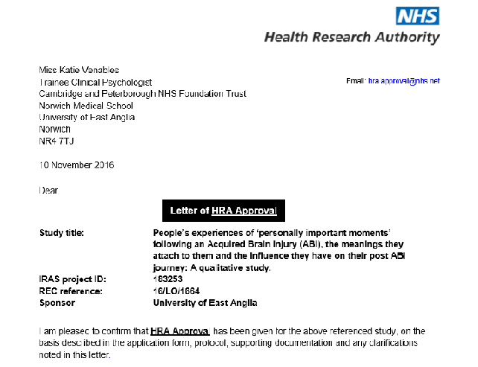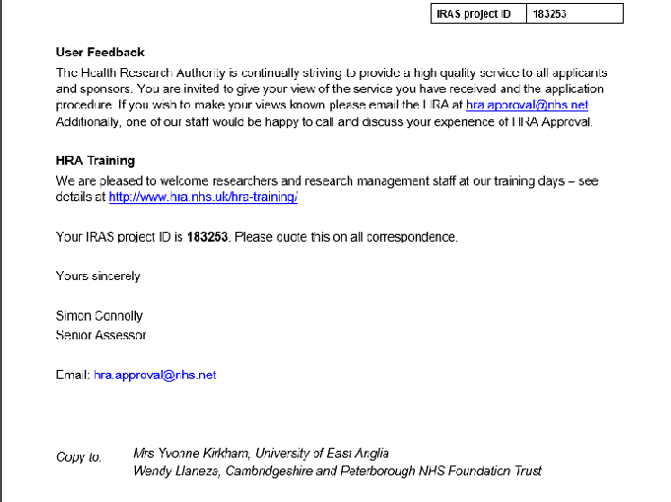

Appendix F
Participant Information Sheet
Date: 02.09.2016 Version number: 2
IRAS Project ID: 183253

Participant Information Sheet

We would like to invite you to take part in a student research study that is looking at people’s experiences following their Acquired Brain Injury (ABI). Before you decide if you would like to take part, please have a look at this information on why the research is happening and what it involves. The researcher will be happy to talk with you about the study and answer any questions you may have.

What is an Acquired Brain Injury (ABI)?
An Acquired Brain Injury (ABI) is any sudden damage to the brain received during a person's lifetime and not as a result of birth trauma.
What is the study about?
ABI can impact on many areas of people’s lives. It can affect thinking skills, mood, behaviour, relationships, work and physical abilities. Research shows that there are big differences in how people respond to these changes. Some research suggests that there are moments that happen after ABI that people hold as important. The meaning that people attach to these moments can change how they respond.
The aim of this study is to explore individual’s experiences of ‘personally important moments’ following an ABI. We are interested in the meaning of these moments and what impact they may have had on people’s post-injury lives. We hope that this study will provide people with a greater understanding of ‘personally important moments’ and their impact, which in turn may inform ABI rehabilitation and improve people’s post-injury lives.
Who is Organising, Funding and Authorising the Study?
The study is a student research project and is organised and funded by the University of East Anglia and been approved by an NHS Research and Ethics Committee (REC).
What Will Participating Involve?
Service users from The Evelyn Community Head Injury Service, The Oliver Zangwill Centre and Headway Cambridgeshire will be invited to take part.
We will invite people for individual, face to face interviews. We will ask them some general questions about important moments that they have experienced since their ABI. This is likely to be one interview lasting up to two hours. It is unlikely, but possible that participants will be invited to be interviewed twice.
It is possible that some people that express interest in my research and provide consent to contact, may not be interviewed, this is because we may have already gathered enough data.
Interviews will be recorded on a Dictaphone. We will make comparisons between people’s experiences, looking for patterns. Some interviews will be transcribed (the verbal information from the Dictaphone being typed up by a professional transcription service, these services abide by the principles of the Data Protection Act (1998) and data will be kept confidentially.
We will also be collecting some information about emotional state, personal details and medical information regarding the ABI. This will require participants to complete some short rating scales and give permission for medical records to be accessed.
A summary of our findings will be shared with those that take part.
In the future findings from this research study may be published in a research journal, but this will not contain any of your confidential information.
Confidentiality
All confidential information will be transported in a lockable case. It will all be stored securely, using password protected computers and lockable drawers. This will only be accessed by Katie Venables and Fergus Gracey.
At the earliest opportunity, participants will be allocated a number. From this point onwards they will be identified via this.
Data will be kept for ten years, and will be the responsibility of the University of East Anglia. Following this time, it will be destroyed.
Participants may be excluded from the study if we felt concerned that it may be harmful to their well-being. If this occurred, the named clinician from the referring service would be contacted.
If, during interviews, we became concerned that participants or others may be at risk of significant harm then confidentiality may have to be broken.
Right to Withdraw
Participation in this study is voluntary and participants have the right to withdraw at any time up until the point of data analysis, without giving any reason and without their care being affected.
Possible Benefits of Taking Part
By taking part in this study, participants will be contributing to a better understanding of the experience people have following an ABI.
Possible Disadvantages of Taking Part
We do not expect any harm will come to participants but the content of the interviews may evoke strong emotions as there will be questions about their ABI and personal experiences.
Should participants become emotionally distressed during the interviews they will be reminded that they can take a break should they want to. Participants do not have to discuss anything they find too distressing and that they can request to stop the interview at any time and re-arrange for a different day.
If any participant was thought to be suffering with severe emotional distress, we would recommend that they contact their GP and would contact the clinician from their referring service so that appropriate support could be provided.
Choosing not to Take Part
You do not have to take part, participation is voluntary, and if you choose not to take part then your clinical care will not be affected.
Complaints
Should you wish to make a complaint, you can contact Ken Laidlaw (Clinical Psychology Programme Director at University of East Anglia) who is independent from this research.
Ken Laidlaw
Faculty of Medicine and Health Sciences
University of East Anglia
Norwich Research Park
Norwich, NR4 7TJ

Tel: 01603 593600

Interested in taking part?
Please contact the Service manager or a member of staff for more details.
Best wishes,
The research team.
Email: K.Venables@uea.ac.uk
F.Gracey@uea.ac.uk
Telephone: 07749 592850

Appendix G
Consent to Contact Form
Consent to Contact
Date: 10.08.16 Version number: 1
CONSENT TO CONTACT FORM FOR STUDY: People’s experiences of ‘personally important moments’ following an Acquired Brain Injury (ABI), the meanings they attribute to them and the influence they have on their post-ABI journey: A qualitative study.
I agree that my contact details as given below can be given (in person via this document or by telephone) to the researchers carrying out the above named study. This will enable them to contact me and arrange a time/place to explain the study in more detail so that I can then decide whether or not to take part. BLOCK CAPITALS PLEASE:
Name: ______________________________________(Mr/Mrs/Miss/Ms, Forename, Surname) Address: _____________________________________________________________ _____________________________________________________________ _____________________________________________________________
Postcode: _____________________________________________________________
Main contact number: ________________________________________________
Alternative contact number: ________________________________________________
When would you prefer to be contacted? E.g. evenings, weekends? _________________________
Signature: _________________________________________________ Date: _____/______/20____

Appendix H
Consent to Participate Form

Consent to participate
Date: 10.08.16 Version number: 1 Participant Identification:
IRAS Project ID: 183253
CONSENT FORM
Title of study: People’s experiences of ‘personally important moments’ following an Acquired Brain Injury (ABI), the meanings they attribute to them and the influence they have on their post-ABI journey: A qualitative study.
Name of Primary Researcher: Katie Venables (Trainee Clinical Psychologist)
Name of Research Supervisor: Dr Fergus Gracey (Clinical Psychologist)
Please initial box
- I confirm that I have read the information sheet dated (date at time of recruitment)
for the above named study. I have had the opportunity to consider the information, ask questions and have had these answered satisfactorily.

- I understand that my participation is voluntary and that I am free to withdraw at any
time up until the point of data analysis, without giving any reason and without my care
being affected.

- I understand that relevant sections of my medical notes may need to be accessed and looked at by Katie Venables and Fergus Gracey where it is relevant to my taking part
in this research. I give permission for these individuals to have access to my records.

- I understand that this study may be published in a journal, but that this will not contain
any of my confidential information.

- I give my consent for Katie Venables and Fergus Gracey to discuss my
participation in this study, with clinicians from the (name of their referring service).

- I understand that I may be excluded from the study if there is an indication that it may
have a negative impact on my well-being, in this instance I give my permission for
Katie Venables and Fergus Gracey to share any concerns with (named clinician)
from (name of their referring service).

- I consent to my interview being audio recorded.

- I understand that I may be requested to take part in a second interview.

- I consent to my data being transcribed by a professional transcription service.

- I agree to take part in the above study.

Name of Participant Date Signature

Name of Person Date Signature
taking consent

NB. Copy to researcher, copy to participant

Appendix I
Sheet to Record Demographic and Medical Information
Identity Number:
Sex:
Current age:
Date of index event:
Time since injury:
GCS:
Scans:
Injury details:

Treatment received:

GP:
Dominant Hand:
Details of index event:

Appendix I
Title

Appendix J
Title

Appendix F
Title

Appendix J
SSI Questions
Semi Structured Interview Questions
- Tell me about any experiences you’ve had following your ABI that have been of personal importance to you?
- How were/are they important to you?
- Are there particular times that stick out in your mind?
- Are there particular moments that were meaningful to you?
- What did that mean to you at that time? What meaning does that hold for you now?
- What emotions were experienced at that time?
- Did that change things for you? How?
- Did that alter your direction?
- How did they shape what happened next?

Appendix K
Examples of Coded Transcripts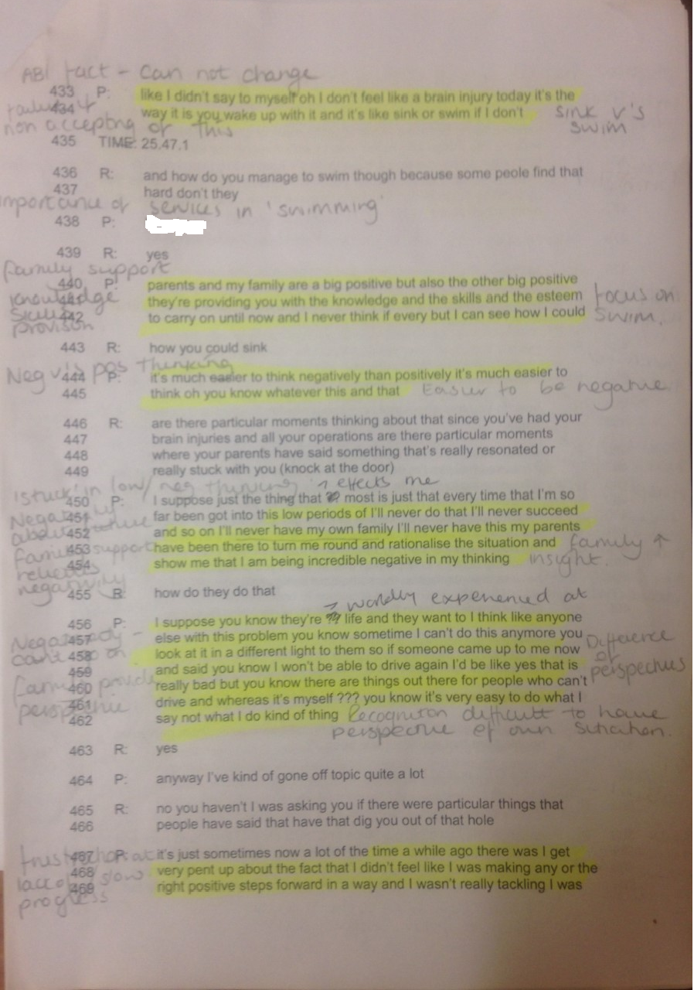
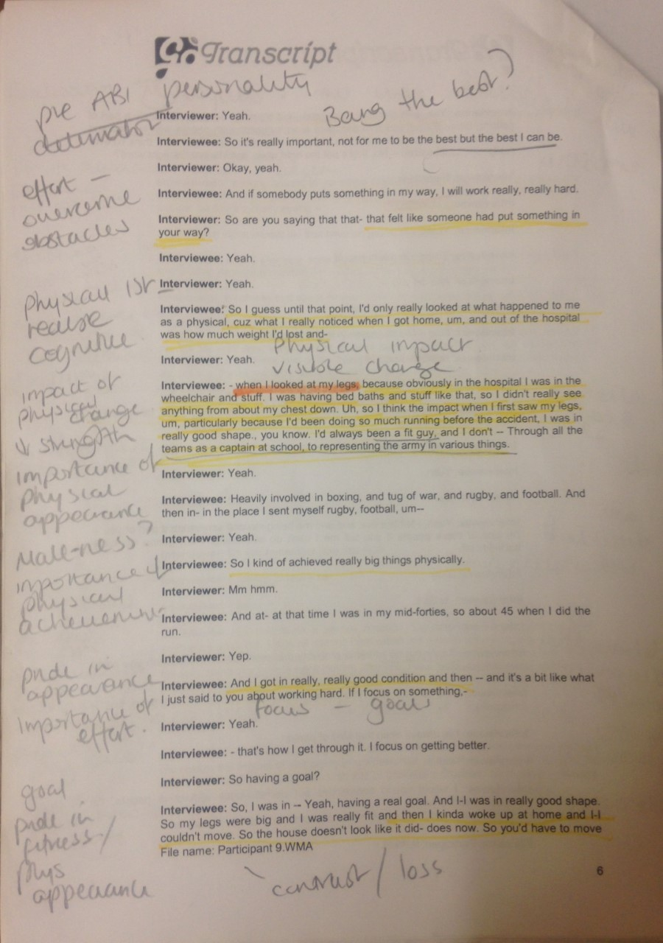

Appendix L
Examples of Memoing
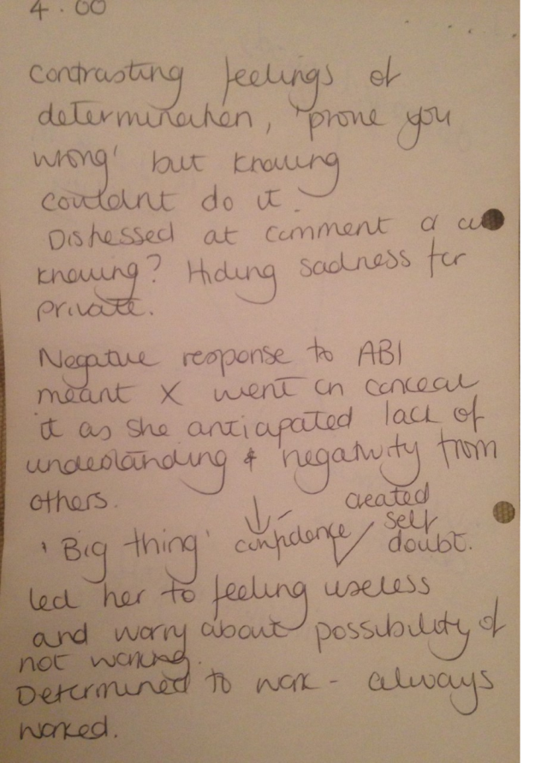

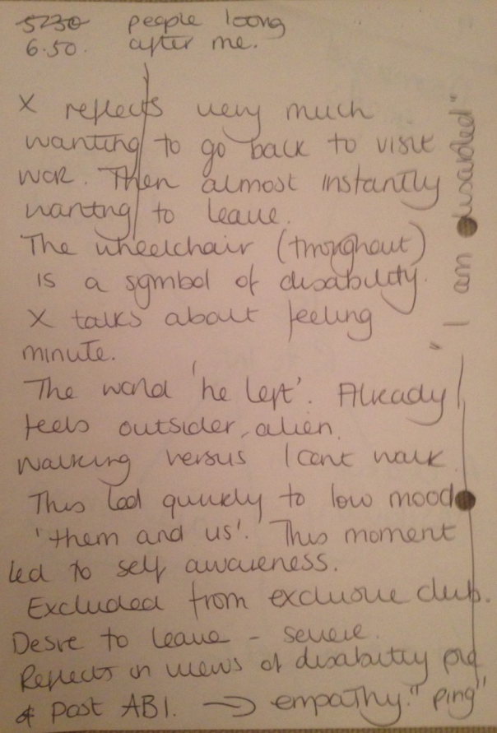

Appendix M
Examples of Clustering

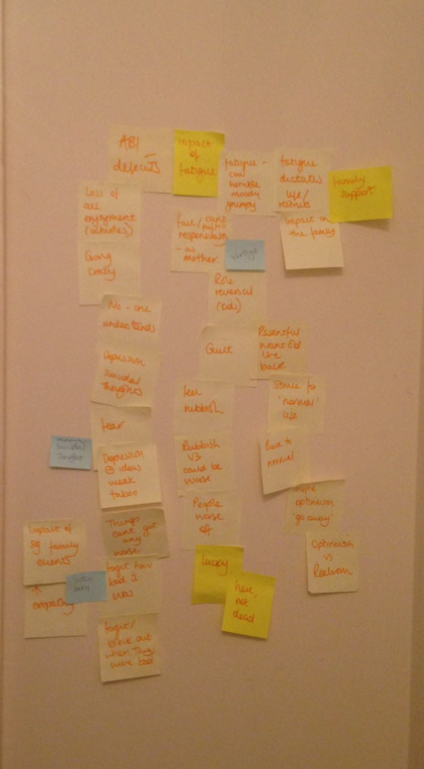
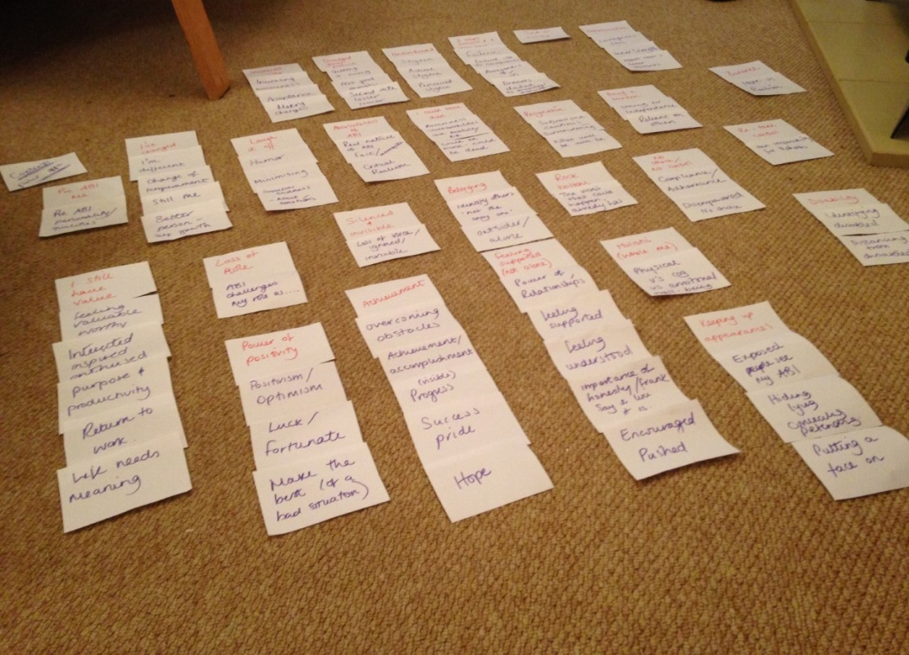

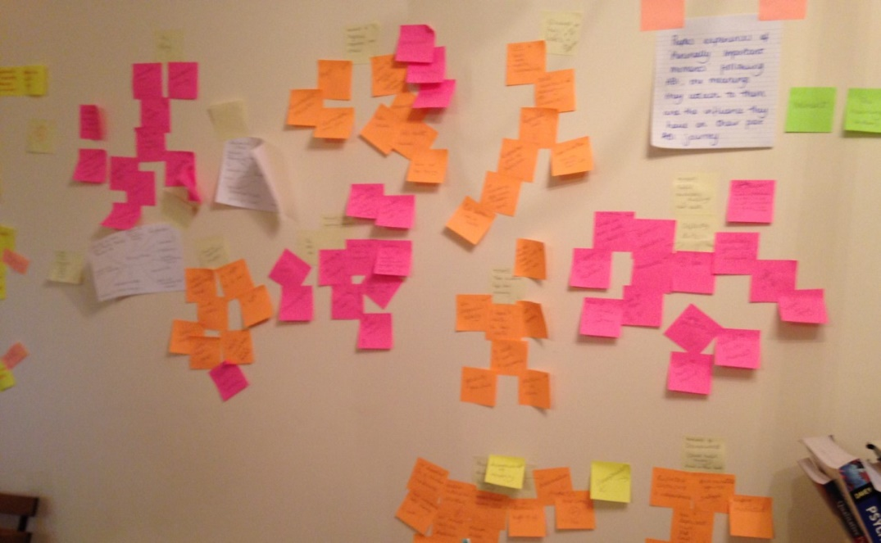
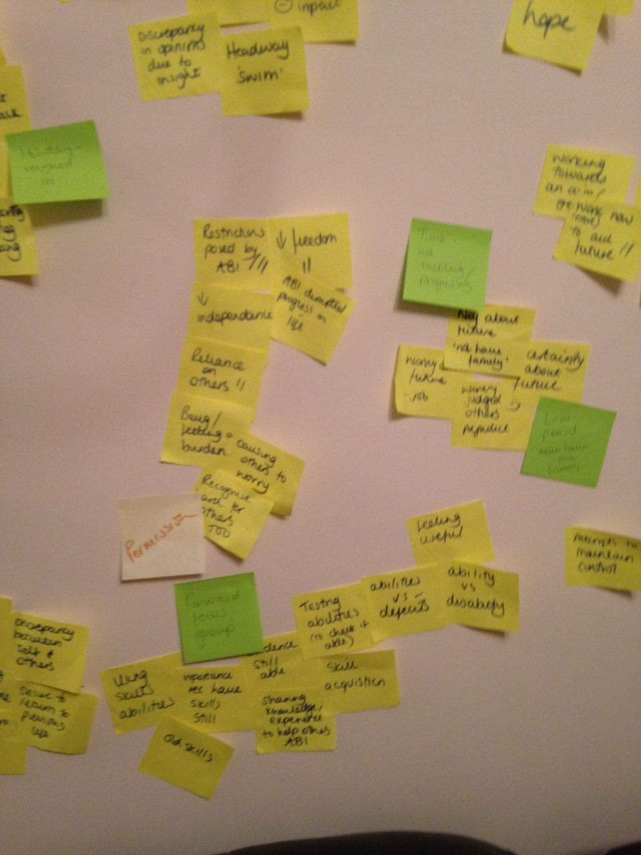

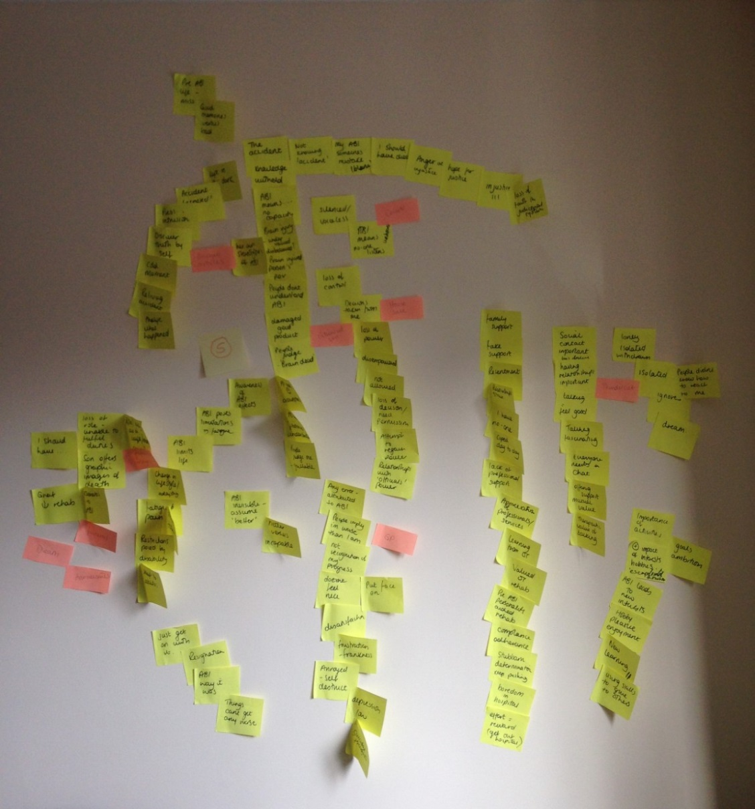

Appendix N
Excel Data Spreadsheet
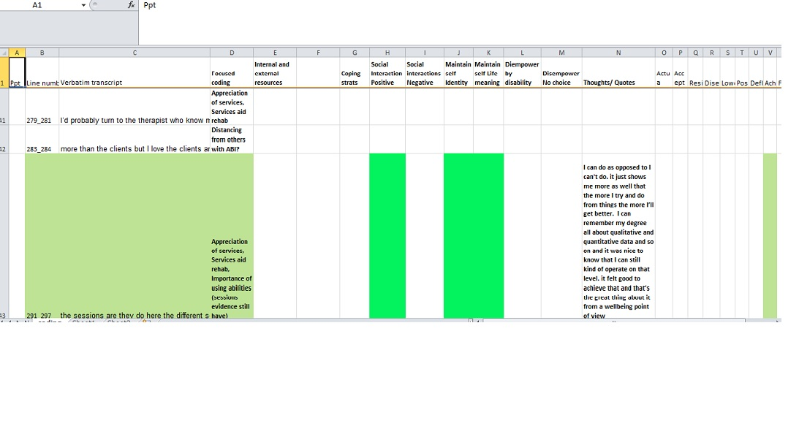
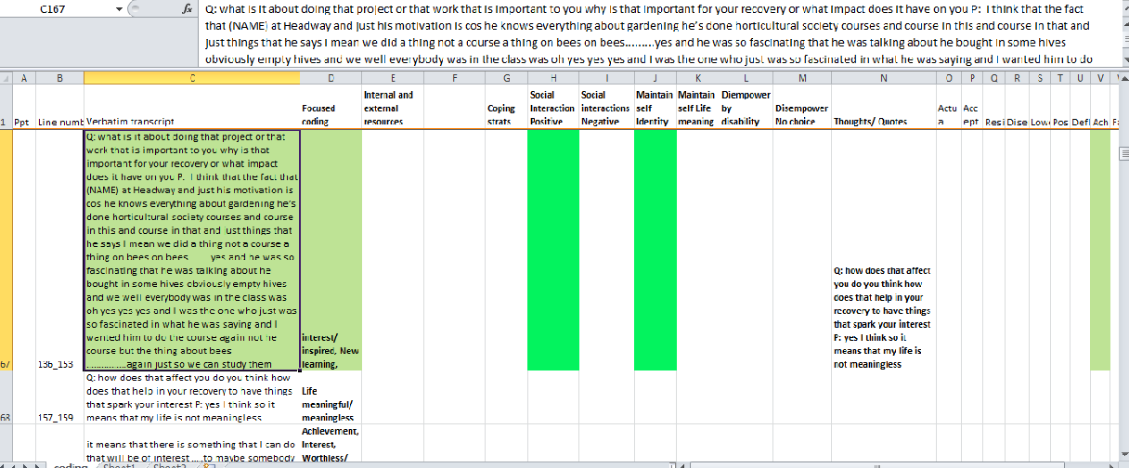

Appendix O
Guidelines for Authors

Instructions for authors
Thank you for choosing to submit your paper to us. These instructions will ensure we have everything required so your paper can move through peer review, production and publication smoothly. Please take the time to read and follow them as closely as possible, as doing so will ensure your paper matches the journal's requirements. For general guidance on the publication process at Taylor & Francis please visit our Author Services website.

This journal uses ScholarOne Manuscripts (previously Manuscript Central) to peer review manuscript submissions. Please read the guide for ScholarOne authors before making a submission. Complete guidelines for preparing and submitting your manuscript to this journal are provided below.

Contents list
About the journal
Peer review
Preparing your paper
- Structure
- Word count
- Style guidelines
- Formatting and templates
- References
- Checklist
Using third-party material in your paper
Declaration of interest statement
Clinical Trials Registry
Complying with ethics of experimentation
- Consent
- Health and safety
Submitting your paper
Publication charges
Copyright options
Complying with funding agencies
Open access
My Authored Works
Article reprints

About the journal
Disability and Rehabilitation is an international, peer reviewed journal, publishing high-quality, original research. Please see the journal’s Aims & Scope for information about its focus and peer-review policy.
Please note that this journal only publishes manuscripts in English.
Disability and Rehabilitation accepts the following types of article: Reviews, Research Papers, Case Studies, Perspectives on Rehabilitation, Reports on Rehabilitation in Practice, Education and Training, and Correspondence. Systematic Reviews should be submitted as “Review” and Narrative Reviews should be submitted as “Perspectives in Rehabilitation”.
Special Issues and specific sections on contemporary themes of interest to the Journal’s readership are published. Please contact the Editor for more information.

Peer review
Taylor & Francis is committed to peer-review integrity and upholding the highest standards of review. For submissions to Disability and Rehabilitation authors are given the option to remain anonymous during the peer-review process. Authors will be able to indicate whether their paper is ‘Anonymous’ or ‘Not Anonymous’ during submission, and should pay particular attention to the below:
- Authors who wish to remain anonymous should prepare a complete text with information identifying the author(s) removed. This should be uploaded as the “Main Document” and will be sent to the referees. A separate title page should be included providing the full affiliations of all authors. Any acknowledgements and the Declaration of Interest statement must be included but should be worded mindful that these sections will be made available to referees.
- Authors who wish to be identified should include the name(s) and affiliation(s) of author(s) on the first page of the manuscript. The complete text should be uploaded as the “Main Document”.
Once your paper has been assessed for suitability by the editor, it will be peer-reviewed by independent, anonymous expert referees. Find out more about what to expect during peer review and read our guidance on publishing ethics.

Preparing your paper
All authors submitting to medicine, biomedicine, health sciences, allied and public health journals should conform to the Uniform Requirements for Manuscripts Submitted to Biomedical Journals, prepared by the International Committee of Medical Journal Editors (ICMJE).
We also refer authors to the community standards explicit in the American Psychological Association's (APA) Ethical Principles of Psychologists and Code of Conduct.
We encourage authors to be aware of standardised reporting guidelines below when preparing their manuscripts:
- Case reports - CARE
- Diagnostic accuracy - STARD
- Observational studies - STROBE
- Randomized controlled trial - CONSORT
- Systematic reviews, meta-analyses - PRISMA
Whilst the use of such guidelines is supported, due to the multi-disciplinary nature of the Journal, it is not compulsory.

Structure
Your paper should be compiled in the following order: title page; abstract; keywords; main text, introduction, materials and methods, results, discussion; acknowledgments; declaration of interest statement; references; appendices (as appropriate); table(s) with caption(s); figures; figure captions (as a list).
In the main text, an introductory section should state the purpose of the paper and give a brief account of previous work. New techniques and modifications should be described concisely but in sufficient detail to permit their evaluation. Standard methods should simply be referenced. Experimental results should be presented in the most appropriate form, with sufficient explanation to assist their interpretation; their discussion should form a distinct section.
Tables and figures should be referred to in text as follows: figure 1, table 1, i.e. lower case. The place at which a table or figure is to be inserted in the printed text should be indicated clearly on a manuscript. Each table and/or figure must have a title that explains its purpose without reference to the text.
The title page should include the full names and affiliations of all authors involved in the preparation of the manuscript. The corresponding author should be clearly designated, with full contact information provided for this person.

Word count
Please include a word count for your paper. There is no word limit for papers submitted to this journal, but succinct and well-constructed papers are preferred.

Style guidelines
Please refer to these style guidelines when preparing your paper, rather than any published articles or a sample copy.
Please use any spelling consistently throughout your manuscript.
Please use double quotation marks, except where "a quotation is 'within' a quotation". Please note that long quotations should be indented without quotation marks.
For tables and figures, the usual statistical conventions should be used.
Drugs should be referred to by generic names. Trade names of substances, their sources, and details of manufacturers of scientific instruments should be given only if the information is important to the evaluation of the experimental data.

Formatting and templates
Papers may be submitted in any standard format, including Word and LaTeX. Figures should be saved separately from the text. To assist you in preparing your paper, we provide formatting template(s).
Word templates are available for this journal. Please save the template to your hard drive, ready for use.
A LaTeX template is available for this journal. Please save the template to your hard drive, ready for use.
If you are not able to use the templates via the links (or if you have any other template queries) please contact authortemplate@tandf.co.uk

References
Please use this reference guide when preparing your paper. An EndNote output style is also available to assist you.

Checklist: what to include
- Author details. Please ensure everyone meeting the International Committee of Medical Journal Editors (ICJME) requirements for authorship is included as an author of your paper. Please include all authors’ full names, affiliations, postal addresses, telephone numbers and email addresses on the cover page. Where available, please also include ORCiDs and social media handles (Facebook, Twitter or LinkedIn). One author will need to be identified as the corresponding author, with their email address normally displayed in the article PDF (depending on the journal) and the online article. Authors’ affiliations are the affiliations where the research was conducted. If any of the named co-authors moves affiliation during the peer-review process, the new affiliation can be given as a footnote. Please note that no changes to affiliation can be made after your paper is accepted. Read more on authorship.
- A structured abstract of no more than 200 words. A structured abstract should cover (in the following order): the purpose of the article, its materials and methods (the design and methodological procedures used), the results and conclusions (including their relevance to the study of disability and rehabilitation). Read tips on writing your abstract.
- You can opt to include a video abstract with your article. Find out how these can help your work reach a wider audience, and what to think about when filming.
- 5-8 keywords. Read making your article more discoverable, including information on choosing a title and search engine optimization.
- A feature of this journal is a boxed insert on Implications for Rehabilitation. This should include between two to four main bullet points drawing out the implications for rehabilitation for your paper. This should be uploaded as a separate document. Below are examples:
Example 1: Leprosy
  - Leprosy is a disabling disease which not only impacts physically but restricts quality of life often through stigmatisation.
  - Reconstructive surgery is a technique available to this group.
  - In a relatively small sample this study shows participation and social functioning improved after surgery.

Declaration of Interest Statement
Please include a declaration of interest statement, using the subheading "Declaration of interest." If you have no interests to declare, please state this (suggested wording: The authors report no conflicts of interest). For all NIH/Wellcome-funded papers, the grant number(s) must be included in the disclosure of interest statement. Read more on declaring conflicts of interest.

Complying with ethics of experimentation
Please ensure that all research reported in submitted papers has been conducted in an ethical and responsible manner, and is in full compliance with all relevant codes of experimentation and legislation. All papers which report in vivo experiments or clinical trials on humans or animals must include a written statement in the Methods section. This should explain that all work was conducted with the formal approval of the local human subject or animal care committees (institutional and national), and that clinical trials have been registered as legislation requires. Authors who do not have formal ethics review committees should include a statement that their study follows the principles of the Declaration of Helsinki.

Consent
All authors are required to follow the ICMJE requirements on privacy and informed consent from patients and study participants. Please confirm that any patient, service user, or participant (or that person’s parent or legal guardian) in any research, experiment, or clinical trial described in your paper has given written consent to the inclusion of material pertaining to themselves, that they acknowledge that they cannot be identified via the paper; and that you have fully anonymized them. Where someone is deceased, please ensure you have written consent from the family or estate. Authors may use this Patient Consent Form, which should be completed, saved, and sent to the journal if requested.

Submitting your paper
This journal uses This journal uses ScholarOne to manage the peer-review process. If you haven't submitted a paper to this journal before, you will need to create an account in the submission centre. Please read the guidelines above and then submit your paper in the relevant Author Centre, where you will find user guides and a helpdesk.
If you are submitting in LaTeX, please convert the files to PDF beforehand (you will also need to upload your LaTeX source files with the PDF).
Please note that Disability and Rehabilitation uses Crossref™ to screen papers for unoriginal material. By submitting your paper to Disability and Rehabilitation you are agreeing to originality checks during the peer-review and production processes.
The Editor of Disability and Rehabilitation will respond to appeals from authors relating to papers which have been rejected. The author(s) should email the Editor outlining their concerns and making a case for why their paper should not have been rejected. The Editor may choose to accept the appeal and secure a further review, or to not uphold the appeal. In case of the latter, the Editor of Disability and Rehabilitation: Assistive Technology will be consulted.
On acceptance, we recommend that you keep a copy of your Accepted Manuscript. Find out more about sharing your work.

Open access
This journal gives authors the option to publish open access via our Open Select publishing program, making it free to access online immediately on publication. Many funders mandate publishing your research open access; you can check open access funder policies and mandates here.
Taylor & Francis Open Select gives you, your institution or funder the option of paying an article publishing charge (APC) to make an article open access. Please contact openaccess@tandf.co.uk if you would like to find out more, or go to our Author Services website.
For more information on license options, embargo periods and APCs for this journal please go here.

My Authored Works
On publication, you will be able to view, download and check your article’s metrics (downloads, citations and Altmetric data) via My Authored Works on Taylor & Francis Online. This is where you can access every article you have published with us, as well as your free eprints link, so you can quickly and easily share your work with friends and colleagues.
We are committed to promoting and increasing the visibility of your article. Here are some tips and ideas on how you can work with us to promote your research.

Article reprints
For enquiries about reprints, please contact the Taylor & Francis Author Services team at reprints@tandf.co.uk. To order a copy of the issue containing your article, please contact our Customer Services team at Adhoc@tandf.co.uk.

Queries
Should you have any queries, please visit our Author Services website or contact us at authorqueries@tandf.co.uk.
Updated May 2016

Taylor & Francis Standard Reference Style | NLM
National Library of Medicine (NLM) is a member of the National Information Standards Organization and its various published standards have been adopted for the Library’s MEDLINE/PubMed database. See https://www.nlm.nih.gov/citingmedicine/
References are numbered consecutively in the order in which they are first mentioned in the text. Identify references in text, tables, and captions by bracketed numbers [1], and provide a list of references at the end of the article in numerical order with square brackets around the numbers. Reuse the original number assigned to the reference each time a reference is repeated in the text. Insert the citation numbers at the relevant place in the text, inside any adjacent punctuation mark. Examples: Myopathy typically occurs in fewer than one in 10,000 patients on standard doses [1]. This approach was successfully implemented by Benders et al. [30] and Zhao [31] for modular NN. For this purpose, the NNs were widely used in structural inverse problems [24], damage identification [14,25], or parameters estimation [26], among many applications.
When citing multiple references, use commas (without spaces) to separate them. Use an unspaced en dash to join inclusive first and last numbers, e.g. [2,3,4,5,7,10] would be abbreviated to [2–5,7,10]. Examples: Compared to the initial shape, the optimized surface shape can substantially improve the structural characteristics [12,13]. Most of the optimization methods proposed in previous studies are parametric methods [3–7]. See, for example, [1,3,10–13,15–20,22–25,27,28]. For some work along these lines, see [3,13,17,18,27]. The crack boundary was discretized using 10 discontinuous quadratic elements, where the crack-tip elements are discontinuous quarter-point [see 17,28].
Give a number even if the author is named in the text: Jones [10] has argued that ... Jones and Smith [12] have argued that … If you want to name more than two authors in the text, use: Jones et al. [3] have argued that …

Reference list
Numerical order based on first appearance in the text.
Surname and initials. Capitalize surnames and enter spaces within surnames as they appear in the document you are citing, e.g. Van Der Horn or van der Horn; De Wolf or de Wolf or DeWolf. Initials follow surname without punctuation, without spaces or full points between initials, e.g. Author AA. Place family designations of rank after the initials, without punctuation, e.g. Author AA Jr
Author AA. Title of article. Abbreviated Journal Title. Date;volume(number):pages. MacGregor RJ. A functional view of consciousness and its relations in brain. J Integr Neurosci. 2004;3(3):253–266.
Title page template:

Taylor & Francis Word Template for journal articles

Author Nameª* and A. N. Author^{b}

ªDepartment, University, City, Country; ^{b}Department, University, City, Country
Provide full correspondence details here including e-mail for the *corresponding author
Provide short biographical notes on all contributors here if the journal requires them.

