Consumption of reactive halogen species from sea-salt aerosol by secondary organic aerosol: Slowing down bromine explosion.

Joelle Buxmann^{A,B,C*}, Sergej Bleicher^{B}, Ulrich Platt^{C}, Roland von Glasow^{E}, Roberto Sommariva^{E,D}, Andreas Held^{F}, Cornelius Zetzsch^{B} and Johannes Ofner^{G}
^{A} now at: Met Office, Exeter, UK
^{B} Atmospheric Chemistry Research Laboratory; University of Bayreuth; Germany
^{C} Institute of Environmental Physics; University of Heidelberg; Germany
^{D} now at: University of Leicester, Department of Chemistry; UK
^{E} Centre for Ocean and Atmospheric Sciences, School of Environmental Sciences, University of East Anglia, Norwich, UK
^{F} Atmospheric Chemistry; University of Bayreuth; Germany
^{G} Vienna University of Technology, Institute of Technology of Chemical Technologies and Analytics, Division Environmental and Process Analytics, Vienna, Austria.

*e-mail: joelle.c.buxmann@metoffice.gov.uk

Environmental context. Secondary organic aerosols together with sea salt aerosols are a major contribution to global aerosols and influence the release of reactive halogens, which affect air quality and human health. In this study, the loss of reactive halogen species from simulated salt aerosols due to 3 different types of secondary organic aerosols was quantified in chamber experiments and investigated with the help of a numerical model. The loss rate can be included into chemistry models of the atmosphere and help to quantify the halogen budget in nature.

Abstract
Secondary organic aerosols (SOA) are formed from various natural and anthropogenic sources in the environment. At the same time, reactive bromine species (e.g. BrO, Br₂, HOBr) have been found at multiple locations.[] The interaction between SOA and bromine compounds is not well understood and not included in current chemistry models. The present study quantifies the quenching of bromine release from artificial salt aerosol caused by SOA from ozonolysis of three precursors (α-pinene, catechol or guaiacol) in a Teflon smog chamber and implements it into a chemical box model. The model simulations perform very well for a blank experiment without SOA precursor, capturing the BrO formation, as detected by Differential Optical Absorption Spectrometry (DOAS). A first order BrO loss rate of 0.001 s⁻¹ on the surface of SOA was estimated for the three different precursors. This rate represents the overall effective Br_{x} (total inorganic bromine) loss onto SOA, which we include in our model. Generally, the model agrees with the maximum BrO mixing ratio in time and magnitude, with some disagreements in the exact shape. These deviations might be due to minor differences in the aerosol size distribution or potentially to wall effects. Formation of reactive chlorine in form of OClO was observed in the presence of organics but could not be reproduced by the model. According to the current knowledge, most of inorganic chlorine would be in the form of HCl in the presence of organics, as predicted by the model. In order to reproduce the net effects of the presence of SOA, the effective uptake coefficients of reactive bromine on the SOA surface are estimated to be 0.01, 0.01 and 0.004 for α-pinene, catechol and guaiacol, respectively. The uptake coefficient can now be implemented in box models and even global models, where sinks for bromine species are thought to be inadequately represented.

Keywords: Secondary organic aerosols, reactive halogen species, uptake coefficient, atmospheric model

Introduction
Organic aerosols play an important role in the atmosphere on a local, regional and global scale. In some areas, organic compounds dominate the budget of total suspended particle mass.[] Global estimations of concentrations and fluxes have been reviewed by Hallquist et al. (2009)[] and applied to regional or global models.[] Oxidation of organic aerosols by gas-phase radicals enhances the hygroscopic properties of aerosols and may lead to cloud droplet formation.[] This heterogeneous processing of organic aerosols therefore becomes important for climate. Only a few studies have considered the interaction of organic matter with halogens under atmospheric conditions[] or even heterogeneous processing of organic aerosols by reactive halogen species.[, ] Related work from our laboratory on heterogeneous processing of organic aerosols with reactive halogen species has been published by Ofner et al. (2012).[] The interaction of reactive halogen species (RHS, such as BrO, ClO, Br and Cl), released from a simulated salt-pan, with SOA is also given by these authors. Their main finding was the occurrence of heterogeneous halogenation, resulting in formation of new functional groups, changes in UV/VIS absorption, chemical composition and aerosol size distribution. The halogen release mechanisms were also found to be affected by the presence of organic aerosol. However, the exact halogenation mechanisms have not been quantified yet.
The quantification of the influence of SOA on the halogen release process is the main focus of the current study. Precursors used in these experiments were chosen based on their aerosol formation potential, their applicability for aerosol smog-chamber studies and their different chemical composition, representing aliphatic, olefinic and aromatic structural elements.[] Furthermore, a time resolved FTIR-spectroscopic degradation study revealed the formation of carboxylic acid groups among other chemical structures during SOA formation.[]
A major source of RHS is photochemical release from sea-salt particles. Acid displacement, e.g. by HNO₃, is a major source of HCl in the marine environment.^{[1,,]} In the dark, bromine and chlorine can be activated by uptake of N₂O₅ in the aerosol, producing gas-phase BrNO₂ or ClNO₂, followed by rapid photolysis to produce Br and Cl.[]
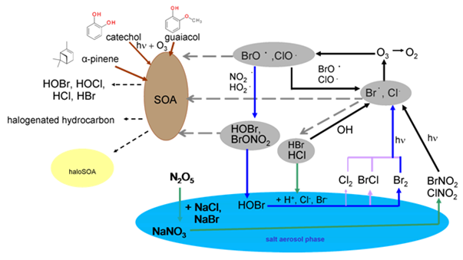
Figure 1: Schematic diagram of the release of reactive halogen species from sea-salt aerosol and potential interaction with SOA, indicating typical reaction cycles (black arrows), the ‘bromine explosion’ mechanism (blue arrows) and initial release reactions due to uptake of N₂O₅ (green arrows). Dashed arrows show competitive reactions with organics (grey) and potential products (black), where the importance of each process is not clear yet. Direct reactions between the organic precursors and reactive halogen species in the gas phase or organic coating of the salt aerosol are possible as well (not shown). In the current study, we parameterize the loss of Br_{x} species by an effective loss of BrO since this influences any further steps of bromine release as well.
At low pH in the salt aerosol, BrCl and Br₂ (the yield depends on pH and Br⁻ concentration[]) are formed and degassed into the gas phase and start a catalytic heterogeneous halogen cycling between the aerosol and gas phase, also called ‘bromine explosion’.[] Gas-phase BrCl and Br₂ are rapidly photolysed during the day and form Br and Cl atoms. Both species can react with O₃ and produce the halogen oxides BrO and ClO. Further reaction with HO₂ leads to the formation of the hypohalous acids HOBr and HOCl. The hypohalous acids are taken up by the aerosol, where the volatile species BrCl or Br₂ are formed, restarting the catalytic cycle (figure 1). Similarly, reaction with NO₂ to form BrONO₂ leads to release of Br₂ after uptake into the salt aerosol phase. Through cross and self-reactions of the ClO and BrO radicals, Br and Cl are formed and O₃ destruction is restarted. The halogen radicals play a key role in the destruction of atmospheric ozone, influencing HO_{x} and NO_{x} chemistry.^{[1,16]} Halogens exhibit potential effects on the global climate system through interaction with SOA, such as influencing the ability of particles to act as cloud condensation nuclei or changing the aerosol contribution to radiative forcing.^{[9]} Furthermore, reactive halogen-species exhibit a SOA-formation potential themselves, producing halogen-induced organic aerosol with exceptional properties.[]
Current model studies often overestimate the activation of bromine as compared to measurements.^{[12, 13]} This discrepancy has been attributed to overproduction of BrCl after uptake of HOBr, due to missing aqueous-phase reactions. Alternatively, they suggest that the uptake of HOBr and degassing of BrCl may be limited in a way not yet included in the models. One potential explanation could be the reactions with SOA and precursors, which has never been quantified before. This study aims to estimate an effective loss rate of BrO due to SOA, which would influence the formation of HOBr and all subsequent reactions (figure 1).

Experimental
Teflon Smog Chamber
All experiments were performed in the 3500-L cylindrical Teflon (FEP 200A, DuPont,
thickness 0.05 mm) smog chamber at Bayreuth in the LOTASC (Low-Temperature Aerosol Simulation Chamber, http://www.eurochamp.org/chambers/lotasc/) facility. The recent set-up is described elsewhere in detail[,], but a summary is given here. Sunlight is simulated using 7 medium-pressure metal vapor (Hydrargyrum (mercury), Medium-pressure arc, Iodide = HMI, Osram) lamps with 1.2 kW each. A filter combination of a borosilicate glass (Tempax, Schott) for the UV and a layer of distilled water for the IR range^{[18]}, achieved a spectrum close to tropospheric conditions.
A differential-pressure sensor (Kalinsky Elektronik DS1) combined with a flow-control system ensured a slight overpressure of around 0.5 Pa to keep room air out of the system and compensate for the sampling by various gas and aerosol monitors. A home-made fan enforces mixing of the chamber air. A chemiluminescence monitor (Ecophysics CLD-88p) was used to detect NO and NO₂, employing a blue-light converter (Ecophysics plc860).
Ozone was produced by passing O₂ (purity 99.995%) through a corona discharge ozonizer (Sorbios) and was monitored using a Thermo Scientifc Model 49i ozone analyzer, a dual-cell, UV photometric analyzer.
A DOAS system (combined with a White cell, described in detail elsewhere[]) was used to detect various compounds including BrO and HCHO. The instrument’s multi-reflection cell^{[20,]} has a base length of 2 m diagonally through the chamber. A total path length of 288 m was achieved using highly reflective dielectric mirrors (Layertec, R > 0.995 between 335 and 360 nm). The measurement error was estimated using the 2 σ statistical error of a single spectral fit. The sensitivity of the DOAS depends on the light intensity after passing the White cell, thus light loss due to Mie-scattering by the aerosol within the light path is represented in the error.
The particle number and size distribution of sea salt aerosols and SOA were monitored via an electrostatic classifier (EC) (TSI, 3071) and a condensation-nuclei counter (CNC) (TSI, 3020). In order to quantify the wall loss-rate of ozone in particular, a simple set of experiments and comparison with model studies was used.^{[18]} Ozone was injected at mixing ratios of up to 1ppm. Ozone is slowly photolyzed during irradiation, forming O₂ and O(¹D), which further reacts with water molecules to produce two OH radicals. The theoretical overall ozone loss depends on O₃ photolysis and the abundance of H₂O molecules, and was compared with the measured ozone loss at various levels of relative humidity (RH) (in the absence of any halogen chemistry). The difference of the measured O₃ loss and the model gives a first-order wall-loss rate constant of (1.3±0.4) ×10⁻⁵ s⁻¹ for RH between 2-70%.^{[19,21]} The smog chamber was cleaned photochemically before each experiment by introducing high humidity (RH >60 %) together with ~700 ppb of ozone and UV radiation, leading to formation of OH radicals and thus oxidation of reactive organic wall deposits as described before.^{[18,20]}

Generation of Aerosols in the Chamber
An ultrasonic nebulizer (Quick-Ohm, QUV-HEV FT25/16A, 35 W, 1.63 MHz) was used to generate sea-spray-aerosol from a salt solution. The salt solutions contained a mixture of pure NaCl (Aldrich, 99+ %, containing less than 0.01 % of bromide) and NaBr (Riedel-de-Haen, 99 %), dissolved in bidistilled water. A molar ratio of Br/Cl of 1/20 was used during the present studies containing 86.4mg/l NaBr and 1g/l NaCl, similar to the Dead Sea.[] Three different SOA precursors were used here: 1) racemic α-pinene with a purity of 98% (Sigma Aldrich), 2) catechol (Riedel de Haen, pro analysis grade, >99% HPLC) and 3) guaiacol (Sigma Aldrich, pro analysis grade, >99% GC). The precursor substances were injected into the chamber either by evaporating the solid or liquid precursors with the help of a heater or injecting into gas phase directly through a gas syringe. Inside the chamber the gas phase species react under the influence of UV light, ozone and OH radicals to form aerosols. Ozone was produced by passing O₂ (purity 99.995%) through a corona discharge ozonizer (Sorbios). Physico-chemical characterizations of SOA from α-pinene and SOA formation from catechol and guaiacol have been reported before ^{[10]}, as well as the role of halogen species. ^{[9]} There are many studies about the chemistry of the formation of SOA through oxidative reactions in the atmosphere(e.g.[, , ]), as well as a review by Kroll and Seinfeld.[]

Experimental procedure:
The experiments presented here were performed following the same procedure:
1. Ozone is injected into the chamber. After the injection of one of the three precursors (α-pinene, catechol or guaiacol), the ozone and light-initiated oxidation starts SOA formation.
2. The solar simulator is switched off in order to stop photochemistry, including light induced reactions of the precursors. Since SOA precursors consume ozone rapidly, additional ozone is injected to provide a sufficient level for halogen release. Injection of salt aerosol (using the ultrasonic nebulizer with salt solution 1g/l NaCl and 86.4mg/l NaBr in bidestilled water) is performed in the dark.
3. The solar simulator is switched on again to start halogen photochemistry, e.g. ‘bromine explosion’.
Four sets of experiments are presented in this study. For the first one, only salt aerosol and no SOA precursors were injected (step 1 was skipped). For the other experiments, steps 1-3 were conducted, using one of the aforementioned SOA precursors.

MISTRA model
The MISTRA v7.4.1 model^{[13, ]} in box model mode was used and adapted to chamber conditions. Photochemistry in the model is switched on or off at the same times as the solar simulator in the chamber is switched on or off. The spectrum of the solar simulator was used to calculate the photolysis frequencies of the photoactive species as described elsewhere.^{[18]} The typical photolysis frequency for NO₂ in the smog chamber is j(NO₂) = 7×10⁻³ s⁻¹. Ozone is the only species for which wall loss was parameterized in the model, treating it like a first order reaction with a rate constant of 1.6 × 10⁻⁵ s⁻¹ (RH 60-70%), as described above. In contrast to other model studies from our laboratory, ^{[18]} we did not include an additional source of active halogens due to the deposits of HBr or HCl from previous experiments. There is no direct evidence that the chamber wall acts as a source of active halogens from HBr or HCl deposited in previous experiments.
Each model run was initialized with the respective chamber conditions, as they were measured. An overview of the initial conditions in the model is given in table 2-5. The temperature in the model was set to 293 K and the RH to 60%. NO and NO₂ were below the detection limit of the chemiluminescence monitor for the experiments shown in this study. Low NOx amounts do not affect the SOA yield significantly,[] and model runs without NO_{x} did not lead to halogen activation. Therefore initial NO, NO₂ mixing ratios were set to 0.6 ppb, respectively, and HNO₃ was set to 1.2 ppb in all experiments. The acidity provided by HNO₃ and NO_{x} after uptake into the aerosol is crucial for the halogen activation (figure 1). A very small residual amount of NO_{x} from former experiments or permeated through the Teflon foil was found in chamber studies before. Furthermore, the detection of an increase of gas-phase HONO during aerosol injection (by chemical ionization mass spectrometry) revealed that our ultrasonic nebulizer produces traces of NO and NO₂.^{[18]}

The particle size distributions are calculated according to:

$\frac{dN(D)}{dlog D}= \sum_{i=1}^{3}{\begin{aligned} \frac{N_{tot,i}}{logσ_{i }\sqrt{2π}}\exp\left(-\frac{{(logD-logD_{N,i})}^{2}}{2{(logσ_{i })}^{2}}\right) \\ \end{aligned}}$ (1)

Here N denotes the particle number concentration, D = particle diameter, i = number of modes, N_{tot,i} = total particle number concentration, D_{N,i} = median particle diameter, σ_{i} = geometric standard deviation. A fit of the log normal distribution of the measured size distribution was used to retrieve the parameters for up to 3 modes. One model run for each experiment was used to describe the experiment without SOA precursor. In order to describe the experiments with SOA, several parameters were varied, such as HCHO initial mixing ratio, higher aldehyde mixing ratio, loss of BrO, HOBr, Br, BrONO₂, organic coating of aerosols influencing the uptake coefficients (of all species andspecies containing Br and Cl treated separately).
The surface area of the salt aerosol is a crucial parameter for the release of reactive bromine species, since the main mechanism is a heterogeneous cycle as was explained in figure 1. Figure 2 shows an example of a measured time profile of size distributions for number density and surface for an experiment with α-pinene as precursor.

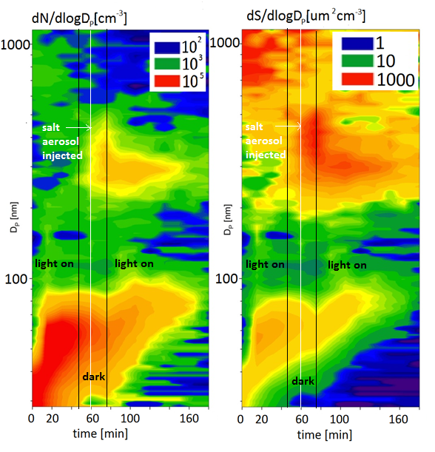
Fig. 2: Example of a measured time profile of size distribution for number density (left) and surface (right) for an experiment with α-pinene as precursor. SOA formation (5 nm-150 nm) is present from the beginning of the experiment. Salt aerosols (150 nm-1000 nm) were injected after 60 minutes. The light was switched off at 48 minutes and on again after 75 minutes, which is indicated by a change in SOA growth rate.

Results and discussion
In this section the results of each experiment will be discussed including the respective model studies. The experiments will be referred to using the following names: ‘blank’, where salt was present but no SOA precursor was added, and ‘cat’, ‘gua’ and ‘alph’ for experiments with catechol, guaiacol and α-pinene added, respectively.

Implementation of aerosol size distributions
Although salt aerosol was injected into the chamber using the same method, significant differences were observed in different experiments regarding the aerosol size distribution, which is shown in figure 3. The method itself, using an ultrasonic nebulizer, might cause some variability, as well as the presence of SOA in the chamber.[] Within the current study it was not possible to quantify the effect of SOA on the salt aerosol size distribution, which leaves some uncertainties. However, we monitored the size distribution of the salt aerosols and included this in the respective model runs, as described in the following.
In the MISTRA model, the salt aerosols are implemented using a lognormal size distribution (equation (1)). Therefore, a log normal fit was applied to the measured size distributions from all experiments, and the parameters were adapted in the model. The measured size distributions show two main modes, the SOA (fine mode, ~20-200nm) and salt aerosols (coarse mode, ~200-1000nm, depending on the minimum between fine and coarse mode). To capture only the salt aerosols from the experiments where SOA was present, the SOA (fine) mode was excluded from the fit. The fit was only applied for the coarse mode particles, as indicated in figure 3.

Analysis of blank experiment
For the first experiment named ‘blank’ (see table 1), no SOA was added (addition of SOA precursors in step 1 was skipped). This experiment was used to verify the model performance without adding any organics and to estimate the halogen activation in a blank chamber.
Figure 4 shows measured ozone, BrO and OClO together with the respective modelled time profiles of the blank experiment. Modelled total inorganic chlorine and total inorganic bromine, as well as the main contributing halogen species are shown. Acid displacement of HCl, as a main source of gas-phase chlorine species, takes place already in the dark. In the dark, the model predicts bromine activation through the reaction between N₂O₅ (formed from NO₃ and NO₂ in the dark) and NaBr in the aerosol, yielding BrNO₂ in the gas phase, followed by rapid photolysis to produce Br as proposed previously.^{[14]} After the light has been switched on for 20 minutes, the model predicts a rapid increase of BrO by the bromine explosion. BrO dominates total bromine, with minor contributions from HOBr and Br₂. Once an equilibrium between uptake of HOBr and release of Br₂ is reached (i.e., most of Br⁻ from the aerosol is released), HOBr is the main bromine species, according to the model. Initial formation of Br₂ is favoured over formation of BrCl and Cl₂, which is linked to the simulated pH in the aerosol, increasing from 4 to 7.5.^{[15]}
Formation of reactive chlorine species starts later at about 20-25 minutes after the light was switched on. The model does not describe the temporal evolution of OClO very well, but both, model and measurement, show a maximum around 100ppt. However, OClO measurements are very close to the mean detection limit of 80 ppt during this experiment. Ozone depletion is faster in the experiment than in the model, which might be due to differences in chlorine chemistry.
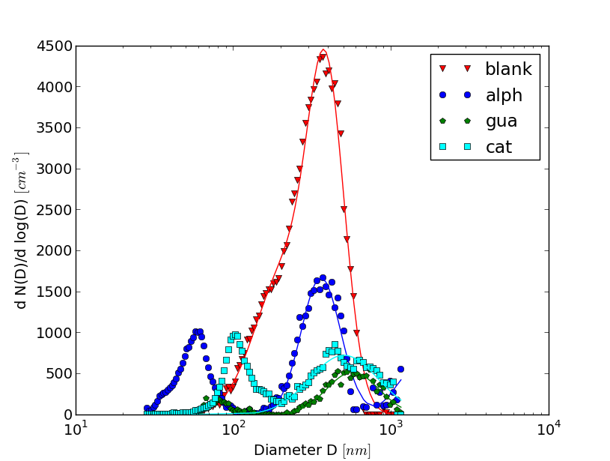
Figure 3: Initial (at model start) particle size distributions used in the model for the experiments: blank (without SOA, red triangles), alph (with α-pinene as precursor, blue circles), gua (with guaiacol as precursor, green hexagons) and cat (with catechol as precursor, cyan rectangles) including salt aerosol and SOA. The line indicates the lognormal fit including only the salt aerosol (coarse) modes (a superposition of two lognormal distributions was used).

For the model data without addition of SOA, a linear rate of increase in BrO mixing ratio was estimated from the maximum BrO mixing ratio and the time at which this maximum was reached. The maximum BrO mixing ratio and the time of the maximum agree very well between the model and the experiment. This will be referred to as BrO production rate $\frac{{d BrO}_{0,model}}{dt}$ in the following, and is 0.46 ppt/s for the blank experiment. The same procedure was followed for each model run without organics, using only the salt aerosol mode of the measured size distributions for each experiment. This is an estimate of the formation of BrO without organics over time, where the BrO production rate $\frac{{d BrO}_{0,model}}{dt}$ was obtained from the model.
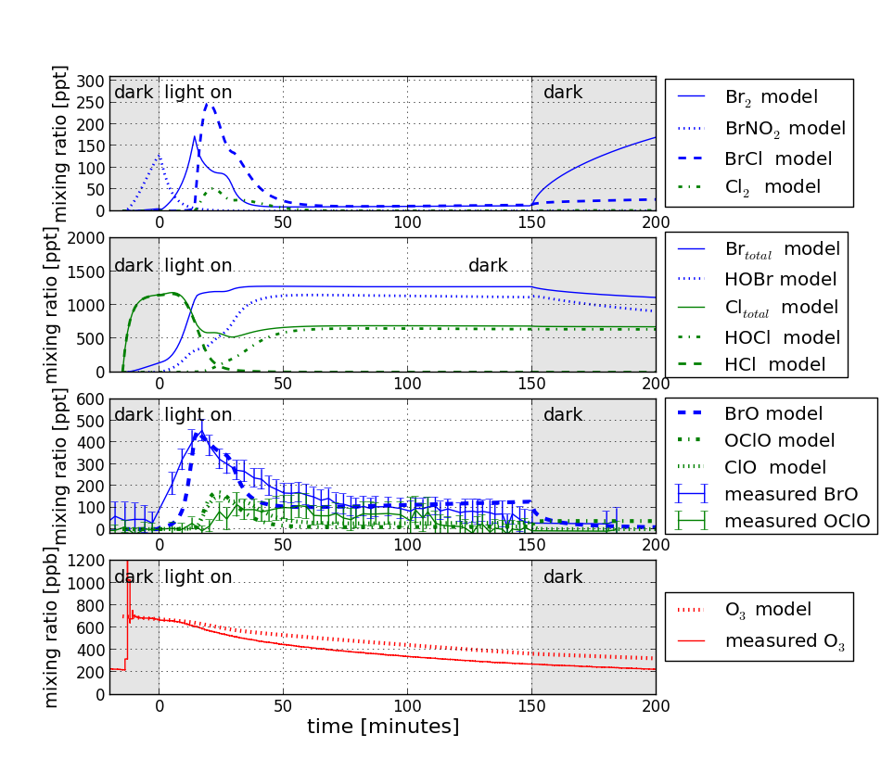
Figure 4: Time profiles of bromine and chlorine species for the blank experiment (without SOA). The solar simulator was switched on at t=0 minutes and switched off at t=150 minutes in the experiment as well as the model. The model represents the maximal BrO mixing ratio very well. The initial slope of BrO increase is slightly faster as compared to the model. The O₃ decrease is slower in the model, most likely caused by differences in chlorine (OClO). As shown in figure 4, the performance of the model in the blank experiment was very close to the observation, and the BrO maximum height and timing were captured exactly by the model. Therefore, we assume the model to be accurate in estimating the BrO production rate in absence of SOA.

Effective BrO loss rate in presence of SOA
The BrO production rate in the presence of SOA was measured and follows the expression:

$\frac{d BrO_{ measured}}{d t}= \frac{{d BrO}_{0,model}}{dt}+ BrO loss rate$ (2)

The BrO loss rate due to SOA for the different experiments is then analyzed. The experiments do not directly reveal information about the mechanism of BrO loss, which will be discussed later. Hence, the BrO loss rate discussed here is an effective loss rate due to SOA and possibly precursor species. During the experiments where the organic precursors were added, formaldehyde (HCHO) was detected by the White (DOAS) system. As Br reacts with HCHO at a reaction rates of 1.1 × 10⁻¹¹ cm³molecule⁻¹s⁻¹ [] at 293K, different HCHO amounts (comparable to the detected amounts, within the uncertainty of the DOAS) were added in the model. Similarly, higher aldehydes can also be formed from gas-phase precursors. A potential impact from this was also tested via model sensitivity studies by adding ALD2 (sum of higher aldehydes, assuming a mean reaction rate of 3.8 × 10⁻¹² cm³molecule⁻¹s⁻¹ with Br at 293K ^{[30]}). Results from the sensitivity studies are summarized in tables 2-4.
To include the BrO loss rate due to SOA in the model, an apparent first order loss of BrO from the gas phase by a heterogeneous process was used:

$BrO loss rate=\frac{d[BrO]}{dt} = -k_{r} [BrO]_{g }$= -γ_{eff} $\frac{c}{4} [SS][BrO]_{g }$ (3)

c is the mean thermal velocity of BrO~273 m s⁻¹ and γ_{eff} denotes the effective uptake coefficient. The final effective uptake coefficients are presented in table 5, based on the experiments and model presented in figures 5-7 and described in the next paragraph. The effective BrO loss rate reflects the loss of Br_{x}. This is because bromine release and ozone destruction are involved in a catalytic recycling mechanism, as shown in figure 1.
The uptake coefficient is defined as the net probability that a molecule, undergoing a gas-kinetic collision with a specific surface [SS] (i.e. surface area of the aerosol phase per volume of gas phase (cm⁻¹) = SOAS (SOA surface)), is actually taken up by the surface. In the present study, γ_{eff} is introduced and represents the probability that BrO is lost from the gas phase. This might be caused by the combination of several loss processes: (i) collision, reaction and/or uptake of Br_{x} with the SOA surface, (ii) reaction of Br species with the SOA precursor or products of the SOA precursor’s oxidation in the gas phase (iii) effect of coating of salt aerosol by organics.^{[6]} Wall loss of Br_{x} is assumed to play a minor role, given the very good agreement with the model and the blank experiment as mentioned above. Since we measured the BrO mixing ratio directly, as well as the SOA concentration, and calculated an ‘effective’ loss rate, we account for all effects where BrO might be lost. Using equation (2) and [BrO]_{max} as the maximal concentration of BrO in the gas phase, the first order rate coefficient k_{r} of the heterogeneous loss reaction was calculated. This coefficient was used to implement the reaction of BrO loss into the model, parameterizing the process as a first-order reaction similar to the wall-reaction mechanism. Using the total surface area of the SOA aerosol mode from the measurements, γ_{eff} was calculated (see table 2). This is the most widely used approach to describe the kinetics of a heterogeneous process[] and thus can be applied to atmospheric chemistry models in general.

Analysis of α-pinene experiment
In the following, the model sensitivity tests for the ‘alph’ experiment are described. Model runs without and with loss of BrO due to SOA are indicated as ‘wol’ and ‘wl’, respectively. As mentioned above, process (i) does include loss of Br_{x} on SOA. In order to test the possible loss of Br, HOBr or BrONO₂, we included the loss of those species instead of BrO loss in the model. The difference between these four model runs (loss of BrO, Br, HOBr or BrONO₂) was minor, confirming that the coupling between these species is very fast. This is in agreement with our assumption to represent the total Br_{x} loss by the loss of BrO.In addition to the parameterization of all losses to process (i), we tried to estimate the contributions of the two other possible loss processes (ii) and (iii) as described in the following. (ii) We included reactions of the precursor α-pinene with ozone (k=8.70x10⁻¹⁷ cm³molecule⁻¹s⁻¹) and Br atoms (k=2.2x10⁻¹¹ cm³molecule⁻¹s⁻¹), respectively. This did not lead to any significant differences in the concentrations of bromine-species, especially BrO. To our knowledge, no reaction rates for catechol or guaiacol have been published, but since the effect is likely to be minor as well, we are confident in neglecting this effect. The sensitivity to addition of gas phase HCHO was tested as well. The maximal BrO of 860 ppb in the ‘alph wol’ model run was reduced to 220 ppt, 200 ppt or 140 ppt for 10 ppb, 20 ppb or 30 ppb of HCHO, respectively. The addition of a heterogeneous loss rate of 0.001 s⁻¹ for BrO on SOA reduced the BrO maximum to 530 ppt. Including 20 ppb HCHO (in agreement with the DOAS measurement) and a BrO loss rate of 0.001 s⁻¹ shows the best agreement with the detected BrO. (iii) Uptake coefficients of all species, including NO_{x}, are multiplied by 0.1, 0.2 and 0.5 to mimic an organic surface coating on salt aerosols, as described in the literature before.^{[6]} Overall, the decrease of uptake coefficients led to about 0.1, 0.15 and 0.2 of the maximal model BrO mixing ratio (alph wol) and a delay of the bromine and chlorine activation by about 20, 10 and 5 minutes (see table 2). Additionally, less BrO caused slower ozone consumption. This means the agreement with the experiment would be worse as compared to case (i). We conclude that the impact of a potential organic coating on sea salt aerosol by SOA-precursors is minor compared to process (i). However, this possibility cannot be ruled out nor quantified in the current study.
Figure 5 shows the model and measured results of experiment ‘alph’. Without including a BrO loss rate (wol), the model calculated that up to 850 ppt BrO would be released from the salt particles, in contrast to up to 190 ppt detected in the presence of SOA during the experiment. This maximum value is in good agreement with the model including a BrO loss rate (wl) of 0.001s⁻¹, which leads to a γ_{eff} of 0.01. The time profile and the total released BrO amount (as well as OClO) was not captured by the model very well. Another difference between the model and the experiments is the slower ozone consumption in the model wl as compared to the measurement. The rate of ozone destruction is influenced by reaction with α-pinene and BrO self-reaction, both included in the model. Chlorine chemistry also leads to fast ozone destruction, which might explain the difference between the model and experiment. In the model wol, ozone is consumed within 50 minutes by BrO, and therefore total bromine is mainly present in the form of Br atoms. The pH in the aqueous phase aerosols stays around 4 in the ‘wol’ case and increases up to 12 in the ‘wl’ case (not shown here). The main difference is the fast ozone consumption for the ‘wol’ model run. Once ozone is totally depleted (in the model) the bromine explosion mechanism is interrupted and no more acid is consumed from the gas phase. In the ‘alph wl’ model run, the acids HNO₃, HCl and HBr are depleted from the aqueous phase by the bromine explosion mechanism within 25 minutes after the light is switched on leading to the predicted strong rise in pH. However, the actual pH in the sea salt is one key area of uncertainty. Direct measurements of aerosol pH are rare and difficult to obtain.
As shown in figure 4, chlorine is mainly released in form of BrCl by uptake of HOBr in the aerosol. Once formation of HOBr stopped due to lack of the precursors BrO and HO₂, no BrCl can be released to the gas phase. A significant amount of OClO of up to 170 ppt is formed in the presence of SOA, which cannot be reproduced by the model. This might be due to an unknown chlorine activation mechanism. It was shown previously that organic acids could lead to chlorine depletion in aerosols.[] Including carboxylic acids (ROOH, with R being an organic moiety) in the model, even lower OClO levels were predicted, as chlorine reacts quickly with organic compounds. Since chlorine was not the main focus of this work, and due to the lack of additional measurements, there is currently no explanation for the observed OClO in the presence of organics.
However, the important result from this study is the initial rate of BrO formation, which is in reasonable agreement between the model and experiment.

Analysis of catechol experiment
In a sensitivity study for the ‘cat’ experiment (summarized in table 3), the HCHO mixing ratio was varied in the model in order to assess the influence of HCHO on the BrO time series. The initial maximum BrO is reduced significantly by addition of HCHO of 10, 15 and 20 ppb from 570 ppt BrO (wol) to 260, 150 and 143 ppt, respectively. After HCHO is consumed, the BrO mixing ratio increased again (after ~50minutes), which does not agree with the observation (see BrO at t=light off in table 3). Addition of higher aldehydes reduces the maximum BrO, as well as the BrO mixing ratio after 50 minutes drastically. The addition of heterogeneous BrO loss on SOA alone does not affect the maximum BrO as drastically as HCHO however, it reduces the further increase of BrO after 50 minutes, in agreement with the observation. OClO formation is influenced more drastically by the addition of HCHO than by the BrO loss rate. OClO is generally underestimated by a factor of 3-15 by the model as compared to the observation. Simulating organic coating of the aerosol by multiplying all uptake coefficients by 0.1, 0.2 and 0.5 reduces the maximum BrO mixing ratio to 170 ppt, 300 ppt and 470 ppt, respectively. The simulation of organic coating leads to a time delay of the maximum BrO, which is not in agreement with the observations. Reducing the uptake coefficients of species containing Br and Cl only has a similar effect. Including a Br or BrONO₂ loss instead of BrO loss of 0.001 s⁻¹ would show good agreement with the maximum BrO in timing and magnitude but over predicts the BrO mixing ratio at t=light off. Heterogeneous loss of HOBr decreases the BrO maximum as well as reducing the total amount of BrO activated to the gas phase. The reduced BrO formation in the experiment by addition of SOA could be caused by a combination of loss of bromine-containing Br. With the current set of experiments, it is not possible to assess the contribution of each process, and a parameterization assuming heterogeneous BrO loss seems appropriate. In fact, a BrO loss rate of 0.001 s⁻¹ and an initial mixing ratio HCHO of 10 ppb showed the best agreement with the experimental observations for the ‘cat’ experiment, as shown in figure 6. 200 ppt of BrO were observed, and the model wl describes the measured time profile very well. Without an additional BrO loss rate, up to 570 ppt BrO are predicted by the model. The pH of the aerosols is 4 at the beginning of the model run providing enough acidity (H⁺) for the conversion of HOBr to Br₂ within the bromine explosion mechanism.^{[15]} Once the pH rises up to 10, acidity is used up; hence no more bromine is released, which coincides with the BrO maximum in the gas phase. The BrO loss rate k_{r} of 0.001s⁻¹ included in the wl model leads to a γ_{eff} of 0.01. Another difference between the wl and wol model runs is that the model predicts formation of HBr due to reaction with HCHO in the presence of organics (wl). Chlorine activation in form of OClO is observed in the experiment but could not be reproduced by the model. This may cause faster ozone depletion in the experiment as compared to the model.

Analysis of guaiacol experiment
Variation of initial HCHO within the ‘gua’ model sensitivity study (summarized in table 4) shows reduction of the maximum BrO from 400 ppt (wol) to 230 ppt and 160 ppt, for 10 ppb 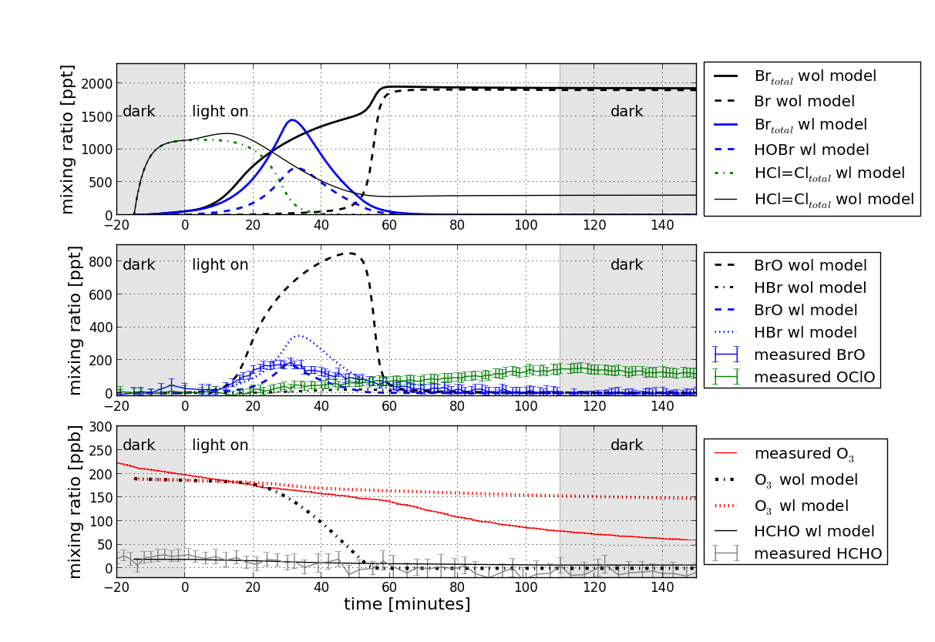
Figure 5: Time profiles measured and modeled, with and without loss rate (wl, wol) of bromine species, total chlorine, ozone and HCHO for ‘alph’ experiment with α-pinene as SOA precursor. The solar simulator was switched on at t=0 minutes and switched off at t=110 minutes in the experiment as well as in the model. The model represents the maximal BrO mixing ratio (middle) and the time profiles of HCHO (bottom) ratio reasonably well. The total amount of BrO, i.e. the integral of the BrO time profiles is underestimated in the model, mainly due to differences in ozone possibly caused by chlorine chemistry. In the model, chlorine release was mainly due to acid displacement in form of HCl (top). The model wol predicts higher HCl=Cl_{total}, due to influence of bromine chemistry, in form of BrCl release. However, significant OClO levels have been detected during the experiment, which cannot be explained by the model so far.

and 15 ppb HCHO, respectively. After HCHO is consumed, the BrO mixing ratio increases again and does not agree with the observation. Addition of 5ppb higher aldehydes, reduces overall BrO drastically. The addition of a heterogeneous BrO loss on SOA alone does not affect the maximum BrO as drastically as HCHO which decreases from 400 ppt to 310 ppt, however, it reduces further increase of BrO towards the end of the experiment, in agreement with the observation. Again, OClO is generally underestimated by a factor of 4-15 by the model as compared to the observation. All uptake coefficients were multiplied by 0.1, 0.2 and 0.5 to simulate organic coating of the aerosols, which results in a reduction of the maximum BrO mixing ratio to 110 ppt, 200 ppt and 350 ppt, respectively. The organic coating would delay the time of the maximum BrO as well, which is not in agreement with the observations.
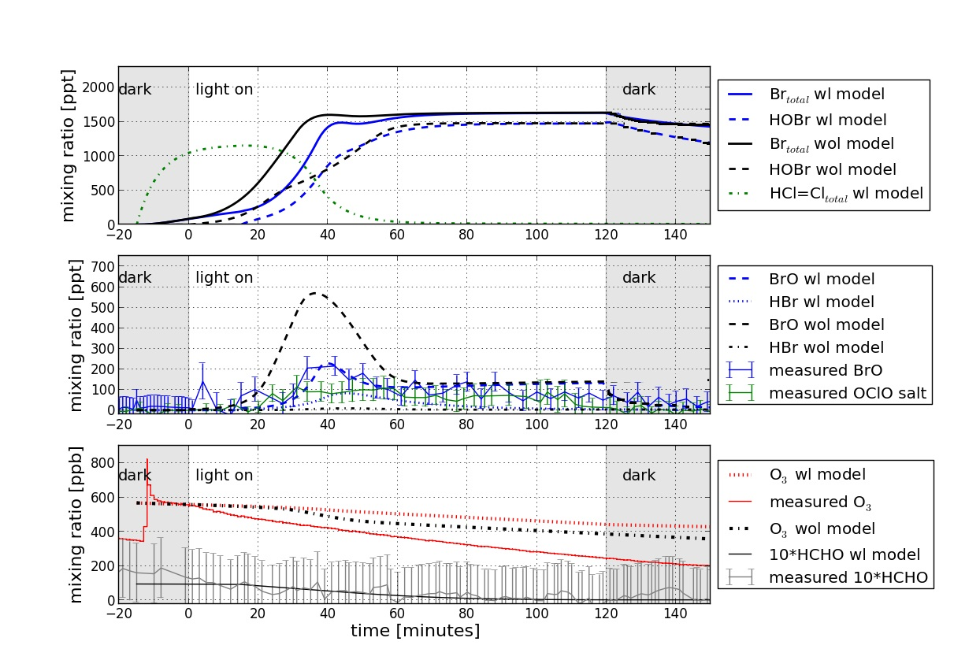
Figure 6: Time profiles of different species (measured and modeled) for cat experiment with catechol as SOA precursor. The solar simulator was switched on at t=0 minutes and switched off at t=120 minutes in the experiment as well as in the model. The model with loss rate (wl) represents the time profiles of BrO (middle) and of HCHO (bottom) very well. HCHO is multiplied by a factor of 10 in the plot for better clarity. The model shows no HBr for the model without loss rate (wol), but up to 95 ppt HBr for wl model due to reaction with HCHO. The maximum measured OClO was around 100 ppt, just above the mean detection limit of 80 ppt, whereas the model predicts no significant formation of OClO and most chlorine to be in the form of HCl (top plot).

The effect by reducing the uptake coefficients of species containing Br and Cl only is very similar. Including a loss of Br, HOBr or BrONO₂ instead of a BrO loss of 0.001 s⁻¹ over predicts the reduction of the BrO maximum. Loss of HOBr would decrease BrO at t=light off to 0 ppt, whereas loss of Br and BrONO₂ predicts 120 ppt and 80 ppt, respectively. A BrO loss rate of 0.001 s⁻¹ and 10 ppb initial HCHO showed the best agreement with the experimental observations for the ‘gua’ experiment.

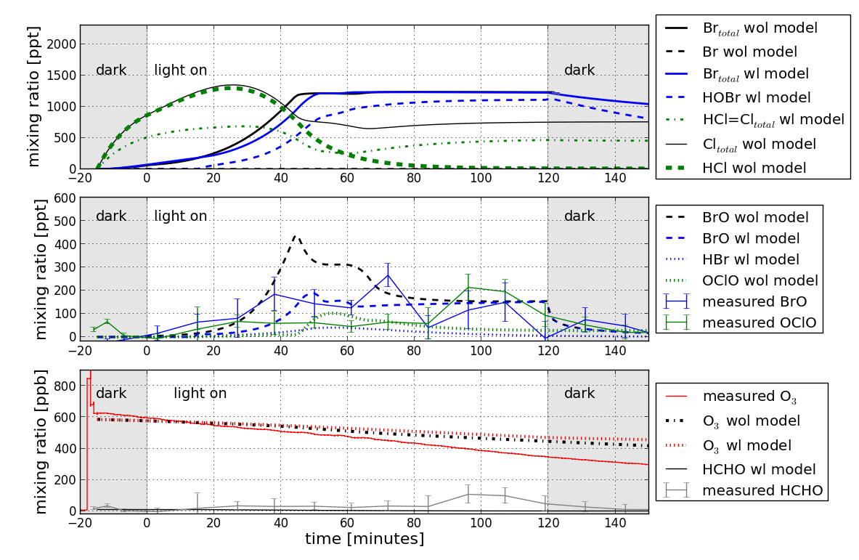

Figure 7: Time profiles of different species (measured and modeled) for ‘gua’ experiment with guaiacol as SOA precursor. The solar simulator was switched on at t=0 minutes and switched off at t=120 minutes in the experiment as well as the model. The model with loss rate (wl) represents the same order of magnitude BrO (middle) as the measurements. Minor formation of HCHO might be detected after 80 minutes of illumination, which is very close to the detection limit of 110 ppb and not confirmed by the model. Again, the model shows no HBr for the model without loss rate (wol), but up to 65 ppt HBr for wl model due to reaction with HCHO. The model wol predicts up to 100 ppt OClO, but no chlorine besides HCl wl.

The results for the ‘gua’ experiment are shown in figure 7, and show the same mean BrO mixing ratio of ~190 ppt in the wl model and experiment. In the ‘gua’ experiment, BrO has a relatively high mean detection limit of 110 ppt since the mirrors of the DOAS system were not perfectly clean (as compared to a mean detection limit of 60 ppt with clean mirrors). However, the amount of BrO detected was lower than the predicted 410 ppt maximal BrO wol-model value. The pH of the aerosols increases from 4 and reaches the maximum of 8 exactly at the same time as the BrO maximum in the gas phase is reached.
An effective BrO loss rate k_{r} of 0.001s⁻¹ has been included in the wl model, which leads to a γ_{eff} of 0.004. This is smaller as compared to ‘cat’ and ‘alph’ experiments, due to the smaller SOAS (see equation (3) and table 2).

Atmospheric implications
SOA accounts for a significant fraction of ambient tropospheric particulate matter across the globe^{[1, 2]}, both from biogenic as well as from anthropogenic sources. At the same time, sea salt aerosol is predominant in the marine area. There are several occasions where both are present at the same time, such as in the continental outflow region, in the case of oil spills over the ocean^{[29]} or in coastal regions where SOA-precursor emitting plants are present. Sea-salt aerosol is thought to be the major source for reactive halogens in the atmosphere by catalytic release mechanisms leading to gas phase Br₂ and BrCl. Here we have described the first quantitative approach to parameterize the loss rate of Br_{x} from the gas phase due to SOA. An effective uptake coefficient on the order of magnitude of ~0.01 was found, using the precursor species α-pinene, guaiacol and catechol. To estimate the significance of diminished formation of reactive bromine, an example will be given: In the Cape Verde region, organic aerosols with a mass load of total carbon between 3-0.25 μg m⁻³ were found[], which corresponds to a surface area of approximate 2.1•10⁻⁶ - 1.1•10⁻⁵ m⁻¹. For simplicity, here we neglect the fact that not all organic aerosols are SOA, and the effective uptake coefficient for other organics might vary. Using our effective uptake coefficient and a mean daytime concentration of 5 ppt BrO, between 0.1 and 2.6 ppt BrO would be lost from the gas phase within the first 5 hours of daylight. Indeed, global models predict a daytime mixing ratio of 5.7 ppt^{[12]} at Cape Verde, whereas mean BrO concentrations of 2.5 ppt are detected.[] So far the overprediction of bromine species in global models, especially BrCl and BrO (as a product through photolysis and reaction with ozone), is not explained and our current study gives one possible sink mechanism. Model implementation of our reported BrO uptake coefficient due to SOA should itself be straight forward. Of course, the reaction rate depends on the SOA surface area, which is highly uncertain. Observed and modeled SOA concentrations in the atmosphere vary by orders of magnitude.^{[2]} However, some box-model studies can explain the daily cycles of BrO at Cape Verde very well ^{[13,]} and thus do not require an additional halogen loss. The exact significance of halogen uptake on SOA can be quantified by further modelling including the uptake coefficient presented here. Overprediction of BrCl and bromine species was also reported in different regions of the tropical marine boundary layer^{[13]}, and a loss on SOA aerosols might be an explanation of the model-measurements discrepancies. The global halogen budget is important, as e.g. the contribution of halogens to ozone removal in the tropical marine troposphere was found to be ~15-30%[], which also influences the global radiation budget.

Conclusions
Several conclusions can be drawn based on the experiments and model simulations performed within this study and are summarized as follows: (1) The model reproduces all experiments with and without SOA reasonably well with respect to the BrO maxima but shows some differences in the time profiles. The model cannot reproduce the OClO concentration and predicts slower O₃ depletion than observed. Chlorine chemistry in these experiments remains poorly characterized. (2) Significant reduction of BrO formation is observed in the experiments with SOA compared to the ones without SOA. The parameterization of an effective BrO loss rate in the model results in a good agreement with the BrO observations. (3) This study provides the first quantitative estimate of an effective uptake coefficient using the SOA surface area. Although some uncertainties remain the uptake coefficient can now be implemented into other model studies. This may be a 'missing' sink of tropospheric bromine in the marine boundary layer.
Our result illustrates the importance of understanding the heterogeneous atmospheric processing of organic aerosols by reactive halogen species. These processes are relevant to climate change and radiative forcing via tropospheric ozone.

Acknowledgements
We are grateful for the financial support by the German Research Foundation (DFG) within the research unit HALOPROC (FOR 763). Roberto Sommariva and Roland von Glasow were also supported by the Natural Environment Research Council (project number NE/J022780/1). We would like to thank Natalja Balzer for useful discussions, and Joelle Buxmann thanks Rob Hall for accommodation in Norwich during work with MISTRA.

References

[] A. Saiz-Lopez, R. von Glasow, Reactive halogen chemistry in the troposphere, Chem. Soc. Rev. 2012, 41, 6448–6472.
[] M.C. Jacobson, H.-C. Hansson, K.J. Noone, R.J. Charlson, Organic atmospheric aerosols: Review and state of the science, Reviews of Geophysics 2000, 38, 8755-1209.
[] M. Hallquist, J.C. Wenger, U. Baltensperger, Y. Rudich, , D. Simpson, M. Claeys, J. Dommen, N.M. Donahue, C. George, A.H. Goldstein, J.F. Hamilton, H. Herrmann, T. Hoffmann, Y. Iinuma, M. Jang, M.E. Jenkin, J.L. Jimenez, A. Kiendler-Scharr, W. Maenhaut, G. McFiggans, Th.F. Mentel, A. Monod, A.S.H. Prévôt, J.H. Seinfeld, J.D. Surratt, R. Szmigielski, J. Wildt, The formation, properties and impact of secondary organic aerosol: current and emerging issues, Atmos. Chem. Phys. 2009, 9, 5155-5236.
[] R. Bergström, H.A.C. Denier van der Gon, A.S.H. Prévôt, K.E. Yttri, D. Simpson, Modelling of organic aerosols over Europe (2002–2007) using a volatility basis set (VBS) framework: application of different assumptions regarding the formation of secondary organic aerosol, Atmos. Chem. Phys. 2012, 12, 8499-8527.
[] I.J. George, J.P.D. Abbatt, Heterogeneous oxidation of atmospheric aerosol particles by gas-phase radicals, Nature Chem. 2010, 2, 713-722.
[] L. Smoydzin, R. von Glasow, Do organic surface films on sea salt aerosols influence atmospheric chemistry? A model study, Atmos. Chem. Phys. 2007, 21, 5555-5567.
[] T. Moise, Y. Rudich, Uptake of Cl and Br by organic surfaces – A perspective on organic aerosols processing by tropospheric oxidants, Geophys. Res. Lett. 2001, 28, 4083–4086.
[] Y. Rudich, Laboratory perspectives on the chemical transformations of organic matter in atmospheric particles, Chem. Rev. 2003, 103, 5097–5124.
[] J. Ofner, N. Balzer, J. Buxmann, H. Grothe, P. Schmitt-Kopplin, U. Platt, C. Zetzsch, Aerosol-halogen interaction: Halogenation processes of SOA, Atmos. Chem. Phys. 2012, 12, 5787-5806.
[] J. Ofner, H.-U. Krüger, H. Grothe, P. Schmitt-Kopplin, K. Whitmore, C. Zetzsch, Physicochemical characterization of SOA derived from catechol and guaiacol, Atmos. Chem. Phys. 2011, 11, 1-15.
[] J. Ofner, H.-U. Krüger, C. Zetzsch, Time Resolved Infrared Spectroscopy of Formation and Processing of Secondary Organic Aerosol, Zeitschrift für Phys. Chemie 2010, 224, 1171–1183.
[] M. S. Long, W. C. Keene, R. C. Easter, R. Sander, X. Liu, A. Kerkweg, D. Erickson, Sensitivity of tropospheric chemical composition to halogen-radical chemistry using a fully coupled size-resolved multiphase chemistry–global climate system: halogen distributions, aerosol composition, and sensitivity of climate-relevant gases, Atmos. Chem. Phys. 2014, 14, 3397-3425.
[] R. Sommariva, R. von Glasow, Multi-phase halogen chemistry in the tropical Atlantic Ocean, Env. Sci. Tech. 2012, 46, 10429-10437.
[] A. Frenzel, V. Scheer, R. Sikorski, C. George, W. Behnke, C. Zetzsch, Heterogeneous Interconversion Reactions of BrNO₂, ClNO₂, Br₂ and Cl₂, J. Phys. Chem A. 1998, 102, 1329-1337.
[] S. Fickert, J. W. Adams, J. N. Crowley, Activation of Br₂ and BrCl via uptake of HOBr onto aqueous salt solutions, J. Geophys. Res. 1999, 104, 23719.
[] U. Platt, C. Janssen, Observation and role of the free radicals NO₃, ClO, BrO and IO in the troposphere, Faraday Discuss. Chem. Soc. 1996, 100, 175-198.
[] J. Ofner, K.A. Kamilli, A. Held, B. Lendl, C. Zetzsch, Halogen-induced organic aerosol (XOA): a study on ultra-fine particle formation and time-resolved chemical characterization, Faraday Discuss. 2013, 161, 135–149.
[] S. Bleicher, J. C. Buxmann, R. Sander, T. P. Riedel, J. A Thornton, U. Platt, C. Zetzsch, The influence of nitrogen oxides on the activation of bromide and chloride in salt aerosol, Atmos. Chem. Phys. Discuss. 2014, 14, 10135-10166.
[] S. Bleicher, Zur Halogenaktivierung im deliqueszenten Aerosol und in Salzpfannen, Ph.D. thesis University of Bayreuth, Germany, 2012.
[] J. Buxmann, N. Balzer, S. Bleicher, U. Platt, C. Zetzsch, Observations of bromine explosions in smog chamber experiments above a model salt pan, Int. J. Chem. Kinet. 2012, 44, 312.
[] J. Buxmann, Bromine and Chlorine Explosion in a Simulated Atmosphere, Ph.D. thesis, University of Heidelberg, Germany, 2012.
[] Z. Sirkes, F. Schirmer, H.-H. Essen, K.-W. Gurgel, Surface currents and seiches in the Dead Sea. The Dead Sea: The Lake and Its Setting, edited by: T. Niemi, Z. Ben-Avrahem, J. Gat, Oxford Monogr. Geol. Geophys. 1997, 36, 104-113.
[] S. Gao, M. Keywood, Nga L. Ng, J. Surratt, V. Varutbangkul, R. Bahreini, R. C. Flagan, J. H. Seinfeld, Low-Molecular-Weight and Oligomeric Components in Secondary Organic Aerosol from the Ozonolysis of Cycloalkenes and α-Pinene, J. Phys. Chem. A 2004, 108, 10147-10164.
[] U. Baltensperger, M. Kalberer J. Dommen, D. Paulsen, M. R. Alfarra,H. Coe, R. Fisseha,A. Gascho,M. Gysel, S. Nyeki,M. Sax, M. Steinbacher,A. S. H. Prevot, S. Sjogren, E. Weingartner, R. Zenobi, Secondary organic aerosols from anthropogenic and biogenic Precursors, Faraday Discuss. 2005, 130, 265–278.
[] Mechanism of the Aerobic Oxidation of a-Pinene U. Neuenschwander, F. Guignard, I. Hermans, ChemSusChem, 2010 3, 75–84
[] J. H. Kroll, J. H. Seinfeld, Chemistry of secondary organic aerosol: Formation and evolution of low-volatility organics in the atmosphere, Atmospheric Environment 2008, 42 , 3593–3624.
[] R. von Glasow, R. Sander, A. Bott, P. J. Crutzen, Modeling halogen chemistry in the marine boundary layer 1. Cloud-free MBL, J. Geophys. Res. 2002, 107, 4341.
[] A. Presto , K . Huffhartz , N. Donahue, Secondary Organic Aerosol Production from Terpene Ozonolysis.2. Effect of NOx Concentration, Environ. Sci. Technol. 2005, 39, 7046-7054.
[] R. Beardsley, M. Jang, B. Ori, Y. Im, C. A. Delcomyn, N. Witherspoon, Role of sea salt aerosols in the formation of aromatic secondary organic aerosol: yields and hygroscopic properties, Environmental Chemistry 2013, 10(3), 167-177.
[ ] R. Atkinson, D. L. Baulch, R. A. Cox, J. N. Crowley, R. F. Hampson, R. G. Hynes, M. E. Jenkin, M. J. Rossi, J. Troe, Evaluated kinetic and photochemical data for atmospheric chemistry: Volume III – gas phase reactions of inorganic halogens, Atmos. Chem. Phys., 2007,7, 981-1191.
[] M. Ammann, R. A. Cox, J. N. Crowley, M. E. Jenkin, A. Mellouki, M. J. Rossi, J. Troe, T. J. Wallington, Evaluated kinetic and photochemical data for atmospheric chemistry: Volume VI – heterogeneous reactions with liquid substrates, Atmos. Chem. Phys. 2013, 13, 8045-8228.
[] S. Ghorai, B. Wang, A. Tivanski, A. Laskin, Hygroscopic Properties of Internally Mixed Particles Composed of NaCl and Water-Soluble Organic Acids, Environ. Sci. Technol. 2014, 48, 2234–2241.
[] K. Müller, S. Lehmann, D. van Pinxteren, T. Gnauk, N. Niedermeier, A. Wiedensohler, H. Herrmann, Particle characterization at the Cape Verde atmospheric observatory during the 2007 RHaMBLe intensive, Atmos. Chem. Phys. 2010, 10, 2709-2721.
[] K. A. Read, A. S. Mahajan, L. J. Carpenter, M. J. Evans, B. V. E. Faria, D. E. Heard, J. R. Hopkins, J. D. Lee, S. J. Moller, A. C. Lewis, L. Mendes, J. B. McQuaid, H. Oetjen, A. Saiz-Lopez, M. J. Pilling, J. M. C. Plane, Extensive halogen mediated ozone destruction over the tropical Atlantic Ocean, Nature. 2008, 453, 1232–1235.
[] A. S. Mahajan, J. M. C. Plane, H. Oetjen, L. Mendes, R. W. Saunders, A. Saiz-Lopez, C. E. Jones, L. J. Carpenter, G. B. McFiggans, Measurement and modelling of tropospheric reactive halogen species over the tropical Atlantic Ocean, Atmos. Chem. Phys. 2010, 10, 4611-4624.
[] A. Saiz-Lopez, J.-F. Lamarque, D. E. Kinnison, S. Tilmes, C. Ordóñez, J. J. Orlando, A. J. Conley, J. M. C. Plane, A. S. Mahajan, G. Sousa Santos, E. L. Atlas, D. R. Blake, S. P. Sander, S. Schauffler, A. M. Thompson, G. Brasseur, Estimating the climate significance of halogen-driven ozone loss in the tropical marine troposphere, Atmos. Chem. Phys. 2012, 12, 3939-3949. Table 1. Smog chamber experimental conditions All experiments were carried out between 292K and 297 K and 60-70% RH; Different amounts of ozone, salt aerosol and SOA precursors were added. NO and NO₂ were below 0.7 ppb in all experiments. The error of the initial formation rate of BrO is based on the measurement error of BrO from the DOAS system. Experiment SAS ^{A} [μm²cm⁻³] SOA volume [μm³cm⁻³] (mass yield) ^{B} Precursor Amount [mg] /concentration [ppb] O₃₀ [ppb] HCHO [ppb] $$\frac{d [BrO]_{ 0,measured}}{d t}$$ blank 7420 -- 0 670 0±15 0.46±0.02 ppt s⁻¹ cat 2540 80 (24%) 1.6mg ~100ppb 600 10±15 0.08±0.03 ppt s⁻¹ gua 1650 25 (7%) 1.8mg ~100ppb 620 10±20 0.1±0.05 ppt s⁻¹ alph 3500 35 (13%) 1.3mg ~100ppb 200 20±15 0.11±0.03 ppt s⁻¹ ^{A} SAS is the total salt surface area of the salt aerosols. The total SOA surface area is given in table 2, since it was used to calculate the uptake coefficient, as described in the text. ^{B} The surface and volume were obtained using the size distributions and assuming a spherical shape. SOA mass yields are calculated using a mean SOA density of 1.4g cm⁻³, a recommended value to use in the absence of direct measurements ^{[2]}. Table 2. Model sensitivity study for ‘alph’ experiment The model was set to 293 K and 60% RH. NO and NO₂ mixing ratios were set to 0.6 ppb each, HNO₃ was 1.2 ppb in all experiments, and initial ozone concentration was 200 ppb. The model runs in bold are shown in figure 5. Exp. Name HCHO₀ [ppb] k_{r} [s⁻¹] BrO_{max} [ppt] BrO_{max} time [min] BrO _{t=light off} [ppt] α-pinene [ppb] alph measurement 20±15 -- 185±25 30 0±25 ~87 alph wol 0 -- 850 50 0 - alph HCHO10 10 -- 220 30 0 - alph HCHO20 alphHCHO20ALD5 20 20 -- -- 200 170 30 40 0 0 - ^{H} alph HCHO30 30 -- 140 30 0 - alph wl no HCHO 0 0.001^{A} 530 40 20 - alph wl1HCHO10 10 0.001^{A} 330 30 0 - alph wl alph wl1 H20 ALD5 20 20 0.001^{A} 0.001^{A} 190 140 30 40 0 0 87 ^{H} alph wl1 HCHO20_{N}A 20 0.001^{A} 190 30 0 - alph wl10 HCHO20 20 0.01 ^{A} 120 30 0 - alph wl Br 20 0.001^{B} 190 30 0 87 alph wl HOBr 20 0.001^{C} 190 30 0 87 alph wl BrONO2 20 0.001^{D} 185 30 0 87 alph org 0.1 20 ^{E} 0.1 86 35 0 87 alph org 0.2 20 ^{E} 0.2 130 45 0 87 alph org 0.5 20 ^{E} 0.5 170 48 0 87 alph up Br 20 _{F} 110 60 0 87 alph up Cl 20 _{G} 100 35 0 87 ^{A}Loss rate of BrO is included in the model. ^{B}Loss rate of Br is included in the model. ^{C} Loss rate of HOBr is included in the model. ^{D} Loss rate of BrONO₂ is included in the model. ^{E} Uptake coefficients on sea salt are multiplied by the stated numbers for all species. _{F} Uptake coefficients on sea salt are multiplied by 0.1 for all species containing Br. _{G} Uptake coefficients on sea salt are multiplied by 0.1 for all species containing Cl. ^{H} 5 ppb of higher aldehydes are added. Table 3. Model sensitivity study for ‘cat’ experiment The model was set to 293 K and 60% RH. NO and NO₂ mixing ratios were set to 0.6 ppb each, HNO₃ was 1.2 ppb in all experiments, and initial ozone concentration was 600 ppb. The model runs in bold are shown in figure 6. Exp. name HCHO₀ [ppb] k_{r} ^{B} [s⁻¹] [BrO]_{max} [ppt] BrO_{max} time [min] [BrO]_{t=light off} [ppt] cat meas 10±15 -- 215±40 30 50±40 cat wol (blank) 0 -- 570 30 140 cat HCHO10 cat H10ALD5 10 10 -- 260 150 30 30 130 60 ^{H} cat HCHO15 15 -- 185 30 135 cat HCHO20 20 -- 143 30 140 cat wl noHCHO 0 0.001^{A} 440 30 60 cat wl cat wl H10ALD5 10 10 0.001^{A} 0.001^{A} 220 140 30 30 60 30 ^{H} cat wl1 HCHO15 15 0.001^{A} 170 30 80 catwl10HCHO10 10 0.01^{A} 100 40 0 cat wl Br 10 0.001^{B} 250 30 120 cat wl HOBr cat wl BrONO2 10 10 0.001^{C} 0.001^{D} 190 220 35 35 0 70 cat org0.1 10 ^{E}0.1 170 65 85 cat org0.2 cat org 0.5 10 10 ^{E}0.2 ^{E}0.5 300 470 50 40 100 100 cat up Br cat up Cl 10 10 ^{F} ^{G} 400 200 65 30 100 100 ^{A}Loss rate of BrO is included in the model. ^{B}Loss rate of Br is included in the model. ^{C} Loss rate of HOBr is included in the model. ^{D} Loss rate of BrONO₂ is included in the model. ^{E} Uptake coefficients on sea salt are multiplied by the stated numbers for all species. ^{F} Uptake coefficients on sea salt are multiplied by 0.1 for all species containing Br. ^{G} Uptake coefficients on sea salt are multiplied by 0.1 for all species containing Cl. ^{H} 5 ppb of higher aldehydes are added. Table 4. Model sensitivity study for ‘gua’ experiment The model was set to 293 K and 60% RH. NO and NO₂ mixing ratios were set to 0.6 ppb each, HNO₃ was 1.2 ppb in all experiments, and initial ozone concentration was 620 ppb. The model runs in bold are shown in figure 7. HCHO₀ [ppb] k_{r} ^{B} [s⁻¹] [BrO]_{max} [ppt] BrO_{max} time [min] [BrO]_{t=light off} [ppt] gua measurement 10±15 -- 250±60 60 40±40 gua wol (blank) 0 -- 400 40 110 gua HCHO10 guaH10ALD5 10 10 -- -- 230 100 40 60 112 40 ^{H} gua HCHO15 15 -- 160 40 112 gua wl1 0 0.001 310 40 60 guawl guawl1H10ALD5 10 10 0.001 0.001 195 100 60 55 70 60 ^{H} guawl2 HCHO10 10 0.002 120 40 50 gua wl Br 10 0.001^{B} 200 50 120 gua wl HOBr gua wl BrONO2 10 10 0.001^{C} 0.001^{D} 150 170 60 60 0 80 gua org 0.1 gua org 0.2 gua org 0.5 gua up Br 10 10 10 10 ^{E} 0.1 ^{E} 0.2 ^{E} 0.5 ^{F} 110 200 350 250 85 80 60 80 100 100 100 100 gua up Cl 10 ^{G} 130 50 100 ^{A}Loss rate of BrO is included in the model. ^{B}Loss rate of Br is included in the model. ^{C} Loss rate of HOBr is included in the model. ^{D} Loss rate of BrONO₂ is included in the model. ^{E} Uptake coefficients on sea salt are multiplied by the stated numbers for all species. ^{F} Uptake coefficients on sea salt are multiplied by 0.1 for all species containing Br. ^{G} Uptake coefficients on sea salt are multiplied by times 0.1 for all species containing Cl. ^{H} 5 ppb of higher aldehydes are added. Table 5. Overview of model parameters and results The model was set to 293 K and 60% RH. NO and NO₂ mixing ratios were set to 0.6 ppb, respectively and HNO₃ was 1.2 ppb in all experiments. Parameters and results (bold) are given for model runs without loss (wol) rate and with loss (wl) rate of BrO due to SOA. Only in experiments with loss rate, indicated by ‘wl’, an additional loss reaction was included in the model. Exp. name O₃ [ppb] HCHO [ppb] SOAS ^{A} [μm²cm⁻³] $$\frac{{d [BrO]}_{0,model}}{dt}$$ [BrO]_{max} [ppt] k_{r} ^{B} [s⁻¹] γ_{eff} ^{C} blank 670 0 -- 0.46 ppt s⁻¹ 450 -- -- cat wol 600 0 420 0.27ppt s⁻¹ 570 -- -- cat wl 600 19 420 0.08 ppt s⁻¹ 200 0.001 0.01 gua wol 620 0 140 0.22 ppt s⁻¹ 410 -- -- gua wl 620 10 140 0.1 ppt s⁻¹ 190 0.001 0.004 alph wol 190 0 450 0.3 ppt s⁻¹ 850 -- -- alph wl 190 10 450 0.11 ppt s⁻¹ 190 0.001 0.01 ^{A} SOAS is the total SOA surface area used as [SS]. ^{B} k_{r} is the first order loss rate, as introduced in equation (3). ^{C} Effective uptake coefficient γ_{eff} obtained from k_{r} and SOAS.

