Community, conflict and continuity between Kulmhof and the Kresy’: Mapping Landscape and
Memory in east-Central Europe, 1918 – 1938.
‘Living plants grow naturally, that is, both freely and according to their own laws, not laws amenable to rational plans; they grow like branchy trees whose roots are hidden in the depths of the national soil and subsoil.’ Lev Kopelev, ‘The Education of a True Believer.’

‘First…the Idols of the Tribe, which “have their foundation in human nature itself, and in the tribe of race of men…and the human understanding is like a false mirror, which receiving rays irregularly, distorts and discolours the nature of things…”; the second…the Idols of the Cave… “For everyone (beside the errors common to human nature in general) has a cave or den of his own…Owing either to his own proper and peculiar nature; to his education and conversation with others; or to the reading of books, and the authorities of those whom he esteems and admires…” The Third…the Idols of the Market Place. “For it is by discourse that men associate…and therefore the ill and unfit choice of words wonderfully obstruct the understanding. Nor do the definitions or explanations wherewith in some learned men are want to guard and defend themselves, by any means set the matter right.” Fourthly, the Idols of the Theatre. These are “Idols which have immigrated into men’s minds from the various dogmas of philosophers, and also from wrong laws of demonstration…all the received systems are but so many stage plays, representing worlds of their own creation after an unreal and scenic fashion.” Francis Bacon. I
Making Opposition to the West: Introduction and background.
In recent years, many prominent European politicians have exalted both the diversity of their peoples, and the international power that closer economic, political and social ‘cohesion’ provides, as well as a platform towards further global understanding. Essentially, Europeans having shattered themselves over the preceding centuries - because of the wealth that their local environment supports - simultaneously laying claim to each others ‘gardens’ and alternately forging pitchforks or swords (as instruments of their own betterment) have wisely accepted that, not only does unity serve to increase their own wealth, overseas adventures (whilst misplaced) are, nonetheless, to be seen as an internationalist approach to foreign relations, which include an ‘improvement’ in less advanced societies, only to willing to accept European advice and material support for their own betterment. Leon Brittan, a British Conservative on the left (one of Mrs Thatcher’s “Wets”), illustrates the centrist approach, commenting that, ‘[i]f for example Europe is to exploit more open world markets to the full, governments must jointly develop domestic policies that give European industry the suppleness to fight against awesome competition abroad, notably from South-east Asia.’ Exploitation, war and scale are the key points – it’s an expansionist approach to world problems which Europeans have utilised to the full, only coming ‘unstuck’ when internal tensions have weakened individual, overseas, ‘aggressor’ nation states. Continental scale rational planning provides a structure within which the ‘nation states’ can be neutered, providing for future prosperity predicated upon international expansion. The ‘Soviet Union’ and the ‘United Kingdom’, amongst others, suggest that these are not new ideas. In fact they are as old as the Apennines and equally shaky, and none more so than in Eastern Europe. Closer cooperation is essential – but the means by which this can be achieved need far closer examination.
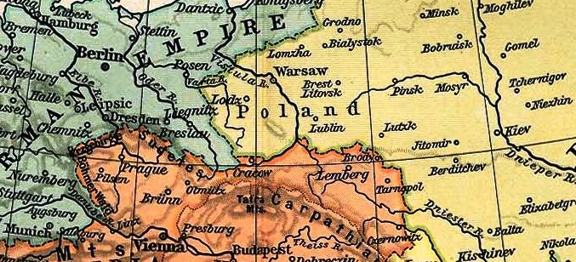
Fig. 1 The ‘Shatter Belt’ within the ‘Dreikaiserbund’ circa. 1910.
This dissertation however, will concentrate upon Europe’s ‘shatter zone’ (Fig. 1), a broad sweep of east-Central European lands stretching, in a loose rectangular arch, from Posen/Poznan and Pilsen in the west, to Bialystok and Lemberg/Lviv/Lvov/Lwow in the east - allowing for some ‘frontier outrages’ where necessary. Significantly, after 1938 the ‘marshy parts of Russia’ provided the sites for ‘annihilation’ on a scale that was not seen in other parts of Central Europe. As far back as the thirteenth century, Teutonic Knights were given Chelmno/Kulmhof as a base with which to perform their “Christian duty” against their ‘Slavic neighbours’, and this vast sweep of the great North European Plain has enticed ‘bloodthirsty, sadistic and unscrupulous invaders’ from across Eurasia. The Battle of Grunewald (1410) - modern Germanys ‘Tannenberg’ - served to ‘sew dragon’s teeth’, encouraging further ‘Drang nach Osten.’ Yet curiously the area was known as a ‘haven for Europe’s religiously persecuted’, and Central Europe was particularly multi-ethnic; “national Freedom” - in modern parlance – consisting mainly in the interests of the nobles. The partitions of the late eighteenth century represented a stalemate, and the ‘official’ Dreikaiserbund (1872) appeared to re-establish continuity (Fig. 2). Up to the eighteenth century the peasantry remained tied to his land, not knowing (or caring) for the abstract notion of ‘Nation’ and certainly not prepared to kill for it. In east-Central Europe their ‘livelihood depended upon the vicissitudes of the European grain market’, but by the end of the nineteenth century he may have served compulsory military service and worked in the nascent nations burgeoning industrial cities. This zone represents most of the nationalistic failings and insecurities which have, and still do prevail in the sub-Continent of Europe, providing scope to explore the aggressive nationalizing tendencies Europeans exported around the globe. Before the ‘Great War’, this region was politically neutered compared to the powder-keg of the Balkans. Here, as in the rest of Europe however, the ‘populace was made “legible” through relentless measuring and standardization’, particularly mapping and accounting (for instance through censuses and passports).
The Great War had made necessary the relocation of political life, away ‘from the royal palaces, houses of parliament, or backrooms, to army barracks, public squares, factories, sports stadiums’, as the feminisation of society coincided with the ‘blossoming’ of the “Gardening State”. In Central Europe, the Hohenzollerns, Habsburgs and Romanovs nurtured their subjects as they treated their POWs, segregating on the basis of nationality, unwittingly ‘sowing the seeds’ of their own suicides. Similarly the wartime flight of populations, particularly millions of Russian and Polish Jews to Vienna and Budapest, disentangled further the complex ethnography of the region, tidying up for future misuse. As Istvan Deak bleakly concluded, east-Central Europe’s only genuine success was in the realm of ethnic cleansing, achieved with ‘the connivance of the majority of [its] citizens’ in ‘forcibly assimilating, deporting or killing most of the ethnic minorities’, not by ‘converting its citizens to one way of thinking.’ It was the victory of the native peasant over the foreign usurper and land hungry farmer settlers.
Whilst many of these observations appertained to all the nationalities and ‘tribes’ in Central Europe (and this definition is in itself open to question), the countries contiguous with the ‘shatter belt’ underwent catastrophic changes, pertinent to the permanent state of flux they experienced during the interwar period. It is notable that later genocidal violence, occurring throughout Central and Eastern Europe, was both acute in and also a destination for, the annihilationist policies of all belligerents in the Eastern European sphere of operation in the later World War. Uniquely Poland, particularly the idea of a greater ‘historic’ ‘Jagiellonian Poland’, also encompassed three zones of previous administrative rule - a creation of the Wilsonian idea of ‘autonomous development, “a Western, semi-Western, and a completely Eastern area”, which exacerbated existing cultural and ethnic tensions. Moreover, within this region not only resided the world’s largest Jewish population - exploding at an even greater rate than the rest of Europe - it was hopelessly destined to be a land for many, they were unable or unwilling to leave. The topography of the region records the ‘delay in nation state development’. That is the ‘multinational environment, internal stagnation and socioeconomic conditions’ which had and still do prevail, hides many of its secrets. The same can be said of the people of all the tribes which made a living from its soil. 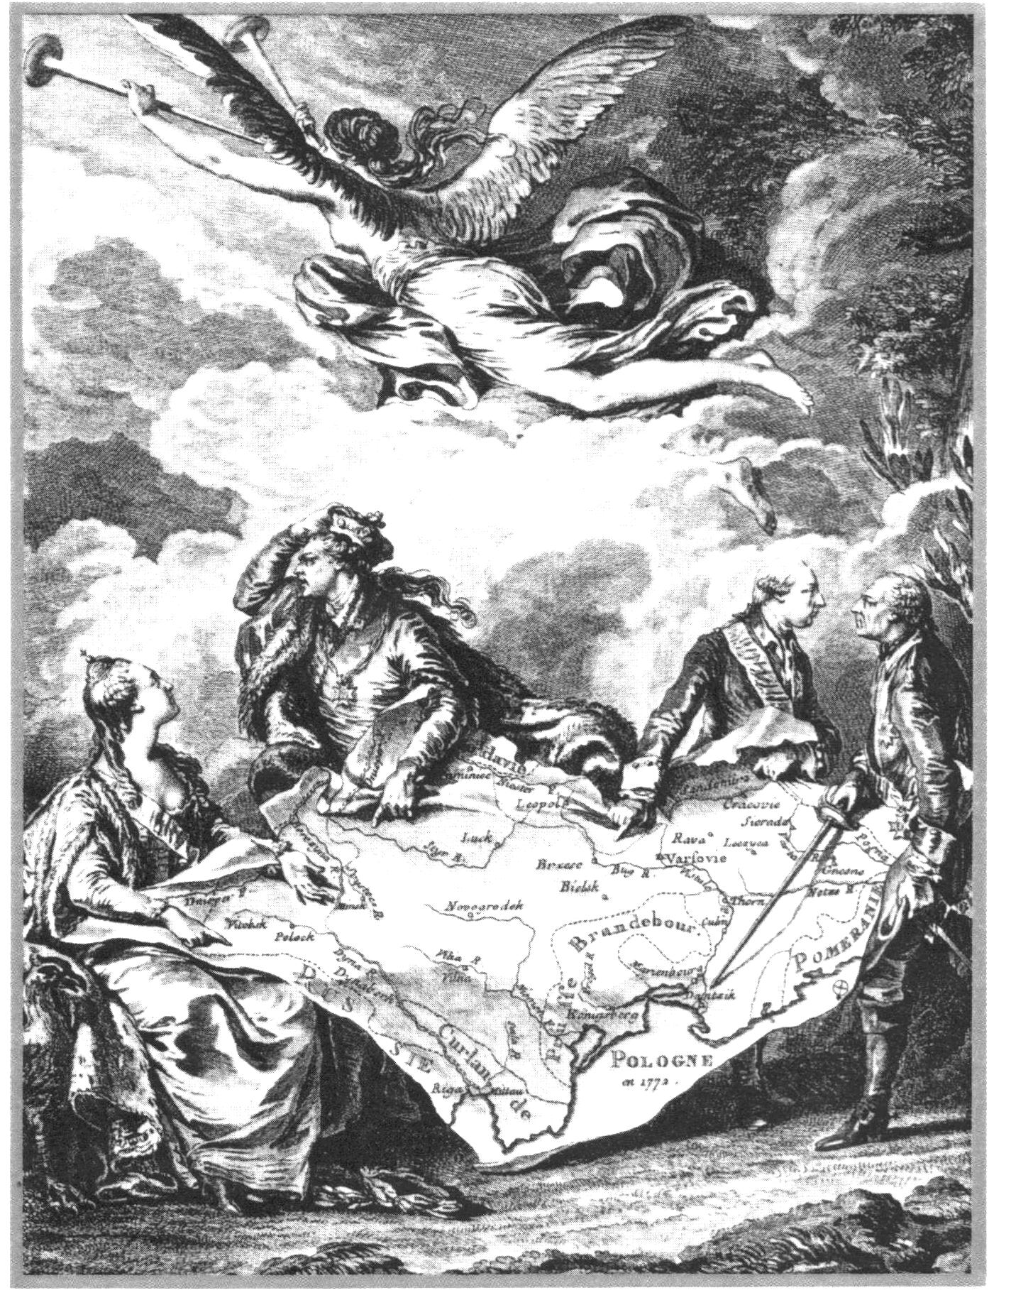
Fig. 2 Contemporary engraving by Noel Lemire portraying the first partitioning of Poland in 1772.

The complex relationships that existed between the peoples of east-Central Europe invite our understanding, but it is also necessary to look beyond their ‘national character.’ National character suggests that people’s behaviour can be explained through a simple, basic, biological omnipresent psycho-social mechanism, without recourse to personality types, cultural dispositions and stereotyping. Interwar Polish nervousness, for example, led some observers to suggest this would make them ‘more obstinate and uncompromising’; Jewish stereotyping created more obvious dangers. Moreover, it can lead to simplistic assertions, by-passing the important questions of history. It is within the intricate coiling of human group relationships, beyond the ‘political culture’, that we may hope to find the existing communities and the means by which they mostly, but not wholly, were destroyed. This requires a more simplistic comparative approach on the one hand, but also using perspective, an inter-disciplinary approach utilising insights from amongst others, a variety of sources in the fields of history, politics, folklore, economics, and psychology. In Kate Browns history of the Kresy, an area difficult to locate exactly, having ‘no definite boundaries…no mountains or vast seas, [r]ather wandering streams and bogs and intermittent plains shaped….into an enigma – untidy, formless, eluding definition’, the author visits modern Ukraine and interviews the present inhabitants. The Kresy (‘borderlands’ in Polish), lies within and between Poland, Russia and Ukraine, and was ‘conquered and lost and re-conquered’ by the Red Army several times during the Civil War and the Polish-Soviet War. (See below Fig. 10) Today it is commonly known as the ‘Chernobyl Zone’ and its past, as a theatre for ‘imperial Russia, socialist Soviet Union, fascist Germany, parliamentary Poland and nationalist Ukrainian’ ideology, reveals much about the modernization and standardization of the twentieth century. Kate Brown follows directions from ever helpful villagers – down to the end of Rosa Luxemburg Street and right into Lenin Avenue – and, looking for one Volodimir Kolchuk (of which there are apparently many); she is informed, ad hoc, that half the village was once German:
‘“The Germans were good farmers. Most of them were moved here from their farms deep in the forest. They came from over that hill there. They dragged the houses here piece by piece and put them up in rows and made this street.” As she spoke, I began to see how the neatly ordered row of cottages in the timeless-looking Ulianovka was really a product of collectivization. I asked Mrs Kolchuk whether there were any German families left in the Village. “No there are only Ukrainians here now. They came and took them.”’
To locate individual understandings and map their memories within the interwar period requires an excursion around the “Shatter Zone”, particularly developments in Germany and Russia. Kurt Graebe, a prominent German Minority leader in Poland, stressed the Reich’s importance succinctly: “An Eastern policy without the cooperation of the German populations...and without their support is unthinkable…Germany is the only nation in Europe that sees everything that takes place in the east-Central European region with its own eyes.” The “Idols of the Tribe” were always strong, and nervousness was rife. Take this statement from the French Government as it attempted to negotiate ‘European Union’ talks in 1932: “[France] would be happy to be able too concert with the British and Italian Governments to determine in what conditions the attention of the Austrian, Hungarian, Roumanian, Czechoslovak and Yugoslav Governments could be urgently drawn to the necessity for frank and complete exchanges of views between them, with a view to making closer their economic relations and ultimately of improving their financial, budgetary and monetary situations.” British fears were allayed because the omission of Germany ‘was apparently a mistake.’ Frau Merkel would surely agree.
Russia’s ‘metamorphosis into the Soviet Union (1923) was a decisive step for all Europeans. Imperial Russia was a discontinued line, the new state was to be a ‘gift’ to the ‘the toilers of all countries’ simultaneously holding control over the new Republics, whilst allowing them considerable autonomy in cultural and linguistic policy. The Bolsheviks ‘Internationalist’ approach to colonial aggrandizement and war appeared straight forward. Lenin in particular regarded the war as the ‘latest - the imperialist – stage of capitalist development’, predicting the Bolshevik Revolution would sweep away national ‘Particularism’ and the ‘subjugation of other nations’; the Polish socialist Rosa Luxemburg and her more ‘nihilistic’ supporters went further, expressing ‘implacable hostility to the very notion of any meaningful distinction between different nationalities.’ The First Comintern (1919) was, if anything, an admission of failure. Lenin favoured a ‘zigzag’ approach, with Russian workers at the forefront and others following on different paths. As Christopher Read suggests: ‘Lenin’s outlook [and until Stalin the Revolutions]…remained complex to the end. He hovered between the need for Soviet Russia to survive and…revolutions to occur elsewhere. Yet…he…castigated the left inside and out…for putting too much stress on the international revolution.’ Lenin’s greater knowledge, as author of The Rights of Nations to Self-Determination, made his Commissar for Nationality Affairs (Narkomnats) Stalin, either an ‘obedient servant’ or ‘secretive opponent.’ The practical effects of the collapse of Tsarist rule and subsequent Bolshevik victory meant significant changes in east-Central Europe, as ‘fierce new energies’ were ’injected’ into the complex demographic make-up of its peoples. This admixture had been stirred by the First World War as millions of refugees crossed such borders as then existed. Cadet Nikolai Shchepkin expressed the enormity of these movements: “The migrations that accompanied the Tatar invasions do not remotely compare with the magnitude of what is happening now.” Significantly he was echoing invasions of the past and equated them with the ‘unfettered, “spontaneous” and unwelcome incursion of “alien” elements.’ This ‘other’ was in stark contrast to the organised eastward expansion of settlers in both the pre-war Russian and German Empires. The protracted ‘Civil War’ also revealed the tenuous nature of the Revolution and the spectre of capitalist strangulation.
Without from this region, but nonetheless exerting political influence, particularly with reference to the abstract ‘invisible borders’ – that is notional boundaries delineated on a map often irrelevant to those inhabiting the borderland - arranged at Versailles (1919), Saint-Germain (1919), and Trianon (1920), were the western powers and their own external idea of ‘internationalism.’They too require ‘identity mapping’ – placing their topographical ideals within the complex nature of east-Central European identity - particularly since their economic weight allowed them to superimpose their orthodoxy upon lesser nations. Israel Zangwill devised a ‘typology’ within which four ‘types’ of nationality existed but which were never to be fixed. France in the interwar period, for instance, could have been a ‘Simple nationality’ in which all members speak the same language. Great Britain and the United States fit the ‘Complex nationality’, where all races mingle towards a political union. The later Soviet Union, and perhaps also Canada, can both be seen as ‘Compound nationalities’ in which different groups are isolated spatially and united federally. The revisionist and ‘bastard children’ of east-Central Europe may well comprise ‘Hybrid nationalities’ where a dominant ‘A’ group restricts the right of others. Israel was a pronounced Zionist, and his motivation was therefore less than disinterested, but the interwar debates on nationalism were urgent. As Walter Pilsbury noted in 1919: ‘If you want to know what national group an individual belongs to, the simplest way is to ask him…his answer is a better criterion than history, or racial descent, or physical measurements. Nationalism is first of all a psychological or sociological problem.’ The peasantry’s inertia, exemplified in rural France during the nineteenth century - where their own brand of regional separatism forestalled attempts at installing a nationwide sense of La Patrie – had similarities with east-Central Europe (and Russia), and was seen by the new nascent states as a threat to social stability, national security and national unity. Fostering a sense of national ‘self’ required not just ‘national service’, but the implanting of civic awareness and patriotism through education. As Weber remarked: “Historians [like education] were the clerisy of the nineteenth century because it fell to them to rewrite foundation myths; and history was the theology…because it provided [modernizing] societies cast loose from the moorings of custom and habit with new anchorage in a rediscovered or reinvented-past.”
Central Europe developed a penchant for eugenics concomitant with a much wider interest in anthropology. In Britain and the United States the investigations sought answers to modernity, immigration and racial segregation, whilst in France and Italy the traumatic human experiences of war provided the major impetus. In Central and Eastern Europe a select few funded by the state looked for legitimacy for ‘strengthening their newly acquired status.’ Roger Griffin describes the end game as ‘Gardening in Jackboots.’ The search for ‘anthropometric…“racial origins”’ in the multiethnic regions of South Eastern and Central Europe, was a feature of the debate surrounding nationalism and eugenics. In seeking to define their minorities in relation to the homogenous national state, there was a need to treat them as foreign and alien; in Romania this took an early unwelcome deviation when minorities were depicted as “a foreign stake thrust into the body of nation.” Even the more enlightened Czech intelligentsia had acquired a propensity for the “healthier” society, subscribing to “reform of life” or Lebensreform in order to prevent further “degeneration.” These were part of a wider interwar debate, which in seeking to preserve their “biological capital”, proposed as a remedy either a liberal western democratic model or a peasant indigenous state; the other option was the corporate/fascist state.
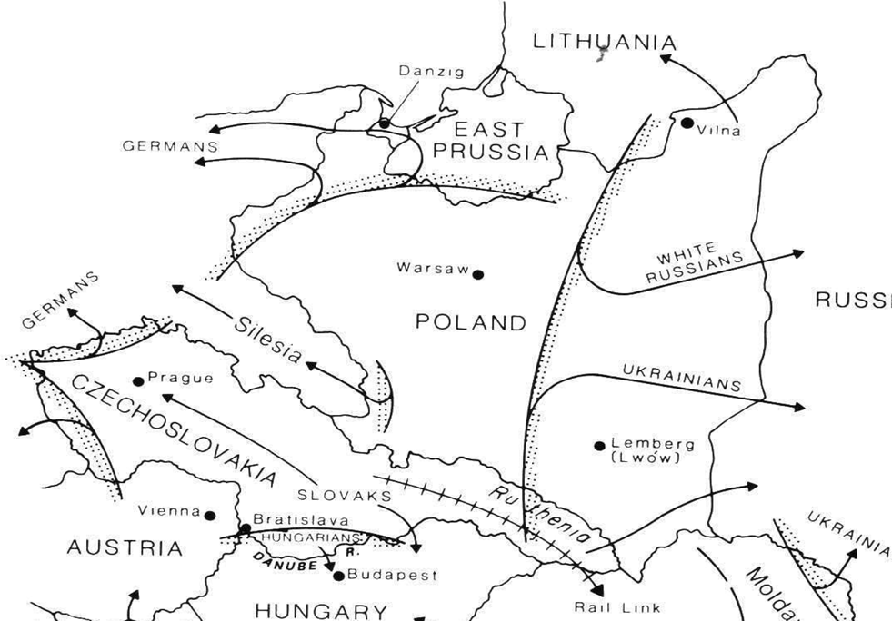

Fig. 3 Tensions revealed by the ‘Versailles Agreements’ in the ‘Shatter Belt.’

This was certainly fertile ground on which to sow the seeds of nationalism. Stripping away false layers in the search for racial purity or, as in the Soviet case, eradicating the “weed which in some manner grew up between the stones of our bright and well-constructed building”, proved to be a profitable business. The irredentist plough provided the motive force and an impressive list of political disputes the fertile soil (Fig. 3). Lithuania and Poland argued over Wilno/Vilnius/Vilna. Poland and Czechoslovakia disputed Teschen/Tesin/Cieszyn for similar ethno-demographic and economic reasons; Czechoslovakia and Hungary over the latter’s revisionism. Hungary also ‘nursed territorial claims’ against Romania, Yugoslavia and Austria. To the south Yugoslavia coveted parts of Austrian Slovenia whilst Bulgarian irredentist resentments festered over Macedonia and Southern Dobruja. Woven within these claims and counter-claims, were convictions that the ‘other’ was permanently disabled by avariciously incorporating too many ‘unabsorbables’, the singularly different perceptions of Hungary’s and the Soviet Union’s roles in the European balance, and the ‘contrasting social structures and national psychologies’ – particularly Polish Gentry versus Czech Bourgeois. (Fig. 4) Poland’s later failure to join the ‘Little Entente’ reinforced her apparent anti-democratic tendencies, and her commercial future was not enhanced by ‘fancy schemes to escape economic laws’ or potential ruination through ‘insane military adventure’ - in marked contrast to Czecho-Slovakia which had a much larger middle-class western bureaucracy. Poland in some ways typified the continuity between a prewar social order of hierarchy - which had come under increasing pressure - and postwar modernization. The Czechs in particular, regarded themselves as a ‘Central European’ people - in the German Mitteleuropa sense of the word - going some way towards explaining their greater willingness, in coming to terms with Nazi Germany and the west in the late 1930s.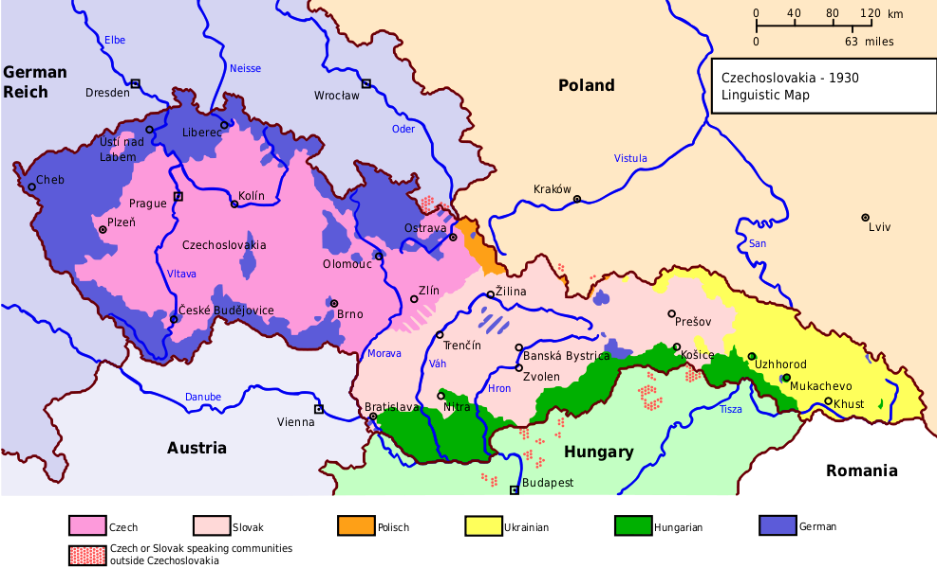
Fig. 4 The Czech-Polish dispute centred on the historic route between the Carpathians.

Within the countries of east-Central Europe it is also necessary to define the 'other', in order to understand the 'self.' Timothy Garton Ash cheekily proffers a warning to all those who enter this debate:
‘We shall at once be lost in a forest of historical complexity – an endlessly intriguing forest to be sure, a territory where peoples, cultures languages are fantastically intertwined, where every place has several names and men change their citizenship as often as their shoes, an enchanted wood full of wizards and witches, but one which bears over its entrance the words: “Abandon hope, ye who enter here, of ever seeing the wood for the trees.’
For good measure he adds: ‘every attempt to distil some common “essence” of history is either absurdly reductionist or invincibly vague.’ A person born into the north-east corner of the Austrian Empire for example, may without ever having moved at all, lived under four separate ‘nationalities’ within two dozen years. Frederick Lindstrom in describing the complex linguistic groups within the Austro-Hungarian Empire, notes the ‘layering’ that occurred as groups moved in to Bohemian lands, contributing to a ‘shifting of the boundaries between Germans and Czechs,… and [a] distinction between cultural identities within the two main groups, especially the Germans, [who] also evolved because [they] ….were from different parts…and adopted different occupations.’
So bearing in mind the pitfalls and gleaning from the paucity of accounts individual reminiscences and details, whilst simultaneously utilising the wealth of contemporary statistics and commentary which exist, (though with the proviso of course that, particularly during such a volatile age, mischievous siren voices are ever present), as well as English language translations of current historical accounts and conjecture, this discussion will ascertain how east-Central European states and their people were nationalized and denationalized by the currents of economic, political and social upheaval. What does this ‘region’ tells us about future political developments, particularly that of ‘meso-government’ and the construction of regionality – or ‘form a basis for identity formation’? What also does it uncover about nationalism and ‘localism’? Were the people, of say Kulmhof/Cholm and the Kresy acting in a particularist fashion or were external forces so strong that the tensions proved unequal to their own predilections to retain ‘independence’? (See above Fig. 3) Following this introduction and broadly following a chronological path, this dissertation will, using the themes described above, and woven within the historical framework of the contiguous nations, set out in five chapters the overlaying historical influences and prejudices within which individual accounts can provide some brief understanding. The borderlands under investigation were neither wholly ‘utopian sites of hybridity nor backward and violent wellsprings of ethnic conflict.’ Howard Aster and Peter Potichnyj focus upon the transformative aspects of modernity, as it ‘rolled through the…continent from west to east…in its wake, shatter[ing] traditional structures, religious institutions, accepted patterns of economic activity and previously sacred political beliefs.’ But, rather than speculating upon its destructive tendencies, they question, as will I, how these transformative possibilities were utilised by, in their particular examples, the Ukrainian-Jewish communities’ opportunity ‘to free themselves from their historical legacies.’
In all the prewar European Empires, secularization, socialism, trade unionism, reform and national autonomy affected a still largely rural population, a process accelerated by modern methods of warfare. Eric Hobsbawm speaks of an ‘under-developed’ or ‘under-developing...collective uncertainty’, in a ‘slope to the east and to the west of what we might call the main mountain-range or crest of European economic and cultural dynamism’, linking physical features with the psychological and emotional. These changes did not go unchallenged and in east-Central Europe they provided the dynamics for resistance. Traditional authority, and of course beliefs, provoked violence and pogroms, the ‘transmutation of traditional authority’ and the ‘weakening of social and political life’ which had existed for centuries, and it was here that ‘ [J. K.Galbraith wrote] the cracks in the old order first appeared…here that [all] dissolved, first in disorder, then in revolution.’ There is a library full of Jewish and German philosophy, particularly upon the vexing subject of history, but I will have to ignore one extremely useful Yiddish saying, “M’darf nisht tantzen of alle khasenes,” or, “About things you don’t know much, it is wise to keep silent.”

II From Paris to Moscow: Making minorities out of people
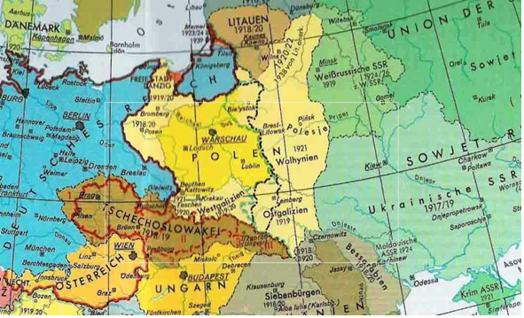
Fig. 5 Putzgers’ interwar Germany and Poland - with changes.

This chapter will provide a résumé of Versailles and its postwar implications, whilst taking an excursion around east-Central Europe to ascertain the struggles which existed between nations, peoples and the agrarian versus industrial debate. Robert Vansittart in 1931, casting a sceptical eye over ‘An Aspect of International Relations’ mischievously sets the scene: ‘We cannot, then, be blind, in attempting the harvest of a quiet eye, to the other side, which is the growth of this old Adam; for the dissipated wretch, far from being dissipated altogether, has actually been putting on weight.’ He focuses on individual aspects, particularly in Germany and Poland. ‘As for the Polish frontier, no German is supposed to forget the lost provinces; in any case he is not allowed to try. In this the Poles are unwise enough to collaborate.’ The ‘other side’ in 1918 was barely a border at all. In Lev Kopelev’s Ukraine, where he grew up amongst Russians, Jews, Poles, Georgians and Germans, looking back sixty years, he admits: ‘thinking back about many of the boys and girls in my class and my troop, I cannot say what “nation” they belonged to. It simply didn’t interest us at the time.’ The eastern borderlands were porous and ill-defined (Fig. 5). Kopelev hints at his own understanding of identity.
‘The miasmas of primitive “group” thinking, barbaric oversimplification, caught up with me later in quite another form: When I believed that one should fear and hate all bourgeois, all landowners, all White Guards, Kulaks, Mensheviks, et al. And assumed, on the other hand, that one ought to love, as one’s own people, all proletarians, Communists, Komsomol members, Red Commanders, veterans of the Civil War.’
Hugh Seton-Watson, writing in early 1940, described the area between Germany and Russia as separated from British shores by just a few hundred miles, ‘but to the British people, which is aware of the existence of Zulus and Malays, Maoris and Afridis, they are unknown. They have unpronounceable names, and live in plains and forests, on mountains and rivers which might be in another world.’ Patrick Leigh Fermor who set out in 1933, like a ‘tramp, a pilgrim, or a wandering scholar’ to walk to Constantinople, recalls Metternich’s “Östlich von Wien, fängt der Orient an”. Brooding upon the West’s confusion over Attila the Hun and Arpad of the Magyars (which incidentally led to them misnaming ‘the land where they took root’) he adds: ‘[f]rom the very first, the Kingdom [of Hungary] included all the lands of the Slovaks and the frontier remained unchanged for the ten centuries that separate Arpad from President Wilson.’ Had the amputation included only Slovaks, it would have been ‘ethnographically just.’ But a strip of land to the north of the Danube contained only Magyars, a ‘double-edged gift’ for the new Czechoslovak state, which included German-speakers, ‘descendants of the Teutonic citizens who had helped to populate most of the cities of Central Europe.’ (See above Fig. 4)
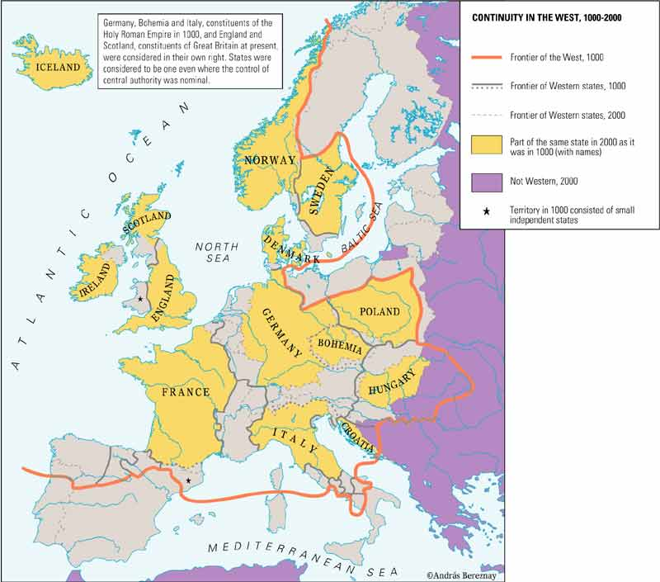 Fig. 6 Continuity between Charlemagne and ‘Modern’ Europe.
History in east-Central Europe is to be sure ‘epic and tragic’, consisting of David and Goliath struggles where the protagonists expectations often exceed reality, where business remains unfinished and opportunities are lost. Yet much remained the same (Fig. 6). A Hungarian historian, remarking on the correlation between the Iron Curtain and the old eastern border of the Carolinian Empire, suggested that, “it is as if Stalin, Churchill, and Roosevelt had carefully studied the status quo of the age of Charlemagne on the 1130th anniversary of his death.’
Poland in the interwar period has variously been described as “God’s Playground”, “New Canaan” or “On the Edge of Destruction”, simultaneously sharing her new found independence and breathing the air of liberty with Ukrainians, Germans, Byelorussians, Ruthenians, Slovaks, Czechs, Lithuanians and, of course, Jews. There have been Jews in Poland since 1240, attracted for more than 500 years by the peace and freedom that was not palpable elsewhere in Europe – a ‘haven in a world of persecution.’ The ‘Idols of the tribe’ attract more than their fare share of attention here, not only in her borderlands, but throughout a ‘society in which two-thirds of the population was engaged in subsistence agriculture and…one third consisted of national minorities.’ Even before her war with Russia (1919-20), this was hardly a country which ‘could afford the gradualist, liberal climate of prosperous and well established western countries’, and it as well, when venturing into Poland’s national identity, to also heed Michael Ignatieff’s warning that: “in no field of history does one wish more fervently that historians could write blind into the future.” To do so would threaten the actual events with a dark cloud of historiography. Poland’s relationship and antagonism with her neighbours can also be succinctly summed up: “‘[T]he fighting spirit of Polish nationalism was subdued in Romanov Poland, suborned in Habsburg Poland and provoked in German Poland.’
‘Externally’, Vladimir Illich Lenin, according to Bruce Lockhart in a memorandum to British Foreign Secretary Arthur Balfour, was now ‘a greater danger to Europe than German militarism…whose eyes were firmly focussed on Central Europe…[and] hopes of a class revolution [were] certain in the Ukraine and Poland.’ The refugee crisis which affected east-Central Europe was even more immediate. Following the Treaty of Brest-Litovsk (3rd March 1918), the Bolshevik Government established Tsentroplenbezh (Central Board for POWs and Refugees). Across the ‘borderlands’ there were 6.5 million belligerents alone who needed repatriation, and by October, whilst half a million refugees had returned “home…spontaneously”, there were still three and a half million ‘desperate to return to Poland and the other successor states.’ The administrators, whom one would think were used to hardships themselves, appealed to their ‘Citizen-refugees’: ‘The movement of people toward the frontier, which is now taking place spontaneously [my italics]…and which is being accomplished by individuals at their own risk and cost brings with it pernicious consequences. The border crossing points are already overflowing with thousands of starving, homeless, and sick people. Beware of following their example.’ James Mayall makes the point, when defining the new ‘International Order’, that this ‘is first and foremost fundamentally the problem of minorities.’ In the course of their history the “nationalities” of Europe had been ‘hopelessly scrambled [and] even assuming that each could have been assigned a territory, there would have been many…left outside; unless the aftermath of [any] plebiscite was to involve major involuntary population movements (Fig. 7).’ Postwar east-Central Europe, even before the fulminations and deal-making in smoke filled rooms at Versailles, was a land in motion. Quite apart from the mass movements of the protagonist’s armies, Russia, through organisations such as the Tatiana Committee, had to deal with 3.3 million refugees (in 1915 alone. By the October Revolution this had grown to a cumulative 7.4 million; more than twice the size of the industrial working class. John Reed in 1915 Tarnopol (then part of the Russian Empire) describes the station platform filled with: ‘Hundreds of peasant refugees – Poles, Moldavians and Hungarians…bewildered among their bundles and rolls of bedding’; it was the national identity equivalent of pre-match musical chairs. It is also significant that, like the League of Nations, many states treated their new minorities in much the same manner as their refugees; as objects rather than subjects.

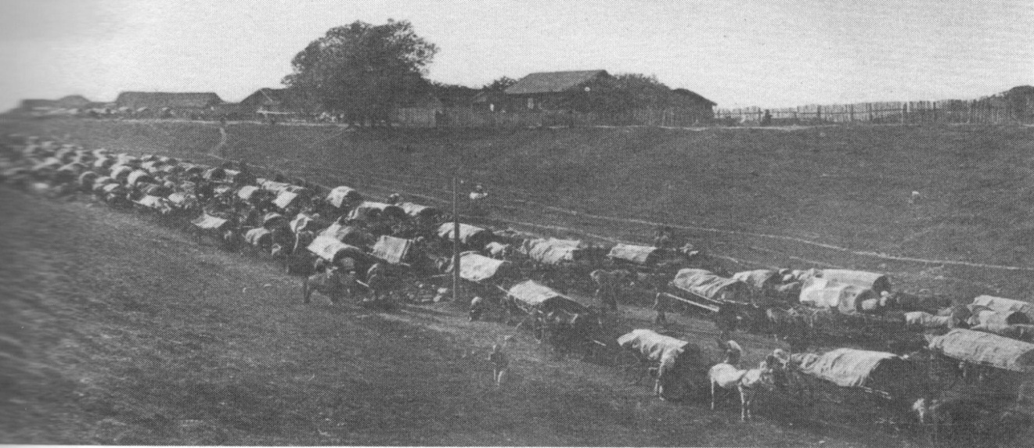
Fig. 7 Refugees heading towards ‘Russia.’

The returnees also experienced a phenomenon, often referred to in Polish literature as “Mit Szklanych Domov” [‘’the myth of glass-houses’]; or a beautiful myth that is easily shattered. Polish nationality policy was often seen in stark contrast to its neighbours, particularly Czecho-Slovakia, from which it harboured hopes of receiving the Silesian territory of Teschen by obstructing a League of Nations Plebiscite. Cieszyn or Tesin (Polish and Czech respectively) moved Dr. Edward Benes, the Czecho-Slovak Minister of Foreign Affairs to write a letter of protest to the London Legation in 1920, against ‘a continual campaign of incitement… [By] M.Zameyski [the Chief Polish Delegate on the Teschen Commission], who declared in a speech…that a war would be most popular…and that if the territory…is not obtained by the Plebiscite it will be won for Poland by the sword.’ (Fig. 8) Dr. Benes, like Thomas Masaryk an immigrant himself, had lobbied Allied Governments and successfully converted another ‘professor-turned-politician’ - Woodrow Wilson of the United States - to a campaign of collusion in both rebelling against the Ausgleich and legitimising the new state before it existed. Benes’ use of the German spelling Teschen, betrayed his own mixed-sense of identity and reinforces Raymond Pearson’s opinion that: ‘Czecho-Slovakia was manufactured in the West, by Czech refugees under licence from the Allies in co-operation with emigrants out of touch with the opinion of their homeland, and then presented to the indigenous Czech and Slovak populations as a fait accompli.’ The later de-hyphenisation would further alienate the 2,500,000 Slovaks (about 16 per cent of the new state), presenting them as backward in an increasingly colonising Czech state. The ‘hyphenated’ state whether as a ‘bond’ or ‘yoke’, has more than just a hint of Slovak irony attached to it, alluding somewhat to their former ‘masters’ Austro-Hungary. The name had been used during the Paris Peace negotiations, and its symbolic importance was underlined by its exclusion from the Czech translation of their own final written constitution. It was reinserted during the brief ‘rump’ Second Republic in 1938-9 and also caused the later ‘hyphen war’ in the spring of 1990. Polish efforts to drive a wedge between the two national groups were indeed ‘promoted’ by the Czecho-Slovakian Governments later decisions. Finding sustenance when the Poles were themselves preoccupied - following victory over the Ukrainian’s in Eastern Galicia and both the Germans and Lithuanians in Upper Silesia and Wilno/Vilnius respectively - created a revisionist reckoning amongst both Poles and Slovaks, which would later return to haunt both countries. It is as well to note that Poland, a country which was adding 400,000 ‘peasants’ annually, was crucial to the future of ‘all Eastern and Central Europe’ in the interwar period.
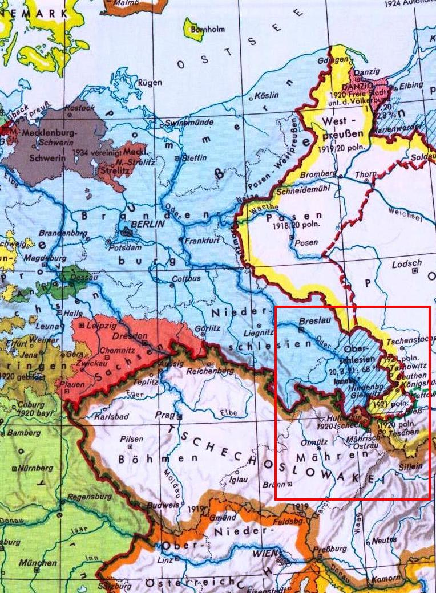
Fig. 8 Disputes along the ‘Shatter Zone’ in the 1920s.

Often the post-Versailles/Brest-Litovsk ‘hedge-funding’ of national identity, proscribing a subjective approach via the Plebiscite, not only failed to produce either a Staatsnation (civic or politically defined and within frontiers) or Kulturnation (personal rather than institutional and externalised through language usage), as we have seen with Benes and Masaryk, it engendered the danger of stirring up ‘old Adam.’ Unlike Western Europe, where the new nationalism corresponded to changing social, economic, and political realities, in east-Central Europe ‘it [had] spread…long before a corresponding social and economic transformation.’ As Dean Rugg points out, this distinction predicated east-Central Europe divining its nationalism from ‘historic rights’, whilst Western Europe’s often ‘rested on human rights.’ Norman Salsitz, contemplating the effects of the railroad on the prewar Austrian town of Kolbuszowa, and whether it would ‘have remained as backward, as traditional’, notes ‘it was never completed: World War One came and everything stopped.’ Poland had ‘more pressing matters to attend to. Kolbuszowa would survive, but without a railroad.’ (Fig. 9) Attempts to either dictate or diffuse Western ideals of nationality fell increasingly on the stony ‘brecklands’ of the region, even when it appeared plain which ‘tribe’ was in the ascendancy. In Sensburg/Mragowo (East Prussia), less than half the population were German-speakers and the Allies aimed to settle the dispute by Plebiscite. The results were demonstrable; only 25 votes were cast for Poland whilst 34,334 wished for inclusion in Germany.
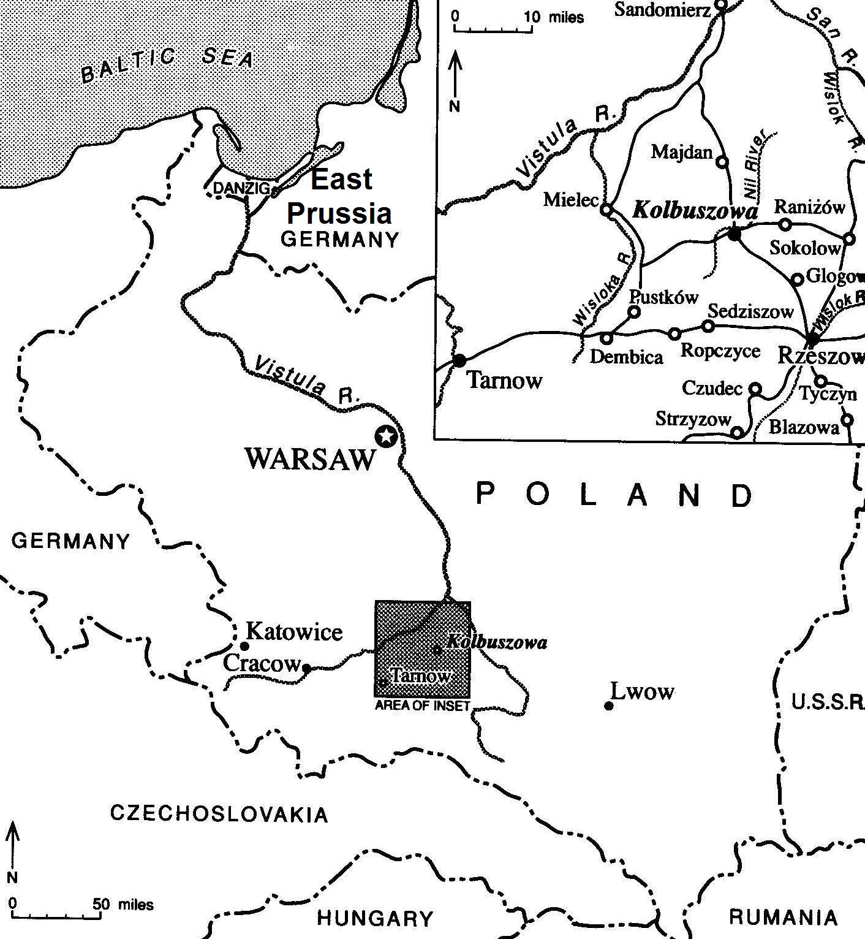
Fig. 9 Galicia in the new Poland (with inset for Kolbuszowa) and East Prussia.

Such an approach was impossible in the area known as the Kresy where, in no particular order, imperial Russia, socialist Soviet Union, fascist Nazi Germany, ‘parliamentary’ Poland, and nationalist Ukraine proceeded to ‘dismantle the confusing mosaic of cultures in [this] contested borderland.’ (Fig. 10) Situated between Polish Lvov/Lviv and Soviet Ukrainian Kiev, it was beyond the purview of the Western democracies largely because the Soviet Union had not signed the Versailles agreements. In a sense it existed beyond even “Backwardness.” The Kresy could also be described as a region in full control of its own limitations:
‘Imagine trying to tax and regulate an economy unhitched from architecture; where in troubled times the tarp-covered stores roll up and disappear, and the population retreat to the woods, gathering and poaching for calories. How does one establish a legal system in a region where people prefer the Samosud, traditional justice to the courts? Imagine the difficulty of standardizing an educational system in which schools (legal or illegal) look indistinguishable from home, where there are no textbooks and teachers are mostly self-taught…in which a disgruntled sorceress can cast a spell so powerful on a communist village chairman that it kills him.’
Agrarian reform swept through the lands between Russia and Western Europe, and despite the loss of production caused by the seizure of estates (as well as ‘some of the best extant examples of large-scale scientific agriculture’), their ‘success’ proved too much ‘even for Soviet despotism.’ Other influences were also at work, particularly in Czecho-Slovakia, Latvia, Estonia, and Transylvania, where their also existed a ‘desire to get rid of an alien and hostile landlord class [alongside] the land-hunger of the peasantry.’ The problem was particularly acute in the much smaller Baltic States, but it was also present in Poland. The peasantry had consistently fought for its own rights, irrespective of their own superimposed nationality, frequently fighting alongside ‘belligerents’ from other countries, to the consternation and exasperation of their own governments. Jews were often singled out for violent repression, particularly in the Ukraine, and N.A.Grigor’ev, a ‘semi-bandit leader’ with Ukrainian Nationalists, the German Hetmanate, the social-democratic Petlyura and the Soviets, alongside a ‘fellow bandit’, described where:
‘Corpses had been left to rot and most homes had been ransacked…[In] one little white house [a]ll its windows had been smashed…By the door lay the body of an elderly man whose eyes had been gouged out and clumps of his beard pulled out. Beside him a disembowelled woman in a torn shirt with her breast cut off…close by, the corpse of a naked girl who had obviously been raped.’
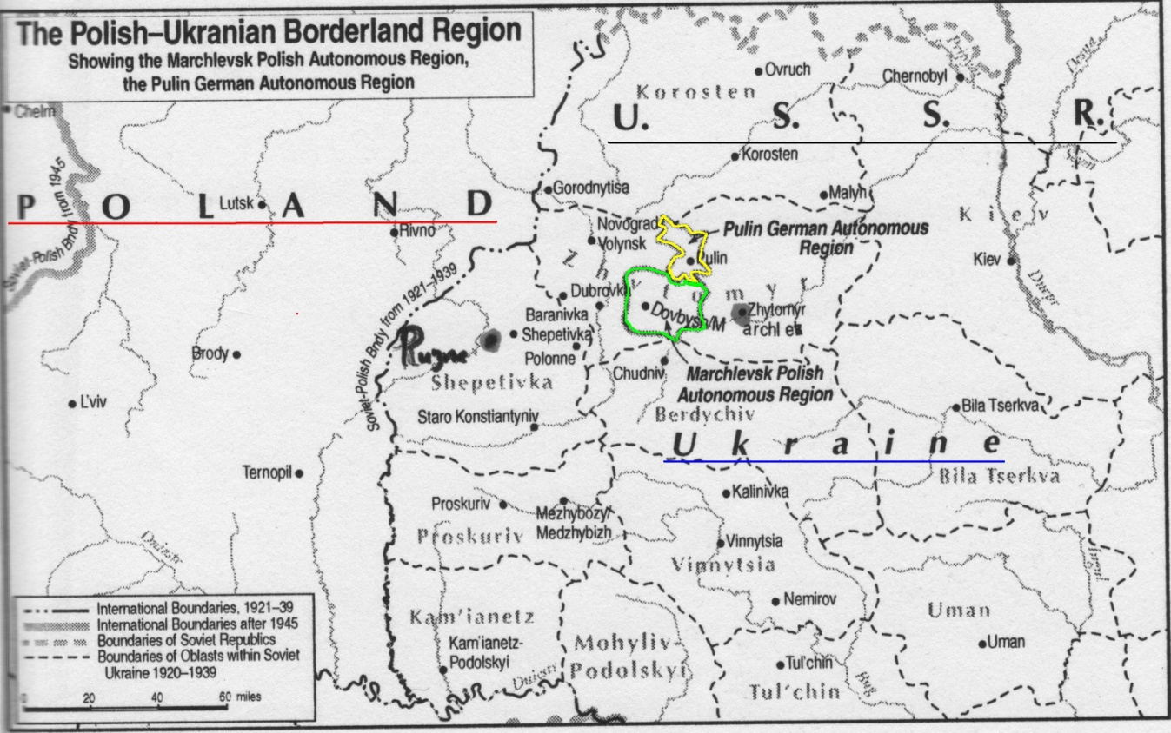
Fig. 10 The ‘Kresy’ and Soviet Autonomous Regions.

In Western Europe Jews aspired to become nationals, but their ‘minority’ status in east-Central Europe encouraged their own ‘self-definition’. Practical necessity brought Poles and Jews together but both viewed mixing as potentially ‘spoiling’ each other; Poles often resented assimilationist Jews who could “penetrate” or “infiltrate”, dangerously blurring the lines. However, ‘marginality’ for the non-petty bourgeoisie peasantry was less of a curse than a blessing because, ‘local inhabitants could blithely ignore nationalists who insisted they remain loyal to one, and only one, national community.’ But, of course, nationalists were happy to denationalise or convert, often using fostering as a surrogate for more aggressive tactics.
Dr. Benes, the Czecho-Slovakian Foreign Minister, elucidated in 1922 some of the substantive problems shared with his fellow Slovaks, who were increasingly dissatisfied with ‘their’ multi-national state; the Czechs themselves numbered only 7,250,000 or roughly 48 per cent. (See above Fig. 4) The ‘Pittsburgh Treaty’ of 1918 had proved somewhat ‘Balfourian’ and, as with Palestine, a ‘great deal of recrimination would have certainly been averted if all signatories…had at the time made it clear…what their respective signatures meant.’ Benes claimed that Andrej Hlinka’s (later dubbed the ‘Father of the Slovak Nation’) faction within the Slovak Popular Party, was ‘largely a personal question’, and that an autonomous Slovakia would mean ‘largely sacrificing…an annual subsidy of nearly £5,000,000 from Prague… [and] enthusiasm manifested in certain circles will be [therefore] somewhat damped.’ Benes and Masaryk until 1917, referred to their pre-nascent state as ‘independent Bohemia’, having also published Bohemia’s Case for Independence. Milan Hodza, from his position inside the Republican Party of the Czechoslovak Countryside (Republikánská strana zemědělského a malorolnického lidu) was a leading Slovak proponent of a European wide ‘Agrarian’ movement, and provided the ethnic and political adhesive which kept the nation together. It merged in 1922 with the Slovak National and Peasant Party (Slovenská národná a roľnícka strana) and consequently changed its name again, becoming the Republican Party of Farmers and Peasants (Republikánská strana zemědělského a malorolnického lidu). However, in usual political life it was called the “Agrarians” (Agrárníci). Before the War, as an advisor to the Archduke Franz Ferdinand, Hodza had proposed a ‘United States of Greater Austria’, based on an ethnographic map of the ‘Distribution of Races in Austria-Hungary’ (1910) (Fig. 11). One of Lev Kopelev’s ‘Capitalists’, Dr. Walther R. - who ‘spoke and thought in German’ and was a Czech by nationality but granted Austrian citizenship in 1945 - commented that ‘life in Czechoslovakia wasn’t bad [but] the ancient national contradictions became more acute there’ adding, ‘the Slovaks had a right to be insulted at having Hungarian authorities and landed gentry.’ Prompted, he comments: ‘What we have, we don’t cherish; when we lose it, we weep.’
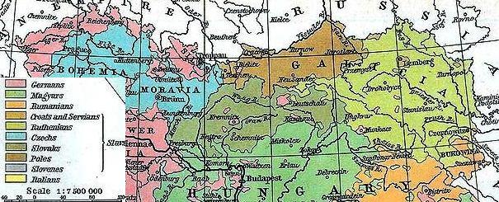
Fig. 11 Section from ‘Austro-Hungarian ethnicity by language’ map, 1910.

The champion of minority rights in the 1920s, in respect of the eight million ethnic Germans (Völksdeutsche) - who had in the preceding centuries spread out across Eastern Europe - was Germanys Gustav Stresemann. Weimar Germany demands our attention particularly because of the “striking similarities” between Germany after the First World War, and Russia after the collapse of the Soviet Union, with perhaps ‘Orange’ Ukraine playing ‘interwar Poland’ in dispute with ‘Weimar Russia’. The German Diaspora was political as well as ethnic (Fig. 12). Many Germans had existed outside of the Kaiserreich in prewar Hungary, Russia and Austria, making it inevitable that many would remain outside the new Republic, wherever the new frontiers were drawn. Völksdeutsche had assimilated in southern Russia and elsewhere, and it must also be remembered that, as with millions of other Europeans, they too discarded their identity when arriving in the ‘New World’; the Auslanddeutschtum in the Russian Volga region for example, had no reason to think that their conditions would not see ‘a marked improvement.’ The Baltic German ‘overlords’ were viewed by Estonians and Latvians as the traditional ruling elite, who had colluded with the German military whilst under occupation. They were well-suited to re-establish their own ‘longstanding organizational networks’ and this proved particularly useful with the setting up in 1925 of the Nationalities Congress, used to lobby outside international organizations. Its true value would be later realised in the 1930s, by Henlein and his Sudetendeutsch. It was the German Völksdeutsche in the Polish provinces of Pomorze, Poznania, Lodz and Upper Silesia to which many revisionists, however, looked both ‘externally’ as Germans and ‘internally’ as Poles. Within Pomorze for example, situated in north-western Poland and referred to as the ‘Corridor’, there were still 175,771 Völksdeutsche in 1921, (as opposed to Reichsdeutsche or “Germans of the Realm”) accounting for nineteen per cent of the population. Under the Minorities Protection Treaty (1919) the League Council and the World Court were to ‘examine infractions’ or ‘adjudicate disputes’ respectively, and all the new or expanded states were ‘forced’ to sign. Under the Versailles Treaty, nationals of new states born within the successor state were entitled to acquire citizenship, along with those who had resided in the new ceded territory since 1908. Many Germans, as well as other national groups throughout east-Central Europe, opted to take up their new citizenship but there was an explicitly understood difference between legal membership of the state and ‘ethnocultural membership of the nation.’ This differentiation in which boundaries were largely ignored within a persons ‘own-self’, caused an endless succession of problems in the “shatter zone”, prompting a Brazilian diplomat working for the League to characterize Poland as his “best client” and the chief testing ground for the internationally sanctioned protection of minorities.’
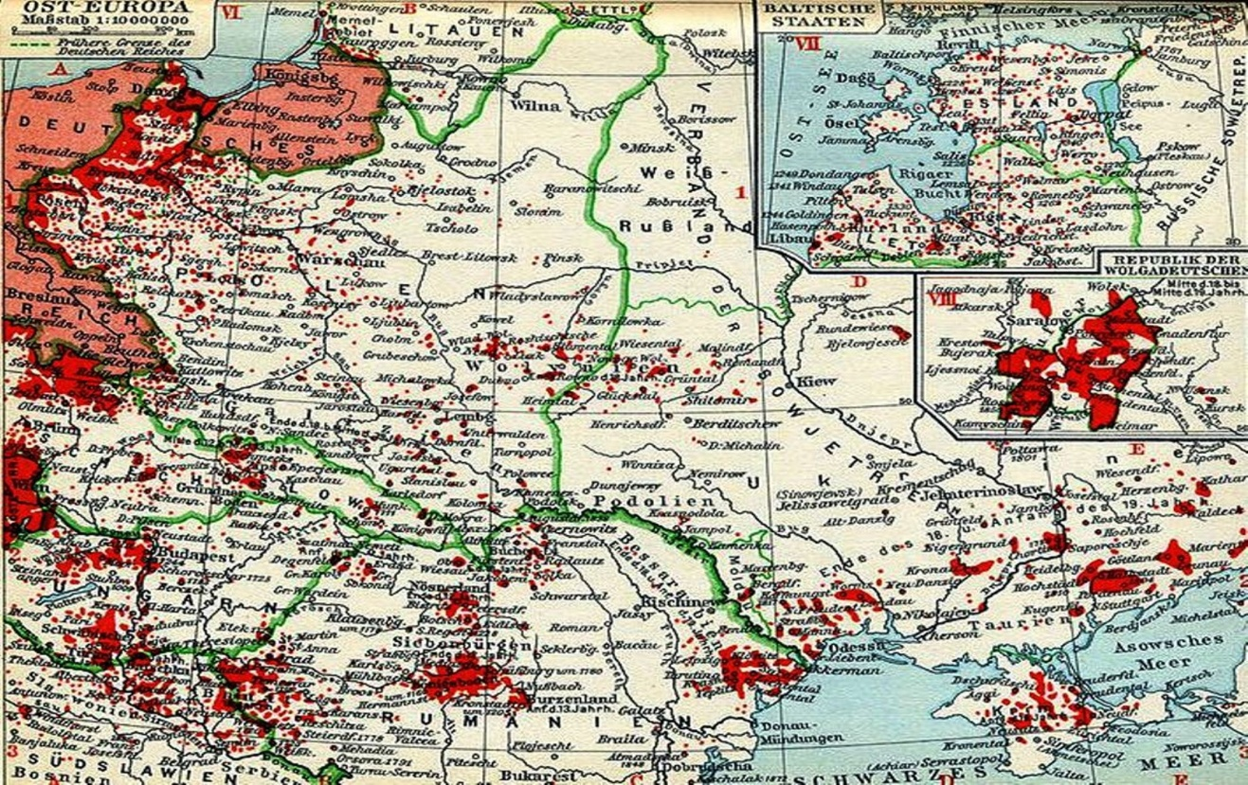
Fig. 12 The Völksdeutsch and their’ Drang Nach Osten’, with ‘colonies’ shown in red. Note the spread along the Baltic coast and also the Oder and Danube valleys.

III
Minorities in transit: new identity infrastructure.
This chapter will concentrate upon the fluidity extant in the peasant/Jewish relationships along the equally mobile Soviet – Polish border, whilst examining contiguous nations such as Romania, and their own particularist understanding of both modernity and the ‘Other.’ The millennium-long eastward movement or Völkwanderung of Germany’s ‘peasant, burgher, miner, monk, and soldier…and the political achievements of Frederick the Great and…Bismarck’ had ceased. Poland fought its way to a draw and an effective ‘ceasefire line’ to the east of the ‘Curzon Line’ (1923). (Fig. 13) Whilst the Poles sought to consolidate and dissimilate under President Grabski, utilizing land reforms (common enough throughout east-Central Europe) by expropriating in particular from alien German landlords in Western Poland - thereby ‘nationalizing’ their new state - they concurrently attempted assimilation (where force had failed) towards other ethnic groups. To be sure, the Völksdeutsche still retained their own sense of Heimat, poetically contrasting ‘between the “new green of German industriousness” and the “swamps and marshes” of the Poles.’ It was Friederich Ratzel who coined the much over-used term Lebensraum, as an expression of Germans’ fascination with the ‘American West’ and the ‘influence of geography on history.’ But by 1926 a more Völkisch concept had developed. German historians regarded German Settlement land in the East as ‘the citizenship certificate of the German in the east, alongside ‘the laughing meadows and flourishing fields that they have wrested from a wild nature… [and] not a yellowing parchment.’ Poland’s Jews however, were tentatively in the assimilationist camp and seen as potentially “available”. Dmowski favoured a non-expansionist, ethnically homogenous and enthusiastically Catholic Poland, admitting that despite ‘too much spoiling the soup’, the Jews were nonetheless ‘the salt of the earth’; therefore it was ‘necessary to court them.’ Poland in 1921 contained 2,110,000 Jews, (and tellingly a further 707,404 Jews who gave their nationality as Polish) and though many were poor, substantial numbers held important positions within the economy, making systematic removal problematic. Dmowski along with other right-wing nationalists preferred to ‘tolerate the prime historical target of minority discrimination in order to expend most of their energies harassing their fellow Slavs.’ The Jews themselves, a large number of whom belonged to the ‘crucial petty bourgeoisie’, lived largely in the main cities, and were ‘victims’ of a European-wide exaggeration and tendency, which equated anti-Bolshevism with anti-Semitism. This was to become more ‘pronounced’ with the “regime of the colonels.”
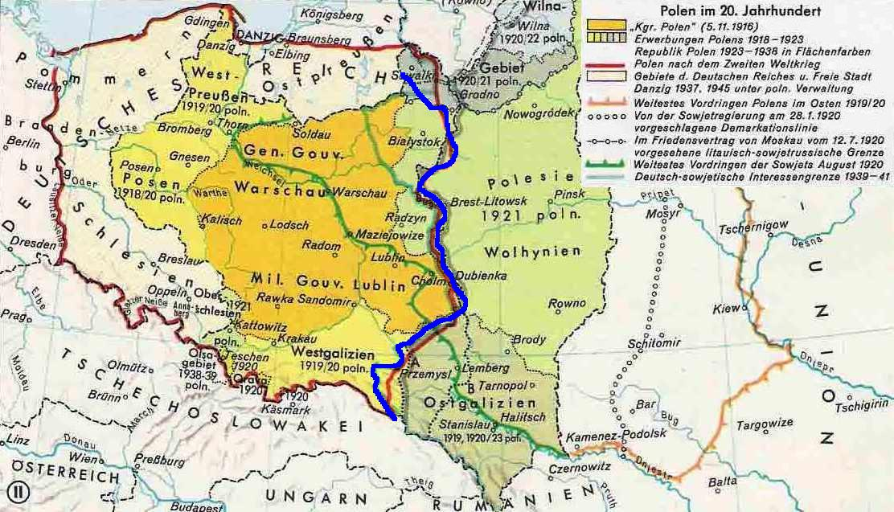
Fig. 13 The Ukrainian/Soviet-Polish interwar border (‘Curzon Line’ in blue).
Whilst in the first half of the twenties’ Soviet policy towards Poles in Ukraine consistently ensured that Polish villages who demanded, for example schools, received them - eliciting positive responses from Moscow on the “eloquent figures from Ukraine” - the Soviet press frequently accused Dmowski’s government of ‘trying to transform the mixed Ukrainian-Belorussian population…into one unambiguously Polish one.’ Ukrainian borderlands suffered disproportionately from a catastrophic sequence of wars lasting seven years, finally ending in the Polish-Soviet Treaty of Riga (1921). Tsarist Russia’s “bread-basket” of “little-Russians” became a much sought after prize as the Eastern Front collapsed, with successive ‘Reds’, ‘Whites’ and ‘Greens’ attempting to assert their ideologies over the Ukrainian Rada (with occasionally two ‘parliaments’ in either Kiev and/or Kharkov). Each regime, whether the ‘Hetmanate’, the Directory or finally the Ukrainian Soviet Republic, had ‘ground a boot heel deeper into the already sullied fabric of the old feudal society’, particularly Right-Bank Ukraine. The first Ukrainian People’s Republic (UNR) had lasted just six months (Nov.1917 - April 1918), culminating in the Brest-Litovsk agreements which offered the possibility of a long-term independent state. (Fig. 14) The Secret Clauses, bought at the price of one million tons of grain (63 million poods), were designed to simplify future relations between Austria and the fledgling Ukrainian Rada ‘along racial lines’ in the disputed Galician territory; the Brotfrieden (or ‘grain treaty’) was simply the ‘colonial exploitation of Ukraine as a puppet-state.’ Austria’s collapse paved the way for the West Ukrainian People’s Republic (ZUNR) in Galicia to establish their own government, which finally fell to the Poles in 1919 (who one may perhaps see as both conquerors of territory and reactionary overlords). Throughout this period historians have suggested that the various armies were utilised by the peasantry, who sought particular advantage with which ever enabled it to ‘keep itself to itself.’ The geographical extent of the Ukraine also played a factor. It has both ambiguous borders - ill-defined and complex - which mirrored the ‘ethnic and socio-economic grievances of the …peasantry’ and the amorphous nature of subsequent discontents and uprisings. Agrarian reforms were beyond the Ukrainian intelligentsia without cooperation from the ‘masses’, and the peasant’s inertia would then always prove the decisive factor. The peasantry in the Kresy borderlands refused to give up their grain, an act of defiance which was to become no less common than the brutal manner in which they were forced to eventually hand it over. The subsequent treaty arrangements estranged the Ukrainian from their Polish masters and forced the Bolsheviks to create the Ukrainian Socialist Republic. As Andrew Wilson points out, the frustrated nationalism which this decision produced, left a ticking time-bomb’, a ‘virtual republic’ which would finally undermine the USSR in 1991.
Lev Kopelev was ‘driven to fury’ by a contemporary student whilst living in Moscow, who felt there was no Ukrainia, but simply ‘some ignorant farmers, the descendants of the Zaporozhian brigands who lived on the Dnieper…they kept upping their price during Russia’s perennial wars with Poland…betray[ing] one side, then another.’ It was a country named Okraina - the outskirts - because it was on the periphery, dreamed up by the ‘brigands…grandchildren.’ (Fig. 14) The continuity with war-ridden Ukraine is striking, but no less so than the pogroms which were concurrent with the peasant uprisings. The anarchy which existed in the region involved the murder of German Officers, Bolshevik officials and in particular, ‘other well-to-do elements (1,236 pogroms were recorded in 1918-1919), [with] peasant attacks on towns becoming the order of the day.’ Moscow wished to export the revolution into Poland from this ‘hard-to-reach, boggy little outpost’ solely because it contained seventy per cent Poles. The Kresy capital Marchlevsk (now Dovbysh), was never likely to compare with the great Polish cities of Warsaw or Krakow to the east, but it was chosen precisely because, as a place, it was never ‘considered to have historical importance [or] a narrative with a beginning, middle [or] end.’ (Fig. 10) The Bolsheviks ‘ignored’ the inhabitants in the same way that the Polish landlords (Szlachta), who had held the great majority of the estates in the eastern borderlands, failed to carry out land reforms ‘for the benefit of non-Polish peasantry’; a position which in the rest of east-Central Europe, had allowed governments to expropriate ‘ethnically alien landlords…for the benefit of “national” peasantries.’ The Economist regarded this as the ‘Great Agrarian Revolution in Eastern Europe’, an event which would sever the ‘Gordion Knot’ without ‘shattering the whole system’, as had been the case in Russia. The Soviets attacked Ukrainian nationalism (as ‘Poles’, ‘Belarusians’ or ‘Jews’ amongst others) not because it wished for a ‘separate identity, administrative autonomy or ethno linguistic rights’ – that was official policy. It was the Ukrainian’s insistence, particularly the so-called Union for the Liberation of Ukraine, on defining and celebrating a ‘rural utopia from the remote but recoverable past, not an urban utopia from the near but ethnically fragmented future.’ As with any colonization, it was the local particularities which were undermined, in order to ensure continuity within the appendage so as not to damage the whole.
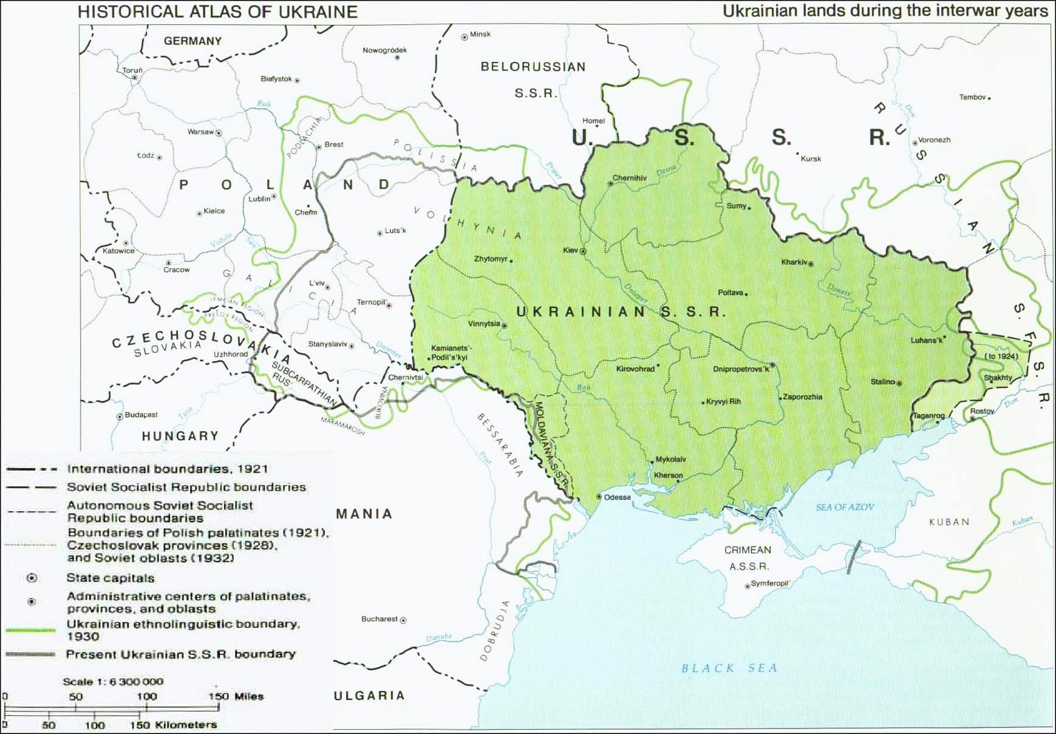
Figs. 14 Ethnographical Ukraine in East-Central Europe.
Long before foreign factors became the “leitmotiv of the Great Terror”, and Stalin (who as Commissar at Narkomnats – the Peoples Commissariat of Nationality Affairs – between 1918 and 1923 had effectively created the bureaucracy of the USSR) galvanized a Kremlin reception to, ‘mercilessly annihilate everyone who by his actions and thoughts (yes, thoughts too) assails the unity of the socialist state’, east-Central Europeans realised that the spirit of the age was not, as had been naively predicted before the war, ‘supranational’, but ‘ultranational.’ British intelligence reports revealed their appraisal of the postwar situation:
‘Austria no doubt fears the restoration of Russia under an autocratic monarchy in alliance with Germany as it would enable the latter to keep her in complete subjection in the future; she would prefer a weak and independent Ukraine on her eastern frontier. A significant sign of the way Austria is being ignored in the Ukraine is the fact that Germany is insisting on the inclusion of Cholm in the Ukraine, while Austria, anxious to conciliate Poles, is doing her best to get it restored to Poland and find compensation fro the Ukrainians in Northern Bessarabia.’
Outside interference, especially after the Civil Wars, was extremely limited. Britain’s approach, along with the rest of the League of Nations members with no contiguous borders, was exemplified by Balfour in particular, and summarized succinctly by the Foreign Office; dryly filing the question away they suggested: ‘The League of Nations has now refused [in 1920] the request of the Ukrainian Government [for recognition]. The present series of documents [concerning the application] may be useful for reference.’ But as we have seen, in the “borderlands”, group identification did not necessarily correlate with a parents or even their own linguistic background. The creation of the ‘Successor States’ (the ‘non-Bolshevik alternative[s] to the Habsburgs’), became an endemic crisis, fuelling annoyance in the West at the ‘quarrelsome, extremely sensitive and short-sighted people with whom they had to deal.’ Their own ‘Minorities’ (particularly those in the French and British Empires), which they had conveniently removed from the more substantial parts of the Minorities Treaty, were quietly and temporarily forgotten.
The Ukraine, and therefore the contiguous territory with Poland, Czechoslovakia and Romania, contained a large proportion of European Jewry (in Ukraine about 1.6 million), mostly settled in Right Bank Ukraine, with almost three quarters living in urban centres such as Odessa, Kiev and Kharkiv. This area was ‘frontier country’ on the edge of the old Tsarist ‘Pale of Settlement’, and the Jews who settled there were ‘true pioneers who brought material and spiritual culture.’ They contained perhaps the ‘most civilized part of the population’, largely because of the historical legacy that the ‘Pale’ and its laws superimposed upon them. They had also ‘closely cooperated with the Polish landlords (Szlachta) who developed the country’, and were therefore largely the impetus for the ‘tremendous effort to colonise it.’ Notably, relations between the two are described as ‘frozen into and by history’, and even up to the present it is significant that the ‘Jewish encyclopaedia does not have a separate entry for Ukraine’; rather the discussion is located under Russia, Poland or Austria-Hungary. As a fundamental part of east-Central Europe, in the political, social and particularly economic frames of reference, the Jewish population found themselves increasingly at the mercy of nationalising influences within the “Succession States” and Stalin’s own search for “Deviationist” tendencies. The continuity between their seventeenth century positions was striking. In their essays Two Solitudes, the authors describe the Jewish predicament as ‘between a hammer an anvil: between landlord and serf, between Polish Catholic and Ukrainian and Muscovite Greek Orthodox, and between Pole and Muscovite.’ Contrast this with the Economists 1924 synopsis of Eastern Europe’s ‘Great Agrarian Revolution’, where ‘on the whole, the change has been for the better, since agricultural and cattle-breeding are showing rapid signs of recovery…[as] before the reform, by far the greater part of large estates were leased to peasants and worked by their primitive methods.’ The modernisation of east-Central Europe, despite later incursions, was a significant factor in interwar Europe, and it was largely successful in its implementation. The Second Polish Republic’s Sejm, under Dmowski’s Endecja, attempted an expansionist exclusive state (albeit with fourteen different administrations), which Pilsudski’s Coup (1926) failed to over-turn. Soviet Russia’s industrialisation through collectivisation hit the Kresy harder and sooner than most. For Ukraine ‘the year 1937 began with the year 1933’, and the peasantry and Jewish Shtetls were increasingly caught ‘between a hammer and the eagle.’
Brubaker makes a key point in understanding the ‘bricolage’ and ‘cultural scraps’ which make up ‘minorities’. The status of all minorities he suggests: ‘are…inscribed in the triadic nexus linking the minority communities themselves, the states in which they live, and their external national “homelands”’ [my italics]. In the Volchansky district, during the famine-stricken spring of 1933, Kopelev recalls visiting ‘several Russian villages’ (which for several centuries had been neighbours with their fellow ‘Ukrainians’), where a ‘pallid, edema-swollen’ peasant woman would not permit her son to marry a young Ukrainian woman: “I won’t let that Uke girl in my cabin – she’s unkept, unkempt; unclean. It’s all show with them: they whitewash their huts and dress up on holidays. Just like gypsies. But take a look under their ribbons, their beads, and what do you find? Lice and nits besides. Not a single bathhouse for the whole village.” Not surprisingly, in a nearby Ukrainian village he hears the following: “If my son takes a Russky girl, he can go and live in the home of his father-in-law. I swear I won’t live under the same roof with her. Those Russkies live like pigs: their huts aren’t whitewashed, never swept, cockroaches everywhere, bedbugs. Their main claim to fame is that they all go running to the bathhouse every Saturday. Big deal; they whip themselves like madmen and then sleep in the filth again.’ Such an identity is familiar and not national, it is firmly situated in ‘the Idols of the Cave” and not traced upon the idea’s of ‘learned men’ or the ‘dogmas of philosophers’.
Externally, peasant political parties throughout the region propagated action in the so-called “Green International.” The appellation was an alternative to the “Red International” of communism and the “White International” of landlords and capitalists. The borderland regions were still characterised by a ‘low degree of ethnoterritorial identification and a high degree of indifference’, and an awareness of the international interests in commodity prices and exchange rates were therefore correspondingly patchy. The peasantry understood that there were external pressures but, just as in the more modernised western states, they also either chose to ignore the warnings or were unable to implement reforms in time. In Poland large scale peasant rebellions increased during the 1930s, with 40,000 to 50,000 gathered in Kolbuszowa, a town of just 4,000 (fifty per cent Jewish). There, they were protesting against – and boycotting - the marketplace, in favour of their own cooperatives. The Warsaw government and the catholic hierarchy ‘muttered darkly about the Jewish problem’ and the need to ‘regain control of the economy.’ However, Peasant politicians often used the requisite language but did not have the impetus to carry out reforms. Roumanian politicians exemplified this approach. They stated that: ‘the program of the newly created National Peasant Party in Rumania pledges…to "propagate the principles of a decentralization of administration and local autonomy within the framework of the political unity of the State as a whole.”’ A worthy example of modern ‘spinning’ techniques. Roumanian nationalism had evolved from a prewar movement, organizing on behalf of its extra-territorial population, into a Kingdom satiated with its acquisitions (Banat, Bukovina, Maramures, Bessarabia and Transylvania), with the impetus and “revolutionary ethos” that this new-found political union garnered. (Fig. 15) The National Peasant Party (1926), a fusion of several failed smaller peasant groups, (who gained a 75% majority at the ‘freest’ elections held in interwar Romania a year later) was only ‘successful’ in accelerating the impoverishment of small holders. There was also a particularly strong anti-modernism in Romania and its roots were evident in a recurring theme across east-Central Europe, an ideology which emerged most especially from the Narodnyks in Tsarist Russia and morphed, later on, into similar German Völkisch or Hungarian Nepies movements. The national struggle was serialised as a ‘clash between [Romanian] culture and the Semitic’ in a syllogistic proposition which went: ‘modernity is foreign to national culture; the foreigner is the Semite par excellence, therefore anything modern was likely to be Semitic.’
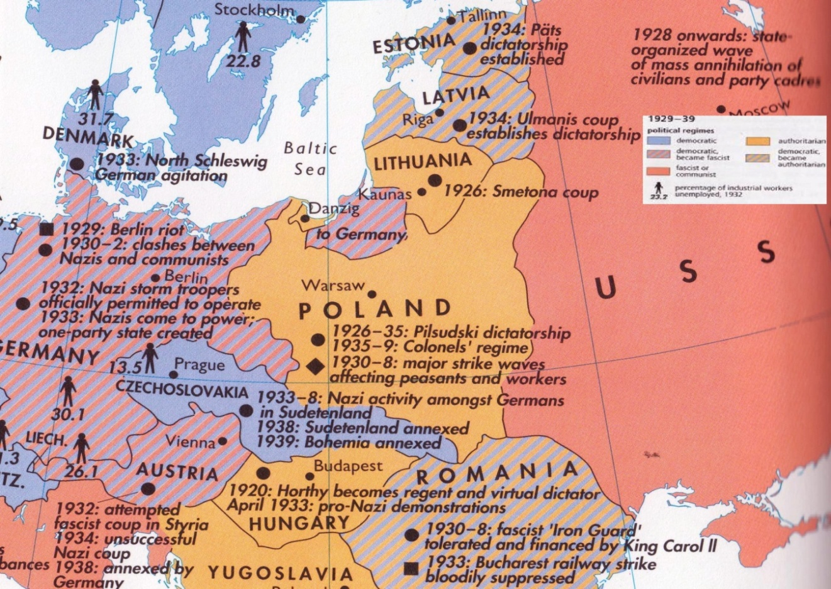
Fig. 15 Political and economic developments in interwar East-Central Europe.

Razvan Paraianu describes this ‘movement’ as an ‘idealist Weltanschauung’ within which intellectuals became ‘acquainted with…Volkisch ideology, Social Darwinism, Wagnerian mythology, Nietzschean philosophy’, an attempt at “togetherness” rather than the “loneliness” of the modern world. Here indeed are the “Idols of the Market Place”, forlornly gazing upon the “Idols of the Theatre”.

IV
Shtetls, Peasants and change: towards the un-tasted fruit.
This chapter will focus upon outside accounts of the region, simultaneously reviewing the political and economic events which drew all of Europe both closer together and increasingly, diametrically opposed. Individual reminiscences will draw upon memories that, although touched by subsequent events, often illicit events which on reflection, reveal more than contemporary accounts are able to provide. Elie Wiesel was born in the Shtetl of Sighet Marmatei (1928), which had been a small regional capital in the North-Eastern corner of Austria-Hungary, but ‘reverted to Transylvania and the postwar’ enlarged Kingdom of Romania. Two million Magyars were therefore added to Romania - a subject for festering irredentism amongst Hungarians - as well as approximately 800,000 Jews, whom Crown Prince Michael of Romania regarded as ‘Galician’, consisting mainly of ‘petty tradesmen and small money-lenders.’ ‘Revisionist’ Hungarian children, ‘within’ and ‘without’ their mutilated state, were drilled in the mantra: “Hungary truncated is not a country; Hungary intact is the divine will.” Indeed, Wiesel later recalls having to ‘learn the Hungarian national anthem overnight’, this following the Second Vienna Award in 1940. His recollections on language illustrate the complex ethnolinguistics which existed in this largely Jewish border town. Yiddish predominated, which suggests this was a largely Hasidic community (Yiddish is still taught today amongst this particular Jewish sect), but he also spoke ‘German, Romanian, and Hungarian’, whilst in the family store, ‘you might also hear Ruthenian, Ukrainian and Russian.’ He admits ‘you need to be a polyglot to communicate with the peasants’ - shades of Lev Kopelev’s youthful infatuation with Esperanto here – adding that just a few words would often do as ‘most of our customers could get along in Yiddish.’ In Poland – in the ex-Austrian province of west Galicia – Jewish shopkeepers looked back to “the golden times”, whilst those in the Shtetls, who had had the strongest ties with the Austrian ‘Polish peasantry’, increasingly in-migrated to the towns because of their ‘growing sense of isolation and increasing pressure to leave.’
Romanian peasants, as with the rest of east-Central Europe, were a predominantly youthful population (over half of Eastern Europeans were under thirty), on farms which were largely unable to support even the existing tenants. The problem of population surplus was immediate. Regional ‘holdings’ were half that of German or French farms, with Czechoslovakia having an excess population of two million, Romania three million and Poland around six million. Without the ‘benefit’ of totalitarian government, at least one as powerful as the Soviet Union, east-Central European states were at the mercy of world farm prices and in particular, western governments immigration policies. Peasant parties were often brutally frank as to whom they regarded as their enemy: “The way of life in the village is uniform; its members hold the same ideas in common. That accounts for the superiority of the village over the village over the city. The city people live by deceit, by idleness, by parasitism, by perversion.” It is surely more than coincidental that the transformation of the Soviet economy ‘from a rural peasant-based economy to an industrialized, mechanized agricultural economy…in the 1930s led to mass deaths from famine and dislocation.’ (Fig. 16) The disparate nature of the peasants, from the ‘better-off’ and ‘agriculturalists’, ‘down gradations of cottagers’ who possessed a home but no land, through to ‘rural proletarians in varying degrees of destitution’, contributed towards their failure to escape the poverty trap and offer effective political reform.
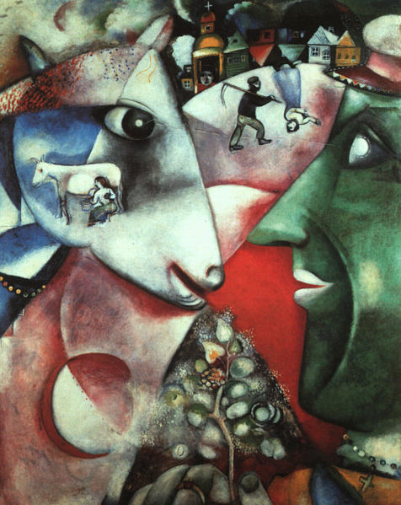
Fig. 16 Marc Chagall, I and the Village (1911)

The Economist’s 1929 summary of Europe’s economic outlook was bleak. Hungary’s crops were satisfactory but ‘prices on the world market were so low that exports were often made at a loss.’ Romania, which also had the benefit of oil production fared little better. Both countries decreased their debts but the overall tax takes were lower, because ‘[t]he decreasing deficit of foreign trade [was] due to the diminishing purchasing power of the [peasant] population.’ In a re-run of Russia’s prewar economic problems, the discrepancy between agricultural and industrial prices directly affected the peasantry, a situation which could only be ameliorated by tariff reform. The world-wide depression – particularly in agriculture – encouraged a new defensive ‘huddling’ of those agrarian countries which had failed to industrialise. The dislocation in the east-Central Europe economy and the growth of ‘national capitalism’ hinged upon ‘Poland and her fellows.’ Any goodwill that she and others undertook for their own minorities, would always be on the condition that ‘similar obligations were accepted by all sovereign states in the world’; the persecuted minorities in Upper Silesia who were seeking sanctuary in Germany, were only the thin end of a wedge which had already experienced economic ruin, ‘brought about by policies of economic self-sufficiency practised by both new and old nations’. German economic expansion was a necessity for the region, and rather than flooding east-Central Europe with ‘cuckoo clocks, aspirin, and thermometers’ in exchange for raw materials, it could and did ‘encourage the diversification of vulnerable one-crop agricultures, and offered a steady market at reasonable prices.’ The portents were however, not good. Reader Bullard a British Diplomat in Moscow in the 1920s and 1930s, whilst speaking to a German agricultural expert, discovered that in the Ukraine famine prevailed, but ‘doctors have been ordered to cease giving certificates that deaths are due to starvation.’ (Fig. 17) Worse still Schiller, the Agricultural Attaché at the German Embassy, reported taking a photograph of a boy whose thighs were ‘only about three or four inches thick.’ He was told: ‘That is going to happen to us’, by two women ‘with tears streaming down their faces’ who then asked tellingly, ‘to give that picture to the newspapers in America so they may send us food?’.
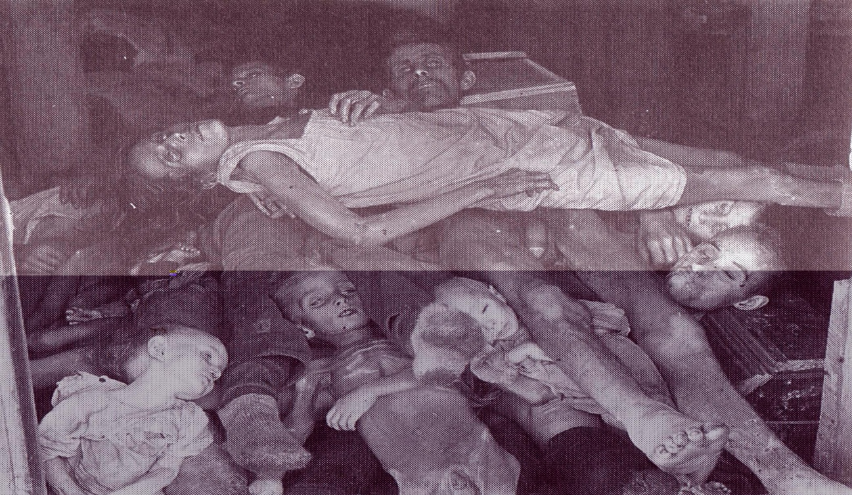
Fig. 17 ‘Refugees’.

The dislocation of people was not representative of the geography of the region which, though complex, was not as insular and isolated as that of south Eastern Europe. Broad rivers gave access to the sea and, apart from the arch of the Carpathians, much of the region is relatively flat and low-lying. The Kresy exemplifies the organic trade which existed and which could be built upon. The majority of the peasantry were bi-lingual and had developed skills which could take advantage of the benevolent landscape but often harsh climate. However, the reforms that governments did introduce in the interwar period, such as support for cooperatives, an expansion of rural credit, and the promotion of industrial crops, ‘benefited almost exclusively the relatively small number of prosperous peasants.’ Underlying the interwar drive towards self-sufficiency, and the concomitant desire to both improve agriculture and produce a mono-cultural population, was the necessity to expand the armed forces for the ‘coming inevitable armed conflicts.’ The improvement in the peasantry and Stalin’s “poor and rotten soldiers” - winnowing out unsuitable potential soldiery - is suggestive of in itself, the self-same need to improve the countries land/soil and its ‘fruits/seed’. In Between the Woods and the Water, the author notes that the old Hungarian rulers were no more illiberal than the new ‘Rumanian rulers’, and that in the past there ‘were fierce times in Eastern Europe; and they still are.’ He equates the Transylvanian region to the ‘tumbling demesnes of the Anglo-Irish in Waterford or Galway, with all their sadness and their magic. Homesick for the past, seeing nobody but their own congeners on the neighbouring estates who worked there, they lived in a backward-looking, a genealogical, almost a Confucian dream and many sentences ended with a sigh.’ Amongst their ‘Rumanian multitude’ one could be forgiven for thinking that the expropriated were no less disorientated than their ‘oppressors’, with the kindness shown to a stranger the last opportunity to prove their own personal civilization was still intact.
Lewis Namier (1888-1960) was a British subject born into a Galician Jewish family, and as part of The New Europe group of historians, he favoured national self-determination with, ‘a few echoes of the Whig vision of history as a series of hard-fought battles against monarchical absolutism’, leading ‘inevitably’ to a cabinet led constitutional government and religious tolerance. Namier also held more Marxist interpretations, which formed part of a singularly Galician socialist reading of ‘what was to be done.’ There they had decried both the ‘exploitation of underdeveloped Galicia by developed Western Austria and the exploitation of the Ukrainian Peasants by the Polish landlords’; and under the tutelage of the Eastern Galician socialist Weissburg, adopted a progressive approach to reform, which was unfortunately overturned by the first waves of fleeing students from Tsarist Russia. Back from the war and working within the British Political Intelligence Department (PID), Namier held to the belief that the nationality problems were a symptom of the underlying class struggle. He explained that Polish imperialism, advocated in particular by his old nemesis Dmowski, existed because the ‘Little Russians, White Russians, and Lithuanians of these [Galician] provinces hate the Poles with a truly fanatical hatred; it is the hatred of a land-hungry peasantry against alien landlords.’ Leigh Fermors experiences in Transylvania, and his assessment of its roots fits closely within the Galician problems which Namier and others hoped to solve. Namier went further by insisting that: ‘For the last 100 years the Conservative elements in Poland have been opposed to “maximalist” or revolutionary tactics with regard to the partitioning Powers; having much at stake they disliked a policy of adventure and preferred to gain some measure of power and freedom by a show of loyalty to their rulers (moreover they naturally disliked revolution of any kind).’ This not only ignored the numerous Szlachty led up-risings - further alienating him from an increasingly antisemitic British intelligentsia - he was forced, as were many others, to conclude that:
‘[T]here is no reason why an ultra-nationalist, anti-Semitic Communism should not arise. Capitalism, in its individualist outlook, was international; Communism, aiming at a nationalized economy, is basically national, and its internationalism will probably disappear like that of the French Revolution. And then woe to him who in a Socialist community will be considered as a stranger!’
The Poles and the Magyars shared, along with the Germans, the notion that they represented the ‘Bulwark’ against the invasive east (Fig. 18). They had of course also forged their own identity and statehood by such incursions. The Poles had recently ‘saved Europe’ with their own modern version of Marathon or Waterloo, and had also defeated the Turks at the gates of Vienna. Poland’s pride in its achievements was echoed by Lord D’Abernon on an epic scale, highlighting at once the growing ethnic and religious tensions in the world: “If Charles Martel had not checked the Saracen Conquest…at Tours…the Koran would now be taught at Oxford. Had Pilsudski…failed to arrest…the Soviet Army at…Warsaw…the very existence of Western Civilization would have been imperilled.” But by 1926 the Poles and their Sejm had become ponderous and its members continually bickered; as we have seen no cabinet could control the pressing problems that one of Europe’s fastest growing populations had to deal with. Pilsudski’s coup and the implementation of “Sanajca” (literally, purification) was an attempt ‘at recreating a political entity that reflected past glories’, but not at least initially, at the expense of the ‘minorities’. Pilsudski’s Sejm set about encouraging Jewish businesses and even rescinded the still extant Tsarist Russian anti-Jewish legislation. The new premier, Kazimierz Bartel expressed the belief that ‘attacking Polish citizens because of their language or religion [stood] in contradiction to the Polish spirit’, and Pilsudski (who exercised power from his position as ‘war minister’) regarded his ‘regime’ as a ‘guided democracy’, an ‘oxymoronic phrase’ taken up with gusto by the “Third World” after the Second World War. Jewish groups were encouraged by the new regimes rhetoric, and in this paternalist climate published a newspaper called simply Nation (1927). (Pilsudski’s death in 1935 brought an unusual invitation from local Poles to ‘join in paying the towns respects’ - which Salsitz himself thought unique). But the ‘cold pogrom’ continued and Neville Laski, a prominent member of the Anglo-Jewish Association, on visit in 1934 found the conditions even more distressing. Interviewing Mr. Wieslicki, a prominent Polish businessman, he asked if the conditions of the Jews that he had seen could be associated with both the Minorities Protection Treaty and the continued discrimination. Wieslicki remarked that: ‘the Treaty would soon be liquidated by the Polish government; Poland would not be deterred from denouncing the…Treaty merely because of her minorities [living] outside, or because of the Treaty of Versailles.’ As the brother of the British Labour MP Harold Laski, this may have been an attempt to neuter the negative response, which the British government was highly likely to proffer in the later negotiations at Geneva. The Fifteenth Assembly of the League (1934) was broadly speaking, an attempt by France to instigate an “Eastern Locarno” which was to resemble the “Western Locarno”; in gaining Russia but ‘losing’ Poland and Germany this was made impossible. Poland’s use of Article XIX, which allowed for the ‘reconsideration of obsolete treaties’, not only ‘whittled down the existing minorities treaties to vanishing point’, it promoted ‘pressure for territorial treaty revision which will increase until it reaches breaking-point.’
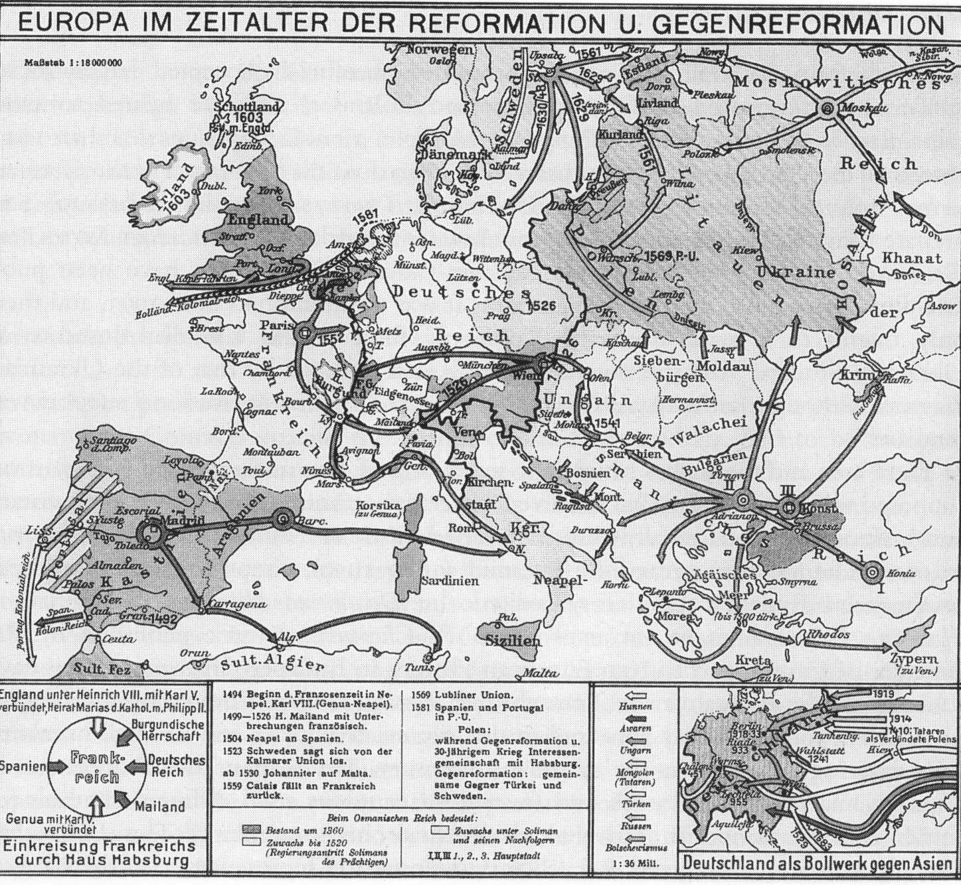
Fig. 18 The Bulwark against the East.

Isaac Metzker’s (1901-1984) short story To The New World, describes a young Galician’s last few days before leaving for America (the author emigrated as a stowaway in the early 1920s), and the gentiles relationship with their Jewish neighbours. The Eastern Jews lived in an environment alongside their neighbours, limited by its soil and harsh climate; where ‘the fragrance of the hops tickles…nostrils and mingles with the fragrance of fresh chalk and white earth and thin young trees with their thin branches. Pretty, beloved, dirty village in Galicia…' This world had made virtually impossible the ‘power-hunger’ and the ‘pretensions to aristocracy’, which they regarded had blighted the intellectual life of the West. But beliefs were changing. Even in orthodox societies, the new generation ‘did not accept as readily the traditions…so revered by [their] fathers.’ Before the War, and ‘the time the Jews on the Russian side of the border were driven from their homes, [and] forced to flee from the Cossacks’, their gentile neighbours on Holy Days had ‘greeted them respectfully and wished them a good year.’ Peter Potichnyj found himself in the new Polish state - having been born in Western Ukraine – and his family, not unlike most, were ‘caught in the storm of repression and intimidation unleashed by some chauvinistic elements in the Polish elite.’ The Kresy was contiguous with Galicia and both communities sought emigration - particularly those young men from the Yeshivas (academies) - to such an extent the Neville Laski carried certificates for Palestine around in his pocket whilst ‘visiting Warsaw.’ The population in the Polish capital was growing at forty thousand annually, and emigration was often unfeasible because of lack of money and ‘destinations.’ Rational explanations as to the nature of Moscow’s plans for the Kresy, which was still recovering from the 1924-25 droughts, had by 1933 convinced, amongst millions of others, Lev Kopelev. Confiscating grain was important, for as ‘warriors on an invisible front, fighting against kulak sabotage’ it was a struggle for socialism, as Stalin had stated. But they also fought ‘for the souls of the peasants who were mired in unconscientiousness, in ignorance, who succumbed to enemy agitation, who did not understand the truth…’ (Fig. 19)
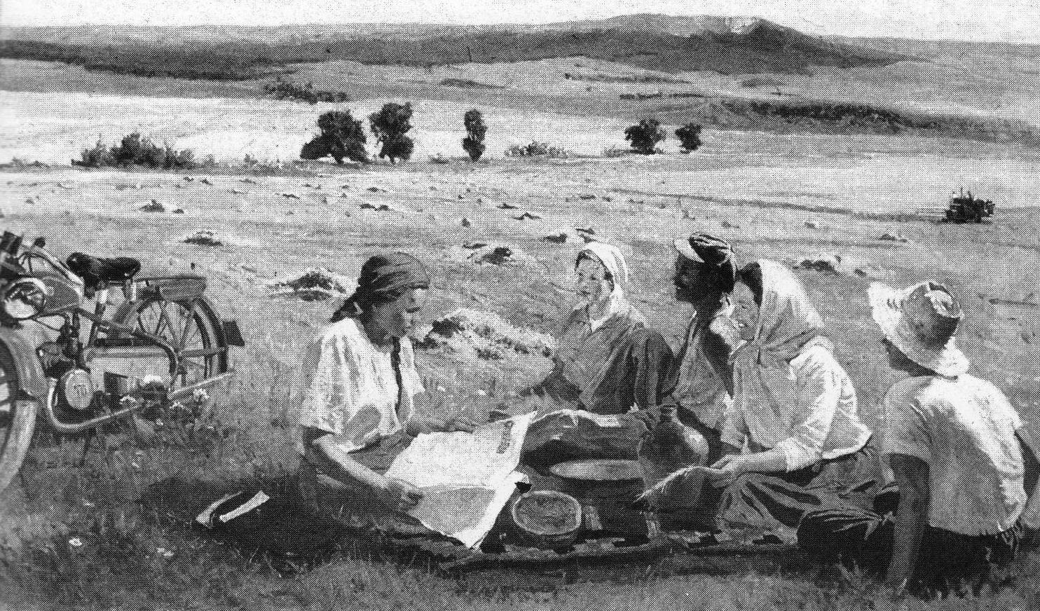
Fig. 19 ‘Europe Deceived.’

The Great Leap Forward was to have catastrophic consequences for the borderlands -literally mired in superstition - where in order to combat drought the locals would either pour water over the grave of a drowned man (to the consternation of ‘their faithless priest’), or ‘harness a woman (preferable young and pretty) to a plow and scatter poppy seeds behind her.’ A seasoned veteran of both the ‘German war’ and Civil War scoffed at the Kurkuls (also “turkeys, gobblers, hoaxers”), who would hide seventy thousand pounds of grain whilst allowing their kids to starve: ‘The hoaxers hope he can sit out the…collections, we’ll give up, then he’ll stuff himself silly. Or else he’s afraid we’ll find the hoard, take away the grain. Then his family’ ll be hungry…and he’ll be cooling his heals with the polar bears. Cunning as cunning can be, but stupid. I know them real good. Born here, ten kilometres away.’ It should be noted that the inference given through the translation is en passant, distinctly that of a ‘good ol’ boy’ with both negative and positive connotations. Indeed Ukraine as a melting pot comprised of Germans, Russians, Greeks, Italians, Jews, Moldavians and Swedes, with a temperate climate, large river valleys and rolling plains has something of the ‘wild west’, situated as it were between the Cossacks and the Tatars (Native American tribal regions?). Further, the plantations of America’s southern states (Virginia, Georgia) could be analogous to the Pale of Settlement and Catherine’s Novorossiya (new Russia). The distinctive summary justice (the Samosud) or Jewish kahal - where the community and rabbi dealt with disputes and meted out punishment – are all indicative of a “backward” subsistence culture which understood its own limitations but was prepared to defend itself. It also should be remembered that whilst the railways could bring cheaper factory-produced goods, they would also as likely as not, tie whole regions into a cycle of dependency and out-compete with similar products produced locally. “Home-grown” stone hammers, chisels, knives and household implements ensured that the ‘kresy postrevolutionary economy [had] a good measure of economic and cultural self-sufficiency…[and] the nonhierarchical and syncretic nature of culture and religion…was well adapted to going underground, to subsisting quietly, unofficially, beyond the reach of cultural authorities.’ (Fig. 20)
The incursions of the Soviet NKVD into the borderlands and subsequent forced emigration contrasted markedly with the Polish response to the Great Depression. The eastern Borderlands had not added to Poland’s economic output in any substantial way, and their inclusion in no way compensated for the loss of the old Tsarist Russian market. Poland’s bloated army (taking a whopping thirty five per cent of GDP) exacerbated a collapsing industrial sector, which by 1932 was producing only fifty four per cent of her 1913 finished cotton output, and a paltry thirty four per cent of her prewar steel production. Caught between the necessity to reschedule foreign loans or utilise Soviet-style modernisation of her industrial sector (which she probably was ‘more impressed by’), the Poles failed to join the ‘Little Entente’, and having signed a worthless Convention with the French in 1921, signed separate pacts with her insular and unruly neighbours. The question of minorities - though it should be remembered this did not apply to Ukrainian ‘nationals’ - was not pressing for the Poles. Poland, along with other nations, was reaching its dénouement in respect of the minorities. Was she ‘more anxious to be quit of her own obligations…than to persuade other Powers to undertake the like’, or were they also ‘less anxious to preserve for Poland’s [and by implication all other] subject minorities their existing guarantees than to avoid being manoeuvred into putting themselves under the same obligations as are now incumbent upon Poland.’ The United States had no ‘minorities’, and they would not have been ‘obliged’ under the Treaty anyway; neither were the Imperial powers subject peoples. But as ‘Article 74 [Minorities Protection Treaty]’ stated: ‘“nationality” was to be a matter of individual choice, not something automatically deduced from native language, and not subject to review or correction by officials.’ However, for millions of people the infatuation that the Leagues ‘League of Governments’ had with their own sovereign status, was increasingly seen to be made at their expense.
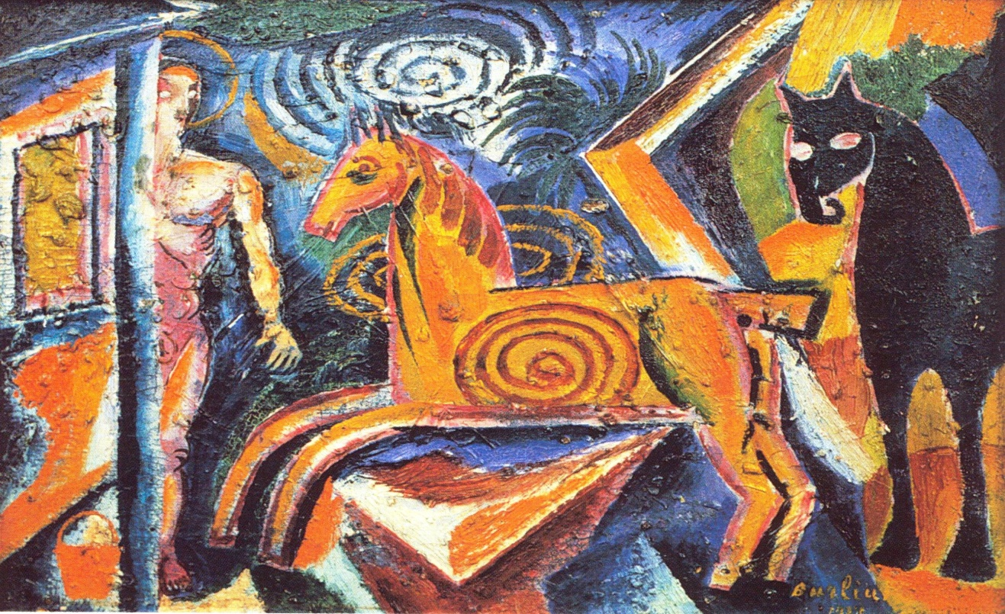
Fig. 20 Carousel, 1921.

Reconstruction of east-Central Europe would have been no small undertaking at any other time in history. But Poland did not achieve ‘economic union’ until the new currency was finally applied in Upper Silesia in 1924, this in a nation with 66 types of rail and 165 different locomotives. The emigration rate had reduced from 178,000 per annum in 1906-10, to 58,000 across Eastern Europe by the mid-twenties; population pressure was further exacerbated by a rising population and ‘nostrification’ of industry, particularly in Romania and Czechoslovakia. In the ‘Danubian Lands’ confiscation of assets belonging to Austrian, German and Hungarian capitalists, fed upon the idea that ‘political independence was incompatible with economic dependence…acting as a powerful stimulus to industrial development in [these] primarily agricultural countries.’ Hayek, assessing the conjuncture of socialism and nationalism suggested that: ‘In the Central European countries the socialist parties had familiarised the masses with political organisations of a semi-military character designed to absorb as much as possible of the private life of the members.’ There was both a strong anti-capitalism and a corralling of the group throughout the region, combining forces which on the one-hand defined the enemy as internal - “Jew” or “Kulak” - or an externalised threat of the ‘other’. The more libertarian postwar views of Hayek were in marked contrast to those of the time. Harold Laski in Liberty in the Modern State perhaps sums up his own era more acutely: “Those who know the normal life of the poor, its haunting sense of impending disaster, its fitful search for beauty which perpetually eludes, will realise well enough that, without economic security, liberty is not worth having.’
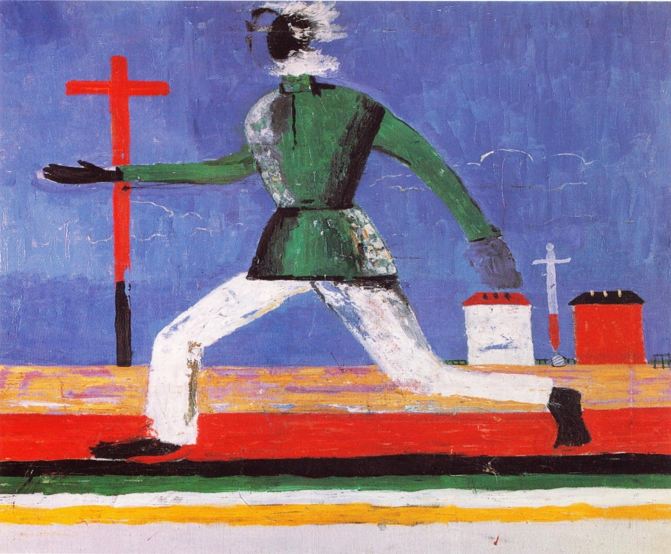
Fig. 21 Kasimir Malevich, The Running Man, 1933-34.

V
Return to Babylon.
“Like the Jews that Moses led out of Egyptian slavery, the half-savage, stupid, ponderous people of the Russian villages…will die out, and a new tribe will take their place – literate, sensible, hearty people.”
This chapter utilises oral history and personal testimony, with particular reference to the sharpening of appetites on the ‘national front.’ German, Polish and Jewish relationships are at the forefront, but attention is also paid to the regions peasantry and the political repercussions which increasingly centralising states had upon their ‘subject’ peoples. William J.Rose on a visit to Silesia in 1932-3 was determined ‘to discover what people felt about the changes affected (sic) by the moving of the frontier’ a decade earlier. His methodology was not to leave a ‘few responsible people, of both nations, an exhaustive questionnaire’, as those of his fellow countryman had done before, but to investigate the human factors. His predecessors had had too ‘cavalier a view’ of economic and social relations, hoping in a few weeks to unravel the complex five-century-long tortuous inter-connections and conflicts, but often returning ‘empty-handed’ (at least one had ‘ended with a nervous breakdown’). In Katowice/Kattowitz, Rose noticed an Officer in charge of a ‘city kitchen’ and was informed, ‘if you want to eat here you must go and get tickets at the office.’ His surprise at appearing ‘thin’ was not shared by a friend who told him ‘that of late the number of the intelligentsia out of work as such that no one could tell from clothes whether one is in need or not.’Rose noted ‘only half of the great chimneys were smoking’ whilst ‘hundreds of men, women and children busy in the fields’ collecting potatoes, which is suggestive of substantial under-employment and poor social welfare. But his encounter in a café full of bilingual Poles and Germans led him to conclude that ‘in ordinary living there is no nationalist friction at all.’ Speaking in German he asked (after twenty minutes of listening), how it was that people could know in which language they were to greet one another. ‘Ach, man kennt seine Leute! [One knows its people!]’, was the response from a woman, who added that she had started school ‘in German’ and left it ‘in Polish.’ Katowice was and still is the most heavily industrialised part of east-Central Europe, often suffering from chronic economic problems, but its people ‘lived their lives’ in and around the city, where there was ‘scarcely a bit of tillable soil lying waste – at the worst it is pastured by sheep and goats.’ This was a land in which country and town lived side-by-side, where the land had a temporary status and fluctuated, as did its people. Another William, this time from England, visiting Poland in the Eighteenth Century had noted: “In many places I observed the wood encroaching upon the fields…I was informed that this was the case in most parts of Poland, many traces of former enclosures, and even the vestiges of paved streets, being discernable in the centre of forests.’
Claude Lanzmann’s 1985 film Shoah is described as having ‘mysterious power’, and Lanzmann himself regarded it as a reminder that: “[G]enocide cannot be brought to life and to attempt this is in some ways to deny the reality of it, to ignore the upsurge of violence.” In recovering the details of the events, we are in some way searching for a continuity using realistic representations, and if ‘those living reality find its representation inadequate’, then searching into the past using the same methods would appear even more insurmountable. His use of geography, in ‘nine and a half hours of “travelling shots, pans”’, and utilising ‘small sites’ in juxtaposition with individual and group interviews, not only replaces pictures of emaciated ‘survivors’ by ‘liberating armies’, it provides a rare opportunity to listen to east-Central European oral history. His ‘refusal to visualize the past’, instead revisiting geographical sites as ‘pieces of earth where the events happened’, is beautifully displayed in his ‘interview’ technique. Martha Michelson, the wife of a German school teacher in Kulmhof (Chelmno) is asked why she had gone to the area (probably in 1939): “Because I was young [and] wanted to be useful.” She elaborates on the conditions (she had wanted to go to ‘Wartheland’): “It was primitive; Super-primitive.” Lanzmann agrees that this is ‘difficult to understand’, so Martha elaborates: “The sanitary facilities were disastrous… [t]he only toilet was in Warthbrucken, in the town. You had to go there, the rest was a disaster!” It was a disaster because, “[t]here were no toilets at all [only] privies.” The memory of the toilets was instantly recalled and the ‘backwards’ environment is encompassed within Martha’s recollections, but this short piece also reminds us of the importance that all nationalities in the region attached to education. The teaching of language was integral to any nationalization programme, and the decline in the ‘minority-school system’ was felt especially amongst those who had been made an ‘internal other’ in the ‘Successor States.’ Germans were particularly vulnerable in the Corridor Area where, ‘fewer than 25 per cent of German children attended such institutions in the 1930s, and in Swiecie/Schwetz county (Pomorze) the decline of German schools was absolute, from forty-one in 1925 to Zero in 1939.’ The ‘bureaucratic’ necessity to reassert German teaching, as part of a re-colonization process was apparently self-evident.
The pioneers of previous German colonization in the east, those in the Ukraine, the North Caucasus, and the Crimea, suffered disproportionately in the ‘dekulakization’ of the early 1930s. In an all-Soviet population of 147 million, approximately 1.8 million, or one and a half per cent, were resettled as “kulaks”; the German total between 1928 and 1932 was 50,000 out of around 1.2 million, or four per cent. (Fig. 21) Following on from Stalin’s ‘dizziness’, the subsequent famine killed a further 150,000 ethnic Germans, representing around twelve per cent of the 1926 Soviet census figures. Further winnowing occurred as the international temperature was raised. “The enemy is everywhere” reported a borderland newspaper the Marchlewska Radziecka in 1933; even local schoolteachers joining in what was increasingly becoming an ‘early modern’ style witch-hunt. A Ukrainian party boss reported ‘long lists of suspicious people sabotaging the border zone’; leaving open to question both the existence and motivations of those ‘others’ that remained in the Ukrainian Republic. Moscow informed the borderlands that: “The commission [on German and Polish Regions of the borderland] should explain to the population that Soviet power does not stand for the smallest attempts at anti-Soviet activity or agitation and will not stop at refusal of the right to live in the Soviet Union and exile to far-off places.” The desperate plight of ethnic Germans had not gone unnoticed in North America, where German language papers such as the Dakota Freie Presse (Bismarck, North Dakota) published excerpts of letters from overseas. They contained veiled messages, frequently using biblical sayings - which Soviet censors schooled in anti-religious doctrines found hard to understand – alluding to the Book of Job or “Read Isaiah, chapter twenty four”; or folk sayings such as “Nothing on the pot, nothing under the pot either.” A letter from 1933 stated:
‘[T[he commandants of our collective have told us, “Now you will see that wherever you destructive insects have settled in our land…that no God will drop manna from heaven to help you, and nowhere will anyone hear your miserable complaints. Hangings, shootings, starvation and freezing – all of those will be done to you if you don’t work to exactly meet the requirements of the predetermined plan.”
In something of an allegorical tale for its time, Vashchenko, the head of the Petrivtsy Soviet in Ukraine explained his method of catching peasants/kurkuls:
“He thought he was so smart. Buried it in a distant field. Only he didn’t outsmart the mice. They found his hoard. And the fox found them. And our lads there, who love hunting, noticed that the fox was always in the same place, mousing in the same field. So that’s how they found that smart hoard. It was filled up – half with grain and half with mouse shit.”
Whilst Soviet planning entailed implementing tout suite the agrarian policies of Tsarist Russia, in a swift attempt to feed its burgeoning industrialization policies (which Moscow regarded as essential in order to defend itself against a resurgent Germany), it also represented “social prophylaxis” and “prophylactic cleansing” in what Peter Holquist correctly identifies as a ‘unionwide antibandit operation’. Implementation of passports (by 1934 their were over 27 million ‘internal’ passports in the Russian Federation alone), which primarily kept ‘starving peasants on the land and out of cities’, prompted the son a dekulakized peasant who had moved from Ukraine to Moscow in 1932, to comment in his diary that: “not only institutions, but also the population follows this work with suspense…All in all, [passportization] is a sorting out, the newest model of a human cleansing machine.” This process, utilised in modern Europe with somewhat more subtlety, ‘played a critical role in fostering a sense of personal nationality amongst Soviet citizens by forcing individuals to proclaim a national sense of affiliation and thus fit themselves within a national grid.’ The apogee of such a process was reached in July 1937, with the infamous NKVD ‘order 00447’, which provided a quota system for those to be repressed in two categories within which : ‘To Category 1 belong the most hostile elements…they are to be arrested immediately and once their cases have been examined by a three-judge panel-SHOT.’ The People’s Commissar for Internal Affairs and State Security, N. Ezhov, had become ‘witch-finder general’, and led (with Stalin’s blessings of course) the attacks upon the ‘the fascist hirelings’ in an atmosphere of fear and poisonous denunciations. Solzhenitsyn succinctly conveys the zeitgeist:
“A new generation had grown up. Its members had no personal memories of the preceding period…they accepted the interpretation placed upon it by their Komsomol instructors…During those years Russia underwent a kind of retrogressive development. The Party had become our father and we, the children obeyed.”
That the state was to be obeyed - despite the harshness of the methods used - and where the very words “me” and “mine” had been forbidden, are testament to Solzhenitsyn’s statement. In some instances where deportees were transferred from western Ukraine to eastern Ukraine, and officials had been notified to not disclose the ‘refugees’ national identity, they arrived as “foreigners” (in their own country!); but once they ‘stepped down from the trains…the secret was out.’ Poles and Germans were easily identified (thanks to Moscow’s previous policy of encouraging linguistic diversity, amongst others) and were greeted thereafter, Edward Guzovskii recalled, as “resettled persons” to whom the ‘locals’ shouted: “We’re going to drag you Poles out and feed you to the dogs.” Identity was firmly established in the minds of ‘others’ and state policies had neither subsumed or alienated those whom it had wished to supersede. It was also the isolation, as Solzhenitsyn had noted, that individuals remembered. A woman from the Kresy, Vera Mikhailovna, seeking to expunge NKVD records in the Zhytomyr State Archive, as a passing remark said sadly, “I was hoping to find some family member, but everyone is gone. I don’t find my maiden name now anywhere in town, I am all alone.” Asked why it was important to see just a name of an arrested or imprisoned relative she elaborates. “Until not long ago, family histories were something to hide. Everyone had scars on their family tree, a repressed father, an exiled aunt, someone with a prison record. It was better not to pass that information on to the children. So now people don’t know anything about where they come from or who their family members were.” The archivist could give her a thorough knowledge of her family history – but no individuals.
The Jewish population in Poland, and other groups who were contiguous with the Soviet border, had to contend with their state authorities, in an increasingly fractious climate of fear in east-Central Europe. Zhytomyr was just sixty miles from Poland’s western border and it is difficult to believe that in such a traditional borderland, encompassing a broad range of customs, attitudes and sharing religious and historical consciousness, that common knowledge of the extent to which populations were being “resettled” was not widely diffused. (Fig. 10) The Soviets decision to join the League of Nation (1934), heightened fears in Poland that’s it significant Russian minority would now find a voice in the wilderness. Germanys decision to withdraw probably emboldened the Poles to follow suit; and it also allowed them to ignore their responsibilities under the Minorities Treaty, particularly in the still contested borderlands. As the Soviets cleansed their borders - though Belarusian Poles and Germans seem to have stayed longer than in Ukraine, which had established its minorities programme seven years earlier - locals who remained viewed the resettlement not as shoring-up defences but as a ‘premature military defeat.’ Deportees recalled the Ukraine in a similar manner as Germans recall Heimat, with nature and forests alongside memories of ‘sticking…hands deep into my grandfather’s beehive and eating the honey by the fistful’, or everything ‘had been fine, until the spring of 1935’, but ‘[w]e were given a few hours to pack our things, only those which we could take in our hands. We left all the rest behind, the hives, our house, and the furniture.’ Elements within the Polish elite were, on a much smaller scale, executing their own clean-up operations. Peter Potichnyj recalls that his own father (a Ukrainian Jew) spent time in jails ‘on several occasions’, the last time ‘in the infamous concentration camp Bereza Kartuzska.’ The chipping away at east-Central Europe’s diversity was well under way, and the sculpting of the individual nations could begin apace. Lev Kopelev equates the ‘foreign…essence of Stalin’s rule’ with the drive to establish ‘agriculture as a cooperative enterprise’ in the Kolkhozes. The village commune’s organic development from the Old Russian Obshchina and the Ukrainian Gromada ‘did not contradict the principles proclaimed…in 1917.’ The new ‘reforms’ were foreign, and ‘had already become an autocracy of bureaucratic serfdom.’ (Fig. 19) A pastoral ideal was being posited throughout much of Europe, but it was in the east that it was developing its cynical dénouement.
Resistance in the linguistically Ukrainian parts of the borderlands was led by the UVO (the Ukrainian Military Organisation), and in the Polish parts of the Soviet borderland by the POV (the Polish Military Organisation). These groups along with the Ukrainian OUN (the Organisation of Ukrainian Nationalists) - a ‘highly disciplined underground movement dedicated to the overthrow of Polish, Romanian, and…Soviet rule’ - intended to destabilise the oppressive host nation and, in a similar manner to Pilsudski, Hitler and Stalin, instigate a defensive programme of ‘integral nationalism.’ By 1933 the POV had become largely redundant, but Vsevolod Balytskyi, the Chief of Security in Ukraine, ‘conjured POV back to life’ to ‘provide overwhelming evidence…of enemy nations’ and nationalist conspiracies. His ‘talent’ was to combine these external threats within the autonomous regions of ‘Polish’ Marchlevsk and ‘German’ Pulin in the Kresy. (Fig. 10) Inspections organised by Balytskyi in 1934 revealed that whilst the Union average for collectivization was 71 per cent in Marchlevsk they ‘achieved’ only 32 per cent; German colonies in Left Bank Ukraine (Eastern Ukraine) collectivized 89 per cent whilst those in Pulin had registered only 34 per cent. Clearly the region was “infested” with wreckers, pro-emigration agitators, smugglers or those seeking aid from foreign governments. In Upper Silesia (Western Galicia), two hundred miles to the west, W.J.Rose in 1933-4 was ‘on a visit to Myslowice, the last German station on the line leading to Cracow…to look at the “corner of the three empires.”’ He borrowed a bicycle and rode for two days throughout Polish Silesia, where he noted that on points on the new frontier, “roads, and even one railway, had been cut off rudely…causing no end of inconvenience to the local inhabitants.” It was he thought, ‘this kind of thing that made the Germans talk about the “bleeding” frontier. We also saw points on the pre-war frontier with Russia which had been notorious haunts of smugglers.’ Reader Bullard was discussing Ukraine with the Italian Vice-Consul (who had recently been in Kharkov), a highly regarded official, who having attacked the Party for its exploitation in the Ukraine, was told to ‘recant’ at the next party meeting: ‘He went to the meeting, asked for a few minutes to correct his speech, went into a side room, telephoned his wife to come for his body, and shot himself.’
Grabow lies between Warsaw and Upper Silesia, an interwar Jewish Shtetl, and not affected by the Gleichschaltung policy of ‘coordination’ in post ‘Reichstag’ Völksdeutsche Poland. As Lanzmann discovered it had a thriving Synagogue (Polish: “Buzinica”) which modern Poles remembered well. An elderly Pole could not remember the Rabbi because “her memory isn’t too good”, but Lanzmann (puffing on a cigarette and leaning nonchalantly against the woman’s outside wall) persists: “Barbara [the interpreter] tell this couple they live in a lovely house. Do they agree? Do they think it’s a lovely house? Tell me about the decoration of this house, the doors, what does it mean?” The couple responded that “[p]eople used to do carvings like that.” The doors had been decorated by Jewish people, they were over a century old; and in fact all the houses within the village square were owned by Jewish businesses. Lanzmann asks where the Poles lived – they lived in the courtyards where the privies are now. Such encounters are rare, and the interviewer has to understand his subject in order to illicit information. Later an SS Unterscharführer Franz Suchomel, breaks into a song that “worker Jews” in Treblinka were “encouraged” to sing as they marched off to their daily labours; Lanzmann’s “magic” prompts Suchomel to remark: “That’s unique – no Jew knows that today.” But the circumstances are not peculiar to Jewish Poland – similar dialogues would certainly occur across east-Central Europe and in the context of different nationalities. Germans in Upper Silesia were the subject of ‘expulsionist’ policies so as to increase Polish power. The ZPS (the Union of Silesian Insurgents) had a programme in German Silesia of “consolidating…the Polish position… [Whilst] combating the ‘privileged’ German position…by means of administrative measure not always consistent with the stipulations of the Upper Silesian Convention.” In other words Polish nationalists were willing, despite an Internationally agreed convention on ‘human rights’ for all Upper Silesian citizens, to use illicit means in ‘extra-territorial’ Poland, in executing an ‘integral-nationalist ideology.’ It would appear that Vansittart’s gratefulness that the Upper Silesian dispute would eventually please the Germans, whilst the ‘Poles swallowed the pill with reasonable docility’, had been premature.
Conclusion
The interwar period proved to be a hiatus which, as we have seen, was to be firmly pushed backed; for the policies of Stalin and others were ‘increasingly [directed] to the exigencies of the future’ – foreign factors were to be the ‘Leitmotiv’. Indeed the attempts by many to understand this period, and the territorial aspects which it throws-up, are indicative of it representing a possible ‘bridge between the pre-modern world of ancient regime Russia and the demands of modernity.’ The ‘resettlements’ which were carried out across east-Central Europe – part of a world-wide relocation still extant – came up against both peasant inertia (particularly in the Kresy) and an Intelligentsia led Glumilis’ in the Ukraine, which ‘sneered at the Dnieper…Dam and at Soviet Ukrainianization.’ Stalin was no normal man. When he had run-out of enemies - millions of who died throughout this period – and when there were ‘no new kulaks…marshals, generals’, he used ‘[a]n old tested trick, used by Tsar Nicholas’ and beat the Jews. The Poles and others had by then beat him to it. Timothy Garton-Ash warned of the wider-regions complexity, but creative and imaginative onlookers - Reader-Bullard and later Lev Kopelev - proved that a regional overview was indeed possible, even here beyond the ‘civilized pale’. Further research amongst the Russian archives may draw upon the feelings of the peasantry who lived in the borderlands, providing even more detailed thoughts on the region. Kopelev’s ruminations upon his own identity illustrated the confusion which reigned between nationality and human identity as a whole. Spontaneity became confused with forced ‘Exodus’, throwing-up words which were to become increasingly common and meaningless. ‘Citizen-refugees’ is as mealy-mouthed now as it must have been in the 1920s. Only the likes of Benes and Masaryk could fit this neat description.
The interruption of the Great War and its possible curtailing of both organic development and the intrusion of the global economy, proved decisive in curtailing as Rugg pointed out, any development of ‘human rights’ in the sense that this was understood in Western Europe. Salsitz confirmed that the new railroad ‘was never completed’. The ‘built railways’ were destined to carry-out a grotesque bacchanalian dance of death. As a contested space, the borderlands elicited highly combustible human emotions; the historical location was indeed a crossroads between the ‘German- speaking world and its eastern neighbours.’ Kate Browns ‘natural laws’ confirmed Vansittart’s concern that, ‘Homo Sapiens is still liable to Palaeolithic homesickness’. Moreover, ‘eating more fruit’ and a fashionable belief amongst anthropologists that: ‘dawn-man was a pacifist full of thalamic goodness and that violence [was] therefore the product of civilisation’, proved to be a false-dawn. The original sins of old Adam were not an opportunity for backslapping. Padraic Kenney reviewing the possibility of every nation affording a ‘Whiggish view of history’ concludes that this ‘twist to modern Poland’s narrative’ may be an invitation to further historical enquiry. Polish treatment of their own minorities – and it was the ‘Zbaszyn outrage [which] unchained the tragic sequence of events’ leading to Kristallnacht – illustrated by both Blanke and their own pedantic antics over League of Nations rules, needs to be carefully but studiously investigated. The western powers failure to deal with Poland, Germany and Russia and the tensions which existed in League policy where their own minority problems existed (whether in India, Africa, the Caribbean or racial policy in the United States), handicapped both understanding and action. Interdependence and the International Monetary Fund are indeed one of the same. Understanding localism and the use of anecdotal evidence can reveal gaps in understanding – indeed contemporary witness accounts were and still are often ignored for political expediency.
East-Central Europe felt multiple tides of organic German settlers, the wash of wars and the rhizomania-style contamination of bourgeois State Socialism, in a period shorter than that which separated the Falklands War from our own. Stalin manoeuvred Russia, and by implication all of Eastern Europe, into a ‘political paradox’, prompting Colonel Beck, the Polish Minister of Foreign Affairs, to invite Romania in joining him in a cordon sanitaire between Russia and the west. By 1937 domestic upheavals in Russia had led Britain - not for the first time - to invite members of the German General Staff and attendees at the Imperial Conference to countenance ‘peaceful collaboration.’ This fumbling around in the dark was not only badly thought out; it shattered the Minorities Treaty by conniving at the stultification of ‘solemn international obligations.’ These were not well-judged attempts at ‘meso-government’, making as Namier and others had, detailed observations of local cultures and economic ties; they were offerings to the idols and fetishes of sovereignty, ‘conceived as mystical abstractions or corporate personalities [overriding] the interests of mere flesh-and-blood men, women and children.’ Concomitant with the political machinations, in which the ‘agony of small nations’ was all too plain to see, the economic polarity which divided (and continued to divide for another fifty years) the sub-continent of Europe exhibited a Kafkaesque logic; where the peasantry used the ‘“moral economy” to denote popular conceptions of what is economically fair and legitimate, based upon customary notions of “social norms and obligations.”’ Whereas borderland peasants (and in Silesia evidently industrial workers too) utilised the ‘free market’, both the “Successors” and the “Revisionists” sort sanctuary in statism and its many varied forms. The Soviet economy, along with the Czech and Polish, although hindered by ‘international uneasiness about China and Spain’, saw substantial improvements in 1937. German preponderance in Central European economics was by far the most effective, utilising a complex system of long-term credits and substantial pre-purchasing of agricultural produce, enabling their poorer neighbours to buy imported manufactured goods which, whether defaulted upon or not, increased commercial and political dependence upon the former. The consequences of this policy are widely known. Nationalist agitation in Poland fanned the flames of the Auslandsdeutsche (which were utilised in the same way that Joseph Chamberlain used the British Uitlanders in the Transvaal before the Boer War), and similar disturbances in Eastern Galicia were produced amongst the Ukrainians. Richard Evans succinctly describes why the predominantly peasant population of this region failed to escape the poverty trap. At the crossroads between the German-speaking world and its eastern neighbours, this region also ‘illuminated the complexity of national identity’ as an arena in which ‘[n]umerous nerve lines tied together different cultural groups [and] environments [where] border populations understood their neighbours; they learned from them.’ When discussing east-Central Europe it is tempting, particularly with the frontier realignments, to end with an illustration of the situation extant on 31st December 1938. But this dissertation has sought to uncover and describe the less pointed incidents as well as reviewing the long duree. In the long run, to coin a phrase, all the frontiers (and by implication States) will exist either in paper (or digitally?); all nations ‘will be dead.’ The lines will not be revealed in the soil. But human beings have an uncanny knack of reflecting and revealing the effects of ‘Old Adam’. Omer Bartovs tour of old Jewish Ukraine reveals some startling pictures, none more so than from Zolotyi Potik, a small town in Ternopil’ (Polish Tarnopol) Oblast in southwest Ukraine (See Fig. 10 - where it appears in interwar Poland). The sands of the region are swallowing up the Jewish cemetery. Memorial history both illustrates and changes the uses of history. The memorial at Treblinka, on the borders of the Kresy, may provide a conundrum for future archaeologists when compared to the remains at Zolotyi. (Figs. 22, 23) Nadezhda Mandelstam suggested that:
Mass deportation is something new, for which we have the twentieth century to thank. Or perhaps the conquering despots of ancient Egypt or Assyria? I have seen the trains taking bearded peasants from the Ukraine…Then there were the trainloads of Volga Germans, Tartars, Poles Estonians…And again cattle cars with prisoners for the camps – sometimes more of them and sometimes less, but never ceasing…I have read somewhere that in the history of all nations there is a time when people “wander in body and spirit.” This is the youth of a nation, the creative period of its history that affects it for many centuries and sets its cultural development in motion.’
State intervention in the new accession countries has brought increasing denationalization in the borderlands of EU member states. In Kisselmenc, southwestern Ukraine, a “golden curtain” has replaced the iron one; the locals describing their predicament as needing to “sell your cow to buy a passport”. Under United States pressure a border control point was installed to provide a point of access; a “transition from ancestral lands to commodified space” was hoped for. Instead ad hoc arrangements became ‘privatized’ and ‘spatially confined’, with all its intendant modernizing influences. Rosa Luxemburg contended that: “Small-scale producers in developed countries and the whole non-industrialised, backward ‘third’ world are the suffering subjects of this constantly recurring process of accumulation and expropriation.” The tensions which further expansion may generate should be carefully thought through, with particular attention paid to the still extant ethno-linguistic nationalization differences which become closer to the ‘cosmopolitan, multicultural European Union’ protection which steam-rollers all in its path. We should not hurry youthful nations.
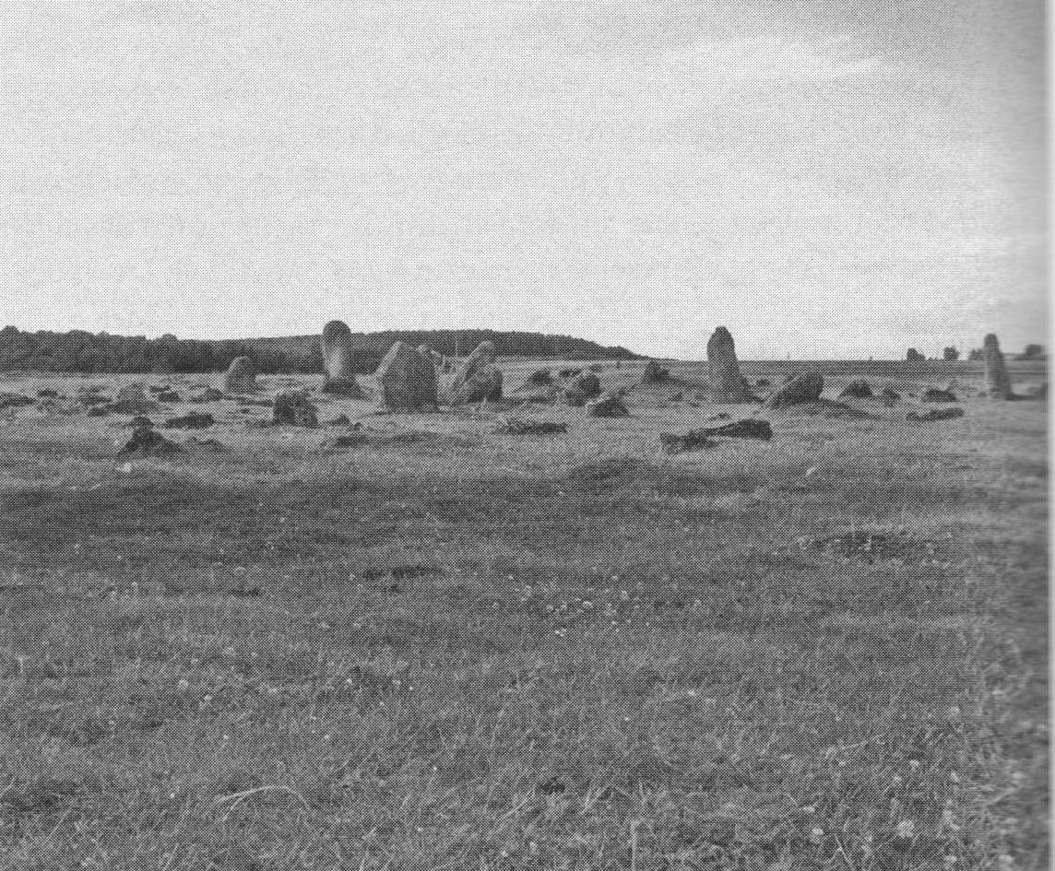
Fig. 22 Zolotyi Potiks old Jewish Cemetery (2004)

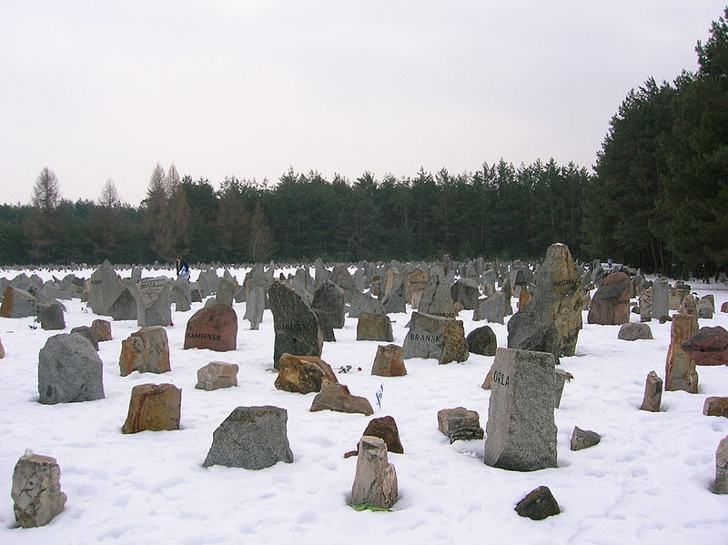
Fig. 23 Treblinka’s Jewish Memorial

Dissertation Bibliography

Primary Sources

Acton Edward and Stableford Tom, The Soviet Union: A Documentary History Vol. I 1917-1940, (Exeter: Exeter University Press, 2005).
Ashton S.R & Stockwell S.E eds., British Documents on the End Of Empire, Series A, Vol I: Imperial Policy and Colonial Practice, 1925-1945, (London: HMSO, 1996).
Bartov Omer, Erased: Vanishing Traces Of Jewish Galicia In Present-Day Ukraine, (Princeton University Press, 2007).
Bullard Julian And Margaret eds., Inside Stalin’s Russia: The Diaries Of Reader Bullard 1930-1934, (Charlbury: Day Books, 2000).
CAB/24/221; An Aspect of International Relations in 1931.

CAB/24/57/ 5010, Recent events in Ukraine, July 1st 1918.

Economist 1843 – 2006.

FO/371/5437.

Kopelev Lev, Ease My Sorrows, (New York: Random House, 1983).
Kopelev Lev, The Education Of A True Believer, (New York: Harper & Row, 1978).
Lanzmann Claude, Shoah, DVD videofilmexpress 2009, (First shown 1985).
Laski Neville, "Report on Journey to Austria, Poland and Danzig. August 15 to 31, 1934,” file 788 (Poland).
Leigh Fermor Patrick, A Time Of Gifts: On Foot to Constantinople from The Hook of Holland, London: John Murray, 1985).
Leigh Fermor Patrick, Between The Woods and the Water: On Foot to Constantinople from The Hook of Holland: The Middle Danube to the Iron Gates, (London: John Murray, 1986).
Namier L.B., In The Margin Of History, (London: Macmillan, 1939).
Potichnyj Peter J. & Aster Howard, Jewish-Ukrainian Relations: Two Solitudes, (New York: Mosaic, 1987).
Salsitz Norman, A Jewish Boyhood in Poland: Remembering Kolbuszowa, (Syracuse: Syracuse University Press, 1992).
Wiesel Elie, All Rivers Run To The Sea: Memoirs Volume One, (London: HarpurCollins, 1996).
Wiesel Elie, Night, (London: Penguin Classics, 2006).

Secondary Sources

Abramsky Chimen, Jachimczyk Maciej and Polonsky Antony eds., The Jews in Poland, (Oxford and New York: Basil Blackwell, 1986).
Acton Edward, Russia: The Tsarist And Soviet Legacy, 2nd ed., (Harlow: Longman, 1995).
Aldcroft Derek H. and Morewood Steven, Economic Change in Eastern Europe Since 1918, (Aldershot: Edward Elgar, 1995).
Allina-Pisano Jessica, ‘From Iron Curtain to Golden Curtain: Remaking Identity in the European Borderlands’, East European Politics and Societies, 23 2, (2009), pp. 266-290.
Applebaum Anne, Gulag: A History, (London: Penguin, 2004).
Arad Yitzhak, Belzec, Sobibor, Treblinka: The Operation Reinhard Death Camps, (Bloomington: Indiana University Press, 1999).
Atkin Nicholas and Biddiss Michael eds., Themes in Modern History, 1890-1945, (Abingdon: Routledge, 2009).
Ball A, ‘NEP 1921–28’, in Ronald Grigor Suny ed., The Cambridge History of Russia Vol. III, (Cambridge: Cambridge University Press, 2006).
Baron Nick and Gatrell Peter eds., Homelands: War, Population and Statehood in Eastern Europe and Russia 1918-1924, (London: Anthem Press, 2004).
Barraclough Geoffrey, The Origins Of Modern Germany, (London: Blackwell, 1988).
Bartov Omer, ‘Eastern Europe as the Site of Genocide’, The Journal of Modern History, 80 (2008), pp. 557-593.
Batonyi Gabor, Britain and Central Europe, 1918-1933, (Oxford: Oxford University Press, 1999).
Bauer Yehuda, rethinking the holocaust, (New Haven: Yale University Press, 2001).
Berend Ivan T., The crisis zone of Europe: An interpretation of East-Central European history in the first half of the twentieth century, (Cambridge: Cambridge University Press, 1986).
Berger David, The Legacy Of Jewish Migration: 1881 And Its Impact, (New York: Columbia University Press, 1983).
Berger Stefan, ‘Germany’, in Gerwath Robert ed., Twisted Paths: Europe 1914-1945, (Oxford University Press, 2007).
Bernstein Michael, Foregone Conclusion: Apocalyptic History, (Berkley, CA: University of California Press, 1996).
Black Jeremy, Visions Of the World: A History of Maps, (London: Mitchell Beazley, 2003).
Blackbourn David and Retallack James eds., Localism, Landscape, and Place: German-Speaking Central Europe, 1860-1930, (Toronto: University of Toronto Press, 2007).
Blanke Richard, Orphans of Versailles: The Germans in Western Poland, (University of Kentucky Press, 1993).
Blitstein Peter A., ‘Cultural Diversity and the Interwar Conjuncture: Soviet Nationality Policy in Its Comparative’, Slavic Review, 65 2 (2006), pp. 273-293.
Brandenberger D. L. and Dubrovsky A. M., ‘The People Need a Tsar': The Emergence of National Bolshevism as Stalinist Ideology, 1931- 1941, Europe-Asia Studies, 50 5 (1998), pp. 873-892.
Brittan Leon, Europe: The Europe We Need, (London: Hamish Hamilton, 1994).
Brown Kate, A Biography Of No Place: From Ethnic Borderland To Soviet Heartland, (London and Cambridge Ma: Harvard University Press, 2003).
Brubaker Rogers, Nationalism Reframed: Nationhood and the national question in the New Europe, (Cambridge: Cambridge University Press, 1996).
Bullard Julian And Margaret eds., Inside Stalin’s Russia: The Diaries Of Reader Bullard 1930-1934, (Charlbury: Day Books, 2000).
Butler L.J., Britain and empire: Adjusting to a Post-Imperial World, (London: I.B.Tauris, 2002).
Carmichael Cathie, Genocide Before The Holocaust, (New Haven and London: Yale University Press, 2009).
Chu Winson, ‘The Geography of Germaneness: Recentering German History in Interwar Poland’, GHI, 42 (2008), pp.94-104.
Cordell Karl and Born Karl Martin, ‘The German Minority in Upper Silesia: Electoral Success and Organizational Patterns’, Nationalism & Ethnic Politics, 7 1 (2001), pp. 41-62.
Crampton R.J., Eastern Europe In The Twentieth Century – And After 2nd ed., (London: Routledge, 1994).
Cymet David, ‘Polish state antisemitism as a major factor leading to the Holocaust’, Journal of Genocide Research, 1 2 (1999), pp. 169-212.
Davies Norman, God’s Playground: A History of Poland Vol. II 1795 to the Present, (Oxford: Clarendon Press, 1981).
Davies Sarah and Harris James eds., Stalin: A New History, (Cambridge: Cambridge University Press, 2005).
Dunn Seamus And Fraser T.G. eds., Europe And Ethnicity: World War I And Contemporary Ethnic Conflict, (London: Routledge, 1996).
Evans R.J.W., ‘The Successor States’ in Gerwath Robert ed., Twisted Paths: Europe 1914-1945, (Oxford University Press, 2007).
Felstiner John, ‘“All poets are Yids”: The Voice of the “Other” in Paul Celan’ in Robert S.Wistrich, Demonizing the Other: Antisemitism, Racism, and Xenophobia, (Amsterdam: Overseas Publishers Assoc., 1999).
Figes Orlando, A People’s Tragedy: The Russian Revolution 1891-1924, (London: Pimlico, 1996).
Figes Orlando, The Whisperers: Private Life In Stalin’s Russia, (London: Penguin, 2008).
Fink Carole, ‘Stresemann’s Minority Policies, 1924-1929’, Journal of Contemporary History, 14 2 (1979), pp. 403-422.
Fitzpatrick Sheila and Gellately Robert, ‘Introduction to the Practices of Denunciation in Modern European History’, The Journal of Modern History, 68 4 (1996), pp. 747-767.
Friedenthal Richard, Luther, (London: Weidenfield and Nicolson, 1967).
Friedlander Saul, Nazi Germany & The Jews: The Years Of Persecution 1933-39, (London: Weidenfeld & Nicolson, 1997).
Friedlander Saul, The Years Of Extermination: Nazi Germany & The Jews 1939-1945, (London: Weidenfeld & Nicolson, 2007).
Gatrell Peter, A Whole Empire Walking: Refugees In Russia During World War I, (Bloomington: Indiana University Press, 1999).
Graham Malbone Jr. W, ‘Central and Eastern Europe in 1924’, The American Political Science Review, 19 2 (1925), pp. 338-361.
Hartshorne Richard, ‘Geographic and Political Boundaries in Upper Silesia’, Annals of the Association of American Geographers, 23 4 (1933), pp. 195-228.
Hayek F.A., The Road to Serfdom, (London: Routledge, 1944).
Hiden John and Smith David, ‘Looking beyond the Nation State: A Baltic Vision for National Minorities between the Wars’, Journal of Contemporary History, 41 3 (2006), pp. 387-399.
Hirsch Francine, ‘Toward an Empire of Nations: Border-Making and the Formation of Soviet National Identities’, Russian Review, 59 2 (2000), pp. 201-226.
Hodza Milan, ‘The Future of Central Europe’, International Affairs, (Royal Institute of International Affairs 1931-1939), 14 4 (1935), pp. 514-530.
Howe Irving & Greenberg Eliezer eds., A Treasury of Yiddish Stories, (London: Andre Deutsch, 1955).
Hughes Michael, Inside The Enigma: British Officials in Russia 1900-1939, (London & Rio Grande: The Hambledon Press, 1997).
Hunt Tooley T., National Identity and Weimer Germany: upper Silesia And The Eastern Border, 1918-1922, (Lincoln: University of Nebraska, 1997).
Johnson Lonnie R., Central Europe: Enemies, Neighbours, Friends, (Oxford and New York: Oxford University Press, 1996).
Kenney Padraic, ‘After the Blank Spots Are Filled: Recent Perspectives on Modern Poland’, The Journal of Modern History, 79 (2007), pp. 134-161.
Keylor, William R., ‘Anti-Clericalism and Educational Reform in the French Third Republic: A Retrospective Evaluation’, History of Education Quarterly, 21 1 (1981), pp. 95-103.
Klier John D. and Lambroza Shlomo eds., Pogroms: Anti-Jewish violence in modern Russian history, (Cambridge: Cambridge University Press, 1992).
Kuus Merje, ‘Europe’s eastern expansion and the reinscription of otherness in East-Central Europe’, Progress in Human Geography, 28 4 (2004), pp. 472-489.
Lawrence Paul, Nationalism: History and Theory, (Harlow: Pearson, 2005).
Lenin, On Peaceful Coexistence, (Moscow: Progress Publishers, 1963).
Lewin Abraham, A Cup of Tears: A Diary of the Warsaw Ghetto, (London: Fontana, 1990).
Lieven Dominic, ‘The Russian Empire and the Soviet Union as Imperial Polities’, Journal of Contemporary History, 30 4 (1995), pp. 607-636.
Lieven Dominic, Russia’s Rulers Under The Old Regime, (London & Newhaven: Yale University Press, 1989).
Longworth Philip, The Making of Eastern Europe, (Basingstoke: Macmillan, 1992).
Lukowski Jerzy and Zawadzki Hubert, A Concise History of Poland, (Cambridge University Press, 2001).
Lundgreen-Nielsen Kay, The Polish Problem at the Paris Peace Conference: A Study of the Policies of the Great Powers and the Poles, 1918-1919, (Odense University Press, 1979).
Macartney C.A., Hungary And Her Successors: The Treaty Of Trianon And Its Consequences 1919-1937, (London, New York and Toronto: Oxford University Press, 1937).
Magosci Paul R. and Stotsky Sandra eds., The Russian Americans, (New York and Philadelphia: Chelsea House, 1996).
Magosci Paul Robert, A History Of Ukraine, (Seattle: University of Washington Press, 1998).
Mares Miroslav and Pseja Pavel, ‘Agrarian and Peasant Parties in the Czech Republic: History, Presence and Central European Context’, Institute for Comparative Political Research Masaryk University, (2007) pp. 1-6.
Marples David R., ‘Anti-Soviet Partisans and Ukrainian Memory’, East European Politics and Societies, 24 1 (2010), pp. 26-43.
Mawdsley Evan, The Russian Civil War, (Edinburg: Berlinn, 2008).
Mayall James, Nationalism And International Society, (Cambridge: Cambridge University Press, 1990).
McCauley Martin ed., The Russian Revolution and the Soviet State 1917 – 1921: Documents, (London: Macmillan Press, 1975).
Midlarsky Manus I., ‘Territoriality and the onset of mass violence: the political extremism of Joseph Stalin’, Journal of Genocide Research, 11 (2009), pp. 265-283.
Miller Kaye & Swatez Gerald, Conventions: The Land Around Us, (University of Illinois: Department of Political Science & Sociology, 1970).
Neilson Keith, Britain, Soviet Russia and the Collapse of the Versailles Order, 1919-1939, (Cambridge: Cambridge University Press, 2006).
Olick Jeffrey K. and Levy Daniel, ‘Collective Memory and Cultural Constraint: Holocaust Myth and Rationality in German Politics’, American Sociological Review, 62 6 (1997), pp. 921-936.
Olin Margaret, ‘Lanzmann’s Shoah and the Topography of the Holocaust Film’, Representations, (1997), pp. 1-23.
Pearson Raymond, National Minorities In Eastern Europe 1848-1945, (London: Macmillan, 1983).
Pohl J. Otto; Schmaltz Eric J.; Vossler Ronald J., ‘“In our hearts we felt the sentence of death”: ethnic German recollections of mass violence in the USSR, 1928-48’, Journal of Genocide Research, 11 2&3, (2009), pp. 323-354.
Putzger F.W., Historischer Welteatlas, (Berlin: Velhagen & Klasing, 1954).
Read Christopher, From Tsar To Soviets: The Russian people and their revolution, 1917-21, (London: Routledge, 1996).
Read Christopher, Lenin, (Abingdon: Routledge, 2005).
Reed John, War In Eastern Europe: Travels through the Balkans in 1915, (London: Orion Books, 1994).
Roskin Michael G., The Rebirth Of East Europe, (New Jersey: Prentice-Hall Inc., 1997).
Roucek Joseph S. and Brown Francis J., ‘The Problem of the Negro and European Immigrant Minorities: Some Comparisons and Contrasts’, The Journal of Negro Education, 8 3, The Present and Future Position of the Negro in the American Social Order (1939), pp. 299-312.
Rugg Dean S., Eastern Europe, (London and New York: Longman, 1985).
Scammell, Michael. Solzhenitsyn, (London and New York: Paladin Books, 1976).
Service Robert, A History Of Modern Russia: From Nicholas II To Putin, (London: Penguin, 2003).
Seton-Watson Hugh, Eastern Europe Between The Wars 1918-1941, (New York: Harper & Row, 1967).
Sholokhov Mikhail, And Quiet Flows The Don, (New York: First Vintage International, 1989).
Smith Jeremy, The Bolsheviks and the National Question, 1917-1923, (Basingstoke: Macmillan, 1999).
Solzhenitsyn Alexander, 1914, Trans. by Michael Glenny, (London: Penguin, 1974).
Stachura Peter ed., Poland Between The Wars, 1918-1939, (Basingstoke: Macmillan, 1998).
Stone Dan, Constructing the Holocaust: A Study in Historiography, (London and Portland: Valentine Mitchell, 2003).
Stone Daniel ed., The Polish Memoirs of William John Rose, (Buffalo: University of Toronto Press, 1975).
Stone Norman, Europe Transformed 1878-1919: 2nd ed., (Malden Ma and Oxford: Blackwell, 1999).
Suny Ronald Grigor ed., The Cambridge History of Russia, Vol. III, The Twentieth Century, (Cambridge: Cambridge University Press, 2006).
Tagil Sven, Regions In Central Europe: The Legacy of History, (London: Hurst, 1999).
Taylor Sally J., Stalin’s Apologist: Walter Duranty: The New York Times Man In Moscow, (Oxford: Oxford University Press, 1990).
Thaler Peter, ‘Fluid Identities in Central European Borderlands’, European History Quarterly, 31 4 (2001), pp. 519-548.
Turda Maruis & Weindling Paul, Blood and Homeland: Eugenics and Racial Nationalism in Central and Southeast Europe 1900-1940, (New York and Budapest: Central European University Press, 2007).
Van Der Meer F and Lemmens G., Shorter atlas of western civilization, (London: Thomas Nelson, 1967).
Viola Lynne, Peasant Rebels Under Stalin: Collectivization and the Culture of Peasant Resistance, (Oxford: Oxford University Press, 1996).
Waldron Peter, Governing Tsarist Russia, (Basingstoke: Palgrave Macmillan, 2007).
Waldron Peter, The End Of Imperial Russia, 1855-1917, (Basingstoke: Palgrave Macmillan, 1997).
Waldron Peter, The Russian Economy, 1861-1932, (2009).
Weber Eugene, Peasants Into Frenchmen, (London: Chatto & Windus, 1976).
Weindling Paul, Epidemics and Genocide in Eastern Europe, 1890-1945, (Oxford: Oxford university Press, 2000).
Weiner Amir, Landscaping the Human Garden: Twentieth-Century Population Management in a Comparative Framework, (Stanford: Stanford University Press, 2003).
Wilson Andrew, The Ukrainians: Unexpected Nation, (New Haven & London: Yale University Press, 2000).
Wood Alan, Stalin and Stalinism, (Abingdon: Routledge, 1990).

Francis Bacon, The New Organon, Aphorisms, Book I, No. XLI. (Indianapolis: Bobbs-Merril, 1960).
Leon Brittan, Europe: The Europe We Need, (Harmondsworth: London, 1994), p. 13.
3 Berend makes the point that, to step out of a strictly defined geographical area is permissible if the historical development show ‘a basic similarity’; Ivan T.Berend, The crisis zone of Europe: an interpretation of East-Central European History in the first half of the twentieth century, (Cambridge: Cambridge University Press, 1986), p. 26.
Cathie Carmichael, Genocide Before The Holocaust, (New Haven & London: Yale University Press), p. 67.
Lonnie R. Johnson, Central Europe: Enemies, Neighbours, Friends, (New York & Oxford: Oxford University Press, 1996), pp. 27-44.
Johnson, Central Europe: Enemies, Neighbours, Friends, pp. 64-148. It was almost all ways ‘he’ in a still largely patriarchal society.
Amir Weiner ed., Landscaping the Human Garden: Twentieth-Century Population Management in a Comparative Framework, (Stanford: Stanford University Press, 2003), p. 3; See also James Scott, Seeing like a state, (Yale University Press, 1998).
Weiner ed., Landscaping the Human Garden, (Stanford: Stanford University Press, 2003), p. 4.
Istvan Deak, ‘How to Construct a Productive, Disciplined, Monoethnic Society: The Dilemma of East Central Europe, 1914-1956’; in Weiner, Landscaping the Human Garden, p. 211.
Deak, pp. 205-217. I have used east-Central Europe rather than ‘Central Europe’ - which could include all of Germany - or Eastern Europe - often seen as delineating the area beyond the ‘Iron Curtain’ whilst it existed. East-Central Europe is what is left minus the Balkans and post Communist Russia.
Johnson, Central Europe, pp. 195-196.
Steve J.Zipperstein, ‘Russian Maskilim and the City’ in David Berger ed., The Legacy Of Jewish Migration: 1881 And Its Impact, (New York: Columbia University Press, 1983), pp. 31-33.
Dean S.Rugg, Eastern Europe, (Harlow: Longman, 1985), p. 198.
CAB/24/221, Robert Vansittart: An Aspect of International relations 1931; See Lonnie R. Johnson, Central Europe and Herder’s ‘unique collective soul’, pp. 130-136.
Howard Aster & Peter J.Potichnyj, Jewish –Ukrainian Relations: Two Solitudes, 2nd Ed., (Ontario: Mosaic Press, 1987), pp. 16-21.
Richard & Ben Crampton, Atlas of Eastern Europe in the Twentieth Century, (London: Routledge, 1996), p. 98; Kate Brown, Biography Of No Place: From Ethnic Borderland To Soviet Heartland, (Cambridge MA and London: Harvard University Press, 2003), pp. 1-17.
Brown, Biography Of No Place, p. 112.
Richard Blanke, Orphans of Versailles: The Germans in Western Poland 1918-1939, (Lexington: University of Kentucky Press, 1993), p. 158; The Manchester Guardian, reporting on Kurt Graebe and others in April 1930, concluded ‘there is no doubt about the complete innocence of the accused [or] about the loyal behaviour of the German Minority population vs. the Polish State,’ p. 101.
CAB/24/229/C.P.101, March 1932.
Edward Acton & Tom Stableford, The Soviet Union: A Documentary History Vol.1 1917-1940, (Exeter: Exeter University Press, 2005), p. 189.
Jeremy Smith, The Bolsheviks and the National Question 1917-1923, (Basingstoke: Macmillan, 1999), pp. 7-19, 239; Orlando Figes, A Peoples Tragedy: The Russian Revolution 1891-1924, (London: Pimlico, 1997), pp. 704-716; The War and Russian Social Democracy (1914) in Christopher Read, Lenin, (Abingdon: Routledge, 2005), p. 111.
Reed, Lenin, pp. 222-227.
Jeremy Smith, ‘Stalin as Commissar for Nationality Affairs’, in Sarah Davies and James Harris, Stalin: A New History, (Cambridge: Cambridge University Press, 2005), pp. 45 -62; 46.
Peter Gatrell, A Whole Empire Walking: Refugees in Russia During World War I, (Bloomington & Indianapolis: Indiana University Press, 1999), p. 199; Nick Baron and Peter Gatrell eds., Homelands: War, Population and Statehood in Eastern Europe and Russia 1918-1924, (London: Anthem, 2004), pp. 10-34.
Figes, A Peoples Tragedy: The Russian Revolution 1891-1924, pp. 555-772. Evan Mawdsley, The Russian Civil War, (Edinburgh: Birlinn, 2008).
Johnson, Central Europe, pp. 190-196; Kaye Miller & Gerald Swatez, Conventions: The Land Around Us, (University of Illinois: Department of Political Science & Sociology, 1970).
Paul Lawrence, Nationalism: History and Theory, (Harlow: Pearson, 2005), pp. 63-69.
Lawrence, Nationalism: History and Theory, p. 62.
William R. Keylor, ‘Anti-Clericalism and Educational Reform in the French Third Republic: A Retrospective Evaluation’, History of Education Quarterly, 21 1 (1981), pp. 95-103; Karl Cordell and Karl Martin Born, ‘The German Minority in Upper Silesia: Electoral Success and Organizational Patterns’, Nationalism & Ethnic Politics, 7 1, (2001), pp. 41-62.; Tara Zahra, ‘The Borderland in the Child: National Hermaphrodism and Pedagogical Activism in the Bohemian Lands’, in David Blackbourn and James Retallack eds., Localism. Landscape, And the Ambiguities of Place: German-Speaking Central Europe, 1860-1930, (Toronto et al: University of Toronto Press, 2007), pp. 214-235.
Celia Applegate, ‘A Europe of Regions: Reflections on the Historiography of Sub-National Places in Modern Times’, The American Historical Review, 104 4 (1999), pp. 1157-1182. Eugene Weber, Peasants Into Frenchman, (London: Chatto & Windus, 1976), pp. 485-496.
Marius Turda and Paul J. Weindling eds., Blood and Homeland: Eugenics and Racial Nationalism in Central and Southeast Europe 1900-1940, (Budapest: Central European Press, 2007), p. 7; Roger Griffin, ‘Tunnel Visions and Mysterious Trees: Modernist Projects of National and Racial Regeneration, 1880-1939’, in ibid, pp. 445-449.
Razvan Paraianu, ‘Culturalist Nationalism and Anti-Semitism in Fin-de-Siècle Romania’, in Turda and Weindling eds., Blood and Homeland, pp. 353-373.
Michael Simunek, ‘Eugenics, Social Genetics and Racial Hygiene: Plans for the Scientific Regulation of Human Heredity in the Czech Lands, 1900-1925’, in Blood and Homeland, pp. 145-166.
Many east-Central European place names have at least two, sometimes four linguistic etymological roots. Though sometimes laboured, where they are written as such, I have followed.
Economist, 30th July 1921.
It should also be noted that the Czechs were also ‘victims’ of their own geography; Rugg, Eastern Europe, pp. 222-227; Polish intransigence could be looked upon as their national ‘obstinacy’, but it is difficult to see after Munich, what choice the Poles or any other nation were still able to make.
Timothy Garton Ash, ‘Does Central Europe Exist?’ The New York Review, 9 October 1986, p. 47.
Ibid., p. 47; Philip Longworth, The Making of Eastern Europe, (Basingstoke: Macmillan, 1992), pp. 1-9.
Austrian Lemburg became Ukrainian Lviv, Polish Lwov, Soviet Lvov, and German Lemburg between 1918 and 1942; for good measure it was also known as (amongst others), Lemberik (Yiddish), Lvou (Belarusian) and Levov (Hebrew)! See also Eric Hobsbawm, On History, (London: Abacus, 1998), p. 2.
Frederick Lindstrom, ‘Region, Cultural Identity and Politics in the late Habsburg Monarchy’, in Sven Tagil ed., Regions in Central Europe: the Legacy of History, (West Lafayette, Indiana: Purdue University Press, 1999), pp. 115-146.
Rune Johansson, ‘The Impact of Imagination: History, Territoriality and Perceived Affinity’, in ibid, pp. 26-29.
Aster & Potichnyj, Jewish –Ukrainian Relations, p. 55.
Hobsbawm, On History, p. 3; Germans were told that ‘rather than harping on the nationalist excesses of Poles, [they] should take a lesson from [National Socialists] and also show greater appreciation for Poland’s role as a “glacis” of European civilization against “eastern-Asiatic cultural forces”, Richard Blanke, Orphans of Versailles, p. 185.
Berend, The crisis zone of Europe, pp. 1-2.
CAB/24/221, Robert Vansittart: An Aspect of International Relations in 1931.
Lev Kopelev, The Education of a True Believer, (New York: Harper & Row, 1980), p. 101.
Hugh Seton-Watson, Eastern Europe Between The Wars 1918-1941, (New York & London: Harper & Row, 1961), p. xv.
‘East of Vienna, the Orient begins’; Patrick Leigh Fermor, A Time Of Gifts. On foot to Constantinople: from the Hook of Holland to the Middle Danube, (Harmondsworth: Penguin, 1977), p. 226.
Fermor, A Time Of Gifts, p. 228.
Johnson, Central Europe, p. 24.
Norman Davies, God’s Playground Vol. 2, (New York: Columbia University Press, 1992); Iwo Cyprian Pogonowski, Jews In Poland: A Documentary History, (New York: Hippocrene Books, 1993); Celia Heller, On The Edge of Destruction, (New York: Columbia University Press, 1977).
C.Abramsky, M.Jachimczyk and A.Polonsky eds., The Jews in Poland, (Oxford: Basil Blackwell, 1986), See Intro., Ch. 1-5, pp. 1-69.
Davies, God’s Playground, p. 410.
Michael Bernstein, Foregone Conclusion: Apocalyptic History, (Berkley, CA: University of California Press, 1996), p. 16.
Omer Bartov, ‘Eastern Europe as the Site of Genocide’, The Journal of Modern History, 80 (2008), pp. 557-593; Yehuda Bauer, rethinking the holocaust, (New Haven: Yale University Press, 2001); Saul, Friedlander Nazi Germany & The Jews: The Years Of Persecution 1933-39, (London: Weidenfeld & Nicolson, 1997); Saul Friedlander, The Years Of Extermination: Nazi Germany & The Jews 1939-1945, (London: Weidenfeld & Nicolson, 2007); Jeffrey K. Olick and Daniel Levy, ‘Collective Memory and Cultural Constraint: Holocaust Myth and Rationality in German Politics’, American Sociological Review, 62 6 (1997), pp. 921-936; Dan Stone, Constructing the Holocaust: A Study in Historiography, (London and Portland: Valentine Mitchell, 2003).
Raymond Pearson, National Minorities In Eastern Europe 1848-1945, (Basingstoke: Macmillan, 1983), p. 161.
CAB/24/73, Mr. [Bruce] Lockhart to Mr. Balfour, November 7th 1918. Balfour typified the postwar British response; one of his many epigrams included – ‘everything is now possible, even orthodoxy.’ Piers Brendon, Eminent Edwardians Four figures who defined their age: Northcliffe, Balfour, Pankhurst, Baden-Powell, (London: Pimlico, 2003; 1979), p. 118.
Gatrell, A Whole Empire Walking, pp. 187-190. See also Weindling’s ‘Cleansing Bodies, Defending Borders’ in Epidemics and Genocide, pp. 49-72.
Gatrell, A Whole Empire Walking, p. 189.
There were still 34 million ‘minorities’ in east-Central Europe in 1930, but this was still less than half the prewar figure. Rugg, Eastern Europe, p. 224.
James Mayall, Nationalism and international society, (Cambridge: Cambridge University Press, 1990), p. 52.
Gatrell, p. 3; and Appendix 1.
John Reed, War In Eastern Europe: Travels Through The Balkans In 1915, (London: Orion, 1994; 1916), p. 79.
John Hiden and David Smith, ‘Looking beyond the Nation State: A Baltic Vision for National Minorities between the Wars’, Journal of Contemporary History, 41 387, (2006), pp. 387-399.
Baron and Gatrell, Homelands: War, Population and Statehood in Eastern Europe and Russia 1918-1924, p. 154.
CAB/24/107/1442, Copy of letter from the S-G, League of Nations, to the members of the League, 24th June 1920.
Pearson, National Minorities In Eastern Europe 1848-1945, p. 150-151.
Pearson, National Minorities In Eastern Europe 1848-1945, p. 150-151.
Paal Sigurd Hilde, ‘Slovak Nationalism and the Break-Up of Czechoslovakia’, Europe-Asia Studies, 51 4 (1999), pp. 647-665.
Peter Stachura, ‘The Battle of Warsaw, August 1920, and the Development of the Second Polish Republic’, in Peter Stachura ed., Poland Between The Wars, 1918-1939, (Basingstoke: Macmillan, 1998), p. 50; See also Adam Zamoyski, Warsaw 1920: Lenin’s Failed Conquest Of Europe, (London: HarpurCollins, 2008), pp. 1-13.
Economist, August 14th 1937. ‘Aftermath in Poland.’
Rugg, Eastern Europe, p. 201.
Norman Salsitz, A Jewish Boyhood in Poland: Remembering Kolbuszowa, (Syracuse: Syracuse University Press, 1992), p. 131.
Peter Thaler, ‘Fluid Identities in Central European Borderlands’, European History Quarterly, 31 4 (2001), p. 526.
Keith Neilson, Britain, Soviet Russia and the Collapse of the Versailles Order, 1919-1939, (Cambridge: Cambridge University Press, 2006), pp. 1-41.
Brown, Biography Of No Place, pp. 81-82.
Economist, August 9th 1922.
Acton & Stableford, The Soviet Union: A Documentary History, n 81 pp. 131-132.
Saul Friedlander, Nazi German & The Jews: The Years of Persecution 1933-39, (London: Weidenfield & Nicolson, 1997), p. 217.
Salsitz, A Jewish Boyhood in Poland, pp. 241-252.
Blackbourn and Retallack eds., Localism. Landscape, And The Ambiguities Of Place: German-Speaking Central Europe, 1860-1930, p.22; and Zahra, ‘The Borderland in the Child’ in Ibid. pp. 214-235.
C.A.Macartney, Hungary And Her Successors 1919-1937, (London: Oxford University Press, 1937), p. 97. It must be noted that debates within the Mandates Commission were fully understood by Poland and ‘Roumania’, two countries which approved the policy of the Balfour Declaration, because ‘it turns Palestine into a dumping ground for [their] Jews of whom…they are anxious to be rid.’ Economist, 24th September 1938.
Economist, August 5th 1922; Interview with Dr. Benes.
W.V.Wallace, ‘From Czechs and Slovaks to Czechoslovakia and from Czechoslovakia to Czechs and Slovaks’, in Seamus Dunn And T.G. Fraser eds., Europe And Ethnicity: World War 1 And Contemporary Ethnic Conflict, (London: Routledge, 1996), p. 50.
Miroslav Mares and Pavel Pseja, ‘Agrarian and Peasant Parties in the Czech Republic: History, Presence and Central European Context’, Institute for Comparative Political Research Masaryk University, (2007) pp. 1-6.
Lev Kopelev, trans. Antonina W. Bouis, Ease My Sorrows: A Memoir, (New York: Random House, 1983), p. 122.
Rogers Brubaker, Nationalism Reframed, (Cambridge: Cambridge University Press, 1996), p. 110.
Blanke, Orphans of Versailles, p. 4.
Hiden and Smith, ‘Looking beyond the Nation State’, JCH, pp. 387-399; See also Peter Durnovo’s Memorandum as an example of pro-German tendencies inside Tsarist Russia; F.Golder, Documents of Russian History, 1914-1917, (Gloucs. MA: Peter Smith, 1964), pp. 3-23; also John C.G.Rohl, The Kaiser and his Court: Wilhelm II and the Government of Germany, (Cambridge: Cambridge University Press, 1994), p. 173.
Blanke, Orphans of Versailles, Appendix B. Population of Western Poland, pp. 244-245.
Carole Fink, ‘Stresemann’s Minority Policies,’ 1924-29’, Journal of Contemporary History, 14 3 (1979), pp. 403-422.
Brubaker, Nationalism Reframed, p. 88.
Blanke, p. 130; As Fink notes ‘the first world war…reduced considerably, from one hundred to approximately twenty-five million…the number of European minorities [but] the peace settlements had created sizeable new minorities.’ Carole Fink, ‘Stresemann’s Minority Policies,’ pp. 403-404; “The object of the minority treaties’, Austen Chamberlain argued in 19225, ‘was to secure for the minorities that measure of protection and justice which would gradually prepare them to be merged in the national community to which they belonged.’ Hidden and Smith, ‘Looking beyond the Nation State’, JCH, 41 (2006), pp. 387-399.
Joseph Rothschild and Nancy M.Wingfield, Return to Diversity 4th Ed., (New York: Oxford University Press, 2008), p. 8; Richard Friedenthal, Luther, (London: Weidenfield and Nicolson, 1967).
Blackbourn, ‘The Garden of our Hearts’, in Blackbourn and Retallack eds., Localism, Landscape, And The Ambiguities Of Place, pp. 149-161.
Ibid., p. 156.
Alvin M. Fontaine, Roman Dmowski: Party, Tactics and Ideology, (New York: Columbia University Press, 1980), p. 110.
Pearson, National Minorities In Eastern Europe, p. 165; Stachura ed., Poland Between The Wars, 1918-1939, p. 62; Stachura notes that Poland was not as antisemitic as much of the historiography has shown, but that nevertheless tensions existed and did spill into violence, ibid, Chapter 4.
Friedlander, Nazi German & The Jews: The Years of Persecution 1933-39, pp. 211-240.
Brown, Biography Of No Place, p. 45.
Ibid., p. 34; Right-Bank Ukraine is the western half of the country and refers to the Tsarist interpretation of ‘Little-Russia’ from the perspective of looking-down from St. Petersburg at the Dnieper River which cuts Ukraine roughly in half. See Noel Lemire’s painting of the ‘First Partition of Poland in 1771.’ (See Fig. 2)
Andrew Wilson, ‘Ukraine: Between Eurasia and the West’, in Dunn and Fraser eds., Europe And Ethnicity, pp. 110-137; See also Oleh S. Fedshyn, Germany’s Drive to the east and the Ukrainian Revolution, 1917-1918, (New Brunswick: Rutgers University Press, 1971).
Andrew Wilson, The Ukrainians: Unexpected Nation, (New Haven & London: Yale University Press, 2000), pp. 119-124.
Kopelev, Ease My Sorrows, p. 107.
See Friedlander, The Years Of Persecution, ‘Redemptive Anti-Semitism,’ pp. 73-112.
Paul Magosci, A History Of Ukraine, (Seattle: University of Washington Press, 1996), pp. 489-499.
Brown, Biography Of No Place, pp. 28-29.
Brubaker, Nationalism Reframed, p. 100.
Economist, May 10th 1924.
Yuri Slezkine, ‘The USSR as a Communal Apartment, or How a Socialist State Promoted Ethnic Particularism’, in Sheila Fitzpatrick ed., Stalinism: New Directions, (London: Routledge, 2000), p. 330.
Jeremy Smith, Stalin as Commissar for Nationality Affairs, 1918-1922’, in Davies and Harris eds., Stalin: A New History; Marx and Engels supported the ‘great’ nations of Central Europe – as ‘bearers of progress’ – the smaller Slavic…peasant peoples, “national refuse” should be assimilated, Eric van Ree, ‘Stalin as Marxist’, in Ibid; Manus I.Midlarsky, ‘Territoriality and the onset of mass violence: the political extremism of Joseph Stalin, Journal of Genocide Research, 11 2-3, (2009), p. 273; Rothschild and Wingfield, Return to Diversity, p. 6.
CAB/24/57/ 5010, Recent events in Ukraine, July 1st 1918.
FO/371/5437, fo.132; David Saunders, ‘Britain and the Ukrainian Question (1912-1920)’, English Historical Review, (1988), pp. 40-68.
Gabor Batonyi, Britain and Central Europe, 1918-1933, (Oxford: Clarendon Press, 1999), p. 223.
Ashton S.R & Stockwell S.E eds., British Documents on the End of Empire, Series A, Vol I: Imperial Policy and Colonial Practice, 1925-1945, (London: HMSO, 1996), pp. xxxix-xliv.
Magosci, A History Of Ukraine, pp. 574-577.
John D.Klier And Shlomo Lambroza Pogroms: Anti-Jewish violence in modern Russian history, (Cambridge: Cambridge University Press, 1992).
Aster & Potichnyj, Jewish –Ukrainian Relations, p. 39.
Ibid. pp. 24-54.
Ibid.
Economist, 10th May 1924. ‘The Agrarian Revolution in Roumania.’
Stachura, ‘National Identity and the Ethnic Minorities’, pp. 60-86; Wilson, ‘Ukraine: Between Eurasia and the West’, in Dunn and Fraser, Europe And Ethnicity: World War I And Contemporary Ethnic Conflict, p. 121; Pilsudski’s ideology can best be expressed by comments to ‘fellow socialists’, congratulating him in 1926 as a ‘comrade’, being told: ‘Gentleman, I am no longer your comrade. In the beginning we followed the same direction and took the same red-painted street car. As for me, I got off at “Independence” station.’ Berend, The crisis zone of Europe, p. 60.
Brubaker, Nationalism Reframed, p. 56. Compare with the ‘incipient national minority (Serbs in Croatia), an incipient nationalizing state (Croatia), and an incipient external national homeland (Serbia).’ Ibid. p. 70.
Kopelev, The Education of a True Believer, pp. 108-109.
See Vansittart on ‘International Relations.’ CAB/24/221.
Salsitz, A Jewish Boyhood in Poland, pp. 25-26.
Central European Observer, June 21, 1924. .
Hugh Seton-Watson, Eastern Europe Between The Wars 1918-1941, pp. 198-216; 288-310. Peasant Parties were often led by Teachers and Doctors in Romania, ibid.
Turda and Weindling eds., Blood and Homeland,
Marius Turda and Paul J. Weindling eds., Blood and Homeland, p. 364.
CAB/24/35, Conversation between Prime Minister and Crown Prince, September 11th 1920.
Johnson, Central Europe, p. 195; Hungary lost two-thirds of its territory and 10.5million people (leaving 3.3 million Magyars as new ‘minorities’) following Bela Kun’s 133 day “Soviet Republic” and the postwar chaos and Treaty of Trianon border revisions. Ibid. p. 194.
Elie Wiesel, All Rivers Run To The Sea, Memoirs Volume One 1928-1969, (London: HarperCollins, 1996; 1994), p. 22. Kopelev, The Education of a True Believer, pp. 96-124.
Salsitz, A Jewish Boyhood in Poland, pp. 241-252.
Longworth, The Making of Eastern Europe, p. 79.
Ibid. p. 80.
Carmichael, Genocide Before The Holocaust, p. 122; Orlando Figes, The Whisperers: Private Life In Stalin’s Russia, (London: Penguin, 2008), pp. 76-315; Peter Waldron, The Russian Economy, 1861-1932, (2009), pp. 24- 33.
R.J.Evans, ‘The Successor States’, in R.Gerwath ed., Twisted Paths, pp. 217-219.
Economist, February 15th 1929.
Peter Waldron, The End Of Imperial Russia, 1855-1917, (Basingstoke: Palgrave Macmillan, 2007), p. 143;
CAB/24/221. p. 28.
CAB/24/221, June 10th 1933.
Rothschild and Wingfield, Return to Diversity, p. 15.
Julian and Margaret Bullard eds., Inside Stalin’s Russia: The Diaries Of Reader Bullard 1930-1934, (Charlbury: Day Books, 2000), pp. 109; 129. The peasant women may well have been wasting their time - Walter Duranty, Liverpool born New York Times journalist and Pulitzer Prize winner for his accounts of 1930s Russia was, like Doris Lessing after him, a ‘Useful Idiot’; See Sally J.Taylor, Stalin’s Apologist: Walter Duranty: The New York Times Man In Moscow, (Oxford: Oxford University Press, 1990).
Keith Hitchins, ‘Romania’, The American Historical Review, 97 4, (1992), pp. 1064-1083.
Patrick Leigh Fermor, Between The Woods And The Water, (Harmondsworth: Penguin, 1986), pp. 97-97.
Amy Ng, ‘A Portrait of Sir Lewis Namier as a Young Socialist’, Journal of Contemporary History, 40 4, (2005), pp. 621-636.
Ibid.
L.B. Namier, In the Margin of History, (London: Macmillan, 1939), p. 76.
Davies, God’s Playground, pp. 400-401.
Rugg, Eastern Europe, pp. 225-226.
Blanke, Orphans of Versailles, p. 91.
Neville Laski, "Report on Journey to Austria, Poland and Danzig. August 15 to 31, 1934,” file 788 (Poland), p. 14.
Economist, 29th September 1934. ‘Security and Nationality’, pp. 572 - 573.
Irving Howe & Eliezer Greenberg, A Treasury of Yiddish Stories, (London: Andre Deutsch, 1955), p. 428.
Salsitz, A Jewish Boyhood in Poland, p. 169.
Ibid., pp. 73-81.
Potichnyj, ‘By Way Of Autobiography’, in Aster & Potichnyj, Jewish –Ukrainian Relations, pp. 75-77.
William W. Hagen, ‘Before the "Final Solution": Toward a Comparative Analysis of Political Anti-Semitism in Interwar Germany and Poland’, The Journal of Modern History, 68 2, (1996), pp. 351-381.
Kopelev, The Education of a True Believer, p. 226.
Kopelev, The Education of a True Believer, p. 227.
Brown, Biography Of No Place, pp. 69-71; 82.
Davies, Gods Playground II, pp. 416-417. Salsitz recalls that after the Polish PM toured in 1937, he ordered ‘Beautification’ become the watchword of the day. “Crazy” Meyer of Kolbuszowa joked that whilst Skladkovski gave orders to paint fences, “Hitler gave orders to build airplanes”! Salsitz, A Jewish Boyhood in Poland, p. 8.
‘The Treaty of Non-aggression’ with the Soviet Union (1932) and a ‘Ten-Year Pact’ with Germany (1934); Davies, Gods Playground II, pp. 420.
This would later cause considerable controversy; See L.J.Butler, Britain and empire: Adjusting to a Post-Imperial World, (London: I.B.Tauris, 2002), pp. 42-47.
Economist, September 29th 1934; Blanke, Orphans of Versailles, p. 30. For Hungarian comparison see Ronald Zweig, The Gold Train, (London: Penguin, 2003), p. 12.
Derek H.Aldcroft and Steven Morewood, Economic Change In Eastern Europe Since 1918, (Aldershot: Edward Elgar, 1995), pp. 24-32.
F.A.Hayek, The Road to Serfdom, (London and New York: Routledge, 1944), pp. 140-144; H.J.Laski, Liberty in the Modern State, (Harmondsworth: Pelican, 1937), p. 51.
Lynne Viola, Peasant Rebels Under Stalin: Collectivization and the Culture of Peasant Resistance, (New York & Oxford: Oxford University Press, 1996), p.13; see in Maxim Gorky, “On the Russian Peasantry”, Journal of Peasant Studies, 4 1, (1976).
Daniel Stone ed., The Polish Memoirs Of William John Rose, (Toronto: University Of Toronto Press, 1975), pp. 198-200. Hereafter Rose.
Rose, p. 201.
Ibid., p. 201.
William Coxe, Travels Into Poland, Russia, Sweden And Denmark: Interspersed With Historical Relations And Political Enquiries’, (London: T.Cadell, 1785), p. 185.
Claude Lanzmann, Shoah, DVD videofilmexpress 2009, (First shown 1985); Margaret Olin, ‘Lanzmann’s Shoah and the Topography of the Holocaust Film’, Representations, 57, (1997), pp. 1-23; Stone, Constructing the Holocaust, p. 26.
Blanke, Orphans of Versailles, p. 102.
By 1934 German teachers in Poland were being urged ‘to stay out of politics’; Blanke, Orphans of Versailles, pp.195-197. Salsitz makes the same points – privies and education – which he recalls clearly. See Salsitz, A Jewish Boyhood in Poland.
J. Otto Pohi; Eric J.Schmaltz; Ronald j.Vossler, ‘“In our hearts we felt the sentence of death”: ethnic German recollections of mass violence in the USSR, 1928-48’, Journal of Genocide Research, 11 2&3, (2009), pp. 323-354; a lower figure of 1.67 million is given elsewhere, but the proportions are still very similar; in Acton & Stableford, The Soviet Union, n 148, pp. 281-282.
Ibid., p. 325; Alan Wood, Stalin & Stalinism 2nd ed., (London: Routledge, 2005), pp. 31-48.
Brown, Biography Of No Place, p. 132.
Pohi et al, ‘ethnic German recollections of mass violence in the USSR, 1928-48’, JGR, p. 338.
Kopelev, The Education of a True Believer, p. 229.
Peter Holquist, ‘State Violence as Technique: The Logic of Violence in Soviet Totalitarianism’ in Amir Weiner ed., Landscaping the Human Garden, pp. 19-45.
Holquist, ‘State Violence as Technique’, p. 35.
Acton & Stableford, The Soviet Union, n 194, pp. 375-379.
Michael Scammell, Solzhenitsyn, (London: Paladin, 1986), p. 88. Solzhenitsyn believed that Russia had paid for failing to press home her advantage in 1812; Wilson comments that it says something about Solzhenitsyn’s (and therefore Russian) national identity that ‘in his eyes the “return” of Galicia rather than the Grand Duchy Poland would not have made Russia more “multiethnic”’. Wilson, The Ukrainians: Unexpected Nation, pp. 120-121.
Brown, Biography Of No Place, p. 155.
Ibid., pp. 134-152.
Potichnyj, ‘By Way Of Autobiography’, p. 75.
Kopelev, The Education of a True Believer, p. 261.
Magosci, A History Of Ukraine, pp. 596-598.
Brown, Biography Of No Place, pp. 123-124.
Ibid.
Rose, p. 208.
Bullard eds., The Diaries Of Reader Bullard 1930-1934, pp. 211-212.
Blanke, Orphans of Versailles, pp. 116-117.
CAB/24/221, Robert Vansittart, p. 31.
Midlarsky, ‘Territoriality and the onset of mass violence’, JGR, (2009), pp. 265-283.
Slezkine, ‘The Soviet Union As A Communal Apartment’, p. 330.
Kopelev, The Education of a True Believer, p. 188-189.
Longworth, The Making of Eastern Europe, p. 8.
Yitzhak Arad, Belzec, Sobibor, Treblinka: The Operation Reinhard Death Camps, (Bloomington: Indiana University Press, 1999).
Thaler, ‘Fluid Identities in Central Europe’, p. 541.
Padraic Kenney, ‘After the Blank Spots Are Filled: Recent Perspectives on Modern Poland’, The Journal of Modern History, 79 (2007), pp. 134-161.
David Cymet, ‘Polish state antisemitism as a major factor leading to the Holocaust’, Journal of Genocide Research, 1 (1999), pp. 169-212.
Merje Kuus, ‘Europe’s eastern expansion and the reinscription of otherness in East-Central Europe’, Progress in Human Geography, 28 4 (2004), pp. 472-489. This is particularly useful for the historiography of Postcolonial theory and links with East European studies.
Bartov, ‘Eastern Europe as the Site of Genocide’, pp. 591-593.
Economist, March 9th 1929.
Lynne Viola, Peasant Rebels under Stalin: Collectivization and the Culture of Peasant Resistance, p. 209.
R.J.W.Evans, ‘The Successor States’, in Robert Gerwath, Twisted Paths ,pp. 210-229;
Peter Thaler, ‘Fluid Identities in Central European Borderlands’, EHQ 31 529, (2001), p. 541.
Nadezhda Mandelstam, Hope against Hope, (London: Collins, 1971), p. 98.
Allina-Pissano, ‘From Iron Curtain to Golden Curtain: Remaking Identity in the European Union Borderlands’, Eastern European Politics and Societies, 23 2 (2009), pp. 266-290. Britons still, despite the Channel Tunnel, sense their own spatial awareness. Geography in this sense is fully understood.
Berend, The Crisis Zone of Europe, p. 34.

